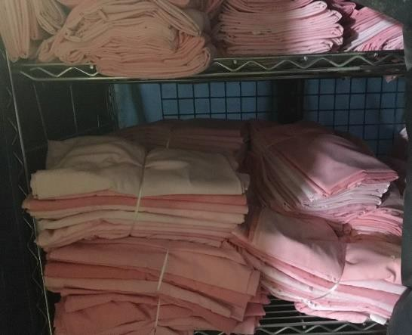
EMS Linen (Pink Linen)
- P50 – EMS Sheet
- P51 – EMS Pillowcase
- P52 – EMS Bath Blanket
- P53 – EMS Bath Towel
- P55 – EMS Gown (Any non-standard, non-HCSC gown)
Material: Varies
Pink Linen does not follow the normal quality standards for HCSC linen. This is a way to gain added servings of linens that
wouldn’t otherwise meet quality standards by filtering them into a high loss area (EMS transports). The following standards should be followed:
- Holes smaller than a ¼” are ok.
- Larger holes and tears are ok if sewn shut.
- Only small light stains are acceptable.
- Excessive pulls are unacceptable and should be cut off before serving.
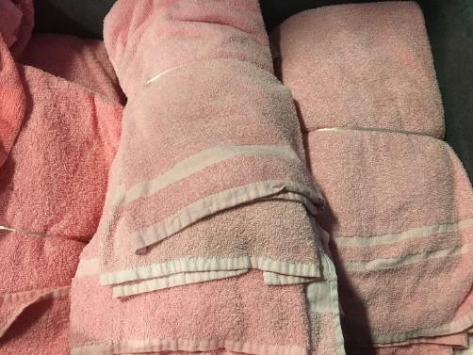
- Foreign Linens – alternative sizes, colors, non-HCSC kaumograph markings, etc., can all be dyed pink and served.
- Stains from stickers or adhesive are ok if they are not tacky.
- Wrinkled Blankets - damaged from the irons.
- Small tails are acceptable on the finished package.

Packaging/Presentation: As per the standard item.
Cart Packing: Packed out at the top of the cart.
