HCSC Mending Department
Mending Department Purpose
The HCSC Mending Departments, also known as the sewing department, serve as one final chance to extend the useful life of the linens. Pre-sorted goods are sent to this department for evaluation and are either repaired or classified as no longer serviceable and pulled as a rag. This section will give an overview of the department who should be using this manual and specifics for each item on guidance to decide what can be repaired, and what is no longer serviceable.
A good thing to keep in mind when completing any mending is: “Would I be happy to use this for a child/parent/loved one?”
Condemned Linen Grading and Ragging Procedures
Condemned linen should be sent to the plant’s mending department. There, linen will be graded as per the specifications detailed in earlier sections of the Quality Control Manual for one of the following situations:
- No flaws were found, and the item should be sent back to soil as rewash.
- Item is likely just stained and sent back to soil as stained.
- Item can be mended using a sewing machine – once complete send to rewash.
- Item cannot be saved through a stained wash or mending and should be ragged out.
  - Item should now be counted and logged on to the rag report form.
  - Items should be considered for alternate use such as a sheet cut down to a draw sheet, a towel cut down to a washcloth, or for use as pink linen.
  - Note: items getting repurposed such as pink linen are considered ragged and should be added to the rag report form
Rags should be collected in the following manner:
- Rags should be separated into carts of:
  - Sheeting, Knit Contours, Thermals, Bath Blankets, Terry items, and Surgical Towels
- All items MUST BE DRY as the rag vendor will not except wet or damp items.
- Please use the “Rags – Already Counted” tags below to prevent confusion.
- All other items (colored polyester) are of no value and should be trashed within each facility.
  - This includes scrubs, pads, gowns, and pj’s.
Full carts of rags should be sent to the Allentown Plant for weekly pickup from the rag vendor.
Note: Kingston currently has their own rag vendor and should follow that vendor’s
directions.

Plants using Allentown’s Mending Department
Carts sent to the Allentown plant for grading and repair by the mending department should follow these guidelines:
- Carts for the mending department can be mixed.
- Mark the cart using the “For Mending from Plant” tag below.
  - Make sure to fill in the plant name.
- Allentown will fill out a separate rag report form for each plant.
- Allentown will log and charge time spent grading and mending back to the originating plant.

Cart Transfer Signage

It is essential that carts transfer between plants, or the Emmaus Warehouse must be properly labeled to prevent confusion and excessive handling. There are three primary reasons plants may transfer linens between plants:
- Rags (or mending for some facilities) – sent to the Allentown Plant for repair or collection for the rag vendor.
- Not our Account – goods that belong to a customer of another plant should be sent to the Emmaus Warehouse for re-distribution to the proper plant.
- Transfer of Linens – these items are being sold or otherwise transferred to another plant for their use.
Below are premade tags that should be used for transfer purposes. Copies of these tags can be found in the SharePoint file library.
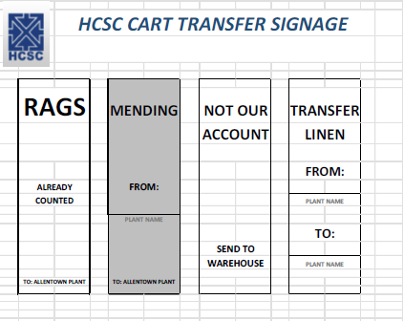

Chemicals to Assist with Linen Rehabilitation
Chemistry can be used to aid with linen rehabilitation. While our machines have stain formulas and adhesive removal formulas, it’s generally best to pre-treat these items while checking items in the sewing department.
- Tape or Glue – specialty chemicals have been successful as a pre-treatment for this type of item.
  - Scraping it with a blunt object such as a butter knife can help the process.
  - Example tape removal product: Goo Gone
  - Note: once adhesive is burned into the linen even chemicals may be unable to remove it
- Stains – a degreaser is an effective way to pre-treat stained linen, though if applying the
product does not help it’s unlikely to come out.
  - Note: Iron stains which have a red hue have their own specialty formula for removal.
  - Example degreasers: Simple Green, LA’s Totally Awesome
- Other chemistry – there are other chemical products on the market that HCSC has some success in utilizing. Please reach out to the corporate Quality team with any questions.
If there are any other stain concerns or potential chemical solutions, please contact the Quality
Assurance Specialist to work out any details, testing, or necessary formulas.
Mending Equipment
Straight Stitch (Lockstitch) Sewing Machine
Standard lockstitch sewing machine uses needle and thread to lay straight stitch through fed fabric.
- Used for collars, cuffs, or straight tears.

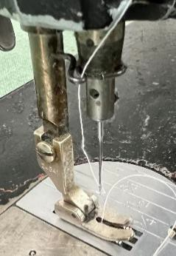

Darning Machine
Item with worn or damaged area is placed on needle bed and warp is laid over area with needle followed by fill across warp.
- Used for repairing holes or worn areas in fabric items such as thermals or blankets.
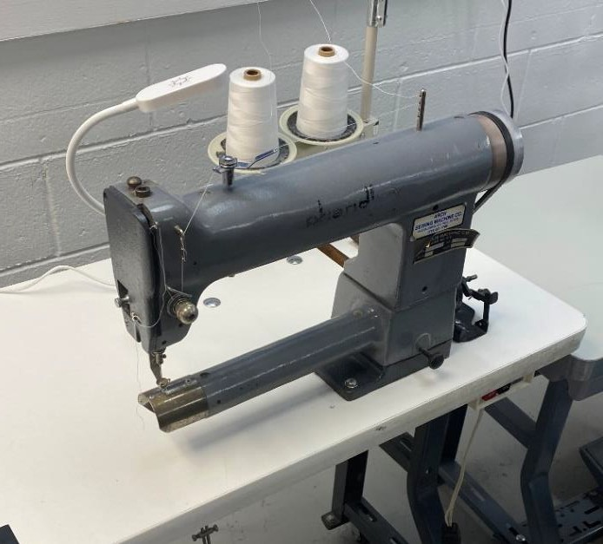

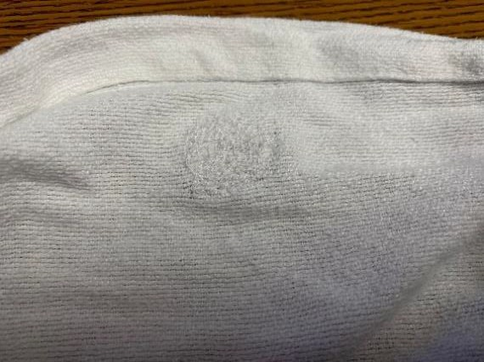

“Merrow” Overlock Sewing Machine
Sews over the edge of one or two pieces of fabric for edging, hemming, or seaming material while simultaneously cutting loose edge of piece(s) being fed.
Used to repair bad hems or frayed ends on items such as thermals or blankets.
If used to repair a hole, the following guidelines should be followed: Patent area repairs should be limited to 2 repairs up to 3 inches each.
The sides of the blanket (defined as within 6” of the edge), can see larger repairs of 4 to 6 inches
long.

The sides of the blanket (defined as within 6” of the edge), can see larger repairs of 4 to 6 inches long.

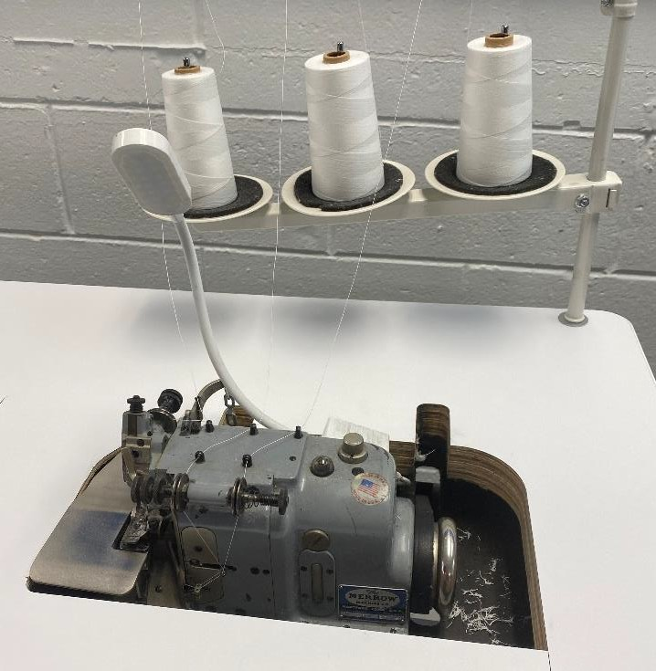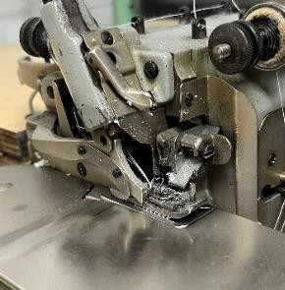

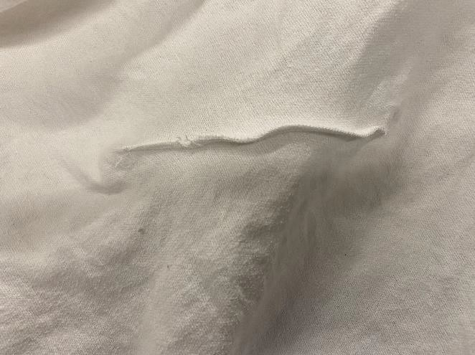

Juki 1910 Machine
The Juki Machine is the newest acquisition by HCSC. Its sole purpose is to sew the square patch that holds the RFID tag in place.

This machine will be used as HCSC converts to RFID scanning of garments, and then to replace missing or failed chips in the future

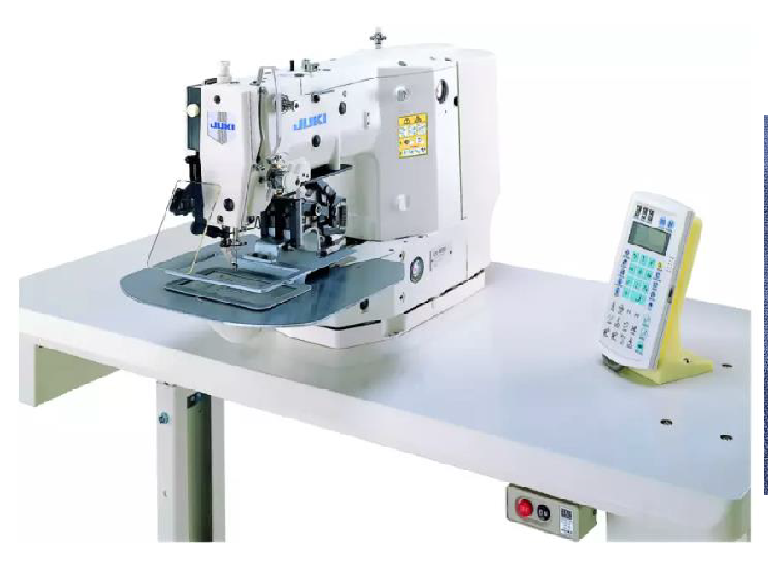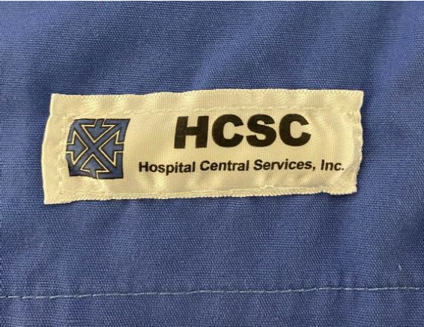

RFID Chip installation Locations
Note: Information from Positek document “UHF Tagging Spec V1_7 2020”.

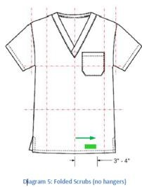

Patch Machines aka Heat Seal Machines
Patching machines, or heat seal machines, are used to heat seal patches and labels to linens. Patching is generally done with products where a sewing machine does not make sense. Heat seal machines come in two head varieties for more efficient operation, or single head for normal
operations.

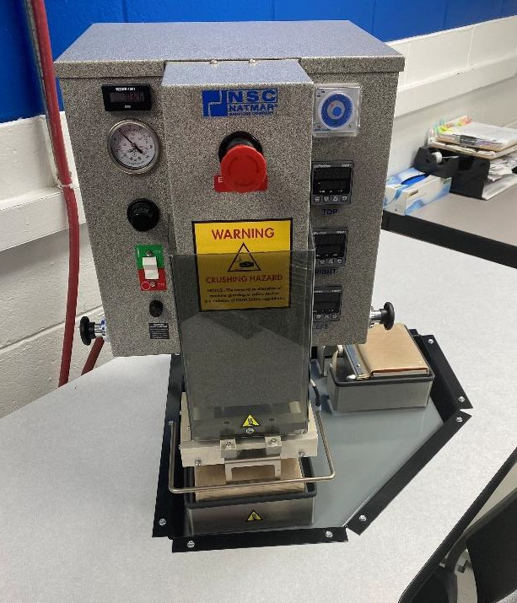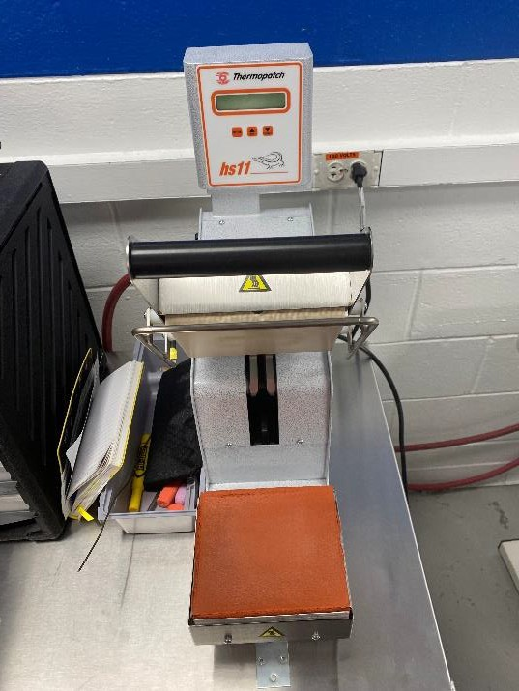

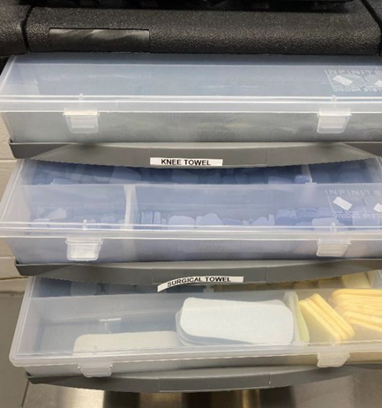

Products that can use patches include (but are not limited to):
- Garments such as scrubs and warmups
- Knit contours and stretcher sheets.
- Precaution gowns
- OR linens (see above section for details)
When patching a reasonable rule would be to limit it to 4 small patches.

Time, Temperature and Pressure Settings
The settings on these machines are more temperamental than one would expect. Here are the best settings recommended by the patch manufacturer for the machines to run under:
- Dwell Time – 10 sec.
- Temperature – 390 degrees
- Pressure – 65 PSI
Other Repairs and Processing
- Items 202 and #301 Reusable Laundry Bags can have their elastic replaced by the department when needed.
  - Contact the warehouse for elastic replacements.
- Replacement of scrub pants draw strings.
  - Make sure to use the correct color for size identification.
  - The ends of the strings must either be sewn, or heat sealed to prevent fraying.
- The mending department can use items classified as rags to create item # 291 Rags.
  - Items should be cut so they are not re-counted if they are returned.
  - See item entry for further details.
- Condemned linens may also be checked and counted by the Mending Department.
  - It used to be their job, however, with the institution of the Quality Control Clerk position that duty was moved. They should stay up to speed as a backup, however, as it’s an important job for the company and the customers.
  - See the section above on the condemned linen program.
HCSC Quality Assurance Program – Item Specifics
Not all items in the laundry are created for the same purpose, or from the same materials. Thus, the inspection of these items should not be the same. The following is an item-by-item breakdown of the items found in HCSC laundry, and what criteria should be used in the inspection.
Important inspection notes:
- The quality criteria of the items are dictated by the customer. That said, there is a balance. As HCSC is a rental company with numerous customers, there are many factors to consider in a standard. Any changes to the quality criteria included in this manual should be sent to the corporate team for review.

- The Quality Clerk/Inspector should always be mindful of the employees they are inspecting. HCSC is trying to provide a quality product, so we do not want to unnecessarily punish employees with inadequate quality scores.
- Always take the time to evaluate the conditions the employees are working under so HCSC can improve quality. Is the lighting poor? Are they new stains we haven’t seen before? Are there stains that should have been removed in the wash? Is the damage
caused by the machines?

General Condition for all Linens:
- All items are to be soft to the touch.
- All items are to be free from foreign objects.
- All items are to be fresh smelling and free from any objectionable odors.
- All items determined as unacceptable by the following guidelines are to be:
  - Rejected as stained and placed in the appropriately marked hamper.
  - Placed in the appropriately marked hamper for the Mending Department, where the final determination will be made as to the serviceable life of the item.
- Patch material will be heat sealable and have the same characteristics as the textile being repaired.

New Defects:
While inspecting items anywhere in the plant always keep note of what you find. Something new that begins repeating is a quick way of finding a problem.
Some examples include:
- Not using enough chemicals in the washing process leaves excess stains.
- Sudden temperature drops in the tunnel causing polyester items to Thermal Shock, which causes the whole batch to look excessively wrinkled.
- High pH on sheeting causes them to burn as they run through the iron, while pH too low will make them stick in the rollers.
- Over-dosing with peroxide leads to blankets tearing as they are fed into the iron.

Use the following guide as a quick reference as to the different quality standards:

HCSC QUALITY – QUICK CHECK
