Setup Installation
TomEE Windows Bundle for BDE

TomEE Setup

For the installation of the custom Bundle for BDE you will need the BDE_tomee8.0.13_jdk11.0.17_bundle_for_Windows_v1.zip found on ftp ( path will be provided)

Unzip BDE_tomee8.0.13_jdk11.0.17_bundle_for_Windows_v1.zip in the location where the webserver need to be installed.
As example:
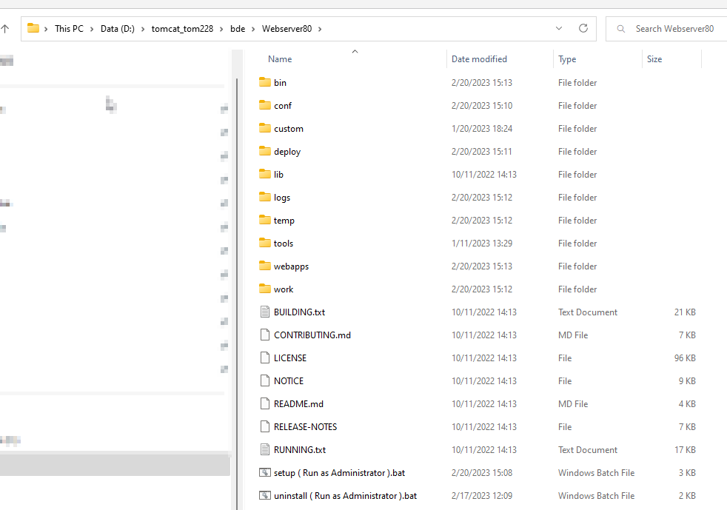
To install Start as Administrator: setup ( Run as Administrator ).bat
Here there are 2 things that need to be considered:
- The installation on ports 81 admin console and 80 web component link will have also dedicated listener port like 86 and all the HTTPS and SNMP ports will be:
HTTPS port 532
SMTP port 5XX depending on the web component.
- The installation on ports 8181 admin console and 8081 web component links will have also dedicated listener port like 86 and all the HTTPS and SNMP ports will be:
HTTPS port 58132
SMTP port will be 581XX depending on the web component.

Running Setup

Will be prompted the following question:
Please specify the value for ABS_WEBSERVERHOME, the default value is D:\tomcat_tom228\bde\Webserver80\: <path of the webserver on the disk>
Please specify the value for ABS_WEBADMINSLOT, the default value is 81: <Web server administration port>
Please specify the value for ABS_WEBSERVERSLOT, the default value is 80: <Web Components access port HTTP>
Please specify the value for ABS_WEBSERVERSERVICENAME, the default value is ABSS80_WebSrv: < Web Server Service Name>
Please specify the value for ABS_WEBSERVERMEMORY, the default value is 1024: <Allocated memory for the TomEE webserver>
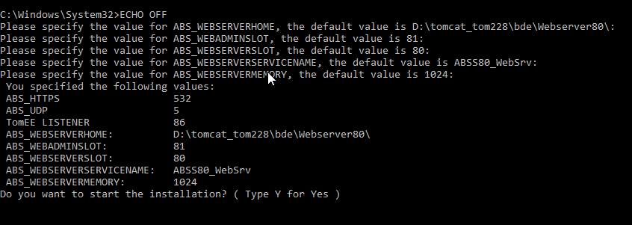
As you can see this is the default installation for the admin 81 port and web components 80. Here there is nothing that needs to be set manually. Only them allocated memory if it needs to be higher than 1024MB
You can see the Port 81 will be HTTPS to access the TomEE console port 80 will be http and can access the web components.
ABS_UDP will be for SNMP verification and that will be displayed upon deploying web components.
For the Test environments or the one that are using 4 digits as ports you need to do the following as seen in the screenshot:
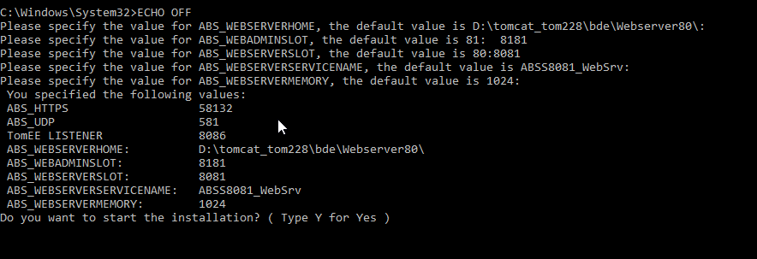
Insert the Web Admin port as 8181 HTTPS
Insert the Web components slot port 8081 HTTP
Find the HTTPS port for the web components HTTPS 58132
This will apply for all the deployments from 8081 till 8089

After Pressing Y the TomEE Apache service will be installed and started with the name as above ABSS80_WebSrv or ABSS8081_WebSrv

Running The Web Components Deployment.
Place the Unzipped web component in the deploy directory as below:
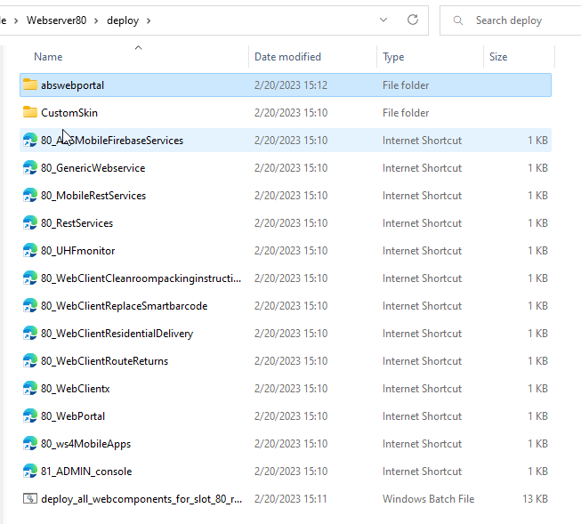
As on the Payara version the Web.xml from the webcomponent location will need to be configured.
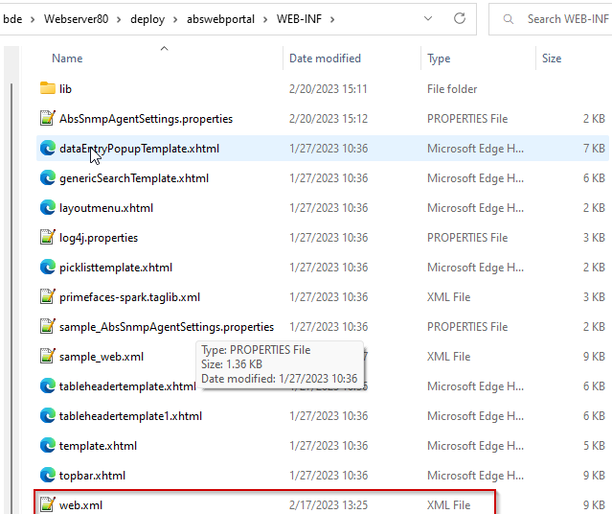

Before starting the web components deployment you need to modify the
deploy_all_webcomponents_for_slot_80_run_as_administrator.bat < edit>
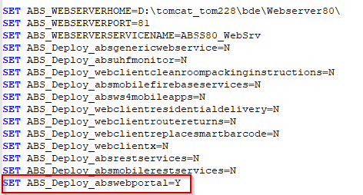
Modify the component that need to be deployed with Y
For the Web portal if there are custom skins or custom resources not included in the installed you can place them in the path
deploy\CustomSkin\images
deploy\CustomSkin\custome_resources
and they will be piked up upon installation.

To have the Deployment done use the:
deploy_all_webcomponents_for_slot_80_run_as_administrator.bat from the deploy folder as administrator.
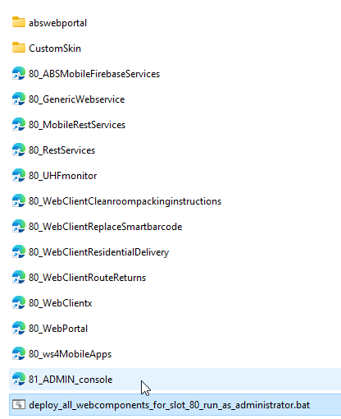
Prompt with Y:
It will proceed with cleaning the TomEE installation and prepare it for the deployment:
