ABSN-17470 WebX Error with p25
Environment | Prerequisites
Version: 9.08.00.RELEASE.p26  Environment=PRODUCTION  DBServerName=abs-srv17.internal.abslbs.com  DBSID= CUST23  DBUser= AUS_MNT90800  DBPassword= AUS_MNT90800 | - Modules: AUSCUSTOM  - Others: BU 503

Contents
Reproduction before fix 1
Retesting after fix 2

Reproduction before fix
BU:503
- Cust.No: 5387842 (customer_id 4334)

select c.customernumber, c.customer_id, g.customer_link_id,
g.route_id, r.routenumber, r.drivingday_id, g.invoiceheader_id, g.invoicedate
from route r, garmentsoilscanhist g, customer c
where r.route_id=g.route_id
and c.customer_id=g.customer_link_id
and c.customernumber in (5387842);
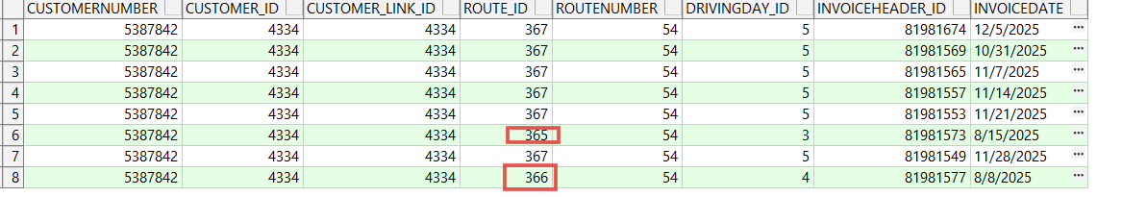
Different route_ids
select * from garmentsoilscanhist hh
where hh.customer_link_id=4334;
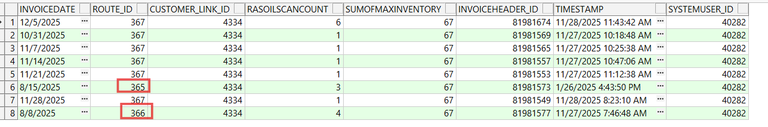
- route checkIn Date 22/08/2025
- route.No=54
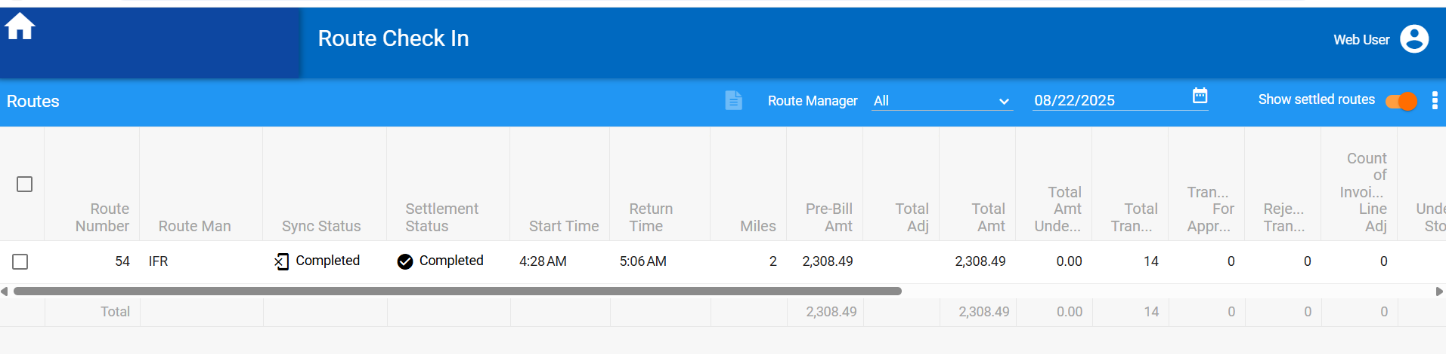
- Open web client x/ route check in page
- On Routes page choose route 54 from 22/08/2025
Actual result:
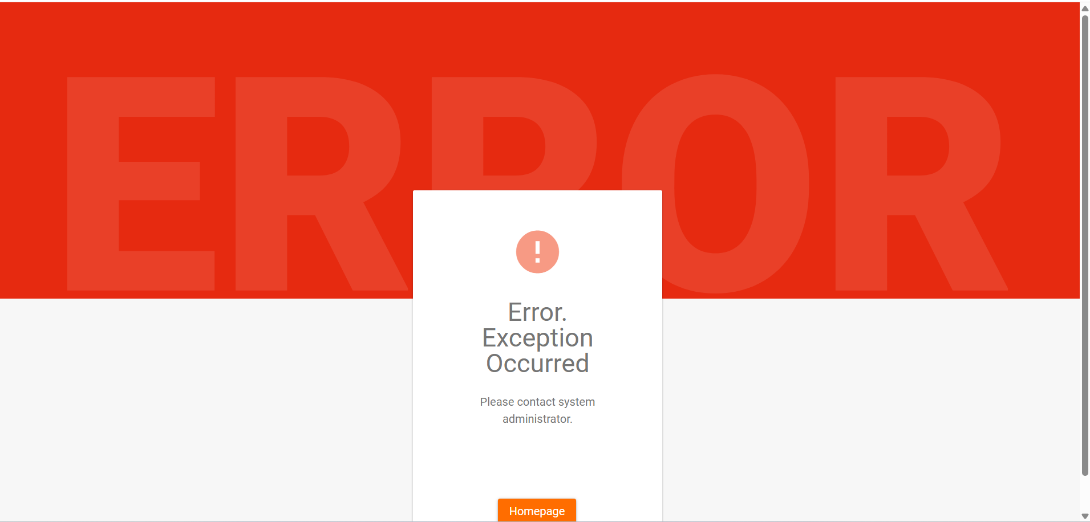

Open Route Check In dlg from Client and choose the same route and date:
Actual result:
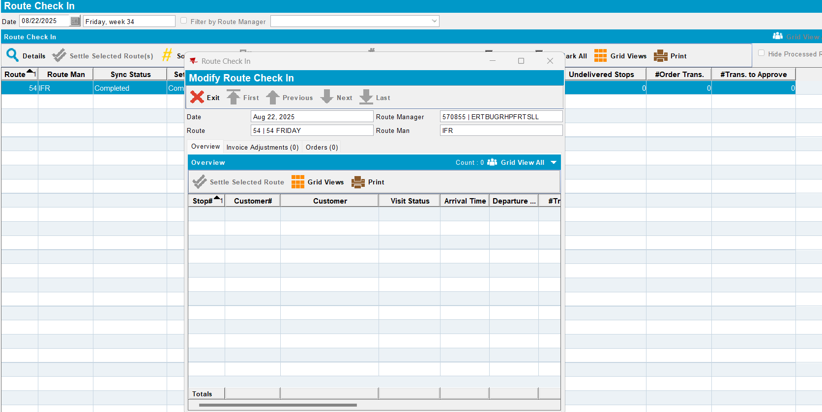
Reproduced.

Retested after fix
Commit:
BU:503
- Cust.No: 5387842 (customer_id 4334)

select c.customernumber, c.customer_id, g.customer_link_id,
g.route_id, r.routenumber, r.drivingday_id, g.invoiceheader_id, g.invoicedate
from route r, garmentsoilscanhist g, customer c
where r.route_id=g.route_id
and c.customer_id=g.customer_link_id
and c.customernumber in (5387842);
Different route_ids
select * from garmentsoilscanhist hh
where hh.customer_link_id=4334;
- route checkIn Date 22/08/2025
- route.No=54
- Open web client x/ route check in page
- On Routes page choose route 54 from 22/08/2025

Actual result/ Expected result:
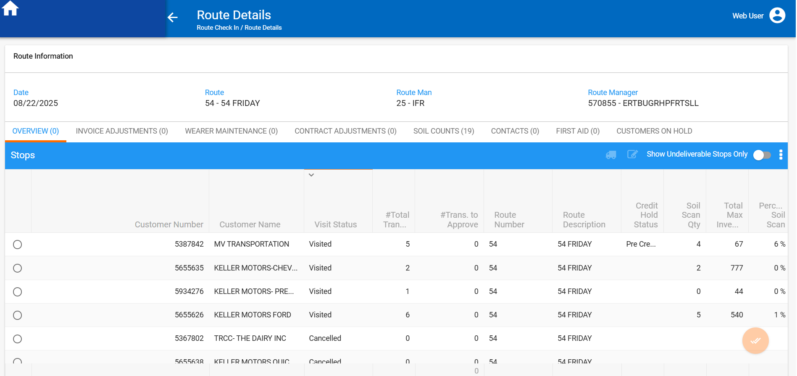

Open Route Check In dlg from Client and choose the same route and date:
Actual result/ Expected result:
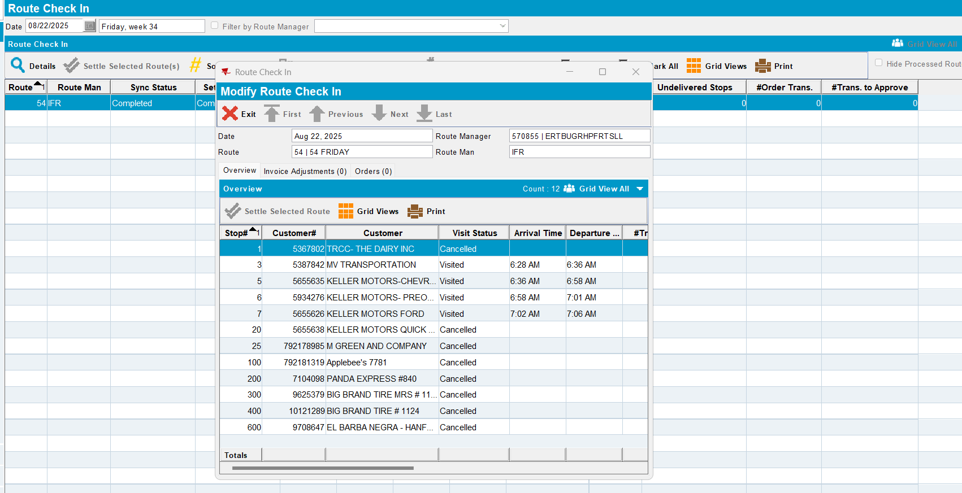
Tested ok.

