ABSN-14421 WebX soil scan - weeks issue
Environment | Prerequisites
Version: 9.08.00.RELEASE.p24  Environment=PRODUCTION  DBServerName=abs-srv17.internal.abslbs.com  DBSID= CUST23  DBUser= AUS_MNT90800  DBPassword= AUS_MNT90800 | - Modules: AUSCUSTOM  - System setting: -  - Others: BU 503
Contents:
WebX enhancements for Credit Hold, Soil Counts and Customers on Hold
#1 Check X-RouteCheckIn dlg/ Route Check In/ Routes page– Passed 1
#2 Check X-RouteCheckIn dlg/ Route Check In/ Overview tab – Passed 6

#1 Check X-RouteCheckIn dlg/ Route Check In/ Routes page– Passed

Expected result:
Other Grid Fields under module AUSCUSTOM
Average scan percentage over the previous 4 weeks – so not including the current route  For GarmentSoilScanHist. InvoiceDate >= route driving date – 35 28 days and less than current route date, sum the values from GarmentSoilScanHist for this route ID.  Sum (GarmentSoilScanHist.RASoilScanScount) / sum (GarmentSoilScanHist.SumOfMaxInventory) | 4 weeks average soil scan % - shown as a % with no decimal places
Average scan percentage over the previous 13 weeks – so not including the current route  For GarmentSoilScanHist. InvoiceDate >= route driving date – 98 91 days and less than current route date, sum the values from GarmentSoilScanHist for this route ID.  Sum (GarmentSoilScanHist.RASoilScanScount) / sum (GarmentSoilScanHist.SumOfMaxInventory) | 13 weeks average soil scan % - shown as a % with no decimal places

Actual/ Expected result:
BU:503

select * from garmentsoilscanhist gs where route_id=367 order by gs.invoicedate;
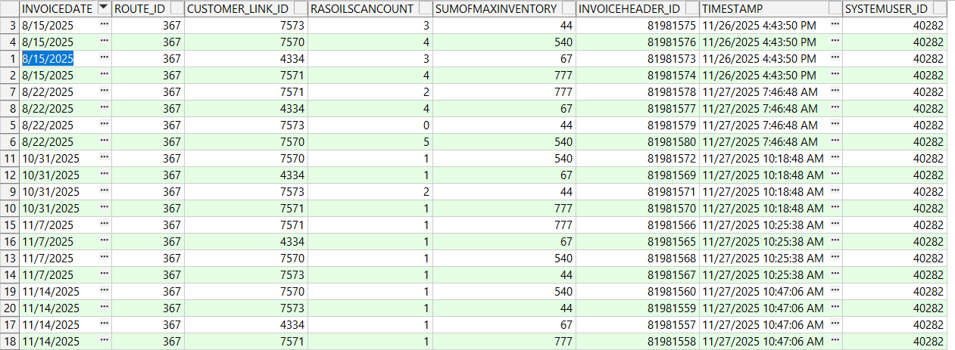

Route 54
- First route (15.08.2025):
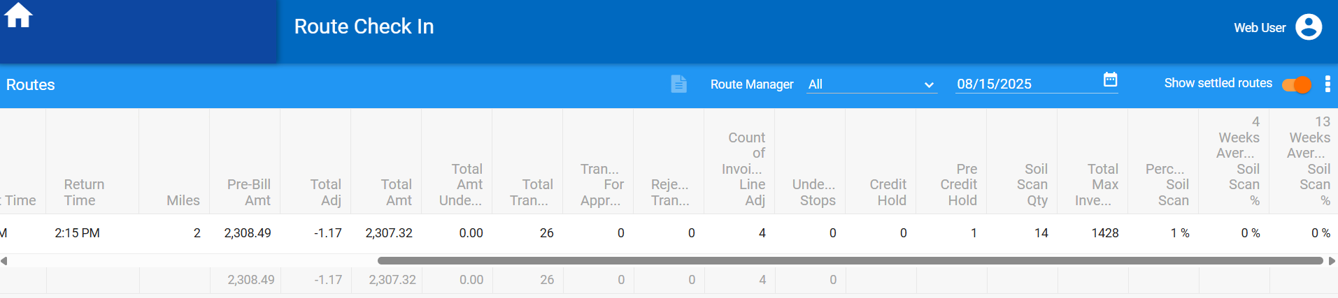

- 4 weeks and 13 weeks average soil scan = 0% (the current route is not included, no previous routes)

- Next route (22.08.2025):
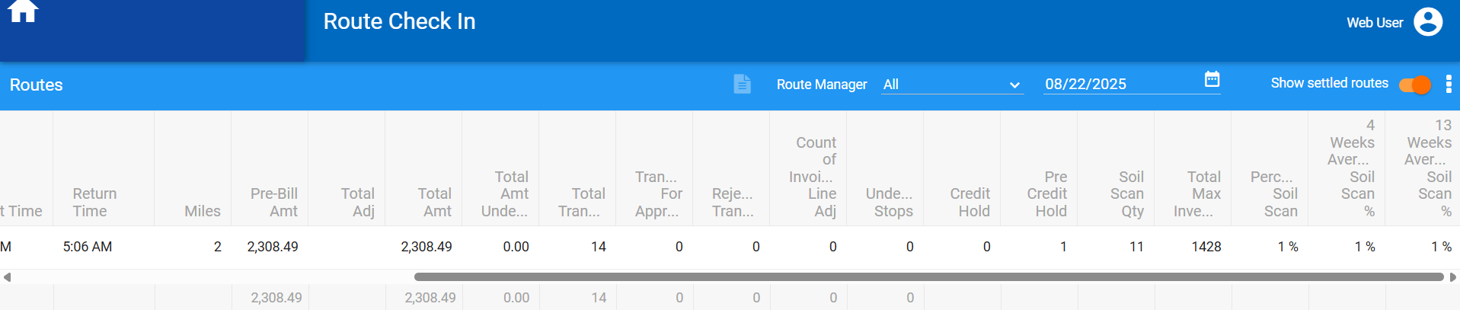

- Soil qty =14 (from previous route)
- Total max = 1428 (from previous route)
- (14/1428)*100=0.98 ~ (round,0) =1%
- 4 weeks average soil scan = 1% (from previous route) (the current route is not included)
- 13 weeks average soil scan = 1% (from previous route) (the current route is not included)

- Next route (31.10.2025):
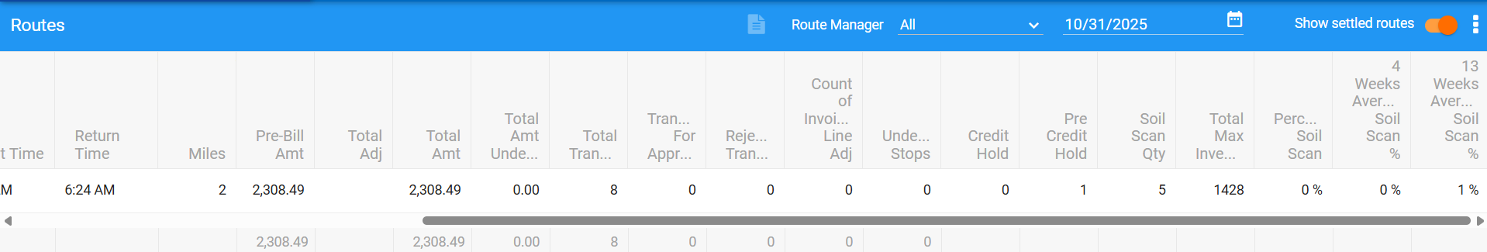

- Soil qty =11
- Total max = 1428
- (11/1428)*100~1%
- 4 weeks average soil scan = 0% (no previous routes for -28 days)
- 13 weeks average soil scan = 1% (from previous routes) (the current route is not included)
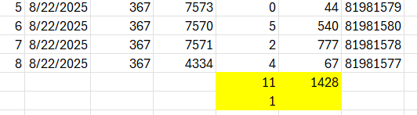

- Next route (07.11.2025):
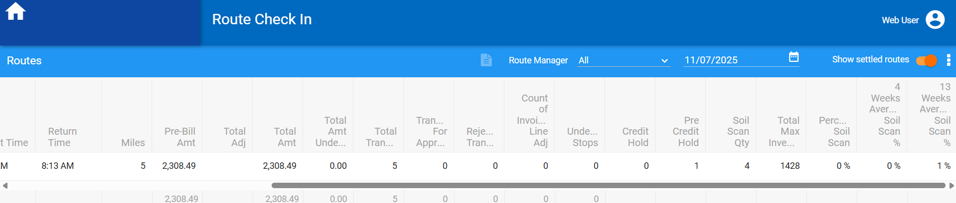

- 4 weeks average soil scan = 0% (no previous routes for -28 days)
- 13 weeks average soil scan = 1% (from previous routes) (the current route is not included)

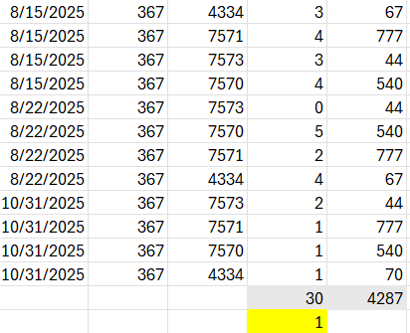

- Next route (14.11.2025):

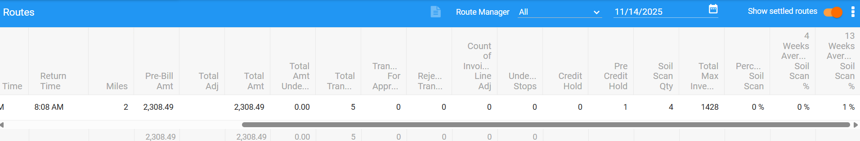

- 4 weeks average soil scan = 0% (no previous routes for -28 days)
- 13 weeks average soil scan = 1% (from previous routes) (the current route is not included)
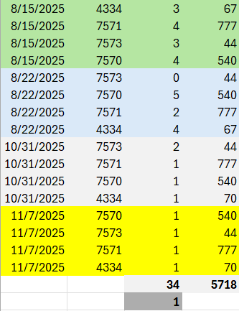

#2 Check X-RouteCheckIn dlg/ Route Check In/ Overview tab – Passed
Expected result:
Average scan percentage over the previous 4 weeks – so not including current route  For GarmentSoilScanHist. InvoiceDate >= route driving date – 35 28 days and less than current route date, sum the values from GarmentSoilScanHist for this customer.  Sum (GarmentSoilScanHist.RASoilScanScount) / sum (GarmentSoilScanHist.SumOfMaxInventory) | 4 week average soil scan % - shown as a % with no decimal places
Average scan percentage over the previous 13 weeks – so not including current route  For GarmentSoilScanHist. InvoiceDate >= route driving date – 98 91 days and less than current route date, sum the values from GarmentSoilScanHist for this customer.  Sum (GarmentSoilScanHist.RASoilScanScount) / sum (GarmentSoilScanHist.SumOfMaxInventory) | 13 week average soil scan % - shown as a % with no decimal places

Actual/ Expected result:
BU:503
Route 54
- First route (15.08.2025):
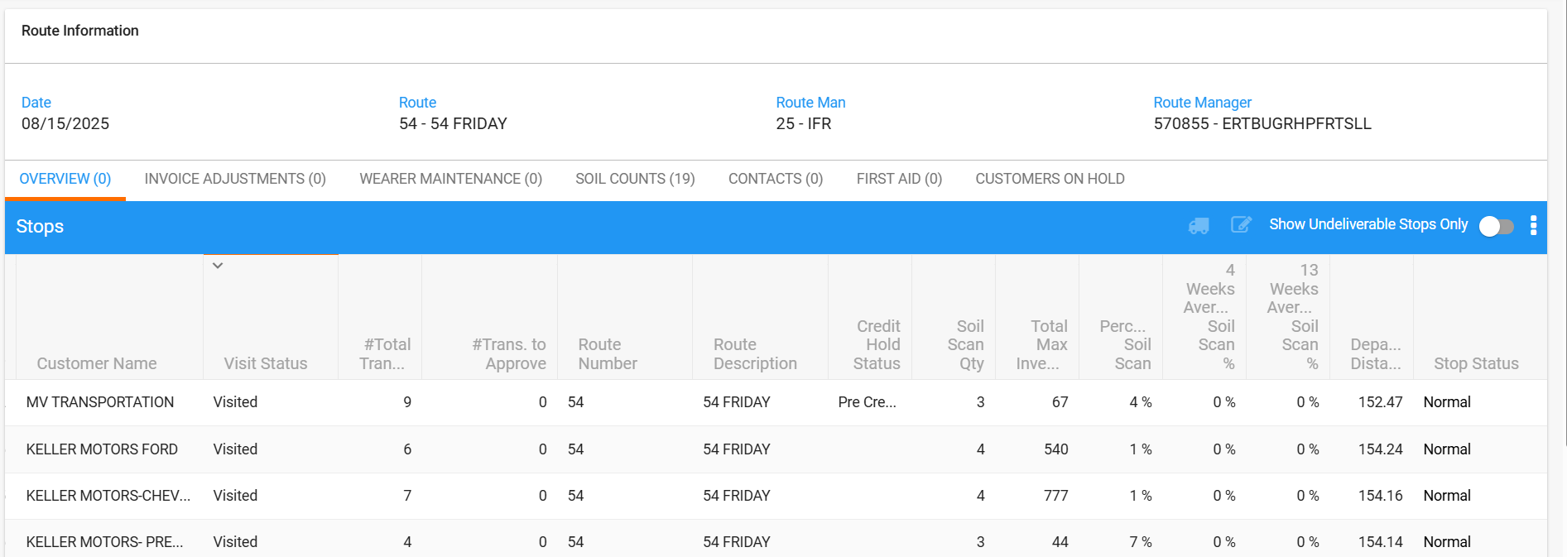
The same result per customer :
- 4 weeks and 13 weeks average soil scan = 0% (no previous routes)

- Next route (22.08.2025) (per customer):
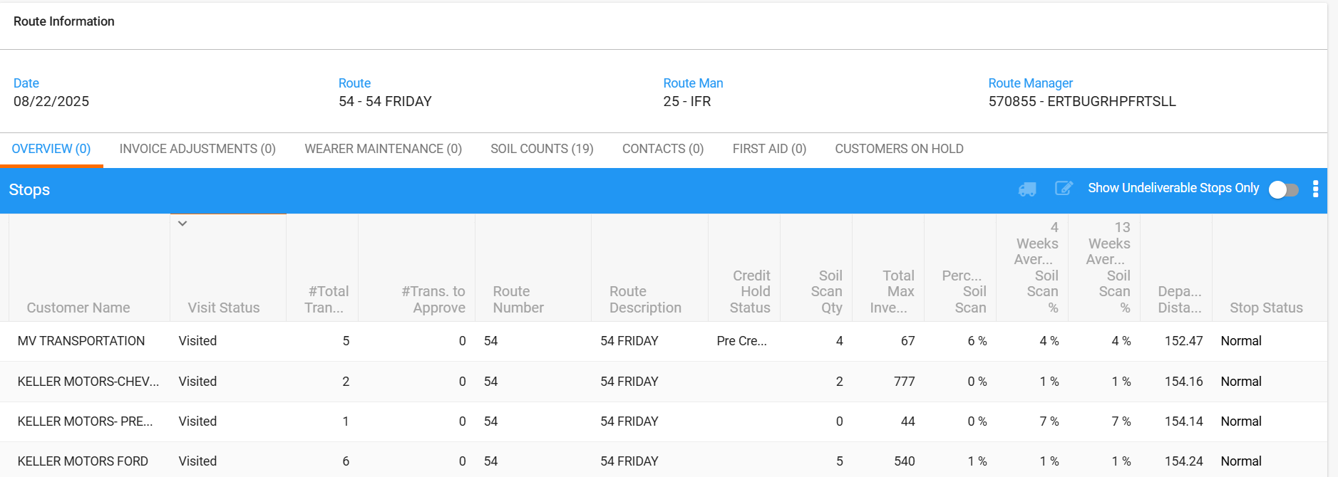
First customer:
- 4 weeks average soil scan = 4% (from previous route) (the current route is not included)
- 13 weeks average soil scan = 4% (from previous route) (the current route is not included)
Second customer:
- 4 weeks average soil scan = 1% (from previous route) (the current route is not included)
- 13 weeks average soil scan = 1% (from previous route) (the current route is not included)
Third customer:
- 4 weeks average soil scan = 7% (from previous route) (the current route is not included)
- 13 weeks average soil scan = 7% (from previous route) (the current route is not included)
Fourth customer:
- 4 weeks average soil scan = 1% (from previous route) (the current route is not included)
- 13 weeks average soil scan = 1% (from previous route) (the current route is not included)

Round ((Soil scan qty/total max. inv) %,0)

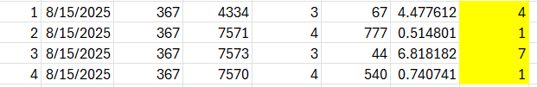

- Next route (31.10.2025):

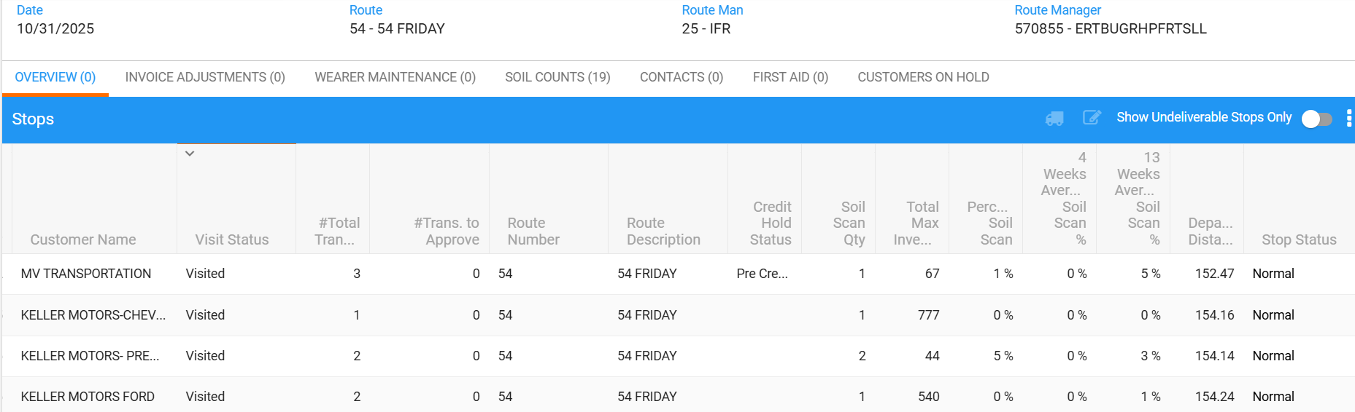

- 4 weeks average soil scan = 0% (no previous routes)

- Customer: 5934276
- 13 weeks average soil scan = 5% (from previous routes) (the current route is not included)

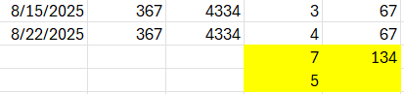

- Customer: 5655635
- 13 weeks average soil scan = 0% (from previous routes) (the current route is not included)

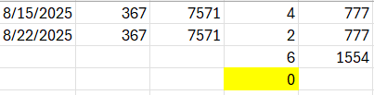

- Customer: 5934276
- 13 weeks average soil scan = 3% (from previous routes) (the current route is not included)

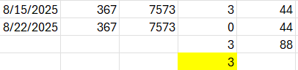

- Customer: 5655626
- 13 weeks average soil scan = 1% (from previous routes) (the current route is not included)

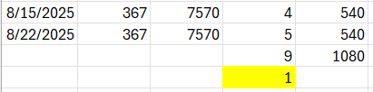

- Next route (07.11.2025):

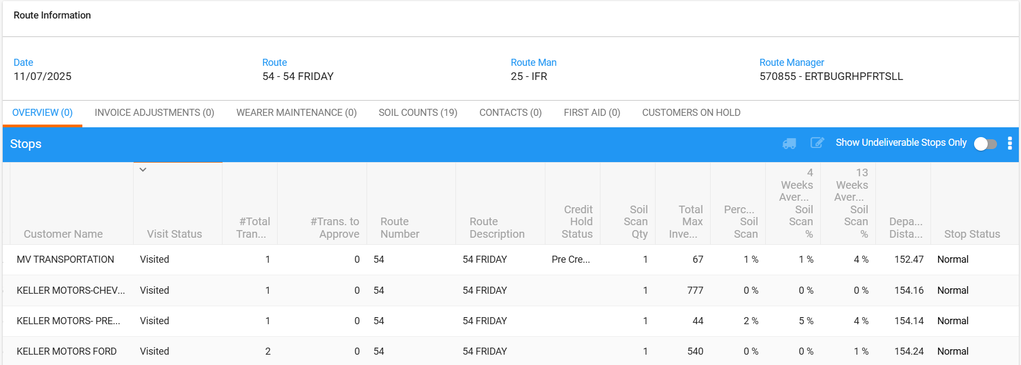

- Customer: 5387842
- 4 weeks average soil scan = 1% (from previous routes) (the current route is not included)
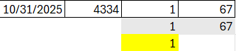

- Customer: 5655635
- 4 weeks average soil scan = 0% (from previous routes) (the current route is not included)
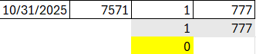

- Customer: 5934276
- 4 weeks average soil scan = 5% (from previous routes) (the current route is not included)
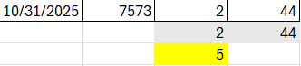

- Customer: 5655626
- 4 weeks average soil scan = 0% (from previous routes) (the current route is not included)

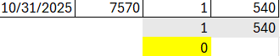

- Customer: 5387842
- 13 weeks average soil scan = 4% (from previous routes) (the current route is not included)

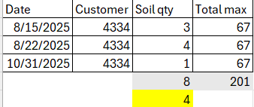

- Customer: 5655635
- 13 weeks average soil scan = 0% (from previous routes) (the current route is not included)
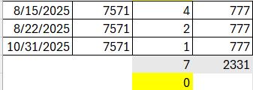

- Customer: 5934276
- 13 weeks average soil scan = 4% (from previous routes) (the current route is not included)
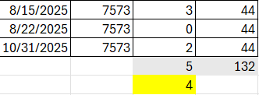

- Customer: 5655626
- 13 weeks average soil scan = 1% (from previous routes) (the current route is not included)
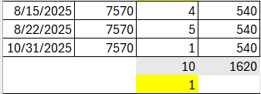

- Next route (14.11.2025):
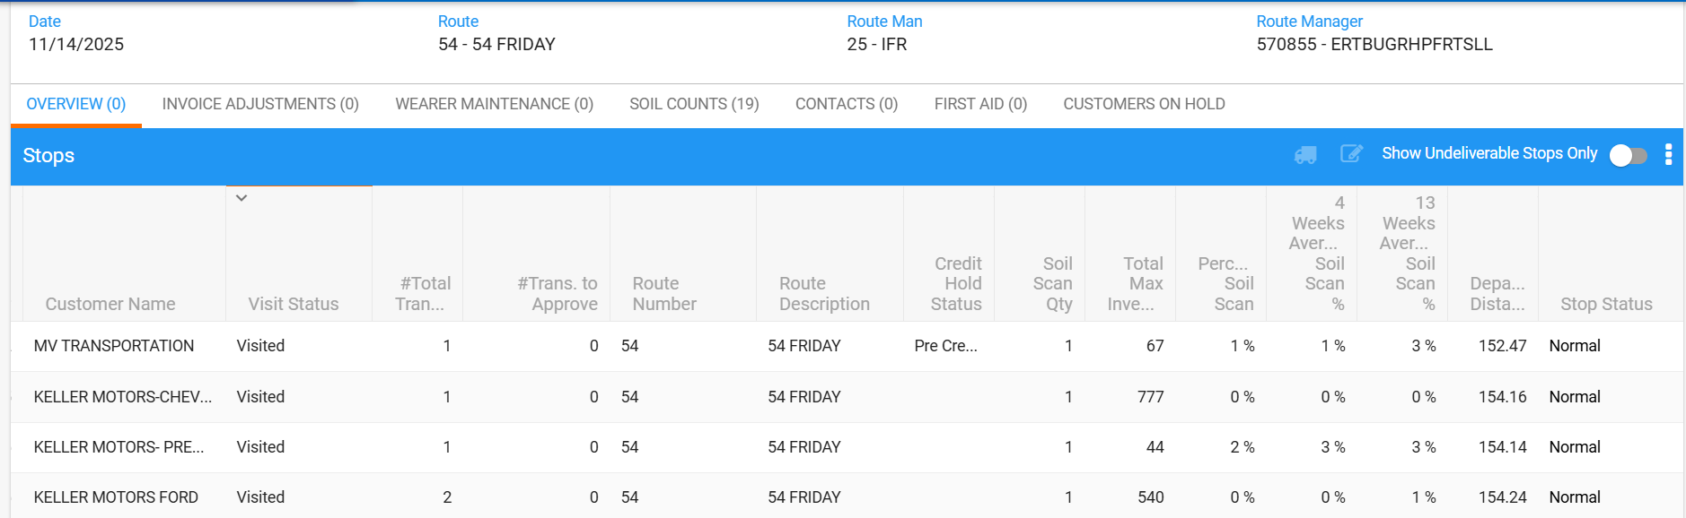

- Per customer 4 weeks:
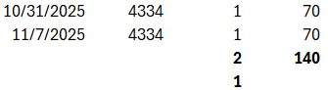

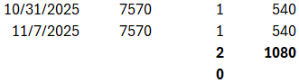

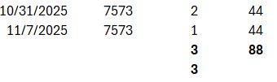

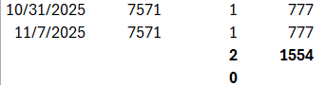

- Per customer 13 weeks:
