ABSN-9446 Observed Issue with ABS Password Resets
Environment | Prerequisites
Version: 9.08.00.RELEASE.p24  Environment=PRODUCTION  DBServerName=db01-buc.internal.abslbs.com  DBSID= CUST25  DBUser= AUS_ND90502  DBPassword= AUS_ ND90502 | - Modules: AUSCUSTOM  - Others: BU 503

Contents
Reproduction before fix 1
Retesting after fix 4

Reproduction before fix

- Only when the below option is checked:
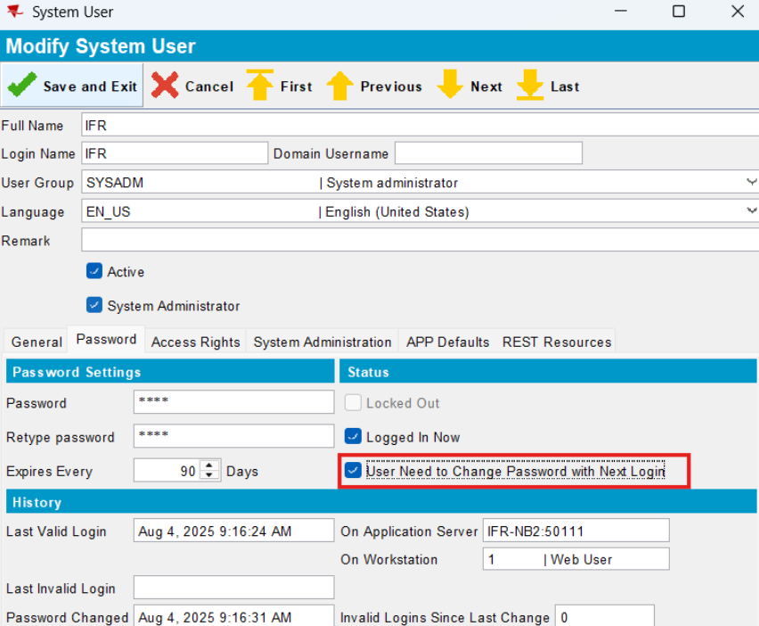
- 2 different passwords can be saved:
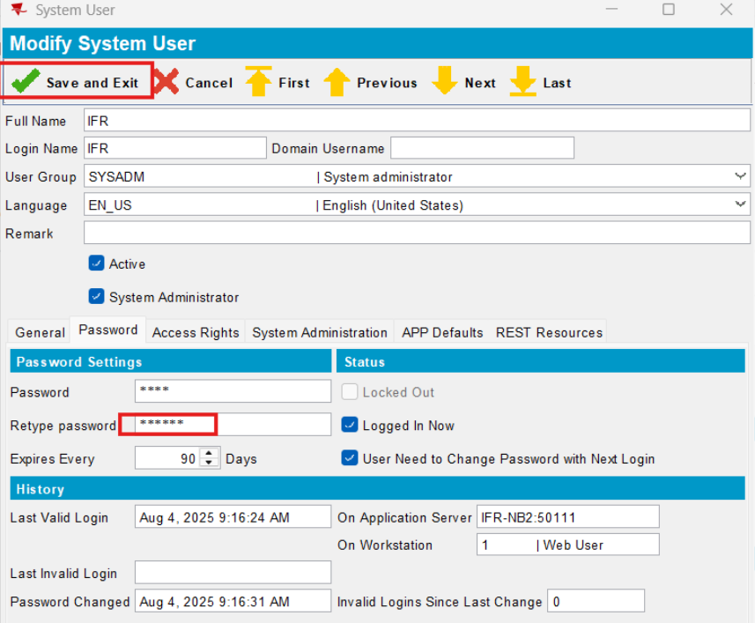

- but if you reopen the dialogue, you will notice that the passwords are now identical and the user can log in with what they passed to: Password field:
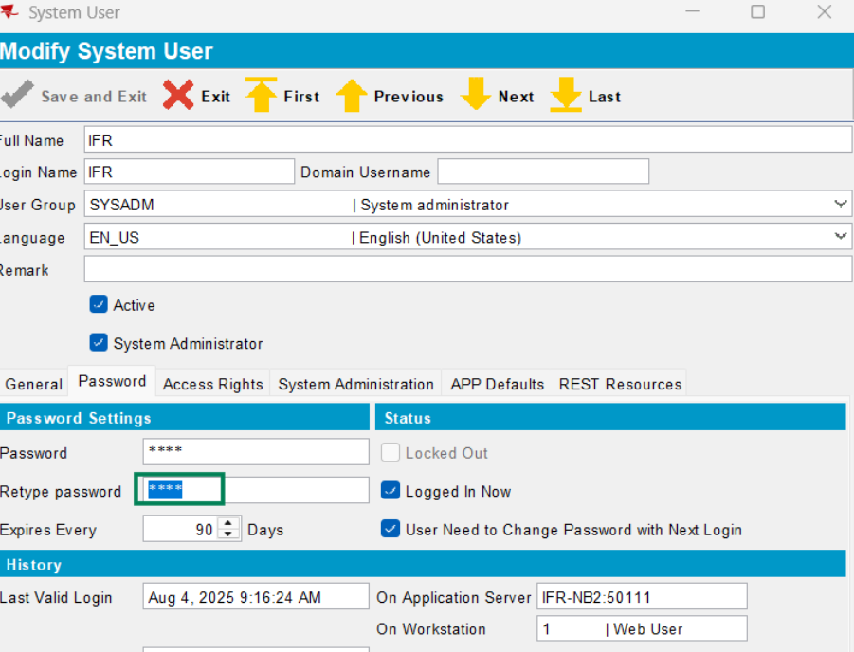

Remark:
- if the option below is not checked, the error message appears:
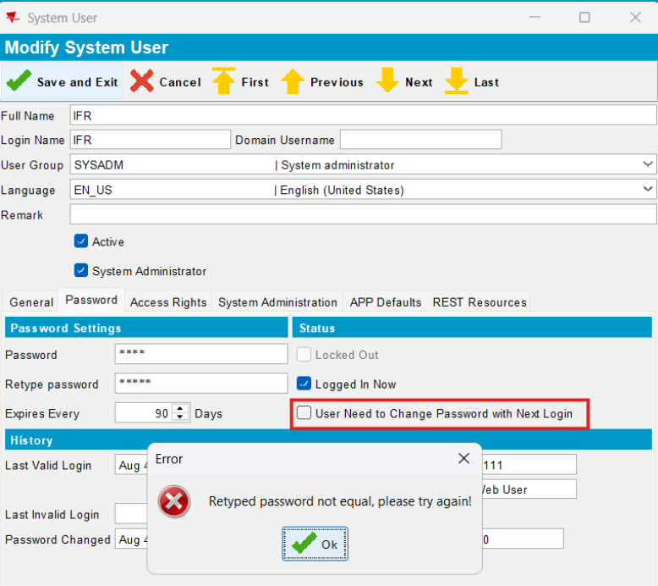

Retesting after fix

- Now, with the force password change option checked, 2 different passwords cannnot be saved:
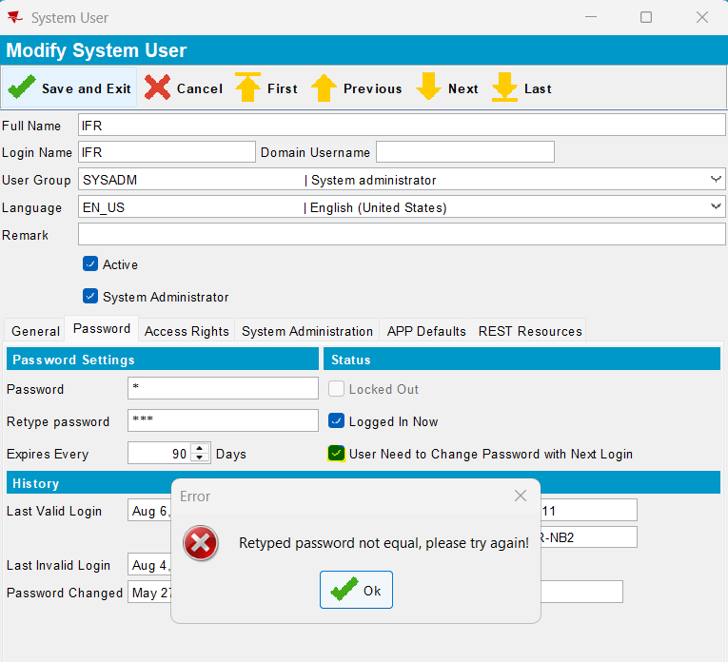

- when the user group has set Password Complexity:
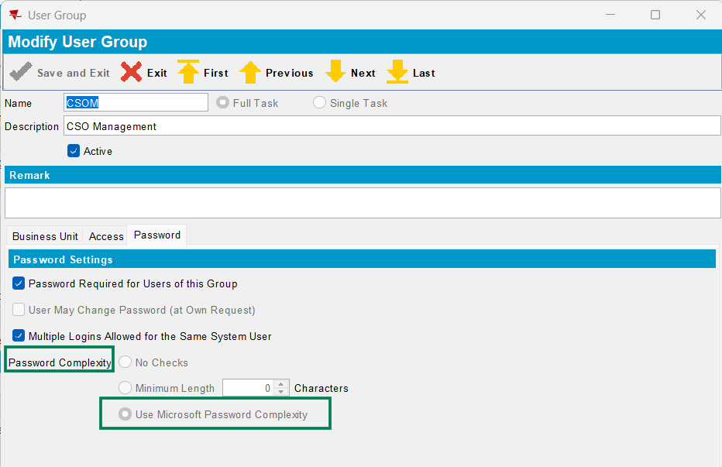

- and force password change option checked:
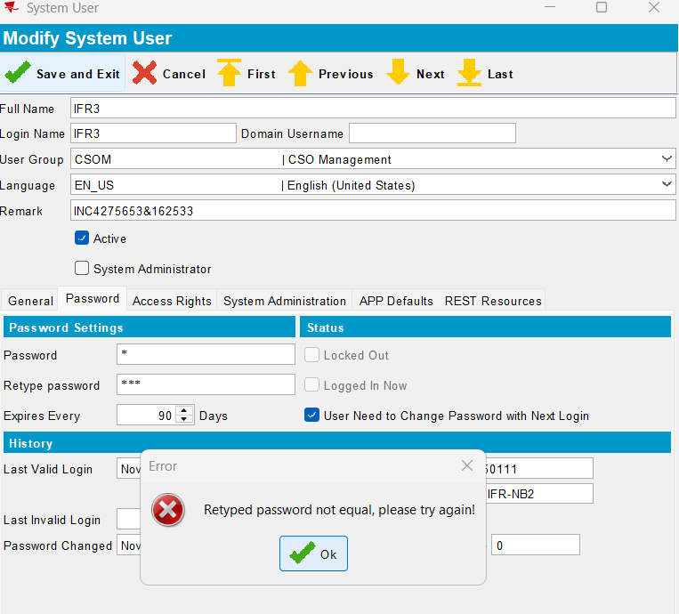

- the first error message is displayed ok
- after the user set the same password, the save it is possible for a simple password because at the first login, when a password change is requested, that password complexity check is performed:
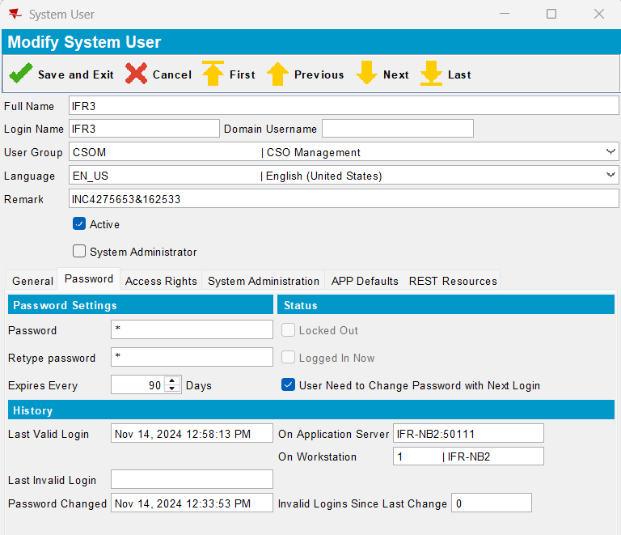

- When the user group has Password Complexity and ChangePasswordNextLogin is checked, the complexity check is performed during the next login, when the user is required to change their password.

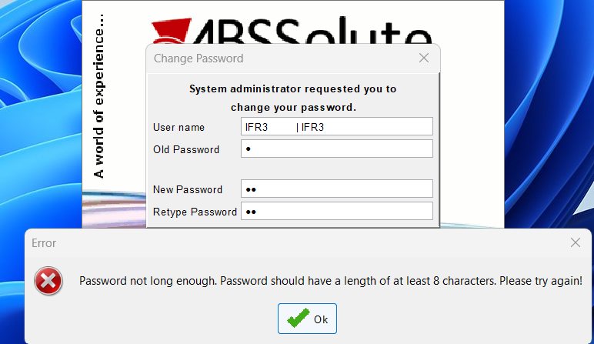

Works as expected:
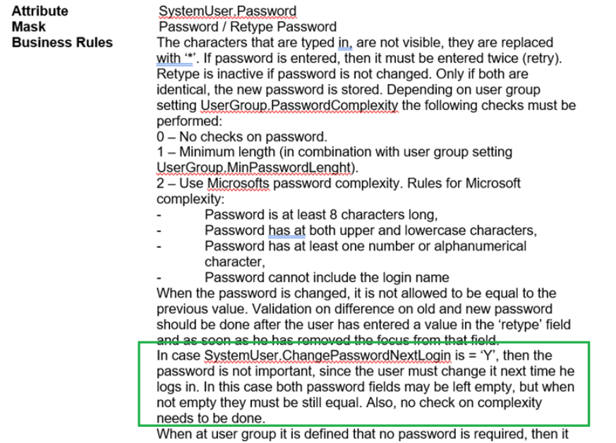

- Also, if the new password is not match the below error message is displayed:
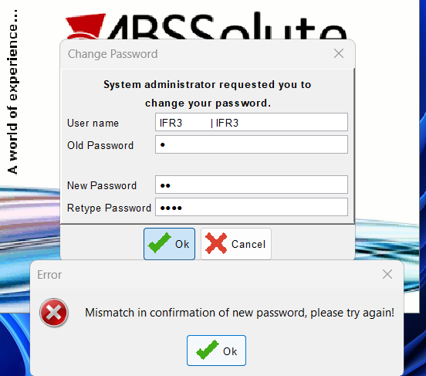
Passed.

