ABSN-9261 First time when an invoice is open (Maintain Invoices dlg) the Total Amount value is not loaded
Environment | Prerequisites
Version: 9.08.00.RELEASE.p24  Environment=PRODUCTION  DBServerName=db01-buc.internal.abslbs.com  DBSID= CUST25  DBUser= AUS_ND90502  DBPassword= AUS_ ND90502 | - Modules: AUSCUSTOM  - Others: BU 503

Contents
Reproduction before fix 1
Retesting after fix 2

Reproduction before fix

Customer: 4716101
Steps to reproduce:
1. Open dlg: Maintain Invoice and tab: Customer
2. Enter customer number
3. Open/ Modify invoices from Unsettled tab and check total amount field
Actual result:
First time when an invoice is open Total Amount is displayed as 0 (nok)
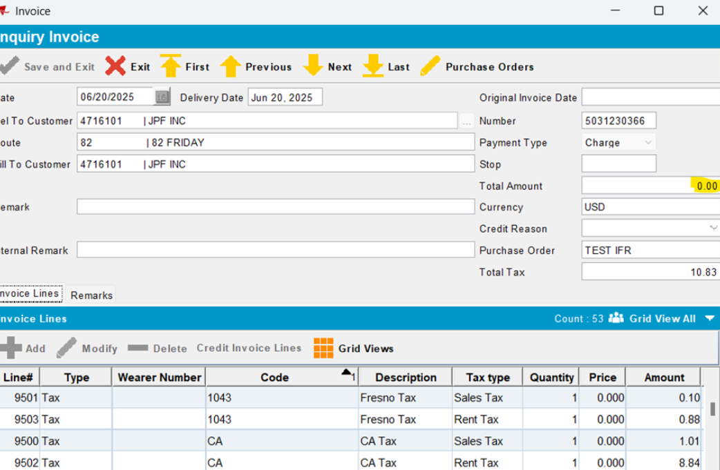

4. Close and reopen invoice
Actual result:
Now the correct value for total amount is displayed (ok):
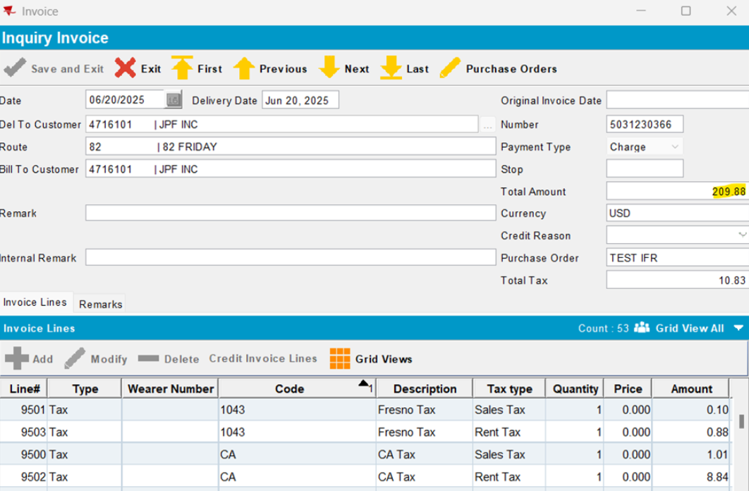

Another invoice:

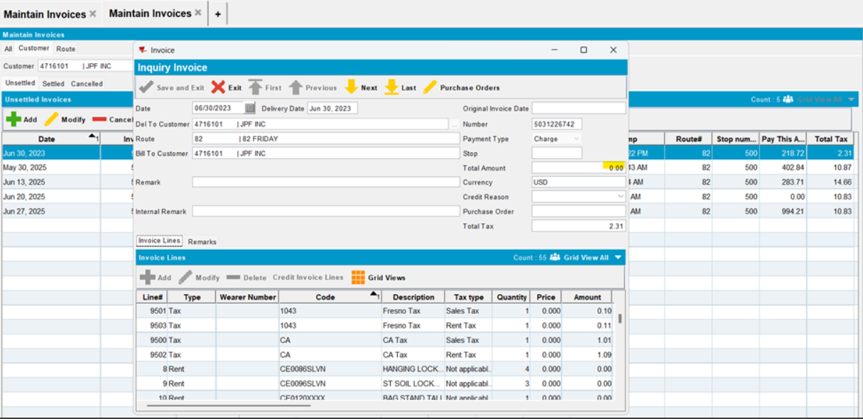

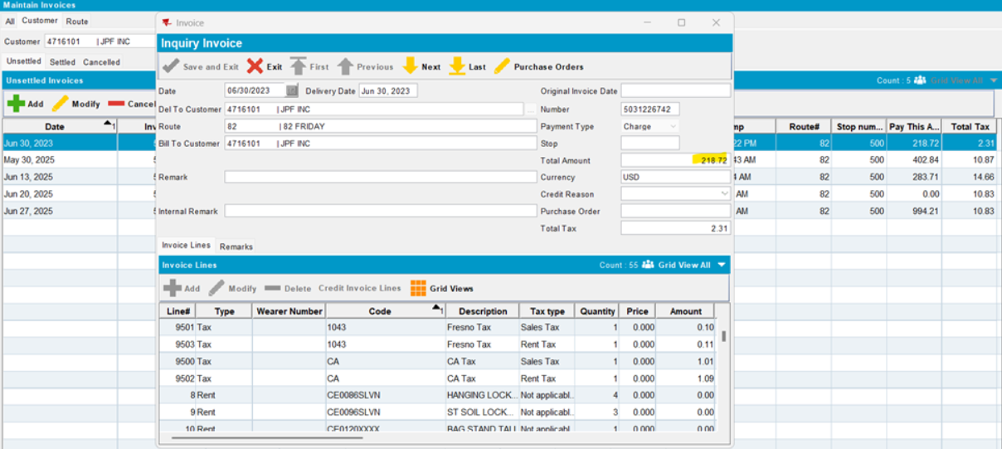

Retesting after fix

Customer: 4848203
Steps to reproduce:
1. Open dlg: Maintain Invoice and tab: Customer
2. Enter customer number
3. Open/ Modify invoices from Unsettled tab and check total amount field
Actual result:
First time when an invoice is open Total Amount is displayed ok (with the correct value)
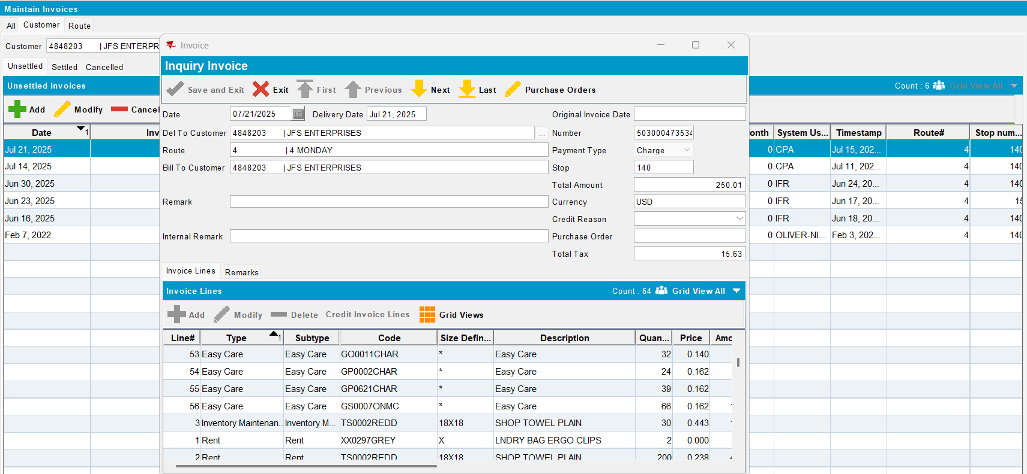

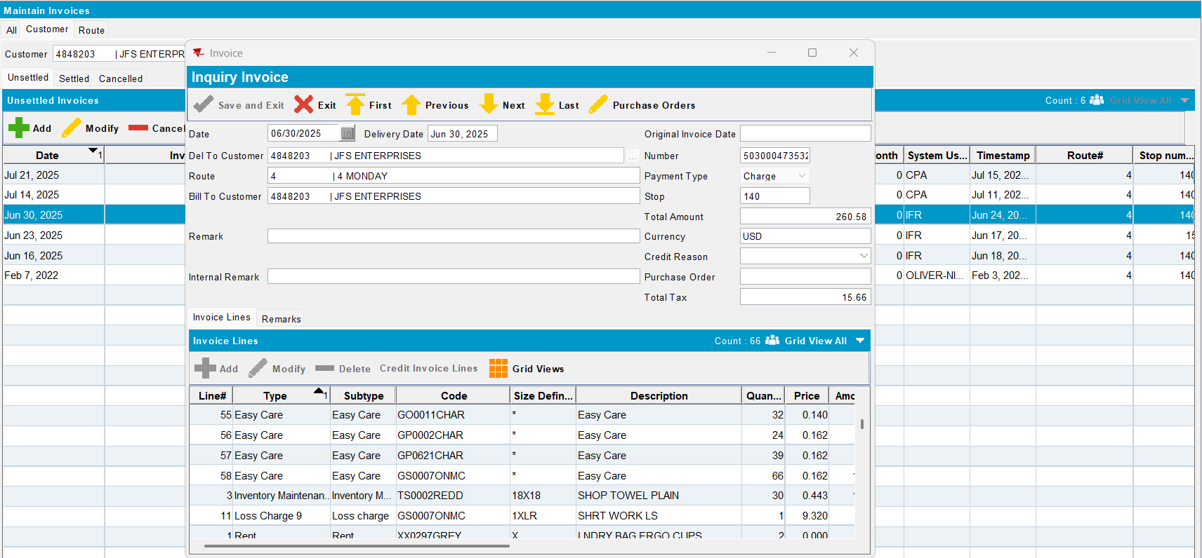
Passed.

