ABSN-9250 Downgrading to 90800_AUS bugfix branch for future patch

Environment | Prerequisites
DBServerName=abs-srv17.internal.abslbs.com  DBSID=CUST23  DBUser=AUS_MNT90800  DBPassword=AUS_MNT90800  Environment=Production  Branch: bugfix/ABSN-9250-remove-null-from-the-view-process-log-dialog-90800AUS | - Module: -  - System setting: -  - Others… : -

Contents
Reproducing before fix 1
Retest after fix 1

Reproducing before fix
Hash: 10fe719
- In View Process Log dlg, open some logs and check how dialog is shown on the log file
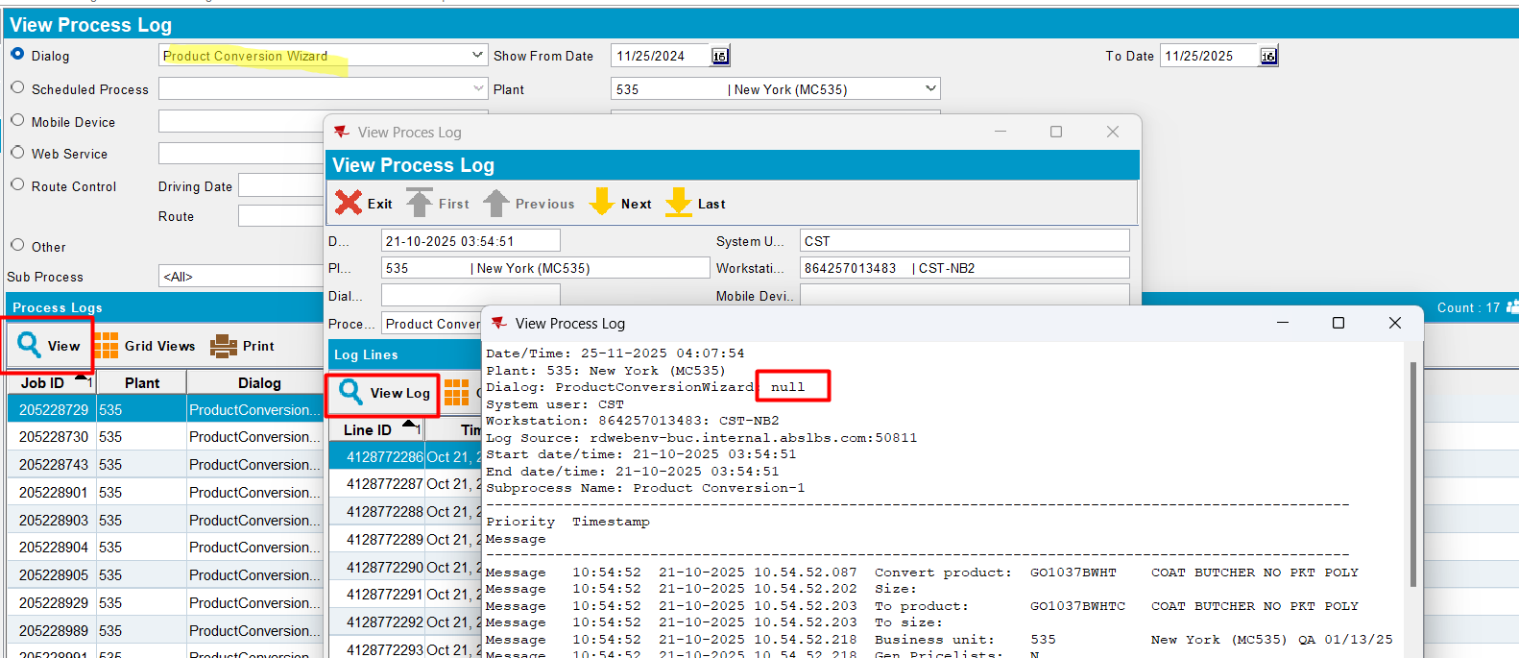
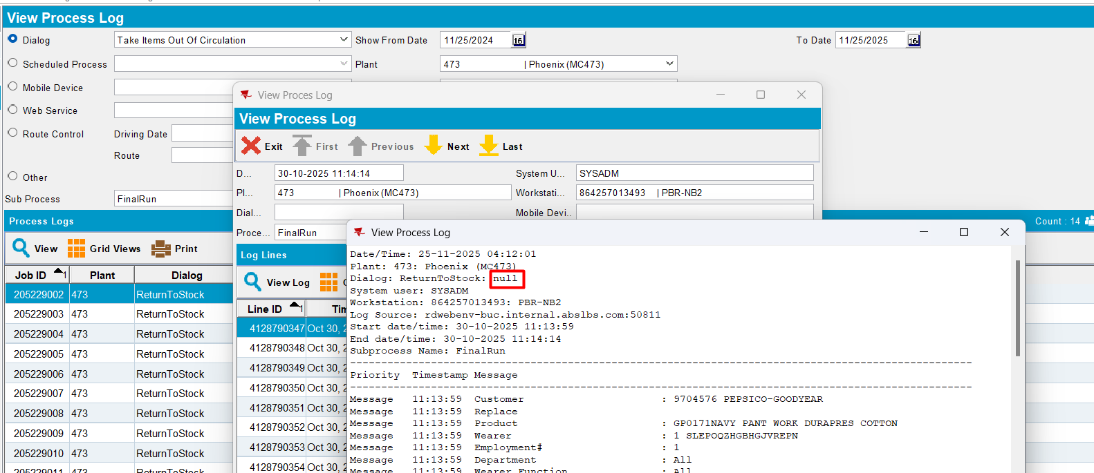
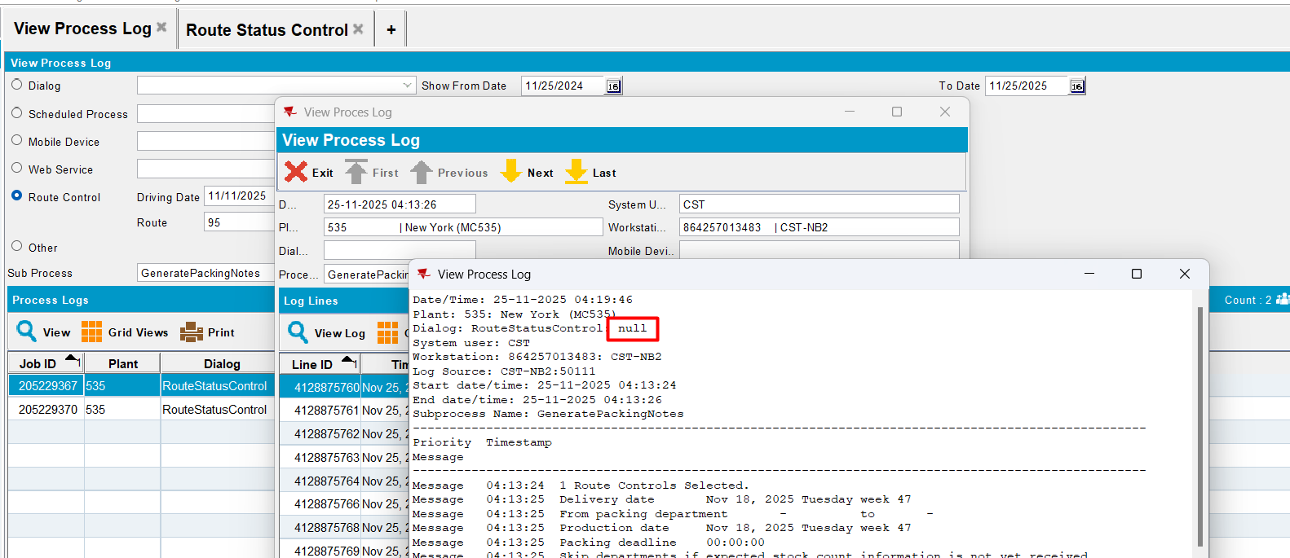
Actual behavior: near the dialogue name is shown “: null”.
Expected behavior: show in log only “Dialogue: Dialogue_Name”
REPRODUCED OK.

Retest after fix

Hash: 1c2623a
- In View Process Log dlg, open some logs and check how dialog is shown on the log file
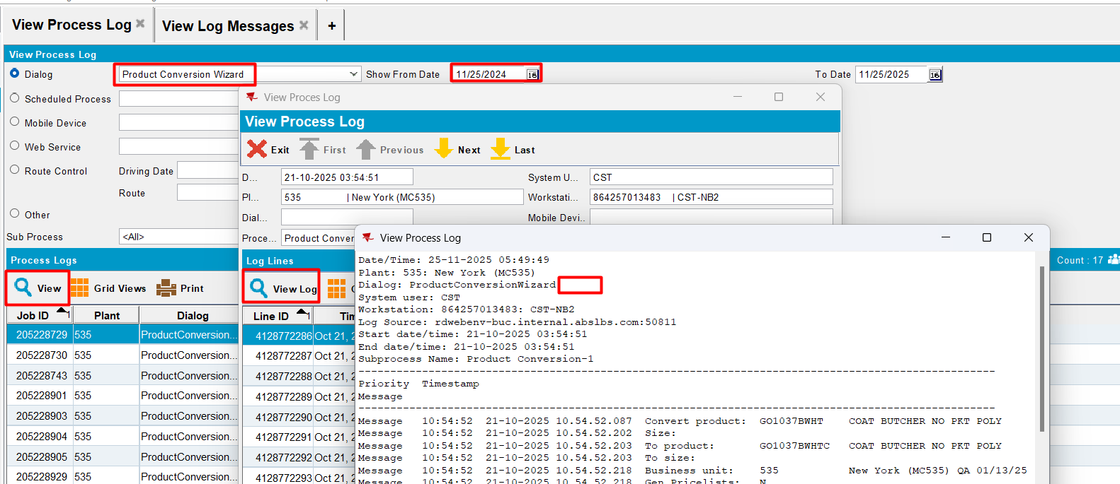
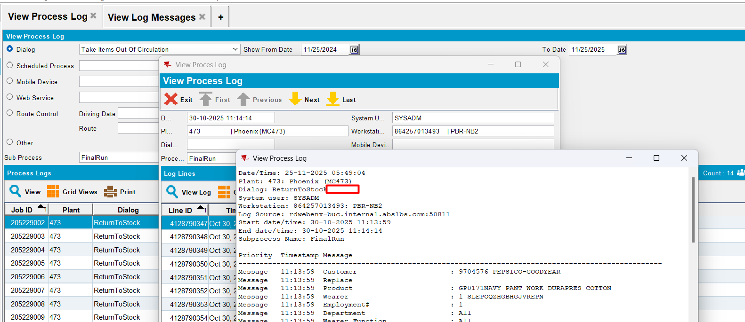
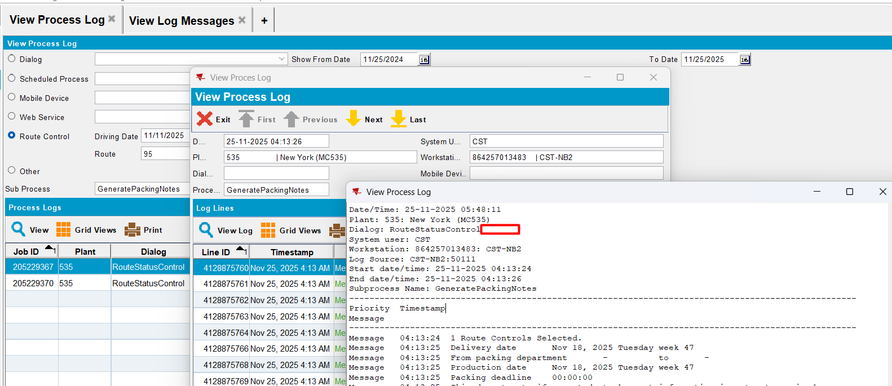
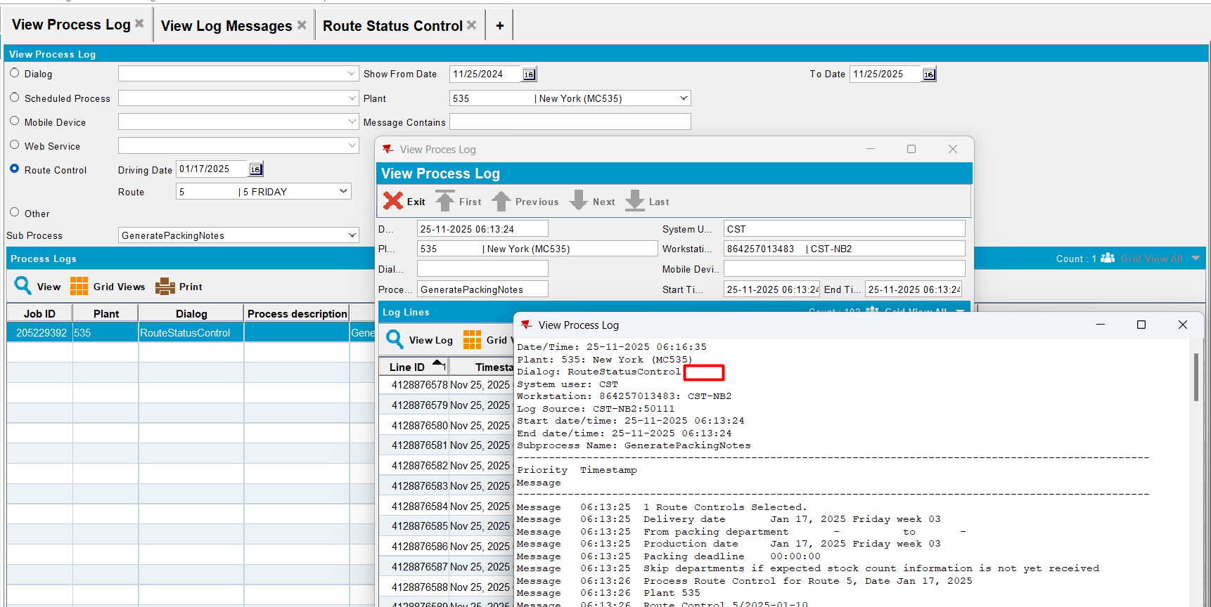
Expected behavior: show in log only “Dialogue: Dialogue_Name”
Actual behavior: as expected
RETEST OK

