ABSN-9011 Product Conversion Wizard dlg - same contract can be added and saved multiple times
Environment | Prerequisites
Version: 9.08.00.RELEASE.p23_AUS(BUGFIX BRANCH)  DBServerName=abs-srv17.internal.abslbs.com  DBSID=CUST23  DBUser=AUS_MNT90800  DBPassword=AUS_MNT90800  EnvironmentNAME=Test  EnvironmentSTAGE=Test | - Module: AUS, PRODUCTCONVERSIONWIZARD  - SS:
Contents
Retest after fix 1
Test Case 1 – Adding the same contract more than once in Product Conversion wizard – TEST PASSED 1
Test Case 2 – Size checkbox and field in Product Conversion wizard – TEST PASSED 5
Regression Test – Convert a product – TEST PASSED 6

Retest after fix
Hash: 805887c066fe
BU.code: 253
Plant.code=253

Test Case 1 – Adding the same contract more than once in Product Conversion wizard – TEST PASSED
Expected behavior: Same contract should be added only once.
- Open the Contract dlg. and select a contract:
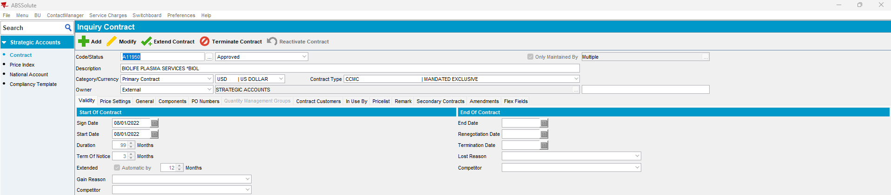

- Open it in Modify mode:
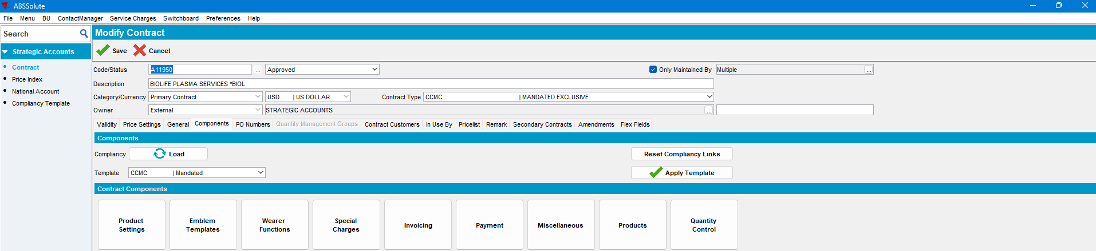

- Move to the components tab, select a template and load it:
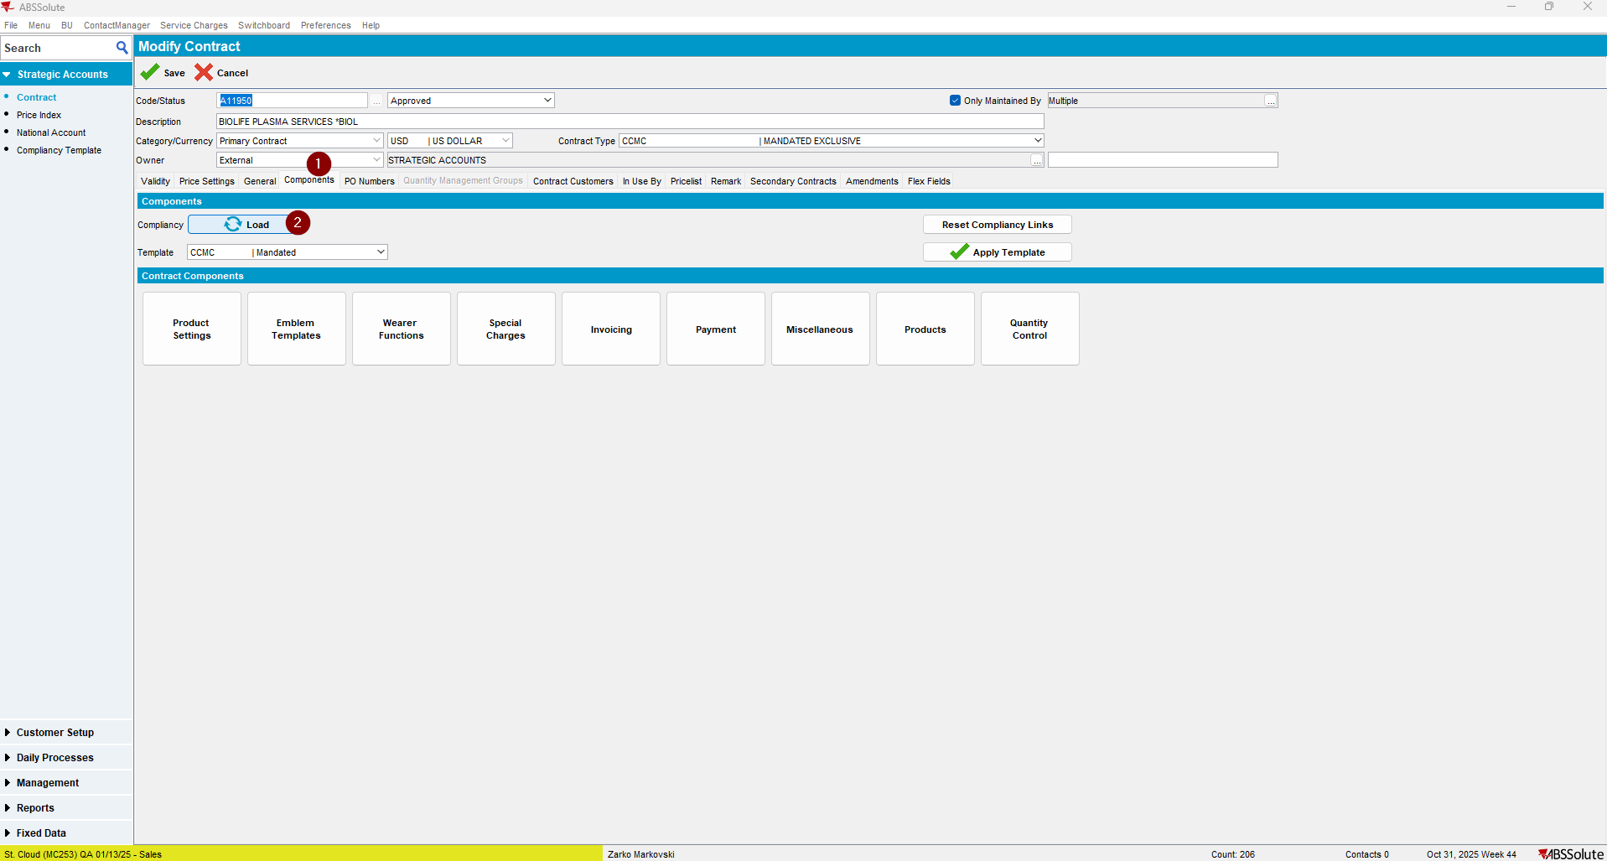

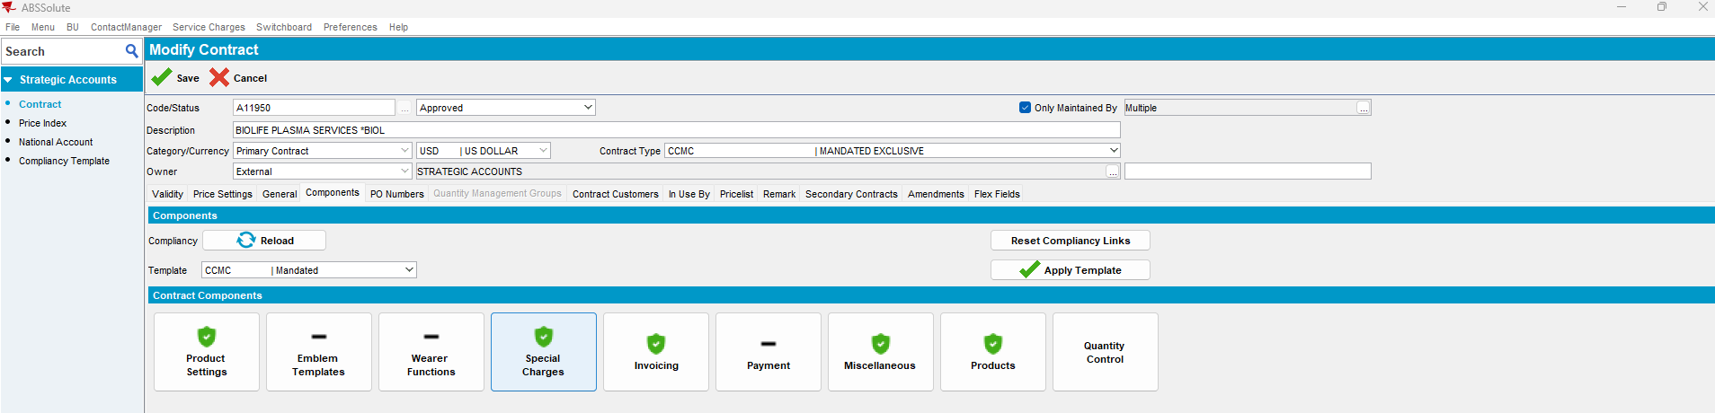
- Press the Products button. Find a Garment product with “*” all product sizes:
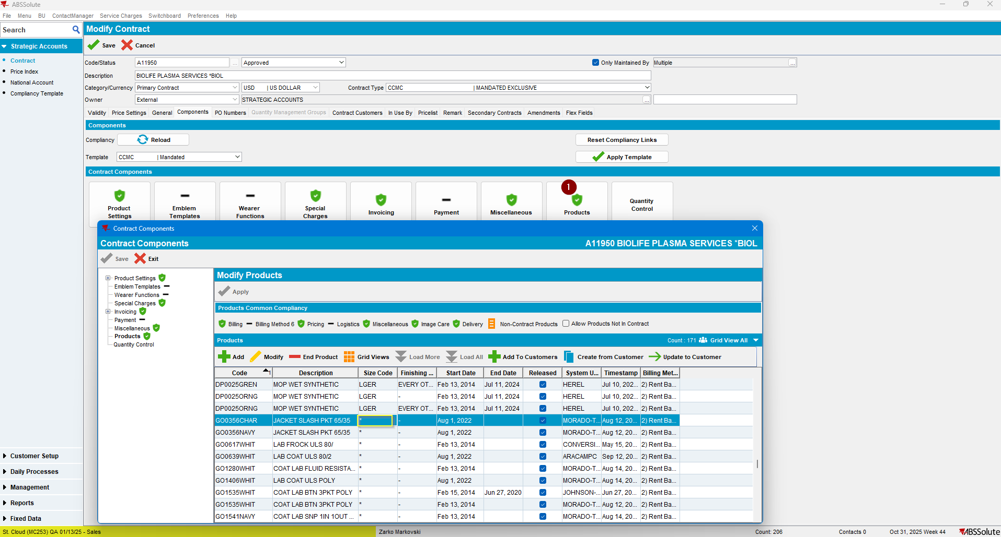
- Check the selected product type, product group and sizes:
The product is a garment and product group 1620 (Synthetic Garments)
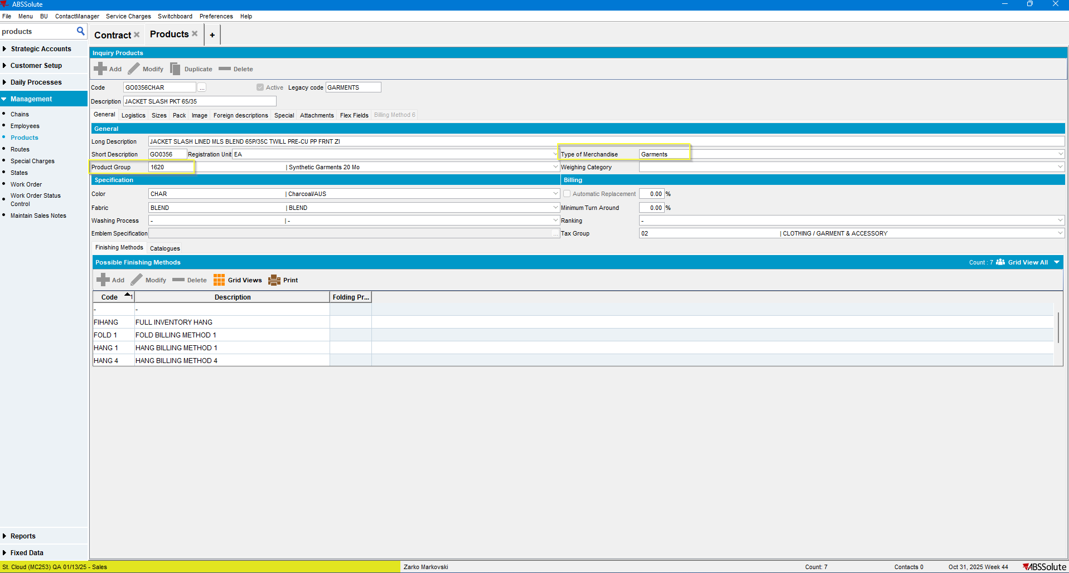

- Sizes:
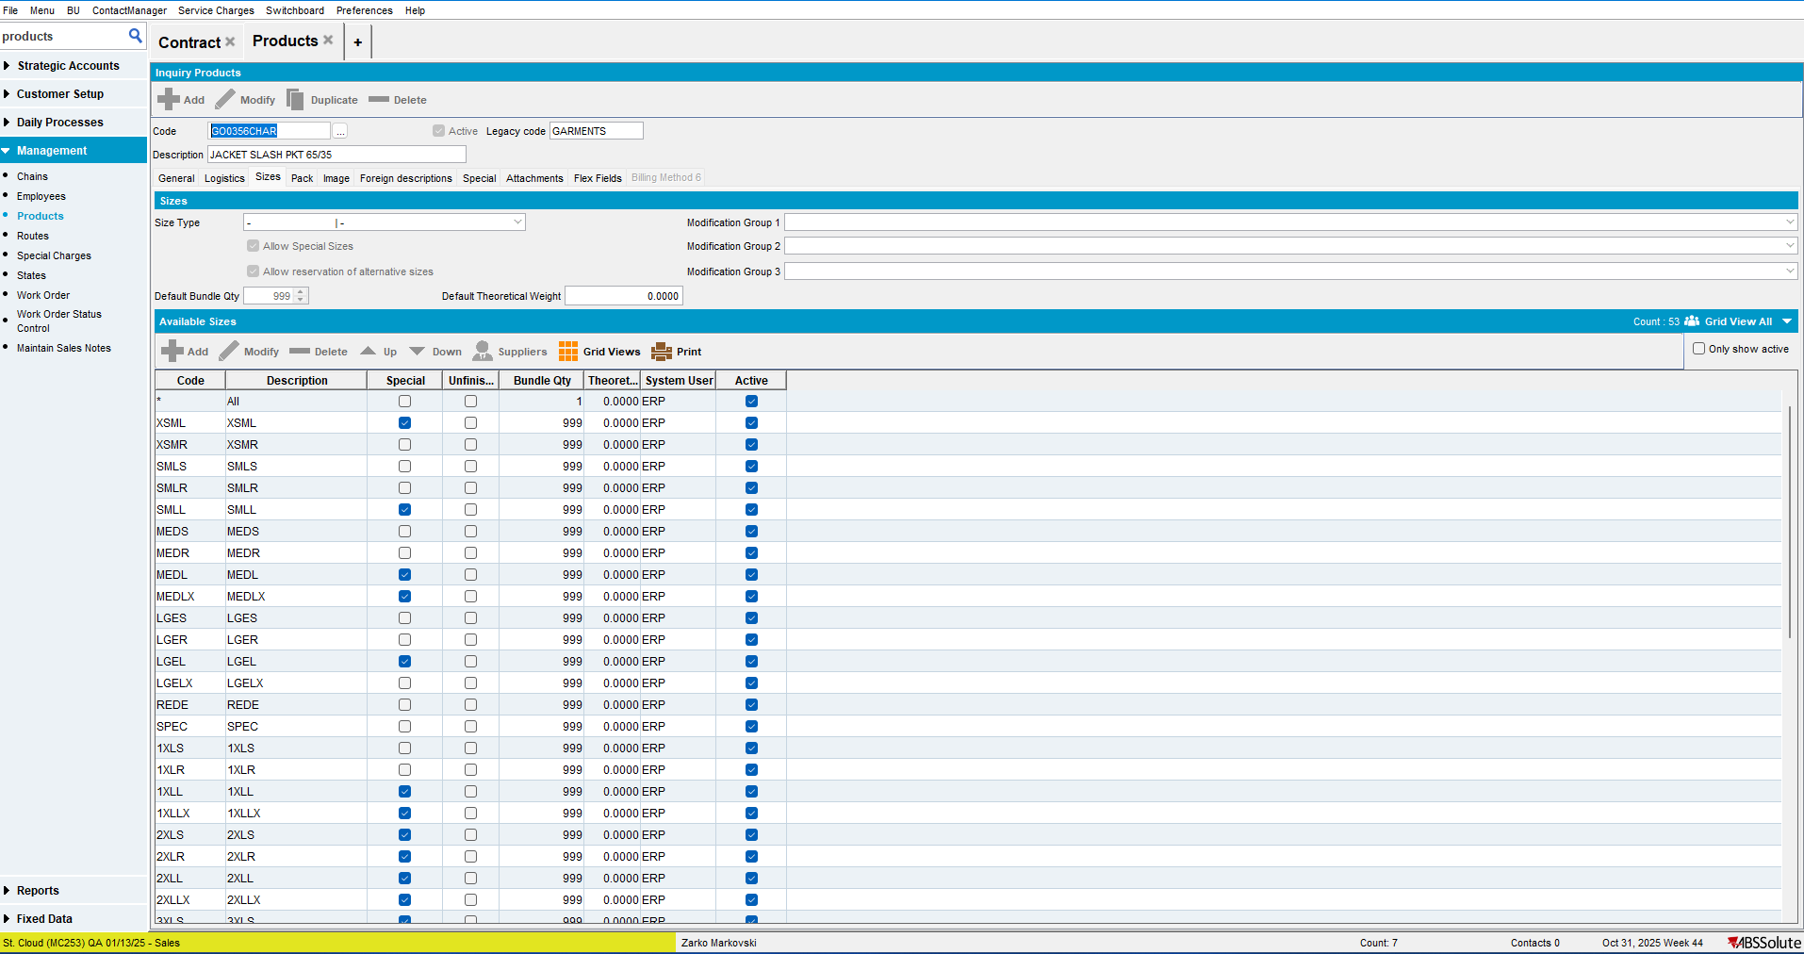
- Duplicate this product to have a new product, non-existent on the contract and of the same type and settings as the existent one.
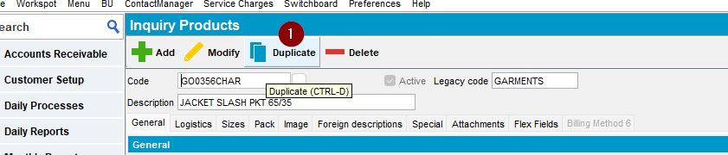

After pressing the Save button select the plant for which this product will be activated for:
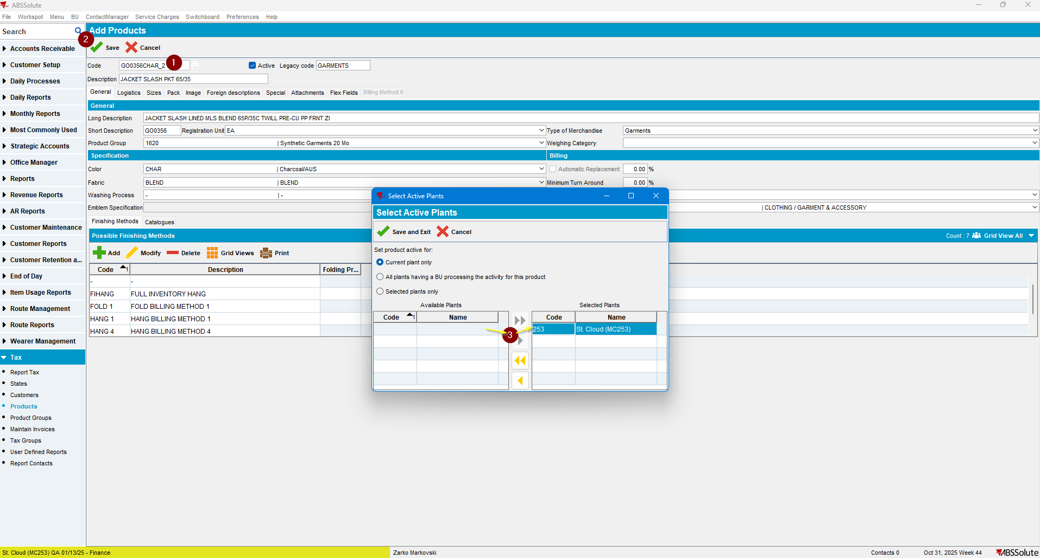

- Open Product conversion wizard and load the contract:
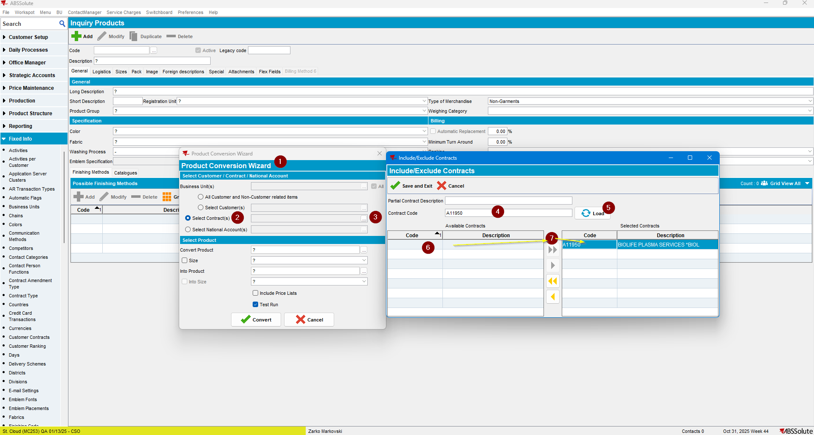

- Now try to load the same contract again:
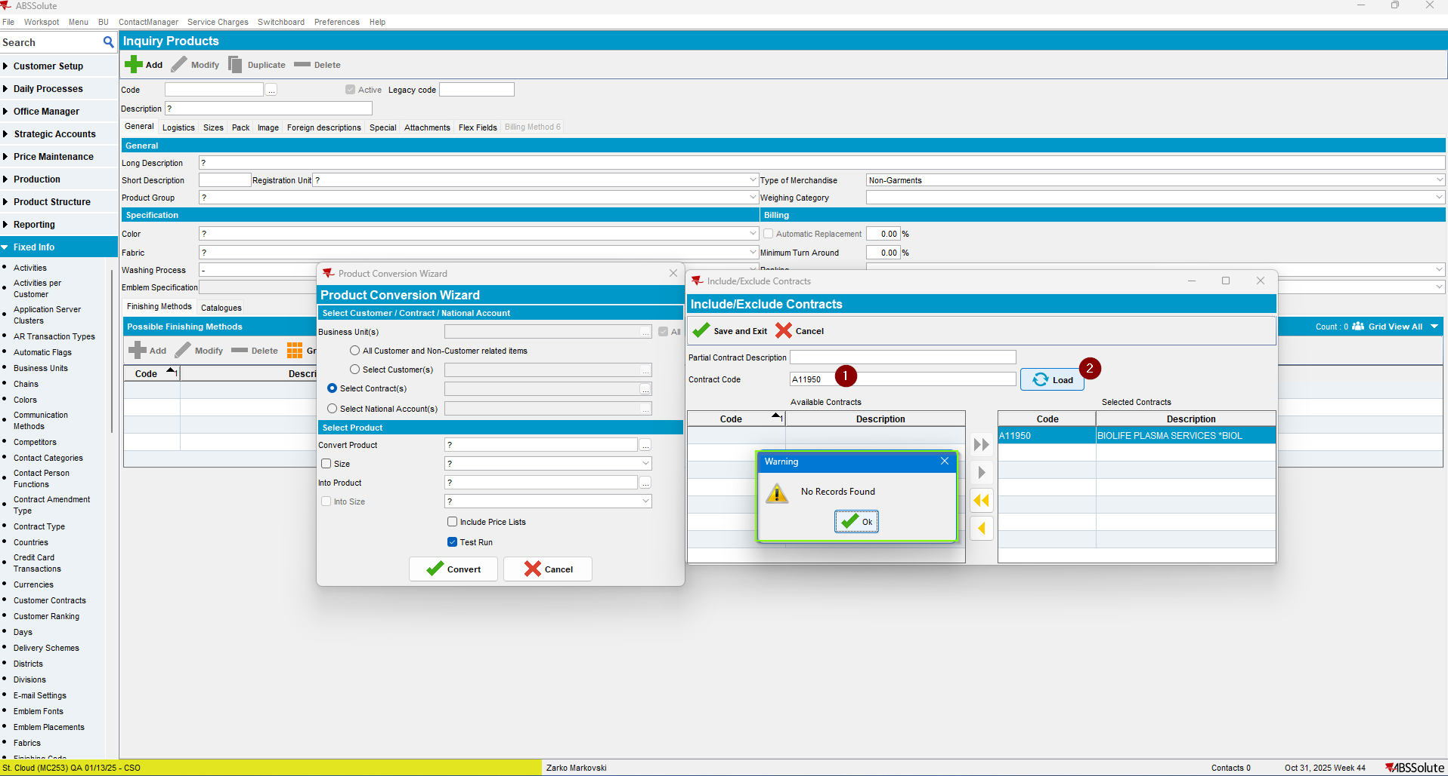
The contract couldn’t be loaded, as the following Warning message was thrown.
The expected behavior was obtained.
TEST PASSED

Test Case 2 – Size checkbox and field in Product Conversion wizard – TEST PASSED
Expected behavior: When unchecking the “Convert Product Size” checkbox, the “Convert Product Size description field” should be left blank, “Into Size” checkbox should be unchecked and “Into Size description field” should be left blank.
Open Product conversion wizard, select the contract in the upper section as in the first test, then the product to be converted and the replacement one. Check the size checkbox and select a size. Do the same for the replacement product:
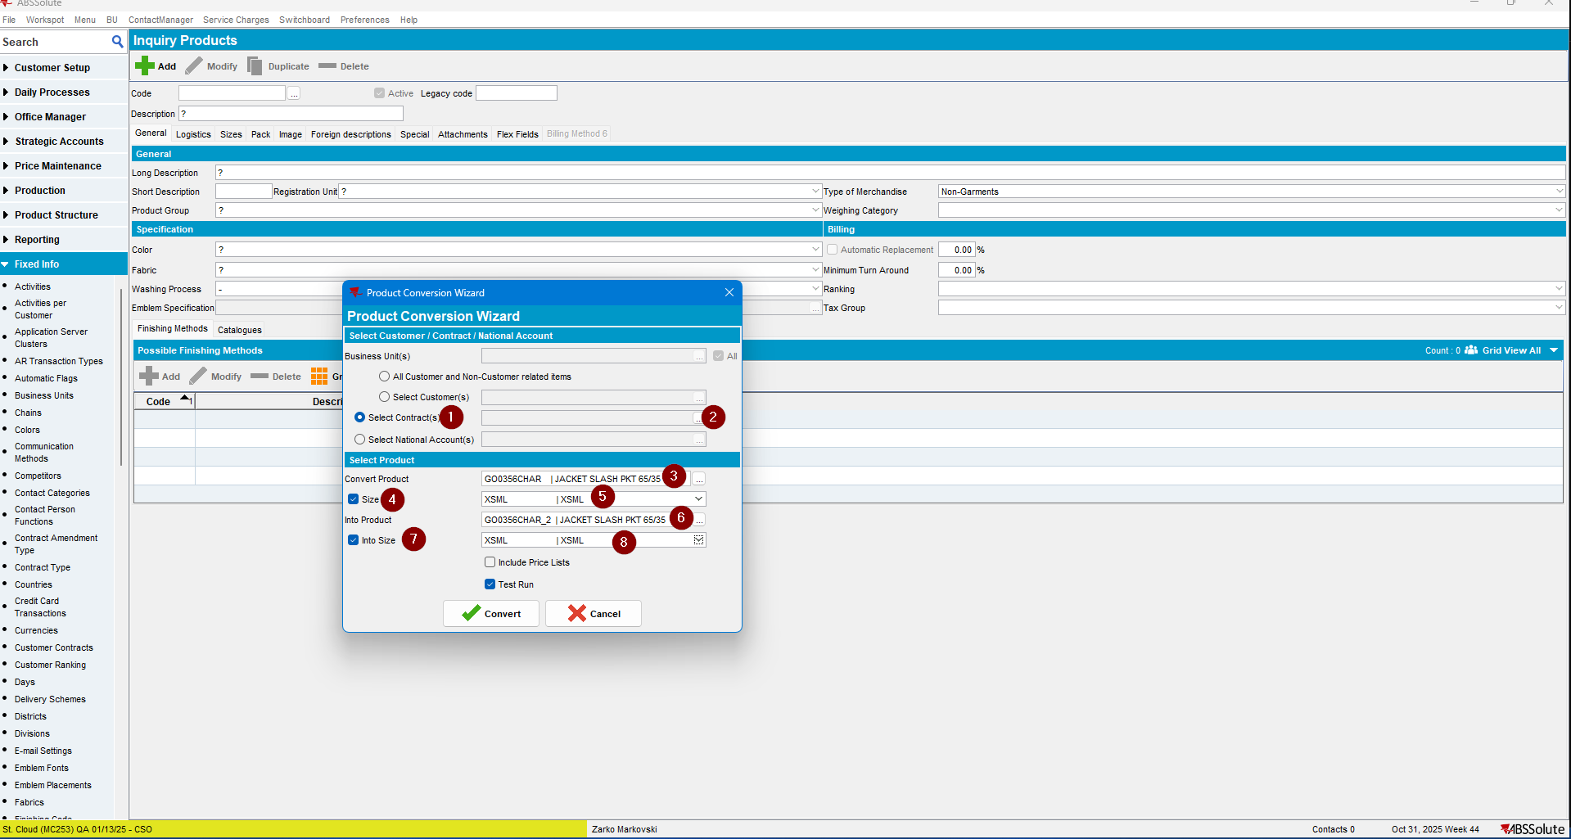
Now uncheck the Convert Product size checkbox:
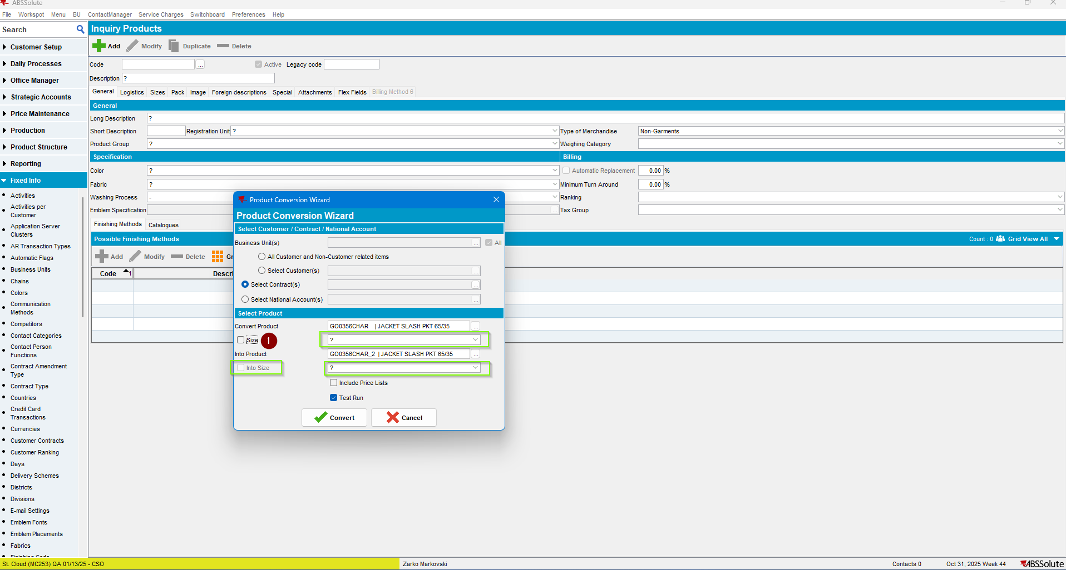

Current result: Is the expected one.
TEST PASSED.

Regression Test – Convert a product – TEST PASSED
Expected behavior: Using the Product Conversion product dlg. a product on a contract should be normally converted to another one.
- Execute the Product conversion for the contract and products analyzed in the previous steps. Note: Initially do a test run:
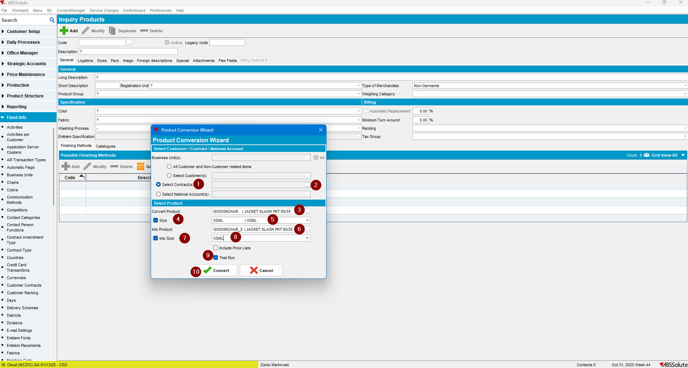

- The process didn’t execute, due to the following error:
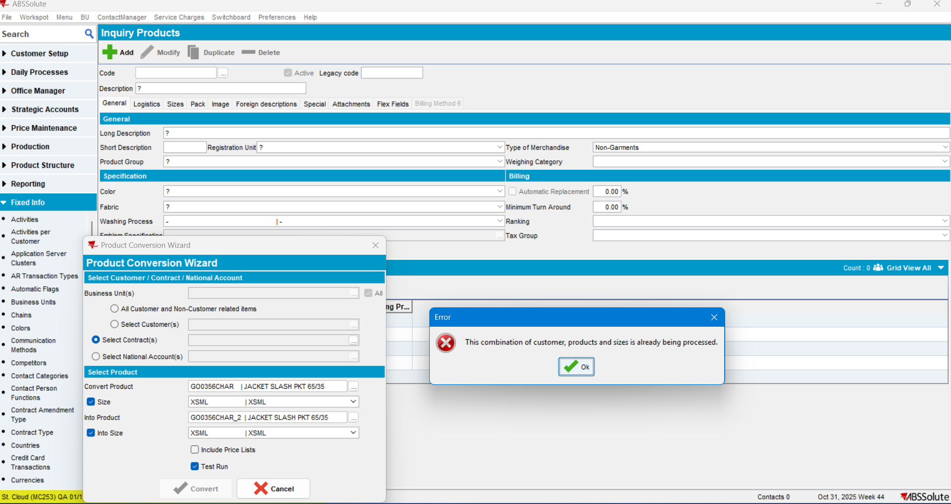

- Try with another Contract product:
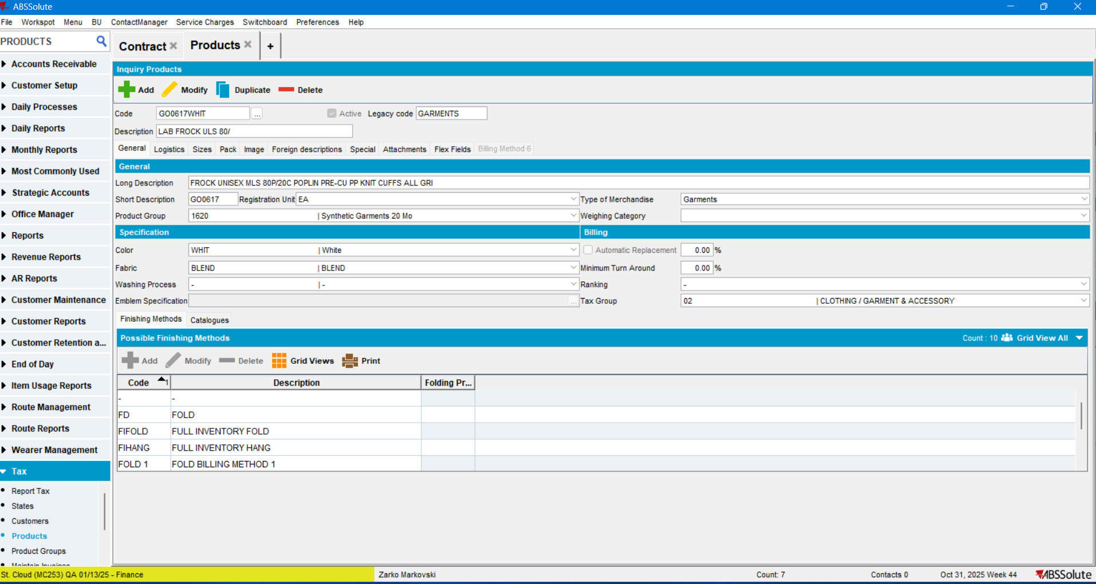

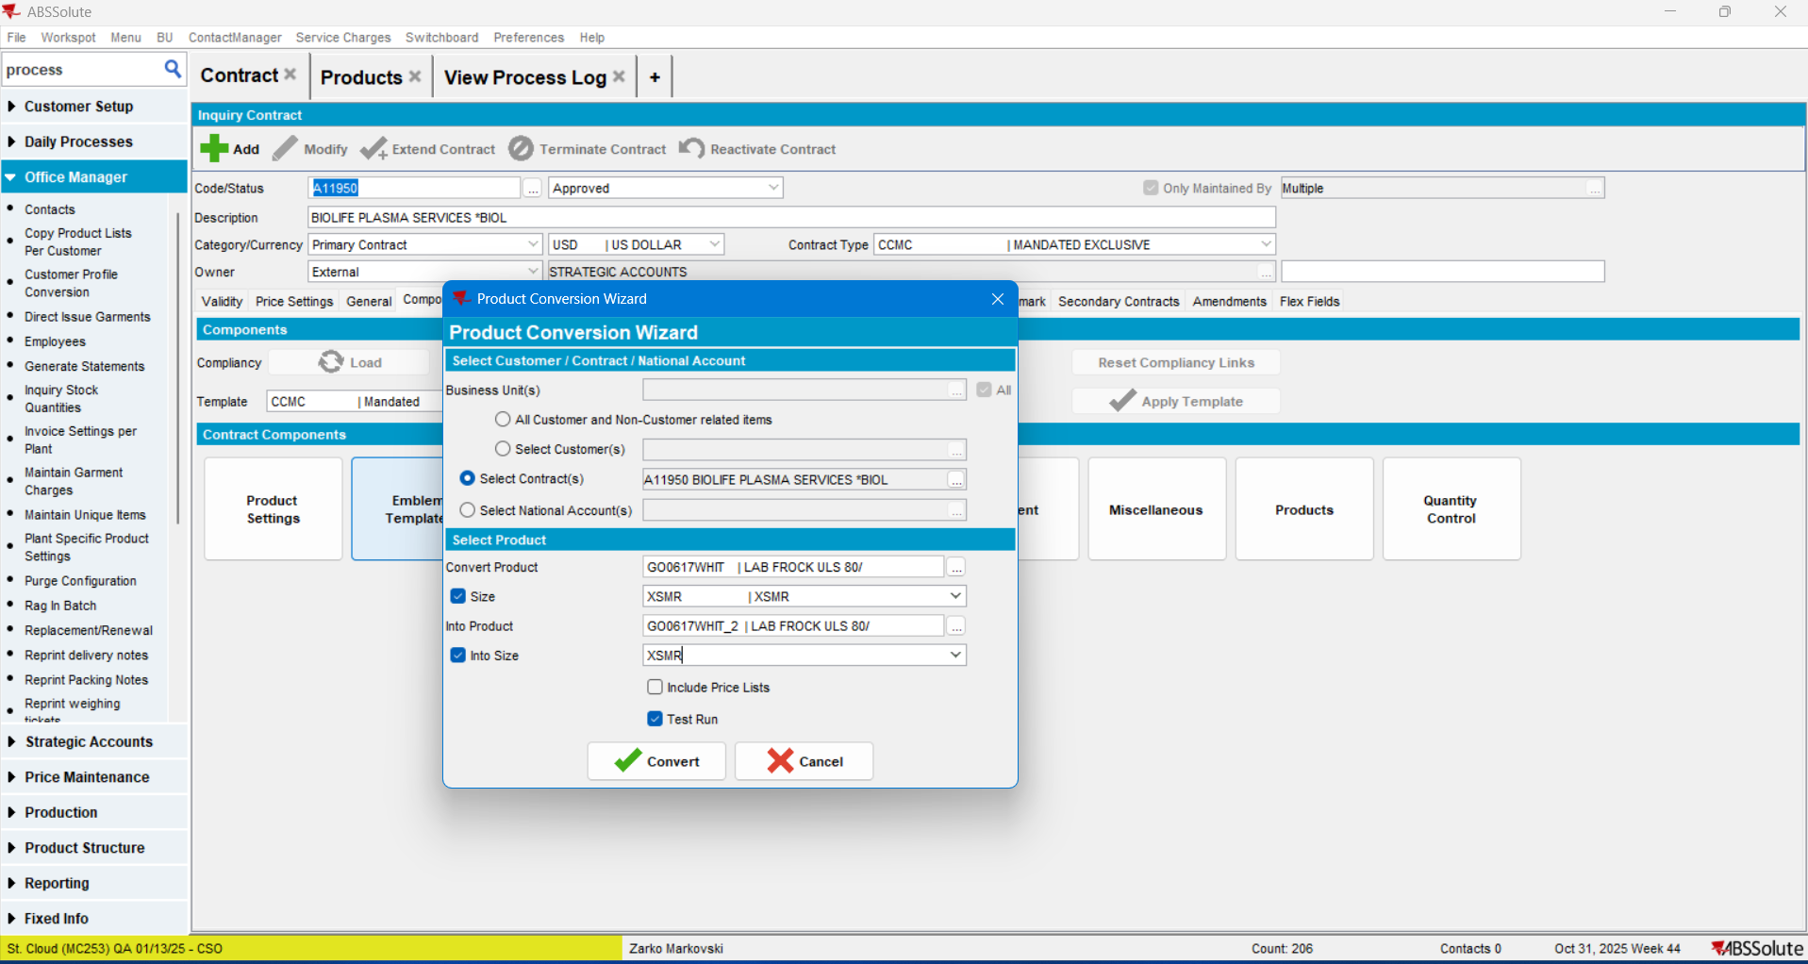
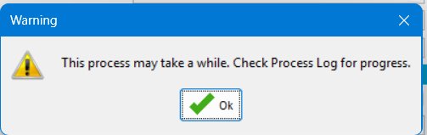
The test was successful:
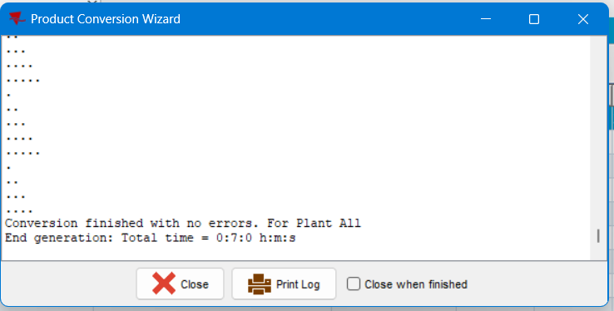
- Execute the final conversion:
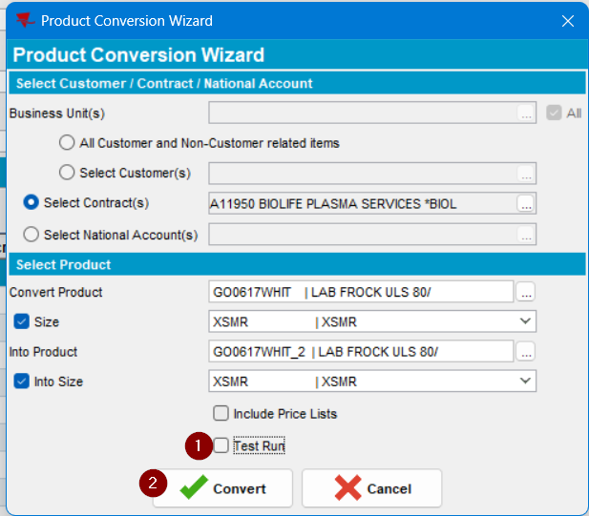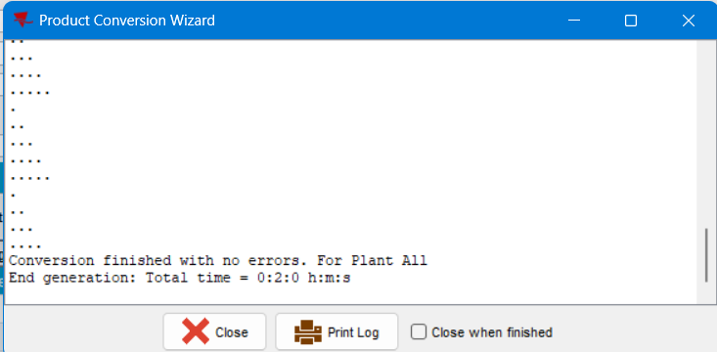
The product was converted without errors which was the Expected behavior.

Check the contract products:
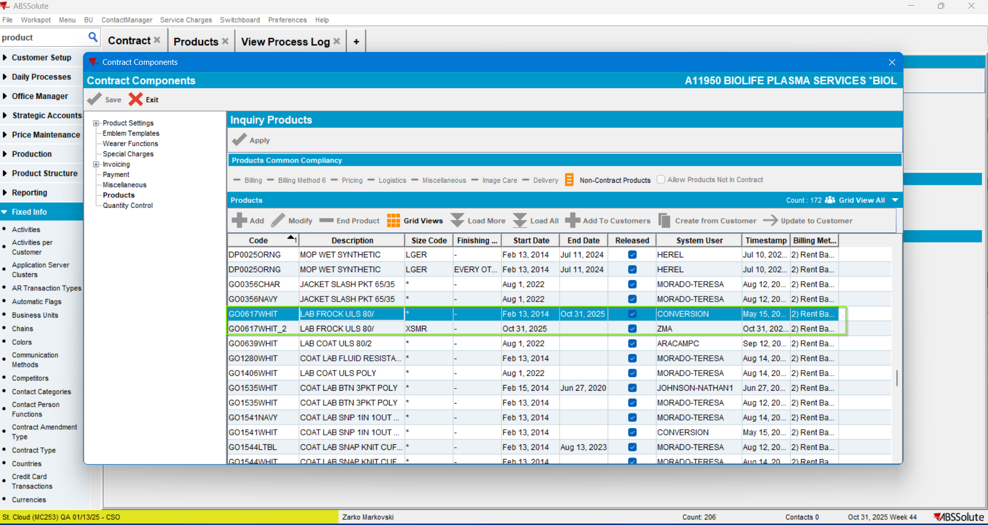
The original product was ended and the convert into product was added to the contract products list.
Which was the expected behavior.
TEST PASSED.

