RASAN-241-RASA - Route instructions editable-downgrade to 9.08.00
Environment | Prerequisites
DBServerName= abs-srv17.internal.abslbs.com  DBSID=CUST23  DBUser=AUS_MNT90800  DBPassword=AUS_MNT90800  Environment=Test  Version: 9.08.00. RELEASE.p23  Hash: 0ecfec110304  Feature branch: https://jenkins.internal.abslbs.com/job/FastBuilder-MultiBranch/job/feature%252FABSN-8786-rasa-route-instructions-editable-90800AUS/ | - Module: ROUTEASSISTANT, ROUTEASSISTANTANDROID, MOBILEAPPACCESSTEMPLATE  - System setting  - Other applications versions (if is applicable)  RouteAssistant_v13.32.INTERNAL_TEST_ONLY.bc40f1ae2.apk  - Android Studio v13 Emulator

Contents
Customer delivered once a week 2
Version: 9.08.00.RELEASE.p23 hash: 0ecfec110304 RouteAssistant_v13.32.INTERNAL_TEST_ONLY.bc40f1ae2.apk (master) 3
BU/Plant: Phoenix (MC473) 3
Data preparation 3
Test case 1: New “Edit” icon for Updating Instructions is visible and editable on both “Stop Info” screen and “Info” screen– TEST OK 5
Test case 2: Verify the transaction can be deleted with long press action on “Instructions” – TEST OK 8
Test case 3: Verify RouteTransaction type 223 is created – TEST OK 10
Test case 4: Verify TransactionDTO table is correctly populated – TEST OK 12
Test case 5: Verify Instructions cannot be edited after departing from Customer” – TEST OK 12
Test case 6: Verify Route List Instructions are correctly updated on both database and ABSSolute – TEST OK 13
Test case 7: Verify all stops (not transferred yet to mobile device) connected to the current RouteStops are updated– TEST OK 16
Test case 8: Update Delivery Instructions can be controlled via Mobile App Access Templates– TEST OK 21
1. Have Mobile applications access templates “Hide” checkbox not checked for “Update Instructions” 21
2. Have Mobile applications access templates “Hide” checkbox checked for “Update Instructions” 24
Customer delivered twice or more days per week 25
Test Case 1: Update delivery instructions for current day – TEST OK 25
Test Case 2: Update delivery instructions for all delivery days, same Delivery Point for Route Stop – TEST OK 30
Test case 3: Verify all stops (not yet transferred to mobile device) connected to the current RouteStops are updated– TEST OK 35

Customer delivered once a week

Version: 9.08.00.RELEASE.p23 hash: 0ecfec110304 RouteAssistant_v13.32.INTERNAL_TEST_ONLY.bc40f1ae2.apk (master)

BU/Plant: Phoenix (MC473)

Data preparation
- Create a new route and mark it ready for transfer
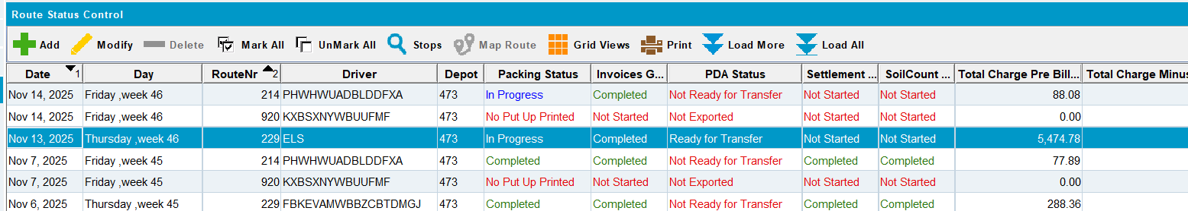
- Have/not have initial Route List Instructions for route stops
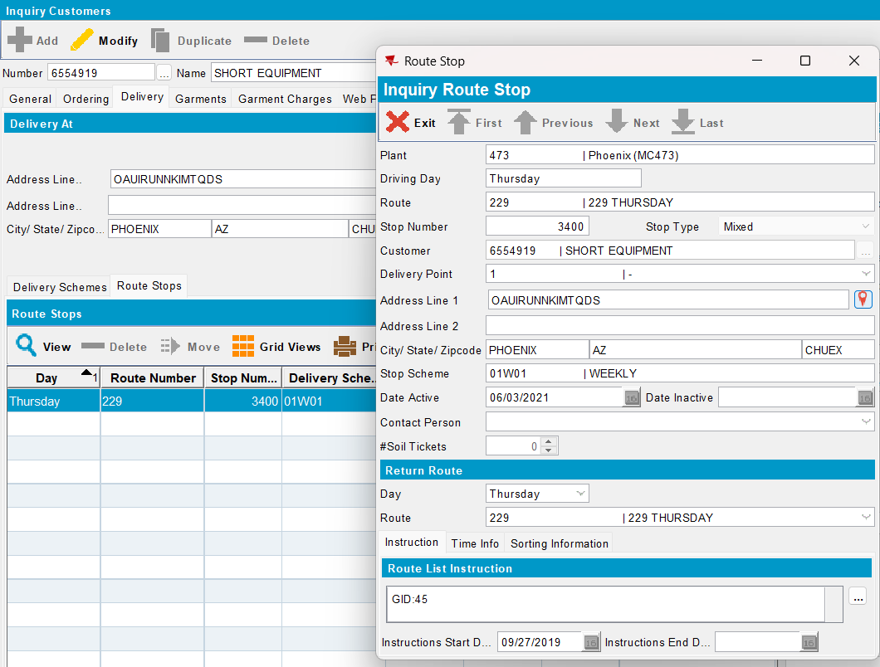
- Configure and start absmobilerestservices.war
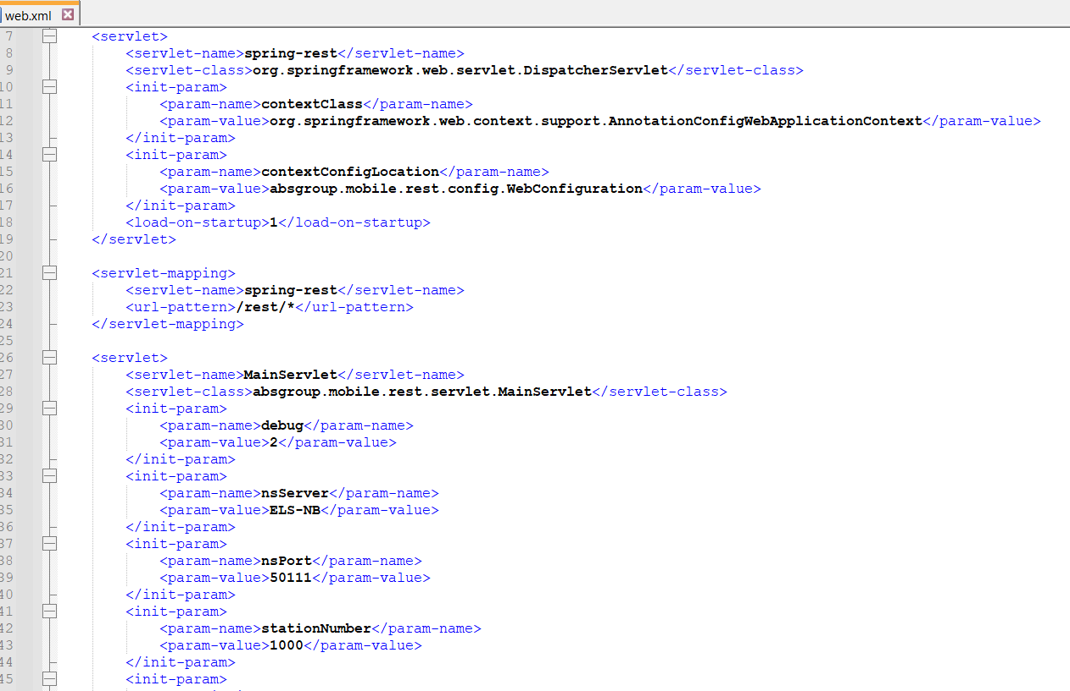
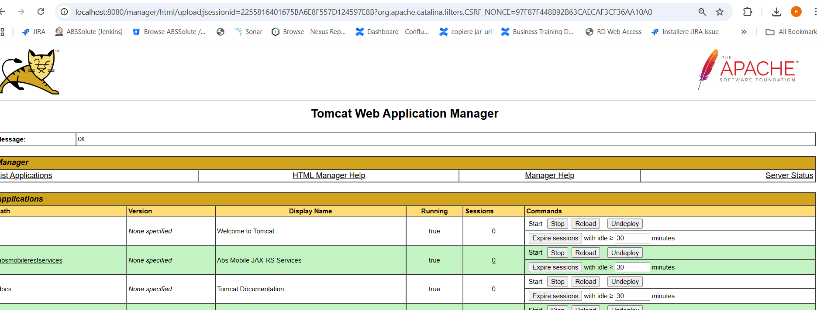

- Login to RASA using system user and password
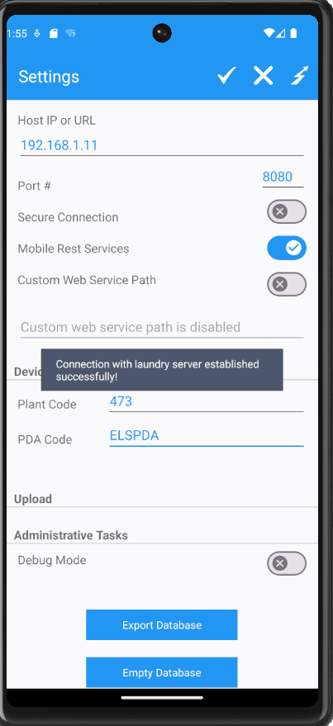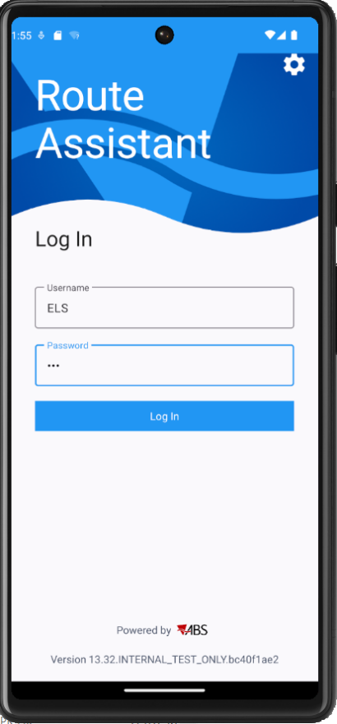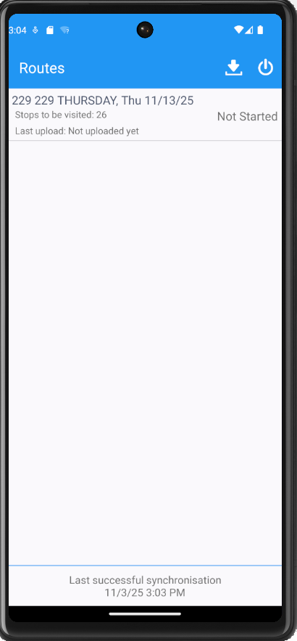

Test case 1: New “Edit” icon for Updating Instructions is visible and editable on both “Stop Info” screen and “Info” screen– TEST OK
- Start the route and select a stop -> “Edit” icon is available and enabled on “Stop Info” screen
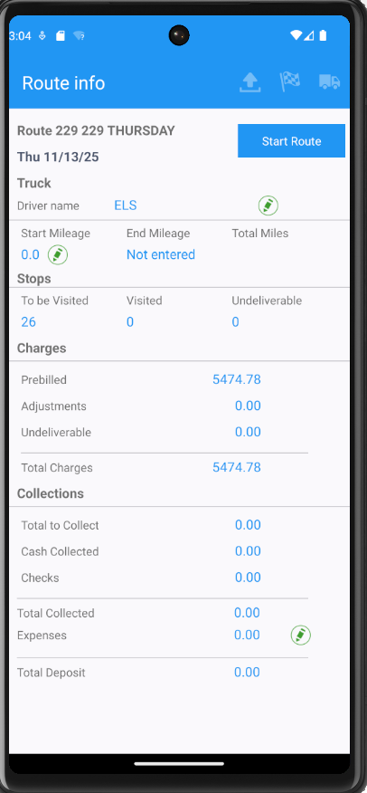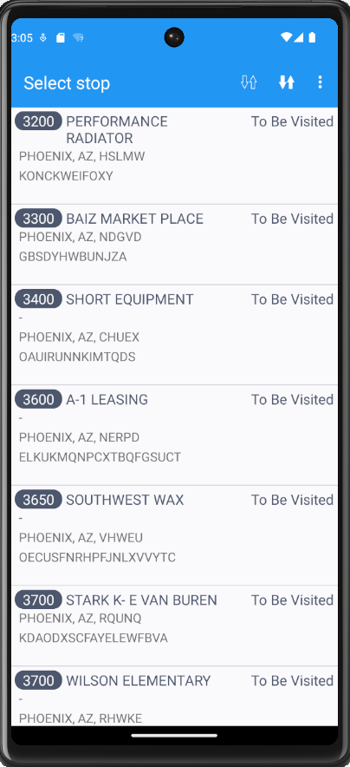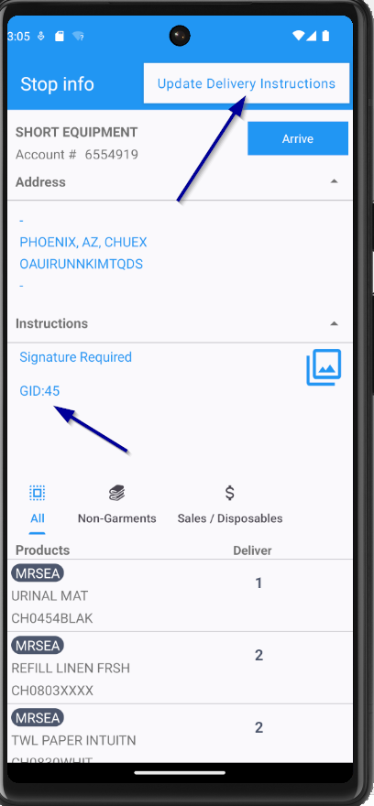
- Press “Edit” icon and update the Delivery Instructions
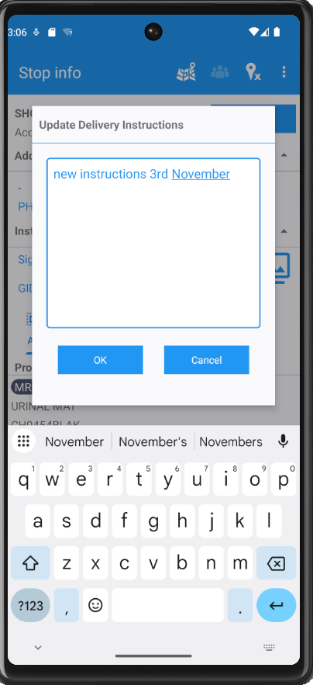
- Press “OK” button -> Updated content for delivery instructions and “UPDATED” text are now displayed
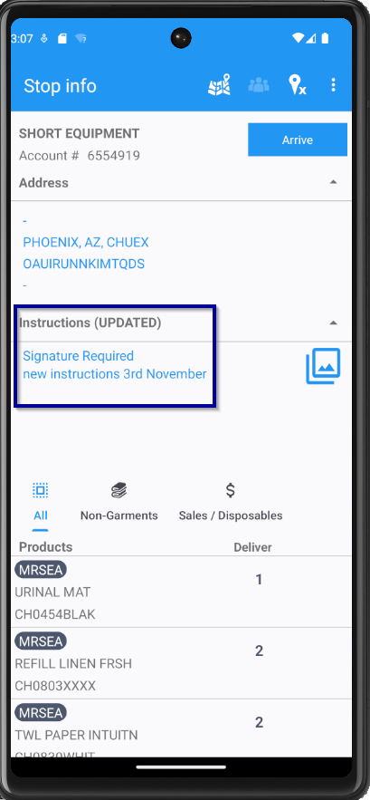
- Arrive at the customer and press “Info” screen -> Same information as on “Stop Info” screen is displayed for Instructions
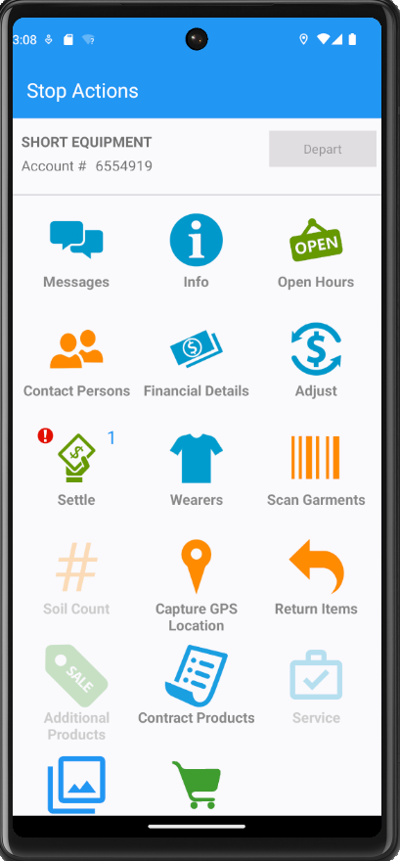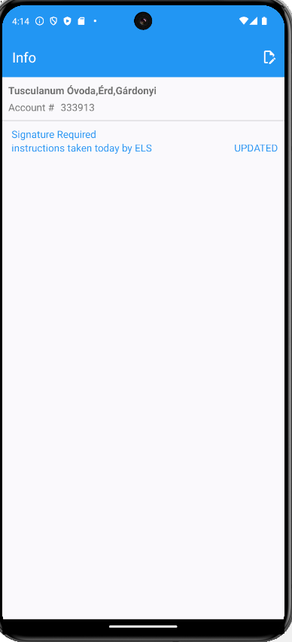
- Press “Edit” icon and update again the instructions -> New updated content for instructions and “UPDATED” text are now displayed on “Info” screen
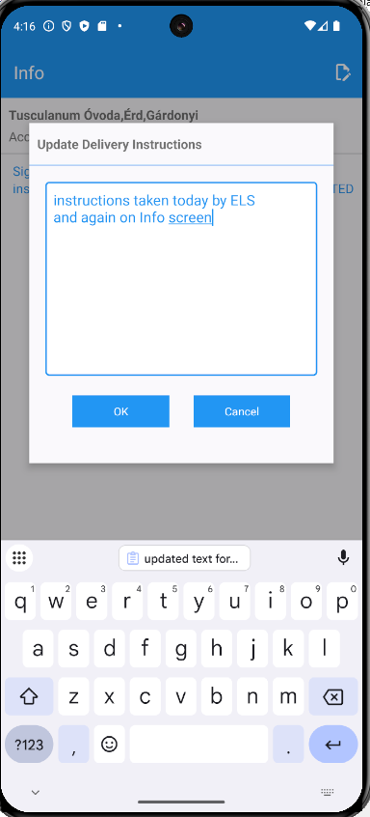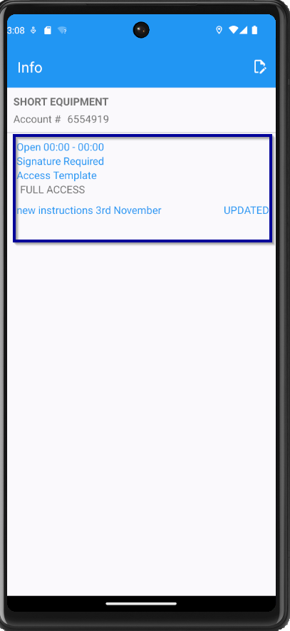

Test case 2: Verify the transaction can be deleted with long press action on “Instructions” – TEST OK
- Now press long on “Instructions -> Warning message “Are you sure you want to cancel this update Transaction?” is displayed
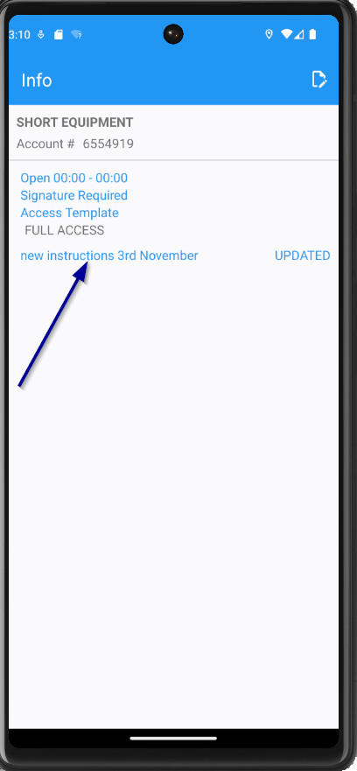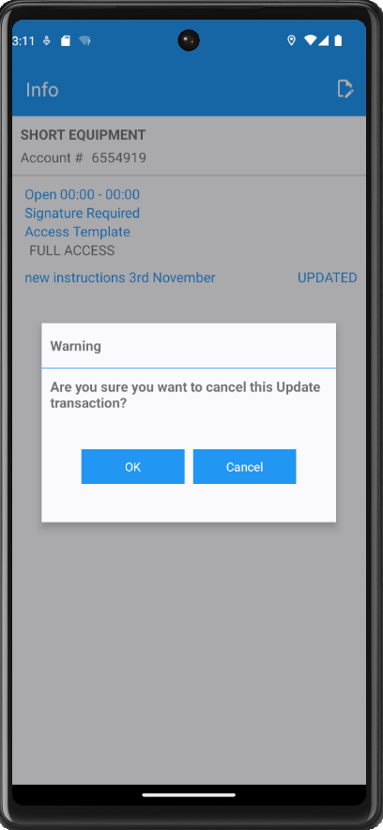
- Press “OK” button -> Updated delivery instructions are deleted from the screen and the initial instructions are displayed.
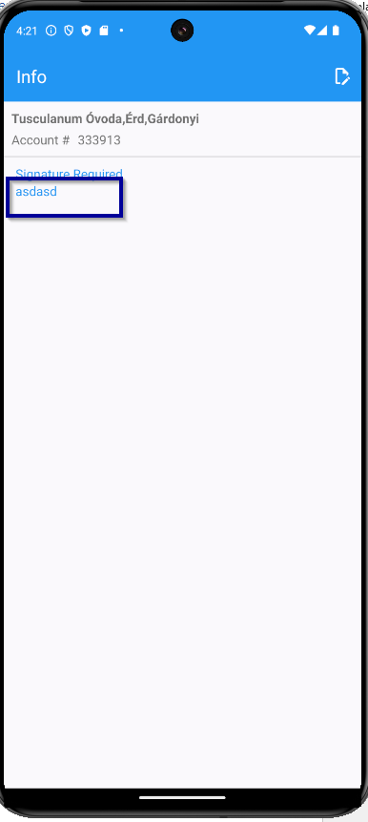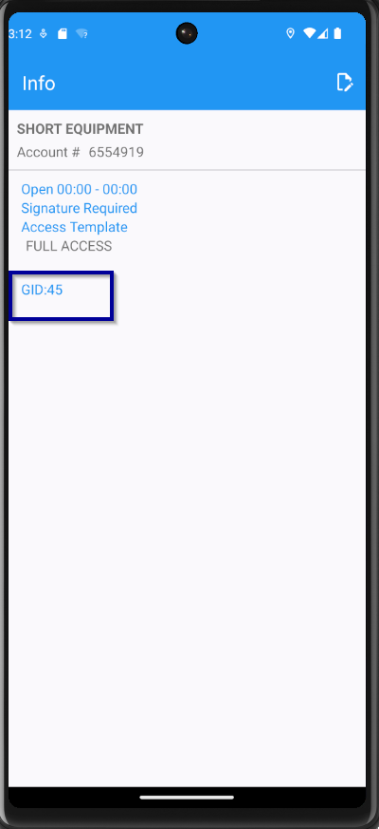
- Go back to “Stop Info” screen, add again some new instructions and delete them -> initial instructions are displayed
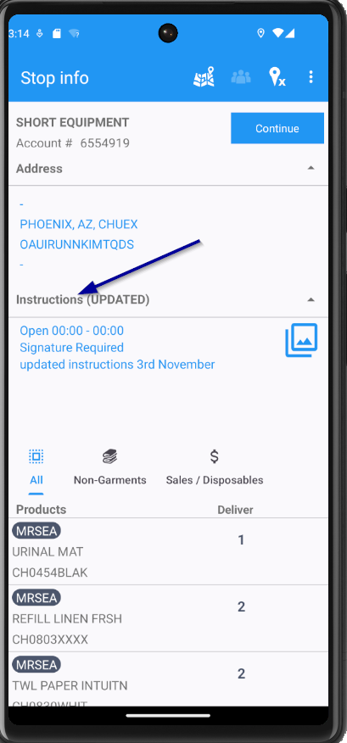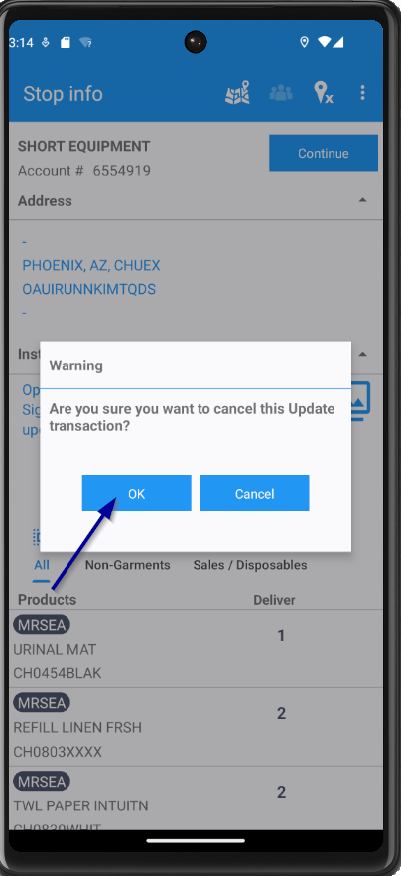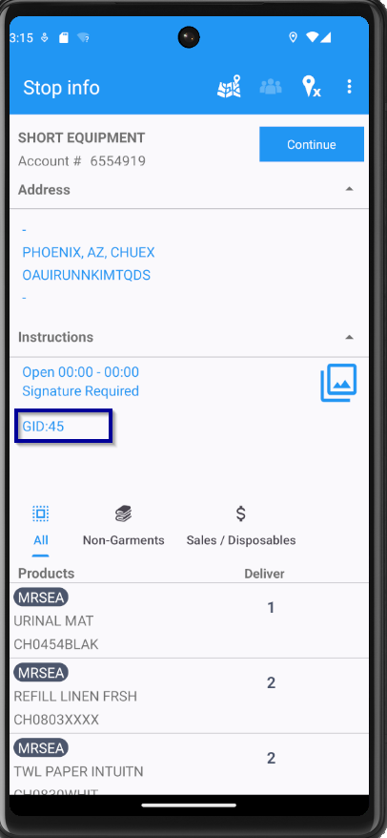

Test case 3: Verify RouteTransaction type 223 is created – TEST OK
- Update again the instructions on either “Stop Info” screen or “Info” screen
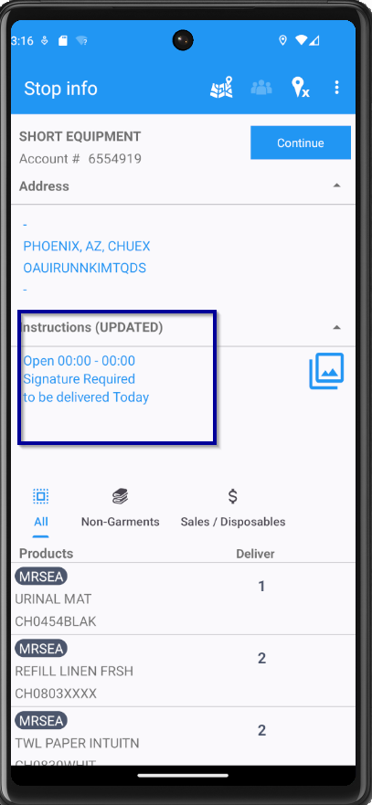
- Export the database and check the 223 transaction has been created for updated Route List Instructions -> 223 transaction has been created.
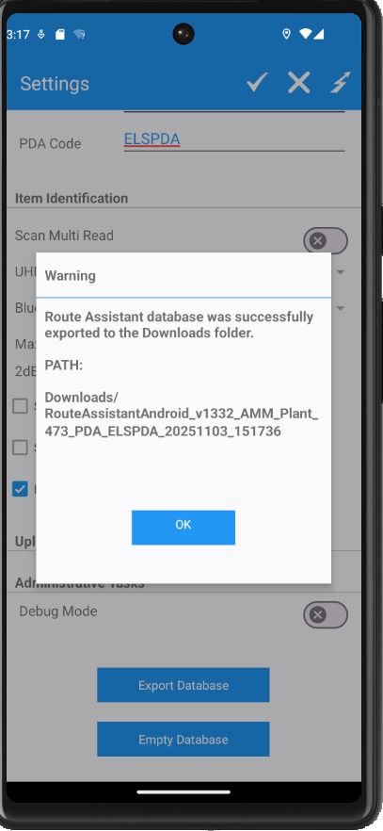

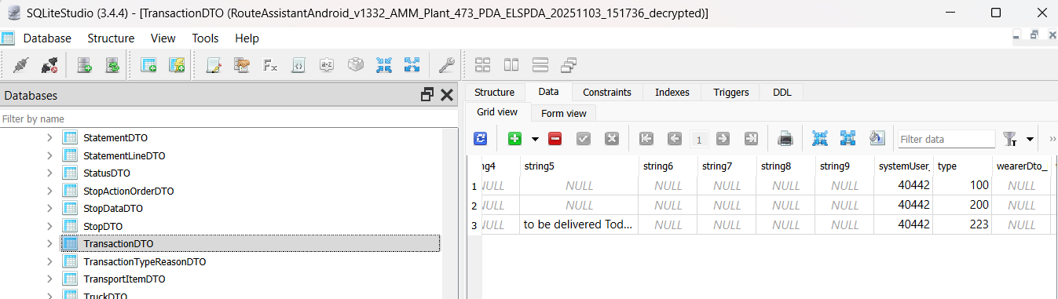

Test case 4: Verify TransactionDTO table is correctly populated – TEST OK
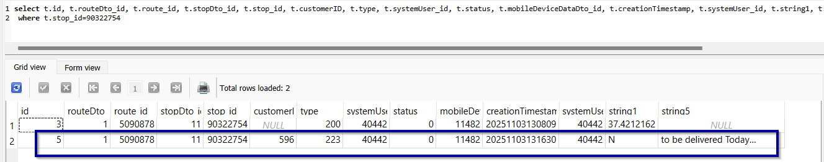

Test case 5: Verify Instructions cannot be edited after departing from Customer” – TEST OK
- Depart from the stop and check if the instructions cannot be edited anymore -> “Edit” instructions icon is now disabled on both Stop Info screen and Info screen.
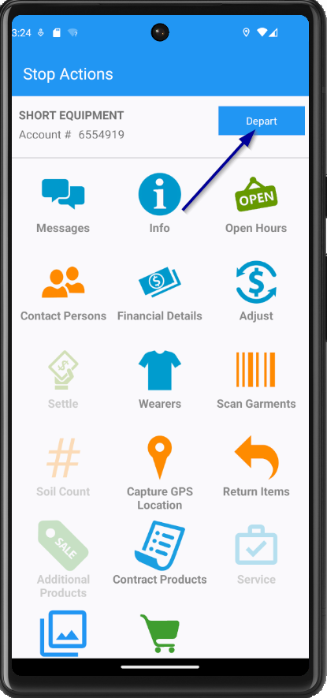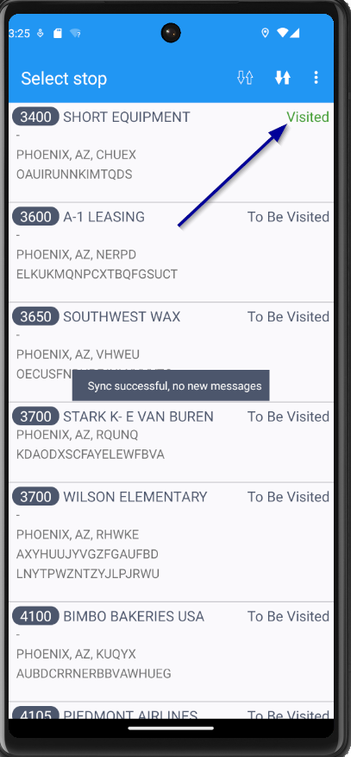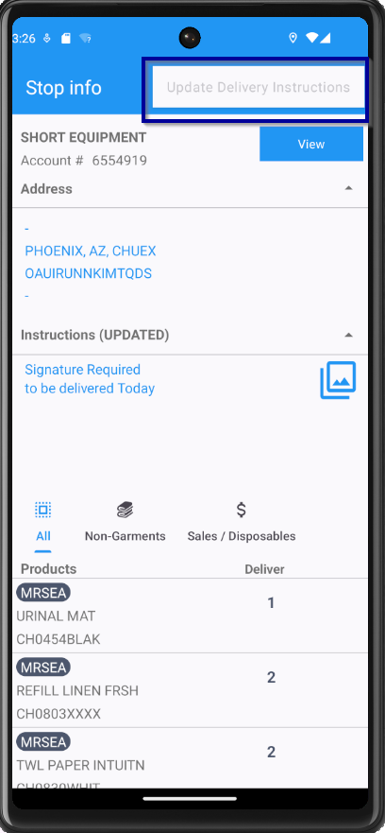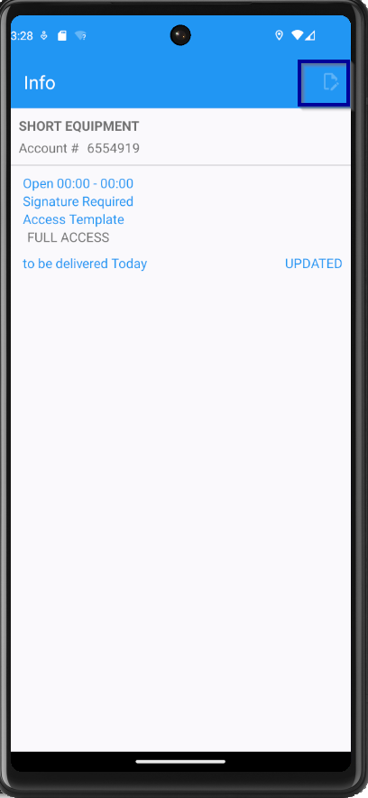

Test case 6: Verify Route List Instructions are correctly updated on both database and ABSSolute – TEST OK

- Visit a stop and update the instructions, then upload the data to the server and export database
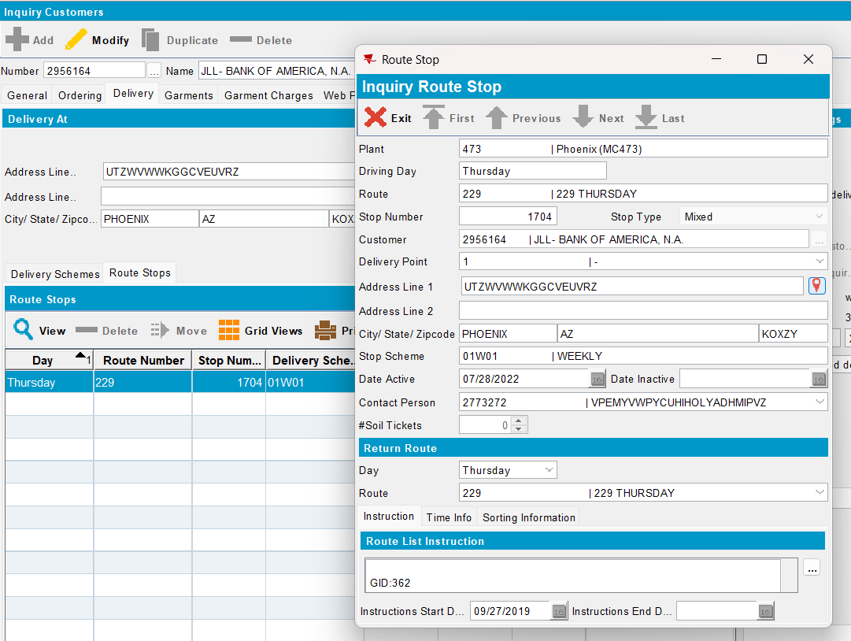
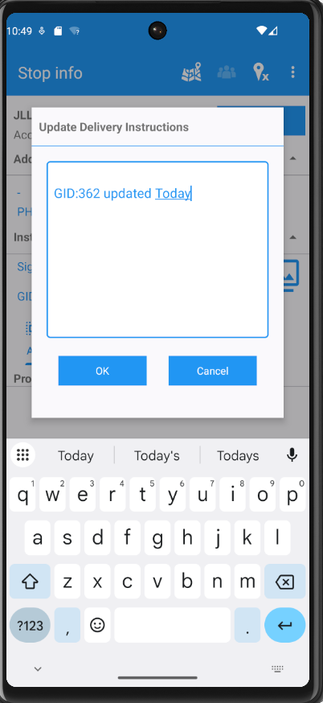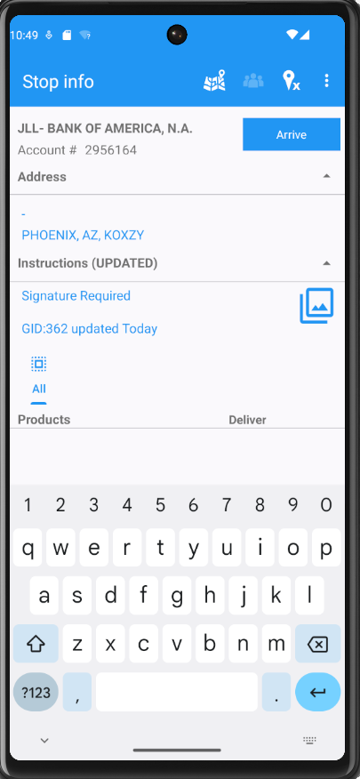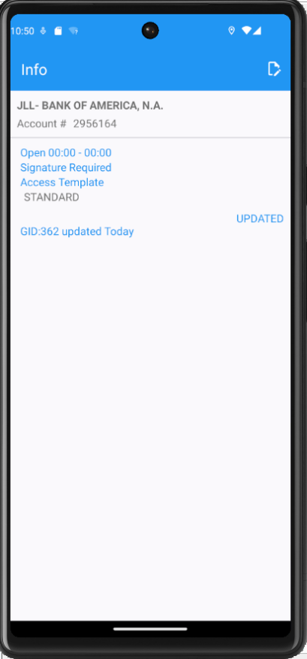
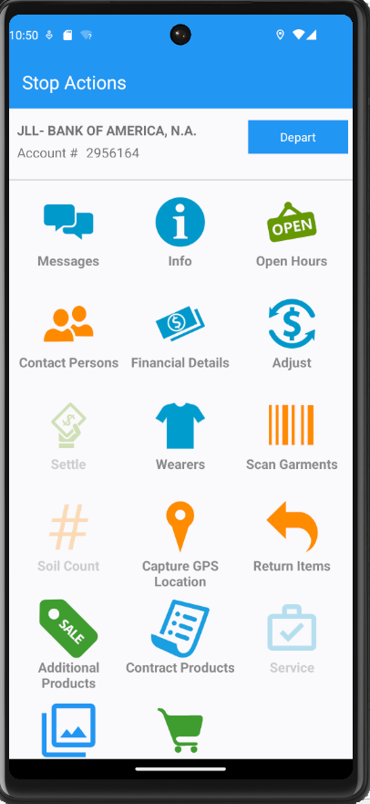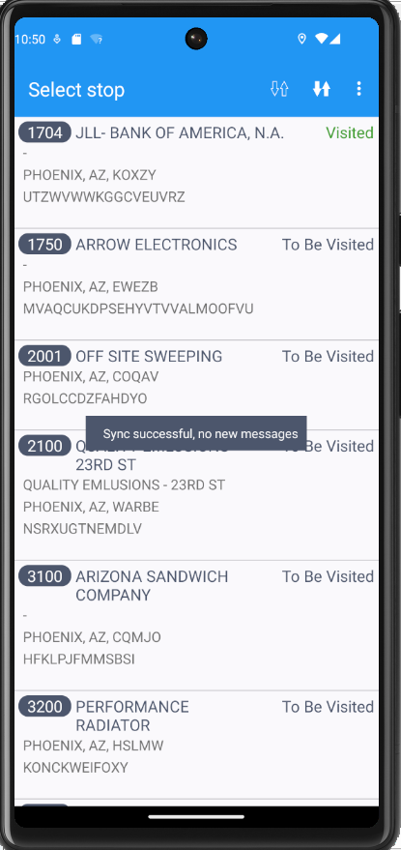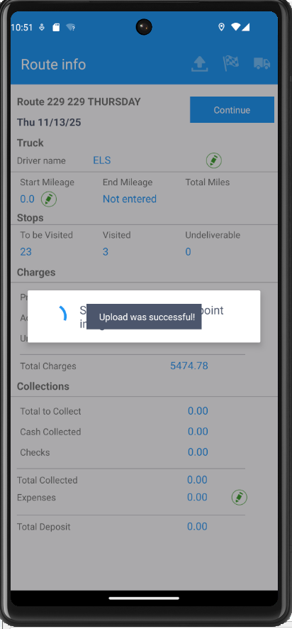
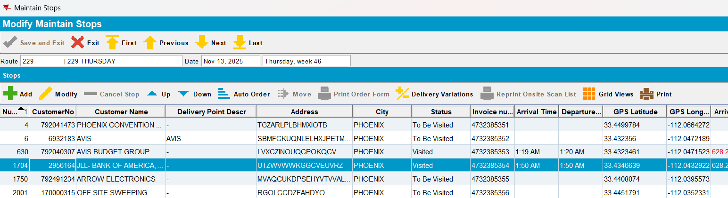

- Check the database record created for route transaction -> Database record created for RouteTransaction is correct
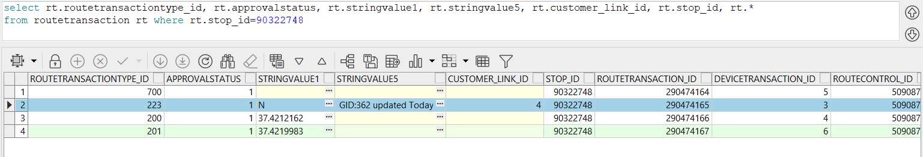

- Check the Route List Instructions have been updated on Route Stop -> The Route List Instructions have been updated in ABSSolute
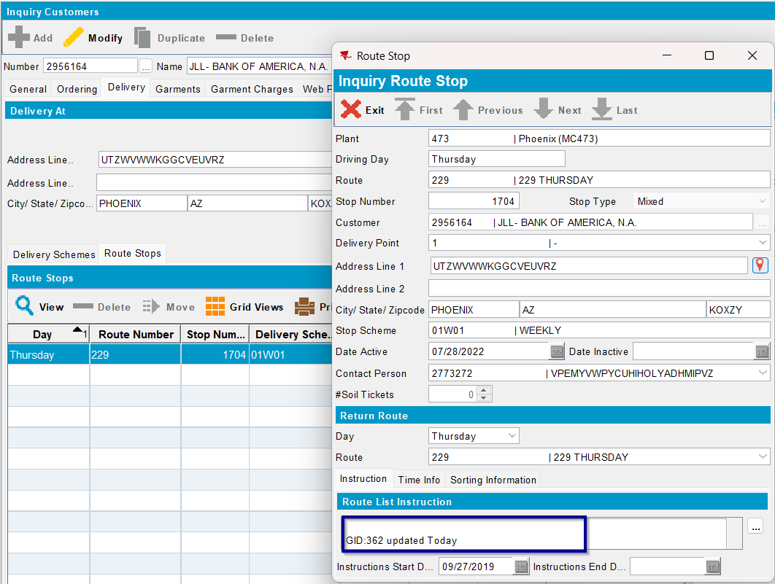

Test case 7: Verify all stops (not transferred yet to mobile device) connected to the current RouteStops are updated– TEST OK

- Create a route and send it to RASA
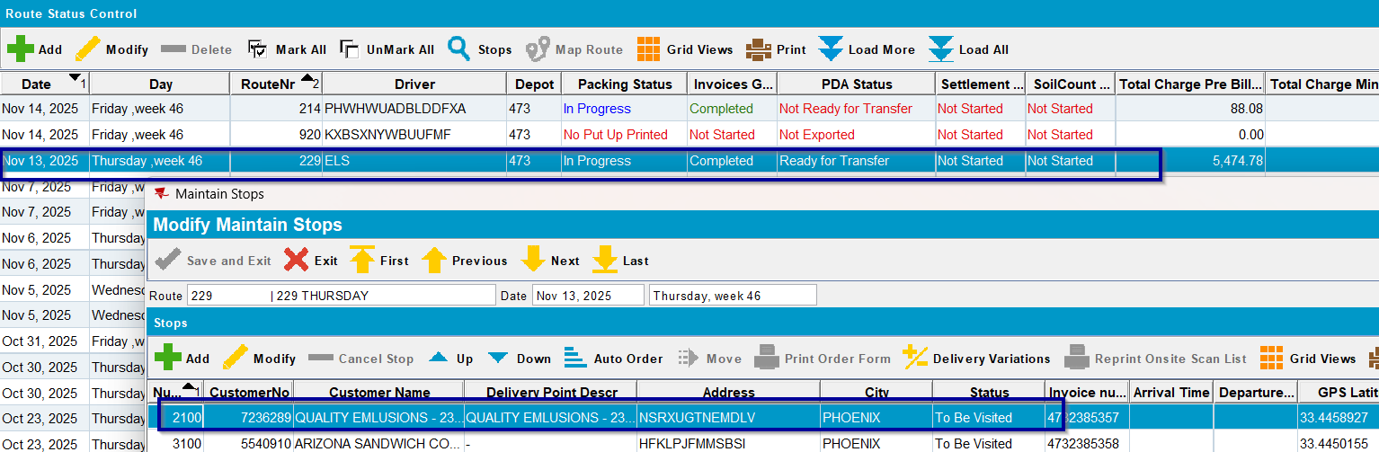
- Create a new route with customer on it, but do not send it to RASA
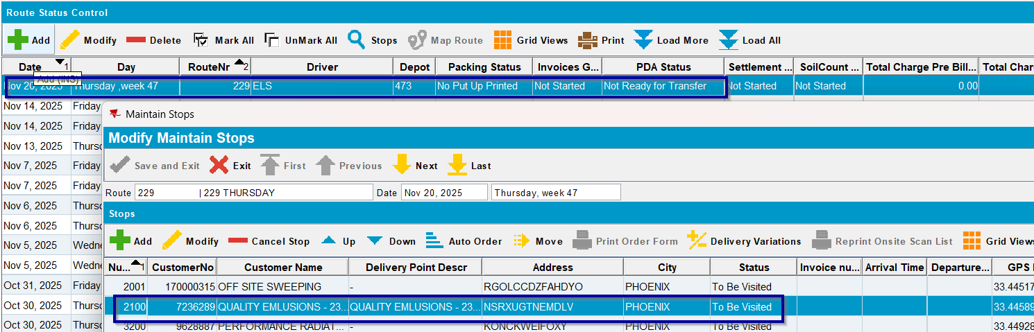
- Create a new route with customer on it and transfer it to RASA
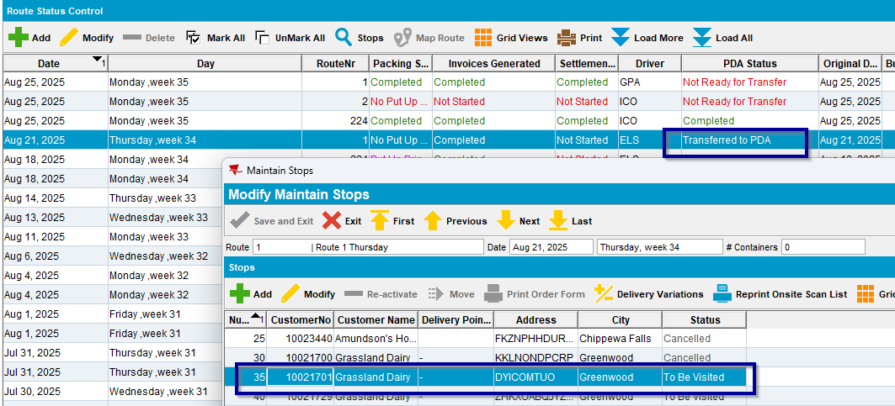
- Have a customer with or without Delivery Instructions on Route Stop
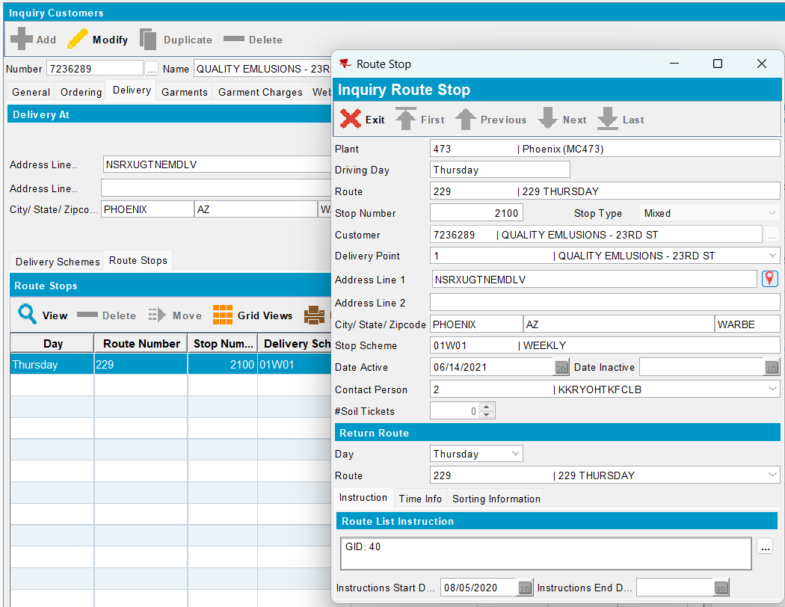
- Configure and start absmobilerestservices.war
- Login to RASA using system user and password
- Start the route and choose a customer
- Update the delivery instructions for this customer
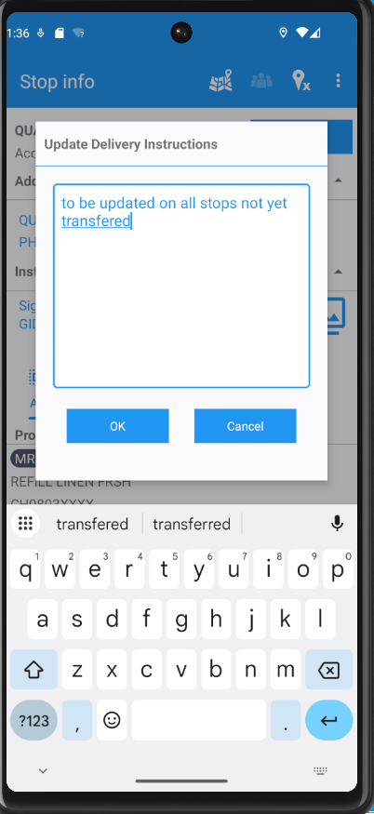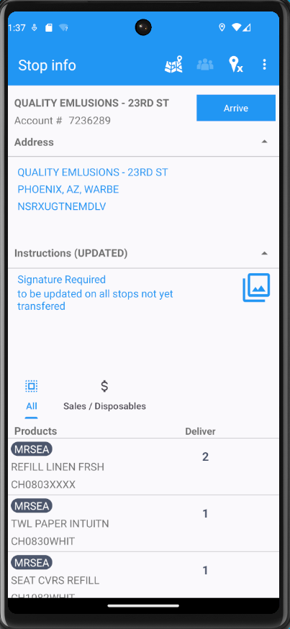
- Depart from the customer and upload the data to the server
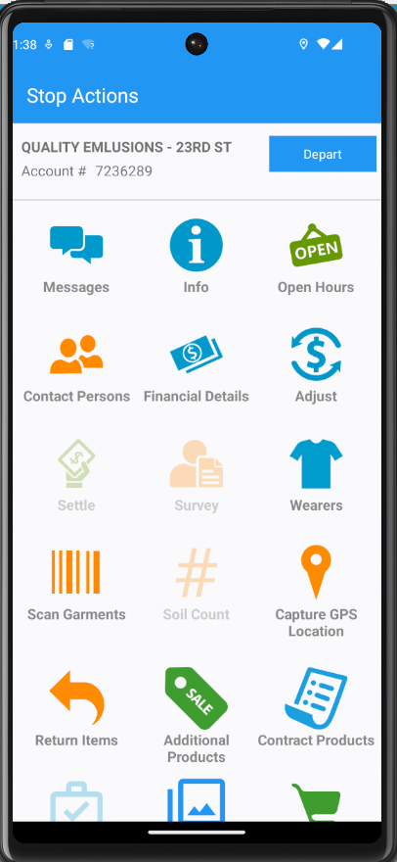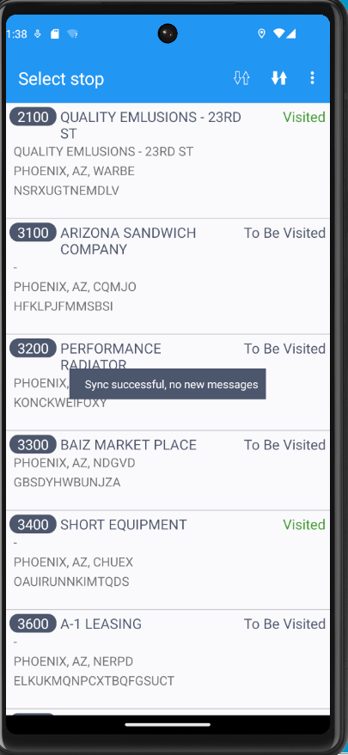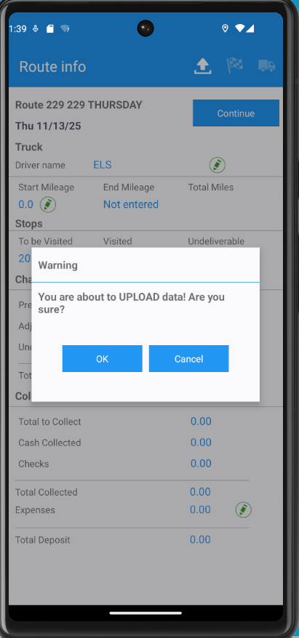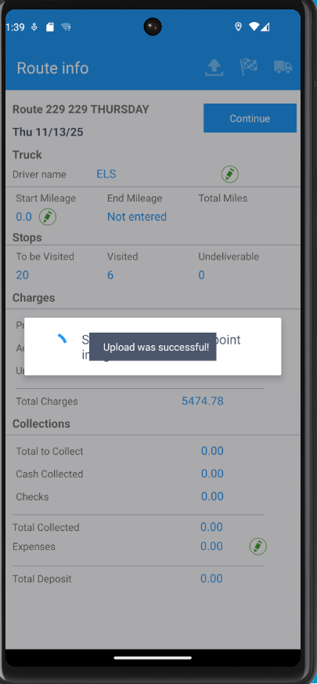
- Check the updated instructions on Route Stop from ABSSolute -> the instructions have been updated
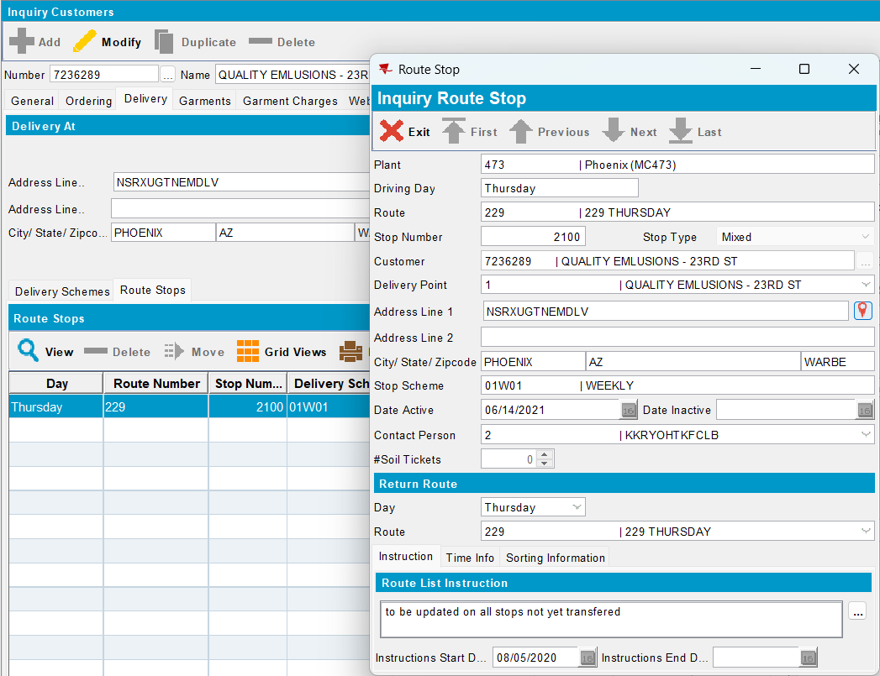
- Check the updated instructions on stop from the current route -> the stop is updated with delivery instructions
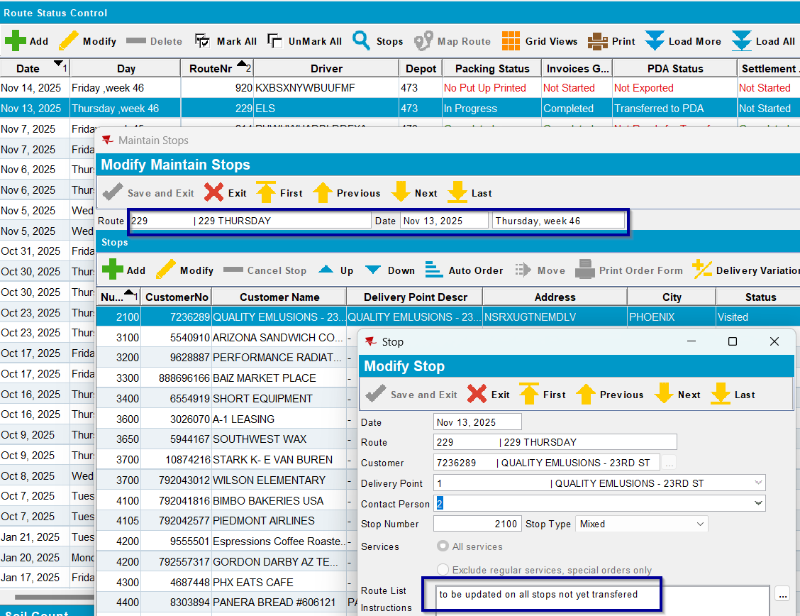
- Check the updated instructions on the other route created, but not sent to RASA -> the stop is updated with delivery instructions
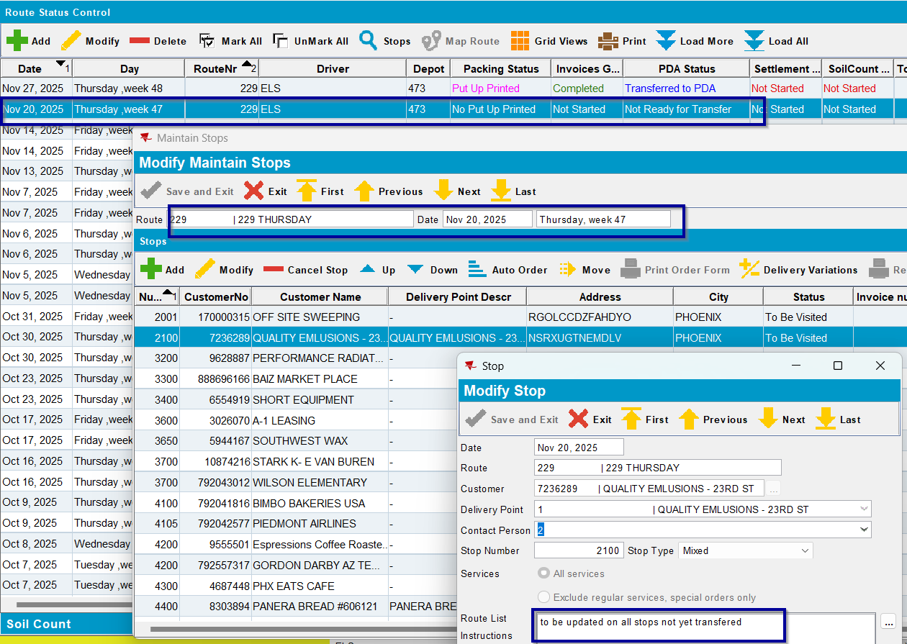
- Check the updated instructions on the other route created, but sent to RASA -> the stop is not updated with delivery instructions
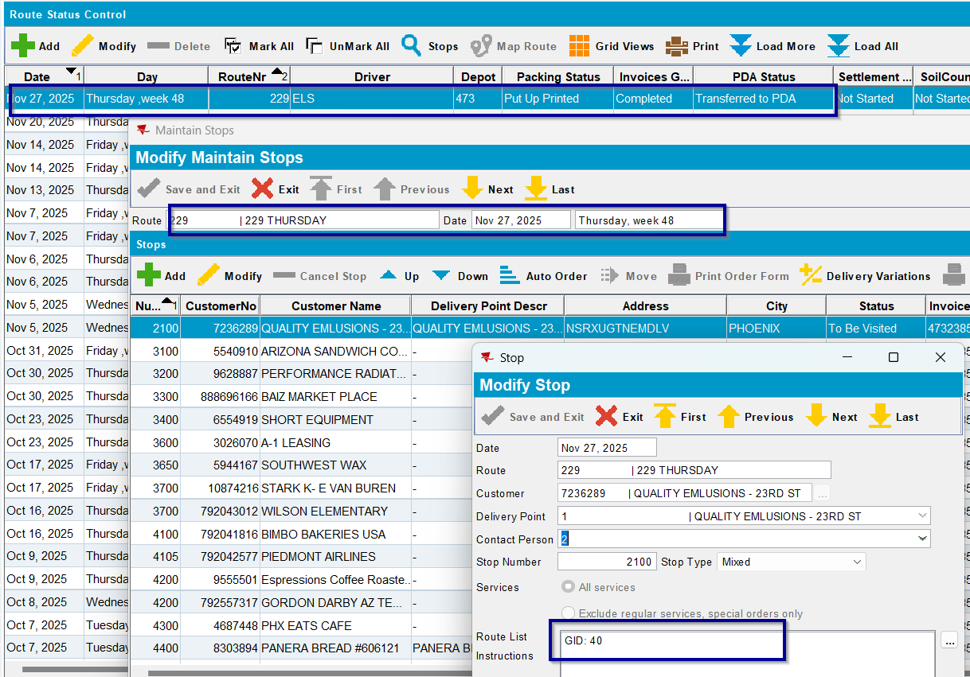

Test case 8: Update Delivery Instructions can be controlled via Mobile App Access Templates– TEST OK

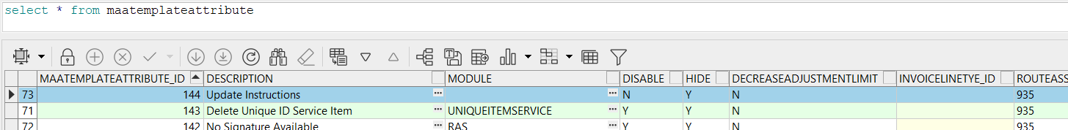

Have Mobile applications access templates “Hide” checkbox not checked for “Update Instructions”

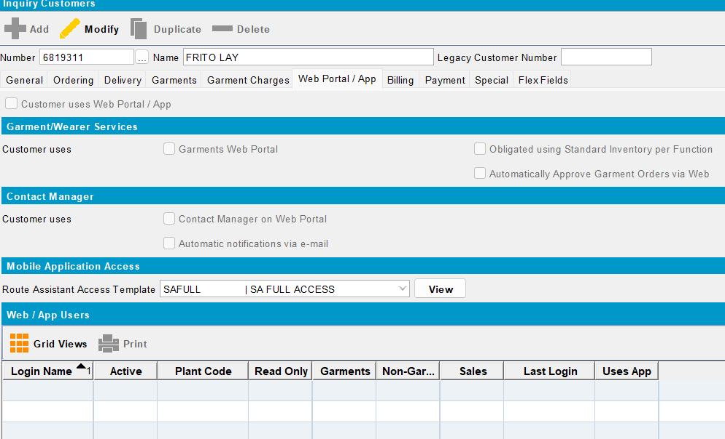
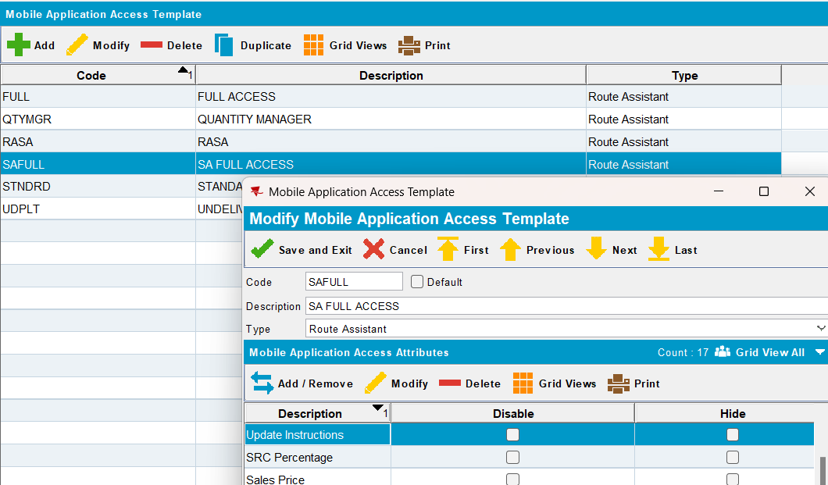
- Create a route and send it to RASA
- Configure and start absmobilerestservices.war
- Login to RASA using system user and password
- Start the route and choose a customer -> “Edit” icon for “Update Delivery Instructions” is displayed.
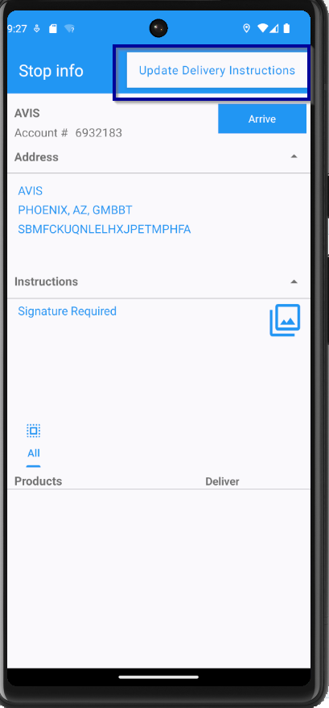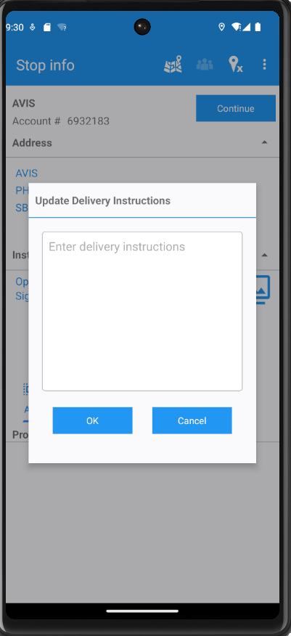
- Arrive at a customer, press “Info” icon -> “Edit” icon for “Update Delivery Instructions” is displayed.
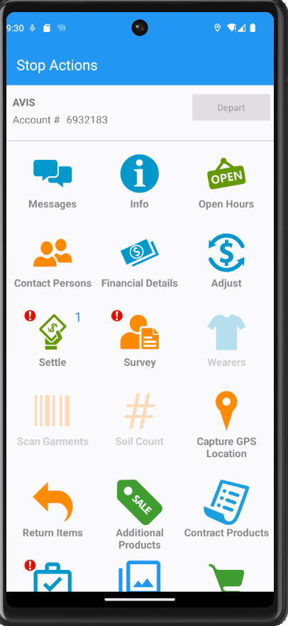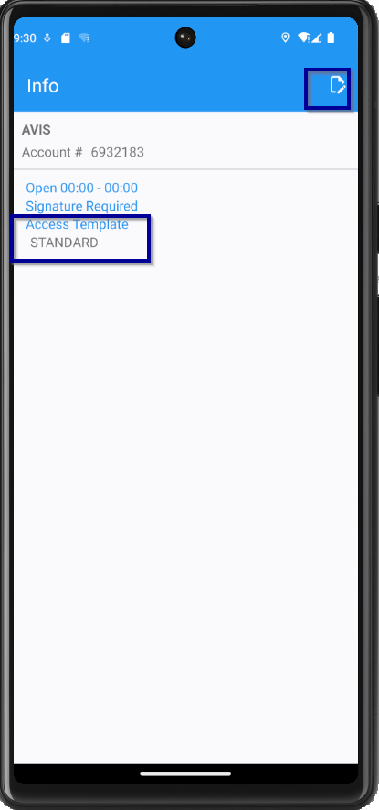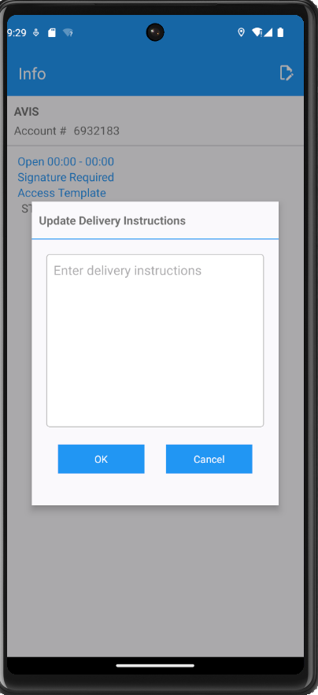

Have Mobile applications access templates “Hide” checkbox checked for “Update Instructions”
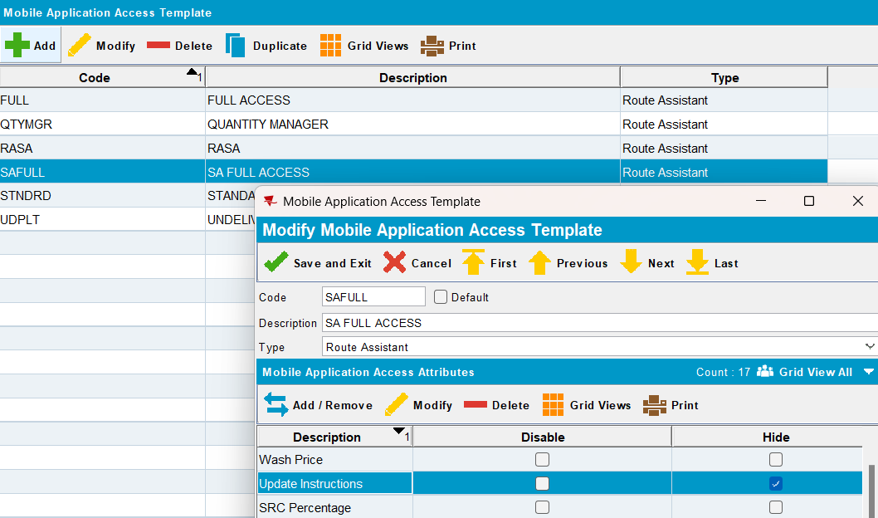
- Create a route and send it to RASA
- Configure and start absmobilerestservices.war
- Login to RASA using system user and password
- Start the route and choose a customer -> “Edit” icon for “Update Delivery Instructions” is not displayed.
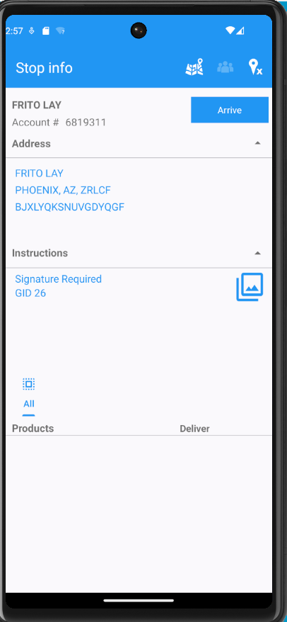
- Arrive at a customer, press “Info” icon -> “Edit” icon for “Update Delivery Instructions” is not displayed.
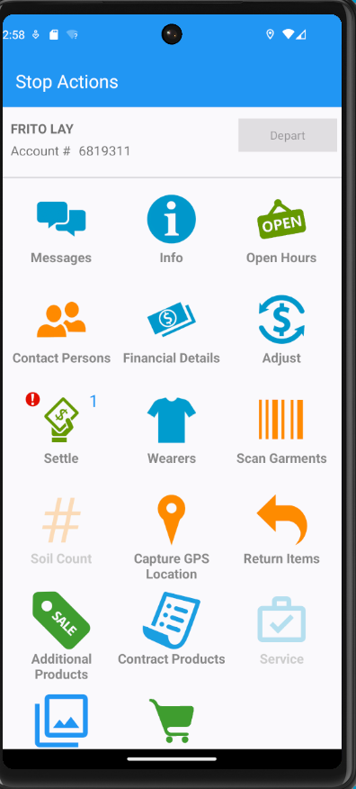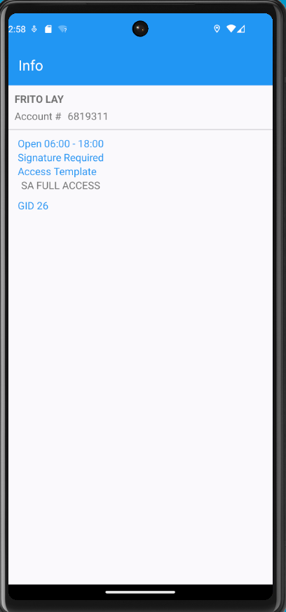

Customer delivered twice or more days per week
Version: 9.08.00.RELEASE.p23 hash: 0ecfec110304 RouteAssistant_v13.32.INTERNAL_TEST_ONLY.bc40f1ae2.apk (master)
BU/Plant: Phoenix (MC473)

Test Case 1: Update delivery instructions for current day – TEST OK

- Create a route and send it to RASA
- Have a customer delivered twice a week
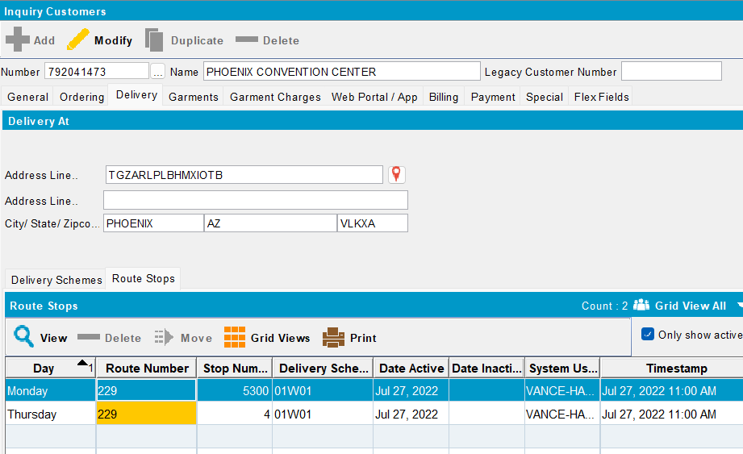
- Have customer with or without Route List Instructions on the route stop
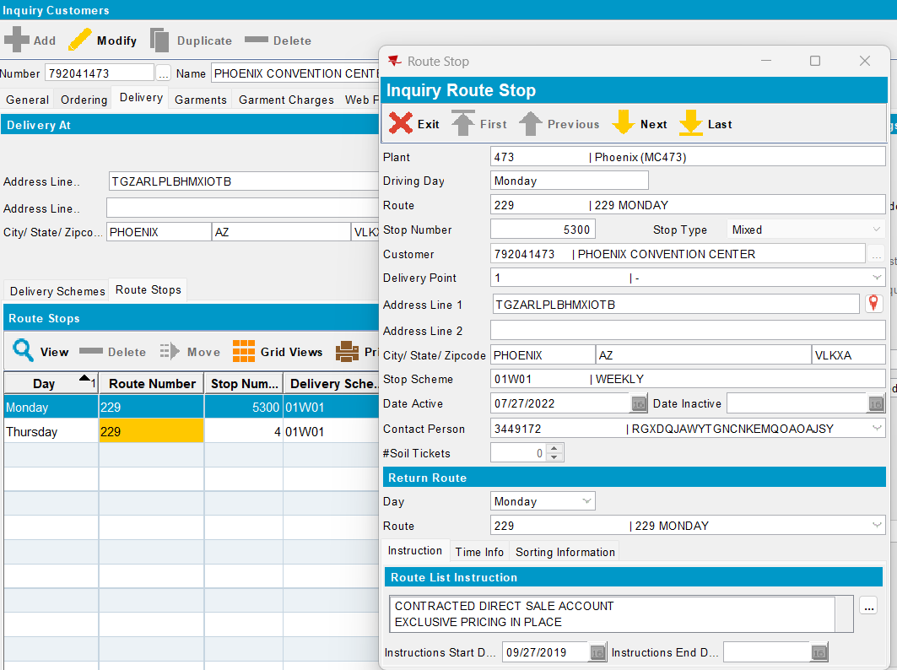
- Configure and start absmobilerestservices.war
- Login to RASA using system user and password
- Arrive at the customer and update Delivery Instructions on Stop Info screen -> Because the customer is delivered many times per week, “Do you want to update the Delivery Instructions for all delivery days?” message is displayed.
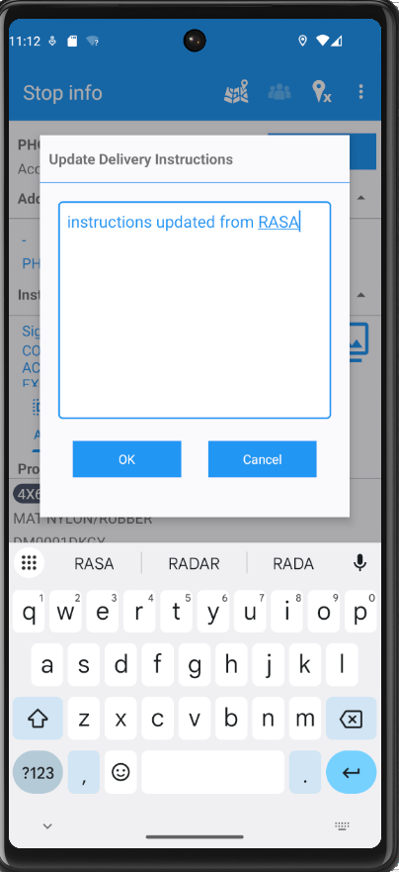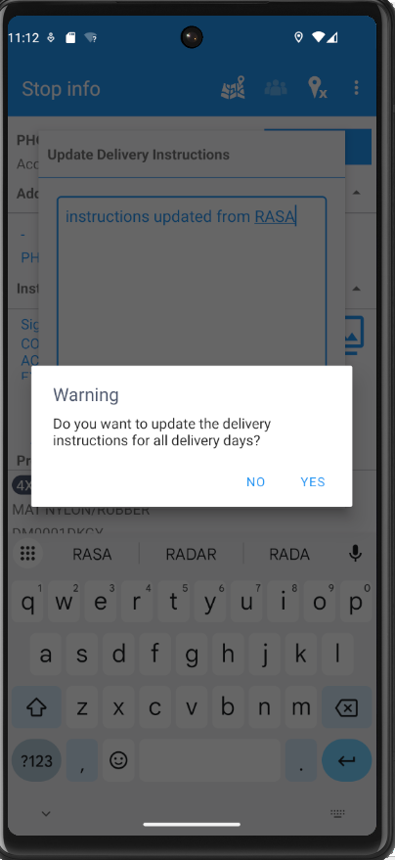
- Press “No” (only the instructions for current stop are updated) and check the instructions have been updated on Info screen also.
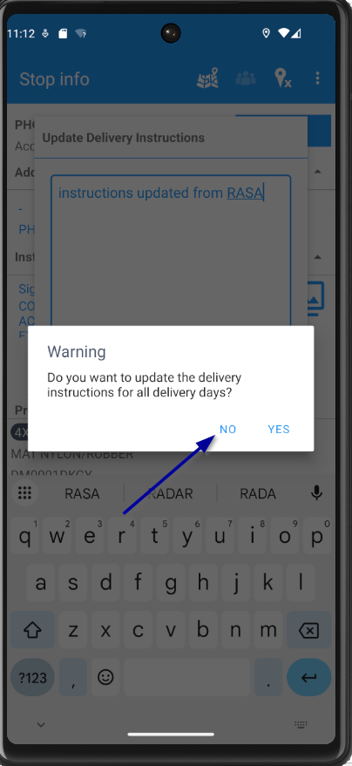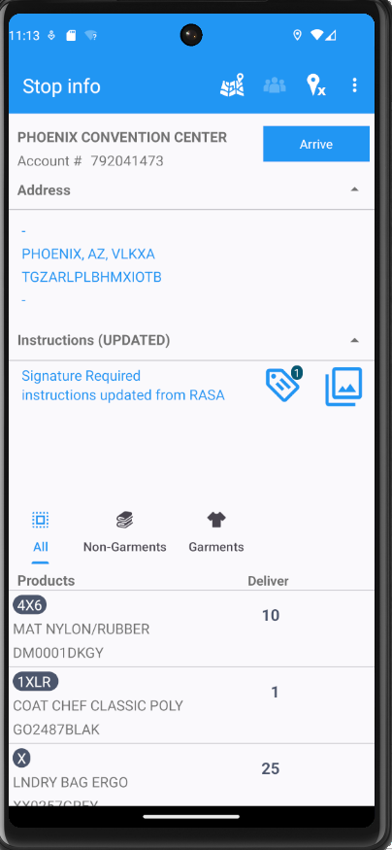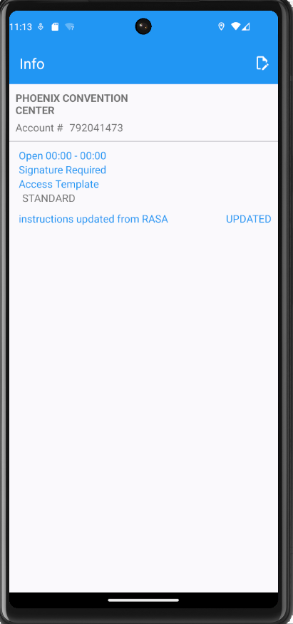
- Depart from the customer

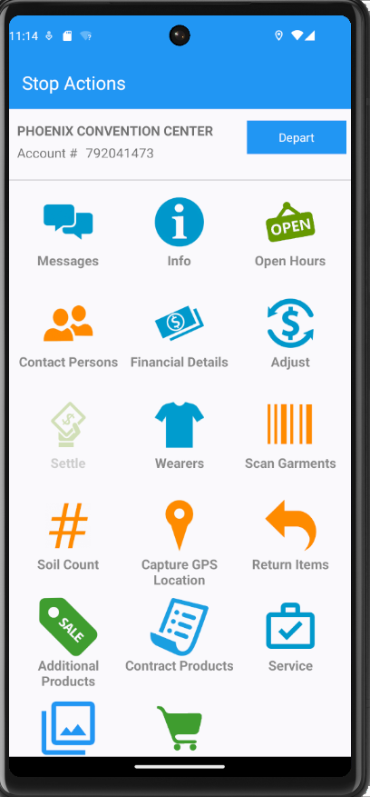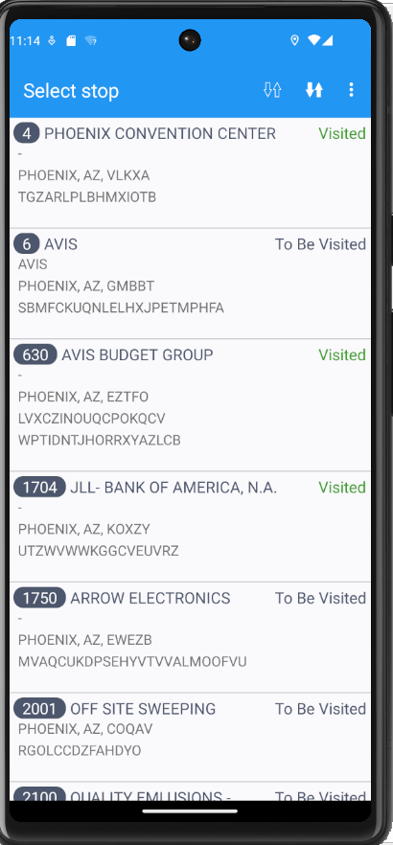

- Upload the data to the server and check the updates in ABSSolute
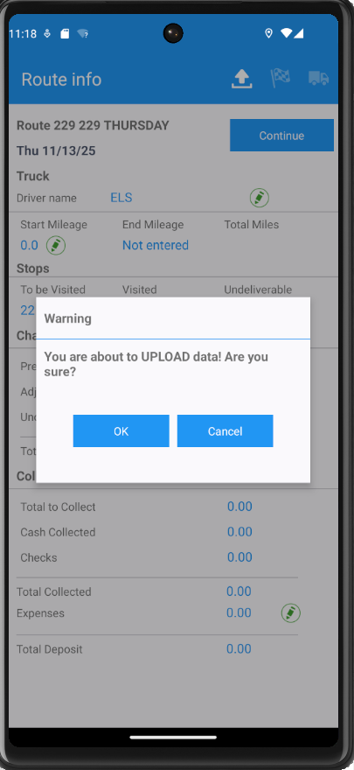
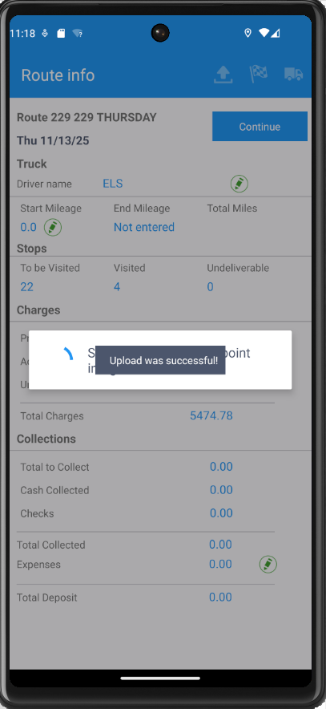
- Check the database record created for route transaction -> Database record created for RouteTransaction is correct
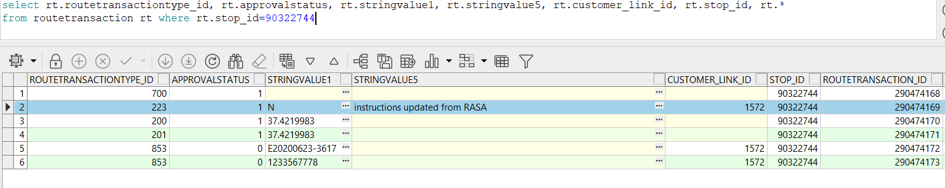

- Check the Route List Instructions have been updated on Route Stop -> The Instructions have been updated
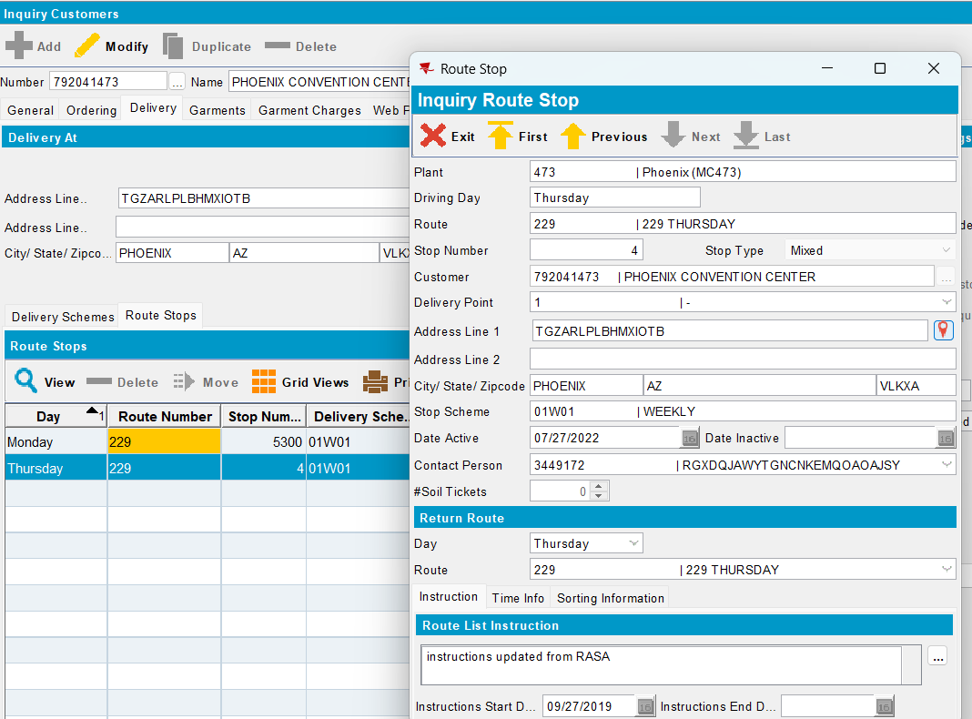

Test Case 2: Update delivery instructions for all delivery days, same Delivery Point for Route Stop – TEST OK

- Create a route and send it to RASA
- Have a customer delivered twice a week and with the same Delivery Point for Route Stop
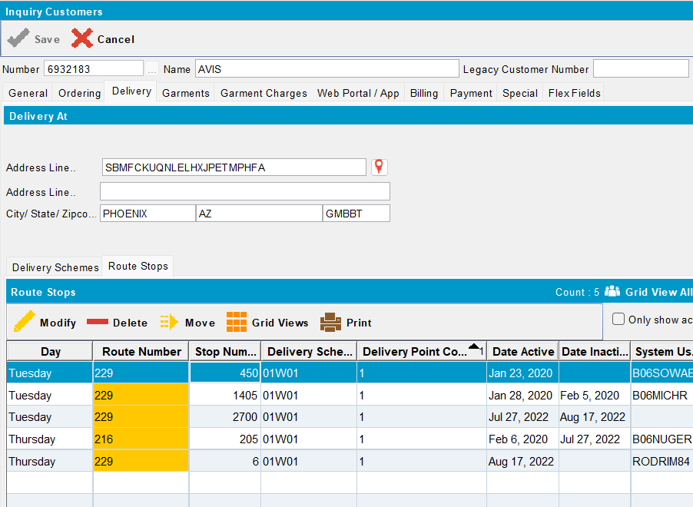
- Have customer with or without Route List Instructions on the route stop
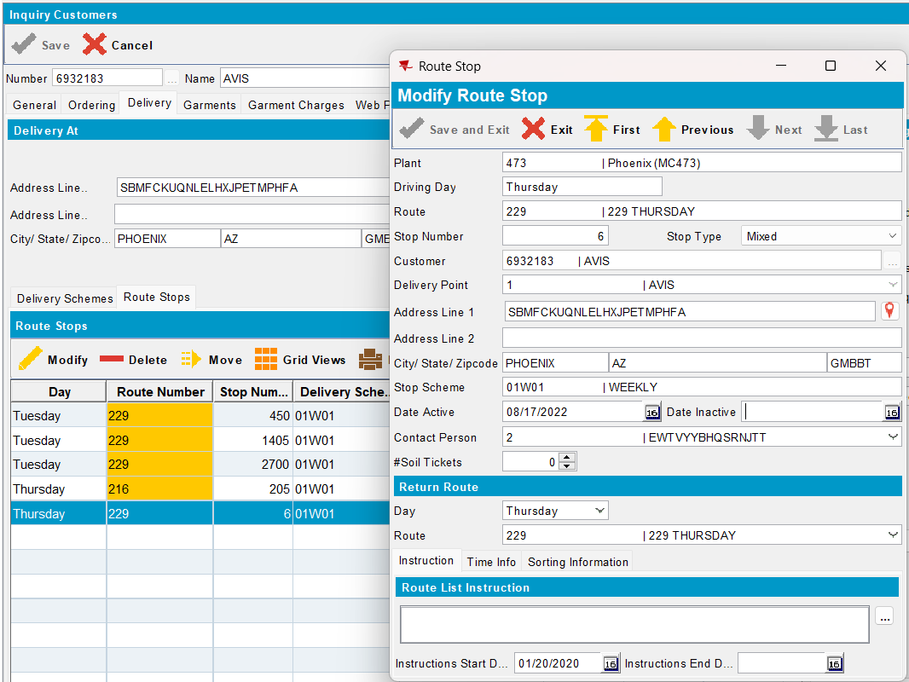
- Configure and start absmobilerestservices.war
- Login to RASA using system user and password
- Arrive at the customer and update Delivery Instructions on Stop Info screen -> Because the customer is delivered many times per week, “Do you want to update the Delivery Instructions for all delivery days?” message is displayed.
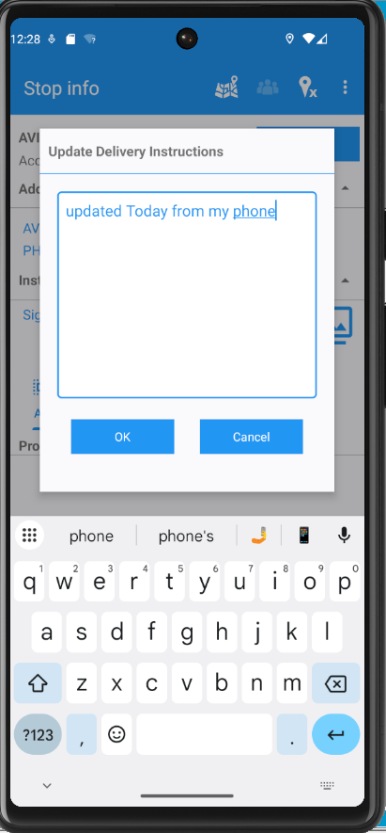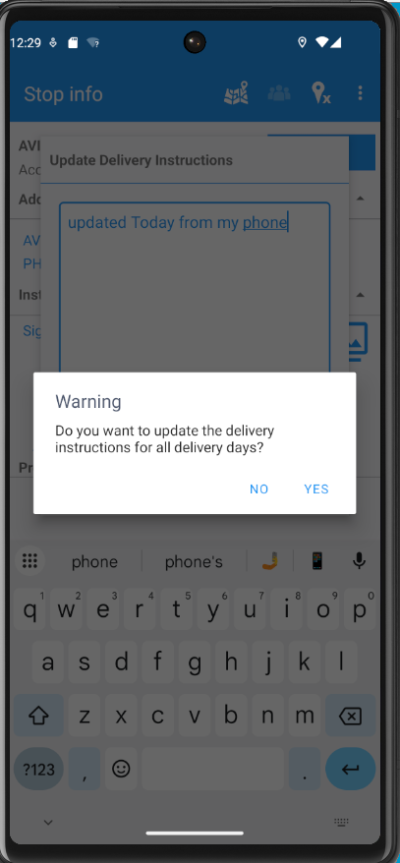
- Press “YES” (the delivery instructions for all delivery days are updated) and check the instructions have been updated on Info screen also
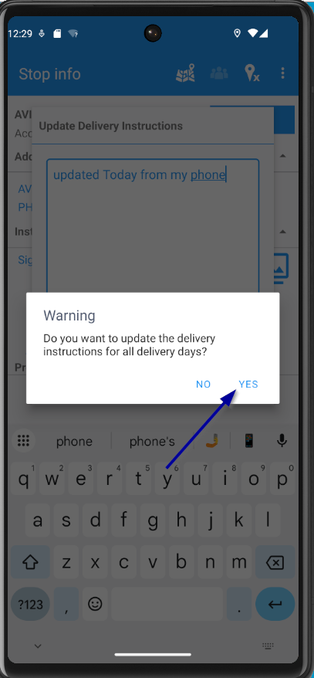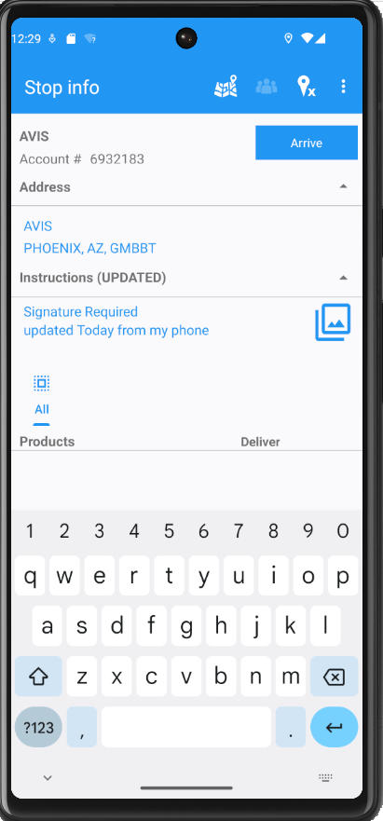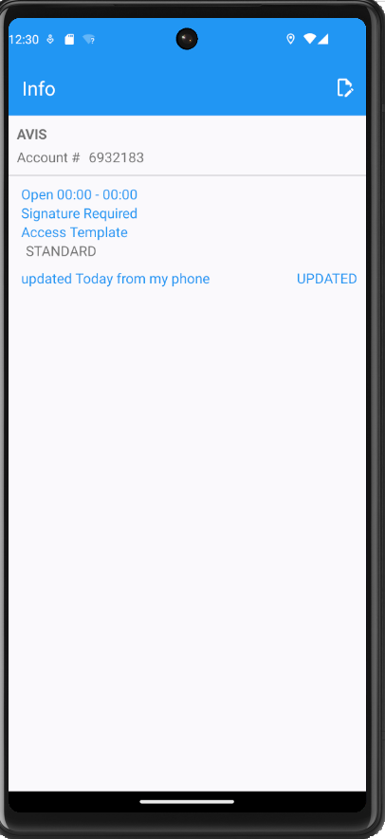
- Depart from the customer
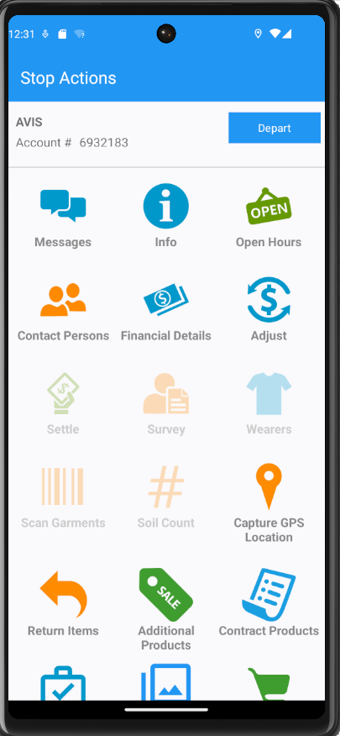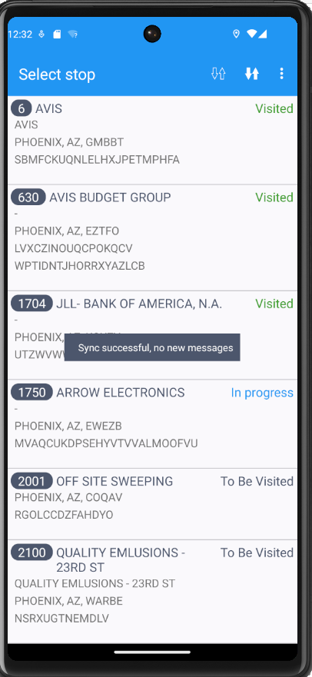

- Upload the data to the server
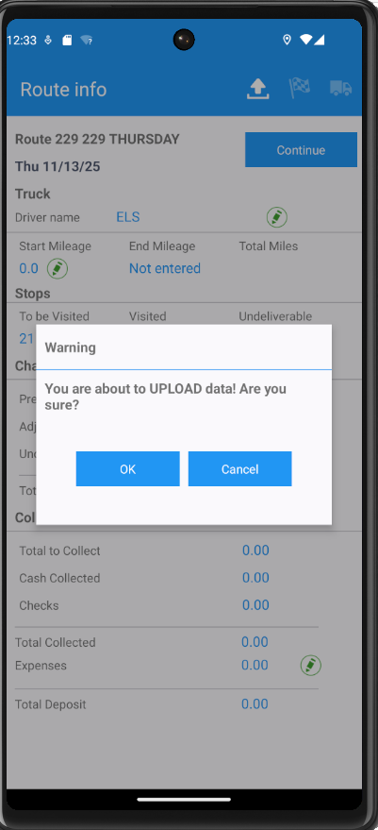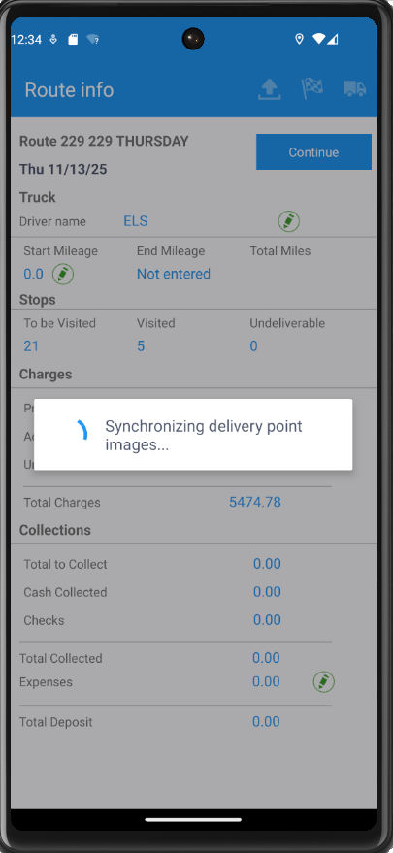

- Check the database record created for route transaction -> Database record created for RouteTransaction is correct
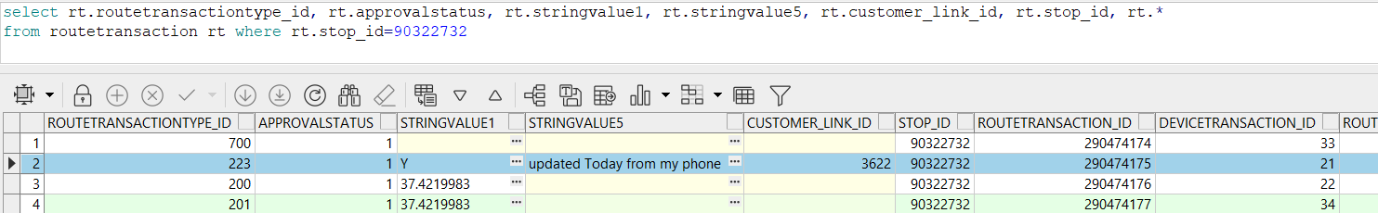

- Check the Route List Instructions have been updated on Route Stop -> the Instructions have been updated

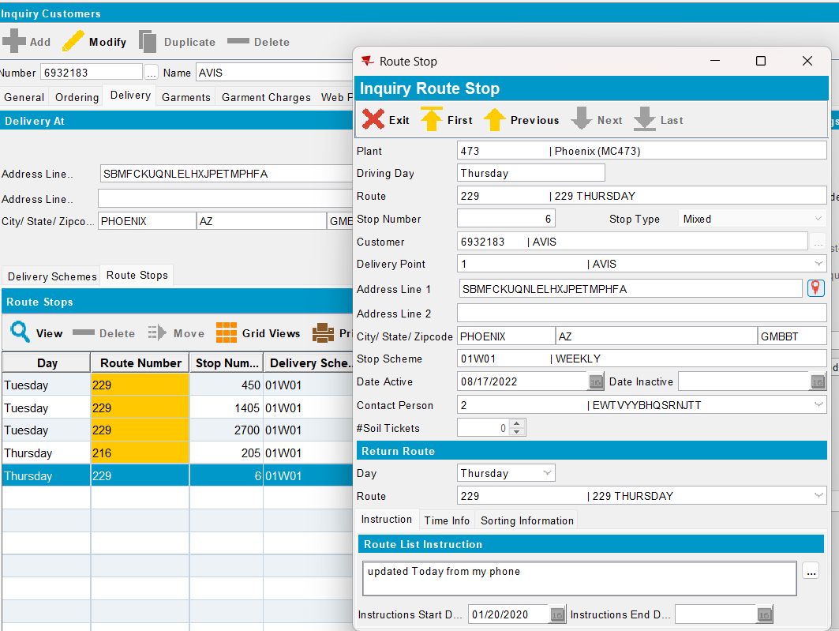
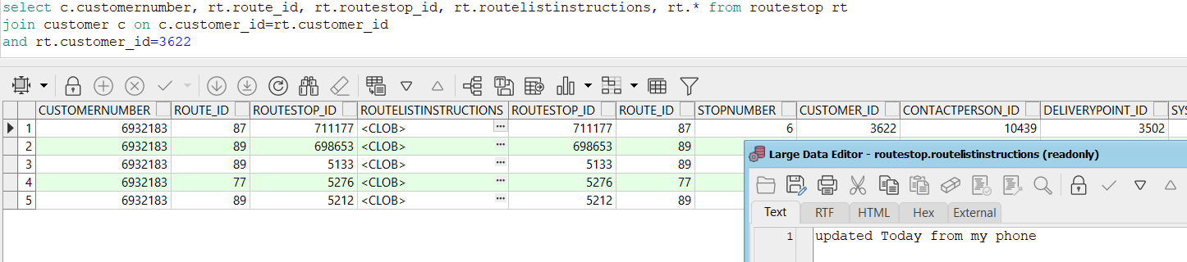
- Check Route List Instructions were updated for all delivery days of the week -> Route List Instructions were correctly updated
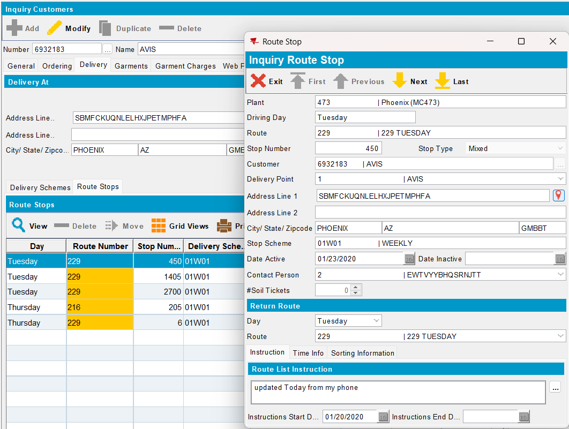

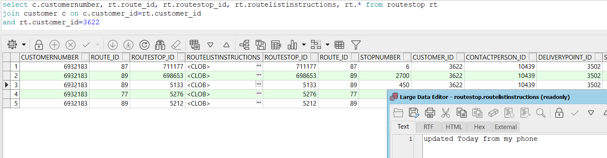

Test case 3: Verify all stops (not yet transferred to mobile device) connected to the current RouteStops are updated– TEST OK

- Create a route and send it to RASA
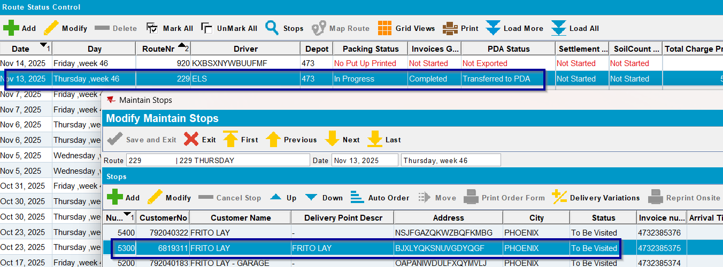
- Create a new route with customer on it, but do not send it to RASA
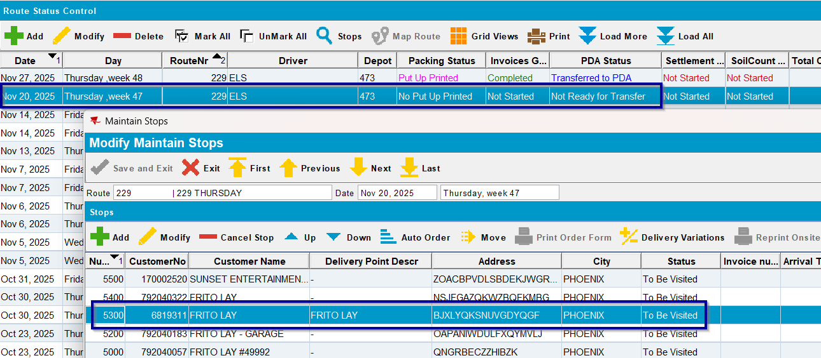
- Create a new route with customer on it and transfer it to RASA
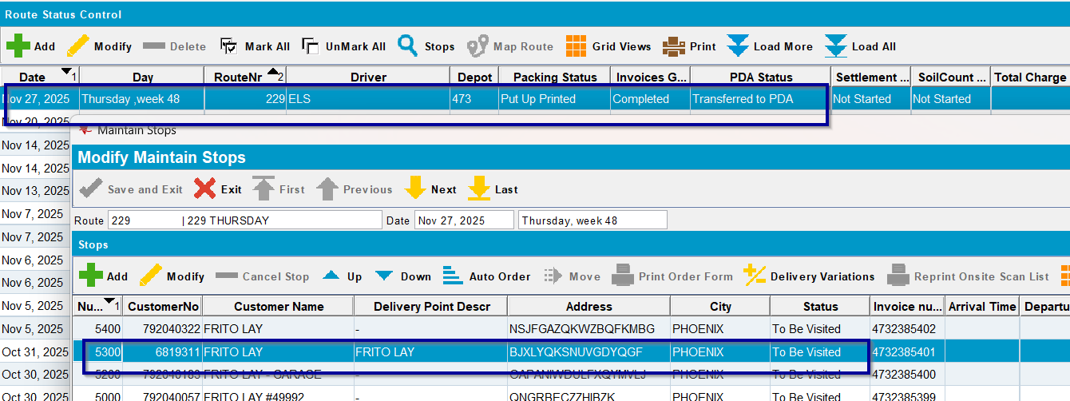
- Have a customer with Delivery Instructions on Route Stop
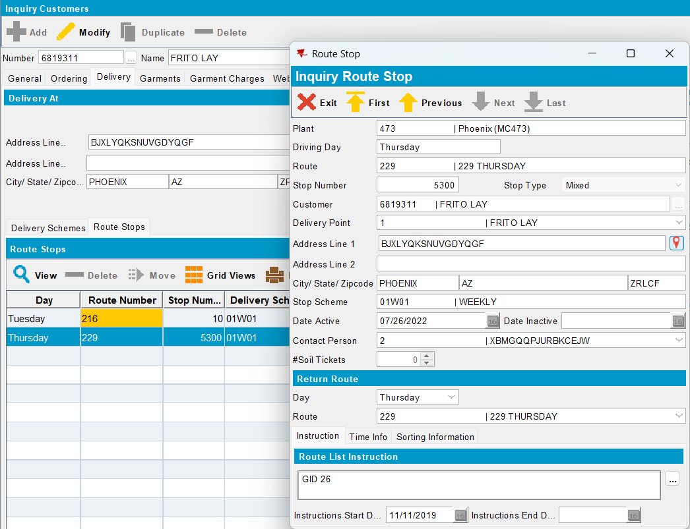
- Configure and start absmobilerestservices.war
- Login to RASA using system user and password
- Start the route and choose a customer
- Update the delivery instructions for this customer
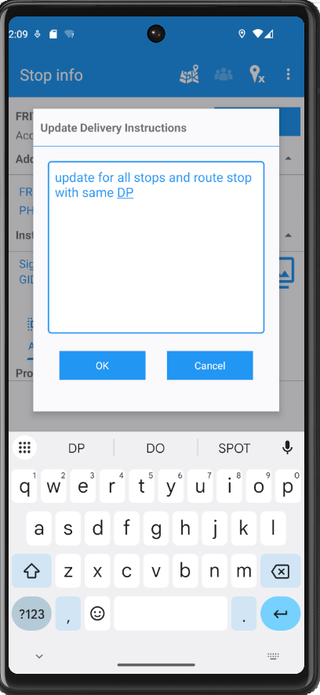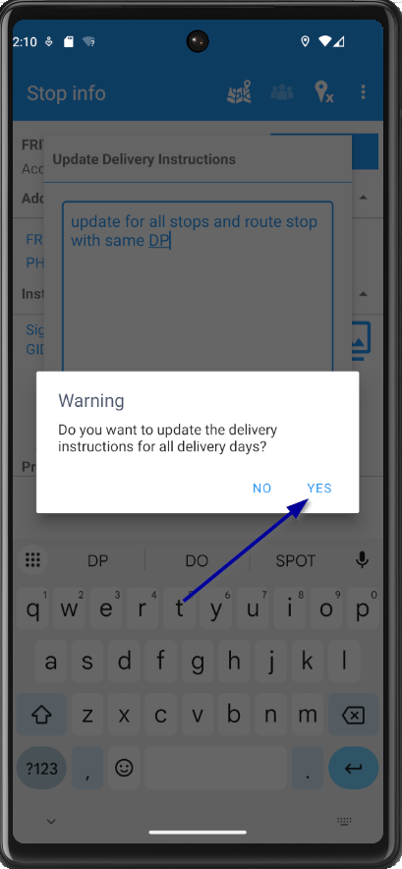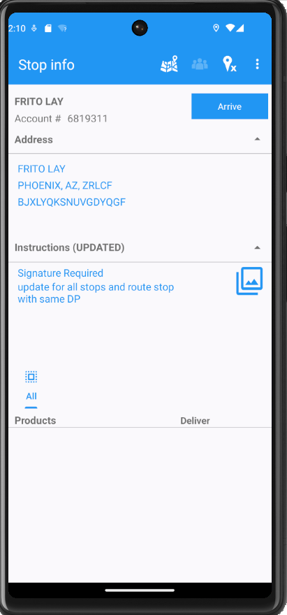
- Depart from the customer and upload the data to the server
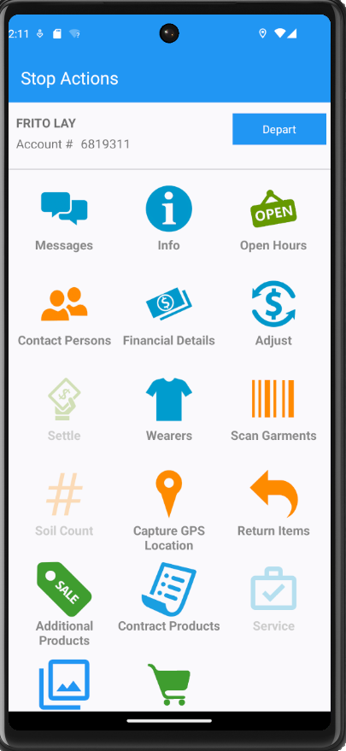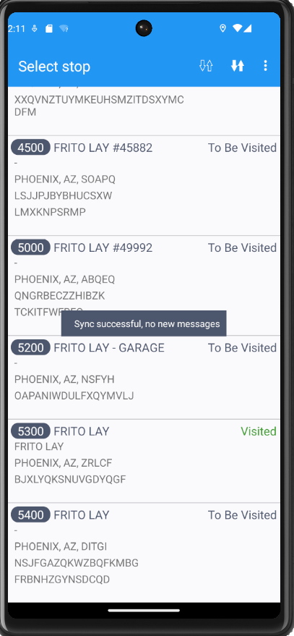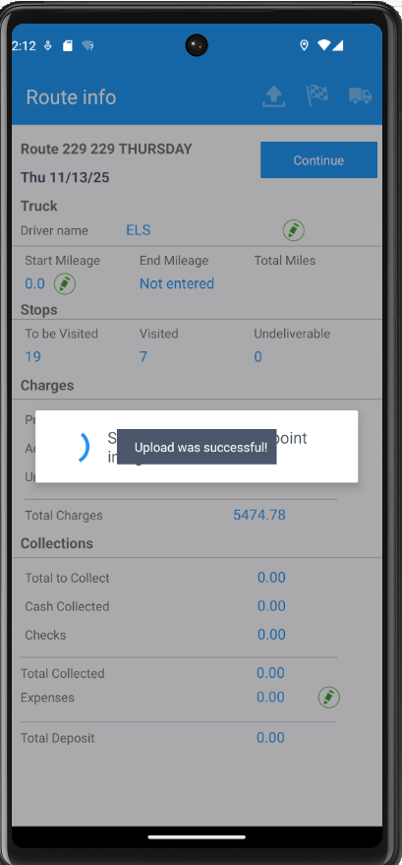
- Check the updated instructions on Route Stop from ABSSolute for both Route Stops -> the instructions have been updated
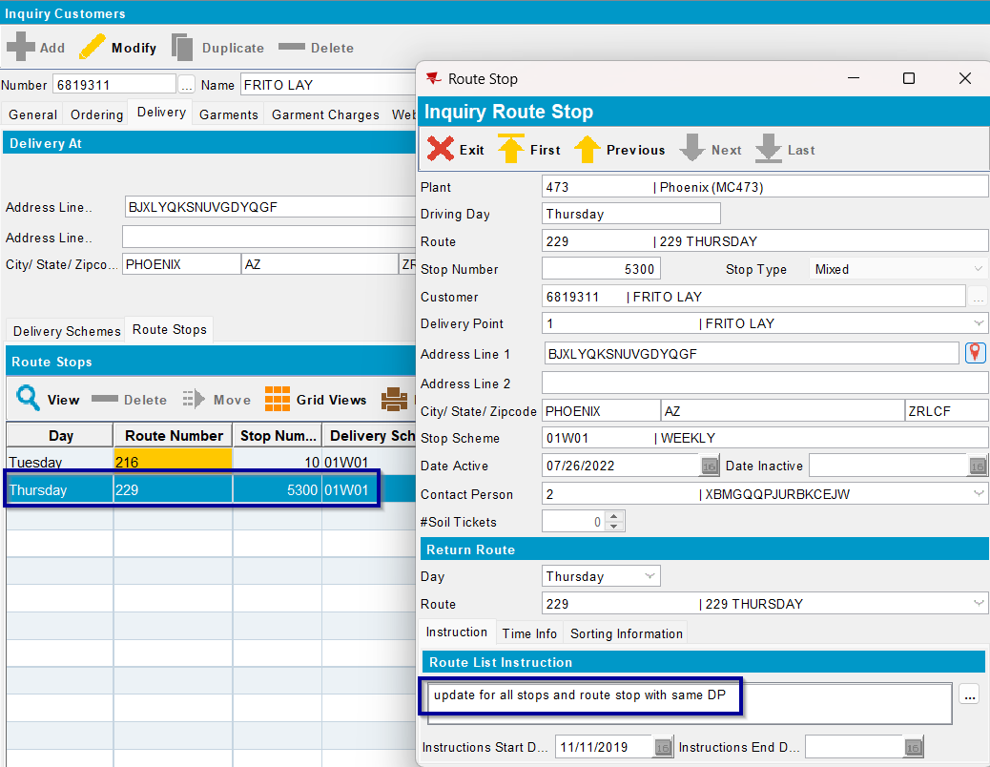
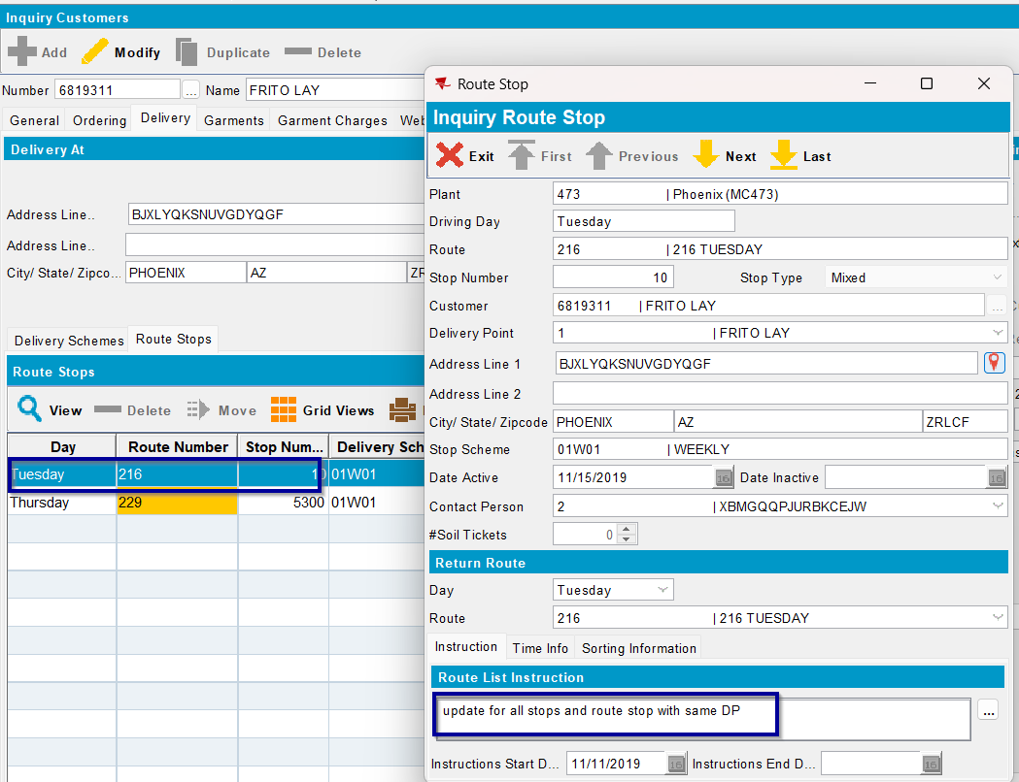

- Check the updated instructions on stop from the current route -> the stop is updated with delivery instructions
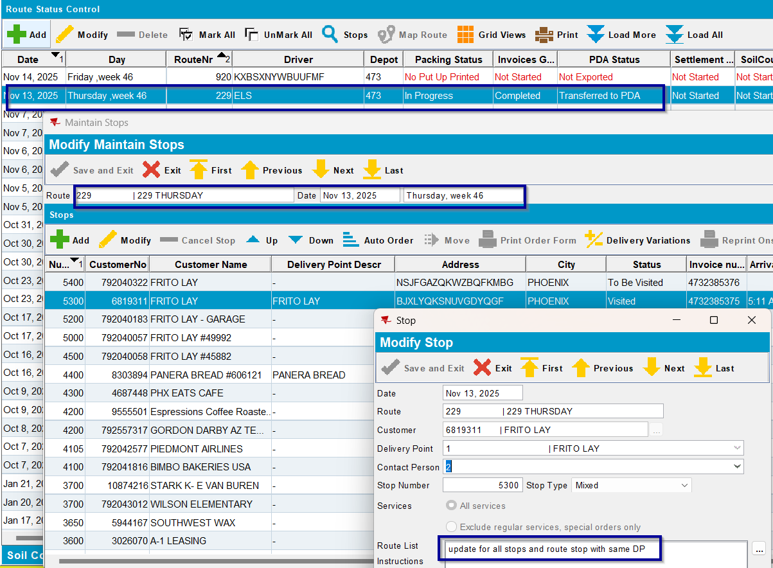
- Check the updated instructions on the other route created, but not sent to RASA -> the stop is updated with delivery instructions
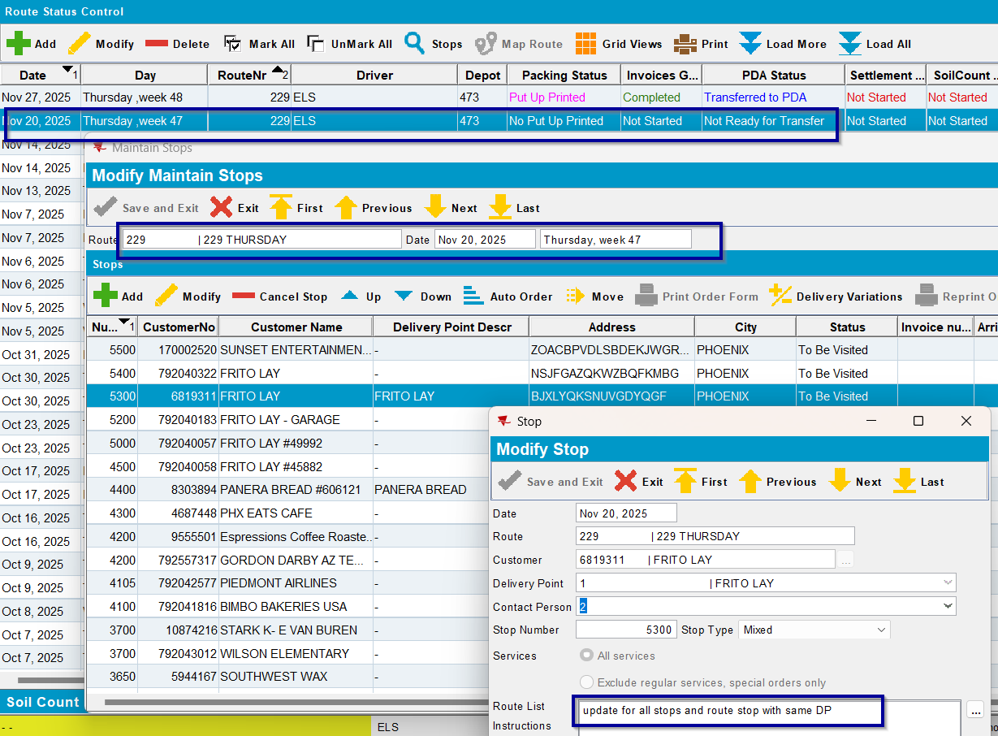
- Check the updated instructions on the other route created, but sent to RASA -> the stop is not updated with delivery instructions

