ABSN-7213 Web Client X - Route Check In - Route Details - Invoice Adjustments tab - Pressing Modify button for a replace loss charge invoice line results in unexpected behavior
Environment | Prerequisites
Version: 9.08.00.RELEASE.p24  Environment=PRODUCTION  DBServerName=db01-buc.internal.abslbs.com  DBSID= CUST25  DBUser= AUS_ND90502  DBPassword= AUS_ND90502 | - Modules: AUSCUSTOM  - Others: BU 503

Contents
Reproduction before fix 1
Retesting after fix 2

Reproduction before fix
BU:503
Route 82 from 30.05.2025
INVOICELINEADJVALUERULE=0
Steps to reproduce:
1. Initial values (came from PDA)
2. Press, in Invoice Adjustments tab, Modify button -> first time looks ok:
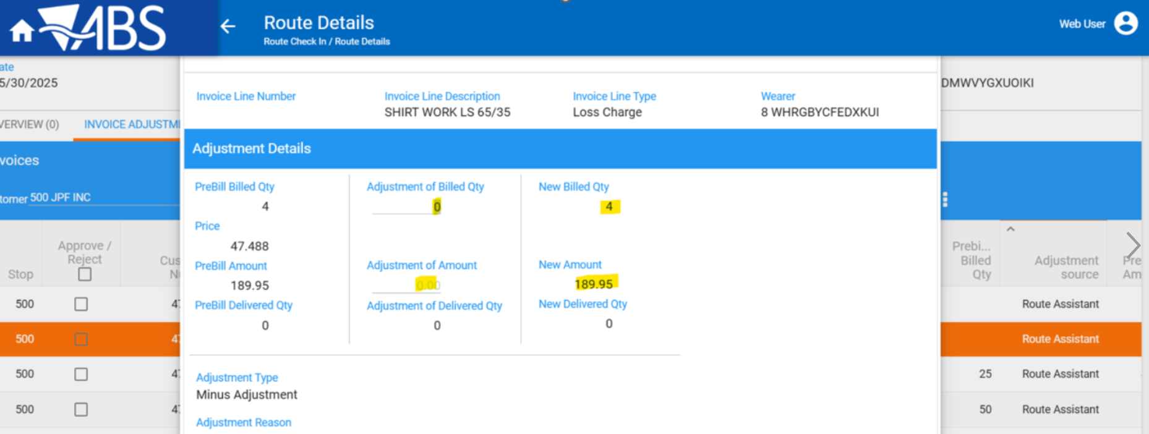
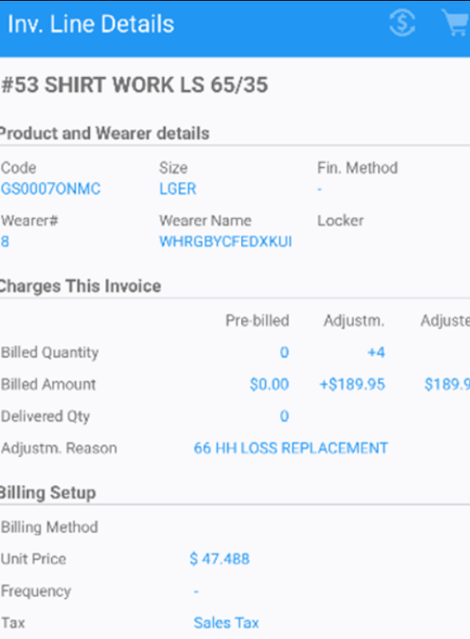

3. Press, second time, Modify button
Actual result:
The amount is doubled because, somehow, an adjustment of 4 qty appears:
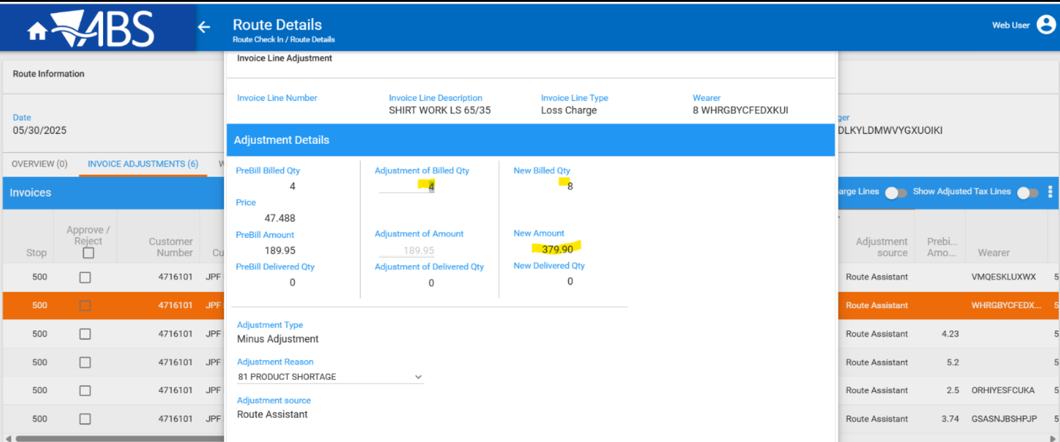

4. Refresh the page and press again modify button for this line -> now looks ok
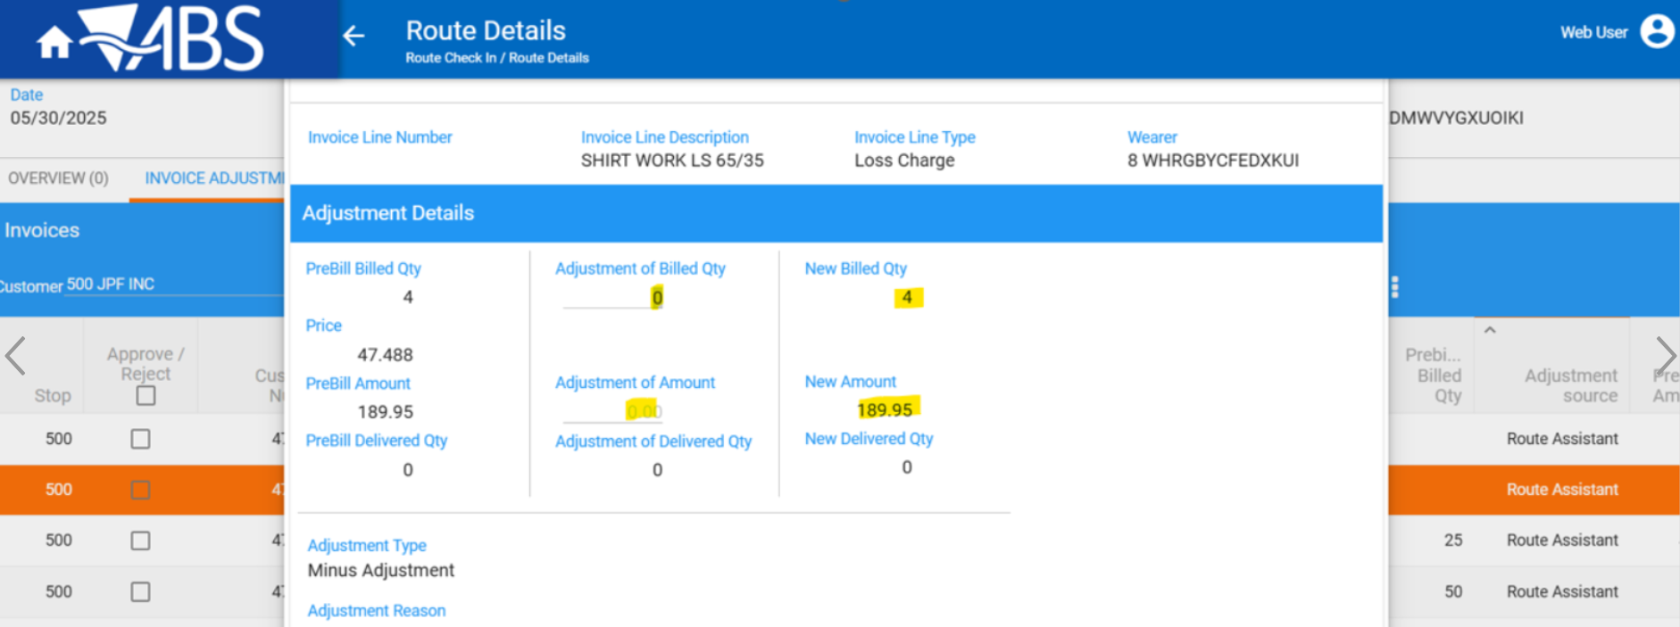

Retesting after fix

- Downloading and starting route
- Decrease max inventory for a wearer/ garment product or replace for loss to obtain replacement or loss charge invoice lines
- Settle and close route
- Uploading route
- Open route in WebX
- Modify replacement or loss charge invoice lines from Invoice Adjustments tab
- Close the pop-up without any changes from x or Discard button
- Modify again the same invoice line
Fixed:

Route 4 from 30.06.2025
- Loss charges the invoice line
Initial:
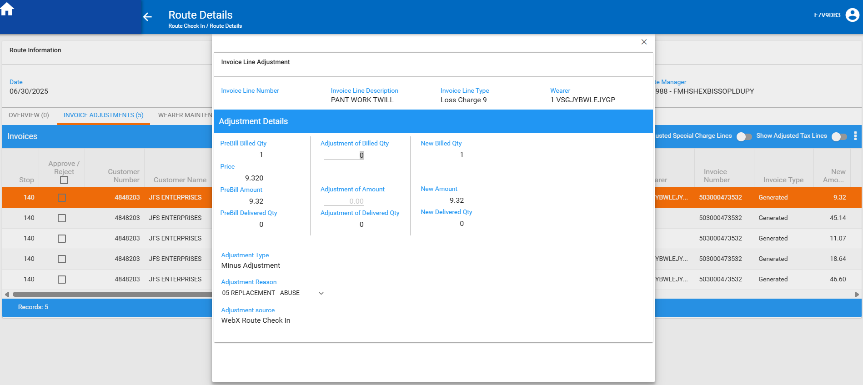

Modify again:
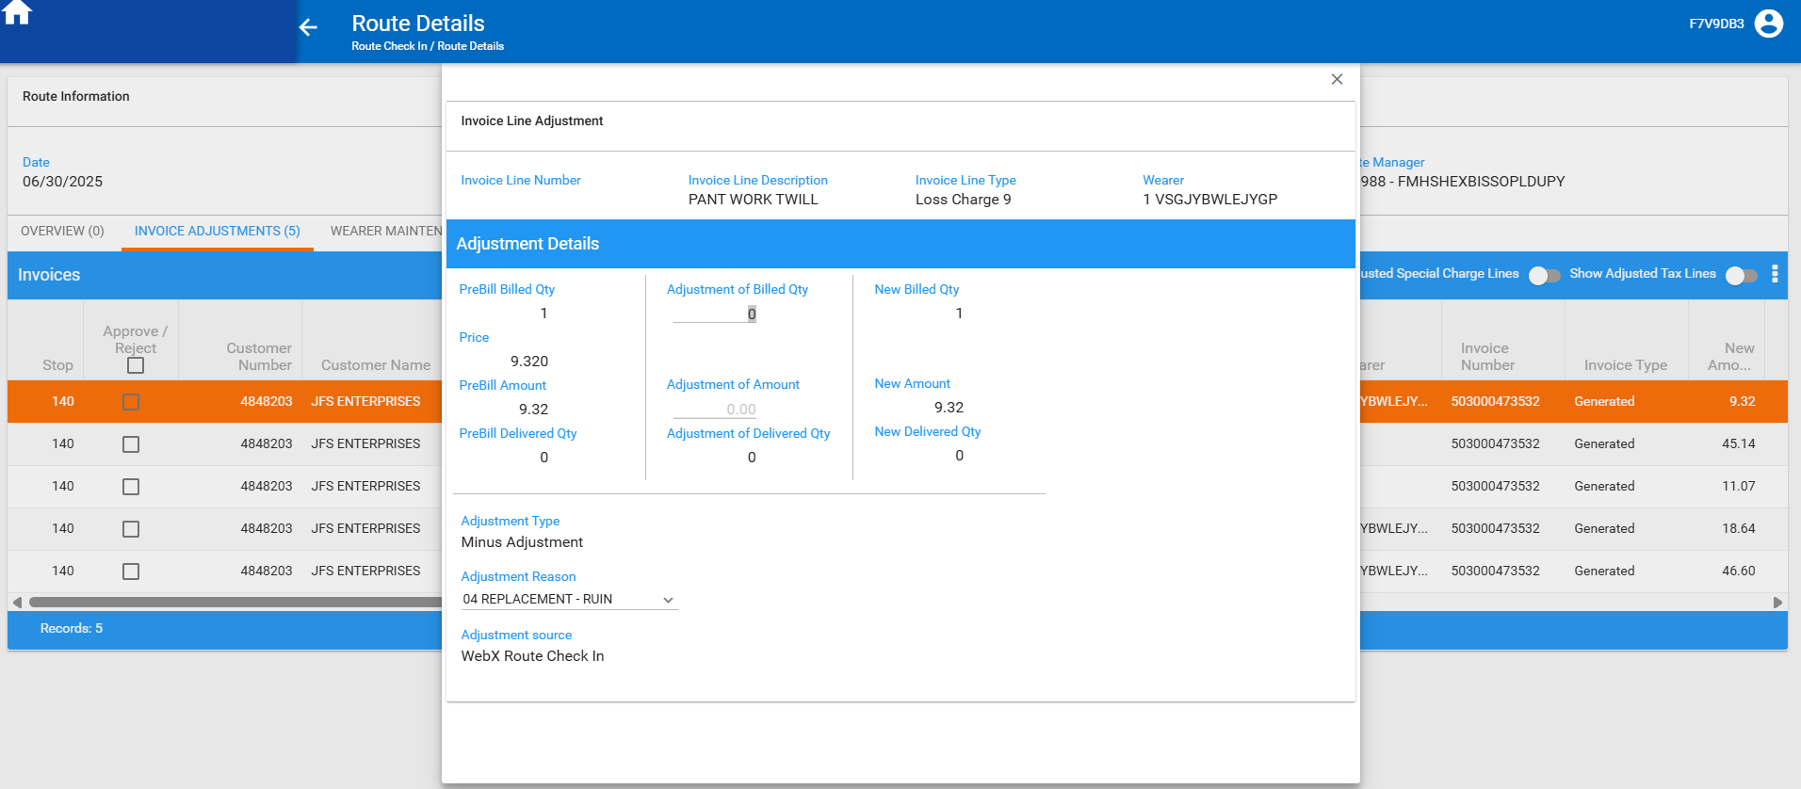

- Replace the invoice line
Initial:
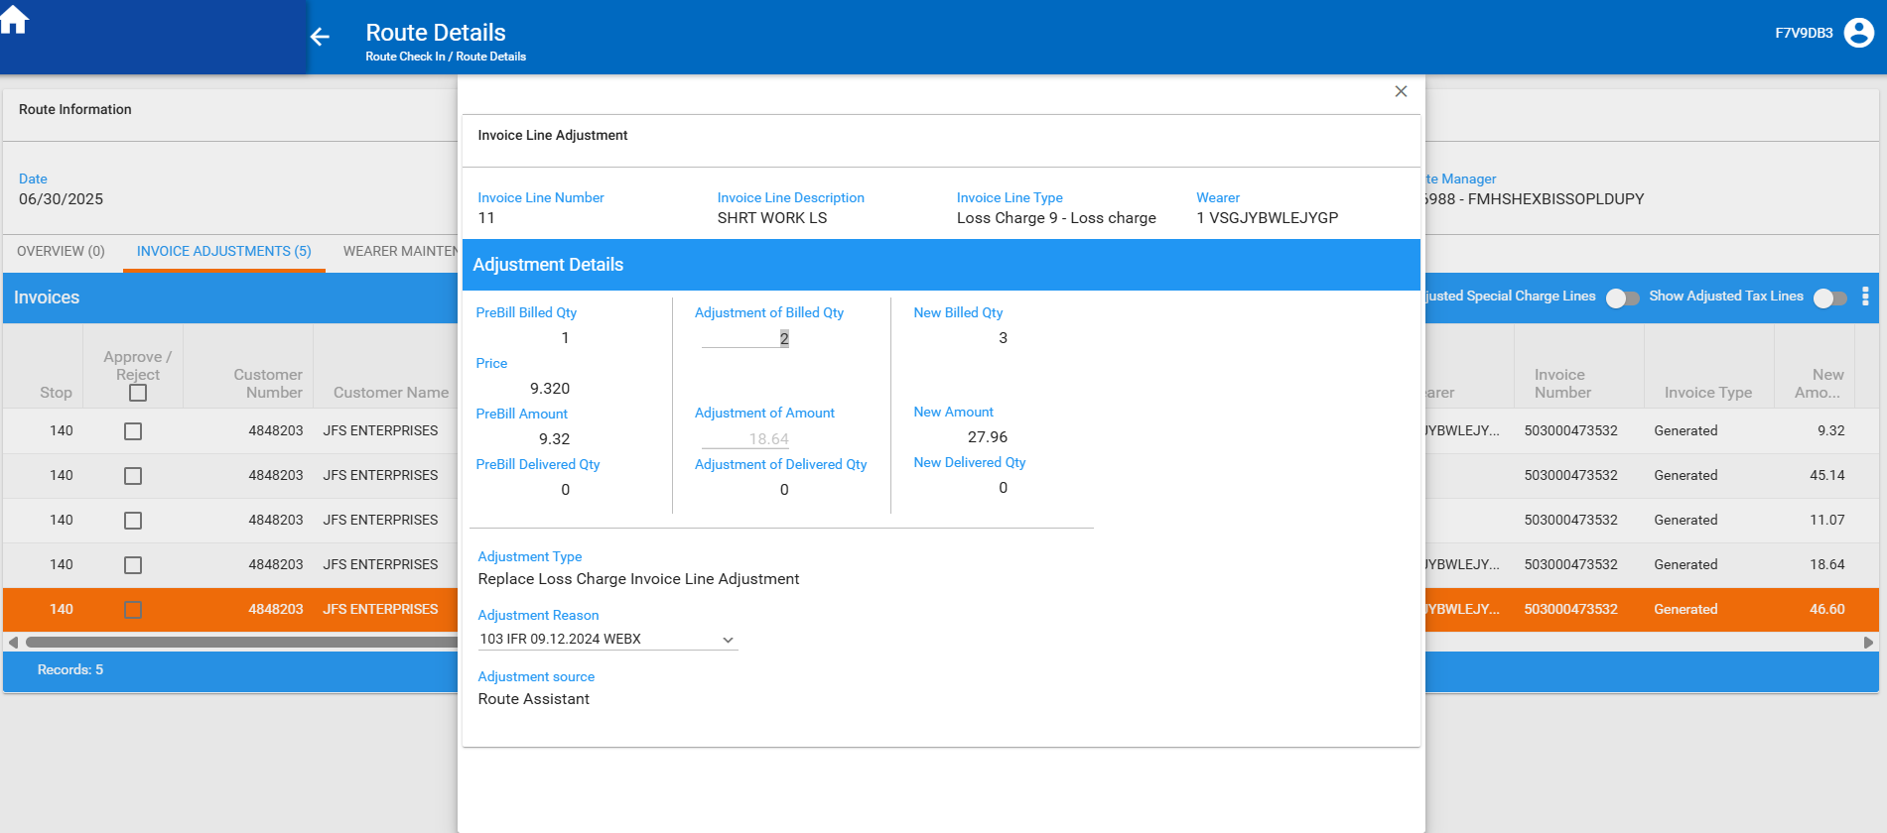
Modify again:
