ABSN-5224 – Duplicate event Product contract ended for customer
Environment | Prerequisites
Version: 9.08.00.RELEASE.p23 (BUGFIX BRANCH)  DBServerName=abs-srv17.internal.abslbs.com  DBSID=CUST23  DBUser=AUS_MNT90800  DBPassword=AUS_MNT90800  Environment=Test  EnvironmentSABStage=Test | - Module: AUS, RAS, WISBASIS, BKLBASIS  - System setting:  - RA: 13.30  - Android Studio

Contents
Retest after fix 1
Test Case 1 – Scanning Return Garment for end-dated PLPC on Route Assistant – TEST PASSED. 1

Retest after fix

Test Case 1 – Scanning Return Garment for end-dated PLPC on Route Assistant – TEST PASSED.
Expected behavior: Scanning return garments on RA, for end-dated PLPC products, on RA should be supported.
Hash: e8625b4a8217
BU.code=250
Plant.code=250
- Find a wearer (on current BU) with a garment that has Circulating Inv.=Max Inv.>0
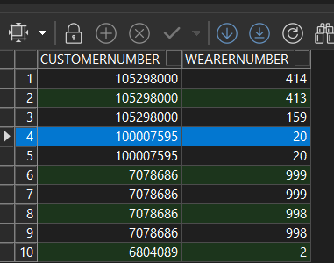
select c.customernumber, w.wearernumber
from wearerinventory wi
join weareremployment we on we.weareremployment_id=wi.weareremployment_id
join wearer w on w.wearer_id=we.wearer_id
join customer c on c.customer_id=w.customer_id
join businessunit bu on bu.businessunit_id=c.defaultbusinessunit_id
where wi.maxinventory=wi.circinventory
and bu.code='250'

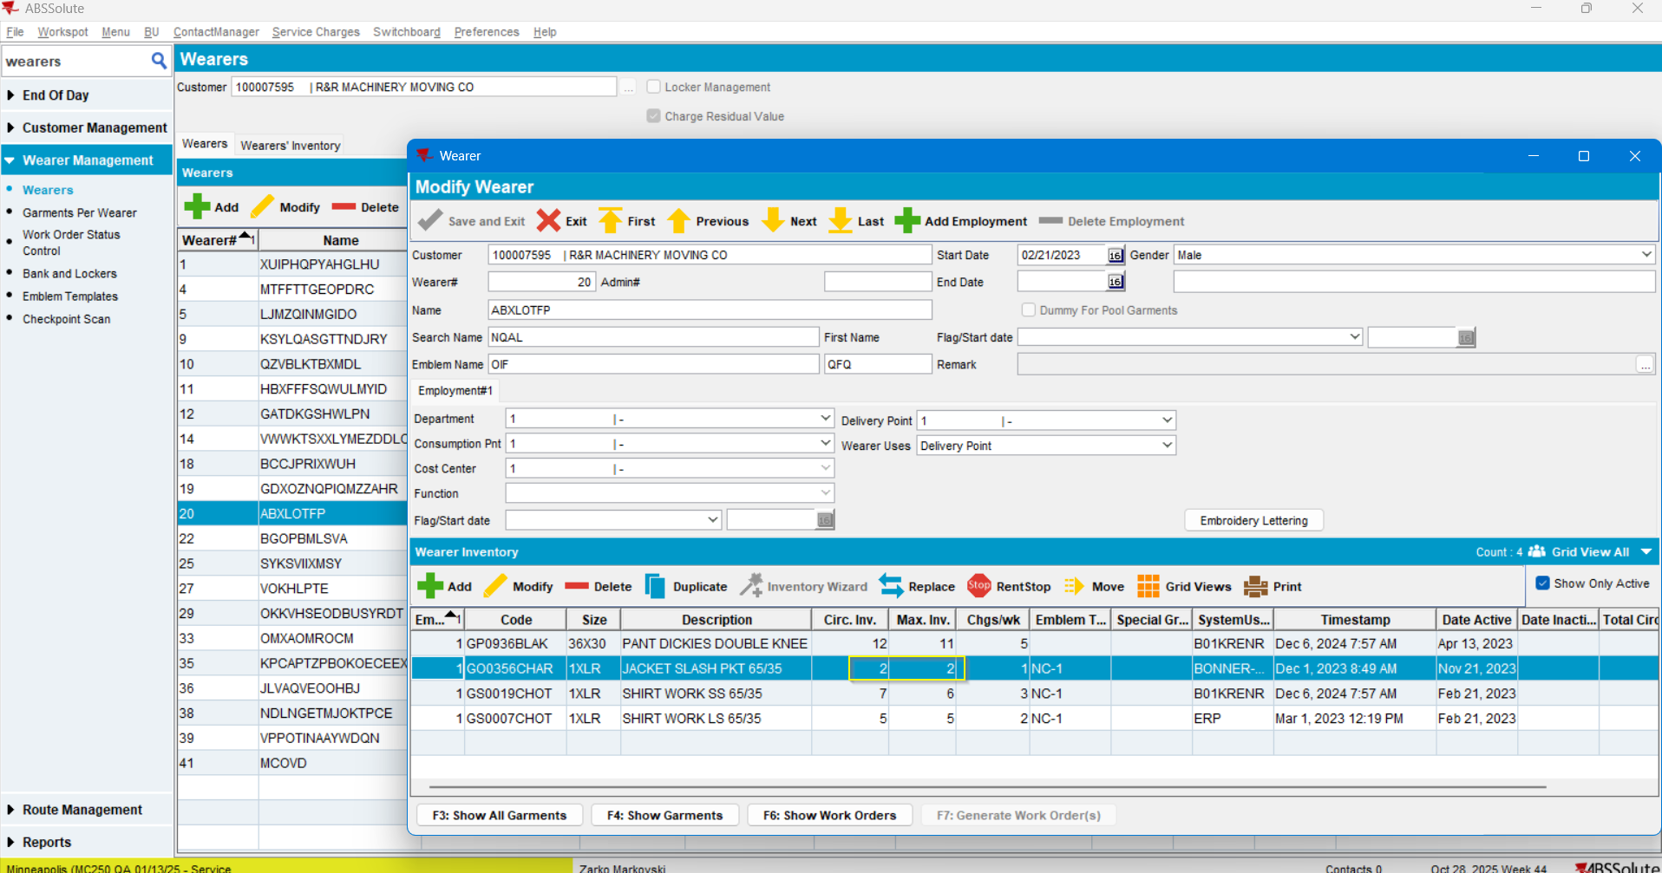

- Find the IDs for this garment:
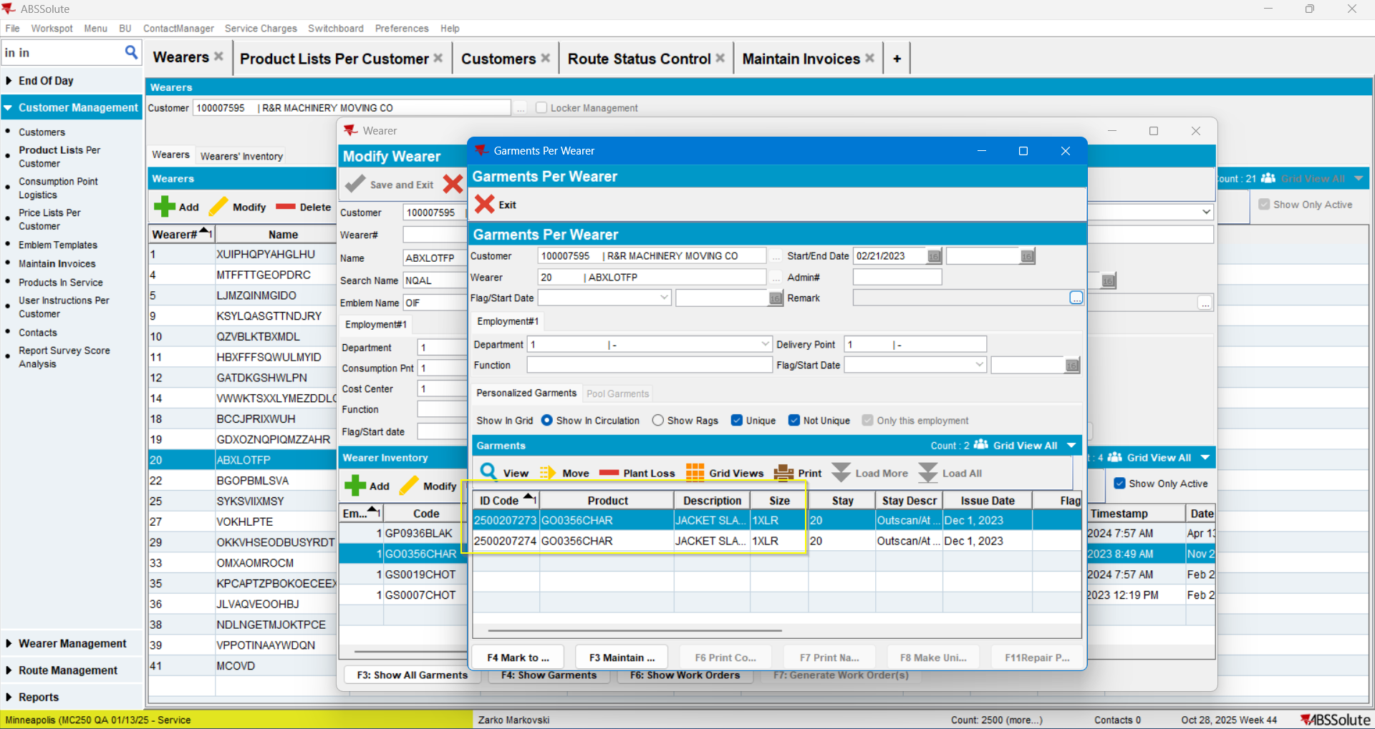
- Go to PLPC and end date that product:
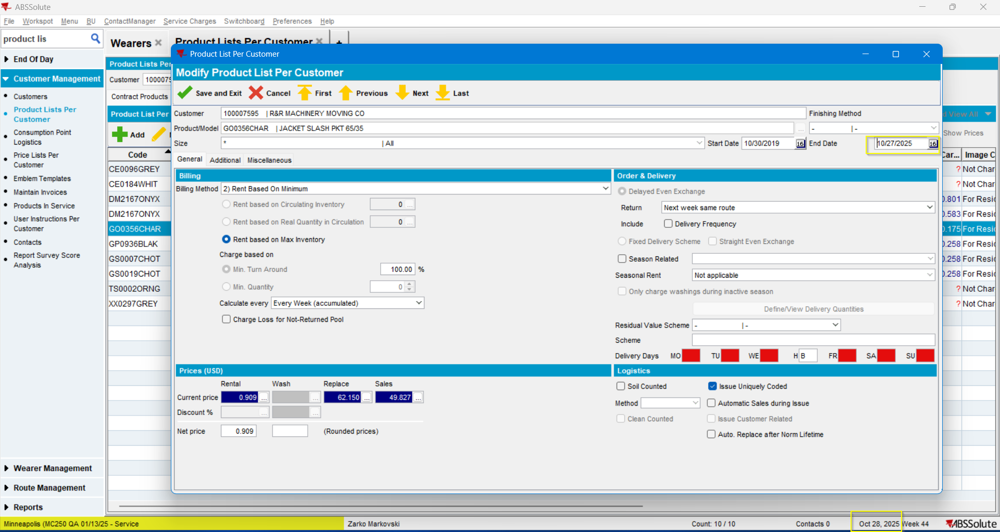

- Find customer’s delivery schedule:
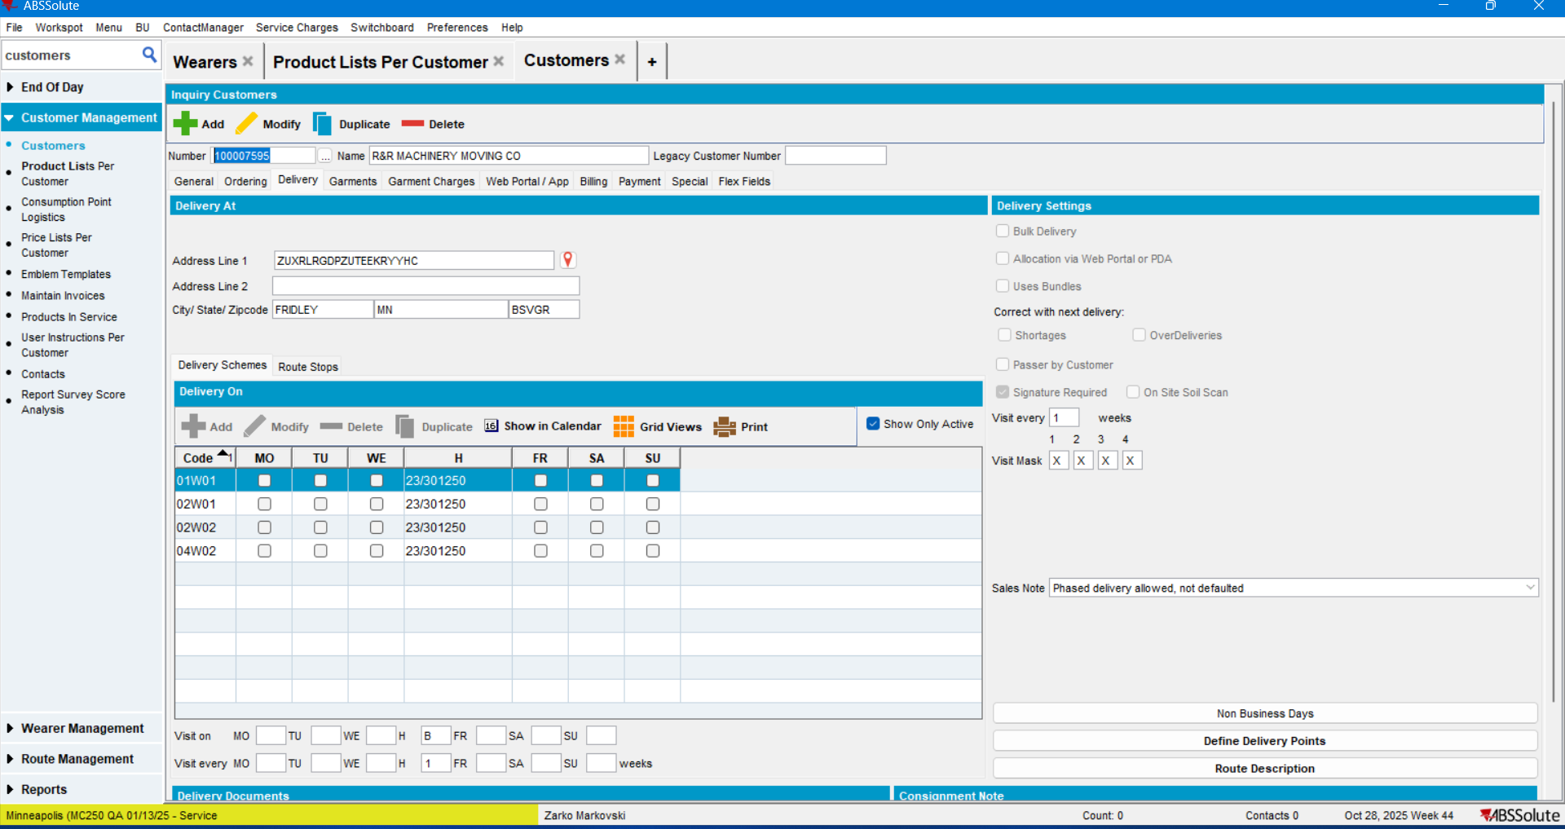
- Create customer’s route in RSC:
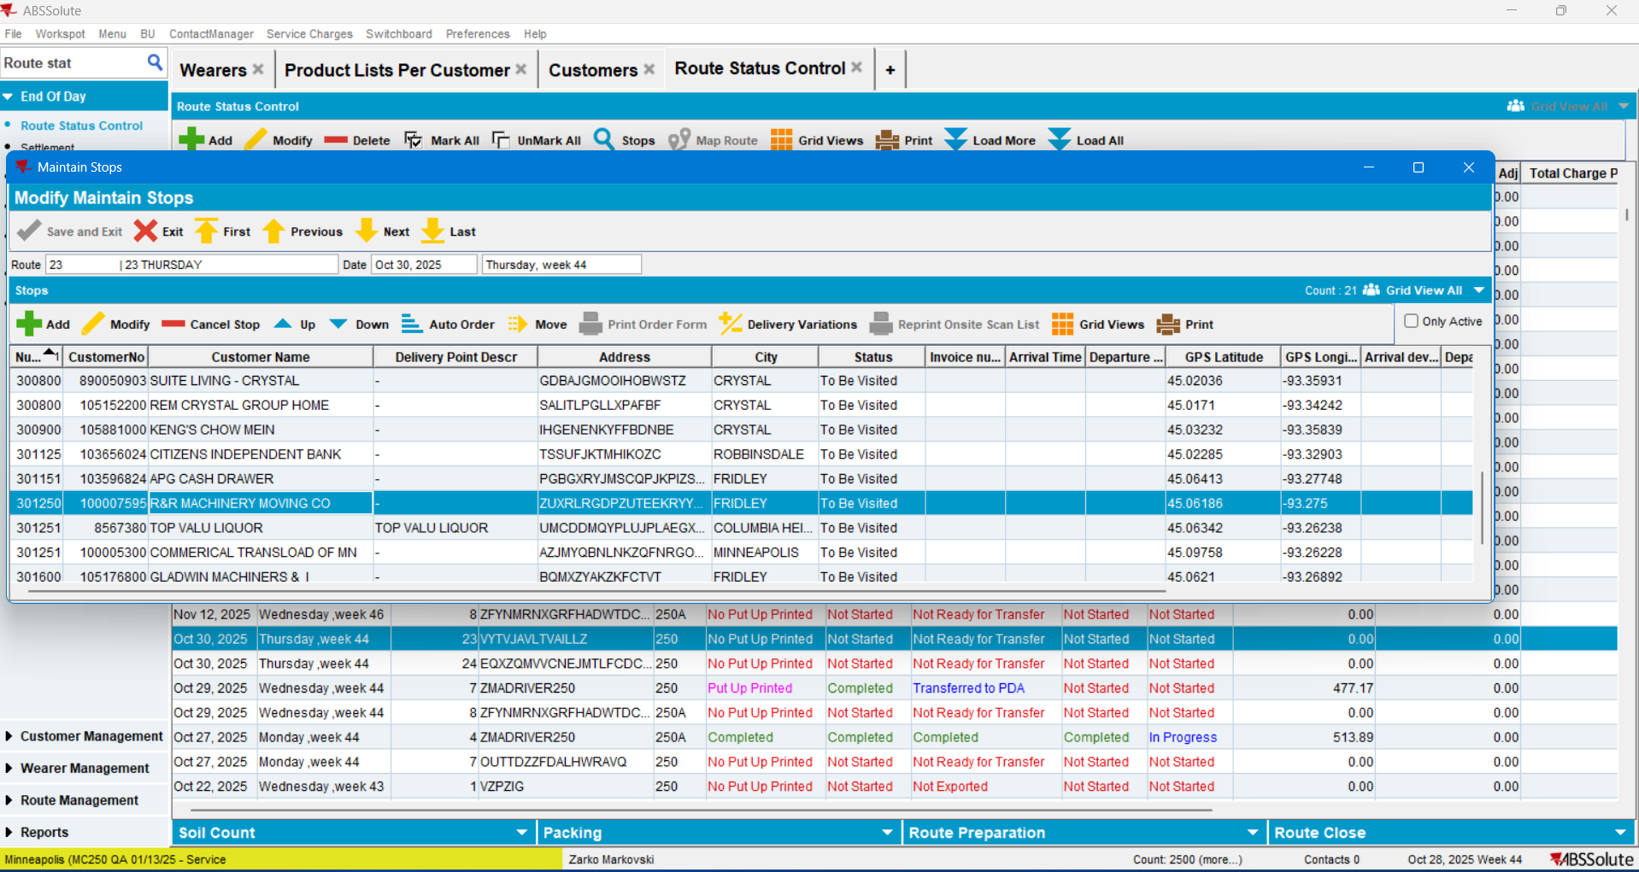

- Move all stops except the one for the customer in case:
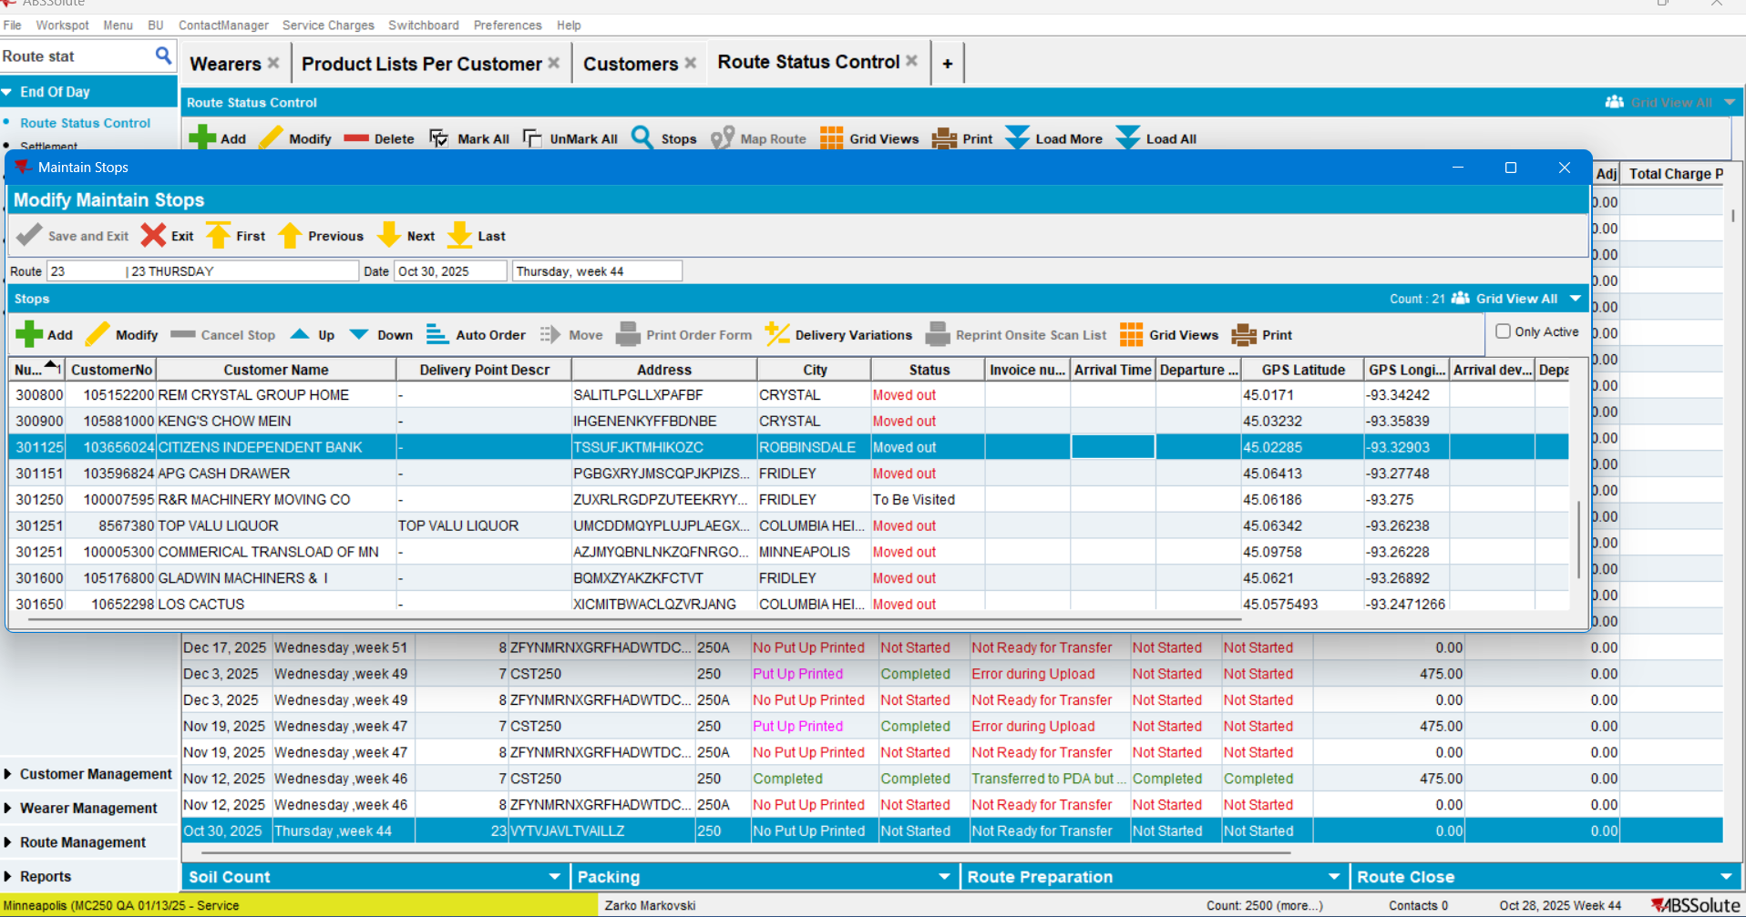

- Generate PN:
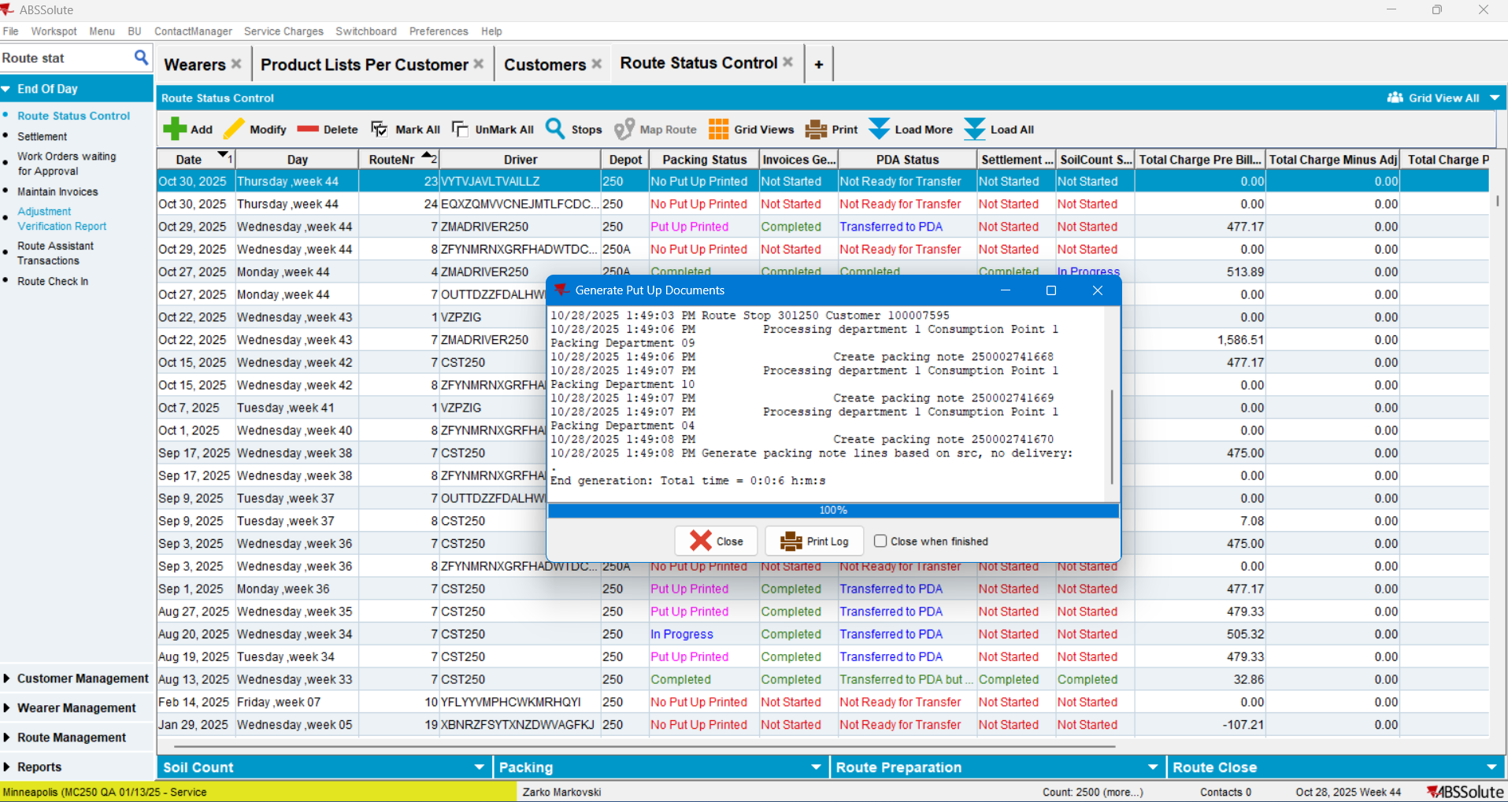

- Generate the Invoices:
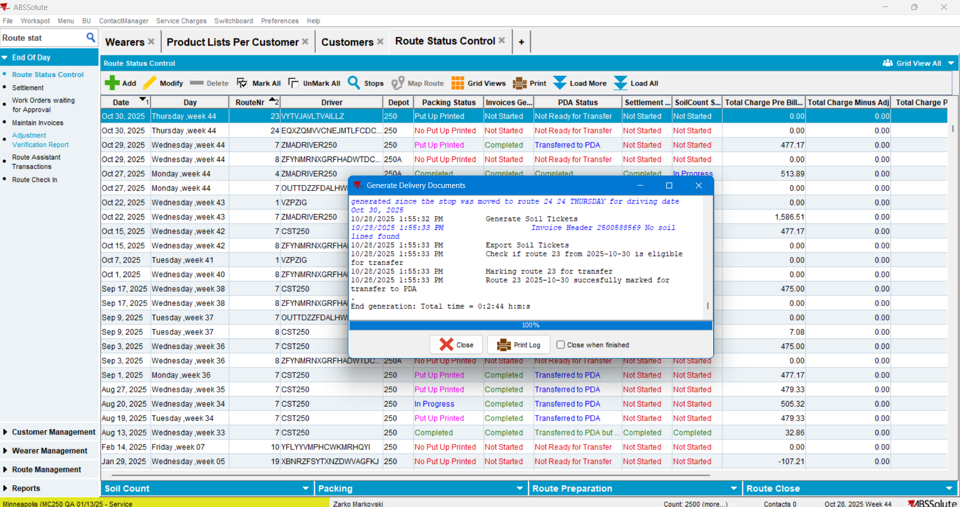

- Check that there is an invoice line for loss with Extend='N'
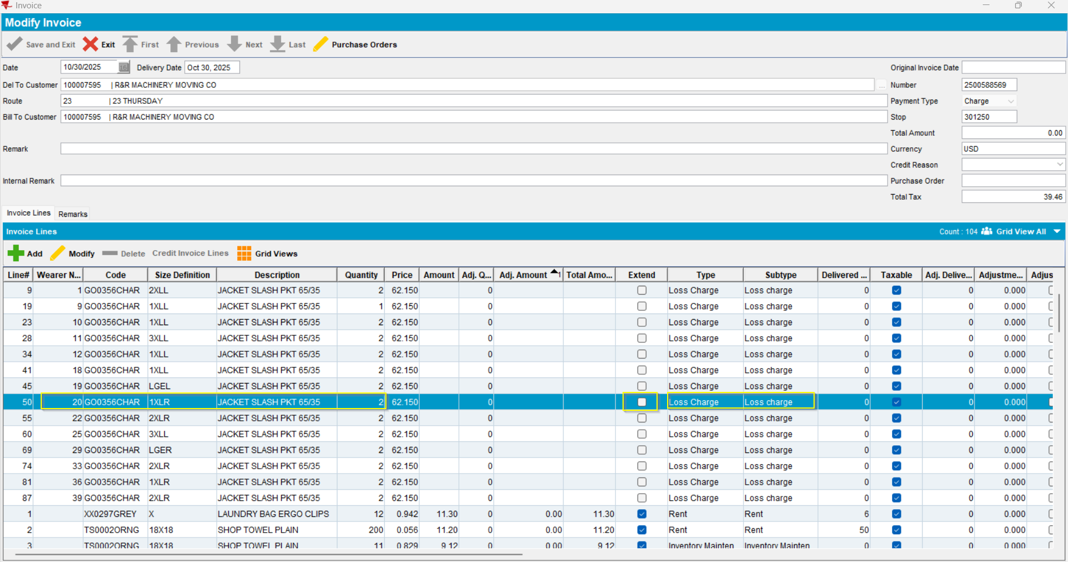

- Set the Driver and mark the route “Ready to be transferred on PDA”:
- Start the Corresponding Webserver
- Deploy the properly adjusted absmobilerestservices.war file
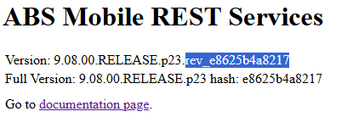
- Start the Android Studio. Start and properly configure RA. Start the Route.
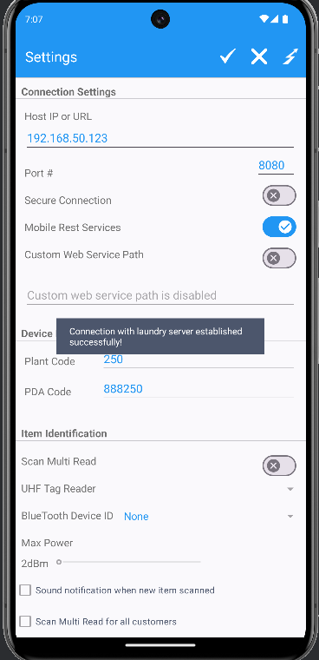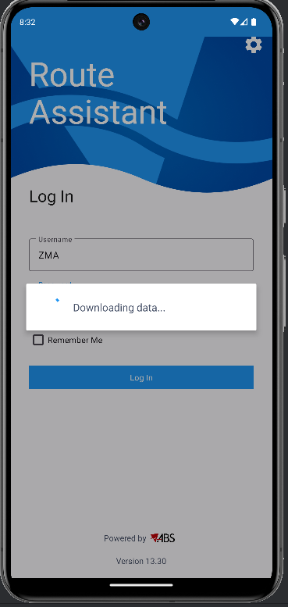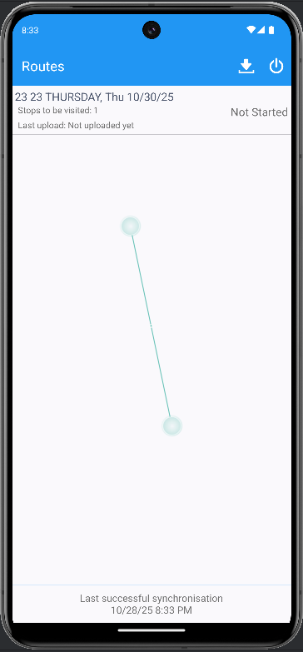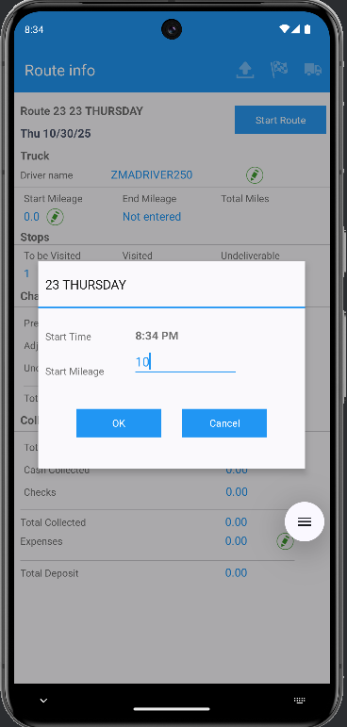
- Select the stop: Arrive: Return Items: Scan return:
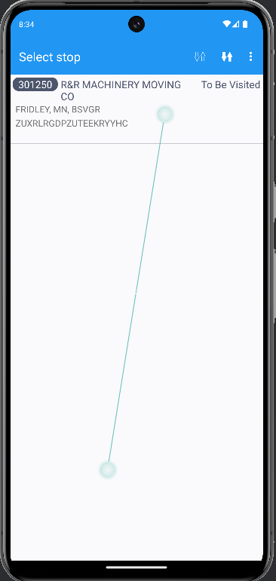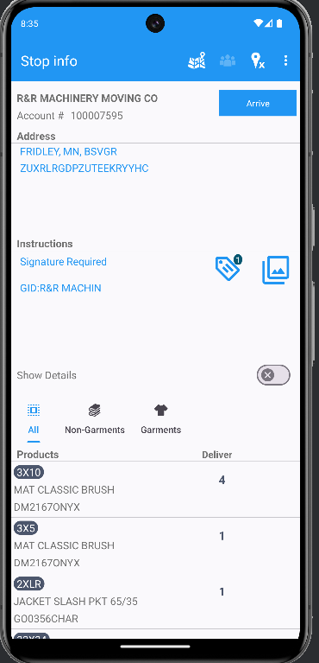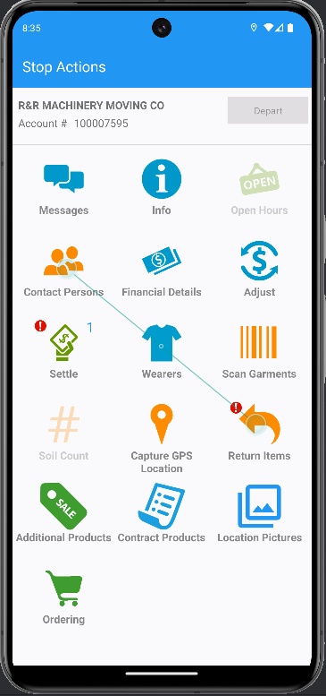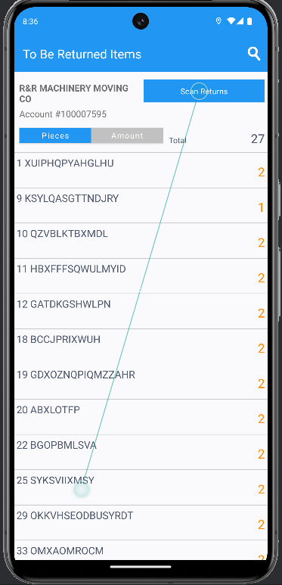

- Scan the IDs> Items scanned successfully> Go back one step > Switch to the amount tab and do a Bill All for Loss Now:
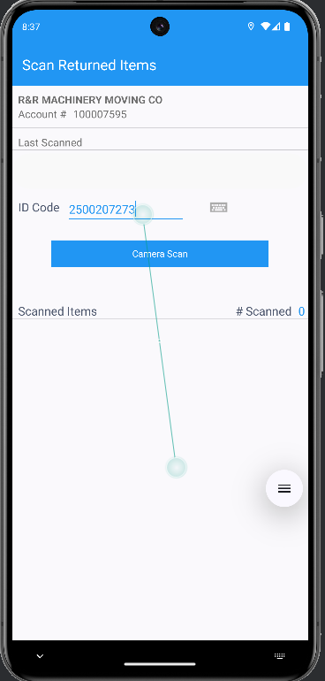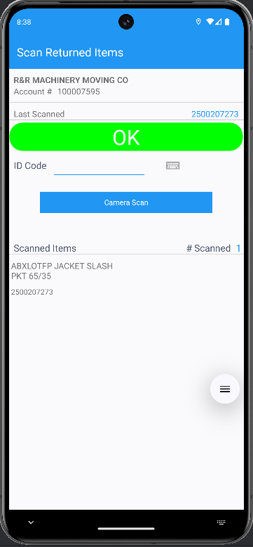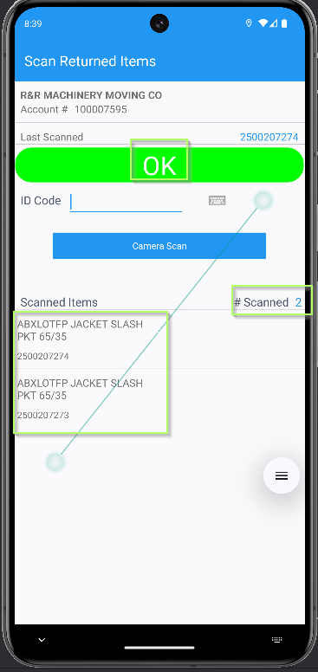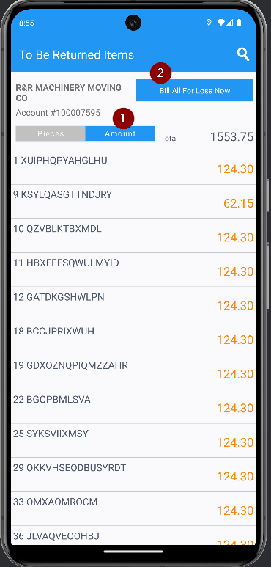
- Settle > Depart> Finish > Upload
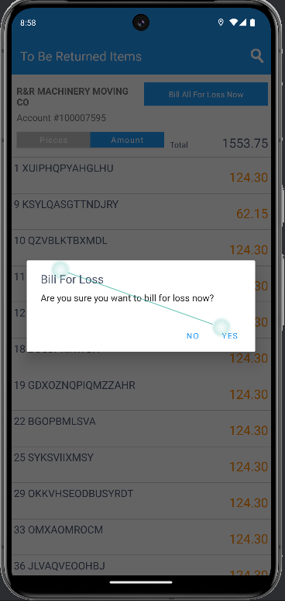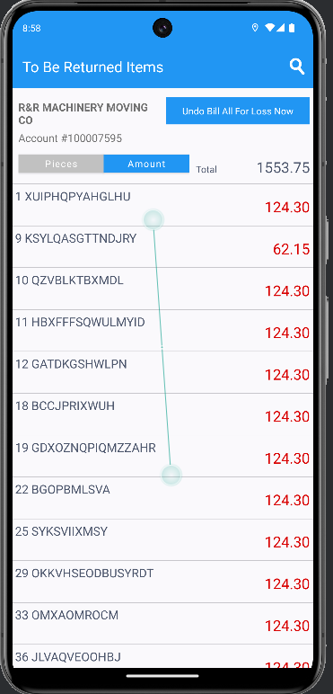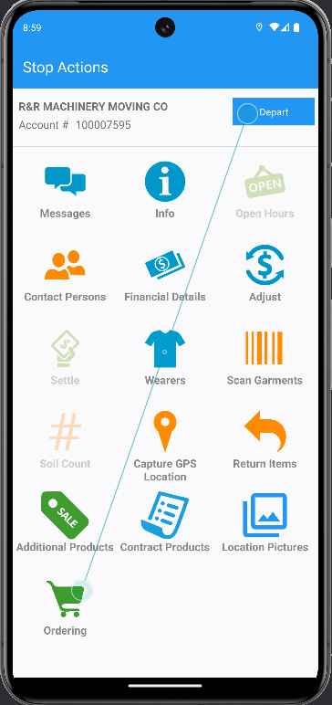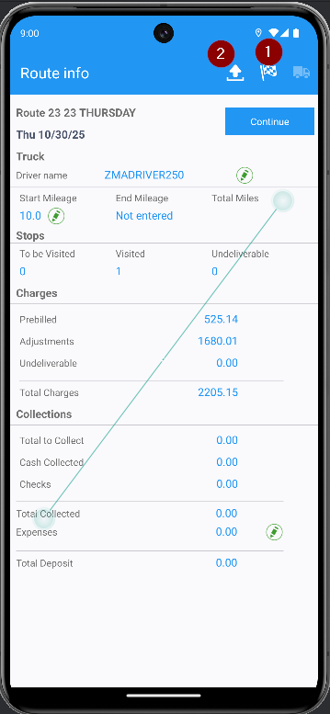
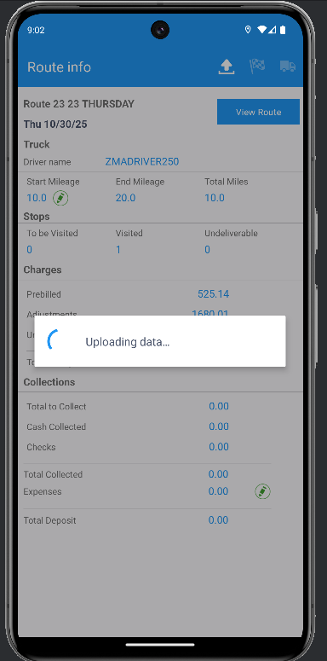
- Start the corresponding webserver, configure the Webclient-X war file, Deploy it). Start the Webclient-X application:
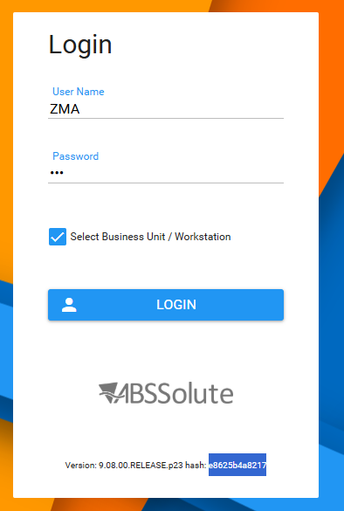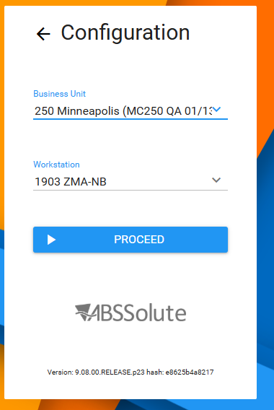
- Settle the route from webclient-X:
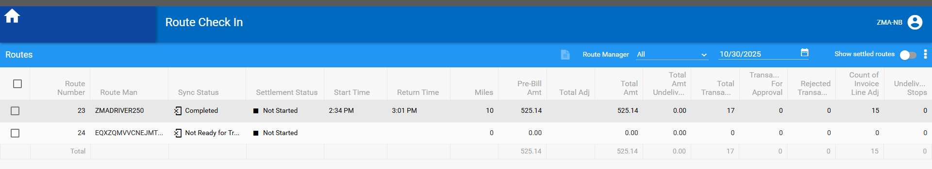
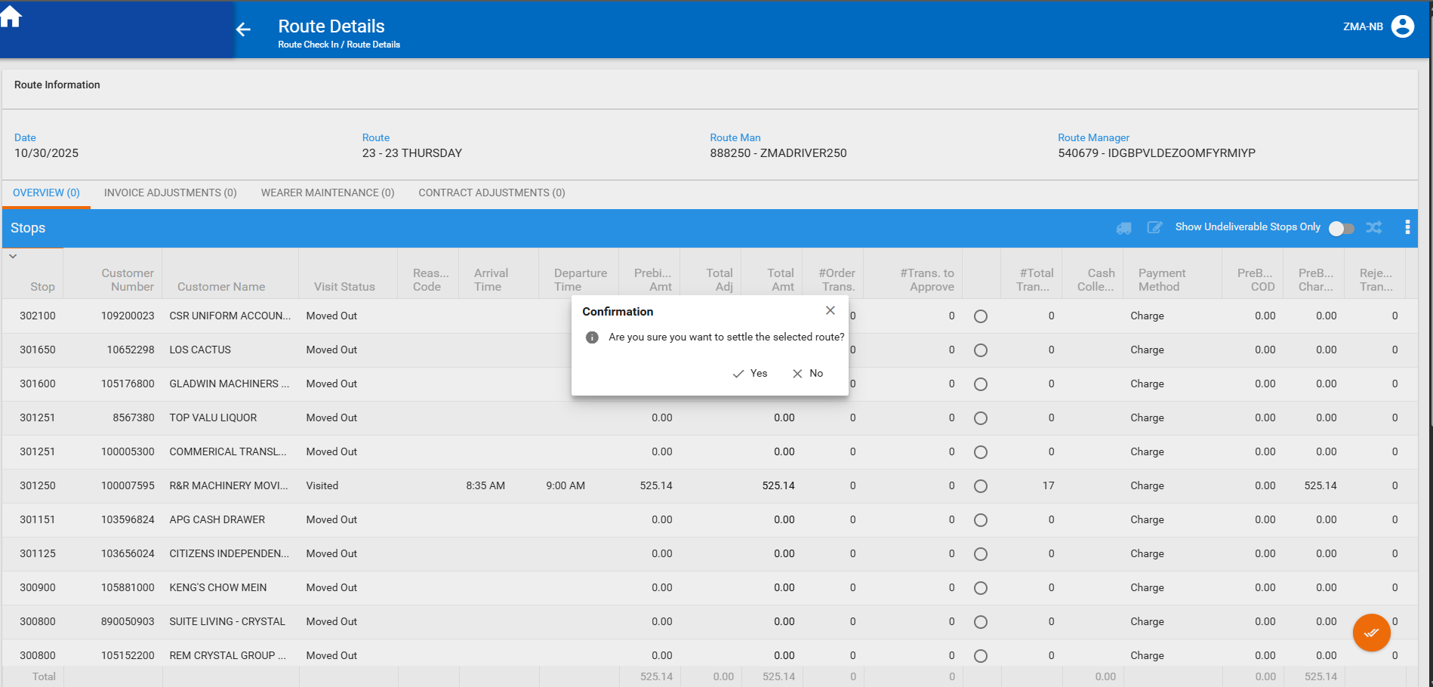
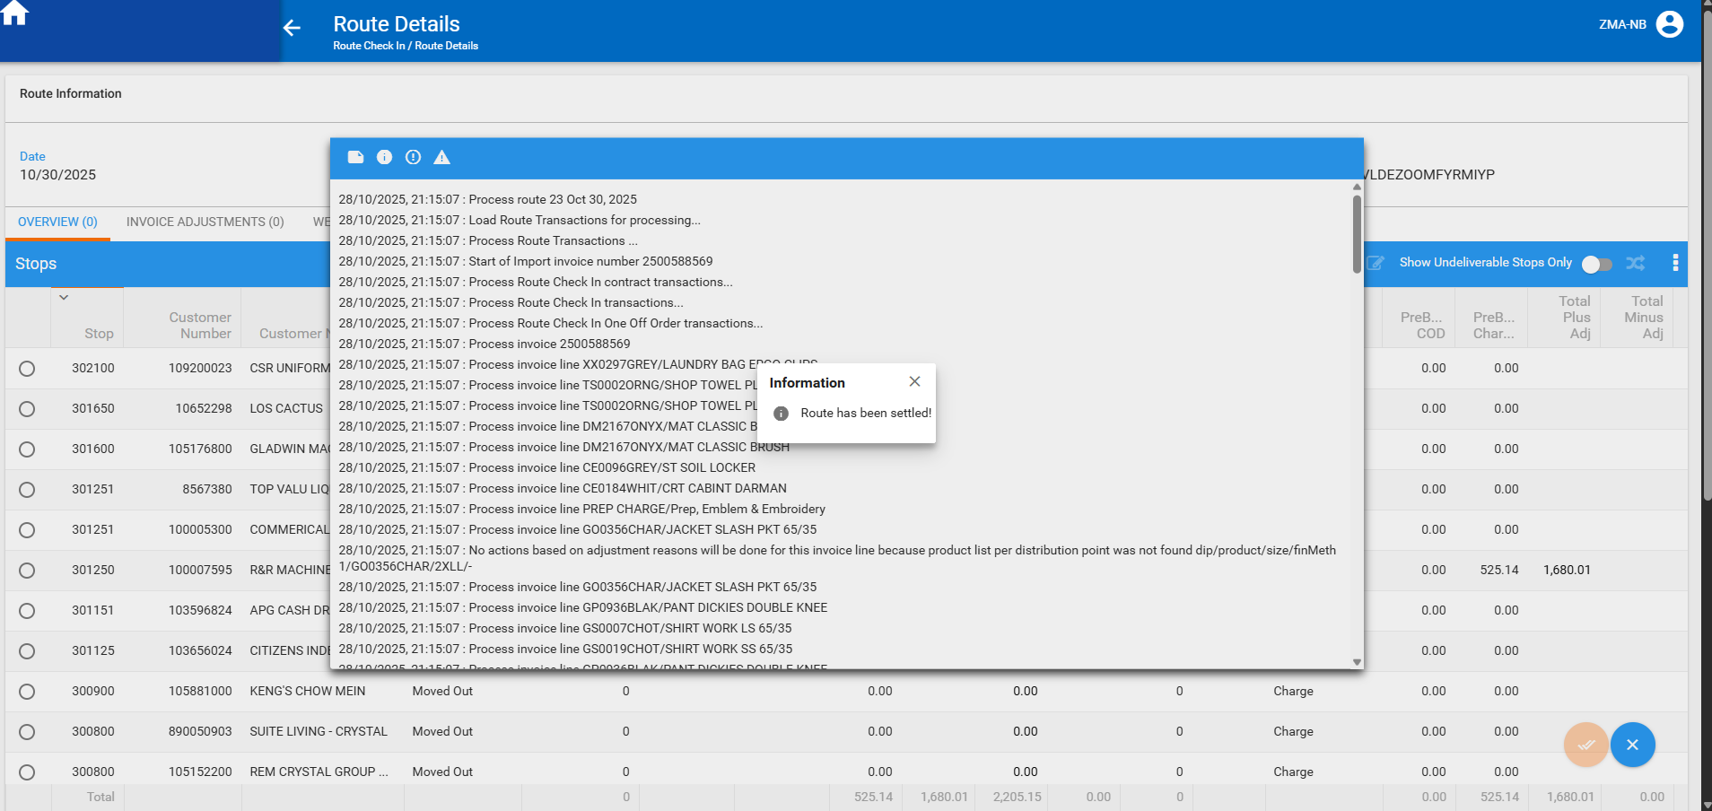
The route has been settled.
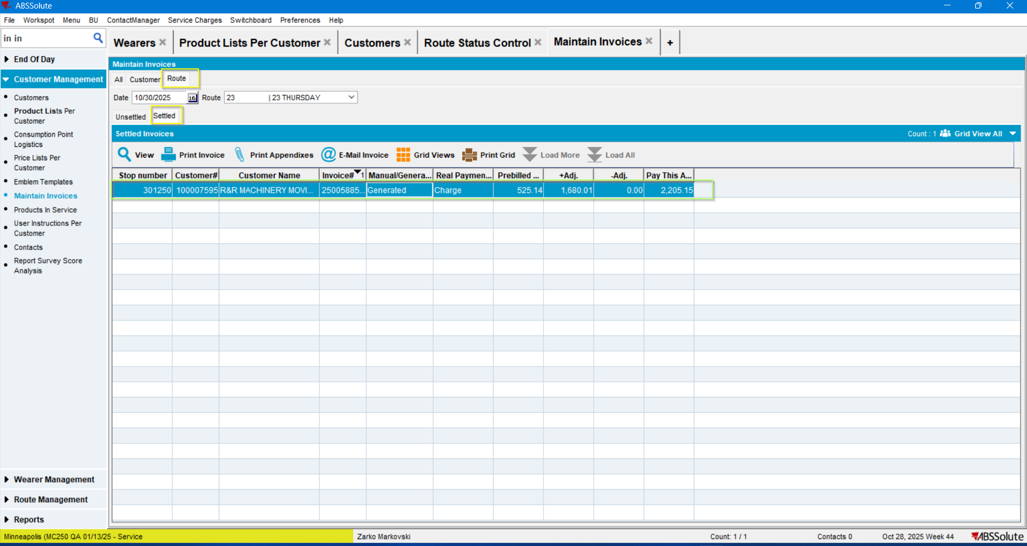
Current result: IS the expected one.
TEST PASSED.

