ABS-154228 New PO Field at Customer level
Environment | Prerequisites
Version: 9.08.02.RC1  Environment=PRODUCTION  DBServerName=abs-srv19.internal.abslbs.com  DBSID= CUST22  DBUser= AUS_COMP  DBPassword= AUS_COMP | - Module: CONTRACTPO  - System setting: SIMPLEINVOICEPO  - Others: BUs 250, 503, 598
Contents:
New PO Field at Customer level
#1 – Check CustomerPuchaseOrder table – Passed 1
#2 – Check Change Purchase Order in X-RouteCheckIn dlg– Passed 2
#3 – Check Customer and Contract dlg– Passed 10
#4 – Check Invoice Line Type dlg– Passed 30
#5 – Check Contract PO Monitor dlg– Passed 33
#6 – Check Sales Order dlg– Passed 34
#7 – Check Special Orders dlg – Passed 45
#8 – Check Generate Direct Invoice and Maintain Invoices dlg – Passed 51
#9 – Check Generate Periodical Invoice dlg – Passed 60
#10 – Check Settlement dlg – Passed 66
#11 – Check Route Assistant PDA flow – Passed 74
#12 – Check Access Rights List – Passed 85

#1 – Check CustomerPuchaseOrder table – Passed

Expected result:
COLUMN_NAME | DATA_TYPE | NULLABLE | COMMENTS
CUSTOMER_ID | NUMBER (PK) | No | FK to Customer table, cascade delete
PurchaseOrderNumber | Varchar2(30) | No
SYSTEMUSER_ID | NUMBER | No
TIMESTAMP | DATE | No

Actual result:
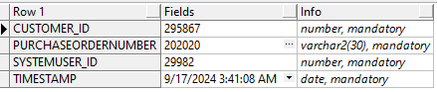

#2 – Check Change Purchase Order in X-RouteCheckIn dlg– Passed

Precondition:
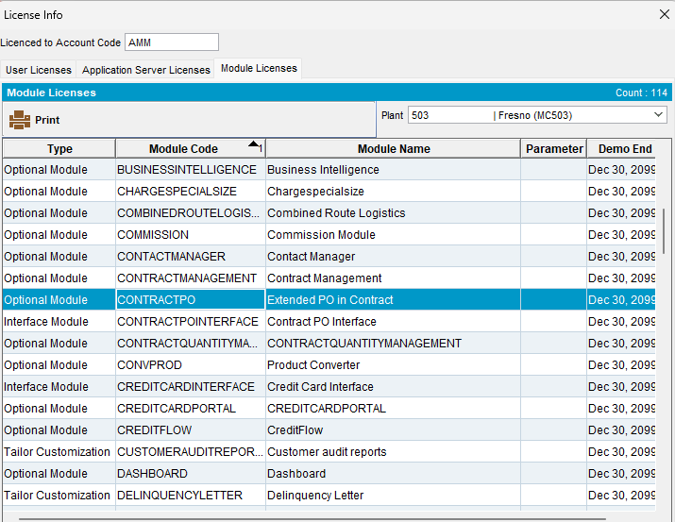
Expected result:
Business Rules Change purchase order button
Only visible if CONTRACTPO module is in the license for the current plant
And system setting SimpleInvoicePO = 0
Only enabled when a line is selected where the customer has an active contract (at least one but may be multiple contracts) with Contract.PurchaseOrderType = 0 or 3
Test case 1:
- SimpleInvoicePO = 0
- Add PO on contract level and link it to a customer
- Customer with predefined contract:
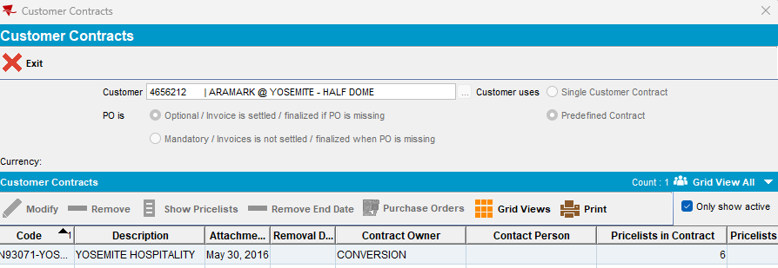

select c.purchaseordertype, c.purchaseorder, c.purchaseordervalue, c.purchaseorderexpirationdate, c.contract_id, c.code, c.description from contract c where c.code like '%N93071-YOSEMITE%';

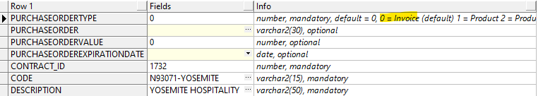

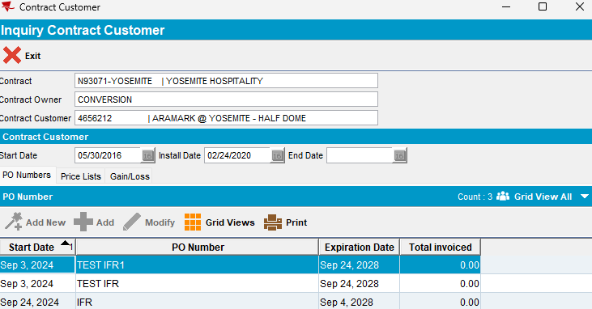

- Add new route for this cusotmer
- Generate invoice for this customer
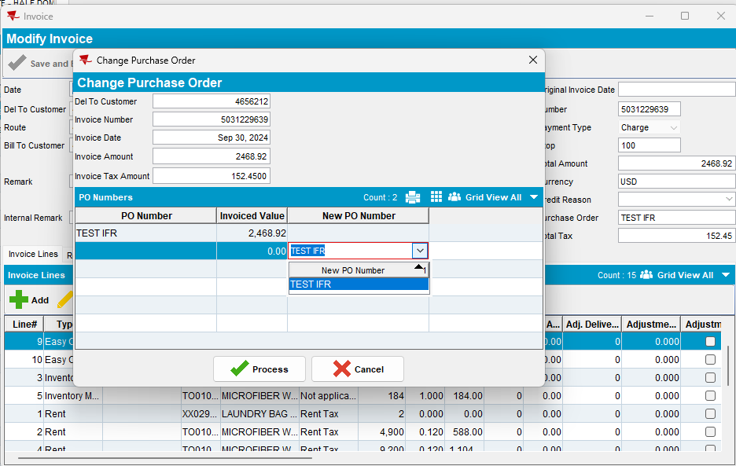
- Open route on WebX and check Charge Purchase Order pop-up on Overview tab for the related customer and route:
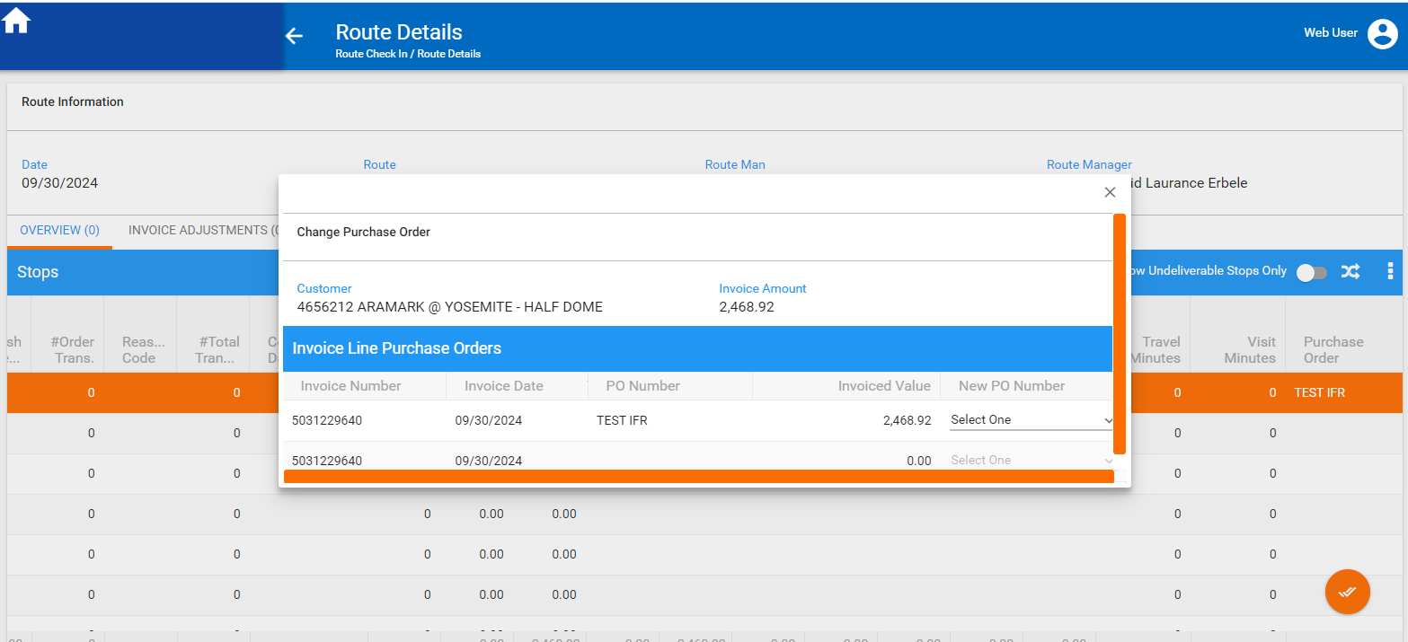
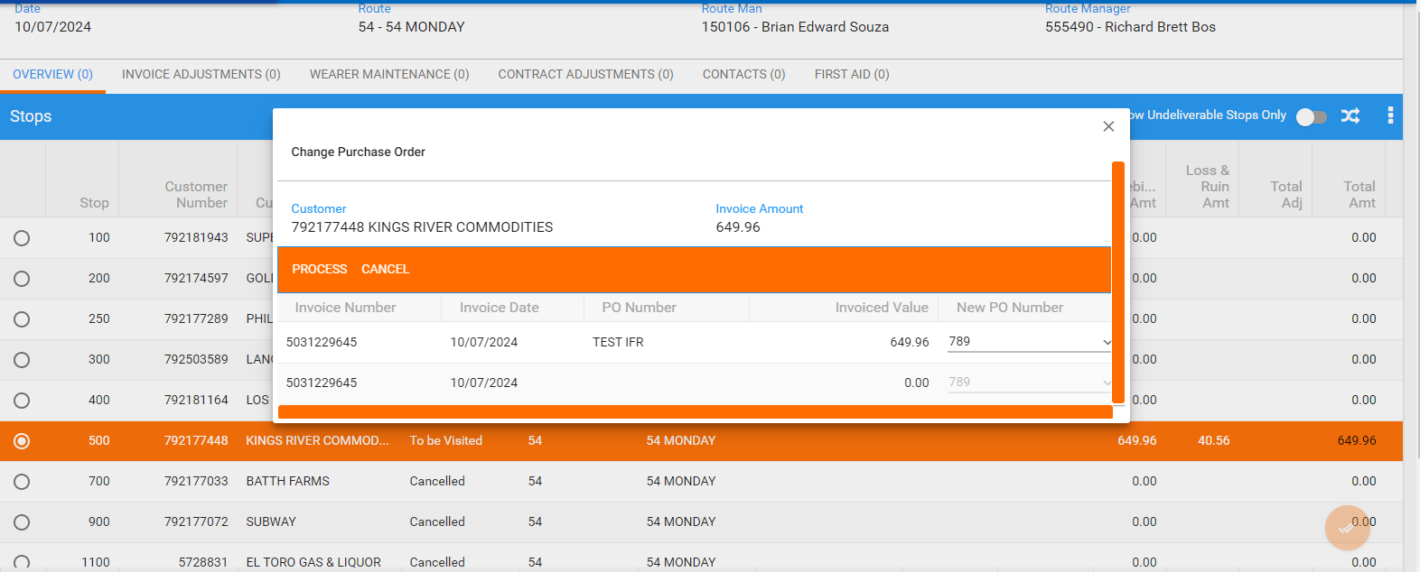
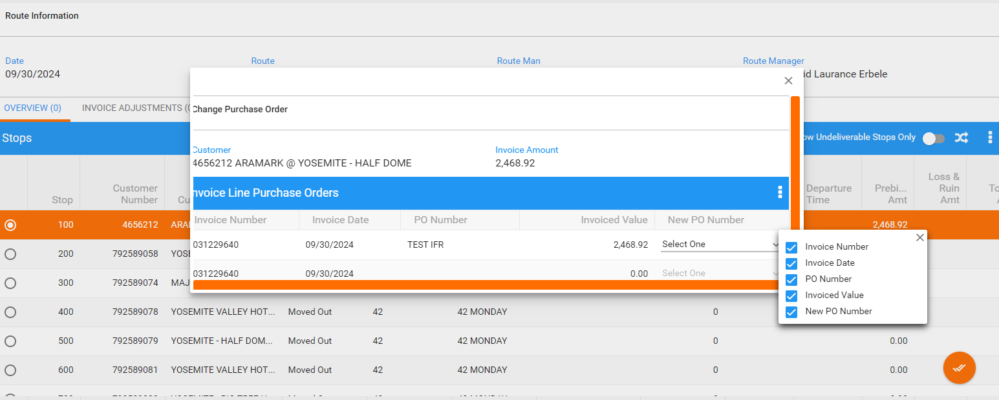
- Check also on the grid, the column Purchase Order:
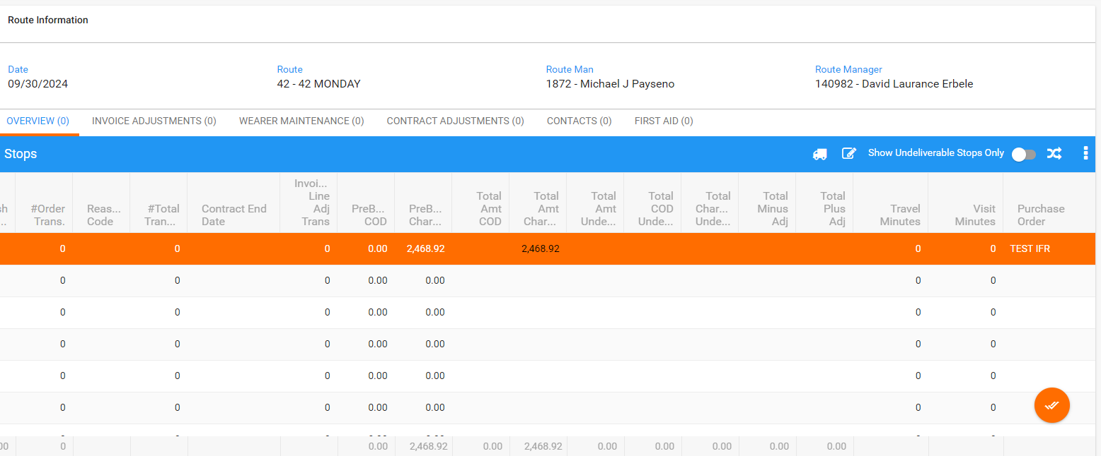
Test case 2:
- SimpleInvoicePO = 1
- Check on WebX, Overview tab, Charge Purchase Order button
Actual result:
- This button it is not anymore displayed for any Visit Status/ Stop:
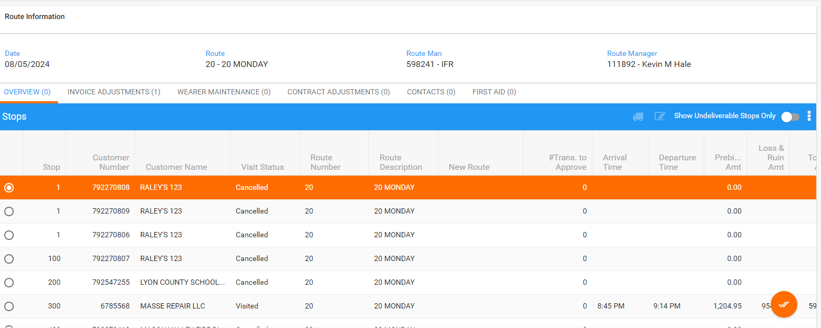
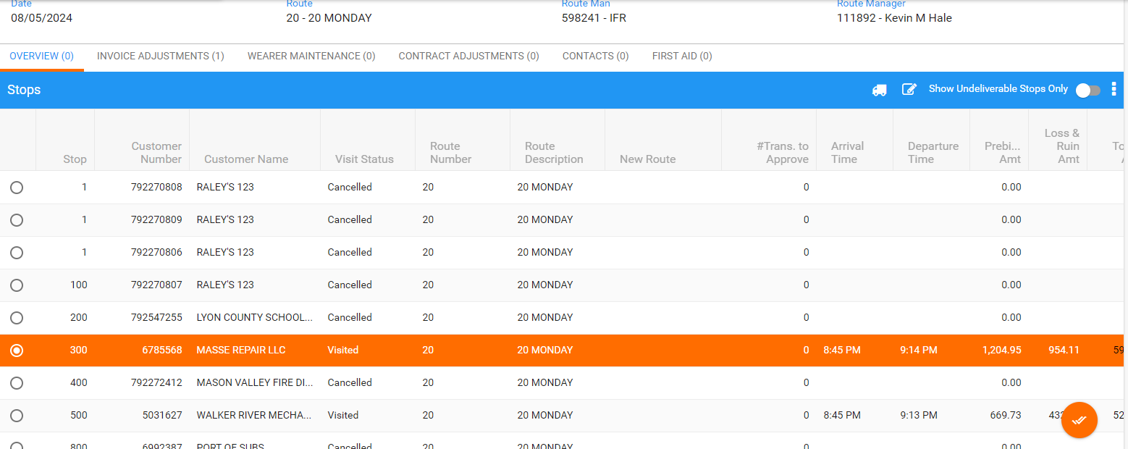
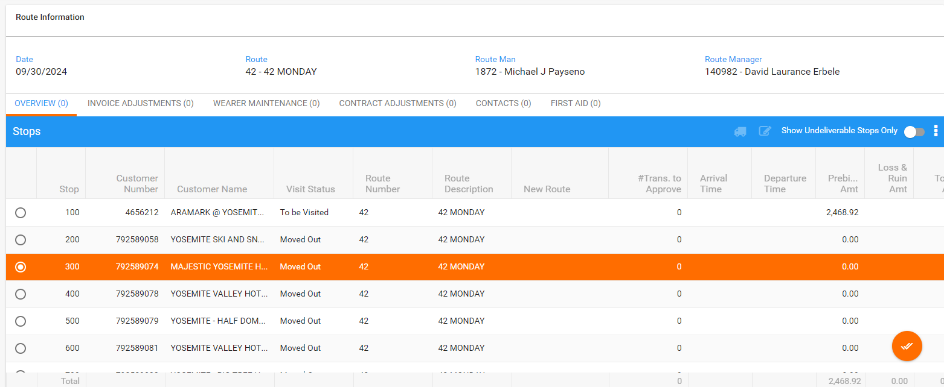

- Check also Purchase Order column on the grid:
Actual result:
This column it is not anymore displayed:
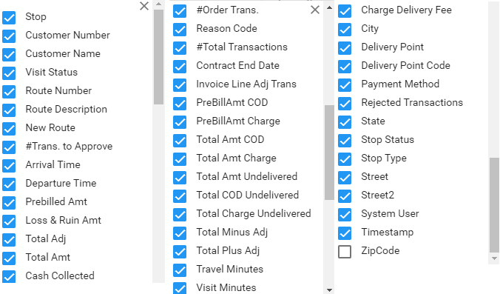
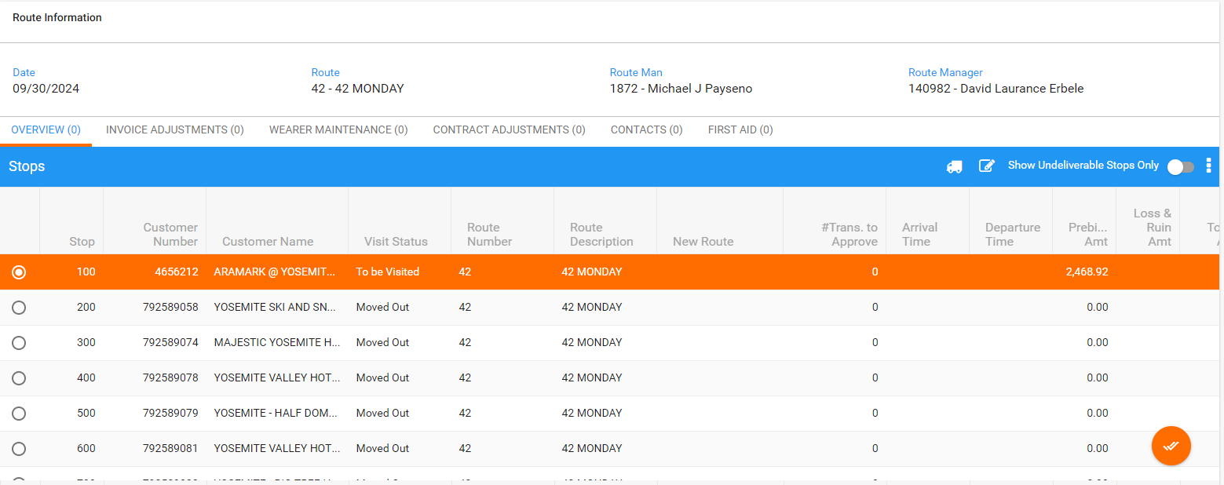
Test case 3:
- Repeat the previous tests for a BU without AUSCUSTOM module in the license:
- BU: 250
- SimpleInvoicePO = 0
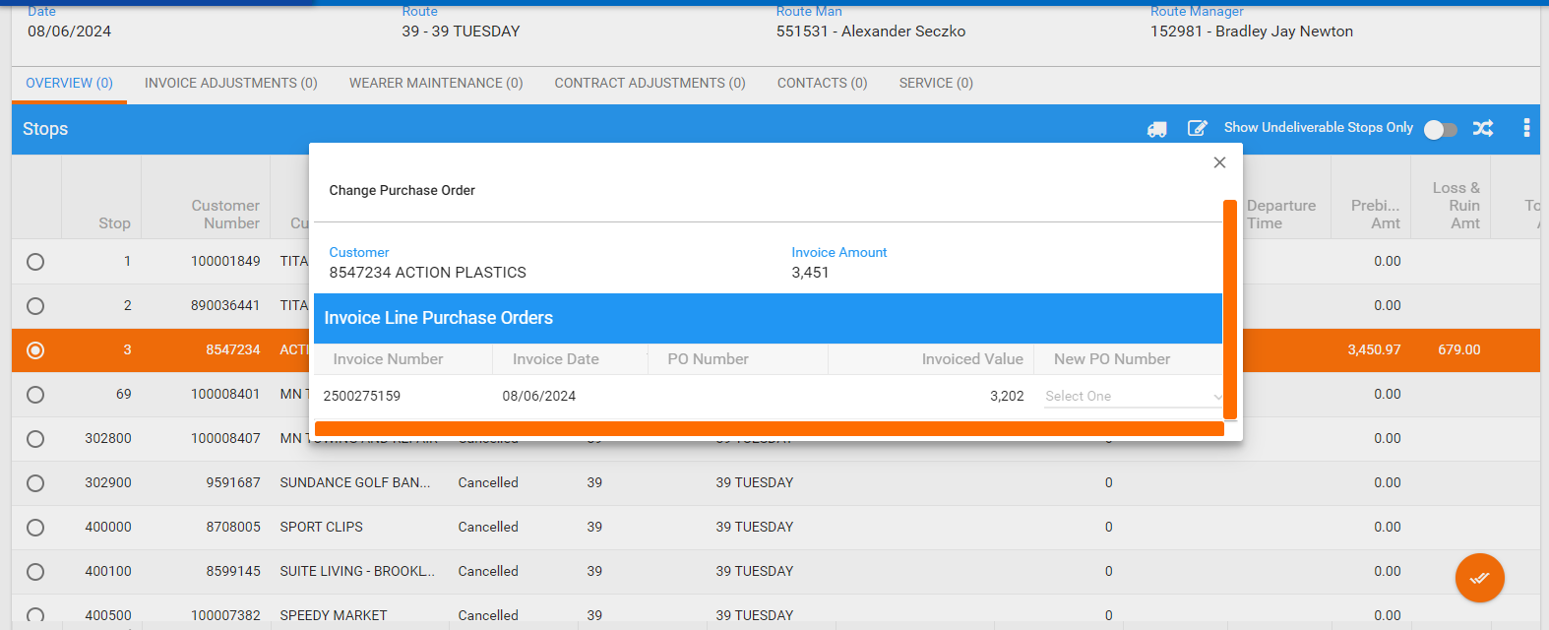

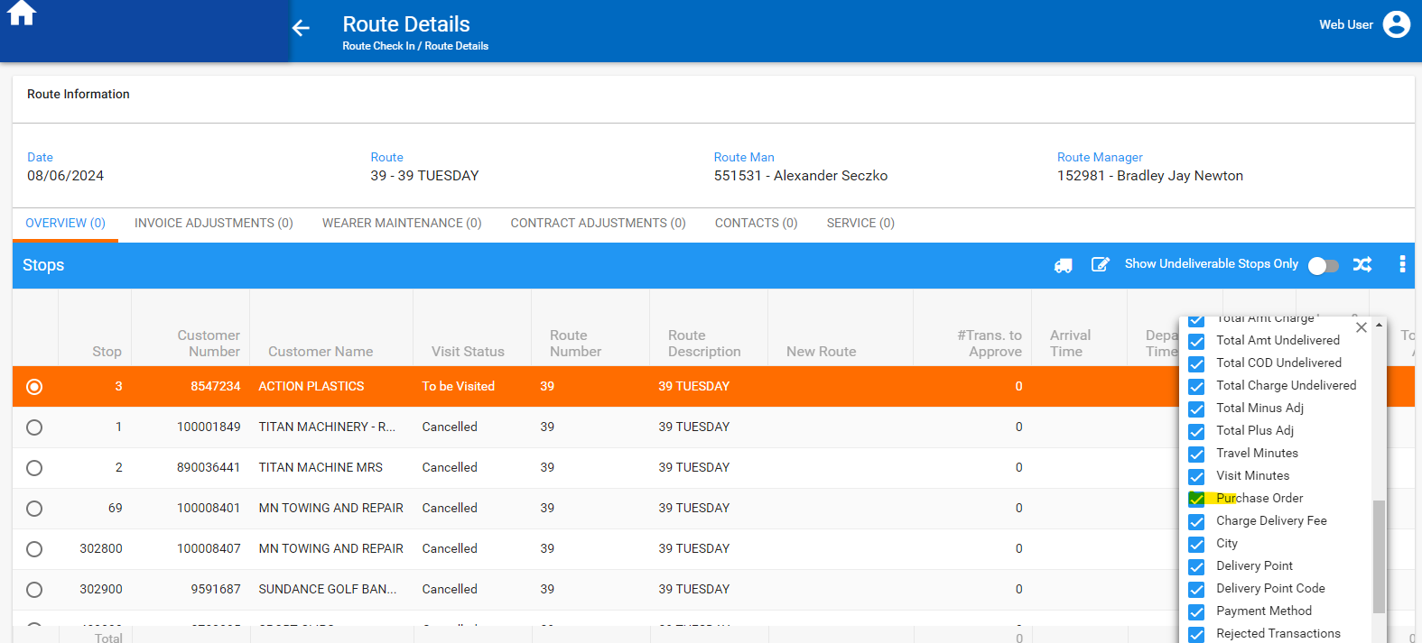
- SimpleInvoicePO = 1
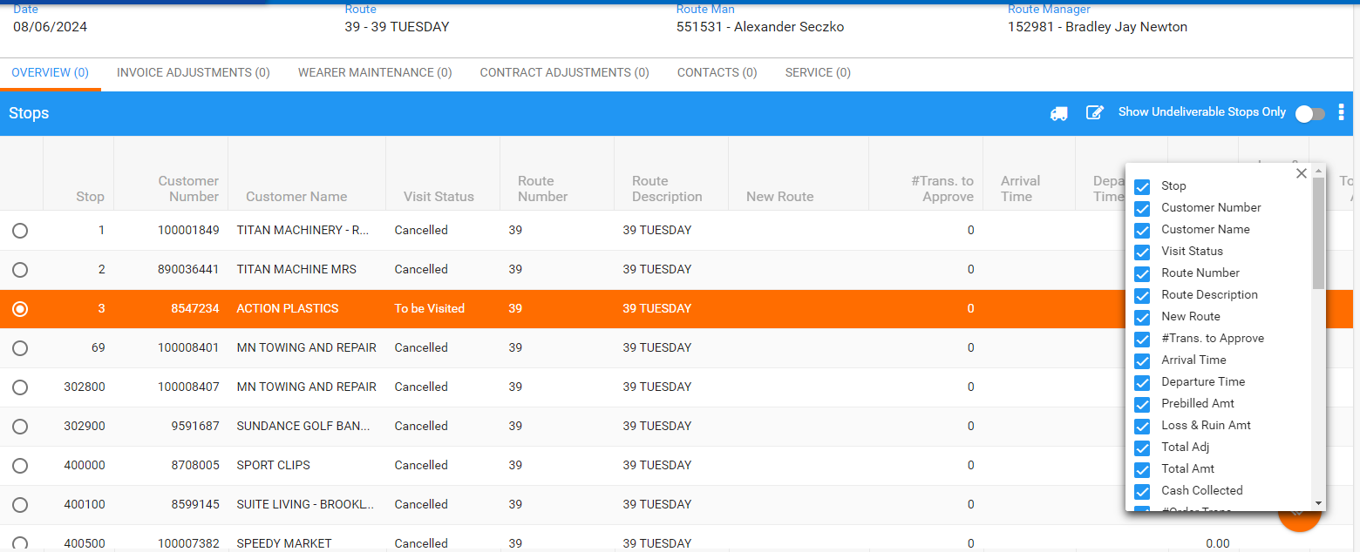

Test case 4:
- Repeat the previous tests for a BU without CONTRACTPO module in the license:
- BU: 250
- SimpleInvoicePO = 0
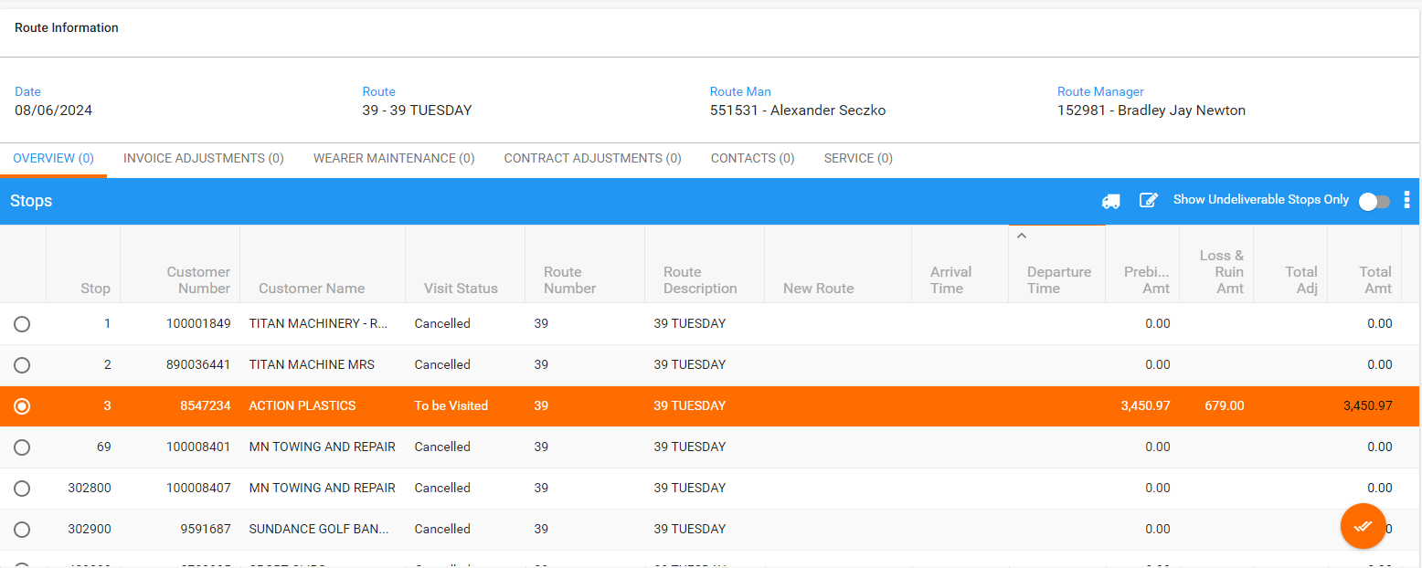
- SimpleInvoicePO = 1
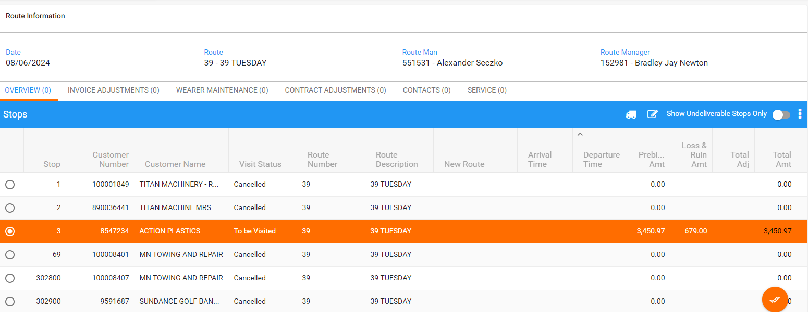

#3 – Check Customer and Contract dlg– Passed

Test case 1:
- SimpleInvoicePO = 1
- Open customer dlg/ Billing tab
- On Miscellaneous area, check Purchase Order Number field
Expected/Actual result:
This field is available and editable with a with a length of 30 characters:
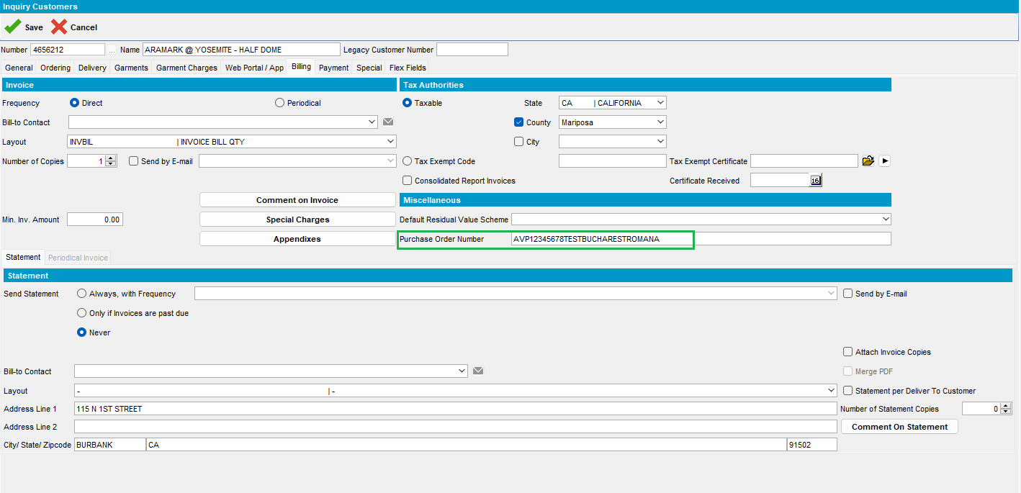
select *from CustomerPurchaseOrder c where c.customer_id=6326;
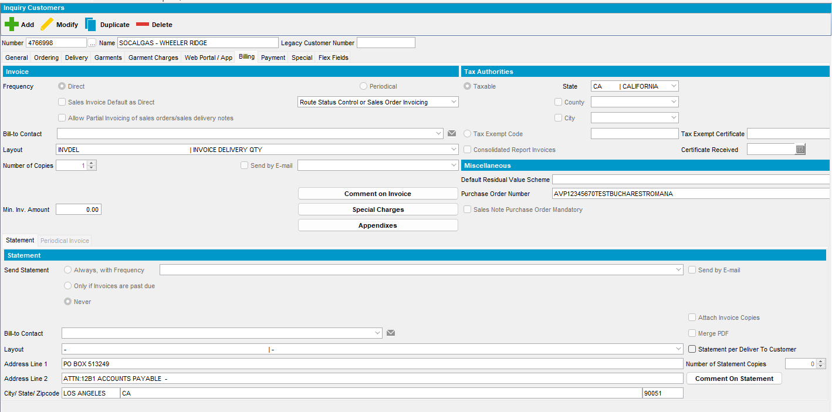
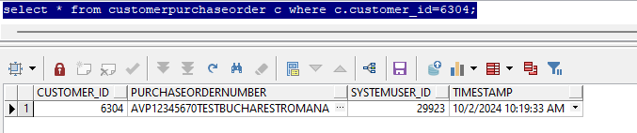
Delete PO and save it:
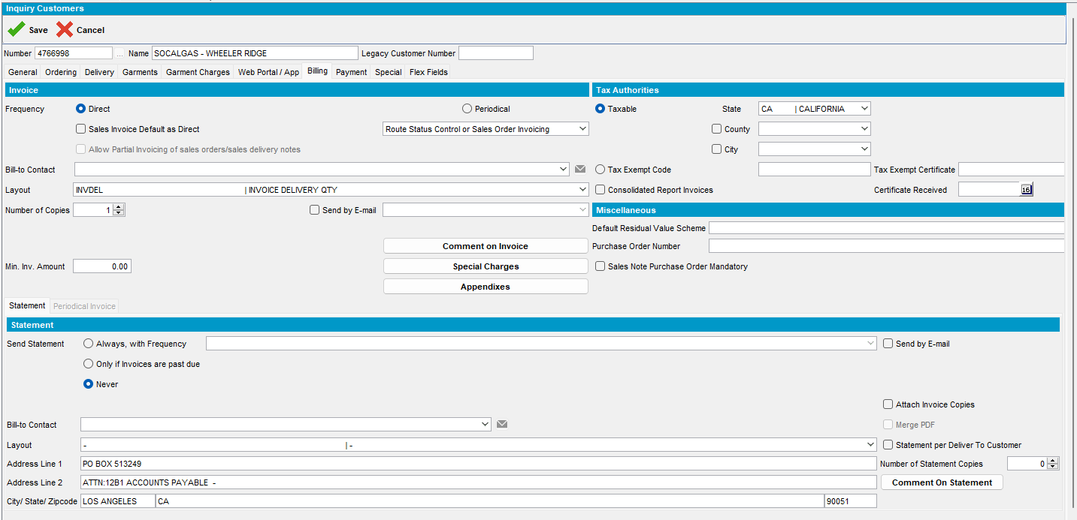
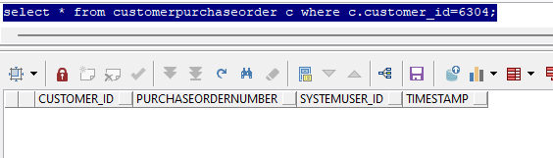
Test case 2:
- SimpleInvoicePO = 0
Purchase Order Number field it is not available:
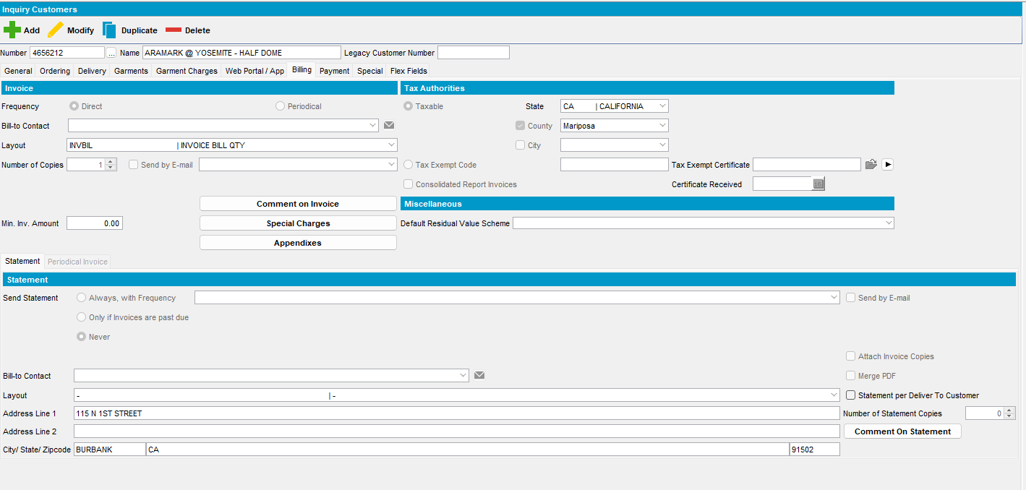
Test case 3:
- SimpleInvoicePO = 0
- Contract with Purchase Order Type = Reference only – no tracking
- Purchase Order Number: 30 characters allowed
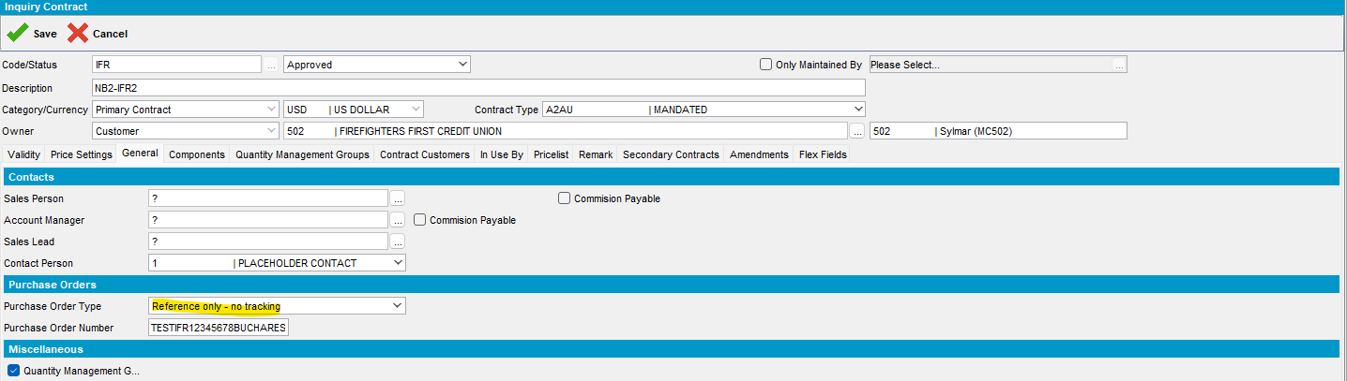
- And PO is Optional/ Invoice is settled if PO is missing
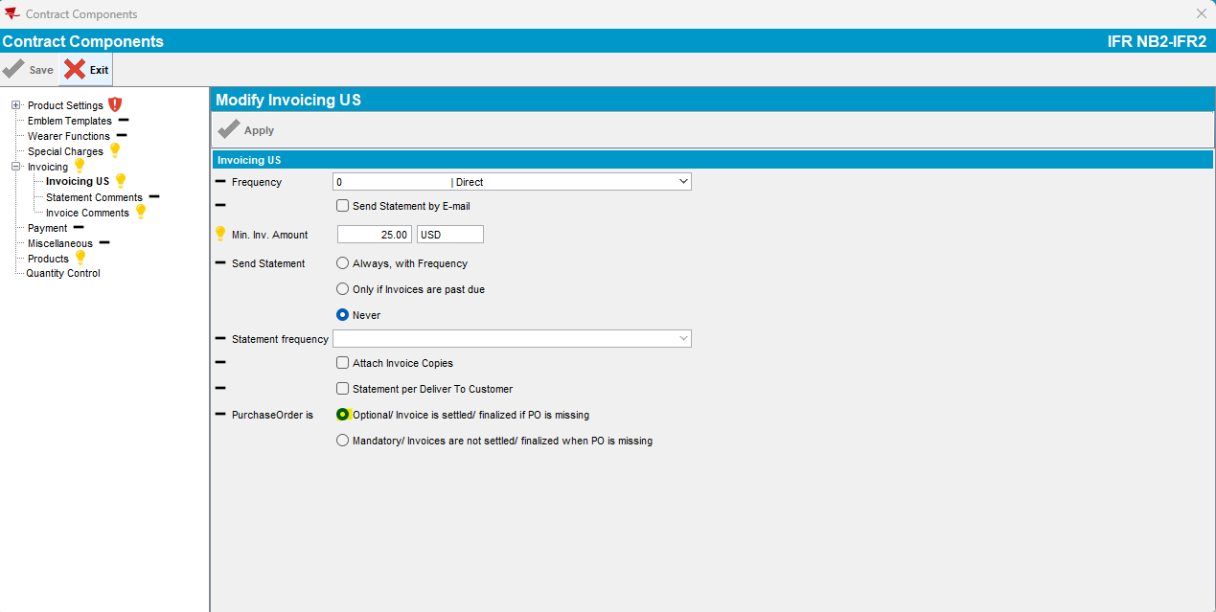
- Contract Customers tab, choose a customer and on PO Number tab add Purchase Order Number:
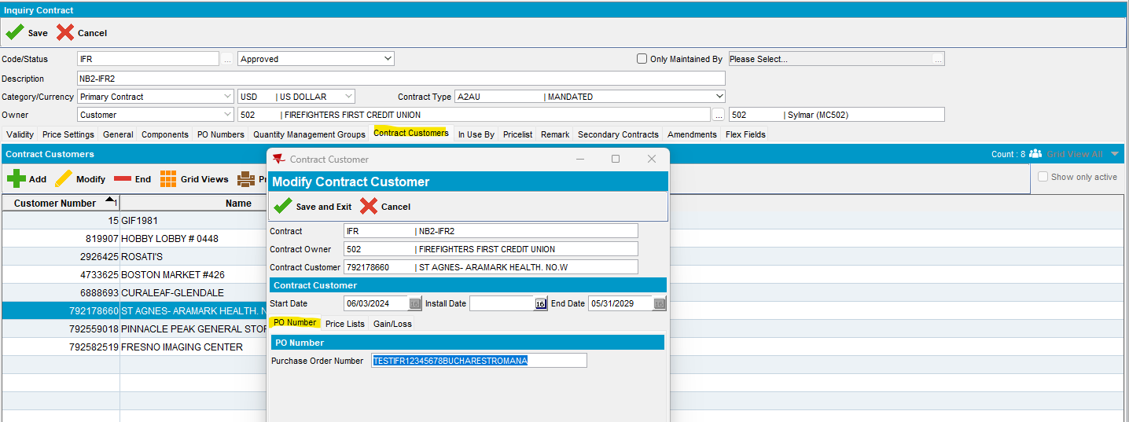
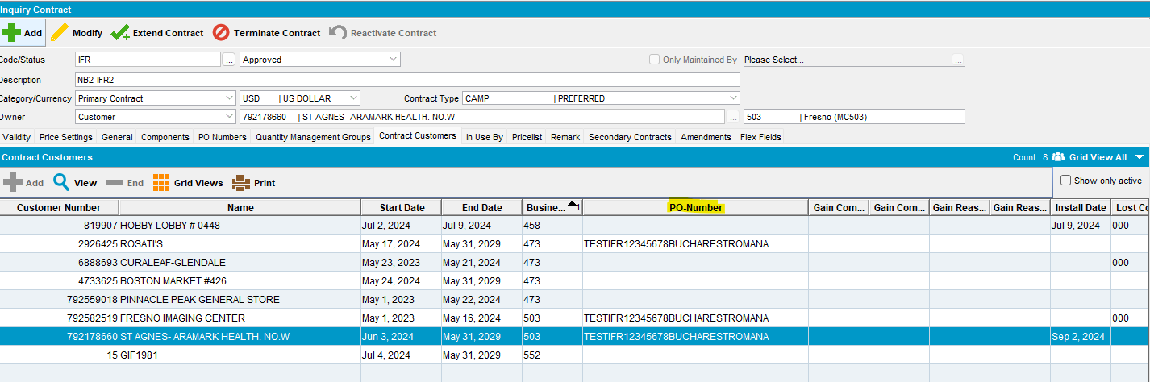
- Add a new customer to a primary contract: IFR
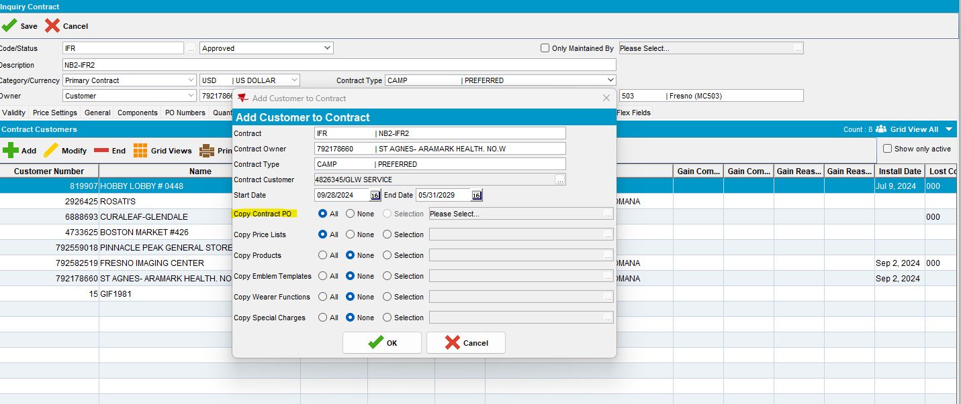
- Check on PO Numbers tab for the existing PO Numbers is this customer is linked automatically to the PO:
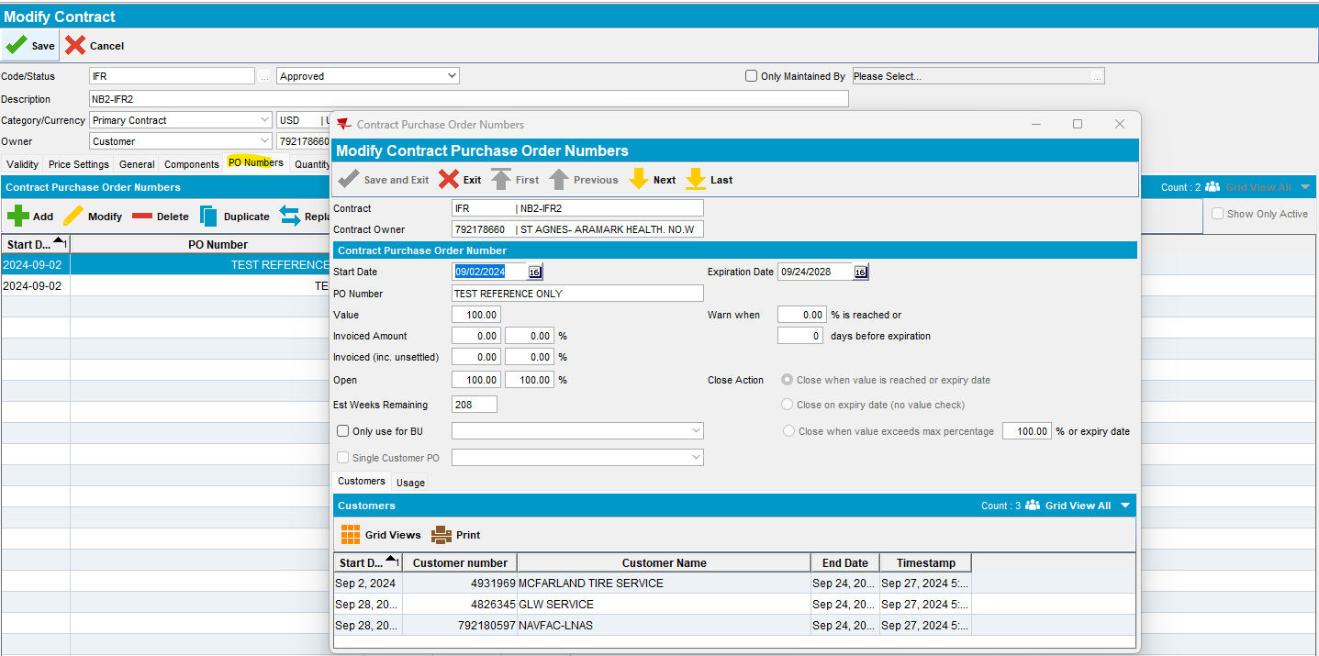
- And also, on Contract Customer for this customer is linked automatically the general PO Number from Contract:
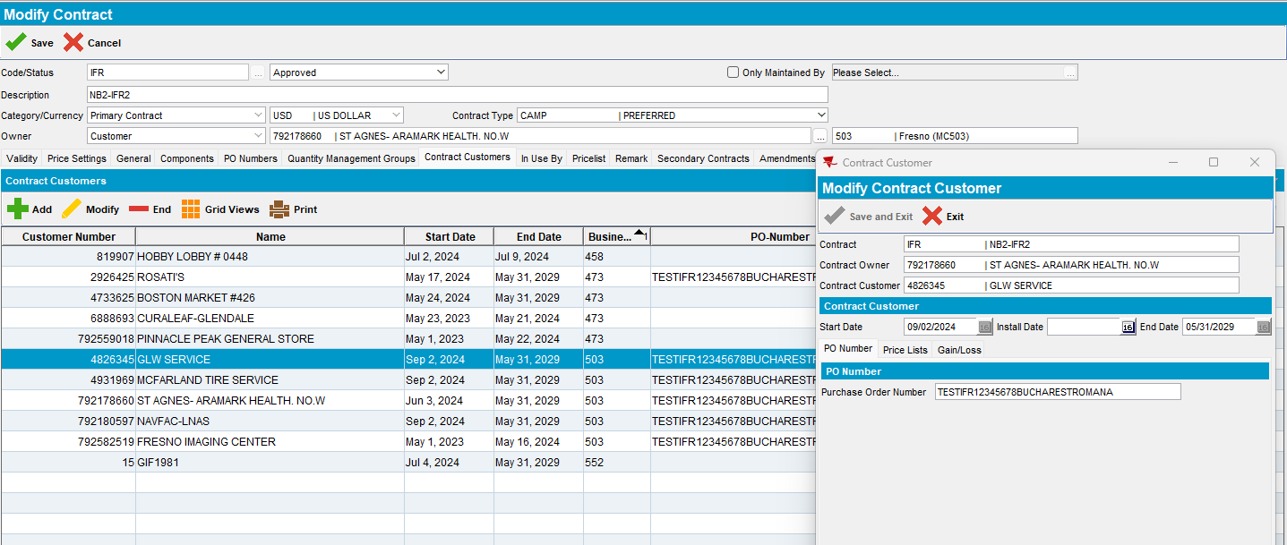
- or In Use By:
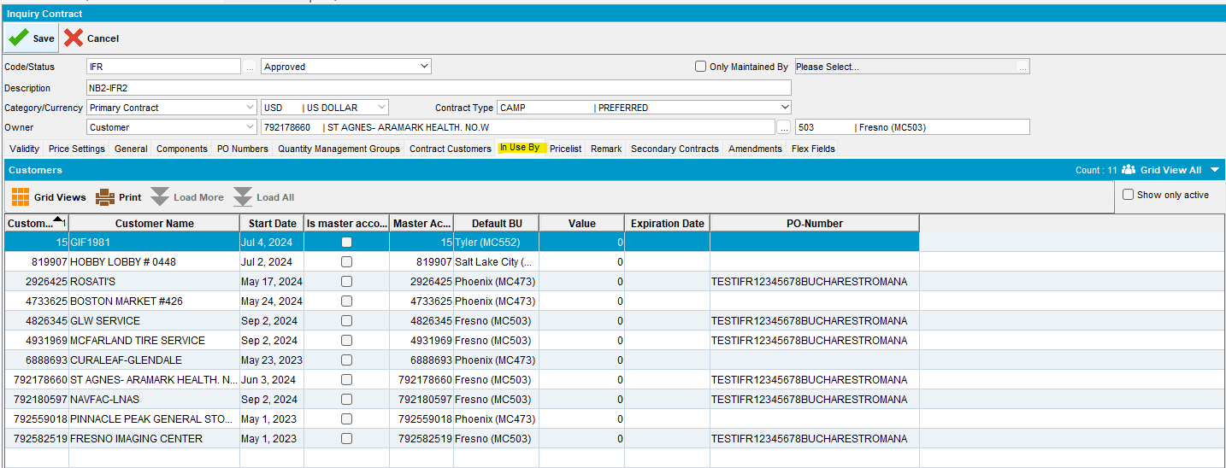
- Add next route and generate invoice:
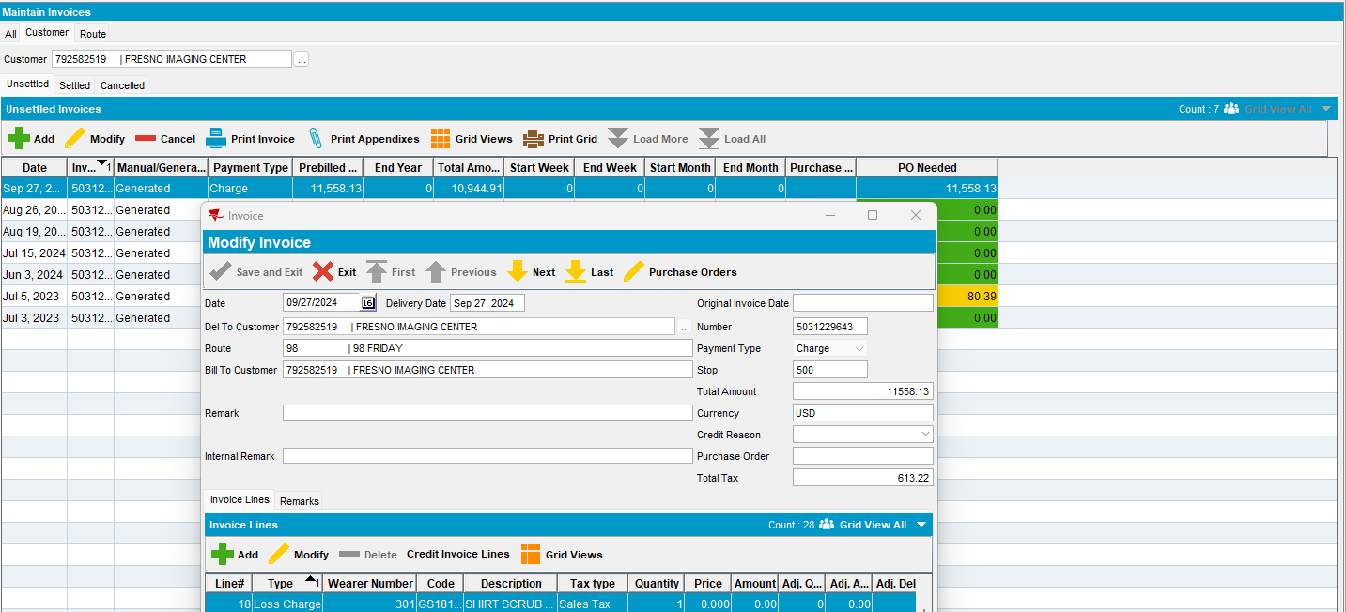
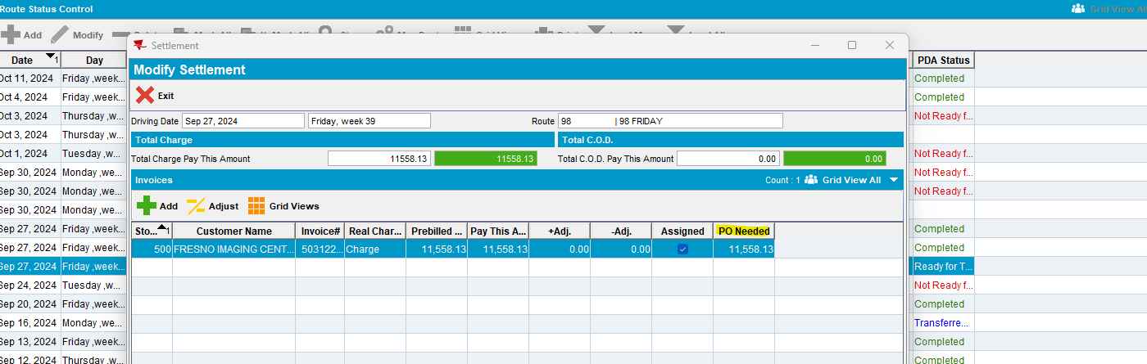
- On Maintain Invoice add a new PO number:
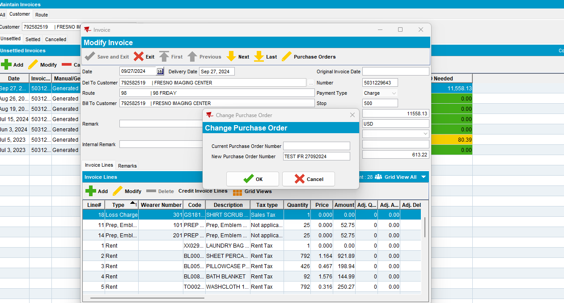
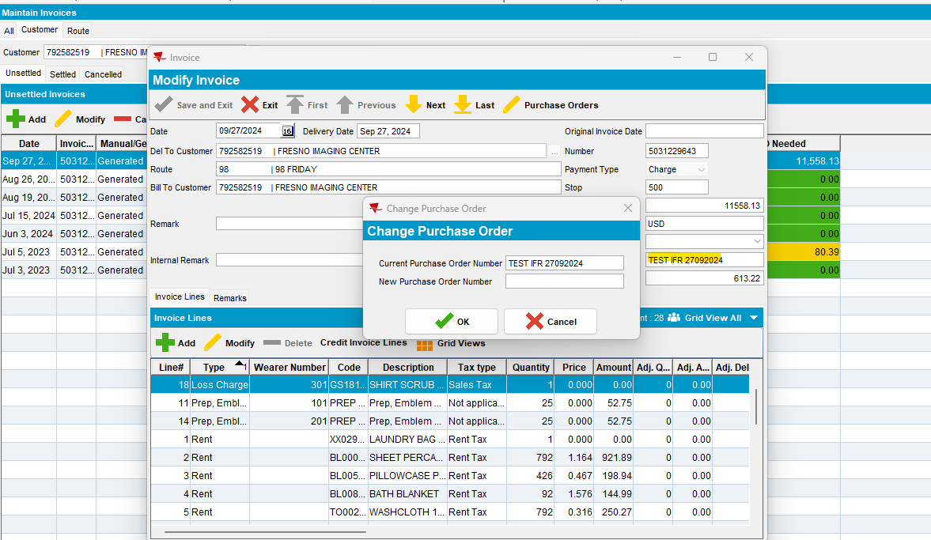
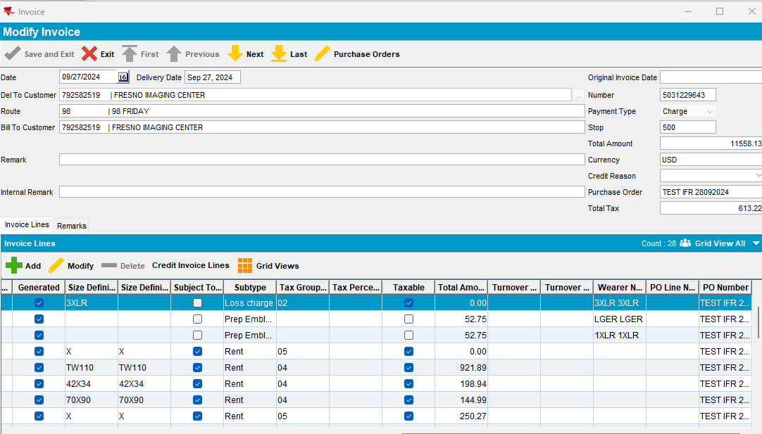
- Settle invoice/ Adjust Invoice:
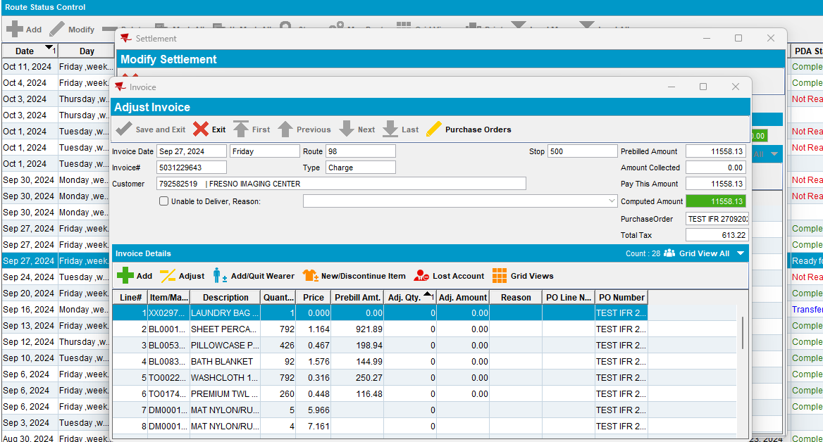

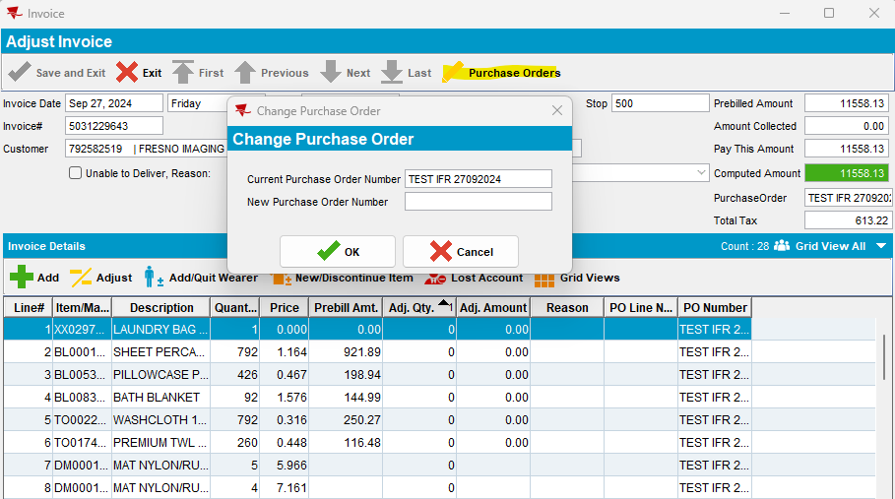

- Settle invoice:
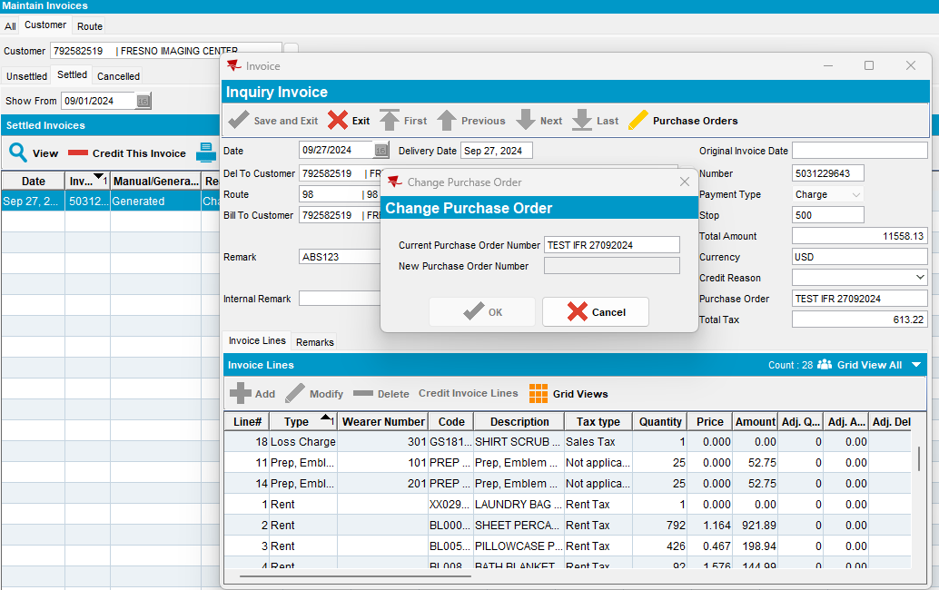

Test case 4:
- SimpleInvoicePO = 1
- Check Contract dlg:
Expected/ Actual result: Purchase Order area from General tab it is not available/ visible anymore and also PO Numbers tab it is not visible anymore
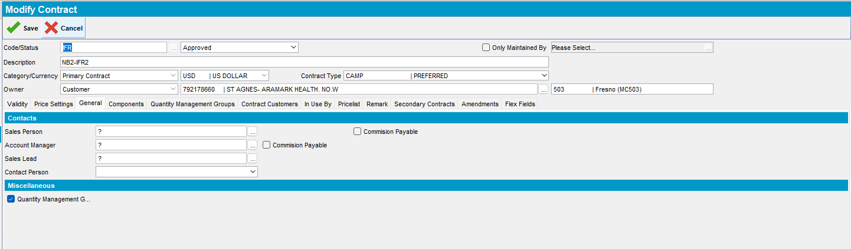
- On Contract Customers tab it is not visible anymore PO Number tab
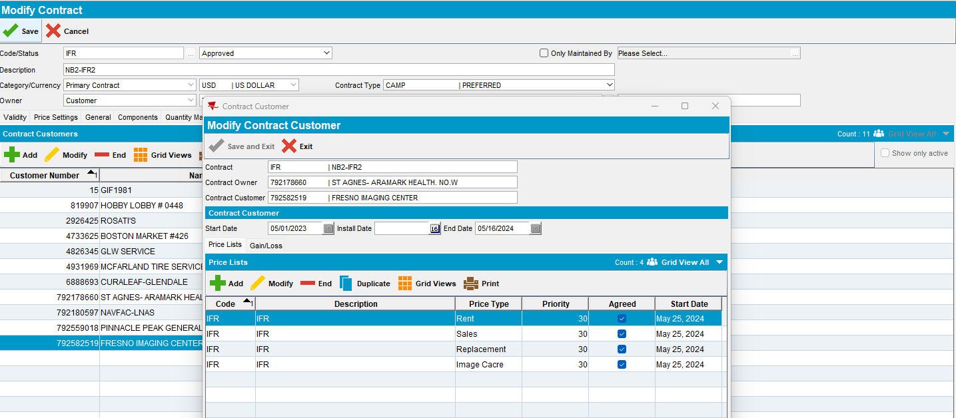
- Also, on the grid PO Number column it is not visible anymore
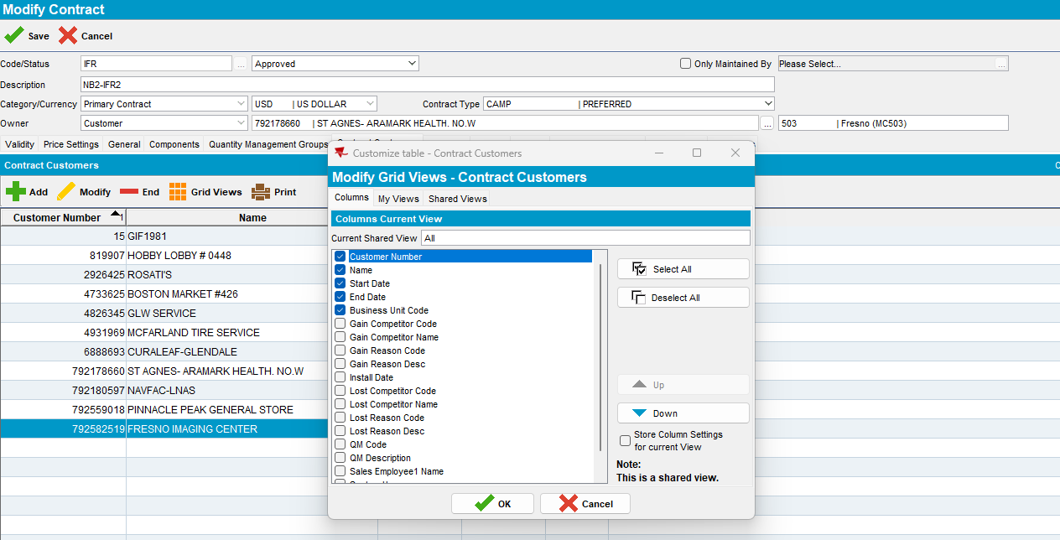
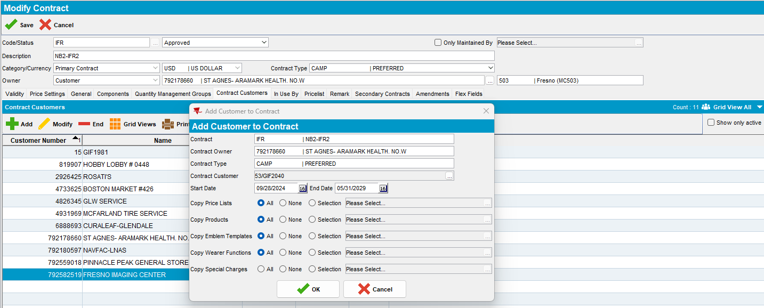
- On Customer dlg/ Billing tab, Purchase Order Number field it is now visible/ available:
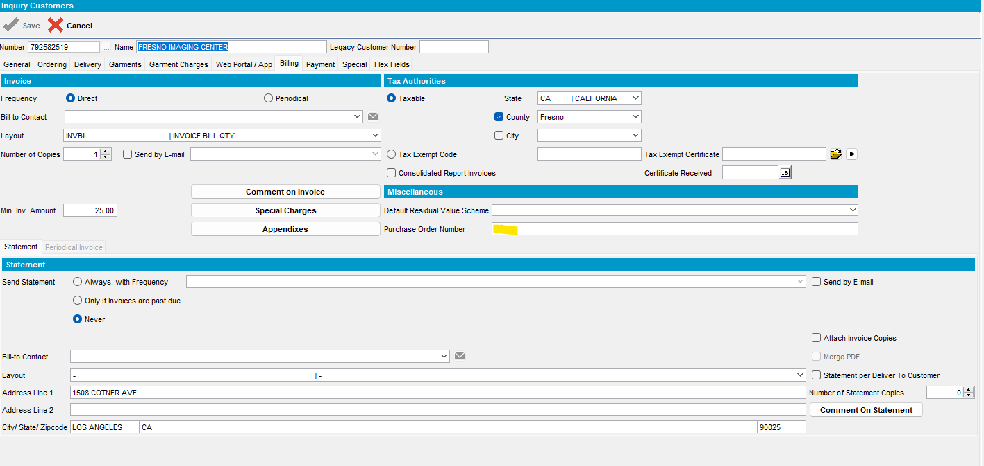
On General tab, on grid, PO-Number it is not visible anymore:
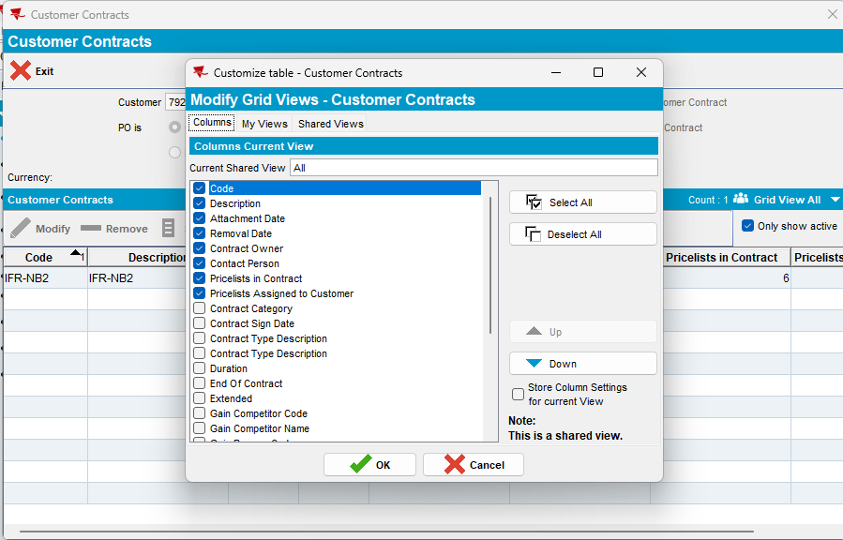

- No PO number column on In Use By tab:
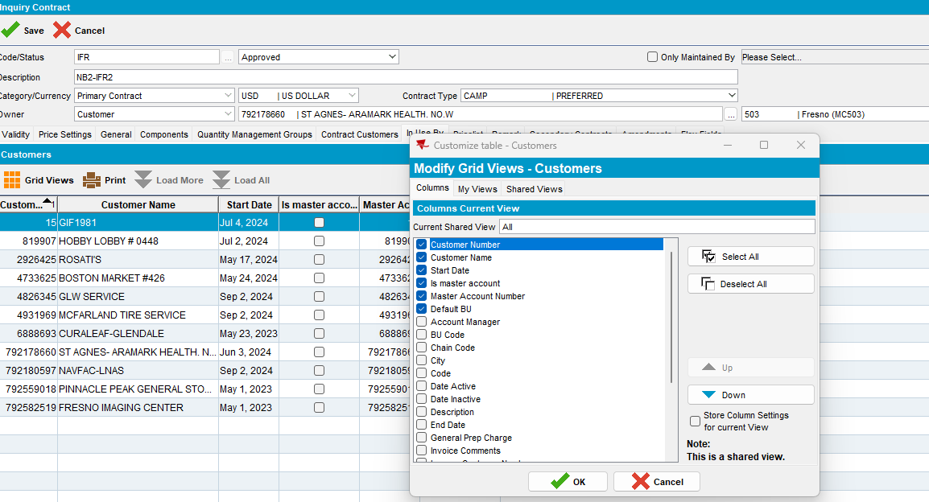
Test case 5:
- SimpleInvoicePO = 0
Primary Contract or Secondary Contract with PO Type = Invoice
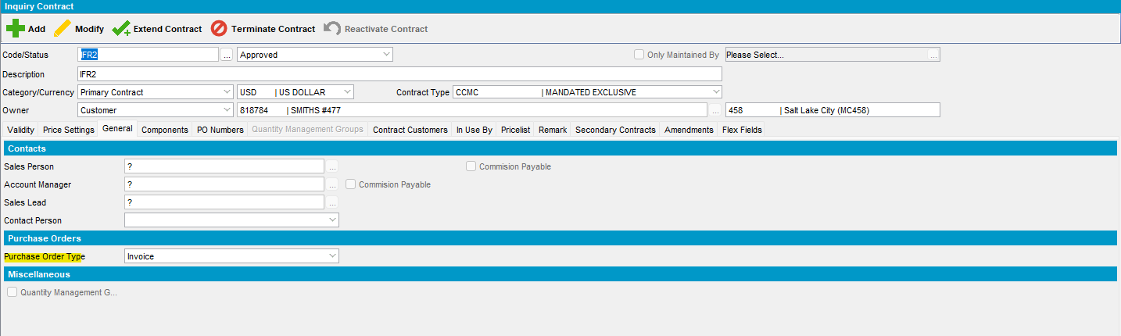
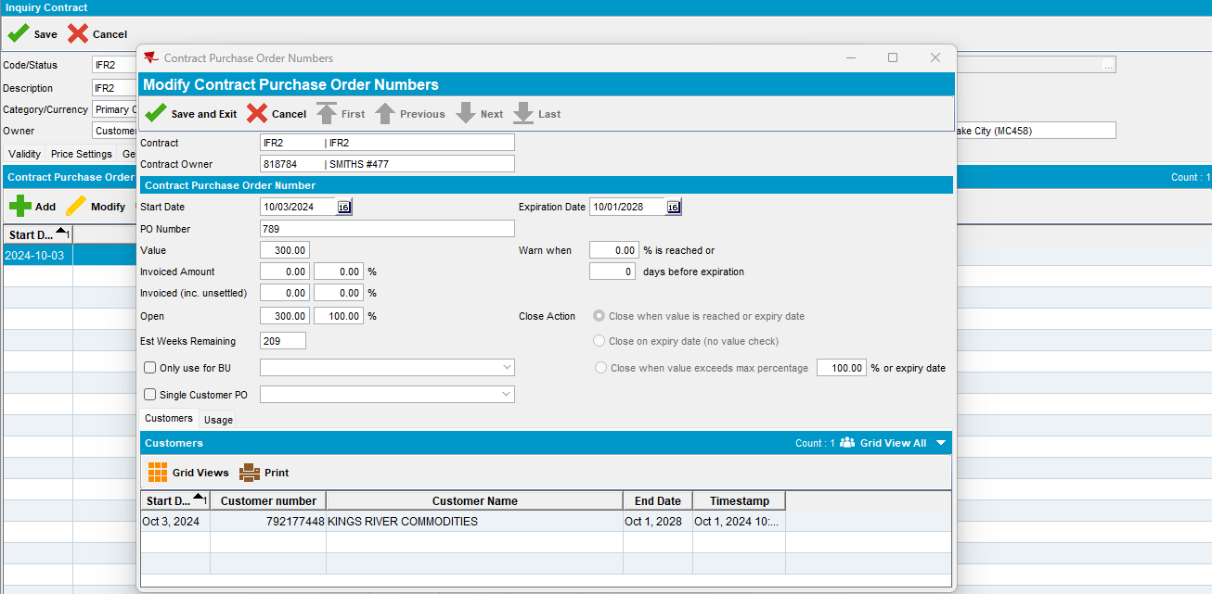
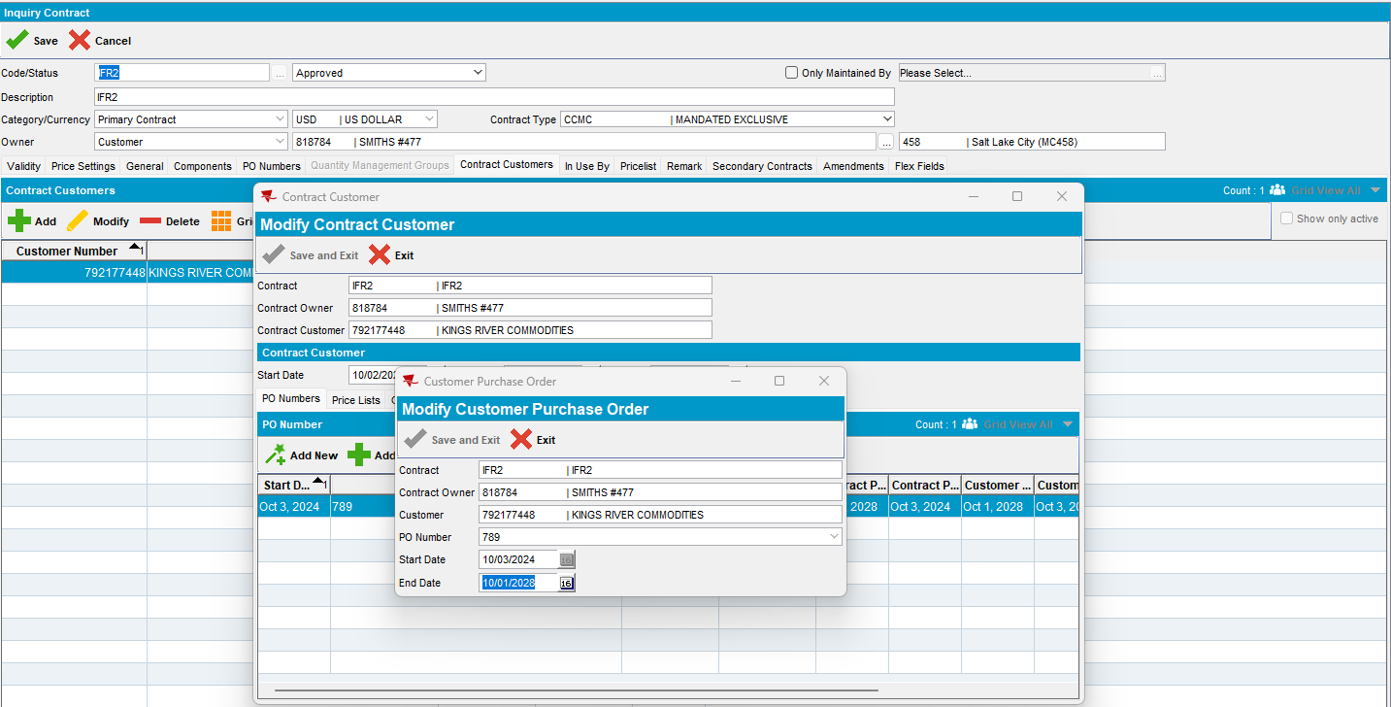
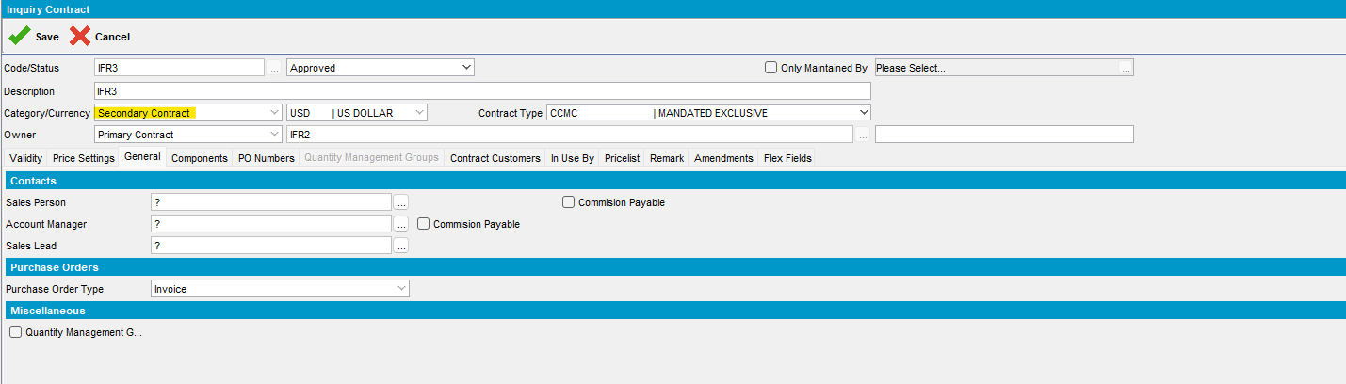
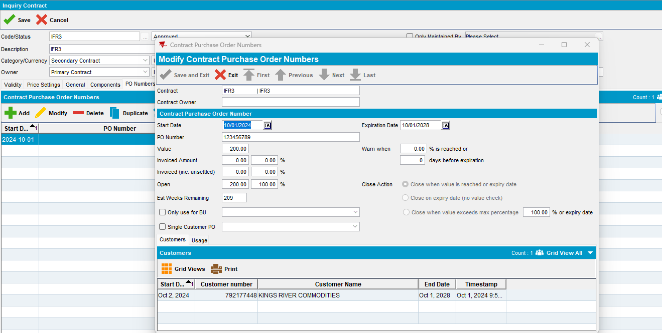
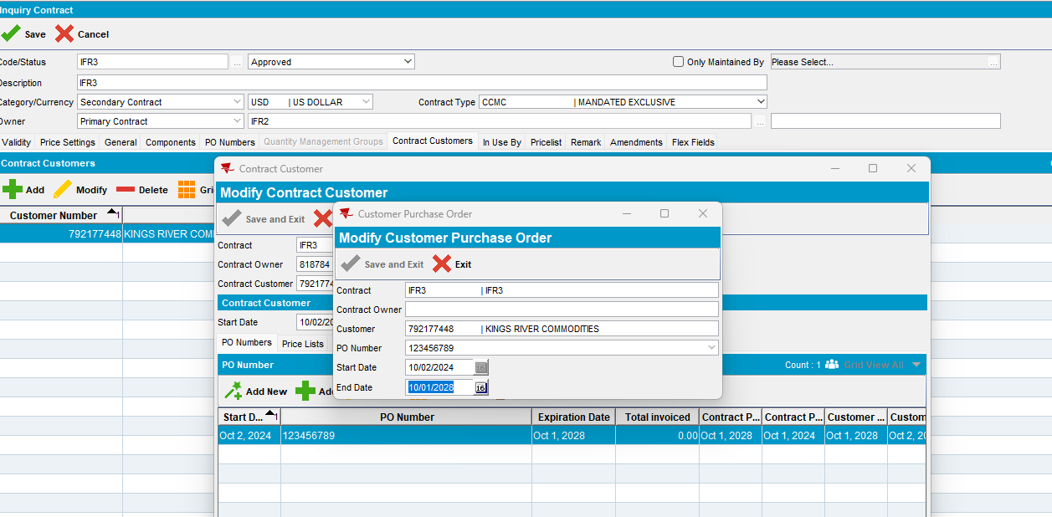

Customer dlg:
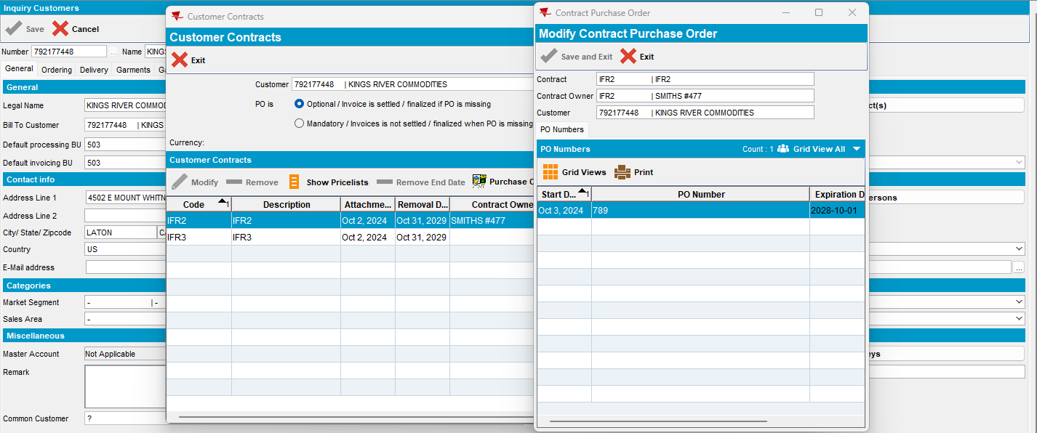
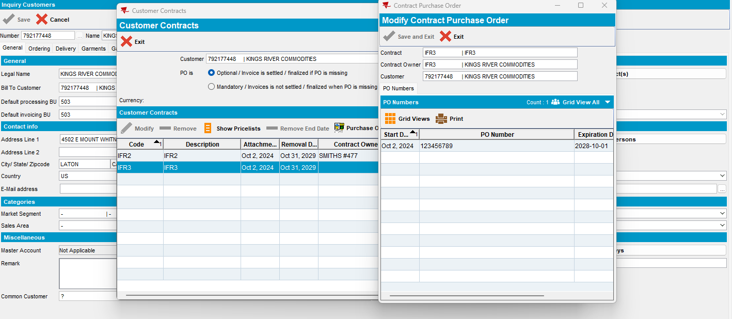

- SimpleInvoicePO = 1
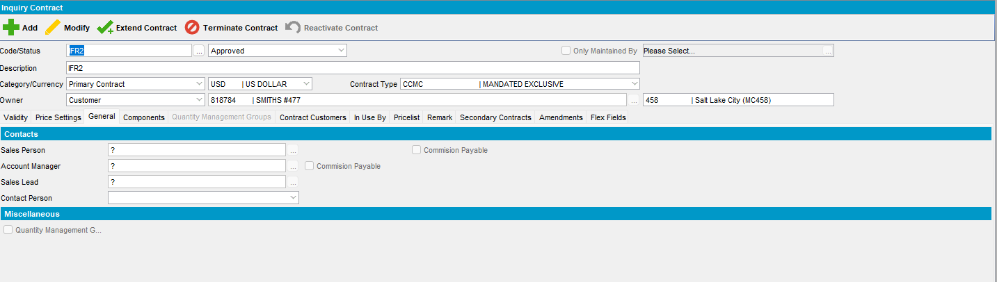
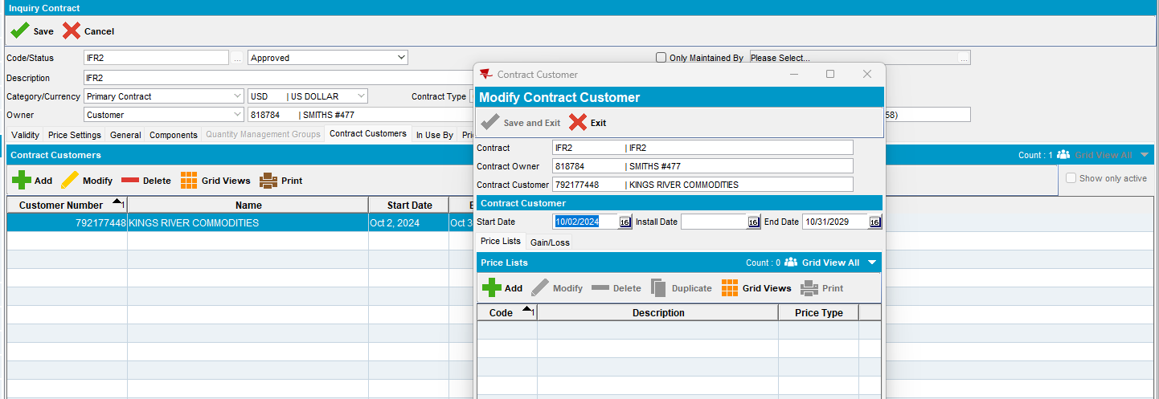
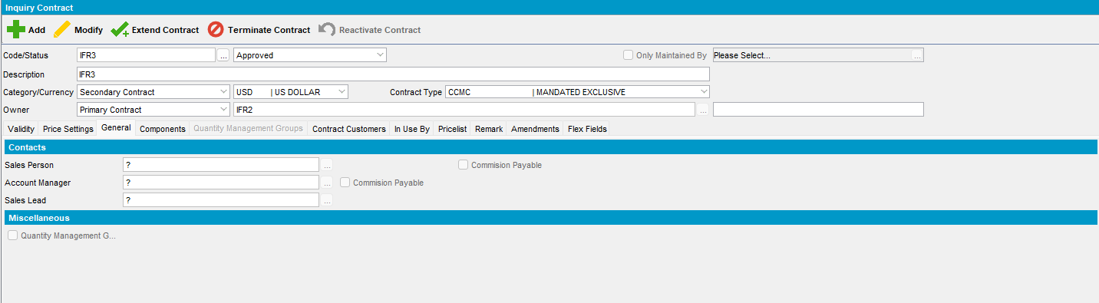
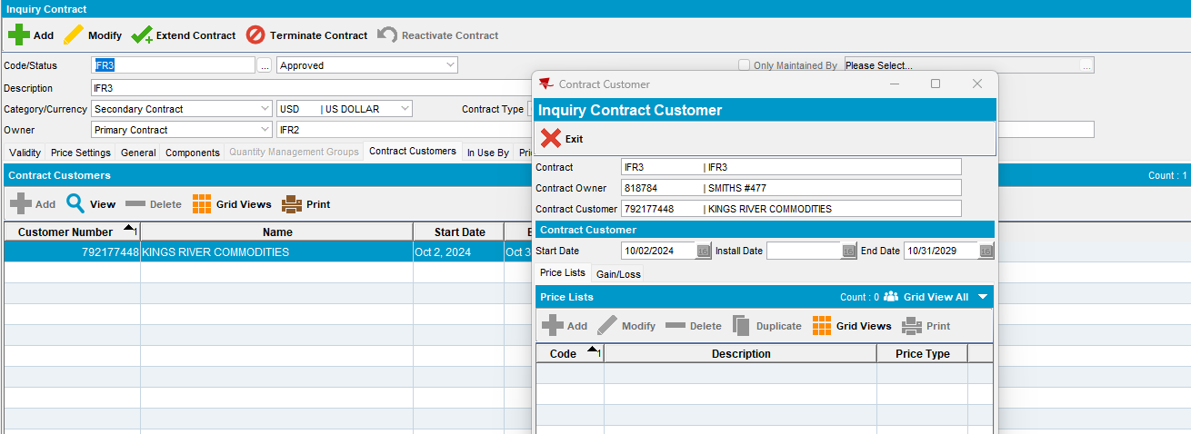

Customer dlg:
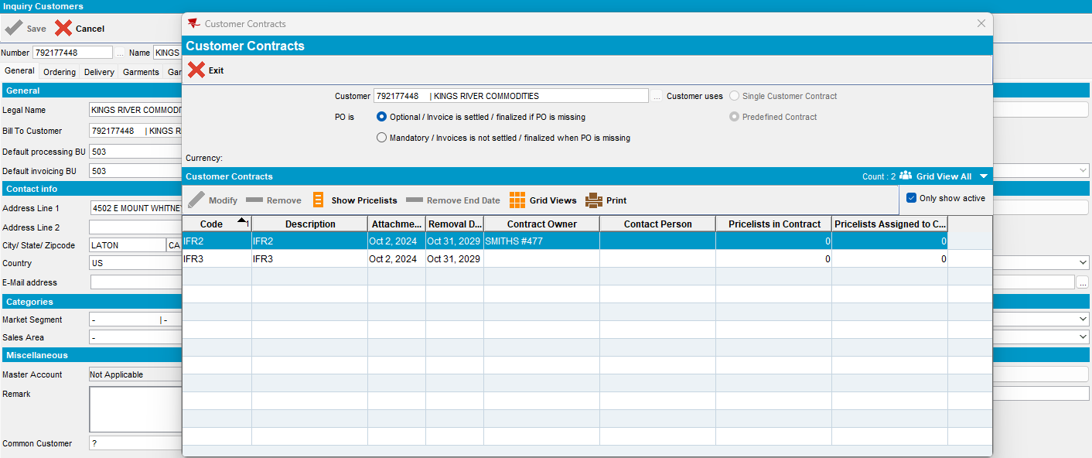

Test case 6:
- SimpleInvoicePO = 0
Single Contract customer:
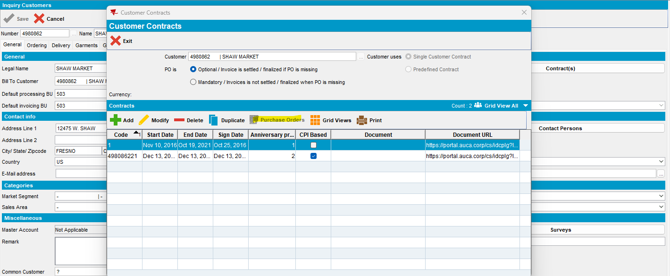
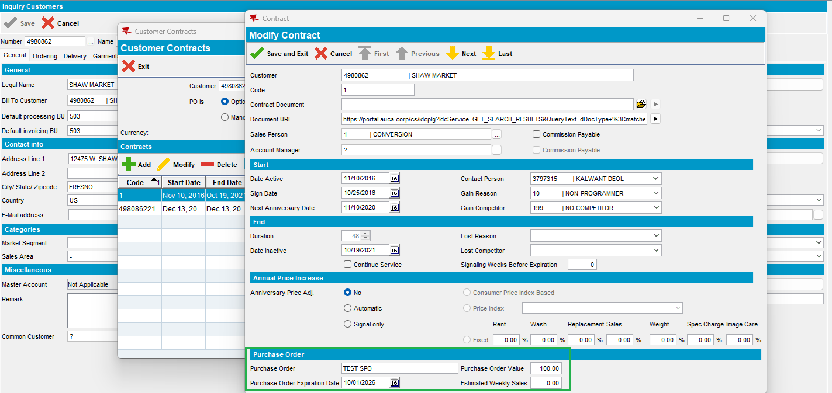
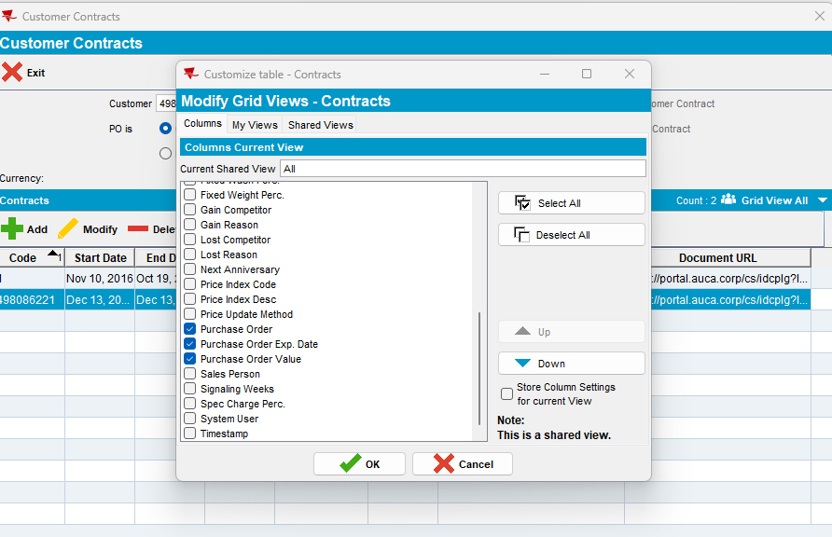
- SimpleInvoicePO = 1

Single Contract customer:
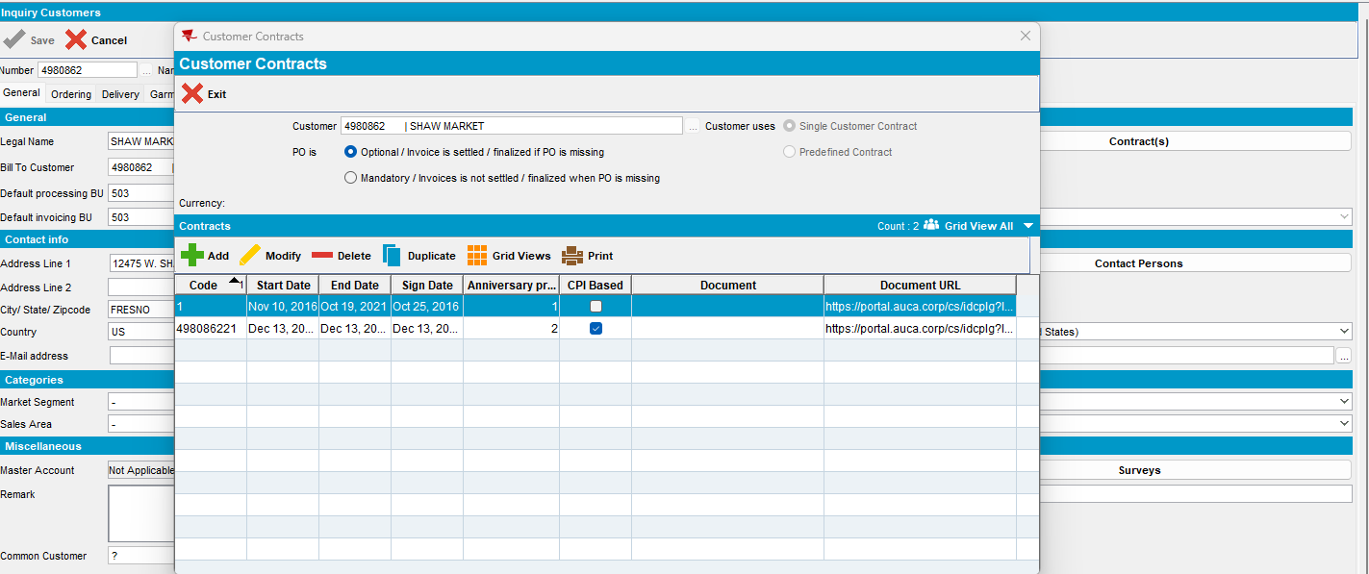
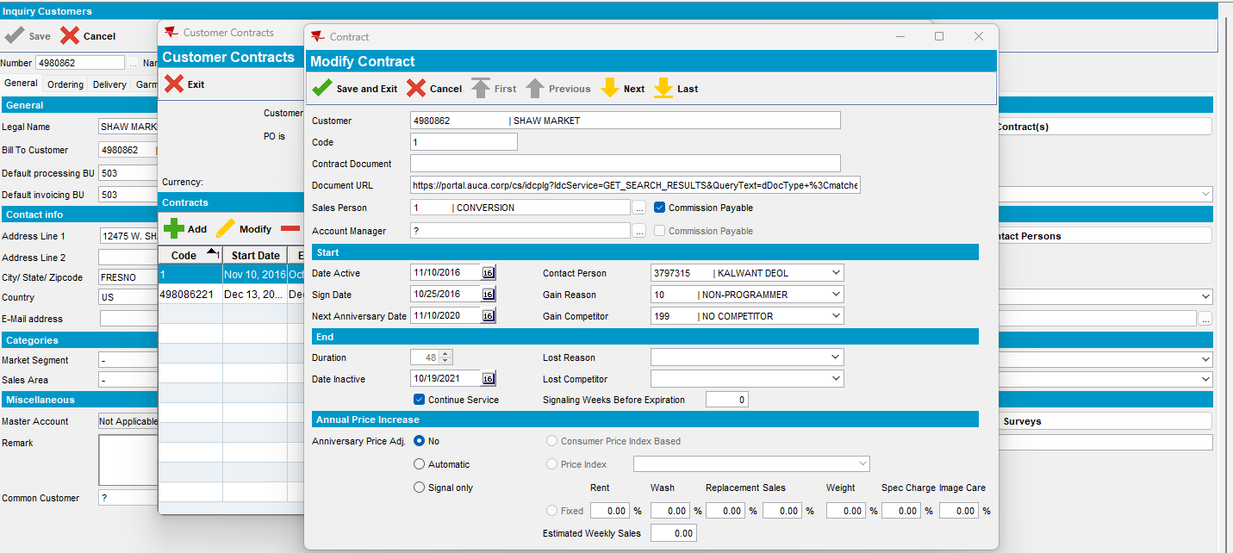
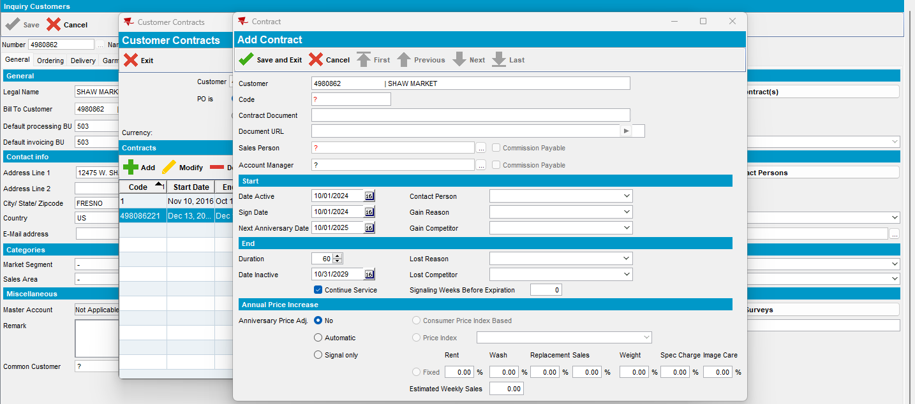
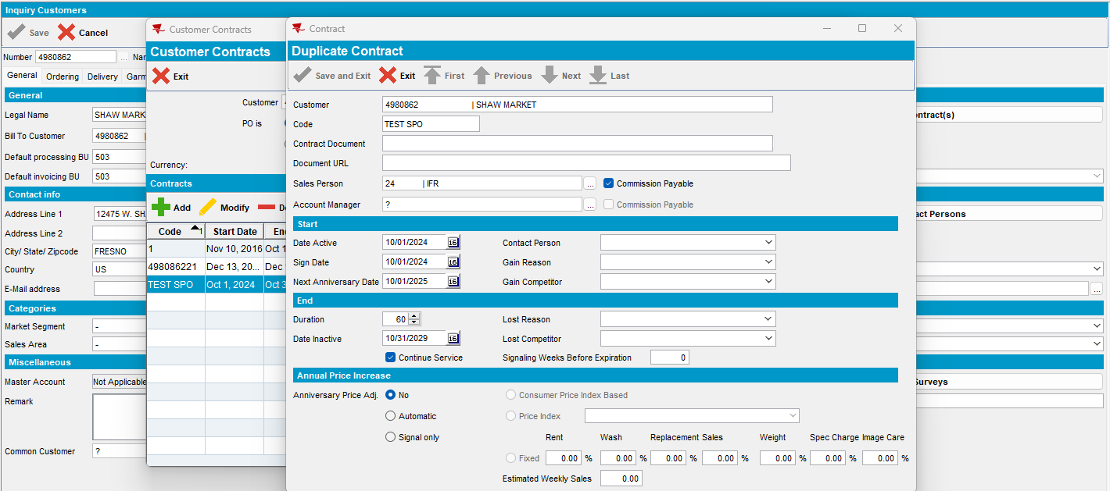

#4 – Check Invoice Line Type dlg– Passed
SimpleInvoicePO = 0
Attribute InvoiceLineType.IncludePOCheck
Business Rules Only visible when the module CONTRACTPO is in the license of the plant and system setting SimpleInvoicePO =0. Must be unchecked and disabled for InvoiceLineType 14 (Cash delay) and 18 (Tax). Enabled for all other invoicelinetypes.

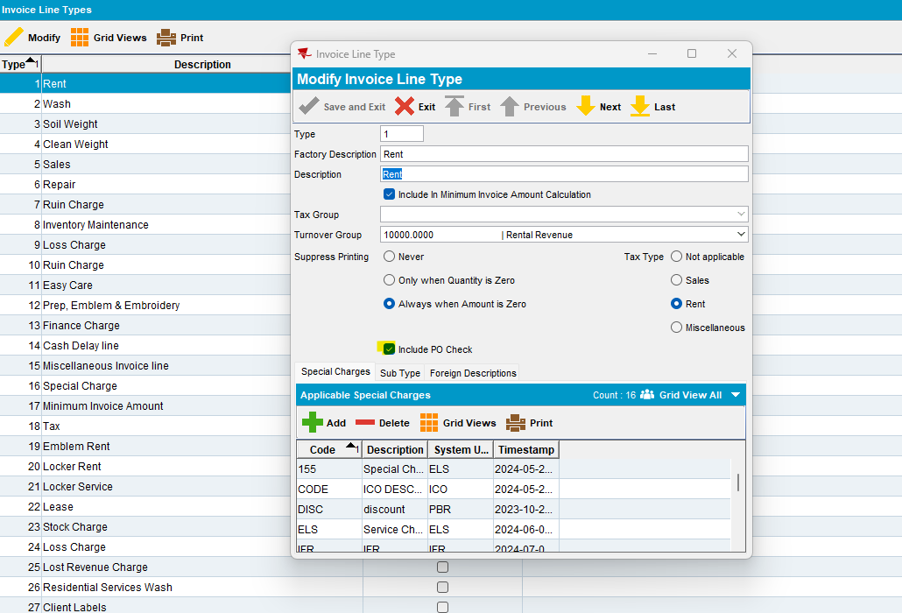
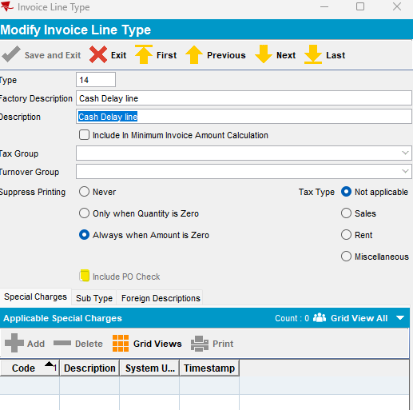
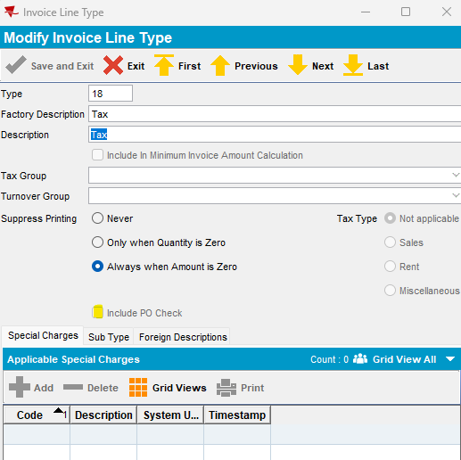
SimpleInvoicePO = 1
Hidden for all invoice lines:
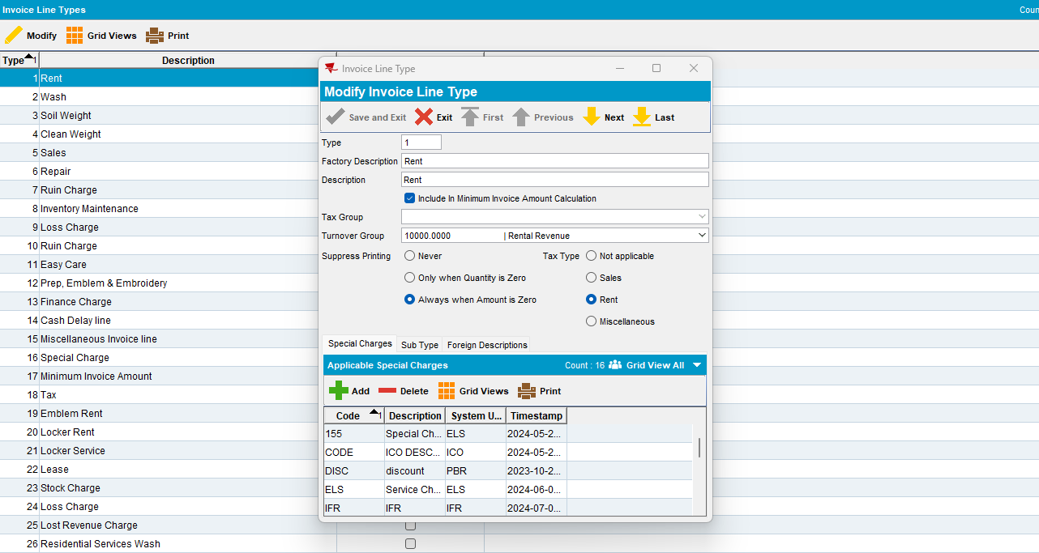

#5 – Check Contract PO Monitor dlg– Passed
SimpleInvoicePO = 0
Contract PO Monitor dlg is available:
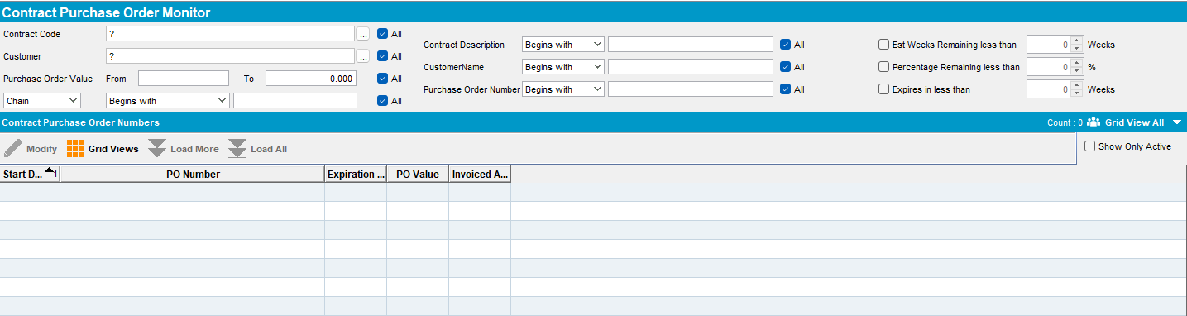
SimpleInvoicePO = 1
If SimpleInvoicePO = 1 then on opening this form, show message “Purchase Orders are set at customer level and cannot be managed in this dialog” OK and then close the dialog
Contract PO Monitor it is not available:
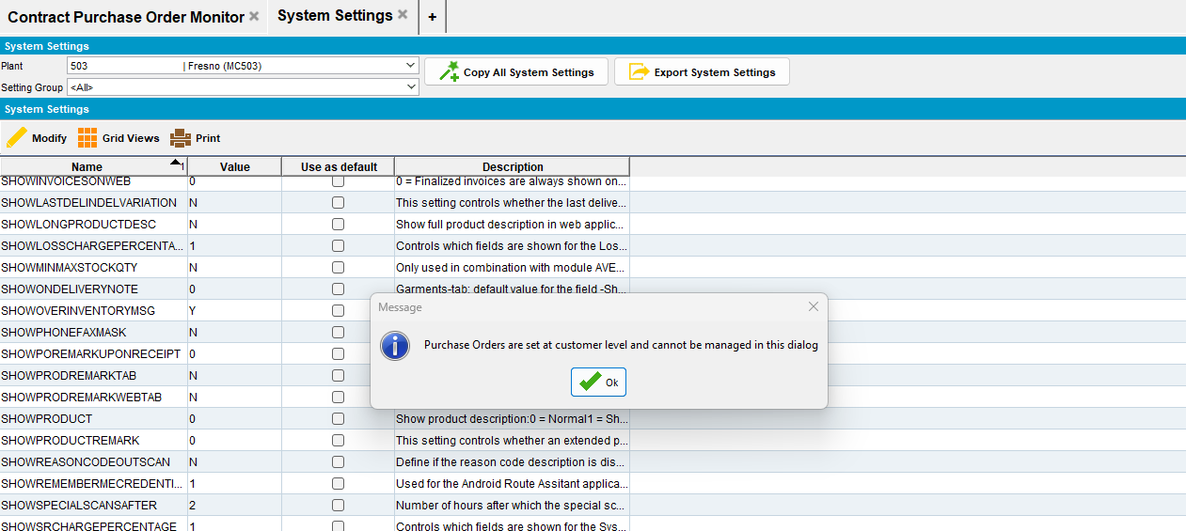
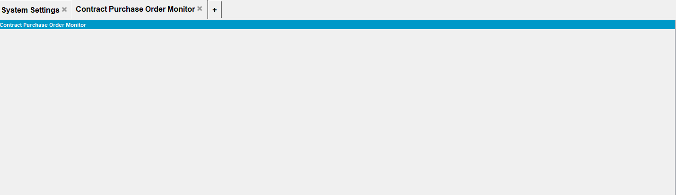

#6 – Check Sales Order dlg– Passed
SimpleInvoicePO = 0
- Add a new sales order -> Customer order number is PO number (user input):
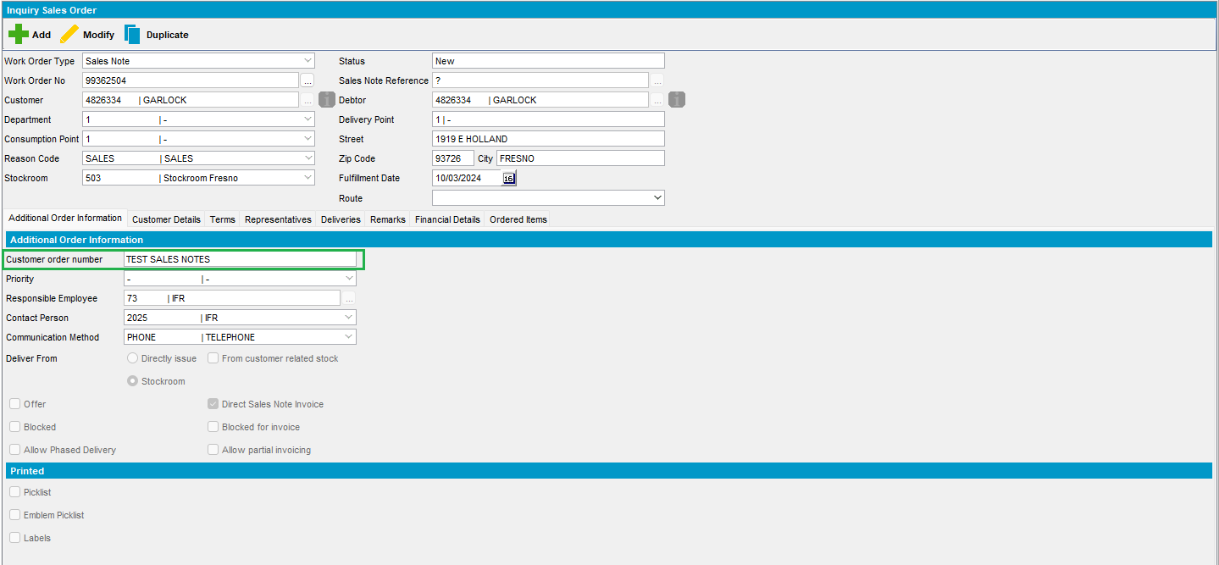
- On Maintain Sales Notes are displayed all the new sales notes:
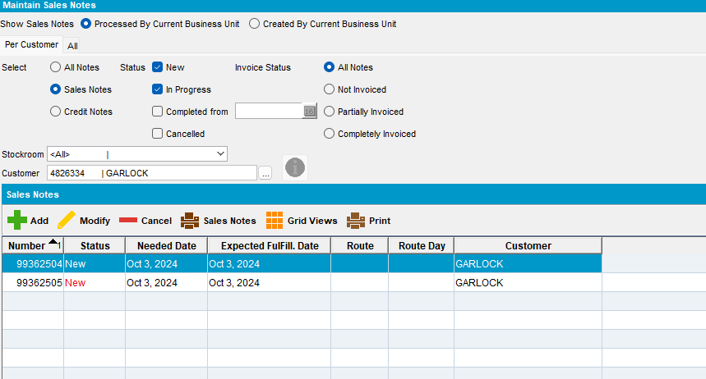
- Print Sales Notes from here -> on the report, Your reference is PO number:
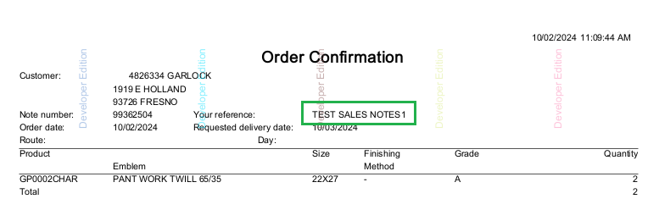
- Press Issue Sales Items and assign the right qty:
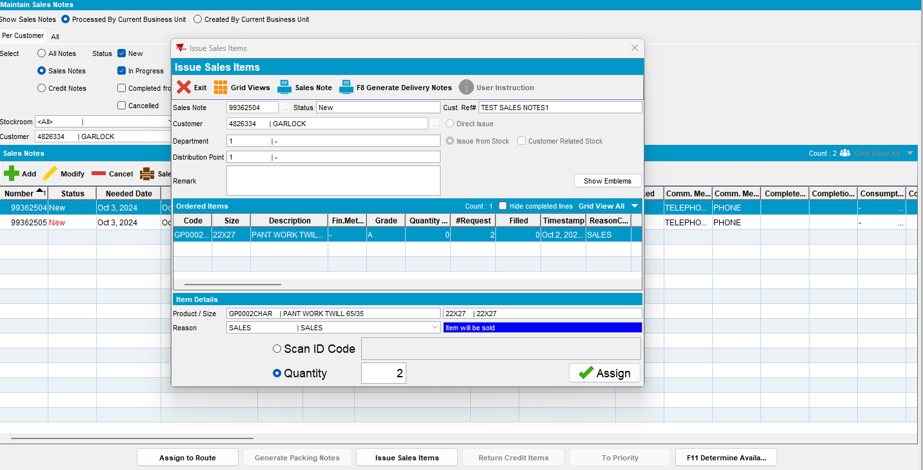
- Generate Delivery Note:
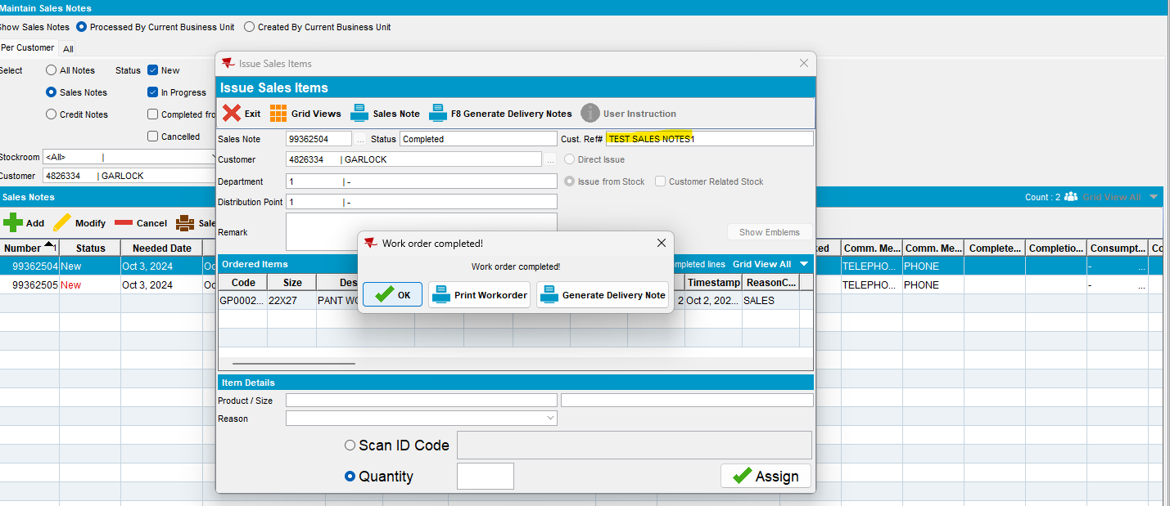
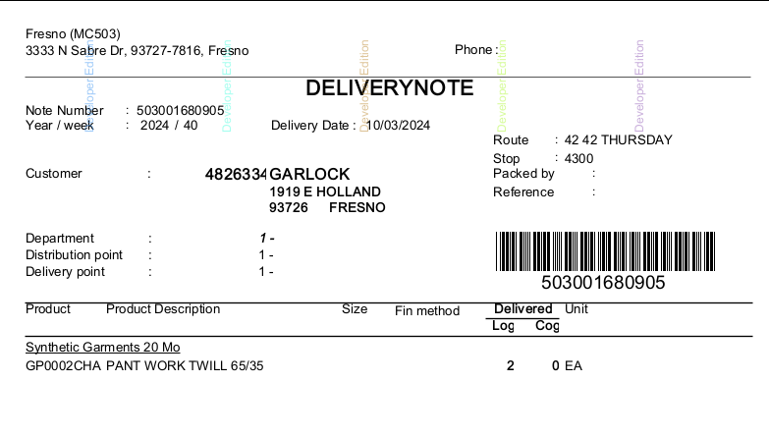
- Generate invoice from RSC -> for sales note PO Number is displayed on the report:
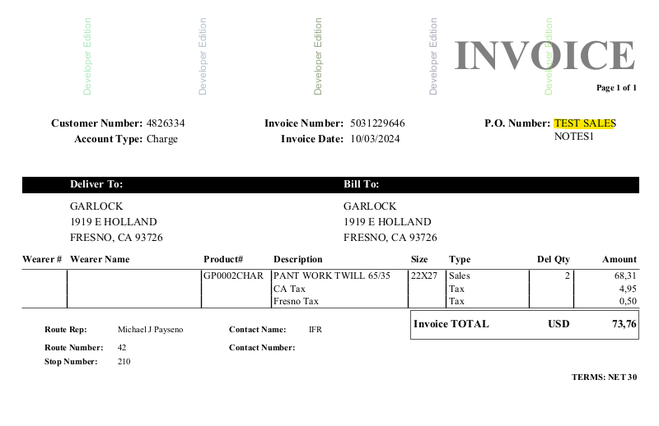
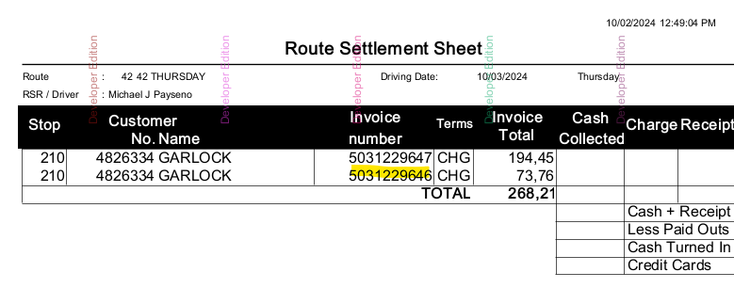
- On Maintain Invoice in the grid is displayed PO number, also:
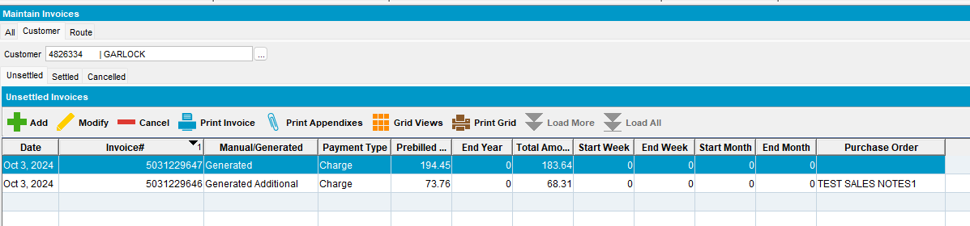
- Modify Invoice for sales note and change PO:
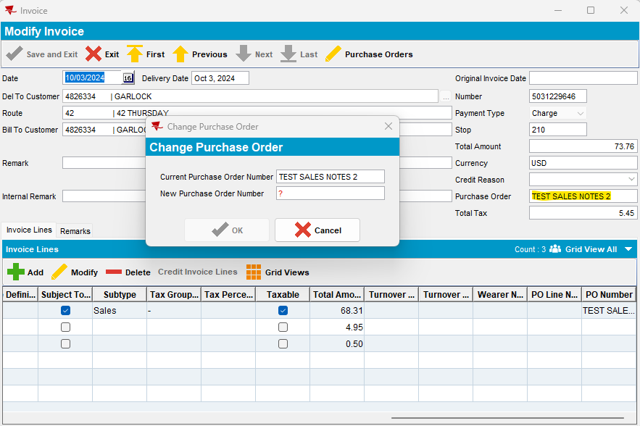

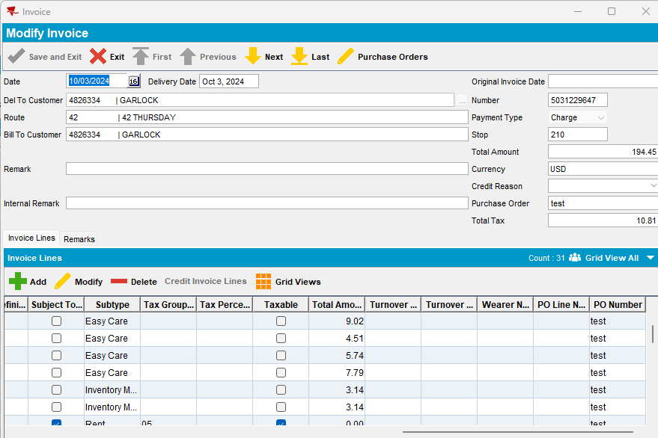
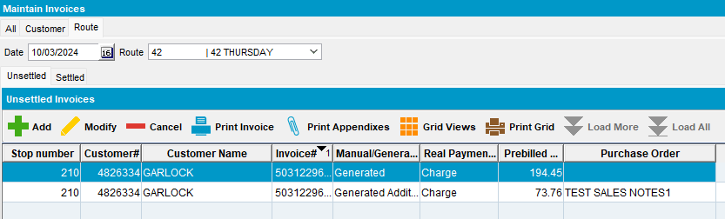
- PO column is available on Maintain Invoice/ All tab, also:
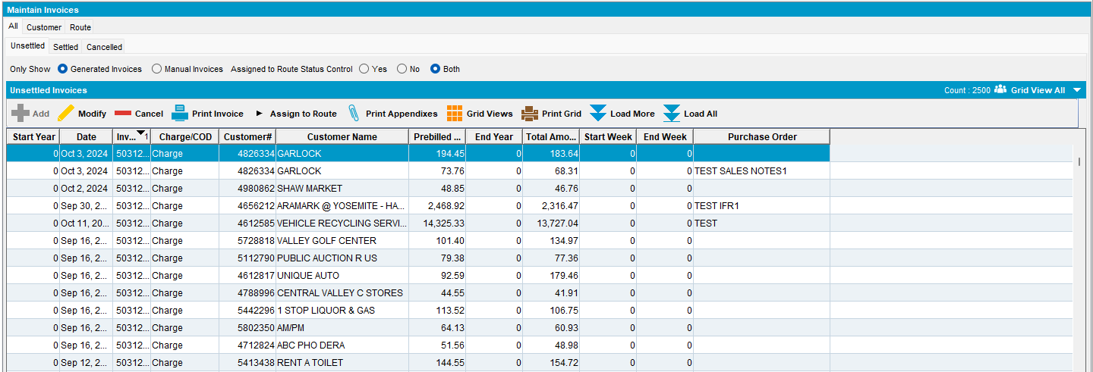

SimpleInvoicePO = 1
If system setting SimpleInvoicePO = 1)
The purchase order number is taken from CustomerPurchaseOrder table for the customer

- Add a new sales order -> Customer order number is Customer’s PO number (from Customer dlg):
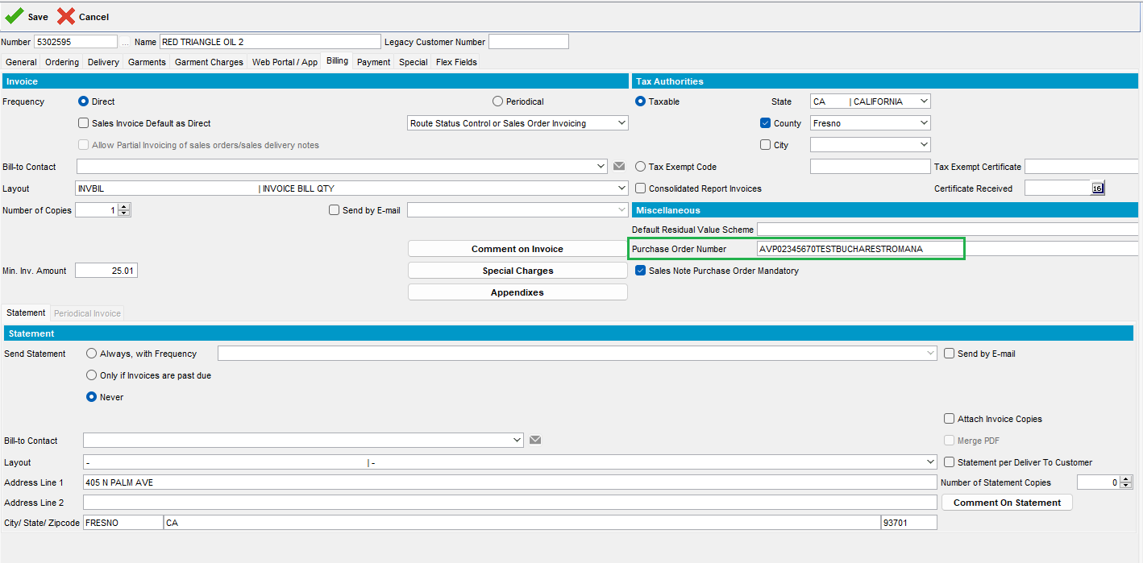
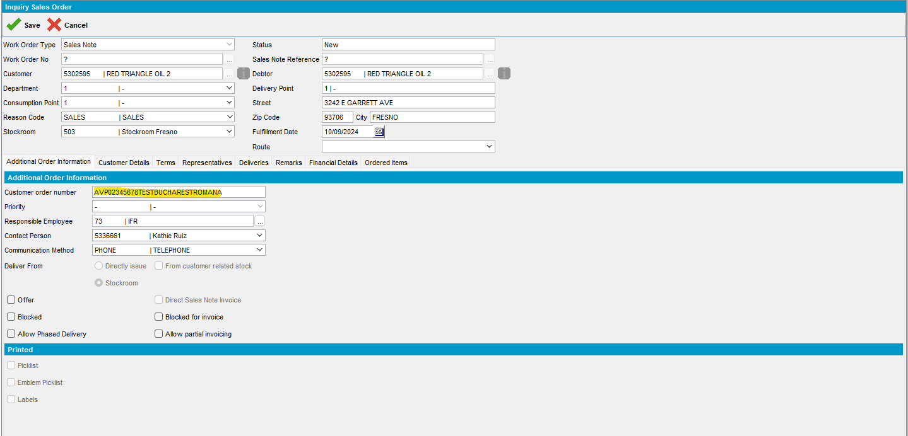
Modify this sales order:
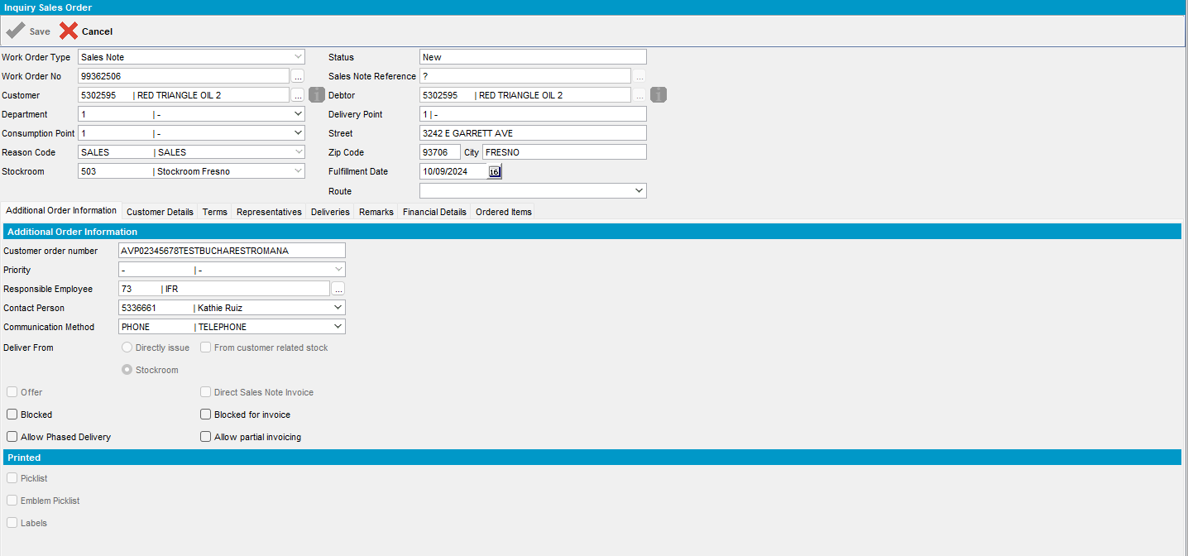
Change Customer/ PO Number:
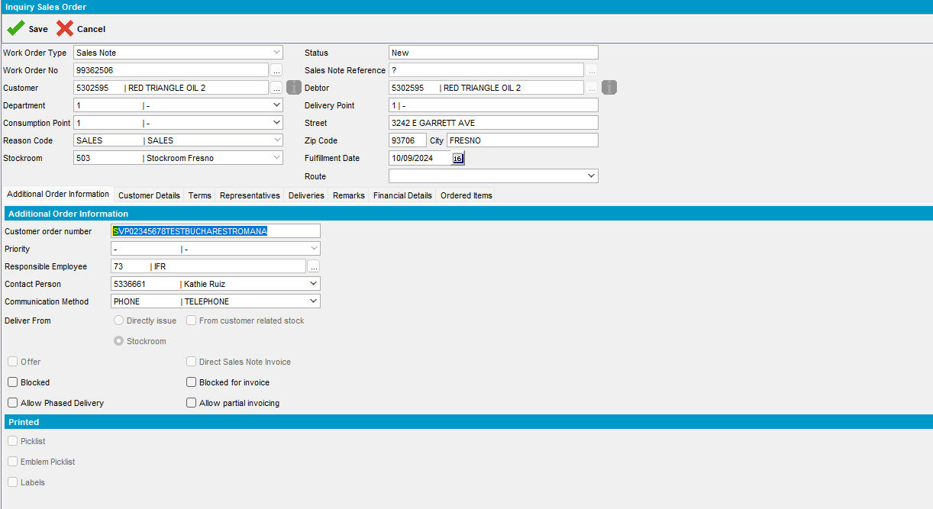
Duplicate an existing sales order and change the Customer order number:
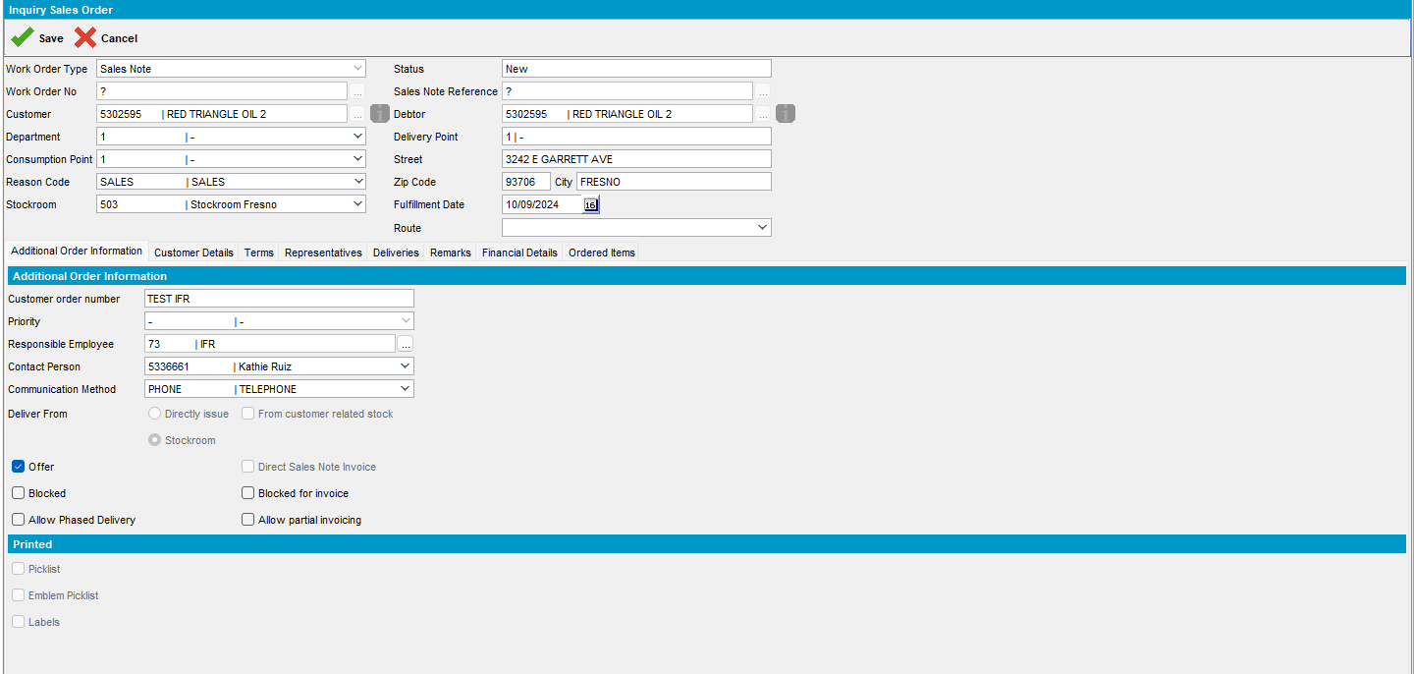
Open Maintain Sales Notes dlg and see Reference No/ PO number:
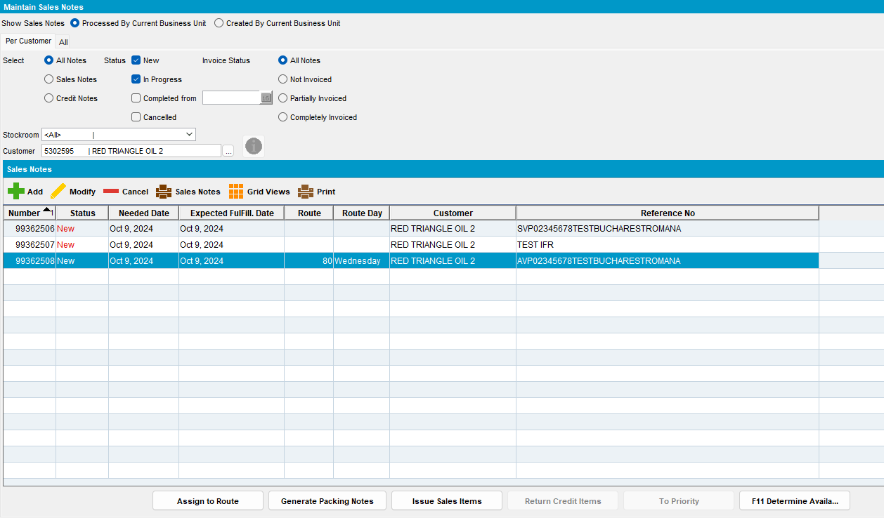

Print sales note:
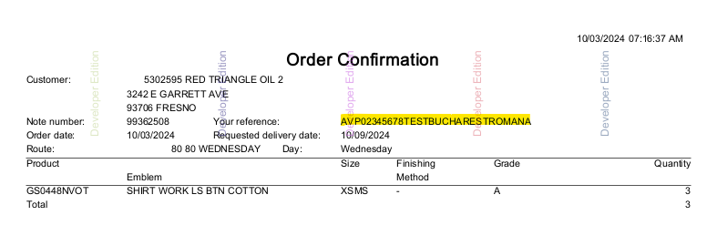
Issue Sales Items:
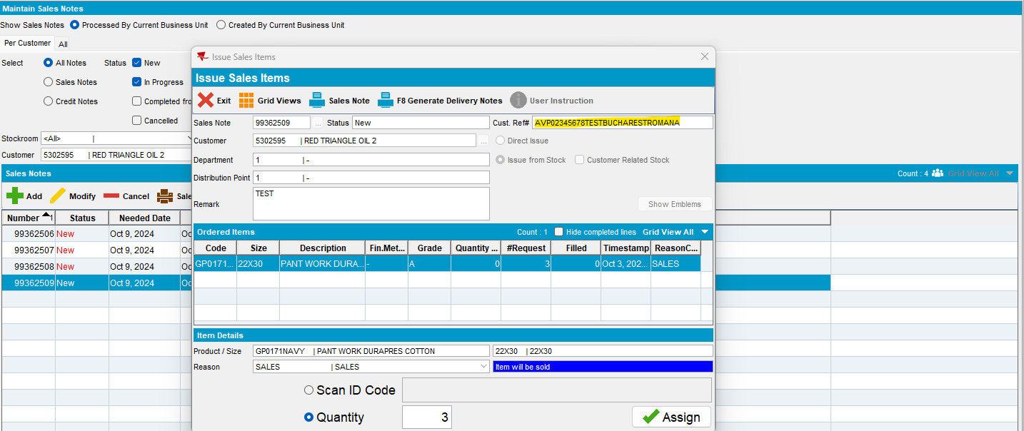
Generate Delivery Note:
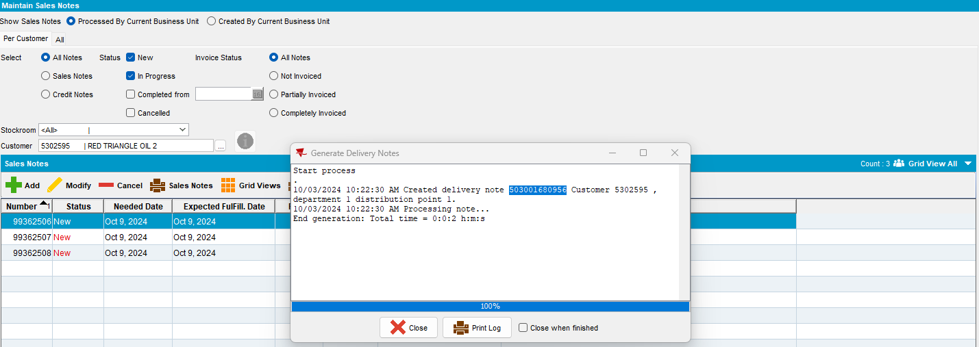
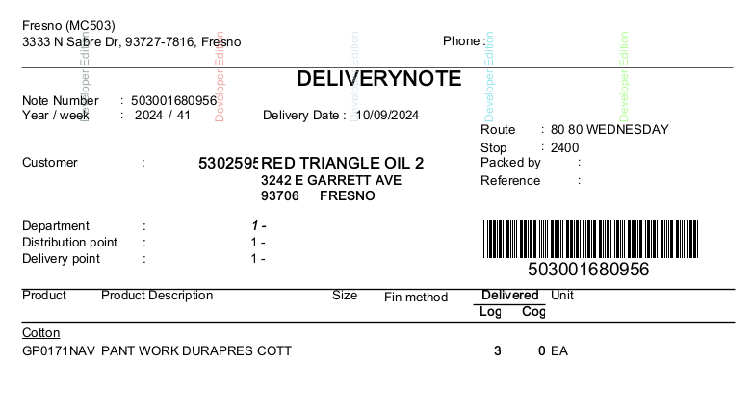
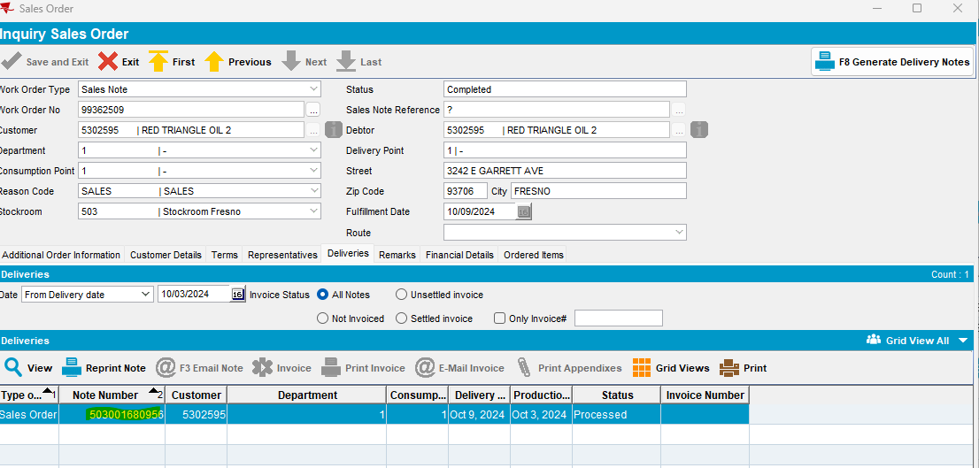
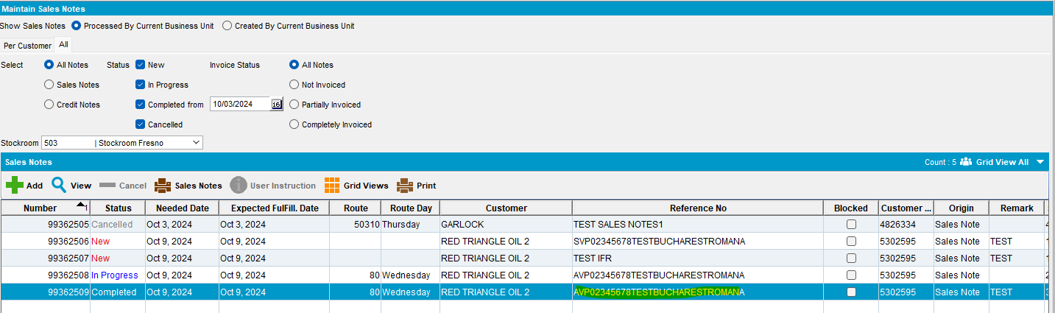
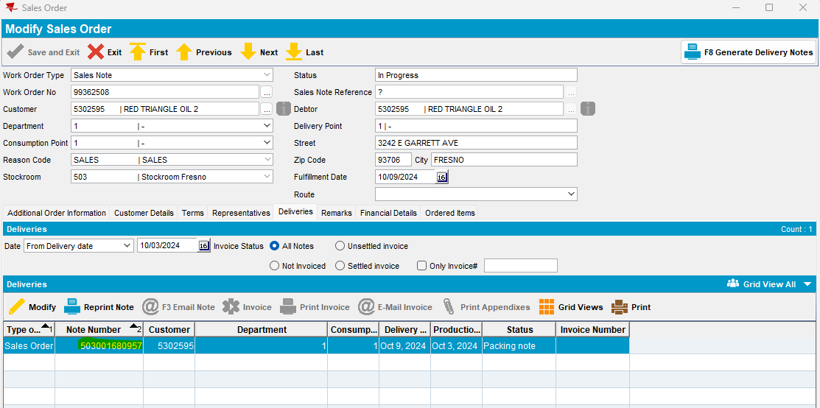

Generate invoice from RSC dlg:
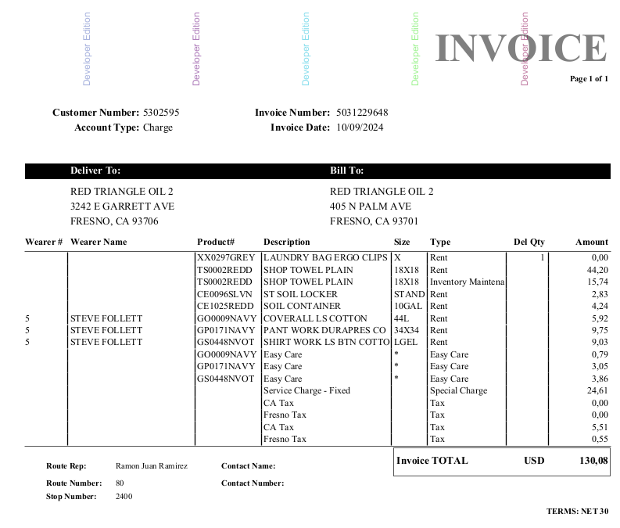
Another customer with Sales Note PO Mandatory not checked:
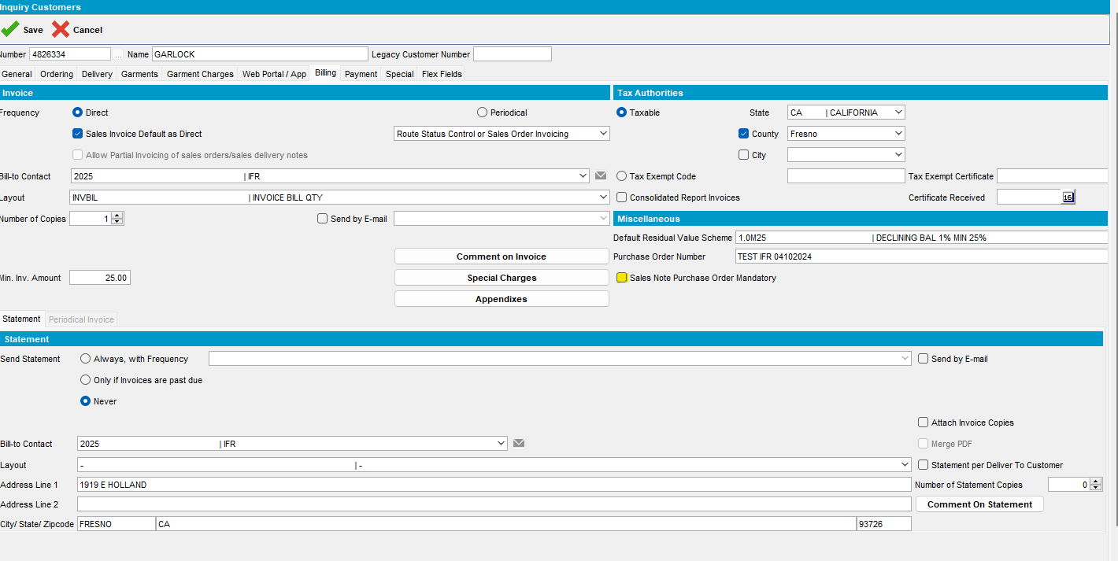

Add a new sales order -> PO number was not mandatory:
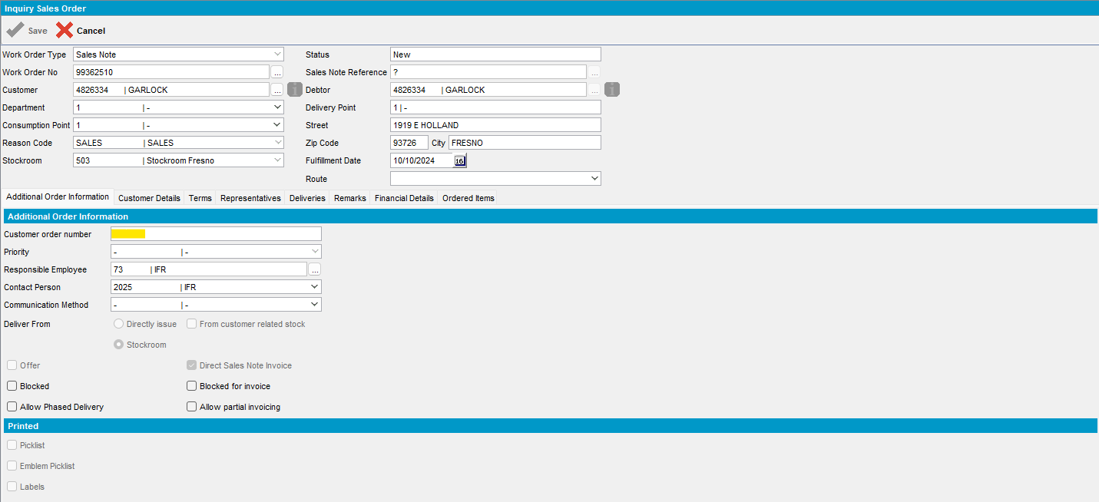

#7 – Check Special Orders dlg – Passed
SimpleInvoicePO = 1
PURCHASEORDER = if system setting SimpleInvoicePO = 1 theN
CustomerPurchaseOrder.PurchaseOrderNumber
Else NULL

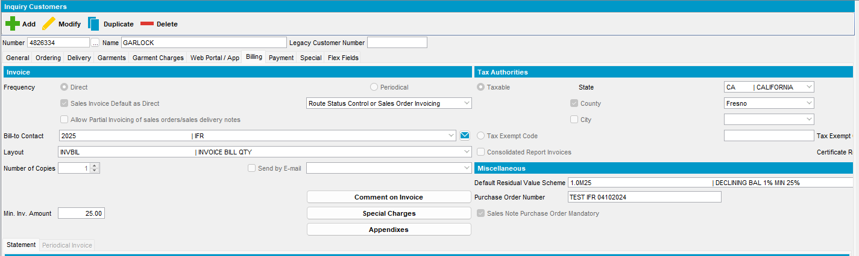

- Add a special order from Special Orders dlg:

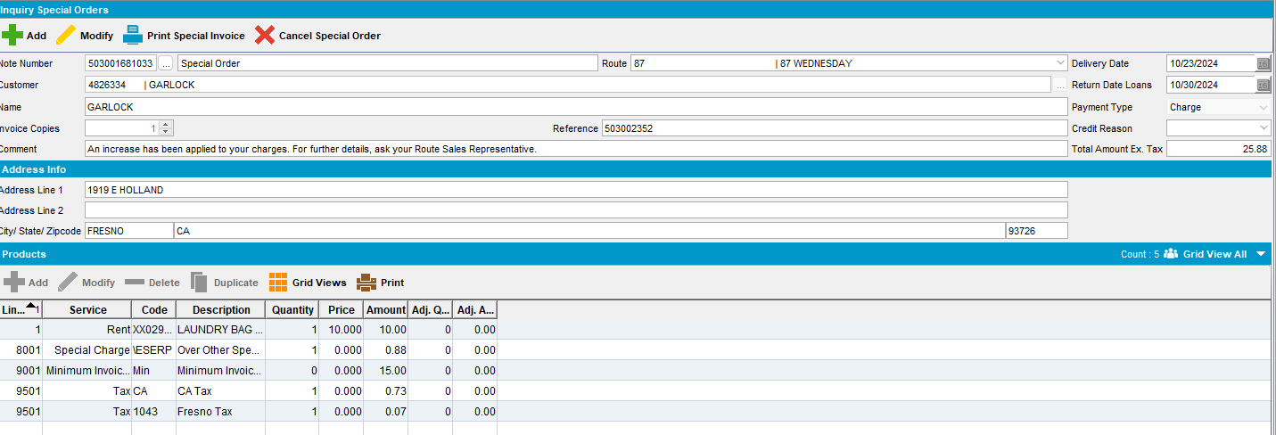

- Check On Maintain Invoices dlg:

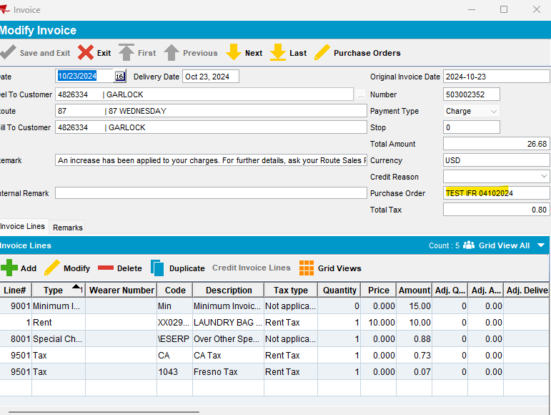

- Change PO number:
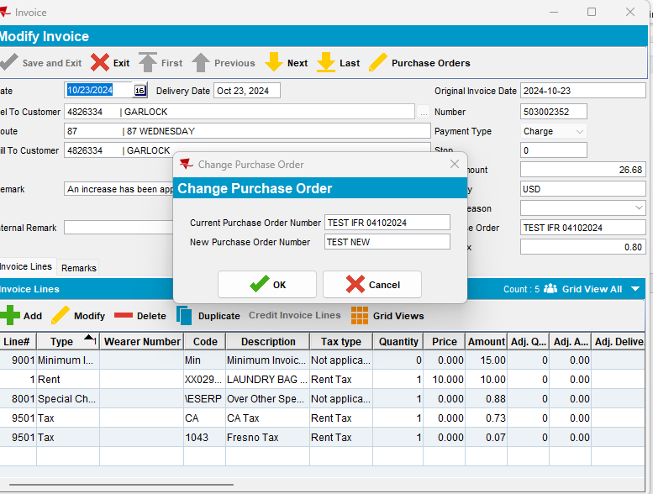

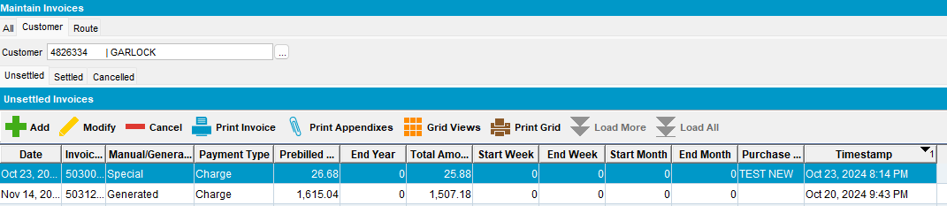

- Assig to the next delivery route and generate invoices

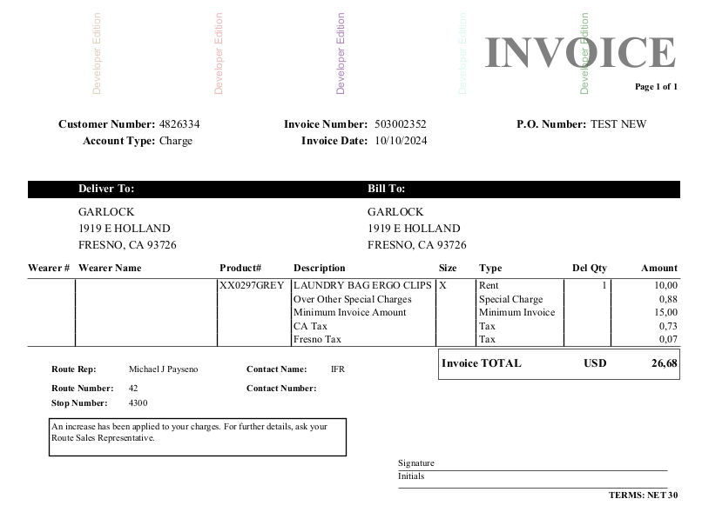

SimpleInvoicePO = 0
- Add a special order from Special Orders dlg:
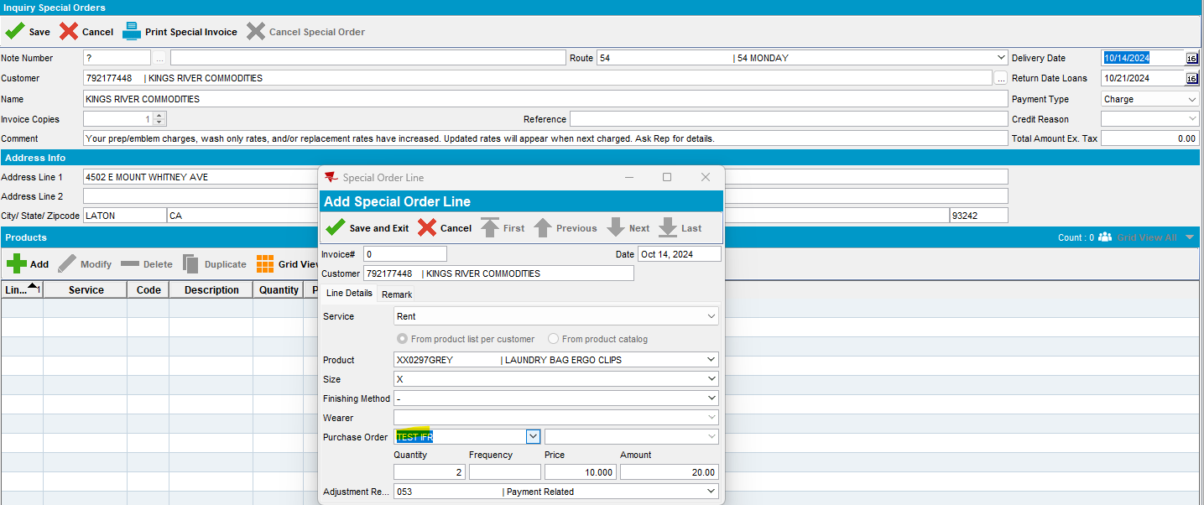
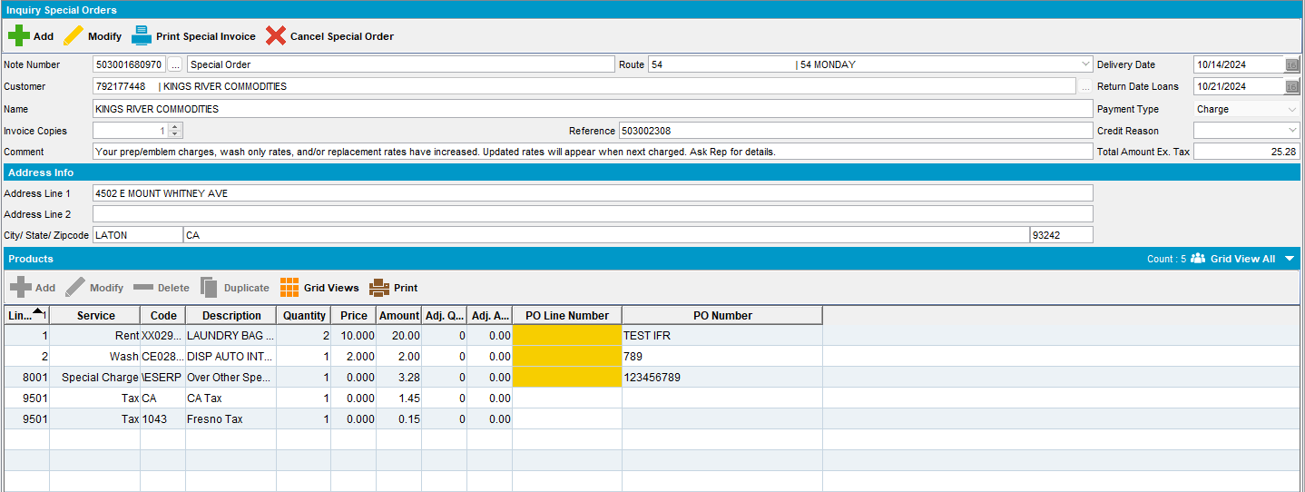
- Print Special Invoice:
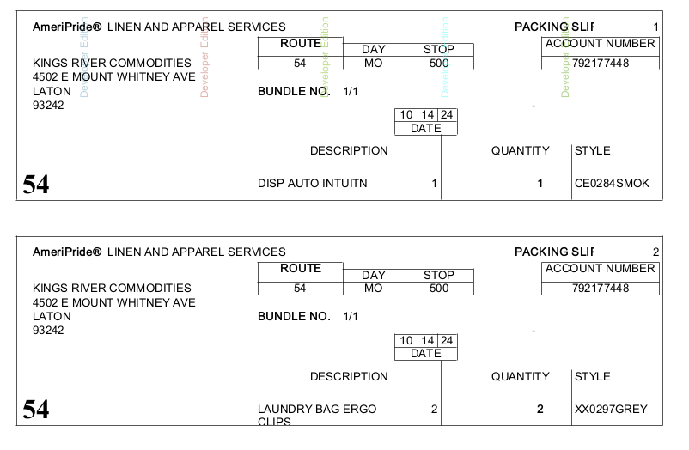
- From Maintain Invoice dlg check special invoice:
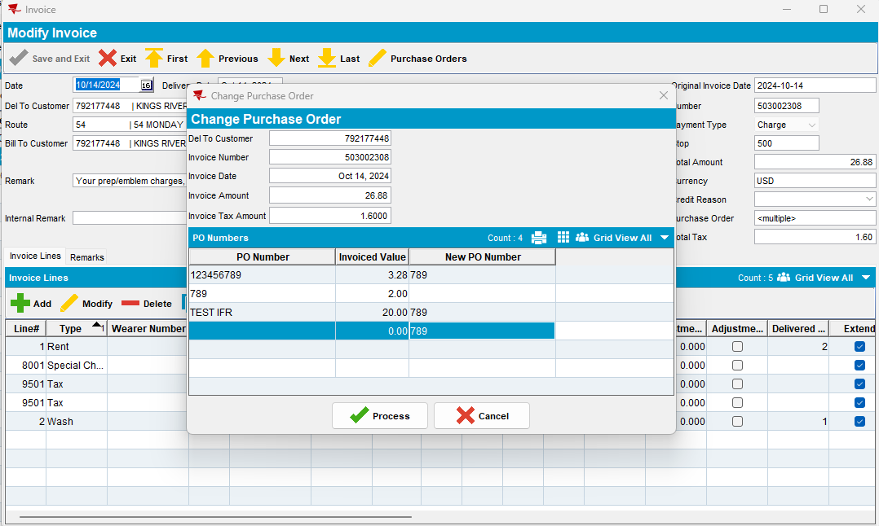
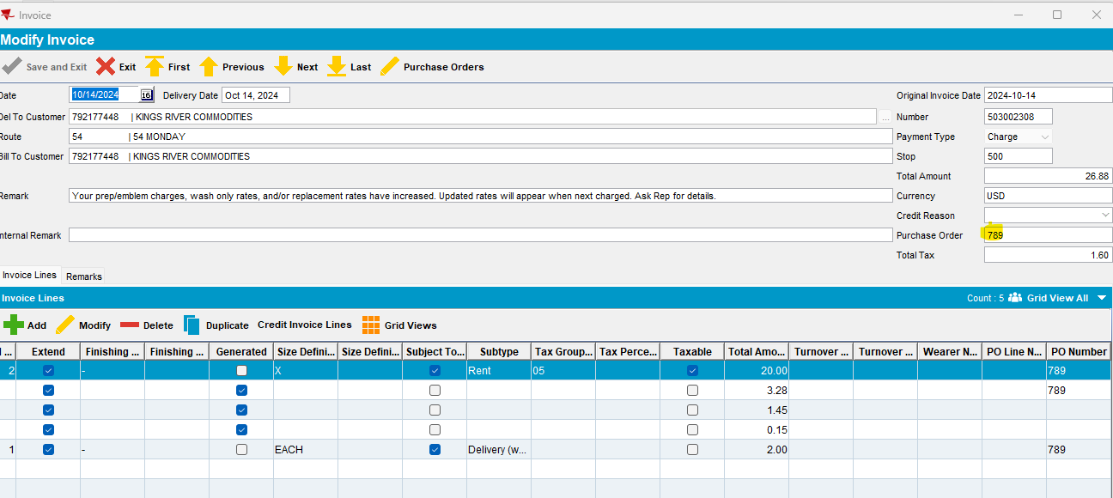
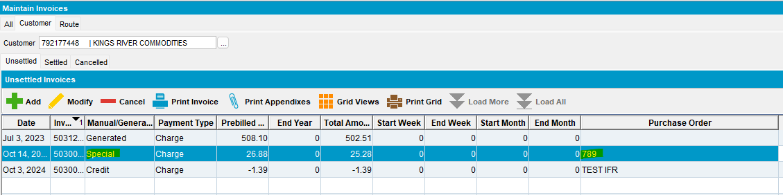

- Print special invoice:
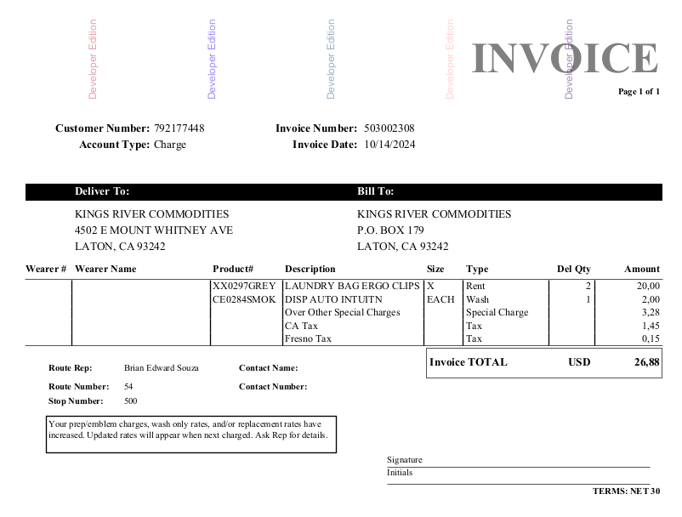

#8 – Check Generate Direct Invoice and Maintain Invoices dlg – Passed
SimpleInvoicePO = 0
Customer with predefined contract:
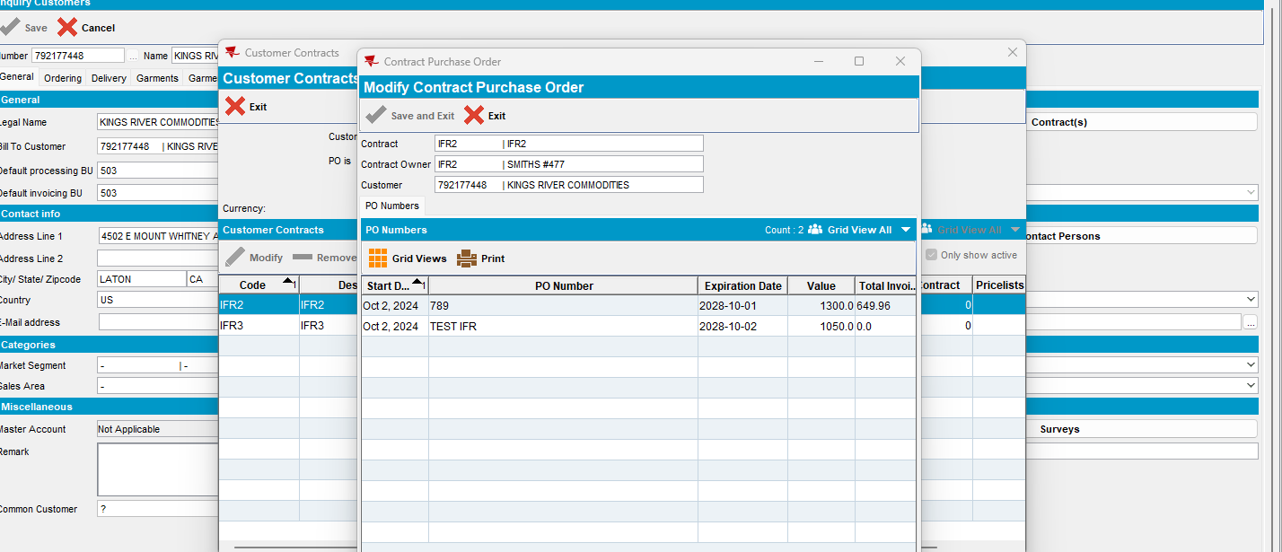
On maintain invoice grid:
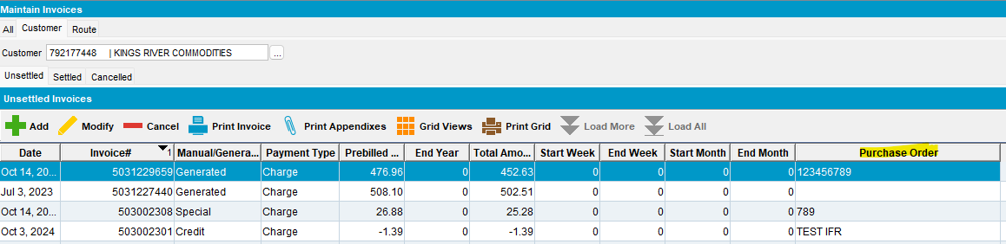
On modify invoice:
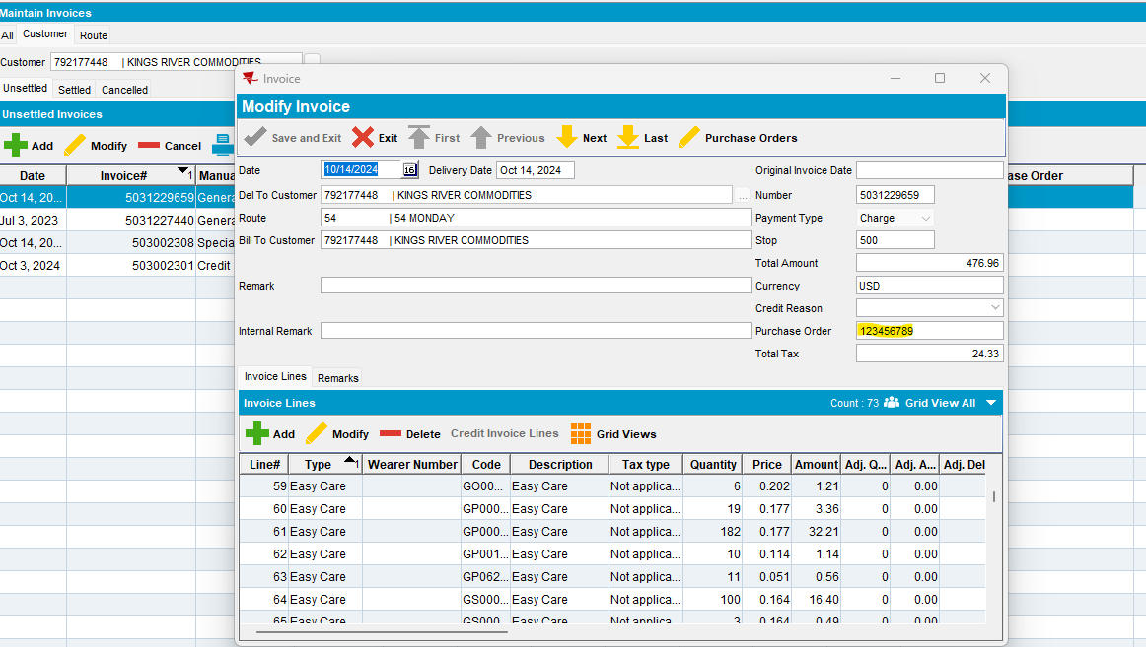
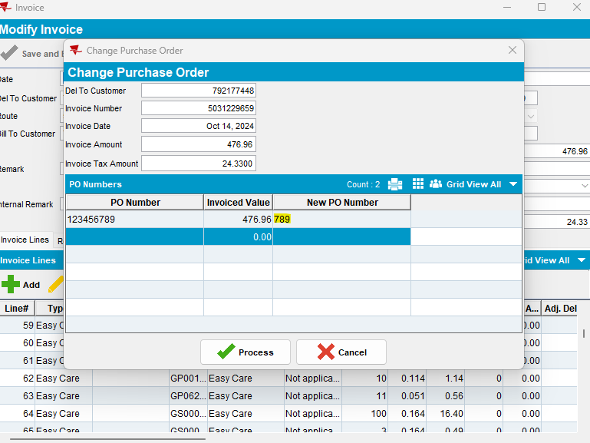
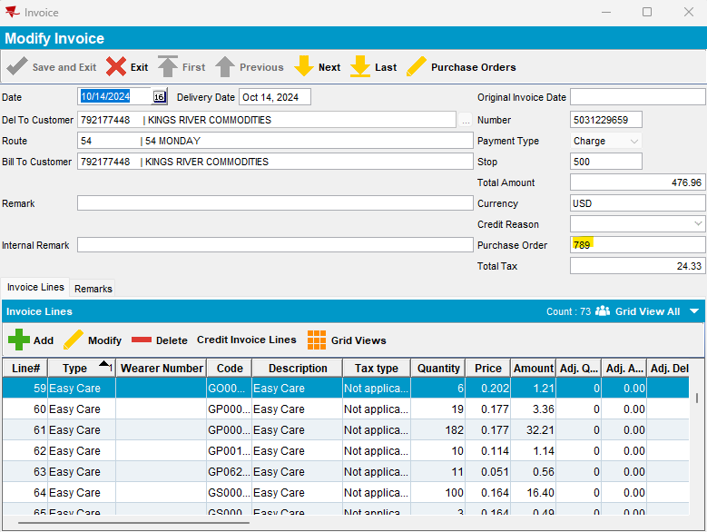
For settled invoice:
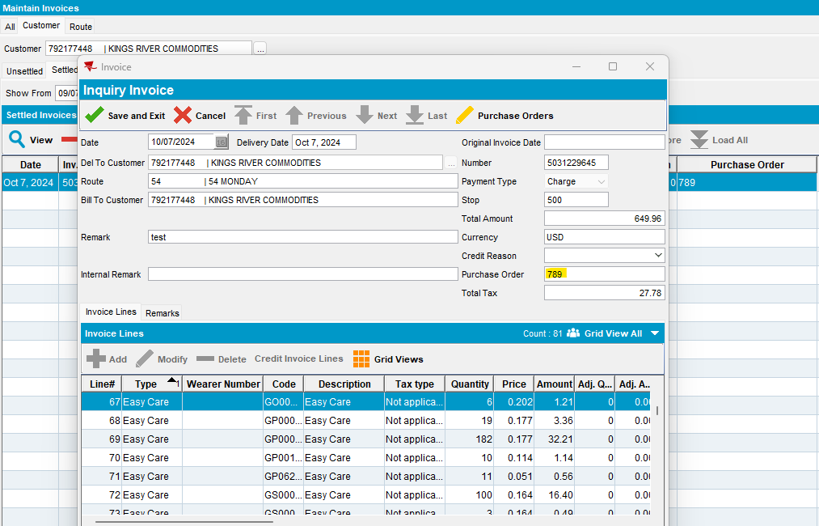
As well as for Special invoice, credit invoice, manual invoice.
Add a manual invoice:
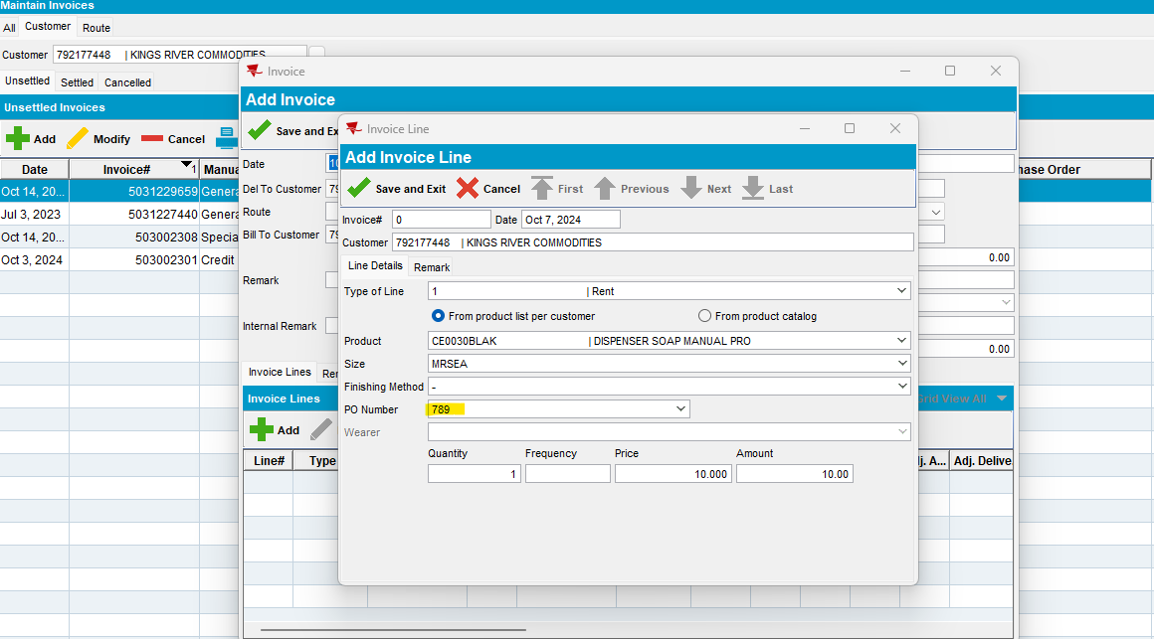
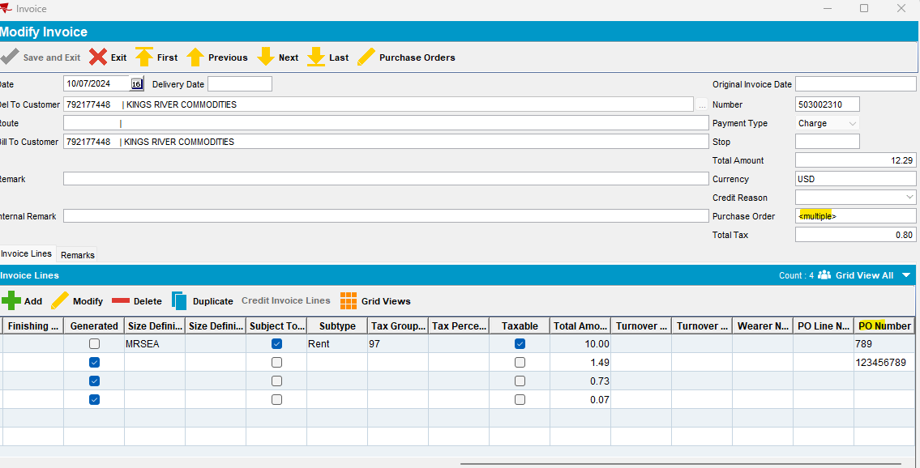
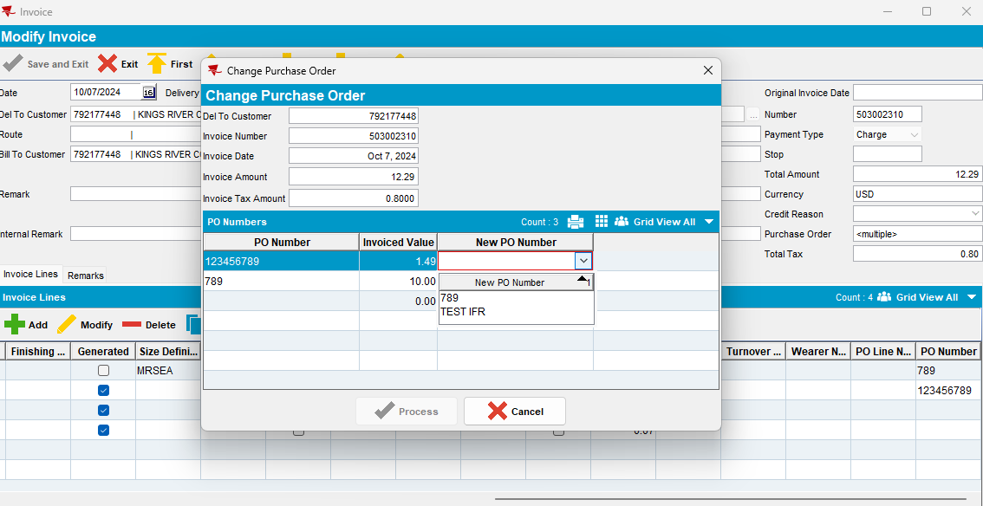
From All and Route tabs, also:
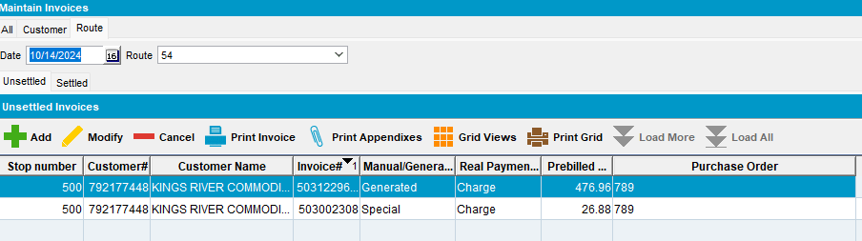
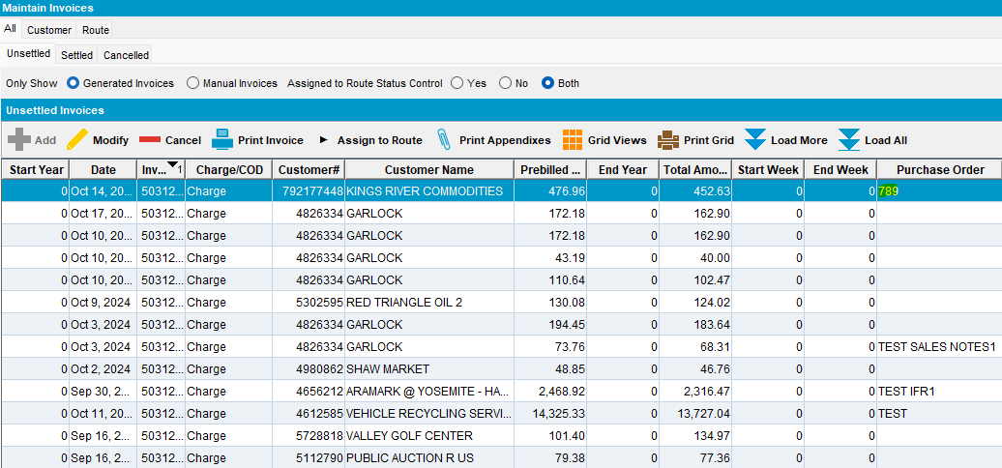
If system setting SimpleInvoicePO = 1
The purchase order number is taken from CustomerPurchaseOrder table for the del to customer

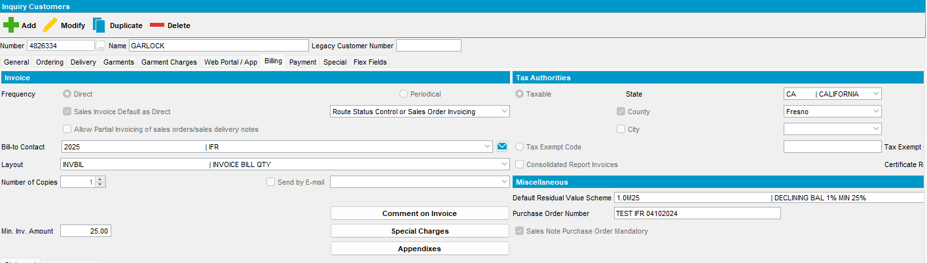
- Generate invoices or add manual invoices
- For some of the invoices change the PO number
- Assign to route
- Settle invoices
- Check PO number
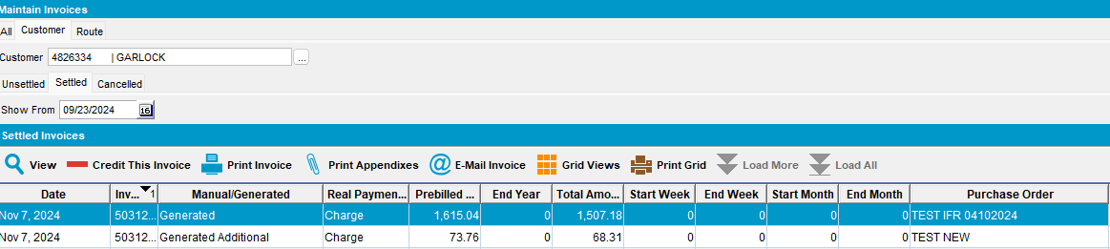
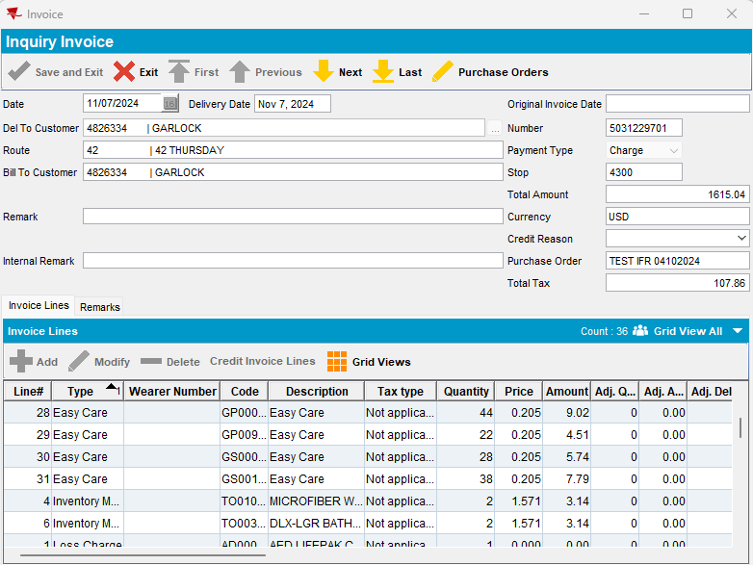
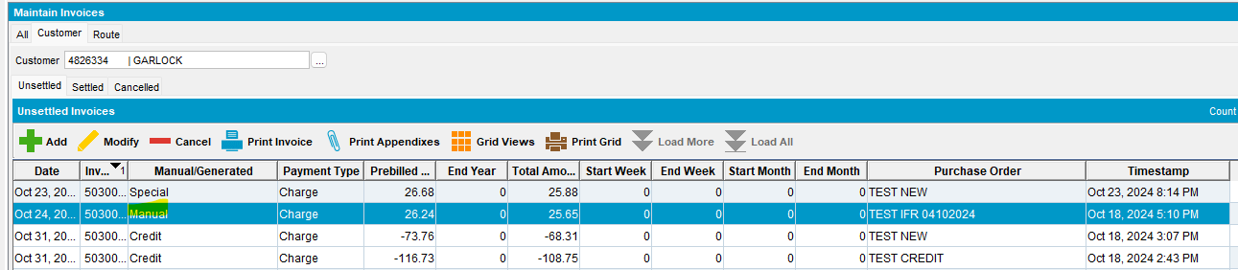
- Credit some invoices
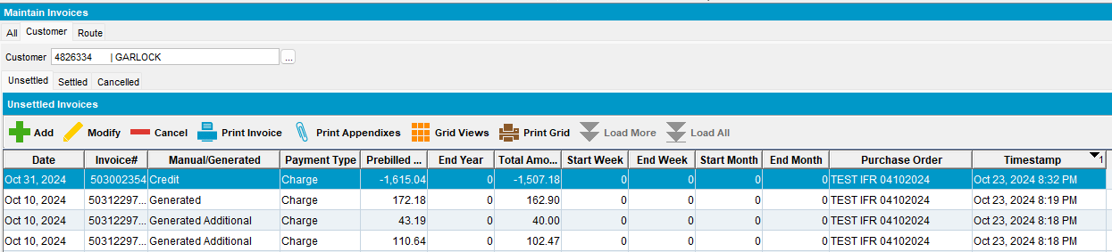

- Change PO number for credit invoices
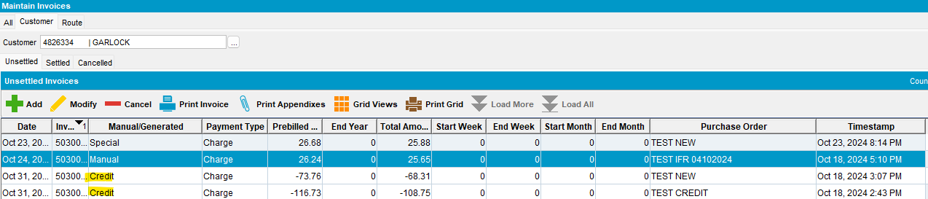

- Print invoice:
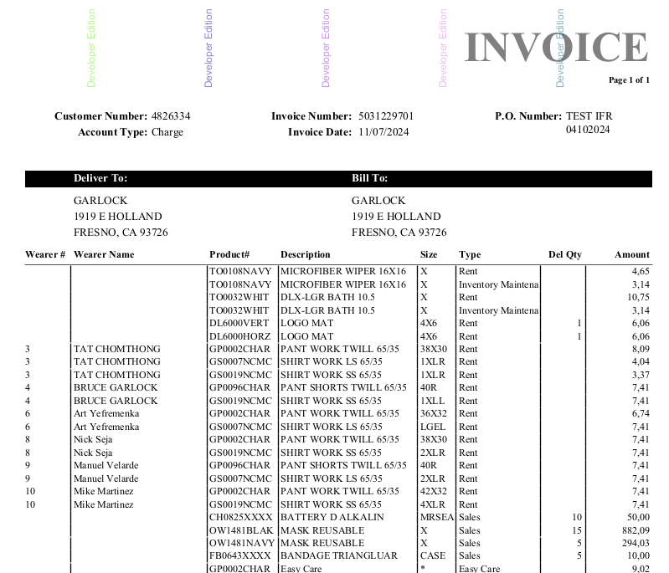

#9 – Check Generate Periodical Invoice dlg – Passed

SimpleInvoicePO = 1
If system setting SimpleInvoicePO = 1 then
CustomerPurchaseOrder.PurchaseOrderNumber

Customer with periodical invoice:
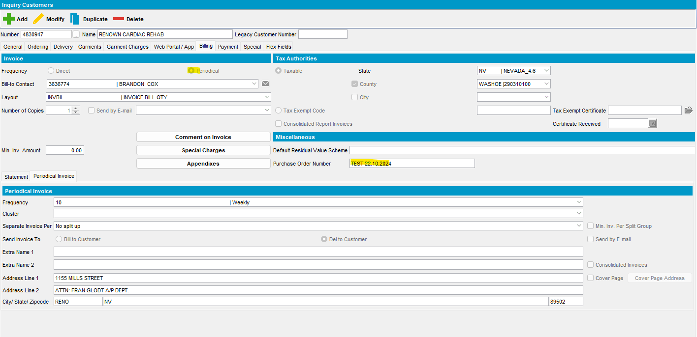
Generate invoice or add manual invoice:
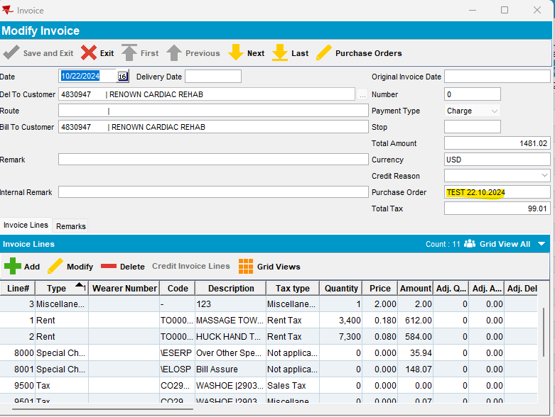
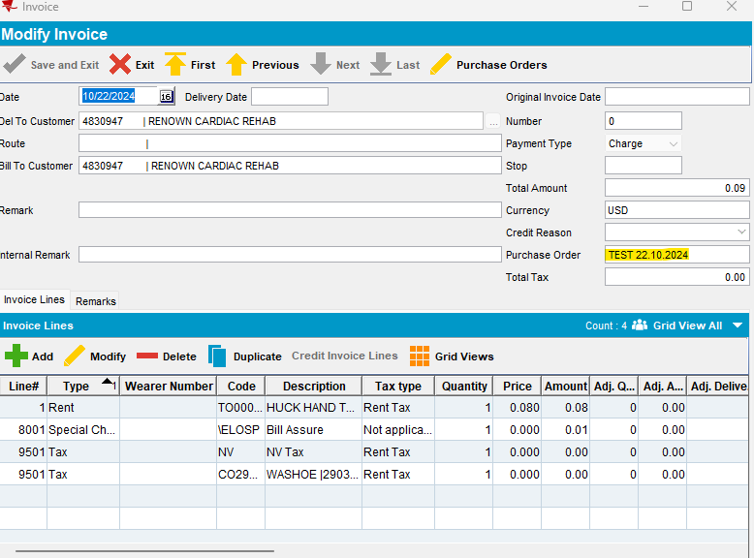
PO number is copied from customer level.

SimpleInvoicePO = 0
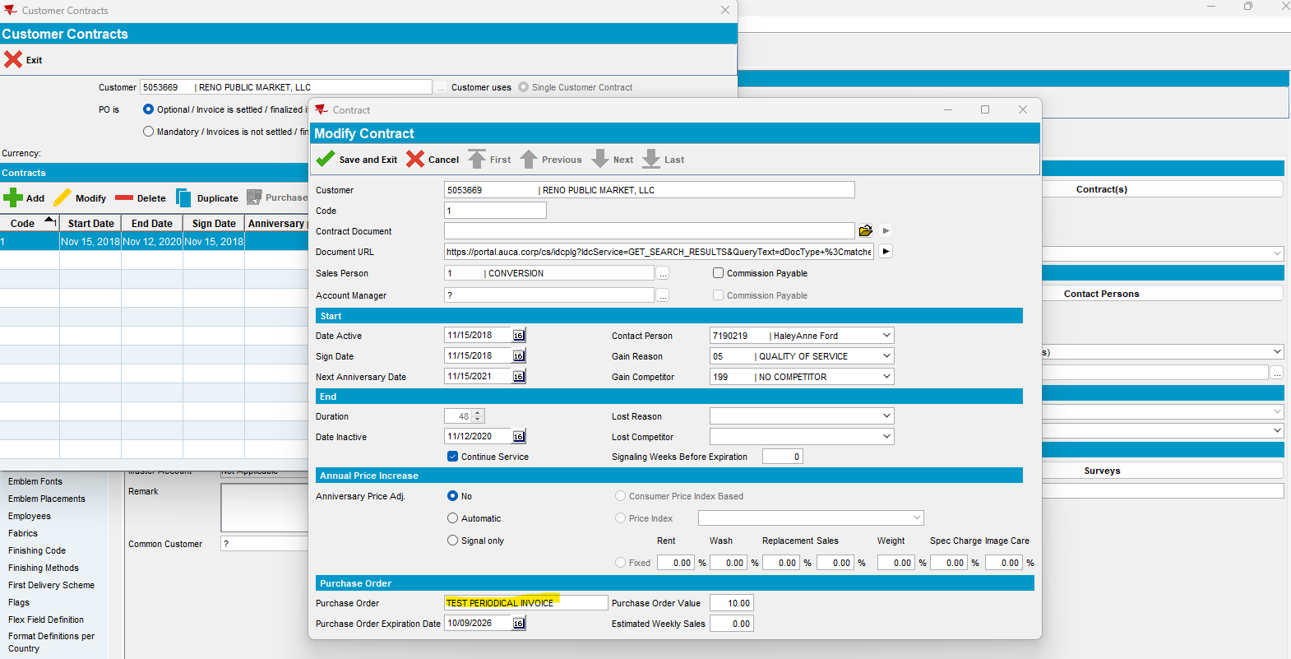

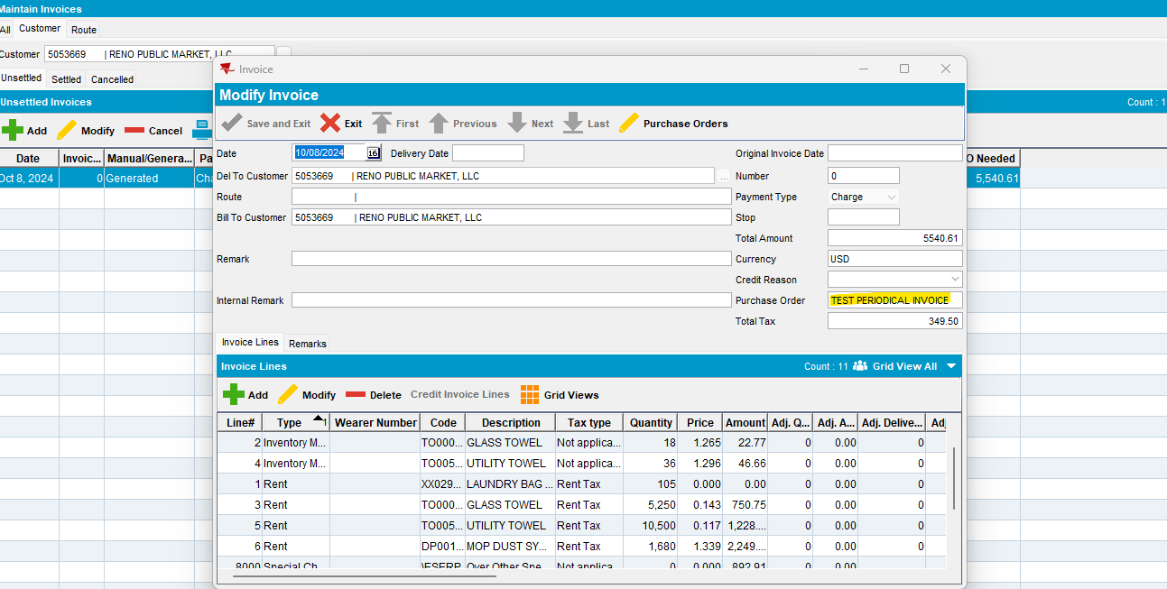

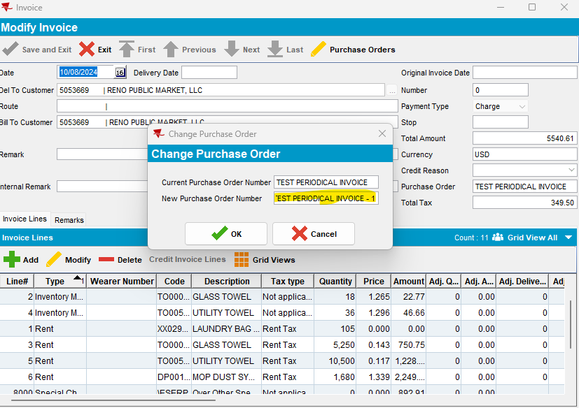

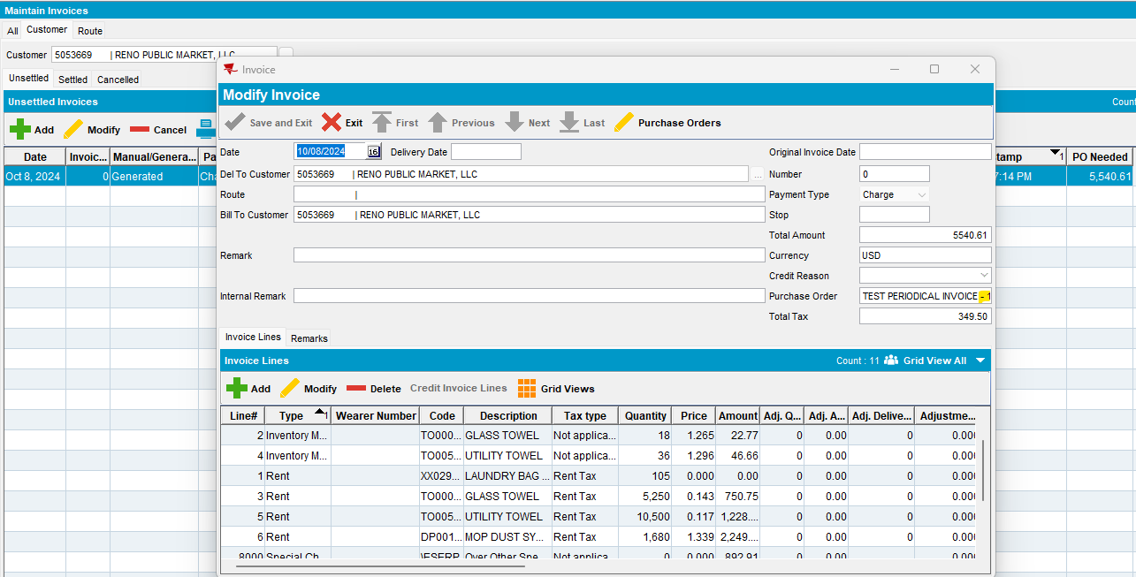

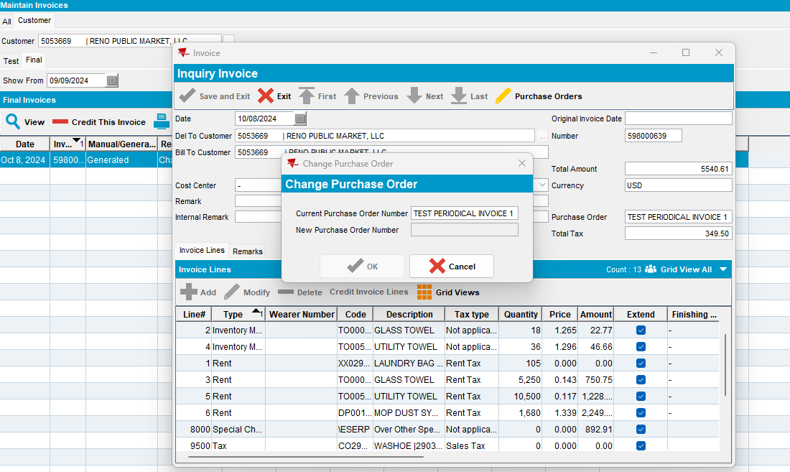
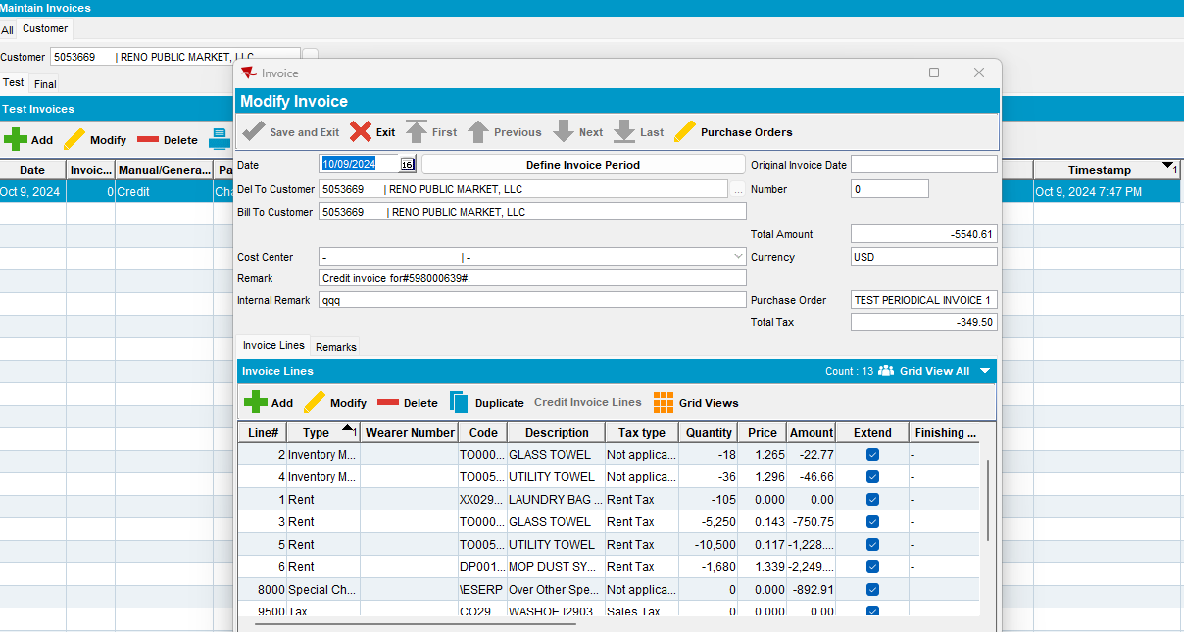

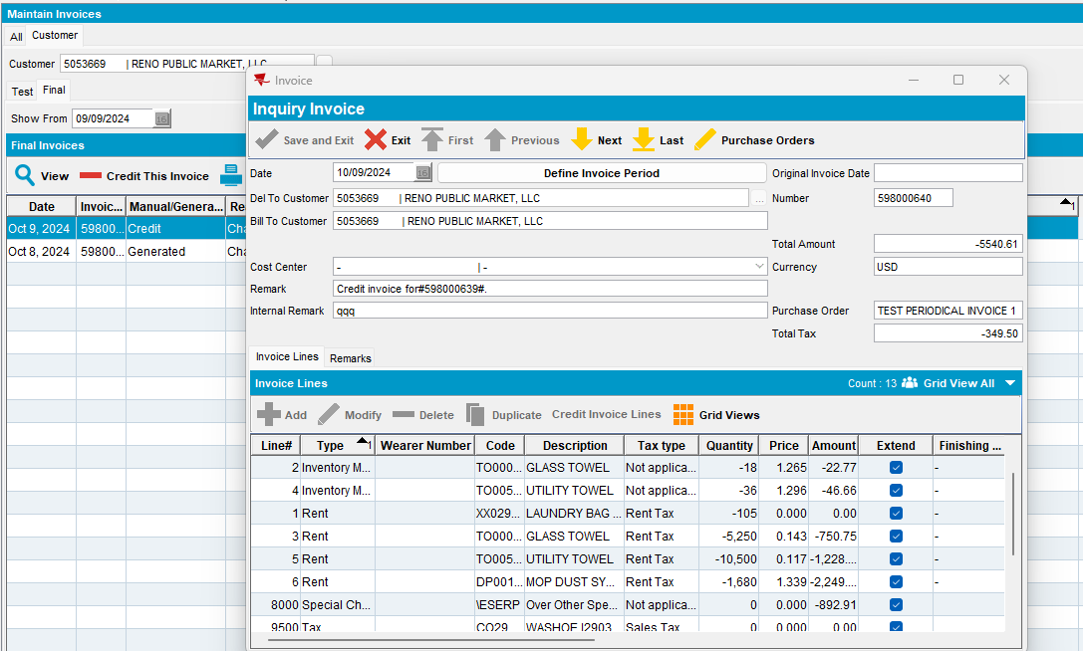

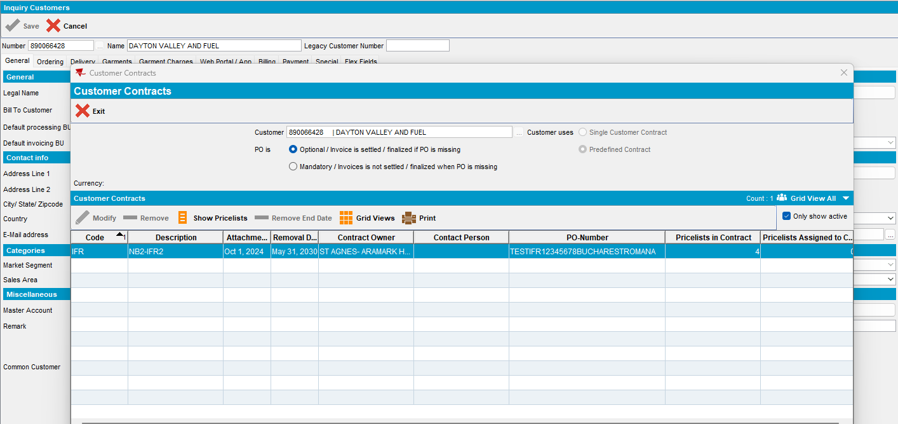

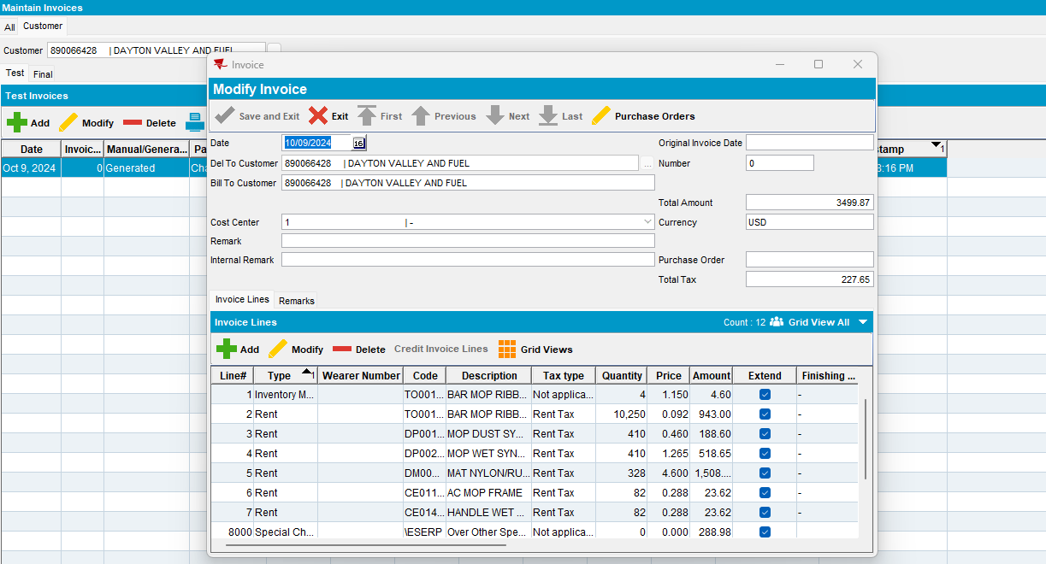

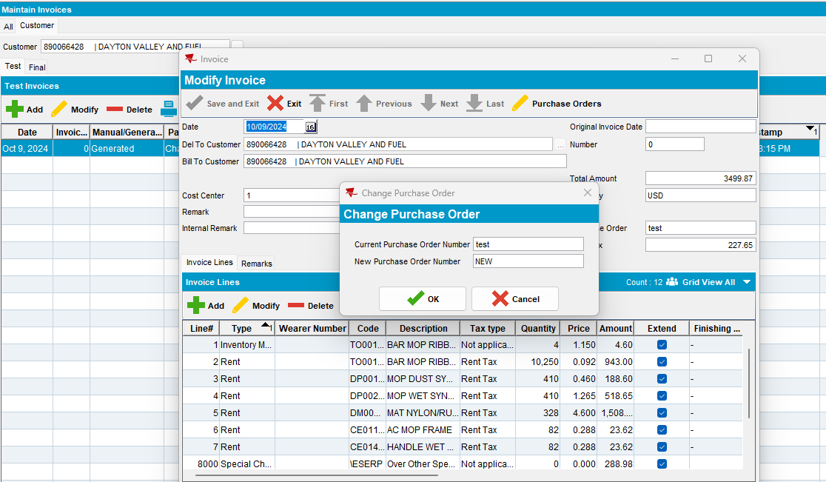

#10 – Check Settlement dlg – Passed

SimpleInvoicePO = 0
Settlement dlg -> Total PO Needed:
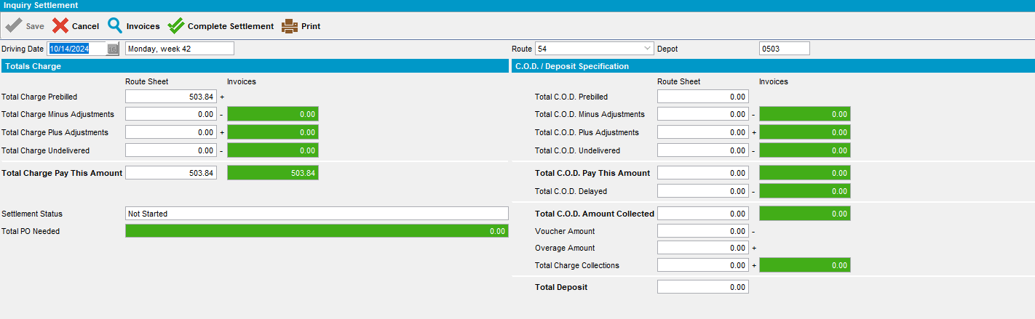

From Settlement dlg - > Adjust Invoice -> PO number:
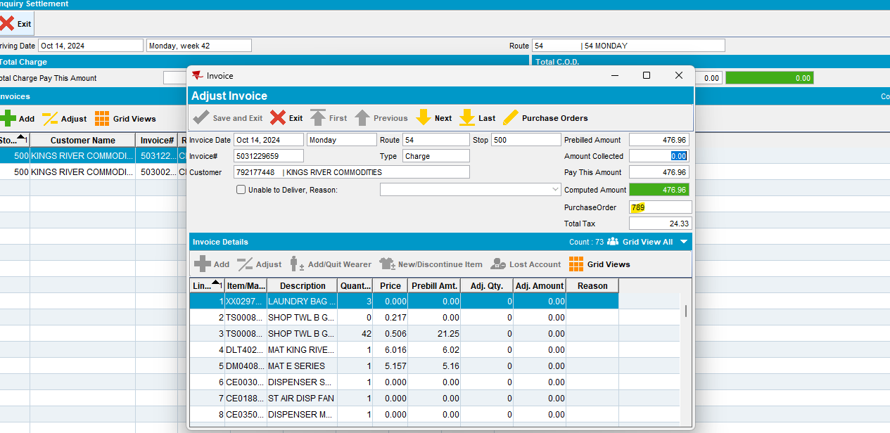
Change PO number (customer with predefined contract):
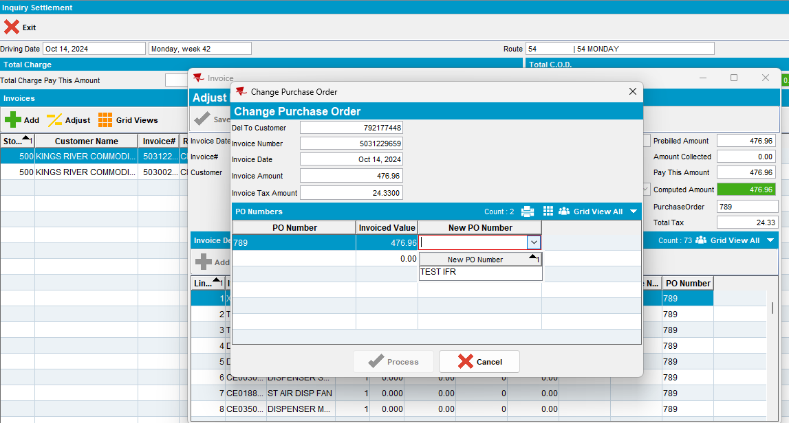
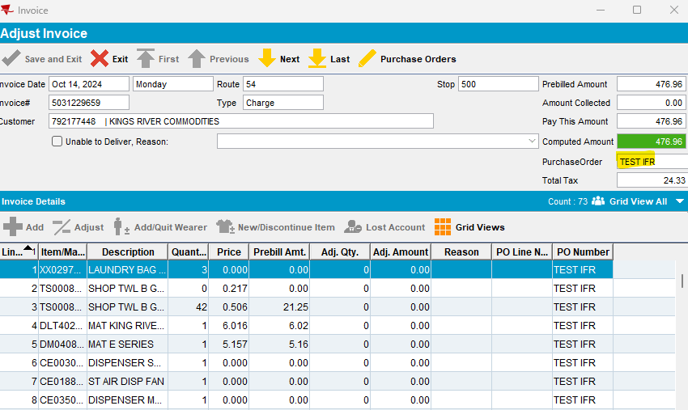
Adjust Invoice line - > PO Number for customer with predefined contract:
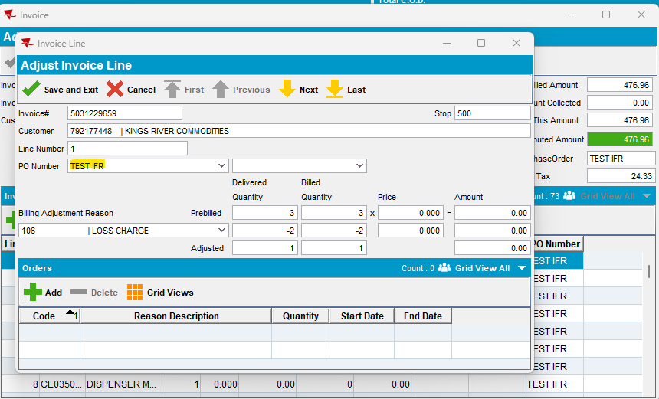

SimpleInvoicePO = 1
- Add next delivery route
- Customer with:
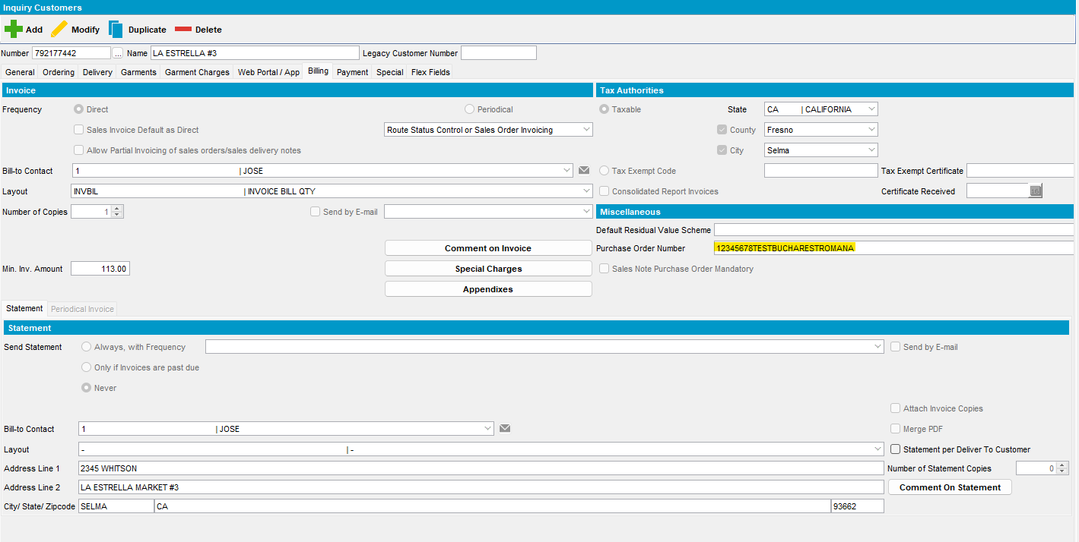
- Generate PNs and invoice for this customer:
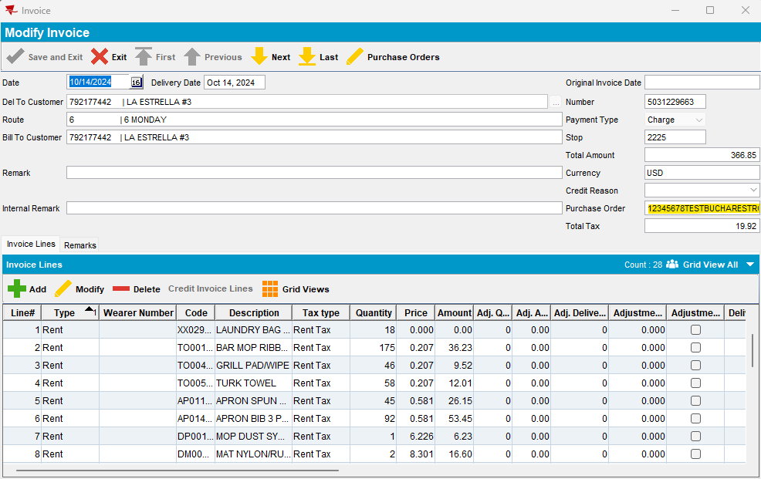
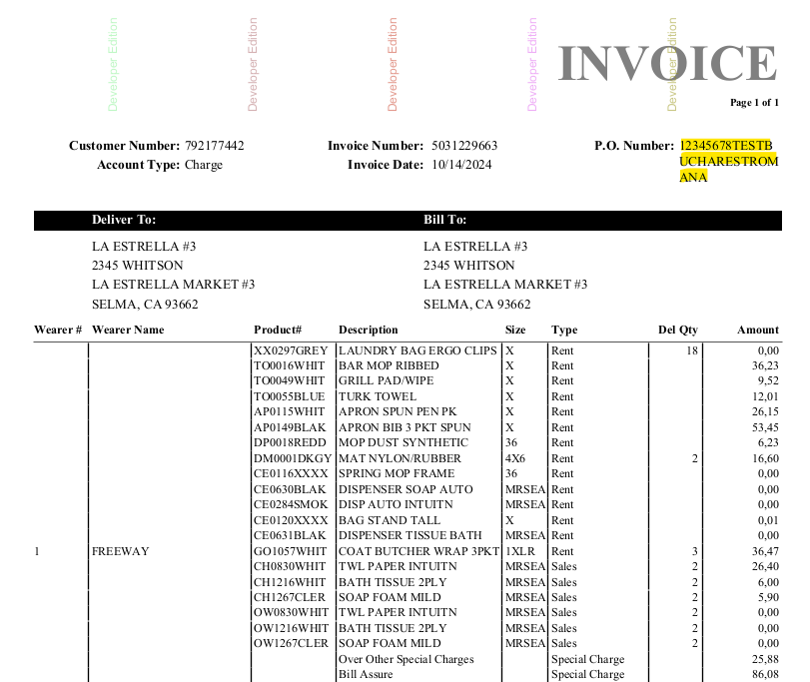

- Change the current PO with a new one:
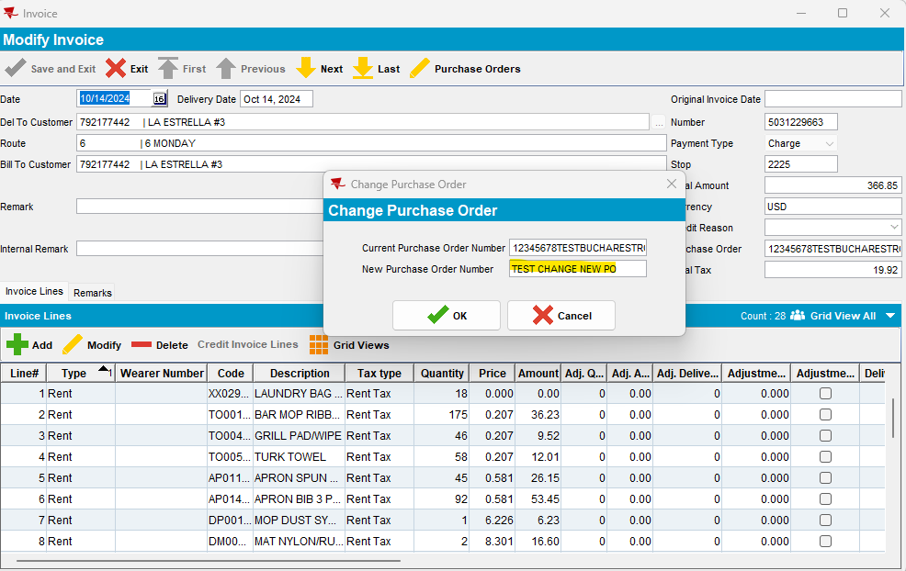
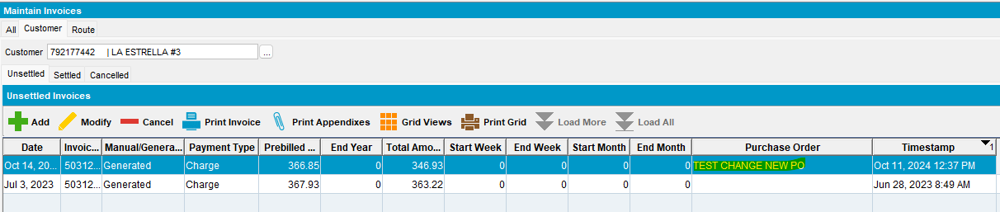
- Plus manual invoice and special order invoice:
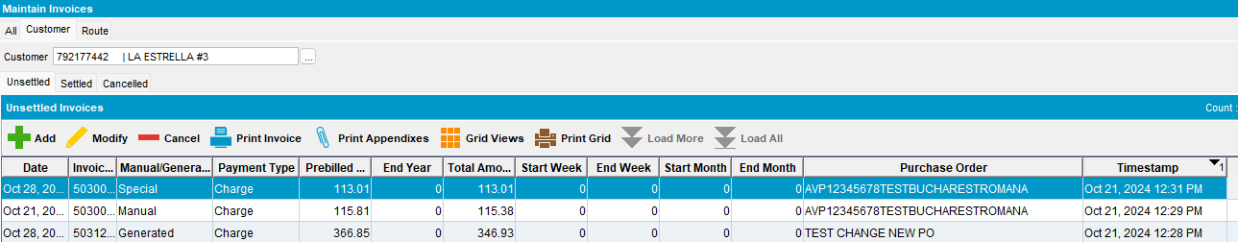
- Export route to PDA
- Downloading and start route
- On Ordering screen change the current PO with a new one
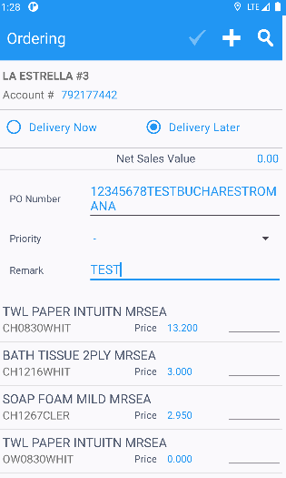

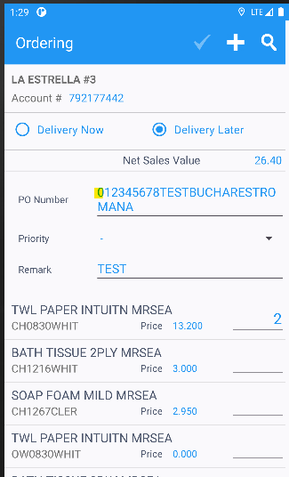
- Settle and depart route
- Uploading route
- Settle route and check the invoice
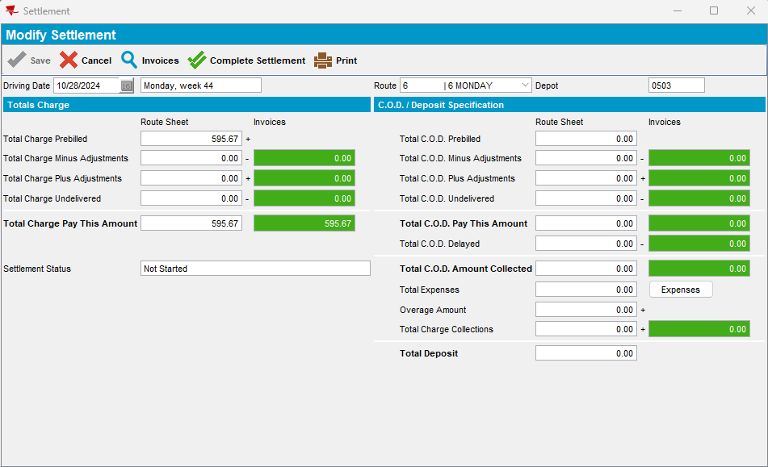
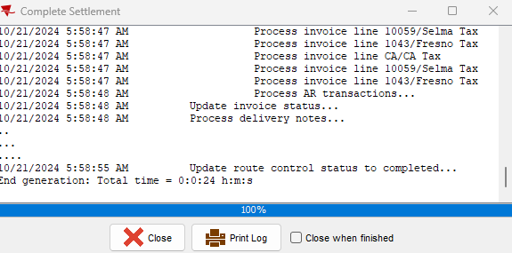

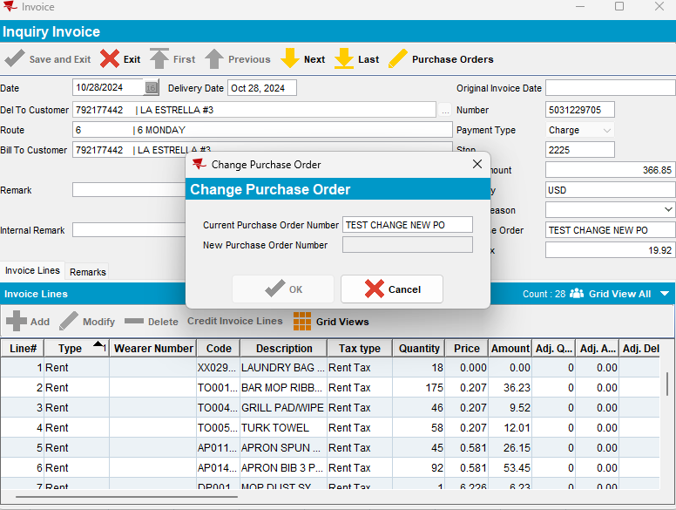
After settlement credit invoices:
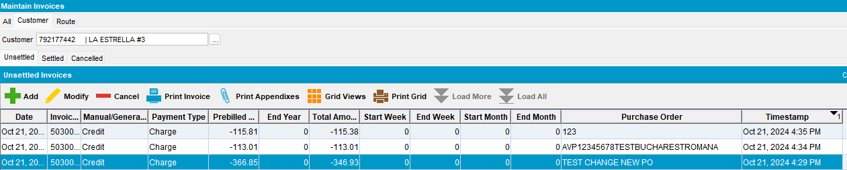

#11 – Check Route Assistant PDA flow – Passed
Pre-conditions:
- Module: FACILITYSERVICE, TRADE, ROUTEASSISTANTONEOFFORDER
- System setting: RECORDPASSIVETRUCKSTOCK = ‘Y’
- Specific steps to create data:
  - Stockroom Locations (Location type SERVICE)-> add disposable products from customer’s PLPC
  - Define a truck for stockroom location already created
  - Route with all customers/stops defined and with truck added -> Mark Ready for Transfer
  - Downloading route
SimpleInvoicePO = 1
- CustomerDTO table /SalesNotePO field (PDA database)
If system setting SimpleInvoicePO = 1
The purchase order number is taken from CustomerPurchaseOrder -> ok
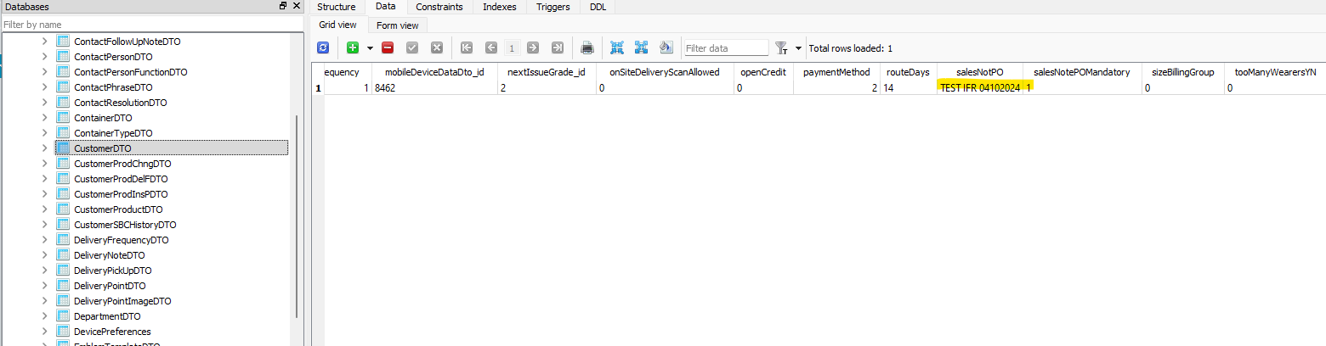
- Start route:
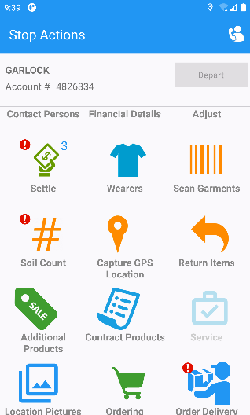

- Open Ordering screen and check PO Number for Delivery Now option -> ok
- Order qty
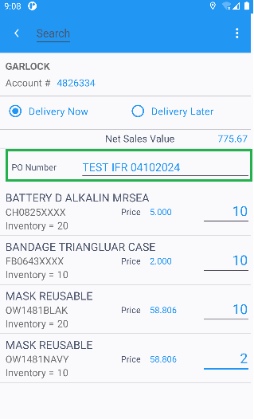

- Open Ordering screen and check PO Number for Delivery Later option -> ok
- Order qty

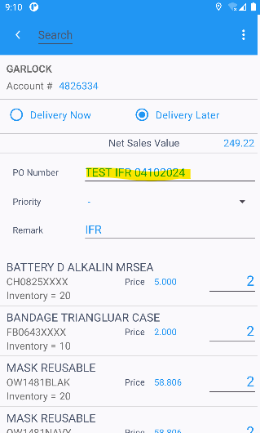

- On Delivery Now screen change PO Number and save the change -> ok

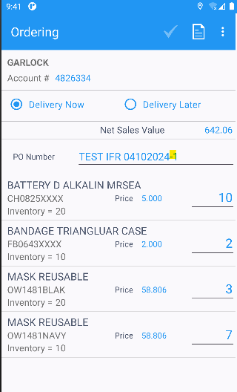
- On Delivery Later screen change PO Number and save the change -> ok

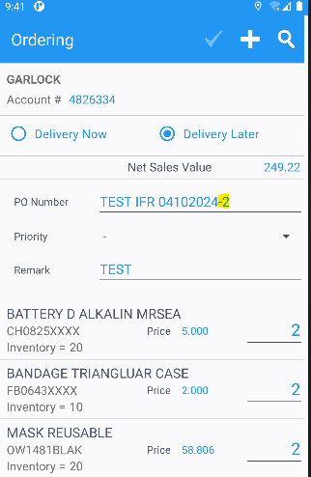
- Check PO Number on Order Delivery screen, also -> ok
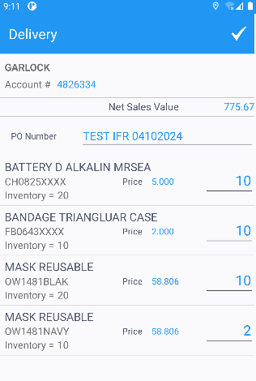
- Check PO number on the same screens from One Off Cycle Customer screen -> ok
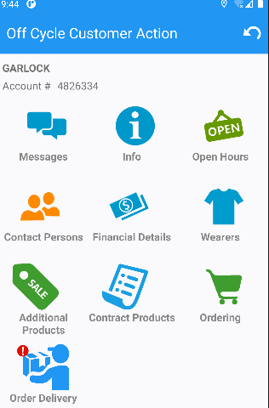
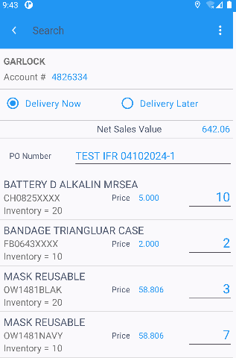
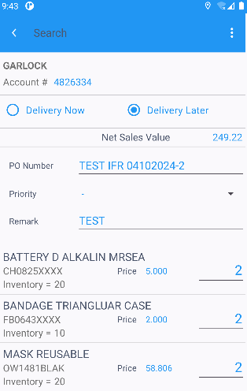

- Check for PO Number, field length -> 30 characters are allowed -> ok
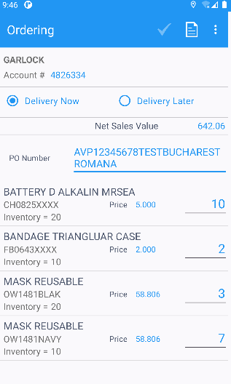
On TransactionDTO table (PDA database) on string 1 field, the changed PO’ numbers are saved:
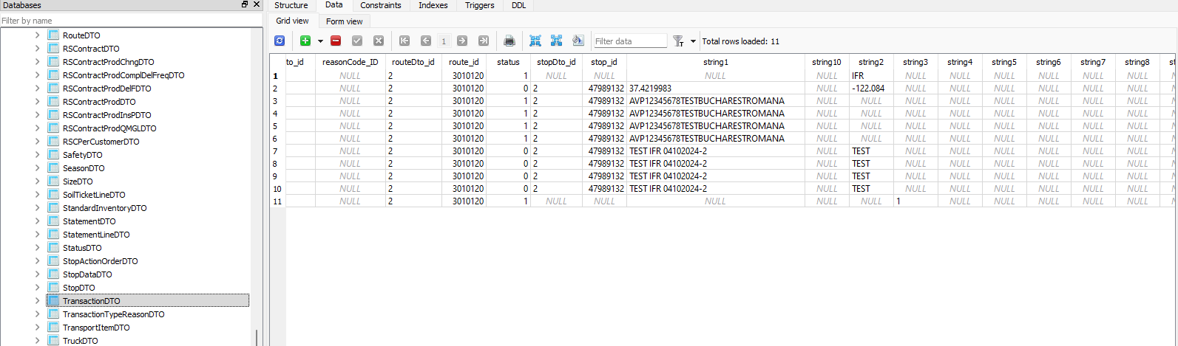

- Settle route, depart route, uploading route
- Settle route on client side
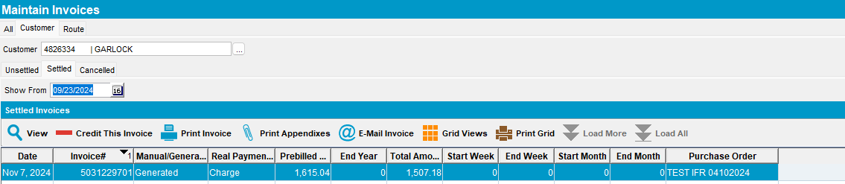

#12 – Check Access Rights List – Passed

SIMPLEINVOICEPO=1
select * from fieldsperdialog;
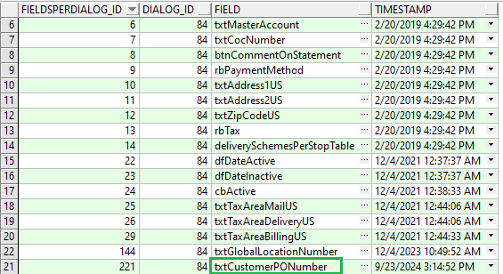
select * from Fieldsrelations;
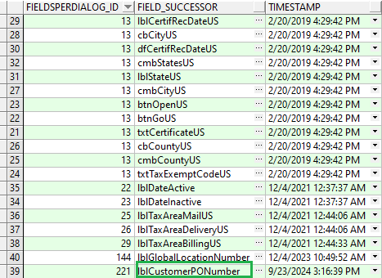

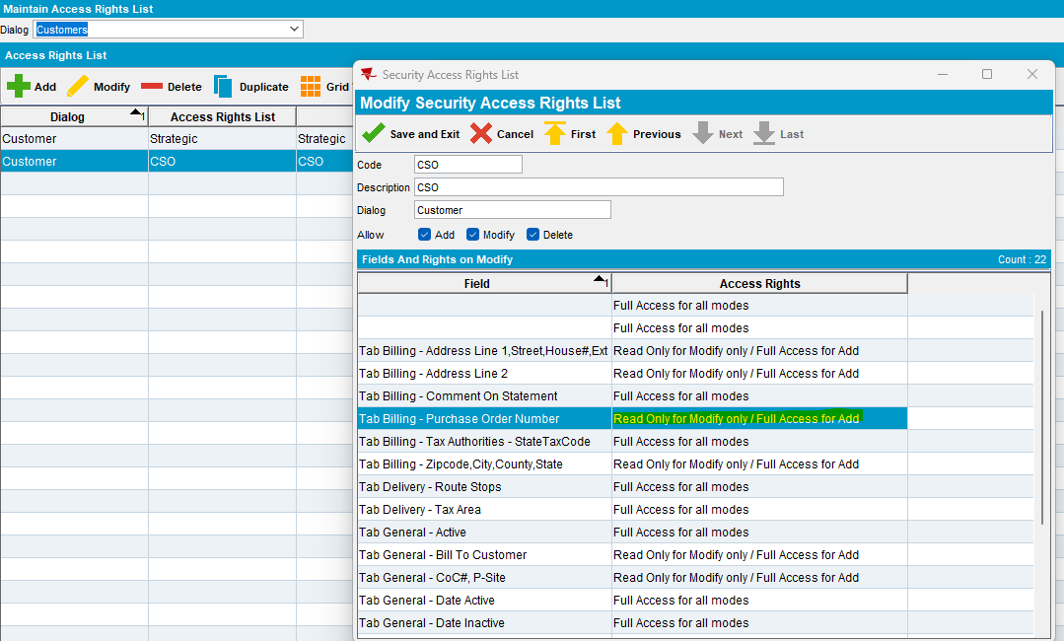

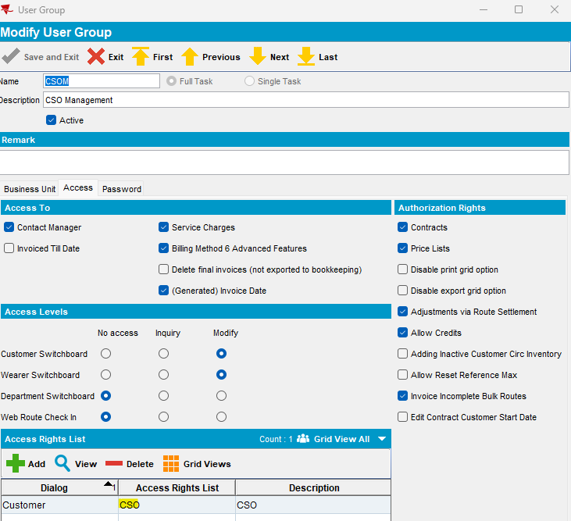
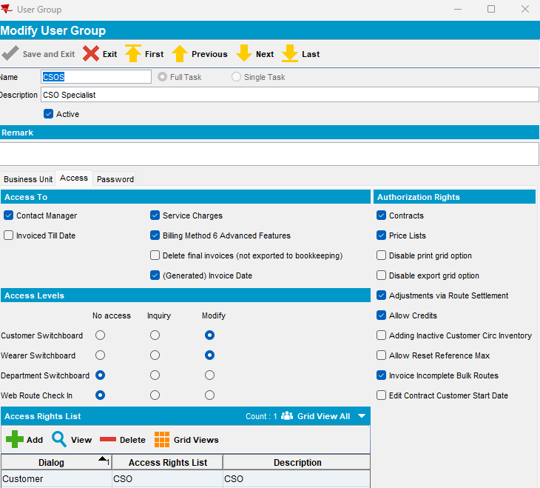
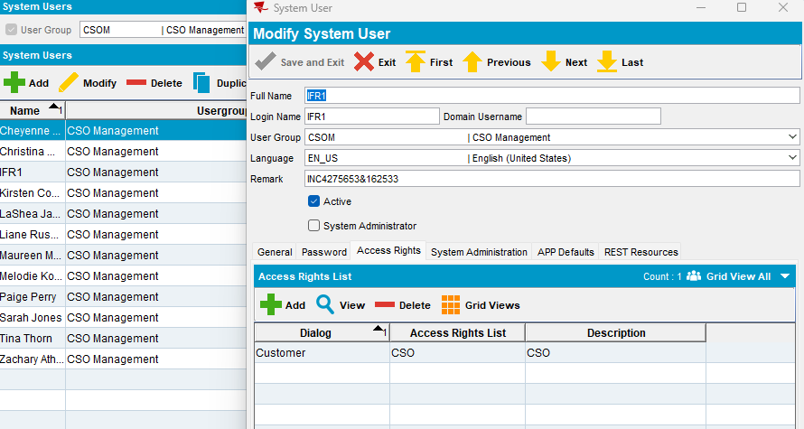
select * from accessrightslist;

select c.* from CustomerPurchaseOrder c where c.customer_id=4136;

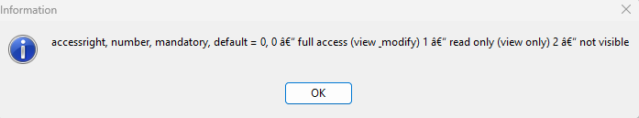
select * from Fieldsrelations;
select * from fieldsperdialog;
select * from accessrightslist;
select * from accessrightfieldlists a where a.accessrightslist_id in (2) and a.fieldsperdialog_id=221;

1.
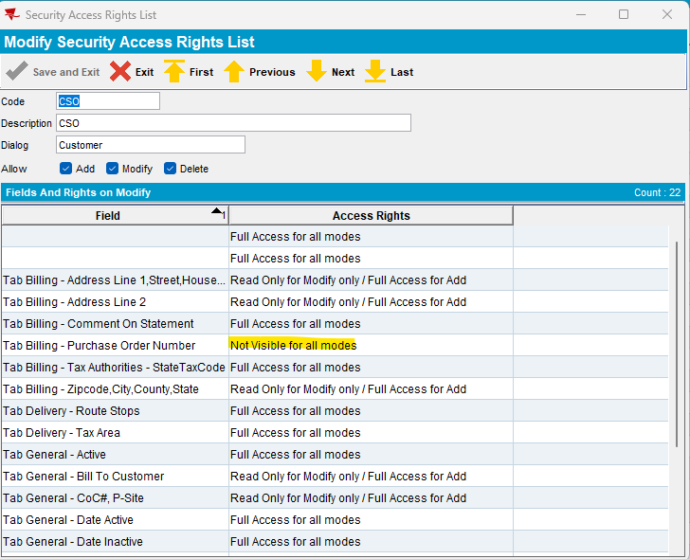
- Modify mode:
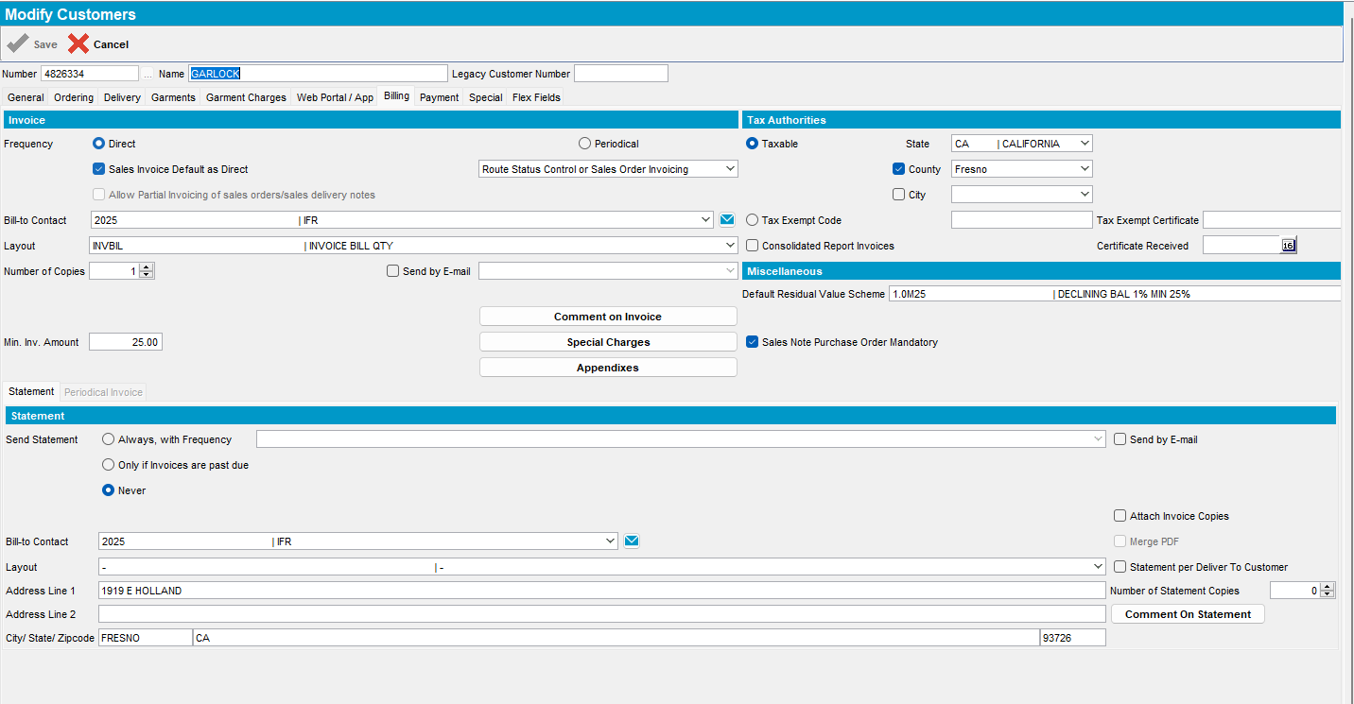
- Add mode:
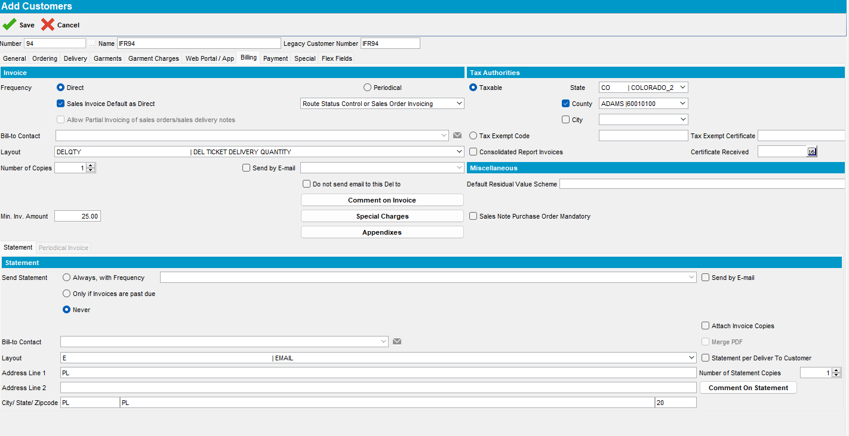
2.
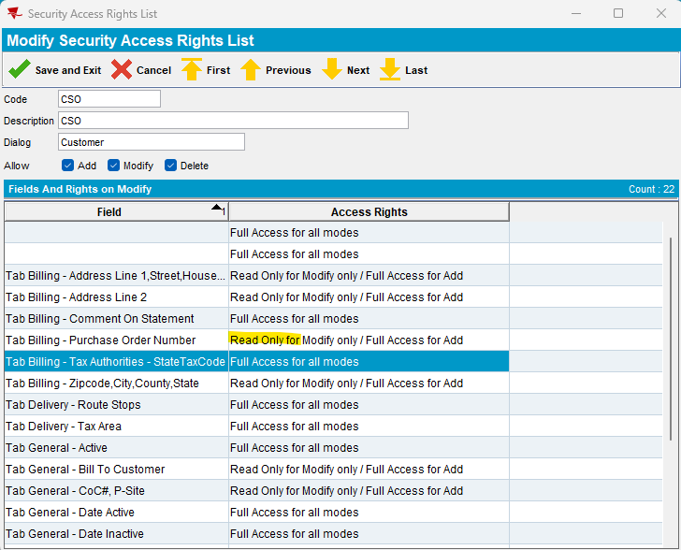

- Read only for Modify:
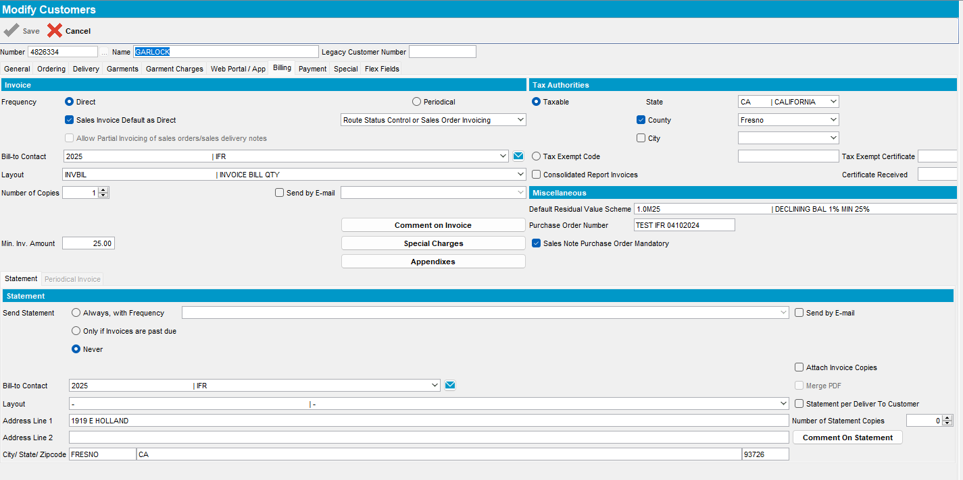
- Full access for add mode:
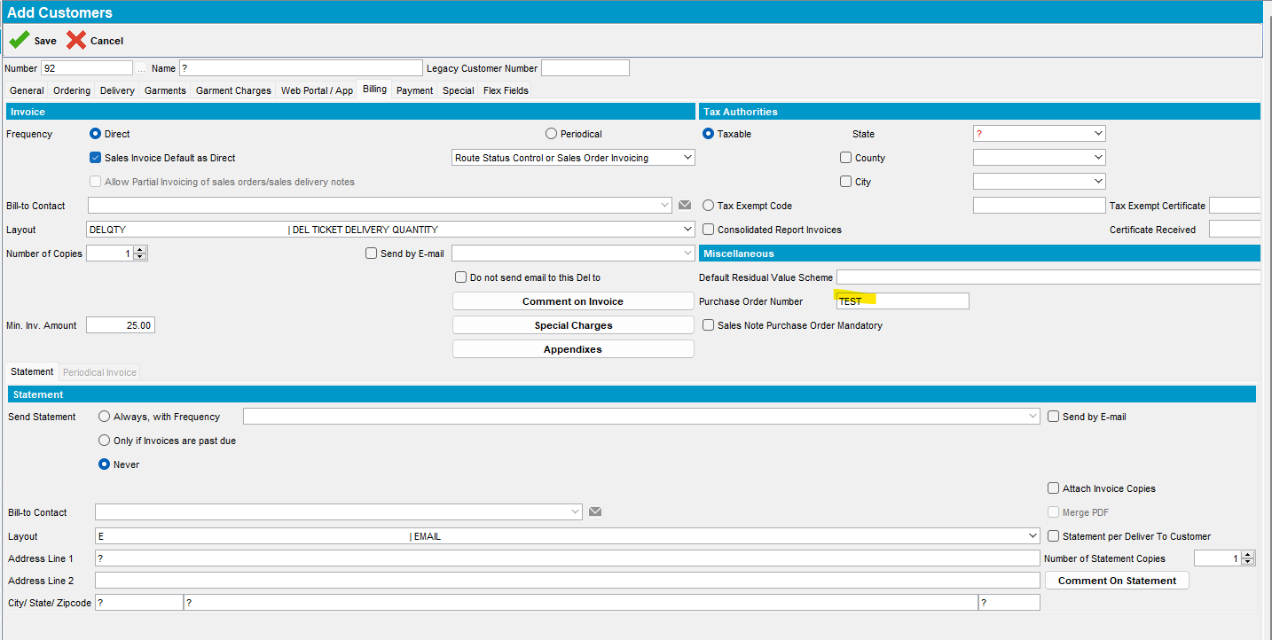

3.
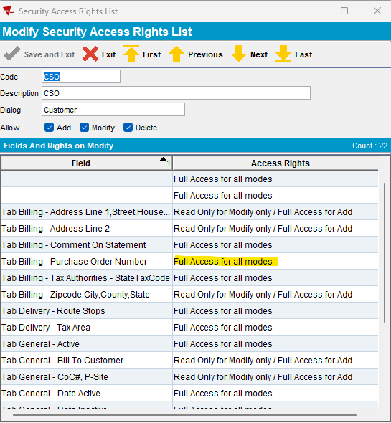
- Modify mode, full access:
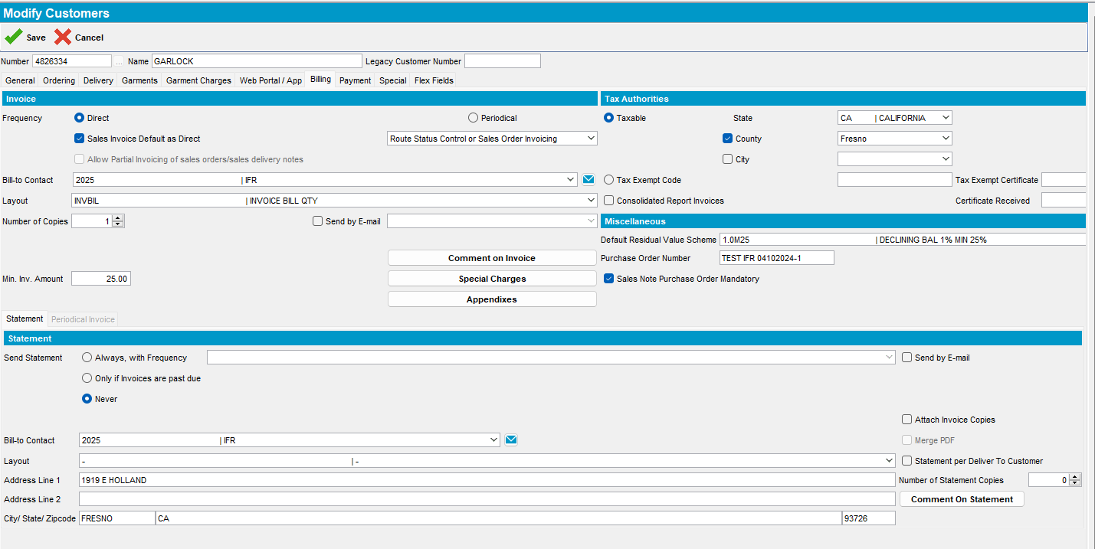
- Add mode, full access:
