ABSN-2164 Contract - Add To Customer should not consider inactive customers
DOWNGRADE TO 9.08.00_AUS
Environment | Prerequisites
Version: 9.08.00.RELEASE.p21  DBServerName=db01-buc.internal.abslbs.com  DBSID=CUST25  DBUser=AUS_ND90502  DBPassword= AUS_ND90502  Environment=Production  EnvironmentSABStage=Production | - Module:  - System setting:  - Other applications versions (if is applicable)  - Device used for mobile applications (if is applicable: Memo, physical device, Nox)

Contents
Reproducing before fix 2
Data preparation 2
Steps to reproduce 7
Current Behavior 8
Expected behavior 8
Retest after fix – In 9.08.00_AUS – Bugfix branch 9
Test Case #1 – Products -> Verify Active Customers are correctly displayed on “Include/Exclude/Customers, when “Add to Customers” – PASSED 9
Steps 9
Test Case #2 – Special Charges -> Verify Active Customers are correctly displayed on “Add to/Remove Special Charges from Customers”, when “Add to / Remove from Customers” – PASSED 11
Steps 11
Test Case #3 – Emblem Templates -> Verify Active Customers are correctly displayed on “Include/Exclude/Customers”, when “Add to Customers” – PASSED 13
Steps 13
Test Case #4 – Wearer Functions -> Verify Active Customers are correctly displayed on “Include/Exclude/Customers”, when “Add To Customers” – PASSED 15
Steps 15

Reproducing before fix
Hash: 9.08.00.RELEASE.p21 hash: e0e292064de8
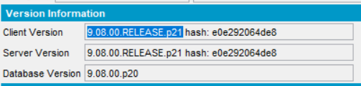
BU/Plant: 473 Phoenix (MC473) / 473 Phoenix (MC473)

Data preparation
Prepare an active contract:
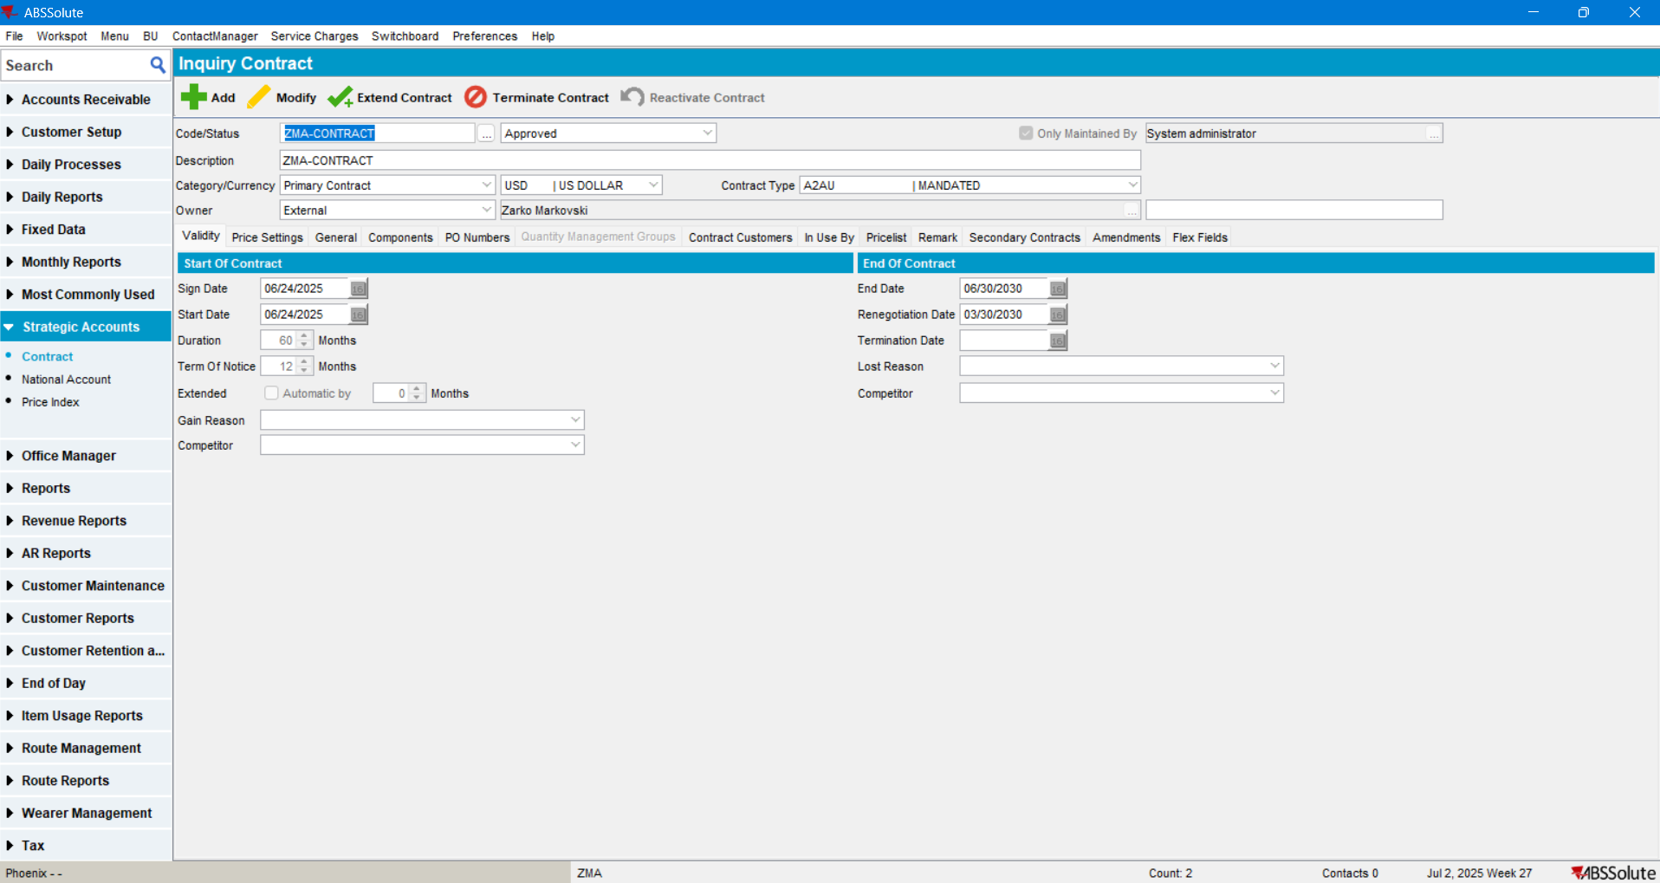
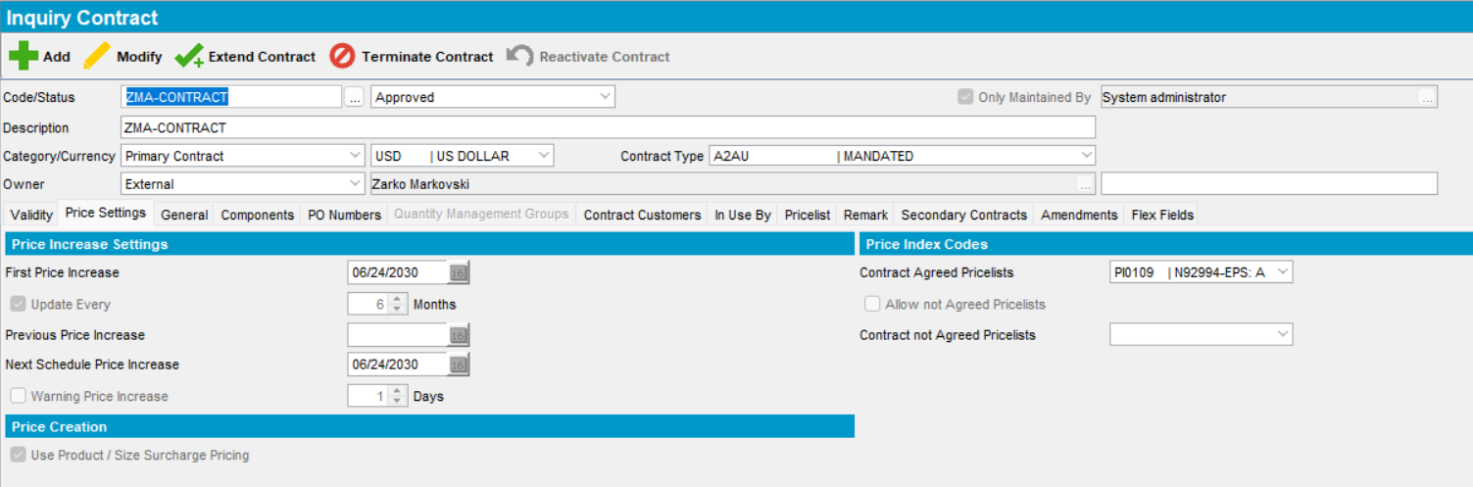

Find inactive customers on the current BU:
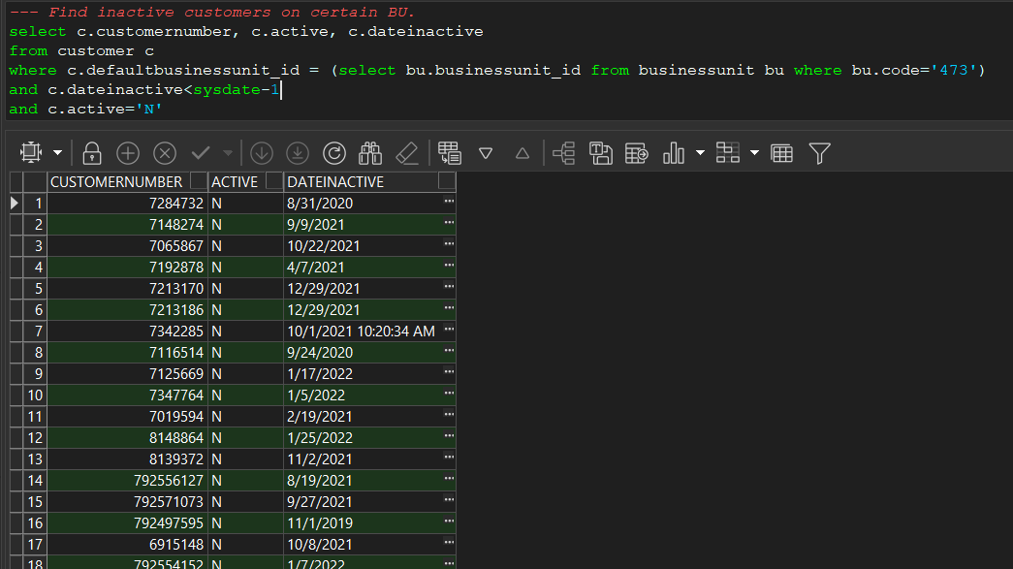
Customer’s are “Not Active” and Date inactive is before current date:
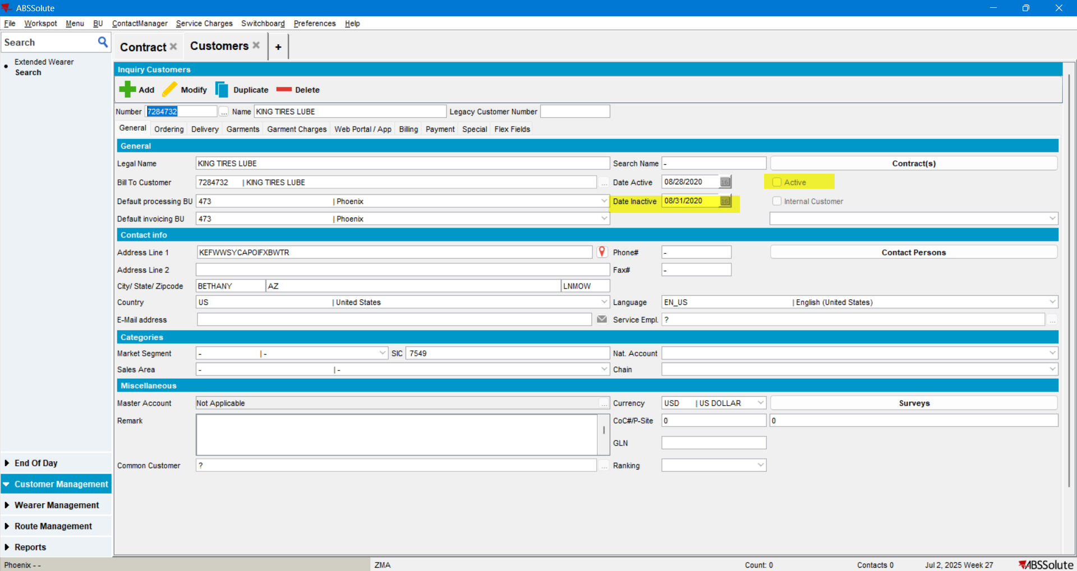
These inactive customers should also be set up:

- To use a Predefined Contract:
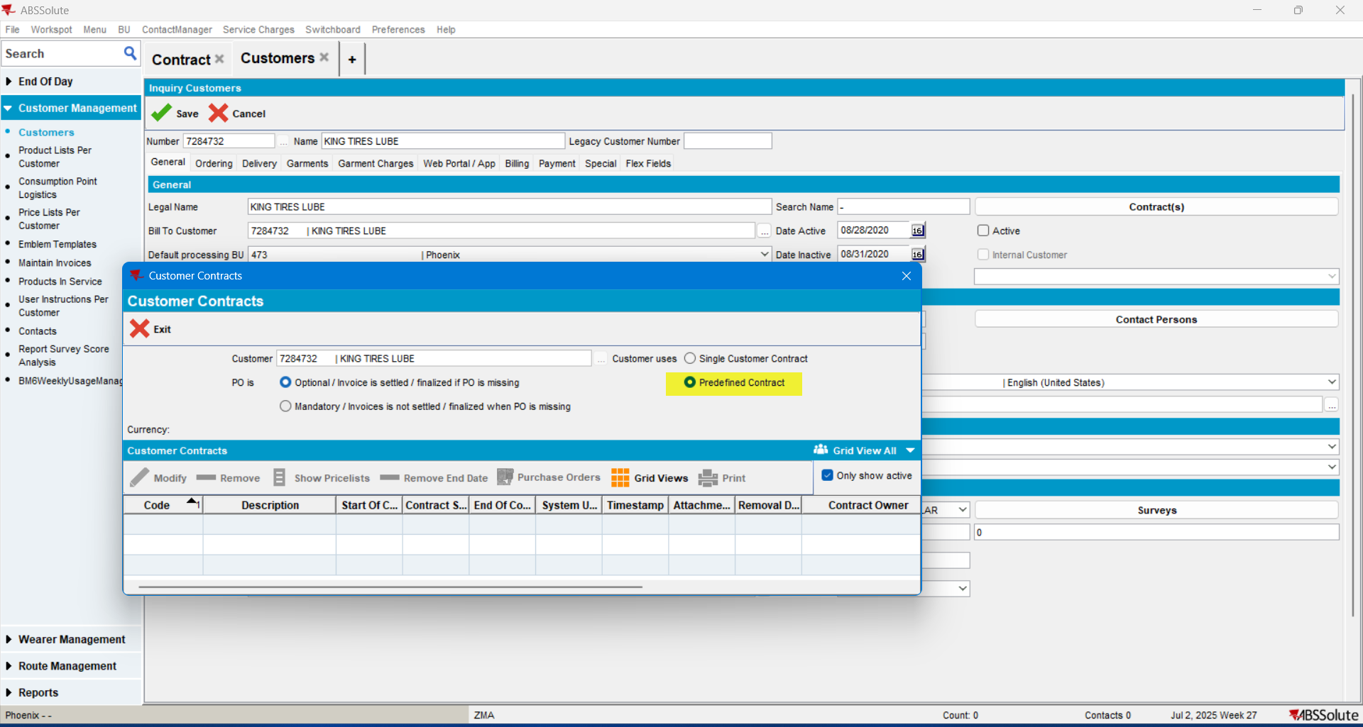

- and should not be related to any contract:
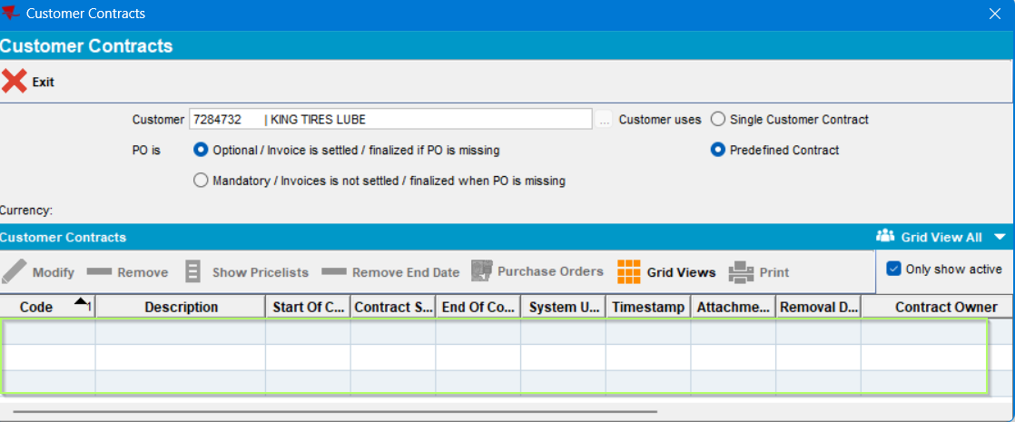

Add several active and inactive customers to the contract:

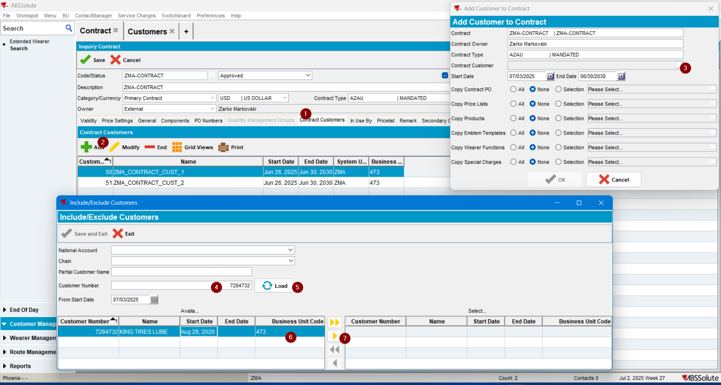

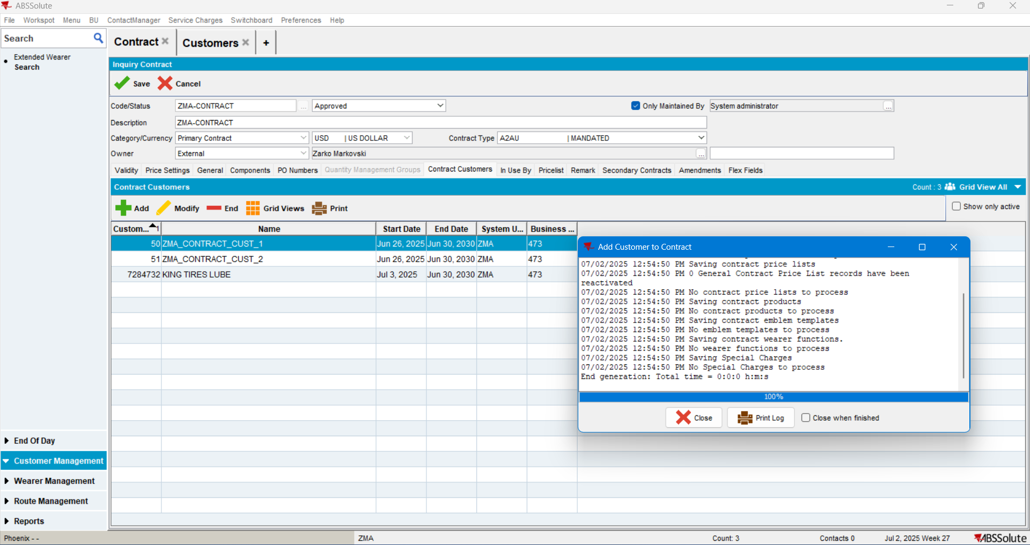

At this point there are active and inactive customers on this contract:

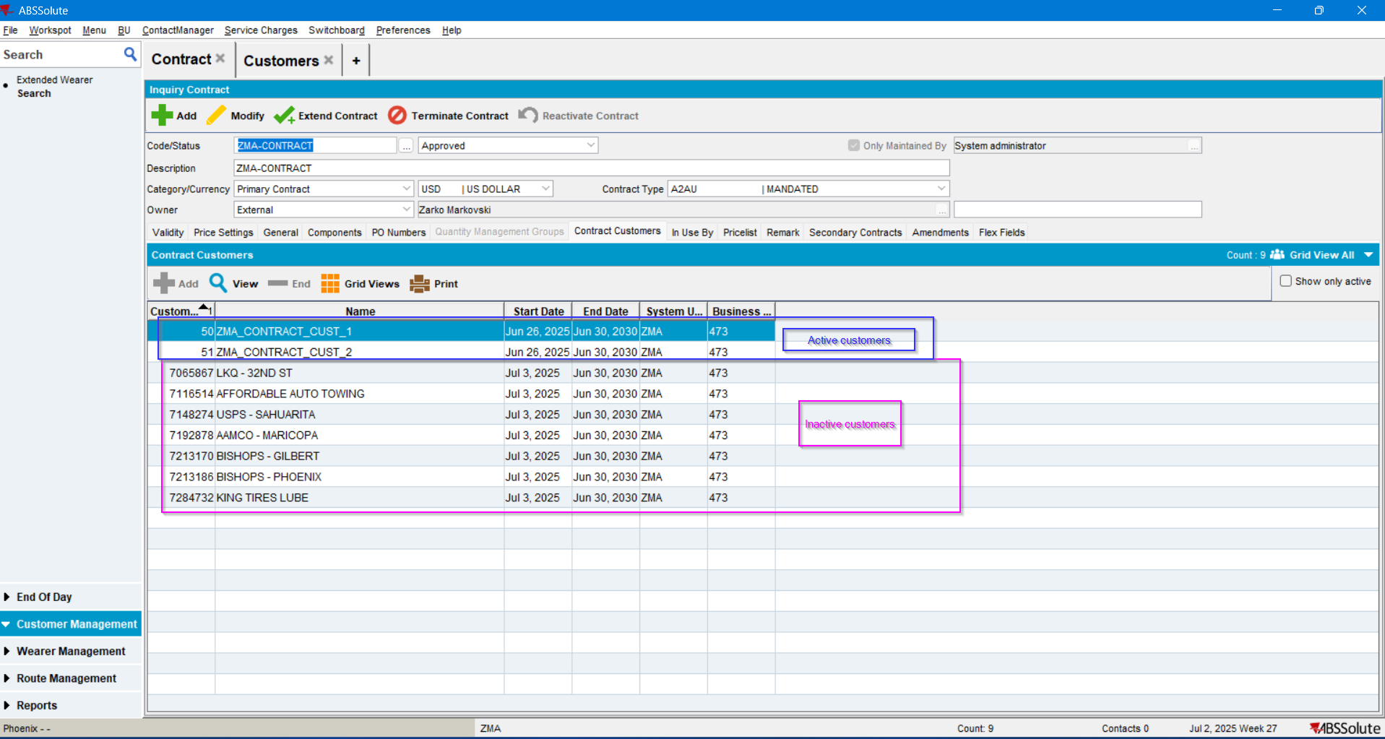

According to the “Contract.dlg” analysis, for the “Add to Customer” button to be active, the following 3 conditions need to be fulfilled: 1. Contract product needs to be “RELEASED”, 2. That product is not to be active in Contract.Customer’s PLPC and 3. Contract.Customer needs to have Delivery Days:
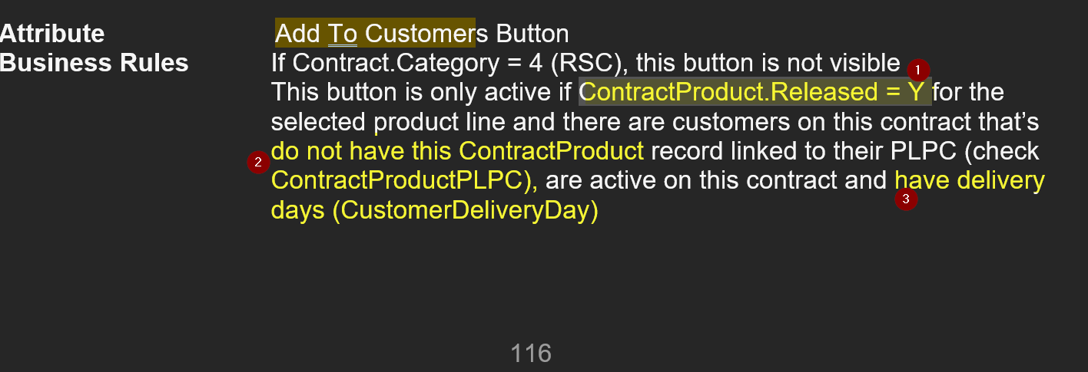

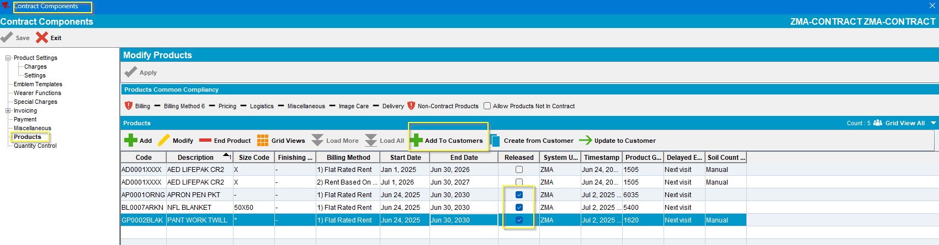

Steps to reproduce
- Open the “Contract” dialog, select the contract in case and press on the “Modify” button:
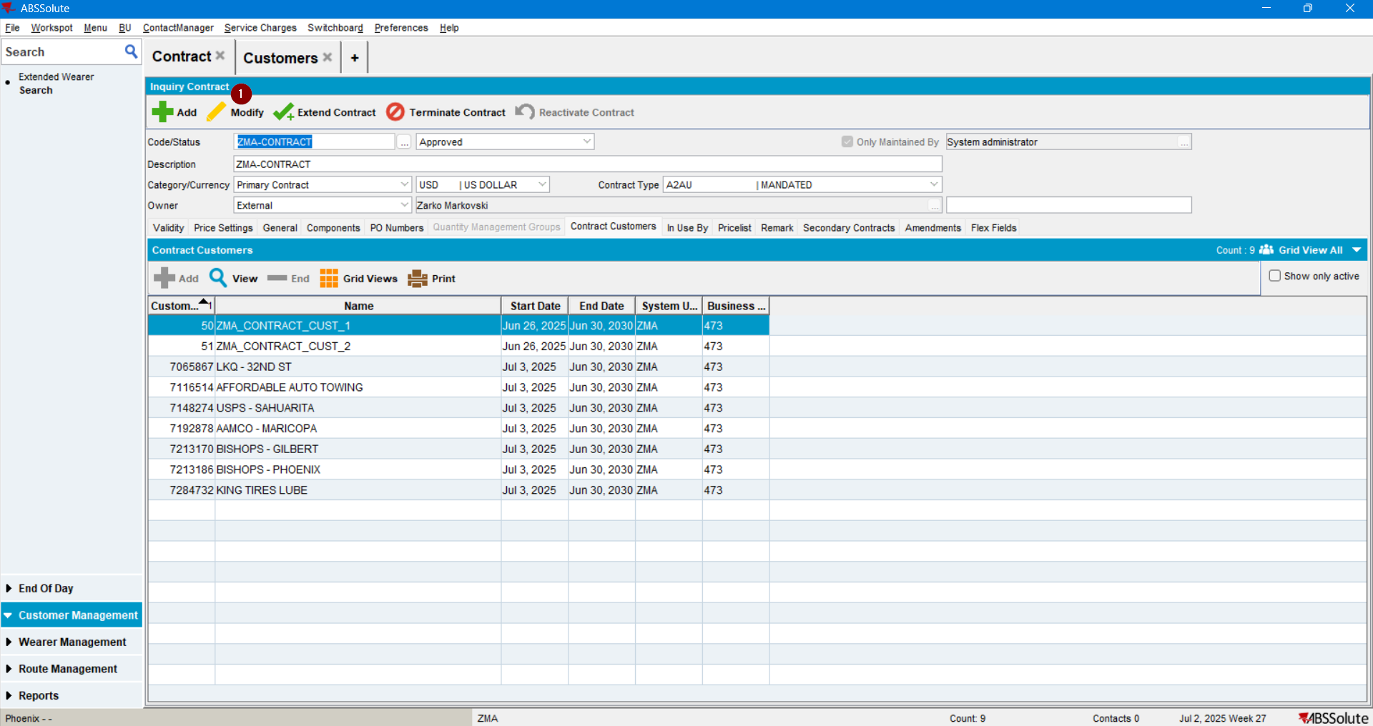

- Move to the “Components” tab and press on the “Product Settings” button: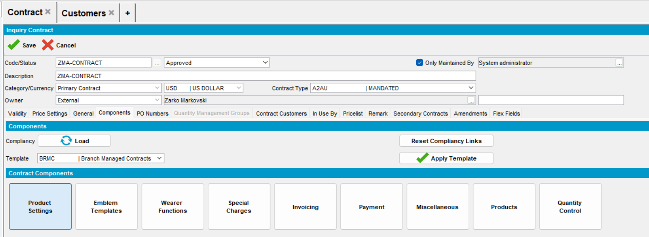

- Select the Products section > than the product > Press “Add to Customers” button:
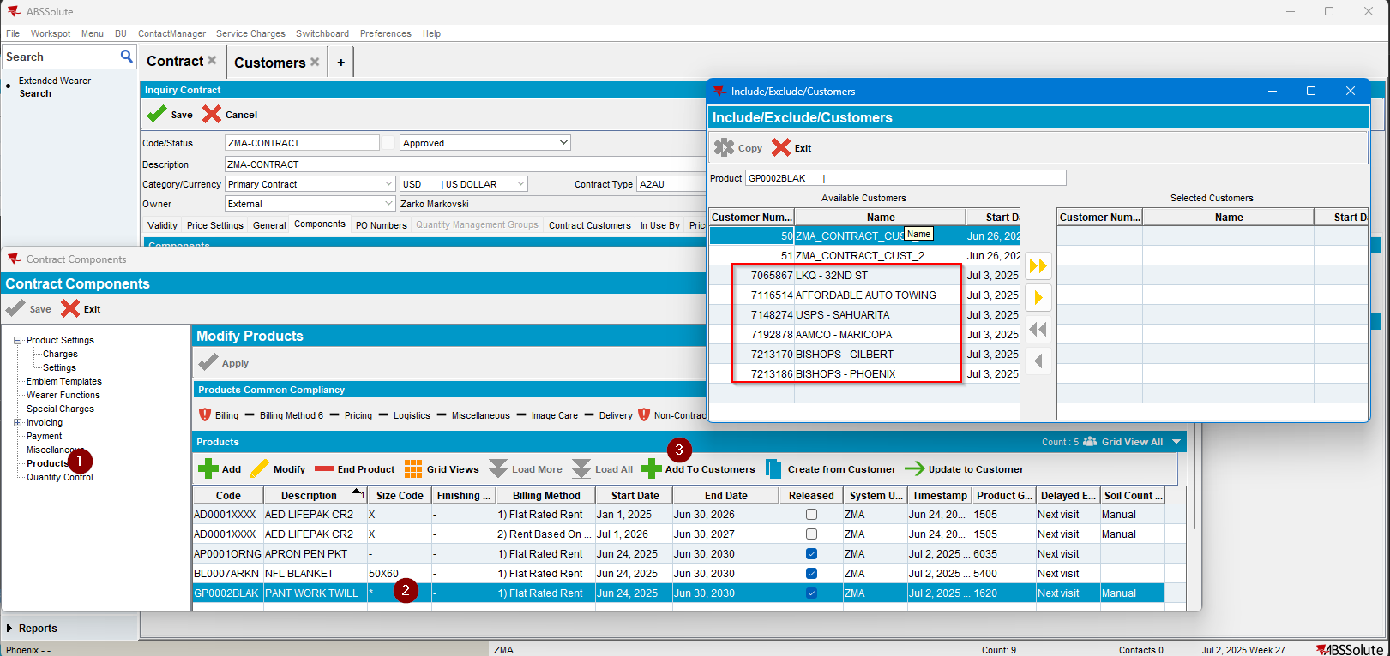

The Inactive customers are shown in the “Include/Exclude/Customers” grid.

REPRODUCED OK.

Current Behavior
Inactive Customers are displayed in “Include/Exclude/Customers” grid.

Expected behavior
Active Customers should be displayed on “Include/Exclude/Customers” grid.

Retest after fix – In 9.08.00_AUS – Bugfix branch
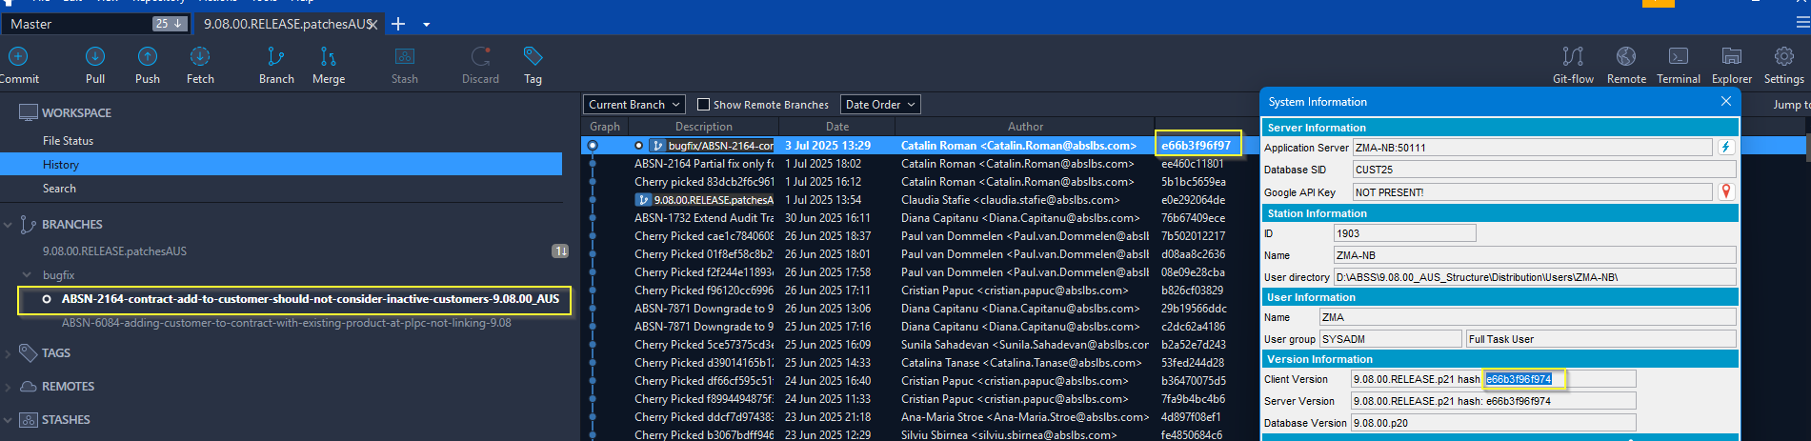

Test Case #1 – Products -> Verify Active Customers are correctly displayed on “Include/Exclude/Customers, when “Add to Customers” – PASSED
Expected behavior: Active/Future active Customers should be displayed on “Available Customers” grid.
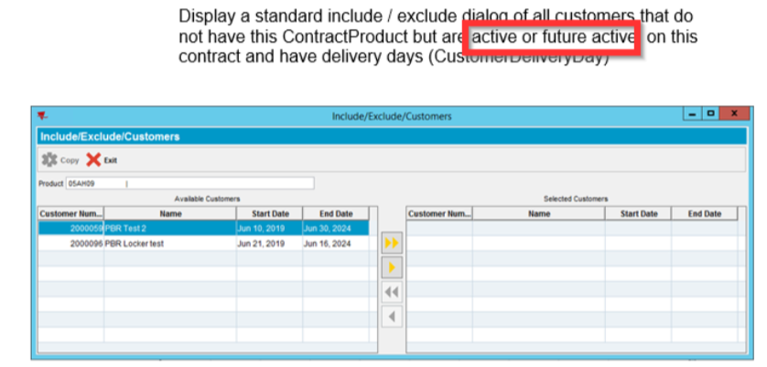

Hash: 9.08.00.RELEASE.p21 hash: e66b3f96f974 (9.08.00_AUS BUGFIX BRANCH)

Steps
- Open “Contract” dialog, select the Contract in case and press on the “Modify” button:
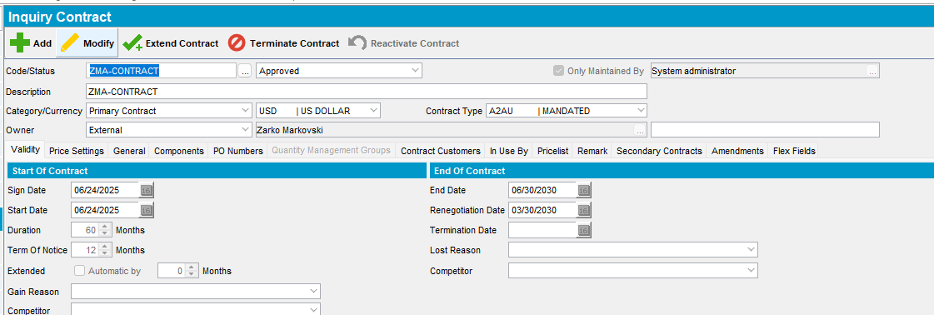
- Move to the “Components” tab and press on the “Product Settings” button:
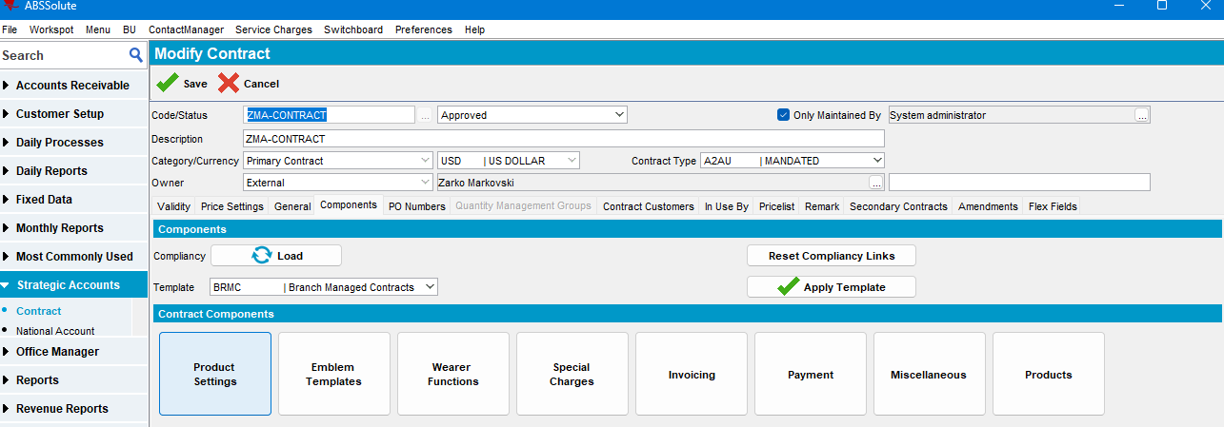

Note: This screen can also be accessed from Components > Products:
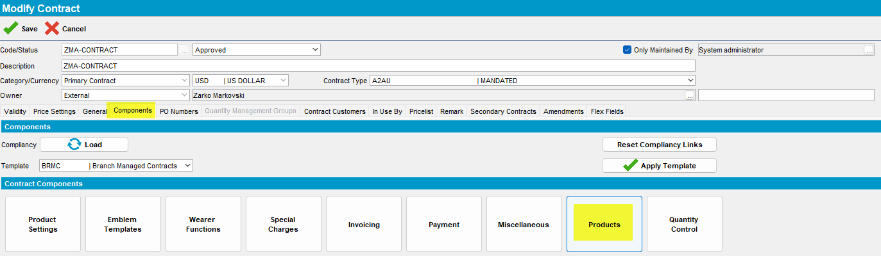

- On the left-hand side select the “Products”, select the product with “Released” checkbox on and press on the “Add to Customers” button:
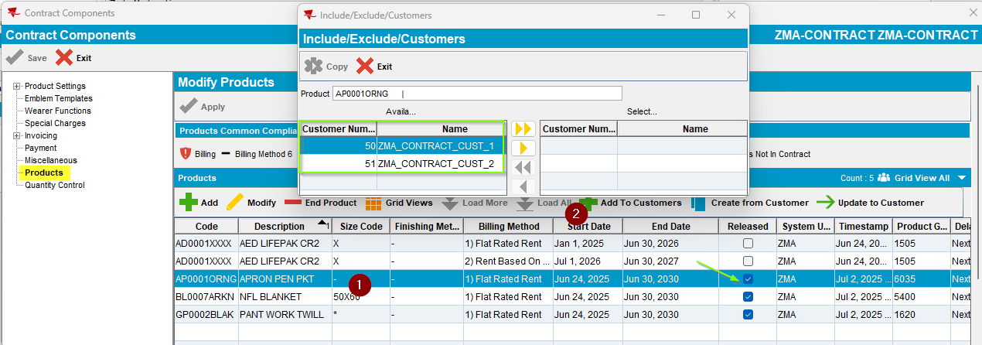

Actual result = Expected result -> Only the Active Customers are available in the Include/Exclude/Customers grid.

TEST PASSED

Test Case #2 – Special Charges -> Verify Active Customers are correctly displayed on “Add to/Remove Special Charges from Customers”, when “Add to / Remove from Customers” – PASSED
Expected behavior: Active/Future active Customers should be displayed on “Available Customers” grid.
Hash: 9.08.00.RELEASE.p21 hash: ee460c118012 (9.08.00_AUS BUGFIX BRANCH)

Steps
- Open the “Contract” dialog, select Contract in case and press on the “Modify” button:

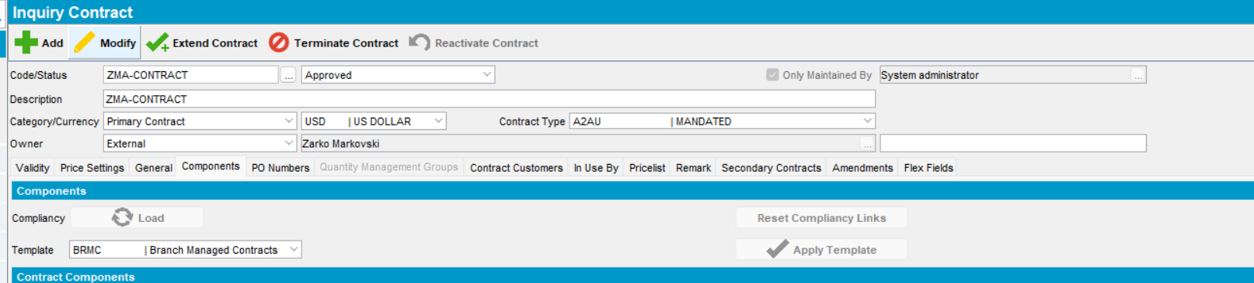

- Switch to the “Components” tab and press the “Product Settings” button:
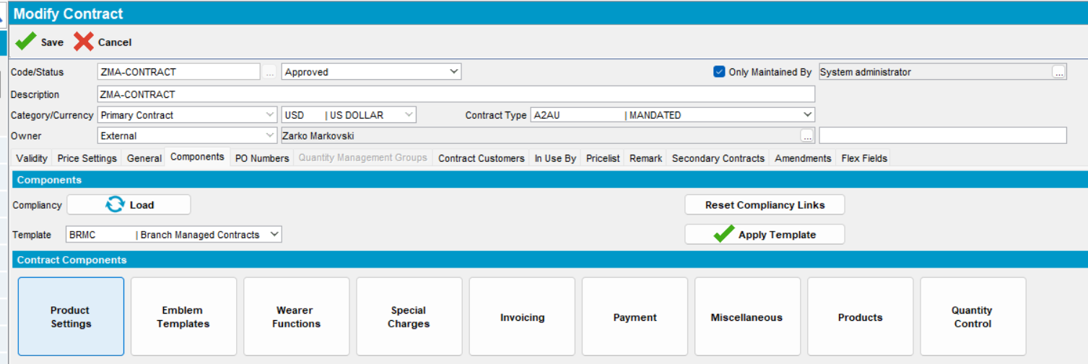

Or select Components > Special Charges directly:
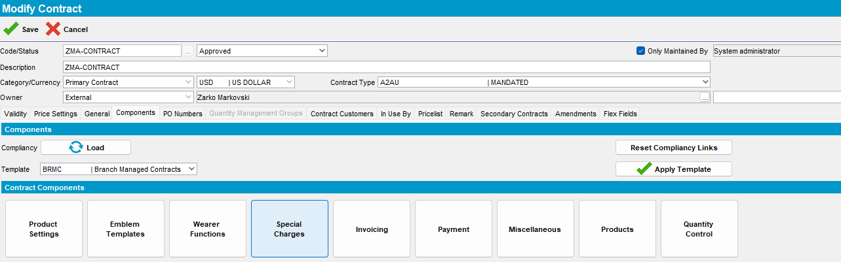

- On the left-hand side select the “Special Charges”:
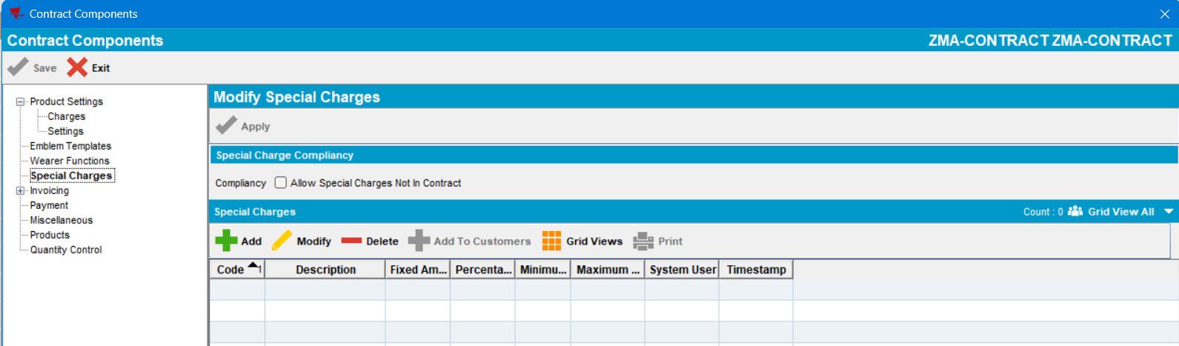
- Currently there are no special charges, so add some:
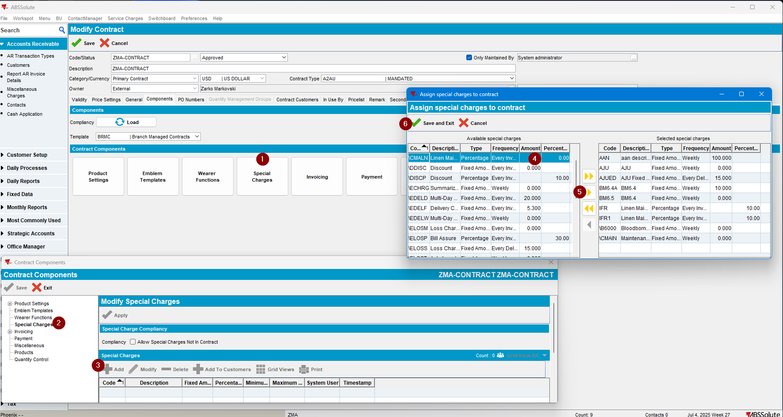
- Select a special charge, then press on the “Add to Customers” button:
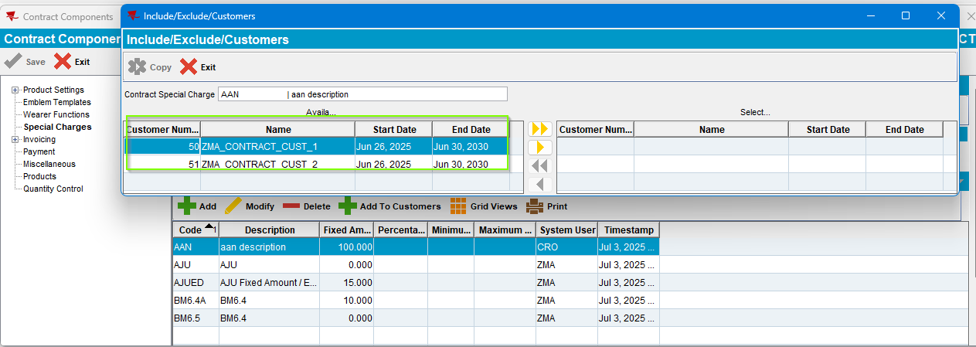
Actual result = Expected result: Only the Active Customers are displayed in the “Add to / Remove from Customers” grid.
TEST PASSED.

Test Case #3 – Emblem Templates -> Verify Active Customers are correctly displayed on “Include/Exclude/Customers”, when “Add to Customers” – PASSED
Expected behavior: Active/Future active Customers should be displayed on “Available Customers” grid.
Hash: 9.08.00.RELEASE.p21 hash: e66b3f96f974 (9.08.00_AUS BUGFIX BRANCH)

Steps
- Open “Contract” dialog, select the Contract in case and click on the “Modify” button:
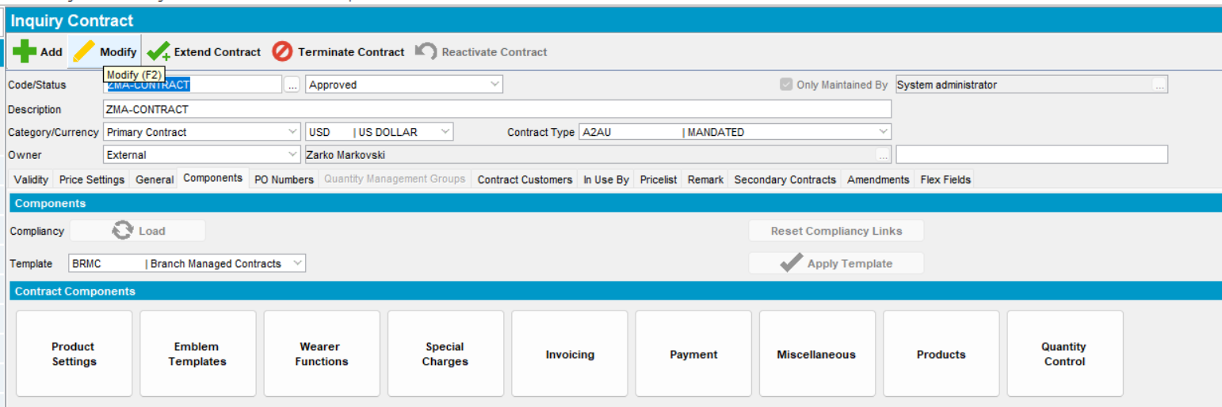
- Move to the “Components” tab and then press on the “Product Settings” button:
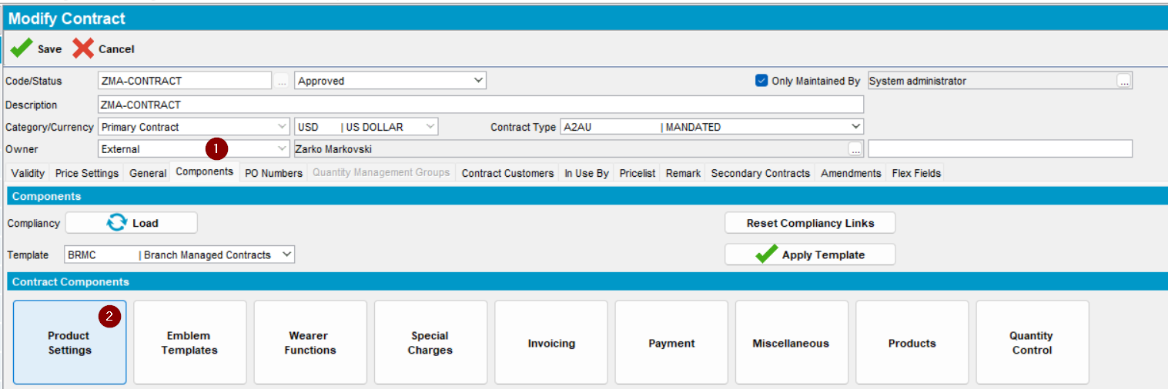
Or select “Emblem Templates” directly from the Components Screen:
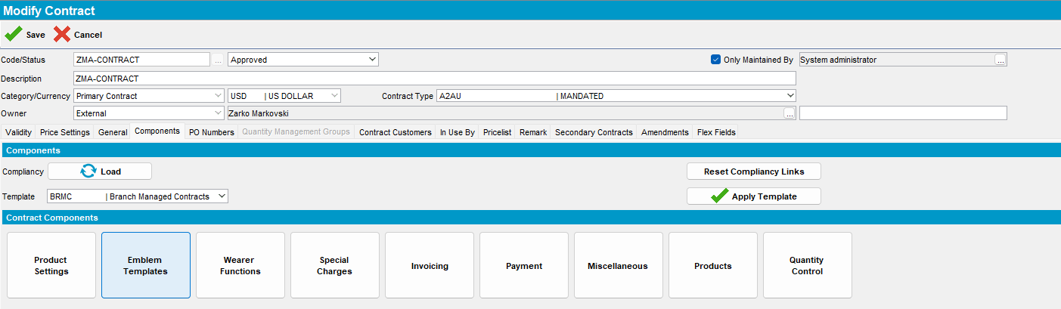

- Select the “Emblem Templates” on the left-hand side:
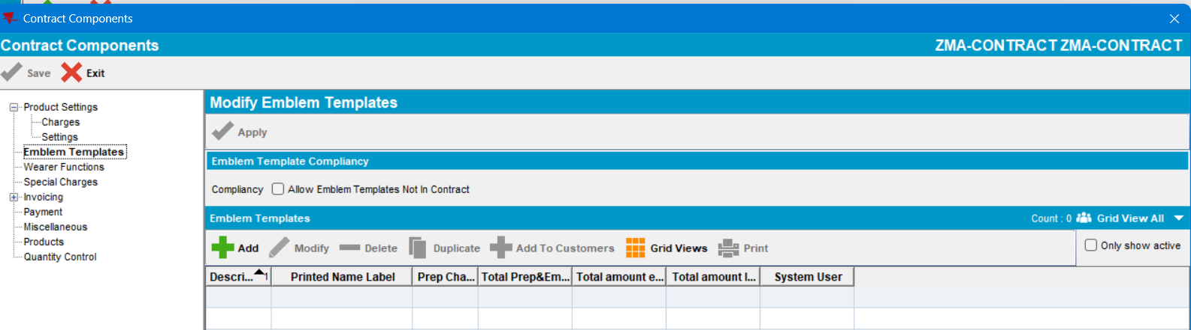

- If there are no Emblem templates in the grid, add some:
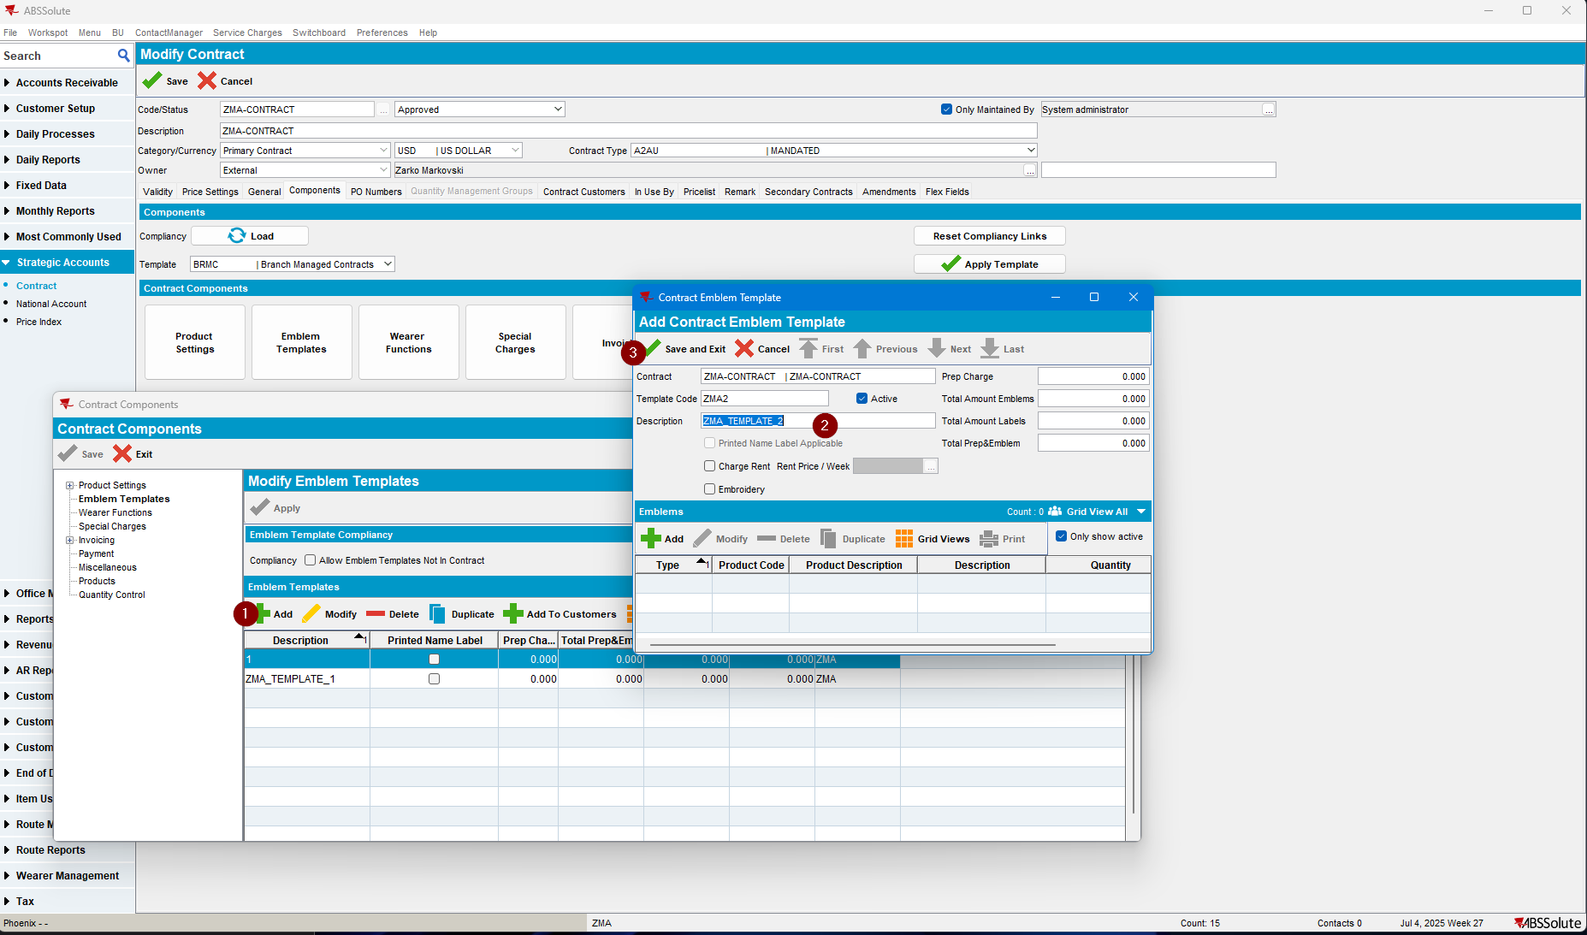

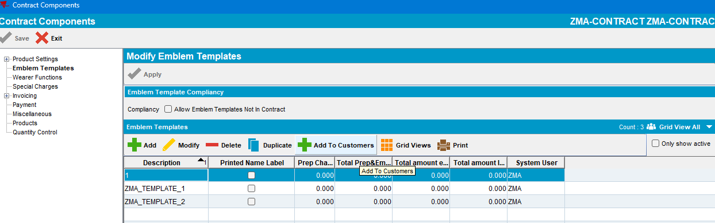
- Choose one emblem template and press the “Add to Customers” button:
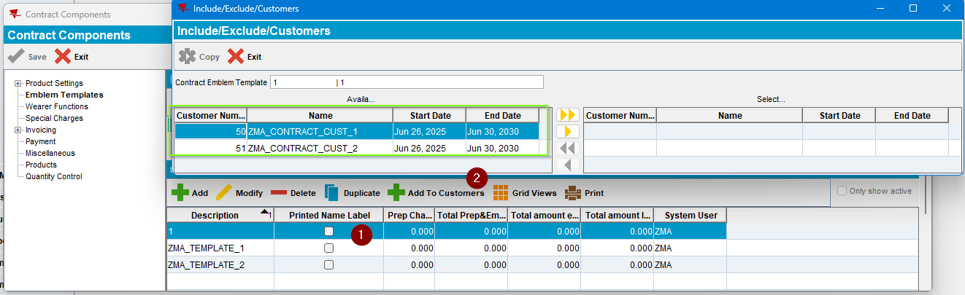
Actual result = Expected result: Only the Active Customers are displayed in the “Include/Exclude/Customers” grid.
TEST PASSED.

Test Case #4 – Wearer Functions -> Verify Active Customers are correctly displayed on “Include/Exclude/Customers”, when “Add To Customers” – PASSED
Expected behavior: Active/Future active Customers should be displayed on “Available Customers” grid.
Hash: 9.08.00.RELEASE.p21 hash: e66b3f96f974 (9.08.00_AUS BUGFIX BRANCH)

Steps
- Open the “Contract” dialog, select the Contract in case and click on the “Modify” button:

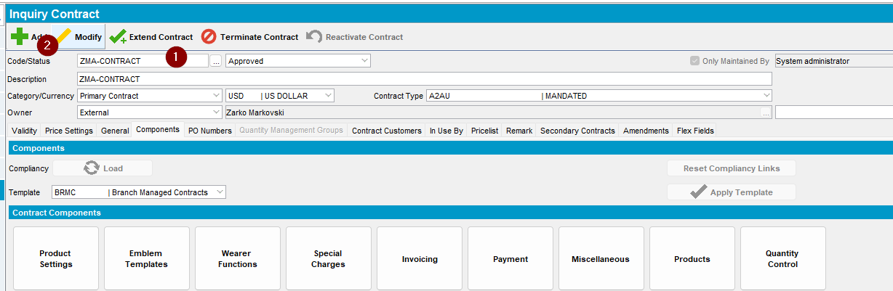

- Move to the “Components” tab and click on the “Product Settings” button, or directly to the “Wearer Functions” button:
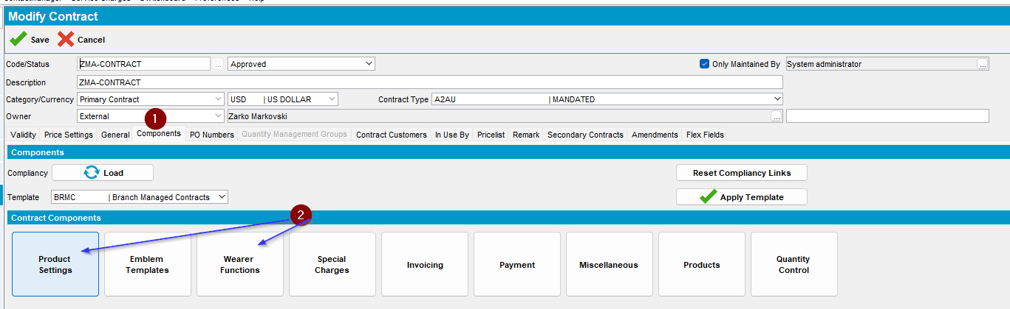

- On the left-hand side select the “Wearer Functions”, or if there are no Wearer Functions than add some: 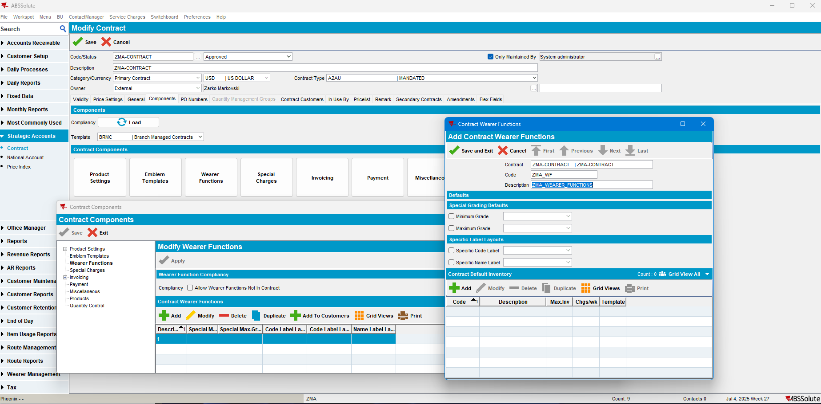

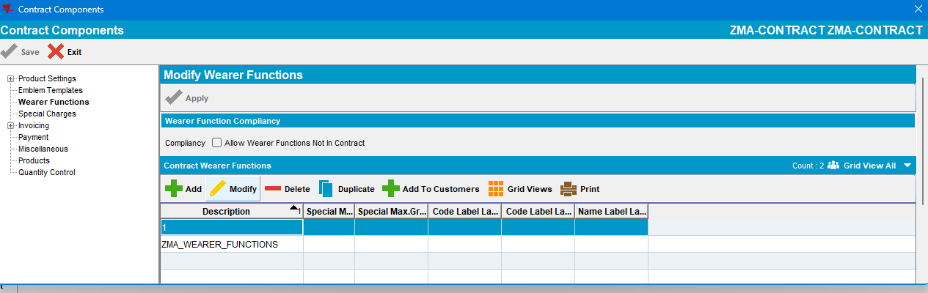

- Select a Wearer Function and press the “Add to Customer” button: 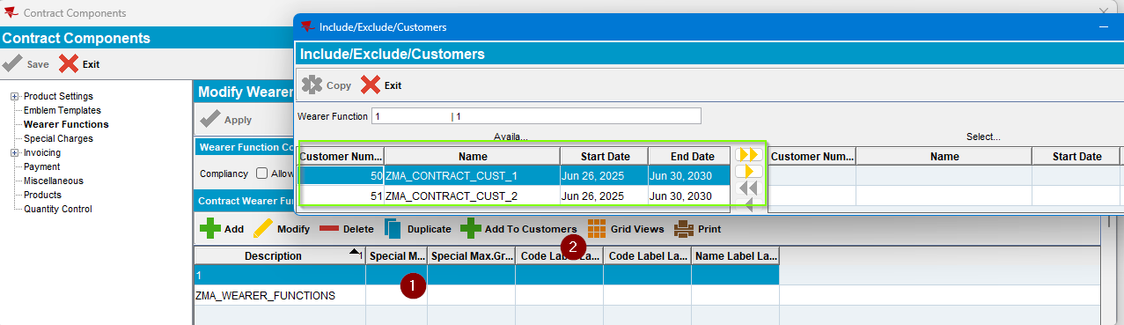

Actual result = Expected result -> Only the Active Customers are displayed in the “Include/Exclude/Customers” grid.

TEST PASSED

