ABSN-2001 Downgrade to 9.08.00.RELEASE.p24_AUS
Environment | Prerequisites
Version: 9.08.00.RELEASE.P23  DBServerName=abs-srv17.internal.abslbs.com  DBSID=CUST23  DBUser=AUS_MNT90800  DBPassword=AUS_MNT90800  Environment=Production | - Module: -  - System setting: -  - RouteAssistant_v13.32.INTERNAL_TEST_ONLY.97b92dcc4  - BU: 632
RASA branch: bugfix/RASA-3780-bm6-weekly-usage-not-allowing-6-digit-values
Contents
Retest after fix 1
Modify existing product 1
Add new product 2
RASA flow 5

Retest after fix
JAVA hash: 1c5ffe0
RASA hash: 97b92dc

Modify existing product
- Open a BM6 customer and change Weekly Usage with a 6 digits number
Customer: 792352611
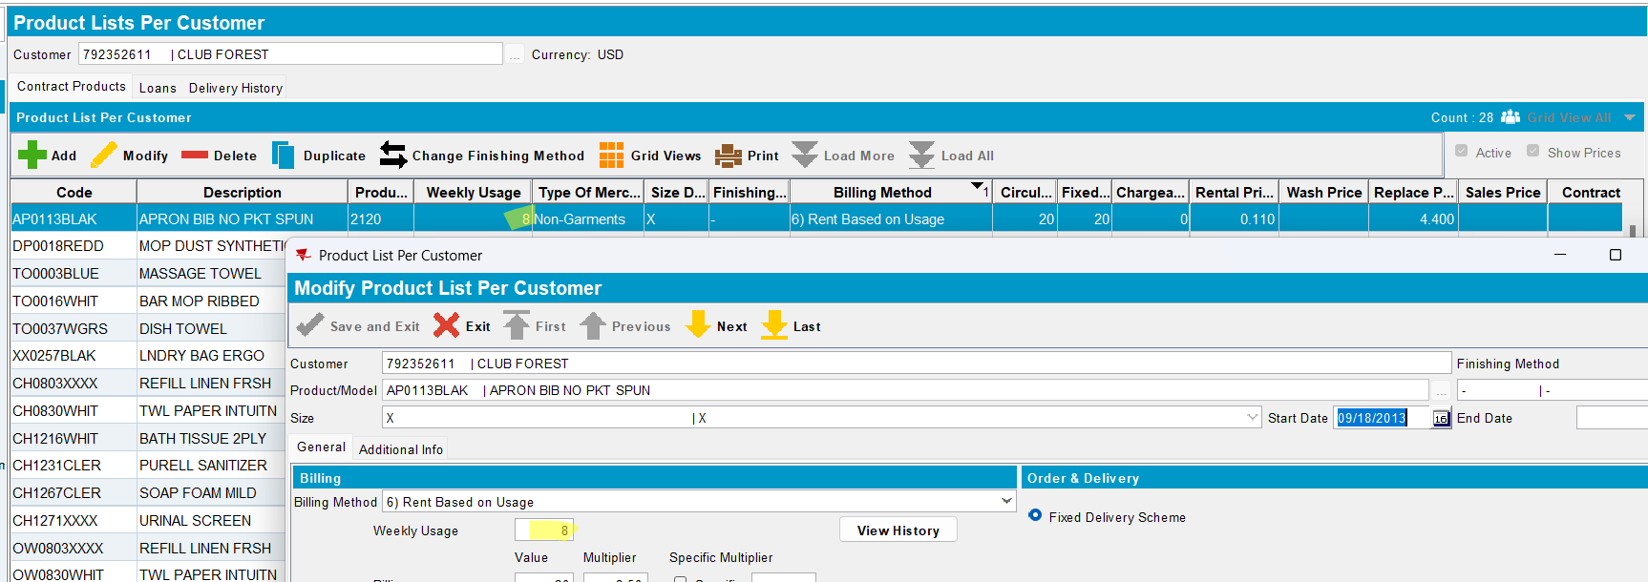
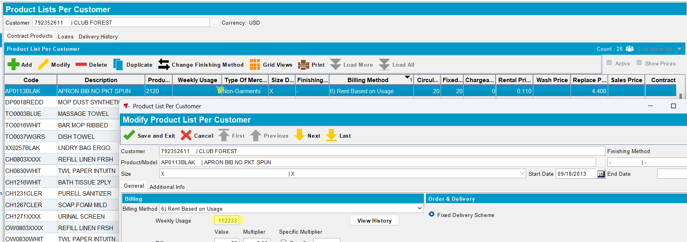
Save.
- Check if the grid was updated. Reopen the product. Check the Weekly Usage field and check also View History
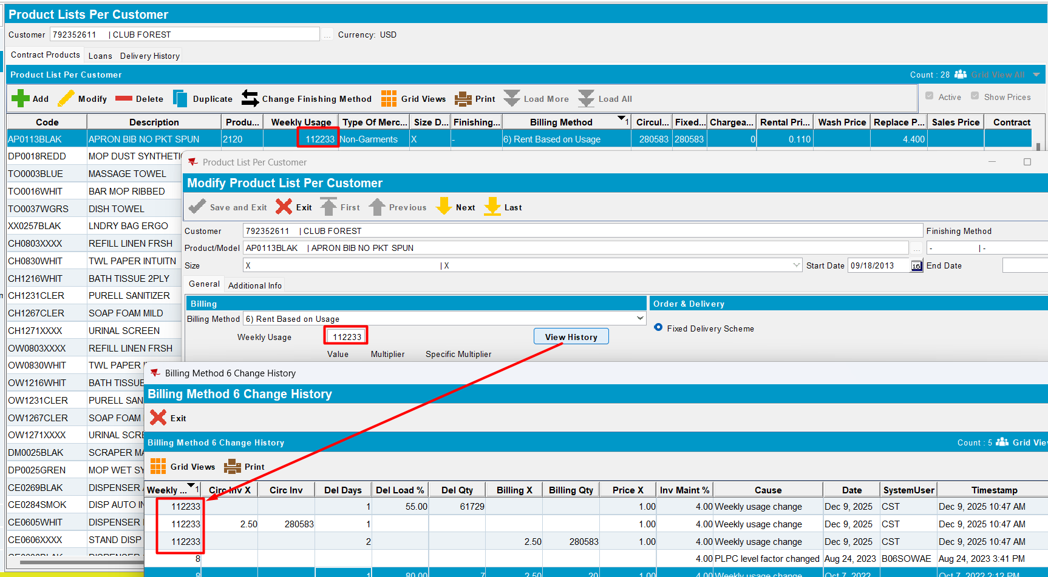
Every field was updated.
TESTED OK.

Add new product
- Add a new BM6 product. Add a 6 digits value for weekly usage. Save
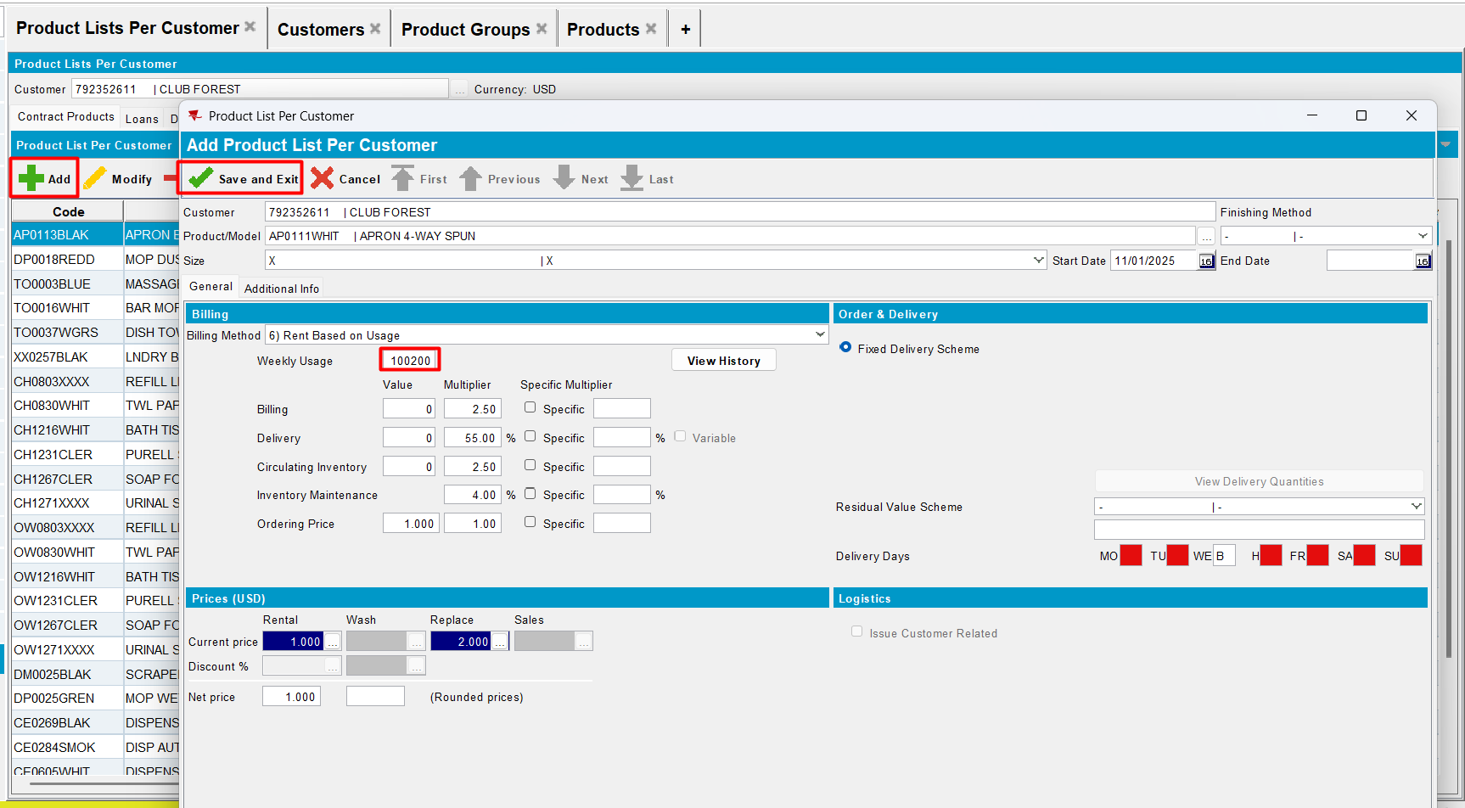
- Reopen product and check values for weekly usage
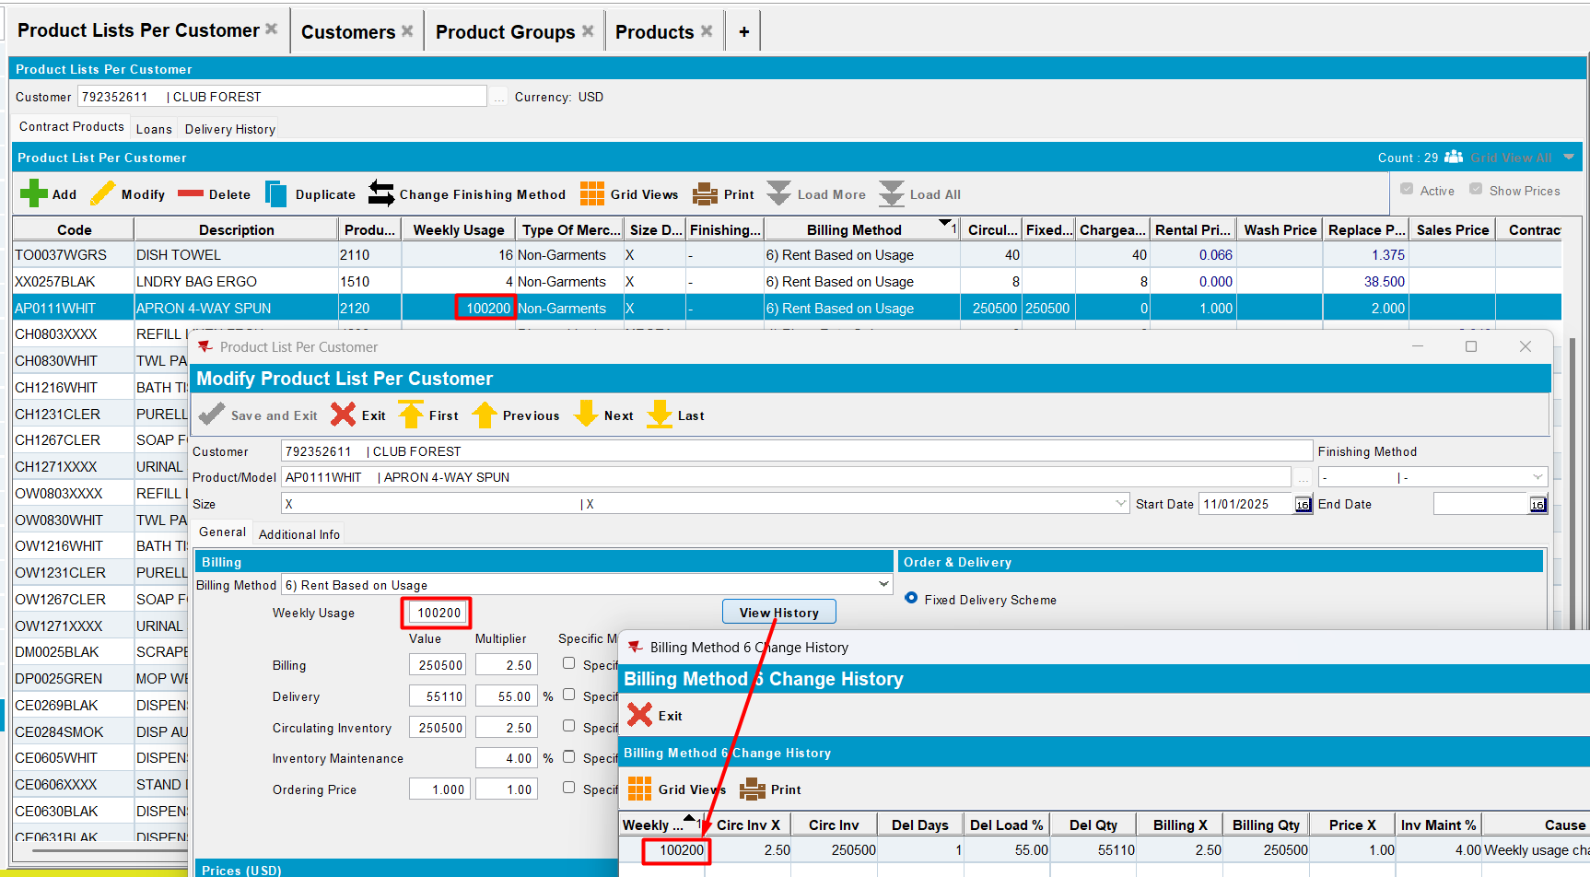
- Modify the weekly usage value and save it
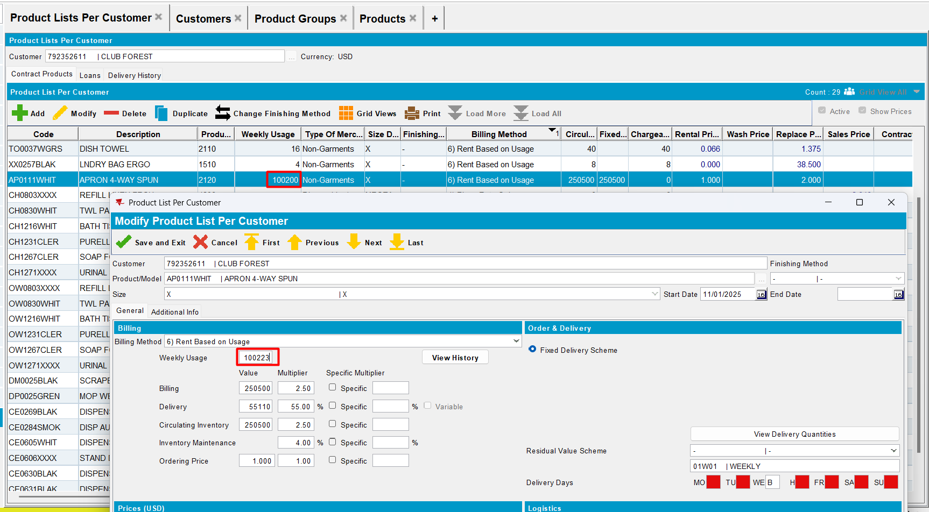
- Reopen product
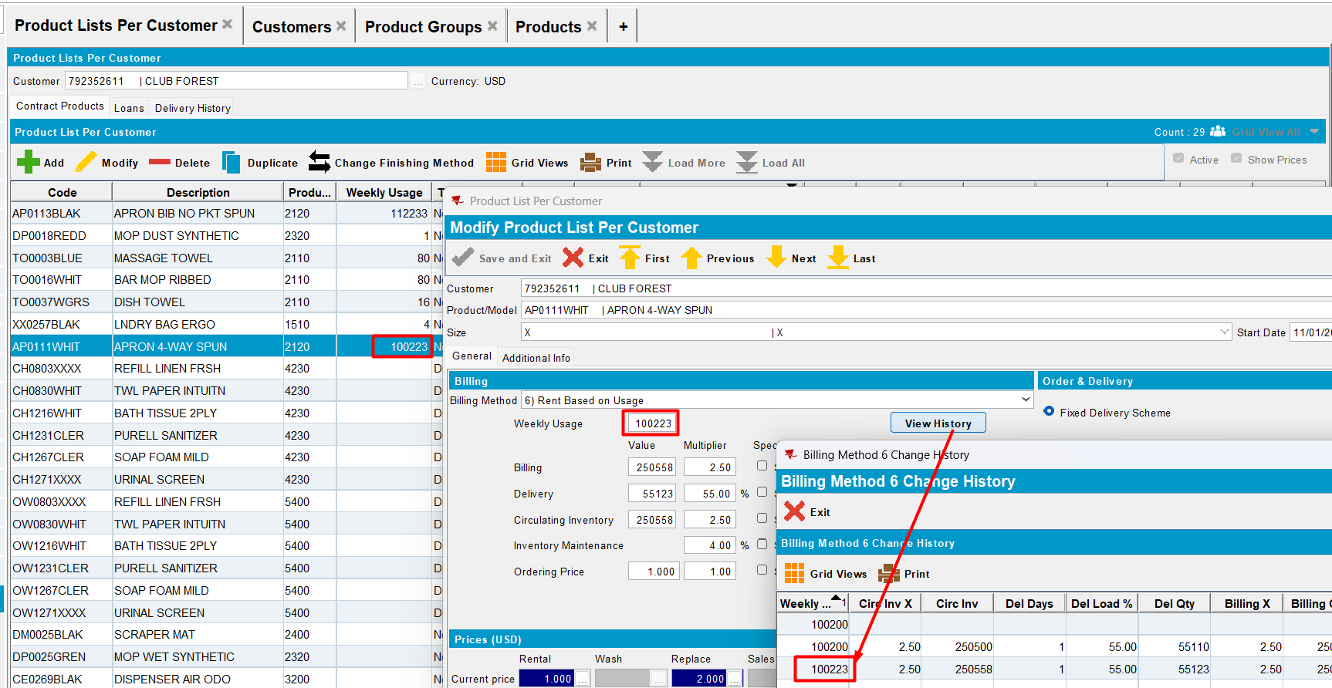
- Check dlg BM6WeeklyUsageManagement
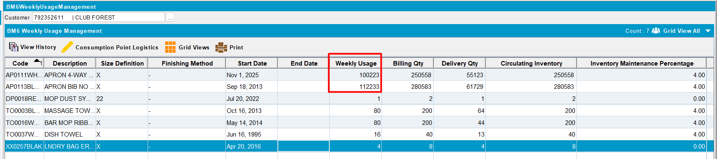
Select a product and modify weekly usage by changing it to a 6 digits value and check if PLPC value is updated
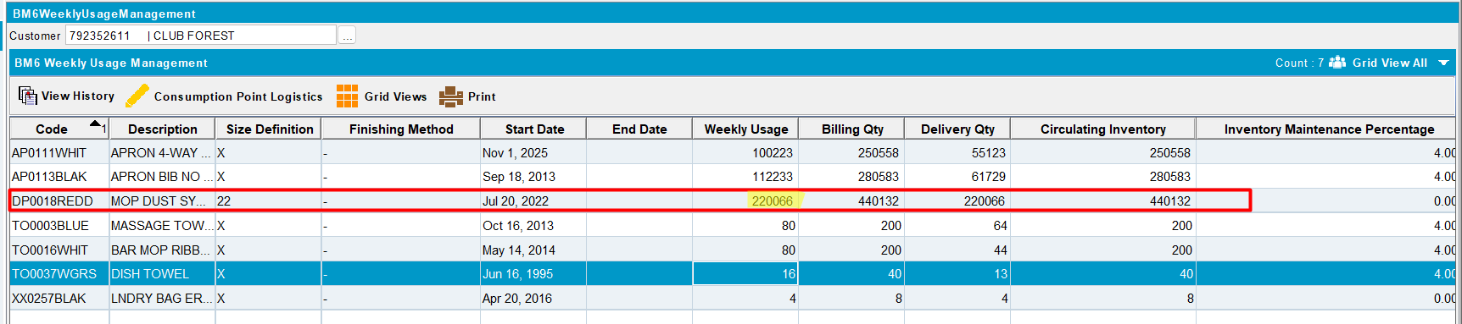
PLPC value is updated
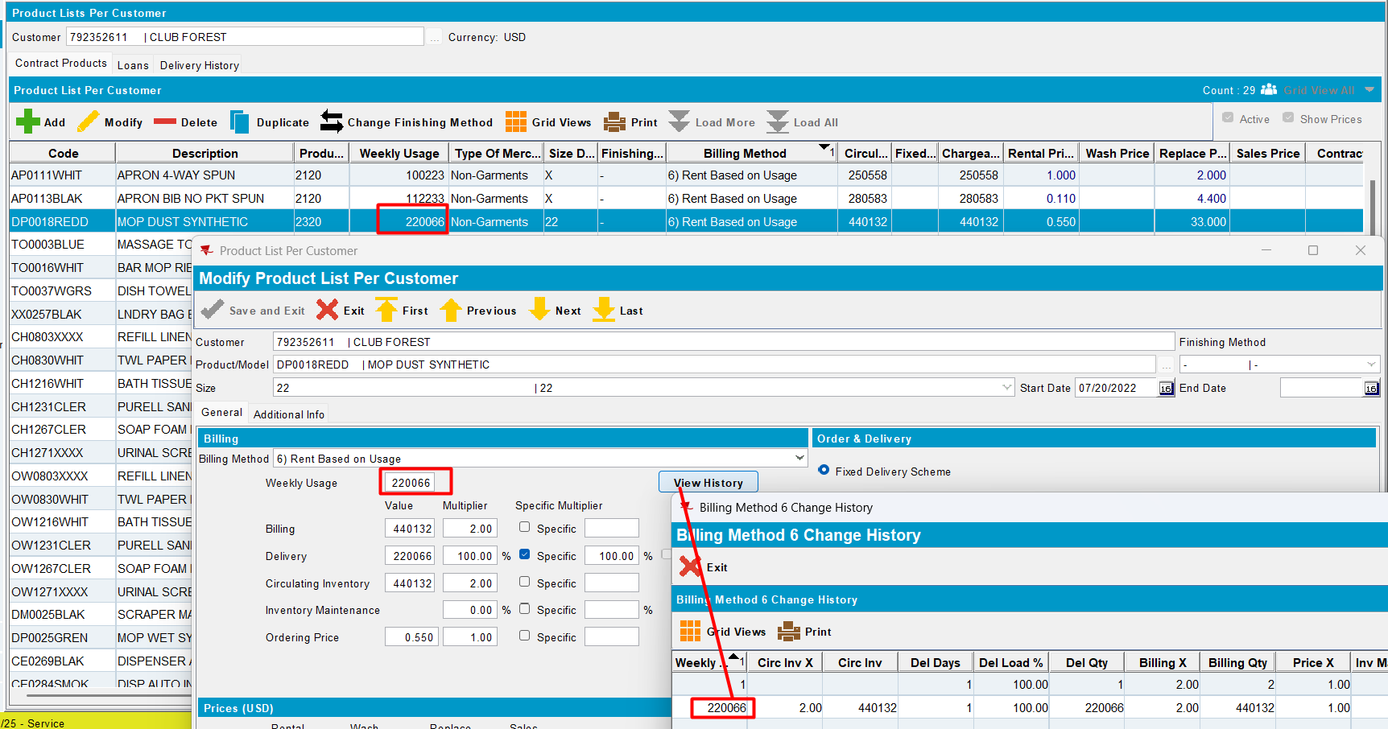
Test OK

RASA flow
- In Route Status Control, add a new route control. Add the driver to that route control
- Generate Put Up Docs
- Generate invoice
- Mark route Ready For Transfer to PDA
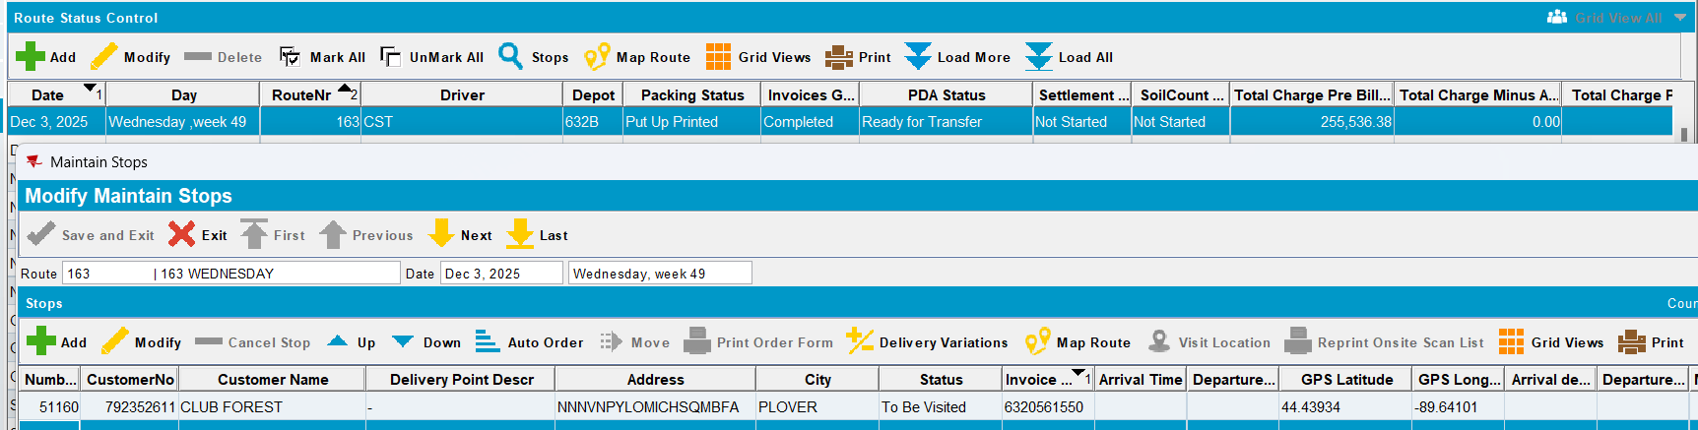
- Transfer to PDA
- Start the route
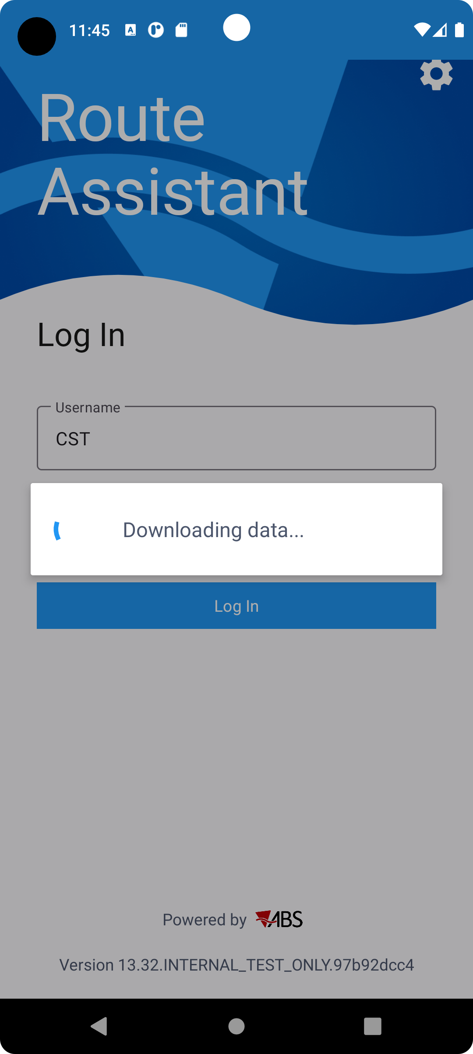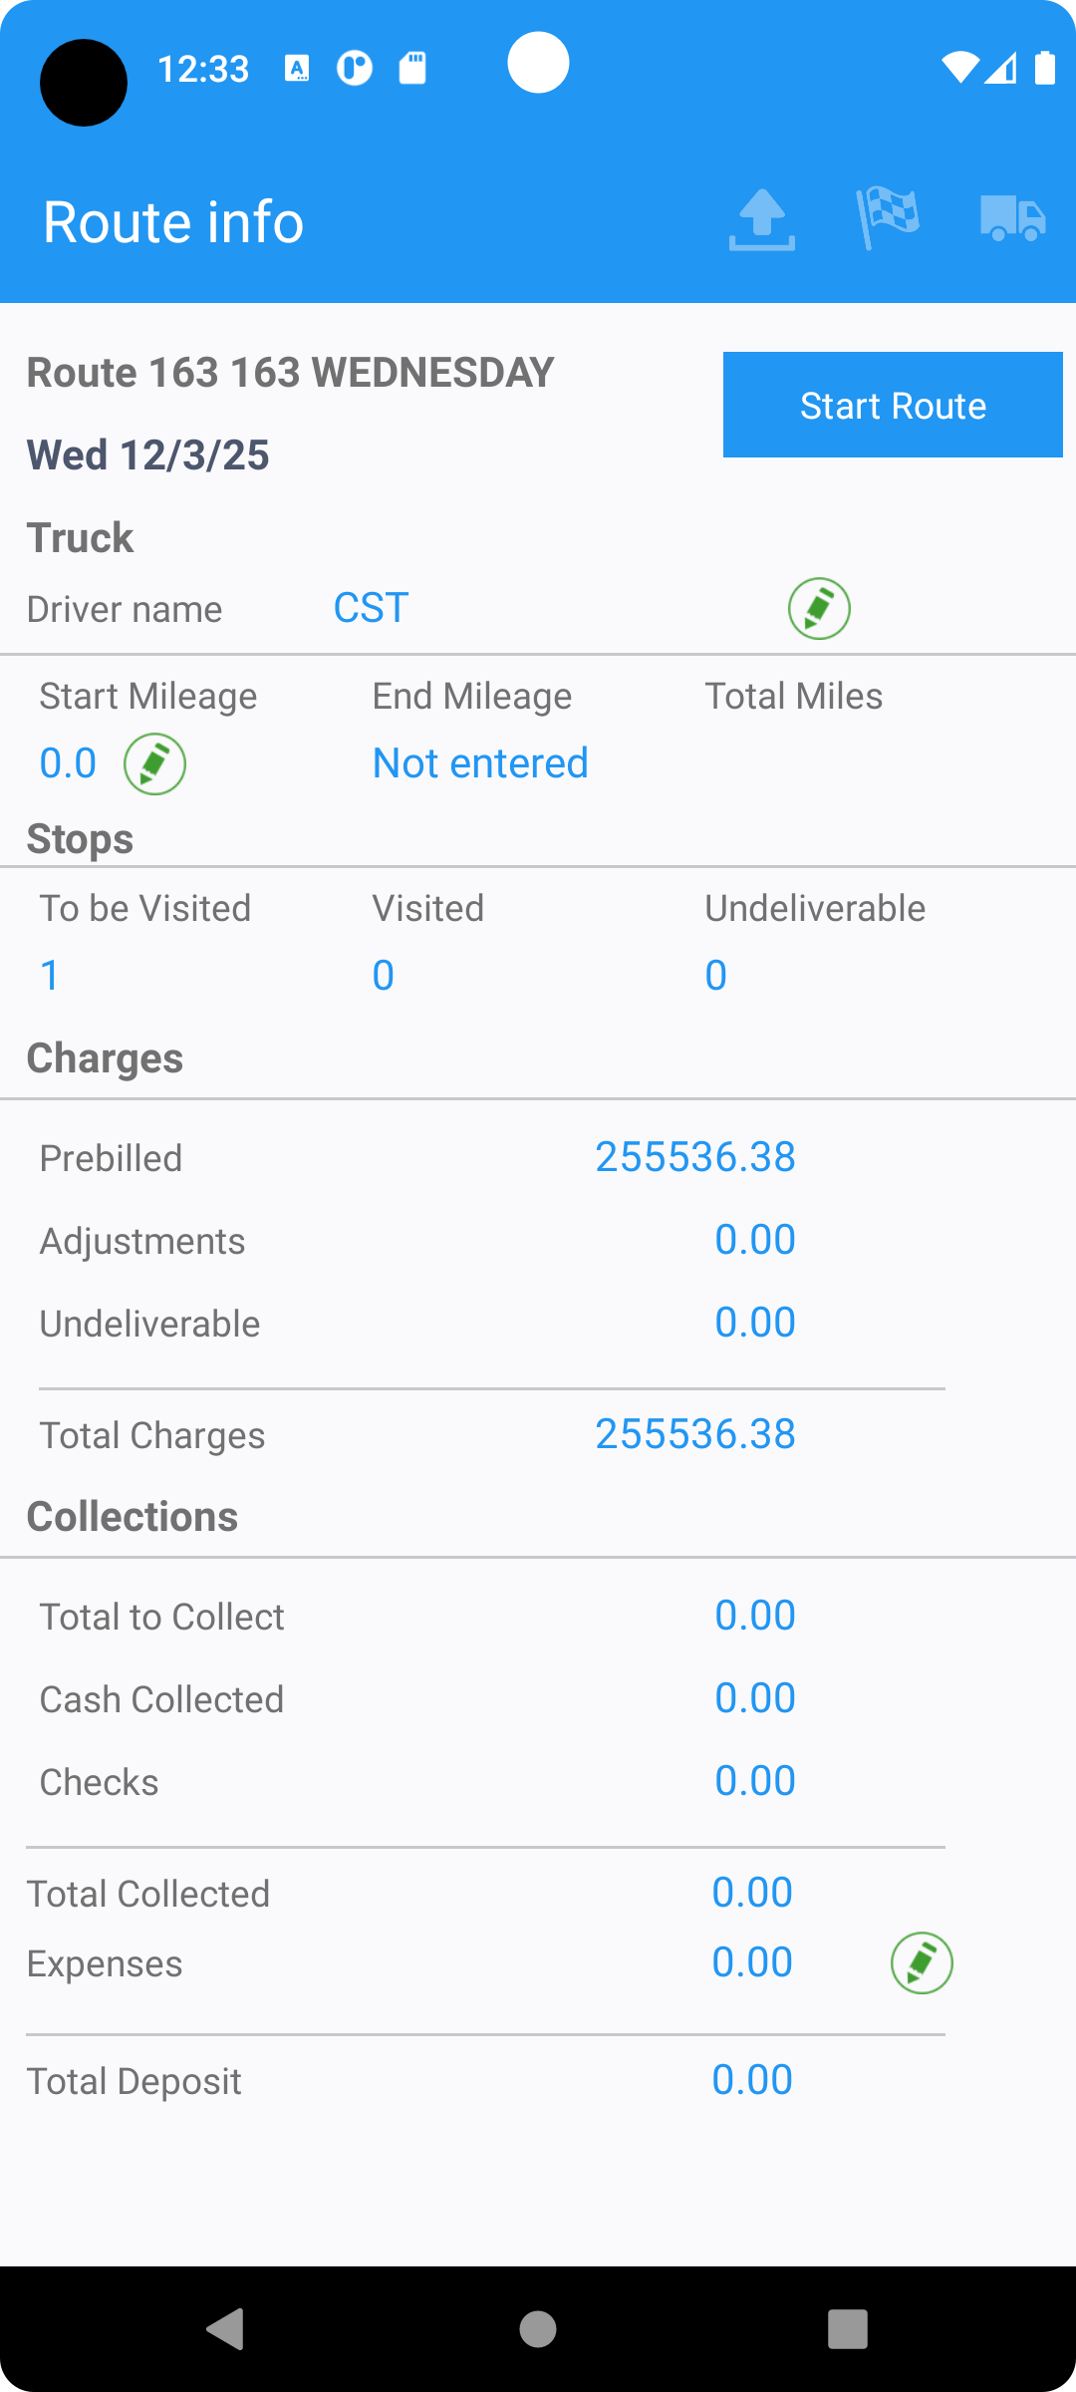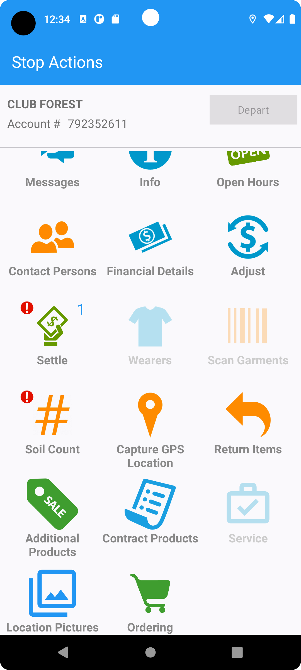
- Go to Contract Products
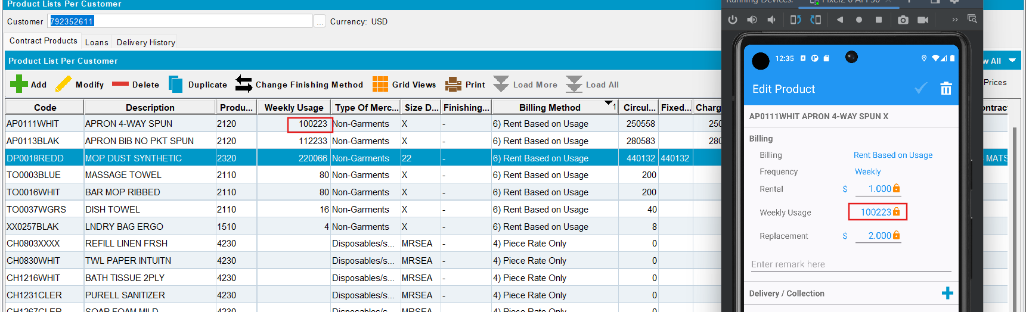
Weekly usage is correctly shown on PDA.
- Change Weekly usage on pda and save
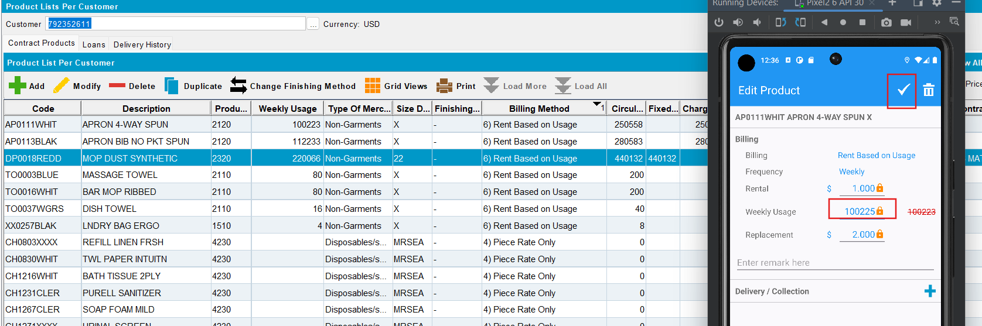
Update another product and try to decrease the weekly usage value on pda
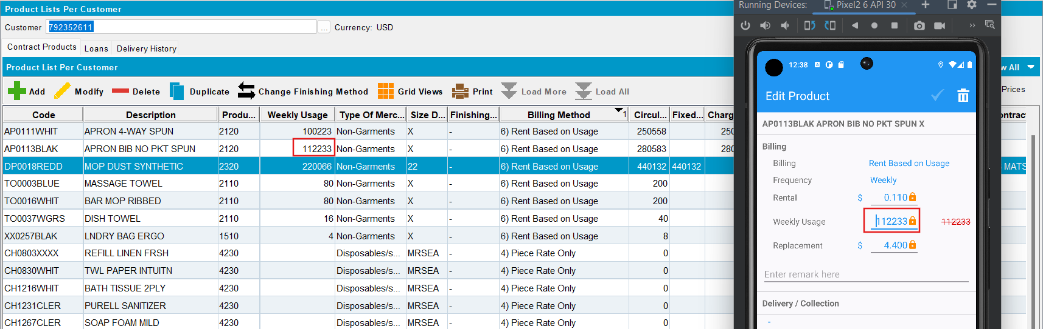
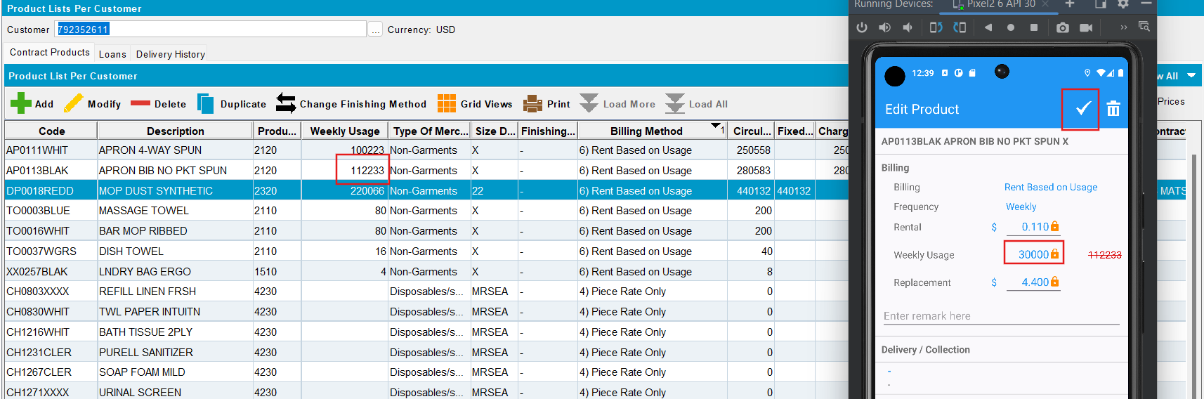
Products are updated
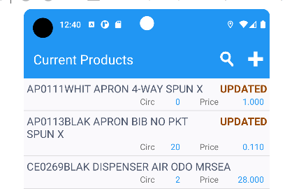
- Add a new product with 6 digits for Weekly usage
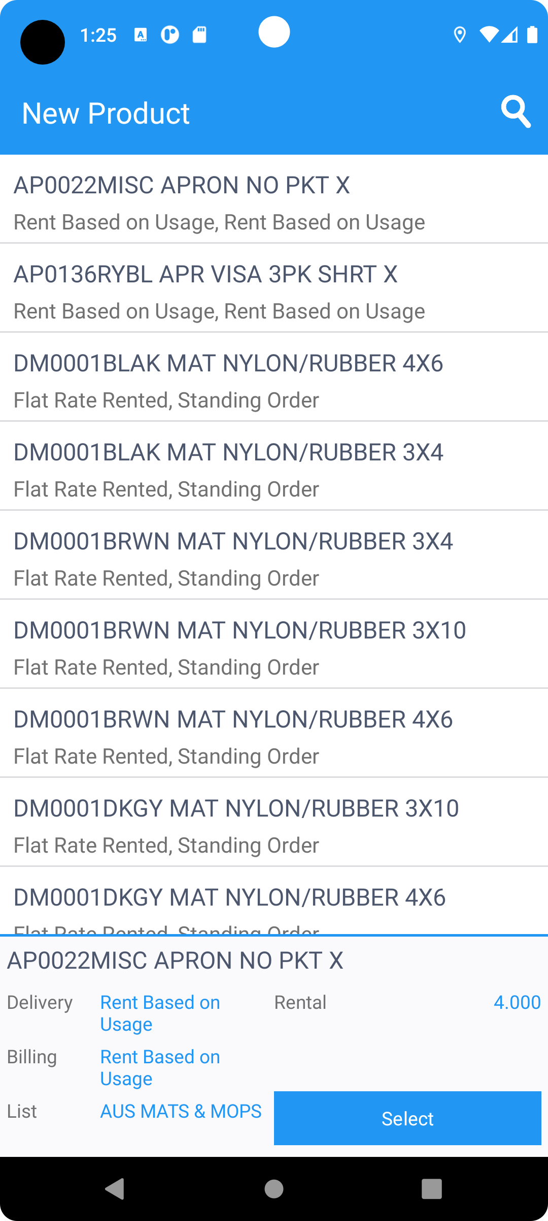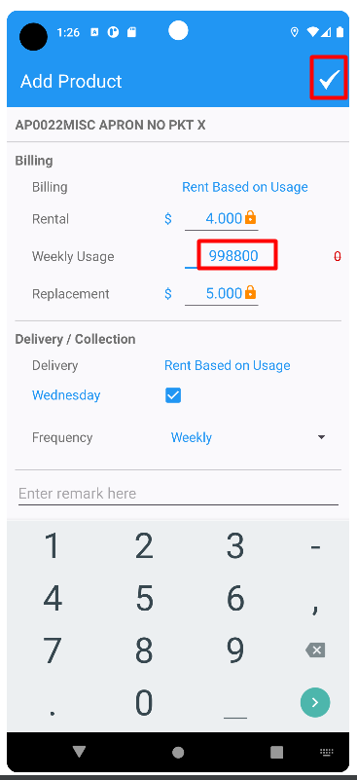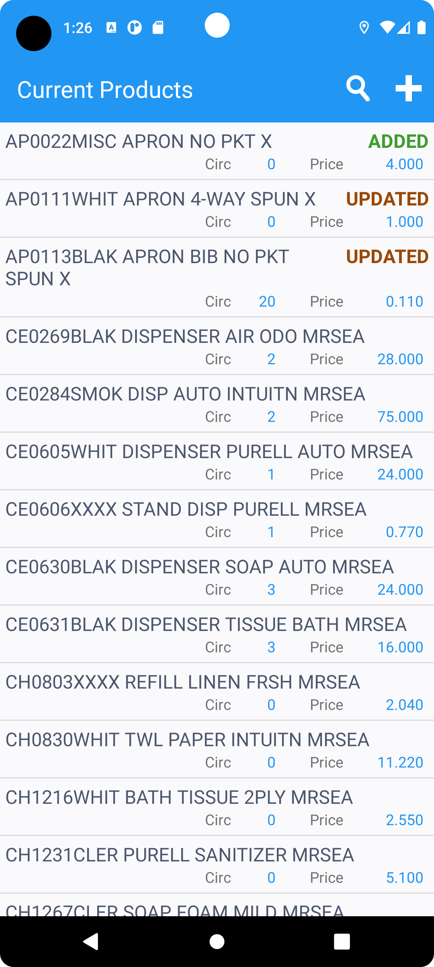
- Settle the route and depart
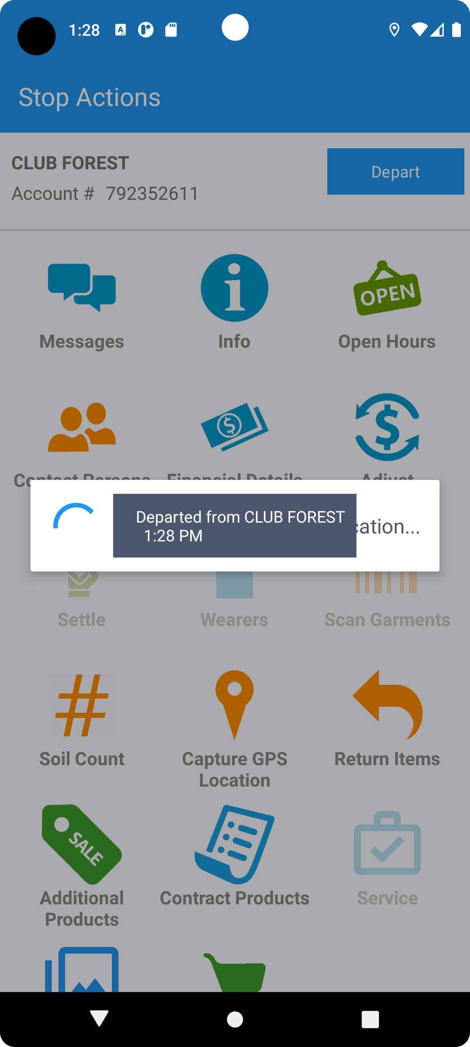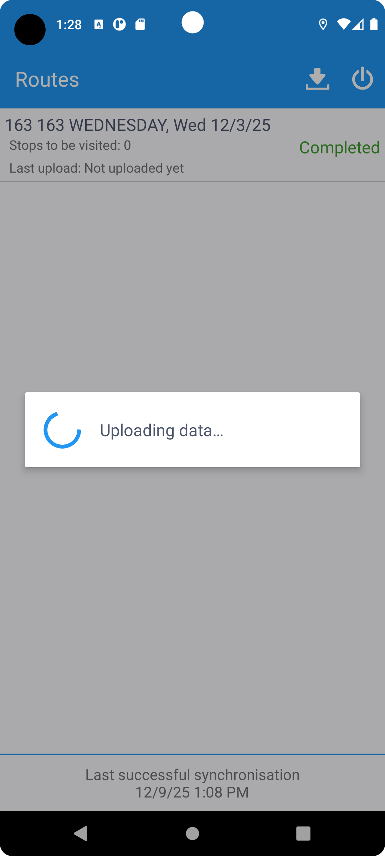
- Approve WebX transactions. Save.
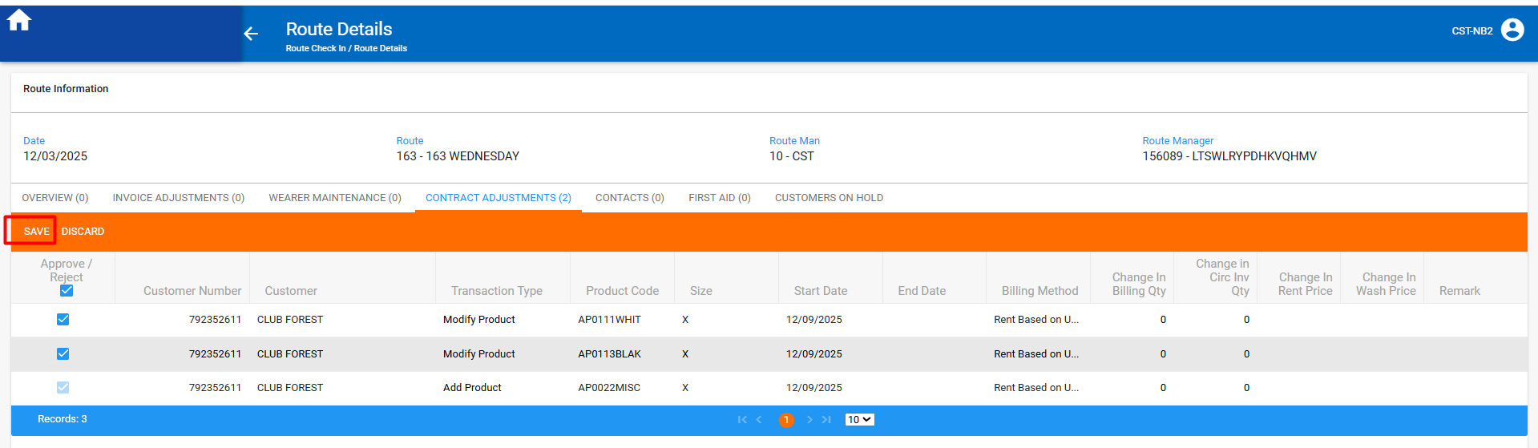
- Settle the route
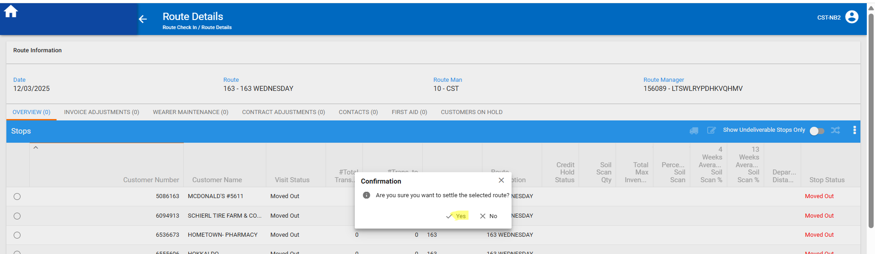
- After settlement, check PLPC
Modified products
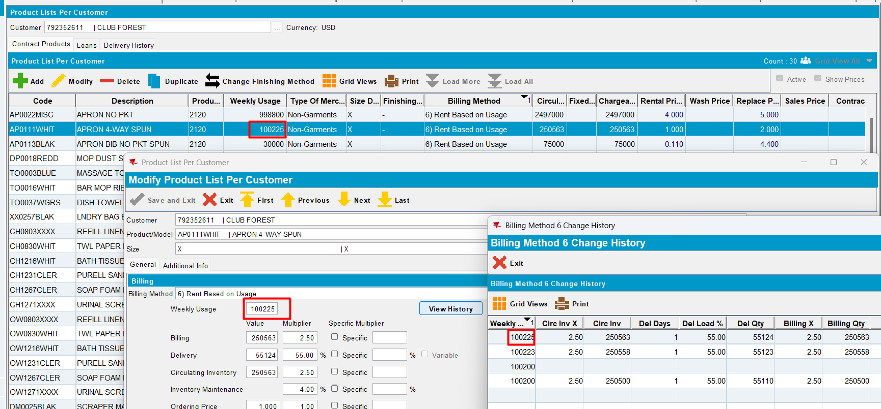
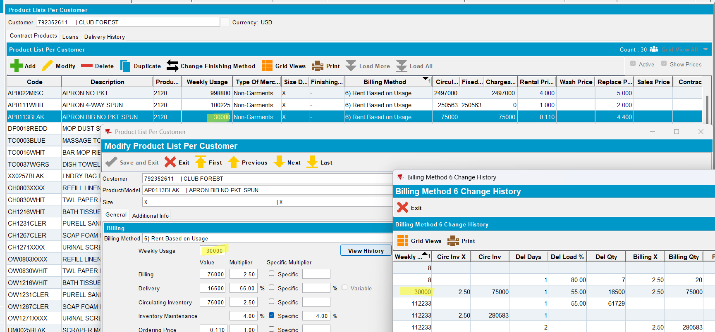
Added products in PDA
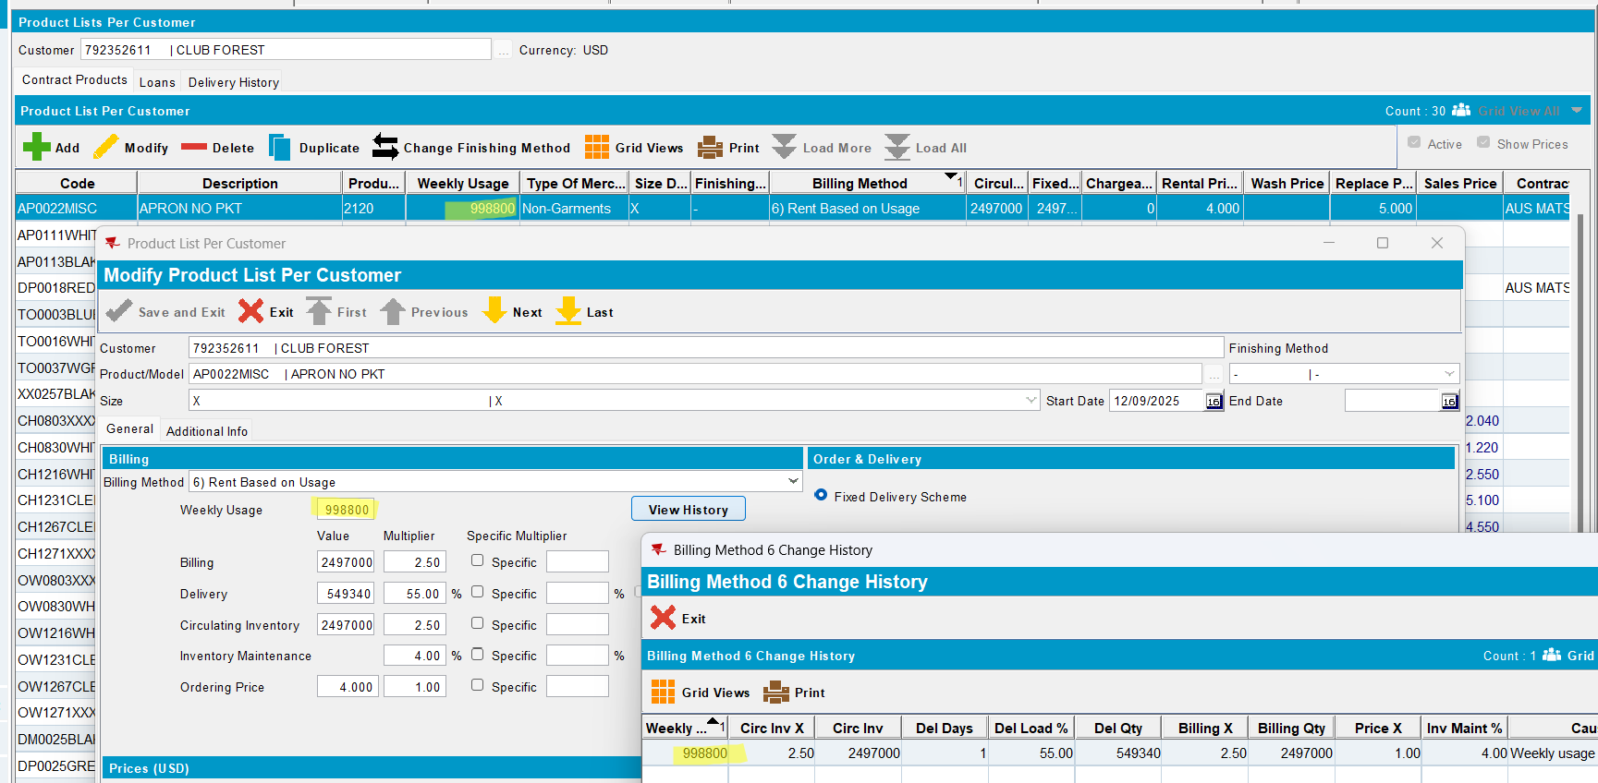
- Check BM6WeeklyUsageManagement
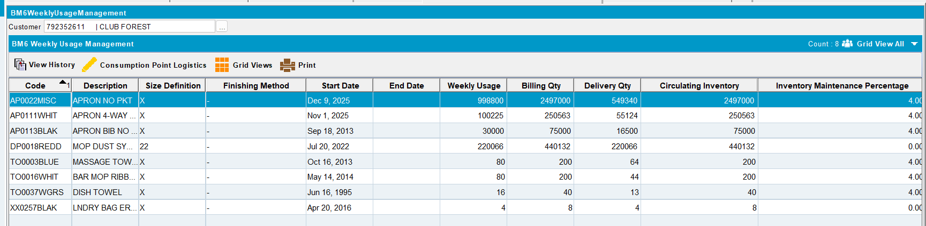
Test OK

