ABSN-1621 duplicating sales PLPC line removes original PLPC line price
Environment | Prerequisites
Version: 9.08.00.RELEASE.p23  DBServerName=abs-srv17.internal.abslbs.com  DBSID=CUST23  DBUser= AUS_MNT90800  DBPassword=AUS_MNT90800  EnvironmentNAME=Test  EnvironmentSTAGE=Test | - Module: AUS, BKLBASIS, PWBBASIS; WISBASIS

Contents
After fix 1
Test Case 1: Customer with PLPC Products using Customer Specific Prices – TEST PASSED. 1
Test Case 2: Source Product Pricing Verification After Cancelled Duplication. – TEST PASSED. 7
Regression Test: Customer with Products using Predefined Contract Prices – TEST PASSED. 8

After fix
Hash: b50480bf54b9
BU/Plant: 502 / 502

Test Case 1: Customer with PLPC Products using Customer Specific Prices – TEST PASSED.
Expected Result: When duplicating a Product in PLPC, Source Product’s price records and history must remain unchanged.
- Find a customer using BM3 products on current BU.
BM3 product can be defined to use all 4 product prices analyzed: Rent, Wash, Replace, Sale.
-- Find a customer using BM3 product
select pr.code, c.customernumber
from productlistpercustomer plpc
join product pr on pr.product_id=plpc.product_id
join customer c on c.customer_id=plpc.customer_id
join businessunit bu on bu.businessunit_id=c.defaultbusinessunit_id
where plpc.billingmethod=3
and bu.code='502'
order by 1
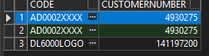
Customer.contractusage=1
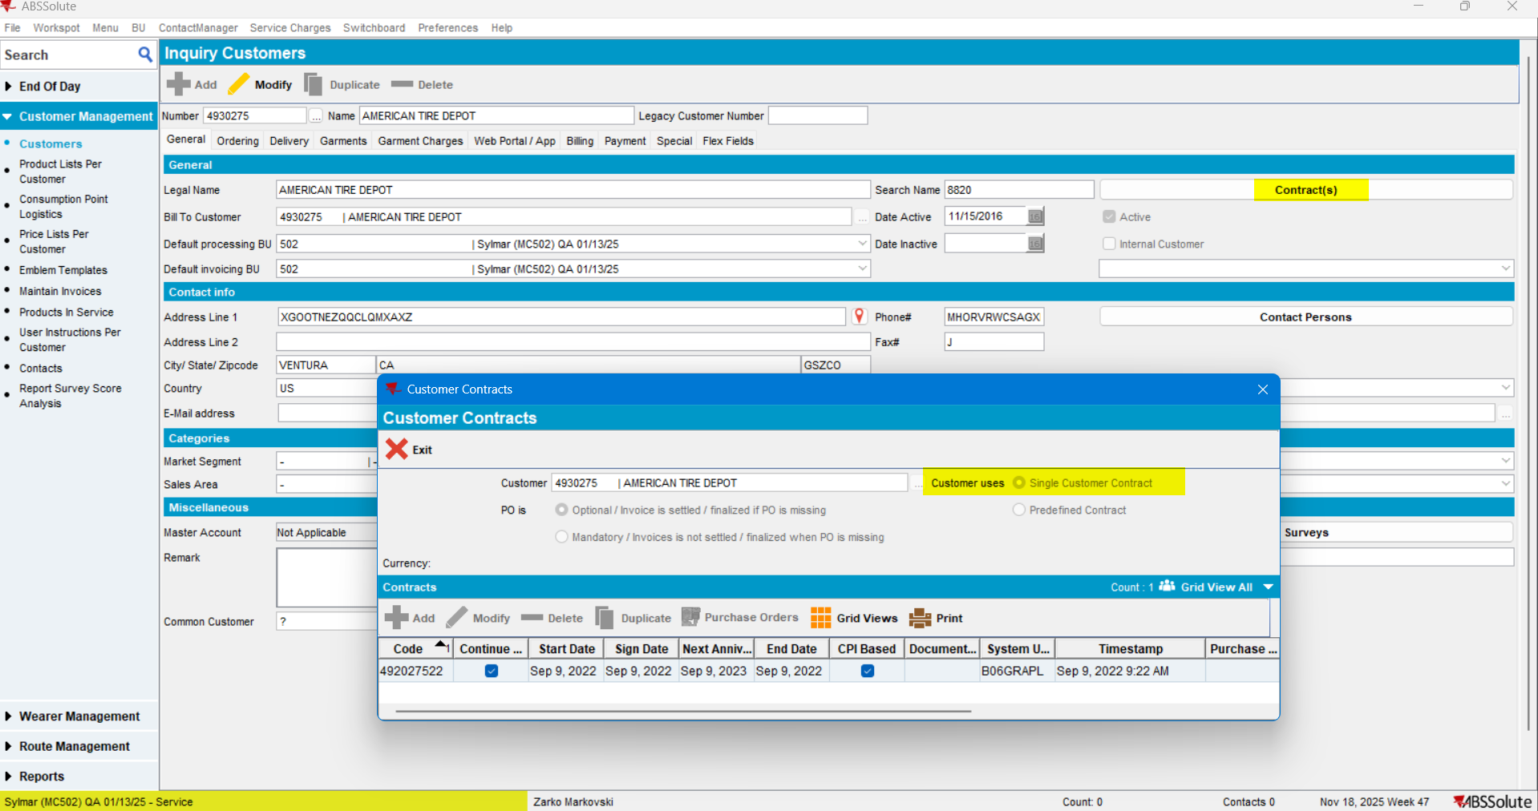

- Add/Verify Product: Ensure the PLPC product has multiple sizes, all 4 price types defined, and multiple price history records:
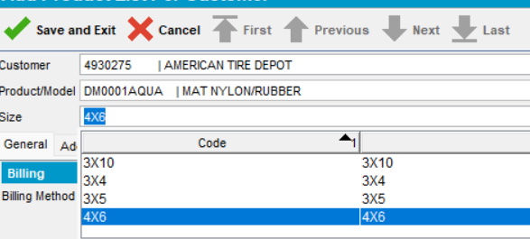

Verification: Check Rent, Wash, Replace, and Sales Price History screens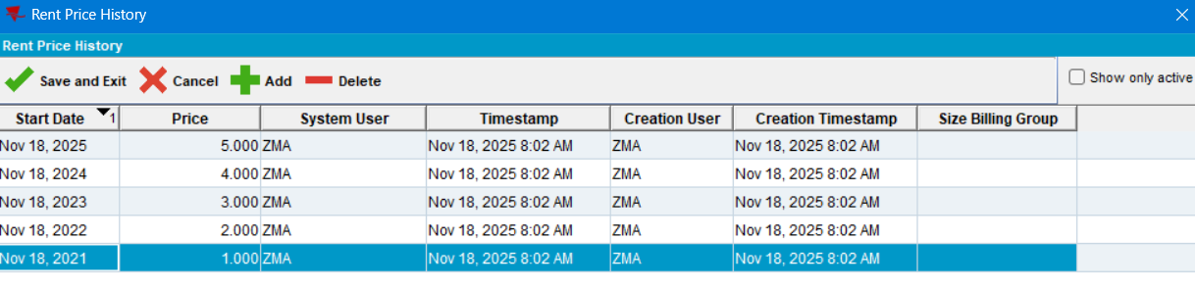

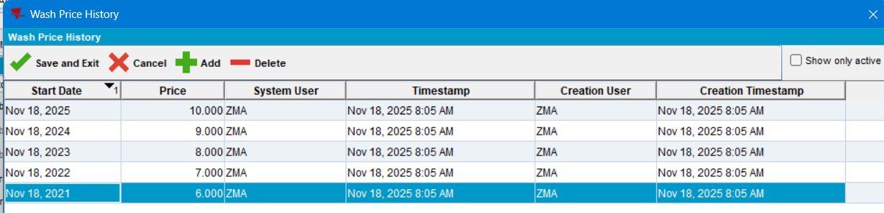
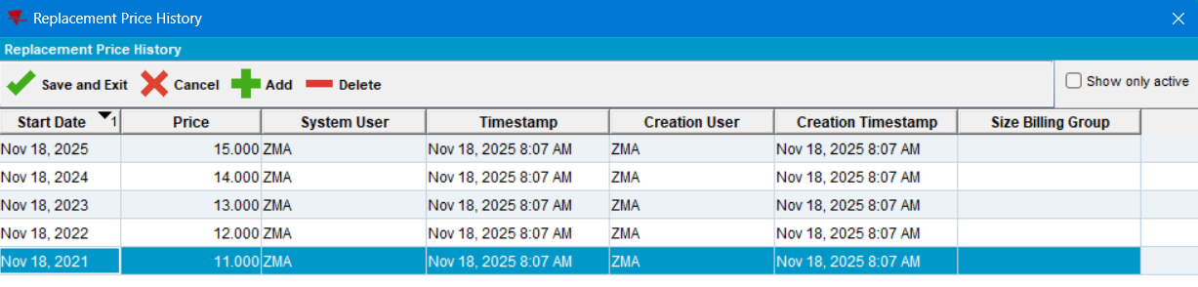
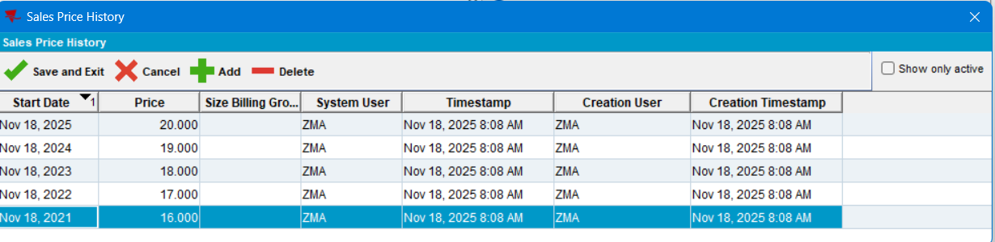
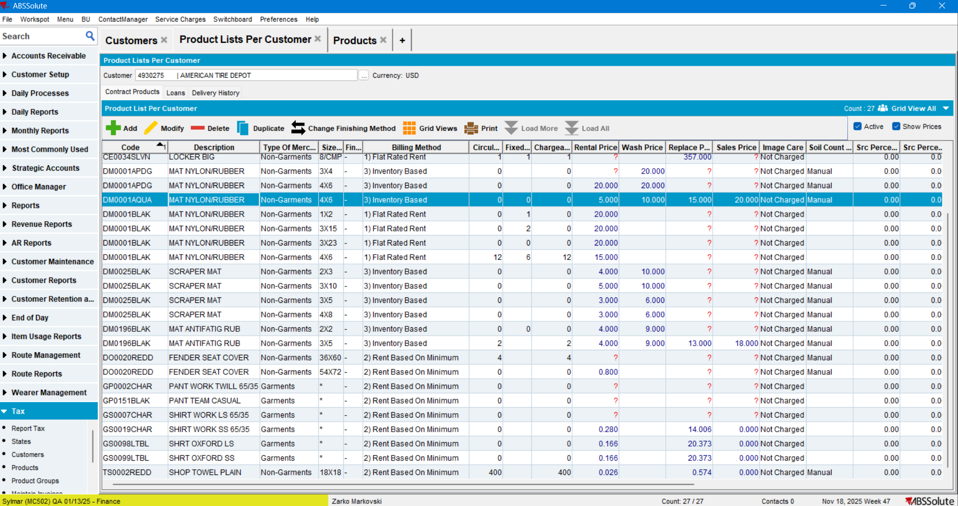

- Duplicate Product: Select the product in the grid and click Duplicate:
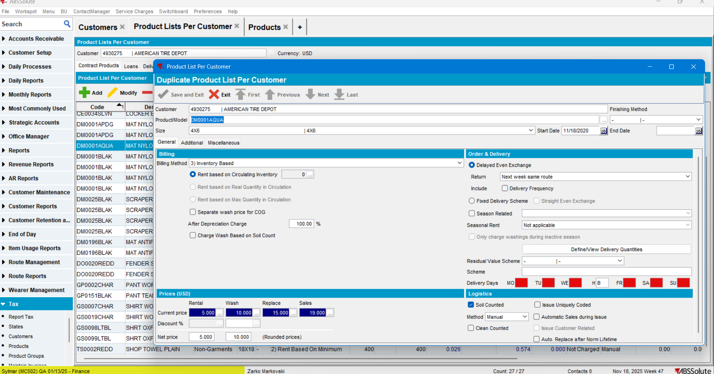

- Modify Duplicate: Change the size of the duplicated line, then click Save and Exit:
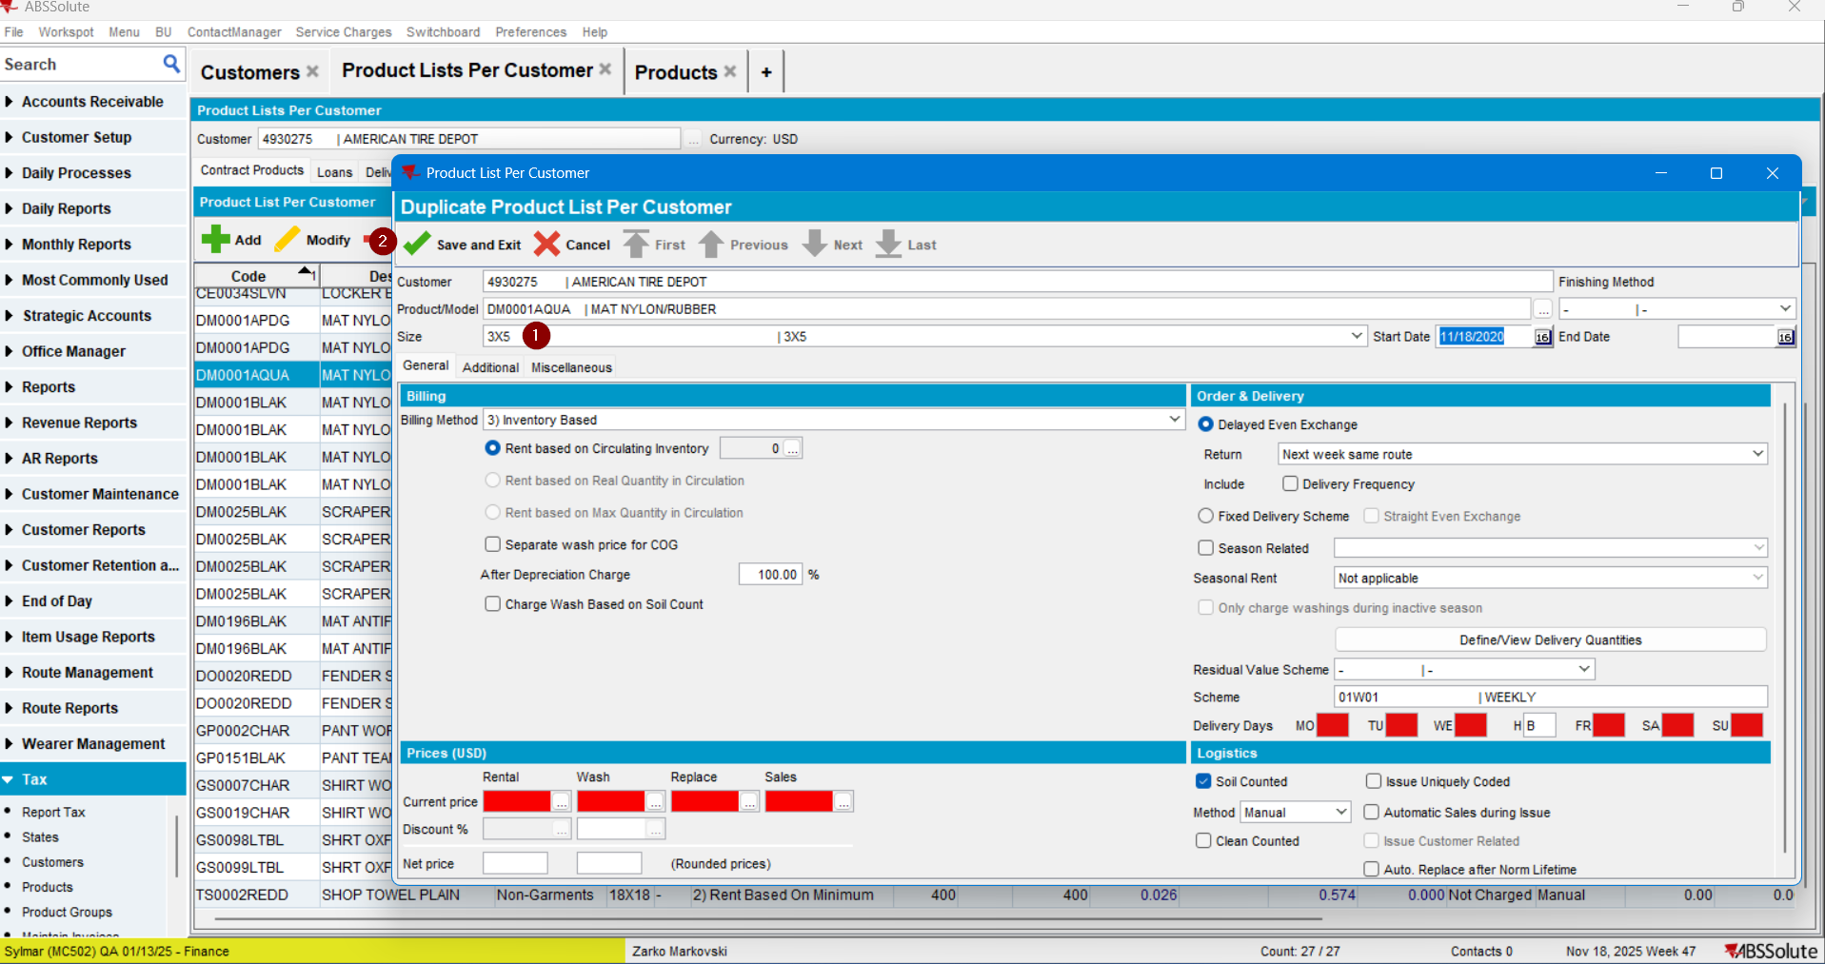

- Verify Source: Refresh the PLPC page, reopen the original (Source) product, and review its prices.
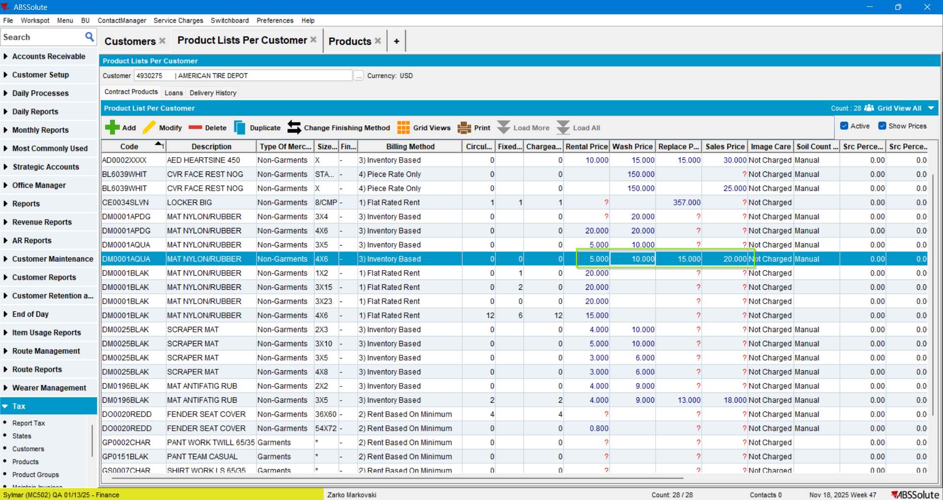
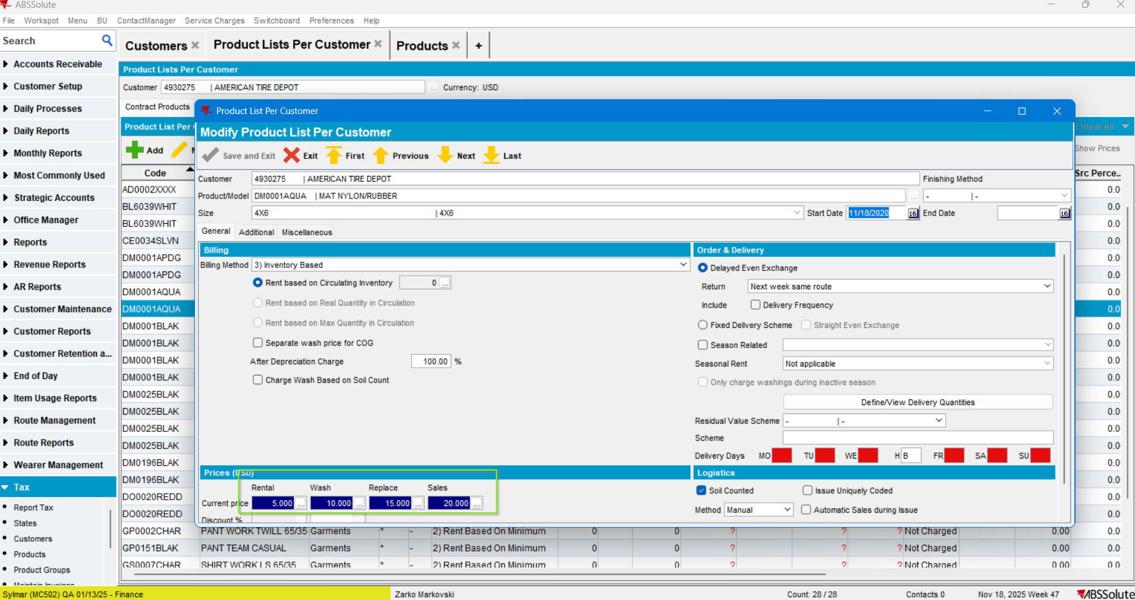

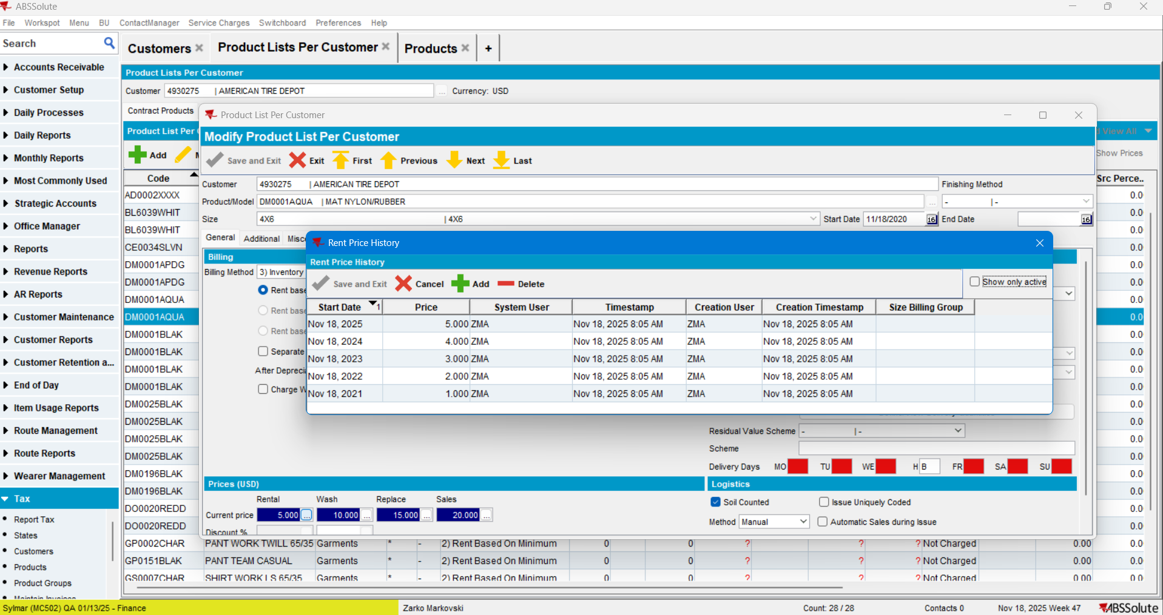
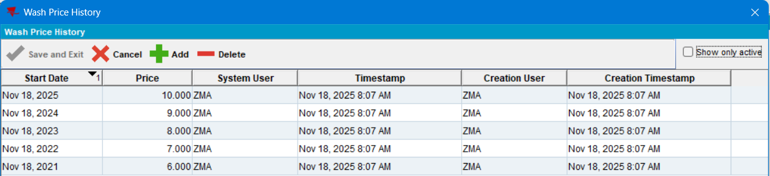
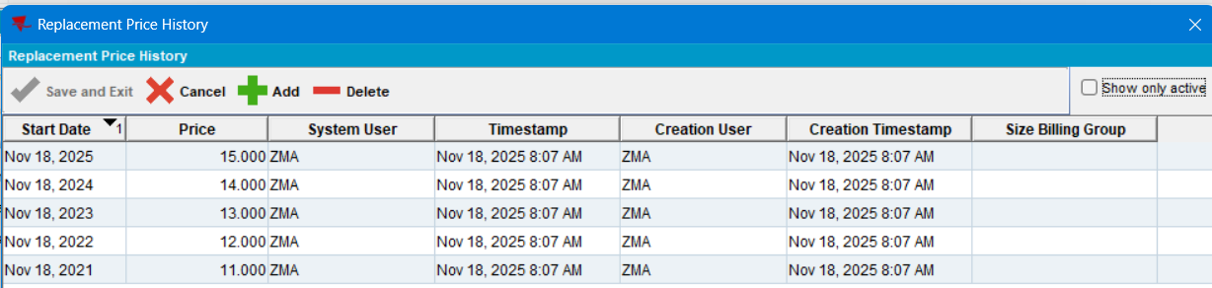
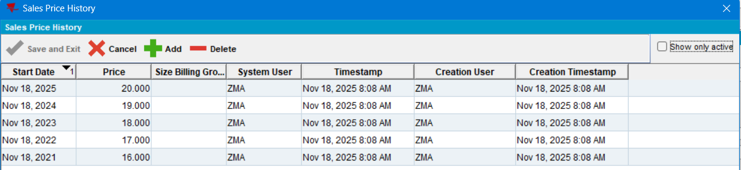
Current behavior: The Source Product prices in the grid and the Price History records (Rent, Wash, Replace, Sales) remained unchanged.
TEST PASSED.

Test Case 2: Source Product Pricing Verification After Cancelled Duplication. – TEST PASSED.
Expected behavior: Cancelling a Duplication PLPC product process should not alter the Source Product Data in any way.
- Baseline Check: Select a product in PLPC and note the prices before duplication:
- Current Prices: Rent: 13.795 | Replace: 0.000 | Sales: 0.000
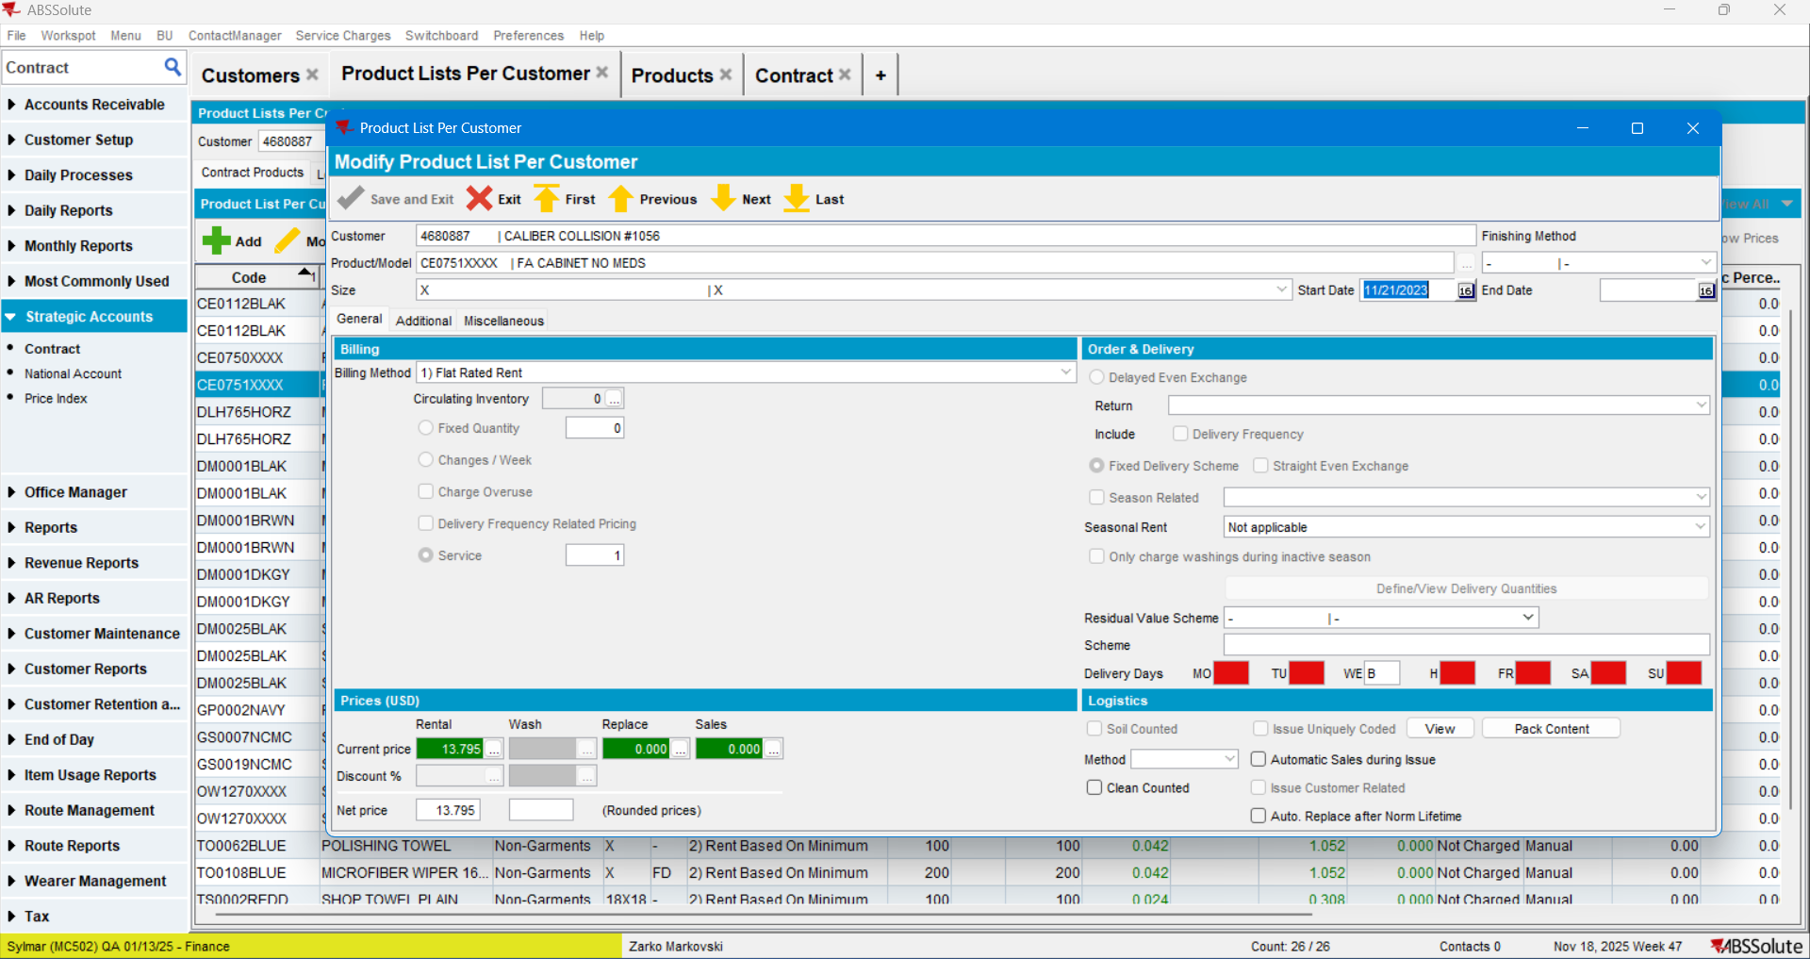
- Initiate Duplication: Click the Duplicate button:
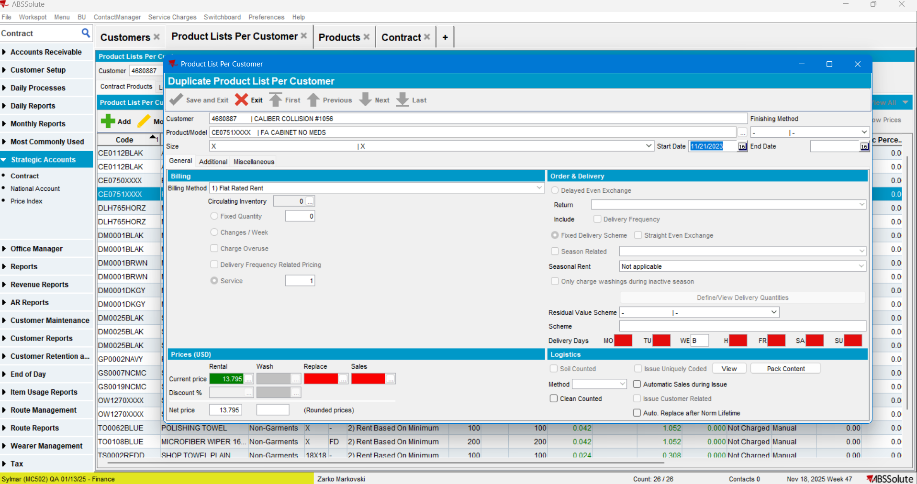

- Cancel Process: Click Cancel or Exit on the duplication screen without saving.
- Re-examine the Source Product prices:
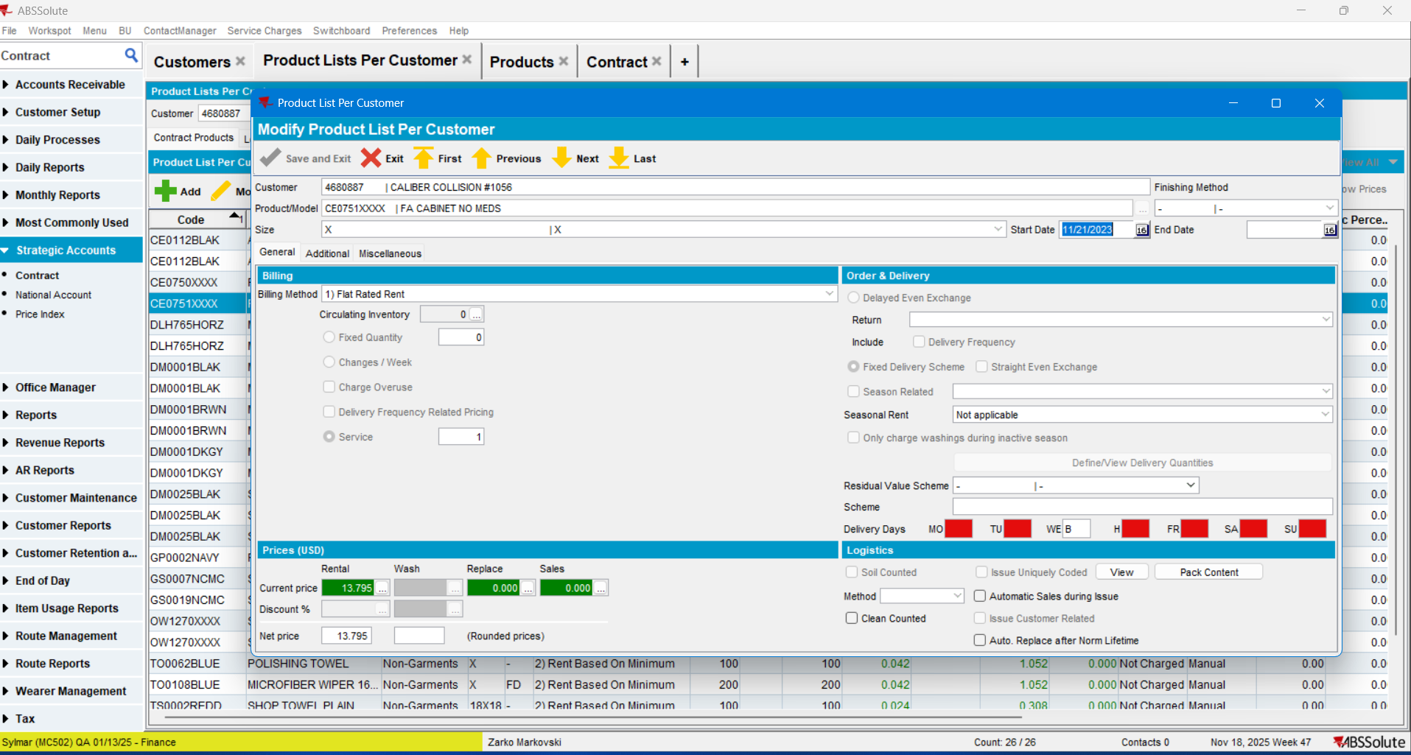
Current behavior: When cancelling the duplication process, the Source Product prices remained exactly the same..
TEST PASSED.

Regression Test: Customer with Products using Predefined Contract Prices – TEST PASSED.
Expected result: After duplicating a PLPC Product associated with a Predefined Contract, no changes should occur on the Source Product.
Prerequisites / Data Setup: Identify a Predefined Contract Customer on the current BU
select c.customernumber, c.name, c.contractusage
from customer c
where c.defaultbusinessunit_id=(select bu.businessunit_id from businessunit bu where bu.code='502')
and c.contractusage=1
and c.active='Y'
order by 1
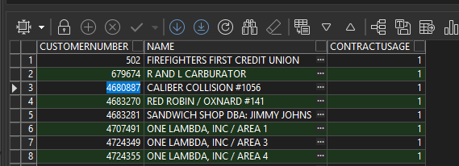

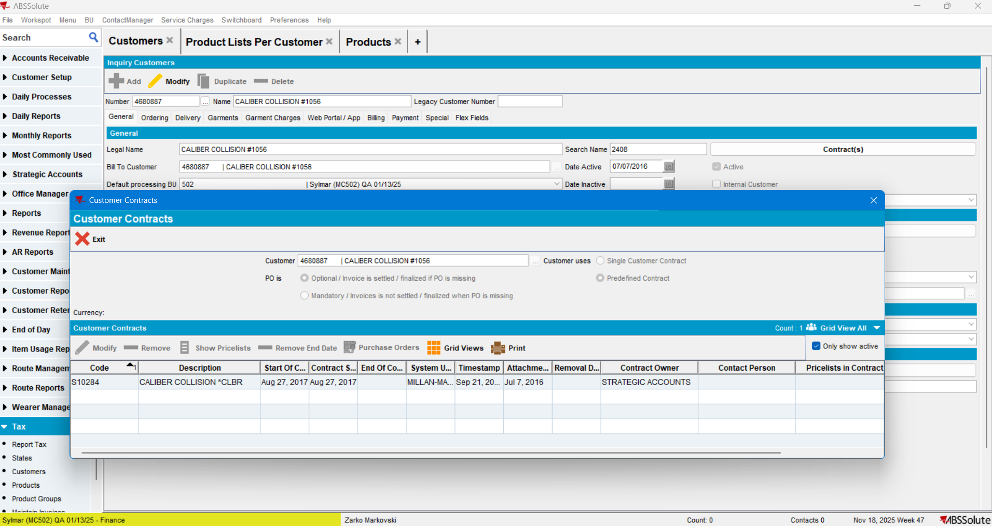
Test Steps:
- Select Product: Open a product from the customer’s PLPC (e.g., Product Code: CE0112BLAK, Size: 48)
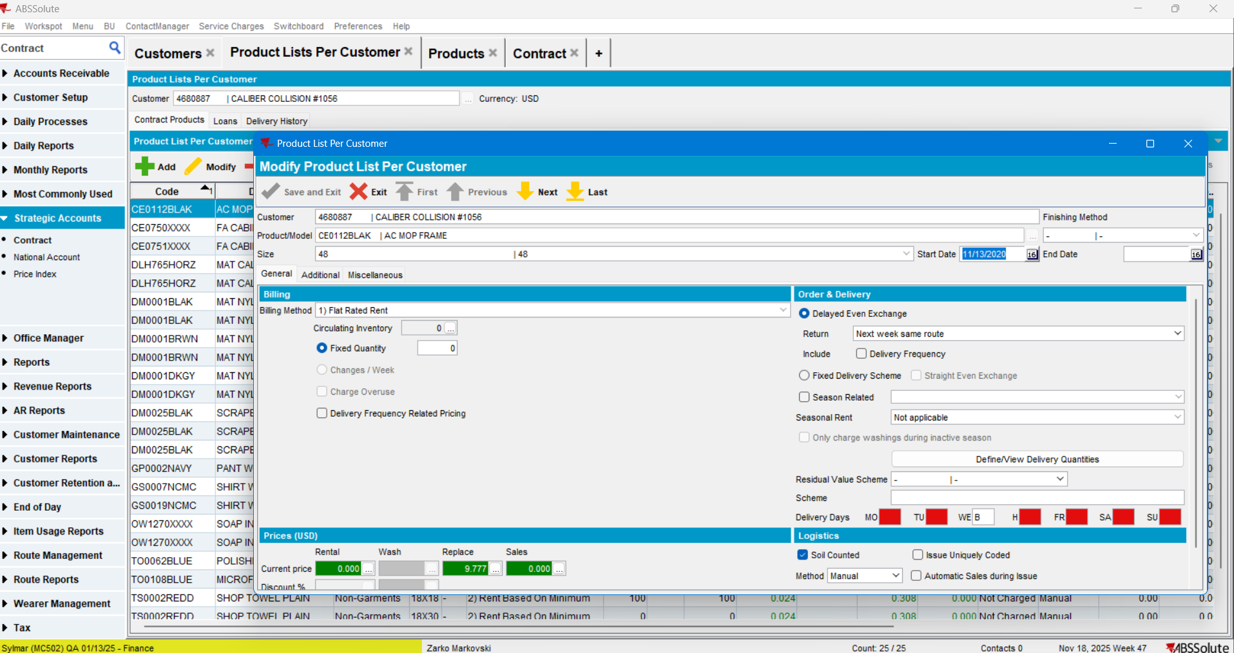

- Verify Contract Prices: Confirm contract prices exist for this product (Rent, Replace, Sales).
Note that pricing varies by size for this product:
Rent:
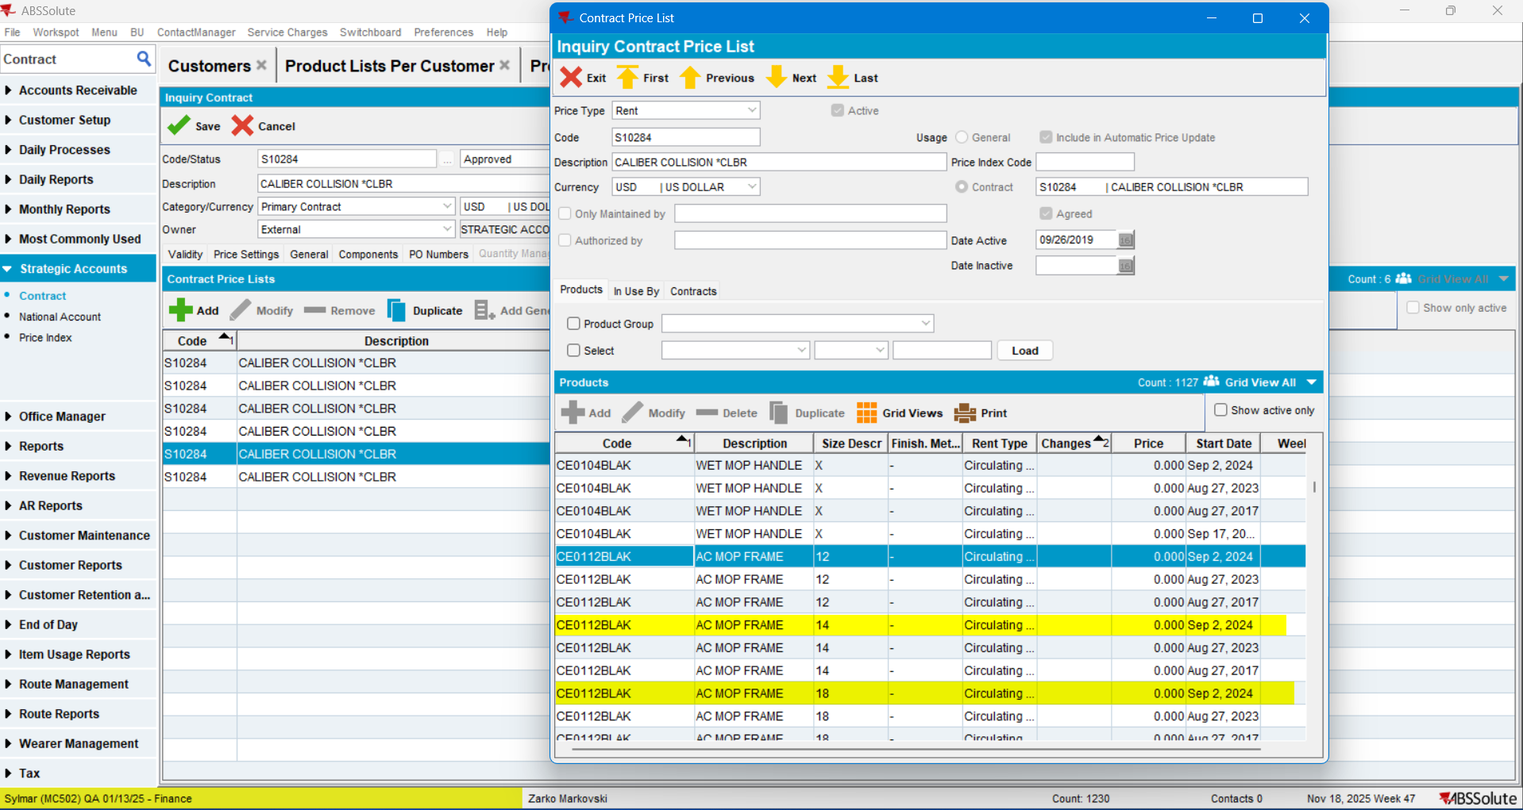
Replace:
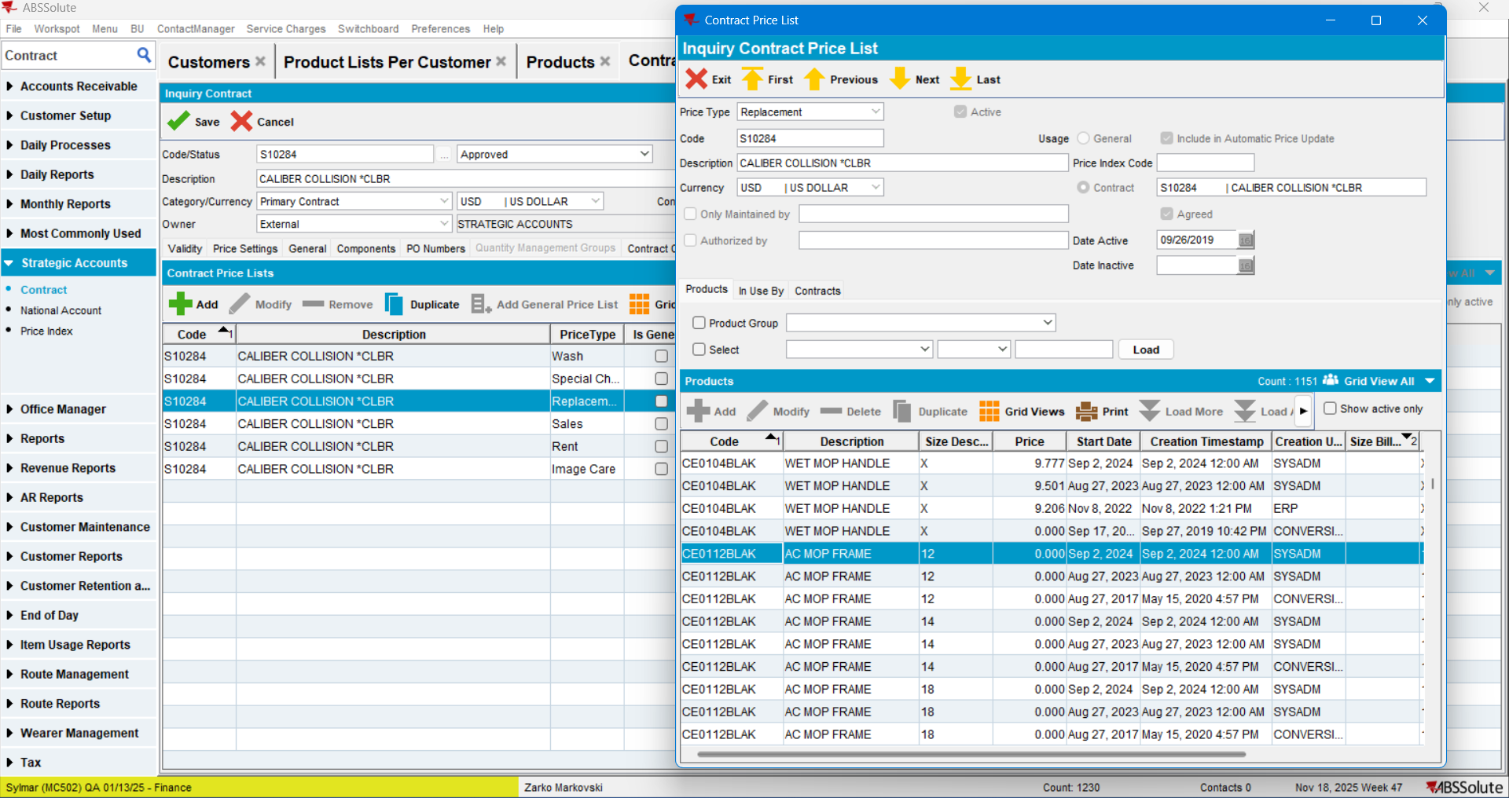

Sales:
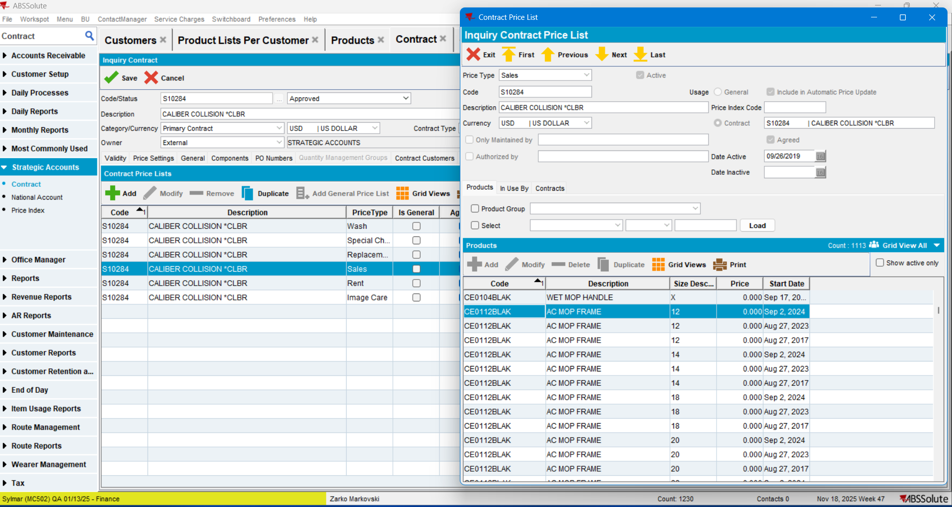
Prices are defined for several sizes of this product.
- Duplicate Product: Select the product line and click Duplicate:
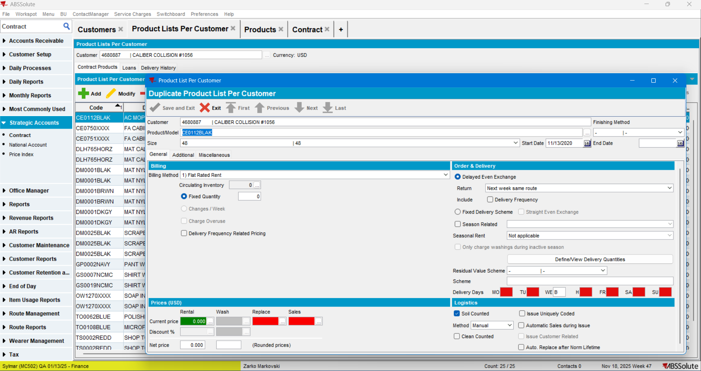

- Modify Duplicate: Change the product size (e.g., to Size 12) and click Save and Exit:
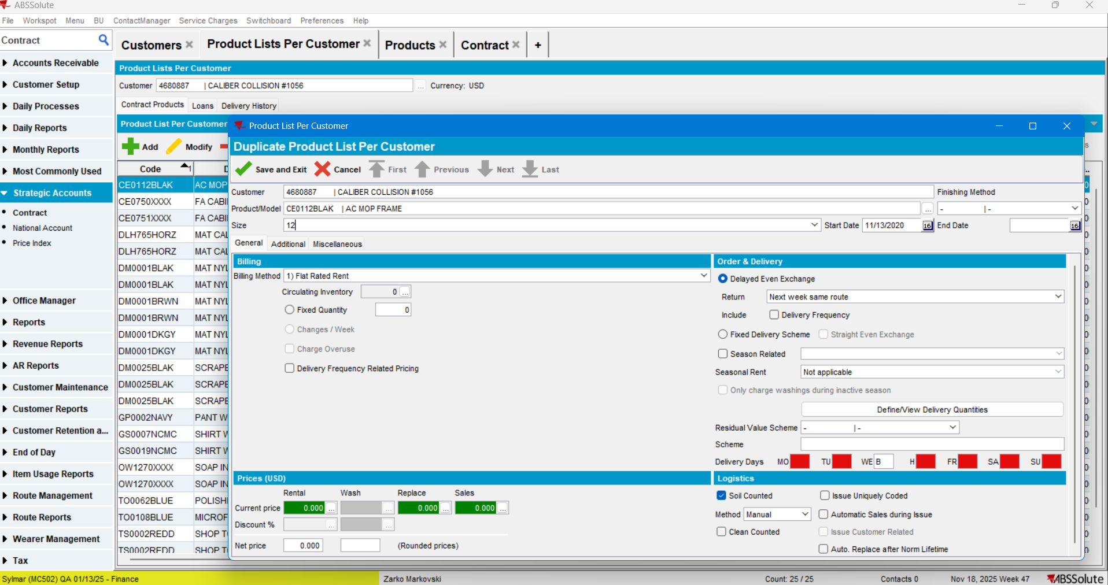

- Verify Source: Reopen the Source Product and check the pricing fields:
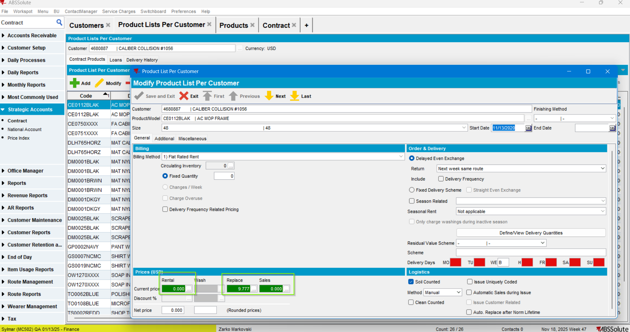
Current behavior: The Source Product prices remained unchanged.
TEST PASSED.

