ABSN-12610 (ex ABS-156244) Rent for Loss Option at Customer and Contract level – 9.08.00.RELEASE.patchesAUS

Environment | Prerequisites
DBServerName=abs-srv16.internal.abslbs.com  DBSID=CUST21  DBUser=AUS_ND90502  DBPassword= AUS_ND90502  Environment=Production  Version: 9.08.00.RELEASE.p14  Feature branch: feature/ABS-156244-rent-for-loss-option-at-customer-and-contract-level | - Module: -  - System setting:  CHARGERENTFORLOSS  RENTALCHARGEFORLOSTGRMT  SETTLEMENTACTIVE  - Other applications versions (if is applicable):-  - BU: 602

Contents
BU/Plant: 602 2
Data preparation 2
1. Test system setting CHARGERENTFORLOSS – TEST OK 3
1.1. CHARGERENTFORLOSS=Y (fixed), RENTALCHARGEFORLOSTGRMT=Y, SETTLEMENTACTIVE=N 4
1.2. CHARGERENTFORLOSS=Y (fixed), RENTALCHARGEFORLOSTGRMT=N, SETTLEMENTACTIVE=Y 6
1.3. CHARGERENTFORLOSS=Y (fixed), RENTALCHARGEFORLOSTGRMT=N, SETTLEMENTACTIVE=N 8
1.4. CHARGERENTFORLOSS=N (fixed), RENTALCHARGEFORLOSTGRMT=Y, SETTLEMENTACTIVE=N 10
1.5. CHARGERENTFORLOSS=N (fixed), RENTALCHARGEFORLOSTGRMT=N, SETTLEMENTACTIVE=Y 12
1.6. CHARGERENTFORLOSS=N (fixed), RENTALCHARGEFORLOSTGRMT=N, SETTLEMENTACTIVE=N 14
1.7. CHARGERENTFORLOSS=Y (default), RENTALCHARGEFORLOSTGRMT=Y, SETTLEMENTACTIVE=N 16
1.8. CHARGERENTFORLOSS=Y (default), RENTALCHARGEFORLOSTGRMT=N, SETTLEMENTACTIVE=Y 18
1.9. CHARGERENTFORLOSS=Y (default), RENTALCHARGEFORLOSTGRMT=N, SETTLEMENTACTIVE=N 20
1.10. CHARGERENTFORLOSS=Y (default), RENTALCHARGEFORLOSTGRMT=Y, SETTLEMENTACTIVE=N 22
1.11. CHARGERENTFORLOSS=Y (default), RENTALCHARGEFORLOSTGRMT=N, SETTLEMENTACTIVE=Y 24
1.12. CHARGERENTFORLOSS=Y (default), RENTALCHARGEFORLOSTGRMT=N, SETTLEMENTACTIVE=N 26
1.13. CHARGERENTFORLOSS=Y (Fixed), RENTALCHARGEFORLOSTGRMT=Y, SETTLEMENTACTIVE=Y 28
1.13.1. Check Customer in ADD mode, when adding a new customer 28
1.13.2. Check Customer In MODIFY mode, when the customer does not have garments, but now it has garments 30
1.13.3. Check Customer In MODIFY mode, when the customer already has garments 31
1.13.4. Check Customer In DUPLICATE mode, when the customer already has garments 34
1.13.5. Check contract 35
1.14. CHARGERENTFORLOSS=N (Fixed), RENTALCHARGEFORLOSTGRMT=Y, SETTLEMENTACTIVE=Y 37
1.14.1. Check Customer in ADD mode, when adding a new customer 38
1.14.2. Check Customer In MODIFY mode, when the customer does not have garments, but now it has garments 39
1.14.3. Check Customer In MODIFY mode, when the customer already has garments 40
1.14.4. Check Customer In DUPLICATE mode, when the customer already has garments 43
1.14.5. Check contract 44
1.15. CHARGERENTFORLOSS=Y (Default), RENTALCHARGEFORLOSTGRMT=Y, SETTLEMENTACTIVE=Y 46
1.15.1. Check Customer in ADD mode, when adding a new customer 46
1.15.2. Check Customer In MODIFY mode, when the customer does not have garments, but now it has garments 48
1.15.3. Check Customer In MODIFY mode, when the customer already has garments 49
1.15.4. Check Customer In DUPLICATE mode, when the customer already has garments 51
1.15.5. Check contract 52
1.16. CHARGERENTFORLOSS=N (Default), RENTALCHARGEFORLOSTGRMT=Y, SETTLEMENTACTIVE=Y 56
1.16.1. Check Customer in ADD mode, when adding a new customer 56
1.16.2. Check Customer In MODIFY mode, when the customer does not have garments, but now it has garments 58
1.16.3. Check Customer In MODIFY mode, when the customer already has garments 59
1.16.4. Check Customer In DUPLICATE mode, when the customer already has garments 60
1.16.5. Check contract 61
2. Test Contract Compliancy – TEST OK 64
3. Test when “Charge Rent For Loss” is not checked -> invoice lines should not be created – TEST OK 69
4. Test Read Only customer – TEST OK 81
5. Test when “Del to customer” is different than “Bill to customer” – TEST OK 83
6. Test when CustomerGarmentCharges does not exist – TEST OK 86

BU/Plant: 602

Data preparation
- Customer level settings:
  - Check loss charge
  - Customer is linked to a predefined contract
- Product List per Customer level settings:
  - Customer has garments
- Customer has wearers with wearer inventories
Customer: 4963487
Contract: S11044

Test system setting CHARGERENTFORLOSS – TEST OK
Hash: c1cd935
- Test the following combinations of system settings:
CHARGERENTFORLOSS |  | Test  No. | RENTALCHARGEFORLOSTGRMT | SETTLEMENTACTIVE | Is new field visible?
Fixed value  (if Fixed=Y -> field is disabled) | Y (user can not change it) | 1.13 | Y | Y | Yes
Fixed value  (if Fixed=Y -> field is disabled) | Y (user can not change it) | 1.1 | Y | N | No
Fixed value  (if Fixed=Y -> field is disabled) | Y (user can not change it) | 1.2 | N | Y | No
Fixed value  (if Fixed=Y -> field is disabled) | Y (user can not change it) | 1.3 | N | N | No
Fixed value  (if Fixed=Y -> field is disabled) | N | 1.14 | Y | Y | Yes
Fixed value  (if Fixed=Y -> field is disabled) | N | 1.4 | Y | N | No
Fixed value  (if Fixed=Y -> field is disabled) | N | 1.5 | N | Y | No
Fixed value  (if Fixed=Y -> field is disabled) | N | 1.6 | N | N | No
Default value  (if Default=Y -> field is enabled) | Y (can be changed) | 1.15 | Y | Y | Yes
Default value  (if Default=Y -> field is enabled) | Y (can be changed) | 1.7 | Y | N | No
Default value  (if Default=Y -> field is enabled) | Y (can be changed) | 1.8 | N | Y | No
Default value  (if Default=Y -> field is enabled) | Y (can be changed) | 1.9 | N | N | No
Default value  (if Default=Y -> field is enabled) | N | 1.16 | Y | Y | Yes
Default value  (if Default=Y -> field is enabled) | N | 1.10 | Y | N | No
Default value  (if Default=Y -> field is enabled) | N | 1.11 | N | Y | No
Default value  (if Default=Y -> field is enabled) | N | 1.12 | N | N | No
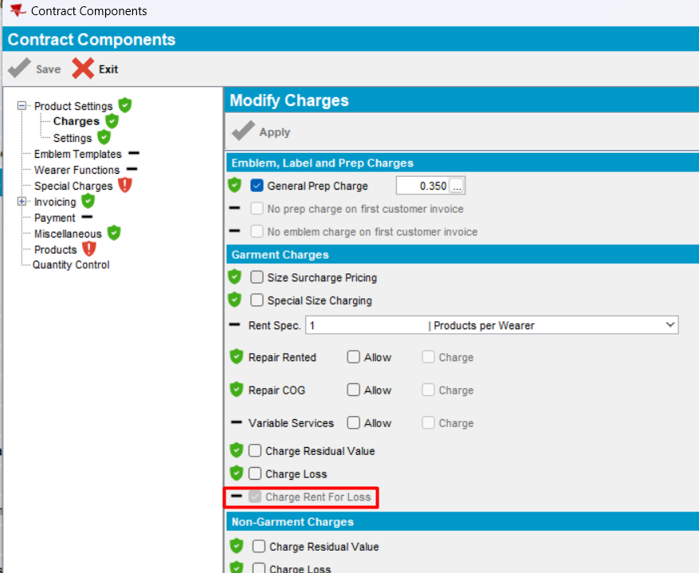

CHARGERENTFORLOSS=Y (fixed), RENTALCHARGEFORLOSTGRMT=Y, SETTLEMENTACTIVE=N
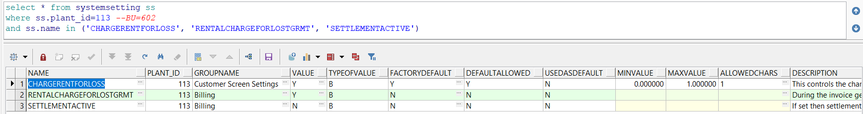
1. Check Customer in ADD mode
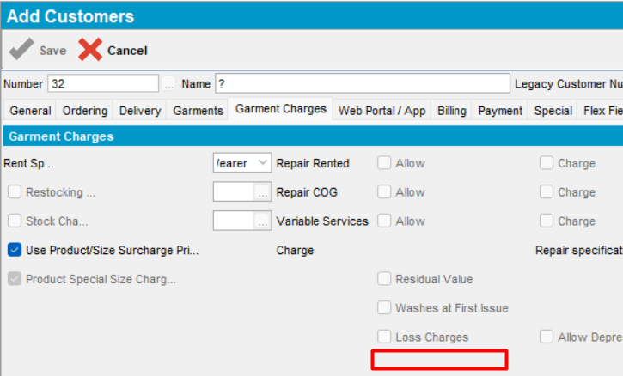
- Check Customer In modify mode
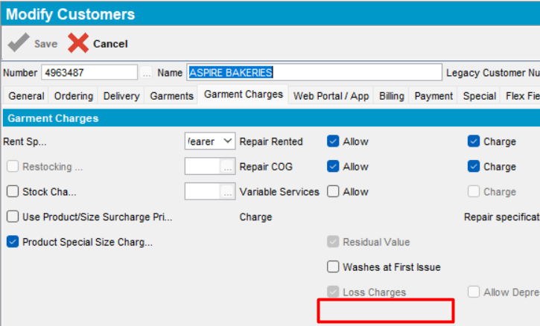
- Check contract
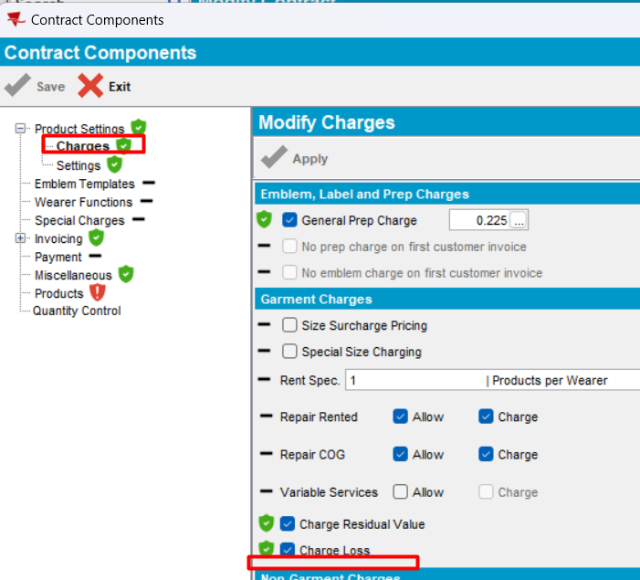
Expected behavior: when the system settings are not set in the following combination: CHARGERENTFORLOSS=Y (fixed), RENTALCHARGEFORLOSTGRMT=Y, SETTLEMENTACTIVE=N, the checkbox “Charge Rent For Loss” does not appear does not appear neither on Contract level, nor on Customer level.
Actual behavior: as expected
Tested OK

CHARGERENTFORLOSS=Y (fixed), RENTALCHARGEFORLOSTGRMT=N, SETTLEMENTACTIVE=Y
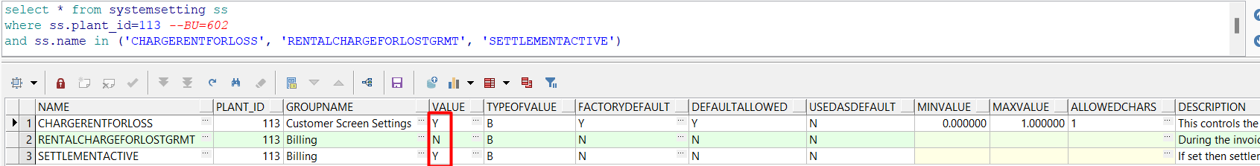
- Check Customer in ADD mode
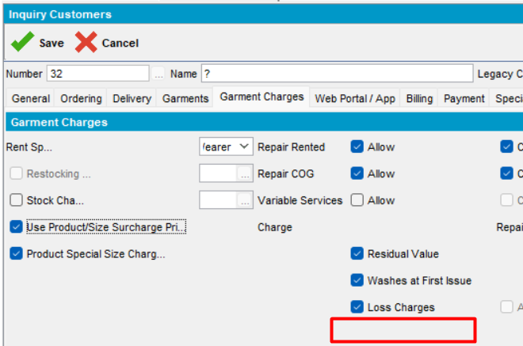
- Check Customer In modify mode
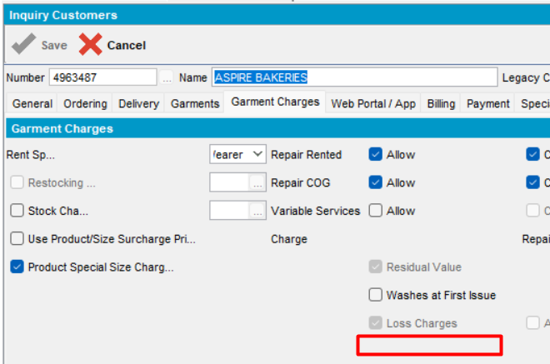
- Check contract
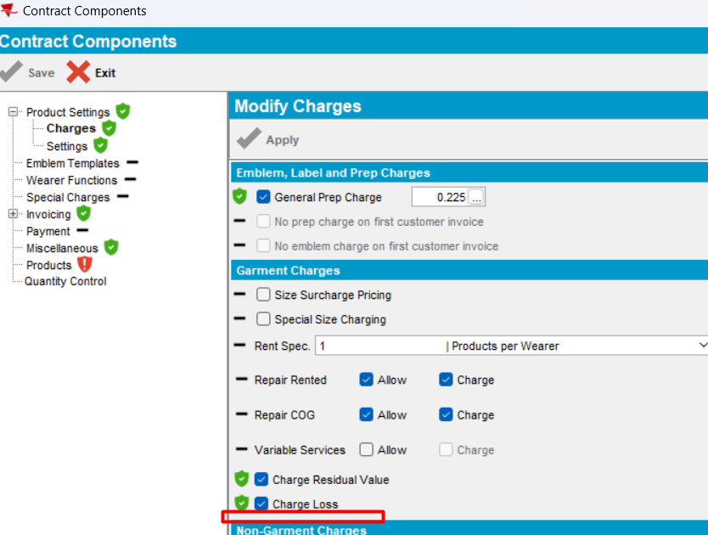
Expected behavior: when the system settings are not set in the following combination: CHARGERENTFORLOSS=Y (fixed), RENTALCHARGEFORLOSTGRMT=N, SETTLEMENTACTIVE=Y, the checkbox “Charge Rent For Loss” does not appear does not appear neither on Contract level, nor on Customer level.
Actual behavior: as expected
Tested OK

CHARGERENTFORLOSS=Y (fixed), RENTALCHARGEFORLOSTGRMT=N, SETTLEMENTACTIVE=N
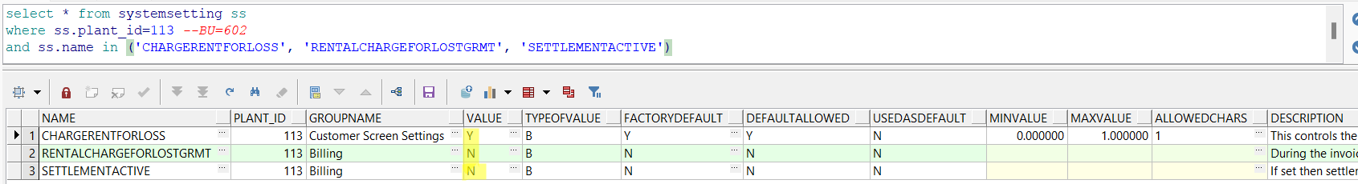
- Check Customer in ADD mode
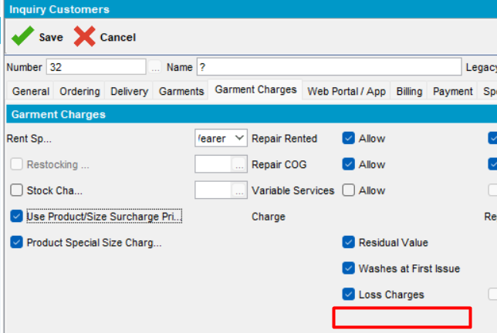
- Check Customer In modify mode
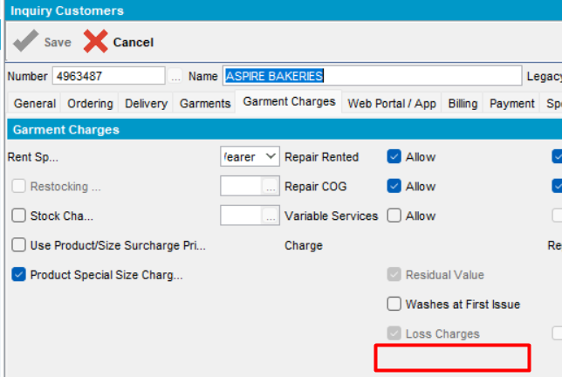
- Check contract
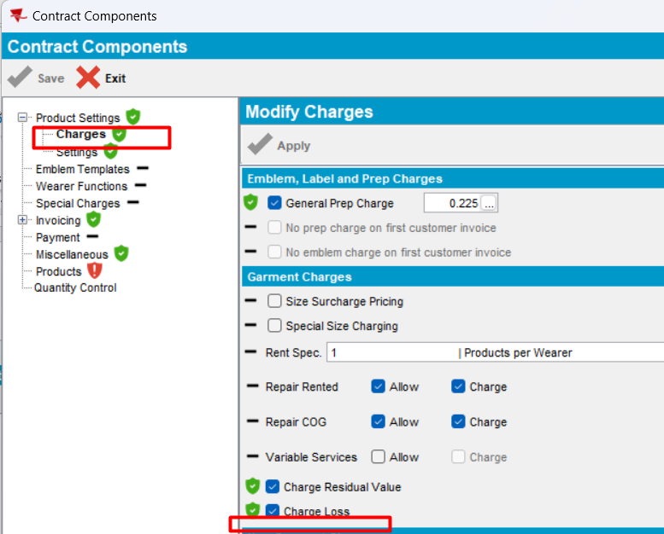
Expected behavior: when the system settings are not set in the following combination: CHARGERENTFORLOSS=Y (fixed), RENTALCHARGEFORLOSTGRMT=N, SETTLEMENTACTIVE=N, the checkbox “Charge Rent For Loss” does not appear does not appear neither on Contract level, nor on Customer level.
Actual behavior: as expected
Tested OK

CHARGERENTFORLOSS=N (fixed), RENTALCHARGEFORLOSTGRMT=Y, SETTLEMENTACTIVE=N
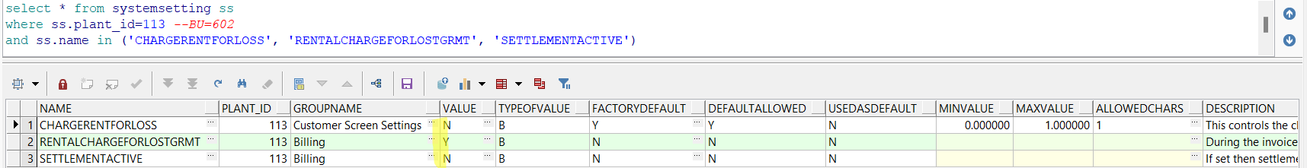
- Check Customer in ADD mode
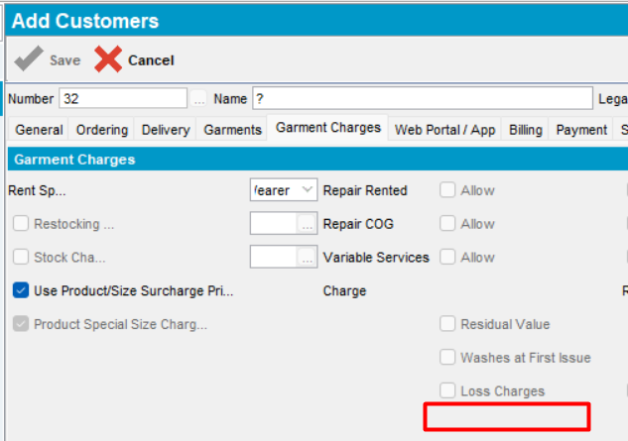
- Check Customer In modify mode
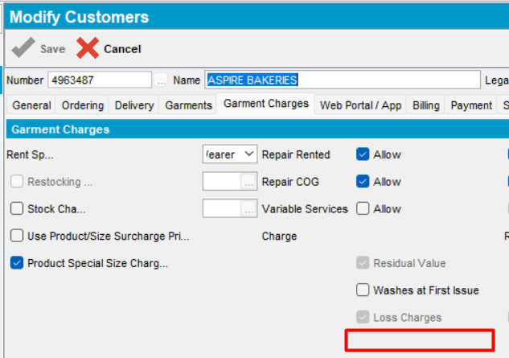
- Check contract
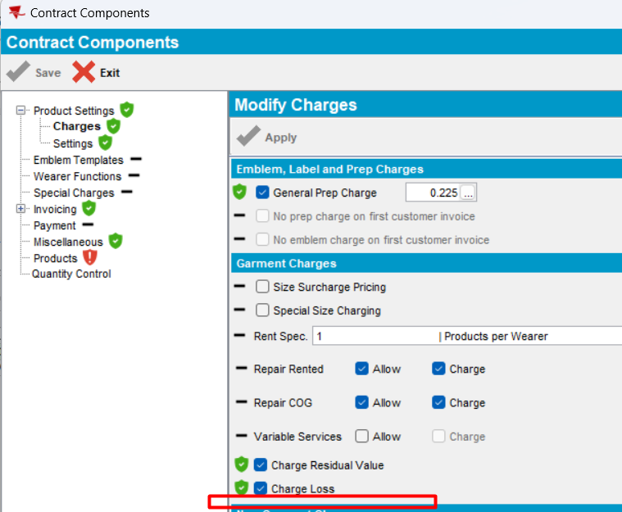
Expected behavior: when the system settings are not set in the following combination: CHARGERENTFORLOSS=N (fixed), RENTALCHARGEFORLOSTGRMT=Y, SETTLEMENTACTIVE=N, the checkbox “Charge Rent For Loss” does not appear does not appear neither on Contract level, nor on Customer level.
Actual behavior: as expected
Tested OK

CHARGERENTFORLOSS=N (fixed), RENTALCHARGEFORLOSTGRMT=N, SETTLEMENTACTIVE=Y
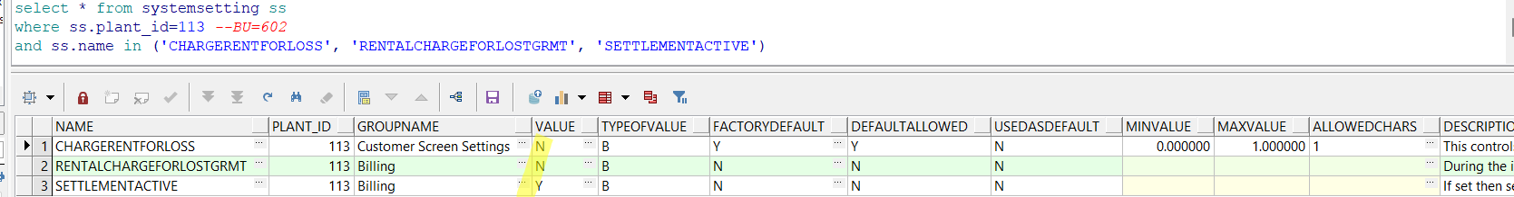
- Check Customer in ADD mode
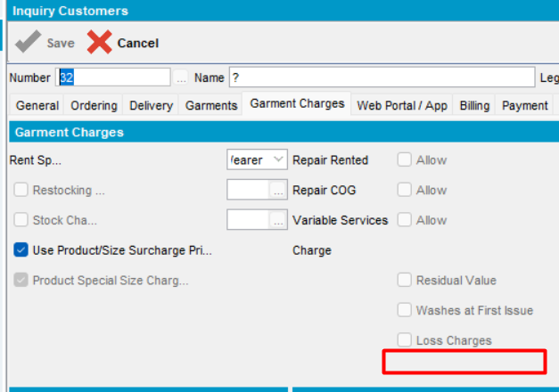
- Check Customer In modify mode
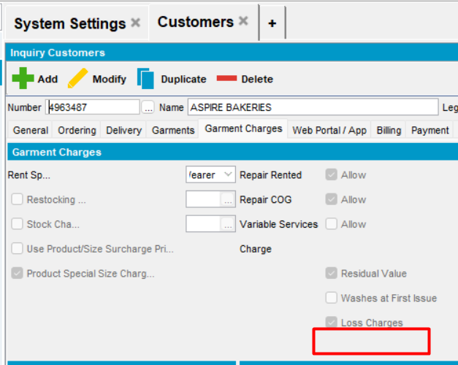
- Check contract
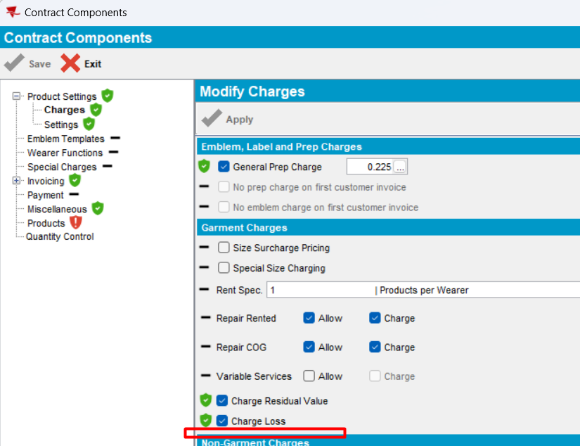
Expected behavior: when the system settings are not set in the following combination: CHARGERENTFORLOSS=N (fixed), RENTALCHARGEFORLOSTGRMT=N, SETTLEMENTACTIVE=Y, the checkbox “Charge Rent For Loss” does not appear does not appear neither on Contract level, nor on Customer level.
Actual behavior: as expected
Tested OK

CHARGERENTFORLOSS=N (fixed), RENTALCHARGEFORLOSTGRMT=N, SETTLEMENTACTIVE=N
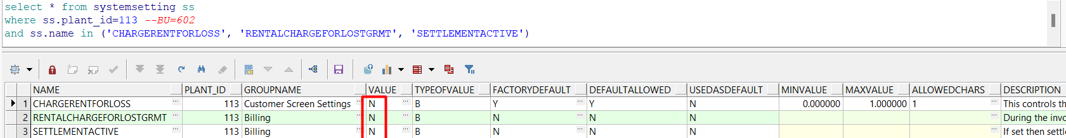
- Check Customer in ADD mode
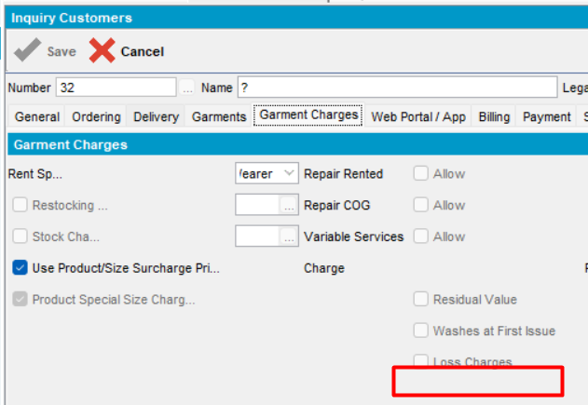
- Check Customer In modify mode
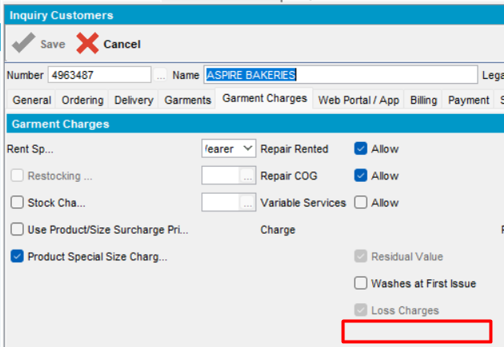
- Check contract
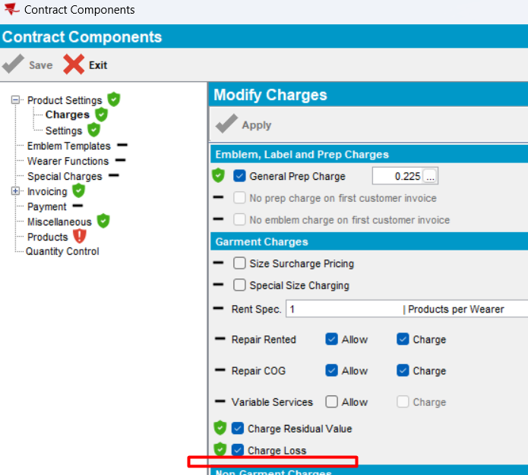
Expected behavior: when the system settings are not set in the following combination: CHARGERENTFORLOSS=N (fixed), RENTALCHARGEFORLOSTGRMT=N, SETTLEMENTACTIVE=N, the checkbox “Charge Rent For Loss” does not appear does not appear neither on Contract level, nor on Customer level.
Actual behavior: as expected
Tested OK

CHARGERENTFORLOSS=Y (default), RENTALCHARGEFORLOSTGRMT=Y, SETTLEMENTACTIVE=N
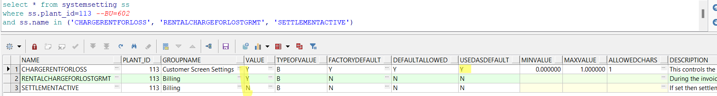
- Check Customer in ADD mode
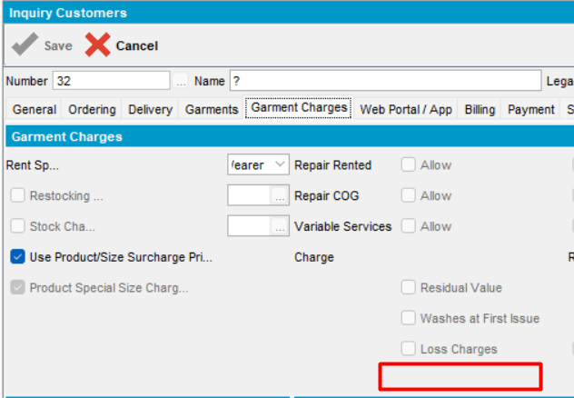
- Check Customer In modify mode
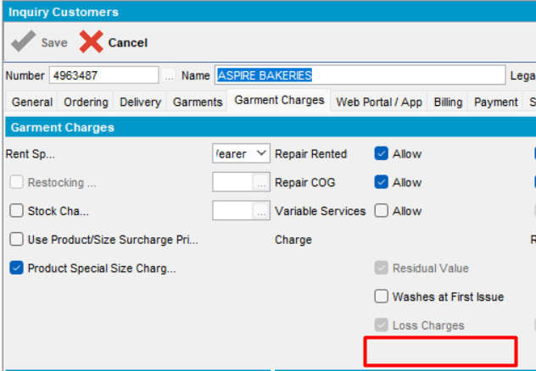
- Check contract
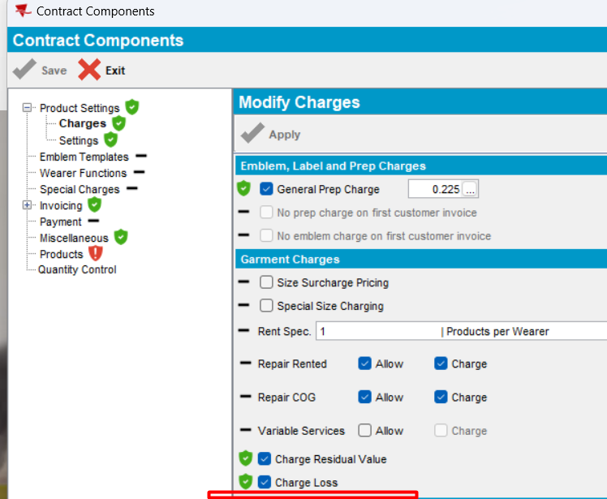
Expected behavior: when the system settings are not set in the following combination: CHARGERENTFORLOSS=Y (fixed), RENTALCHARGEFORLOSTGRMT=Y, SETTLEMENTACTIVE=N, the checkbox “Charge Rent For Loss” does not appear does not appear neither on Contract level, nor on Customer level.
Actual behavior: as expected
Tested OK

CHARGERENTFORLOSS=Y (default), RENTALCHARGEFORLOSTGRMT=N, SETTLEMENTACTIVE=Y
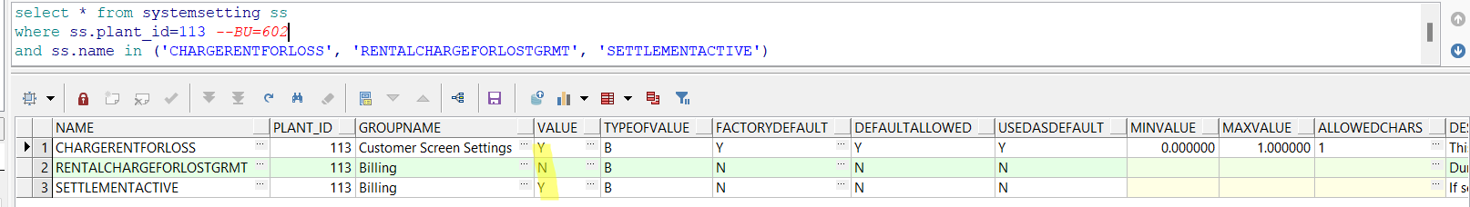
- Check Customer in ADD mode
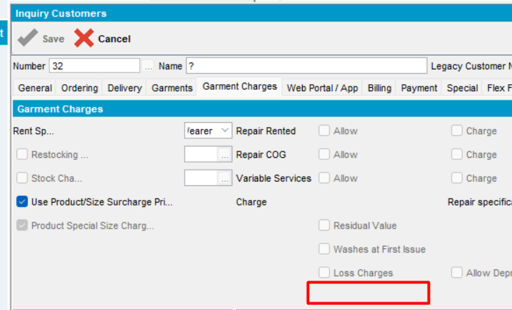
- Check Customer In modify mode
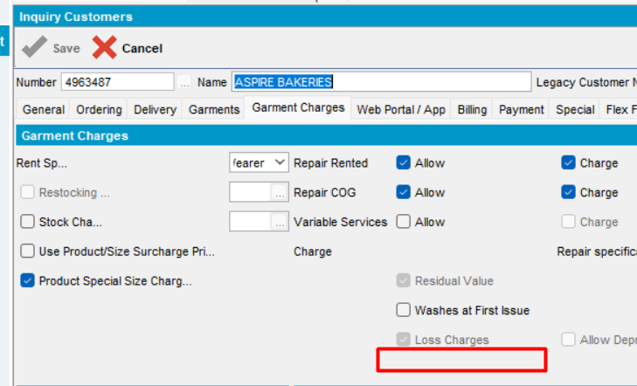
- Check contract
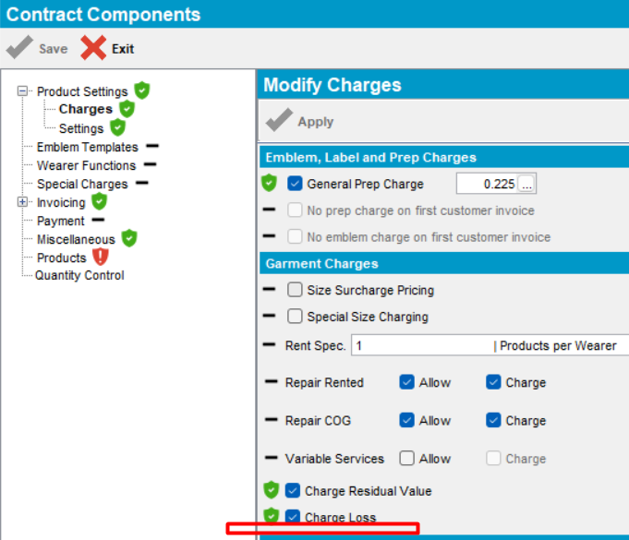
Expected behavior: when the system settings are not set in the following combination: CHARGERENTFORLOSS=Y (fixed), RENTALCHARGEFORLOSTGRMT=N, SETTLEMENTACTIVE=Y, the checkbox “Charge Rent For Loss” does not appear neither on Contract level, nor on Customer level.
Actual behavior: as expected
Tested OK

CHARGERENTFORLOSS=Y (default), RENTALCHARGEFORLOSTGRMT=N, SETTLEMENTACTIVE=N
- Check Customer in ADD mode
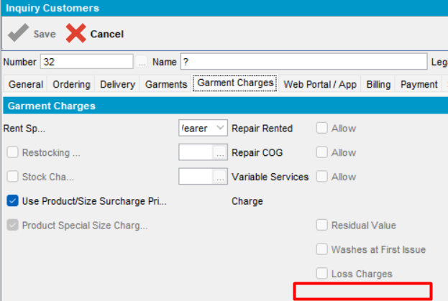
- Check Customer In modify mode
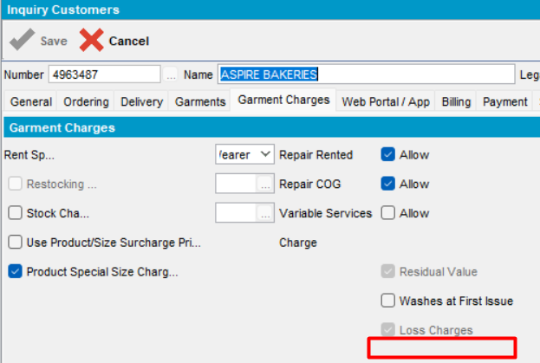
- Check contract
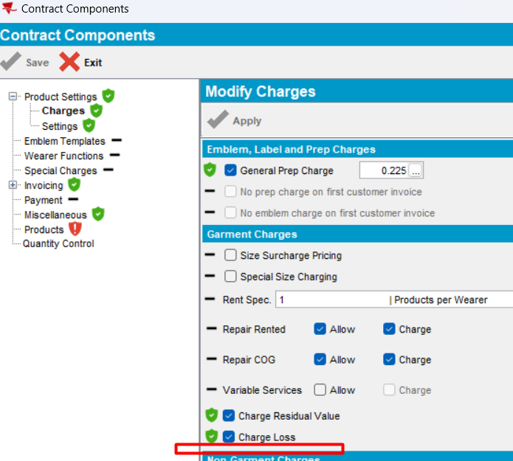
Expected behavior: when the system settings are not set in the following combination: CHARGERENTFORLOSS=Y (fixed), RENTALCHARGEFORLOSTGRMT=N, SETTLEMENTACTIVE=N, the checkbox “Charge Rent For Loss” does not appear neither on Contract level, nor on Customer level.
Actual behavior: as expected
Tested OK

CHARGERENTFORLOSS=Y (default), RENTALCHARGEFORLOSTGRMT=Y, SETTLEMENTACTIVE=N
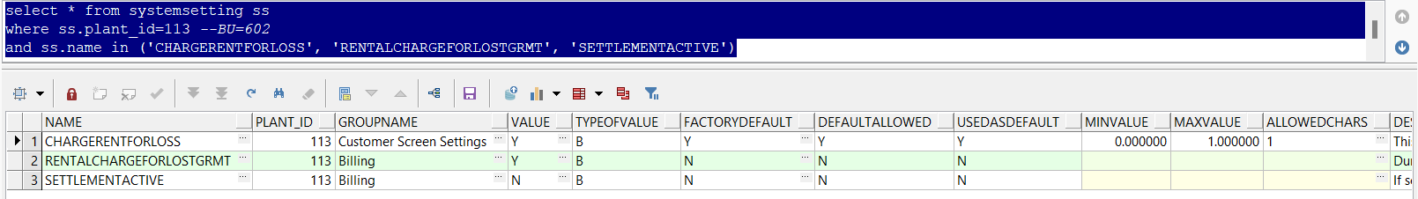
- Check Customer in ADD mode
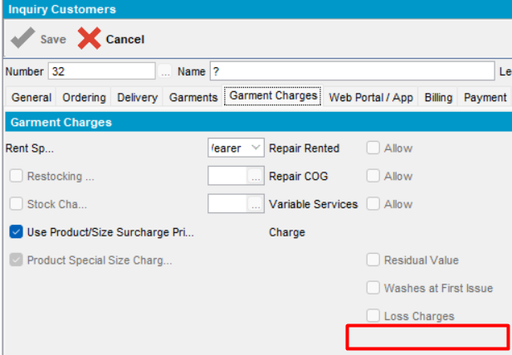
- Check Customer In modify mode
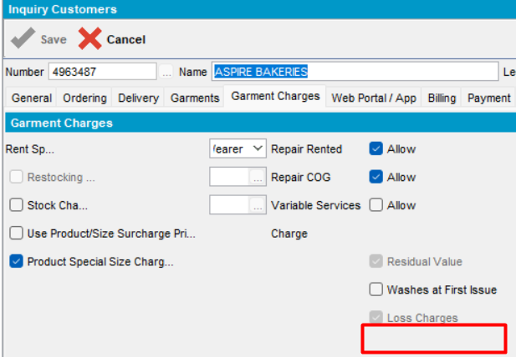
- Check contract
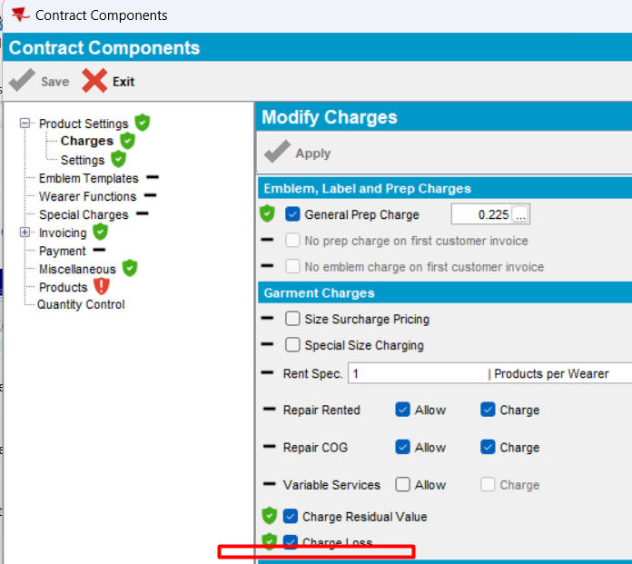
Expected behavior: when the system settings are not set in the following combination: CHARGERENTFORLOSS=Y (fixed), RENTALCHARGEFORLOSTGRMT=Y, SETTLEMENTACTIVE=N, the checkbox “Charge Rent For Loss” does not appear neither on Contract level, nor on Customer level.
Actual behavior: as expected
Tested OK

CHARGERENTFORLOSS=Y (default), RENTALCHARGEFORLOSTGRMT=N, SETTLEMENTACTIVE=Y
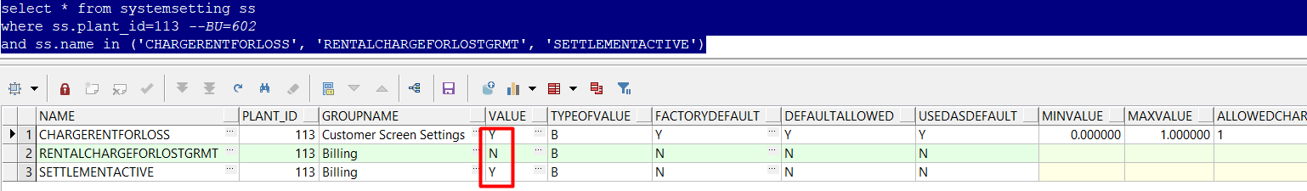
- Check Customer in ADD mode
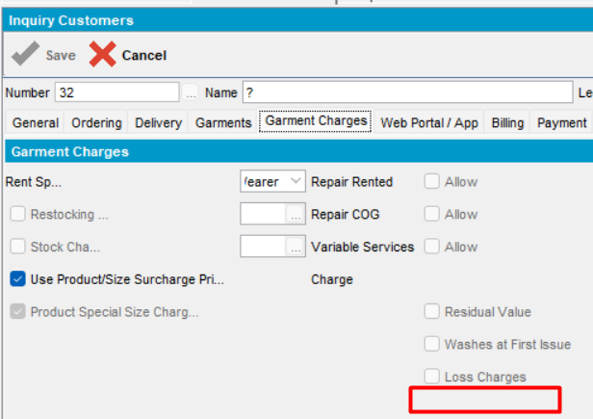
- Check Customer In modify mode
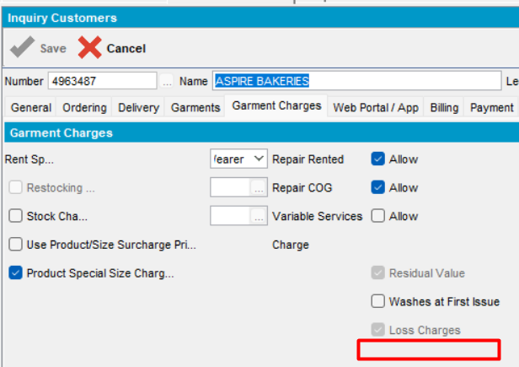
- Check contract
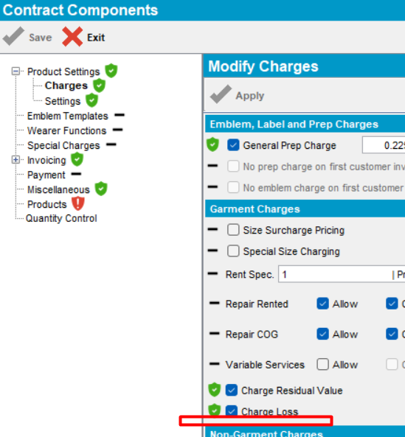
Expected behavior: when the system settings are not set in the following combination: CHARGERENTFORLOSS=Y (fixed), RENTALCHARGEFORLOSTGRMT=N, SETTLEMENTACTIVE=Y, the checkbox “Charge Rent For Loss” does not appear neither on Contract level, nor on Customer level.
Actual behavior: as expected
Tested OK

CHARGERENTFORLOSS=Y (default), RENTALCHARGEFORLOSTGRMT=N, SETTLEMENTACTIVE=N
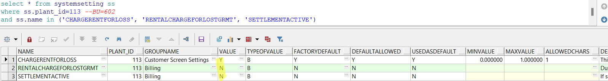
- Check Customer in ADD mode
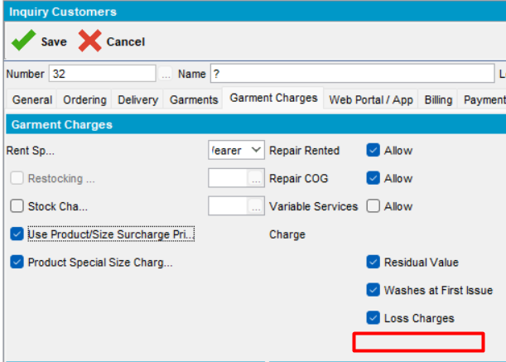
- Check Customer In modify mode
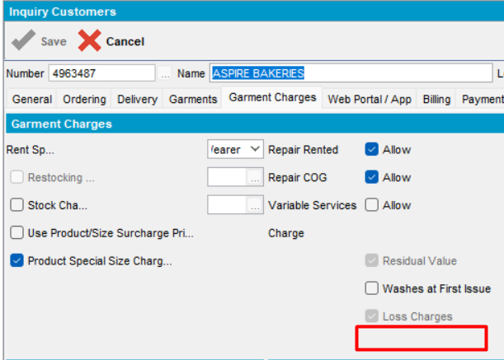
- Check contract
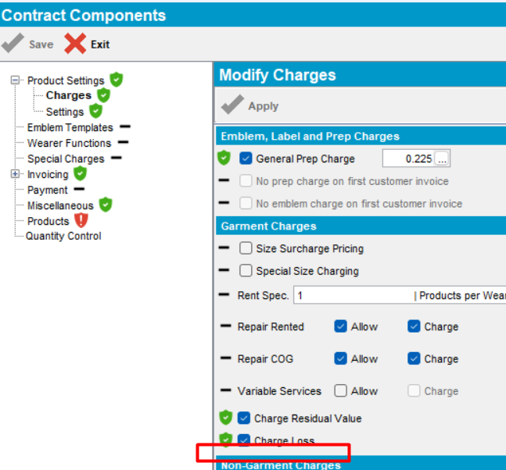
Expected behavior: when the system settings are not set in the following combination: CHARGERENTFORLOSS=Y (fixed), RENTALCHARGEFORLOSTGRMT=N, SETTLEMENTACTIVE=N, the checkbox “Charge Rent For Loss” does not appear neither on Contract level, nor on Customer level.
Actual behavior: as expected
Tested OK

CHARGERENTFORLOSS=Y (Fixed), RENTALCHARGEFORLOSTGRMT=Y, SETTLEMENTACTIVE=Y
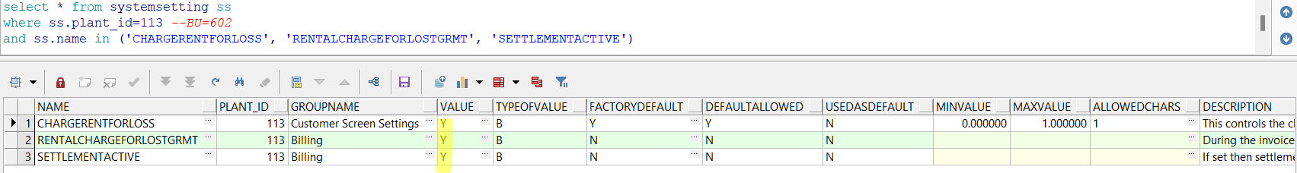

Check Customer in ADD mode, when adding a new customer
            - In Customer dlg, press ADD
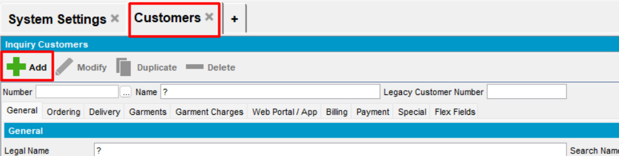
            - In Garment Charges tab, verify the new checkbox “Charge Rent For Loss”
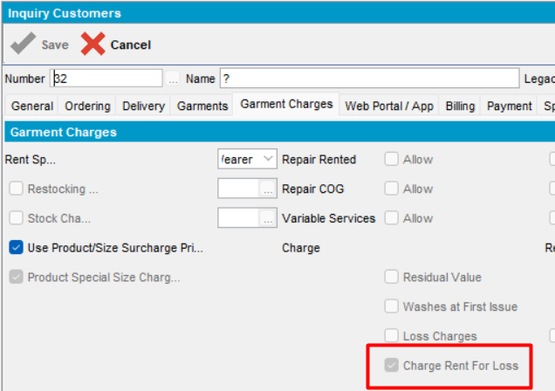
Save the customer.
Expected behavior: new checkbox is checked, visible and disabled in ADD mode
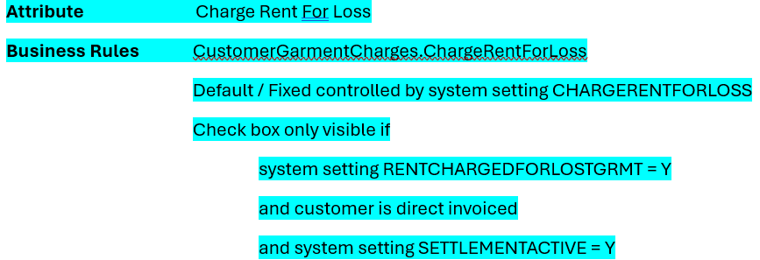
Actual behavior: as
Tested OK
            - Check in database table customergarmentcharges if the new option is saved
select g.chargerentforloss from customer c
left outer join customergarmentcharges g on c.customer_id=g.customer_id
where c.customernumber=32
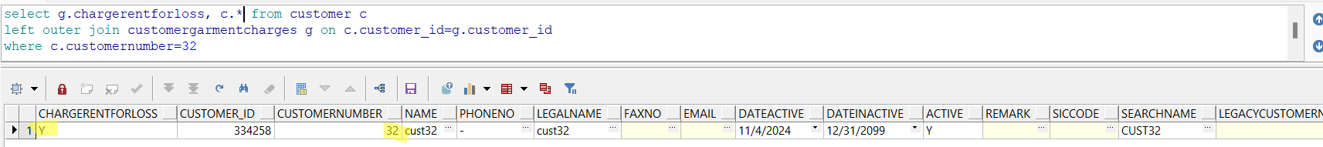
Expected behavior: value to be saved in the table customergarmentcharges, column chargerentforloss
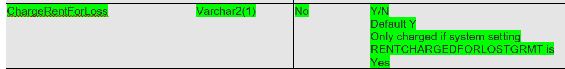
Actual behavior: as expected
Tested OK

Check Customer In MODIFY mode, when the customer does not have garments, but now it has garments
- Load customer from above. Press Modify
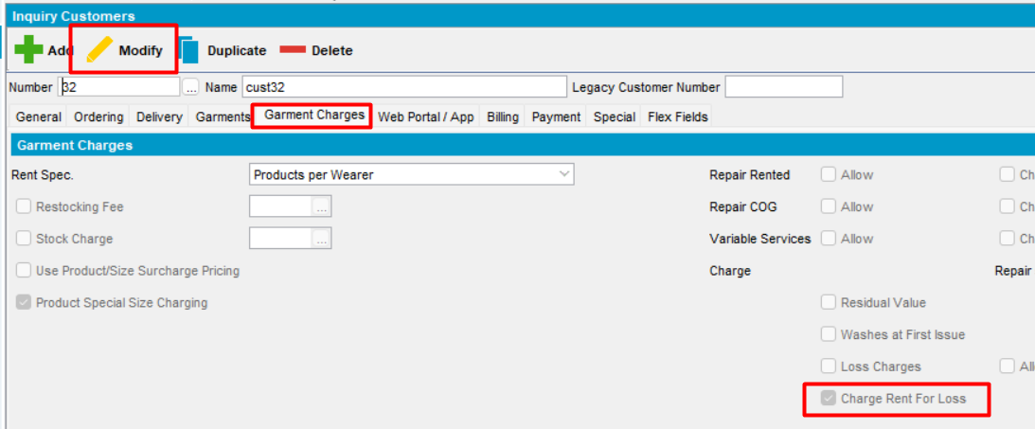
- Verify new option
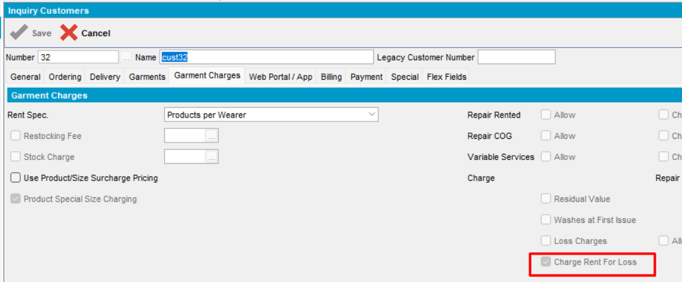
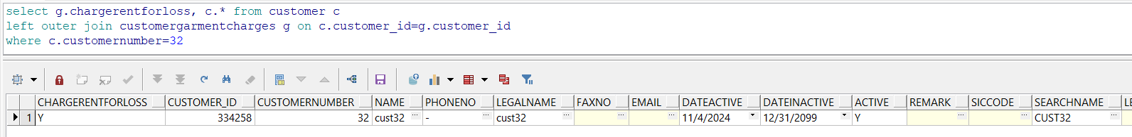
Expected behavior: new checkbox is checked, visible and disabled in MODIFY mode
Actual behavior: as
Tested OK

Check Customer In MODIFY mode, when the customer already has garments
- For the selected customer add a delivery scheme
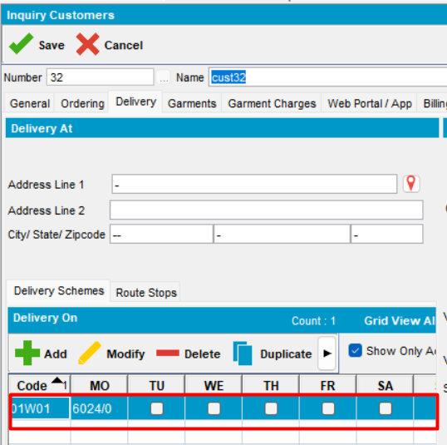
- In Garments tab, add a day to bill the garments
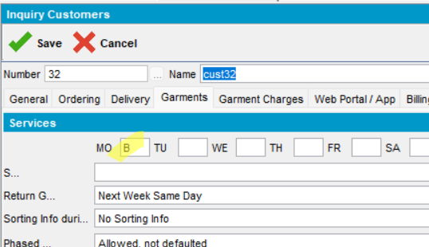
- Check Garment Charges tab.
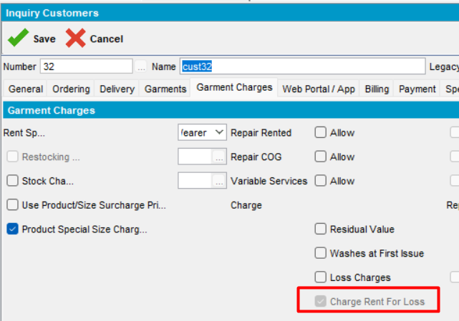
After adding delivery scheme and selecting a day to bill the garments, in Garment Charges tab, all the necessary options are checked and the new checkbox is checked, visible and disabled.
Expected behavior: new checkbox is checked, visible and disabled in MODIFY mode
Actual behavior: as expected
Tested OK
- Save the modications
- Reopen customer
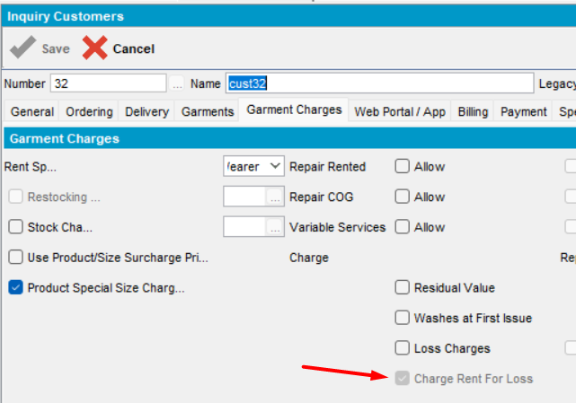
Tested OK

Check Customer In DUPLICATE mode, when the customer already has garments
- Load customer and press Duplicate
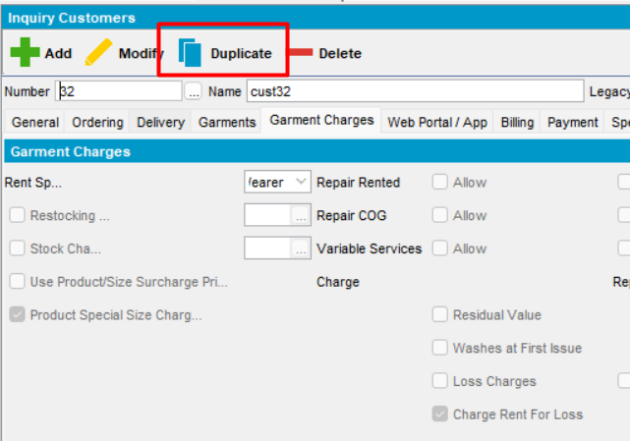
- Change the name
- Charge Rent For Loss option. Save
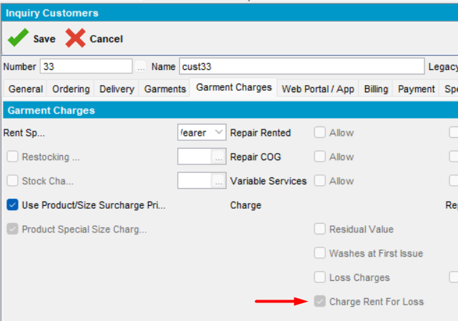
- Check the database
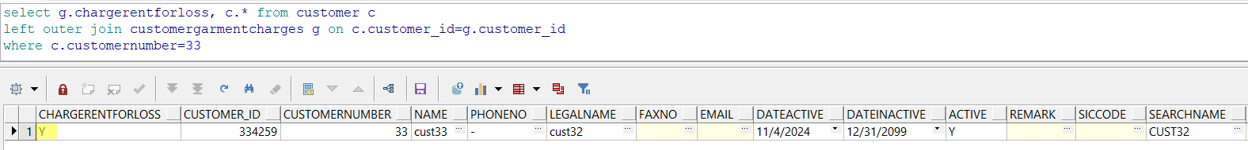
Modification is correctly saved in db table.
Tested OK

Check contract
- Open a contract. Press Modify, go to Components and load Compliancy. Go to Product Settings -> Charges tab
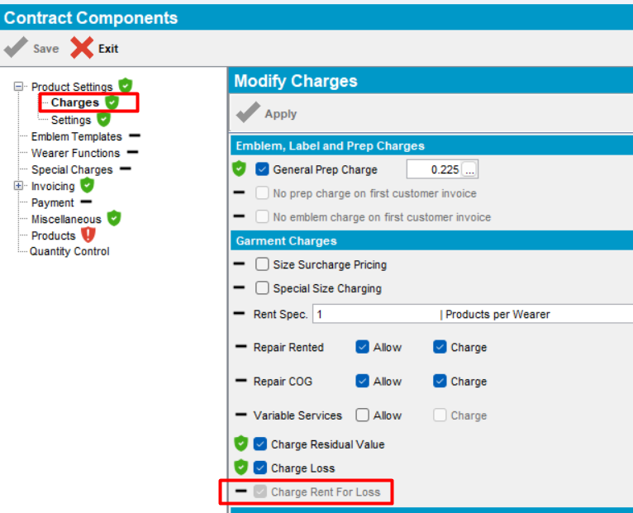
select cg.chargerentforloss, ct.*
from contract ct
left outer join contractcomponentgrmcharges cg on cg.contract_id=ct.contract_id
where ct.code='S11044'
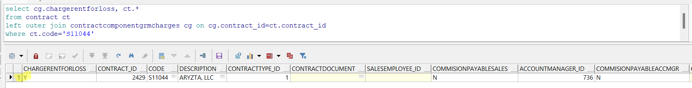
Expected behavior: new checkbox is checked, visible and disabled on Contract level for this combination of system settings
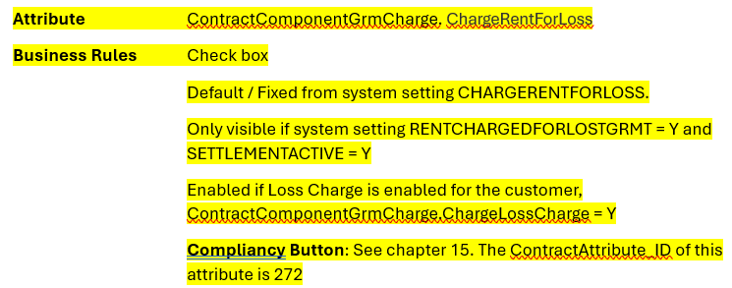
Actual behavior: as expected
- Check on a new added contract
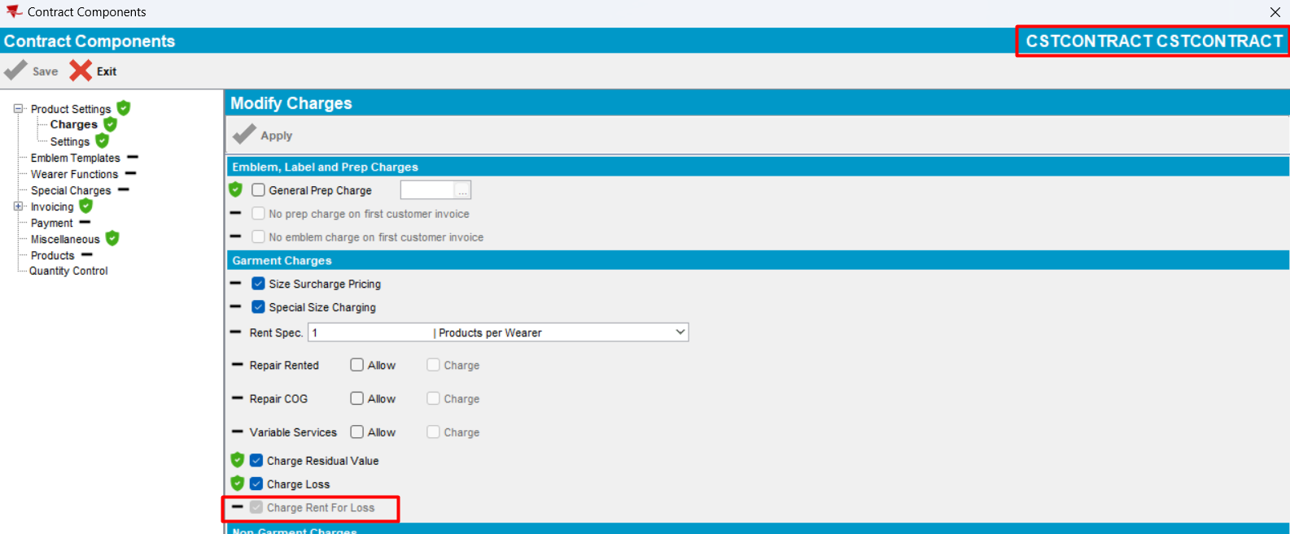
The new checkbox is unchecked, visible and disabled on Contract level for this combination of system settings
Tested ok

CHARGERENTFORLOSS=N (Fixed), RENTALCHARGEFORLOSTGRMT=Y, SETTLEMENTACTIVE=Y
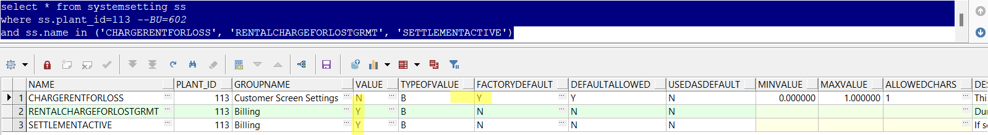

Check Customer in ADD mode, when adding a new customer
            - In Customer dlg, press ADD
            - In Garment Charges tab, verify the new checkbox “Charge Rent For Loss”
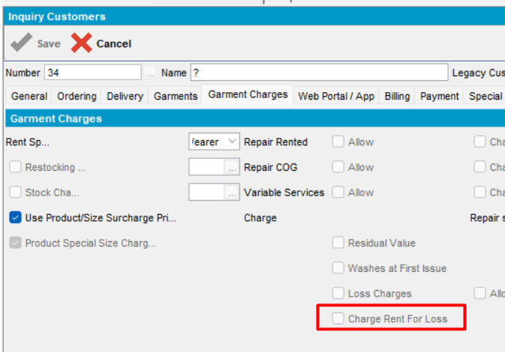
Save the customer as customer number 34
Expected behavior: new checkbox is unchecked, visible and disabled in ADD mode
Actual behavior: as expected.
Tested OK
            - Check in database table customergarmentcharges if the new option is saved
select g.chargerentforloss from customer c
left outer join customergarmentcharges g on c.customer_id=g.customer_id
where c.customernumber=34
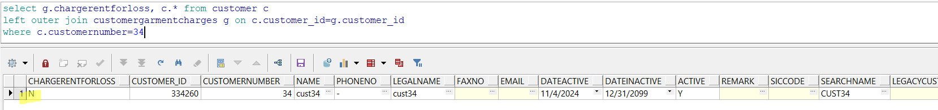
Expected behavior: value to be saved in the table customergarmentcharges, column chargerentforloss
Actual behavior: as expected
Tested OK

Check Customer In MODIFY mode, when the customer does not have garments, but now it has garments
- Load customer from above.
- Press Modify and Verify new option
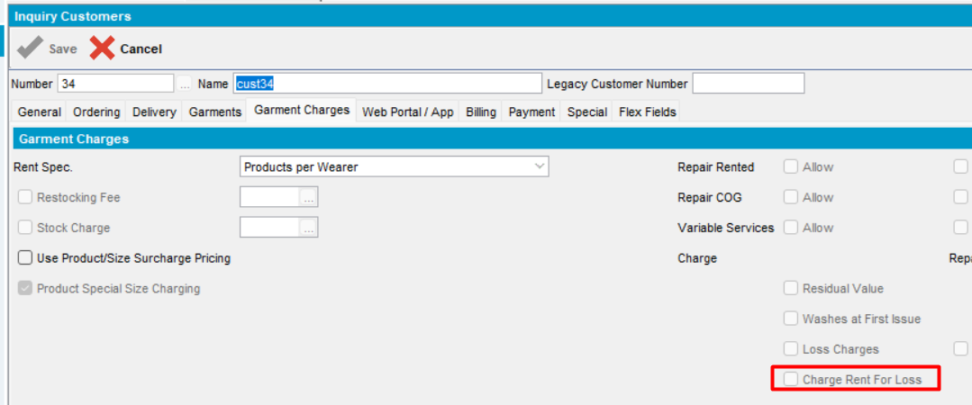
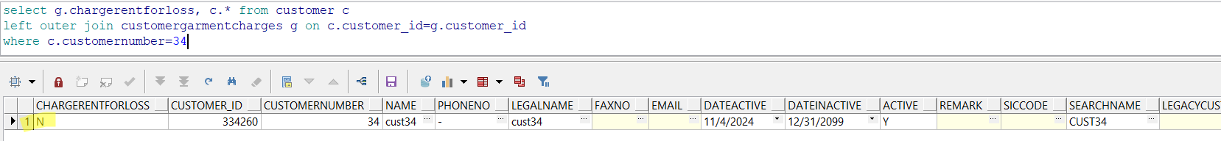
Expected behavior: new checkbox is unchecked, visible and disabled in MODIFY mode
Actual behavior: as
Tested OK

Check Customer In MODIFY mode, when the customer already has garments
- For the selected customer add a delivery scheme
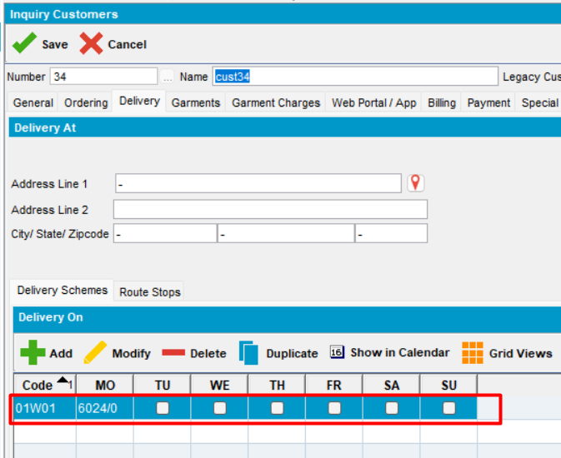
- In Garments tab, add a day to bill the garments
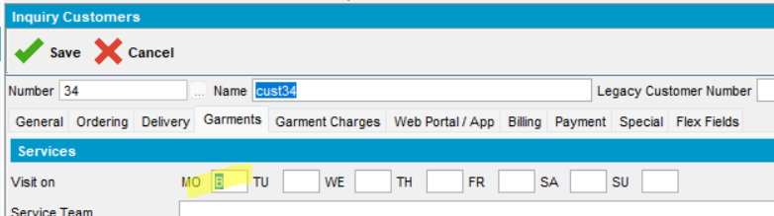
- Check Garment Charges tab.
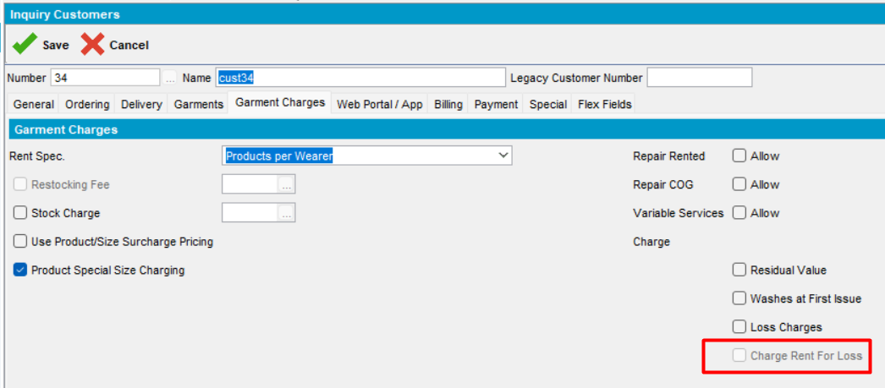
After adding delivery scheme and selecting a day to bill the garments, in Garment Charges tab, all the necessary options are checked and the new checkbox is unchecked, visible and disabled.
Expected behavior: new checkbox is unchecked, visible and disabled in MODIFY mode
Actual behavior: as expected
Tested OK
- Save the modications
- Reopen customer
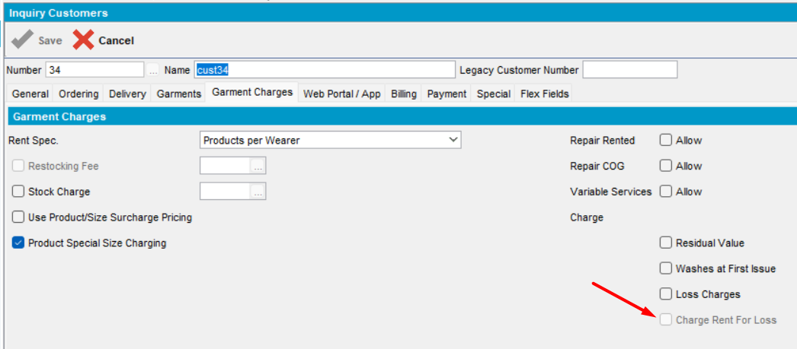
Tested OK

Check Customer In DUPLICATE mode, when the customer already has garments
- Load customer and press Duplicate
- Change the name
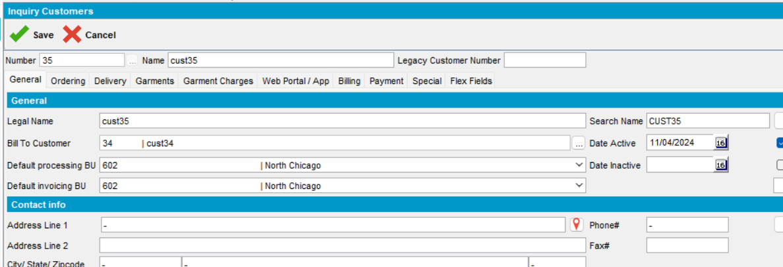
- Check “Charge Rent For Loss” option. Save
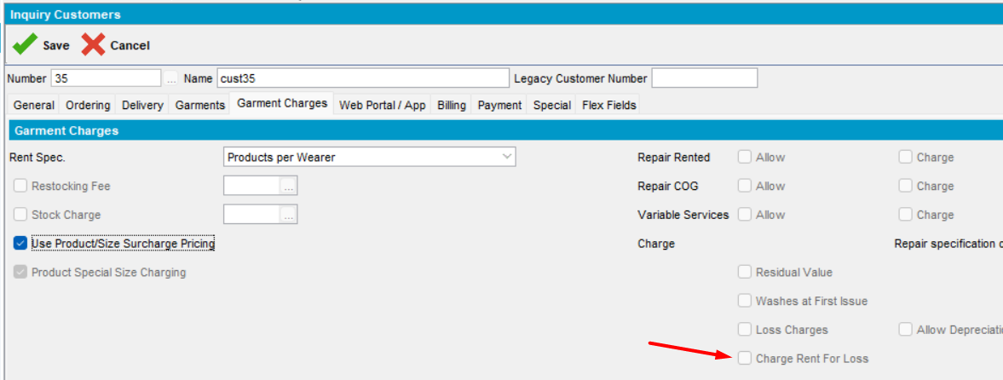
Checkbox is unchecked, visible and disabled in DUPLICATE mode
- Check the database
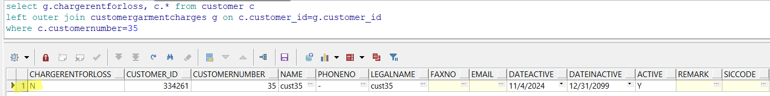
Modification is correctly saved in db table.
Tested OK

Check contract
- Open a new created contract. Press Modify, go to Components and load Compliancy. Go to Product Settings -> Charges tab
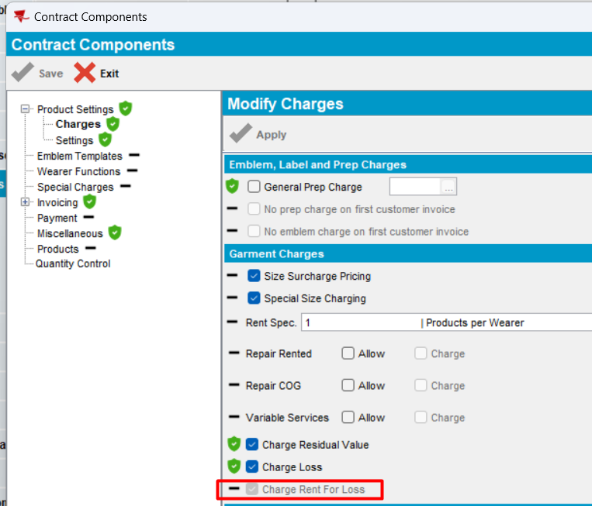
select cg.chargerentforloss, ct.*
from contract ct
left outer join contractcomponentgrmcharges cg on cg.contract_id=ct.contract_id
where ct.code='CSTCONTRACT'
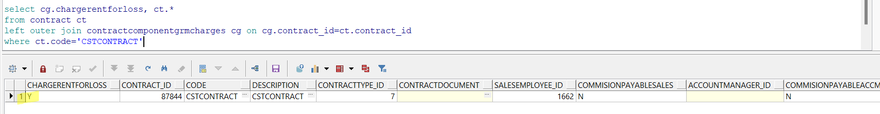
Expected behavior: new checkbox is unchecked, visible and disabled on Contract level for this combination of system settings
Actual behavior: as expected
Tested ok

CHARGERENTFORLOSS=Y (Default), RENTALCHARGEFORLOSTGRMT=Y, SETTLEMENTACTIVE=Y
HASH: de72ee3
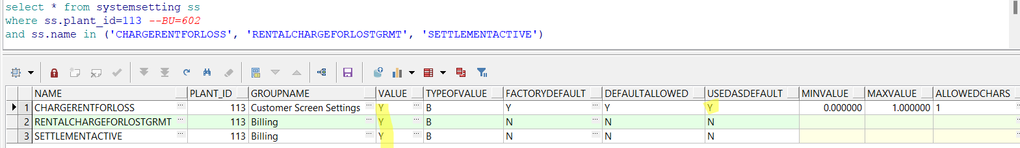
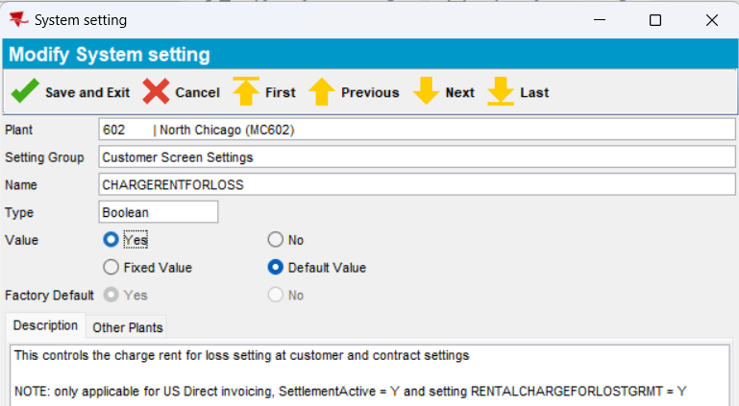

Check Customer in ADD mode, when adding a new customer
            - In Customer dlg, press ADD
            - In Garment Charges tab, verify the new checkbox “Charge Rent For Loss”
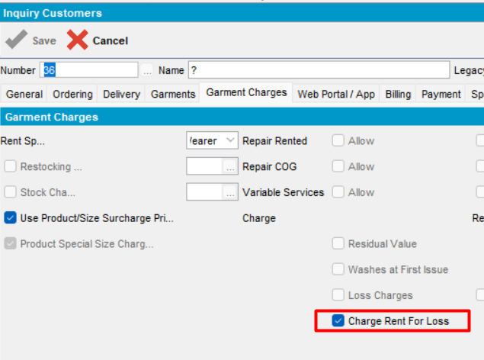
Save the customer
Expected behavior: new checkbox is checked, visible and enabled in ADD mode
Actual behavior: as expected.
Tested OK
            - Check in database table customergarmentcharges if the new option is saved
select g.chargerentforloss from customer c
left outer join customergarmentcharges g on c.customer_id=g.customer_id
where c.customernumber=36
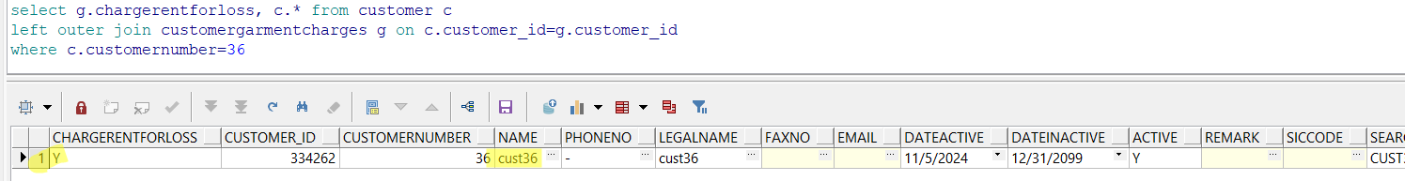
Expected behavior: value to be saved in the table customergarmentcharges, column chargerentforloss
Actual behavior: as expected
Tested OK

Check Customer In MODIFY mode, when the customer does not have garments, but now it has garments
- Load customer from above.
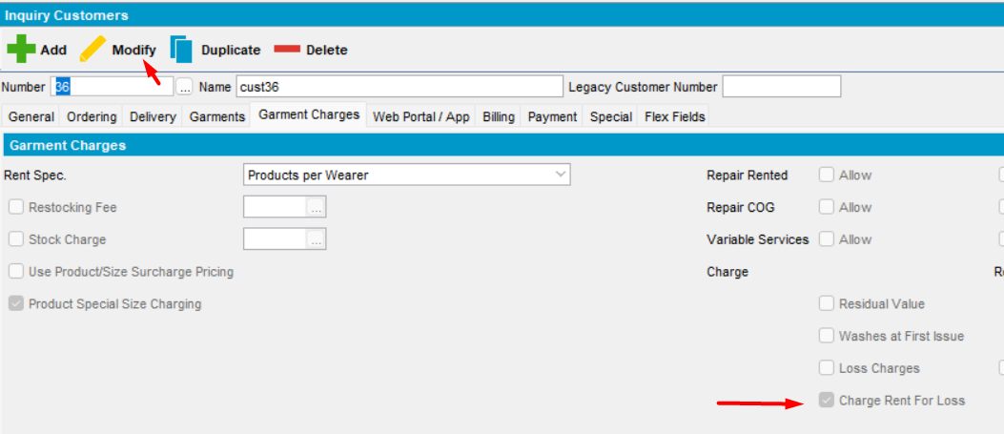
- Press Modify and Verify new option
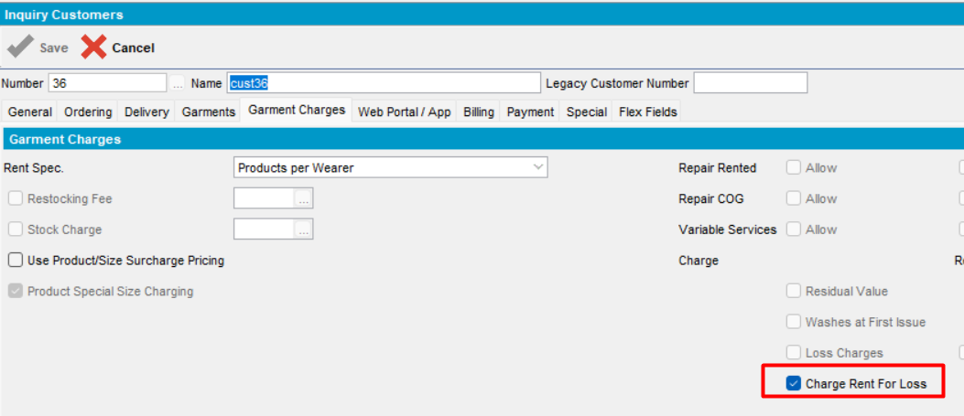
Expected behavior: new checkbox is checked, visible and disabled in MODIFY mode
Actual behavior: as expected
Tested OK

Check Customer In MODIFY mode, when the customer already has garments
- For the selected customer add a delivery scheme
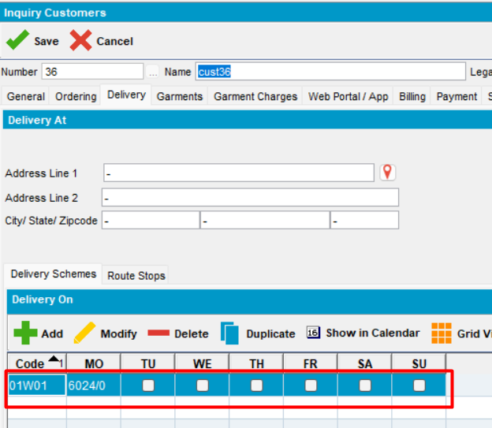
- In Garments tab, add a day to bill the garments
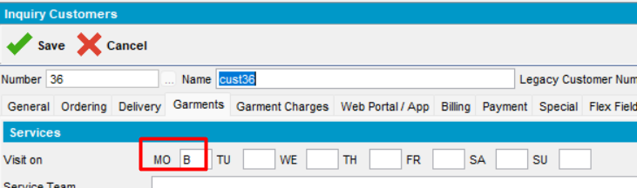
- Check Garment Charges tab.
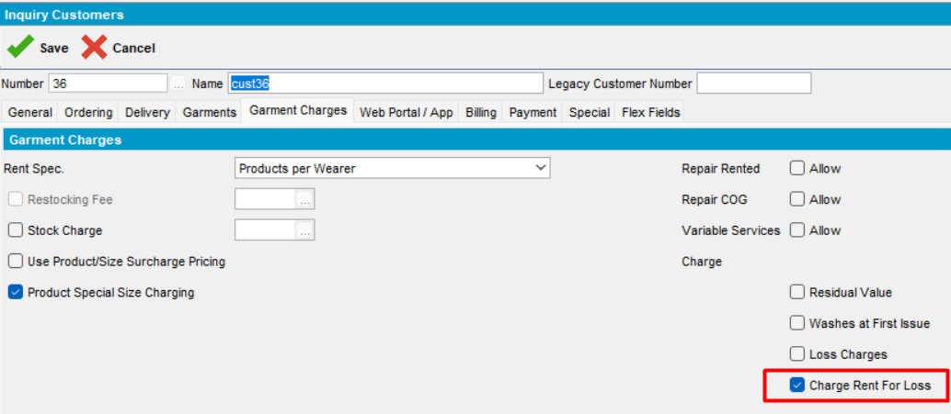
After adding delivery scheme and selecting a day to bill the garments, in Garment Charges tab, all the necessary options are checked and the new checkbox is checked, visible and enabled.
Expected behavior: new checkbox is checked, visible and disabled in MODIFY mode
Actual behavior: as expected
Tested OK
- Save the modifications
- Reopen customer
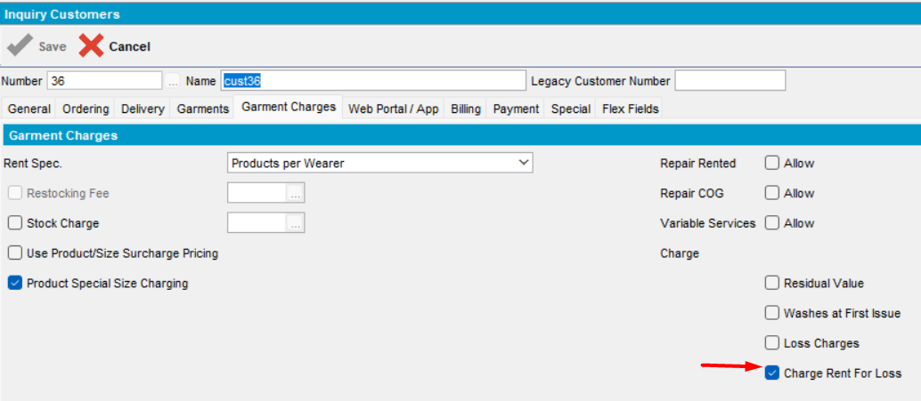
Tested OK

Check Customer In DUPLICATE mode, when the customer already has garments
- Load customer and press Duplicate
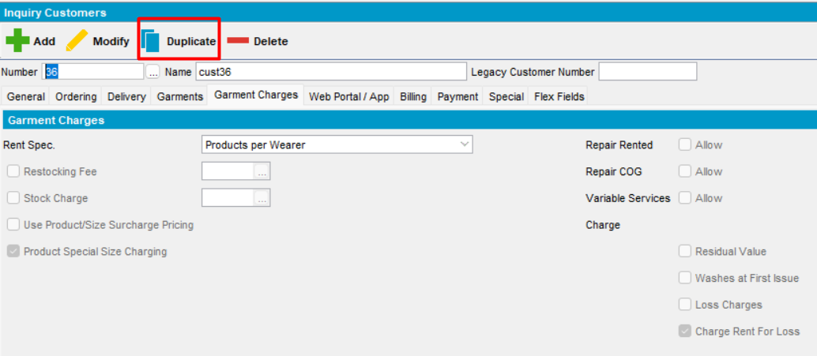
- Change the name
- Verify “Charge Rent For Loss” option. Save
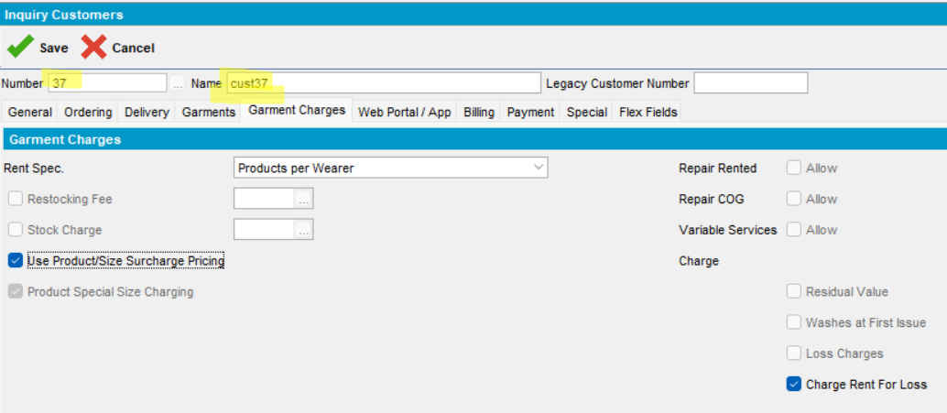
- Check the database
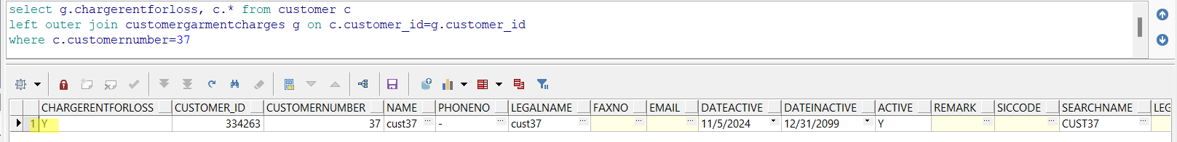
Modification is correctly saved in db table.
Tested OK

Check contract
- Open a new created contract. Press Modify, go to Components and load Compliancy. Go to Product Settings -> Charges tab
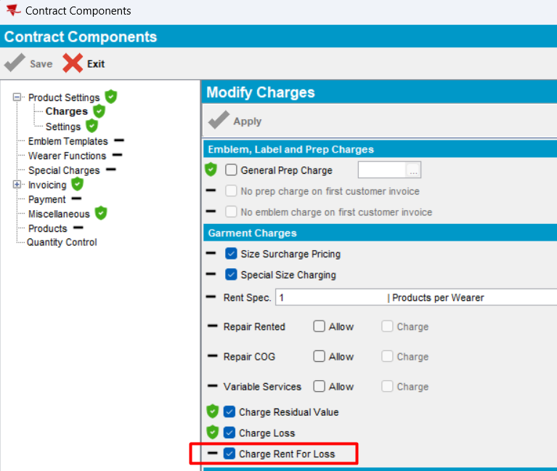
select cg.chargerentforloss, ct.*
from contract ct
left outer join contractcomponentgrmcharges cg on cg.contract_id=ct.contract_id
where ct.code='CST2'
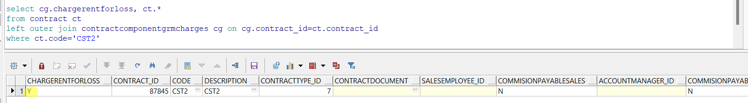
Expected behavior: new checkbox is checked, visible and enabled on Contract level for this combination of system settings
Actual behavior: as expected
- Uncheck the checkbox and save
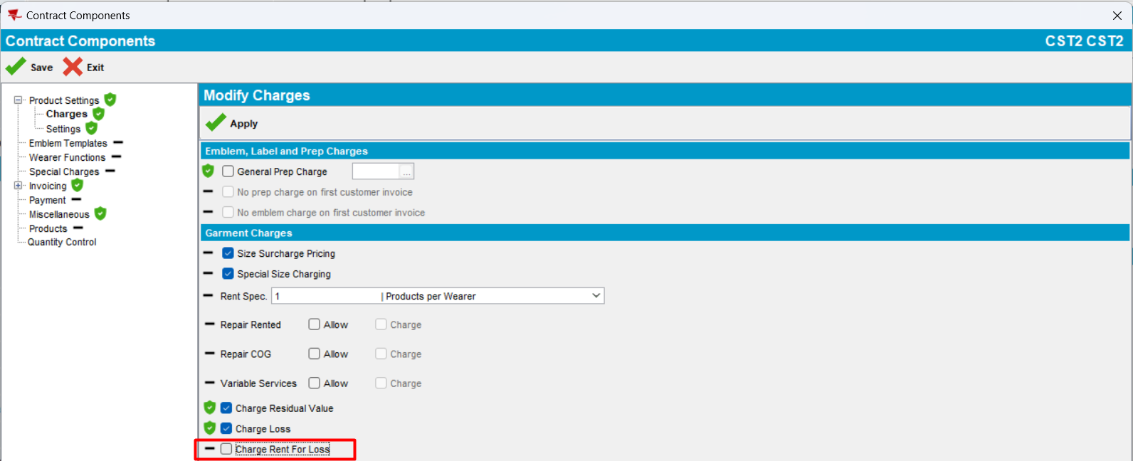
- Reopen
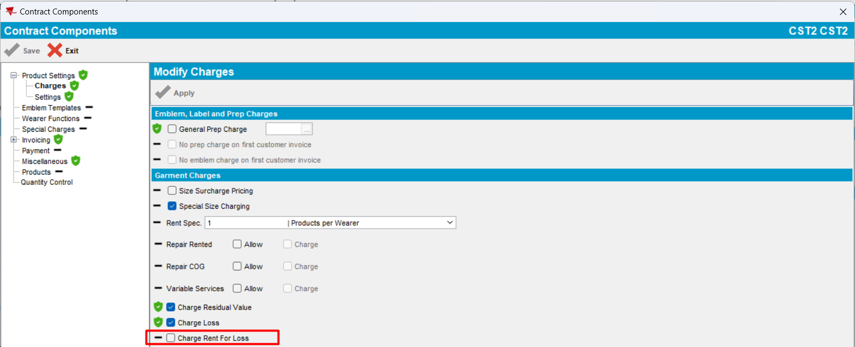
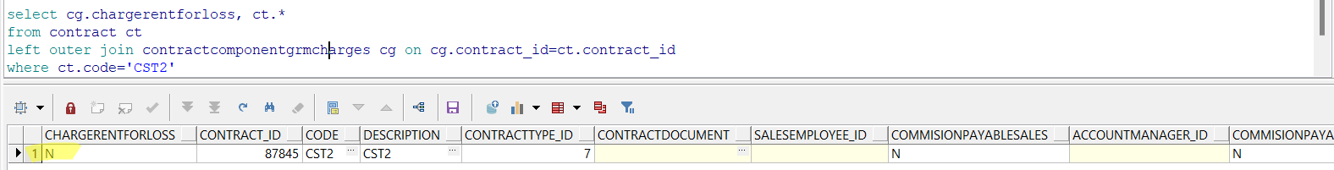
Check the checkbox and save
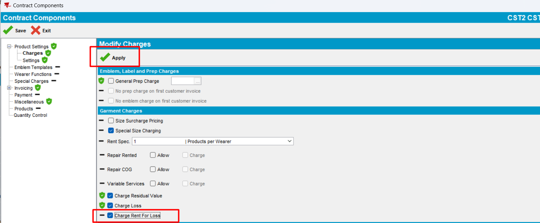
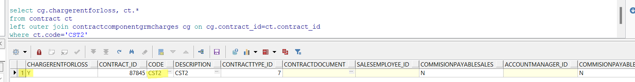
Tested ok

CHARGERENTFORLOSS=N (Default), RENTALCHARGEFORLOSTGRMT=Y, SETTLEMENTACTIVE=Y
HASH: de72ee3
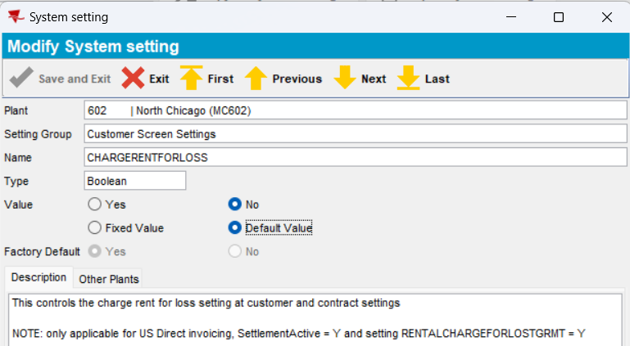

Check Customer in ADD mode, when adding a new customer
            - In Customer dlg, press ADD
            - In Garment Charges tab, verify the new checkbox “Charge Rent For Loss”
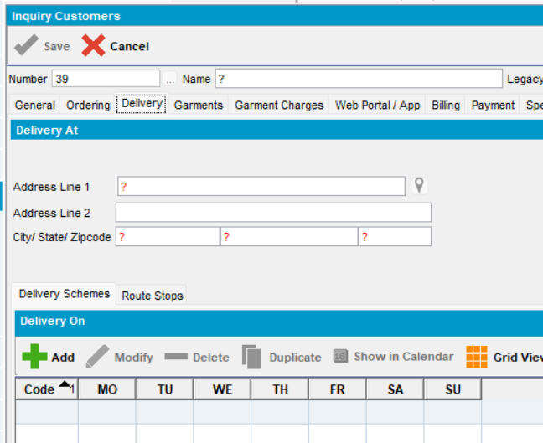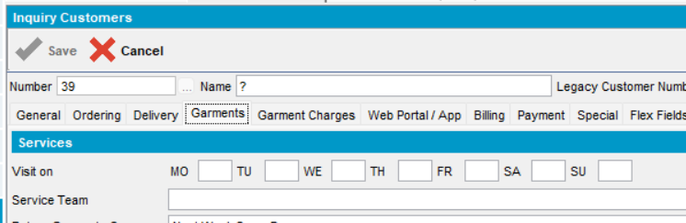
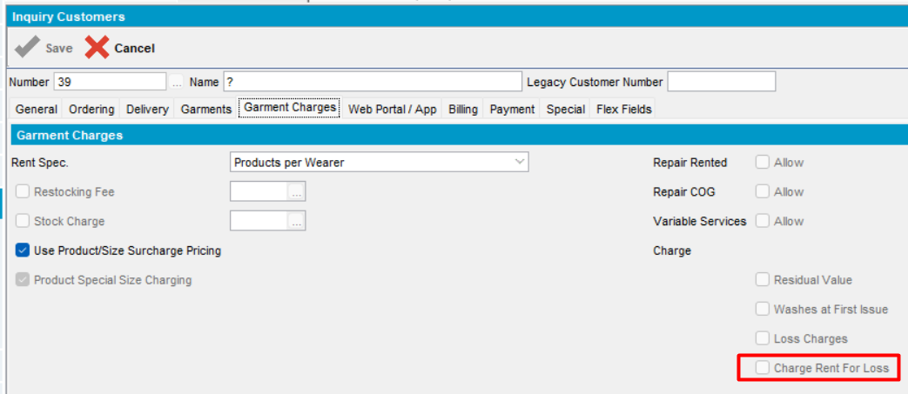
Save the customer

Expected behavior: new checkbox is unchecked, visible and disabled in ADD mode, because the customer does not have garment delivery days
Actual behavior: as expected.
Tested OK
            - Check in database table customergarmentcharges if the new option is saved
select g.chargerentforloss from customer c
left outer join customergarmentcharges g on c.customer_id=g.customer_id
where c.customernumber=39
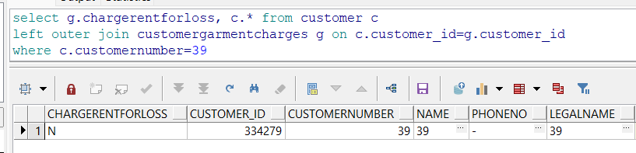
Expected behavior: value to be saved in the table customergarmentcharges, column chargerentforloss
Actual behavior: as expected
Tested OK

Check Customer In MODIFY mode, when the customer does not have garments, but now it has garments
- Load a new created customer.
- Press Modify and Verify new option
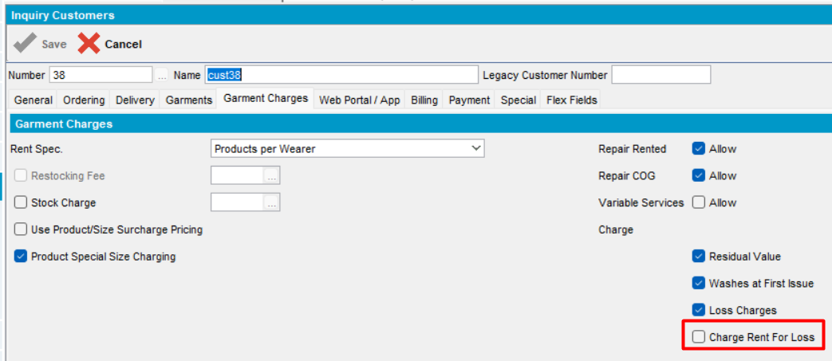
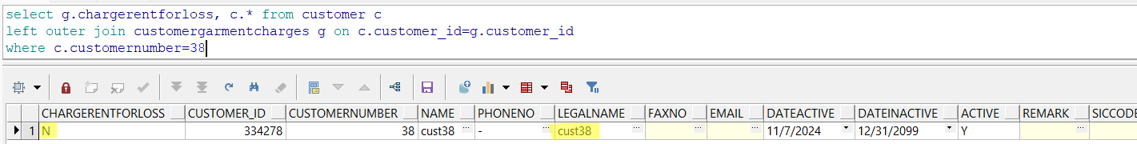
Expected behavior: new checkbox is unchecked, visible and enabled in MODIFY mode
Actual behavior: as expected
Tested OK

Check Customer In MODIFY mode, when the customer already has garments
- For the selected customer add a delivery scheme. In Garments tab, add a day to bill the garments
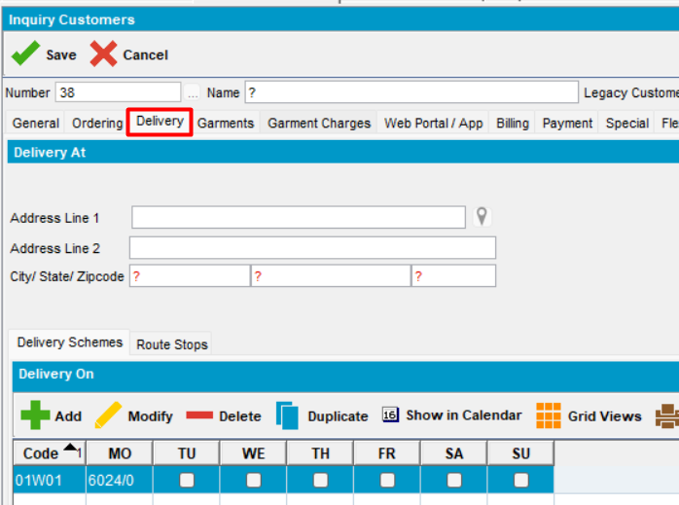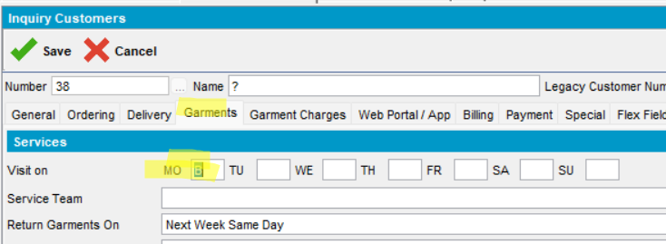
- Check Garment Charges tab.
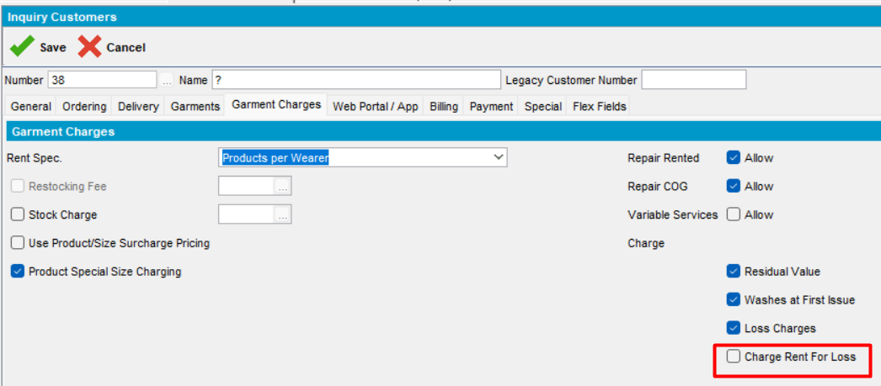
After adding delivery scheme and selecting a day to bill the garments, in Garment Charges tab, all the necessary options are checked and the new checkbox is unchecked, visible and enabled.
Expected behavior: new checkbox is unchecked, visible and disabled in MODIFY mode
Actual behavior: as expected
Tested OK
- Save the modifications
- Reopen customer
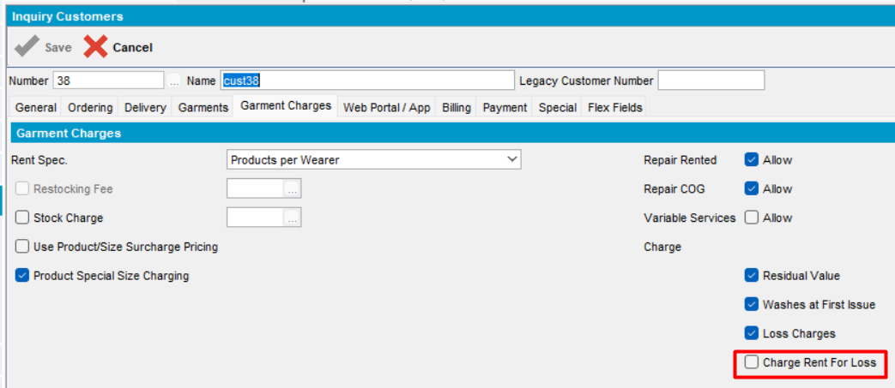
Tested OK

Check Customer In DUPLICATE mode, when the customer already has garments
- Load customer and press Duplicate
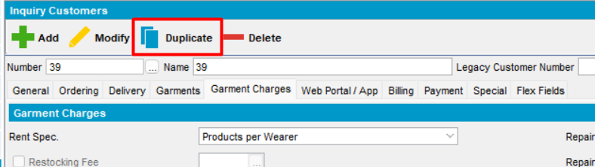
- Change the name
- Verify “Charge Rent For Loss” option. Save
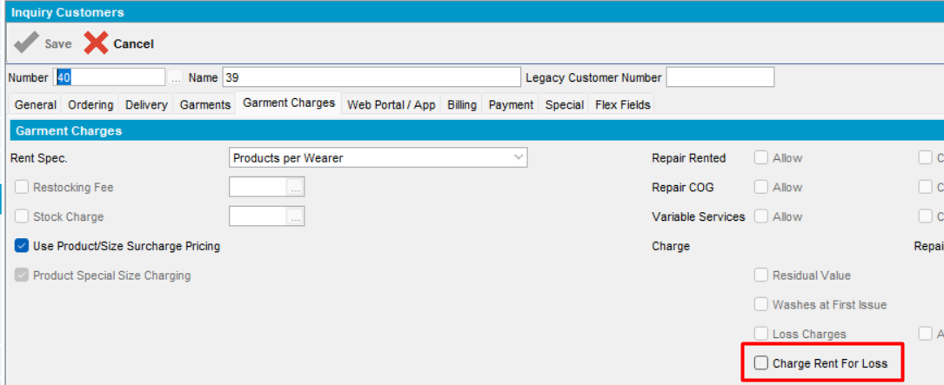
Save
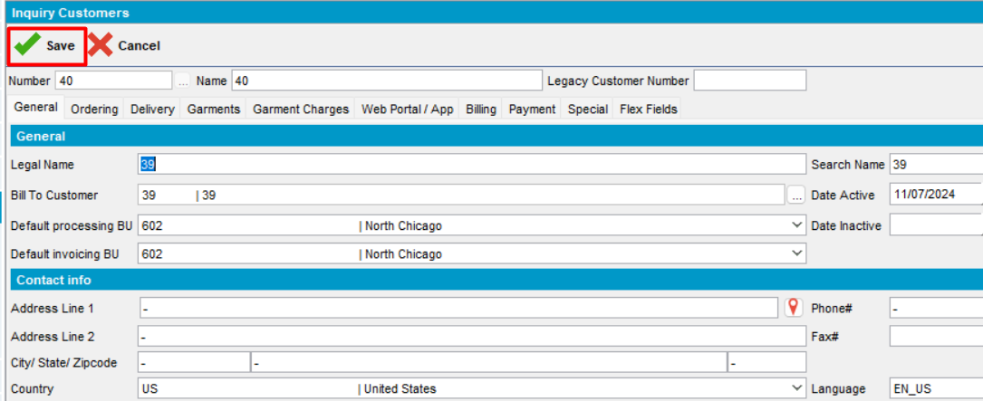
- Check the database
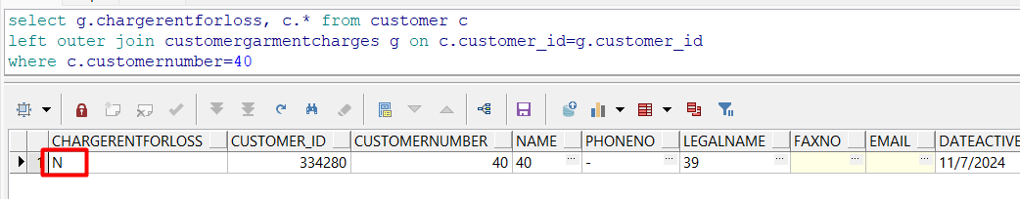
Modification is correctly saved in db table.
Tested OK

Check contract
- Open a new created contract. Press Modify, go to Components and load Compliancy. Go to Product Settings -> Charges tab
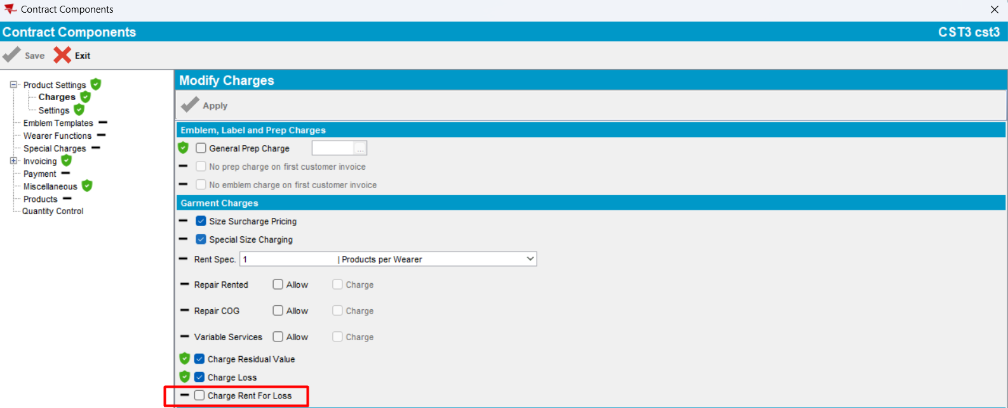
select cg.chargerentforloss, ct.*
from contract ct
left outer join contractcomponentgrmcharges cg on cg.contract_id=ct.contract_id
where ct.code=’CST3’
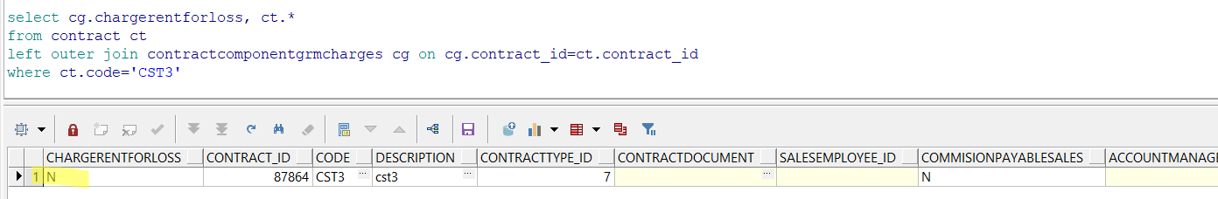
Expected behavior: new checkbox is unchecked, visible and enabled on Contract level for this combination of system settings
Actual behavior: as expected
- Check the checkbox and save
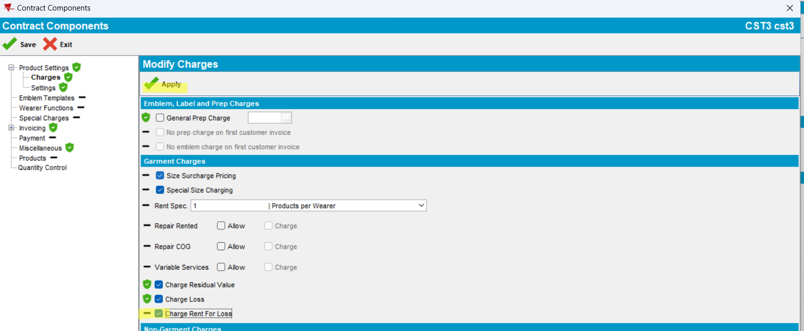
- Reopen
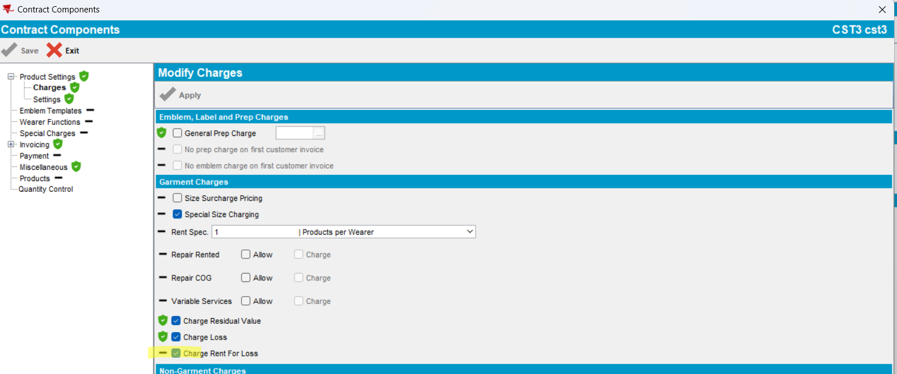
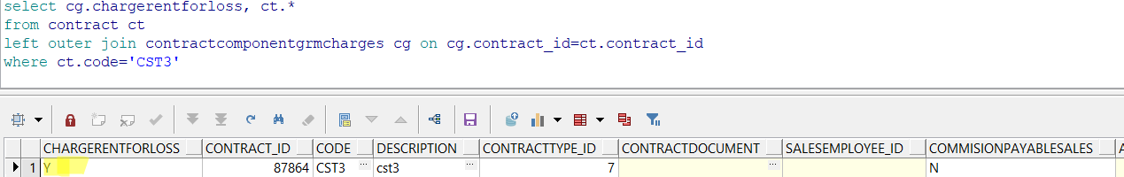
Uncheck the checkbox and save
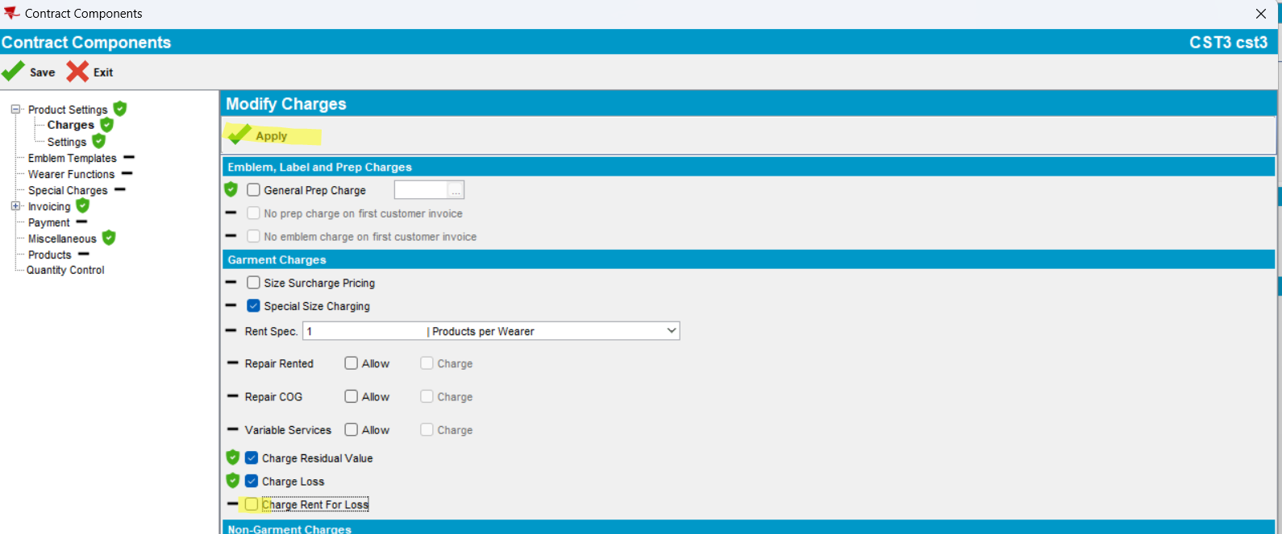
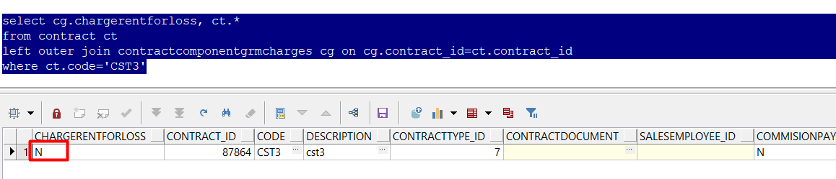
Tested ok

Test Contract Compliancy – TEST OK
Hash: 946b843
- Set the ss:
- CHARGERENTFORLOSS = N (DEFAULT)
- RENTALCHARGEFORLOSTGRMT = Y
- SETTLEMENTACTIVE = Y
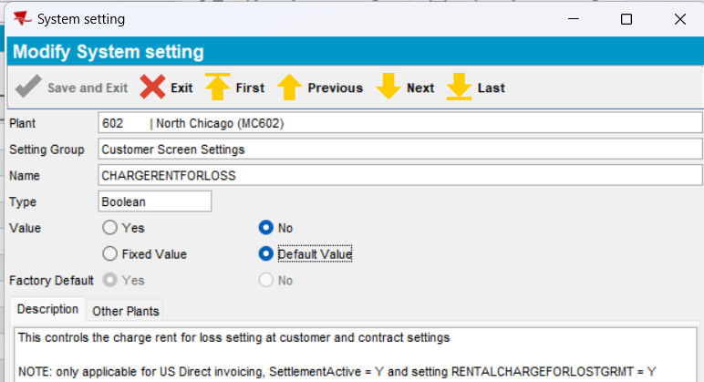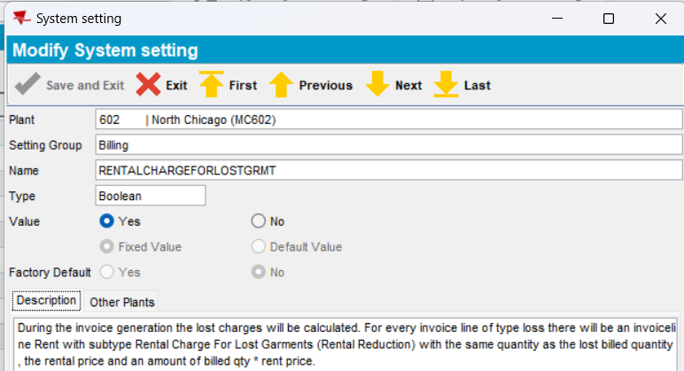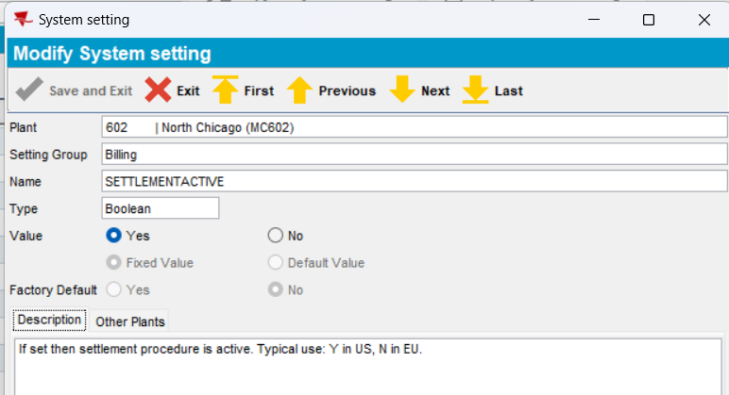
- Open a contract. Press Modify, go to Components and load Compliancy. Go to Product Settings -> Charges tab.
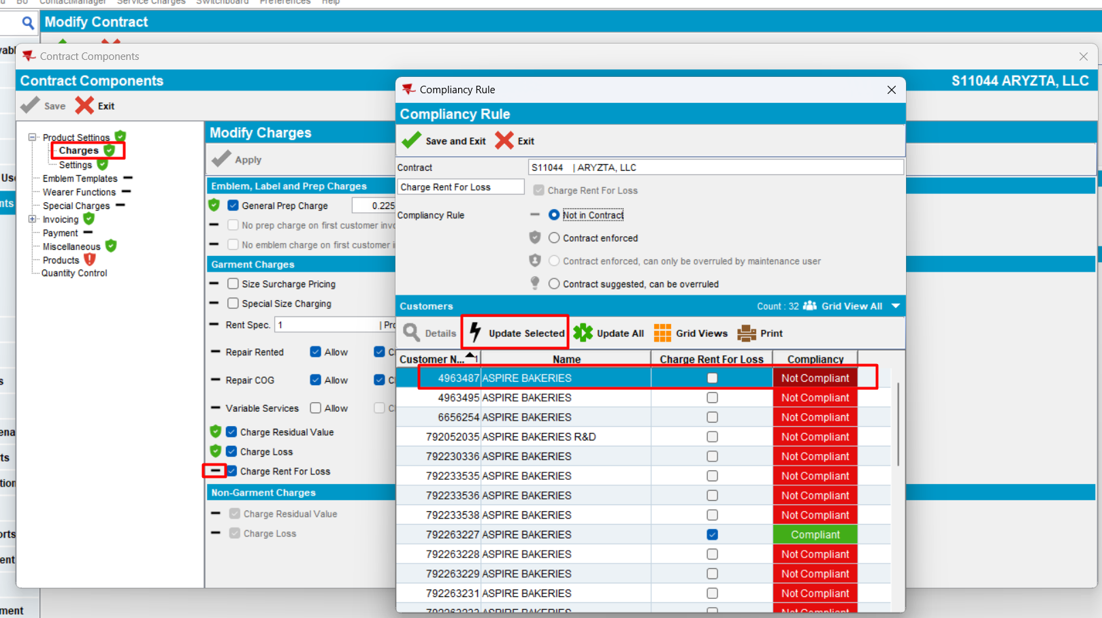
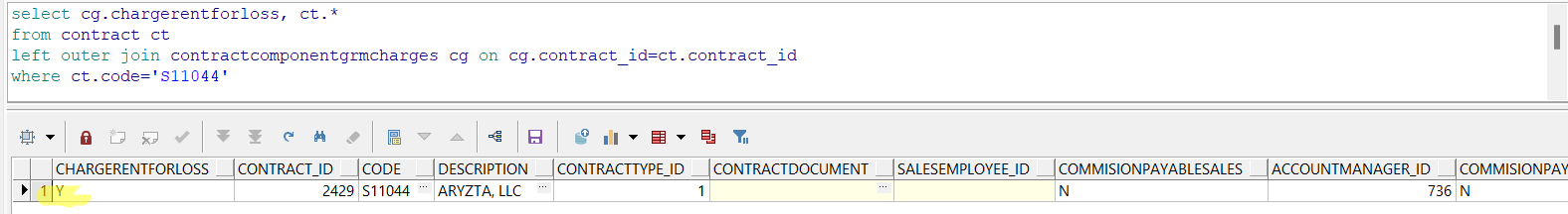
- Verify Compliancy Rule
- Select the 1st customer and press “Update Selected” to make it compliant
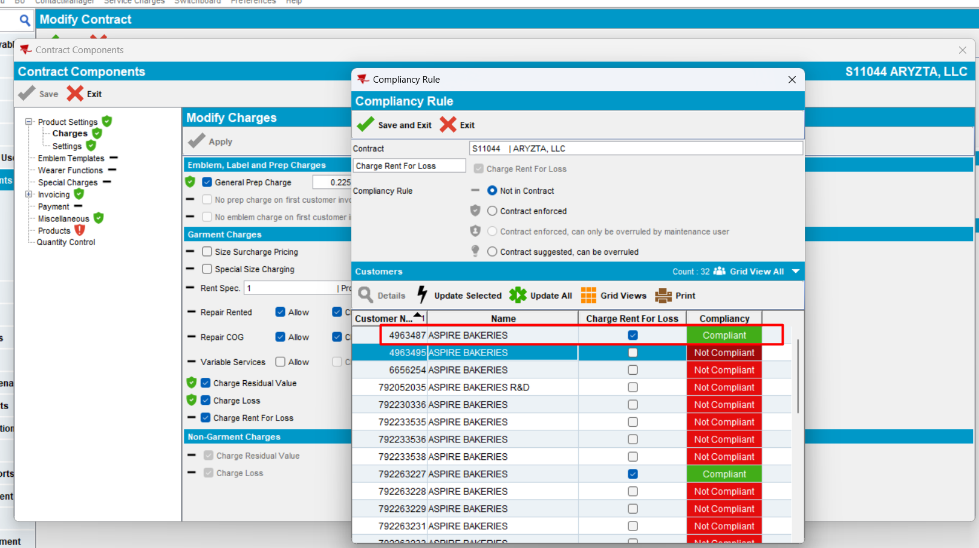
After pressing Update Selected, the customer became compliant.
- Check at Customer level.
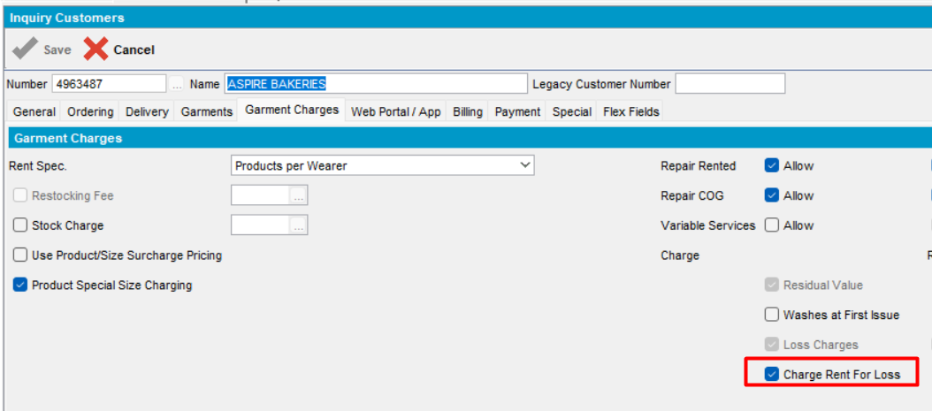
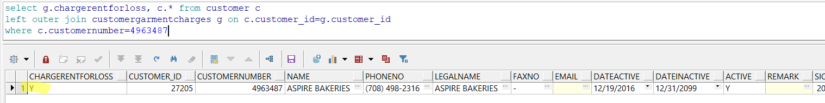
Option is checked.
Tested OK
- Uncheck the checkbox in contract and press Apply. Save the contract and reopen it.
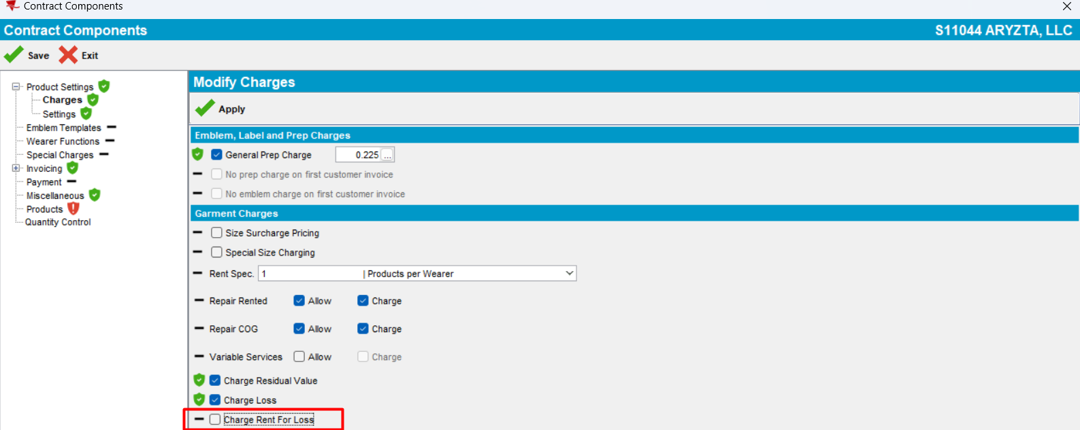
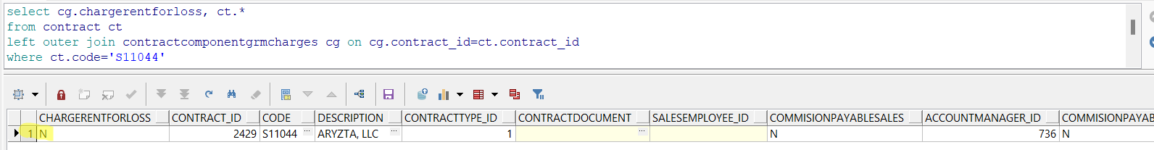
- Press Update ALL
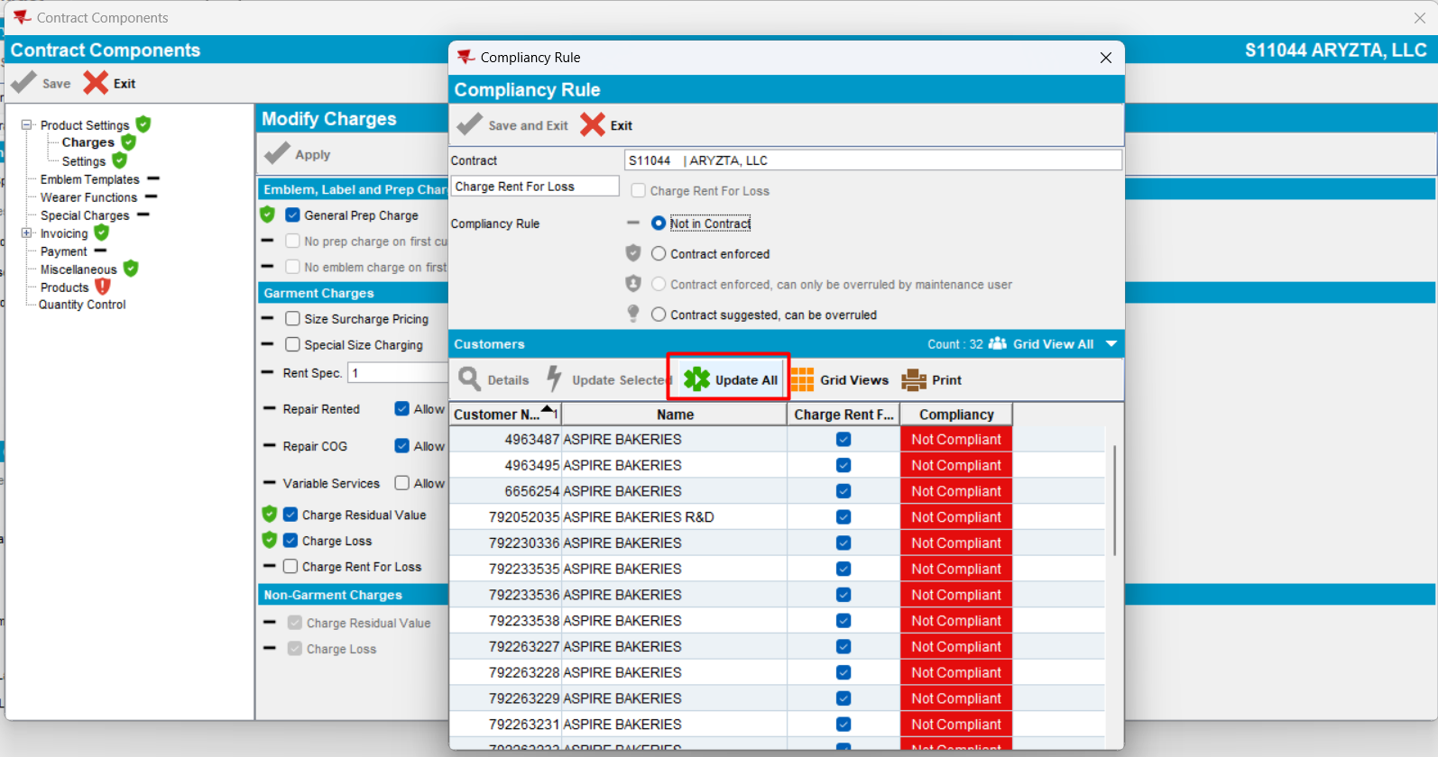
The compliancy is updated for all customers
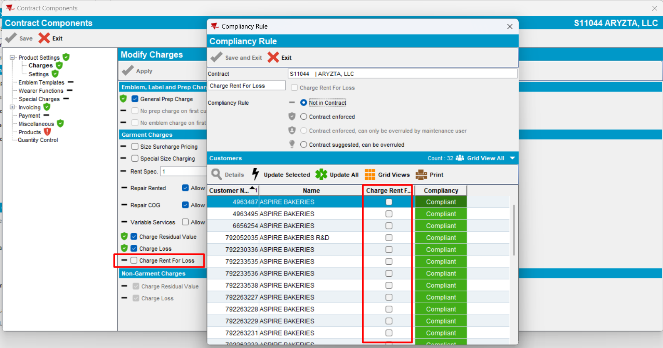
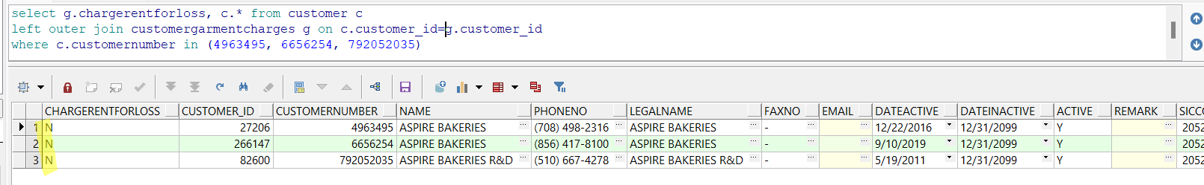
- Check again the checkbox and press Yes
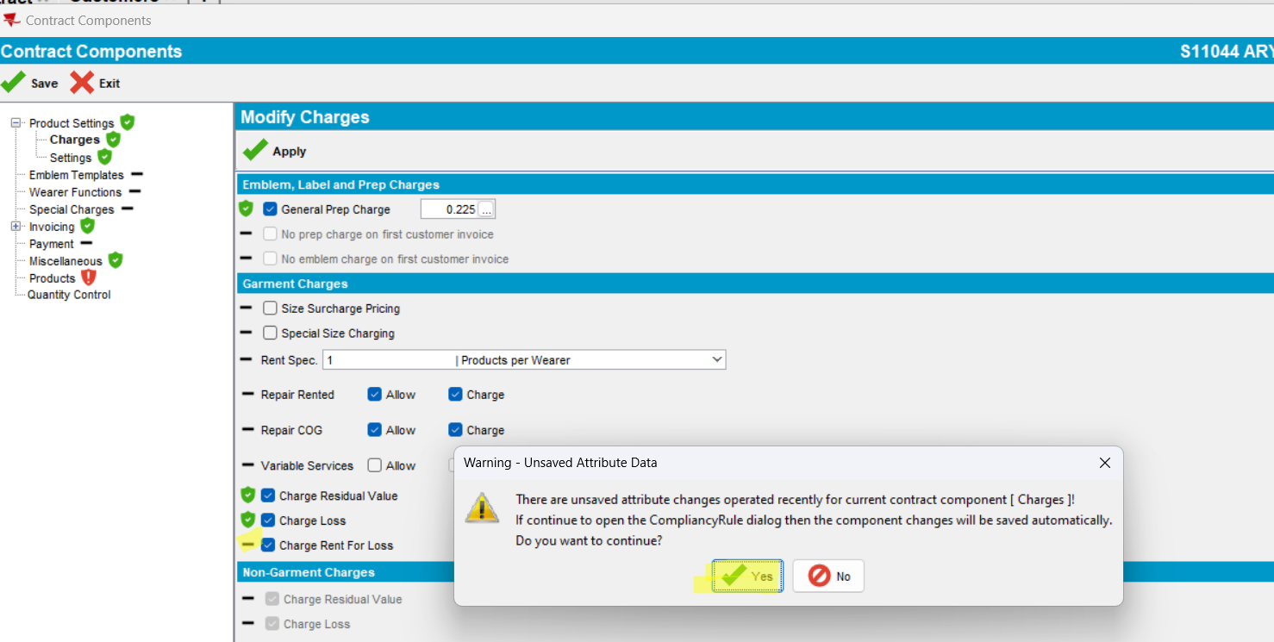
- Select some customers and press Update selected
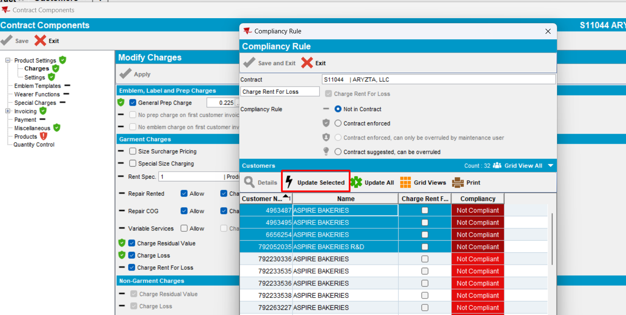
The compliancy for the selected customers is updated.
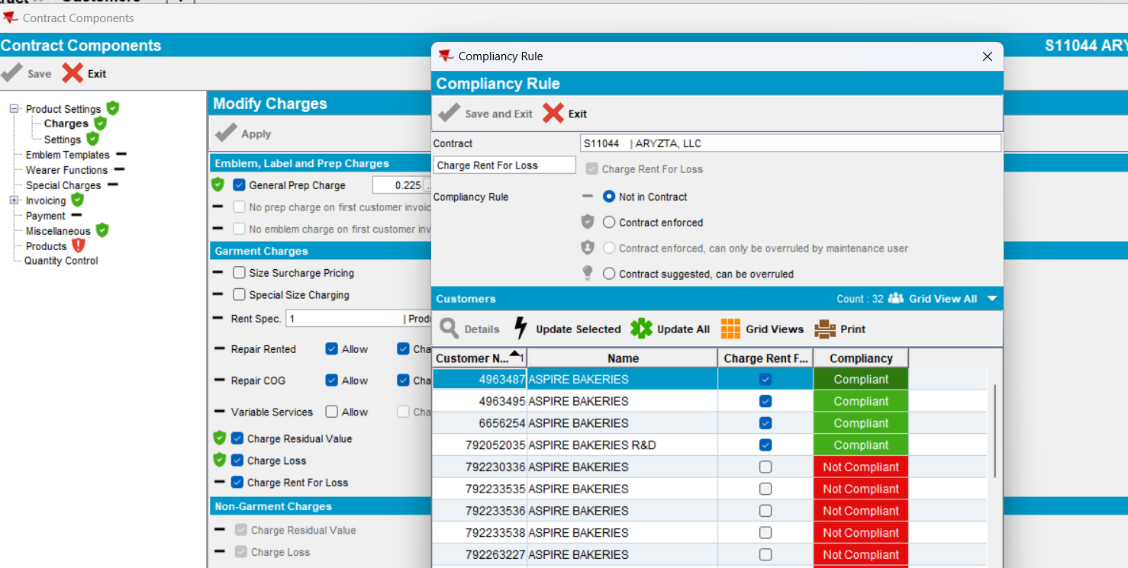
Tested OK

Test when “Charge Rent For Loss” is not checked -> invoice lines should not be created – TEST OK
Hash: 946b843
            - Set the ss:
- CHARGERENTFORLOSS = N (DEFAULT)
- RENTALCHARGEFORLOSTGRMT = Y
- SETTLEMENTACTIVE = Y
- WEEKSWARNLOSSCHARGE = 2
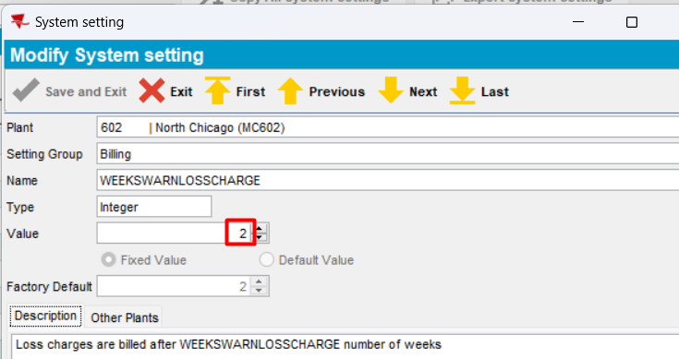
            - Open a customer that has the following options checked:
- Loss charge
- Charge rent for loss
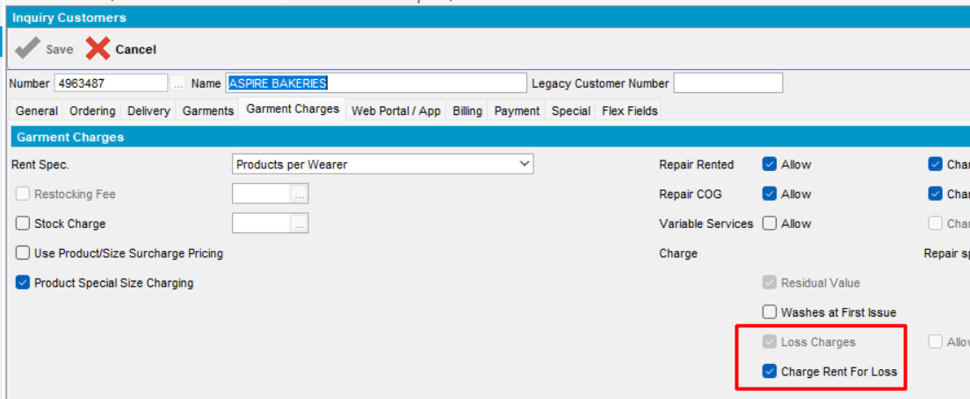
            - In Wearers dlg, do the following actions:
- Inactivate a wearer
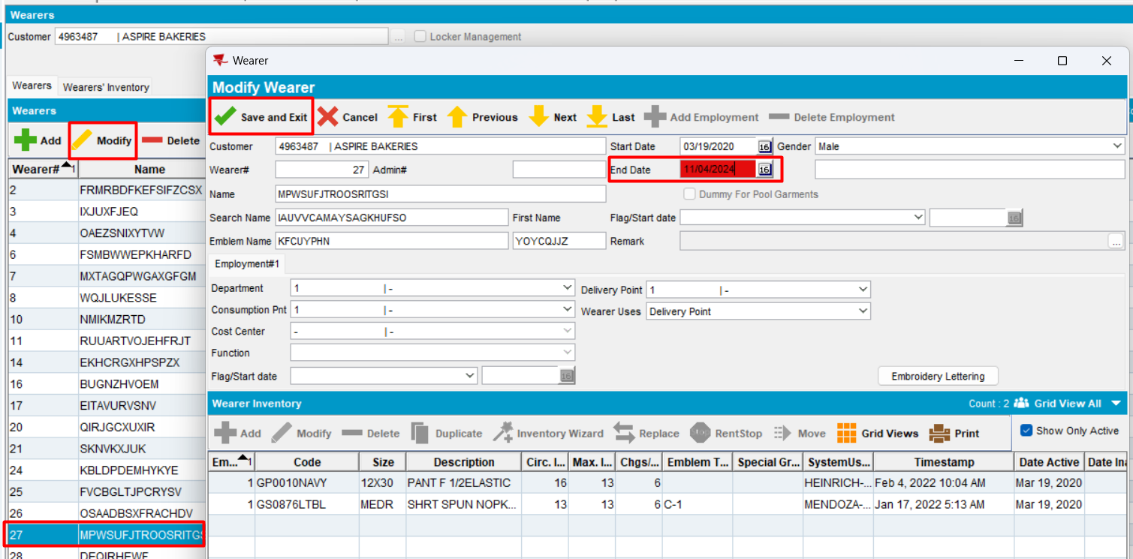
- Inactivate a Wearer Inventory
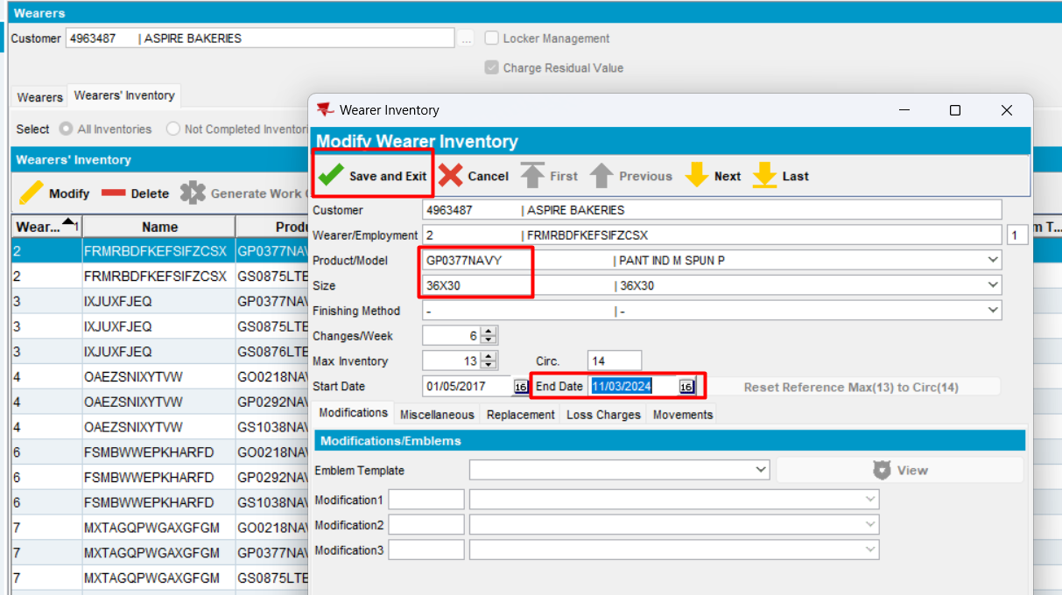
            - In Product List Per Customer dlg, inactivate a garment
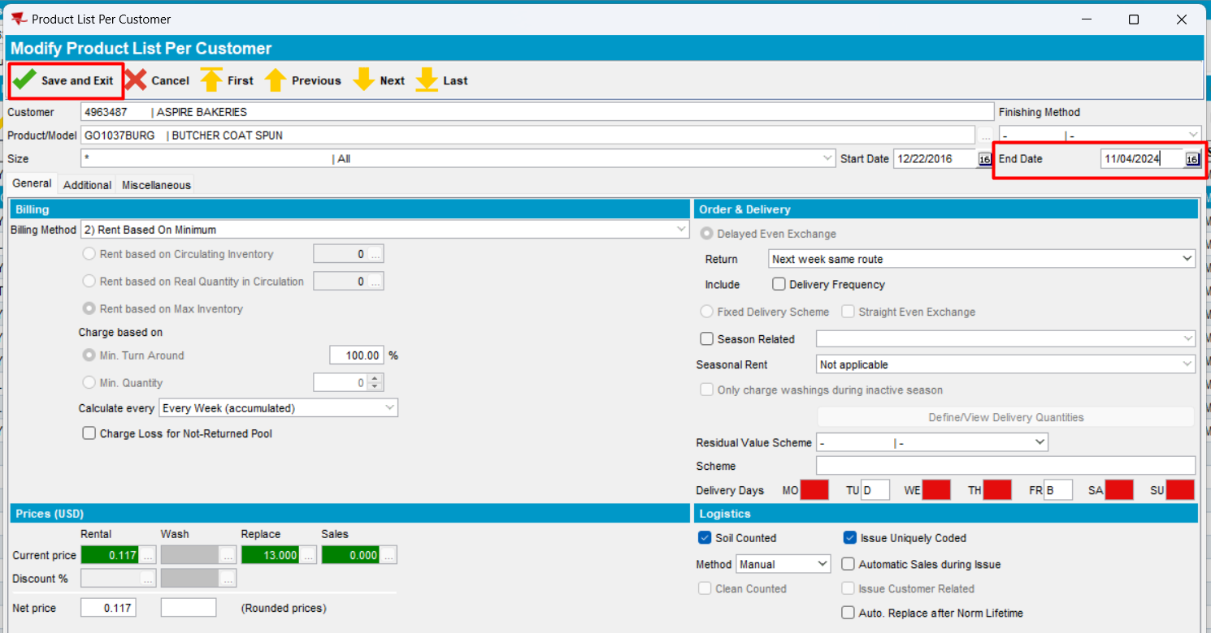
            - In Route Status Control dlg, add the route control and generate put ups and invoice. Invoice date to be greater than end date
            - Check the invoice
If there is a loss line from Quit Wearer (wearer inactive) or Quit Wearer Inventory or End PLPC (inactive), there is also a “rent for loss line”, unless it is switched off from customer level.
This is the invoice for week 1:
- Loss Charge line will be on invoice, with extend=no -> it is not charged.
- Rent For Loss line - charged
The following invoice lines, subtype loss charge and rent for loss, will be on invoice
- Line from inactivate PLPC
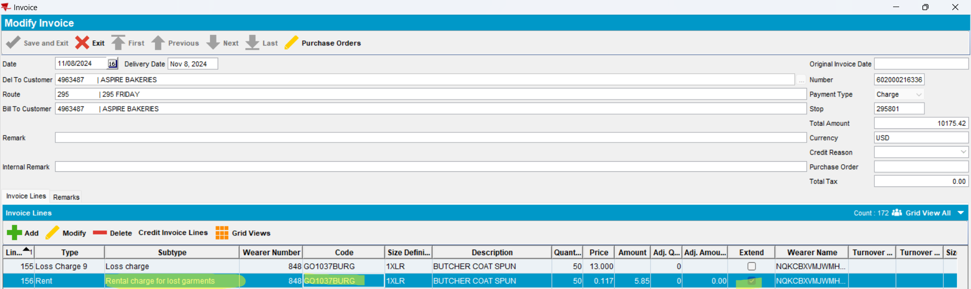
- Lines from inactivate WEARER
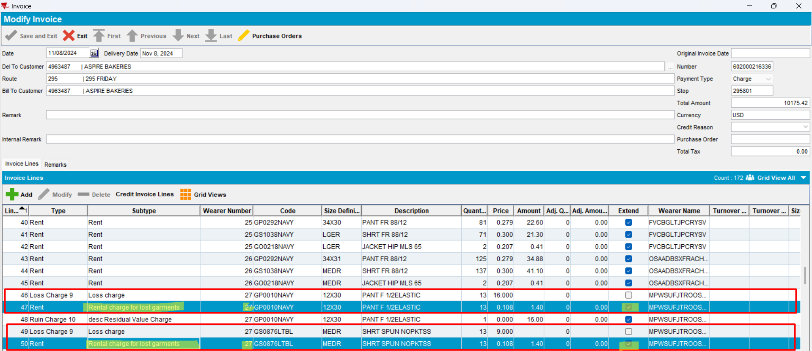
- Lines from inactivate WEARER INVENTORY
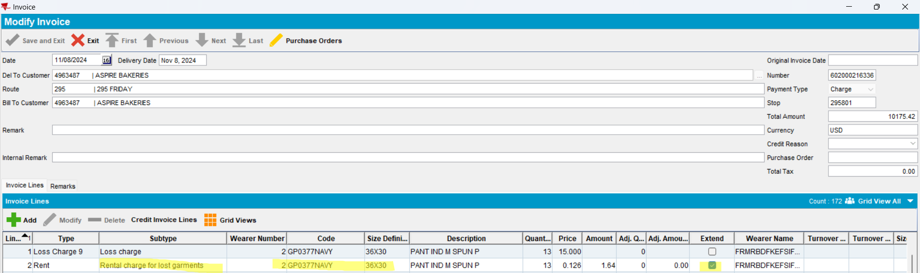
            - Cancel the invoice
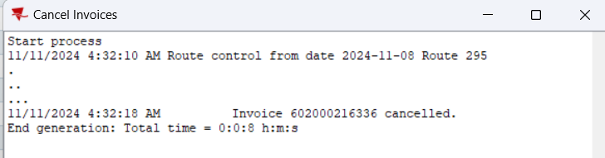
            - In Customer dlg, uncheck “Charge Rent For Loss” and save
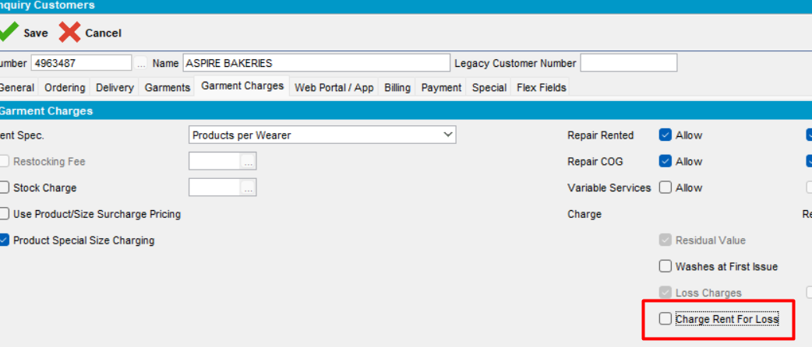
            - Regenerate invoice
            - Check the invoice lines in maintain invoices dlg
If there is a loss line from Quit Wearer (wearer inactive) or Quit Wearer Inventory or End PLPC (inactive), there is also a “rent for loss line”, unless it is switched off from customer level.
- Line from inactivate PLPC
- Lines from inactivate WEARER
- Lines from inactivate WEARER INVENTORY
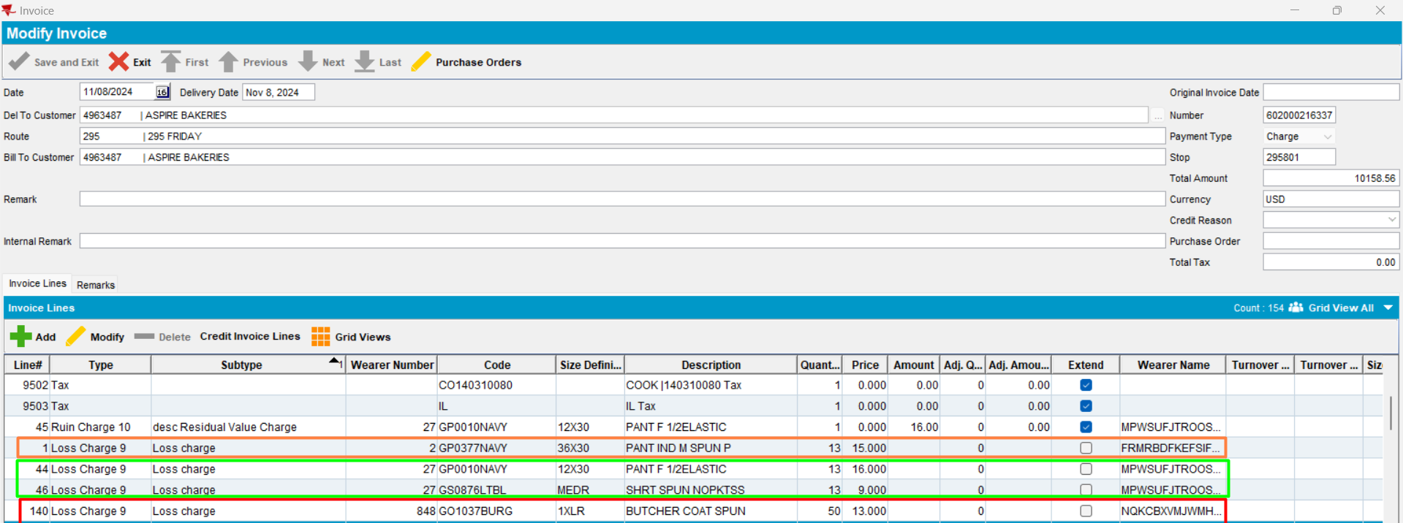
Expected behavior: If for the Del To customer, the setting CustomerGarmentCharges.ChargeRentForLoss = N then do not charge rent for loss. Because “charge rent for loss” is switched off from customer level, no invoice line will be on invoice with this subtype, for week 1.
Actual behavior: as expected
Tested OK
            - In Customer dlg, check again “Charge Rent For Loss” and save
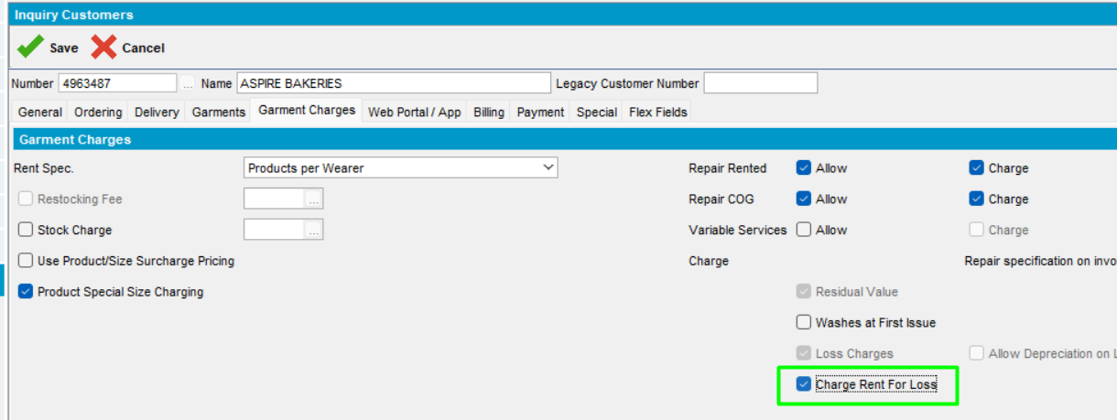
            - Settle the current route.
            - Add a route control one week later. Generate put up docs and invoice
            - Check the invoice
If there is a loss line from Quit Wearer (wearer inactive) or Quit Wearer Inventory or End PLPC (inactive), there is also a “rent for loss line”, unless it is switched off from customer level.
This is the invoice for week 2:
- Loss Charge line will be on invoice, with extend=no -> it is not charged.
- Rent For Loss line - charged
The following invoice lines, subtype loss charge and rent for loss, will be on invoice
- Line from inactivate PLPC
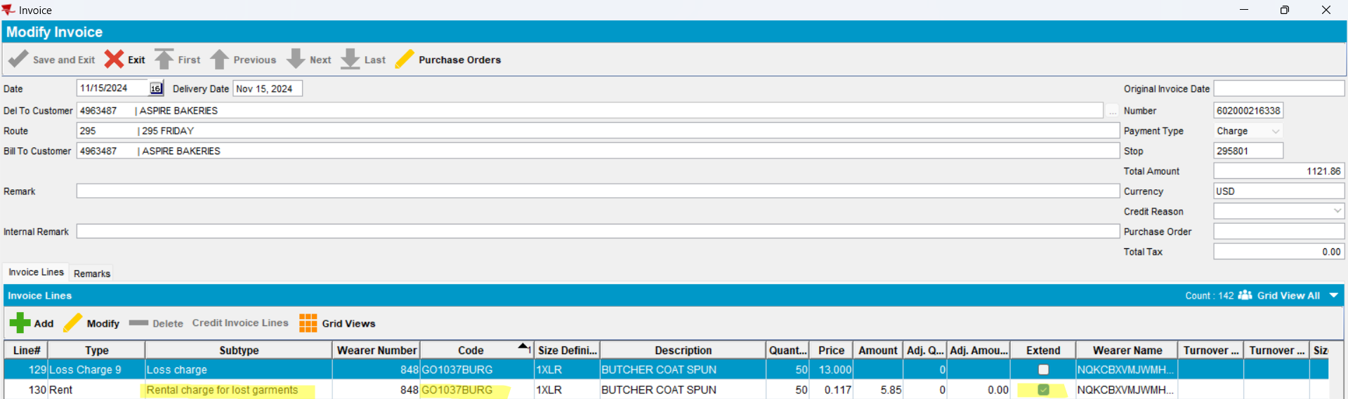
- Lines from inactivate WEARER
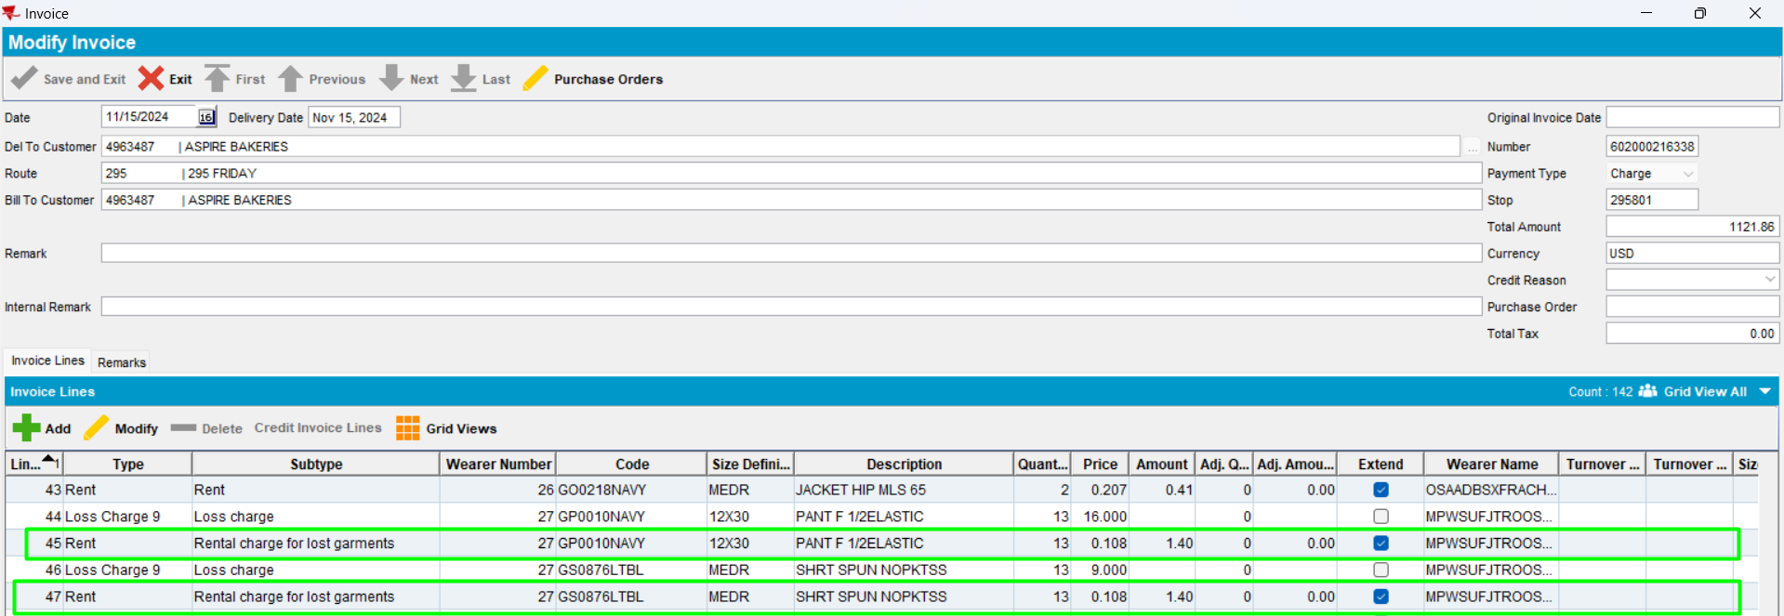
- Lines from inactivate WEARER INVENTORY
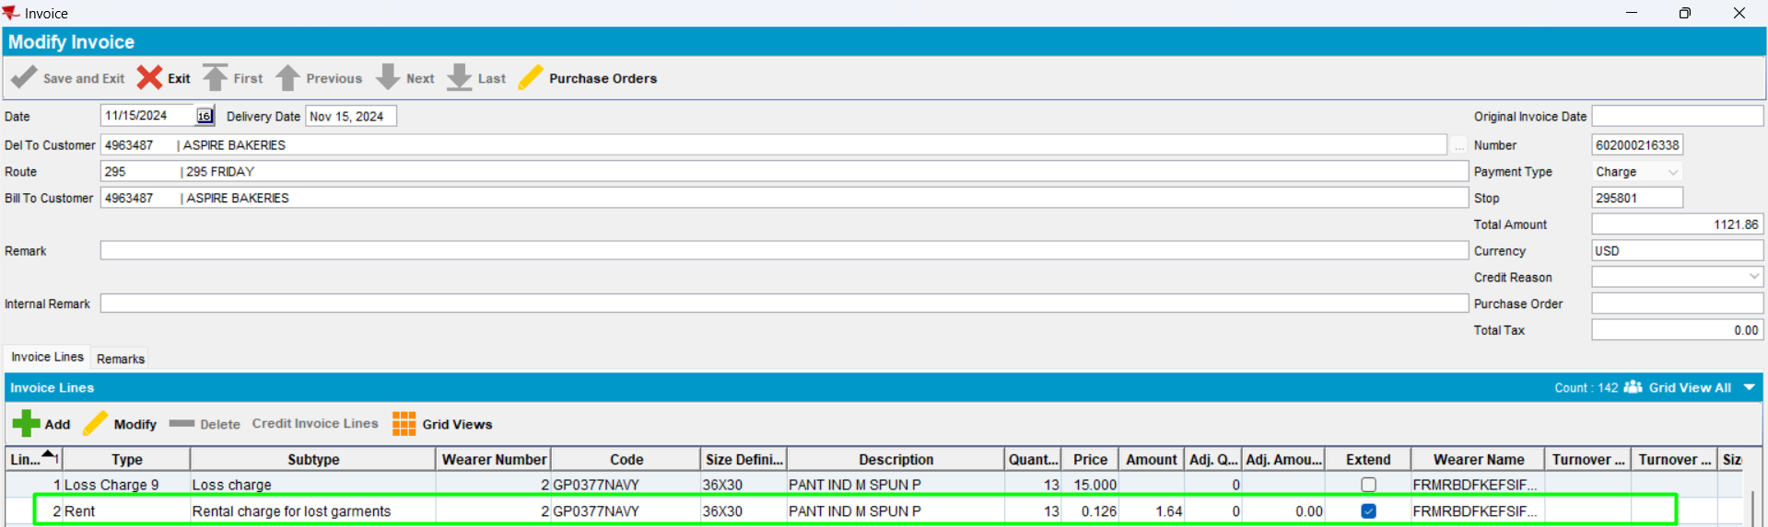
            - Cancel the invoice
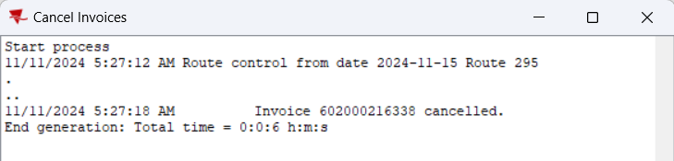
            - In Customer dlg, uncheck “Charge Rent For Loss” and save
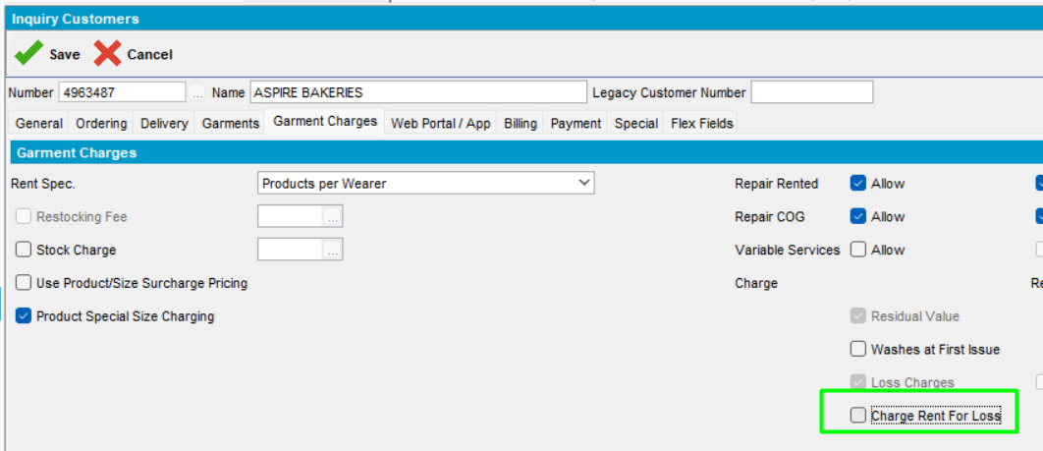
            - Regenerate invoice
            - Check the invoice lines in maintain invoices dlg
If there is a loss line from Quit Wearer (wearer inactive) or Quit Wearer Inventory or End PLPC (inactive), there is also a “rent for loss line”, unless it is switched off from customer level.
- Line from inactivate PLPC
- Lines from inactivate WEARER
- Lines from inactivate WEARER INVENTORY
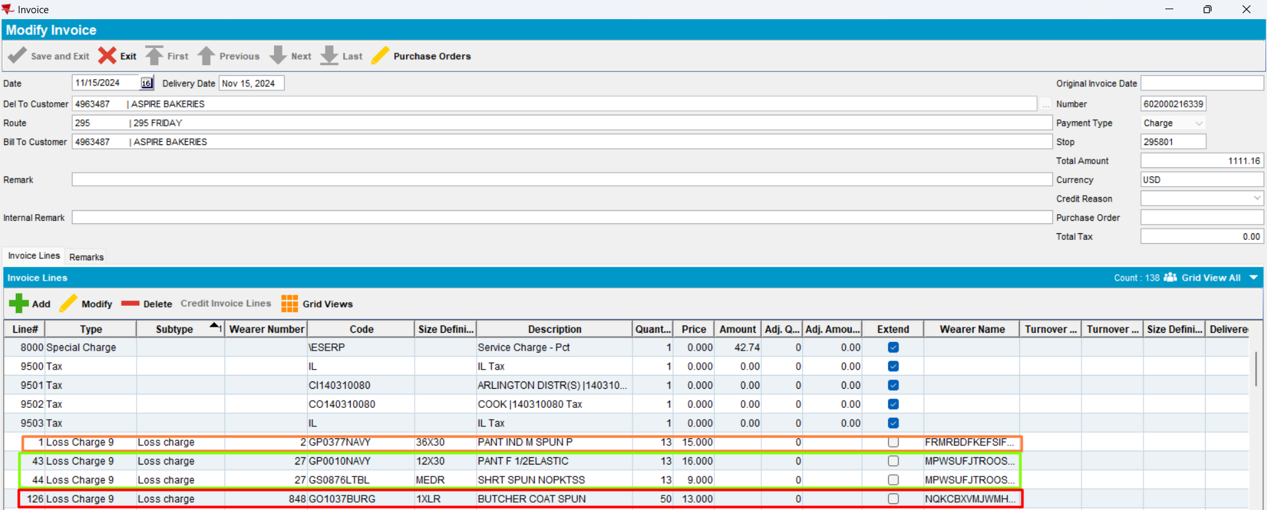
Expected behavior: If for the Del To customer, the setting CustomerGarmentCharges.ChargeRentForLoss = N then do not charge rent for loss. Because “charge rent for loss” is switched off from customer level, no invoice line will be on invoice with this subtype, for week 2.
Actual behavior: as expected
Tested OK
            - In Customer dlg, check again “Charge Rent For Loss” and save
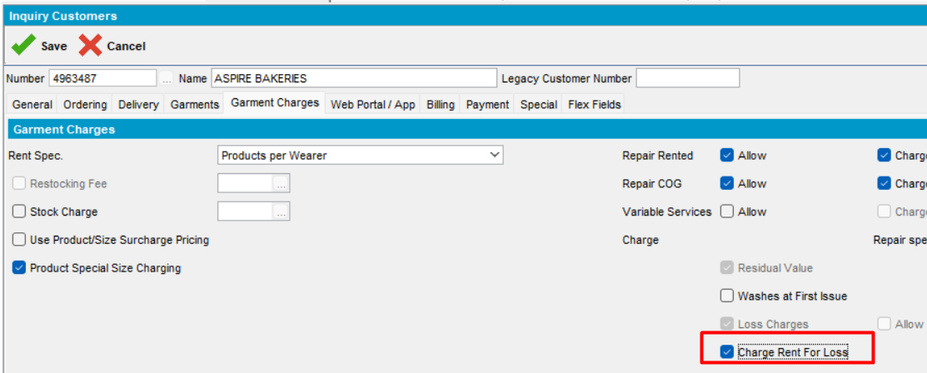
            - Settle the current route.
            - Add a route control one week later (for week 3). Generate put up docs and invoice
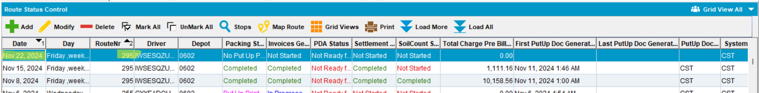
            - Check the invoice for week 3
If there is a loss line from Quit Wearer (wearer inactive) or Quit Wearer Inventory or End PLPC (inactive), there is also a “rent for loss line”, unless it is switched off from customer level.
This is the invoice for week 3:
- Loss Charge line will be on invoice, with extend = Y -> it is charged.
- Rent For Loss line - charged
The following invoice lines, subtype loss charge and rent for loss, will be on invoice
- Line from inactivate PLPC
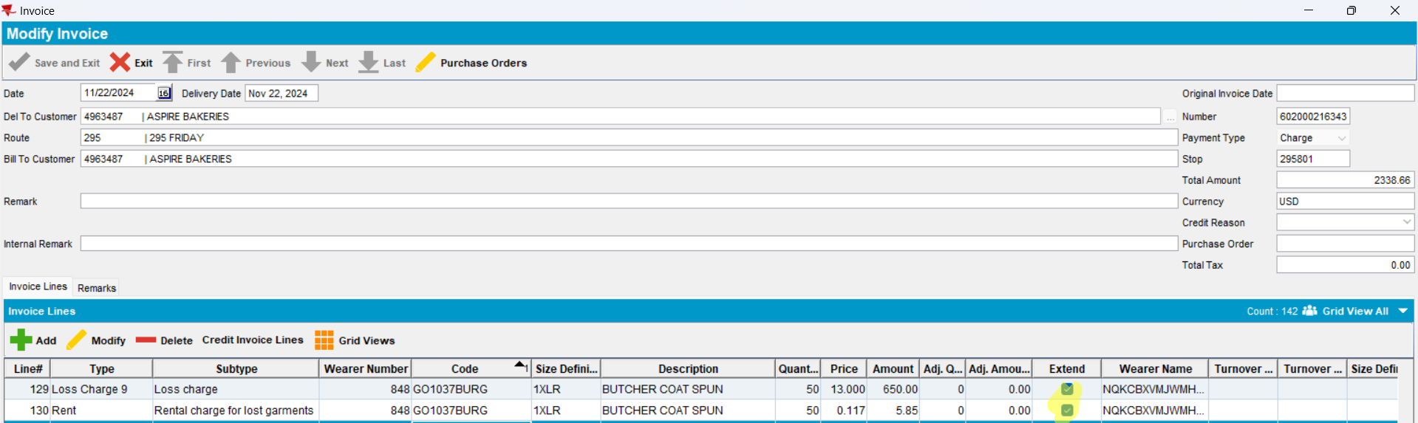
- Lines from inactivate WEARER
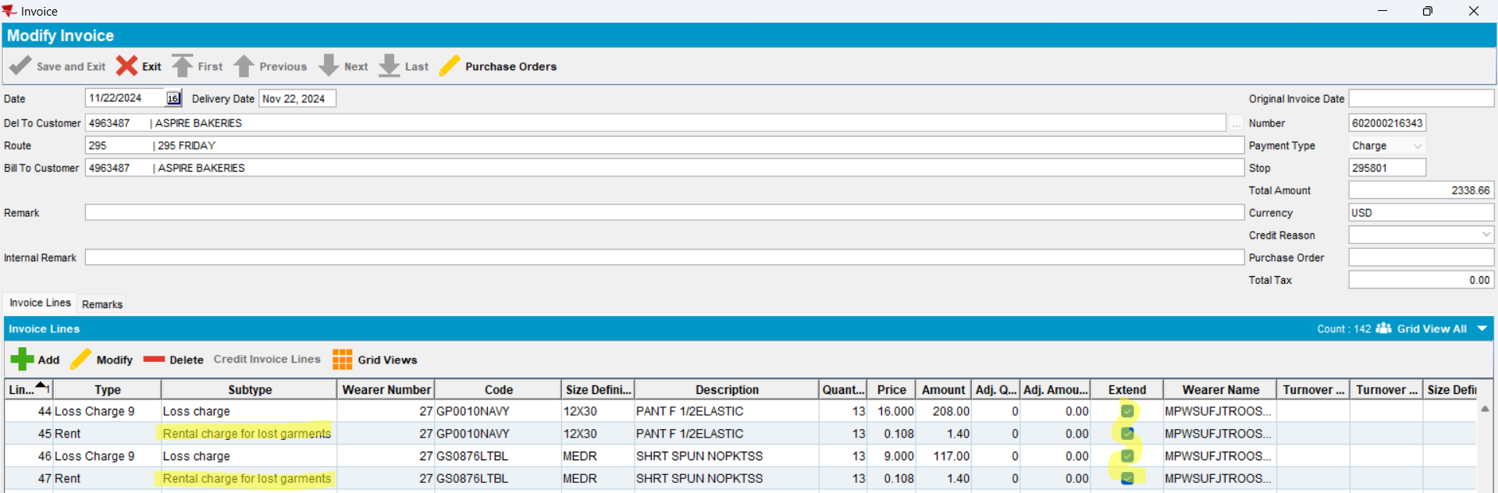
- Lines from inactivate WEARER INVENTORY
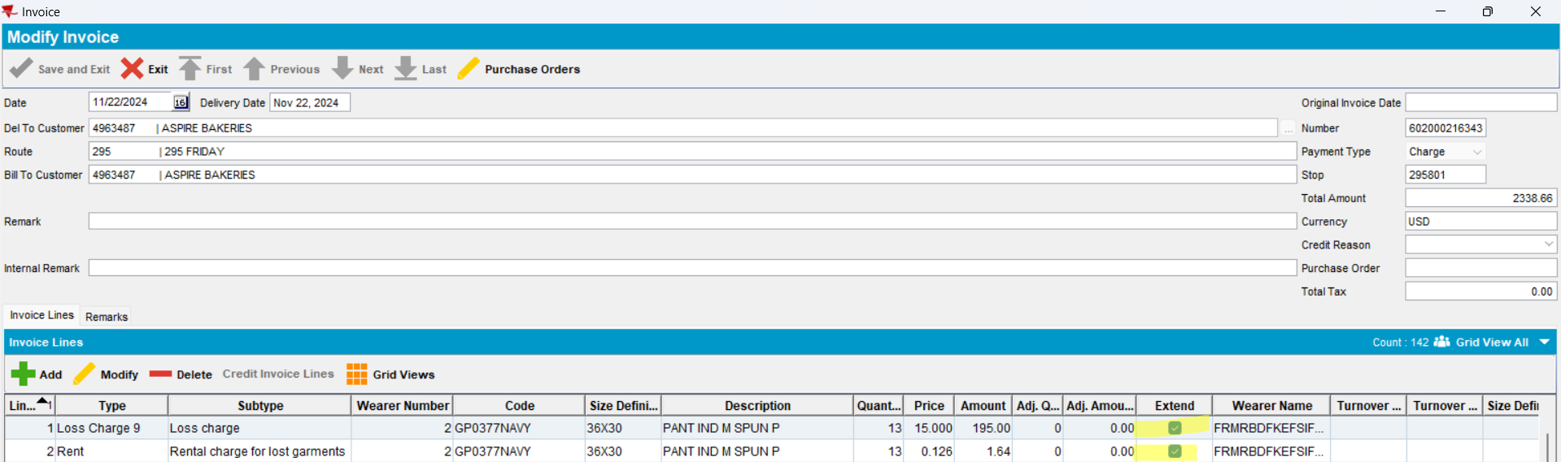
            - Cancel the invoice
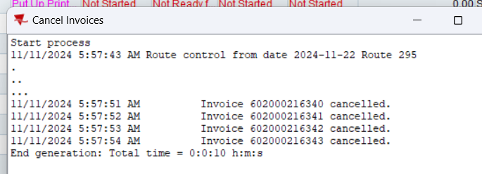
            - In Customer dlg, uncheck “Charge Rent For Loss” and save
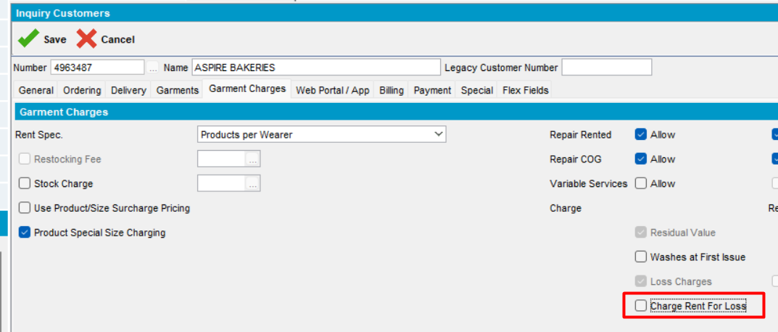
            - Regenerate invoice
            - Check the invoice lines in Maintain Invoices dlg
If there is a loss line from Quit Wearer (wearer inactive) or Quit Wearer Inventory or End PLPC (inactive), there is also a “rent for loss line”, unless it is switched off from customer level.
- Line from inactivate PLPC
- Lines from inactivate WEARER
- Lines from inactivate WEARER INVENTORY
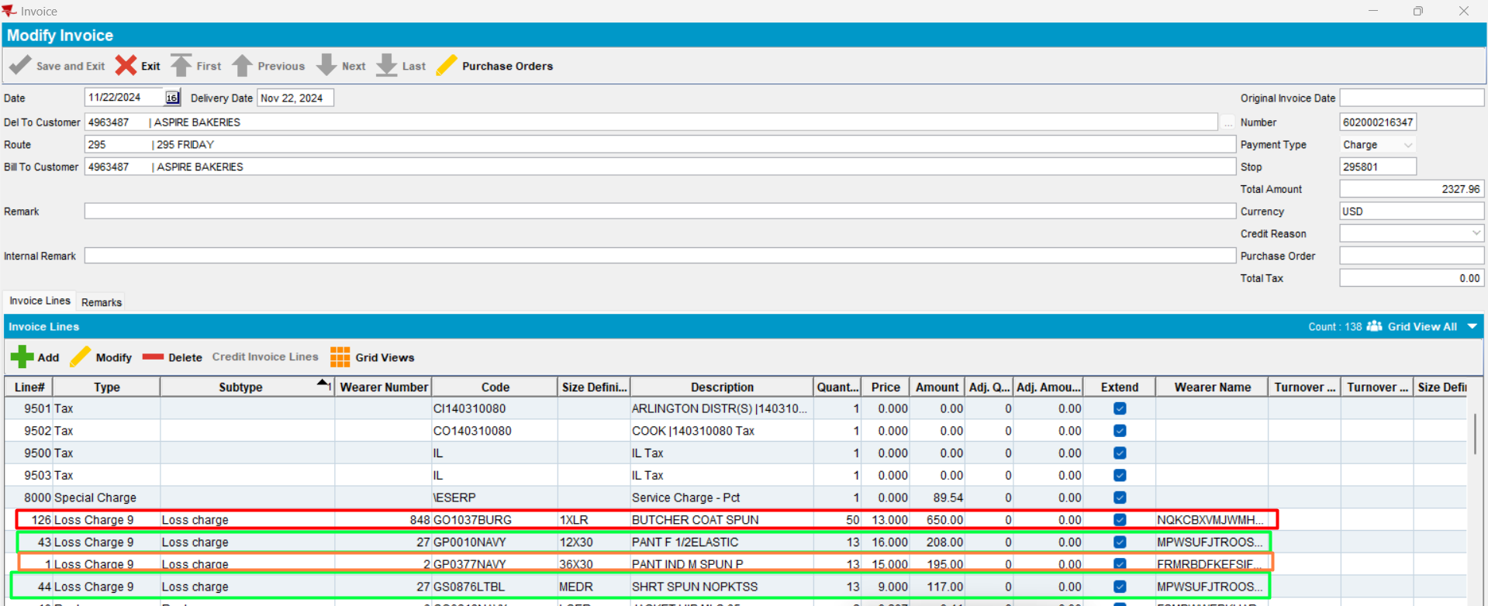
Expected behavior: If for the Del To customer, the setting CustomerGarmentCharges.ChargeRentForLoss = N then do not charge rent for loss. Because “charge rent for loss” is switched off from customer level, no invoice line will be on invoice with this subtype, for week 2.
Actual behavior: as expected
Tested OK

Test Read Only customer – TEST OK
Hash: 946b843
      - Login in with a Read Only user that is part of a Read Only User Group
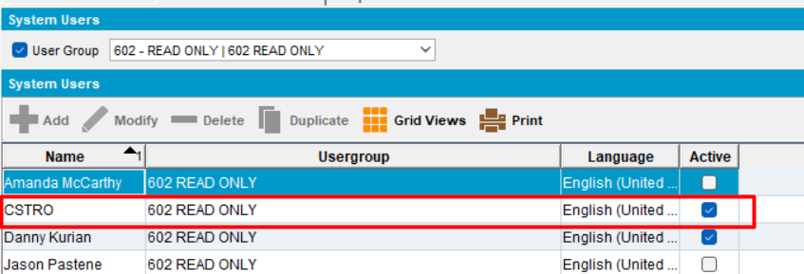
      - System setting can not be modified. Modify button is disabled
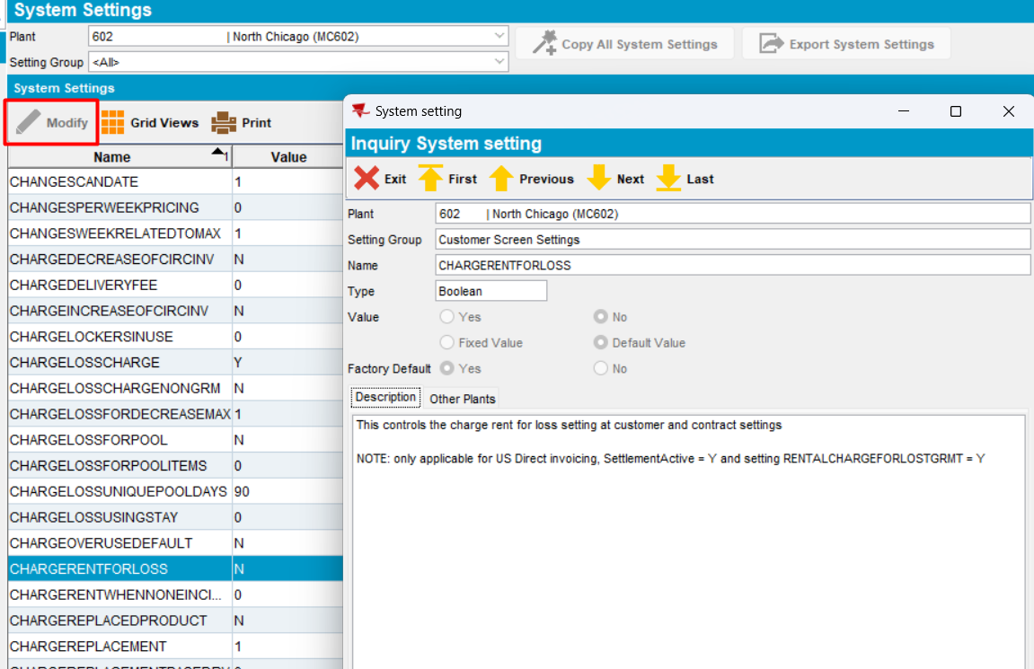
      - Load a customer. Modify button is disabled
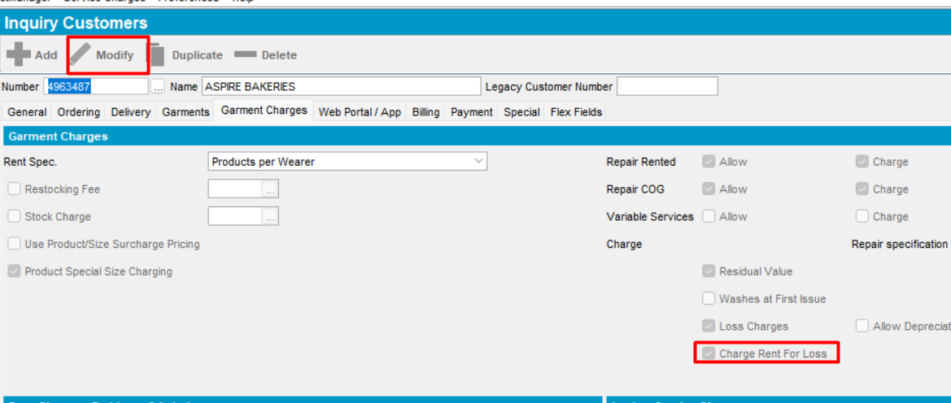
The new field is disabled.
      - Load a contract
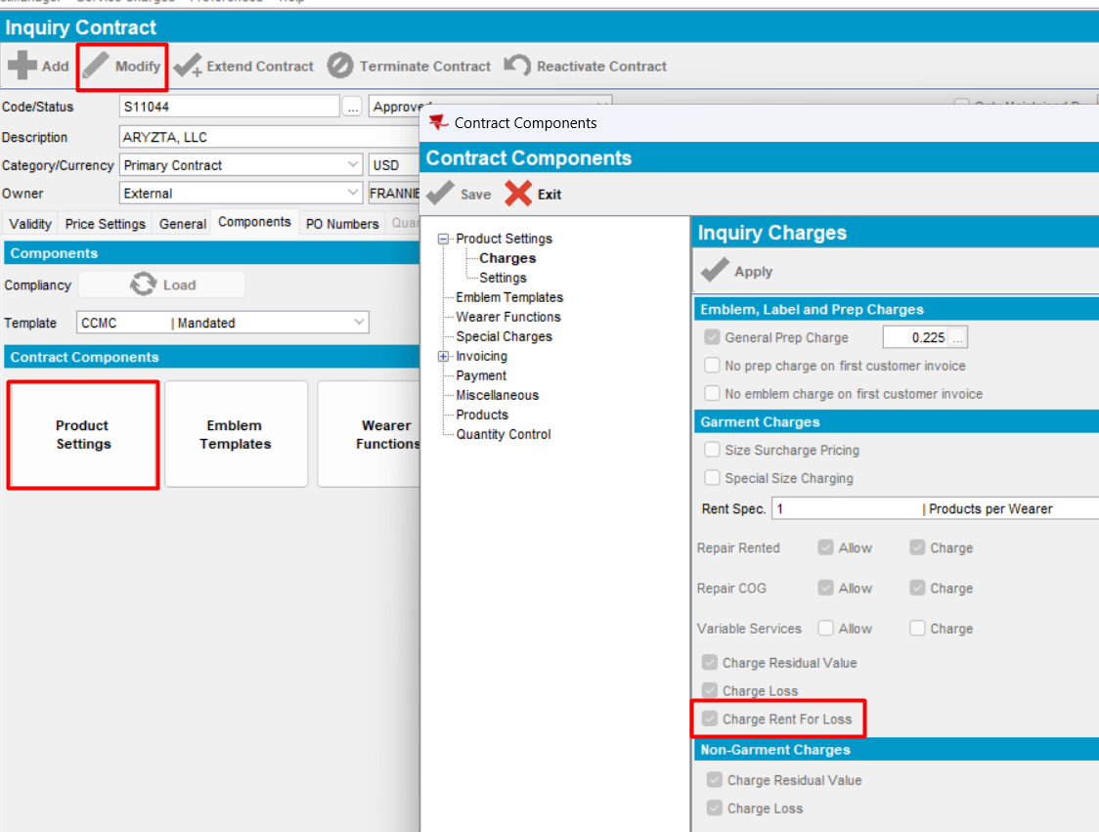
Everything is disabled.
Tested OK

5. Test when “Del to customer” is different than “Bill to customer” – TEST OK
Hash: 946b843
Set ss:
- CHARGERENTFORLOSS = Y (DEFAULT)
- RENTALCHARGEFORLOSTGRMT = Y
- SETTLEMENTACTIVE = Y
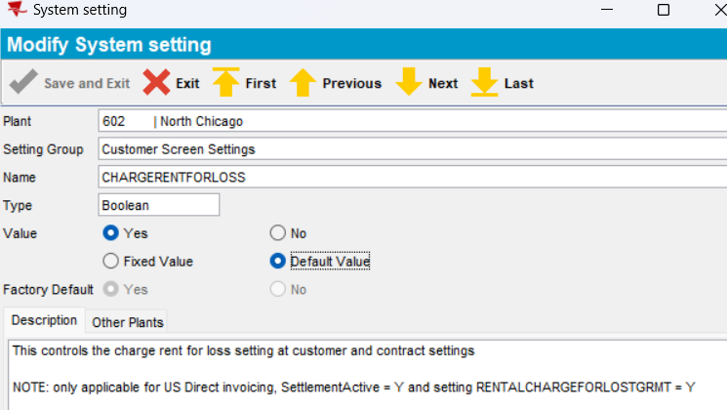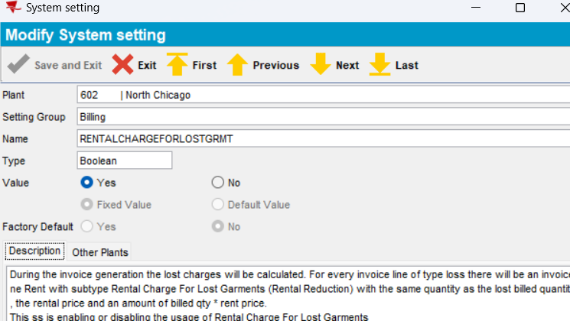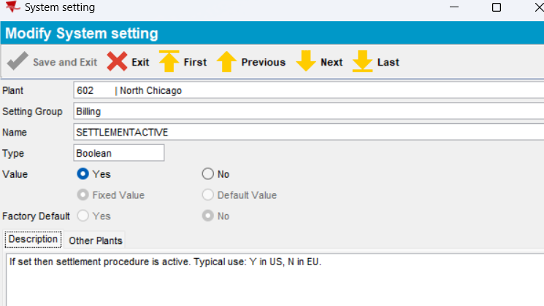
            - Open a customer that has the following options checked:
- Loss charge
- Charge rent for loss
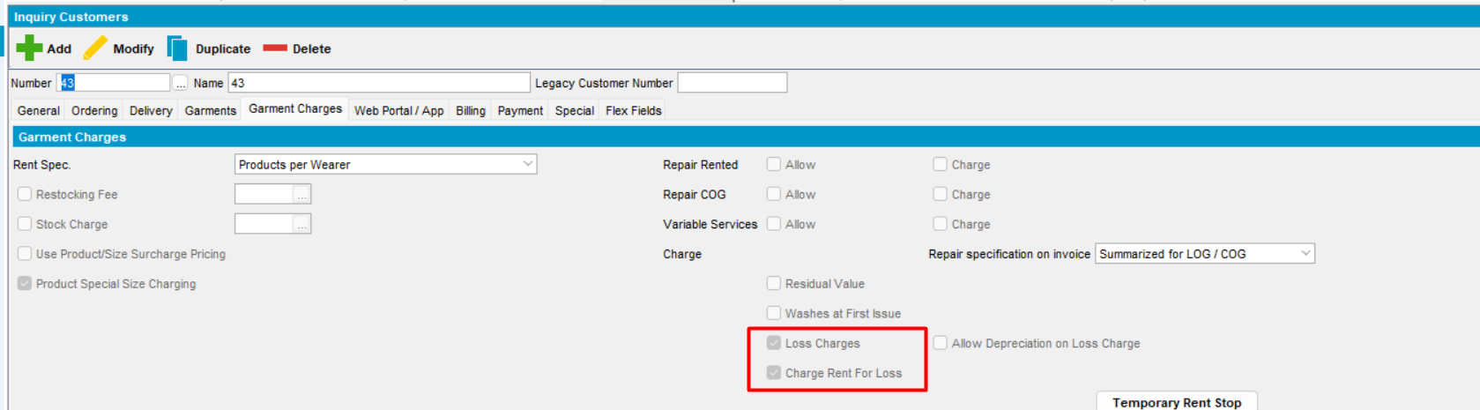
            - Chage “Bill to customer” and save
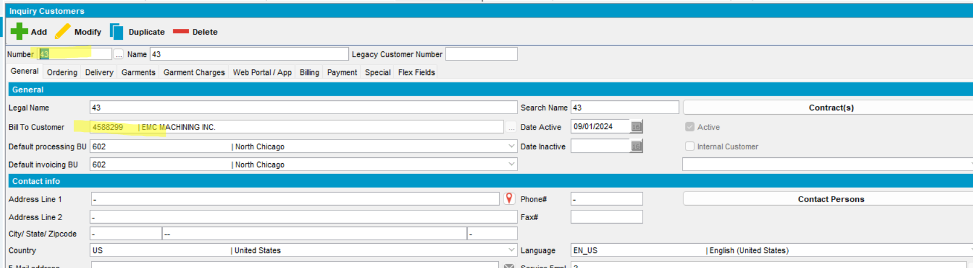
Bill to customer” does not have the option checked, so the “Rent for loss” line will come from Del to customer.
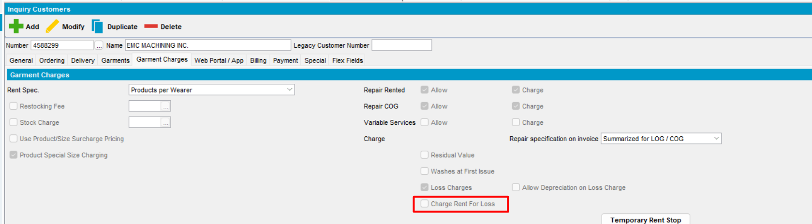
            - End date a wearer inventory
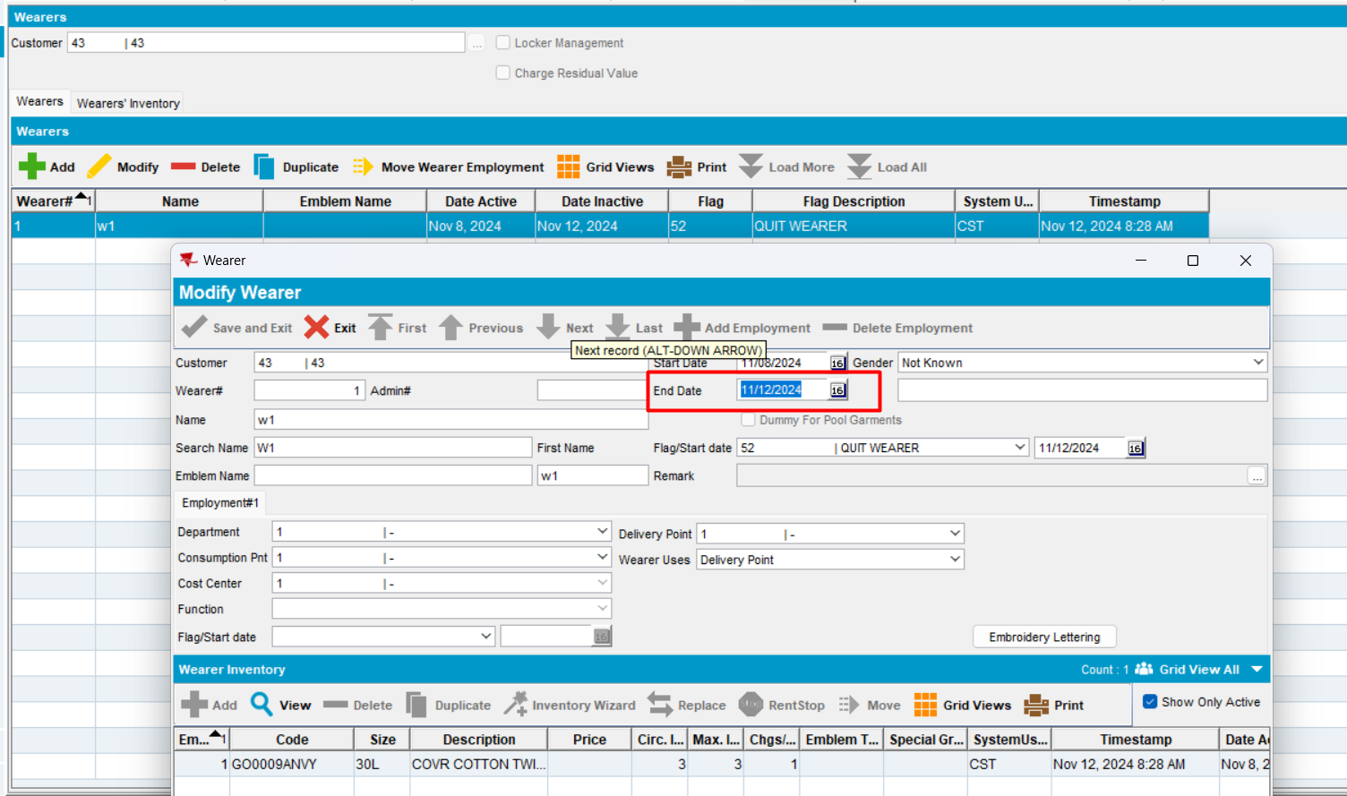
            - In Route Status Control dlg, generate put up docs and invoice.
            - In Maintain Invoices dlg, verify if Rent For Loss Invoice line is created and it is coming from “Del to” customer
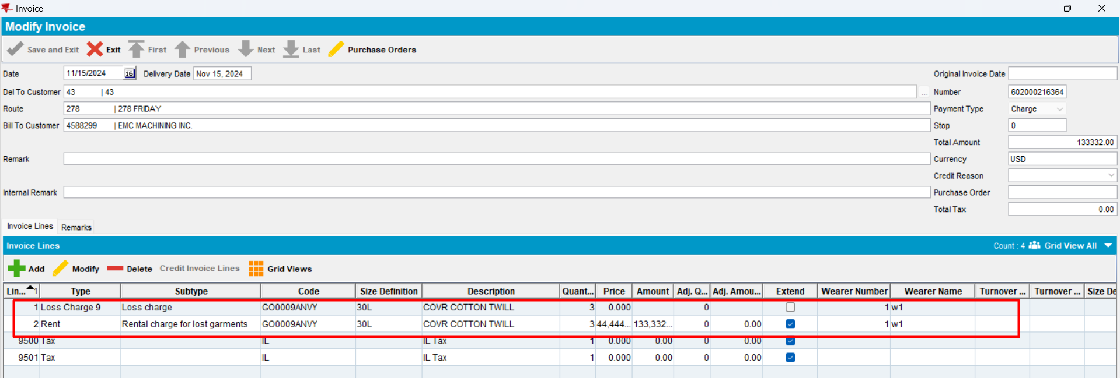
Actual behavior: when checkbox Charge Rent For Loss is checked at customer level, a Rent For Loss Invoice line will be created and it is coming from “Del To” customer, not from “bill to customer.
Expected behavior: as expected
Tested ok
            - Uncheck option on del to customer
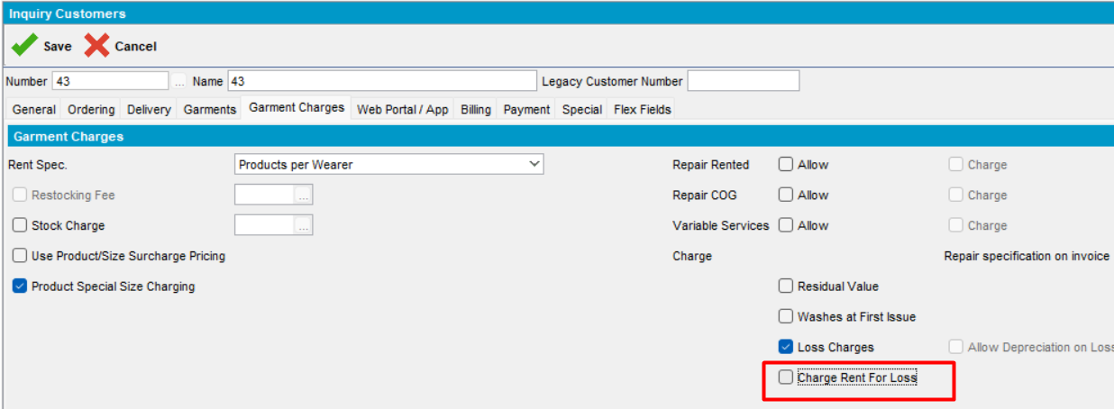
            - Cancel and regenerate invoice. Rent For Loss Invoice line will not appear on invoice
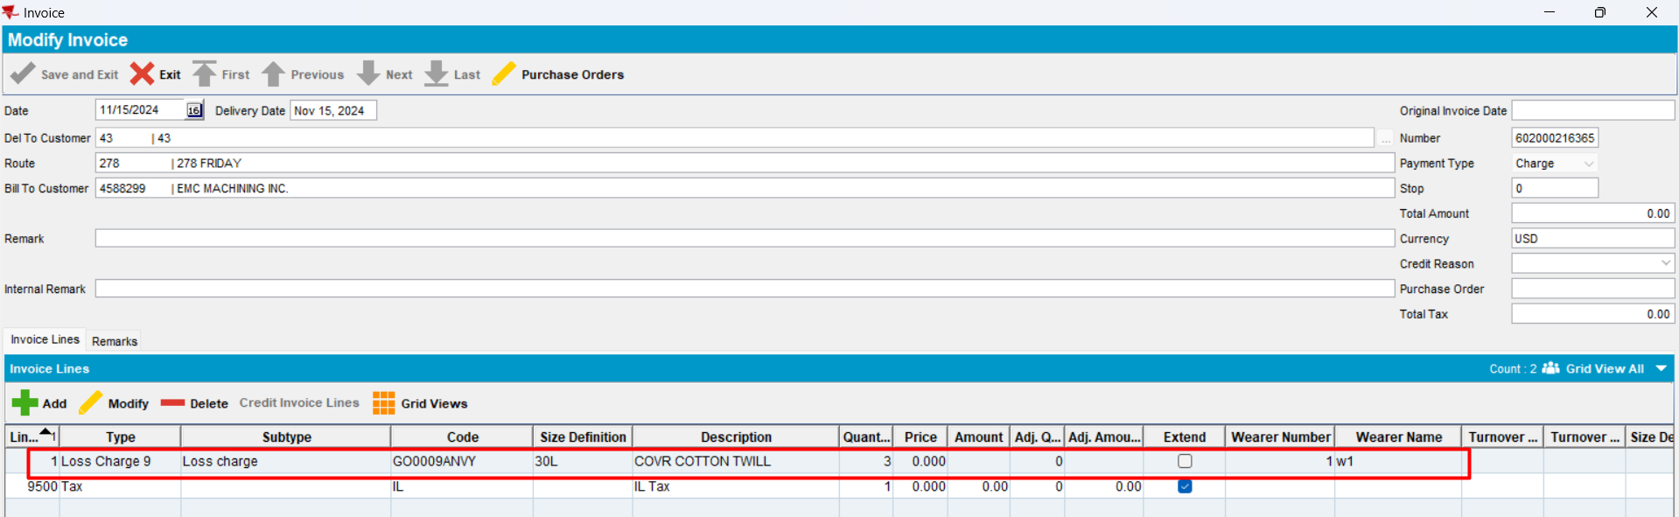
Actual behavior: when checkbox Charge Rent For Loss is not checked, at customer level, no “Rent For Loss” invoice line will be created that will come from “Del To” customer, not from “bill to customer.
Expected behavior: as expected
Tested ok

6. Test when CustomerGarmentCharges does not exist – TEST OK
Hash: 946b843
- Verify in db tables. There is no record for the customer for this test.
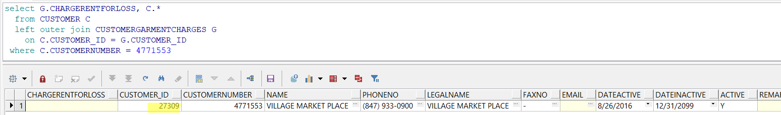
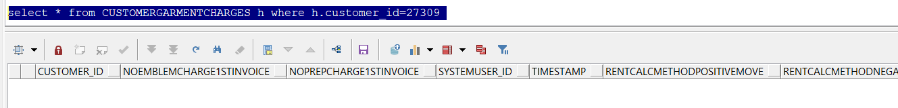
- Uncheck the checkbox
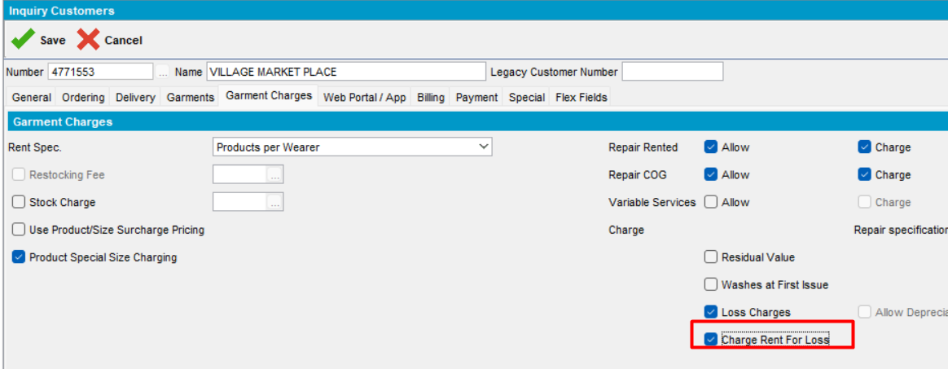
The checkbox is unchecked:
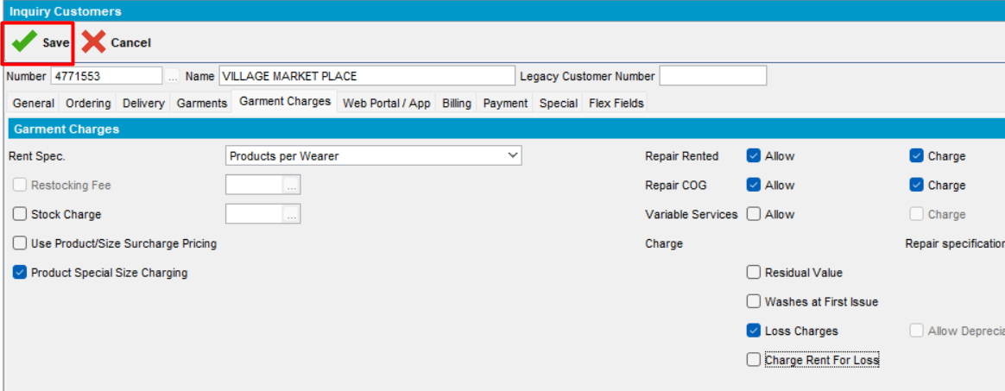
- Check the db table if the new record is created
select g.chargerentforloss, g.*, C.*
from customer c
left outer join customergarmentcharges g on c.customer_id=g.customer_id
where c.customernumber = 4771553
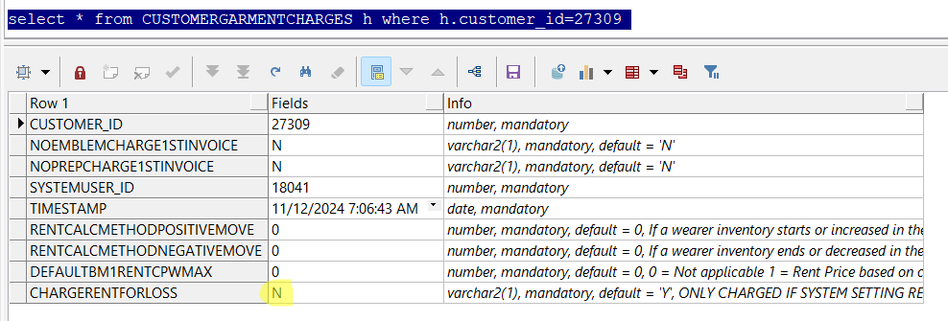
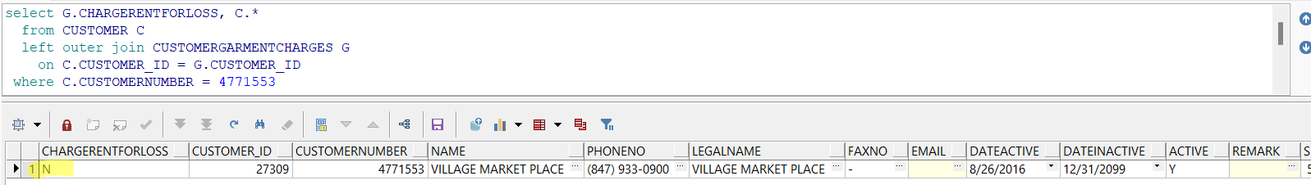
After the modification is saved on customer level, a new record is created in the db table.
Test OK

