ABSN-11507 Switchboard Customer not found error
Environment | Prerequisites
Version: 9.08.00.RELEASE.p23 (BUGFIX BRANCH)  DBServerName=abs-srv17.internal.abslbs.com  DBSID=CUST23  DBUser=AUS_MNT90800  DBPassword=AUS_MNT90800  Environment=Test  EnvironmentSABStage=Test | - Module: DASHBOARD, AUS

Contents
Retest after fix 1
Test Case 1 – Selecting customer in Switchboard – TEST PASSED. 1

Retest after fix

Test Case 1 – Selecting customer in Switchboard – TEST PASSED.
Expected behavior: When using the switchboard to search for customer, no null pointer exception errors should be thrown, when pressing the “Find Button” multiple times.
Hash: d7c20719f4d6
- Open the switchboard:
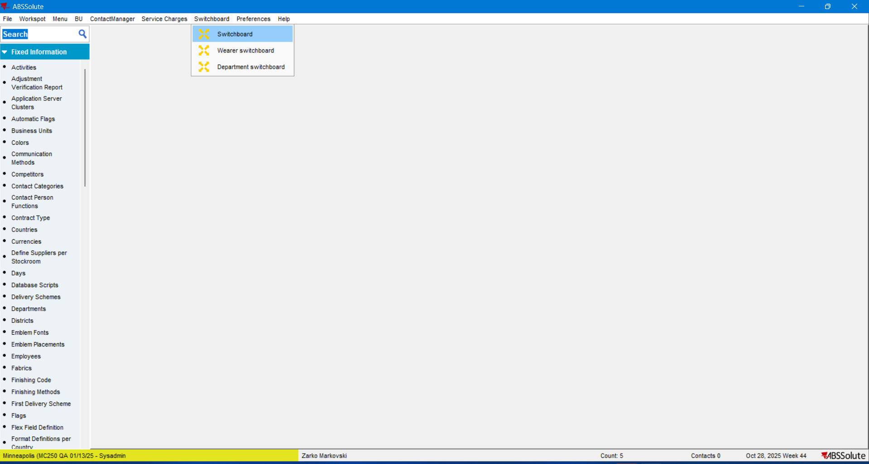

- Press the Find button:
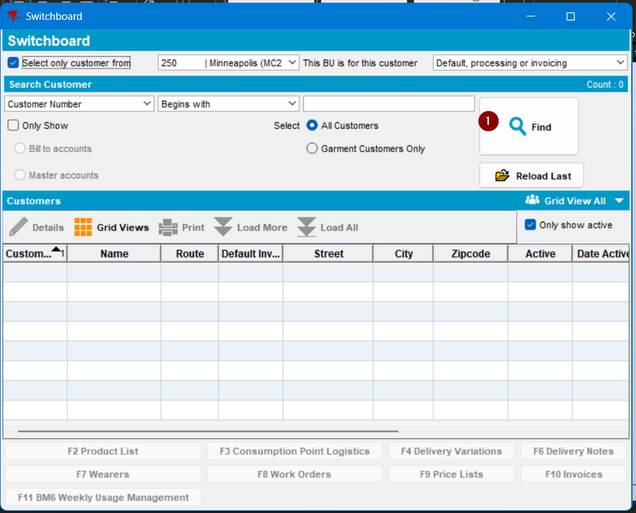
The grid is filled:
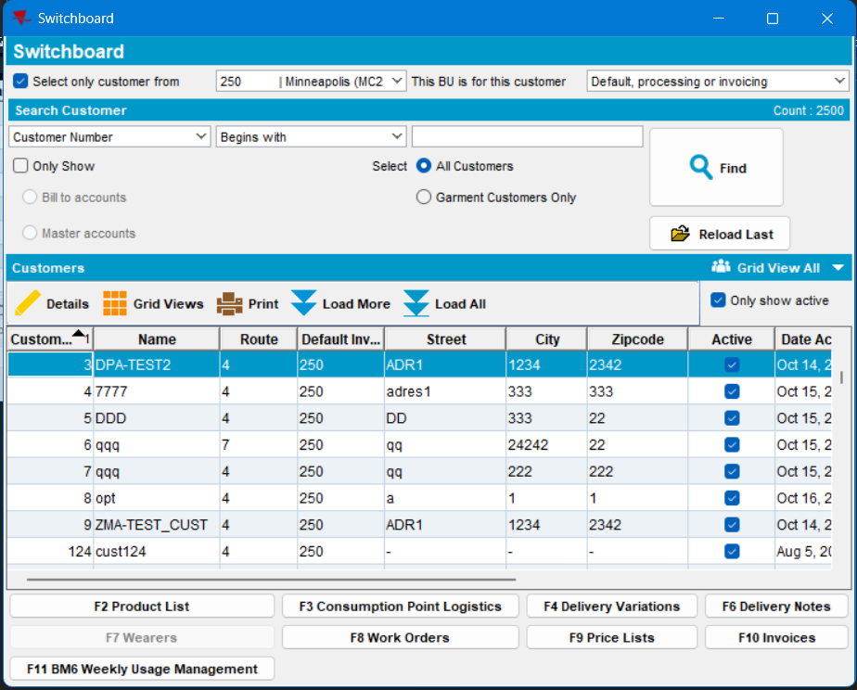

- Search for a certain customer: fill in the Customer Number (Begins With) field and press again the Find button:
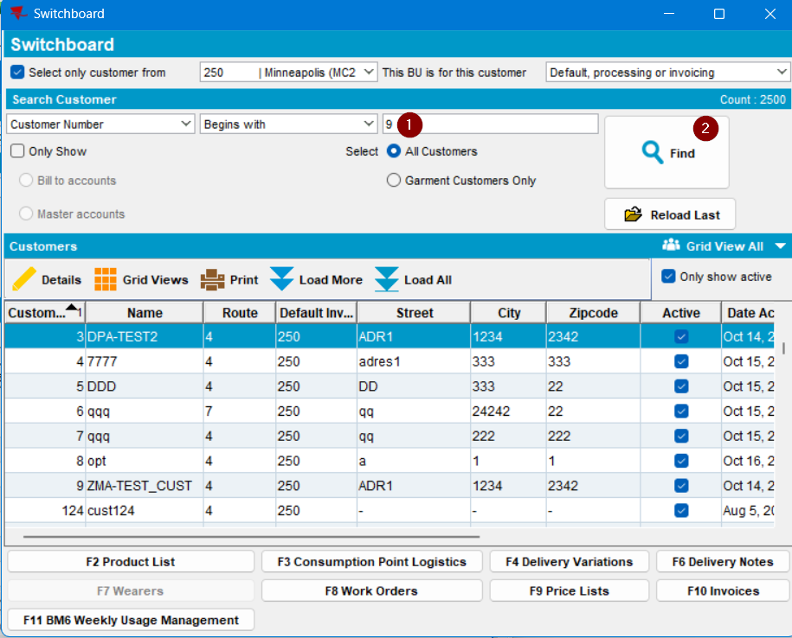
The grid is correspondingly filled:
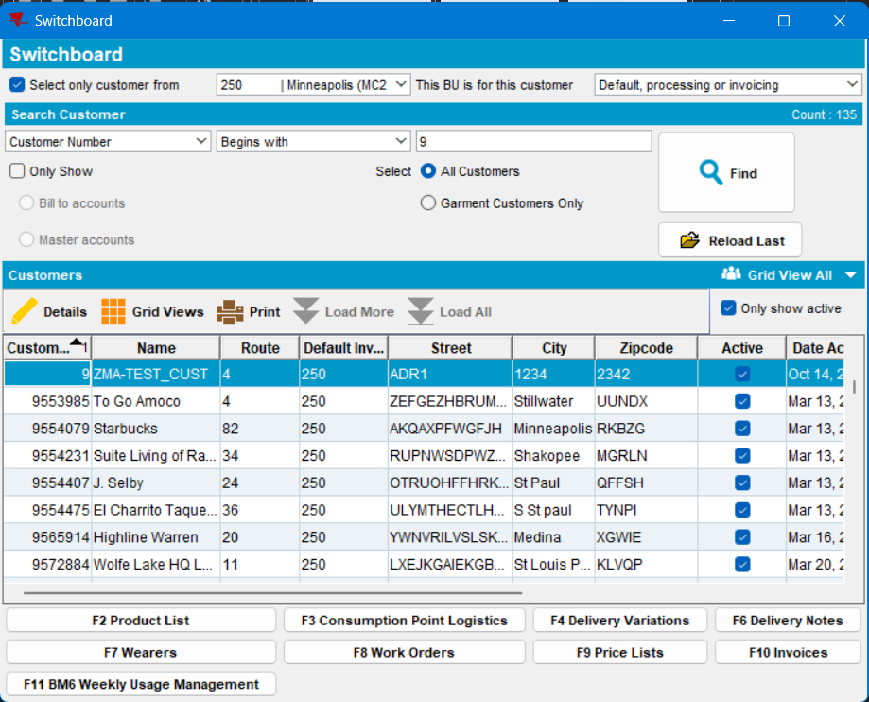
- Press the “F3 Consumption Point Logistics” button:
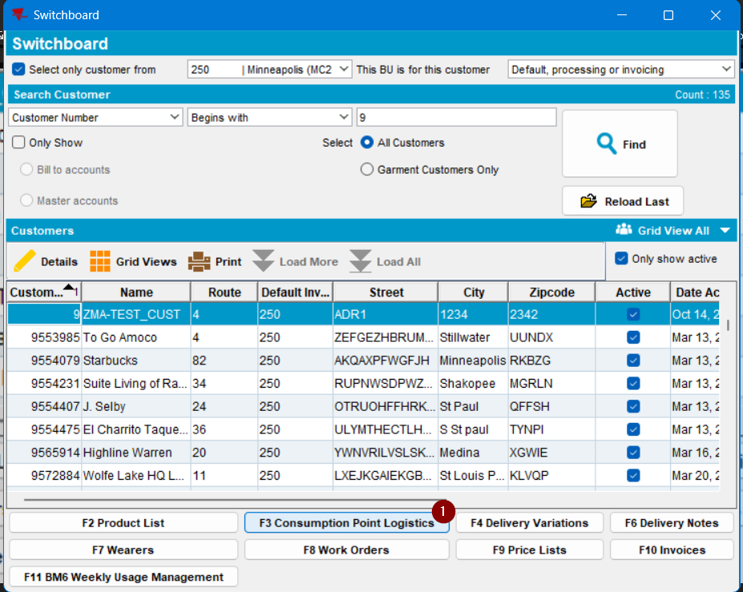
The dialogue is shown:
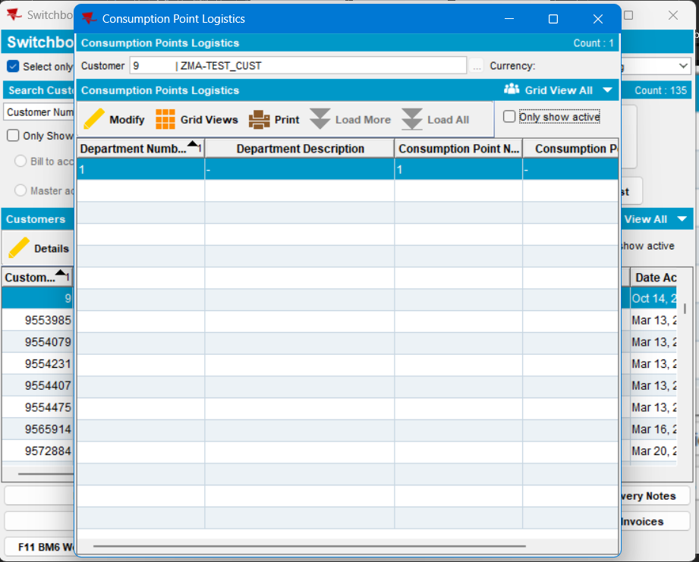

- Close the CPL screen, then check the “Only Show” checkbox:
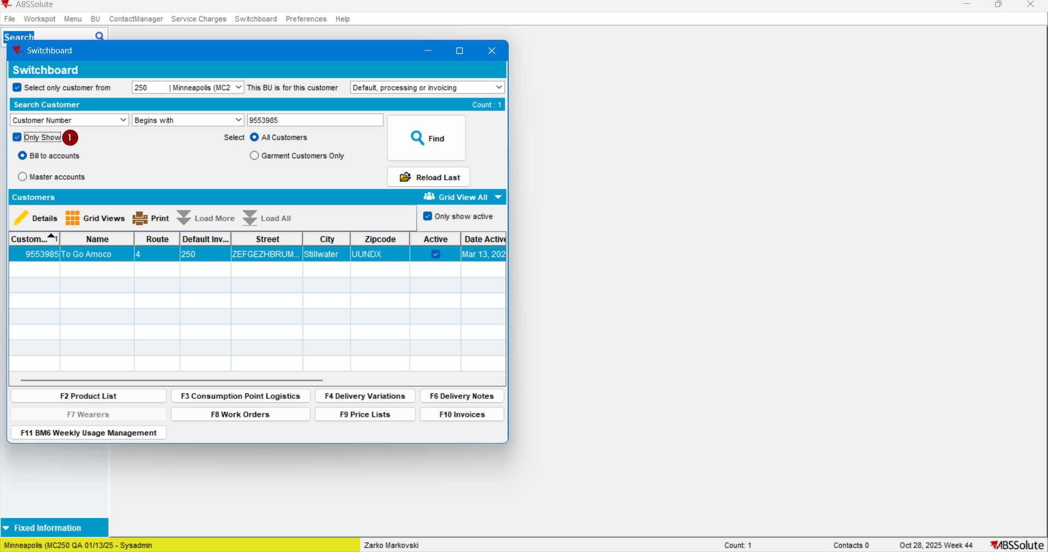
- and uncheck it:
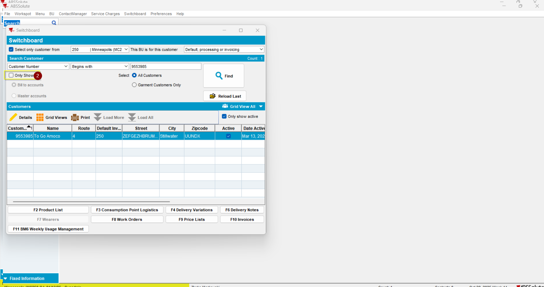

- Press the “Find” button and then the “F3 CPL” button:
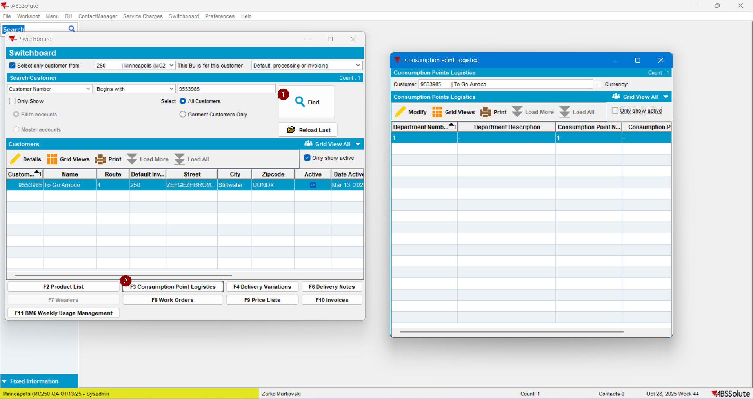
No null pointer exception error has been thrown.
- Continue searching for customers using the switchboard using other filtering criteria:
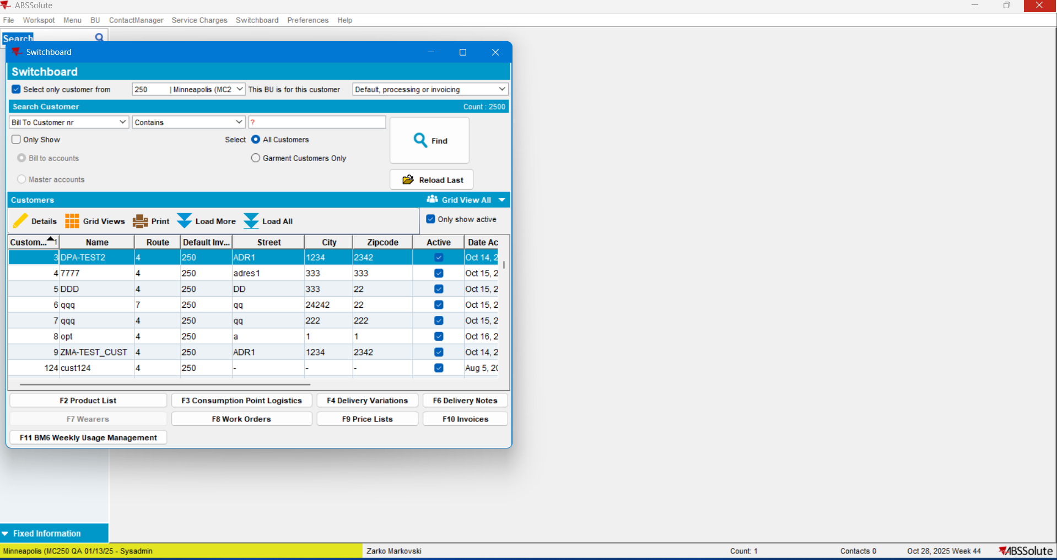
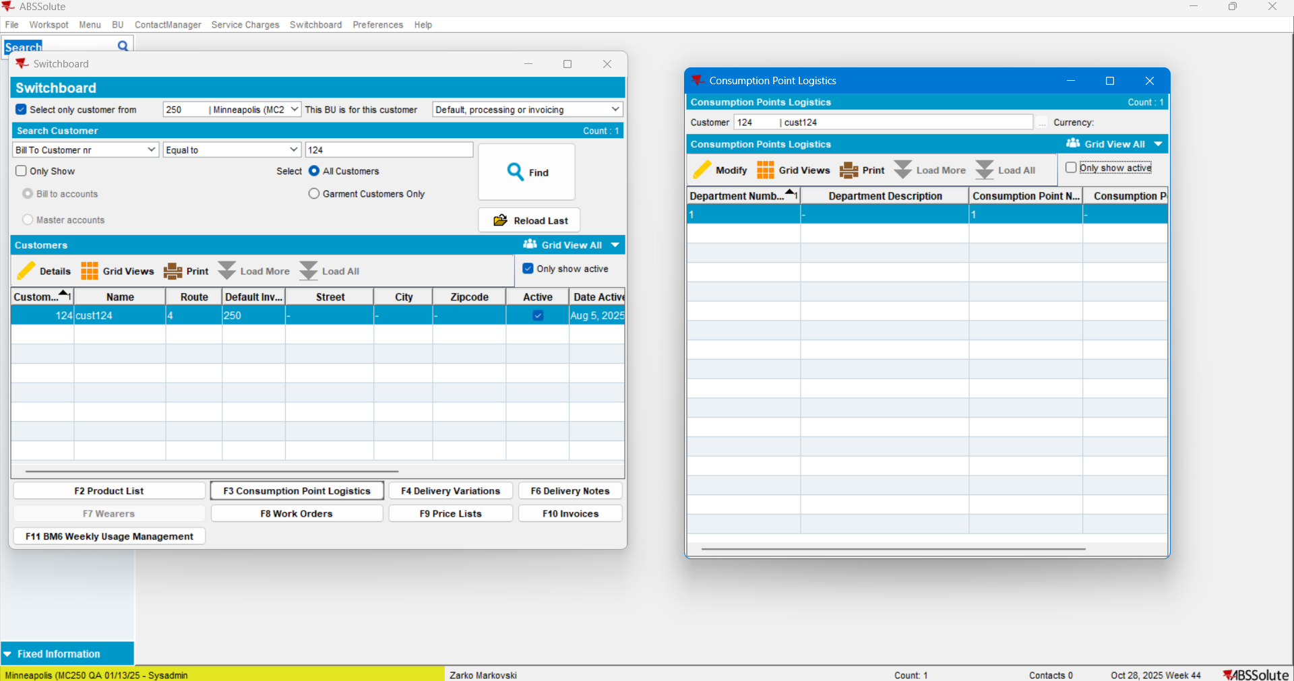

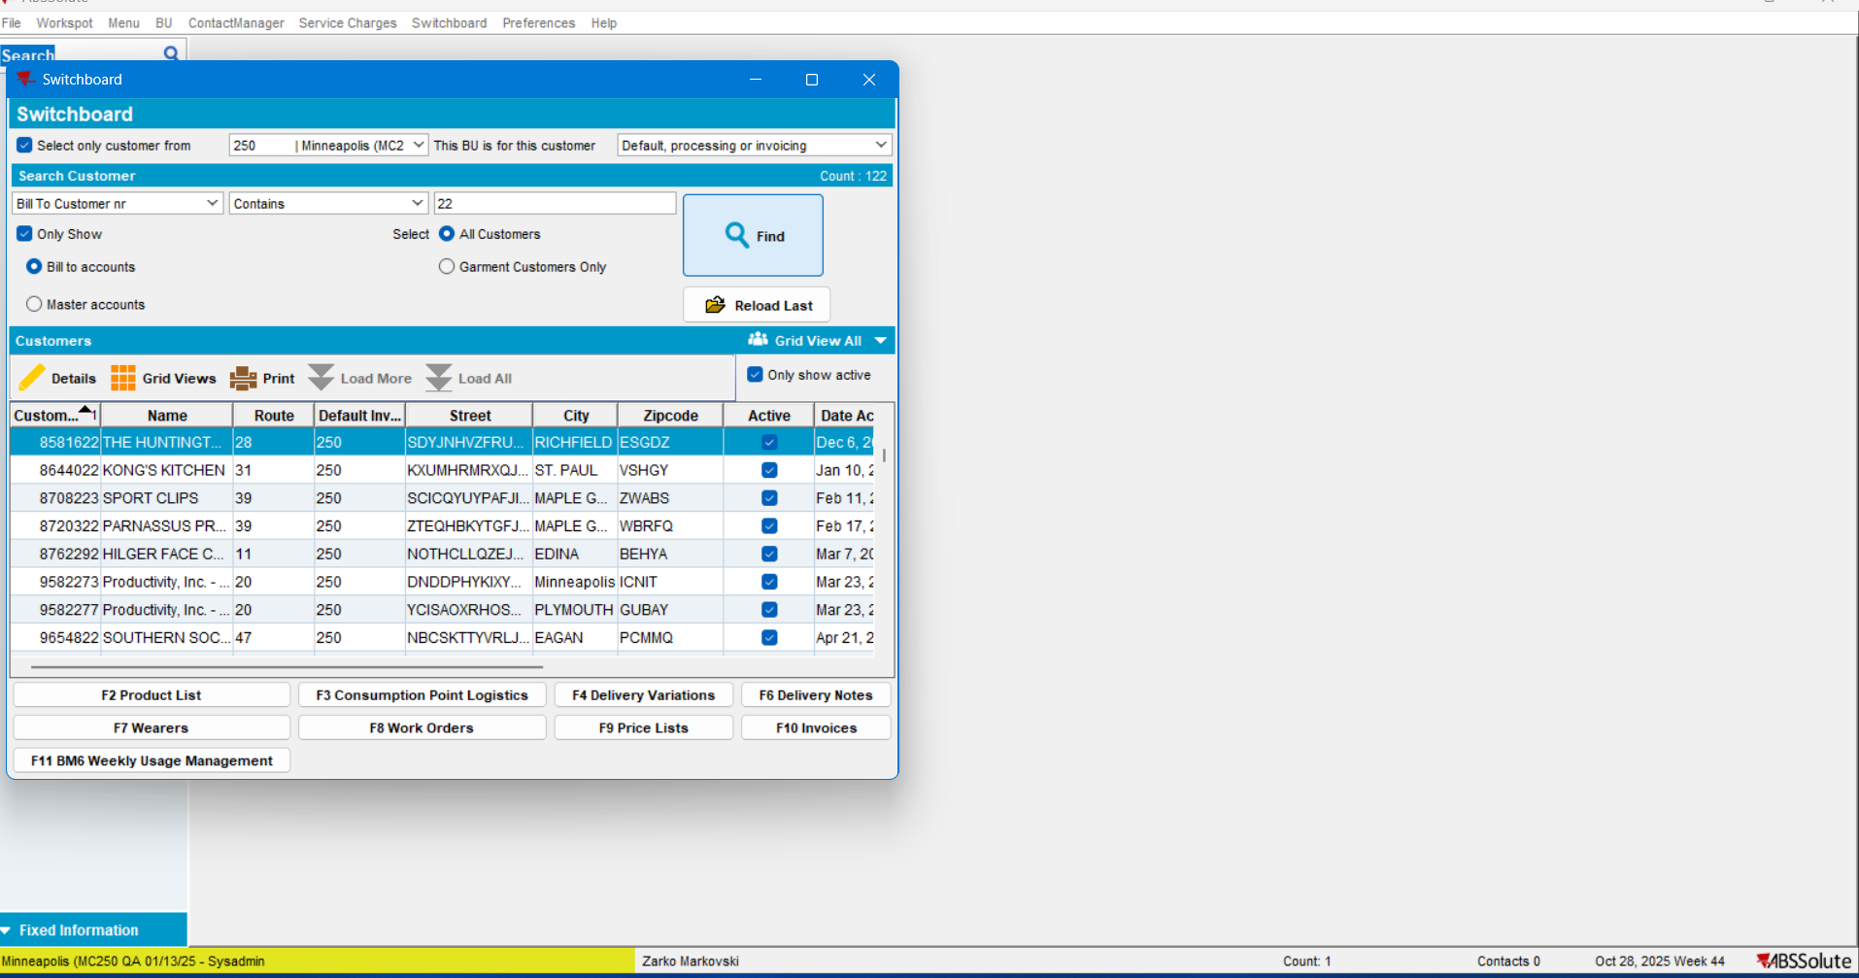

No errors were thrown:
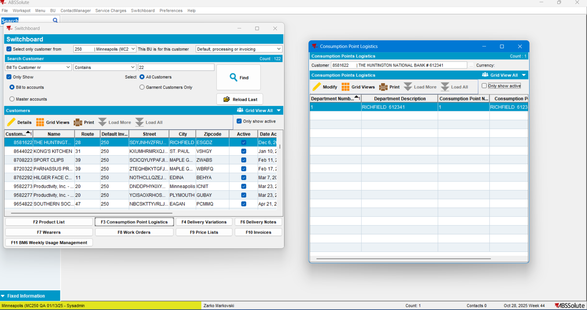

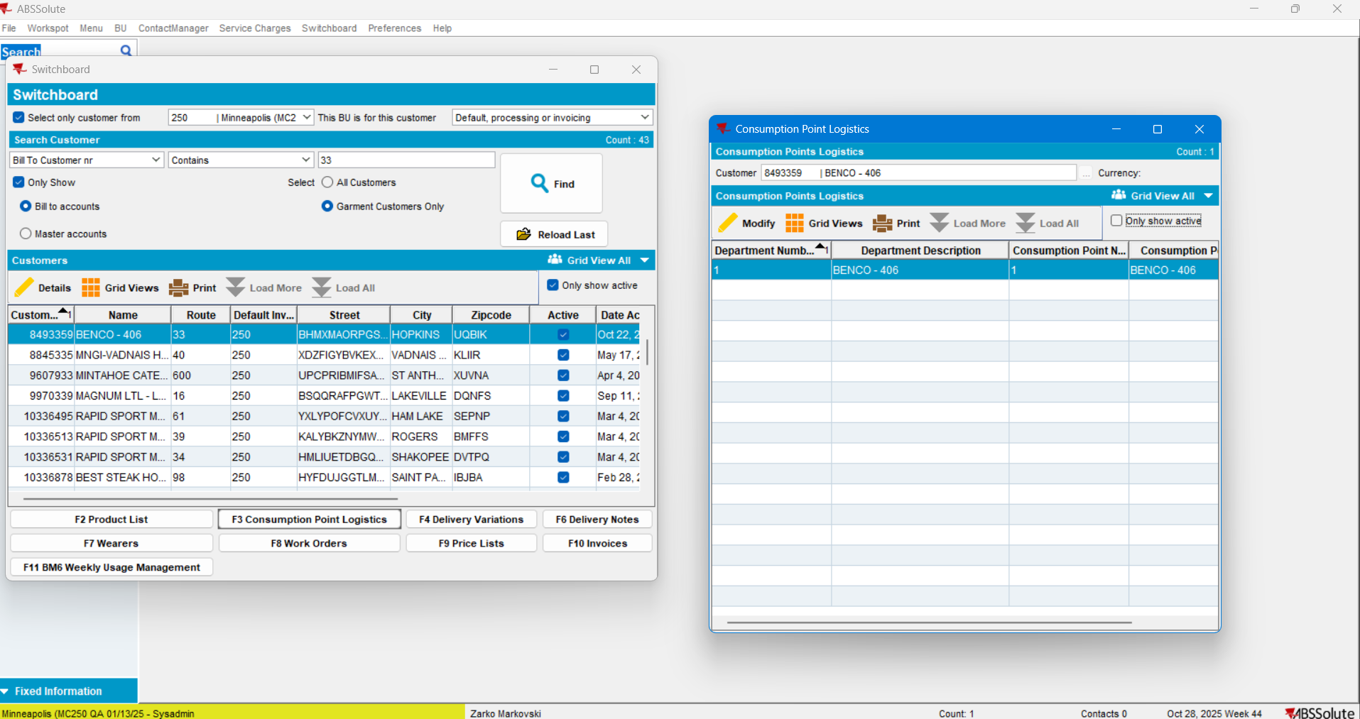
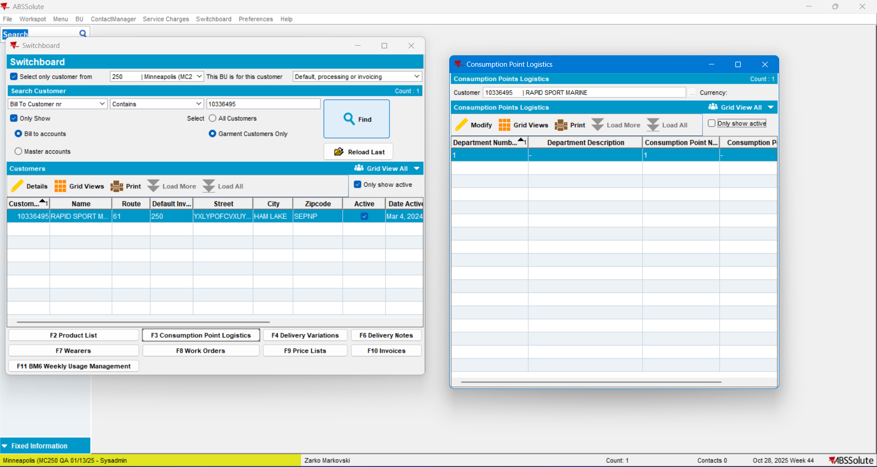
Current behavior: Is the expected one.
TEST PASSED

