ABSN-10718 Copy PLPC - contract products
BUGFIX BRANCH TEST
Environment | Prerequisites
Version: 9.08.00.RELEASE.p23(AUS BUGFIX BRANCH)  DBServerName=abs-srv17.internal.abslbs.com  DBSID=CUST23  DBUser=AUS_MNT90800  DBPassword=AUS_MNT90800  Environment=Test  EnvironmentSABStage=Test | - Module: PWBBASIS, WISBASIS, BKLBASIS  - SS:
Contents
Retest after fix 1
TEST SET 1: Copying In-Contract-Product(s) (Strict Contract) – ALL TESTS PASSED. 3
Test Case 1) Copy a single Contract product from one customer to another – TEST PASSED 3
Test Case 2) Copy a single Contract product from one customer to multiple customers – TEST PASSED 5
Test Case 3) Copy multiple Contract products from one customer to another – TEST PASSED 7
Test Case 4) Copy multiple Contract products from one customer to multiple customers – TEST PASSED 8
Regression Test Set 1 – Copying Not-In-Contract-Product(s) (Strict Contract). (TEST PASSED/FAILED) 10
RS1-RT1 – Copy single Not-In-Contract-Product from one customer to another – TEST PASSED 10
RS1-RT2 – Copy single Not-In-Contract-Product from one customer to multiple customers. – TEST PASSED 13
RS1-RT3 – Copy multiple products (at least one Not-In-Contract-Product) from one customer to another– TEST PASSED 14
RS1-RT4 – Copy multiple products (at least one Not-In-Contract-Product) from one customer to multiple customers – TEST PASSED 16
REGRESSION TEST SET 2 - Copying Not-In-Contract-Product(s) (Flexible Contract) 17
RS2-RT1 – Copy single Not-In-Contract-Product from one customer to another – TEST PASSED 17
RS2-RT2 – Copy single Not-In-Contract-Product from one customer to multiple customers – TEST PASSED 18
RS2-RT3 – Copy multiple products (at least one Not-In-Contract-Product) from one customer to another – TEST PASSED 19
RS2-RT4 – Copy multiple products, at least one Not-In-Contract-Product, from one customer to multiple customers. (TEST PASSED/FAILED) 20

Retest after fix

ALL TESTS SUMMARY
Test Set | Description | Total Cases | Passed | Failed | Status
TEST SET 1 | Copying In-Contract-Product(s) (Strict Contract) | 4 | 4 | 0 | PASS
REGRESSION TEST SET 1 | Copying Not-In-Contract-Product(s) (Strict Contract) | 4 | 4 | 0 | PASS
REGRESSION TEST SET 2 | Copying Not-In-Contract-Product(s) (Flexible Contract) | 4 | 4 | 0 | PASS

Used TERMINOLOGY:
In-Contract-Product: A product defined in the Customer's Contract PLPC.
Not-In-Contract-Product: A product not defined in the Customer's Contract PLPC.
"FROM" Customer: The customer from whom products are copied.
DESTINATION Customer: The customer to whom products are copied.
Strict Contract: Destination Customer’s Contract that does not allow Not-In-Contract-Products.
Flexible Contract: Destination Customer’s Contract that allows Not-In-Contract-Products.

TEST SET 1: Copying In-Contract-Product(s) (Strict Contract) – ALL TESTS PASSED.
Expected Result: Copying of In-Contract-Products should be allowed even when the contract is strict.

TEST SET MATRIX:
ID | Product Type | Contract PLPC Status | Destination PLPC Pre-Copy | Expected Result
Test Case 1 | Single In-Contract | Defined | Absent | Success. Product is added to "DESTINATION" Customer PLPC. No error/warning. ContractProductPLPC table link added
Test Case 2 | Single In-Contract | Defined | Absent | Success. Product is added to all "DESTINATION" Customer PLPCs. ContractProductPLPC table link added
Test Case 3 | Multiple In-Contract | Defined | Absent | Success. All products are added to "DESTINATION" Customer PLPC. ContractProductPLPC table link added
Test Case 4 | Multiple In-Contract | Defined | Absent | Success. All products are added to all "DESTINATION" Customer PLPCs. ContractProductPLPC table link added

Test Case 1) Copy a single Contract product from one customer to another – TEST PASSED
HASH: 61a16474af98
BU.code: ‘616’ (Appleton MC516) QA
Plant code: 616

- Configure DESTINATION customer's contract not to allow Not-In-Contract-Products (Strict Contract).
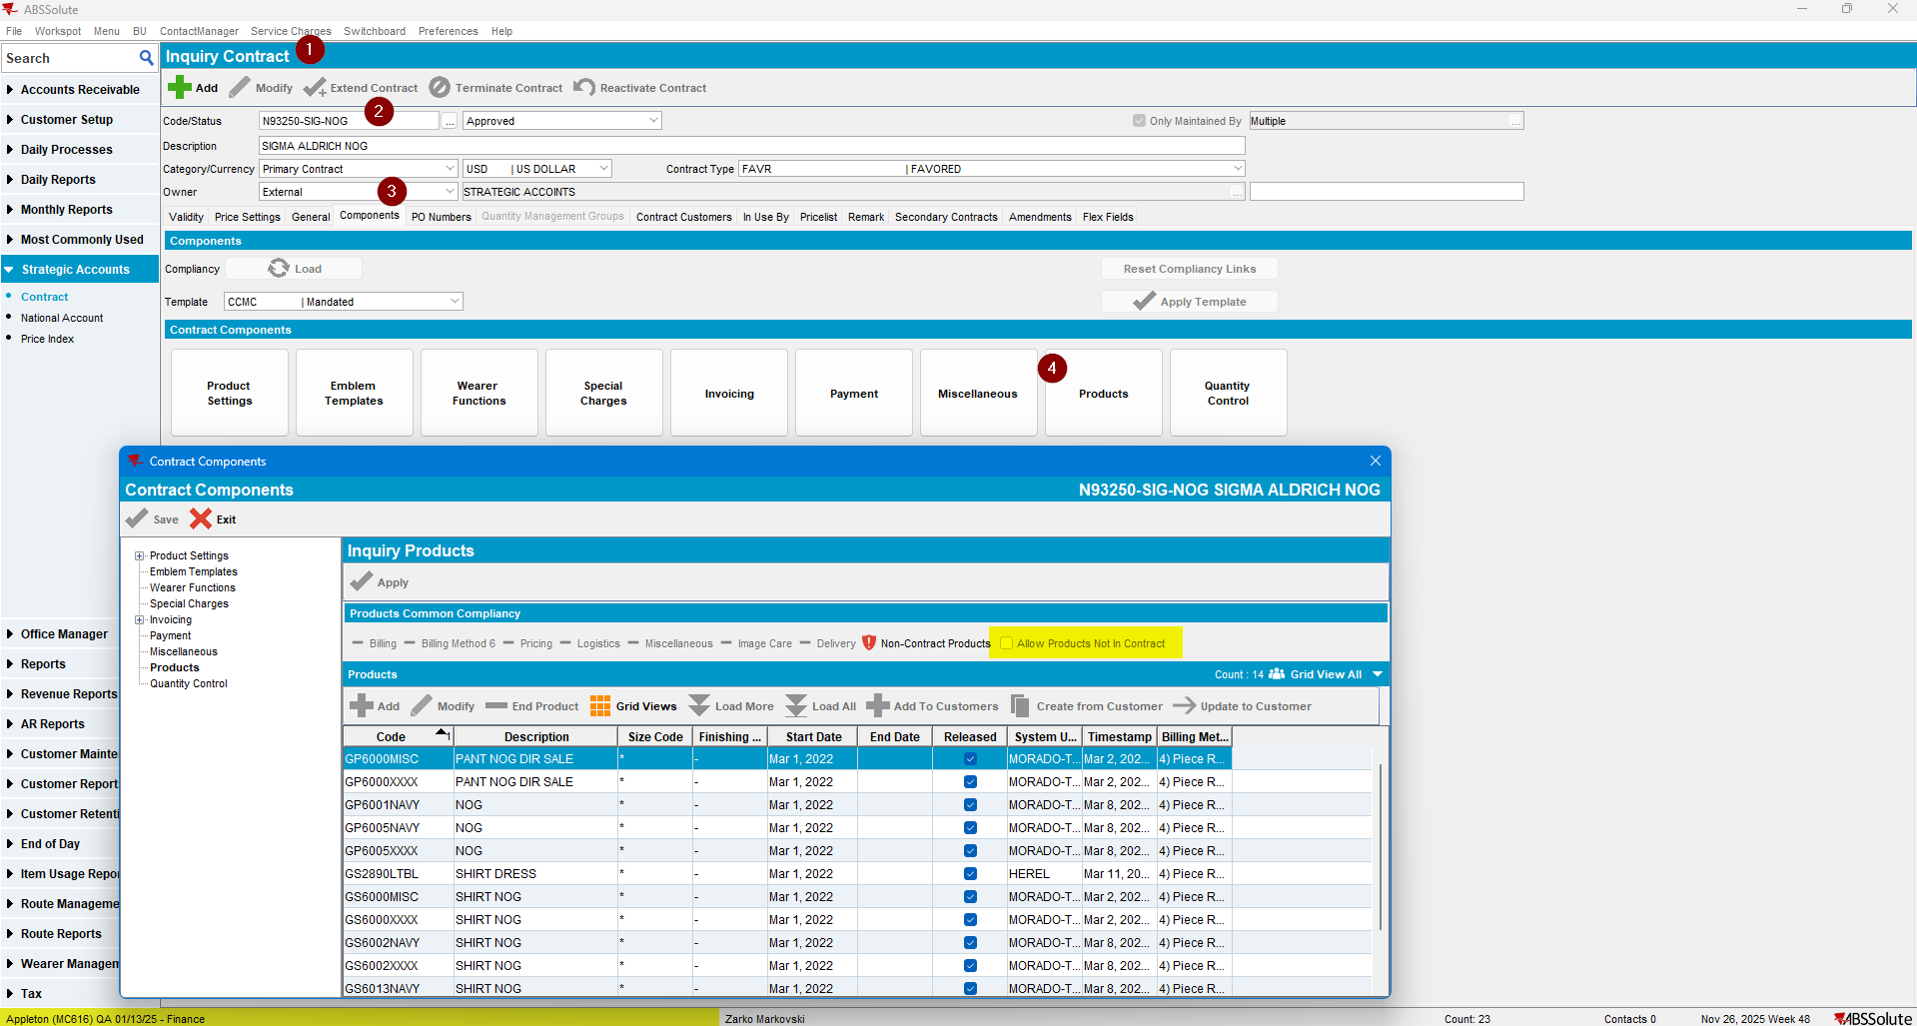
- Check the DESTINATION customer’s PLPC:
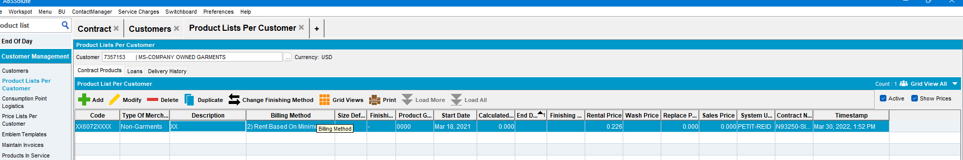

- Check the FROM customer PLPC list:
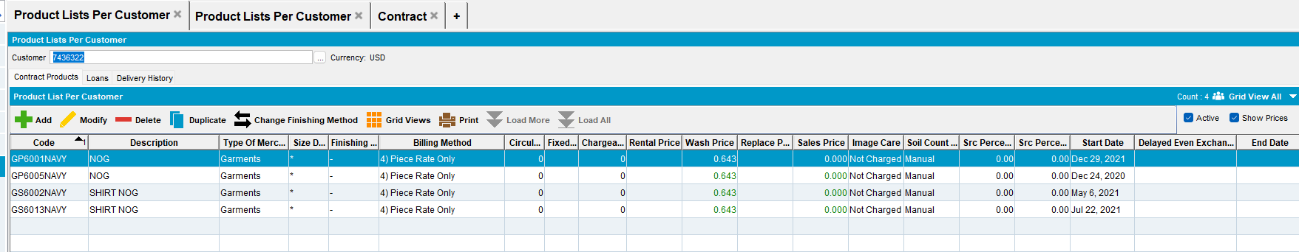
- Copy one product, using the “Copy Product List Per Customer” dlg.
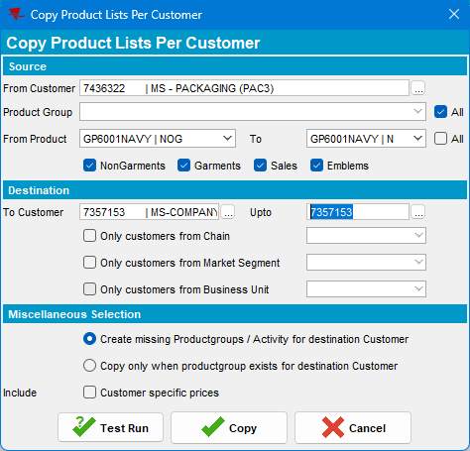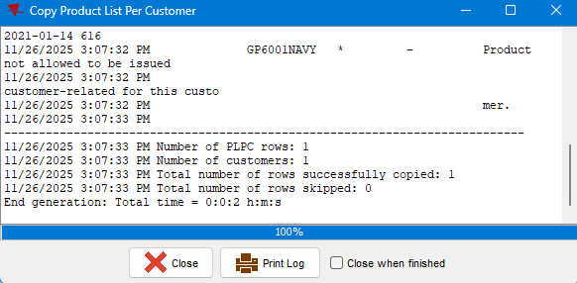
Product successfully copied
- Check the Destination customer’s PLPC:
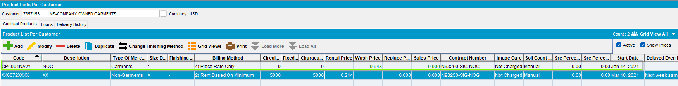
The product was successfully copied. Its defining parameters: SIZE, FM, BM, prices, and contract number are correct.
- Check if the new product was linked to the ContractProductPLPC table:
SELECT *
FROM contractproductplpc cplpc
JOIN productlistpercustomer plpc
ON plpc.productlistpercustomer_id = cplpc.productlistpercustomer_id
JOIN product pr
ON pr.product_id = plpc.product_id
JOIN customer c
ON c.customer_id = plpc.customer_id
WHERE c.customer_id = (
SELECT c.customer_id
FROM customer c
WHERE c.customernumber = 7357153
)
AND pr.code = 'GP6001NAVY';
New record was added to this table.
Current Behavior: Is the expected one.

TEST PASSED.

Test Case 2) Copy a single Contract product from one customer to multiple customers – TEST PASSED
- Identify suiteble Customers range:
The product is copied by Copy PLPC, to a range of destination customers. To shorten the processing time, and Customers on different BU-s, choose customers with close numerical IDs. Using widely dispersed IDs or customers spread across many Business Units (BUs) may result in an excessively long copying process.

Chosen range of contract customers:
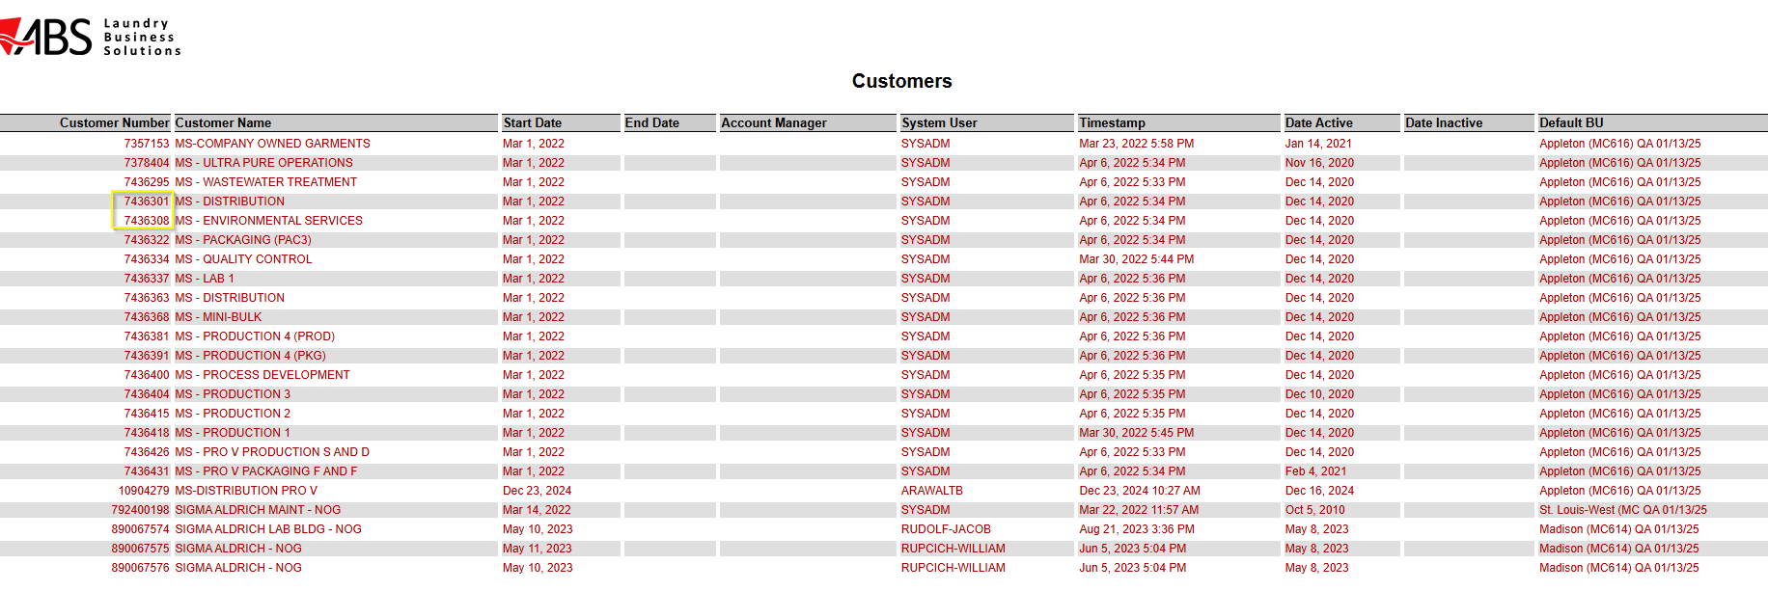
Selected product, “FROM” Customer’s PLPC:
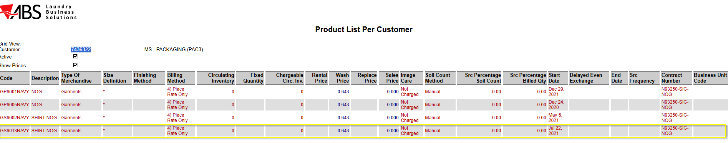
Product, currently not available on Destination Customer 1 and Destination Customer 2 PLPC:
DC1 PLPC:
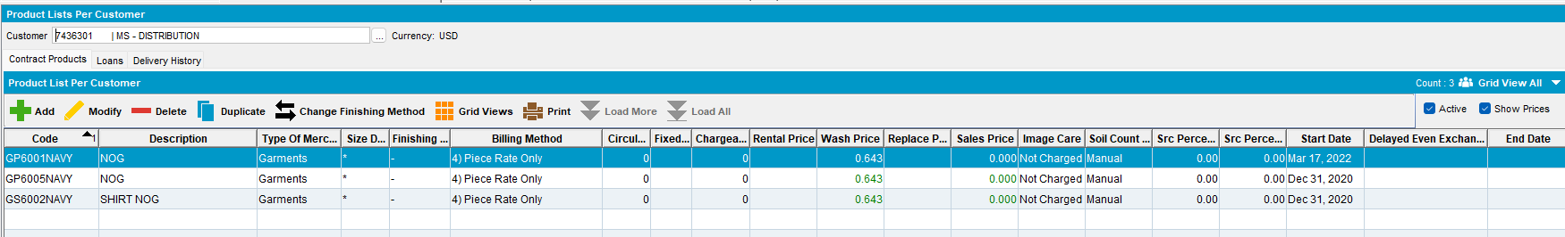
DC2 PLPC:
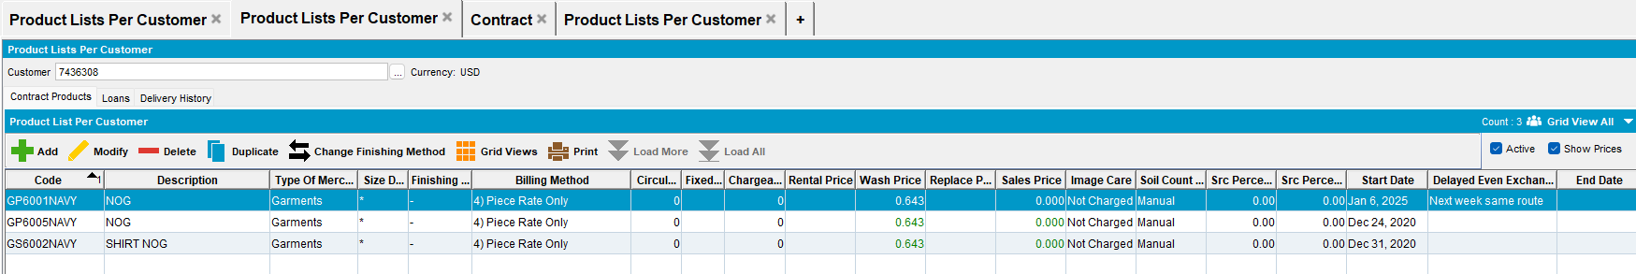

- Copy the product to the selected range of customers:
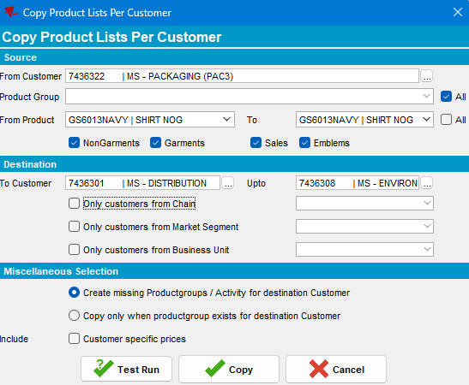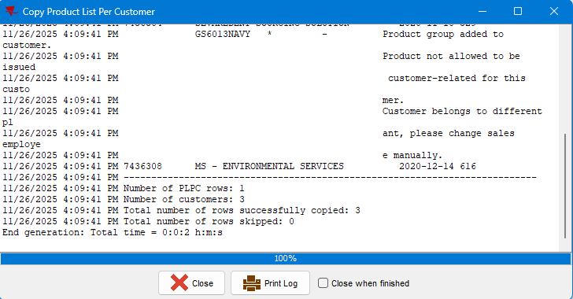
Product copied successfully.
- Check the Destination customers PLPC:
Destination Customer 1:
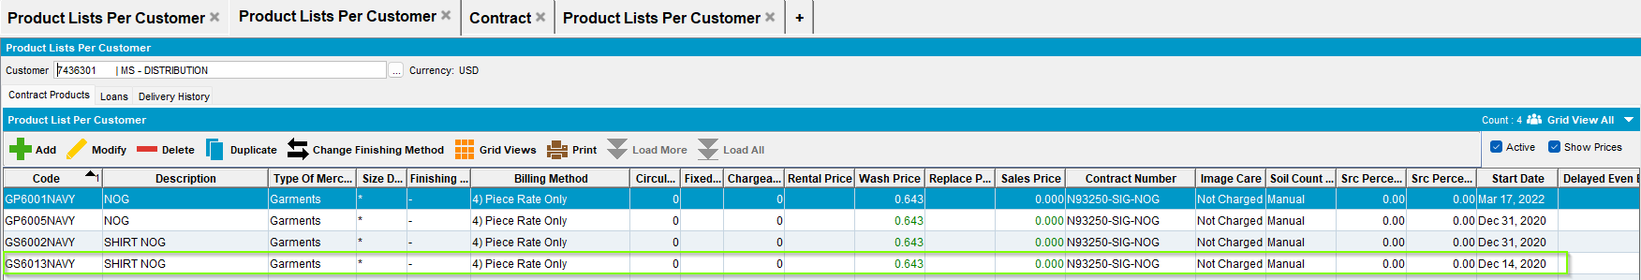
Destination Customer 2:
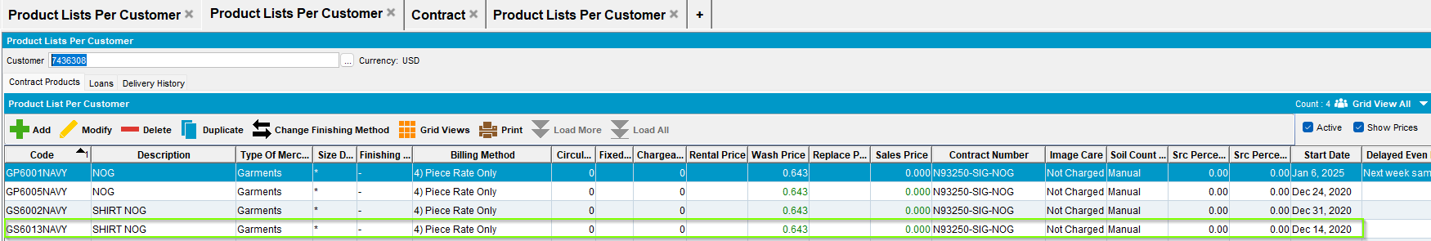The product was successfully copied to both Customers PLPCs. Its defining parameters: SIZE, FM, BM, prices, and contract number are correct.

- Check if the new product was linked to the ContractProductPLPC table:
select *
from contractproductplpc cplpc
join productlistpercustomer plpc
on plpc.productlistpercustomer_id = cplpc.productlistpercustomer_id
join product pr
on pr.product_id = plpc.product_id
join customer c
on c.customer_id = plpc.customer_id
where c.customer_id in (select c.customer_id
from customer c
where c.customernumber in ('7436301', '7436308'))
and pr.code = 'GS6013NAVY'
New records were created in this table.
Current Behavior: Is the expected one.
TEST PASSED.

Test Case 3) Copy multiple Contract products from one customer to another – TEST PASSED
- Identify at least 2 products not on Destination Customer PLPC list:
Destination customer PLPC:
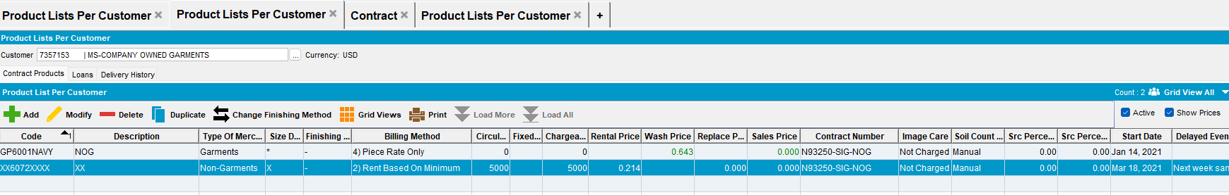
The following 2 products on the “FROM” customer’s PLPC, are not on the DC PLPC:
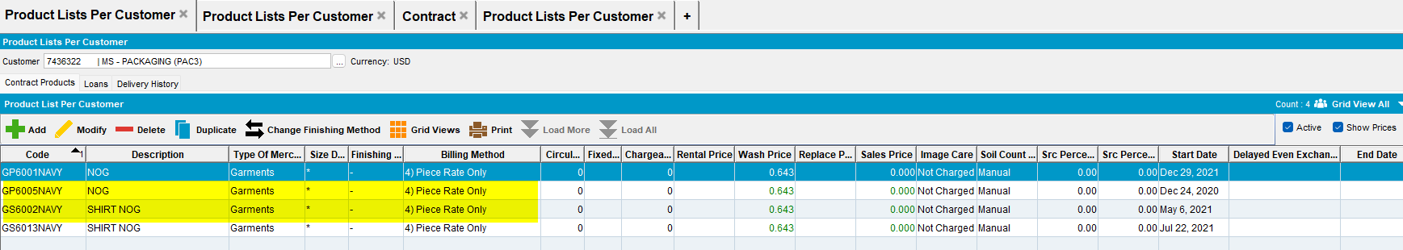
- Copy these products:
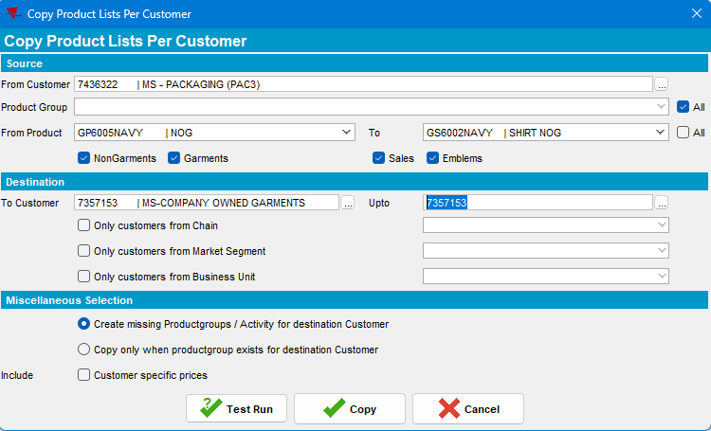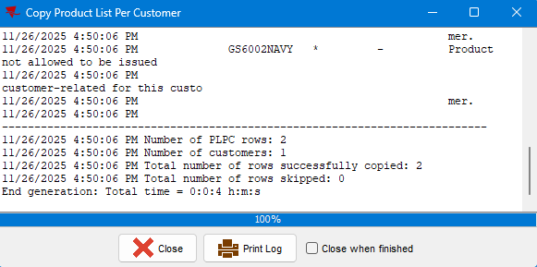
The products were successfully copied.
- Check the Destination Customer’s PLPC:
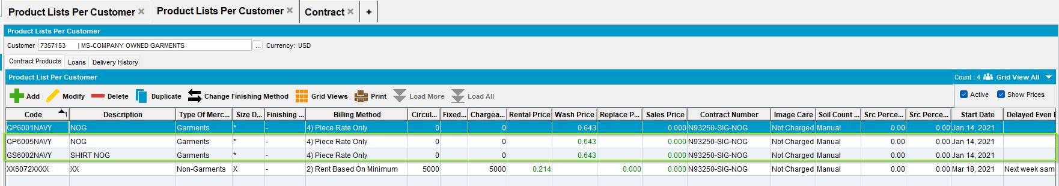
The products were successfully copied. Their defining parameters: SIZE, FM, BM, prices and Contract are correct.
- Check if the new products were linked to the ContractProductPLPC table:
select *
from contractproductplpc cplpc
join productlistpercustomer plpc
on plpc.productlistpercustomer_id = cplpc.productlistpercustomer_id
join product pr
on pr.product_id = plpc.product_id
join customer c
on c.customer_id = plpc.customer_id
where c.customer_id = (select c.customer_id
from customer c
where c.customernumber = 7357153)
and pr.code in ( 'GP6005NAVY' , 'GS6002NAVY' )
2 records were added to the table.
Current Behavior: Is the expected one.
TEST PASSED.

Test Case 4) Copy multiple Contract products from one customer to multiple customers – TEST PASSED
- Add at least 2 new products to the FROM customer’s PLPC list:
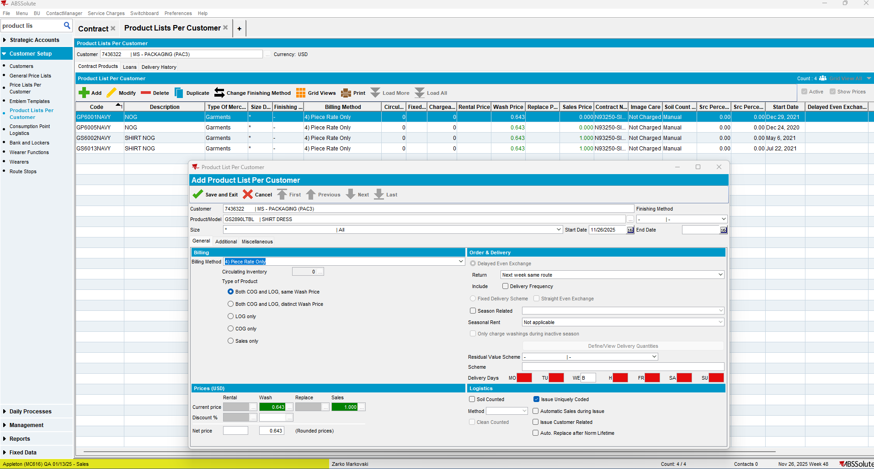
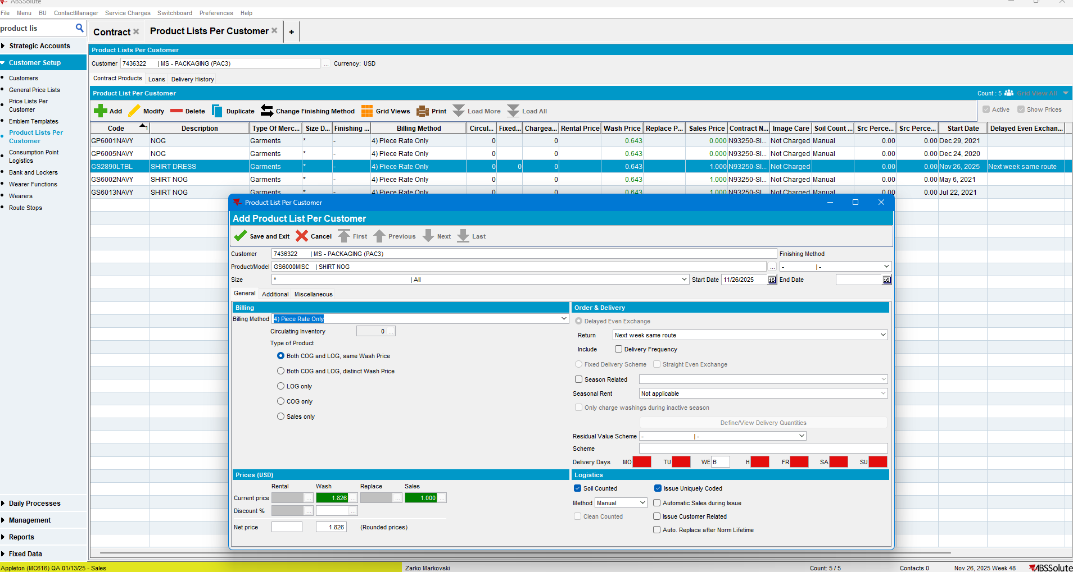

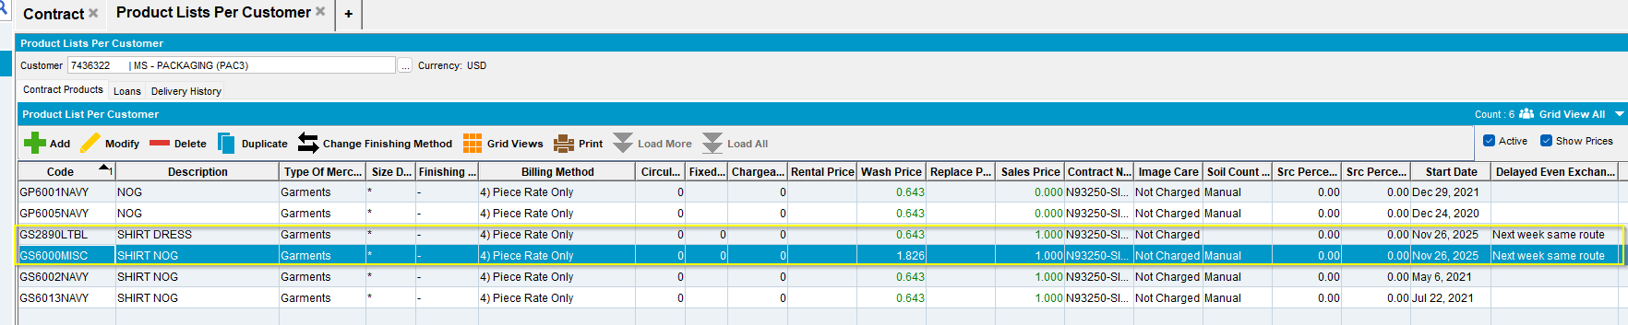
- Identify close customers that do not have these products on their PLPC:
Found two close customers that do not have these products on their PLPC:
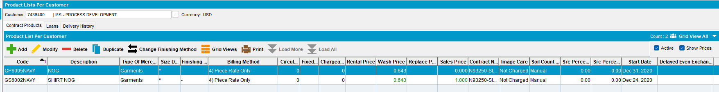
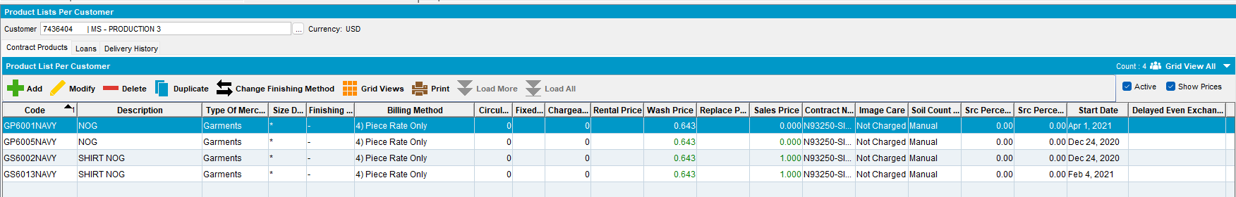
- Copy all products from the Source Customer to the selected range of customers:
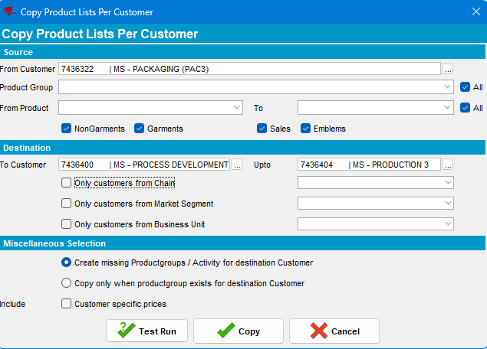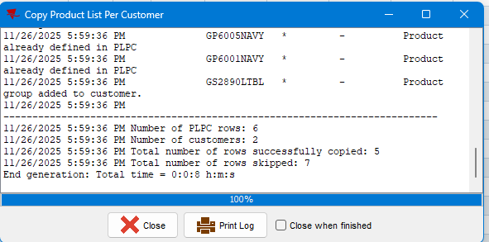
Copying was successful.

- Check the destination customer’s PLPC:
Destination Customer 1:
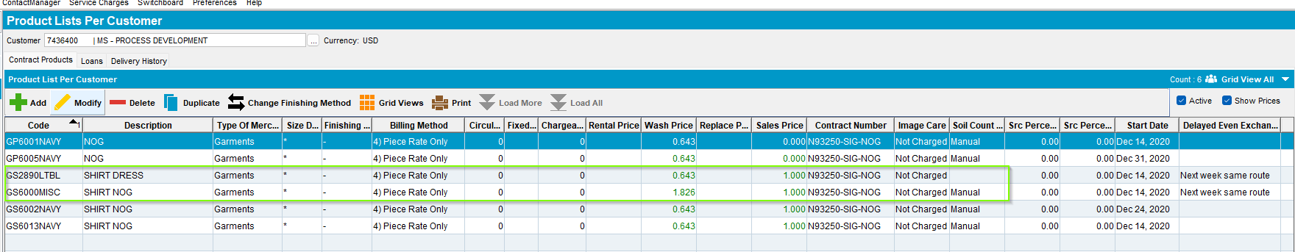
Destination Customer 2:
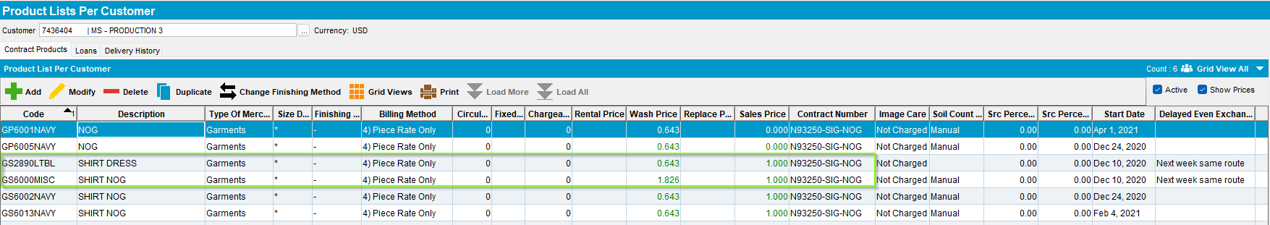
The products were successfully copied. Its defining parameters: SIZE, FM, BM, prices, and contract number are correct.

- Check if the new products were linked to the ContractProductPLPC table:
select *
from contractproductplpc cplpc
join productlistpercustomer plpc
on plpc.productlistpercustomer_id = cplpc.productlistpercustomer_id
join product pr
on pr.product_id = plpc.product_id
join customer c
on c.customer_id = plpc.customer_id
where c.customer_id in (select c.customer_id
from customer c
where c.customernumber in ('7436400', '7436404'))
and pr.code in ('GS2890LTBL', 'GS6000MISC') 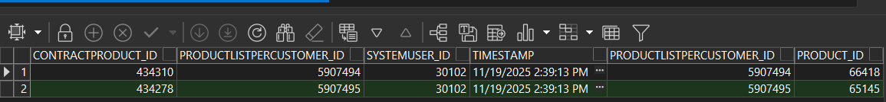
4 records were added to the table.
Current Behavior: Is the expected one.
TEST PASSED.

Regression Test Set 1 – Copying Not-In-Contract-Product(s) (Strict Contract). (TEST PASSED/FAILED)
Goal: Verify regression—that Not-In-Contract-Products are correctly blocked, and ensure Mixed Sets handle partial failure.
Destination customer Contract Setting: Does NOT Allow Not-In-Contract-Products (Strict).
Test Case Matrix and expected results:
Regression test ID | Product / Product Type | Product in Contract PLPC | Destination PLPC Pre-Copy | Expected Result
RS1-RT1 | Single / Not-In-Contract | Absent | Absent | Product is NOT copied. Error message displayed.
RS1-RT2 | Single / Not-In-Contract | Absent | Absent | Product is NOT copied to any customer. Error message displayed.
RS1-RT3 | Multiple / All Not-In-Contract | Absent | Absent | No products copied. Error message displayed.
RS1-RT4 | Multiple / Mostly Not-In-Contract | Absent | Absent | No products copied. Error message displayed.

RS1-RT1 – Copy single Not-In-Contract-Product from one customer to another – TEST PASSED
- Configure DESTINATION customer's contract not to allow Not-In-Contract-Products.
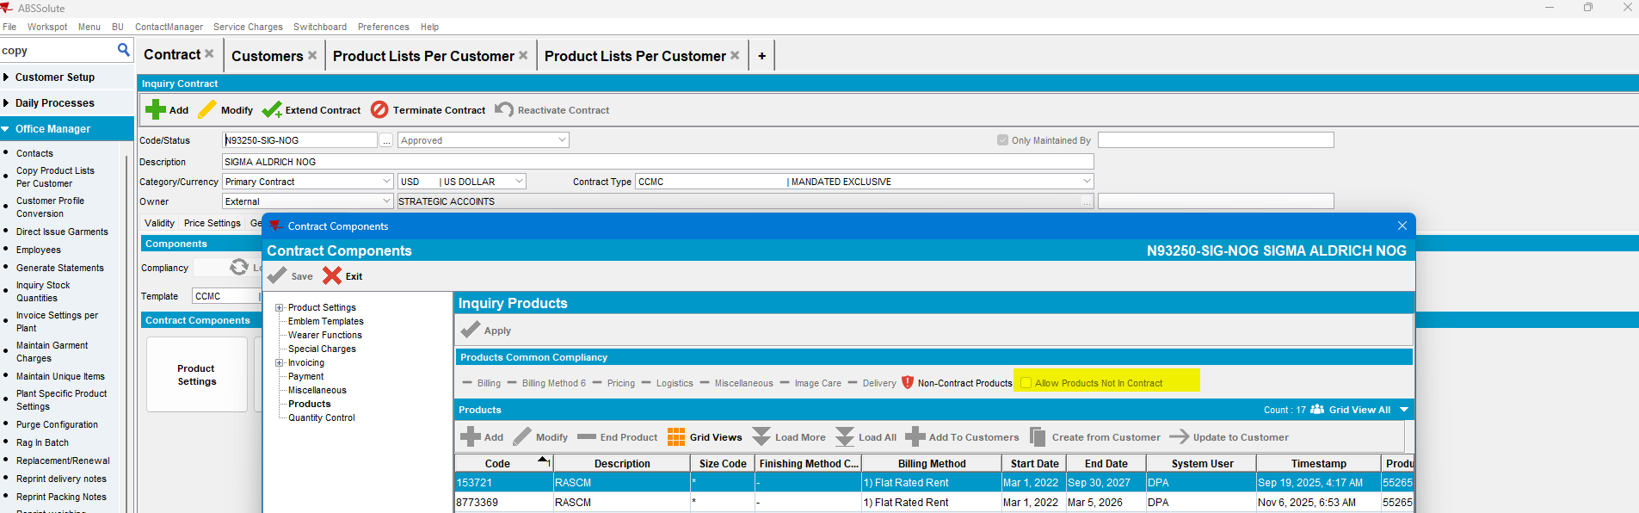

- DESTINATION Customer should: use pre-configured contracts.
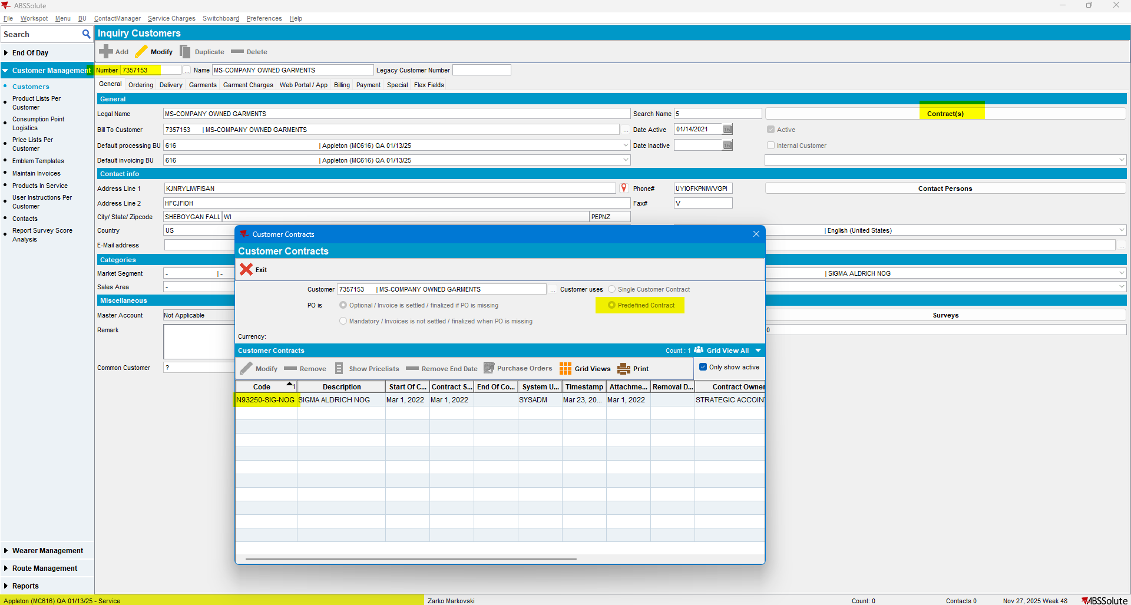
- Find a FROM customer that uses Predefined Contract on current BU:
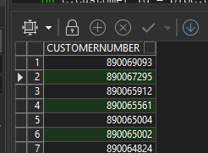
SELECT c.customernumber
FROM customer c
WHERE c.contractusage = 1
AND c.defaultbusinessunit_id = (
SELECT bu.businessunit_id
FROM businessunit bu
WHERE bu.code = '616'
)
ORDER BY 1 DESC;

- Selected Customer’s Predefined Contract:
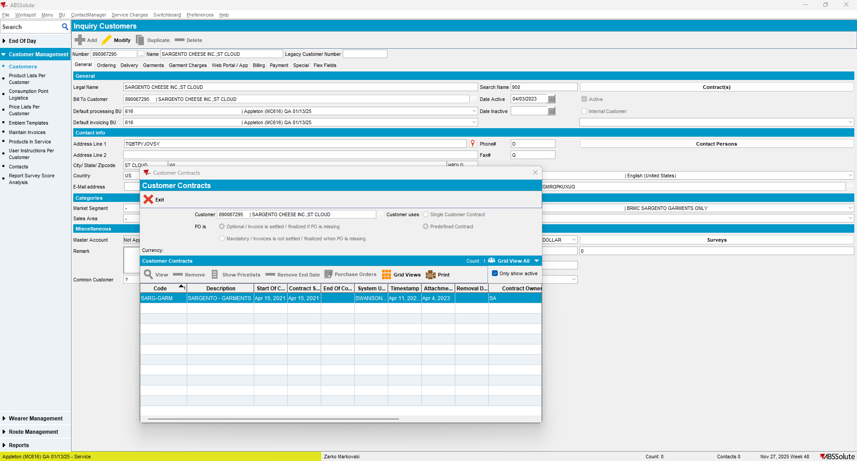

- Select a product from this (FROM) customer’s PLPC list:
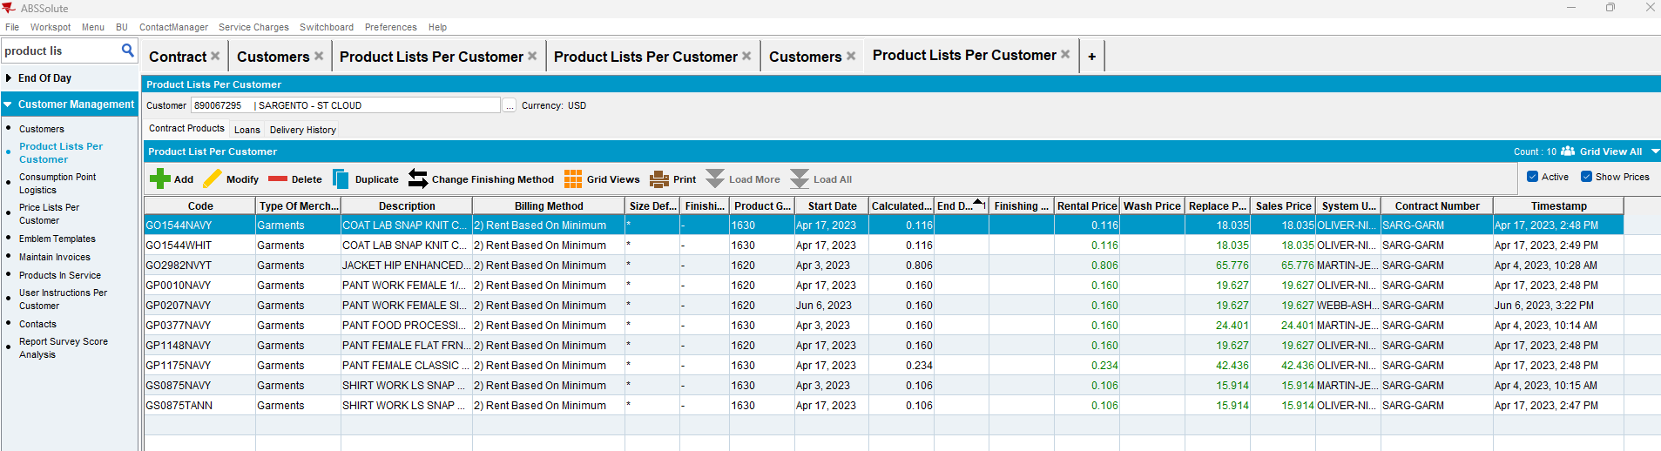
- Check if the product is in DESTINATION customer's contract:
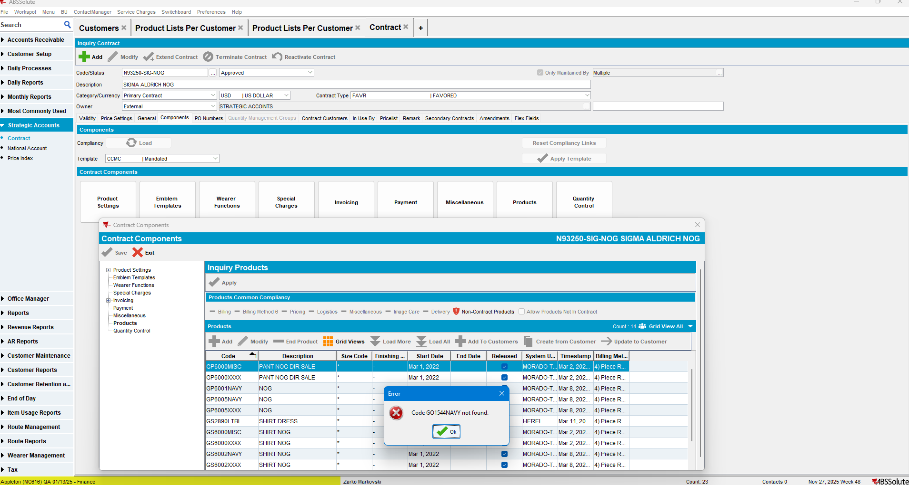
- Try to copy this product:
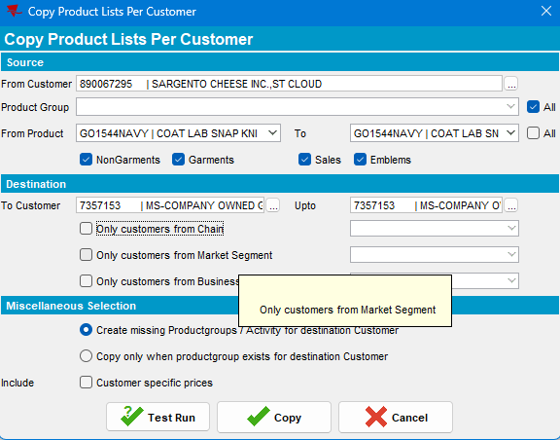
Current Behavior: Copying of products was not allowed. The expected error message was displayed.
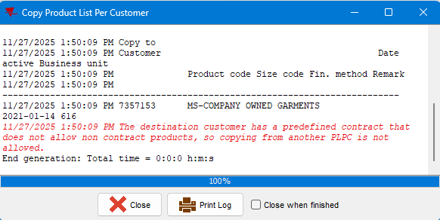
TEST PASSED.

RS1-RT2 – Copy single Not-In-Contract-Product from one customer to multiple customers. – TEST PASSED
- Select close id numbers from the Contract Customers:
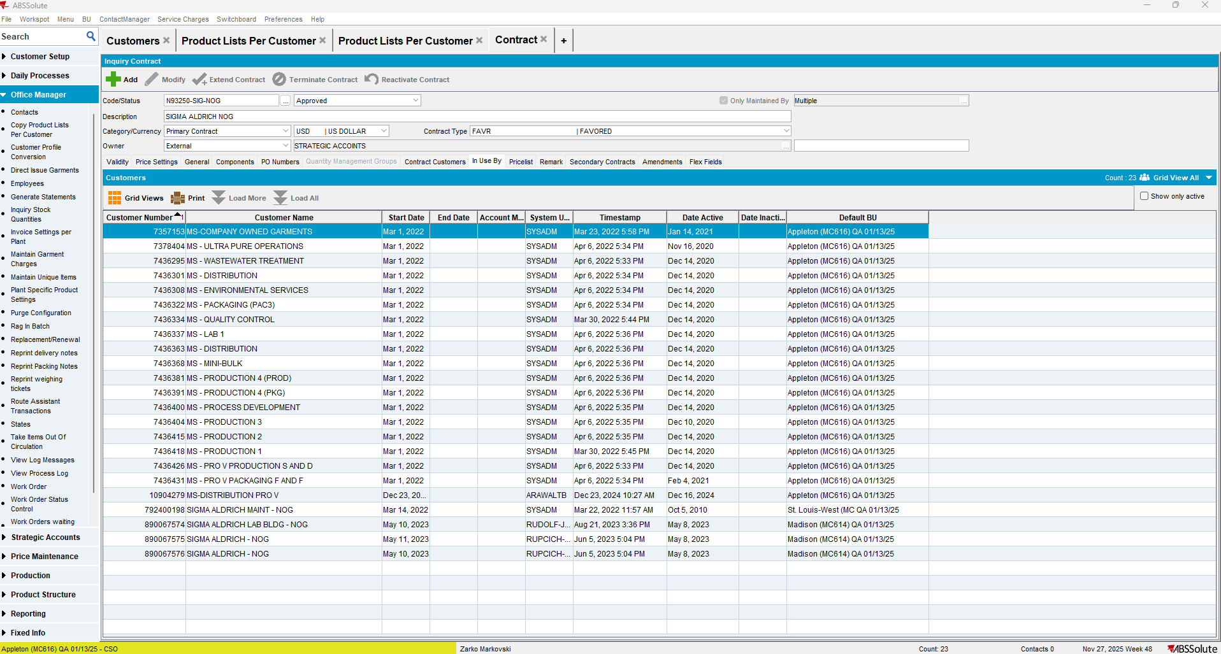
Selected range of customers:
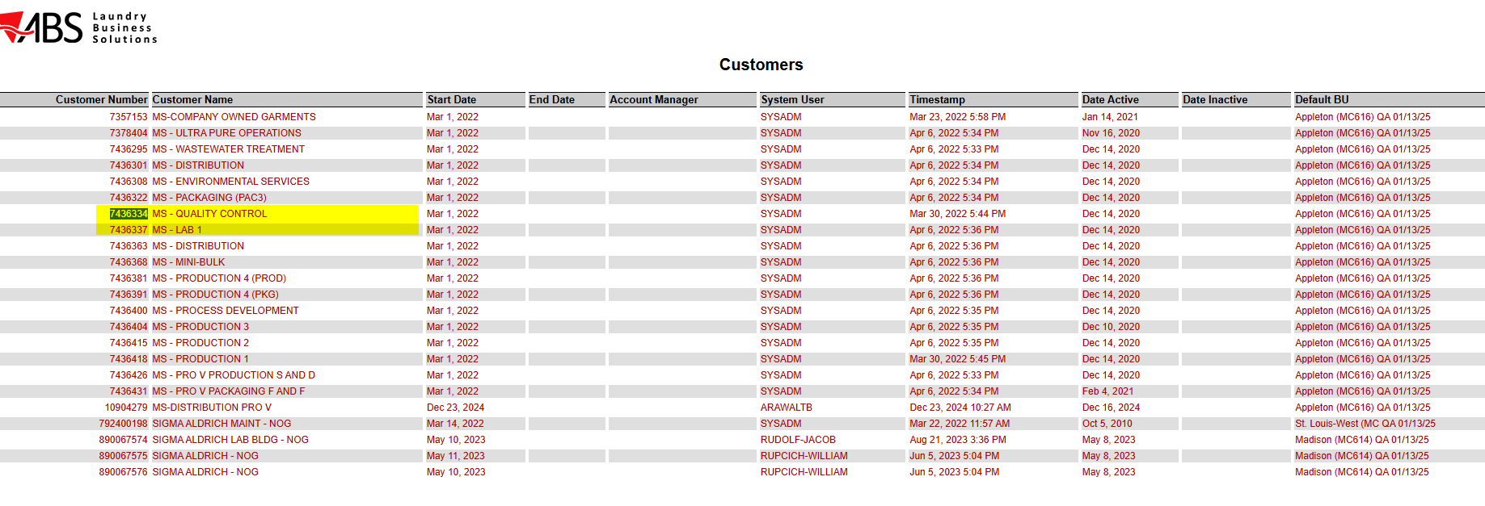

- Copy the product from RS1-RT1 to the selected range of customers:
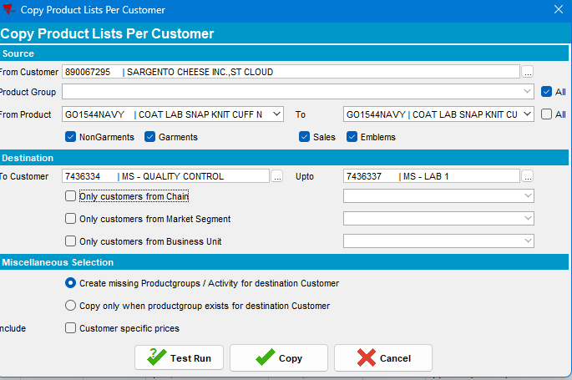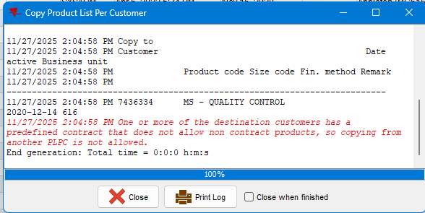
Current Behavior: Copying of products was not allowed. The expected error message was displayed.
TEST PASSED.

RS1-RT3 – Copy multiple products (at least one Not-In-Contract-Product) from one customer to another– TEST PASSED
Step 1) Using the same contracts, customers as in Regression Test 3, identify one more product that is not on the destination contract’s Product list:
From Customer’s PLPC:
GO1544WHIT
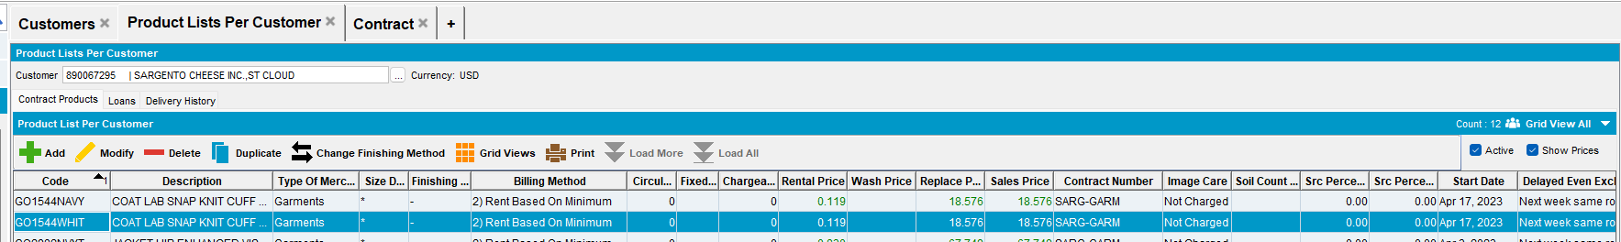
Destination Customer’s Product list:
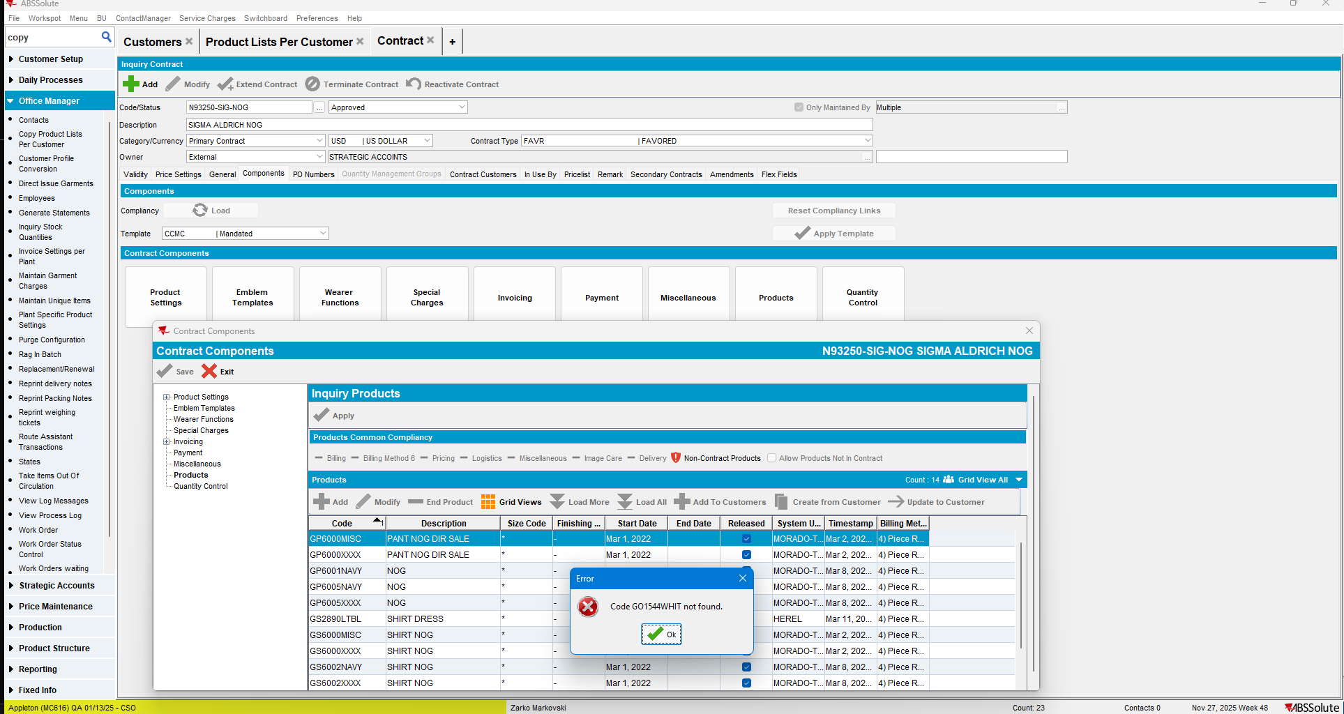

- Try to copy the selected products to the destination customer:
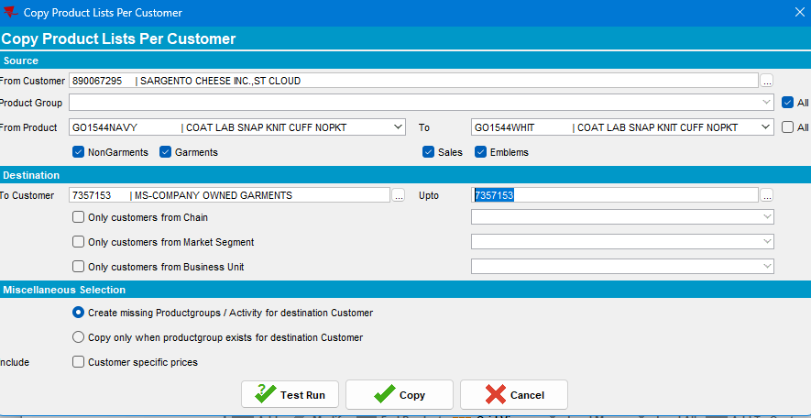
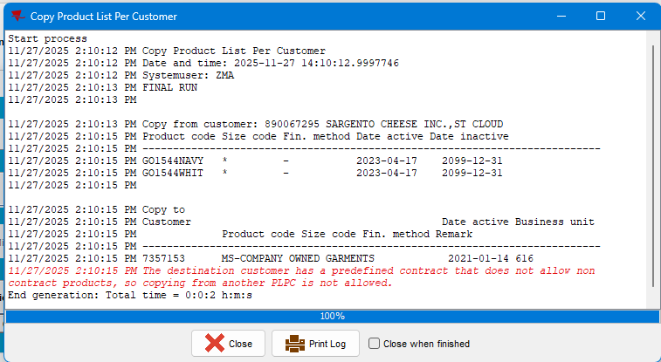
Current Behavior: Copying of products was not allowed. The expected error message was displayed.
TEST PASSED.

RS1-RT4 – Copy multiple products (at least one Not-In-Contract-Product) from one customer to multiple customers – TEST PASSED
Step 1) Copy the selected 2 products to the two customers identified in RS1-RT2
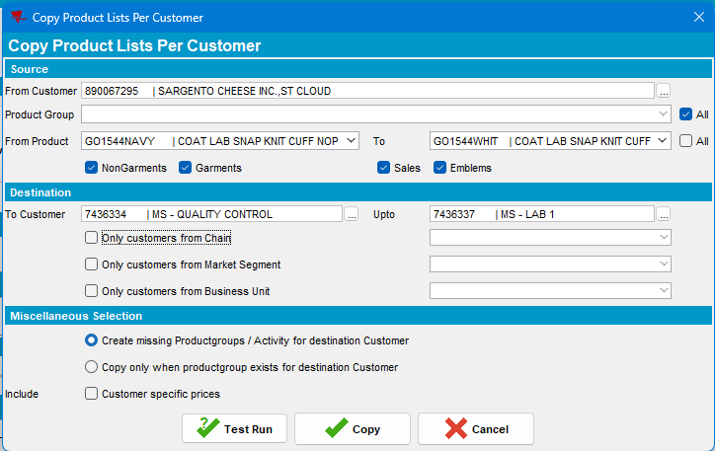
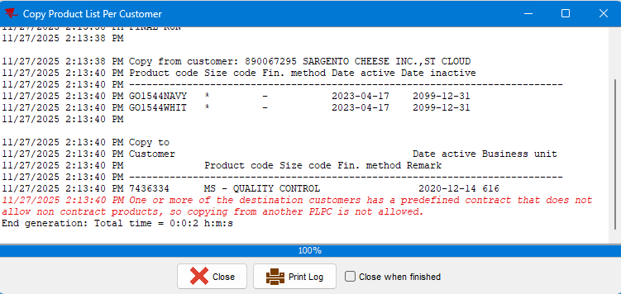
Current Behavior: Copying of products was not allowed. The expected error message was displayed.
TEST PASSED.

REGRESSION TEST SET 2 - Copying Not-In-Contract-Product(s) (Flexible Contract)
Goal: Verify the flexible scenario—that the contract allows copying products that are not explicitly defined. Destination customer Contract Setting: ALLOWS Not-In-Contract-Products (Flexible).
Test Case Matrix and expected results:
ID | Product Type | Product in Contract PLPC | Destination PLPC Pre-Copy | Expected Result
RS2-RT1 – | Single Not-In-Contract | Absent | Absent | Success. Product is copied to DESTINATION Customer PLPC.
RS2-RT2 | Single Not-In-Contract | Absent | Absent | Success. Product is copied to all DESTINATION Customer PLPCs.
RS2-RT3 | Multiple (Mixed In & Not-In) | Mixed | Absent | Success. All products (In- and Not-In-Contract) are copied successfully.
RS2-RT4 | Multiple (Mixed In & Not-In) | Mixed | Absent | Success. All products are copied to all DESTINATION Customer PLPCs.
Prerequisites:
1. Configure DESTINATION customer's contract TO ALLOW Not-In-Contract-Products.
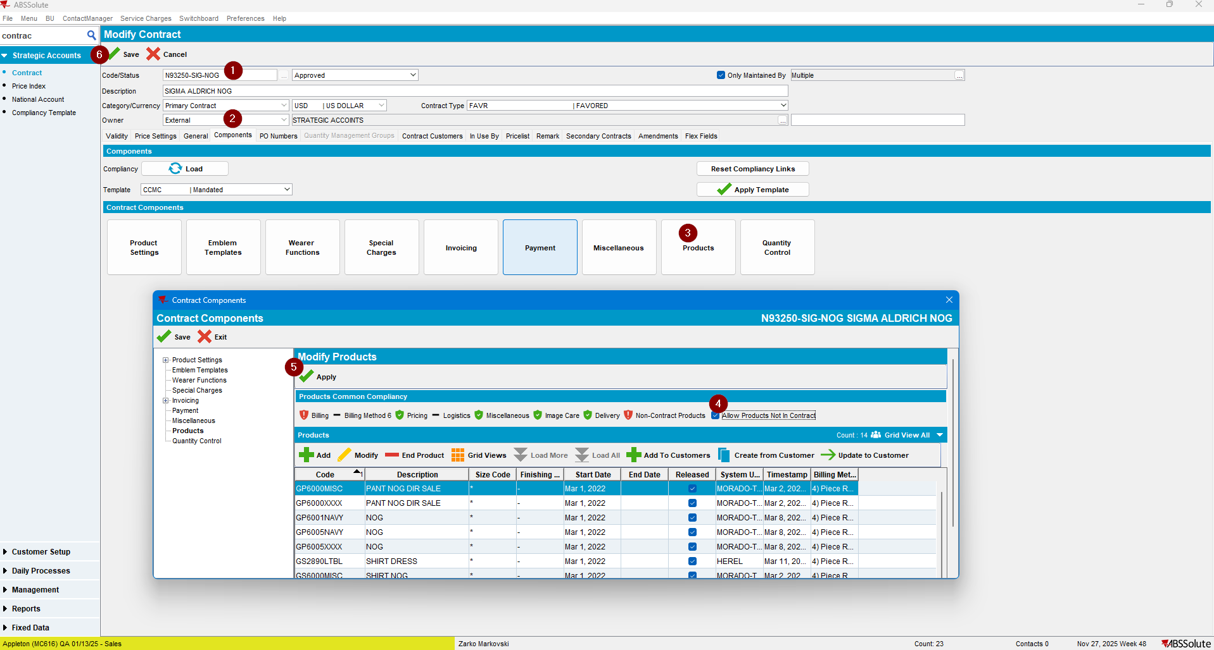

RS2-RT1 – Copy single Not-In-Contract-Product from one customer to another – TEST PASSED
- Copy the Not-In-Contract product to the Destination Customer:
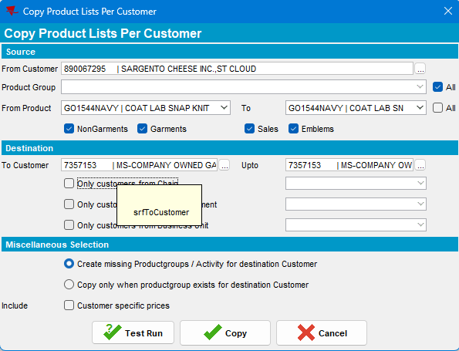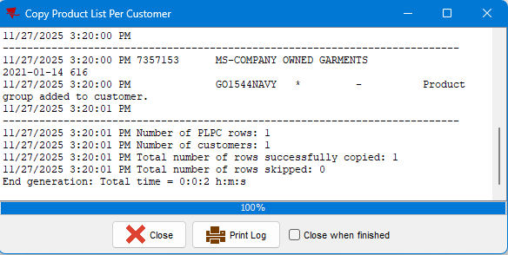
Copying finished successfully.
- Check the destination customer’s PLPC:
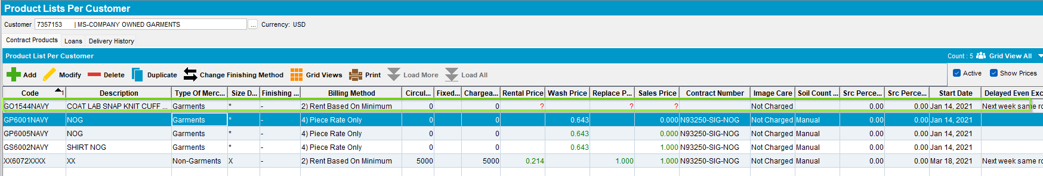Current Behavior: The Not-In-Contract-Product was copied on the FLEXIBLE Contract’s Customer PLPC list.
TEST PASSED.

RS2-RT2 – Copy single Not-In-Contract-Product from one customer to multiple customers – TEST PASSED
- Copy the selected Not-In-Contract-Product to the 2 previously identified Destination Customers:
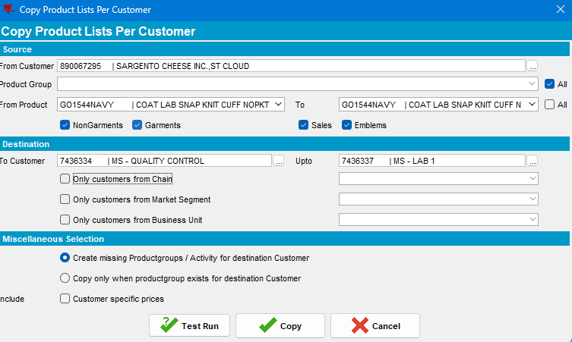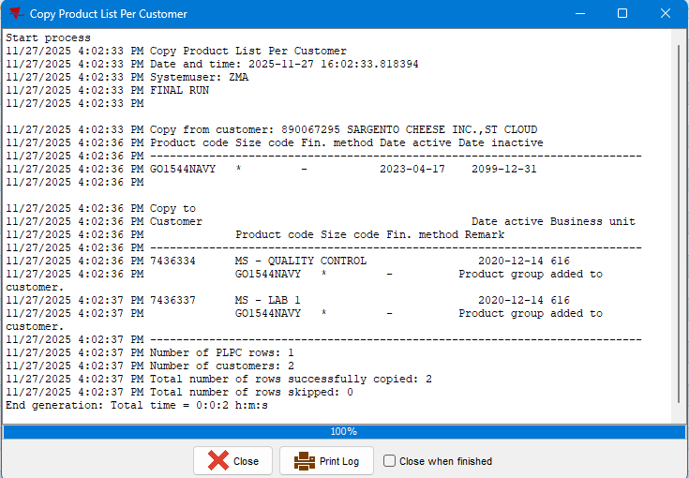
Copying was successful.
- Check Destination Customers’ PLPC list:
Destination Customer 1:
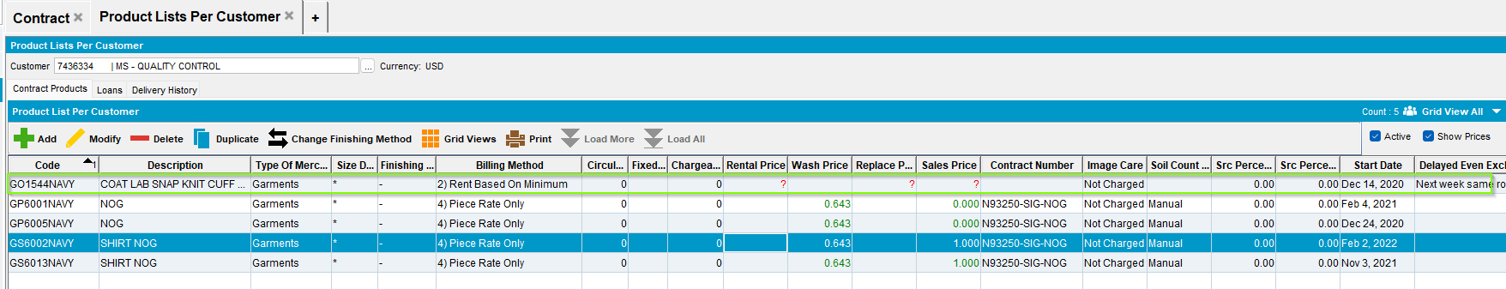
Destination Customer 2:
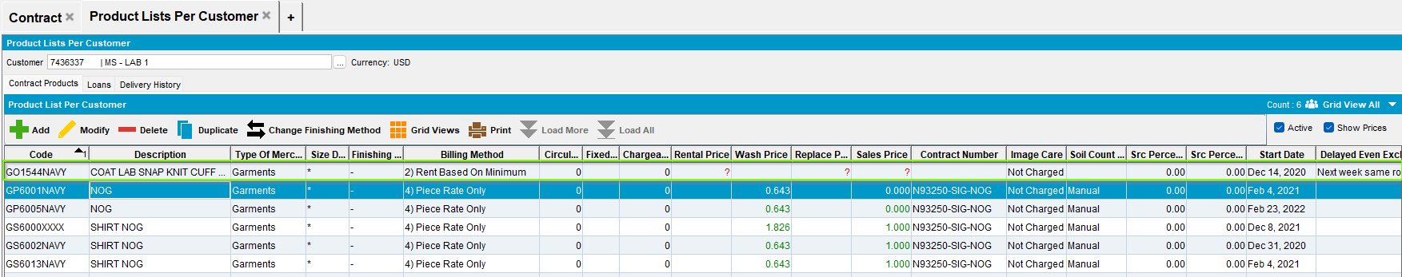
Current Behavior: As expected, the Non-existent, Not-In-Contract-Products were copied on the FLEXIBLE Contract Customers PLPC list, without prices and Contract number.
TEST PASSED.

RS2-RT3 – Copy multiple products (at least one Not-In-Contract-Product) from one customer to another – TEST PASSED
- Identify 2 more Not-in-Contract Products from the Source Customer’s PLPC:
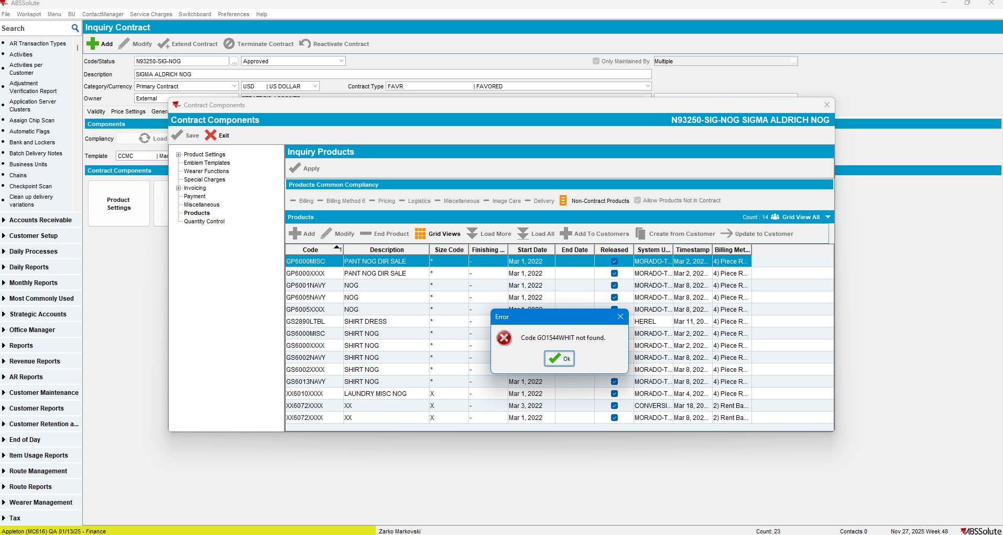
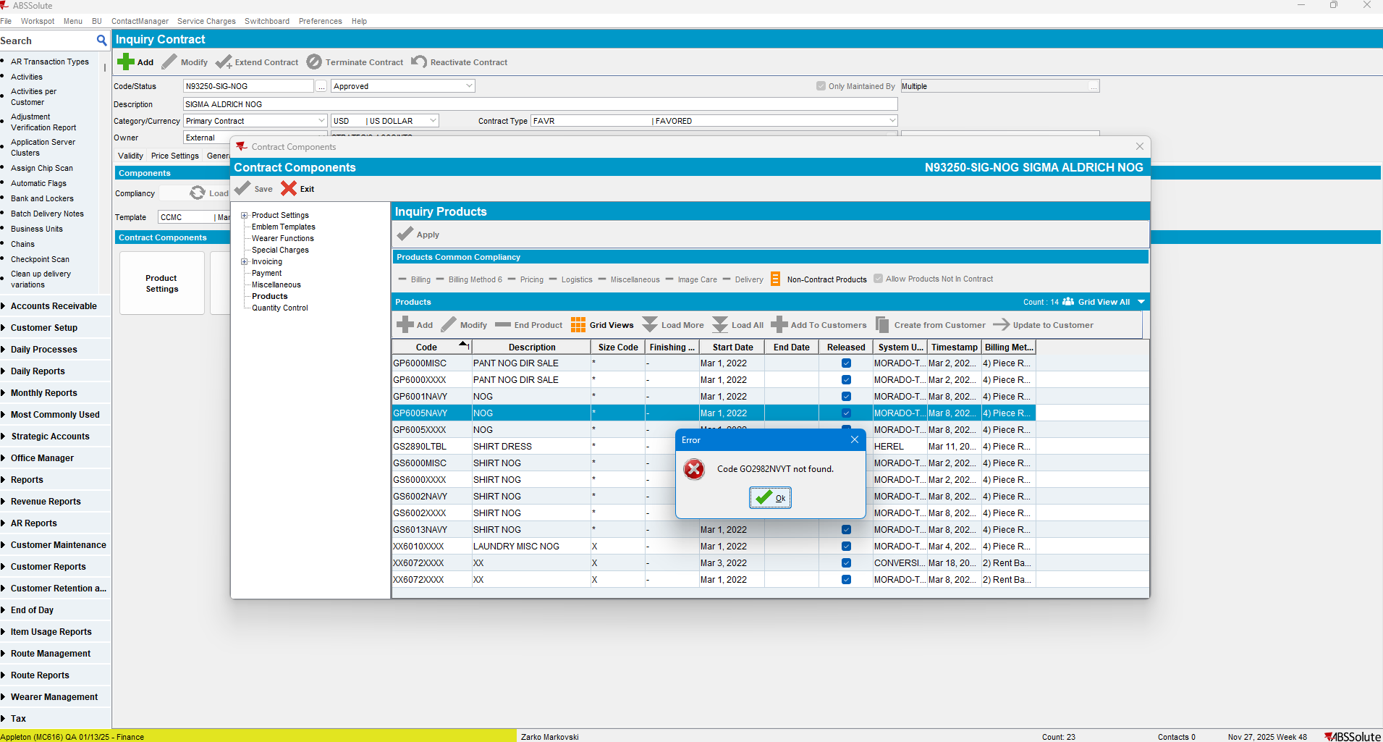

- Copy the selected Not-In-Contract-Product to the Destination Customer 7357153:
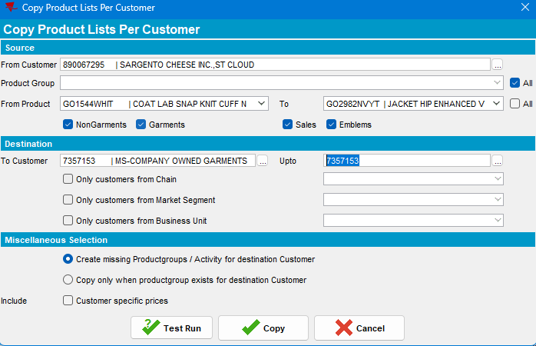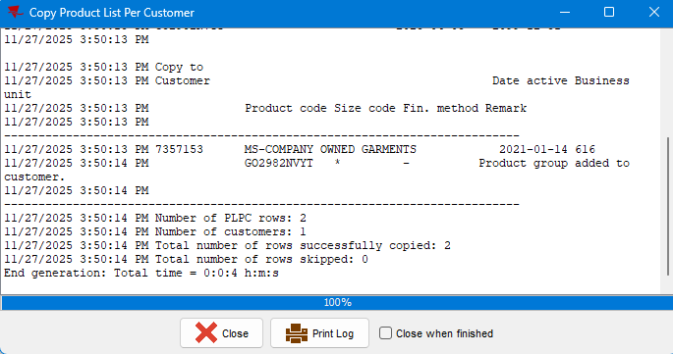
Copying was successful.
- Check Destination Customer’s PLPC list:
Current Behavior: As expected, the Non-existent, Not-In-Contract-Products were copied on the FLEXIBLE Contract’s Customer PLPC list, without prices and Contract number. Matching and Existent products were updated.
TEST PASSED.

RS2-RT4 – Copy multiple products, at least one Not-In-Contract-Product, from one customer to multiple customers. (TEST PASSED/FAILED)
- Copy the 2 products identified in RS2-RT3 to the two customers used in RS2-RT2:
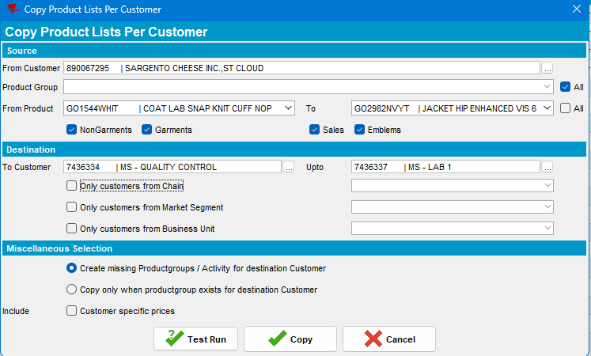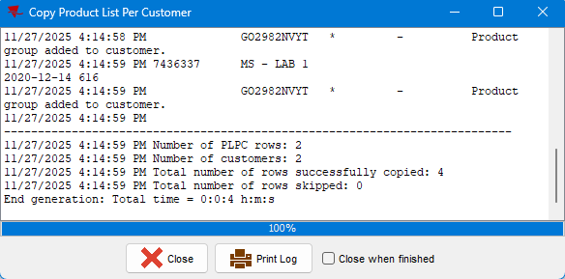
Products were copied
- Check the Destination Customers’ PLPC lists:
Destination customer 1:
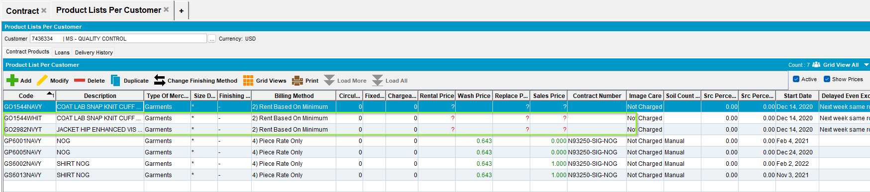

Destination customer 2:
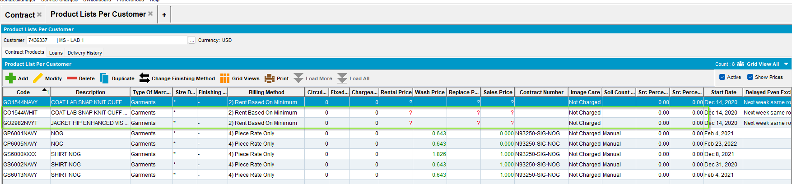
Current Behavior: As expected, the Non-existent, Not-In-Contract-Products were copied on the FLEXIBLE Contract’s Customers’ PLPC lists, without prices and Contract number. Matching and Existent products were updated.
TEST PASSED.

FINAL SUMMARY:
- Total Test Cases: 12
- Passed: 12
- Failed: 0
- Status: PASS

