Requirement Specification – ABSSolute

Subject | Rent on Loss Opt Out
Reference #
ABS Request # (issued by ABS) | ABS-156244
Date Issued | 9/25/23
ABS Account Code / Name  (See Application under Help - License Info) | AUS
Contact Person | Mack Traynor
ABS Contact Person | Boris Anderson
Document Name
Format: Account Code - Ref# - title - version
Document Version | 1.0

Revision Overview
Rev.# | Date | By | Remarks
1.0 | 9/20/23 | Mack Traynor | First Draft
1.1
3.0
4.0
5.0
6.0

Approval
The contents of this document have been approved by:
Date / Name of ABS Consultant | Date / Name of Customer

Executive summary
Short summary of requested functionality and reason why requested

Background and Purpose
AUS made the decision that all customers would pay rent for quit garments during the loss warn period. As a result, we’d like to add an option in ABS at the customer and contract level that allows customers to opt out of receivng rental charges for garments once they are quit.

AUS currently has the system setting for billing rental on quit garments set to ON. This setting applies to all customers in the BU when the setting is on. We would like the ability to disable this setting for specific customers and contracts, based on their needs.

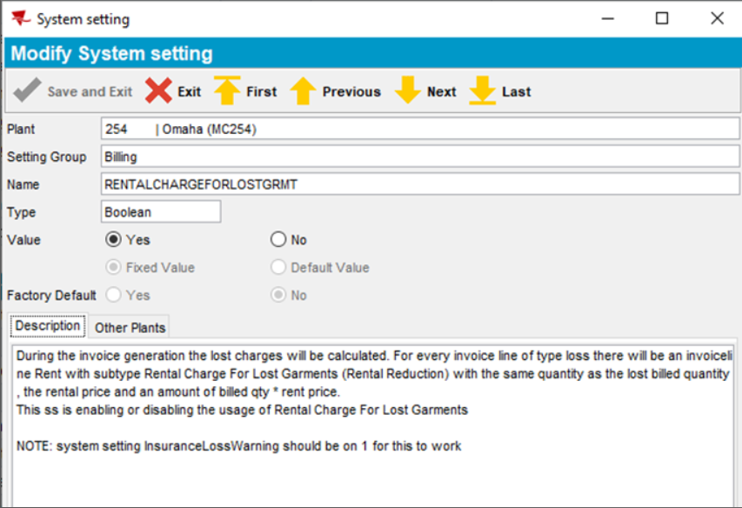

Requirement Specification
Detailed description of required functionality

Requirements
We would like to add a checkbox in the Customers dialog under the Garment Charges tab. When selected, this checkbox would disable the ”RENTALCHARGEFORLOSTGRMT” system setting so that rental charges do not bill during the loss warn period for that customer.
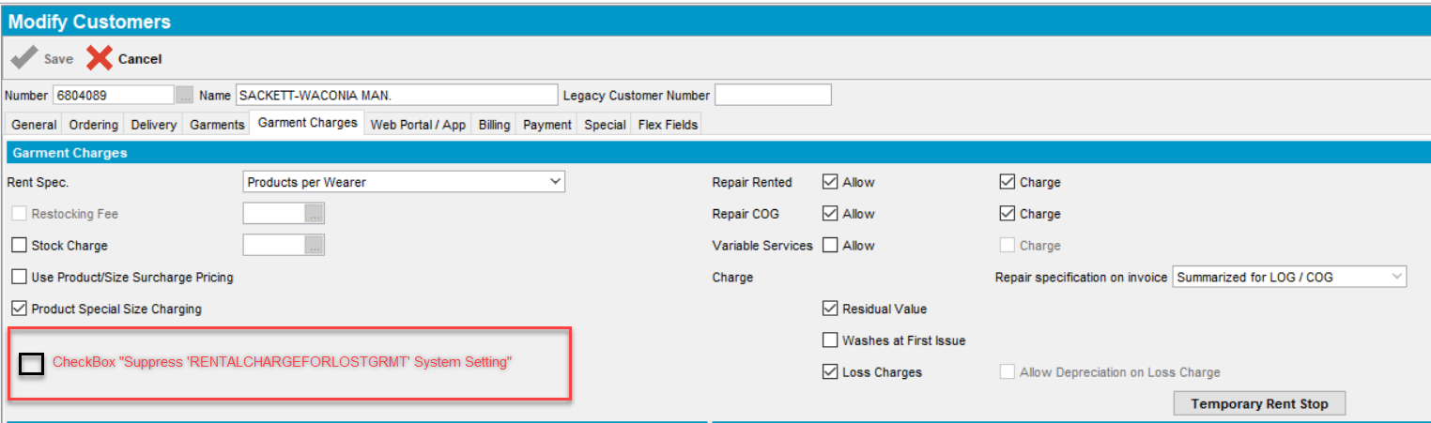

We would like to add a checkbox in the Contract dialog under the Components tab in the Invoicing Section. When selected, this checkbox would disable the ”RENTALCHARGEFORLOSTGRMT” system setting so that rental charges do not bill during the loss warn period for customers under that contract.
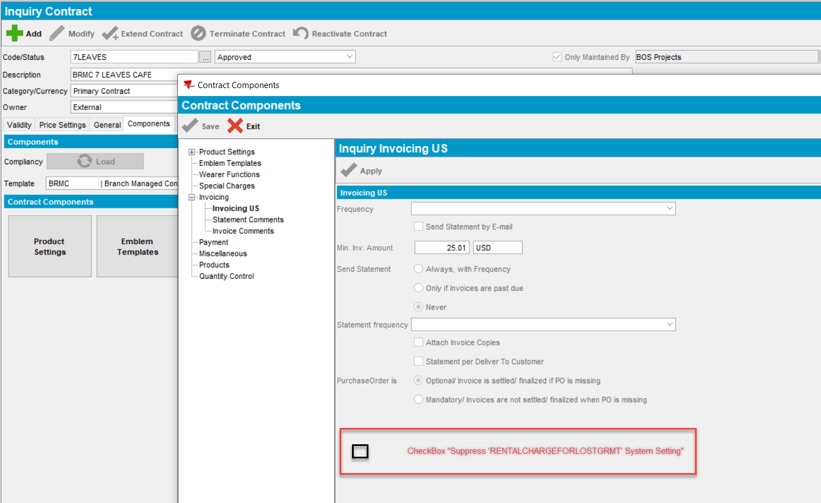

Downgrade
Downgrade to 9.05.02 AUS dedicated release, and 9.07.xx future dedicated release.

