ABSN-9882 Unable to settle house routes in webclient
Environment | Prerequisites
Version: 9.08.00.RELEASE.p22 (AUS) BUGFIX BRANCH  DBServerName=abs-srv17.internal.abslbs.com  DBSID=CUST23  DBUser=AUS_MNT90800  DBPassword=AUS_MNT90800  Environment=Test  EnvironmentSABStage=Test | - Module: AUS, RAS, WISBASIS, BKLBASIS, PWBINTERNET  - SS:
Contents
Retest After Fix 1
Test Case 1 – Settling House (Spare) Routes from Webclient-X – TEST PASSED 1

Retest After Fix
HASH: 40302e2e6bc0
BU code: 250
Plant code: 250

Test Case 1 – Settling House (Spare) Routes from Webclient-X – TEST PASSED
Expected behavior: Settling of House (Spare) Routes from Webclient-X should be possible without any errors.
Step1) Find / create an House (Spare) Route:
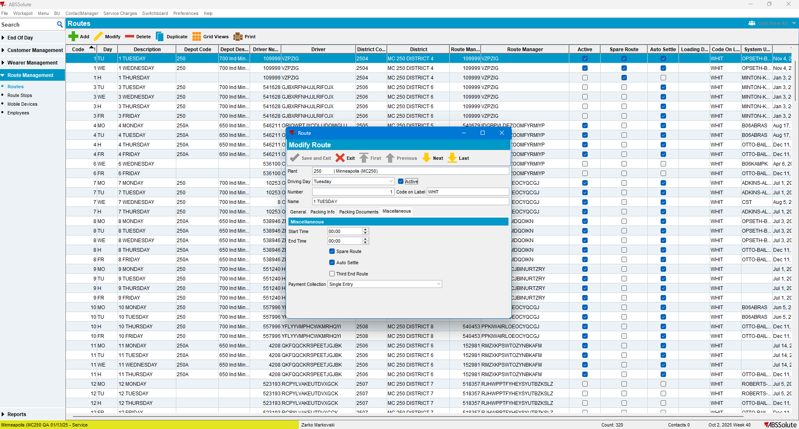

Step2) Create a “House Route” in RSC:
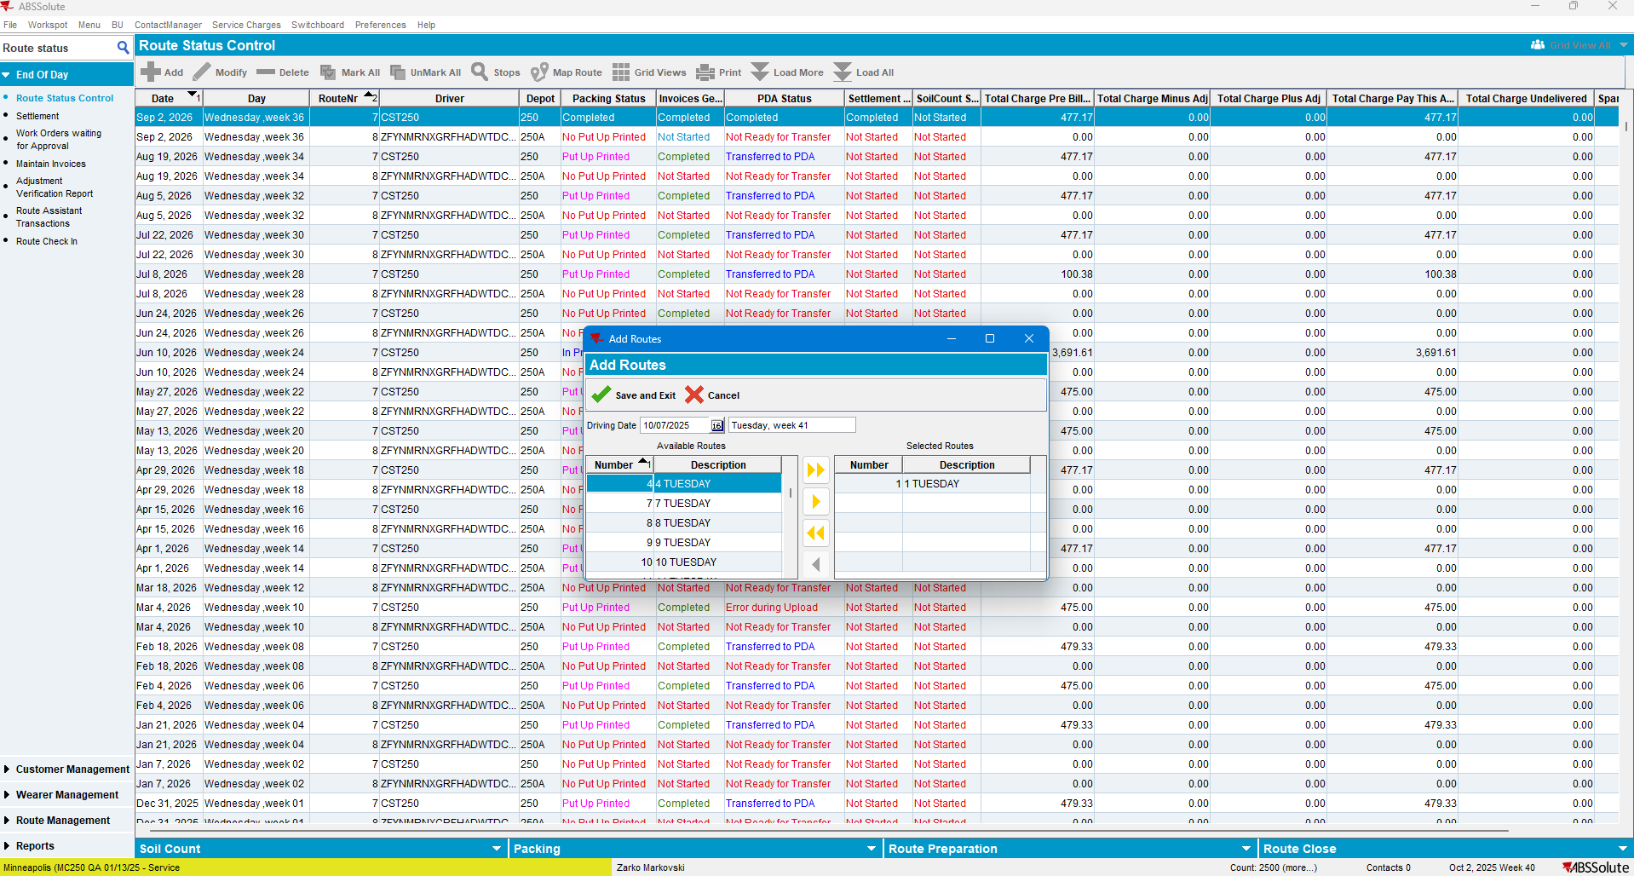

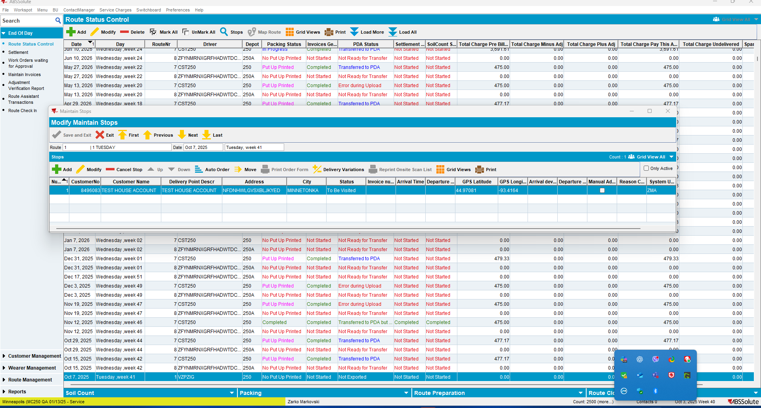

Step3) Open WebclientX and select the corresponding BU and workstation:
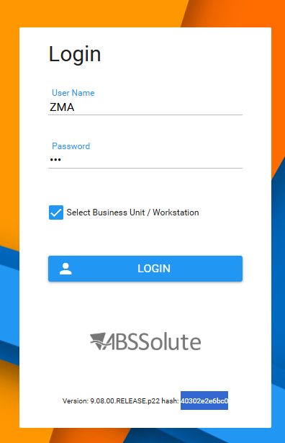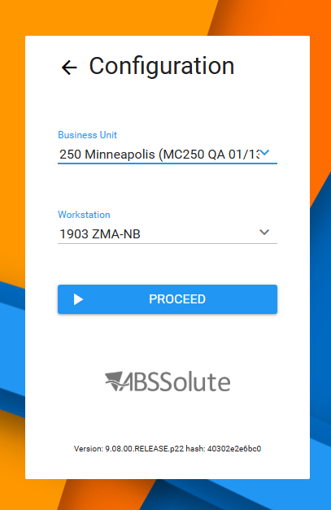
Step 4) Select the “House Route” created in RSC:
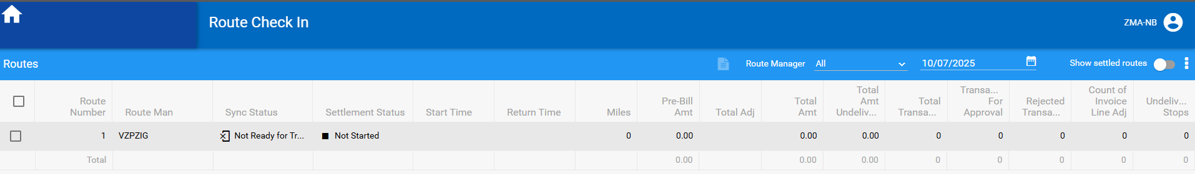
Step 5) Try to Settle It:
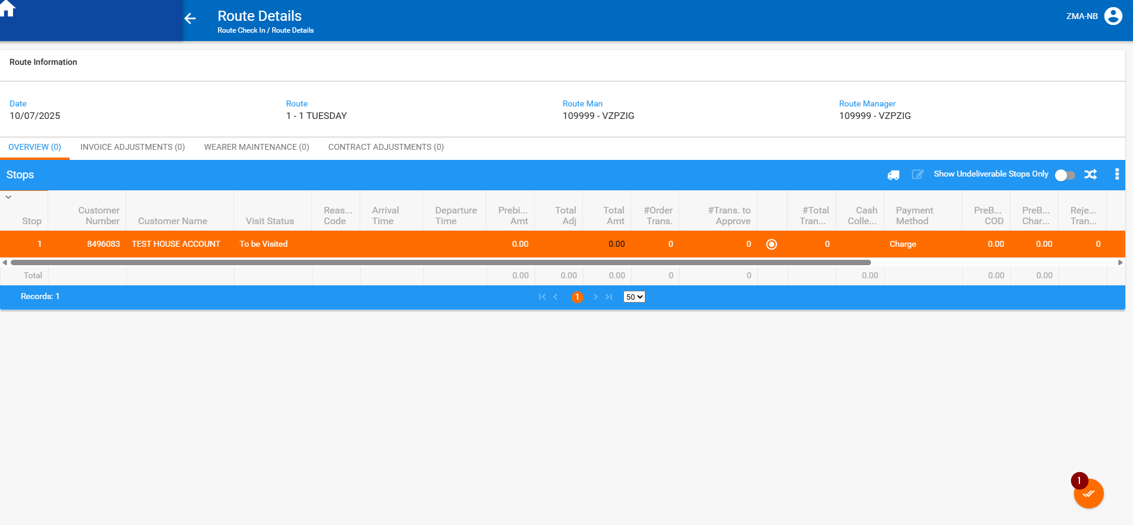

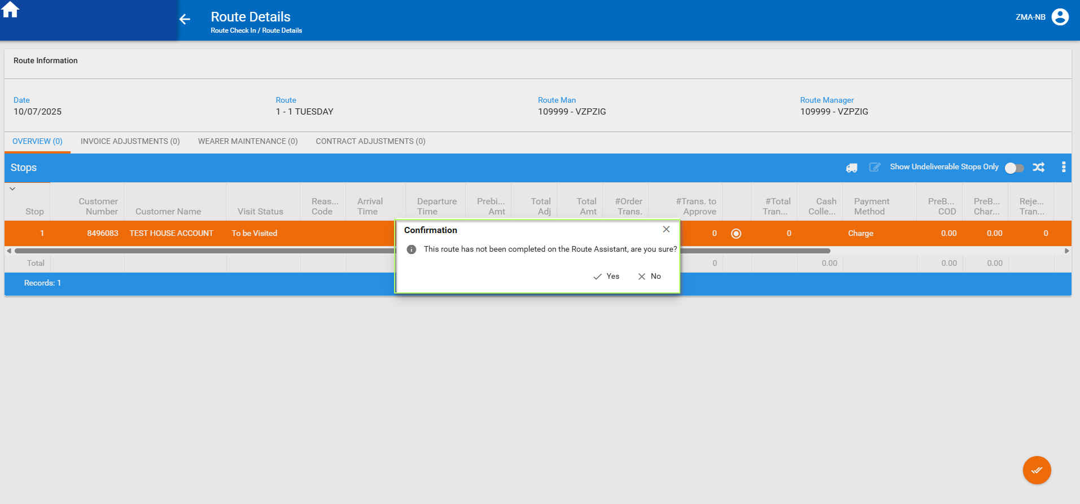
Route was settled; no error message was prompted.
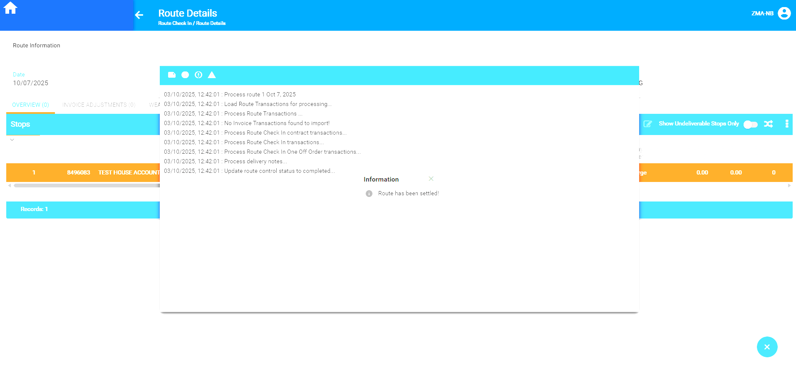

Step 6) Check the route status in RSC:
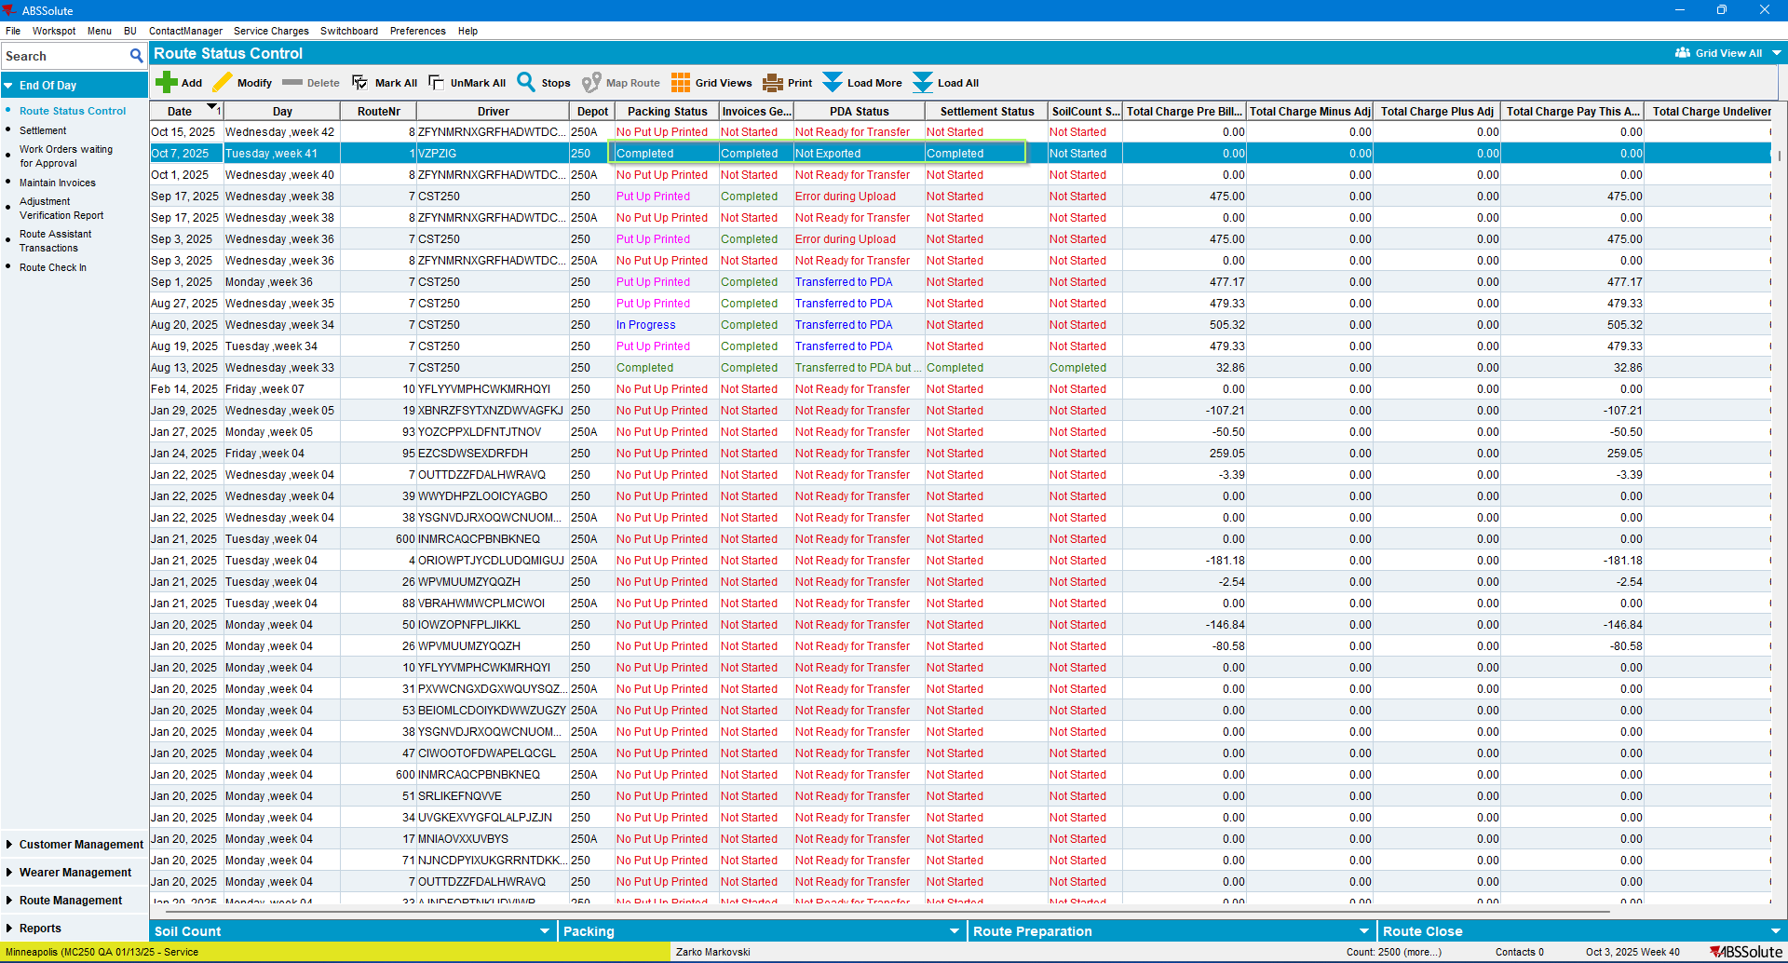
Route is settled.
Current Behavior
Is the Expected one: The previously appearing error message was not prompted. Route was settled.

TEST PASSED

