ABSN-9504 Add SBG to SOAP webservice for price update
Environment | Prerequisites
Version: 9.08.00.RELEASE.p22  Environment=PRODUCTION  DBServerName= db01-buc.internal.abslbs.com  DBSID= CUST25  DBUser= AUS_ND90502  DBPassword= AUS_ND90502 | - Module: CHARGESPECIALSIZE  - System setting:  SIZESPECIALCHARGEOPTIONS  - Others: BU 503
Contents:
Add SBG to SOAP webservice for price update
#1 Check Add SBG in PLPC to SOAP webservice for price update – Passed 1

#1 Check Add SBG in PLPC to SOAP webservice for price update – Passed

Test case 1:
- Module: CHARGESPECIALSIZE
- System setting: SIZESPECIALCHARGEOPTIONS=7
Pre-setup for Size billing Group:
- Not check on customer level the option: Use Product/ Size Surcharge Pricing (it is the one of the option necessary to be set)
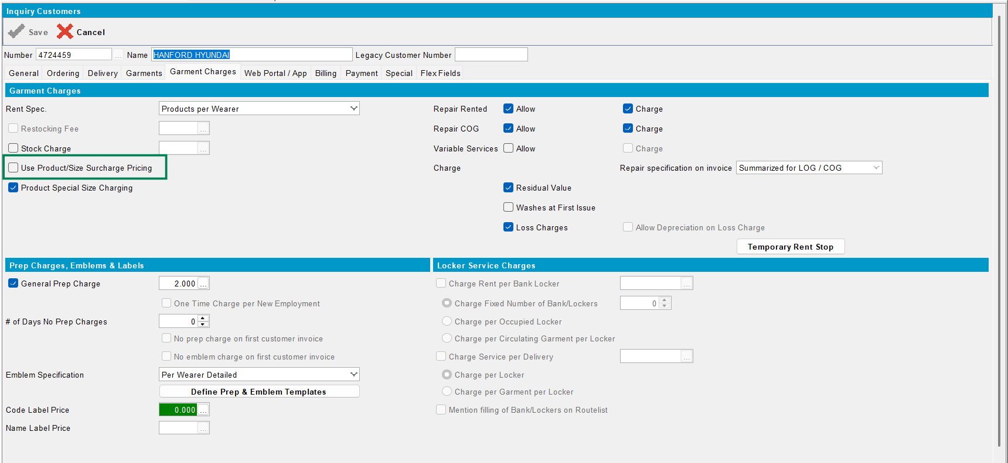

- Add, on Size Billing Group dlg, some codes:
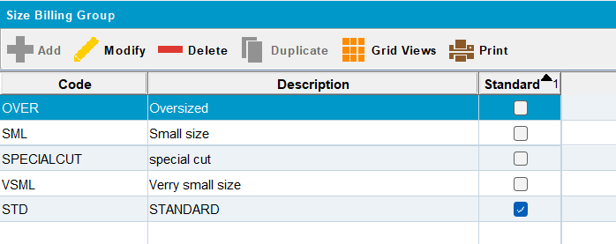
- On Product Group set, for each code, the percentage to be applied:
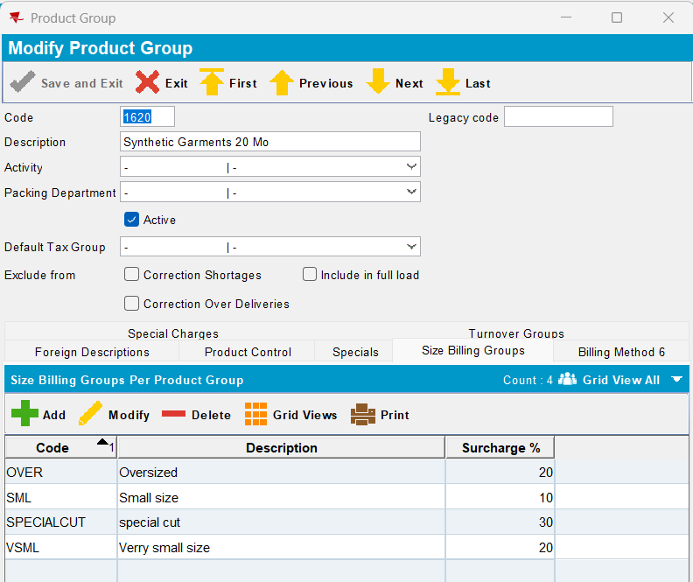

- Choose a garment:
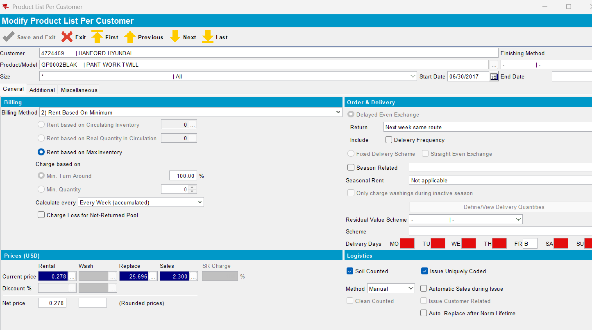
Request:
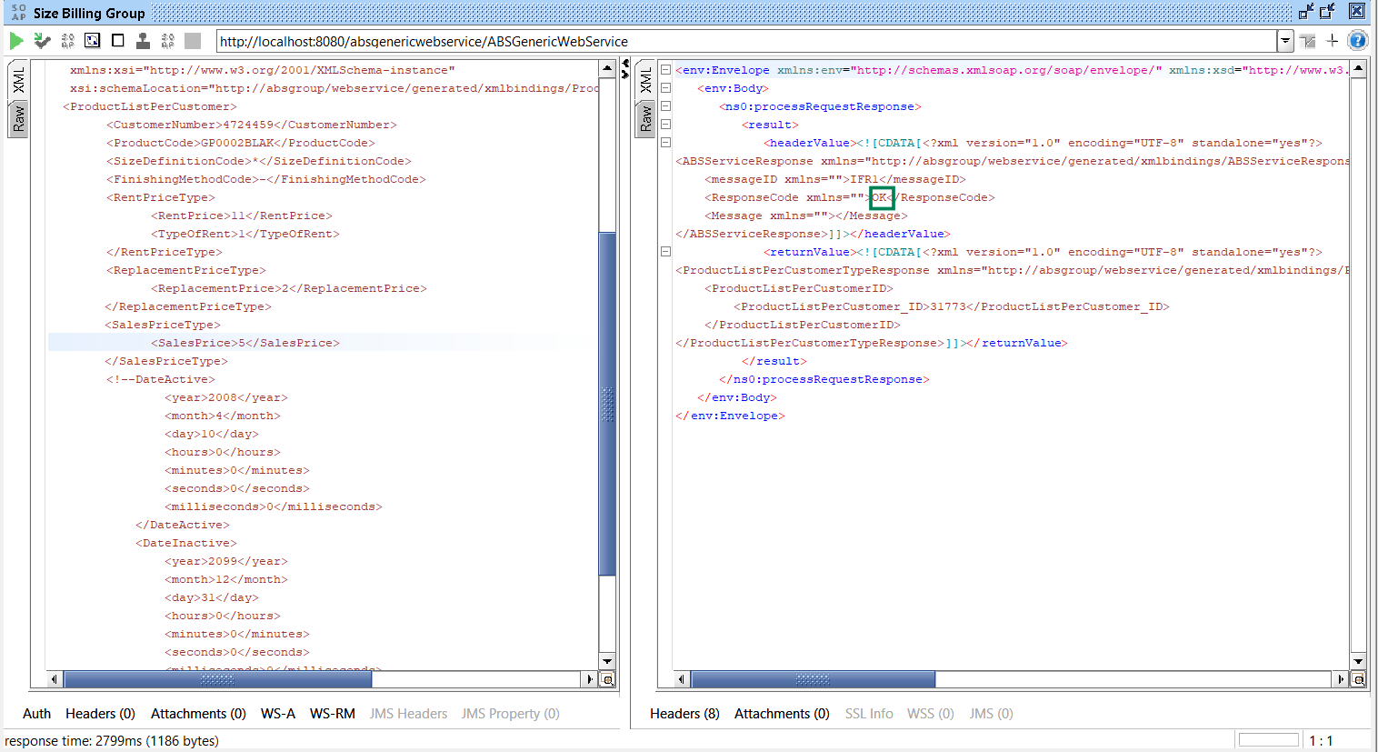

Result: ok
- Because customer wasn’t set for SBG, the prices added on garment are without SBG:
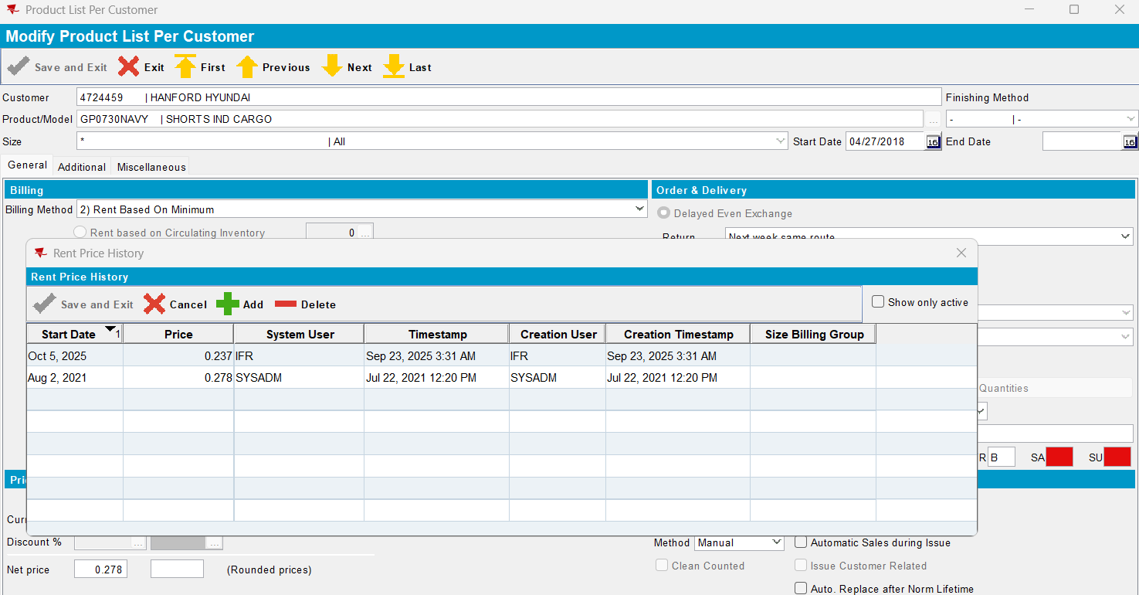
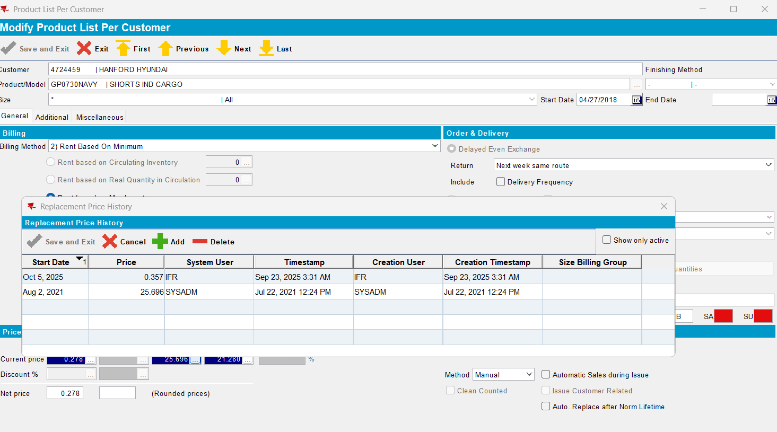
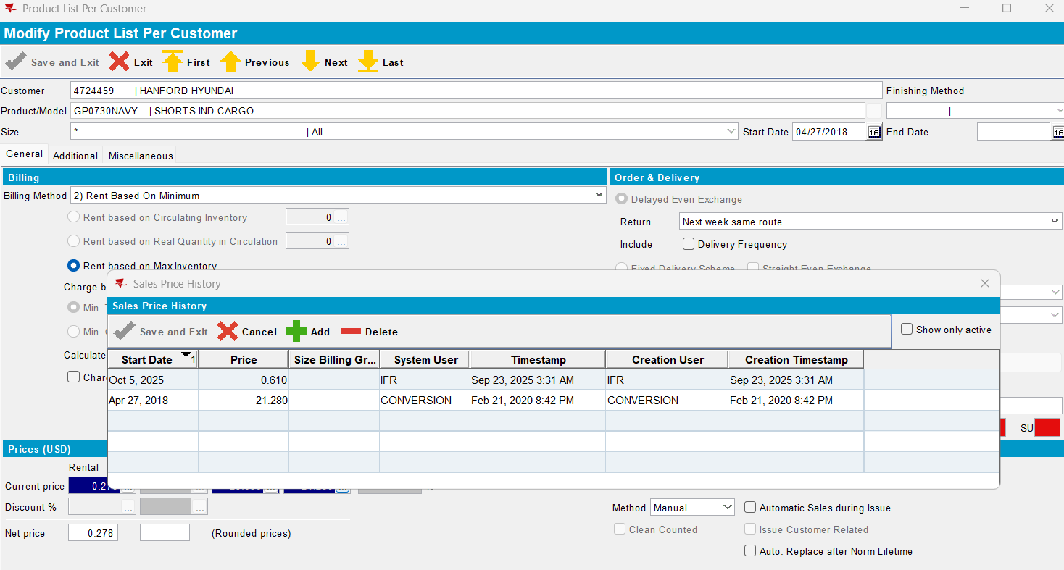

Test case 2:
Set also the customer for SBG:
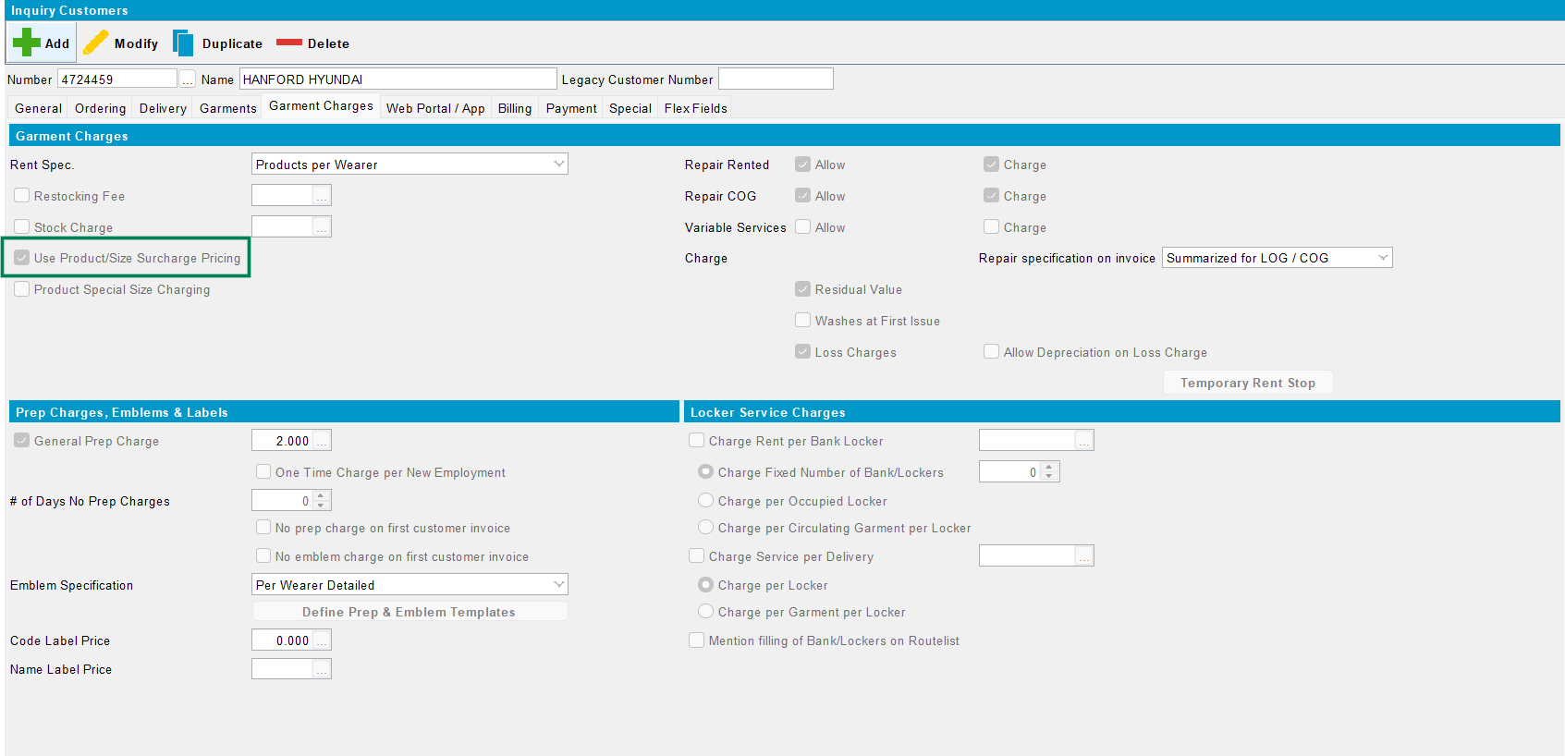

Request:
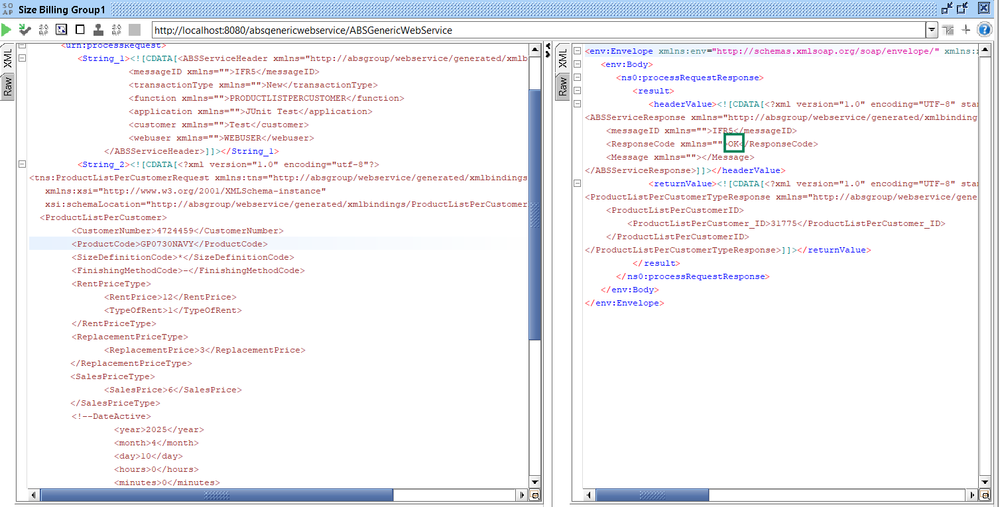
<?xml version="1.0" encoding="UTF-8"?>
<soapenv:Envelope xmlns:soapenv="http://schemas.xmlsoap.org/soap/envelope/" xmlns:urn="urn:ABS">
<soapenv:Header/>
<soapenv:Body>
<urn:processRequest>
<String_1><![CDATA[<ABSServiceHeader xmlns="http://absgroup/webservice/generated/xmlbindings/ABSServiceHeader">
<messageID xmlns="">IFR5</messageID>
<transactionType xmlns="">New</transactionType>
<function xmlns="">PRODUCTLISTPERCUSTOMER</function>
<application xmlns="">JUnit Test</application>
<customer xmlns="">Test</customer>
<webuser xmlns="">WEBUSER</webuser>
</ABSServiceHeader>]]></String_1>
<String_2><![CDATA[<?xml version="1.0" encoding="utf-8"?>
<tns:ProductListPerCustomerRequest xmlns:tns="http://absgroup/webservice/generated/xmlbindings/ProductListPerCustomerRequest"
xmlns:xsi="http://www.w3.org/2001/XMLSchema-instance"
xsi:schemaLocation="http://absgroup/webservice/generated/xmlbindings/ProductListPerCustomerRequest">
<ProductListPerCustomer>
<CustomerNumber>4724459</CustomerNumber>
<ProductCode>GP0730NAVY</ProductCode>
<SizeDefinitionCode>*</SizeDefinitionCode>
<FinishingMethodCode>-</FinishingMethodCode>
<RentPriceType>
<RentPrice>12</RentPrice>
<TypeOfRent>1</TypeOfRent>
</RentPriceType>
<ReplacementPriceType>
<ReplacementPrice>3</ReplacementPrice>
</ReplacementPriceType>
<SalesPriceType>
<SalesPrice>6</SalesPrice>
</SalesPriceType>
<!--DateActive>
<year>2025</year>
<month>4</month>
<day>10</day>
<hours>0</hours>
<minutes>0</minutes>
<seconds>0</seconds>
<milliseconds>0</milliseconds>
</DateActive>
<DateInactive>
<year>2099</year>
<month>12</month>
<day>31</day>
<hours>0</hours>
<minutes>0</minutes>
<seconds>0</seconds>
<milliseconds>0</milliseconds>
</DateInactive-->
</ProductListPerCustomer>

</tns:ProductListPerCustomerRequest>]]></String_2>
</urn:processRequest>
</soapenv:Body>
</soapenv:Envelope>

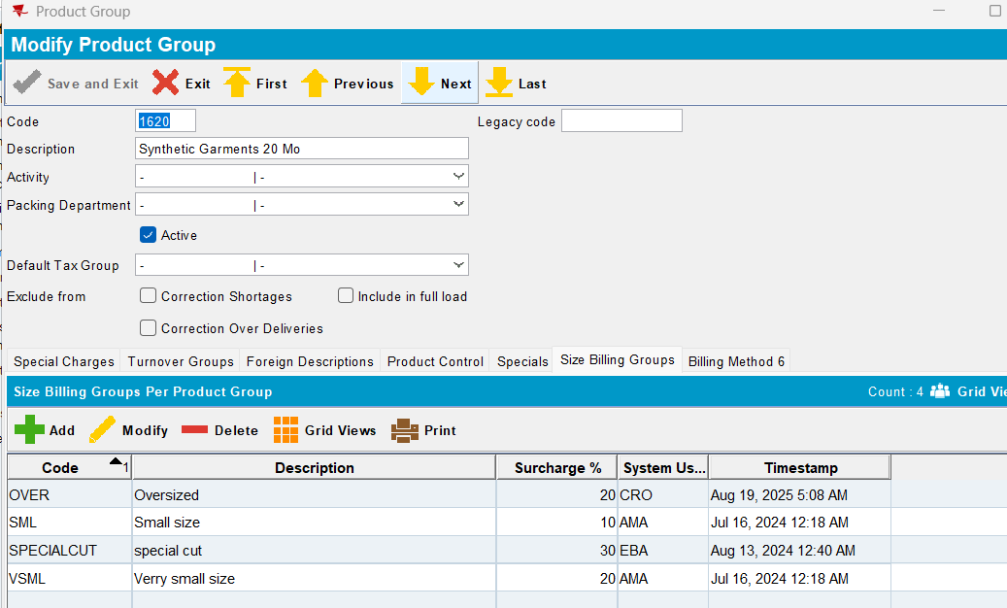

Result: ok
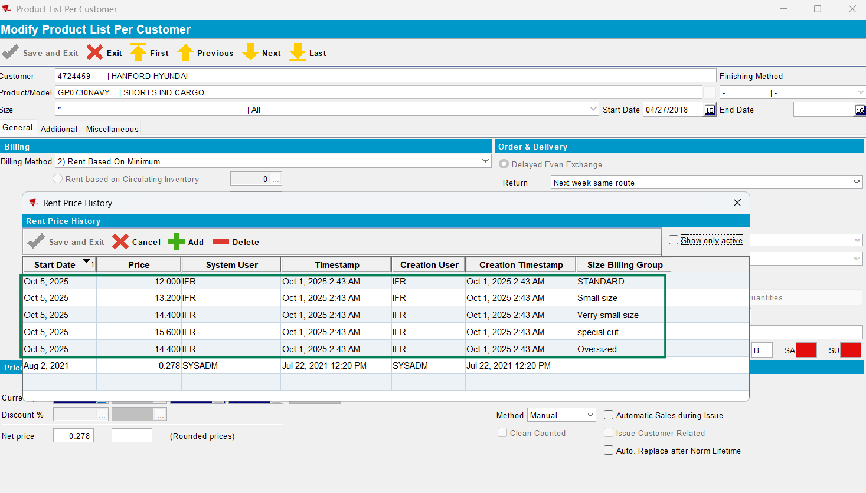
- 12.00* 20% =14.40
- 12.00*10%=13.20
- 12.00*30%=15.60

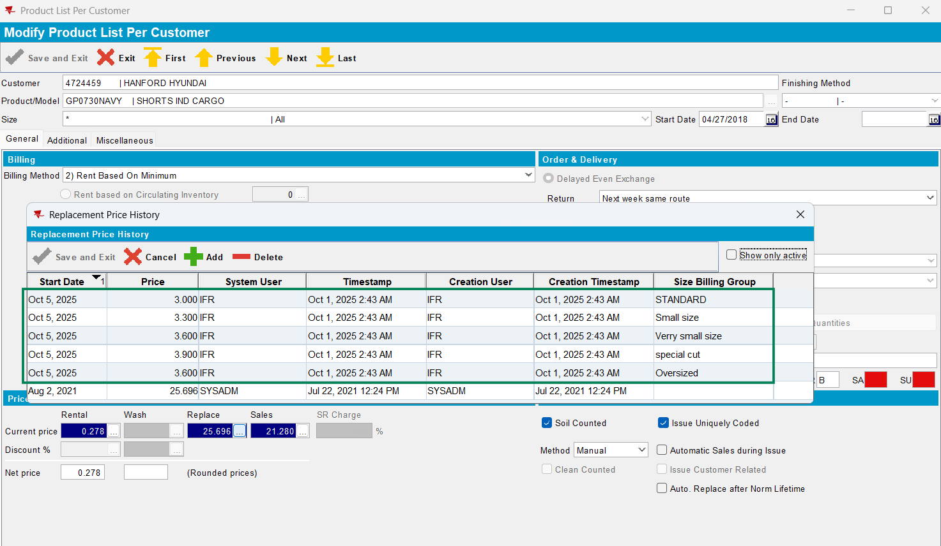
- 3*20%=3.60
- 3*10%=3.30
- 3*30%=3.90
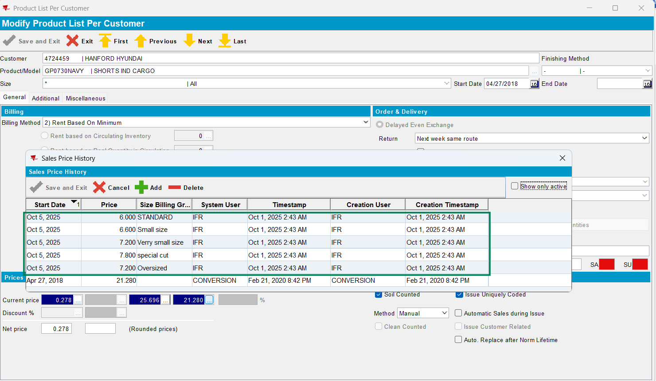
- 6*20%=7.20
- 6*10%=6.60
- 6*30%=7.80

Test case 3:
- Transaction type: New: ok
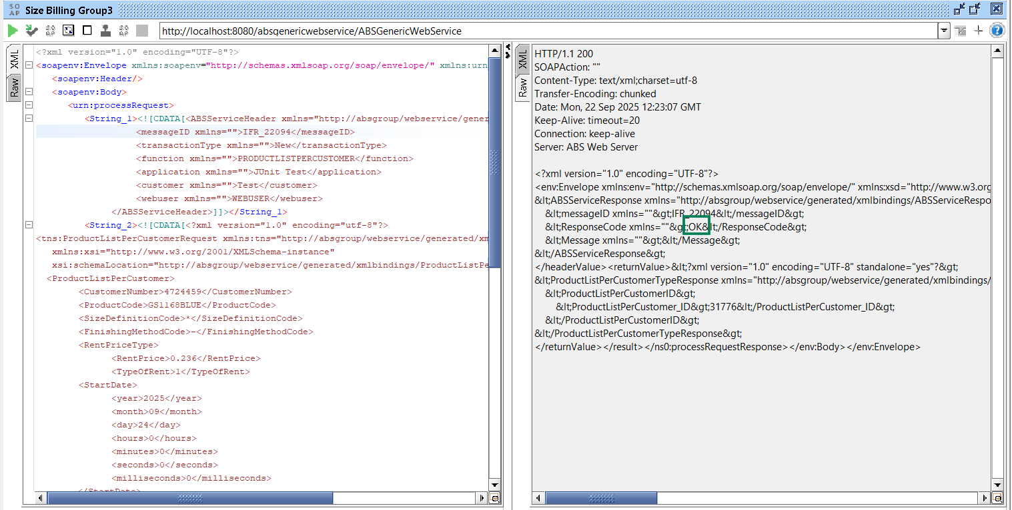
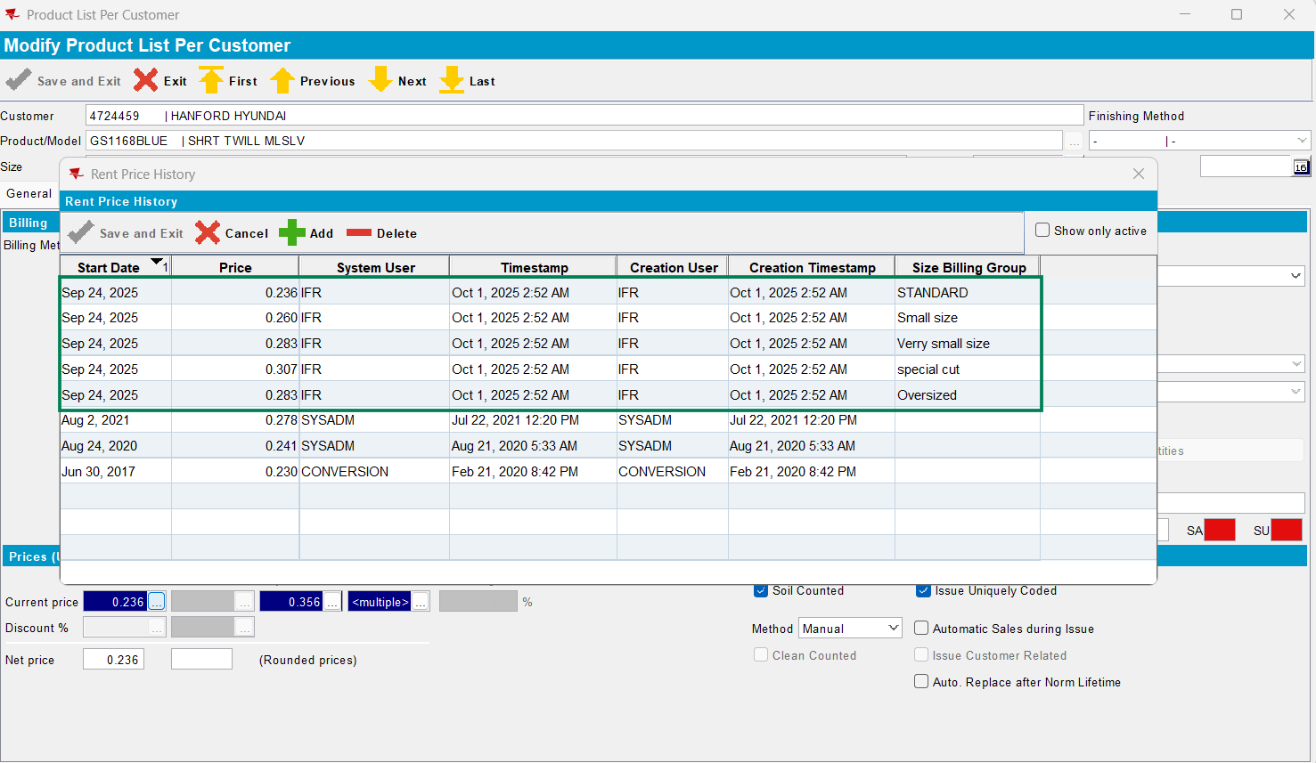

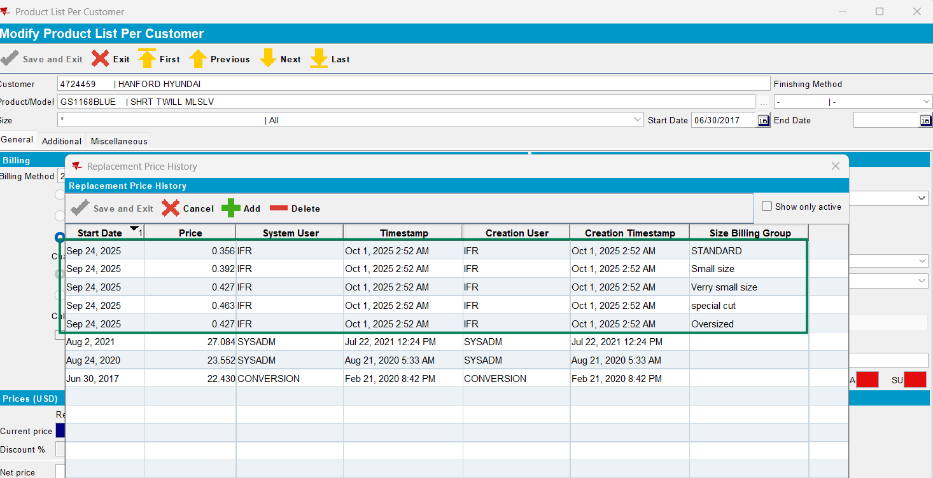

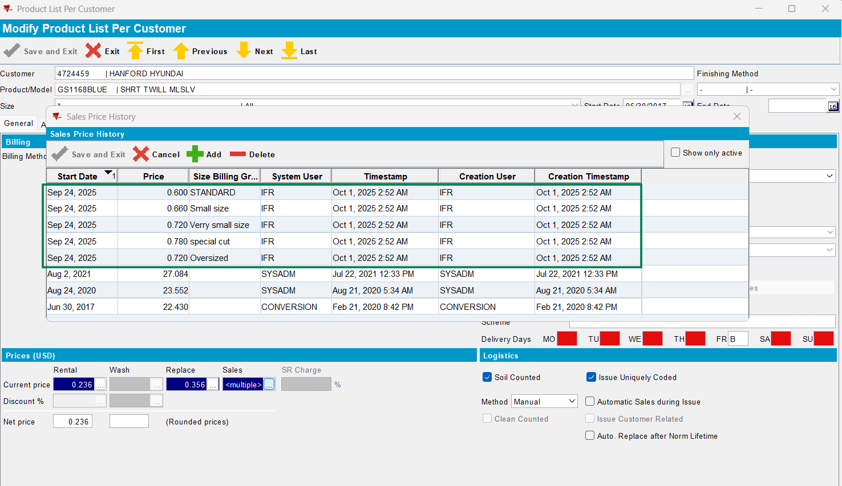

Request:
<?xml version=”1.0” encoding=”UTF-8”?>
<soapenv:Envelope xmlns:soapenv=”http://schemas.xmlsoap.org/soap/envelope/” xmlns:urn=”urn:ABS”>
<soapenv:Header/>
<soapenv:Body>
<urn:processRequest>
<String_1><![CDATA[<ABSServiceHeader xmlns=”http://absgroup/webservice/generated/xmlbindings/ABSServiceHeader”>
<messageID xmlns=””>IFR_22098</messageID>
<transactionType xmlns=””>New</transactionType>
<function xmlns=””>PRODUCTLISTPERCUSTOMER</function>
<application xmlns=””>Junit Test</application>
<customer xmlns=””>Test</customer>
<webuser xmlns=””>WEBUSER</webuser>
</ABSServiceHeader>]]></String_1>
<String_2><![CDATA[<?xml version=”1.0” encoding=”utf-8”?>
<tns:ProductListPerCustomerRequest xmlns:tns=”http://absgroup/webservice/generated/xmlbindings/ProductListPerCustomerRequest”
xmlns:xsi=”http://www.w3.org/2001/XMLSchema-instance”
xsi:schemaLocation=”http://absgroup/webservice/generated/xmlbindings/ProductListPerCustomerRequest”>
<ProductListPerCustomer>
<CustomerNumber>4724459</CustomerNumber>
<ProductCode>GS1168BLUE</ProductCode>
<SizeDefinitionCode>*</SizeDefinitionCode>
<FinishingMethodCode>-</FinishingMethodCode>
<RentPriceType>
<RentPrice>0.237</RentPrice>
<TypeOfRent>1</TypeOfRent>
<StartDate>
<year>2025</year>
<month>09</month>
<day>25</day>
<hours>0</hours>
<minutes>0</minutes>
<seconds>0</seconds>
<milliseconds>0</milliseconds>
</StartDate>
</RentPriceType>
<ReplacementPriceType>
<ReplacementPrice>0.357</ReplacementPrice>
<StartDate>
<year>2025</year>
<month>09</month>
<day>25</day>
<hours>0</hours>
<minutes>0</minutes>
<seconds>0</seconds>
<milliseconds>0</milliseconds>
</StartDate>
</ReplacementPriceType>
<SalesPriceType>
<SalesPrice>0.61</SalesPrice>
<StartDate>
<year>2025</year>
<month>09</month>
<day>25</day>
<hours>0</hours>
<minutes>0</minutes>
<seconds>0</seconds>
<milliseconds>0</milliseconds>
</StartDate>
</SalesPriceType>
</ProductListPerCustomer>
</tns:ProductListPerCustomerRequest>]]></String_2>
</urn:processRequest>
</soapenv:Body>
</soapenv:Envelope>

Response:
<env:Envelope xmlns:env=”http://schemas.xmlsoap.org/soap/envelope/” xmlns:xsd=”http://www.w3.org/2001/XMLSchema” xmlns:xsi=”http://www.w3.org/2001/XMLSchema-instance” xmlns:enc=”http://schemas.xmlsoap.org/soap/encoding/” xmlns:ns0=”urn:ABS”>
<env:Body>
<ns0:processRequestResponse>
<result>
<headerValue><![CDATA[<?xml version=”1.0” encoding=”UTF-8” standalone=”yes”?>
<ABSServiceResponse xmlns=”http://absgroup/webservice/generated/xmlbindings/ABSServiceResponse”>
<messageID xmlns=””>IFR_22098</messageID>
<ResponseCode xmlns=””>OK</ResponseCode>
<Message xmlns=””></Message>
</ABSServiceResponse>]]></headerValue>
<returnValue><![CDATA[<?xml version=”1.0” encoding=”UTF-8” standalone=”yes”?>
<ProductListPerCustomerTypeResponse xmlns=”http://absgroup/webservice/generated/xmlbindings/ProductListPerCustomerResponse”>
<ProductListPerCustomerID>
<ProductListPerCustomer_ID>31776</ProductListPerCustomer_ID>
</ProductListPerCustomerID>
</ProductListPerCustomerTypeResponse>]]></returnValue>
</result>
</ns0:processRequestResponse>
</env:Body>
</env:Envelope>

- Transaction type: Retrieve: ok
Request:
<?xml version=”1.0” encoding=”UTF-8”?>
<soapenv:Envelope xmlns:soapenv=”http://schemas.xmlsoap.org/soap/envelope/” xmlns:urn=”urn:ABS”>
<soapenv:Header/>
<soapenv:Body>
<urn:processRequest>
<String_1><![CDATA[<ABSServiceHeader xmlns=”http://absgroup/webservice/generated/xmlbindings/ABSServiceHeader”>
<messageID xmlns=””>IFR_22097</messageID>
<transactionType xmlns=””>Retrieve</transactionType>
<function xmlns=””>PRODUCTLISTPERCUSTOMER</function>
<application xmlns=””>Junit Test</application>
<customer xmlns=””>Test</customer>
<webuser xmlns=””>WEBUSER</webuser>
</ABSServiceHeader>]]></String_1>
<String_2><![CDATA[<?xml version=”1.0” encoding=”utf-8”?>
<tns:ProductListPerCustomerRequest xmlns:tns=”http://absgroup/webservice/generated/xmlbindings/ProductListPerCustomerRequest”
xmlns:xsi=”http://www.w3.org/2001/XMLSchema-instance”
xsi:schemaLocation=”http://absgroup/webservice/generated/xmlbindings/ProductListPerCustomerRequest”>
<ProductListPerCustomer>
<CustomerNumber>4724459</CustomerNumber>
<ProductCode>GS1168BLUE</ProductCode>
<SizeDefinitionCode>*</SizeDefinitionCode>
<FinishingMethodCode>-</FinishingMethodCode>
</ProductListPerCustomer>
</tns:ProductListPerCustomerRequest>]]></String_2>
</urn:processRequest>
</soapenv:Body>
</soapenv:Envelope>

Response:
<env:Envelope xmlns:env=”http://schemas.xmlsoap.org/soap/envelope/” xmlns:xsd=”http://www.w3.org/2001/XMLSchema” xmlns:xsi=”http://www.w3.org/2001/XMLSchema-instance” xmlns:enc=”http://schemas.xmlsoap.org/soap/encoding/” xmlns:ns0=”urn:ABS”>
<env:Body>
<ns0:processRequestResponse>
<result>
<headerValue><![CDATA[<?xml version=”1.0” encoding=”UTF-8” standalone=”yes”?>
<ABSServiceResponse xmlns=”http://absgroup/webservice/generated/xmlbindings/ABSServiceResponse”>
<messageID xmlns=””>IFR_22097</messageID>
<ResponseCode xmlns=””>OK</ResponseCode>
<Message xmlns=””></Message>
</ABSServiceResponse>]]></headerValue>
<returnValue><![CDATA[<?xml version=”1.0” encoding=”UTF-8” standalone=”yes”?>
<ProductListPerCustomerTypeResponse xmlns=”http://absgroup/webservice/generated/xmlbindings/ProductListPerCustomerResponse”>
<ProductListPerCustomerID>
<ProductListPerCustomer_ID>31776</ProductListPerCustomer_ID>
<ProductListPerCustomer>
<CustomerNumber>4724459</CustomerNumber>
<ProductCode></ProductCode>
<DateActive>
<year>2017</year>
<month>6</month>
<day>30</day>
<hours>0</hours>
<minutes>0</minutes>
<seconds>0</seconds>
<milliseconds>0</milliseconds>
</DateActive>
<DateInactive>
<year>2099</year>
<month>12</month>
<day>31</day>
<hours>0</hours>
<minutes>0</minutes>
<seconds>0</seconds>
<milliseconds>0</milliseconds>
</DateInactive>
<BillingMethod>2</BillingMethod>
<ChangesPerWeek>false</ChangesPerWeek>
<RentPricePerFrequency>false</RentPricePerFrequency>
<ChargeWashOnlyForCOG>0</ChargeWashOnlyForCOG>
<MinTurnAround>100</MinTurnAround>
<MinimumQuantity>0</MinimumQuantity>
<MinimumFrequency>1</MinimumFrequency>
<AutoReplacementDifference>false</AutoReplacementDifference>
<PriceUsage>0</PriceUsage>
<InventoryBillingType>2</InventoryBillingType>
<ChargeOveruse>false</ChargeOveruse>
<PercAfterDepreciation>0</PercAfterDepreciation>
<ChargeWashesPack>1</ChargeWashesPack>
<InvoiceFrequencyRelatedRentPrice>false</InvoiceFrequencyRelatedRentPrice>
<InvWashOnSoilCount>false</InvWashOnSoilCount>
<ReturnStockAllowed>false</ReturnStockAllowed>
<RentPriceType>
<RentPrice>0.236</RentPrice>
<TypeOfRent>1</TypeOfRent>
<ChangesPerWeek>0</ChangesPerWeek>
<StartDate>
<year>2025</year>
<month>9</month>
<day>24</day>
<hours>0</hours>
<minutes>0</minutes>
<seconds>0</seconds>
<milliseconds>0</milliseconds>
</StartDate>
</RentPriceType>
<RentPriceType>
<RentPrice>0.236</RentPrice>
<TypeOfRent>1</TypeOfRent>
<ChangesPerWeek>0</ChangesPerWeek>
<StartDate>
<year>2025</year>
<month>9</month>
<day>23</day>
<hours>0</hours>
<minutes>0</minutes>
<seconds>0</seconds>
<milliseconds>0</milliseconds>
</StartDate>
</RentPriceType>
<RentPriceType>
<RentPrice>0.277725</RentPrice>
<TypeOfRent>1</TypeOfRent>
<ChangesPerWeek>0</ChangesPerWeek>
<StartDate>
<year>2021</year>
<month>8</month>
<day>2</day>
<hours>0</hours>
<minutes>0</minutes>
<seconds>0</seconds>
<milliseconds>0</milliseconds>
</StartDate>
</RentPriceType>
<RentPriceType>
<RentPrice>0.2415</RentPrice>
<TypeOfRent>1</TypeOfRent>
<ChangesPerWeek>0</ChangesPerWeek>
<StartDate>
<year>2020</year>
<month>8</month>
<day>24</day>
<hours>0</hours>
<minutes>0</minutes>
<seconds>0</seconds>
<milliseconds>0</milliseconds>
</StartDate>
</RentPriceType>
<RentPriceType>
<RentPrice>0.23</RentPrice>
<TypeOfRent>1</TypeOfRent>
<ChangesPerWeek>0</ChangesPerWeek>
<StartDate>
<year>2017</year>
<month>6</month>
<day>30</day>
<hours>0</hours>
<minutes>0</minutes>
<seconds>0</seconds>
<milliseconds>0</milliseconds>
</StartDate>
</RentPriceType>
<WashPriceType>
<WashPrice>0.0</WashPrice>
<TypeOfWash>1</TypeOfWash>
<StartDate>
<year>2017</year>
<month>6</month>
<day>30</day>
<hours>0</hours>
<minutes>0</minutes>
<seconds>0</seconds>
<milliseconds>0</milliseconds>
</StartDate>
</WashPriceType>
<RentDiscountType>
<RentDiscount>0.0</RentDiscount>
<StartDate>
<year>2017</year>
<month>6</month>
<day>30</day>
<hours>0</hours>
<minutes>0</minutes>
<seconds>0</seconds>
<milliseconds>0</milliseconds>
</StartDate>
</RentDiscountType>
<WashDiscountType>
<WashDiscount>0.0</WashDiscount>
<StartDate>
<year>2017</year>
<month>6</month>
<day>30</day>
<hours>0</hours>
<minutes>0</minutes>
<seconds>0</seconds>
<milliseconds>0</milliseconds>
</StartDate>
</WashDiscountType>
<DelayedEvenExchange>2</DelayedEvenExchange>
<SeasonTypeCode></SeasonTypeCode>
<ChargeRentInActiveSeason>false</ChargeRentInActiveSeason>
<StraightEvenExchange>false</StraightEvenExchange>
<ResidualValueSchemeCode>-</ResidualValueSchemeCode>
<DEEDeliverySchemeCode></DEEDeliverySchemeCode>
<ProductDeliveryDayType>
<DayNumber>5</DayNumber>
<DeliveryType>B</DeliveryType>
</ProductDeliveryDayType>
<SoilCountMethod>1</SoilCountMethod>
<CleanCount>false</CleanCount>
<CodeUniquely>true</CodeUniquely>
<AutomaticSales>false</AutomaticSales>
<CustomerRelated>false</CustomerRelated>
<AutoReplAfterLifeTime>false</AutoReplAfterLifeTime>
<CustomBundleQuantity>0</CustomBundleQuantity>
<MaxWashes>0</MaxWashes>
<SpecificPutUpType>0</SpecificPutUpType>
<WashingProcessCode></WashingProcessCode>
<FinishingCode></FinishingCode>
<NumberWashesSpecialTreatment>0</NumberWashesSpecialTreatment>
<QtyFreeOfCharge>0</QtyFreeOfCharge>
<FreeQtyFrequency>0</FreeQtyFrequency>
<SoilWeight>0.0</SoilWeight>
<EmblemTemplateCode></EmblemTemplateCode>
<SalesEmployeeNumber>1</SalesEmployeeNumber>
<BudgetRelevant>false</BudgetRelevant>
<WearerGarmentsBudgetValue>0</WearerGarmentsBudgetValue>
<EANNumber>0</EANNumber>
<SRCMethod>0</SRCMethod>
<SRCPercSoilCount>0.0</SRCPercSoilCount>
<SRCPercInventory>0.0</SRCPercInventory>
<SRCQuantity>0</SRCQuantity>
<DeliverReplacementQty>false</DeliverReplacementQty>
<SRCFrequency>0</SRCFrequency>
<SRCChargeRent>0</SRCChargeRent>
<OnSiteInventoryCount>false</OnSiteInventoryCount>
<ChargeResValueNewOnly>false</ChargeResValueNewOnly>
<GainReasonCode></GainReasonCode>
<GainCompetitorCode></GainCompetitorCode>
<LossReasonCode></LossReasonCode>
<LossCompetitorCode></LossCompetitorCode>
<DepositStockAllowed>false</DepositStockAllowed>
<DepositStockChargePercentage>0</DepositStockChargePercentage>
</ProductListPerCustomer>
</ProductListPerCustomerID>
</ProductListPerCustomerTypeResponse>]]></returnValue>
</result>
</ns0:processRequestResponse>
</env:Body>
</env:Envelope>

Test case 4:
- Module: CHARGESPECIALSIZE
- System setting: SIZESPECIALCHARGEOPTIONS=6
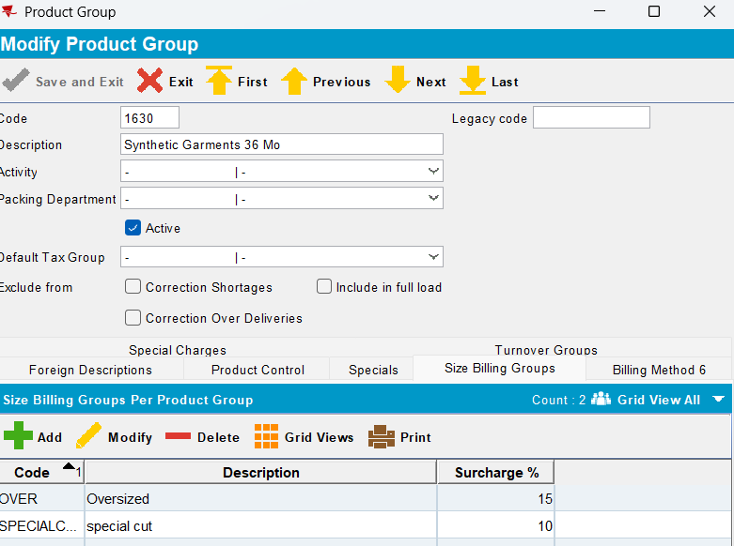
Request:
<?xml version="1.0" encoding="UTF-8"?>
<soapenv:Envelope xmlns:soapenv="http://schemas.xmlsoap.org/soap/envelope/" xmlns:urn="urn:ABS">
<soapenv:Header/>
<soapenv:Body>
<urn:processRequest>
<String_1><![CDATA[<ABSServiceHeader xmlns="http://absgroup/webservice/generated/xmlbindings/ABSServiceHeader">
<messageID xmlns="">IFR_01102</messageID>
<transactionType xmlns="">New</transactionType>
<function xmlns="">PRODUCTLISTPERCUSTOMER</function>
<application xmlns="">JUnit Test</application>
<customer xmlns="">Test</customer>
<webuser xmlns="">WEBUSER</webuser>
</ABSServiceHeader>]]></String_1>
<String_2><![CDATA[<?xml version="1.0" encoding="utf-8"?>
<tns:ProductListPerCustomerRequest xmlns:tns="http://absgroup/webservice/generated/xmlbindings/ProductListPerCustomerRequest"
xmlns:xsi="http://www.w3.org/2001/XMLSchema-instance"
xsi:schemaLocation="http://absgroup/webservice/generated/xmlbindings/ProductListPerCustomerRequest">
<ProductListPerCustomer>
<CustomerNumber>4724459</CustomerNumber>
<ProductCode>GS1724RYBL</ProductCode>
<SizeDefinitionCode>*</SizeDefinitionCode>
<FinishingMethodCode>-</FinishingMethodCode>
<RentPriceType>
<RentPrice>0.237</RentPrice>
<TypeOfRent>1</TypeOfRent>
<StartDate>
<year>2025</year>
<month>09</month>
<day>25</day>
<hours>0</hours>
<minutes>0</minutes>
<seconds>0</seconds>
<milliseconds>0</milliseconds>
</StartDate>
</RentPriceType>

<ReplacementPriceType>
<ReplacementPrice>0.357</ReplacementPrice>
<StartDate>
<year>2025</year>
<month>09</month>
<day>25</day>
<hours>0</hours>
<minutes>0</minutes>
<seconds>0</seconds>
<milliseconds>0</milliseconds>
</StartDate>
</ReplacementPriceType>

<SalesPriceType>
<SalesPrice>0.61</SalesPrice>
<StartDate>
<year>2025</year>
<month>09</month>
<day>25</day>
<hours>0</hours>
<minutes>0</minutes>
<seconds>0</seconds>
<milliseconds>0</milliseconds>
</StartDate>
</SalesPriceType>
</ProductListPerCustomer>

</tns:ProductListPerCustomerRequest>]]></String_2>
</urn:processRequest>
</soapenv:Body>
</soapenv:Envelope>

Response:
<env:Envelope xmlns:env=”http://schemas.xmlsoap.org/soap/envelope/” xmlns:xsd=”http://www.w3.org/2001/XMLSchema” xmlns:xsi=”http://www.w3.org/2001/XMLSchema-instance” xmlns:enc=”http://schemas.xmlsoap.org/soap/encoding/” xmlns:ns0=”urn:ABS”>
<env:Body>
<ns0:processRequestResponse>
<result>
<headerValue><![CDATA[<?xml version=”1.0” encoding=”UTF-8” standalone=”yes”?>
<ABSServiceResponse xmlns=”http://absgroup/webservice/generated/xmlbindings/ABSServiceResponse”>
<messageID xmlns=””>IFR_220917</messageID>
<ResponseCode xmlns=””>OK</ResponseCode>
<Message xmlns=””></Message>
</ABSServiceResponse>]]></headerValue>
<returnValue><![CDATA[<?xml version=”1.0” encoding=”UTF-8” standalone=”yes”?>
<ProductListPerCustomerTypeResponse xmlns=”http://absgroup/webservice/generated/xmlbindings/ProductListPerCustomerResponse”>
<ProductListPerCustomerID>
<ProductListPerCustomer_ID>31777</ProductListPerCustomer_ID>
</ProductListPerCustomerID>
</ProductListPerCustomerTypeResponse>]]></returnValue>
</result>
</ns0:processRequestResponse>
</env:Body>
</env:Envelope>

- Result: ok -> only replacement and sales prices are with SBG:

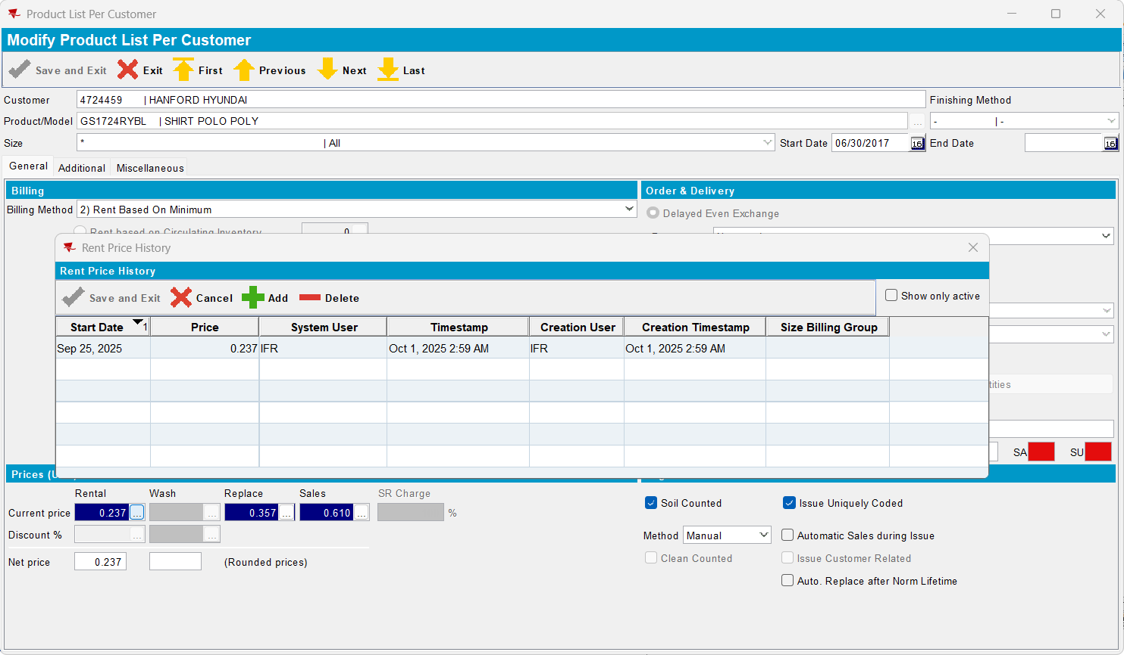

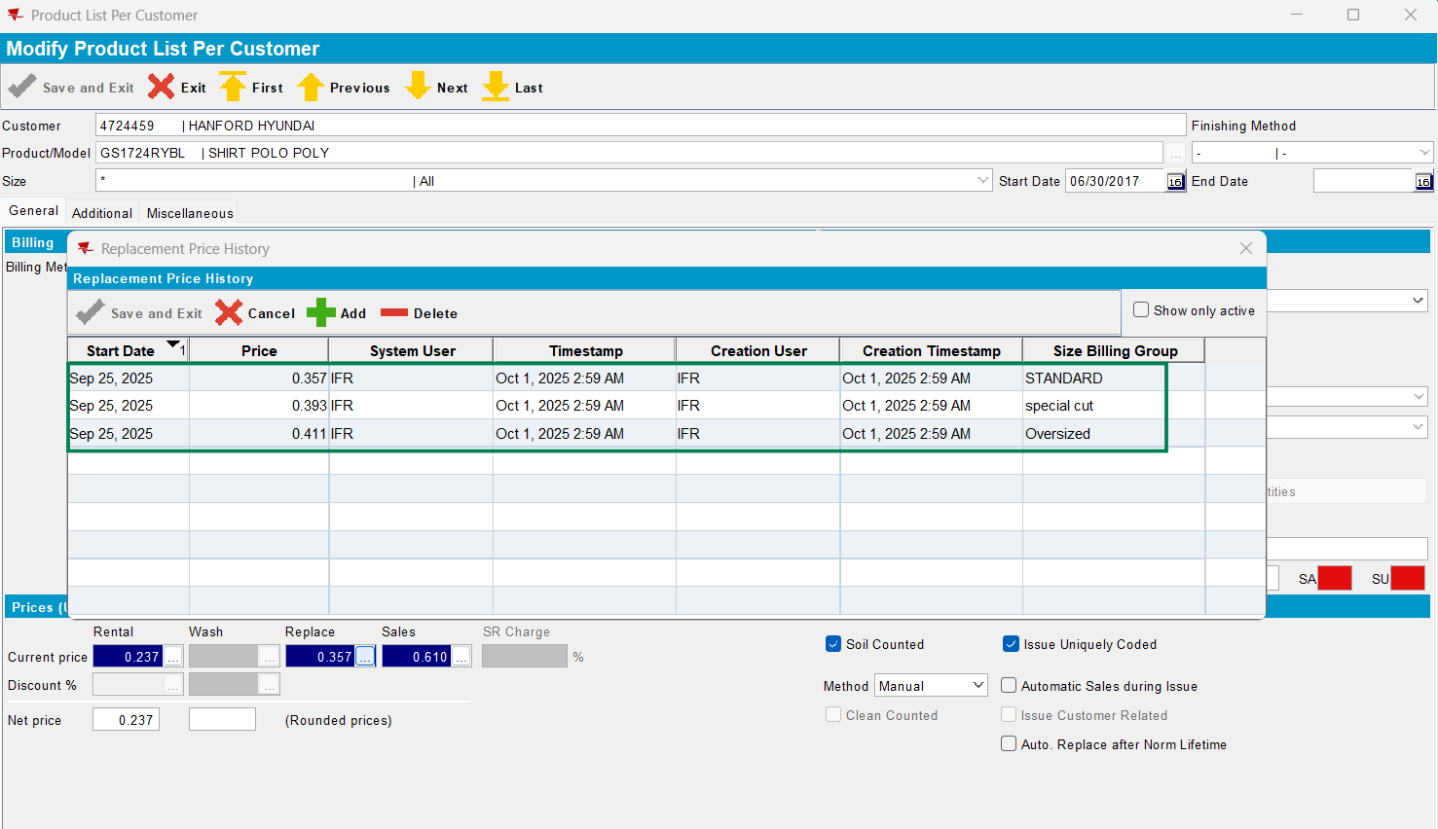

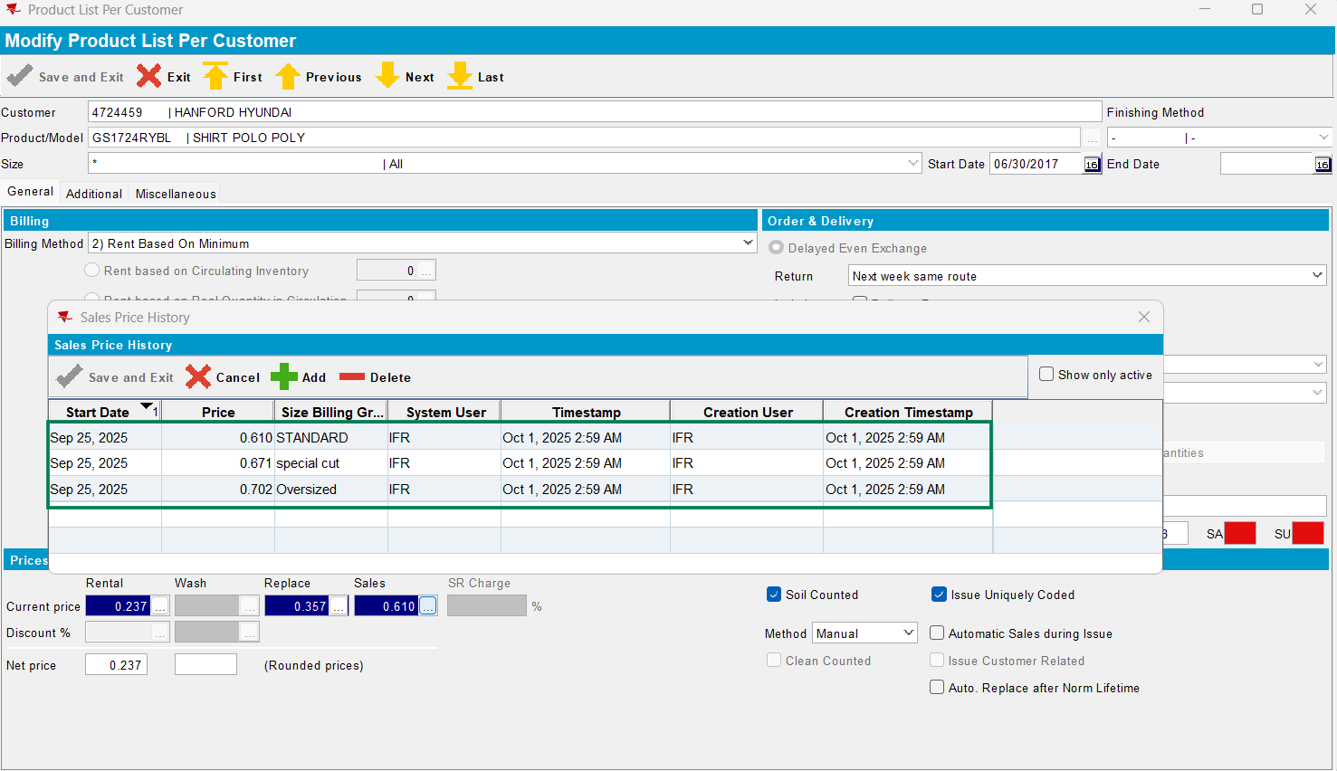

Test case 5:
- Module: CHARGESPECIALSIZE
- System setting: SIZESPECIALCHARGEOPTIONS=5

- Result: ok -> only rent and replacement prices are with SBG:

Request:
<?xml version="1.0" encoding="UTF-8"?>
<soapenv:Envelope xmlns:soapenv="http://schemas.xmlsoap.org/soap/envelope/" xmlns:urn="urn:ABS">
<soapenv:Header/>
<soapenv:Body>
<urn:processRequest>
<String_1><![CDATA[<ABSServiceHeader xmlns="http://absgroup/webservice/generated/xmlbindings/ABSServiceHeader">
<messageID xmlns="">IFR_01103</messageID>
<transactionType xmlns="">New</transactionType>
<function xmlns="">PRODUCTLISTPERCUSTOMER</function>
<application xmlns="">JUnit Test</application>
<customer xmlns="">Test</customer>
<webuser xmlns="">WEBUSER</webuser>
</ABSServiceHeader>]]></String_1>
<String_2><![CDATA[<?xml version="1.0" encoding="utf-8"?>
<tns:ProductListPerCustomerRequest xmlns:tns="http://absgroup/webservice/generated/xmlbindings/ProductListPerCustomerRequest"
xmlns:xsi="http://www.w3.org/2001/XMLSchema-instance"
xsi:schemaLocation="http://absgroup/webservice/generated/xmlbindings/ProductListPerCustomerRequest">
<ProductListPerCustomer>
<CustomerNumber>4724459</CustomerNumber>
<ProductCode>GS1724RYBL</ProductCode>
<SizeDefinitionCode>*</SizeDefinitionCode>
<FinishingMethodCode>-</FinishingMethodCode>
<RentPriceType>
<RentPrice>0.437</RentPrice>
<TypeOfRent>1</TypeOfRent>
<StartDate>
<year>2025</year>
<month>10</month>
<day>01</day>
<hours>0</hours>
<minutes>0</minutes>
<seconds>0</seconds>
<milliseconds>0</milliseconds>
</StartDate>
</RentPriceType>

<ReplacementPriceType>
<ReplacementPrice>0.457</ReplacementPrice>
<StartDate>
<year>2025</year>
<month>10</month>
<day>01</day>
<hours>0</hours>
<minutes>0</minutes>
<seconds>0</seconds>
<milliseconds>0</milliseconds>
</StartDate>
</ReplacementPriceType>

<SalesPriceType>
<SalesPrice>0.7</SalesPrice>
<StartDate>
<year>2025</year>
<month>10</month>
<day>01</day>
<hours>0</hours>
<minutes>0</minutes>
<seconds>0</seconds>
<milliseconds>0</milliseconds>
</StartDate>
</SalesPriceType>
</ProductListPerCustomer>

</tns:ProductListPerCustomerRequest>]]></String_2>
</urn:processRequest>
</soapenv:Body>
</soapenv:Envelope>

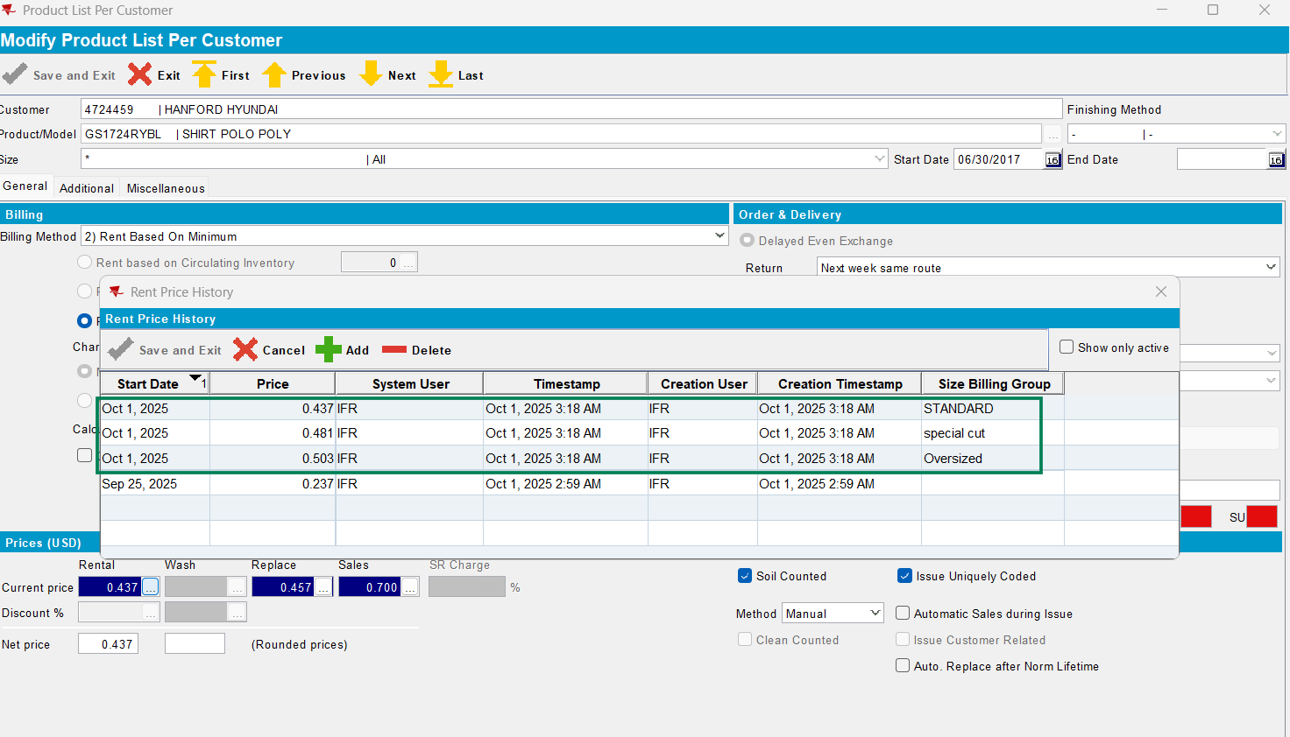
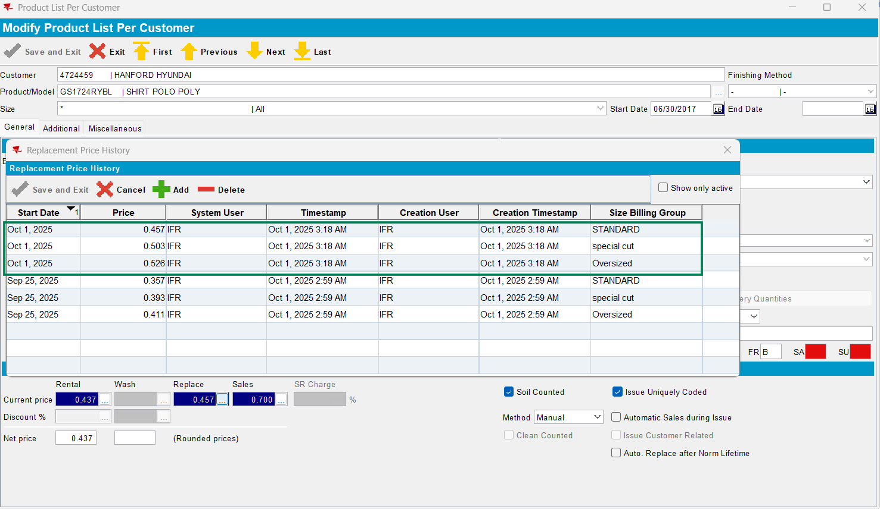
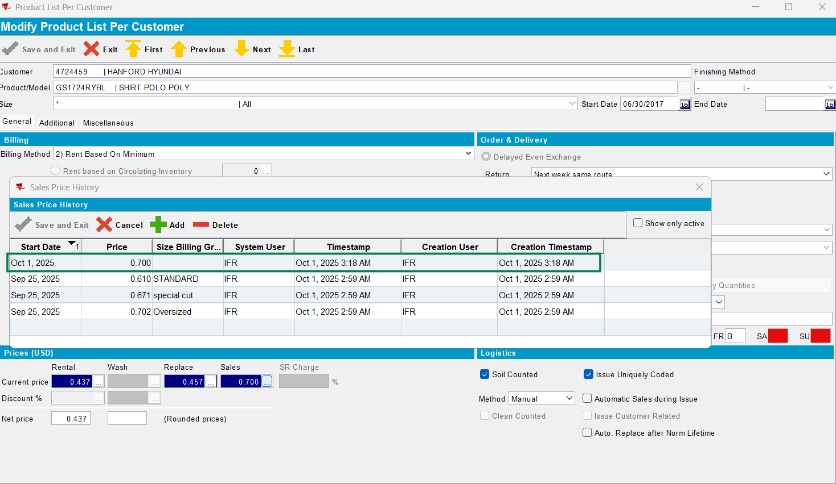
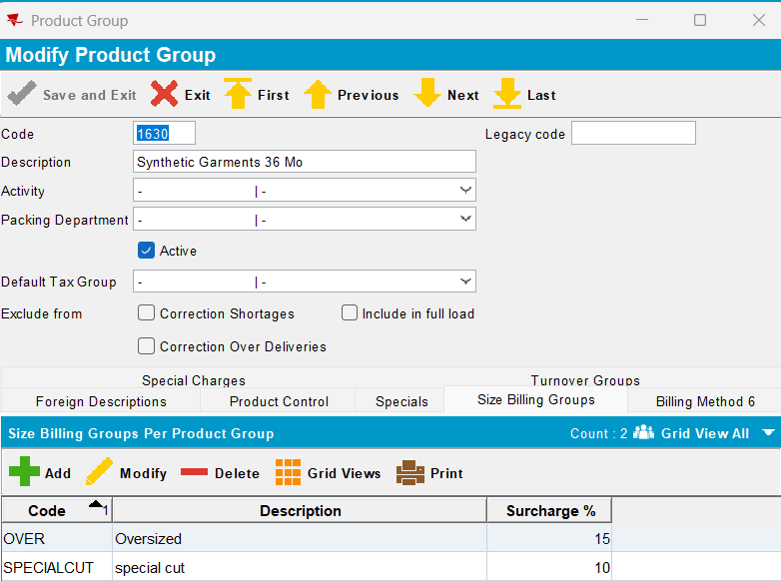

- SIZESPECIALCHARGEOPTIONS=2
- Sales with SBG:
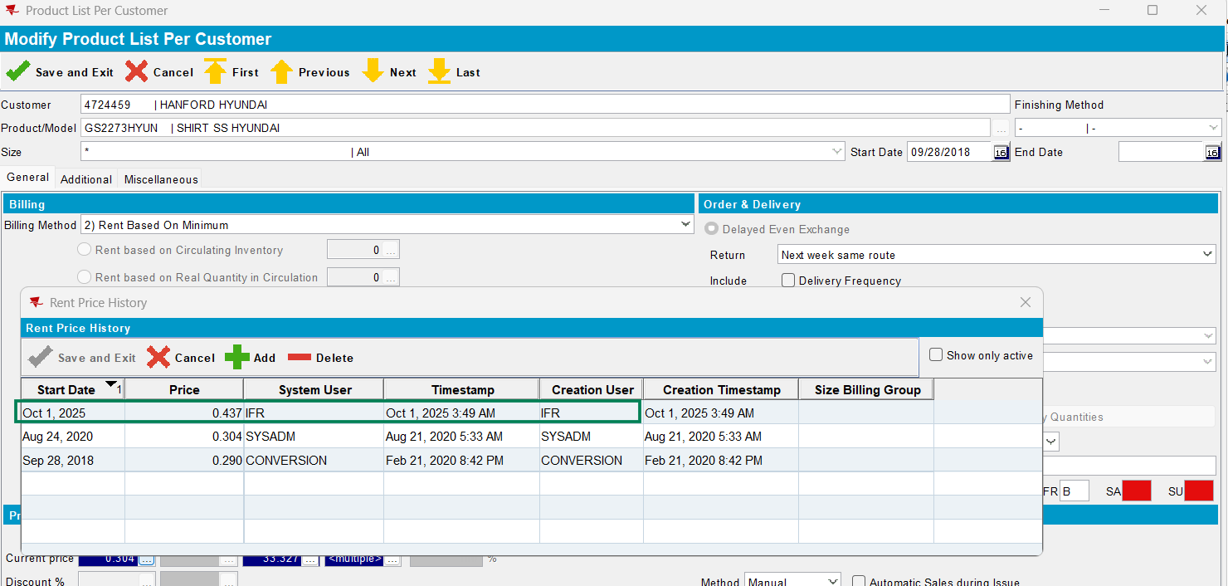
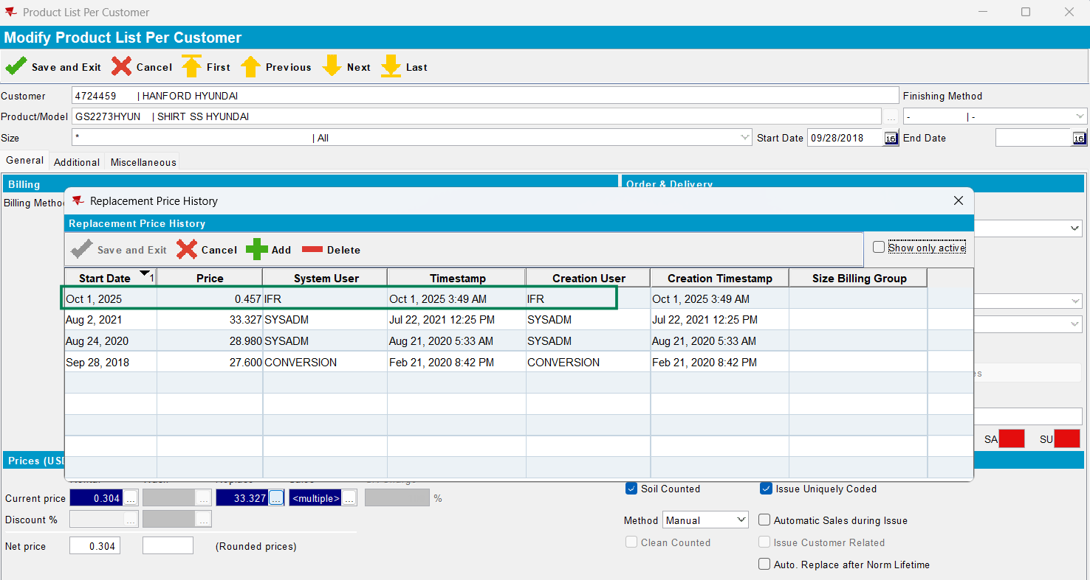
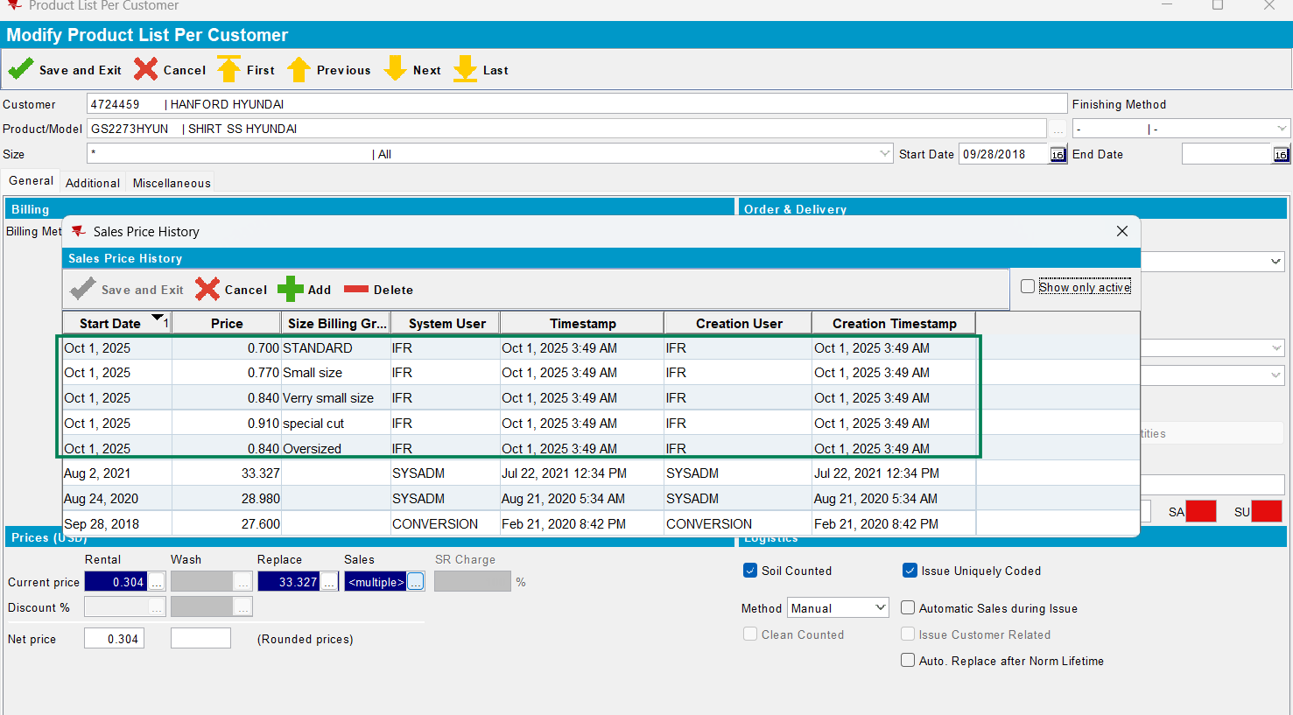

Test case 6:
- No module: CHARGESPECIALSIZE
- Prices without SBG:
