ABSN-8801 Get the invoice into Visit status on Web Checkin with a PayThisAmount 0 and no adjustment reason code
Environment | Prerequisites
Version: 9.08.00.RELEASE.p22  Environment=PRODUCTION  DBServerName=abs-srv17.internal.abslbs.com  DBSID= CUST23  DBUser= AUS_MNT90800  DBPassword= AUS_ MNT90800 | - Modules: AUSCUSTOM,  USEROUTECHECKINSCREEN, INVOICELINEADJADDRULE,  INVOICELINEADJAPPROVERULE,  INVOICELINEADJMODIFYRULE,  INVOICELINEADJVALUERULE  - Others: BU 503

Contents
Reproduction before fix 1
Retesting after fix 2

Reproduction before fix

Pre-conditions:
USEROUTECHECKINSCREEN=Y
INVOICELINEADJADDRULE=1
INVOICELINEADJAPPROVERULE=1
INVOICELINEADJMODIFYRULE=1
INVOICELINEADJNORARULE=1
INVOICELINEADJVALUERULE=0
Route: 82 from 20.06.2025 on master

Steps to reproduce:
- Initial:
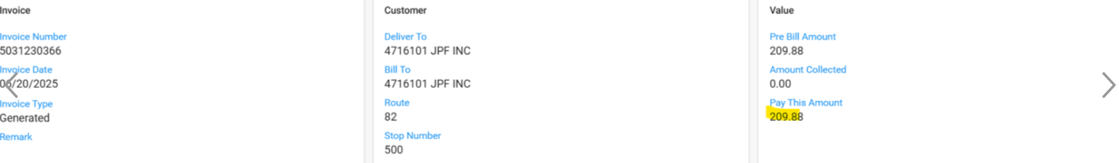

- Press Change Visit Status button (WebX/ Overview tab), check Unable to deliver check box, choose a reason code and press save:
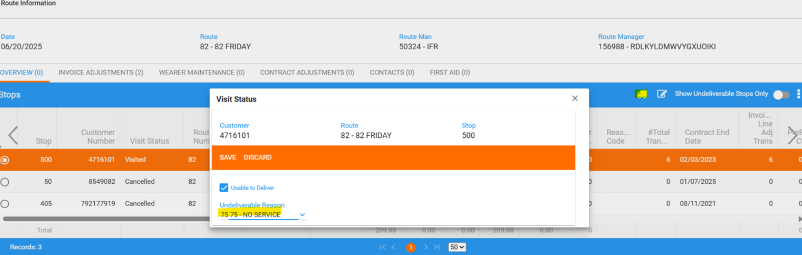
- Total amount now is = 0
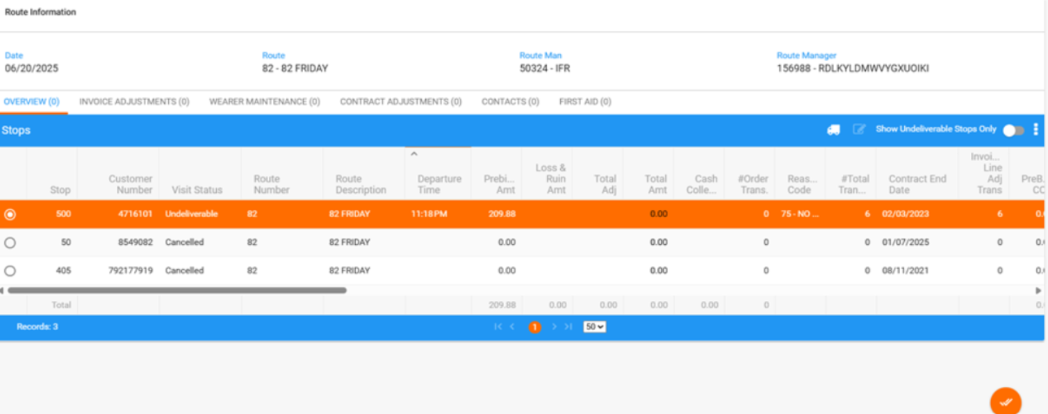

- Click on the truck again, for same line, and uncheck Unable to deliver, but don't select an Undeliverable Reason
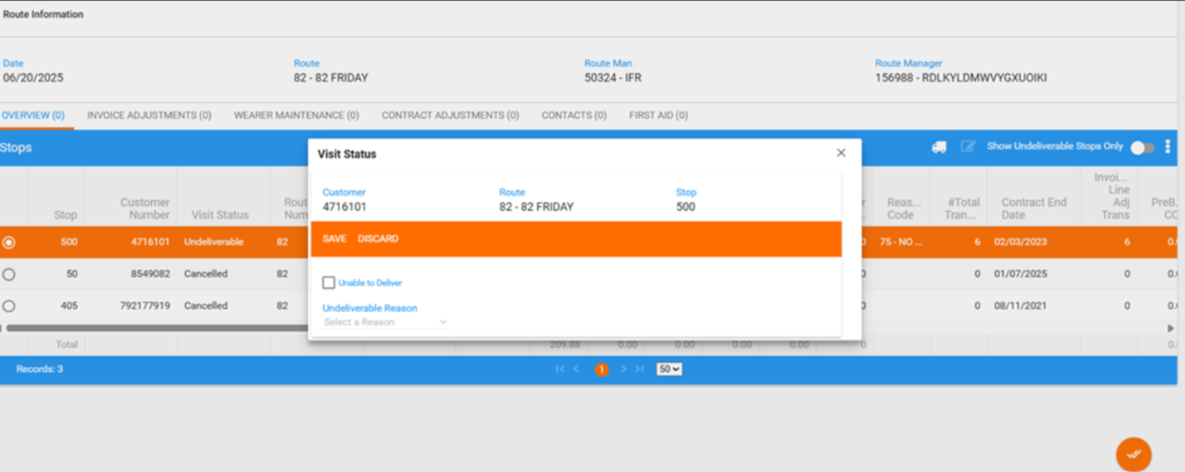

Actual result:
- Then re-check the Unable to Deliver checkbox, and now the system lets you save the record still without selecting a reason -> nok

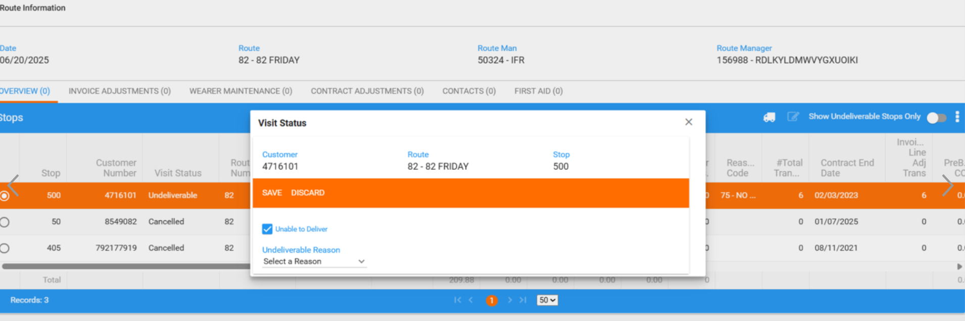

- Status becomes = Visited but total amount is 0 -> nok
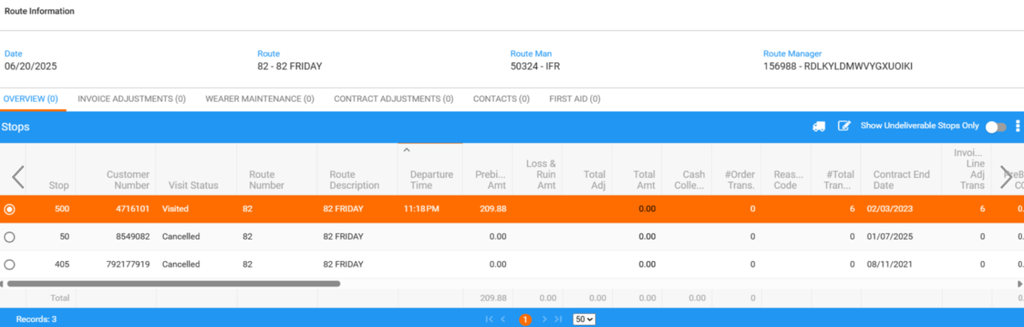

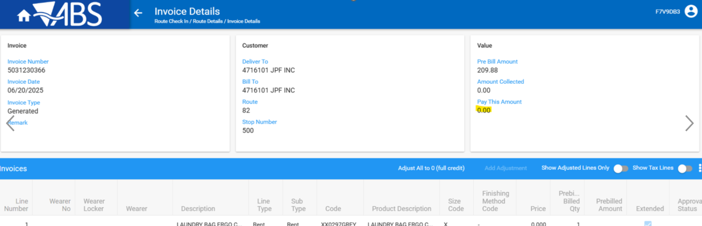

- and the transactions are further rejected:

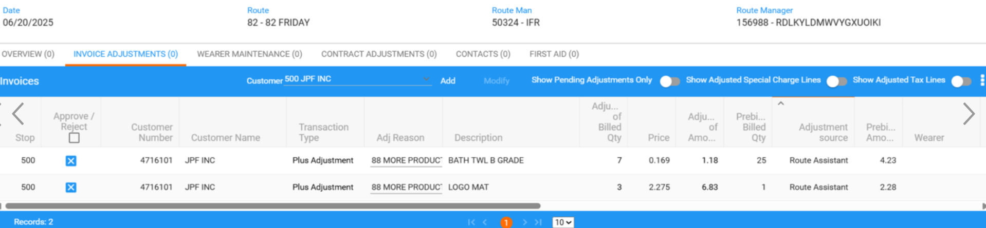

Retesting after fix

Route 6 from 13.01.2025
Initial:
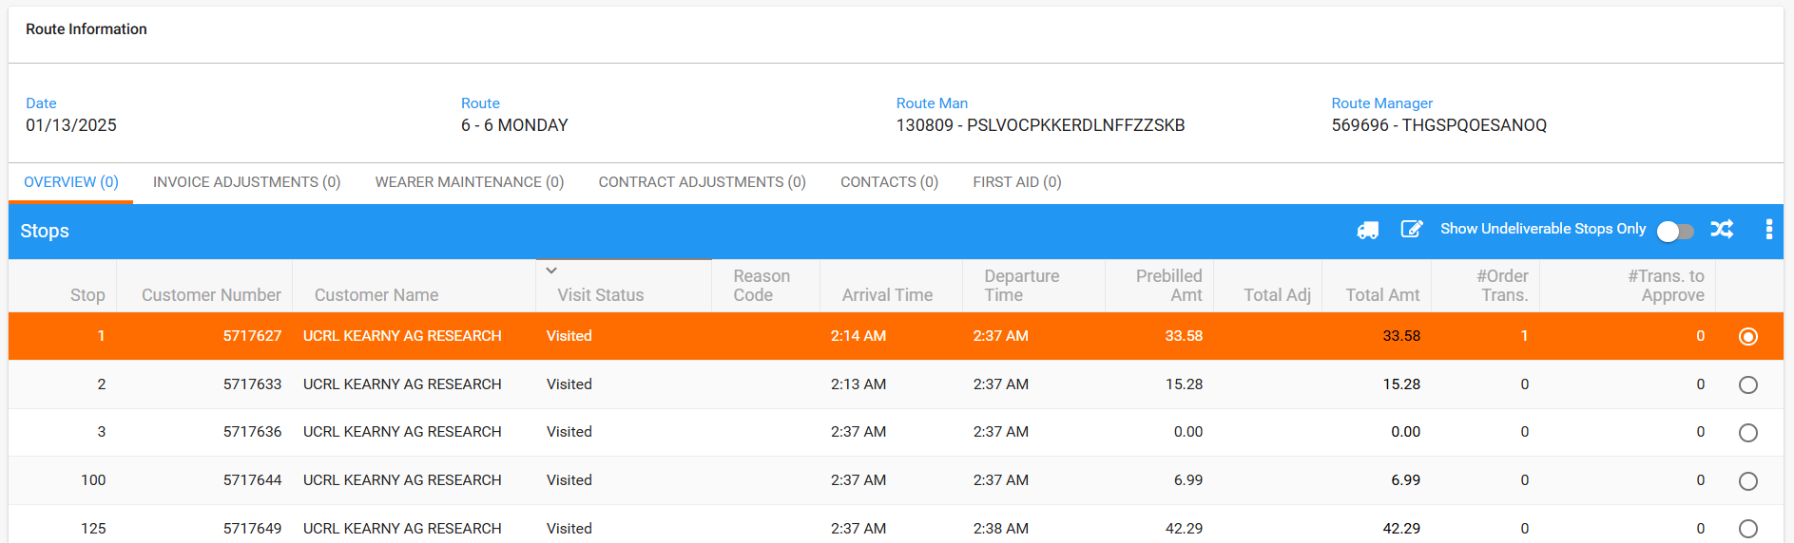

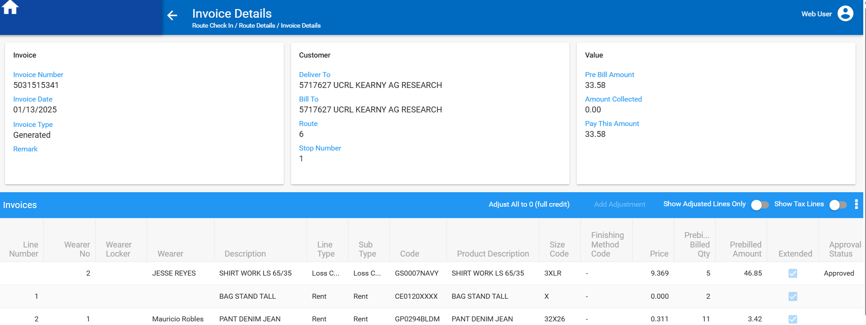

- Press Change Visit Status button (WebX/ Overview tab), check Unable to deliver check box, choose a reason code and press save:

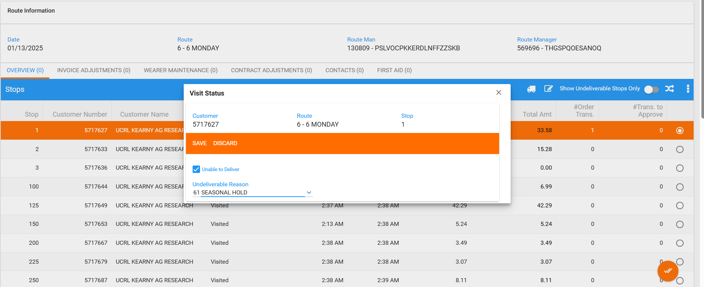

- Total amount now is = 0

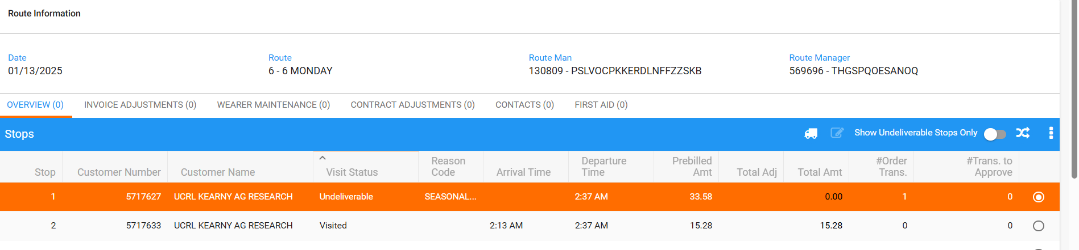

- All transactions are rejected:

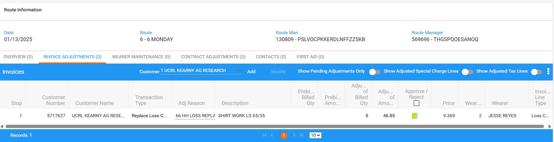

- Click on the truck again, for same line, and uncheck Unable to deliver, but don't select an Undeliverable Reason
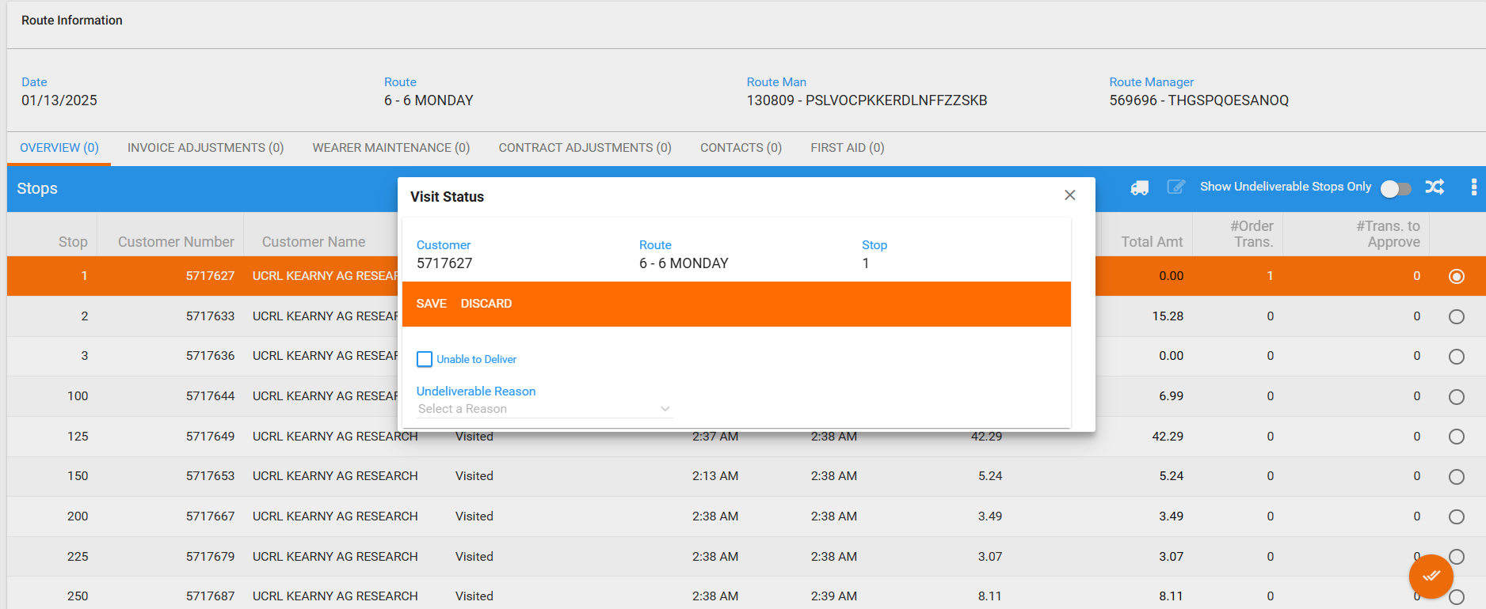
- Then re-check the Unable to Deliver checkbox, and now the system doesn’t let you save the record without selecting a reason -> ok

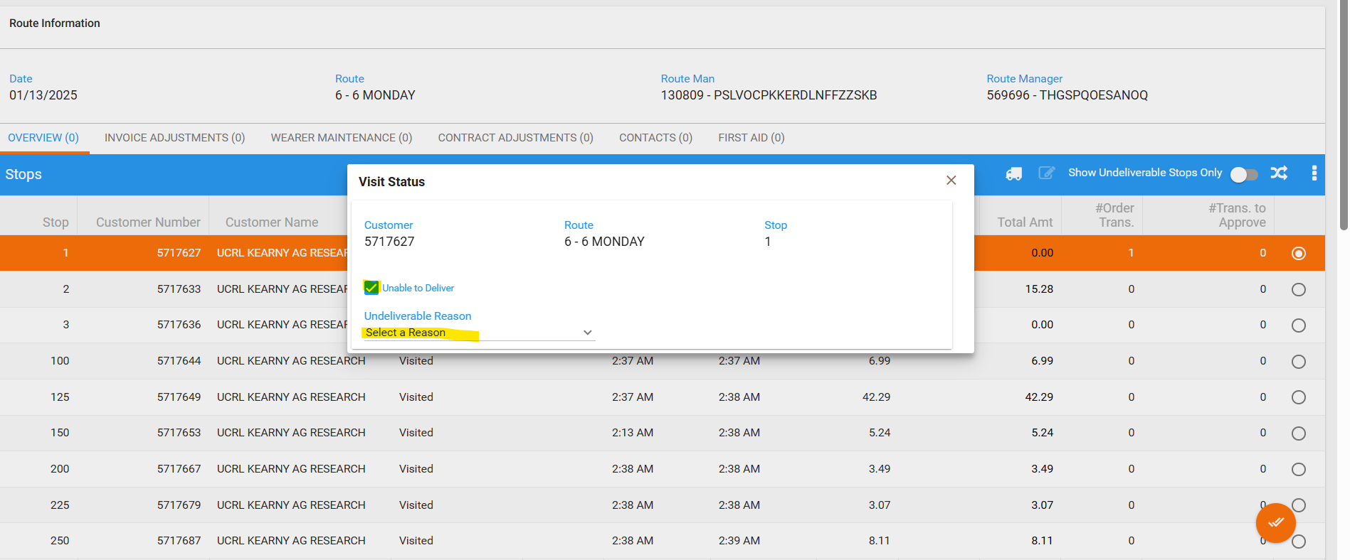

Passed.

