ABSN-8518 Stops with order now and deliver now are not uploading
Environment | Prerequisites
Version: 9.08.00.RELEASE.p21  DBServerName=abs-srv17.internal.abslbs.com  DBSID=CUST23  DBUser=AUS_MNT90800  DBPassword= AUS_MNT90800  Environment=Production  Branch: bugfix/ABSN-8518-stops-with-order-now-and-deliver-now-are-not-uploading-90800_AUS | - Module: AUSCUSTOM  ROUTEASSISTANT  ROUTEASSISTANTCONTRACT  ROUTEASSISTANTGARMENT  ROUTEASSISTANTNAVIGATION  FACILITYSERVICE  TRADE  ROUTEASSISTANTANDROID  ROUTEASSISTANTONEOFFORDER  BULKPACKINGASSISTANT  - System setting: BPAPACKBYSTOP, SALESNOTEDIRECTINVOICE, ERPCUSTOMERINTEGRATION, REASONCODEFORTRUCKSALE,  PDAAUTOSYNCROUTE,  PDAAUTOSYNCSTOP  - Others: BU:250 Minneapolis, RA: 13.25

Contents
Reproducing before fix 1
Retest after fix 18

Reproducing before fix
Hash: 0575915
- Have following modules in the license file:
- ROUTEASSISTANT
- ROUTEASSISTANTCONTRACT
- ROUTEASSISTANTGARMENT
- ROUTEASSISTANTNAVIGATION
- FACILITYSERVICE
- TRADE
- ROUTEASSISTANTANDROID
- ROUTEASSISTANTONEOFFORDER
- BULKPACKINGASSISTANT
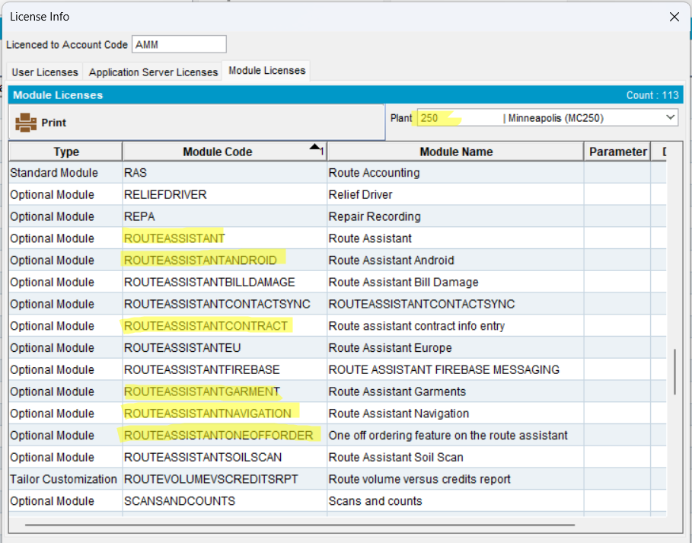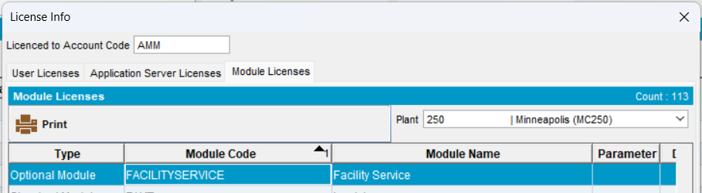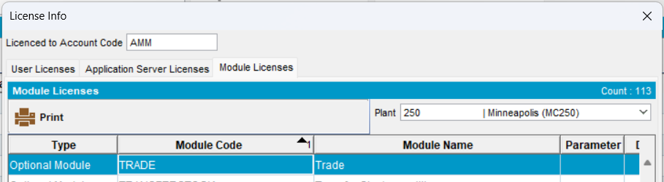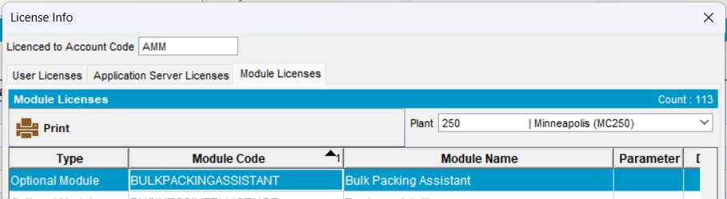
- Set the following ss:
- PDAAUTOSYNCROUTE = Y
- PDAAUTOSYNCSTOP = Y
- BPAPACKBYSTOP = 1
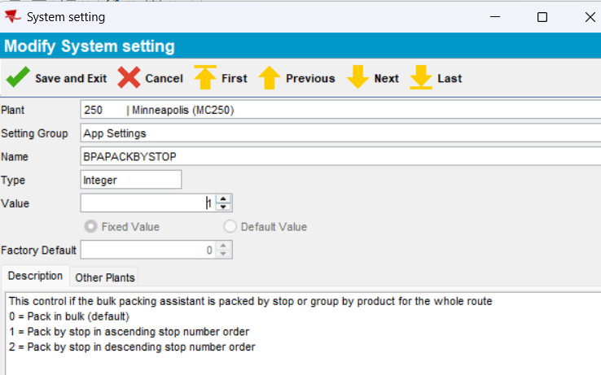
- SALESNOTEDIRECTINVOICE =YES
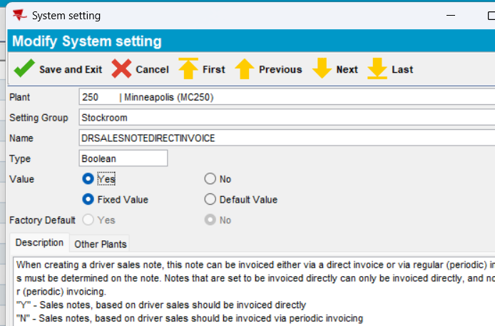
- REASONCODEFORTRUCKSALE
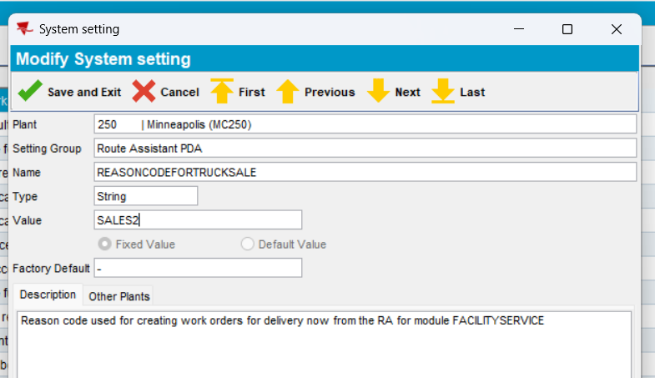
- RECORDPASSIVETRUCKSTOCK=Y
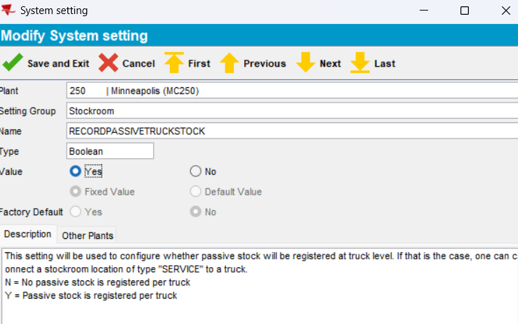
- ADD THE Reason code
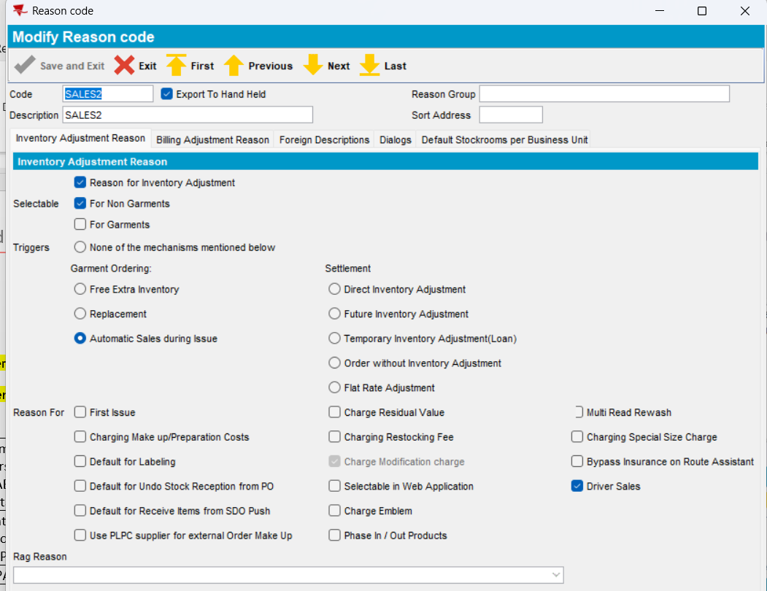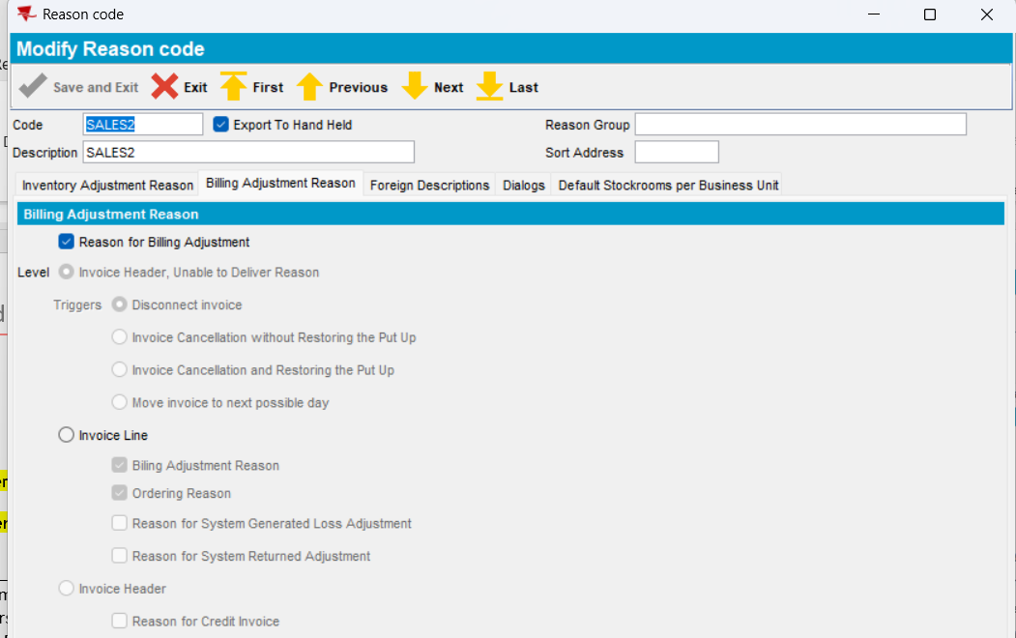
- Configure stockrooms correctly at the Business Unit level
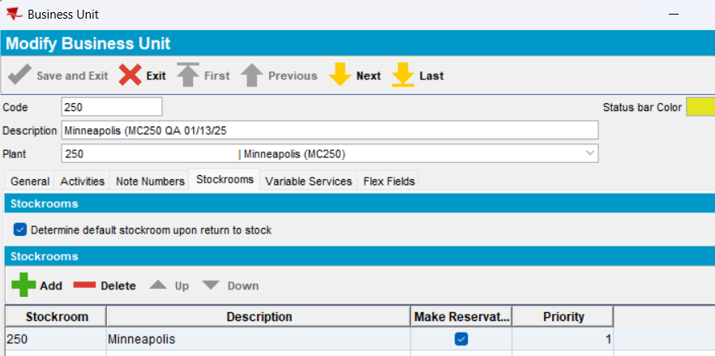
- Add a truck
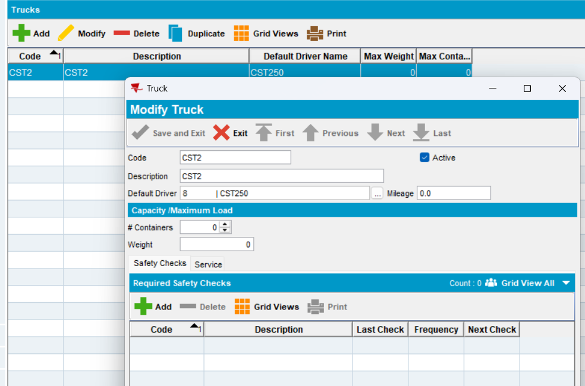
- First, a Stockroom needs to be set up for each truck. (In order to sell product directly from the driver’s truck, each truck must be set up as a separate stockroom, with the products carried on the truck defined with standard locations. If automatic truck stock replenishment orders are to be created, minimum stock quantities must be defined, and an internal customer must be set up and linked to the truck stockroom.)
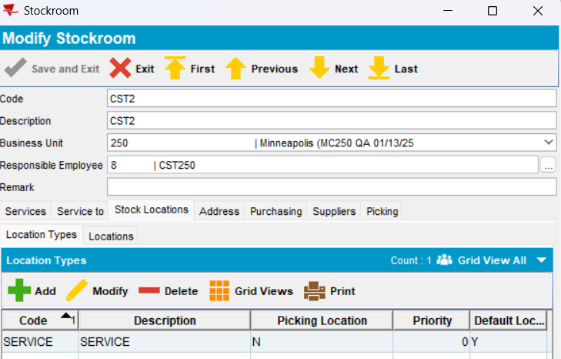
- One location must be set up for the truck stockroom as well – type of merchandise: sale/disposable, NON-UNIQUES
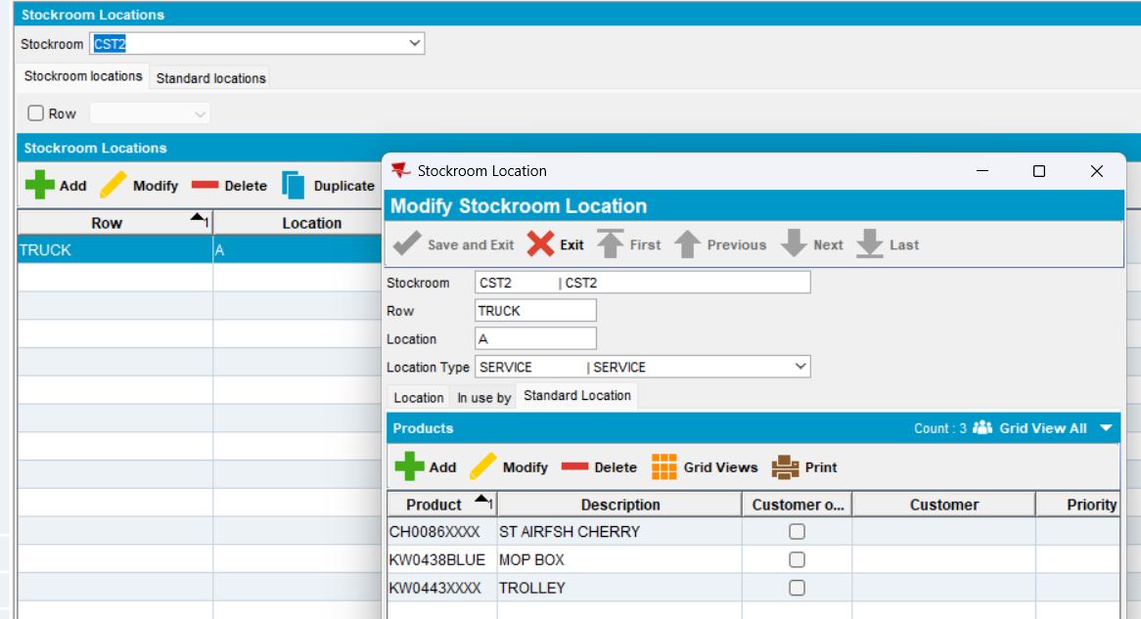
- In Non-Unique Stock Correction, the minimum stock quantity per product can then be set up for each product that will be carried on the truck:

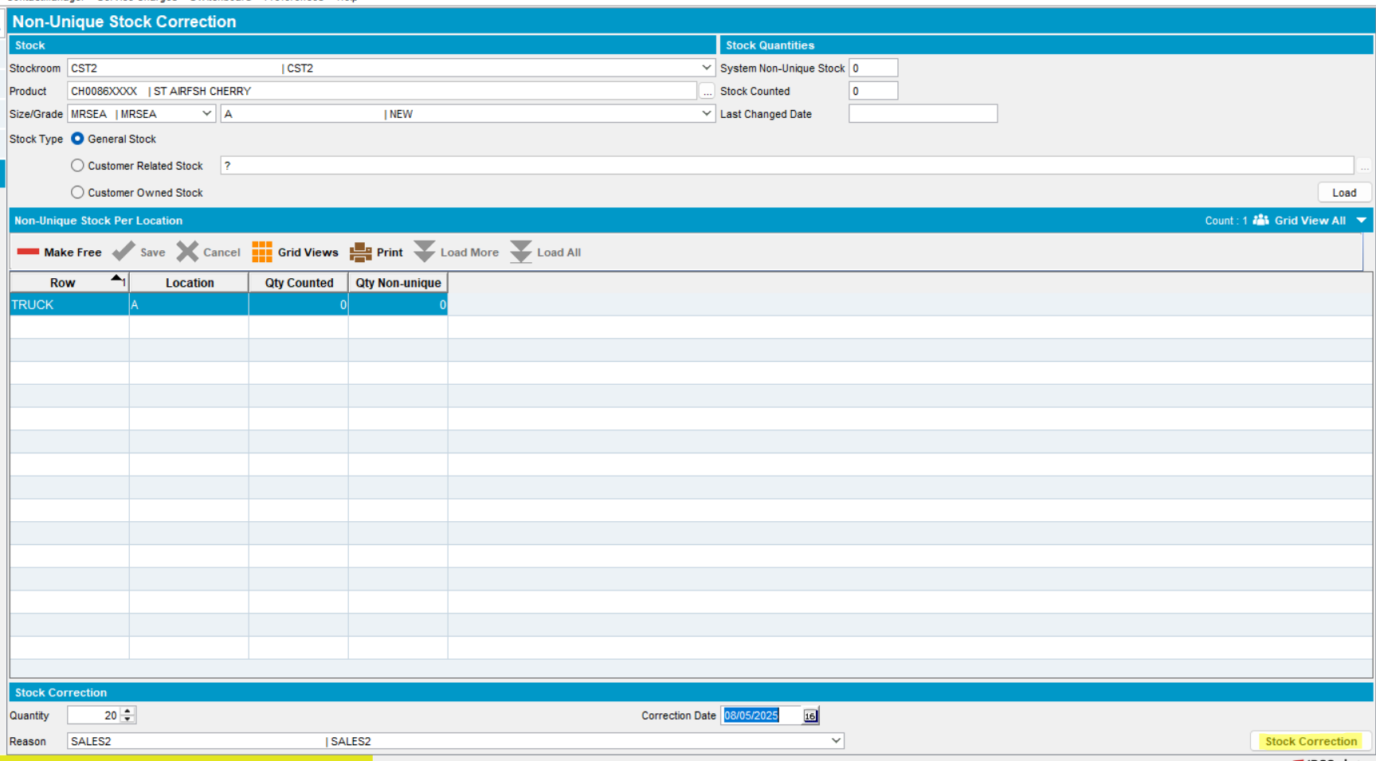
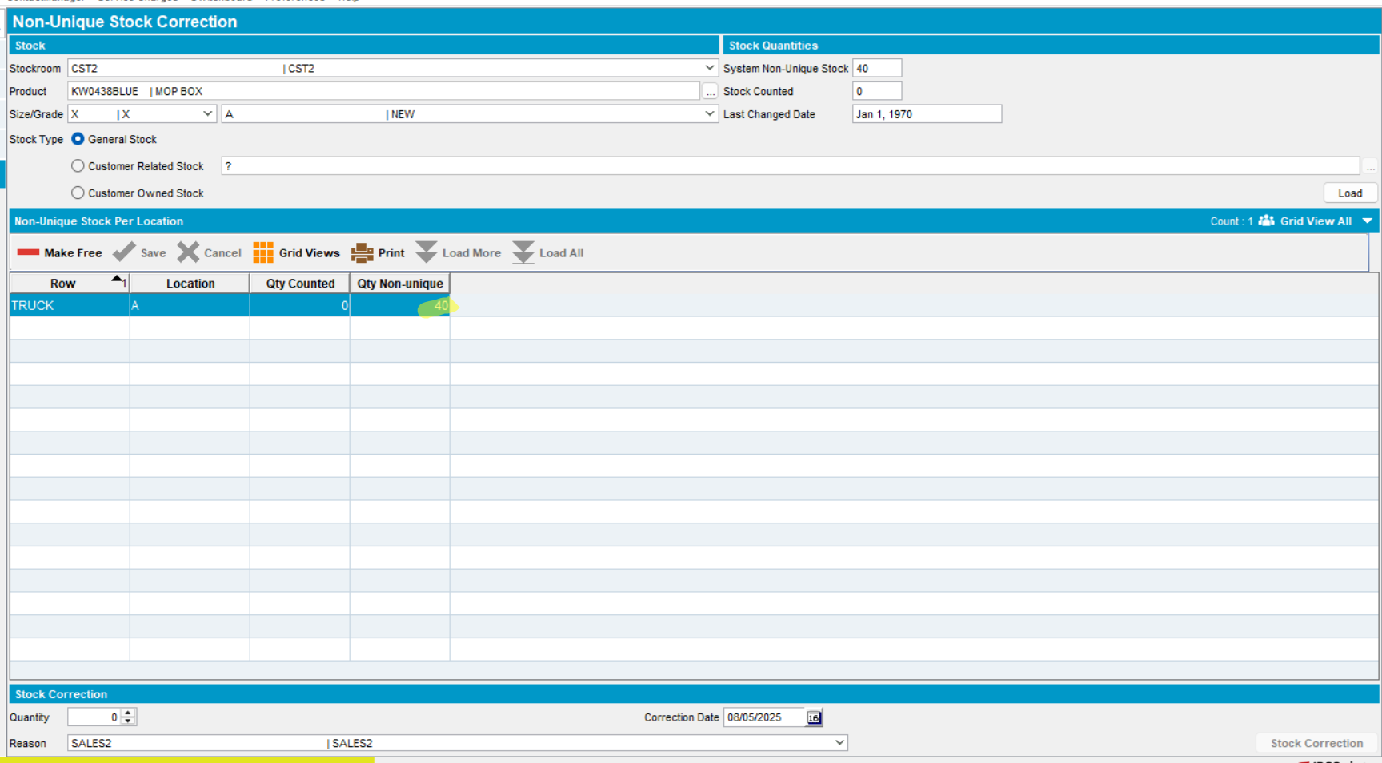
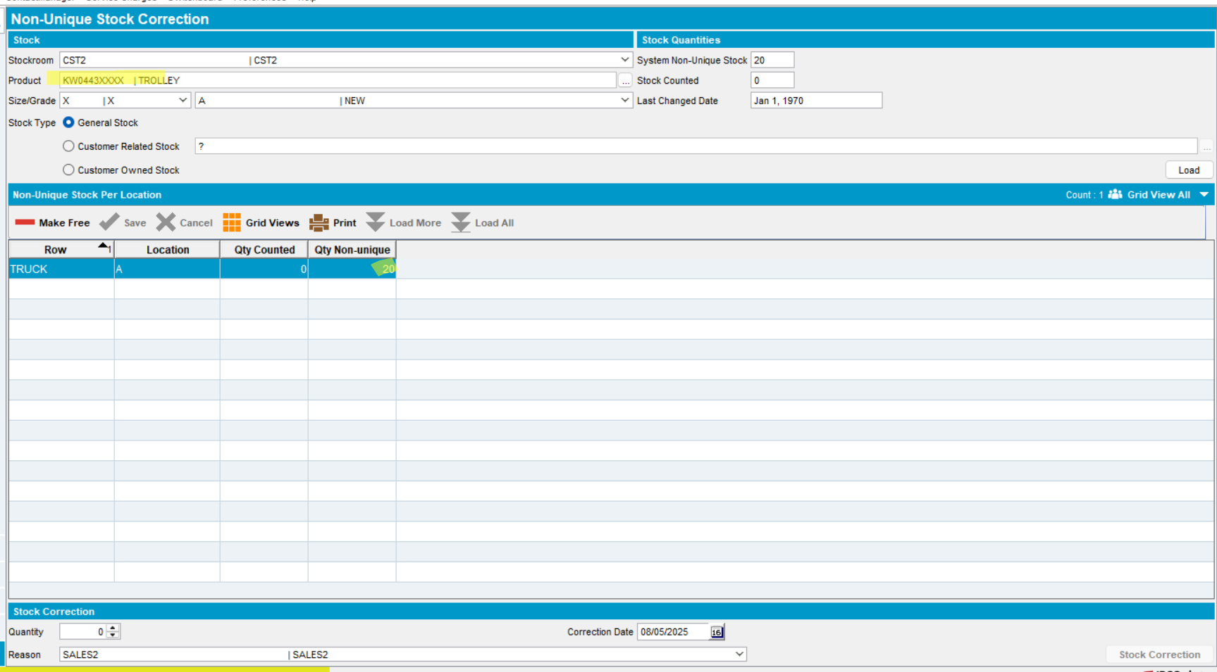
- Items were received in stock
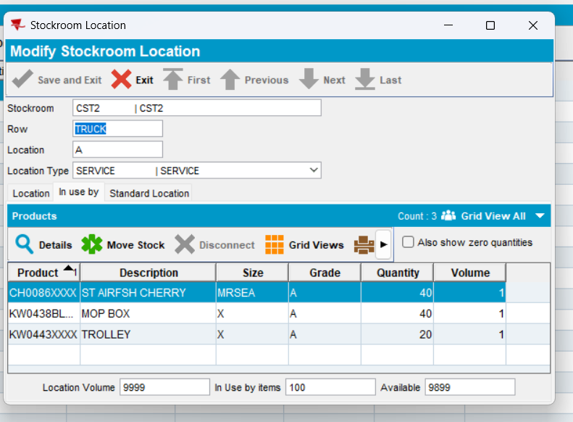
SPECIAL NOTE: All truck stock transactions will be created for the Quality Grade of type New with the highest priority as defined by the laundry.
- To note, for use of the BPA, products need to be set as putup type Bulk Packing at the Product level.
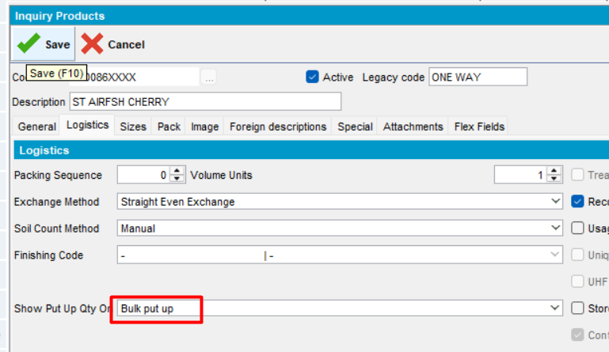
- Next, a unique Customer needs to be created per truck that is set up as an Internal Customer, linked to a Truck Stockroom:
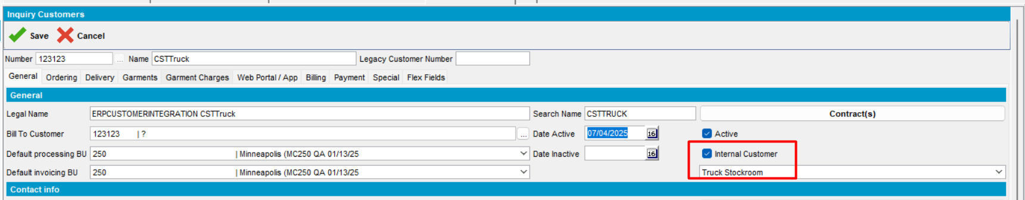
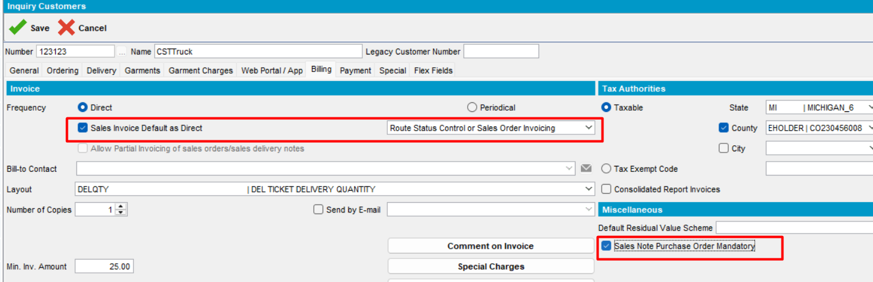
This customer does not need to have any delivery schemes set up, or be linked to any routes at the Customer level.
- Finally, a Truck needs to be created and linked to the truck stockroom, and the Internal Customer:
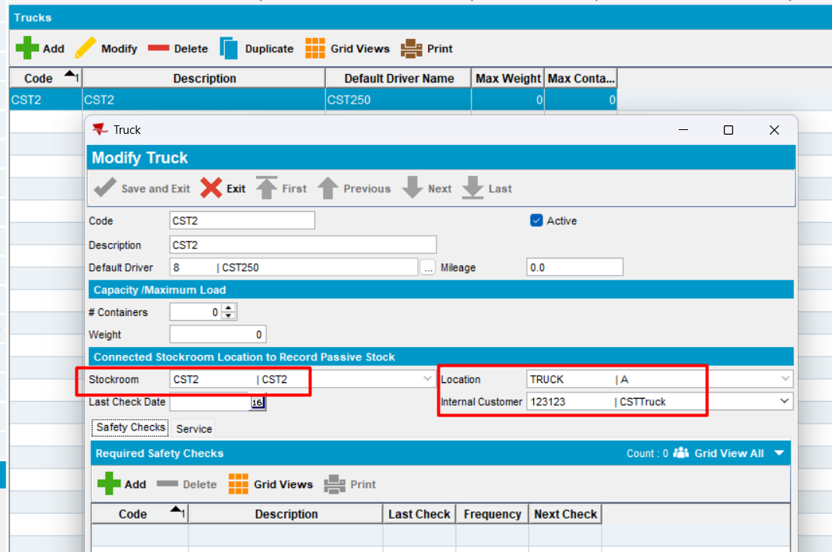
This truck should be set at the Route level accordingly as well.
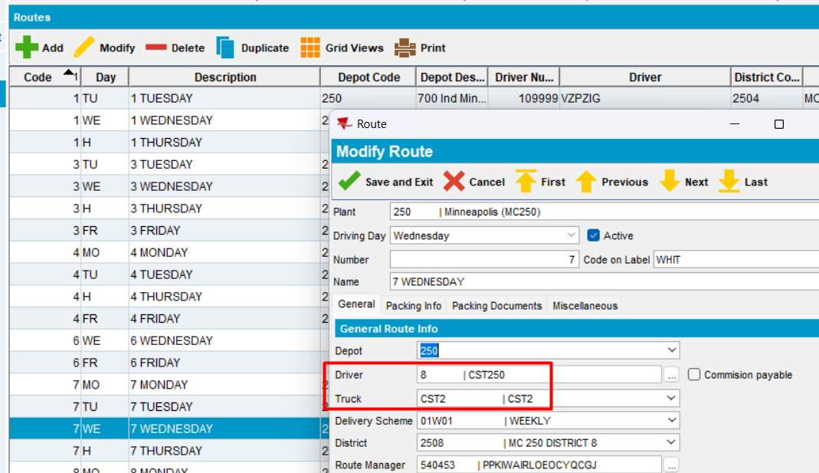
To properly set the starting inventory of a truck stockroom, manual stock transactions can be created, keeping in mind to use the correct quality grade as noted above.
- In order for inventory to be properly tracked to truck stock, the stockroom supplying the truck must be set up with the products that the truck uses as well. This would typically be the main stockroom or warehouse of the laundry. In the stockroom, the products that will be stocked to the truck stockroom must have a standard location set in a location of type PICK:
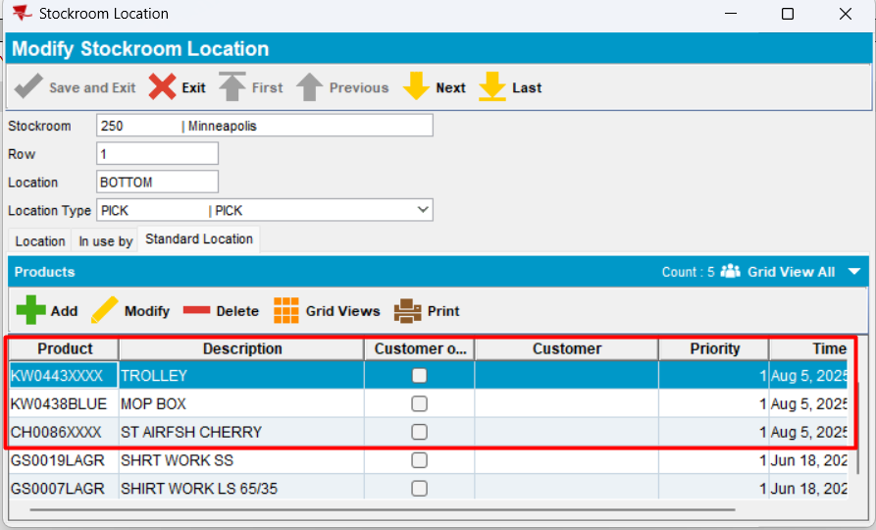
- Set an activity per customer
- Add a general price lists
- In price lists per customer, add the general price list to customer
- In PLPC, for a different customer that is on the same route control, add the products
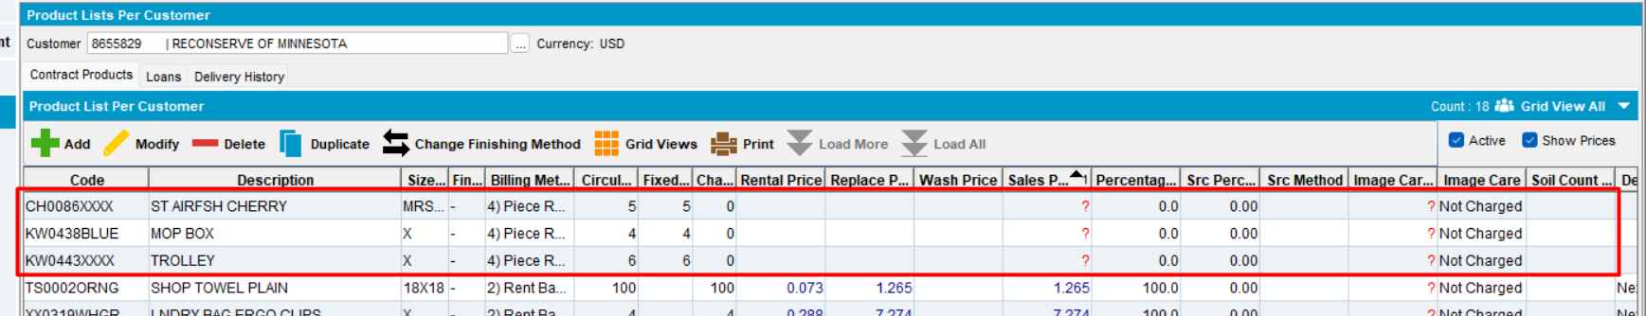
- Workstation settings
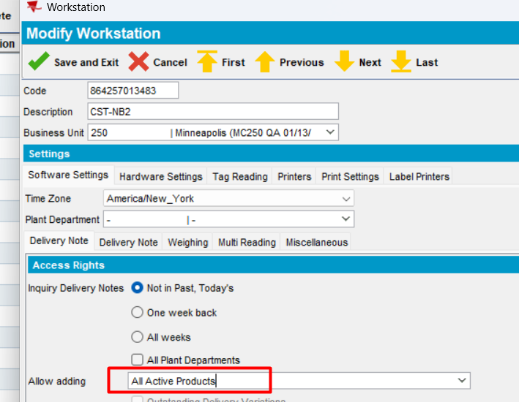
- Consumption Point Product level, the Circulating Inventory can be set to indicate on the RA what the stock level of each given product should be:
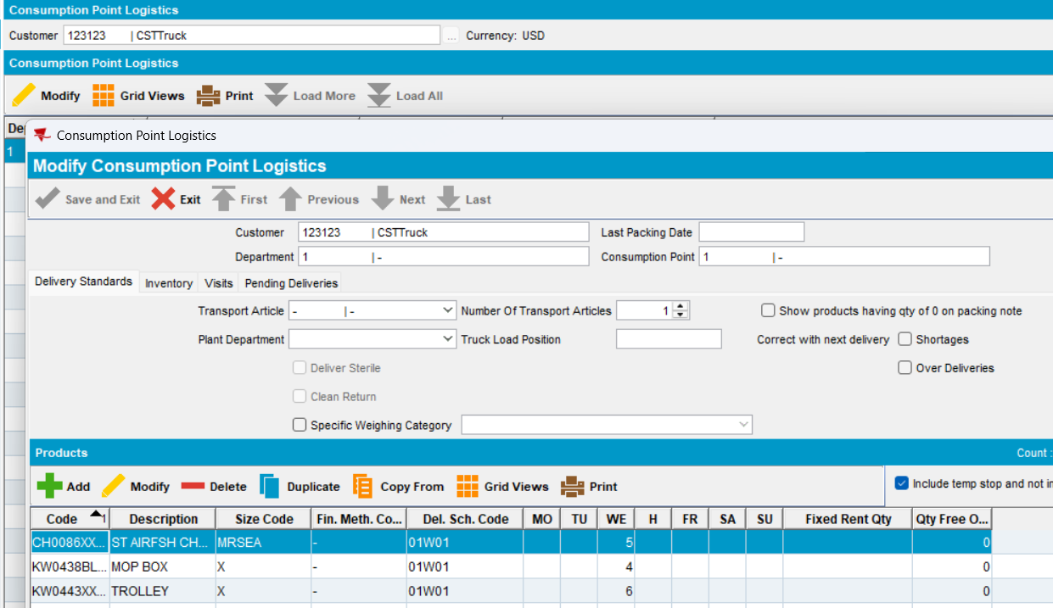
- In Route Status Control dlg, add a route control. Keep only the internal customer and the customer that has products added in PLPC
- Add an employee
- Add a mobile device and attach the employee to mobile device
- Add the driver to the specific route control
- Generate Packing Notes for the route
- Generate Invoices for the route
- Mark the route control “Ready for transfer to PDA”
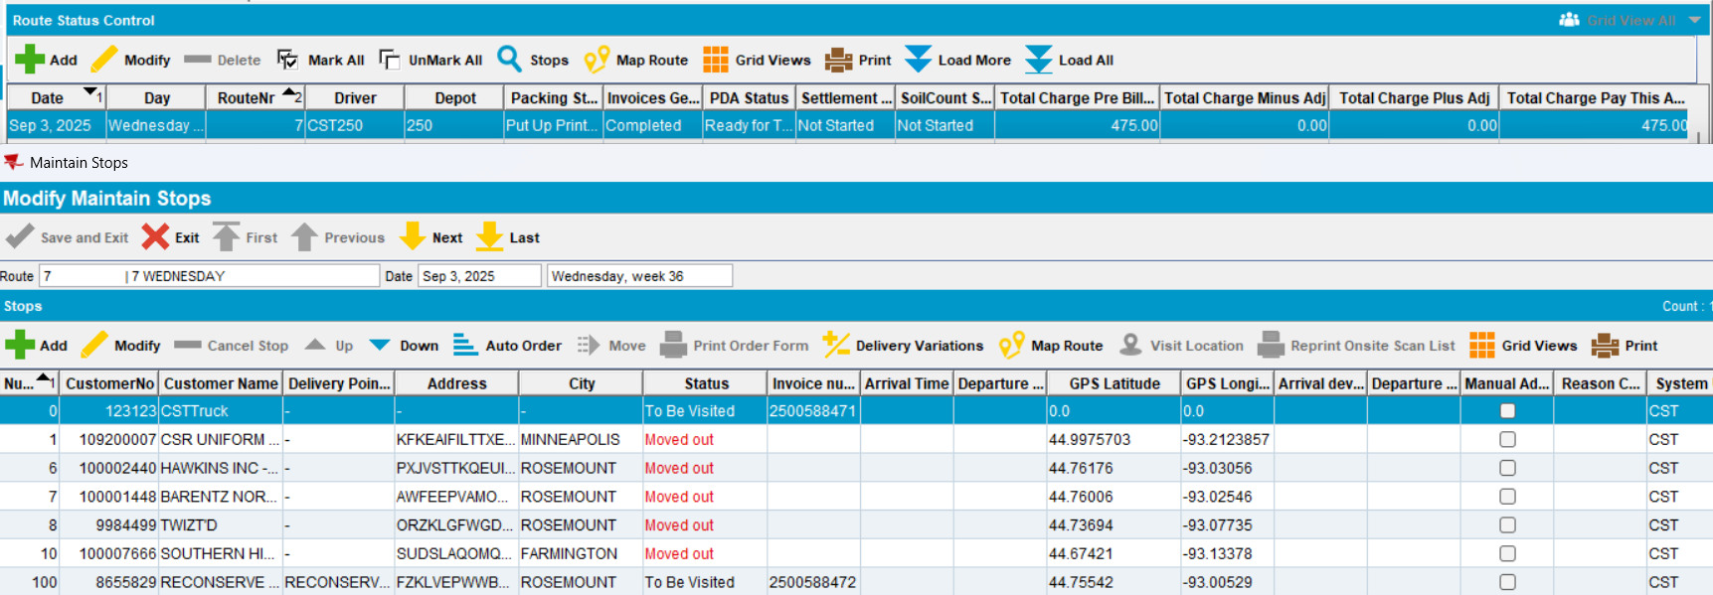
- Download the route to PDA
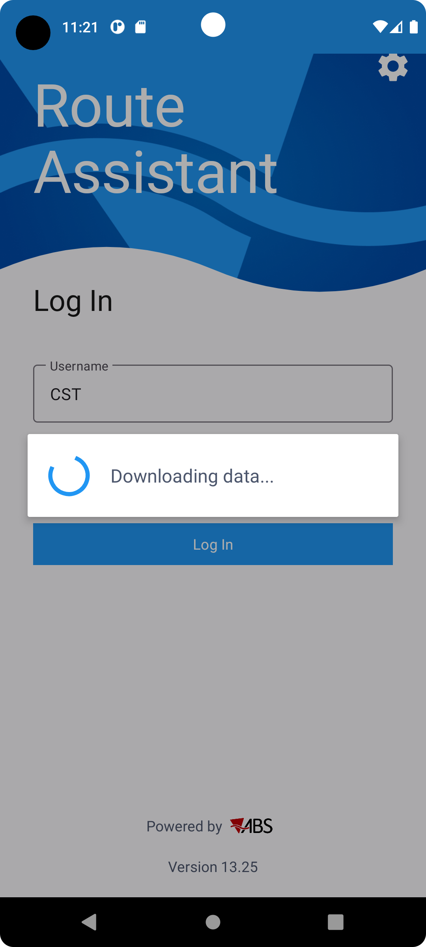
ORDERING
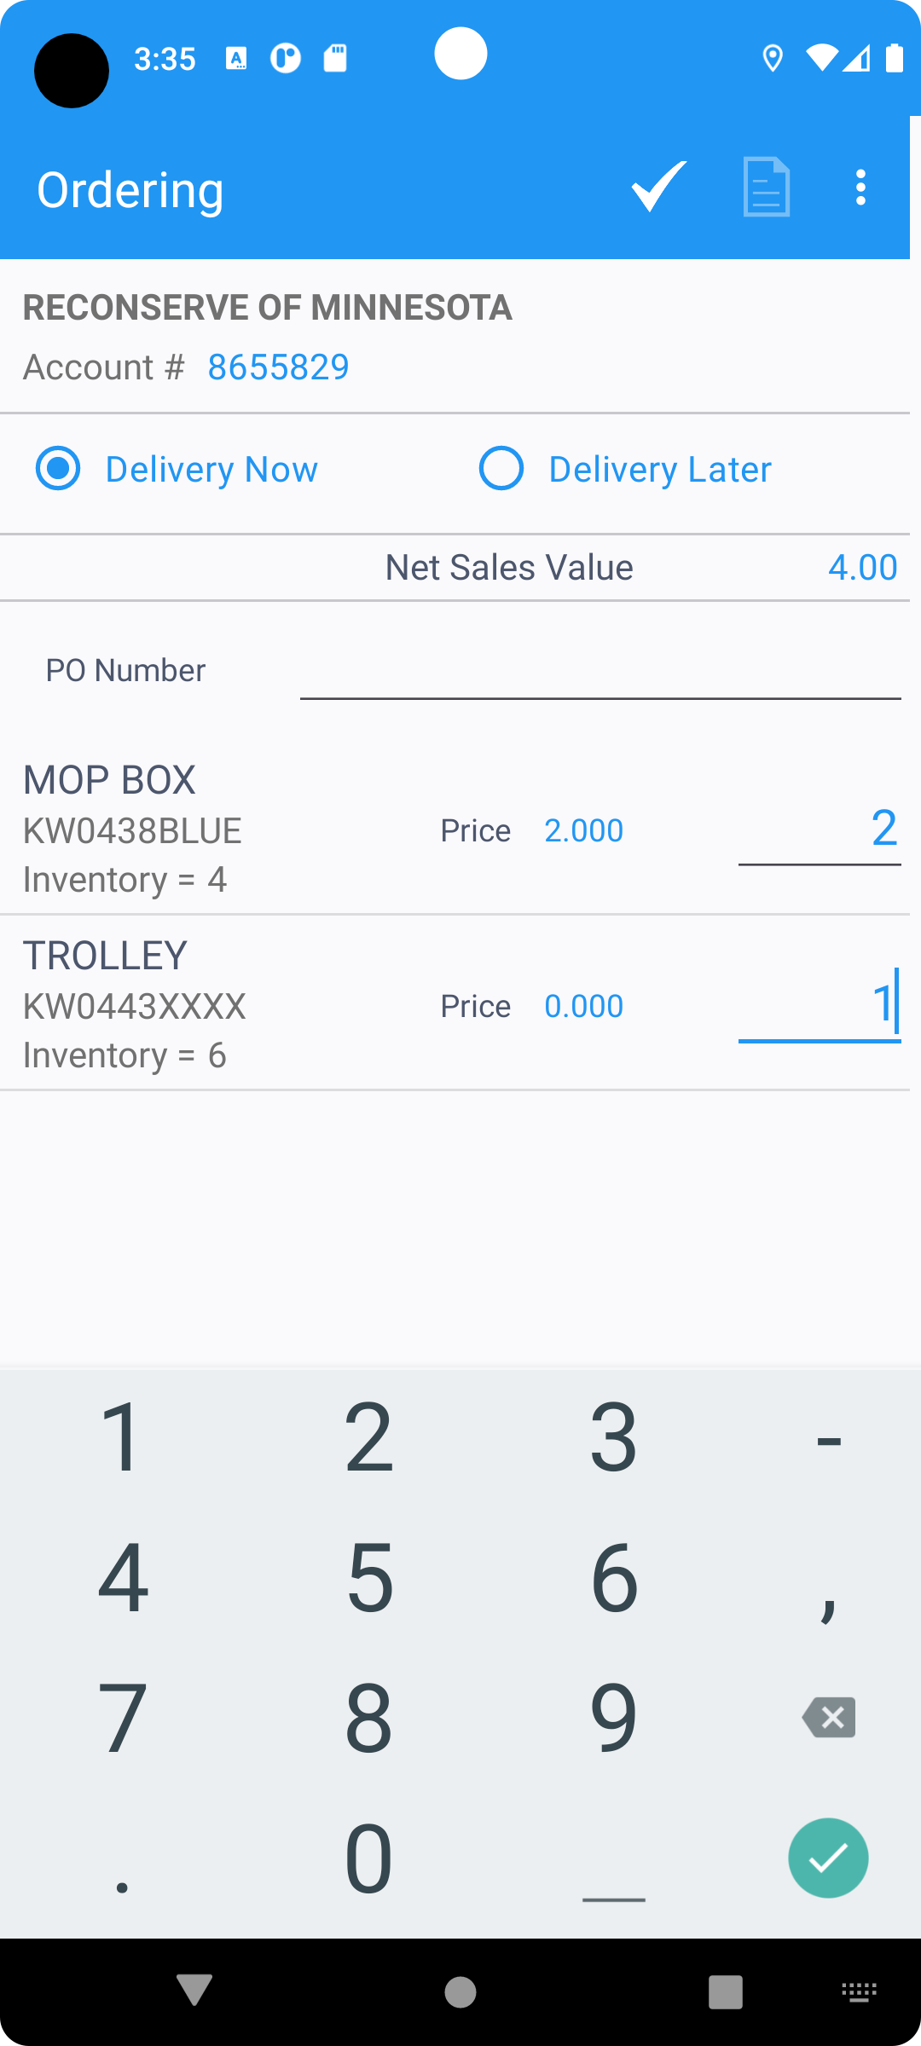
SAVE
ORDER DELIVERY
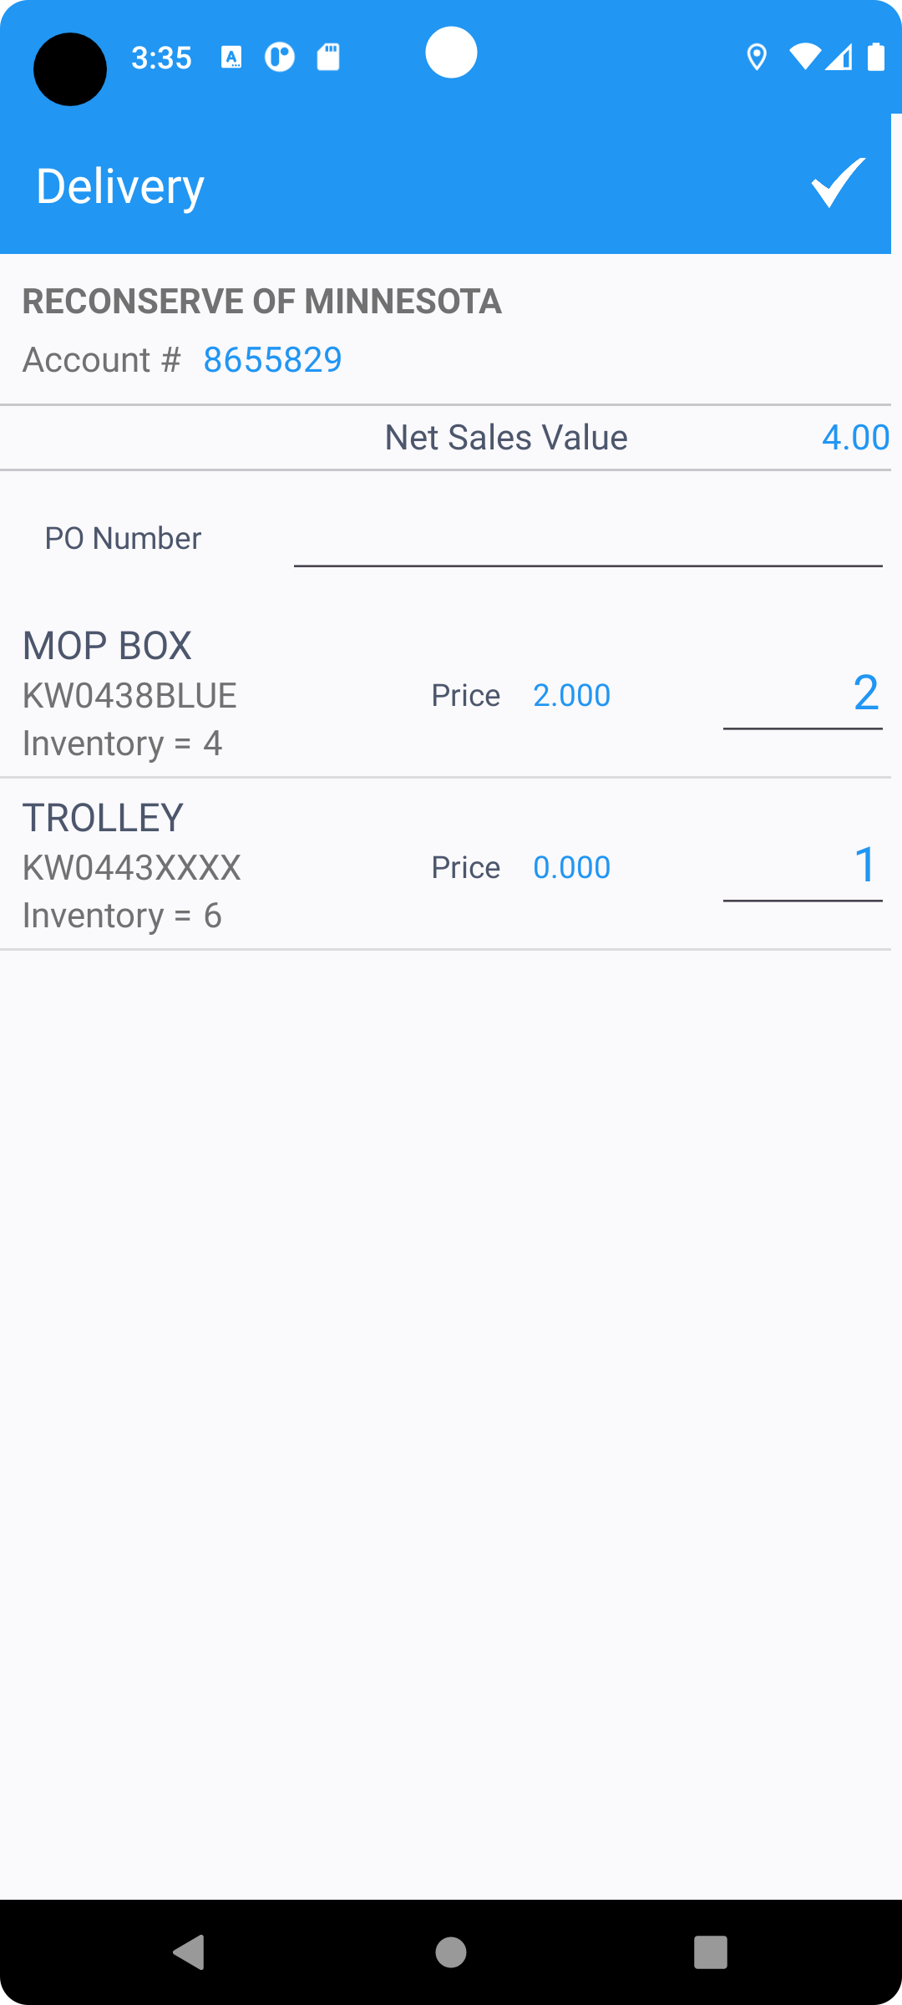
SIGN IT
SETTLE THE ROUTE
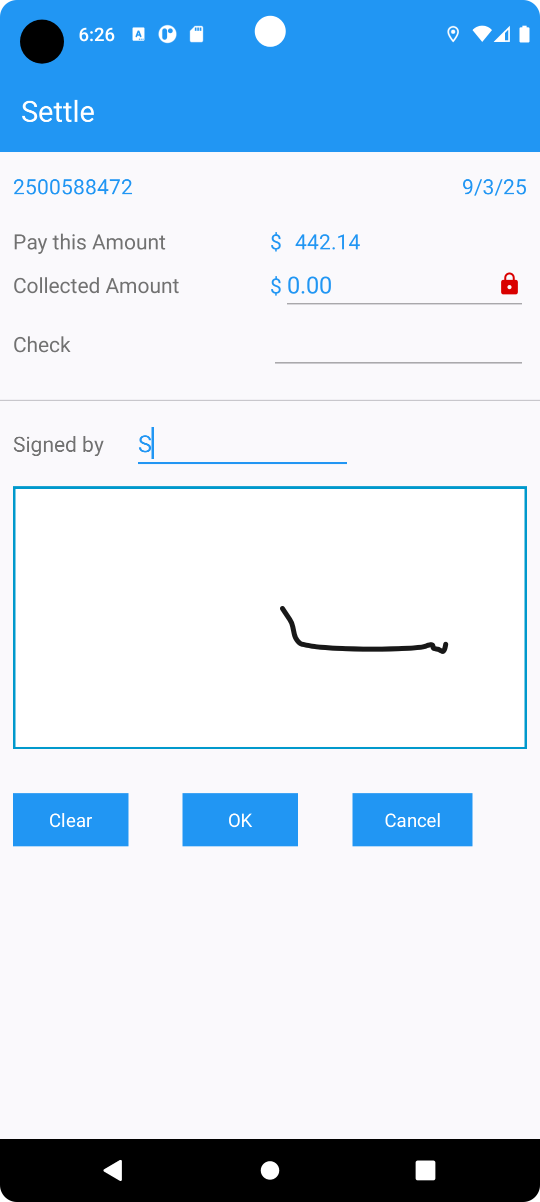
Depart from route
- In the client, in View process log, check the logs for current route control
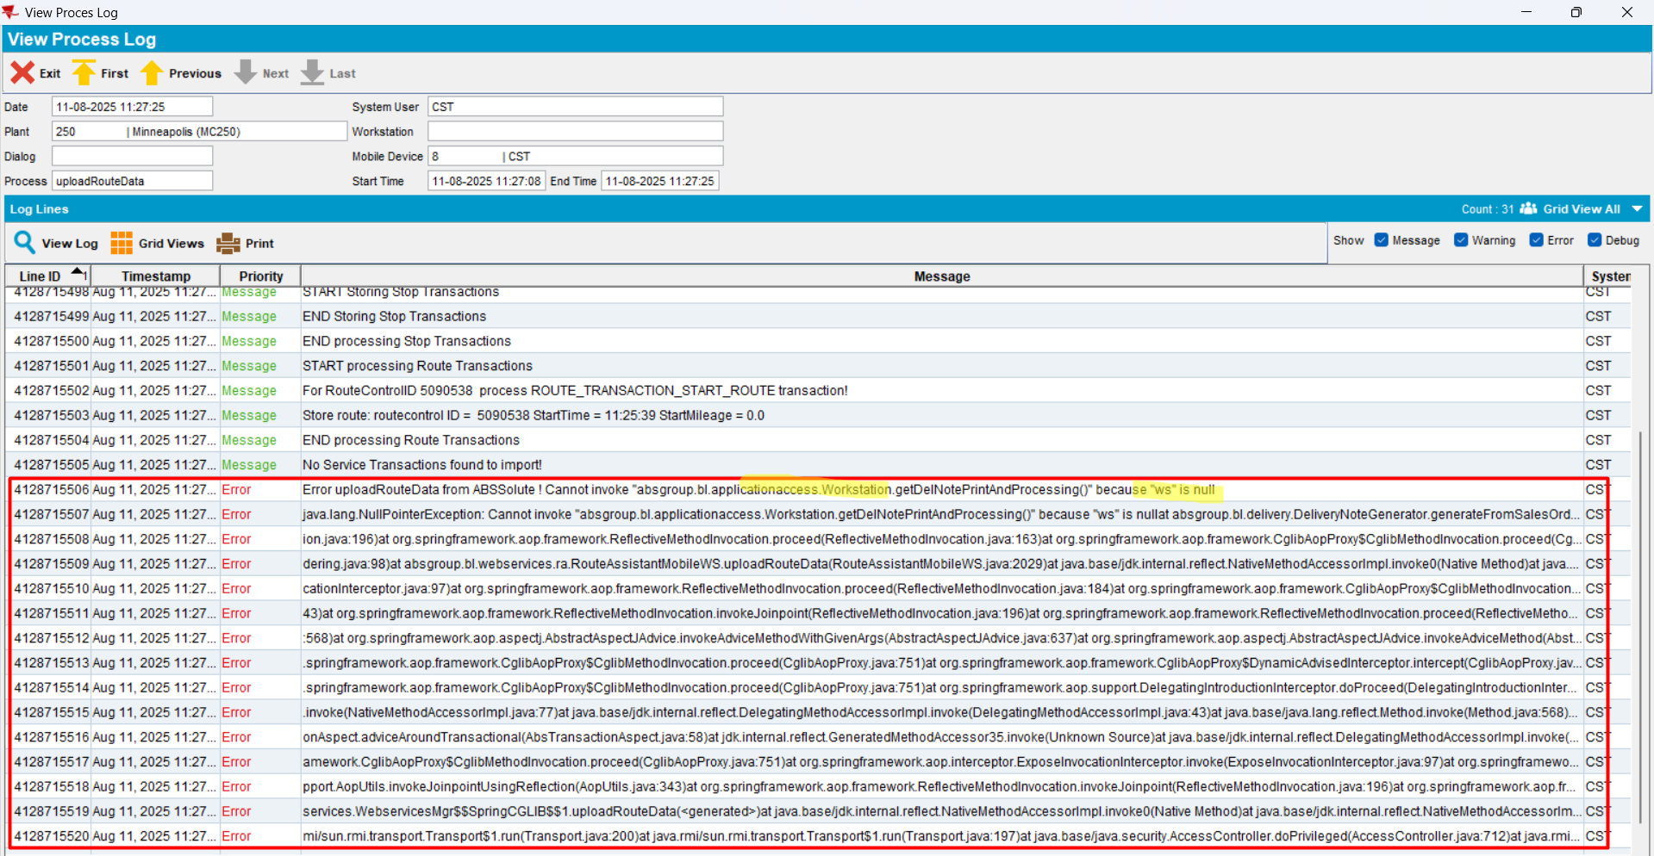
Actual behavior: After visiting all customers on RA and then trying to upload the route, it would not upload and there is an unexpected error in the logs. This happens for the stops with order now/deliver now (incidental stops with sales note invoices).
REPRODUCED OK.

Retest after fix
Hash: 95b8888
- Keeping the same settings, add a route control same day, next 2 weeks in the future. On the route control, keep only the 2 stops of interest
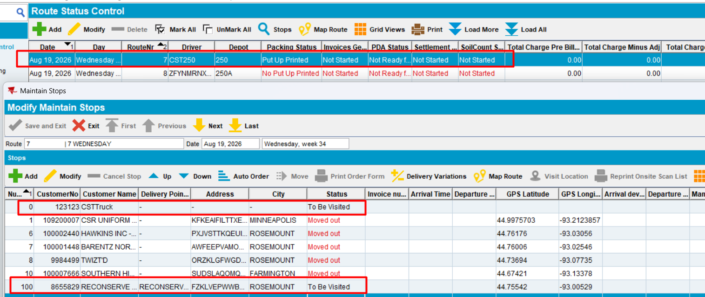
- Generate Packing Notes for the route
- Generate Invoices for the route
- Mark the route control “Ready for transfer to PDA”
- Download the route to PDA and start the route, visit stop
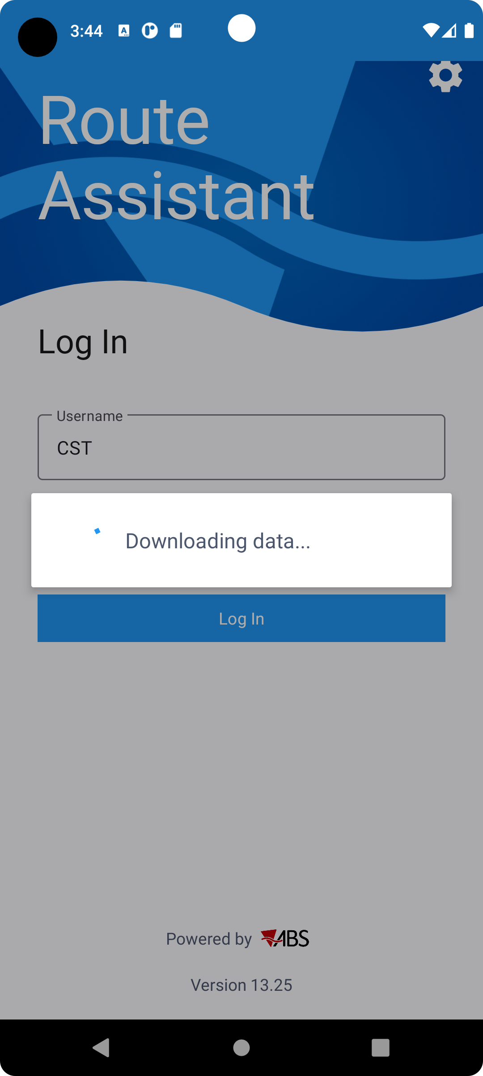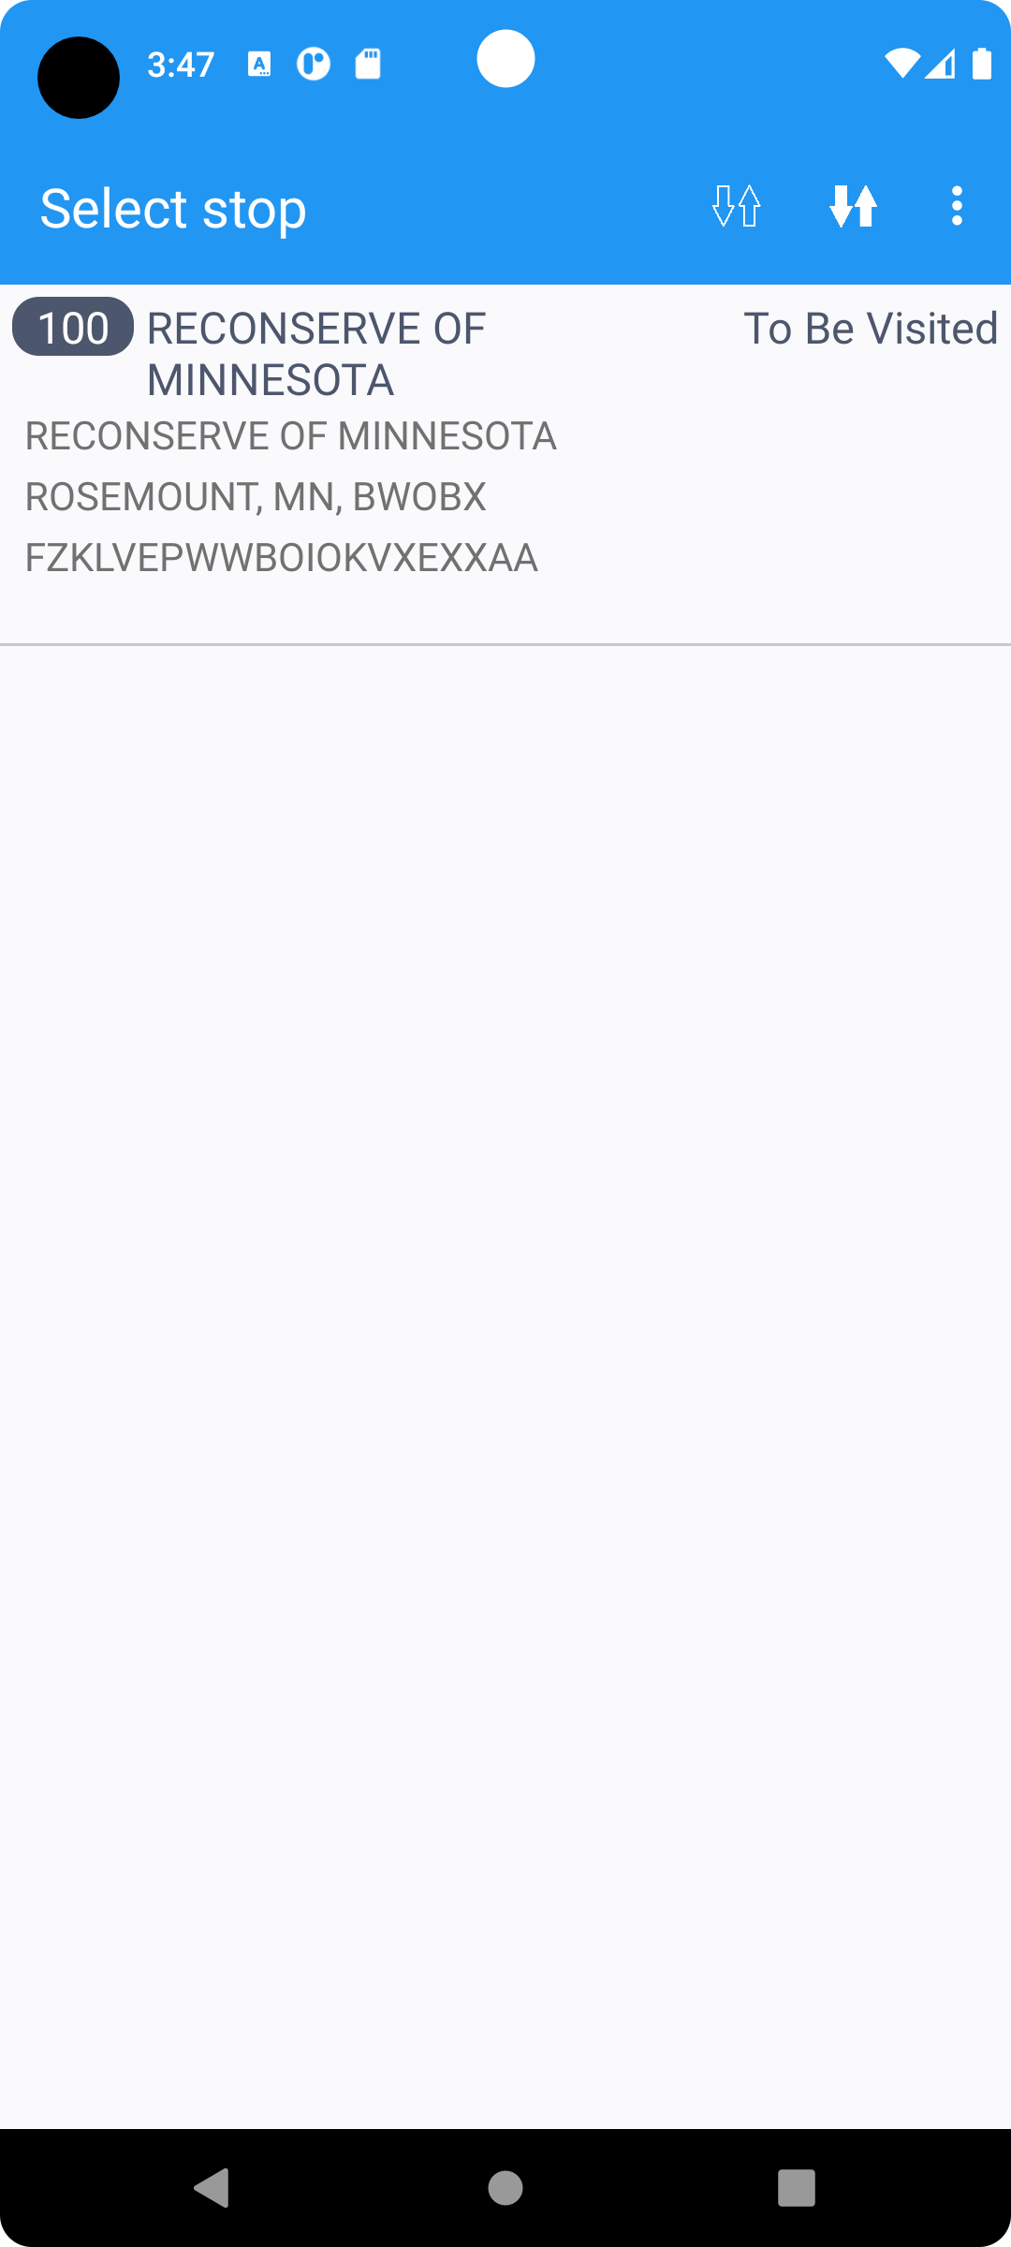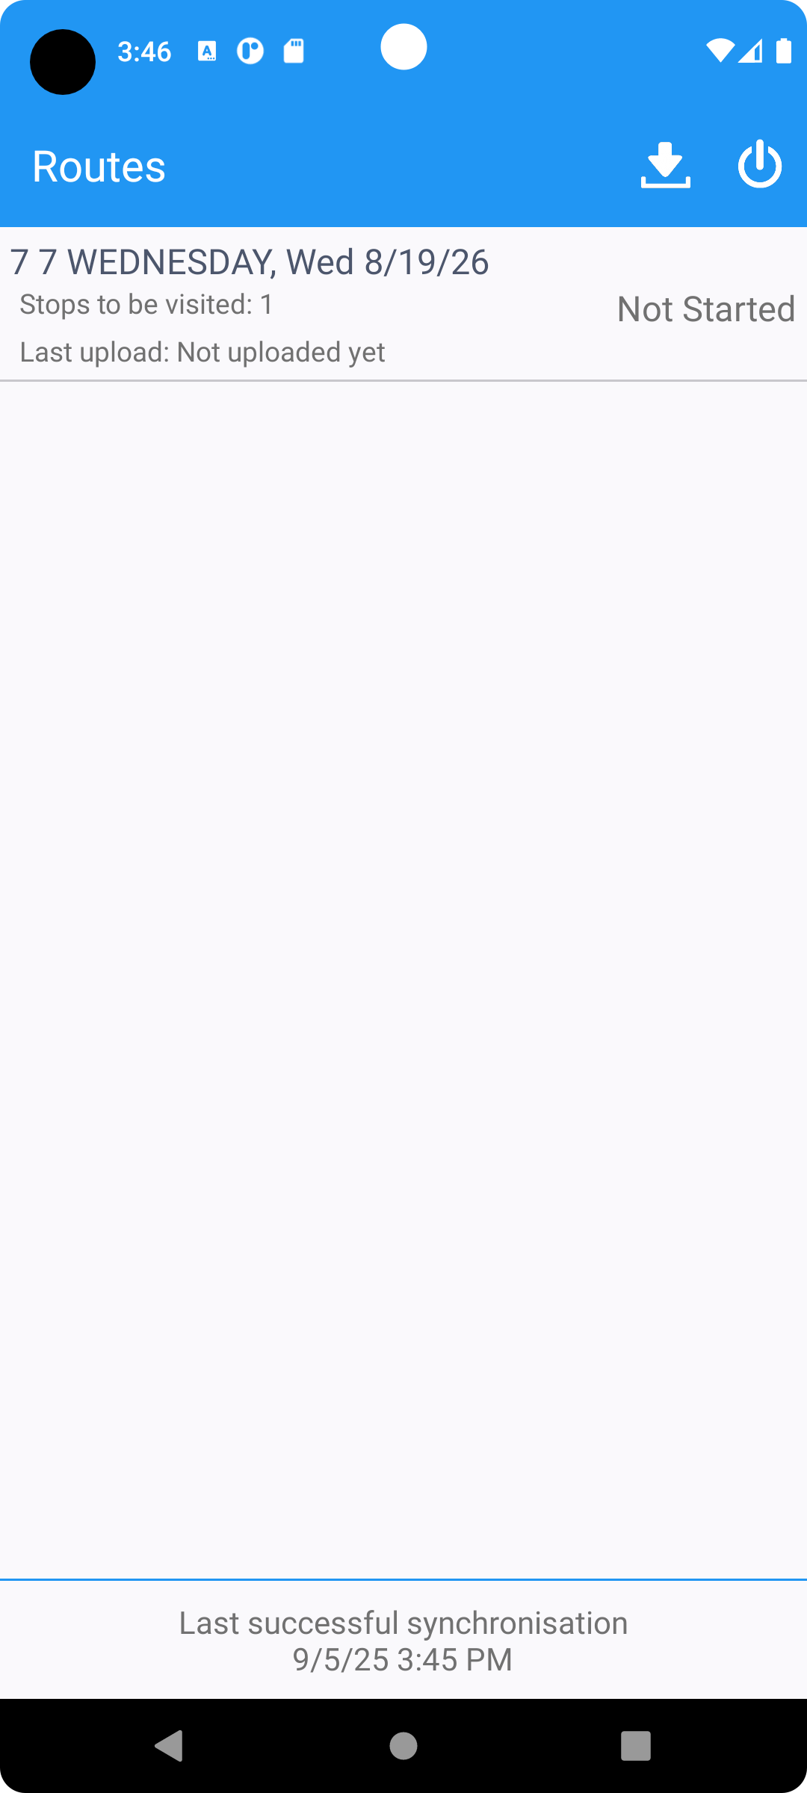
Ordering and delivery
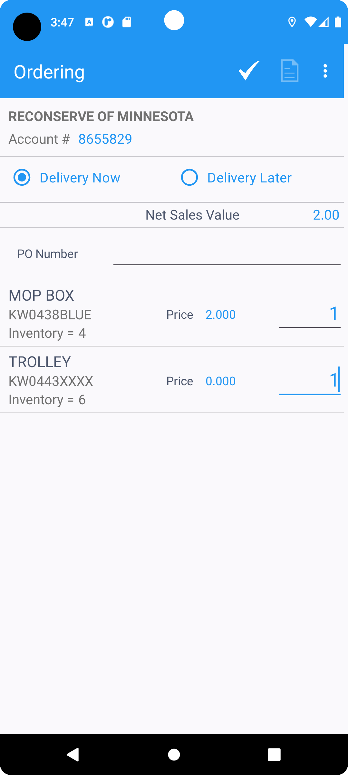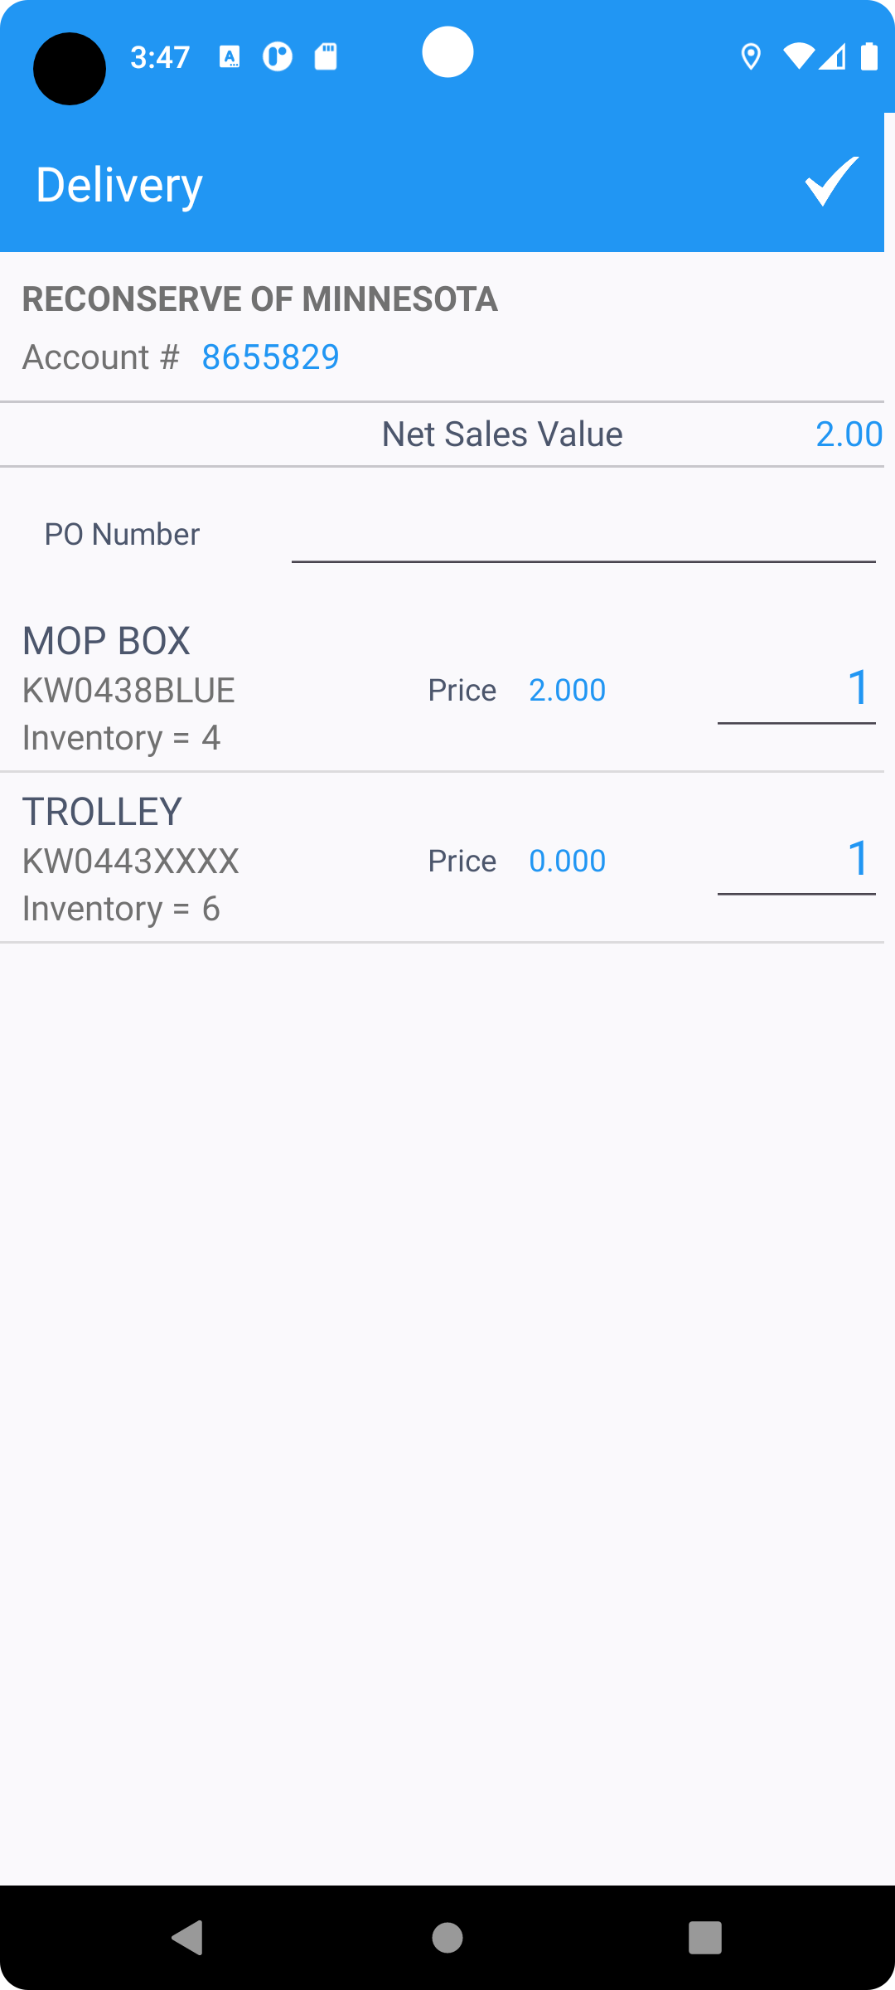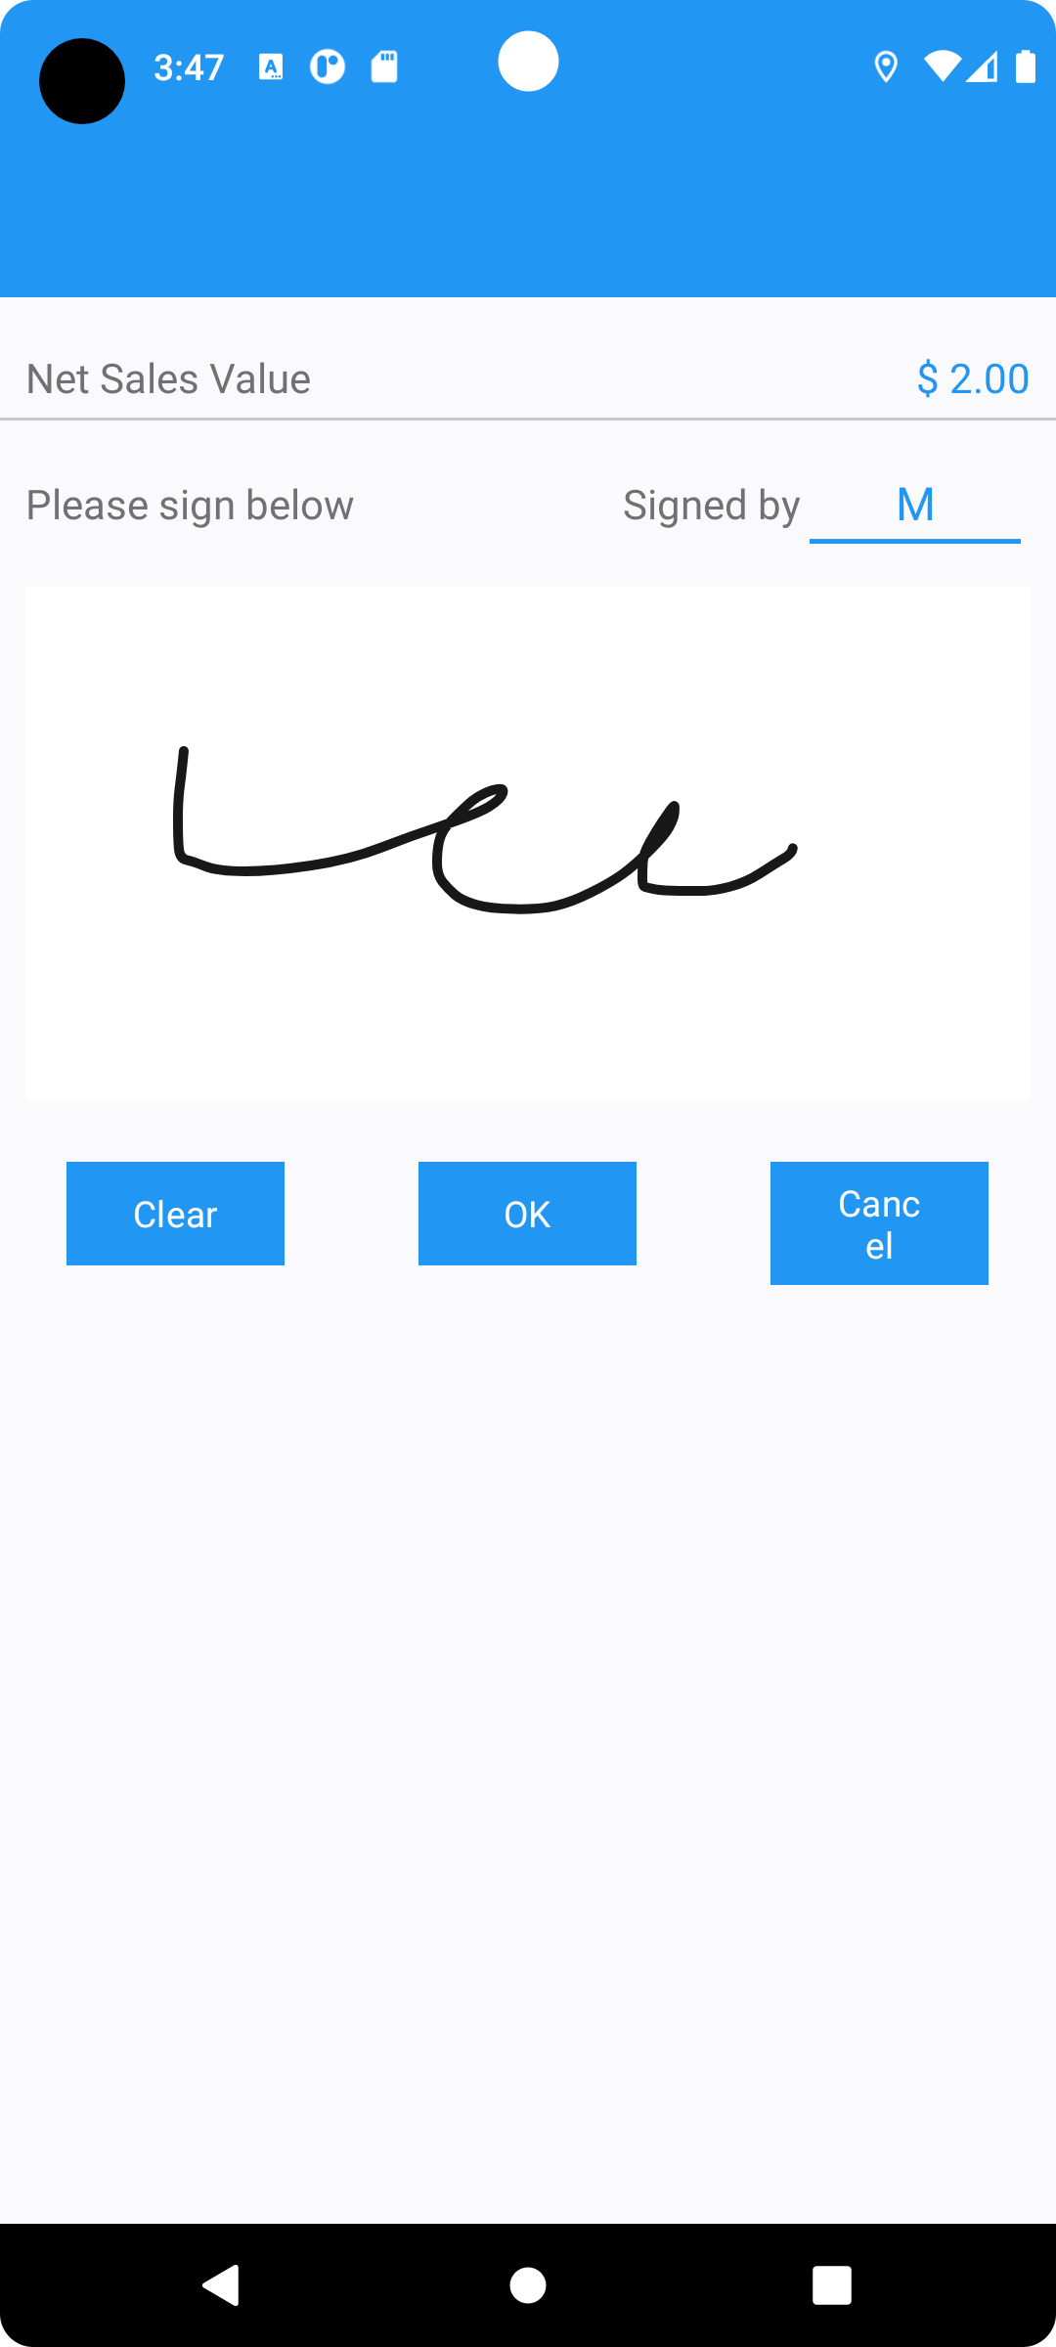
Settle and depart
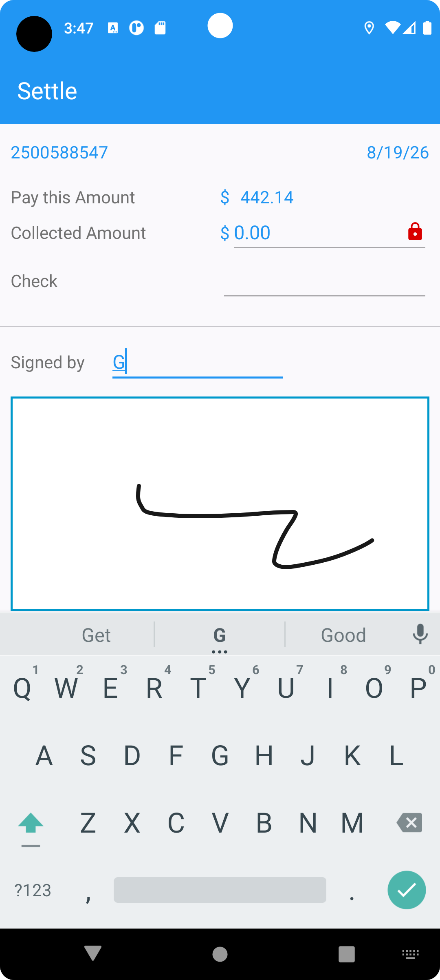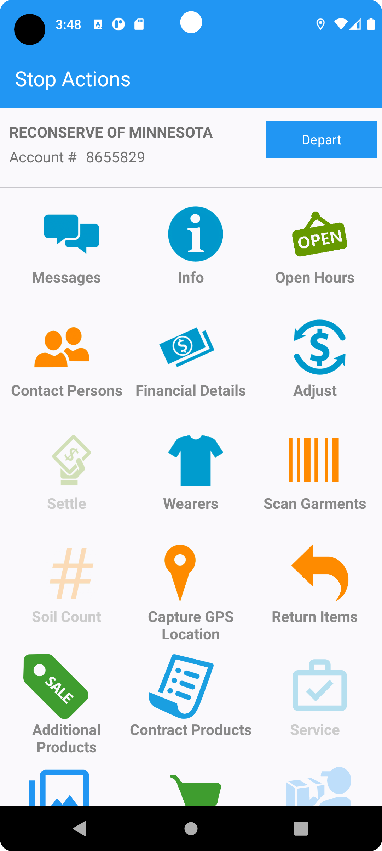
- In the client, in View process log, check the logs for current route control
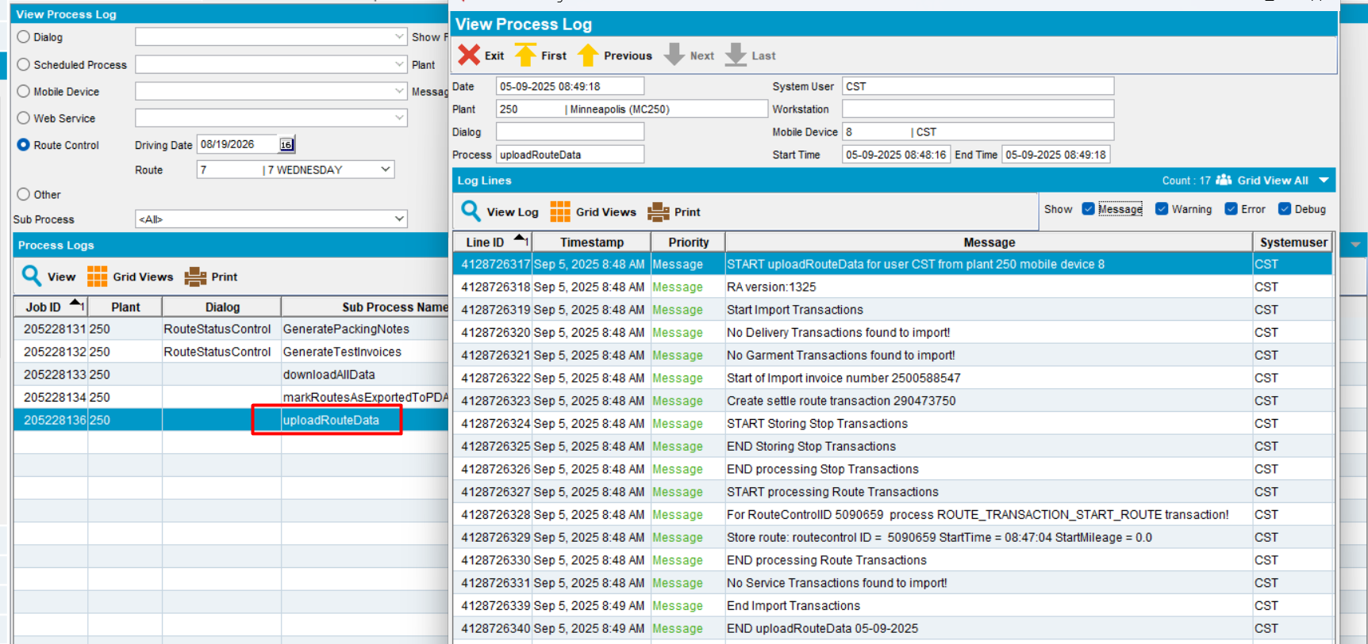
No error is shown after departing the route, in View process log, for the selected route control.
Test OK

