ABSN-6622 Downgrade to 9.08.00.RELEASE.p23_AUS
Environment | Prerequisites
Version: 9.08.00.RELEASE.P22  DBServerName=abs-srv17.internal.abslbs.com  DBSID=CUST23  DBUser=AUS_MNT90800  DBPassword= AUS_MNT90800 | - Module: ROUTEASSISTANTCONTRACT  ROUTEASSISTANTGARMENT  ROUTEASSISTANT  ROUTEASSISTANTANDROID  - System setting:  PDAAUTOSYNCROUTE=N  PDAAUTOSYNCSTOP=N  DEBUG_LEVEL=2  ONLYPLANTACTIVEPRODUCTSRA = N  - Other applications versions: RouteAssistant_v13.28  - Device used for mobile applications: Android Studio
Contents
Reproducing before fix 1
Retest after fix 7
1. Test performance 7
2. Data consistency test 8

Reproducing before fix
Preconditions: Hash: 9.08.00.RELEASE.P22, hash: 939d373
- Modules in license file:
- ROUTEASSISTANTCONTRACT
- ROUTEASSISTANTGARMENT
- ROUTEASSISTANT
- ROUTEASSISTANTANDROID
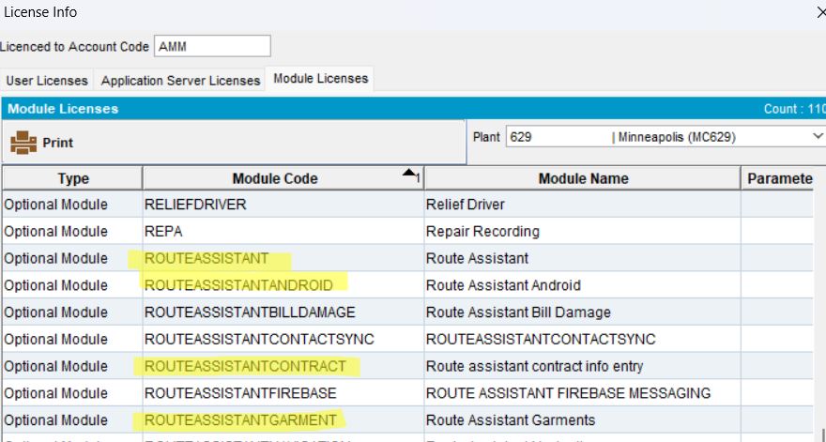
- Set the system settings:
- PDAAUTOSYNCROUTE=N;
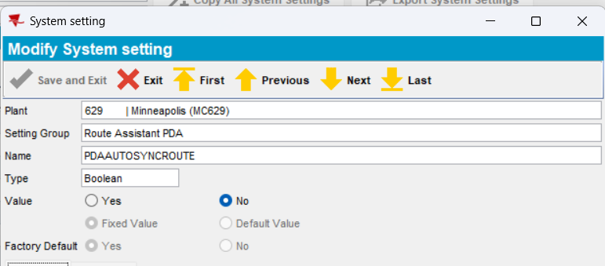
- PDAAUTOSYNCSTOP=N;
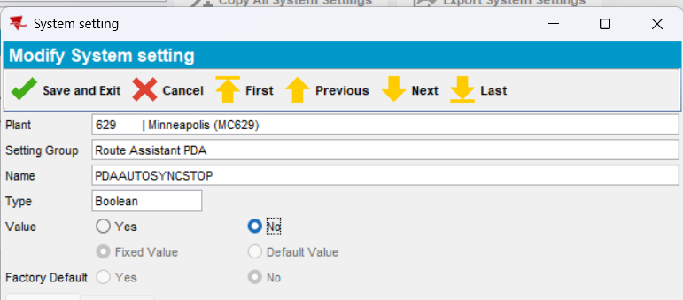
- DEBUG_LEVEL=2;
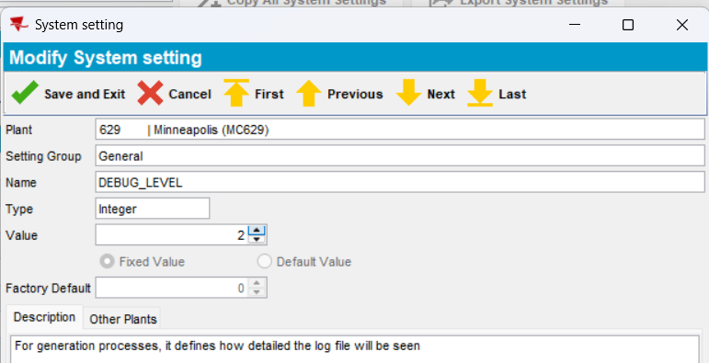
- PLSQL: find a route with a large amount of contractproducts attached to the contracts that belong to customers on the route. The contractproducts should have image care attached:
select count(cp.contractproduct_id), c.customernumber, rc.drivingdate, r.routenumber, p.code from routecontrol rc
join route r on r.route_id = rc.route_id
join plant p on p.plant_id = r.plant_id
join stop s on s.routecontrol_id = rc.routecontrol_id
join customer c on c.customer_id = s.customer_link_id
join contractcustomer cc on cc.customer_link_id = c.customer_id
join contract co on co.contract_id = cc.contract_id
join contractproduct cp on cp.contract_id = co.contract_id
where c.dateinactive > sysdate
and cc.enddate > sysdate
and co.enddate > sysdate
group by c.customernumber, rc.drivingdate, r.routenumber, p.code
having count(cp.contractproduct_id) > 200;
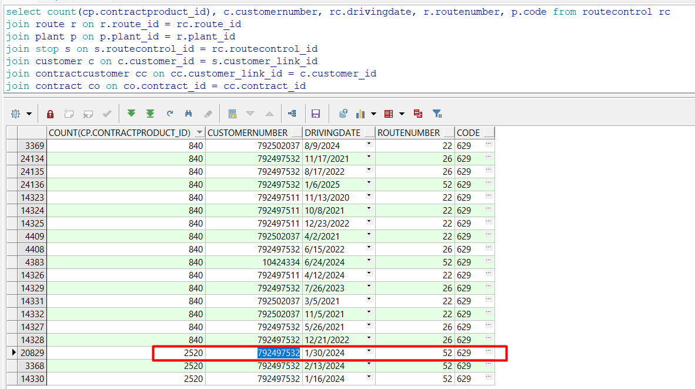
- Make sure the contract follows these conditions: if the select does not return your customer, then the select that was improved with this fix won’t be used and test cannot be performed.
select CT.CONTRACT_ID,
CT.CODE,
CT.DESCRIPTION,
(case
when CT.CATEGORY = 4 then
'Y'
else
'N'
end) as ROUTESERVICECONTRACT,
(case
when not exists (select 1
from CONTRACTCOMPLIANCY CPL
where CPL.CONTRACT_ID = CT.CONTRACT_ID
and CPL.CONTRACTATTRIBUTE_ID = 101
and CPL.COMPLIANCYRULE = '2') then
'Y'
else
'N'
end) as BILLINGCANBEEDITED,
(case
when not exists (select 1
from CONTRACTCOMPLIANCY CPL
where CPL.CONTRACT_ID = CT.CONTRACT_ID
and CPL.CONTRACTATTRIBUTE_ID = 102
and CPL.COMPLIANCYRULE = '2') then
'Y'
else
'N'
end) as LOGISTICSCANBEEDITED,
(case
when not exists (select 1
from CONTRACTCOMPLIANCY CPL
where CPL.CONTRACT_ID = CT.CONTRACT_ID
and (CPL.CONTRACTATTRIBUTE_ID = 101 or
CPL.CONTRACTATTRIBUTE_ID = 106 or
CPL.CONTRACTATTRIBUTE_ID = 174)
and CPL.COMPLIANCYRULE = '2') then
'Y'
else
'N'
end) as INSURANCECANBEEDITED,
CC.CUSTOMER_LINK_ID
from CONTRACT CT, STATUS S, CONTRACTCUSTOMER CC
where CT.STARTDATE <=
TO_DATE('2025-07-21 00:00:00', 'YYYY-MM-DD HH24:MI:SS')
and CT.ENDDATE >=
TO_DATE('2025-07-21 00:00:00', 'YYYY-MM-DD HH24:MI:SS')
and CC.STARTDATE <=
TO_DATE('2025-07-21 00:00:00', 'YYYY-MM-DD HH24:MI:SS')
and CC.ENDDATE >=
TO_DATE('2025-07-21 00:00:00', 'YYYY-MM-DD HH24:MI:SS')
and CT.STATUS_ID = S.STATUS_ID
and CC.CONTRACT_ID = CT.CONTRACT_ID
and (CT.CATEGORY <> 4 and exists
(select 1
from CONTRACTPRODUCT CP
where CP.CONTRACT_ID = CT.CONTRACT_ID
and CP.PRODUCT_ID not in
(select CP2.PRODUCT_ID
from CONTRACTPRODUCT CP2, PRODUCTLISTPERCUSTOMER PLPC
where CP2.CONTRACT_ID = CT.CONTRACT_ID
and PLPC.CUSTOMER_ID = CT.CUSTOMER_LINK_ID
and CP2.PRODUCT_ID = PLPC.PRODUCT_ID
and CP2.FINISHINGMETHOD_ID = PLPC.FINISHINGMETHOD_ID
and (CP2.SIZEDEFINITION_ID = PLPC.SIZEDEFINITION_ID or
PLPC.SIZEDEFINITION_ID =
(select SIZEDEFINITION_ID
from SIZEDEFINITION
where CODE = '*')))) and
(CC.CUSTOMER_LINK_ID = 10172))
and S.CODE in (20, 30)
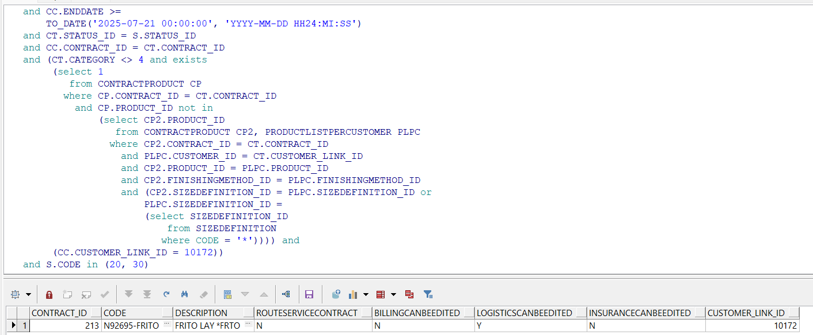
- Add this route and make sure customer is a stop to be visited:
- Generate put-up docs:
- Generate invoices:
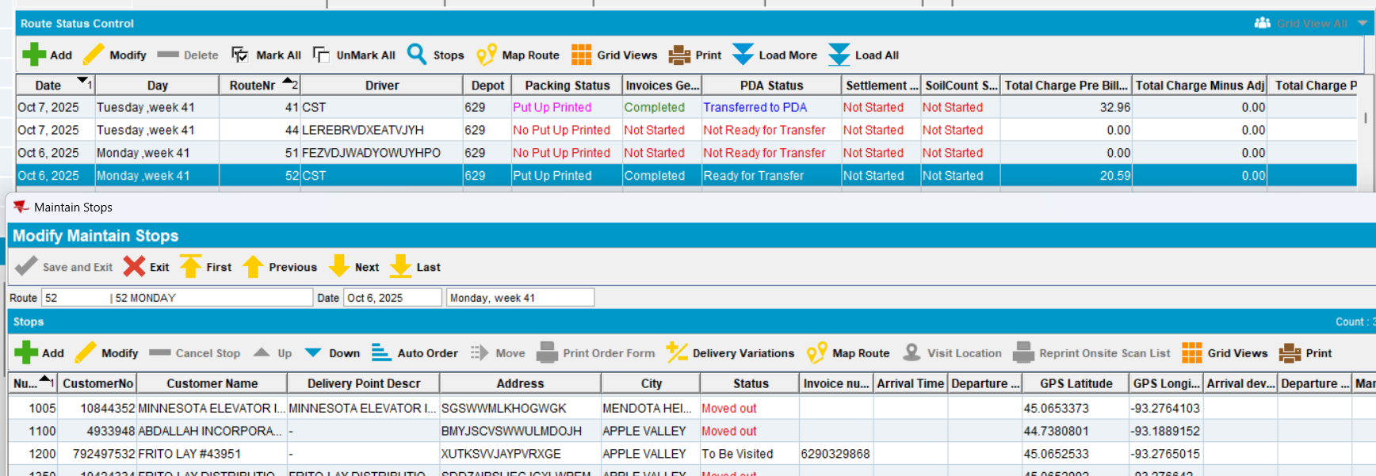
Note: Make sure status for invoices is completed:
select rc.routecontrol_id, r.routenumber, rc.invoicesgenerated , rc.timestamp from routecontrol rc
join route r on r.route_id=rc.route_id
where r.plant_id=64 and r.routenumber=41
order by rc.timestamp desc
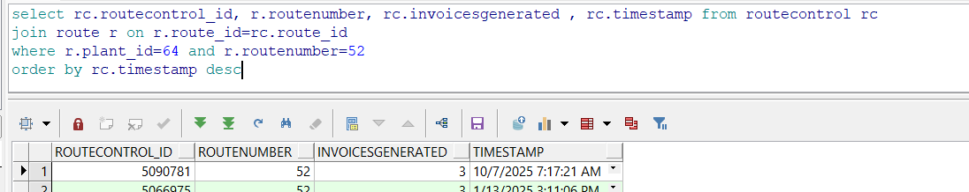
- Transfer to PDA:
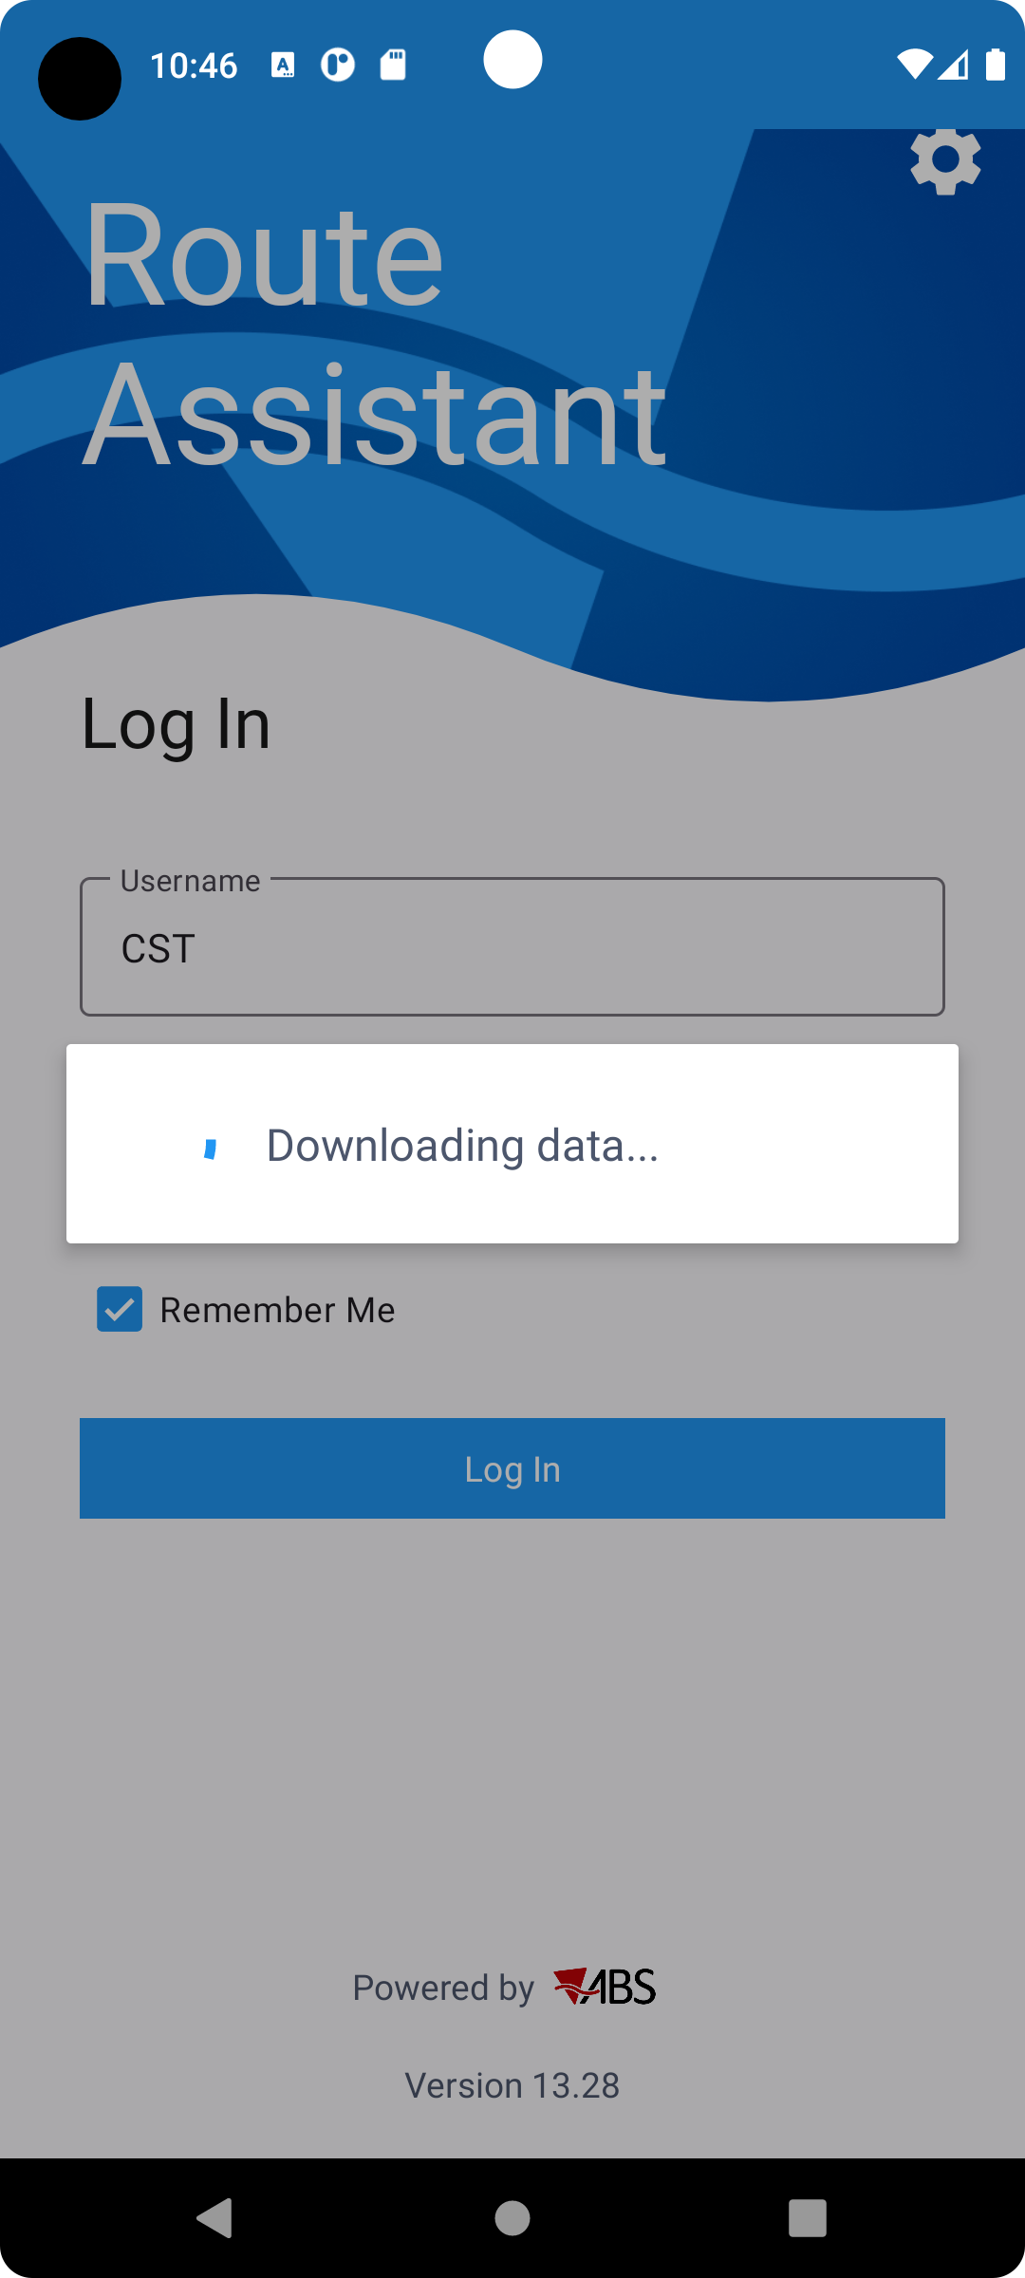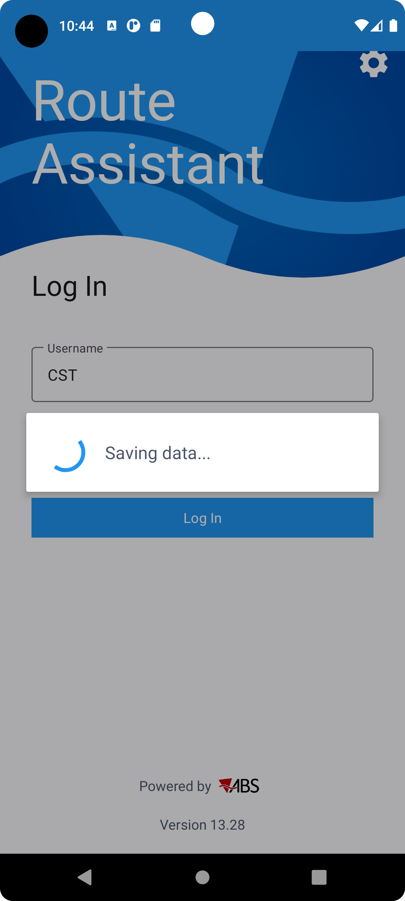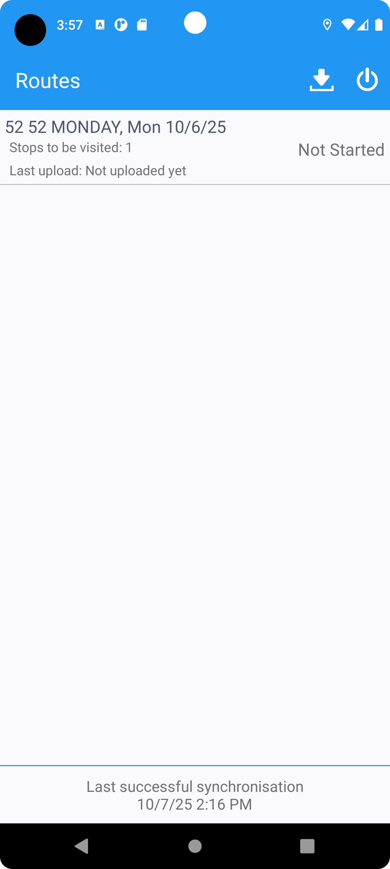
- Monitor how much it takes to download route on PDA:
Notice it took: 2min:25sec
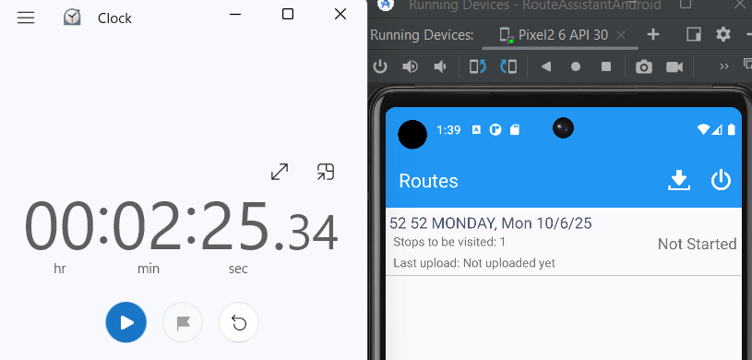
REPRODUCED OK

Retest after fix
Preconditions: Hash: 9.08.00.RELEASE.P22 hash: ee4496a

Test performance
- Retransfer route to PDA:
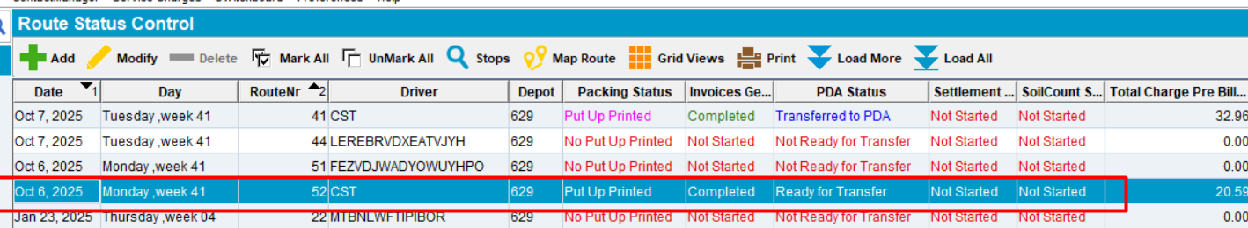
- Monitor how much it takes to download route on PDA:
Notice it took 1min:45s -> a difference of 40s improvement
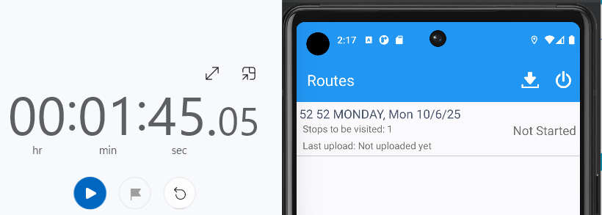
RETEST OK

Data consistency test
Have contract products released to the customer for interest:
- Garment with per change billing
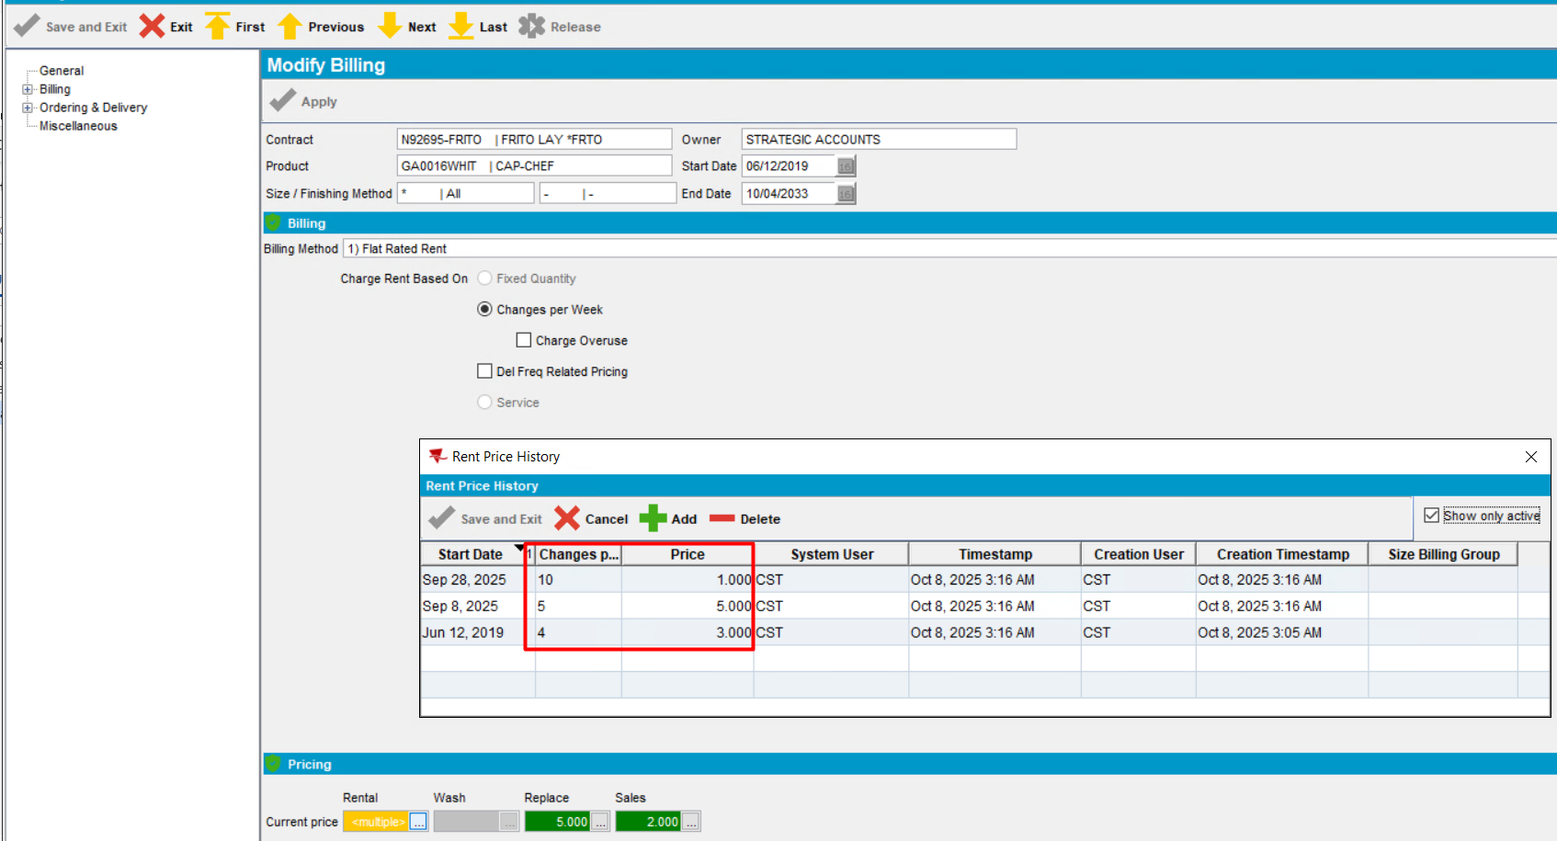
- Non garment with delivery frequency related pricing
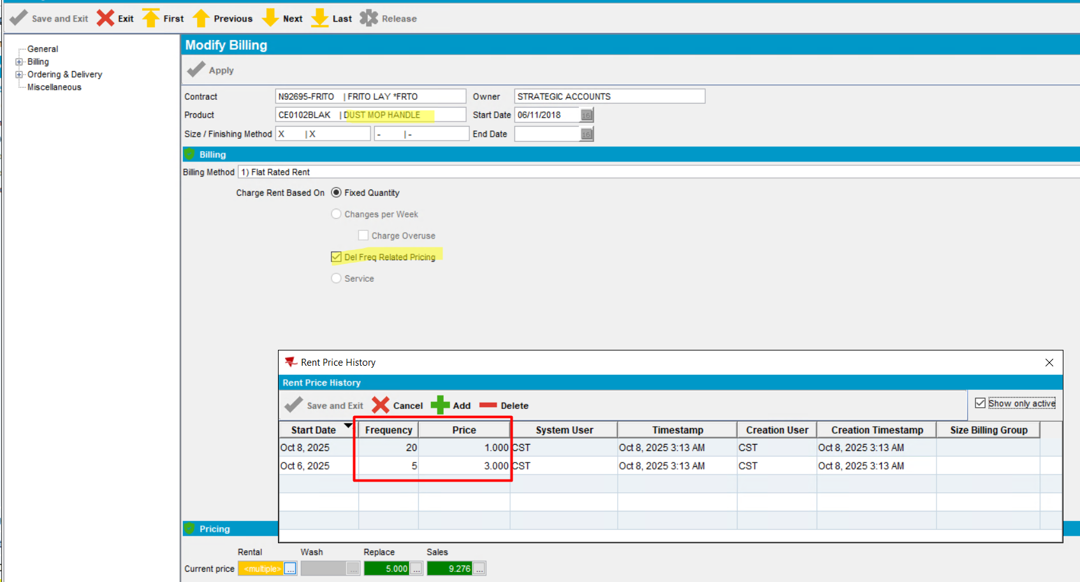
- Start the server before fix.
- PLSQL: find a route with a large amount of contractproducts attached to the contracts that belong to customers on the route that have all 4 relevant price types (rent, sales, wash, Replacement)

select c.customernumber, rc.drivingdate, r.routenumber, p.code from routecontrol rc
join route r on r.route_id = rc.route_id
join plant p on p.plant_id = r.plant_id
join stop s on s.routecontrol_id = rc.routecontrol_id
join customer c on c.customer_id = s.customer_link_id
join contractcustomer cc on cc.customer_link_id = c.customer_id
join contract co on co.contract_id = cc.contract_id
join contractproduct cp on cp.contract_id = co.contract_id
where c.dateinactive > sysdate
and cc.enddate > sysdate
and co.enddate > sysdate
and exists (select 1 from contractpricelist cpl
where cpl.contract_id = co.contract_id
and cpl.pricetype = 1) -- wash
and exists (select 1 from contractpricelist cpl
where cpl.contract_id = co.contract_id
and cpl.pricetype = 2) --Rent
and exists (select 1 from contractpricelist cpl
where cpl.contract_id = co.contract_id
and cpl.pricetype = 3) --Replacement
and exists (select 1 from contractpricelist cpl
where cpl.contract_id = co.contract_id
and cpl.pricetype = 4) --Sales
AND R.PLANT_ID=64
and c.customernumber=792497532
order by rc.timestamp desc
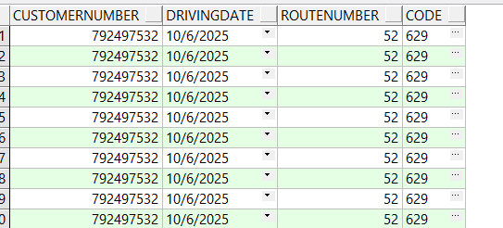
- Route Status Control DLG: Add a new route for one of your customers/route/driving date you found
- Route Status Control DLG: Generate packing notes
- Route Status Control DLG: Generate invoices
- Route Status Control DLG: Mark ready to transfer
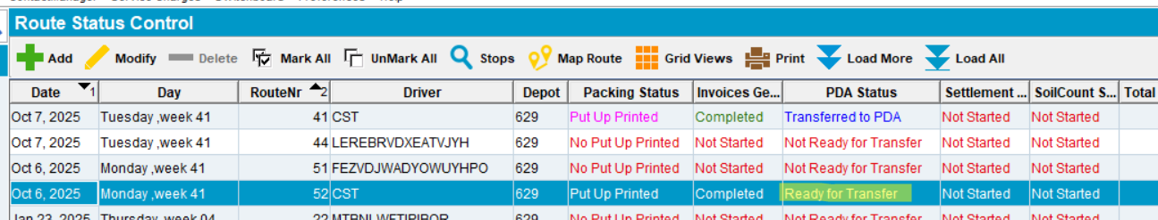
- Download the route on RA
- Save the RA database for future checks -> routeAssisstDBBeforeFix
- Delete the database from the mobile device
- Start the server with the fix
- Redownload the same route
- Export the database from RA after download
- Save the RA database for future checks -> routeAssisstDBAfterFix
- Compare the tables.
The result of the data is identical, only the ids are different.

RSContractsDTO
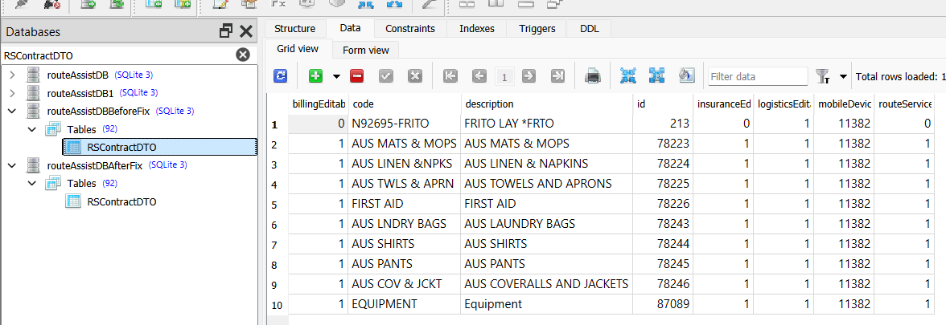
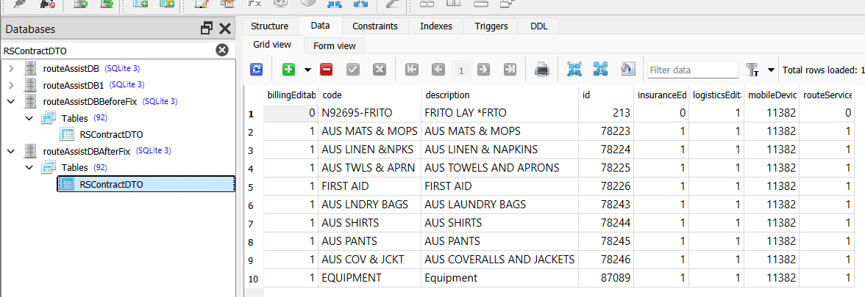

RSContractProdComplDelFreqDTO
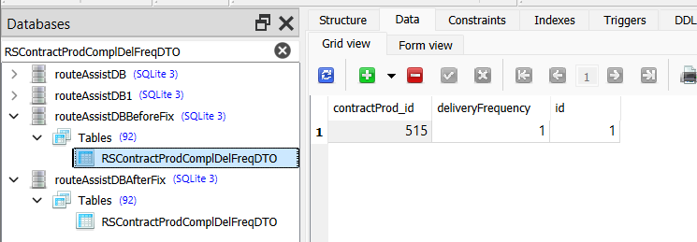
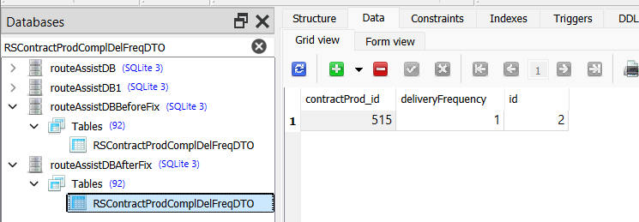

RSContractProdQMGLDTO
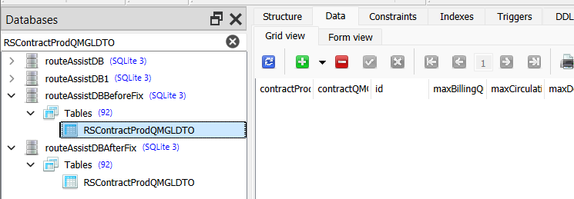
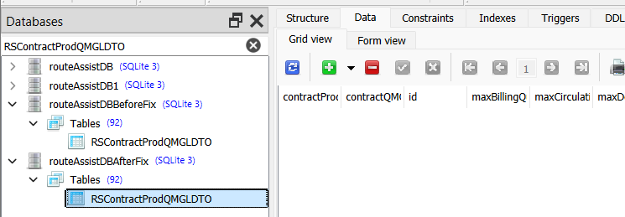

FirstDeliverySchemeDTO
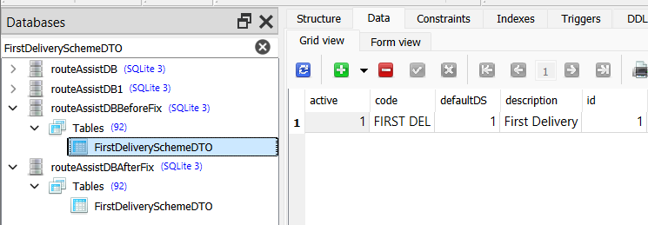
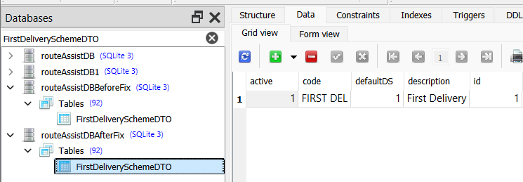

RSCPerCustomerDTO

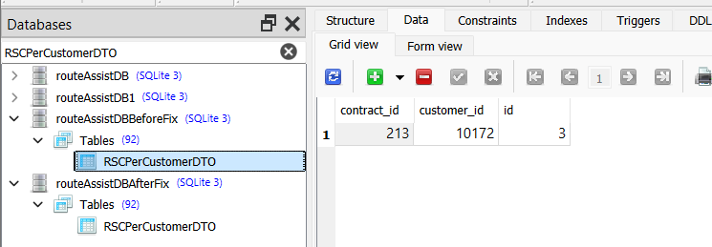
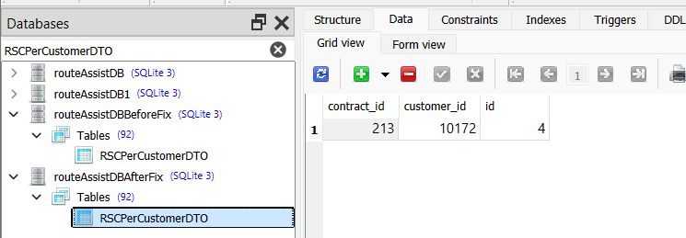

RSContractProdInsPDTO
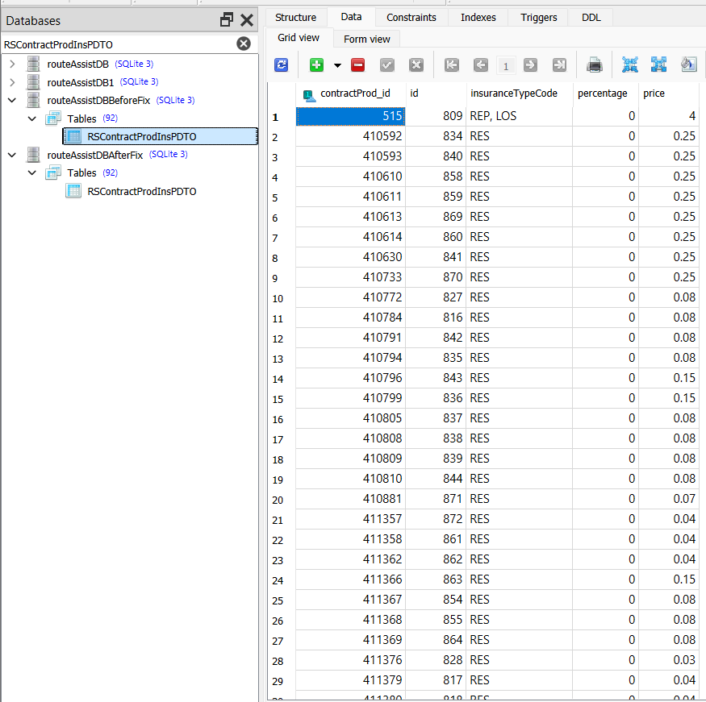
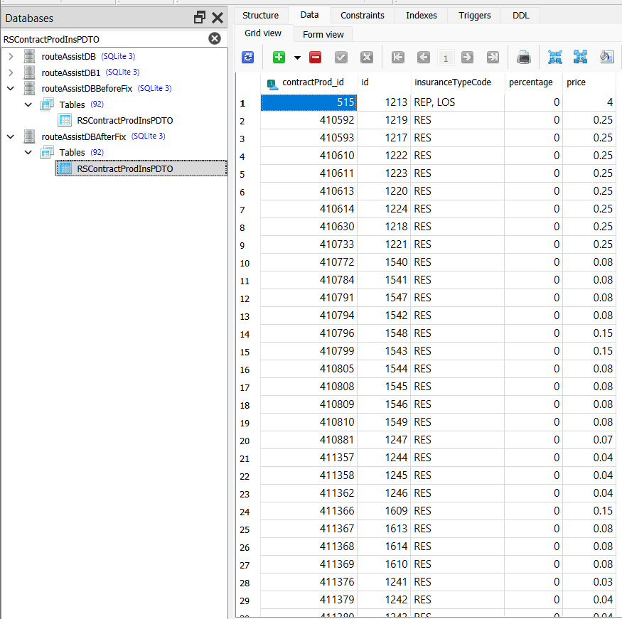

RSContractProdDelFDTO
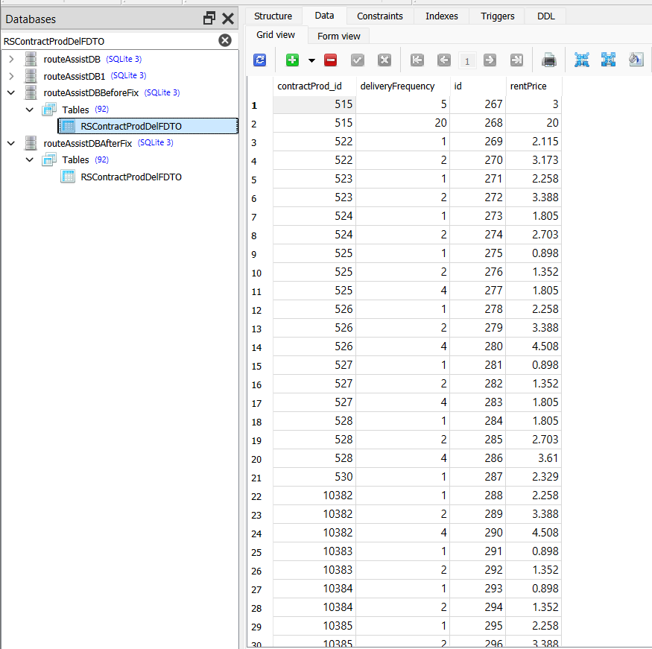
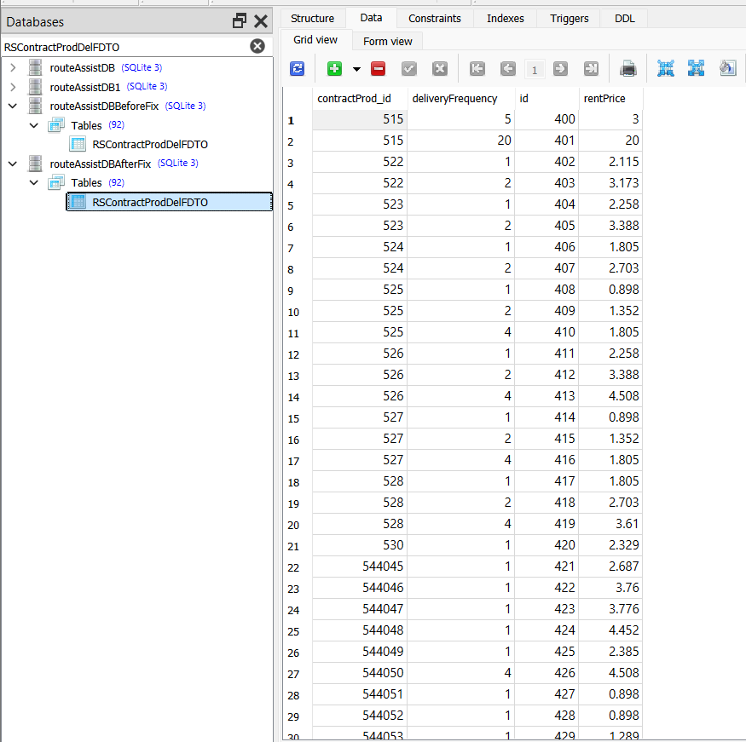

RSContractProdChngDTO
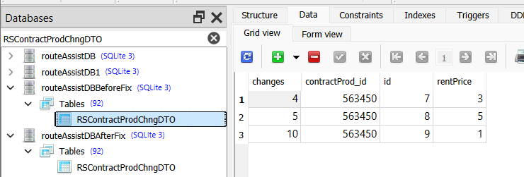
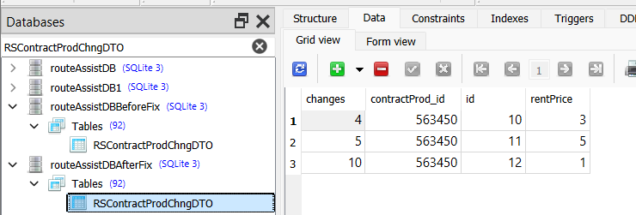

RSContractProdDTO
