ABSN-6621 D_UBS_2699 Do not transfer the contract tables to RA when module ROUTEASSISTANTCONTRACT is not in use
Environment | Prerequisites
Version: 9.08.00.RELEASE.p22  DBServerName= abs-srv17.internal.abslbs.com  DBSID=CUST23  DBUser= AUS_MNT90800  Business Unit: 503 | - Module: ROUTEASSISTANTCONTRACT  ROUTEASSISTANTGARMENT, ROUTEASSISTANT,  ROUTEASSISTANTANDROID  - System setting: PDAAUTOSYNCROUTE=N,  PDAAUTOSYNCSTOP=Y, DEBUG_LEVEL=2  - Other applications versions: RouteAssistant_v13.30

Contents
Test before fix 12
Test Case 1 - Without ROUTEASSISTANTCONTRACT in the license – reproduced 12
Test Case 2 - With ROUTEASSISTANTCONTRACT in the license – reproduced 17
Test after fix 22
Test Case 1 - Without ROUTEASSISTANTCONTRACT in the license – passed 22
Test Case 2 - With ROUTEASSISTANTCONTRACT in the license – passed 27
Test Case 3 - With ROUTEASSISTANTCONTRACT in the license – regression - passed 31

Test before fix

Test Case 1 - Without ROUTEASSISTANTCONTRACT in the license – reproduced
Bu: 503
Route 80 from 06.10.2025

Expected behavior:
When module ROUTEASSISTANTCONTRACT is not in the license we do the following:
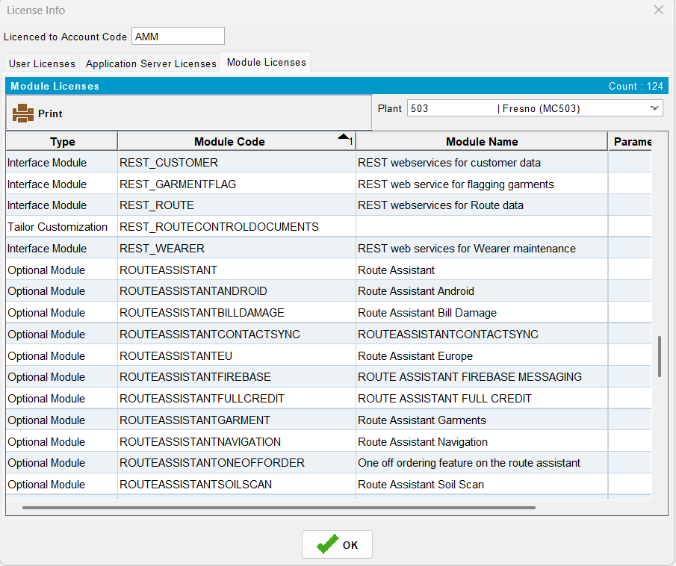

- Do not load any info in the following tables on RA:
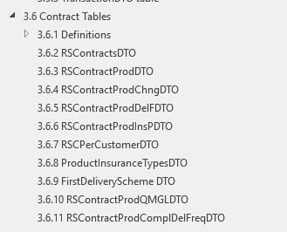

- Put 0 in the fields CustomerProductDTO
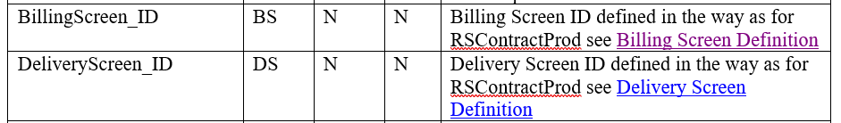
- And null in the following field on the CustomerProductDTO

Test Steps:
- Find a route with contract products attached to the contracts that belong to customers on the route
- PLPC of that customer
- Route Status Control DLG: Add a new route for one of your customers/route/driving date you found. Move out the rest of the customers.
- Route Status Control DLG: Generate packing notes
- Route Status Control DLG: Generate invoices
- Route Status Control DLG: Mark ready to transfer
- Download the route on RA
- Save the RA database for future checks
- Open the database from RA after downloading
- Open the database dump from RA with SQLITE and
- Check that there is no information for the following tables:

select * from RSContractDTO;
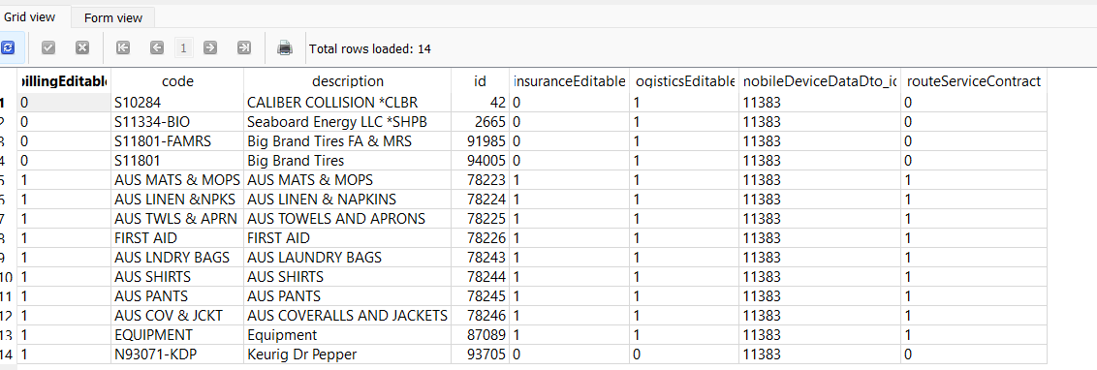

select * from RSContractProdChngDTO;
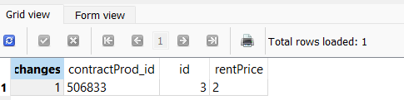

select * from RSContractProdDTO;
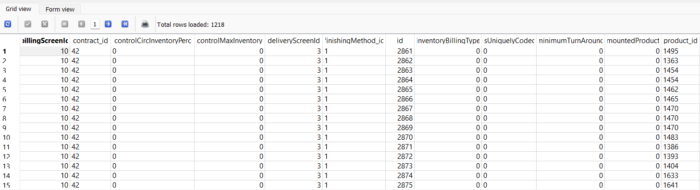

select * from RSContractProdDelFDTO;
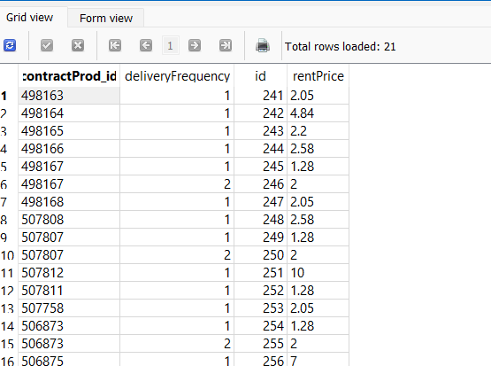

select * from RSContractProdInsPDTO;
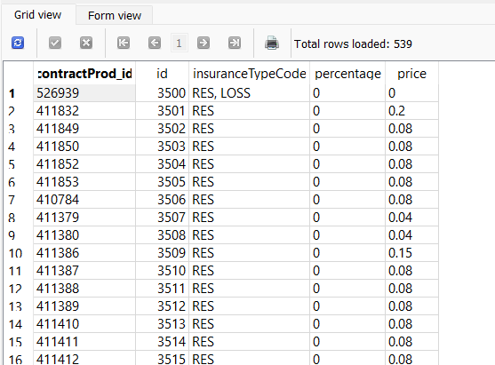

select * from FirstDeliverySchemeDTO;
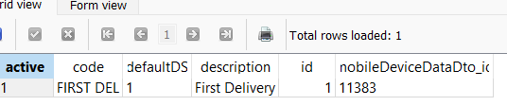

select * from RSCPerCustomerDTO;
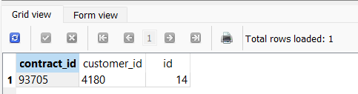

select * from RSContractProdQMGLDTO;
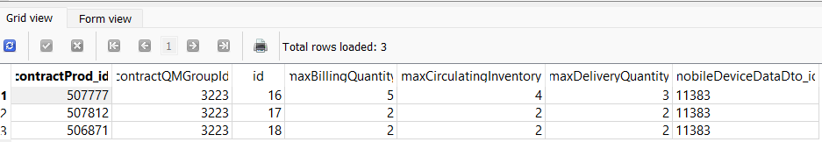

select * from RSContractProdComplDelFreqDTO;
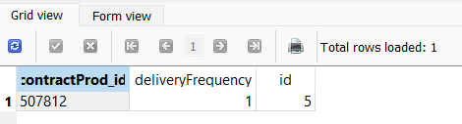

select CustomerProductDTO.billingScreenId, CustomerProductDTO.deliveryScreenId, CustomerProductDTO.contractProductId, CustomerProductDTO.* from CustomerProductDTO;

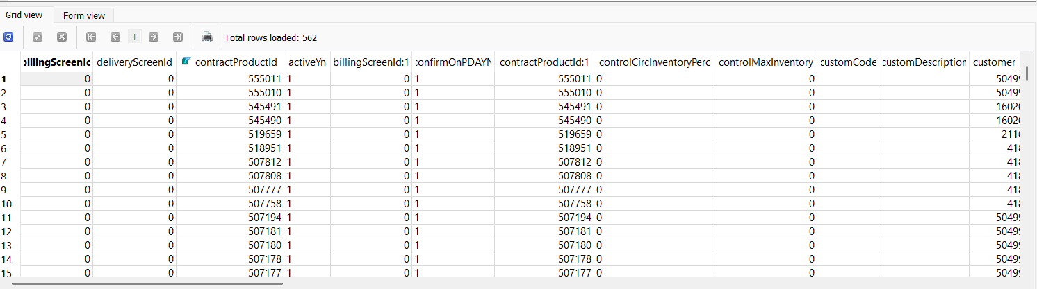
Without fix the expected result is not fulfilled.

Test Case 2 - With ROUTEASSISTANTCONTRACT in the license – reproduced
Bu: 503
Route 80 from 06.10.2025
Expected behavior:
When module ROUTEASSISTANTCONTRACT is in the license we do the following:
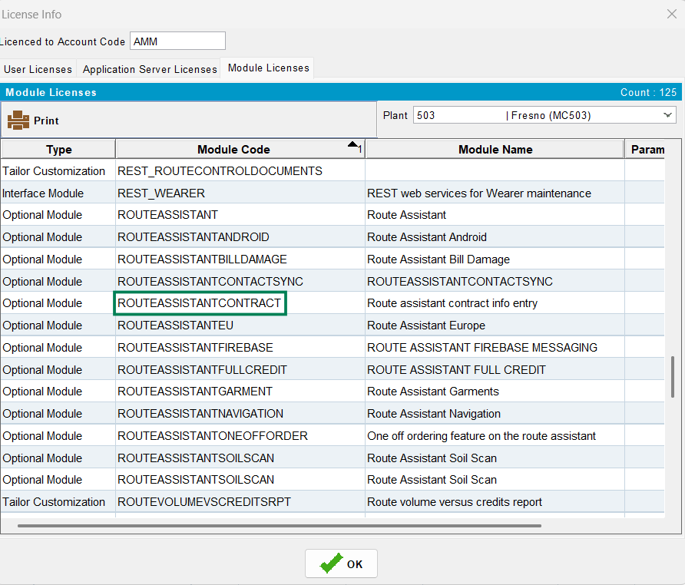
- Load any info in the following tables on RA:
- Load any info in the fields CustomerProductDTO
- And in the CustomerProductDTO

Test Steps:
- Delete the database from the mobile device
- Re-download the same route
- Download the route on RA
- Save the RA database for future checks
- Open the database from RA after downloading
- Open the database dump from RA with SQLITE and
- Check that there is information for the following tables:

select * from RSContractDTO;
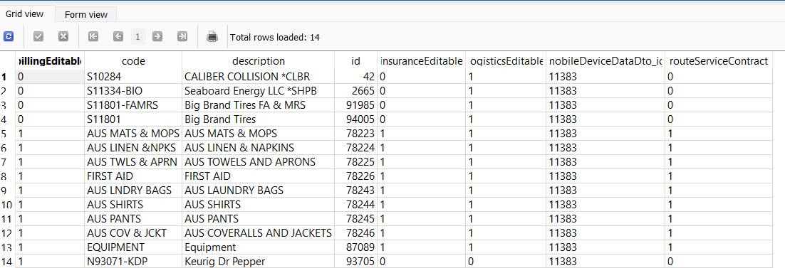

select * from RSContractProdChngDTO;
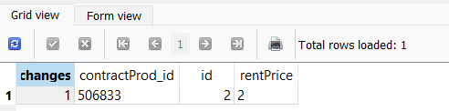

select * from RSContractProdDTO;
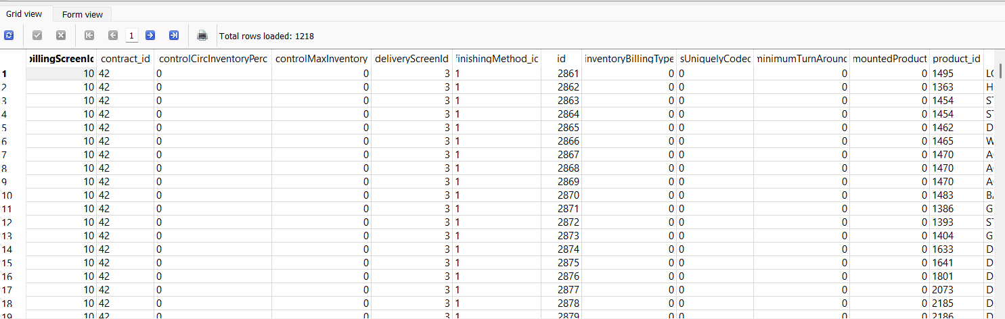

select * from RSContractProdDelFDTO;
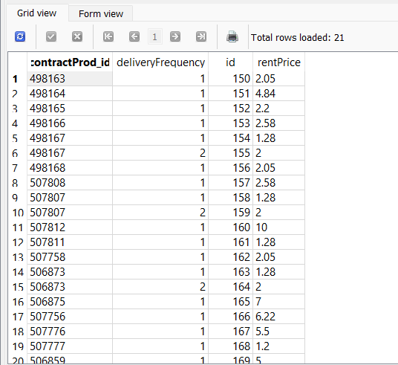

select * from RSContractProdInsPDTO;
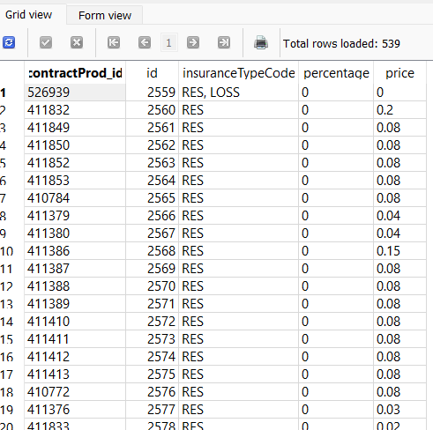

select * from FirstDeliverySchemeDTO;
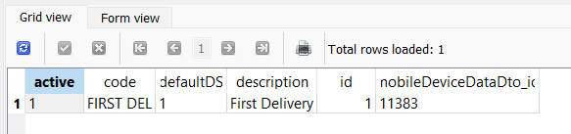

select * from RSCPerCustomerDTO;
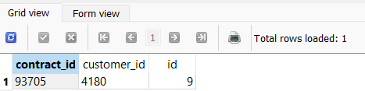

select * from RSContractProdQMGLDTO;
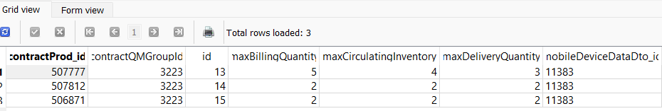

select * from RSContractProdComplDelFreqDTO;
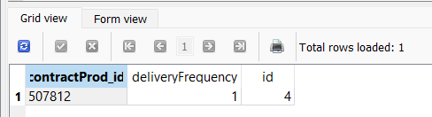

select CustomerProductDTO.billingScreenId, CustomerProductDTO.deliveryScreenId, CustomerProductDTO.contractProductId, CustomerProductDTO.* from CustomerProductDTO;
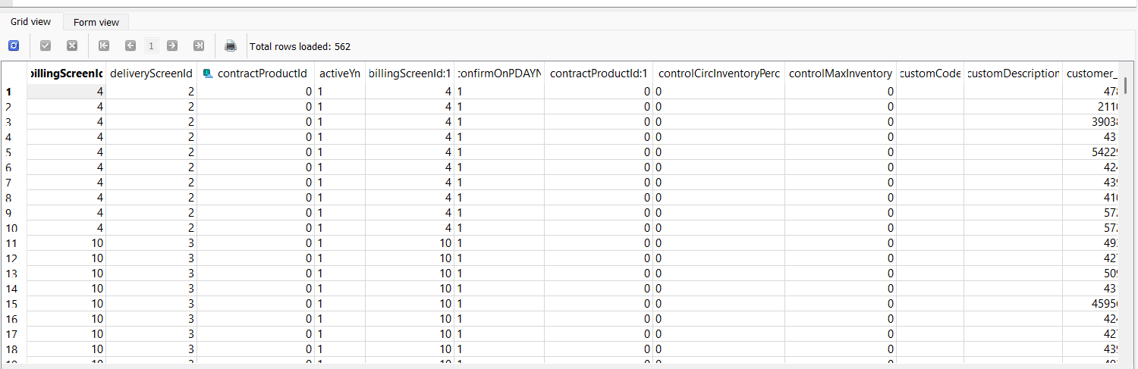

Time for download:
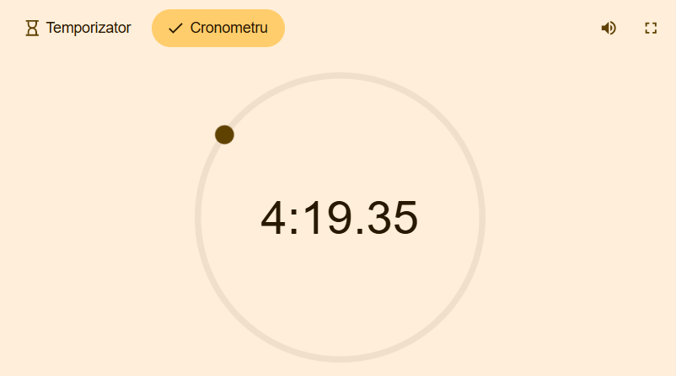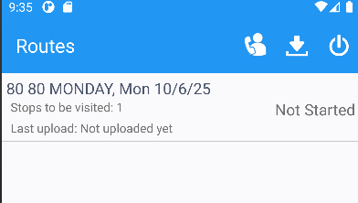
Without fix the expected result is fulfilled but the time for downloading is not very good (a route with a single customer to be visited)

Test after fix

Test Case 1 - Without ROUTEASSISTANTCONTRACT in the license – passed
Bu: 503
Route 80 from 06.10.2025
Expected behavior:
When module ROUTEASSISTANTCONTRACT is not in the license we do the following:
- Do not load any info in the following tables on RA:

- Put 0 in the fields CustomerProductDTO
- And null in the following field on the CustomerProductDTO
Test Steps:
- Find a route with contract products attached to the contracts that belong to customers on the route
- PLPC of that customer
- Route Status Control DLG: Add a new route for one of your customers/route/driving date you found. Move out the rest of the customers.
- Route Status Control DLG: Generate packing notes
- Route Status Control DLG: Generate invoices
- Route Status Control DLG: Mark ready to transfer
- Download the route on RA
- Save the RA database for future checks
- Open the database from RA after downloading
- Open the database dump from RA with SQLITE and
- Check that there is no information for the following tables:
select * from RSContractDTO;
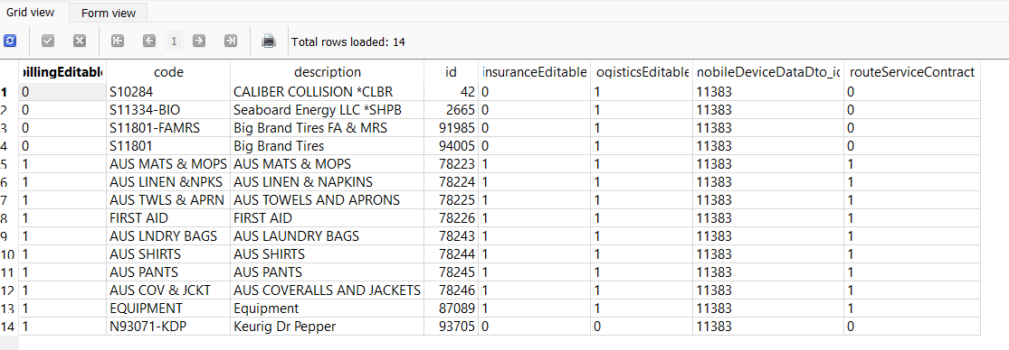
select * from RSContractProdChngDTO;
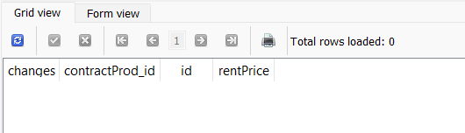

select * from RSContractProdDTO;
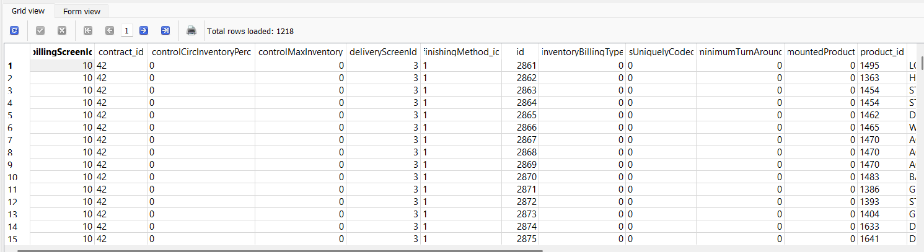
select * from RSContractProdDelFDTO;
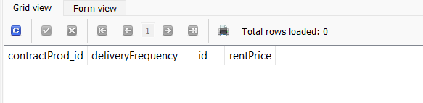
select * from RSContractProdInsPDTO;
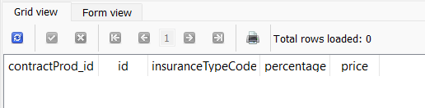
select * from FirstDeliverySchemeDTO;
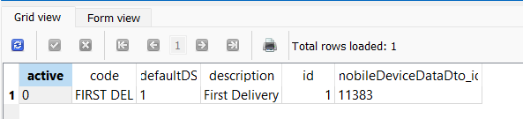
select * from RSCPerCustomerDTO;
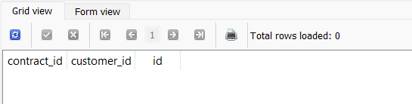

select * from RSContractProdQMGLDTO;
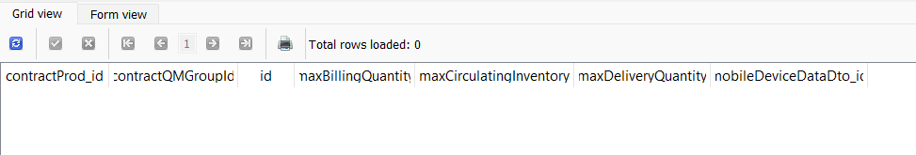
select * from RSContractProdComplDelFreqDTO;
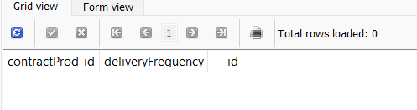
select CustomerProductDTO.billingScreenId, CustomerProductDTO.deliveryScreenId, CustomerProductDTO.contractProductId, CustomerProductDTO.* from CustomerProductDTO;
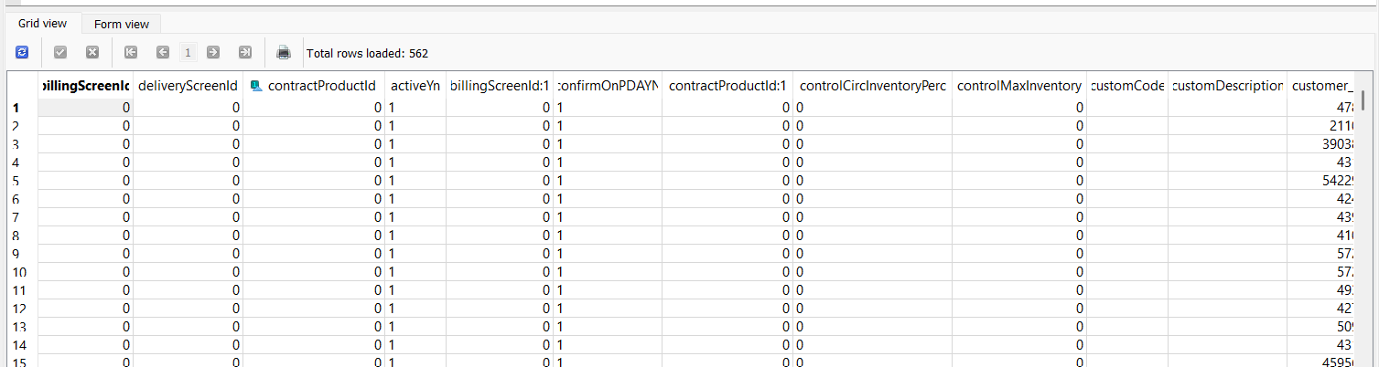

Time for download:

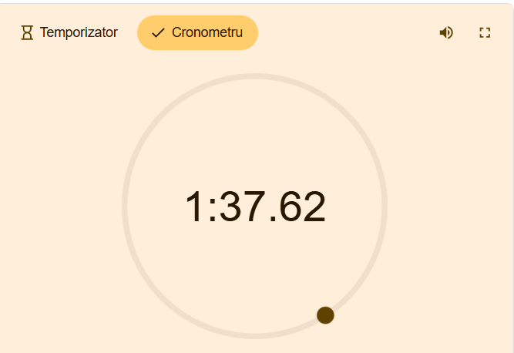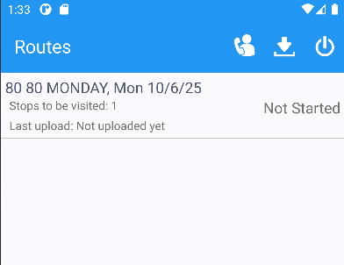

The performance is good, even if not all the above tables are empty (most of the tables are empty and download time has improved).
Vestis uses this module: ROUTEASSISTANTCONTRACT, for all plants and, also, with this module in the license download time has improved.

Test Case 2 - With ROUTEASSISTANTCONTRACT in the license – passed
Bu: 503
Route 80 from 06.10.2025
Expected behavior:
When module ROUTEASSISTANTCONTRACT is in the license we do the following:
- Load any info in the following tables on RA:
- Load any info in the fields CustomerProductDTO
- And in the CustomerProductDTO

Test Steps:
- Delete the database from the mobile device
- Redownload the same route
- Download the route on RA
- Save the RA database for future checks
- Open the database from RA after downloading
- Open the database dump from RA with SQLITE and
- Check that there is information for the following tables:

select * from RSContractDTO;
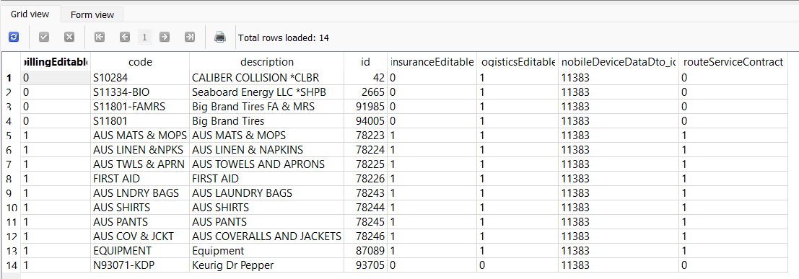
select * from RSContractProdChngDTO;
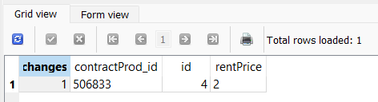
select * from RSContractProdDTO;
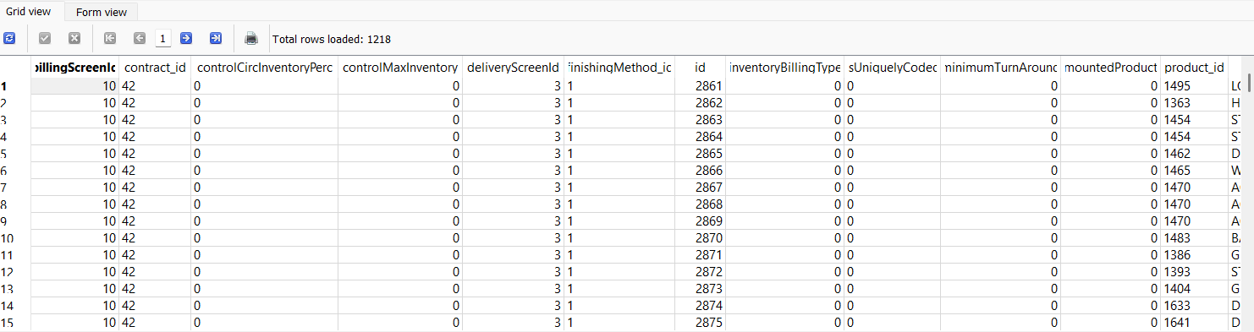
select * from RSContractProdDelFDTO;
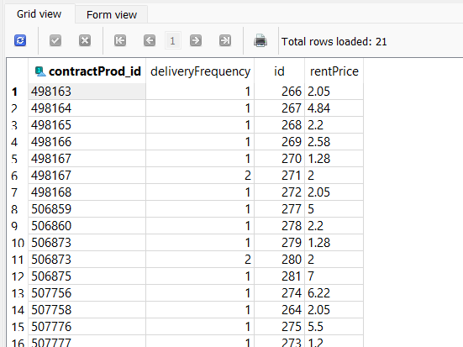
select * from RSContractProdInsPDTO;
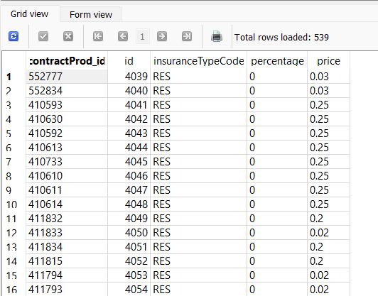
select * from FirstDeliverySchemeDTO;
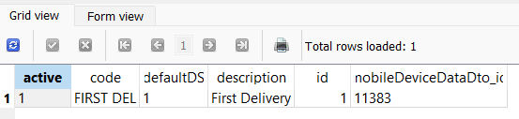
select * from RSCPerCustomerDTO;
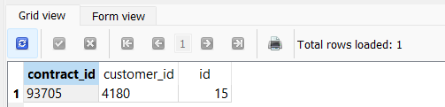
select * from RSContractProdQMGLDTO;
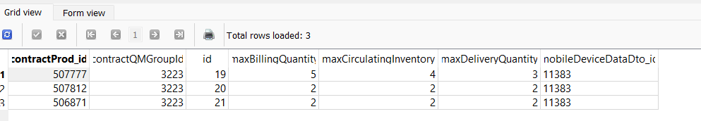
select * from RSContractProdComplDelFreqDTO;
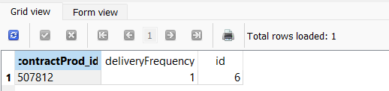
select CustomerProductDTO.billingScreenId, CustomerProductDTO.deliveryScreenId, CustomerProductDTO.contractProductId, CustomerProductDTO.* from CustomerProductDTO;
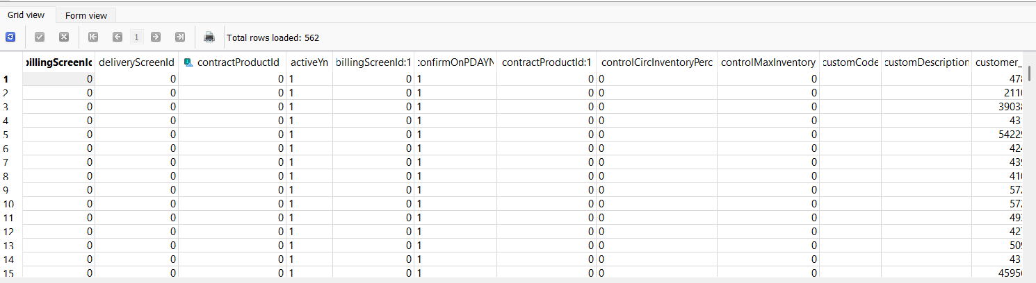
Time for download:
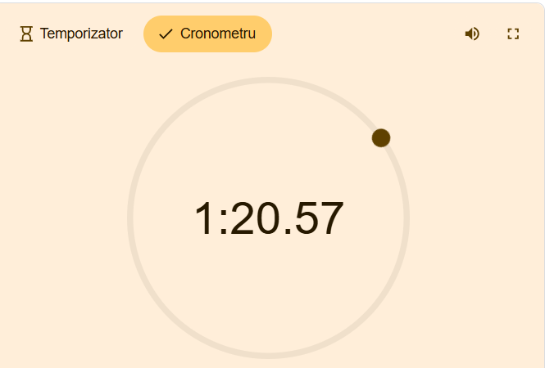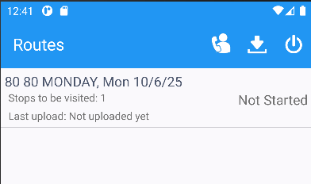

Test Case 3 - With ROUTEASSISTANTCONTRACT in the license – regression - passed
Bu: 503
Route 38 from 09.10.2025 with 24 stops
Time for download:
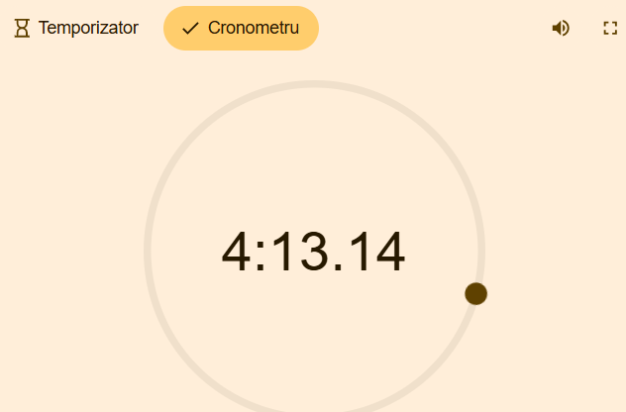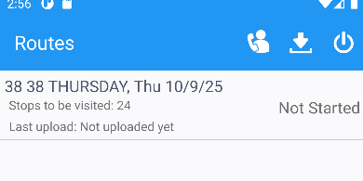
- Actions on PDA:
Customer: 5178683
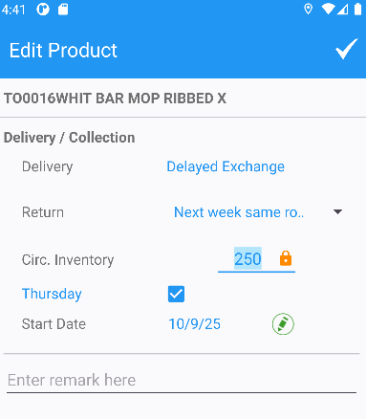
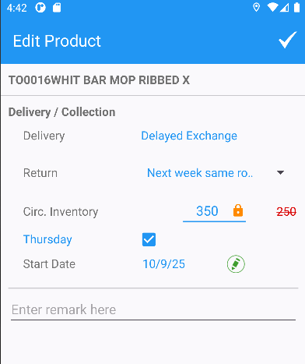
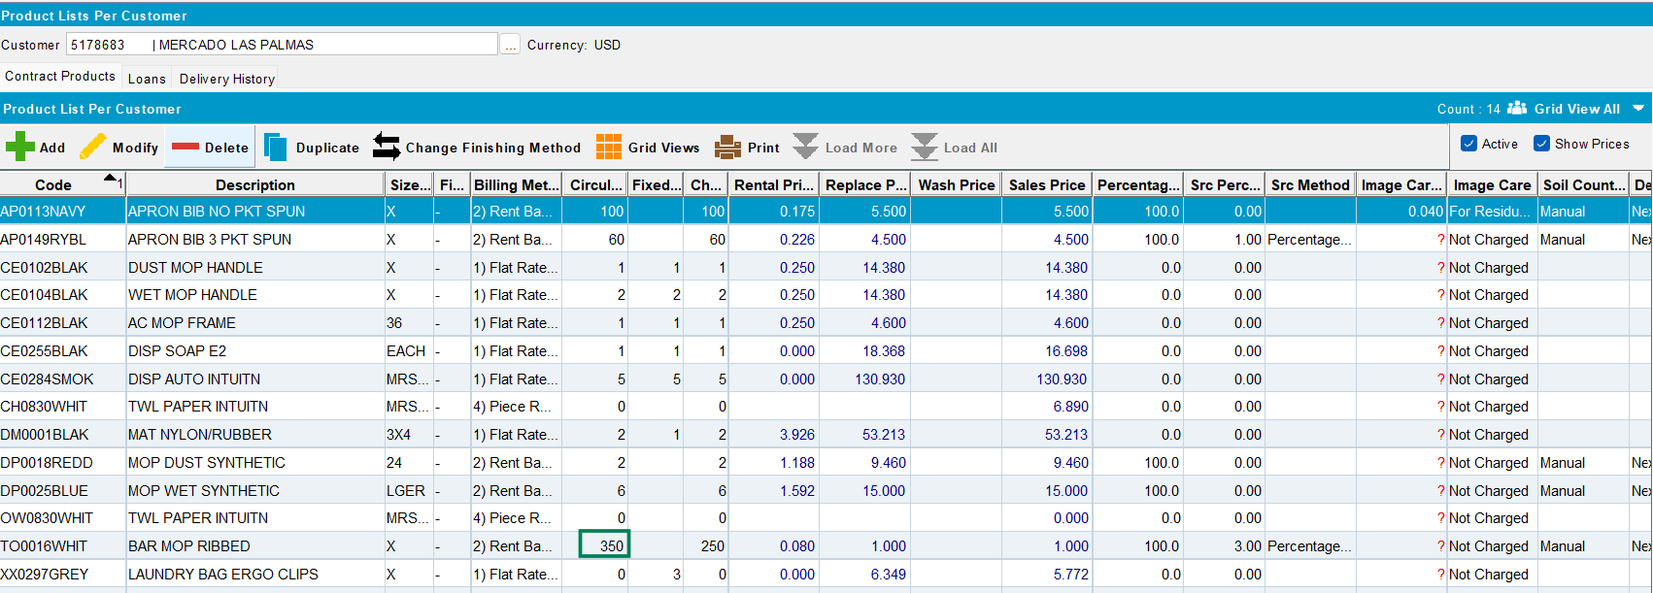
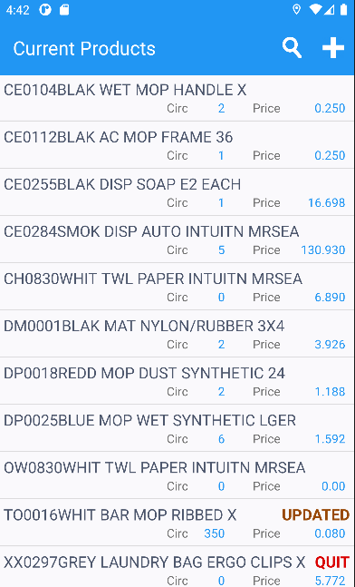
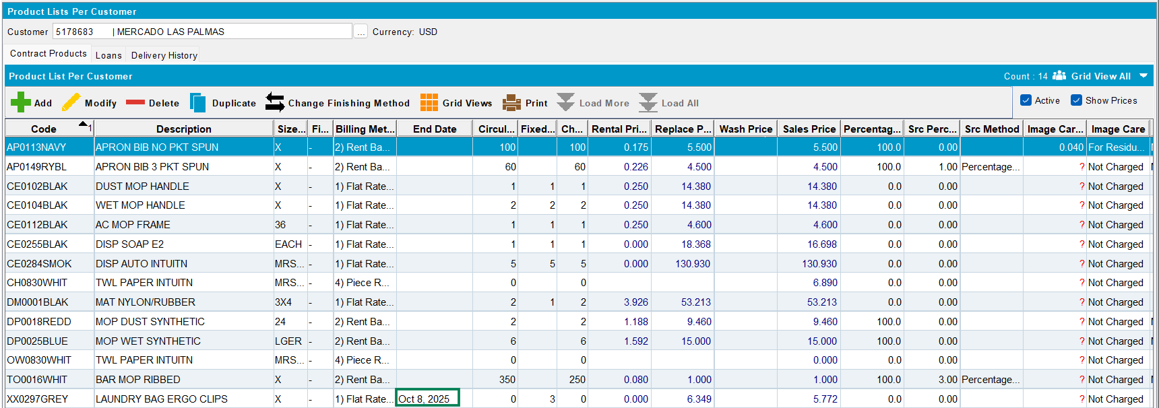
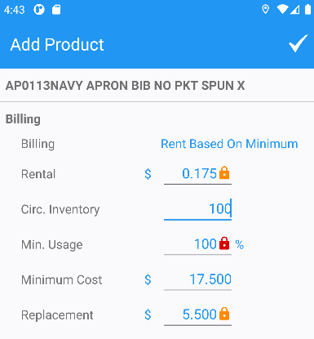
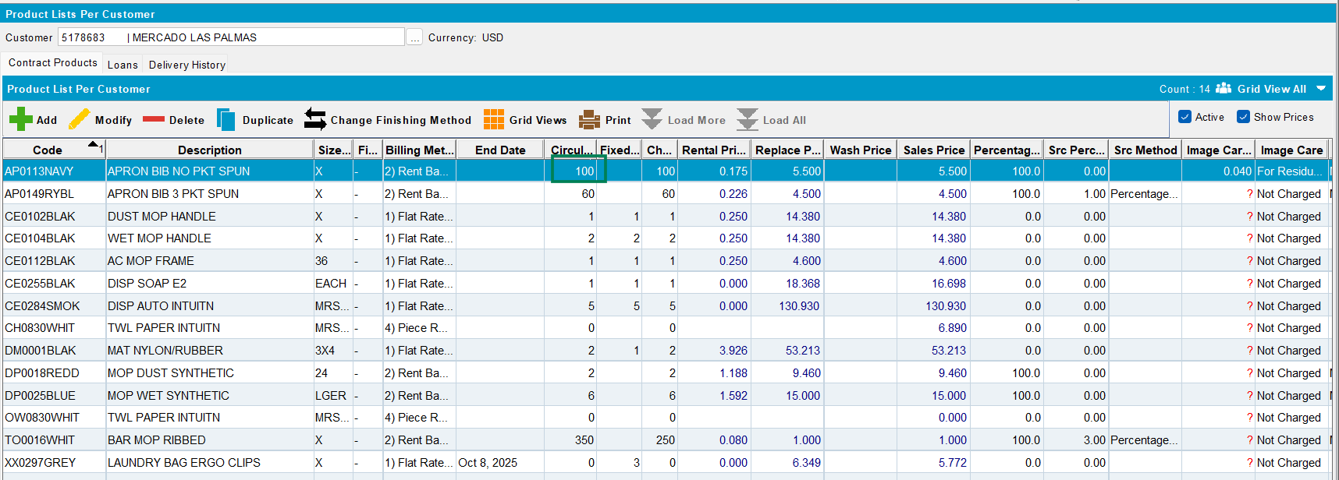
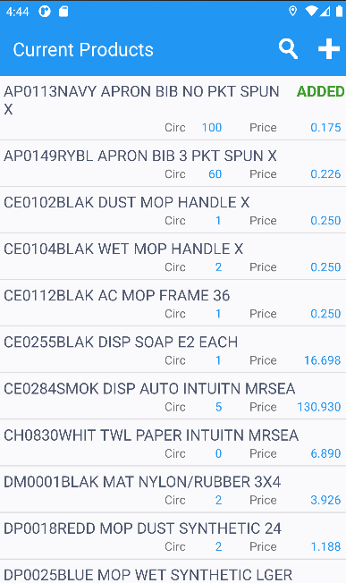
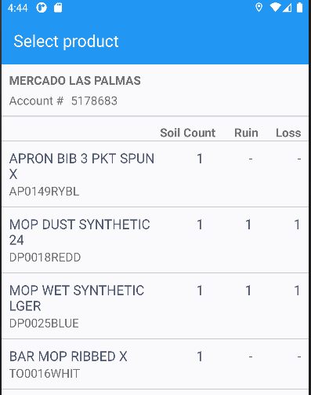
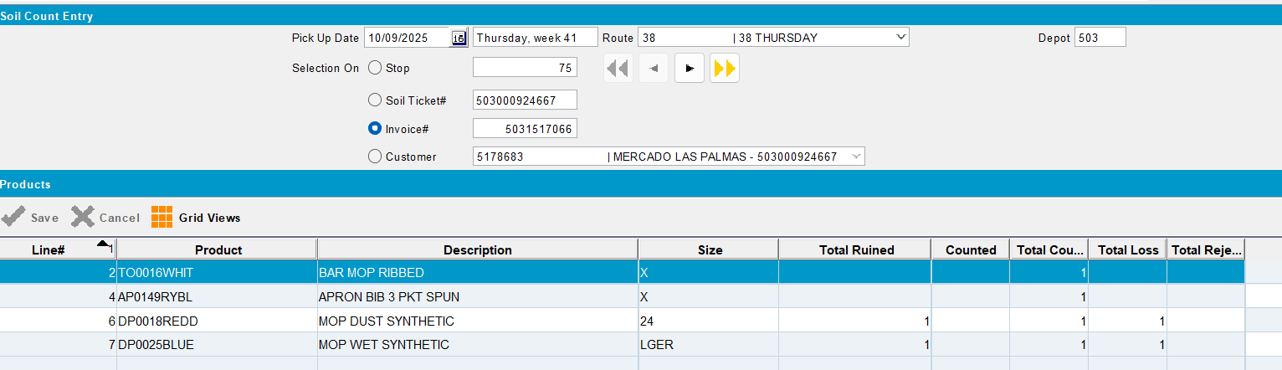
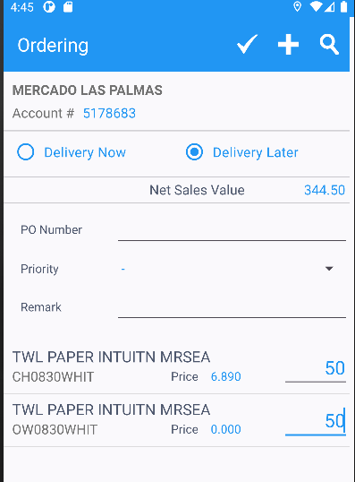
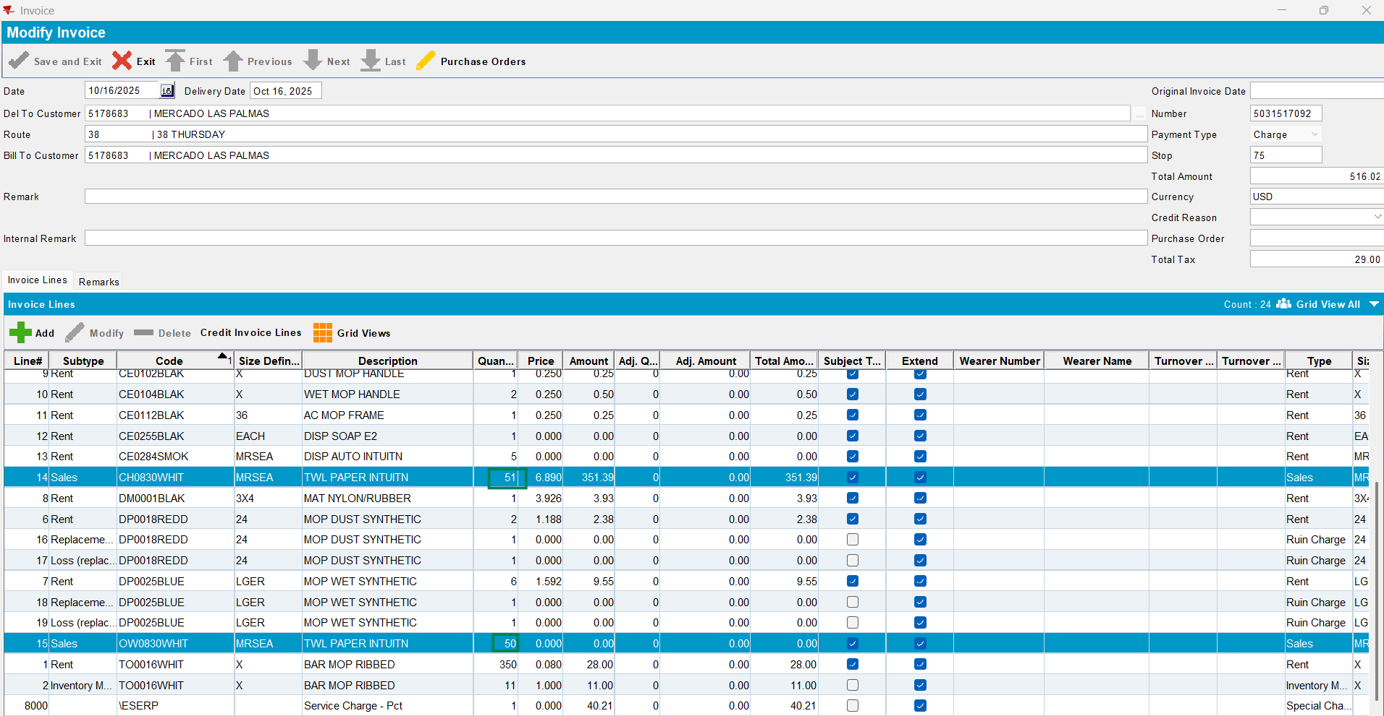
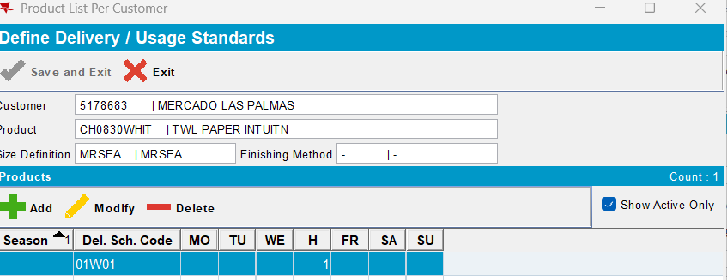
SDQ=1+ DVs=50=51
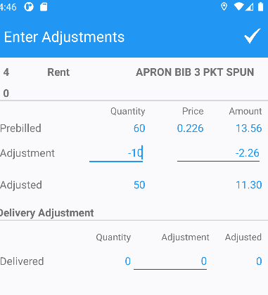
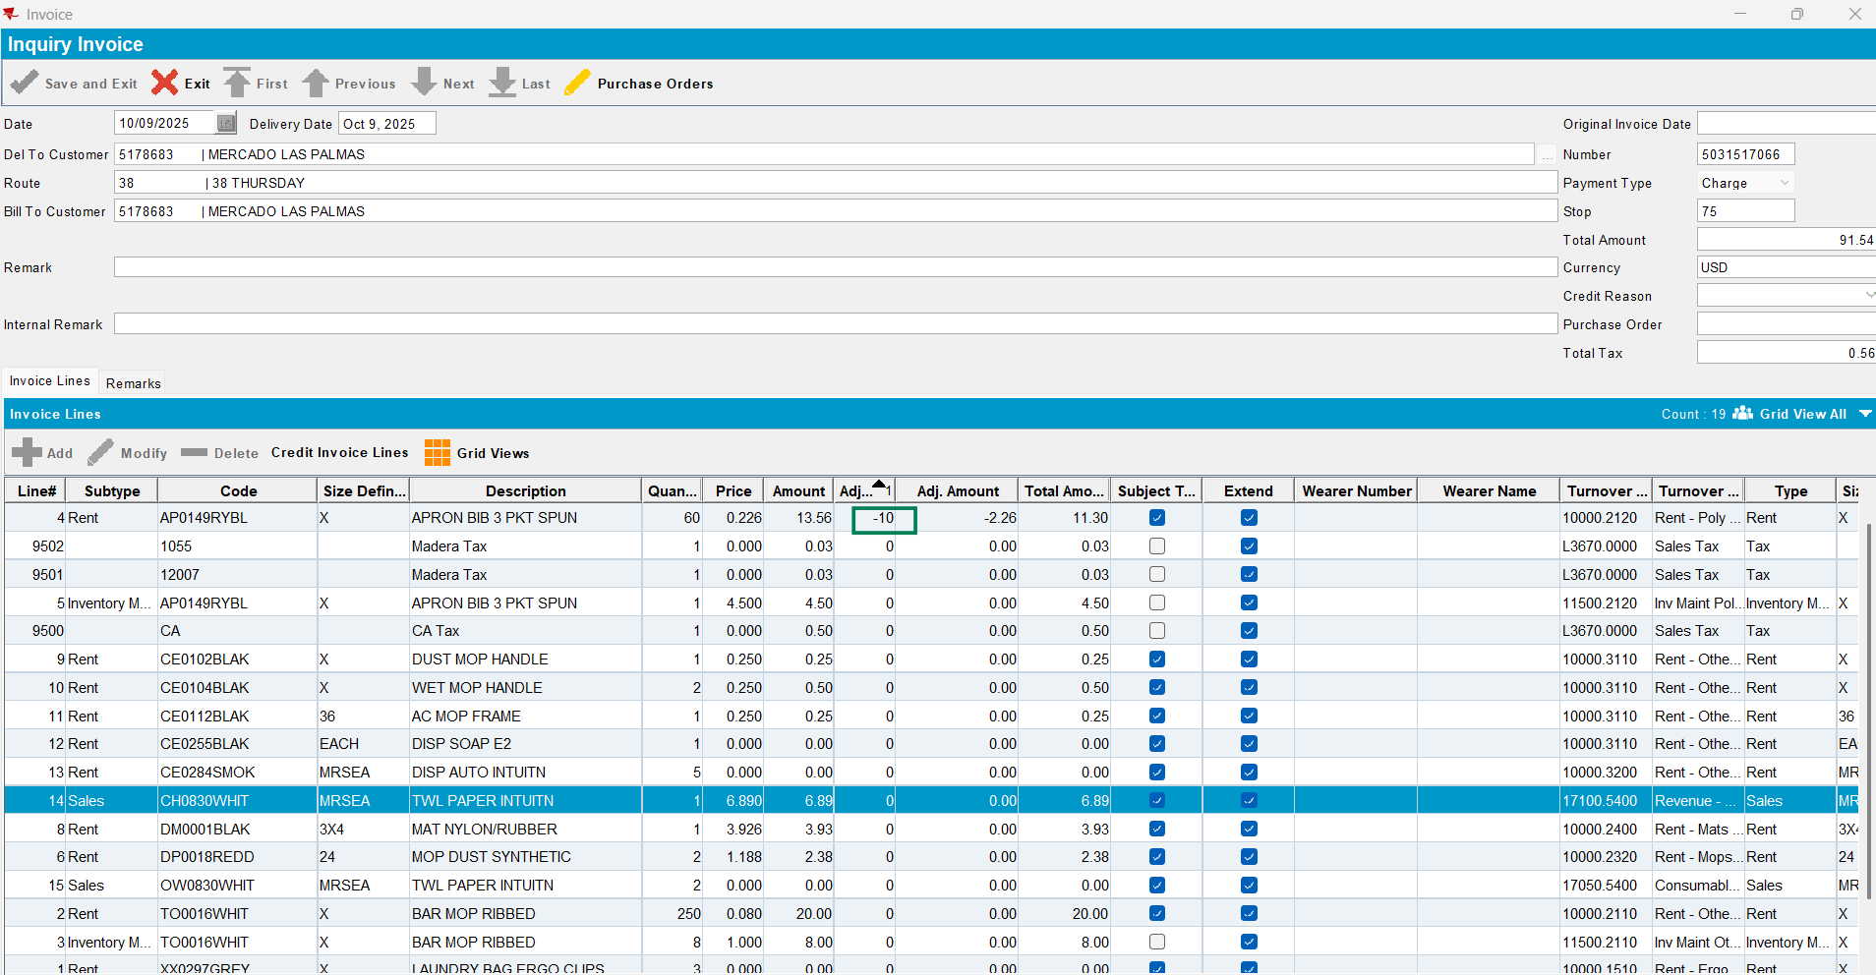
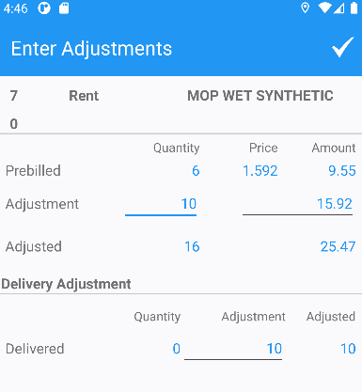
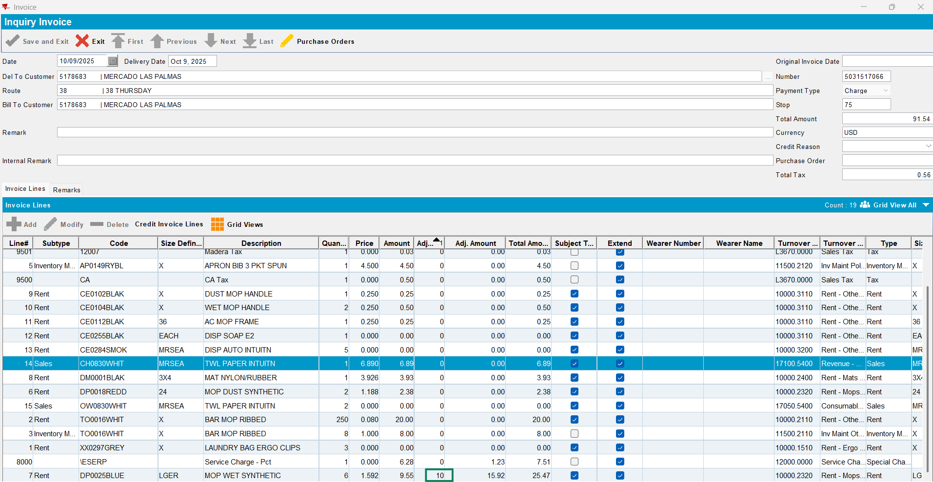

Customer: 5506109
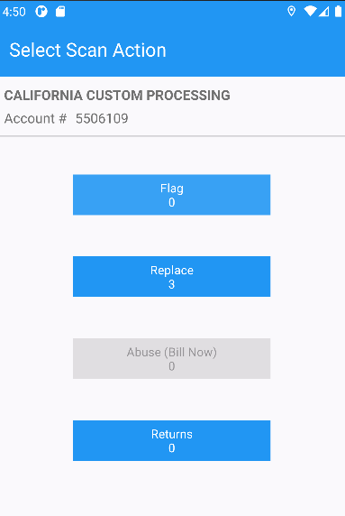
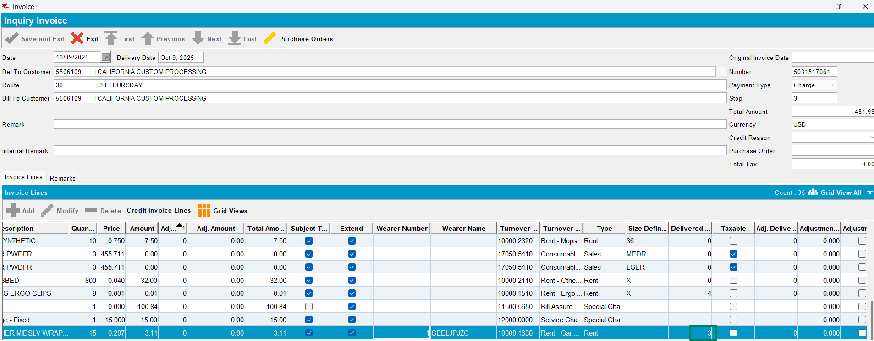
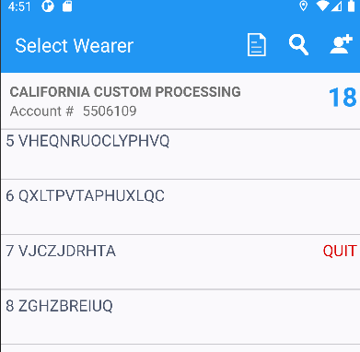
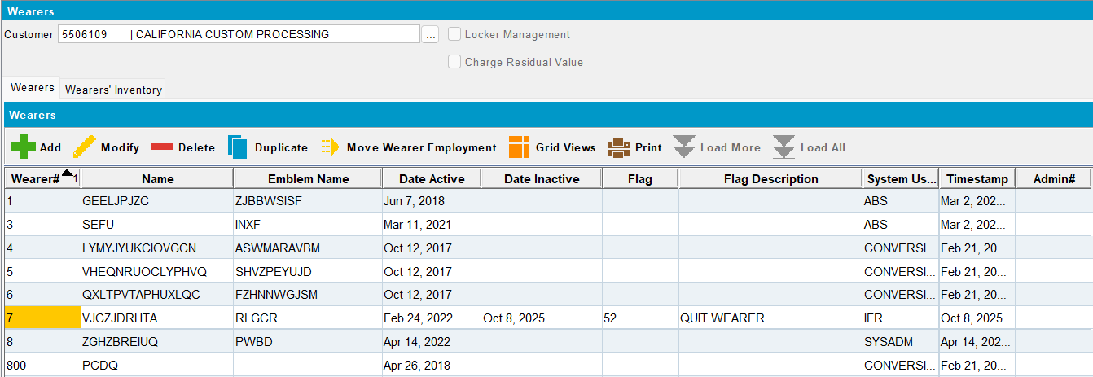

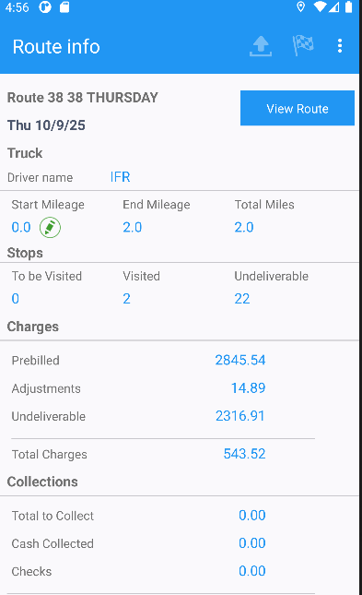
select RT.ROUTETRANSACTIONTYPE_ID, rt.doublevalue1, rt.doublevalue11, rt.processedstatus, rt.stringvalue1, rt.stringvalue2, rt.stringvalue3, RT.APPROVALSTATUS, rt.processedstatus, rt.numbervalue9, rt.numbervalue1, rt.doublevalue2, rt.doublevalue3, rt.routetransactiontype_id, rt.invoiceline_id, rt. doublevalue1, rt.routecontrol_id, rt.stop_id, rt.invoiceheader_id, rt.invoiceline_id, rt.reasoncode_id, rt.doublevalue11, rt.ApprovalTimestamp, rt.approvedbysystemuser_id,
rt.timestamp from ROUTETRANSACTION RT where RT.ROUTECONTROL_ID =5090784;
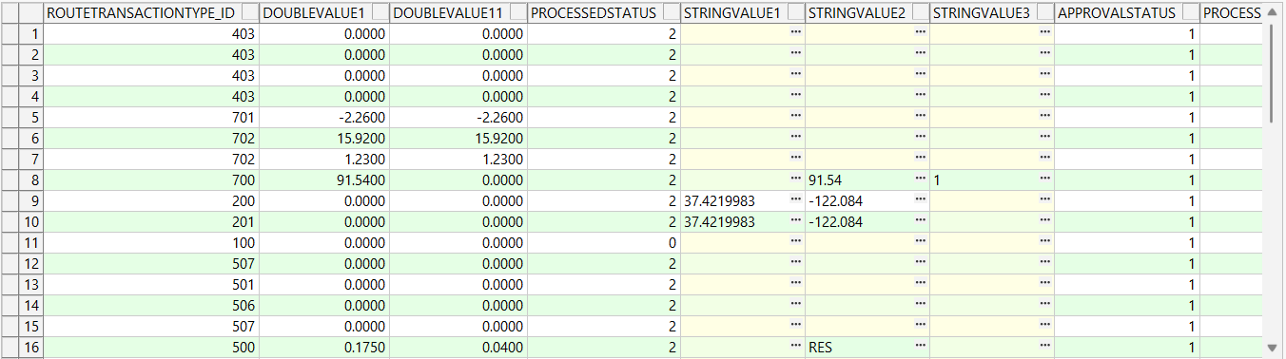

After upload/settlement (see above) all transactions are ok and are saved correctly on the server.

