ABSN-6492 D_UBS_2699 Improve SQL for loading ContractProducts at Download
Environment | Prerequisites
Version: 9.08.00.RELEASE.p22 (AUS)  DBServerName= abs-srv17.internal.abslbs.com  DBSID=CUST23  DBUser=AUS_MNT90800  DBPassword=AUS_MNT90800  Environment=Test  EnvironmentSABStage=Test | - Module: ROUTEASSISTANTCONTRACT; ROUTEASSISTANTGARMENT; ROUTEASSISTANT; ROUTEASSISTANTANDROID;  - SS: PDAAUTOSYNCROUTE=N; PDAAUTOSYNCSTOP=N;  DEBUG_LEVEL=2;  - Other applications versions: RouteAssistant_v13.30  - Device used for mobile applications: Android Studio
Contents
Scope of development: 1
Reproduction before fix 2
Steps to reproduce 2
Retest after fix 20
Test Case 1 - Performance testing – Test OK. 20
Expected behavior: 20
Test Steps: 20
DATA CONSISTENCY TEST 1 – Test OK. 22
Expected behavior: 22

Scope of development:
Improve the download time on PDA when a route control containing customer with many contract products (> 200) and ROUTEASSISTANTCONTRACT module is in the license of the plant.
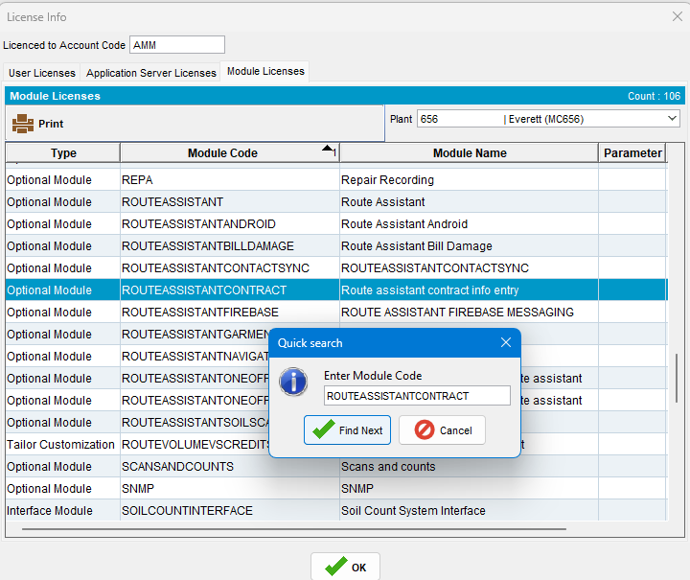

Reproduction before fix
BU.CODE / BU.Decription: 656 /Everett (MC656) QA 01/13/25
Plant.code / Plant.description: 656 / Everett (MC656)
hash: 0a372ea5d8f6

Steps to reproduce
- Find a route with a large number of contractproducts attached to the contracts that belong to customers on the route:
select count(cp.contractproduct_id), c.customernumber, rc.drivingdate, r.routenumber, p.code from routecontrol rc
join route r on r.route_id = rc.route_id
join plant p on p.plant_id = r.plant_id
join stop s on s.routecontrol_id = rc.routecontrol_id
join customer c on c.customer_id = s.customer_link_id
join contractcustomer cc on cc.customer_link_id = c.customer_id
join contract co on co.contract_id = cc.contract_id
join contractproduct cp on cp.contract_id = co.contract_id
where c.dateinactive > sysdate
and cc.enddate > sysdate
and co.enddate > sysdate
group by c.customernumber, rc.drivingdate, r.routenumber, p.code
having count(cp.contractproduct_id) > 200;
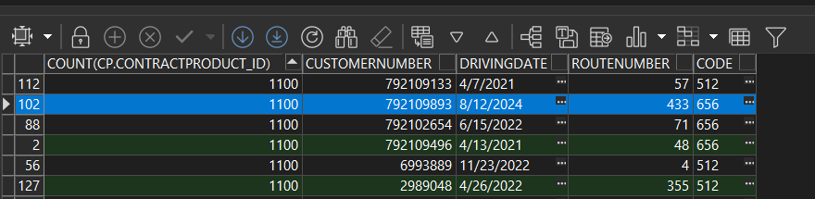

- Find customer’s Contract:
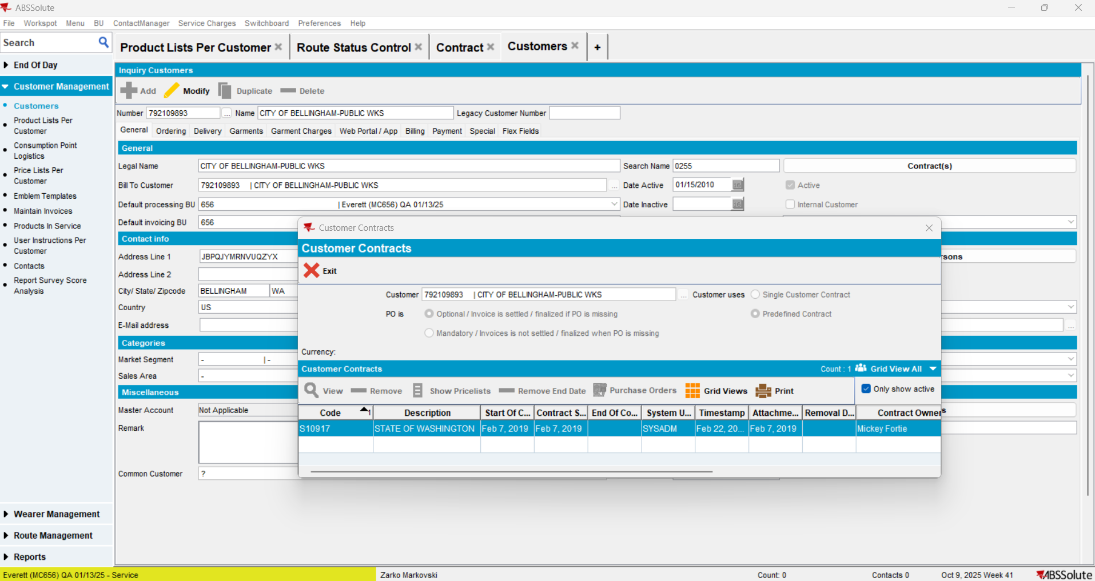

- Check customer’s PLPC list:
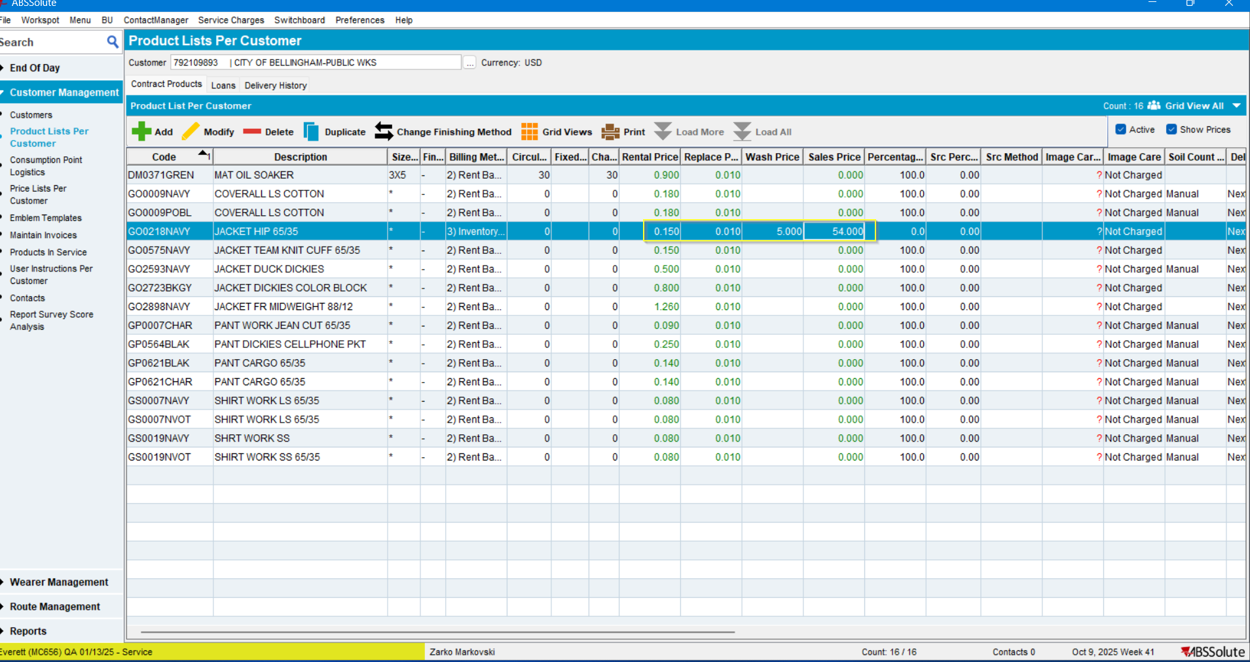
For better data consistency comparison, make sure that the customer has at least one product for which all price types are set: Rent, Replace, Wash and Sales.

- If some of the prices are missing, add them through the Contract dlg.:
CONTRACT dlg > Modify > Components > Products >
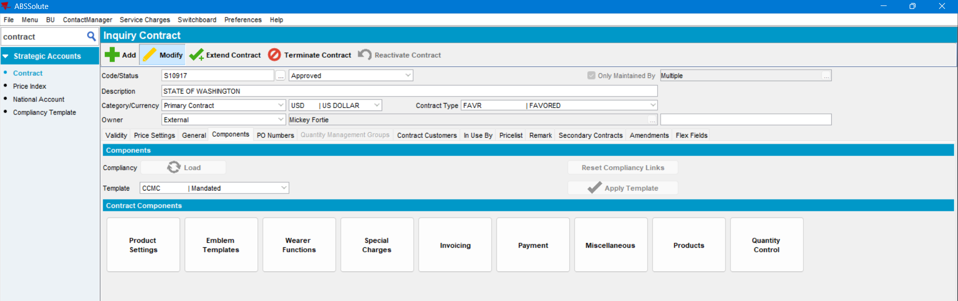

Select product > Modify:
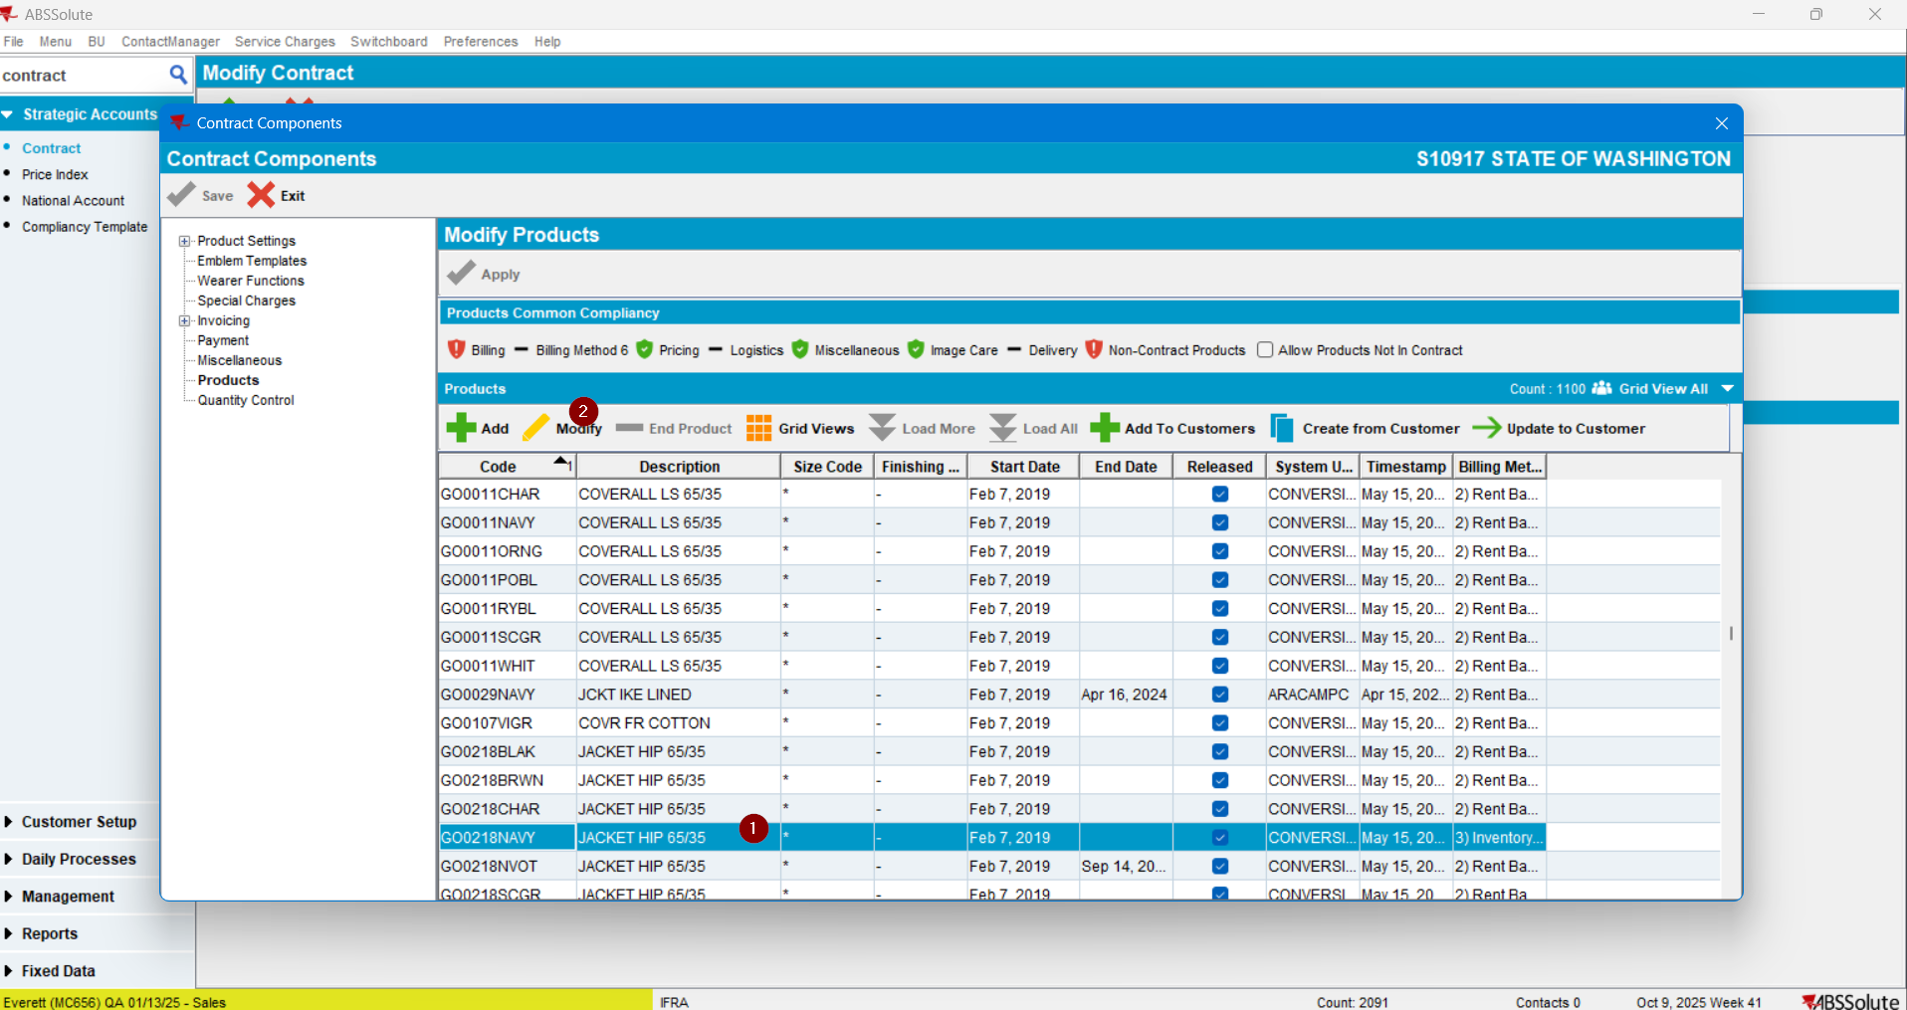
Select Billing > Change BM > Set the prices > Save and Exit:
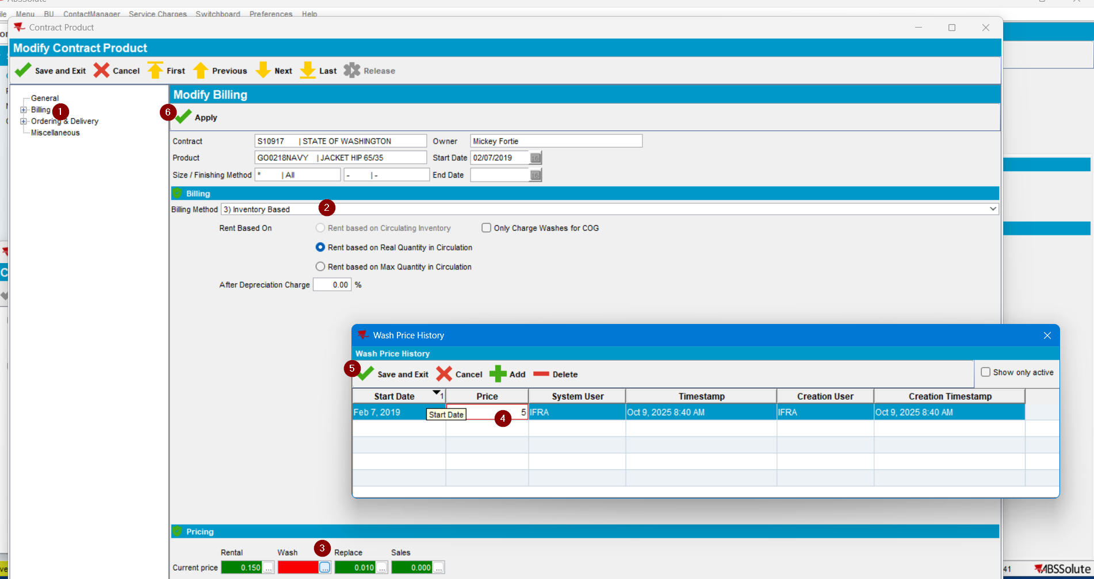

Apply:
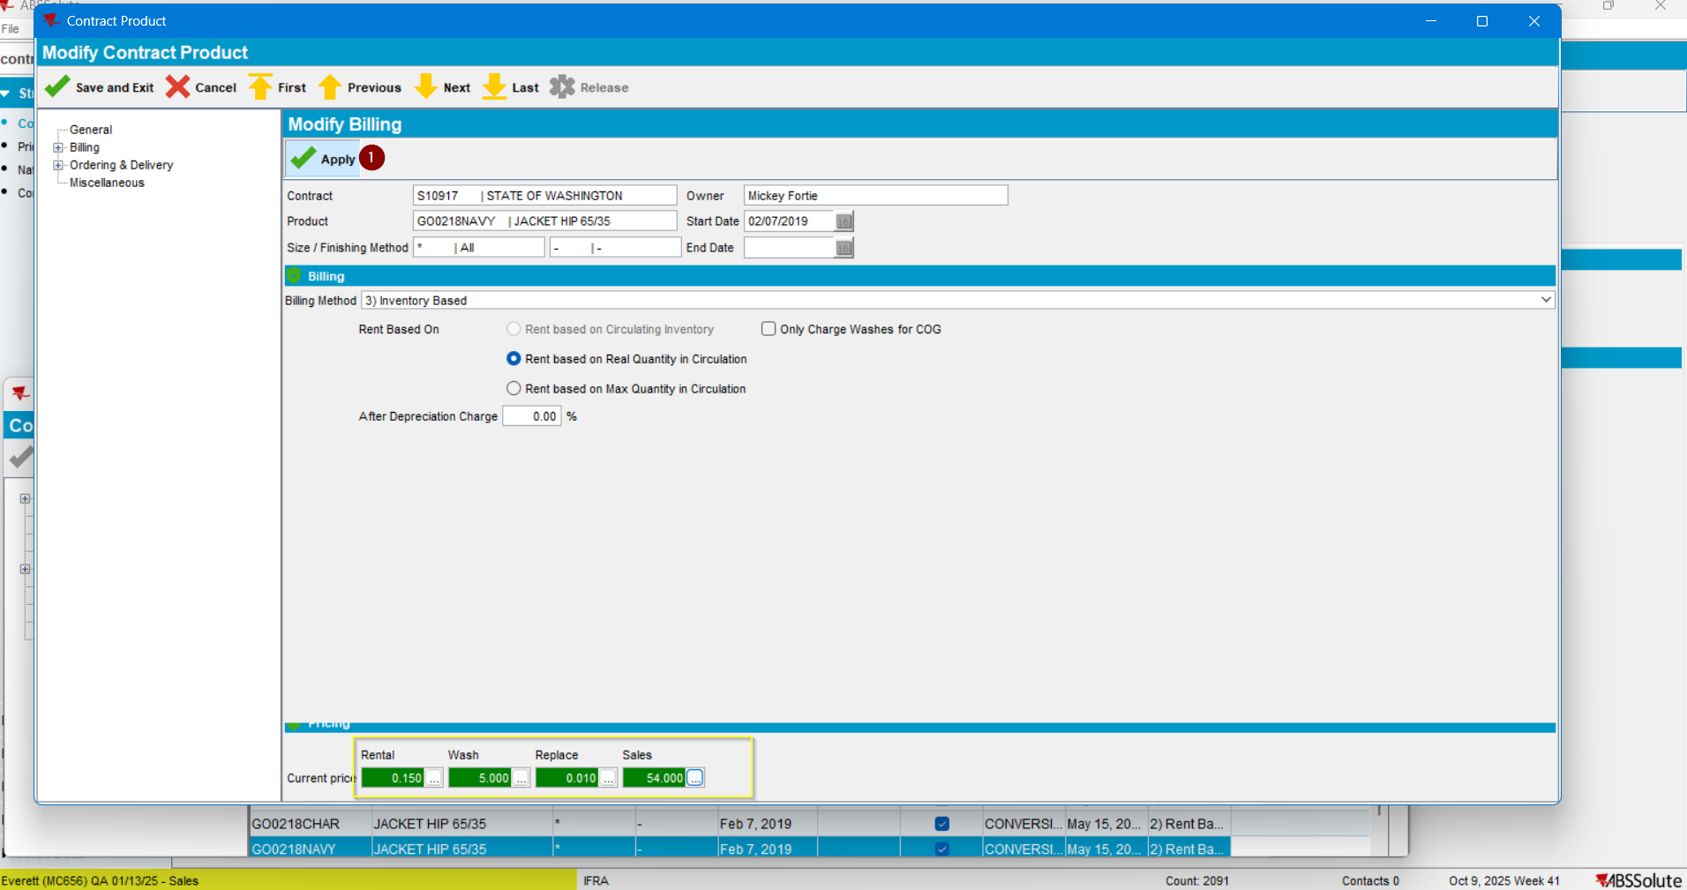
- Update the prices to Customer:
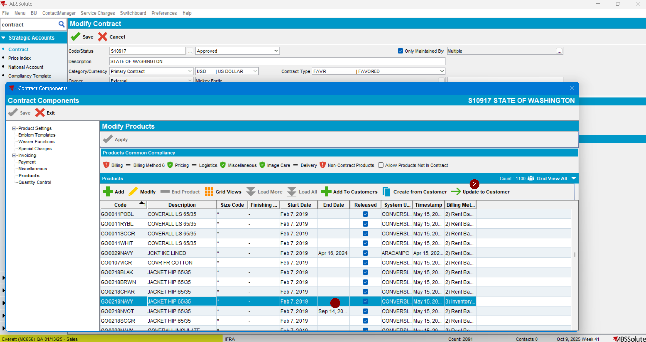

Note: The price was updated only for the customer used:
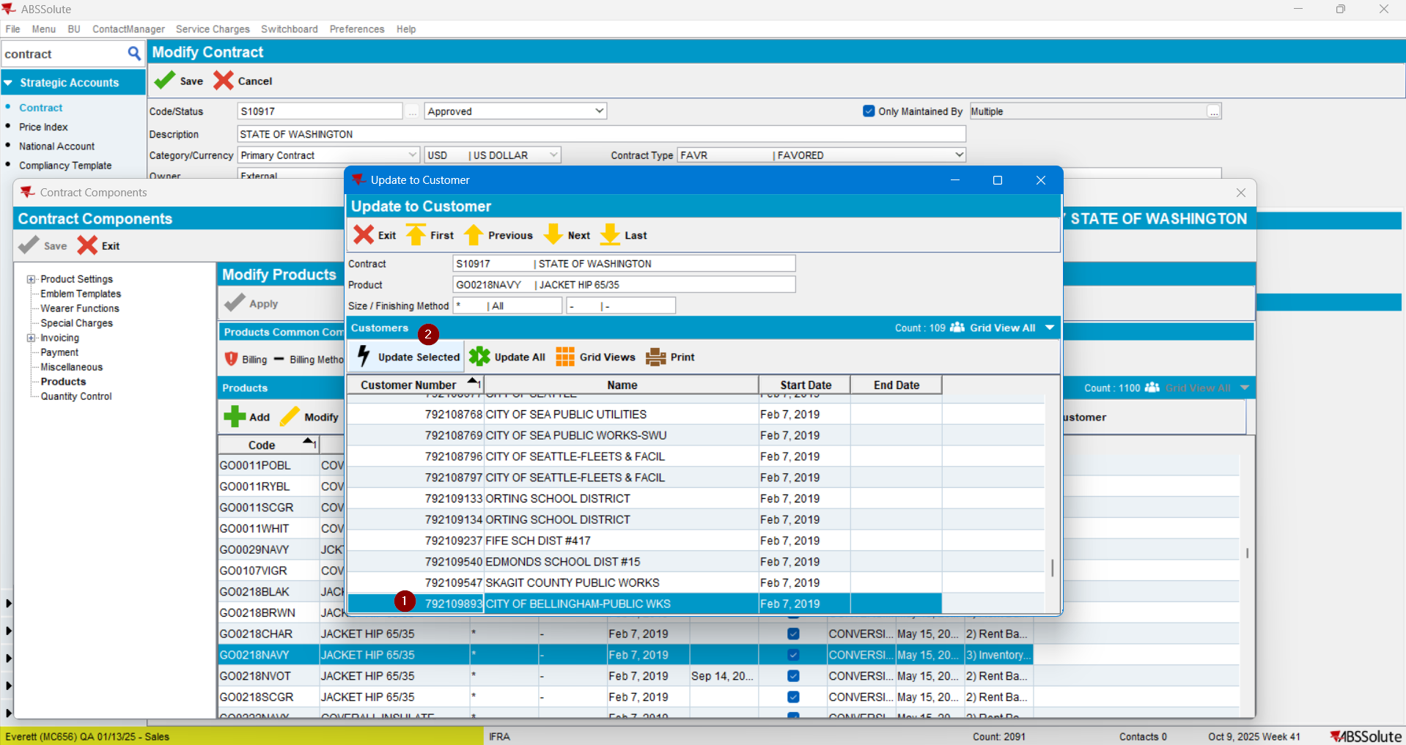

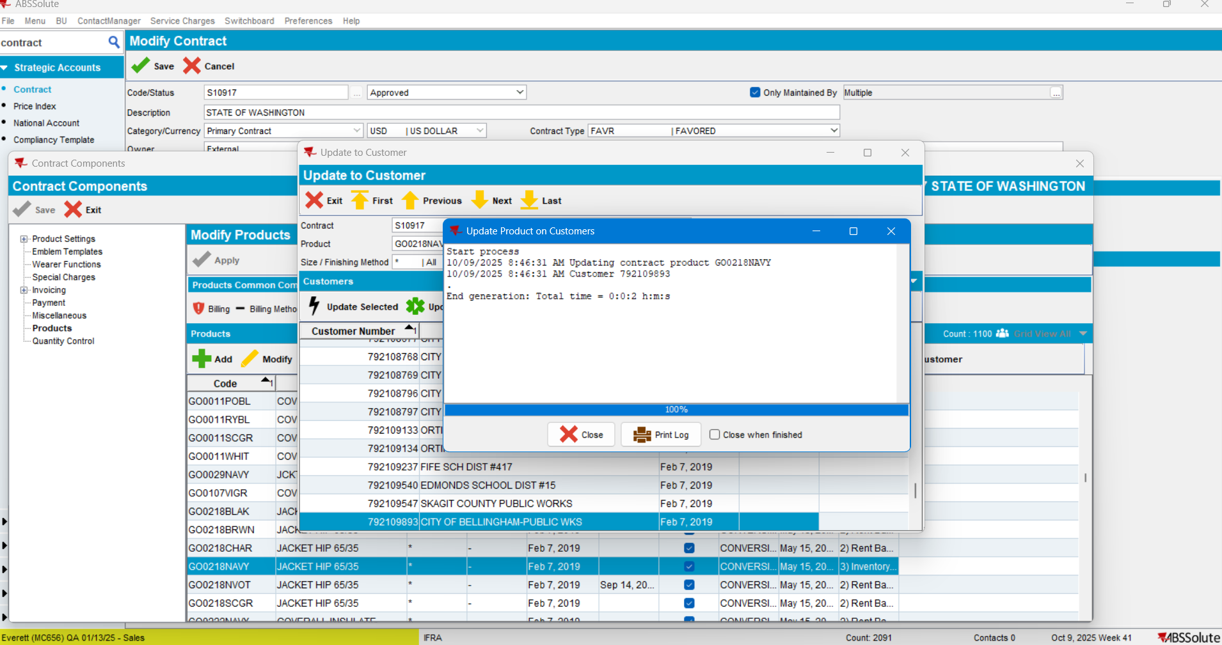

In conclusion the Customer has all price types defined at least on one of its PLPC products:
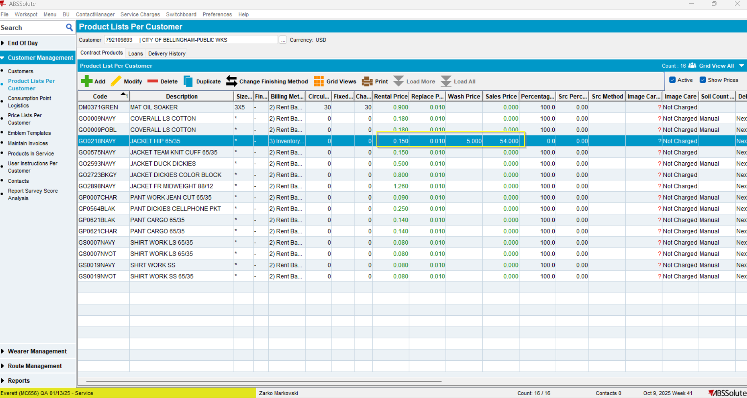
- Create a new route control for the route identified:
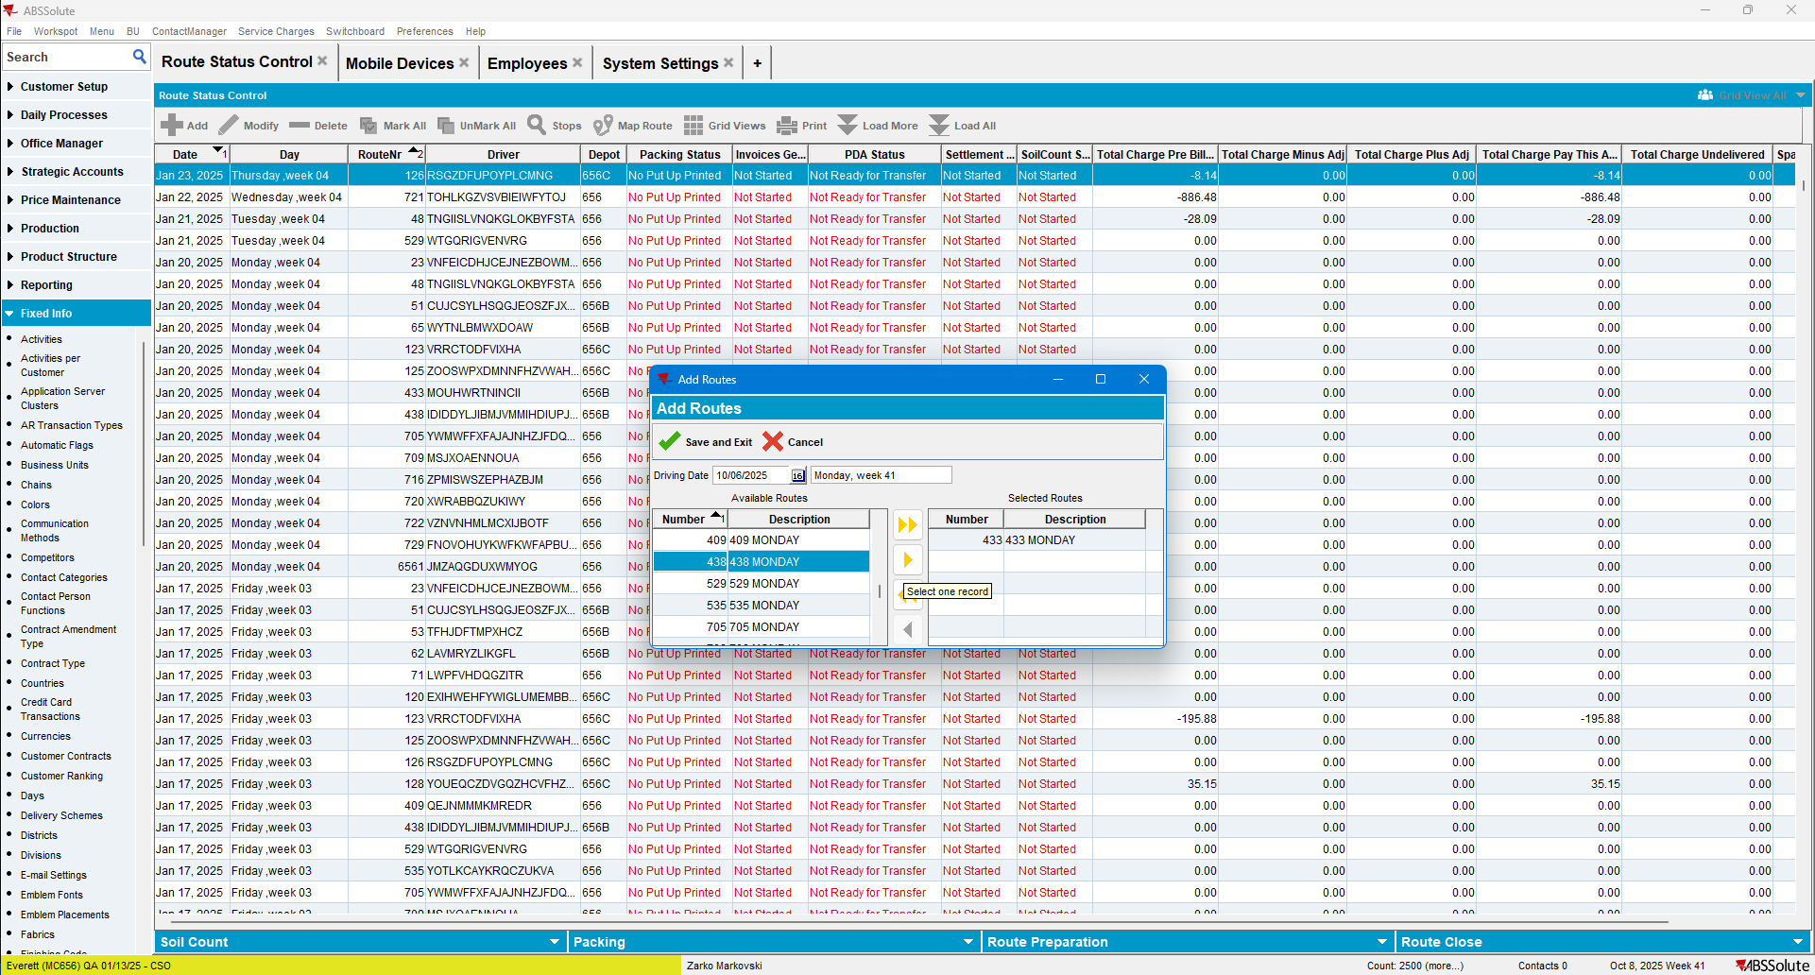

- Make sure that the route contains a stop for the identified customer:
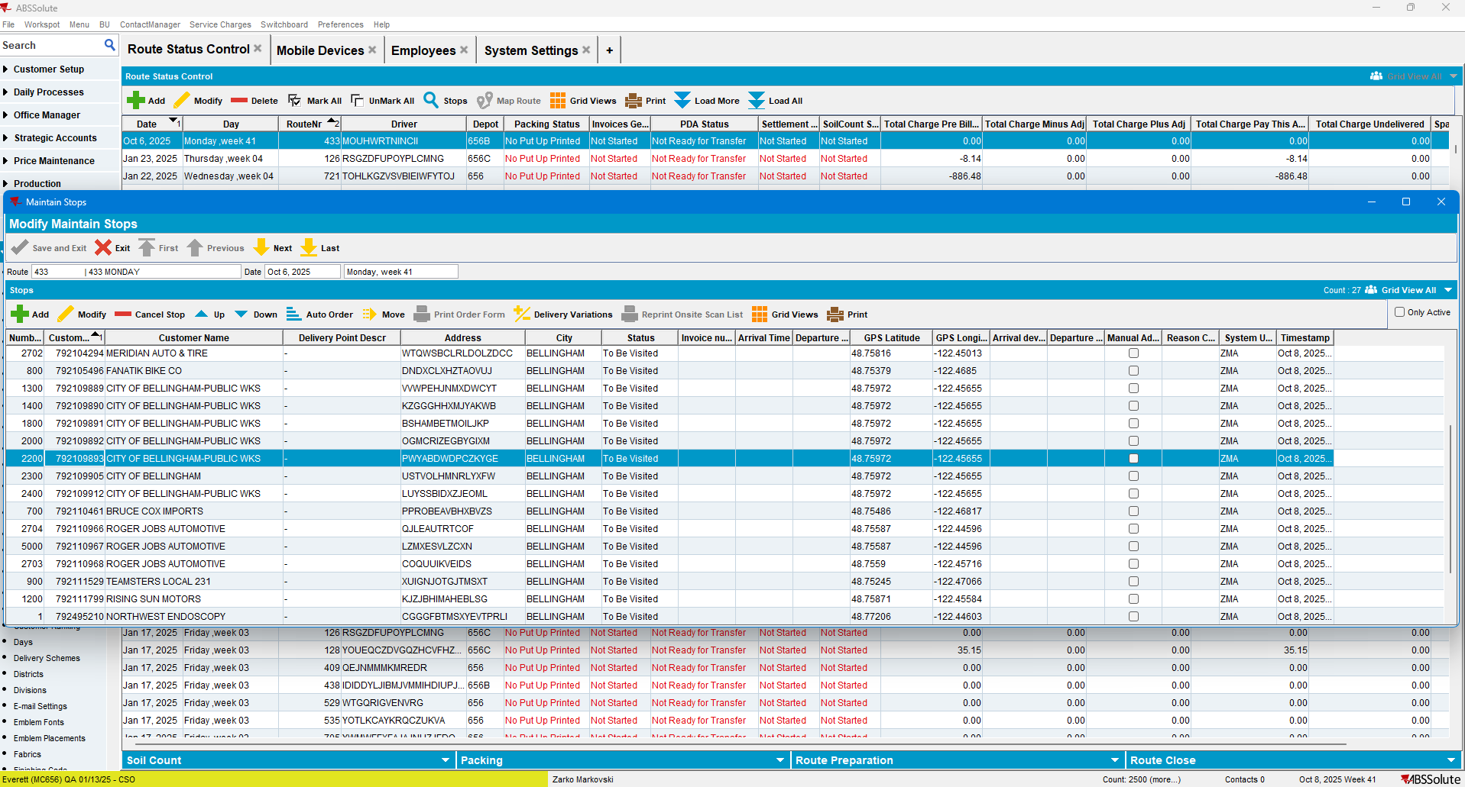
- Generate put-up docs:
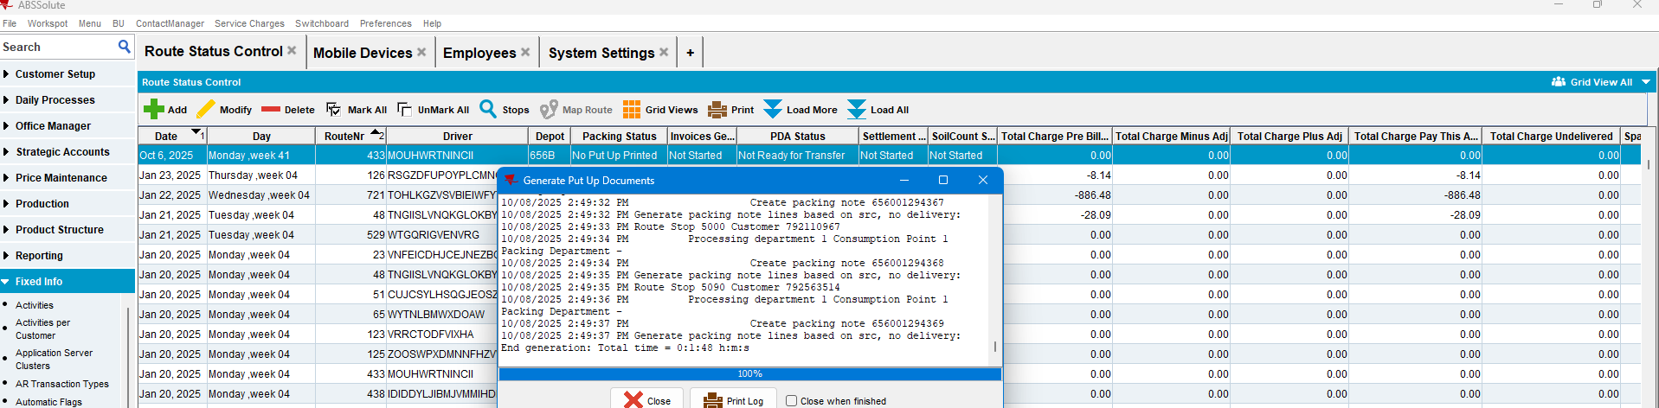
- Generate the Invoices:
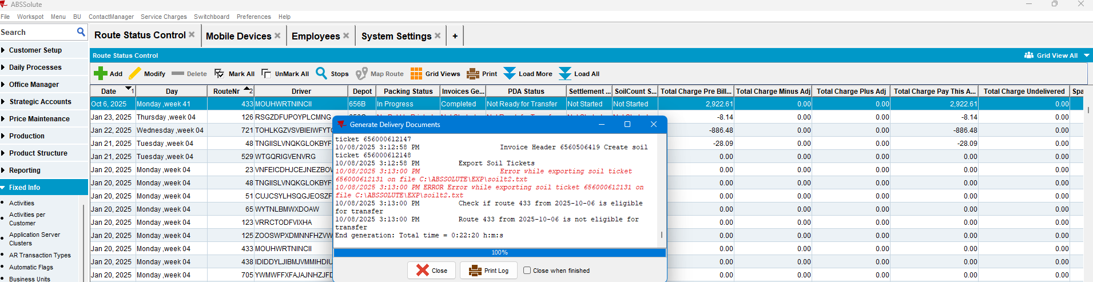

The invoices were generated:
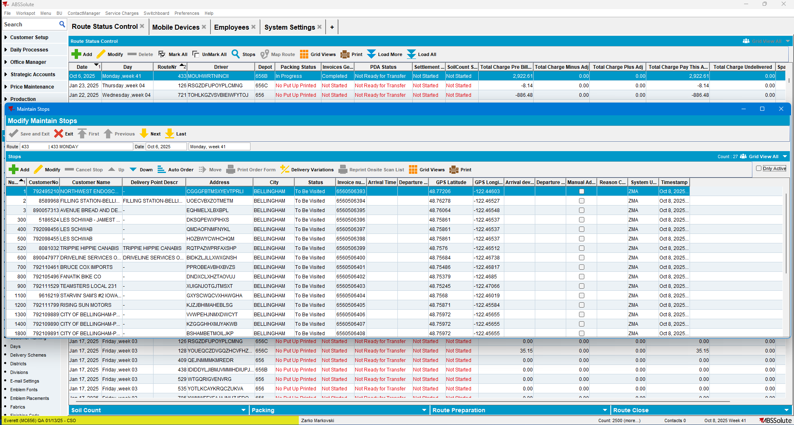

- Configure/Create a mobile device:
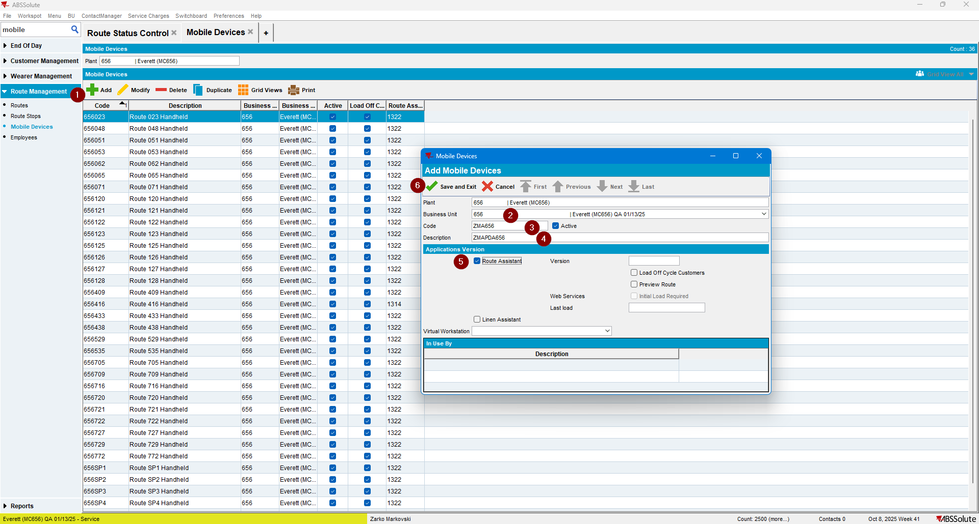

- Associate the mobile device with an existing or new employee:
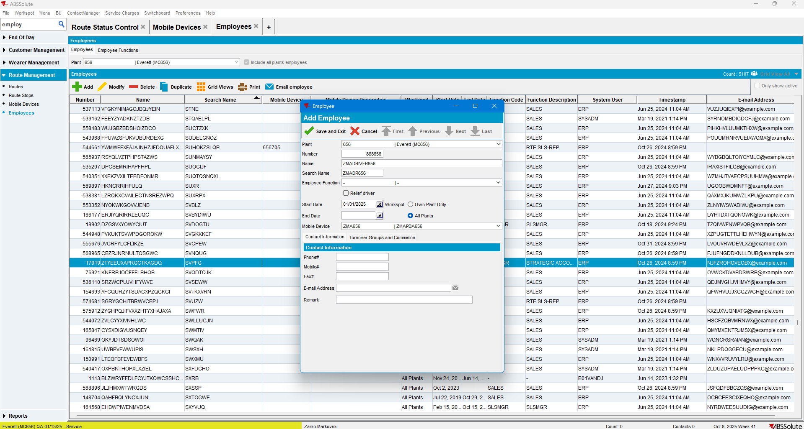

- Associate route control with the configured driver(employee):
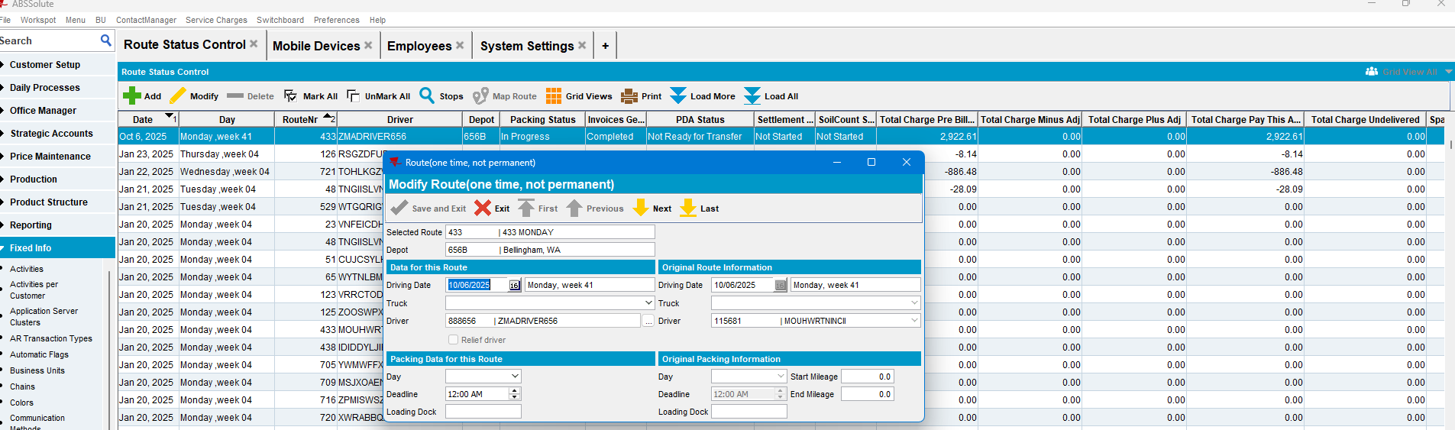

- Mark, the route ready for transfer to PDA:
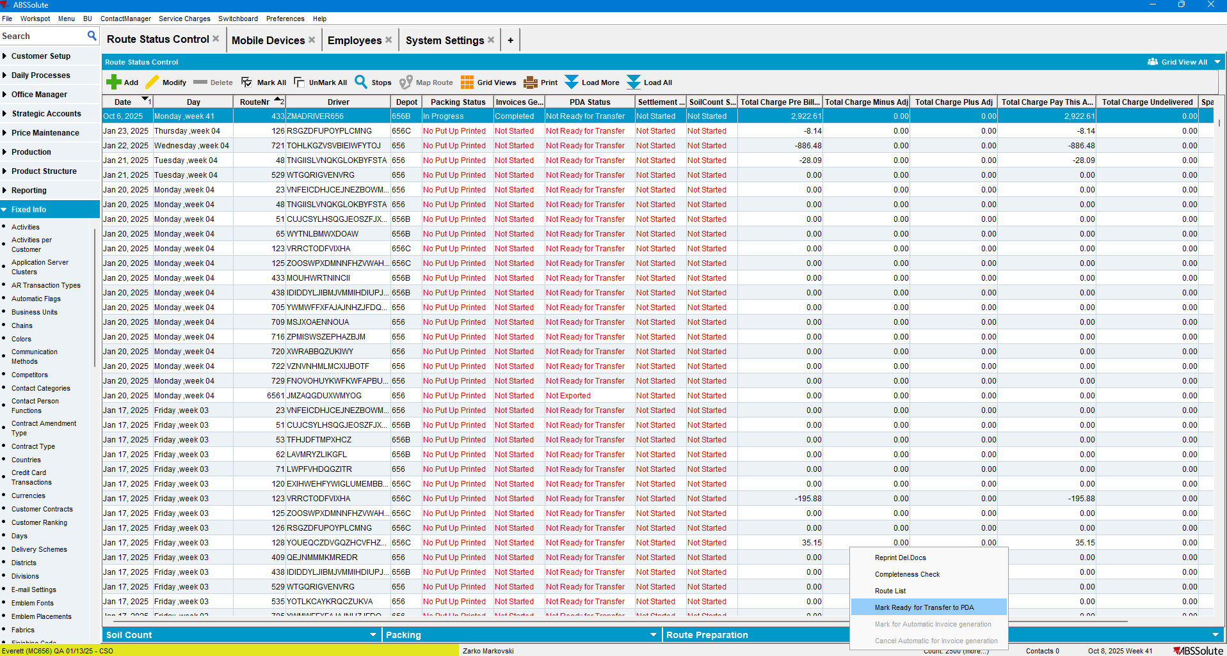

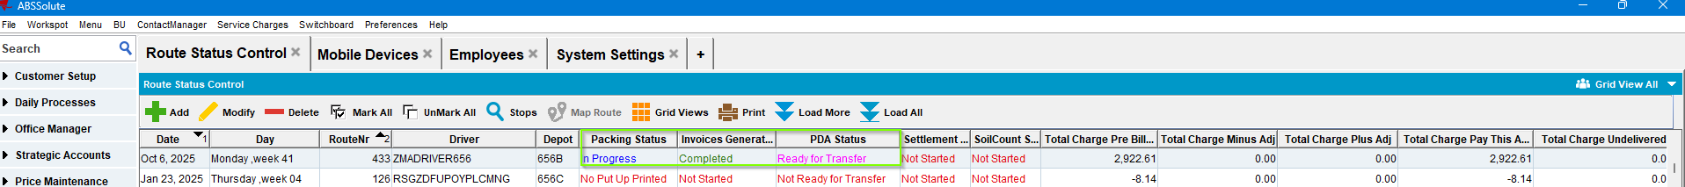

- Configure the absmobilerestservices.war file correspondingly:
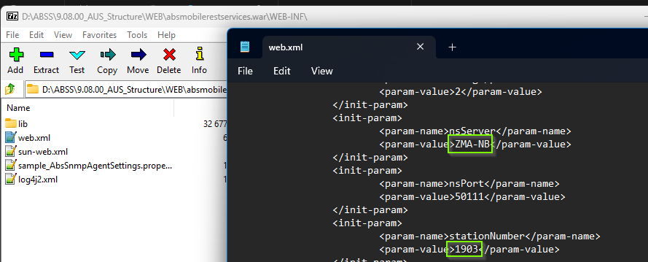

- Check the ABS Matrix and Start the corresponding webserver:
https://conf.abslbs.com/spaces/AID/pages/294977714/TomEE+Tomcat+technical+compatibility+matrix
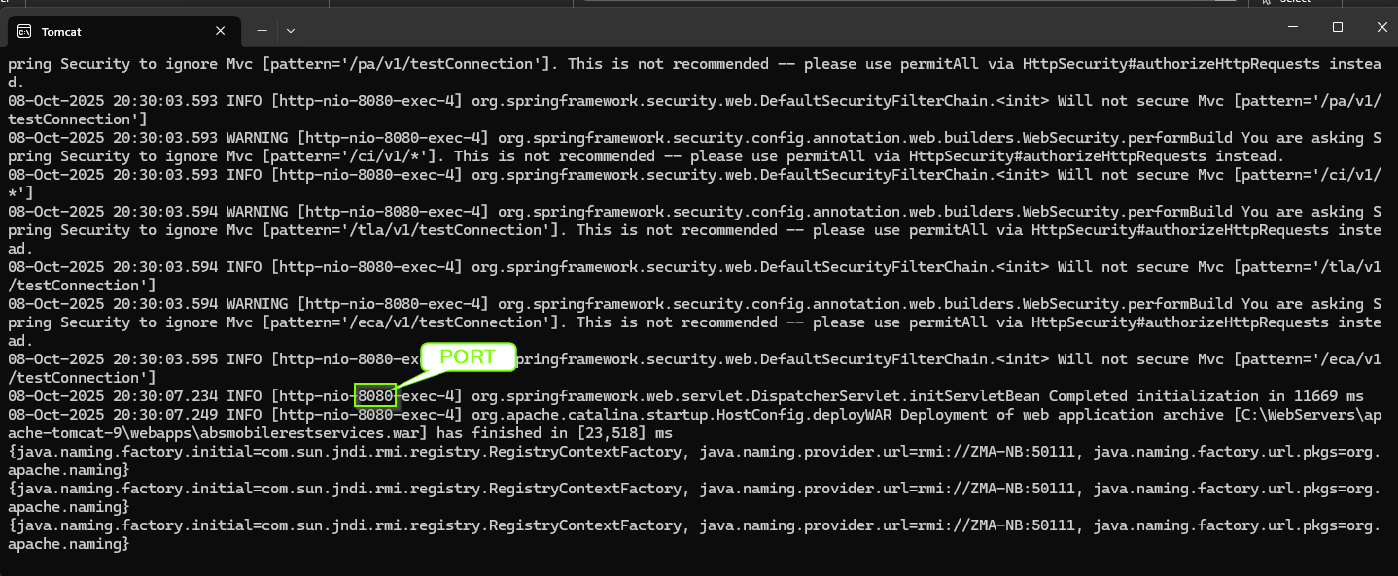
- Deploy the war file:
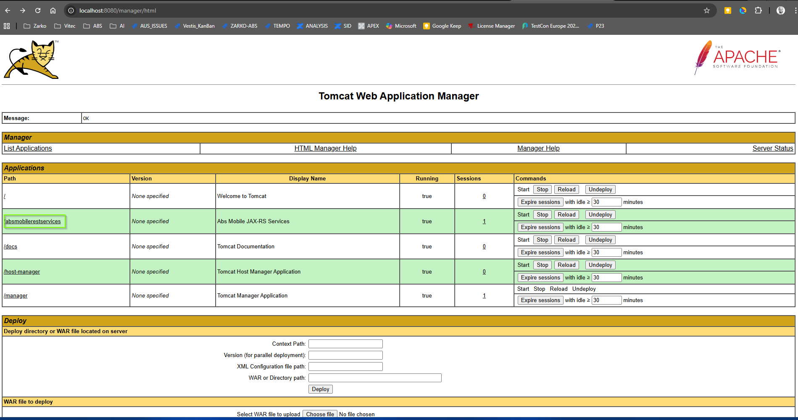
- Check The ABS Mobile Rest Services war file’s version:
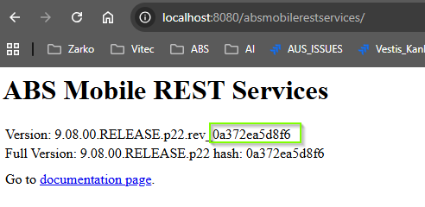
It is the same as the client/server.

- Configure the Android Assistant mobile device:
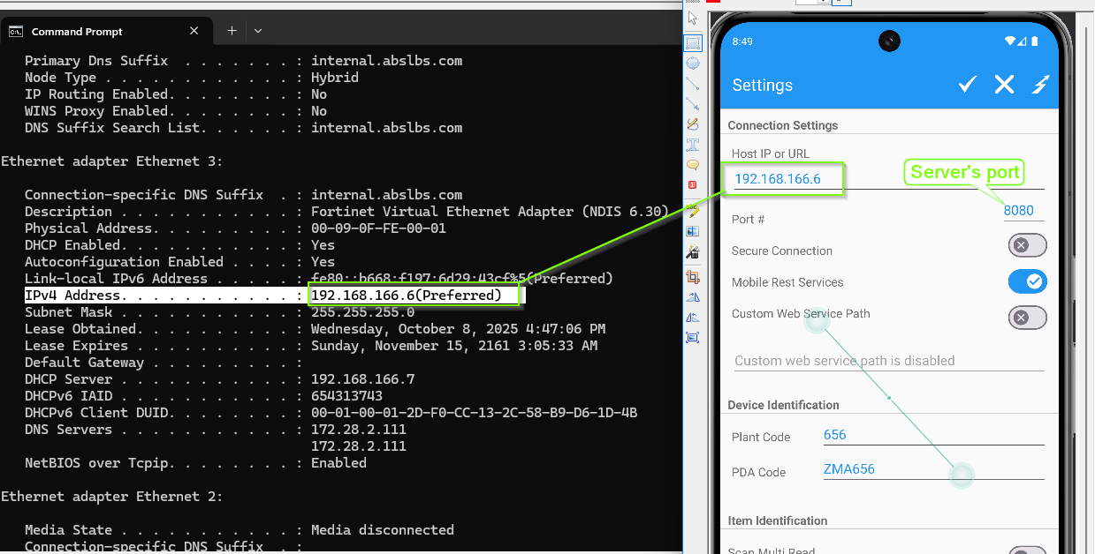
- Test the connection:
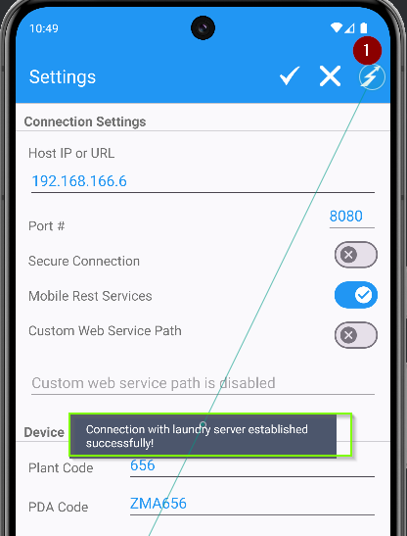
Connection was successful.

- Log into the RA app using the Swing client credentials and track the downloading time of the route control to the PDA:
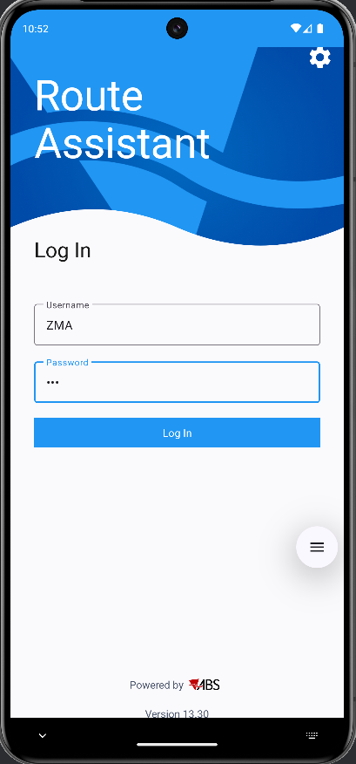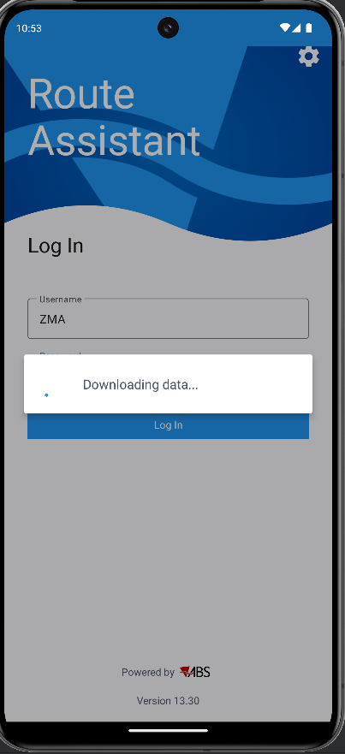
The route was downloaded in 6 min 29 sec:
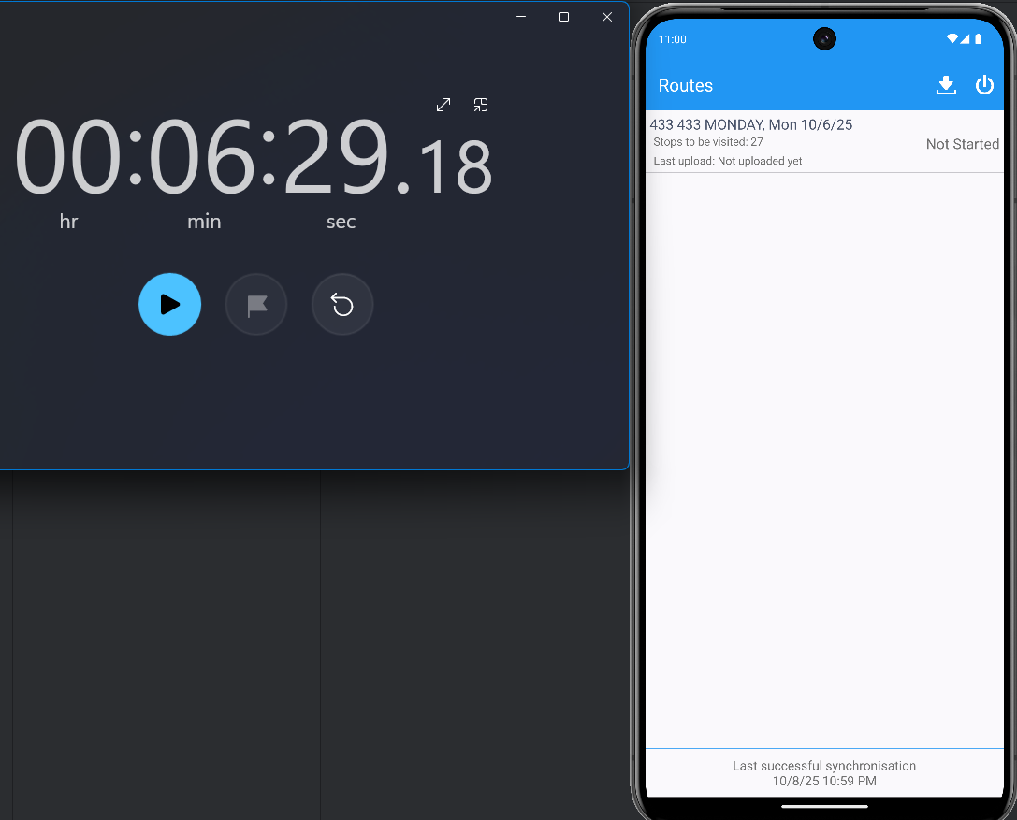

- Export RA’s DB. Remember the encryption Key (123 in this case):
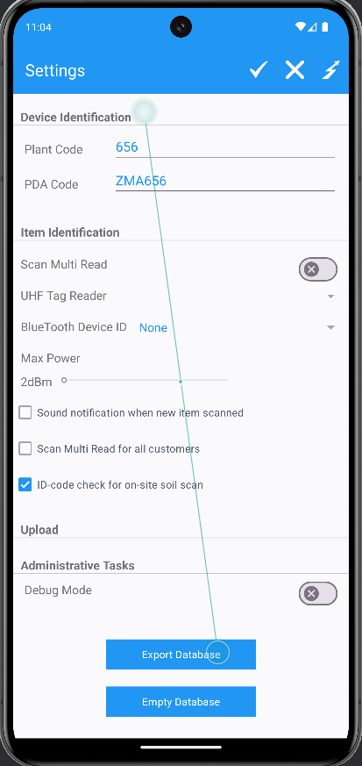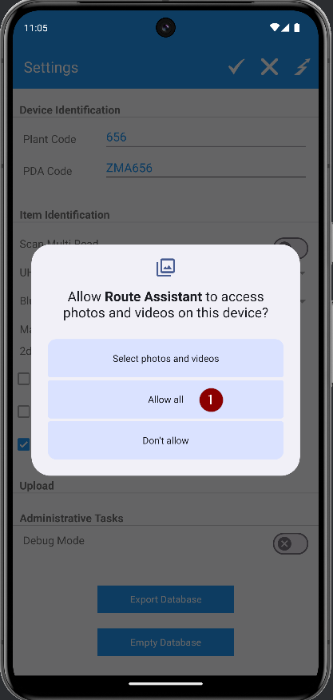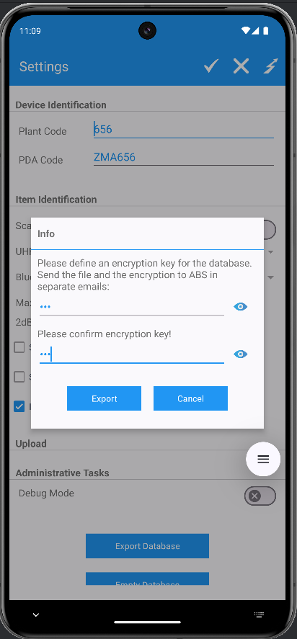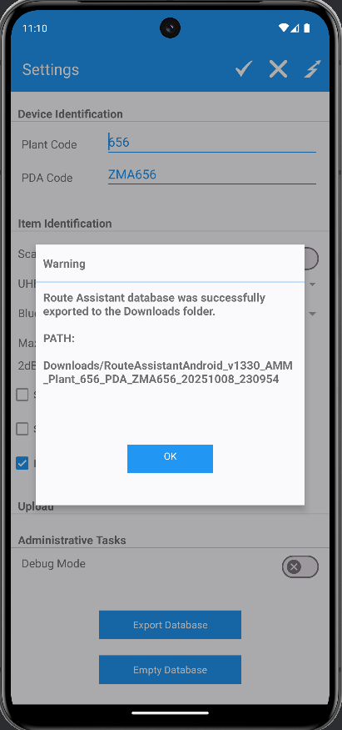

- Save the DB from Android Studio to a local folder: Open the Device explorer > sdcard > Downloads > right click then “Syncronize”:
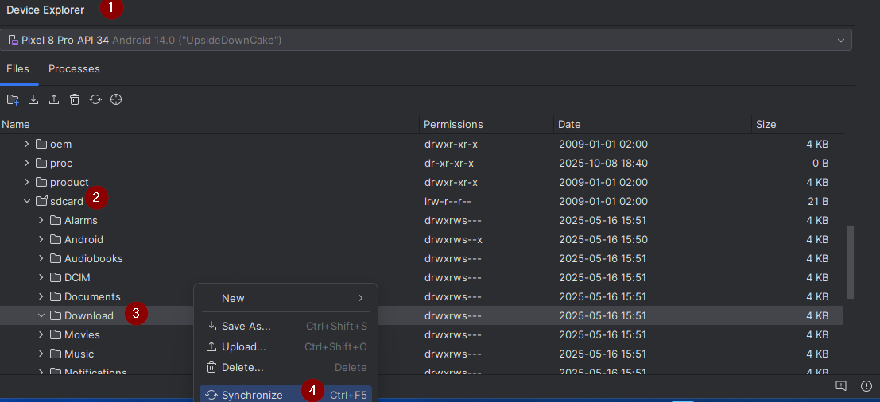

- Save the file locally:
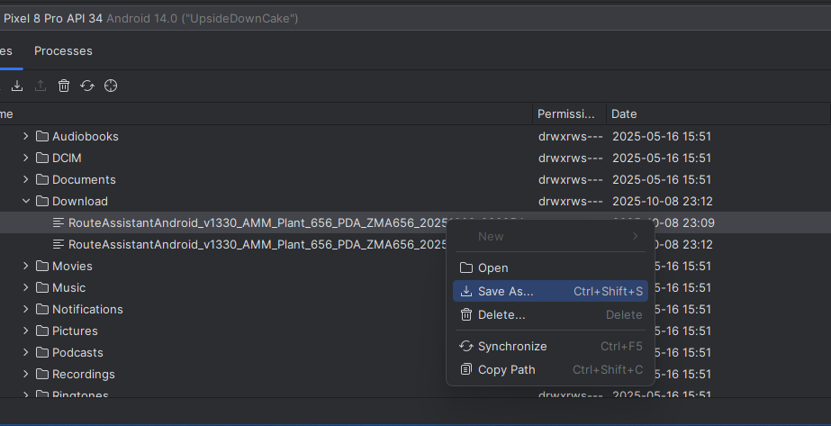

- Decrypt the DB File using “ABS Android Database Decrypter”:
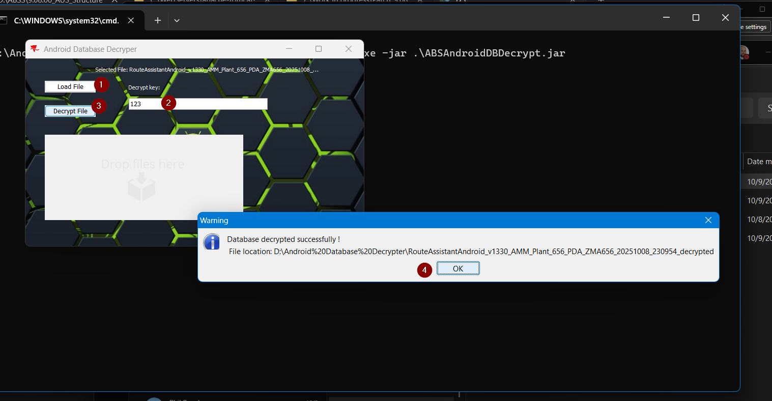

- Open the decrypted DB in SQL Studio Lite:
Add a DB:
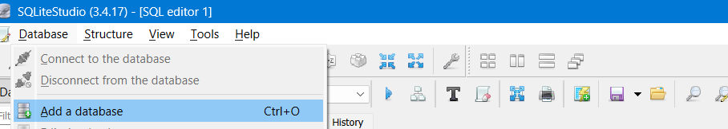
Select the Decrypted DB file:
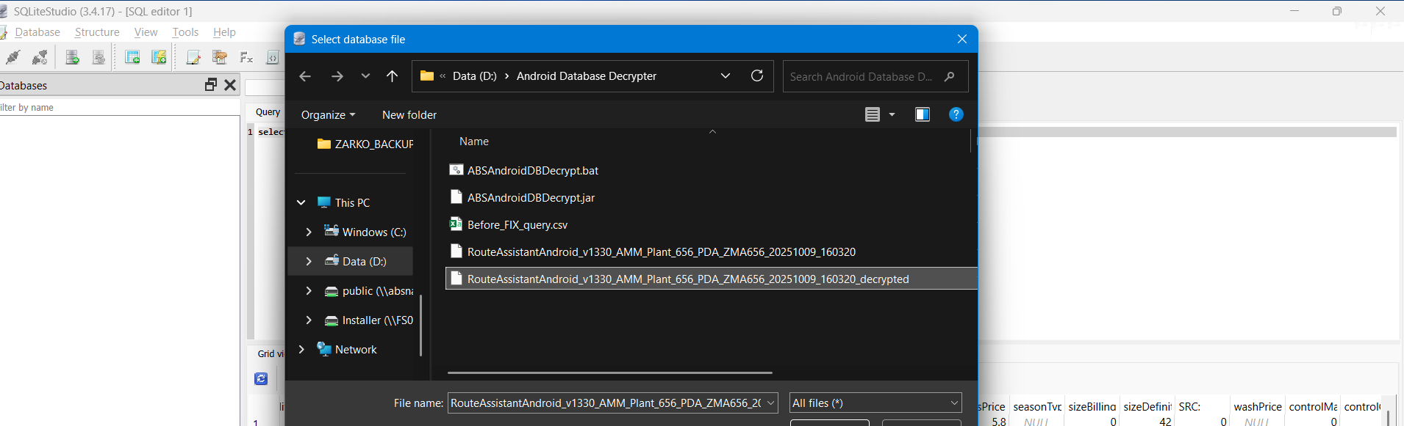
Double click on the DB to connect:
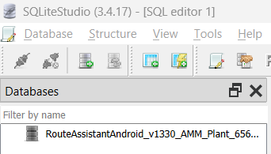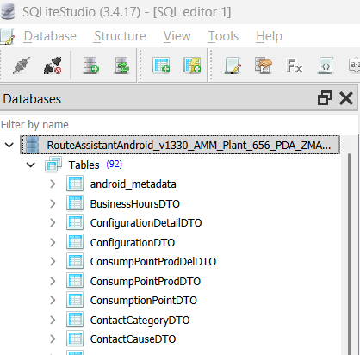
- Run the following query against the DB:
select * from RSContractProdDTO order by id;
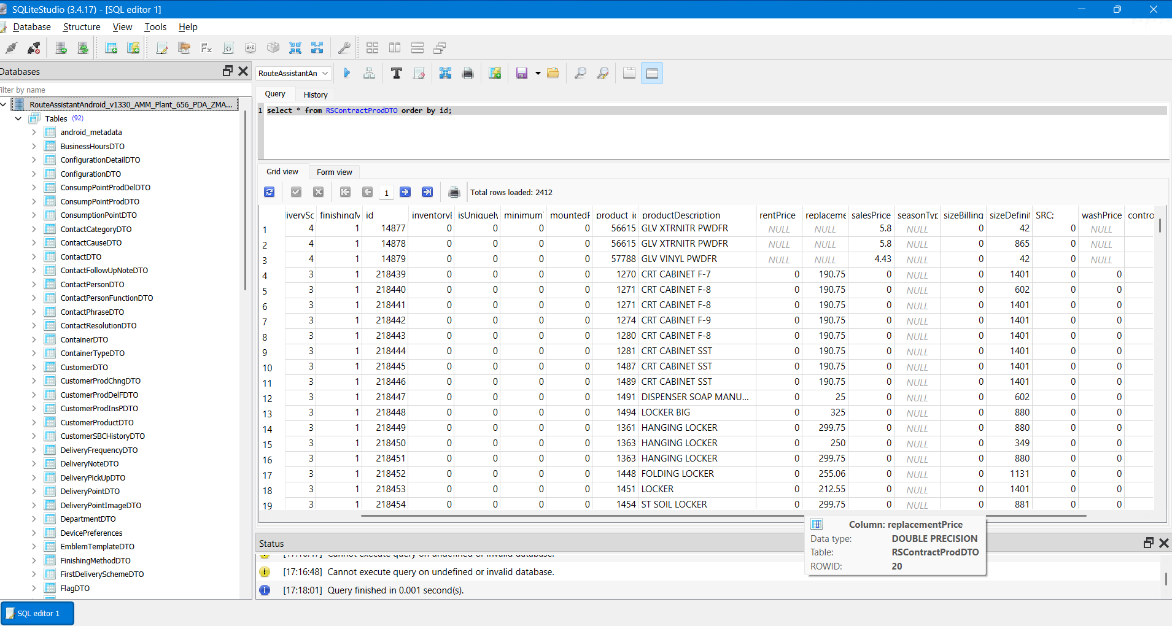
- Export the obtained dataset in *.CSV format:
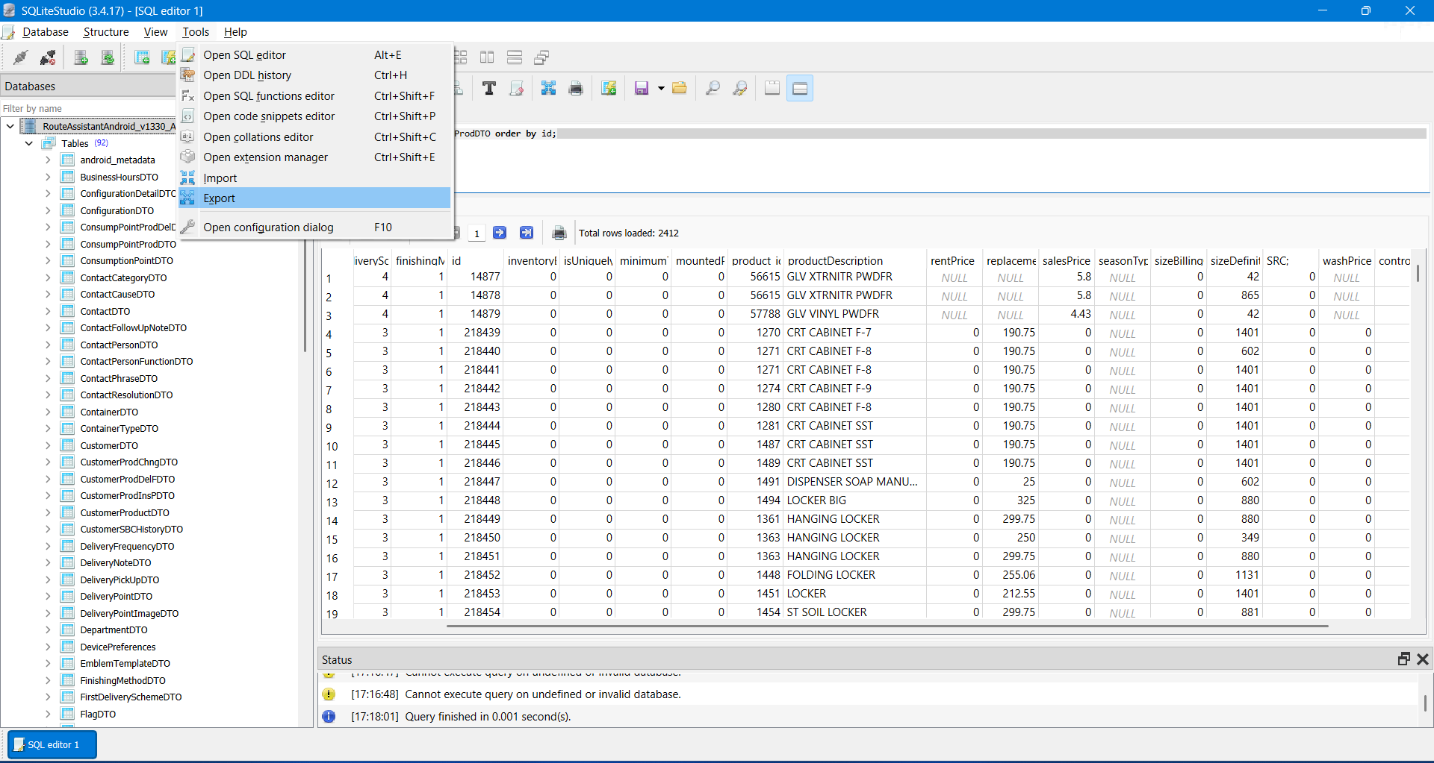
Query Results:
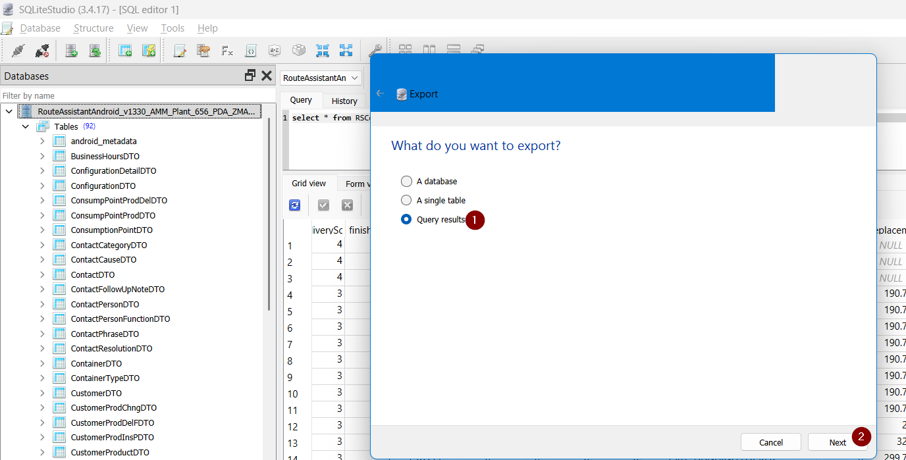

Place the Query and press Next:
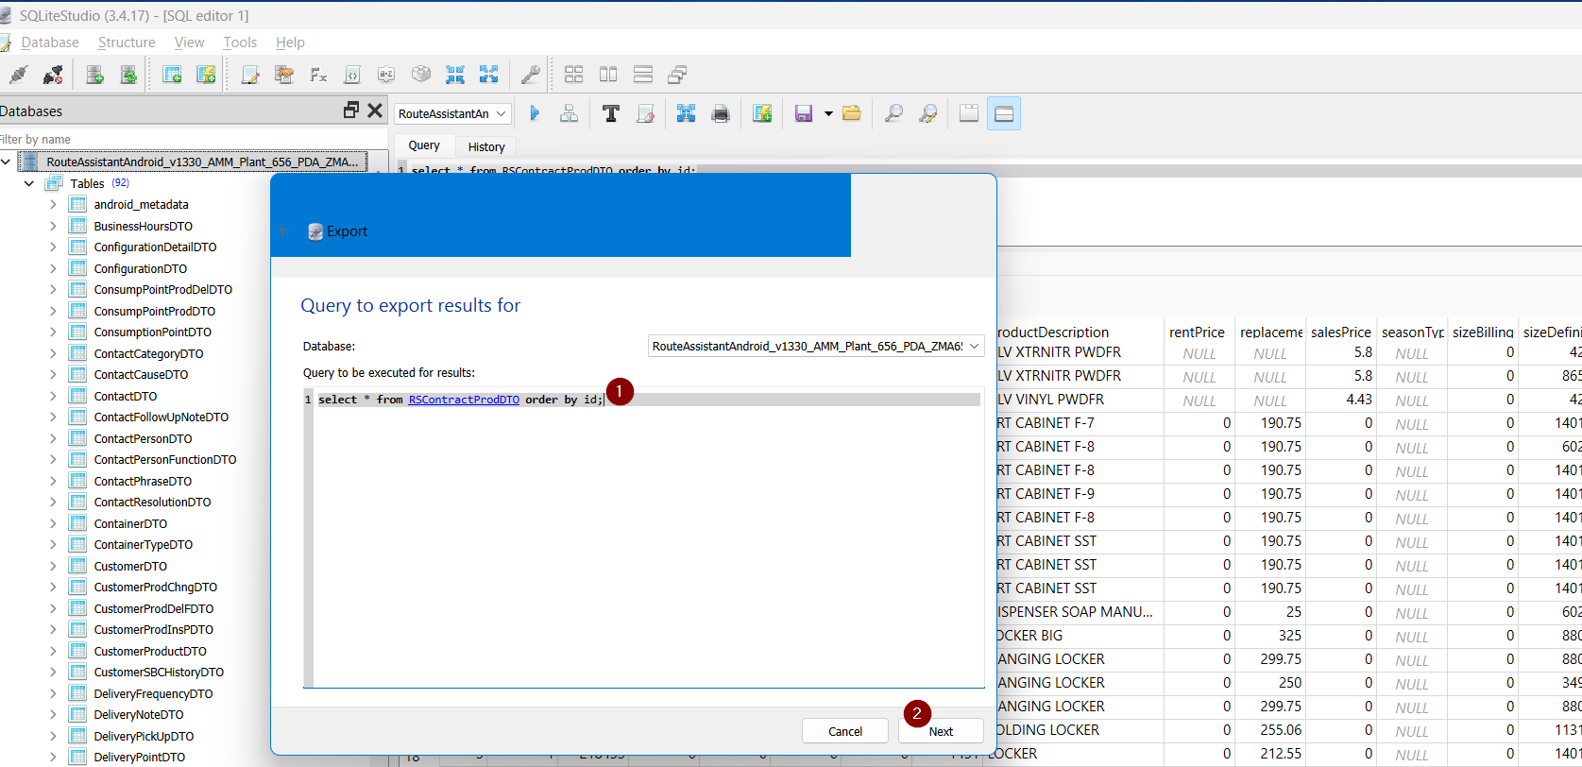
Set the File Path and Name, check the “Column Names in First Row” checkbox and press Finish:
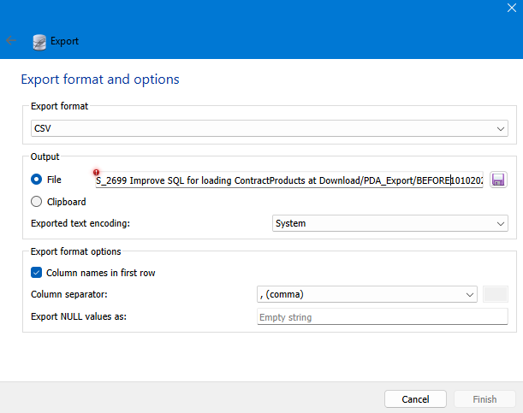
The exported *.csv file:

- Empty the Database:
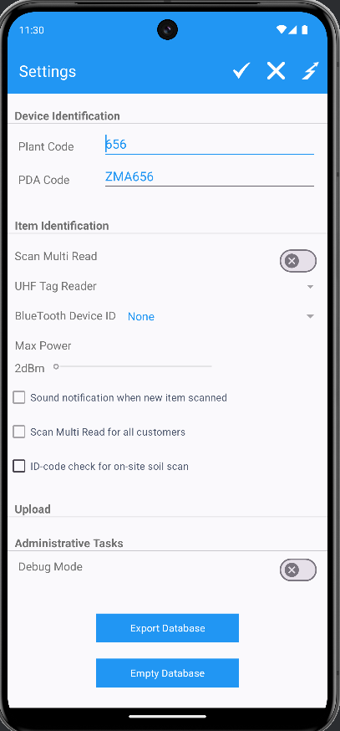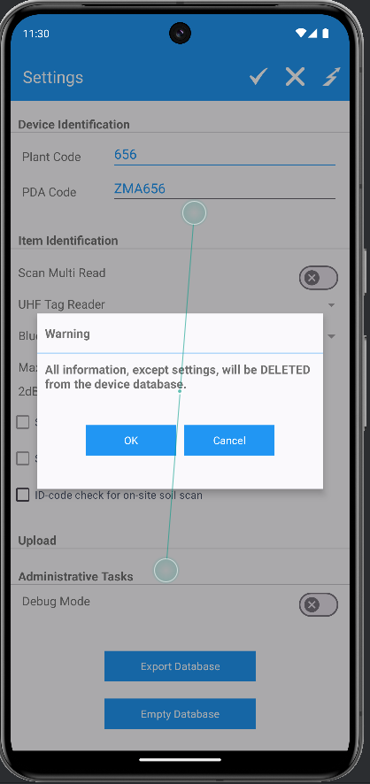
- Close the Android studio, Swing client an server.

Retest after fix
HASH: 4ccba1cade16
BU.code=Plant.code: 656

Test Case 1 - Performance testing – Test OK.
BU.code: 656
Plant.code: 656

Expected behavior:
Time to download a Route Control with customers on contracts with many contract products, to the PDA’s RA application should be improved.

Test Steps:
- DB team has ran/installed the following Database objects:
- f_getcontractprice_type.fnc
- contractprice_types.tps
- Run the Update Script “Script_9.09.02.08.sql” on the current database.
- Configure the NEW absmobilerestservices.war file.
- Re-Deploy the NEW war file using the corresponding webserver:
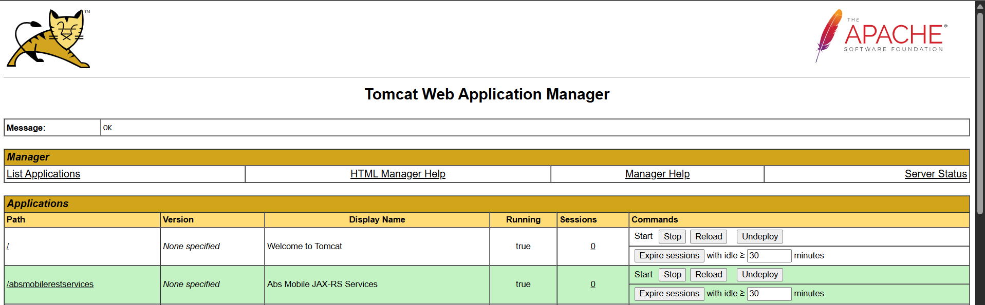

- Launch the Android studio and start the RA mobile app:
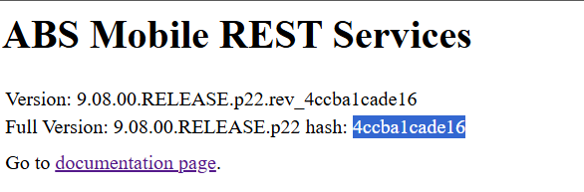
- Check the connection to the server:
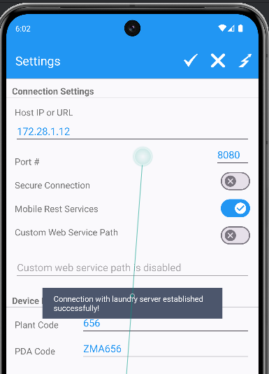
- Mark Route Ready for Re-Transfer to PDA:
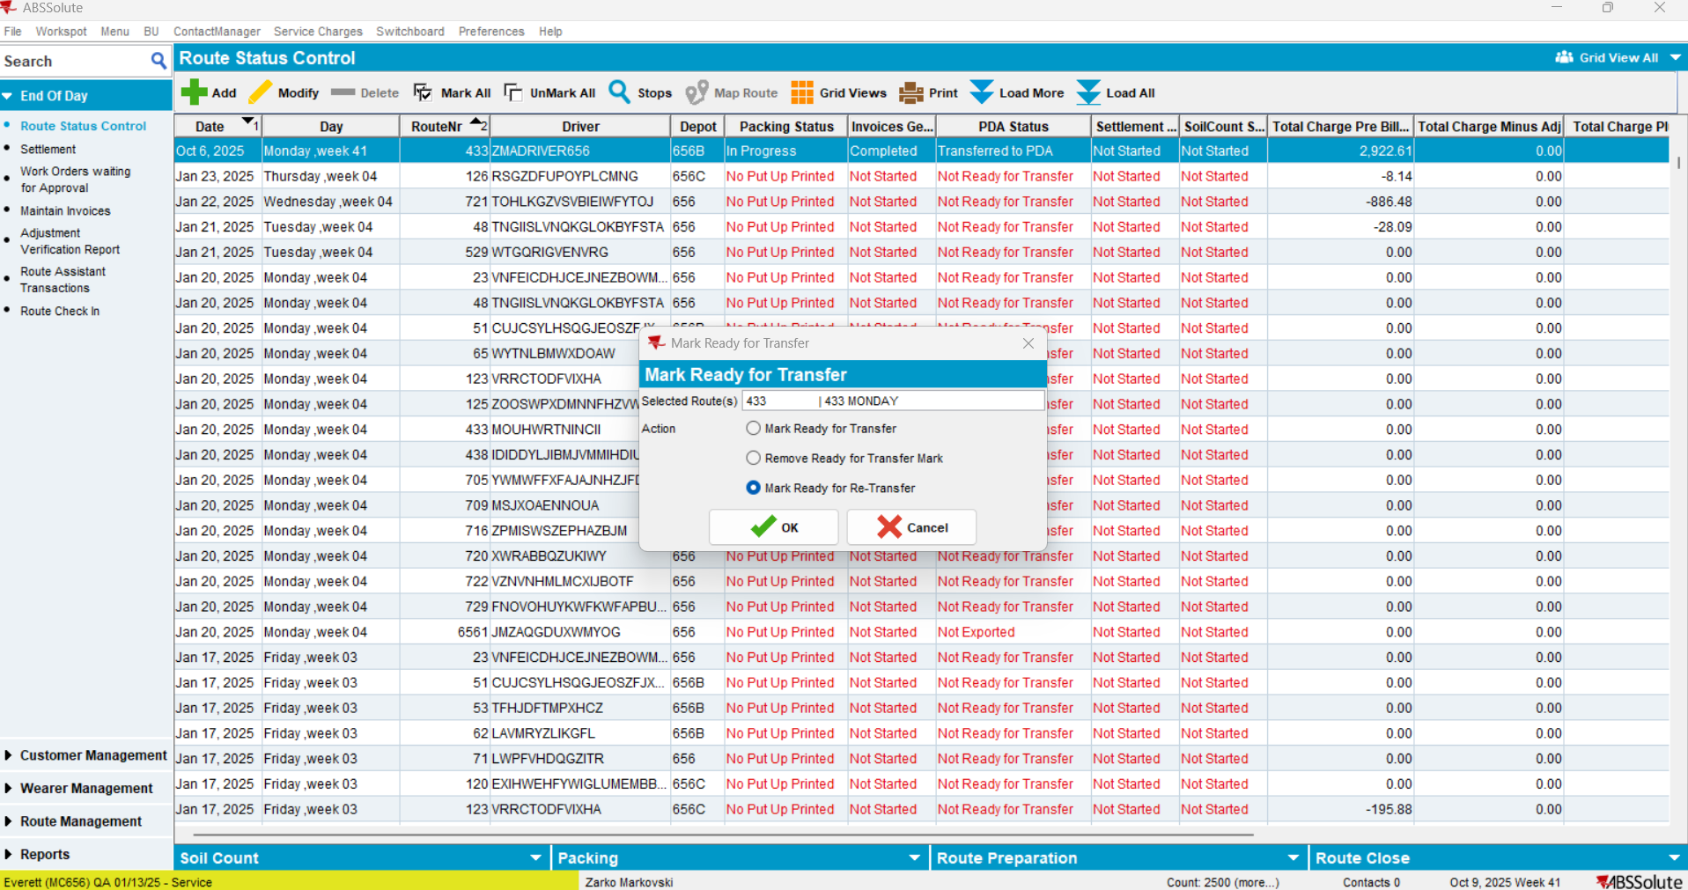
Status changed:
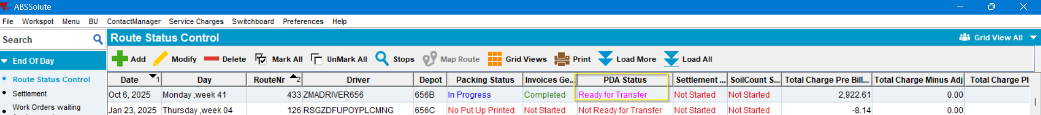

- Log into the RA and clock the downloading time.
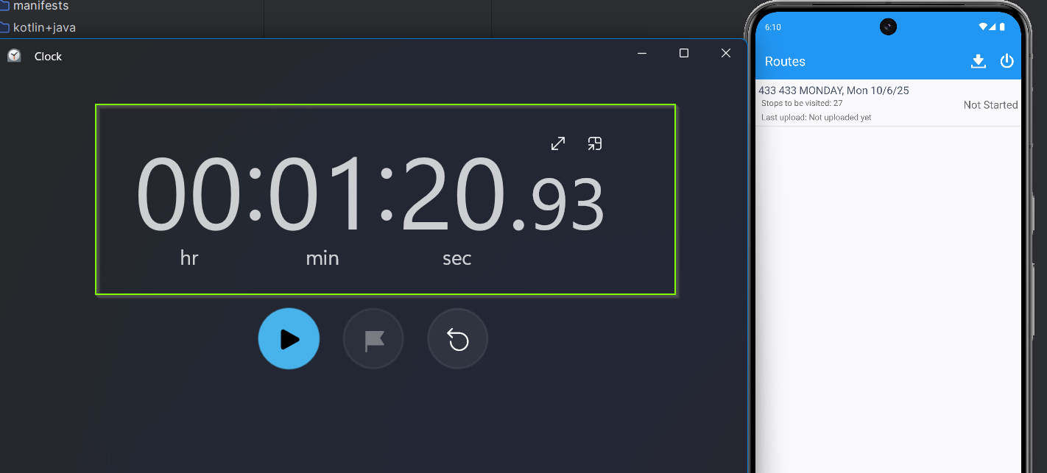
The Route Control was downloaded in 1 min 20 seconds which is considerably faster than before fix (6 min 29 seconds).
TEST OK.

DATA CONSISTENCY TEST 1 – Test OK.
Expected behavior: There should not be differences in the exported queries before and after fix.
- Export the database from RA after download:
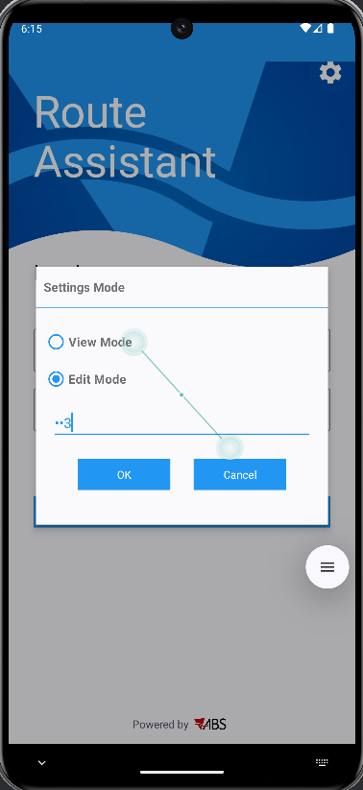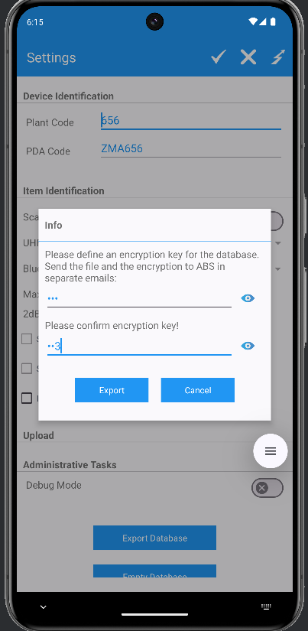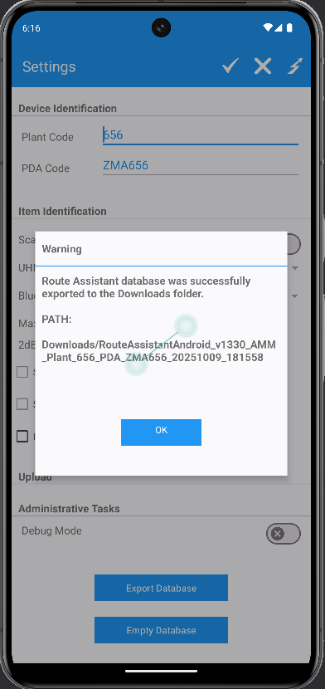
Encryption key: 123.

- Save the RA database:
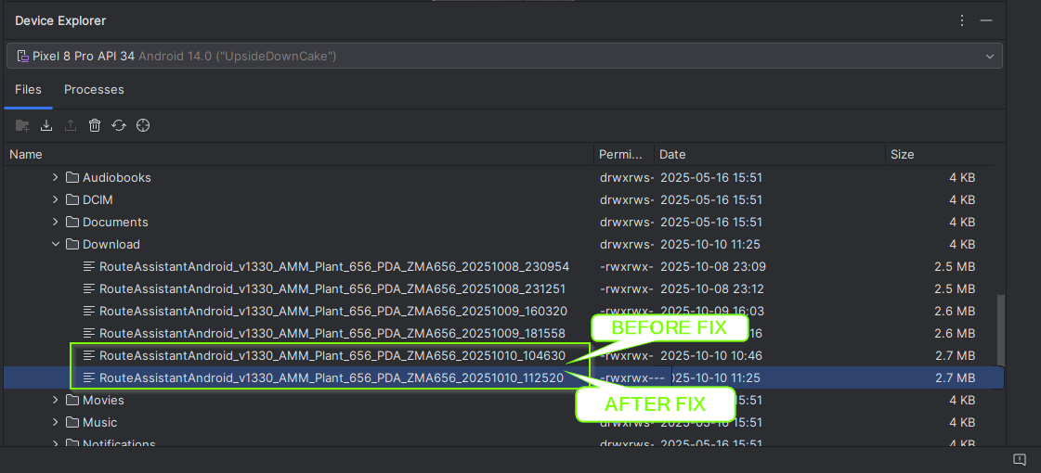
- Decrypt the DB with the ABS Decryption tool:
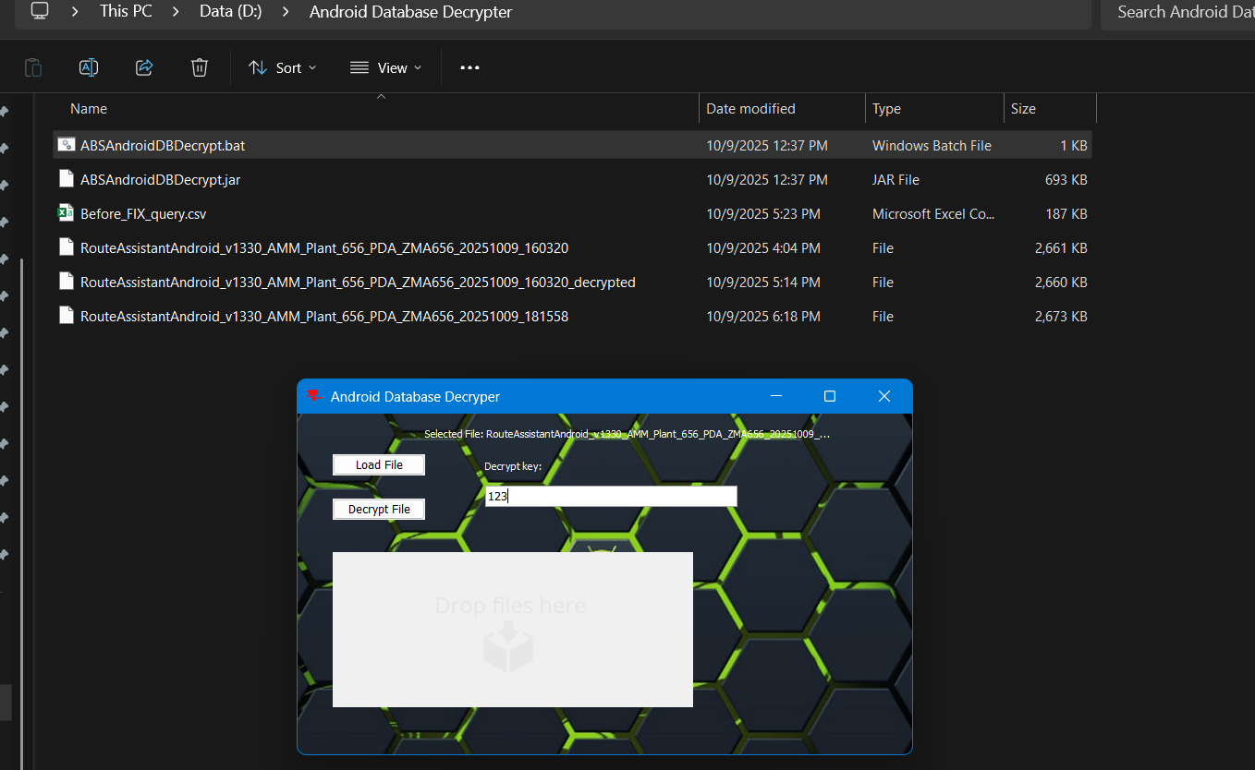

- Add the DB file in SQL Lite Studio:
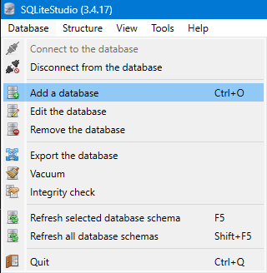
- Select the corresponding DB and connect to it:
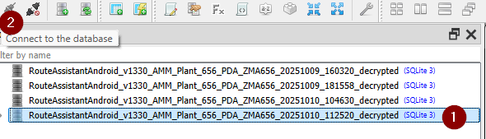
Connected:
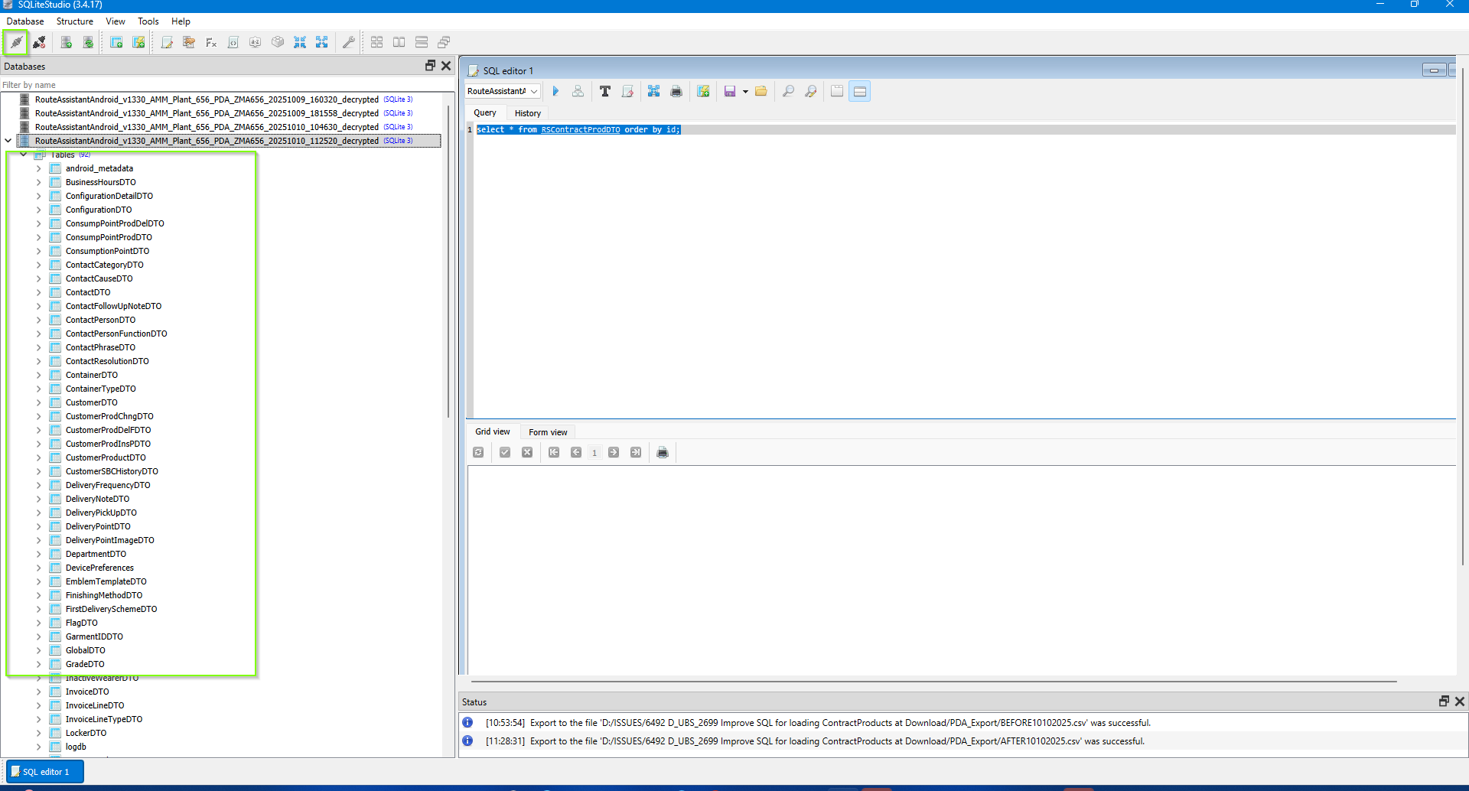

- Export the dataset in *.CSV format from the following query
select * from RSContractProdDTO order by id;
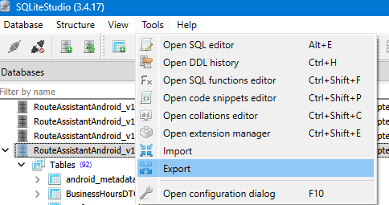
- Export the results in CSV: Tools > Export:
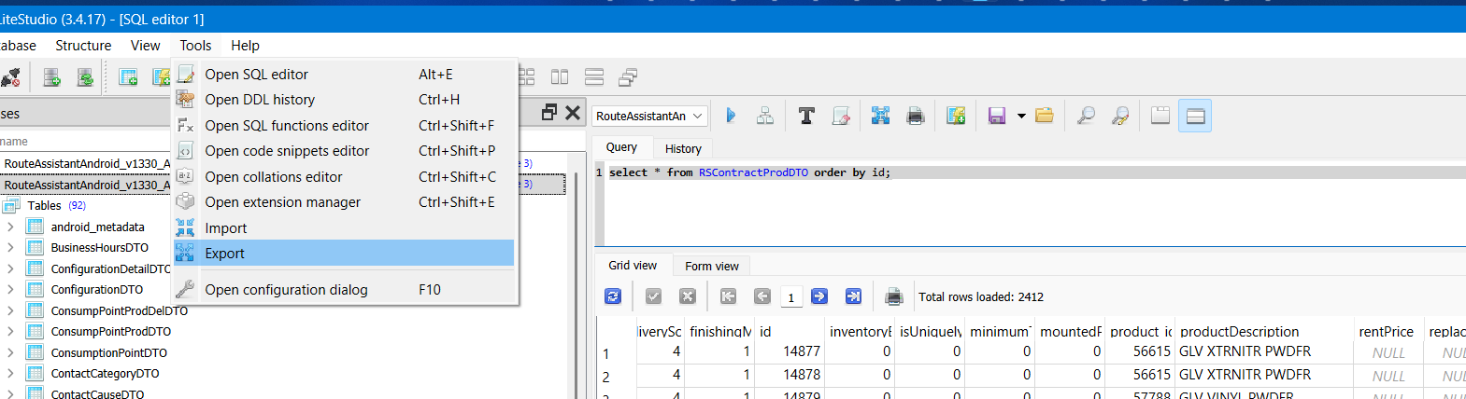
query results:
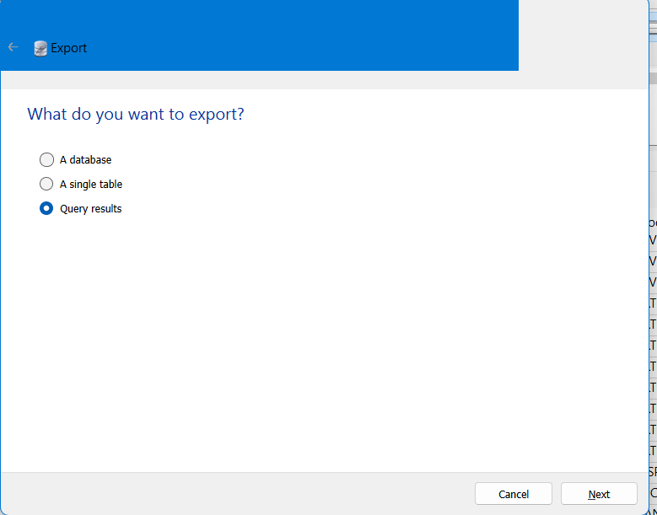

Execute the query again: select * from RSContractProdDTO order by id;
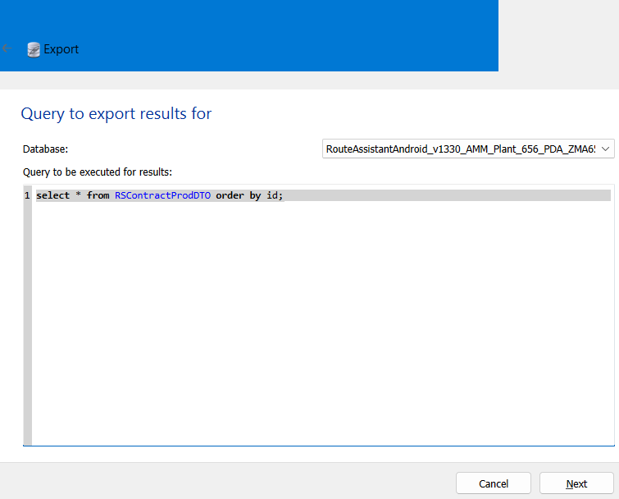
save the CSV file. Note: Don’t forget to check the “Column names in the first row” checkbox:
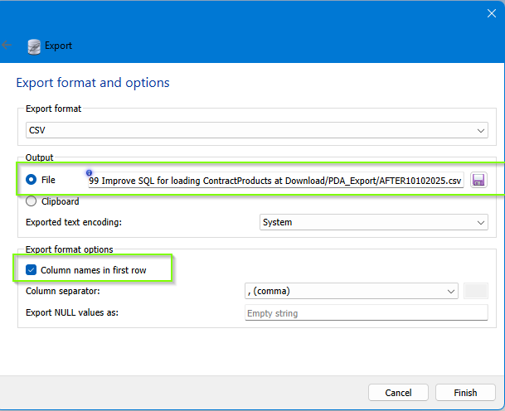
The *.CSV files (BEFORE and AFTER FIX):

- Compare the CSV files using: Kdiff:
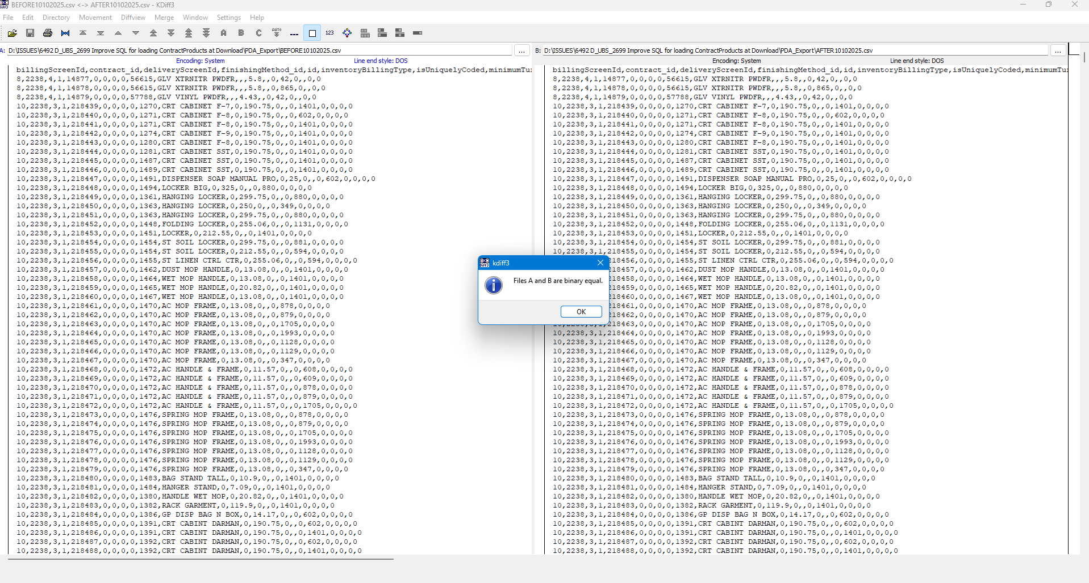
The files are BINARY identical.
- Compare the CSV files using Open Source tool MELD: https://meldmerge.org/
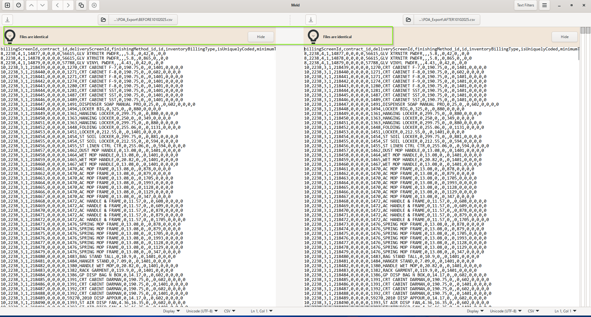
Files are identical.

- Or use a more visual comparison of columns in EXCEL
- Create a new Excel file and open/import the CSV files in two separate sheets and create a third, comparison one:
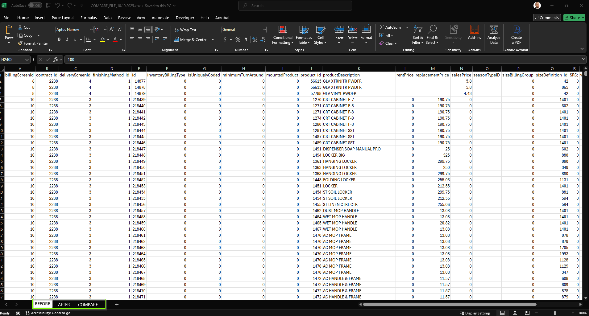
- In the Comparison sheet, in the top left corner cell (A1), write this formula: “=IF(BEFORE!A1=AFTER!A1, AFTER!A1, "BEFORE: " & BEFORE!A1 & " vs AFTER: " & AFTER!A1)” and drag it to be created for all Columns and Rows
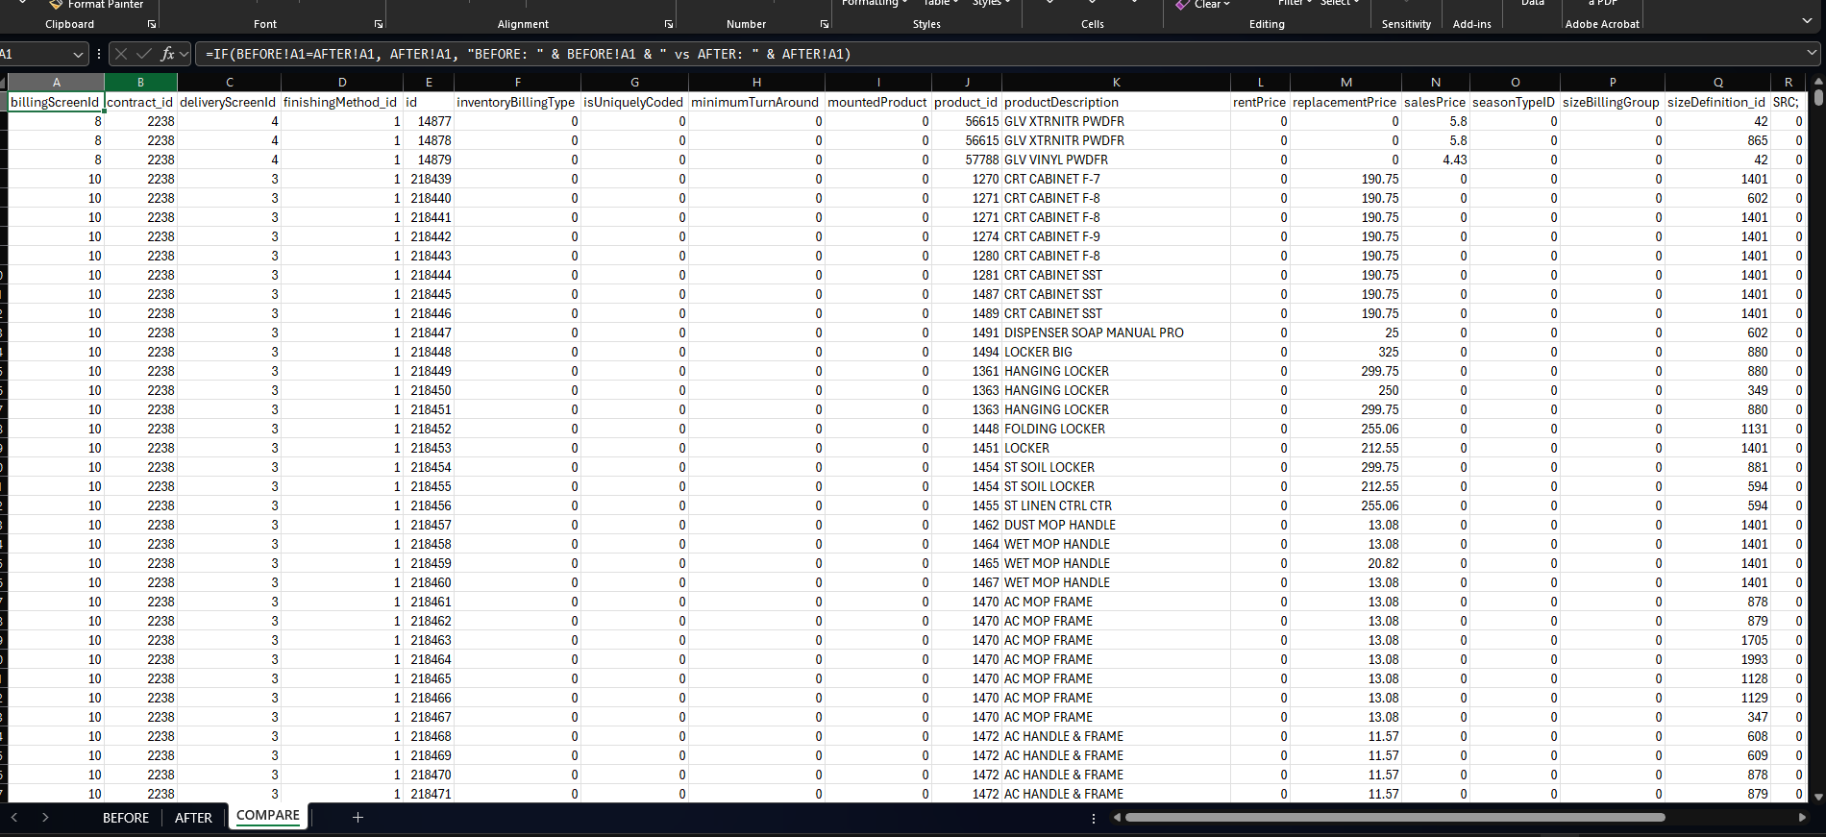

- Select all cells and create a new Conditional formatting rule:
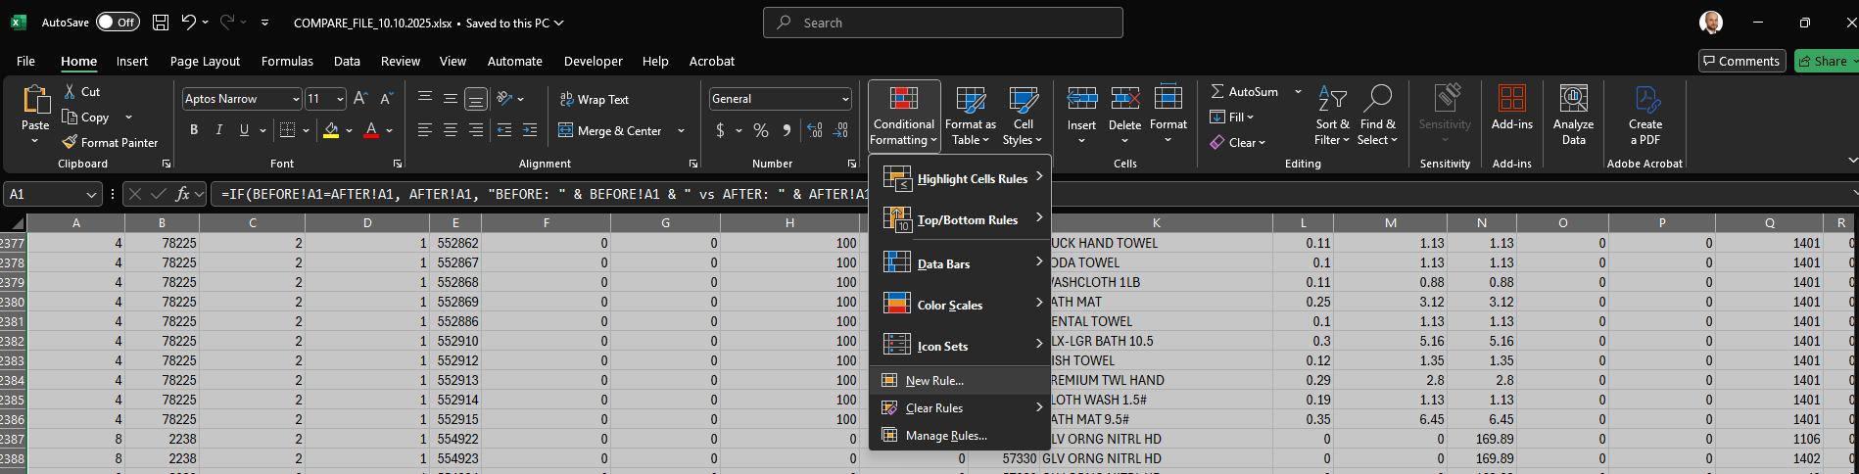
- Create the rule to use the following formula: “BEFORE!A1<>AFTER!A1” if the formula is TRUE , change the formatting of the cell by FILLING it / Coloring it in certain color.
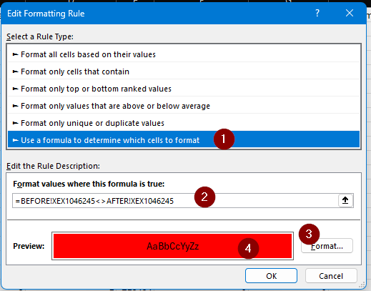
- Check the result:

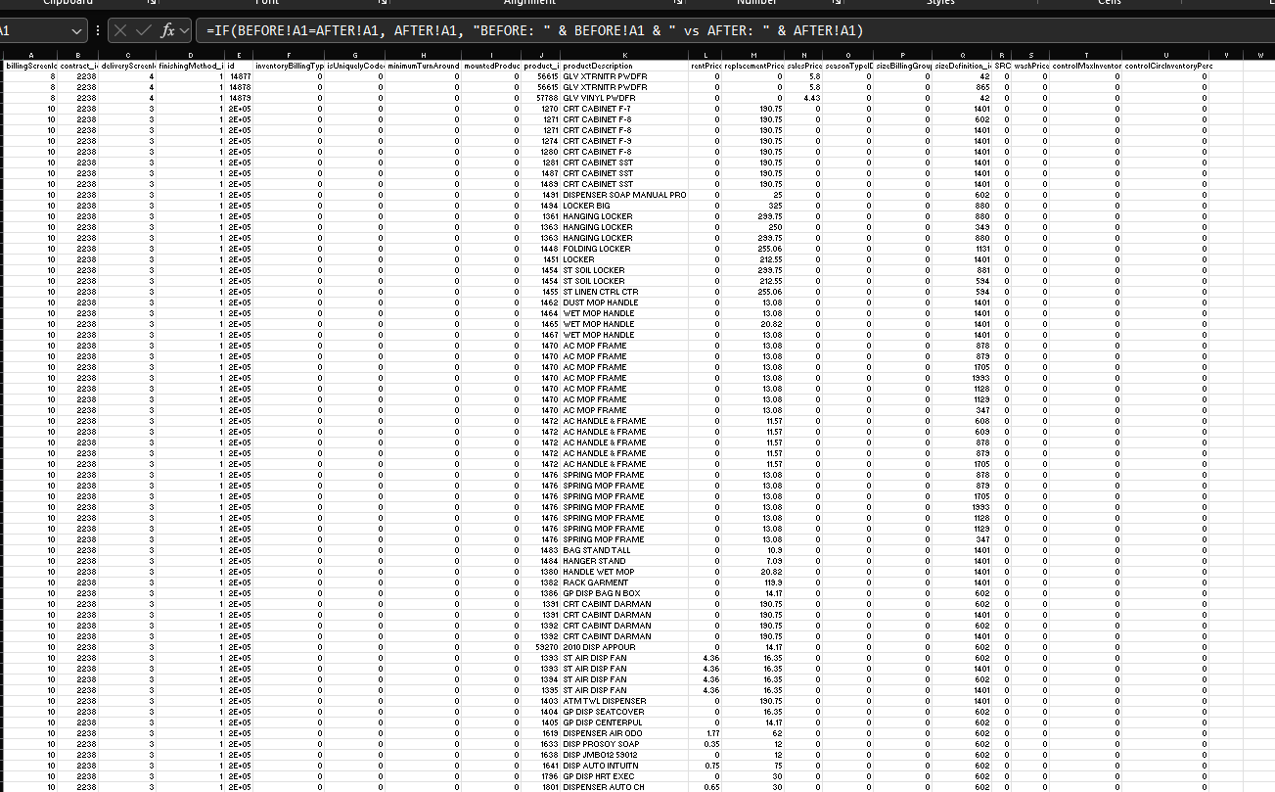
No differences/highlighted cells were found.
Tested OK

COMPARISSON file:

