ABSN-6225 Pay this amount is 0 after setting as undeliverable in client and settling in WebX
Environment | Prerequisites
Version: 9.08.00.RELEASE.p22-90800AUS branch  DBServerName=abs-srv17.internal.abslbs.com  DBSID=CUST23  DBUser=AUS_MNT90800  DBPassword=AUS_MNT90800  Environment=Test  EnvironmentSABStage=Test | - Module: AUSCUSTOM, RAS, WISBASIS, BKLBASIS, PWBINTERNET  - SS:
Contents
After Fix 1
TEST CASE 1) Marking Stop Undeliverable with 2 simultaneous WebclientX users connected – TEST PASSED 1
TEST CASE 2) Marking Stop Undeliverable with 2 simultaneous users: in WebclientX and Swing Client – TEST PASSED 7

After Fix
HASH: ee4496a5ce9c
BU code: 473
Plant code: 473

TEST CASE 1) Marking Stop Undeliverable with 2 simultaneous WebclientX users connected – TEST PASSED
Step 1) Create a route, Generate Packing Notes, Invoices:
Route created, stops moved:
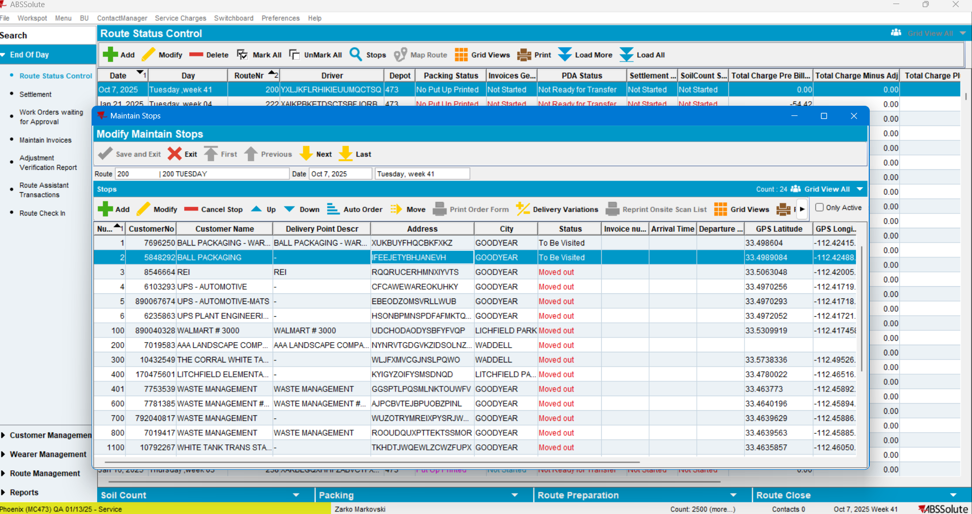
Generate PN
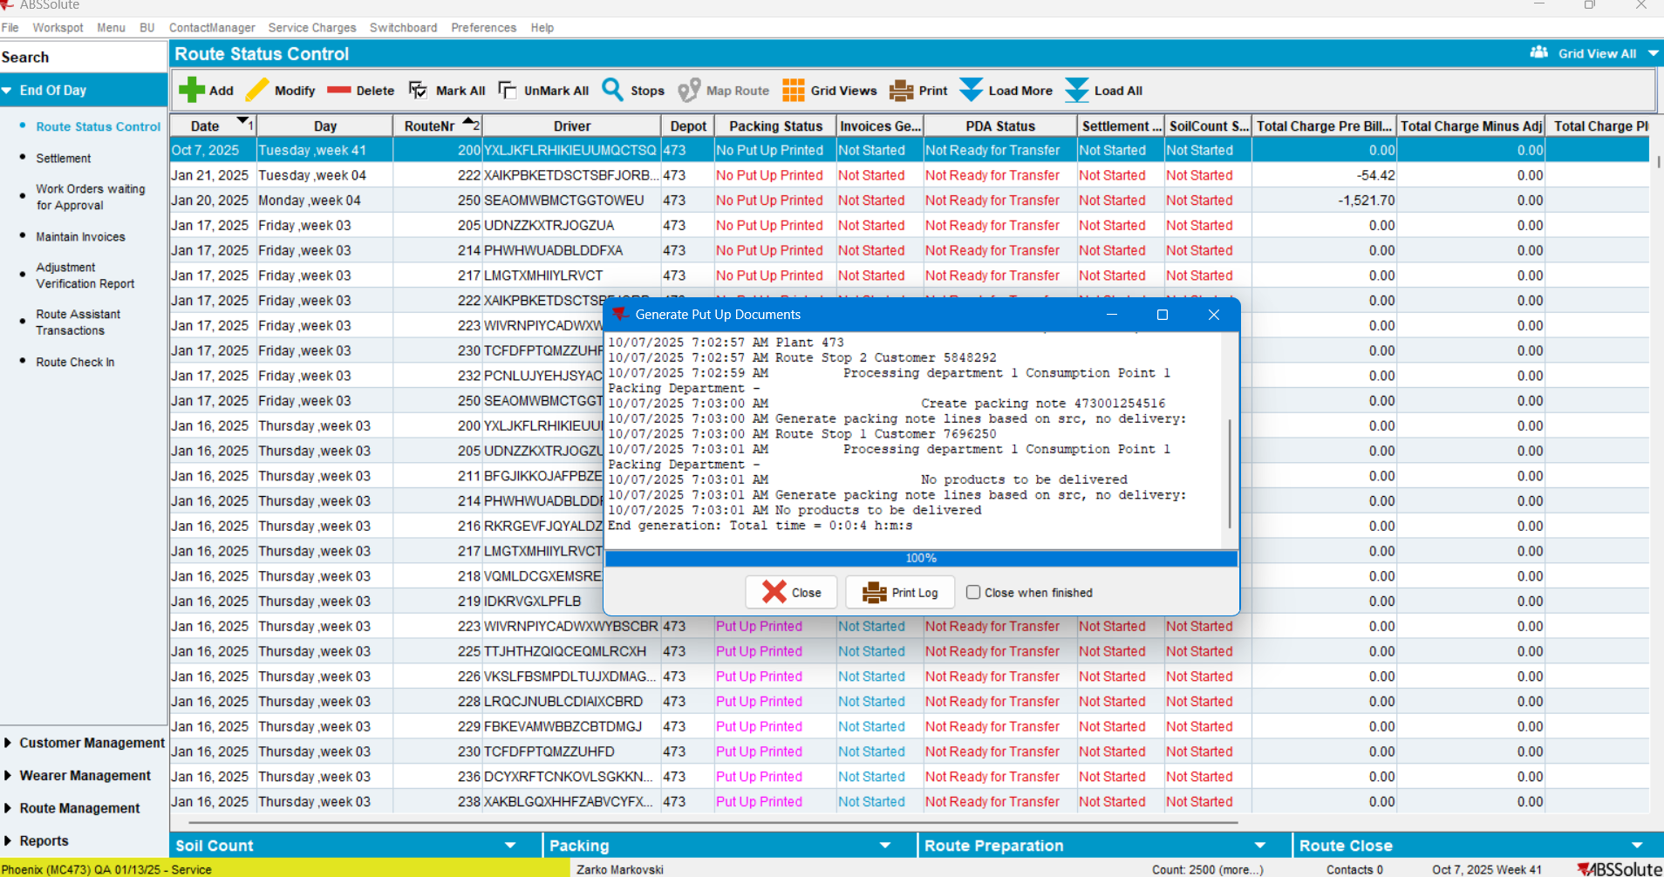
Generate invoices:
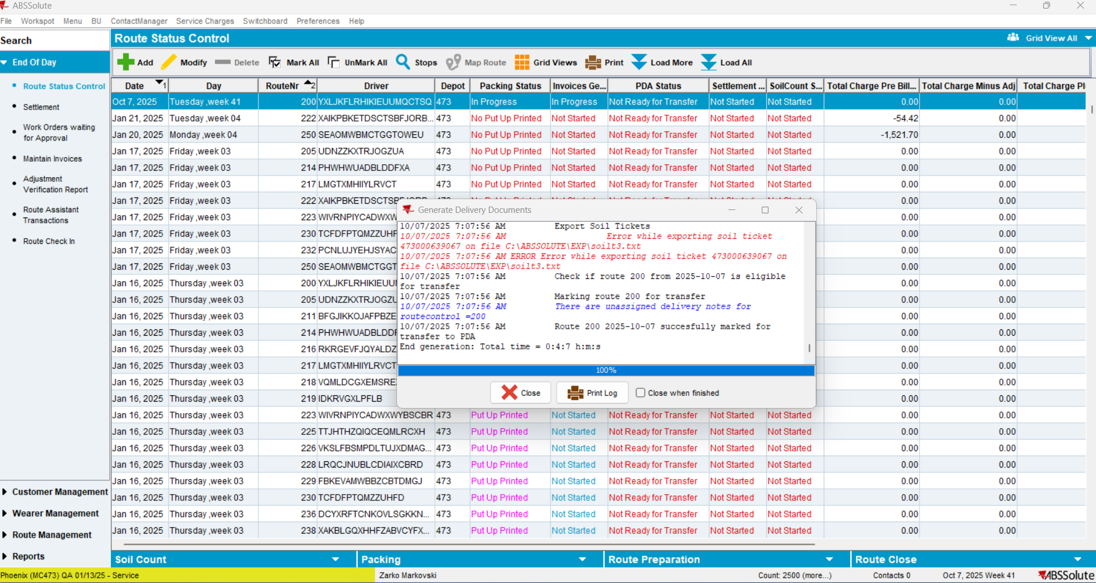
Finished PN + Invoices:
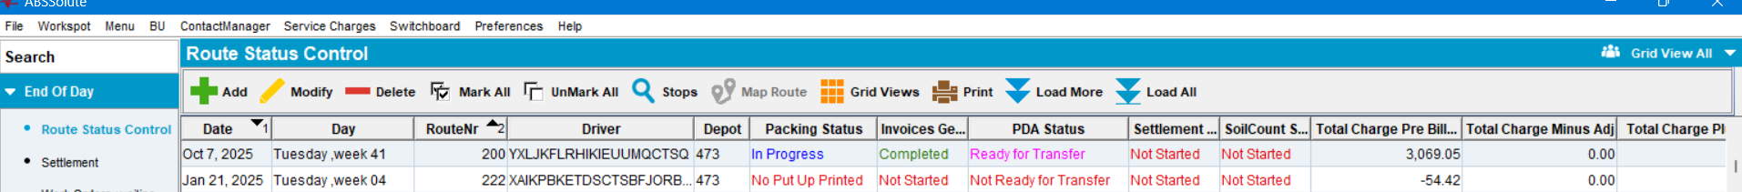
Step 2) Log in to the Webclient-X using 2 different Web Users (ON 2 DIFFERENT Computers):
First WebclientX:

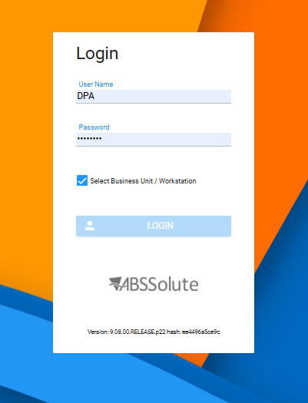
And the second user:
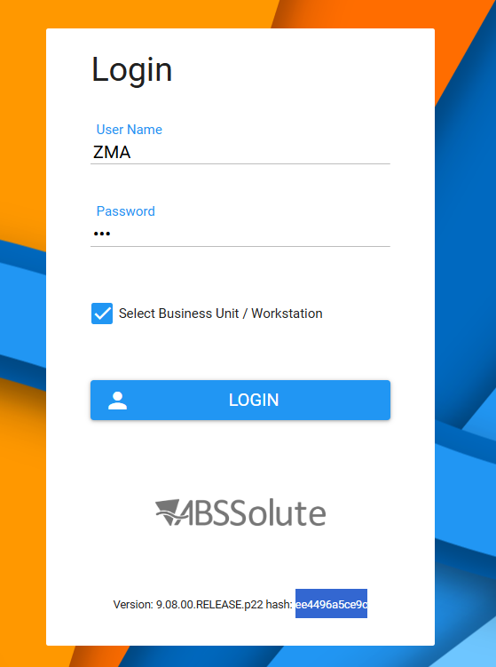

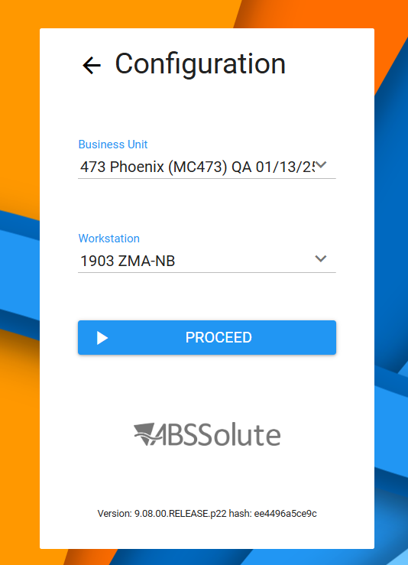
Step 3) Select the route from both web users:
1st user: 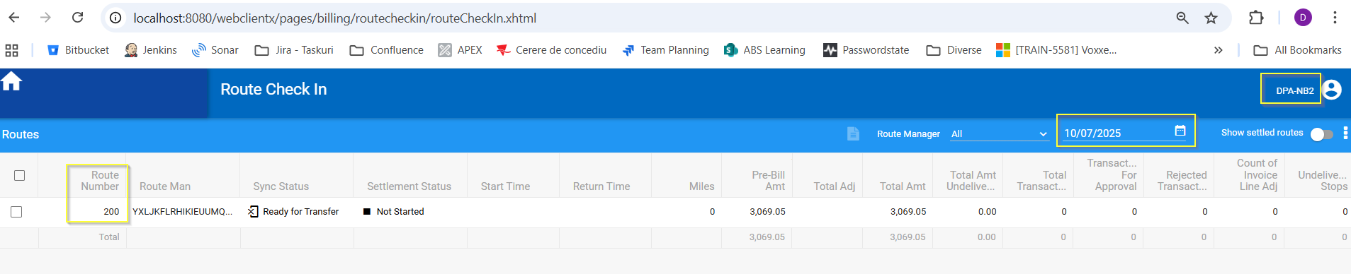

2nd user:
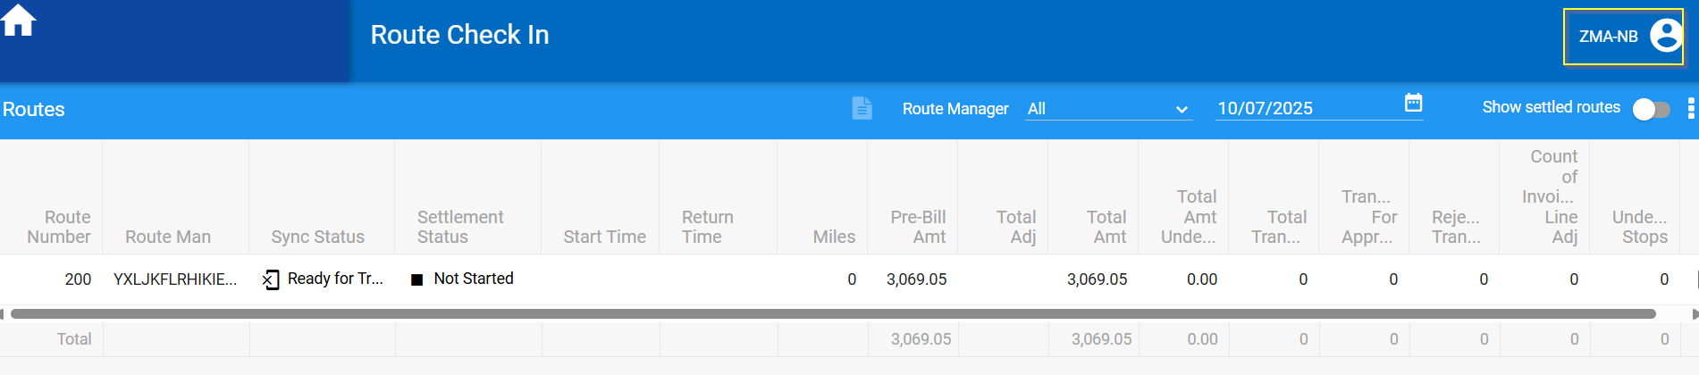

Step 4) Settle the route from the first WebclientX:
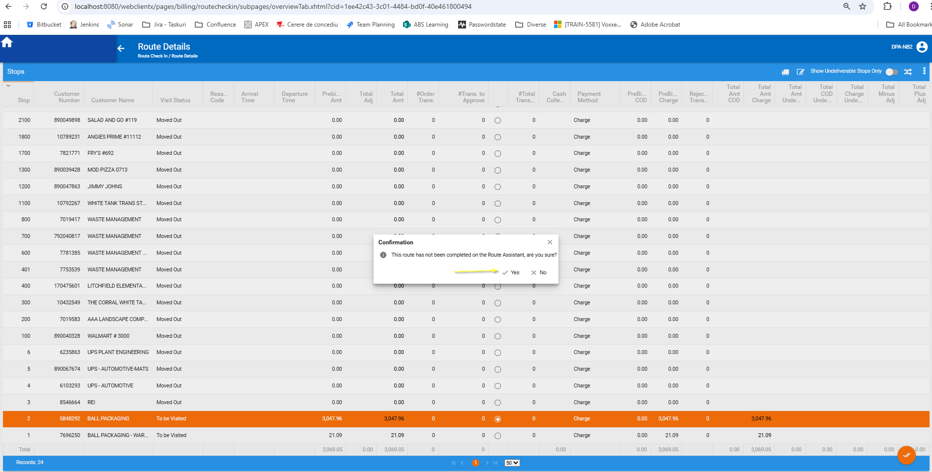

Route has been settled:
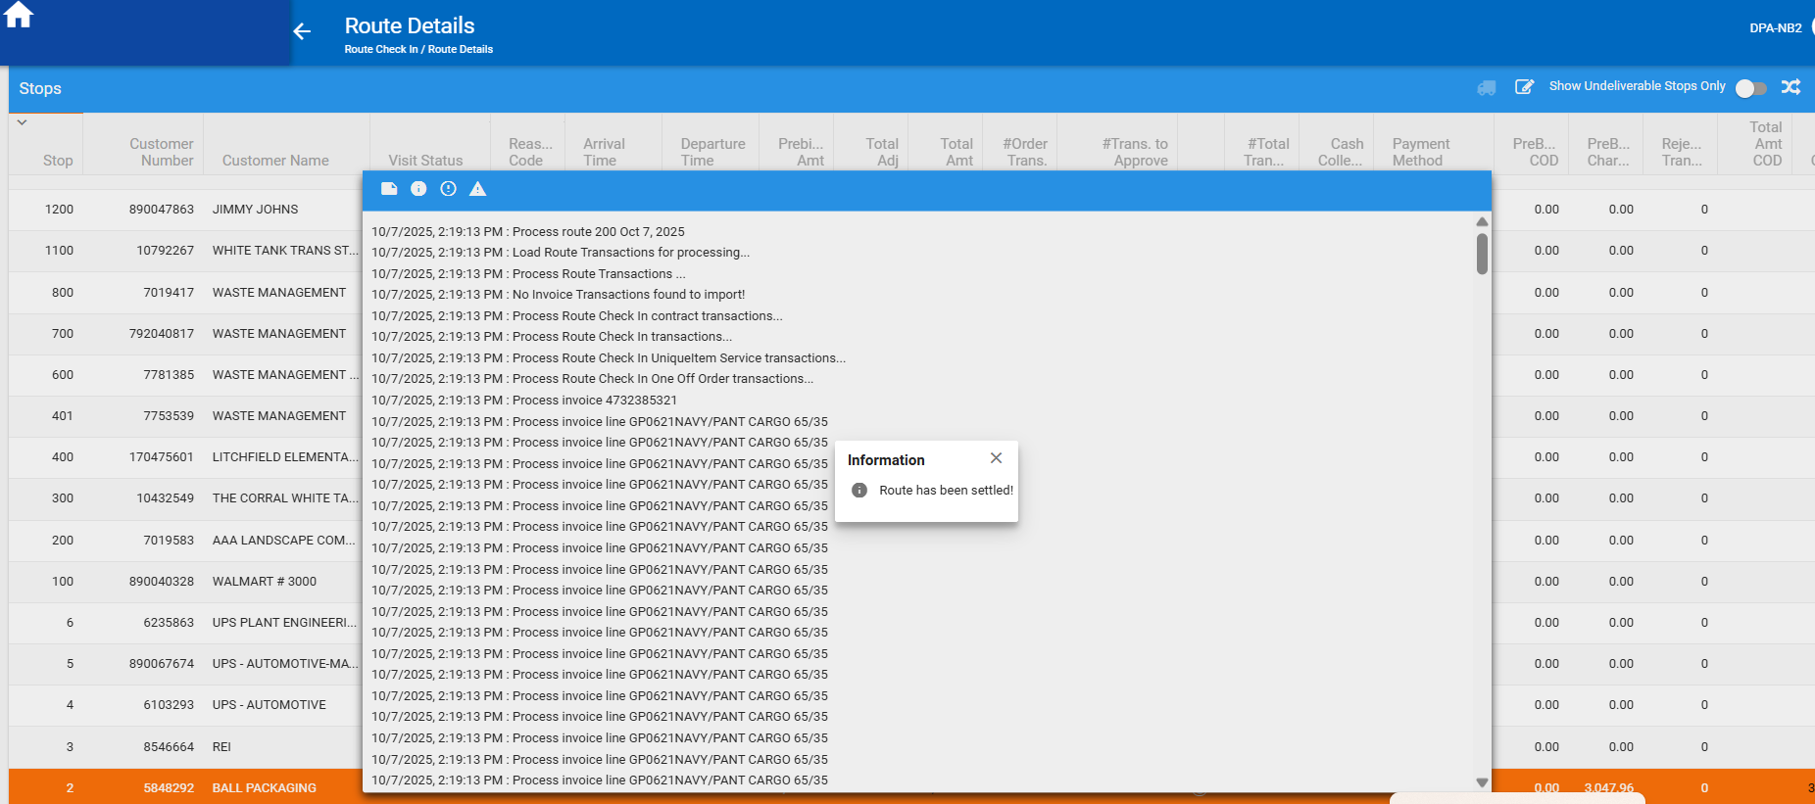

Step 4) Try to mark one of the stops undeliverable on the second WebclientX user:
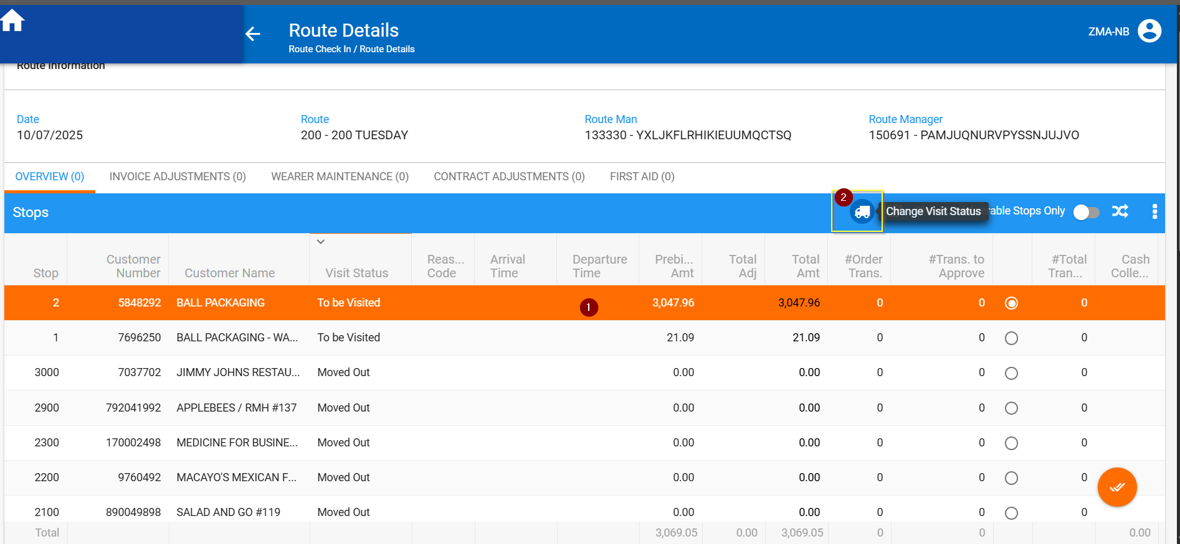

This action was not allowed with the following error message:
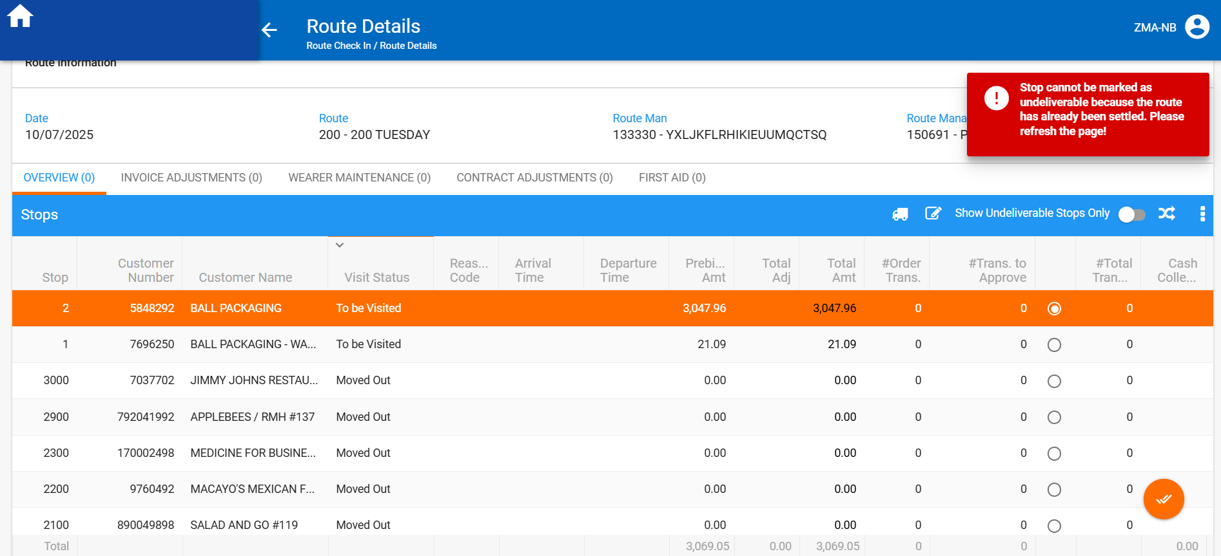
Current behavior is the expected one.

Step 5) Refresh the page or move through the existent tabs.
Expected behvior: The “truck” icon – marking a stop as Undeliverable should be disabled.
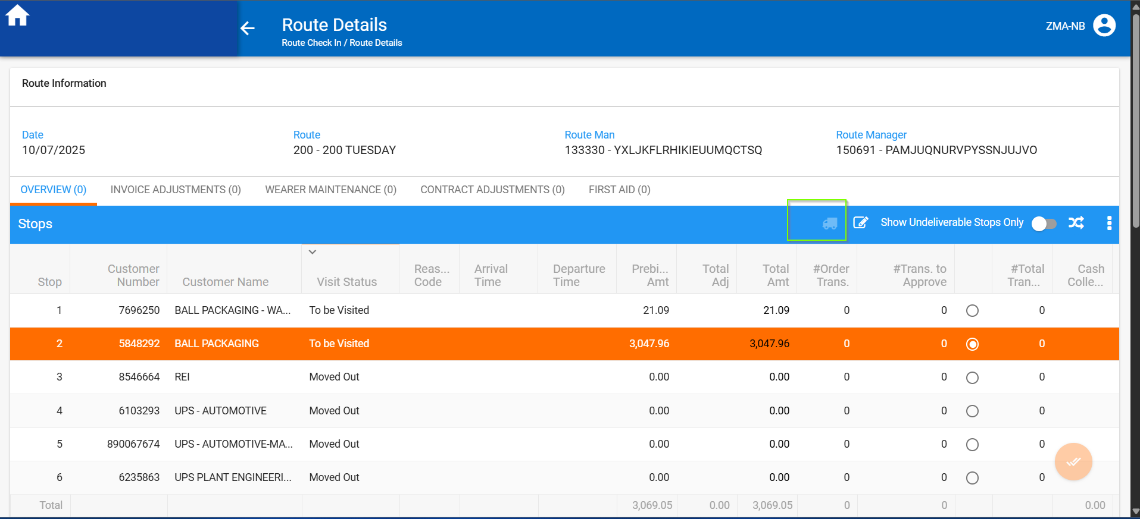
IN RSC, route is settled:
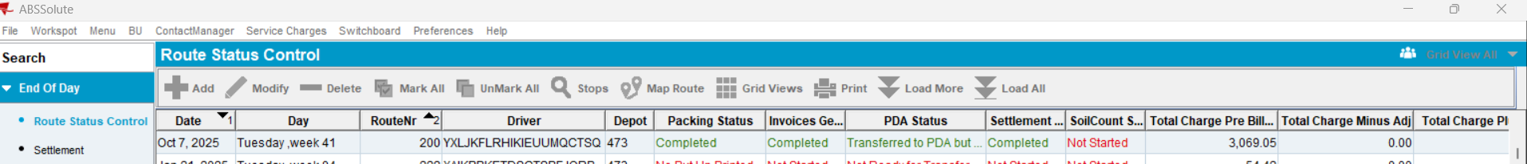

TEST PASSED

TEST CASE 2) Marking Stop Undeliverable with 2 simultaneous users: in WebclientX and Swing Client – TEST PASSED
Create a route, Generate Packing Notes, Invoices:
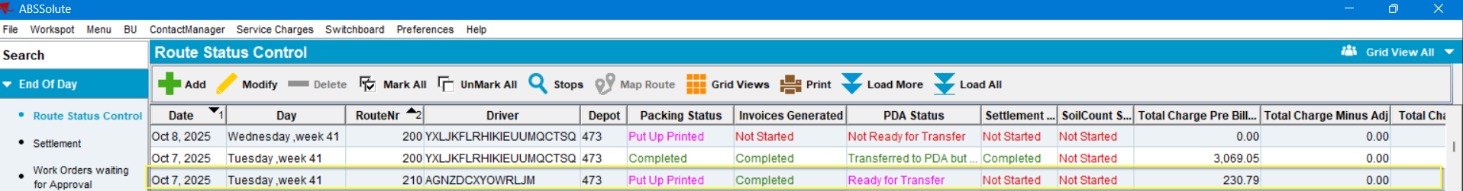
Open the Webclient-X and select the route and a stop:
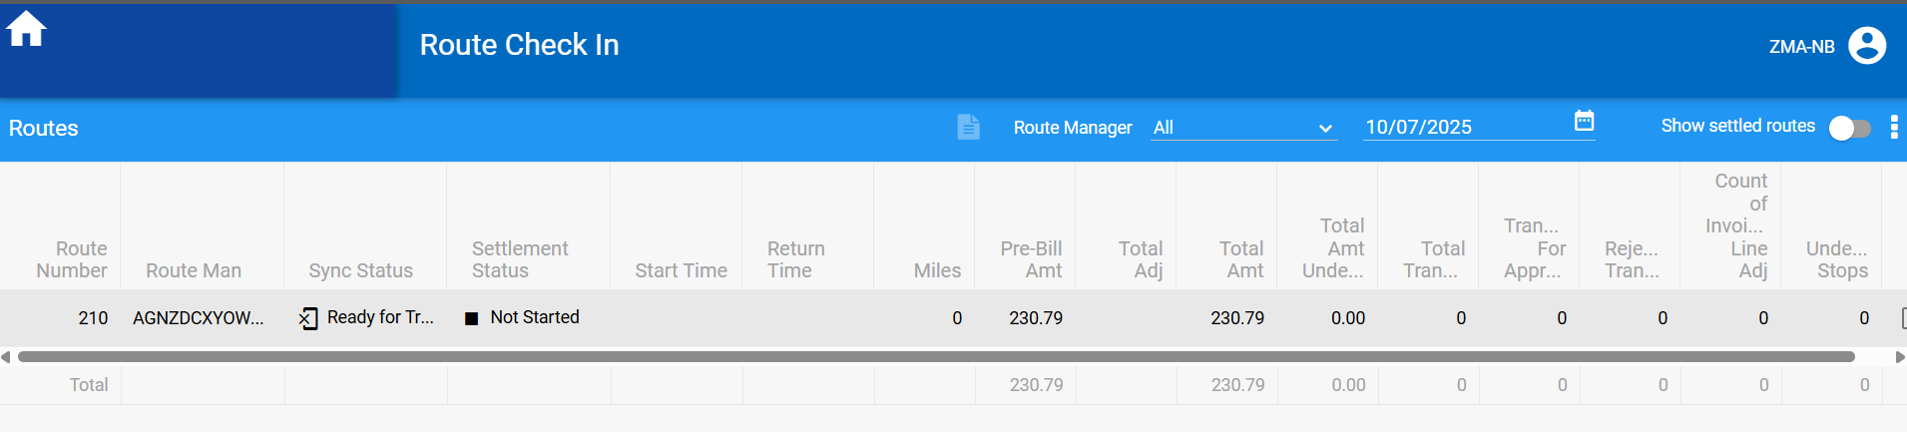

Select a stop. The “truck” button (Mark Stop Undeliverable) is enabled:
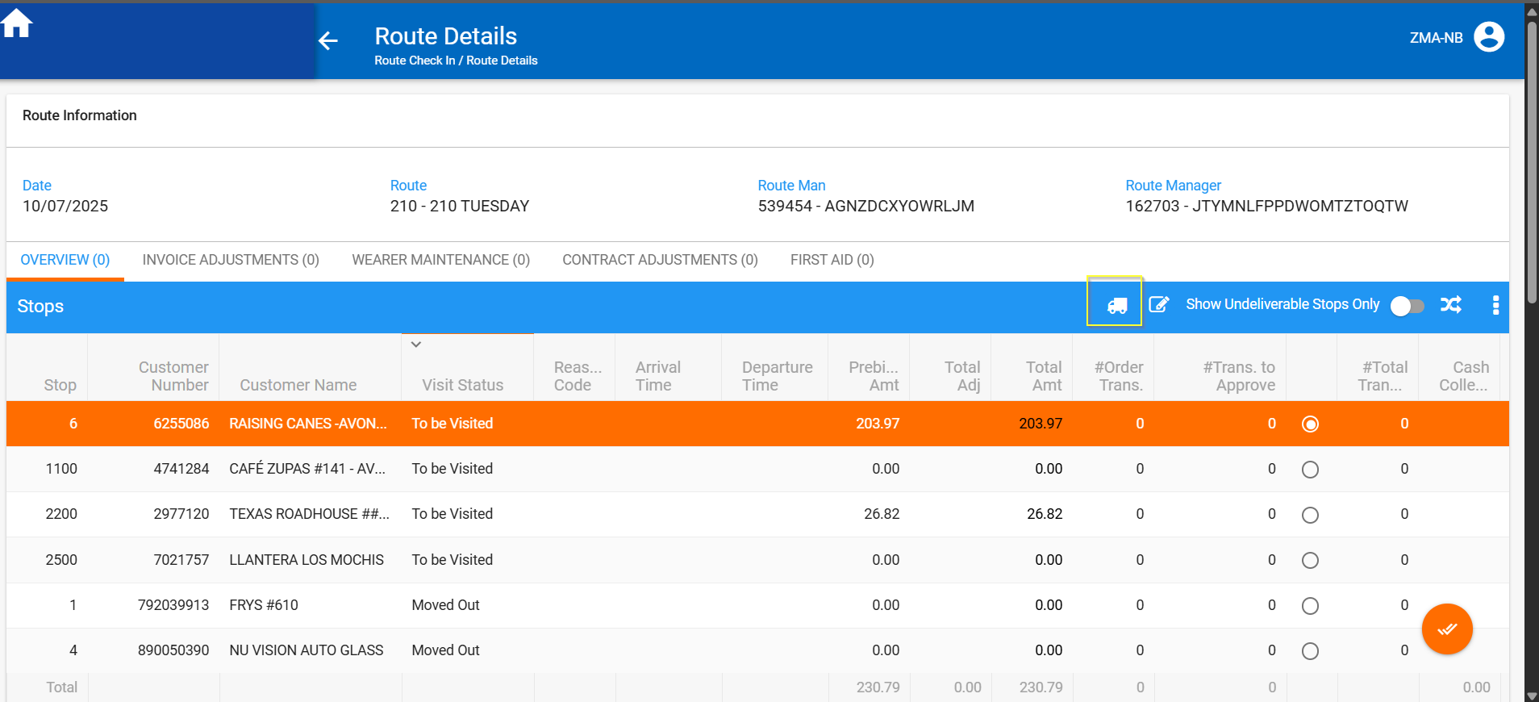
Settle the route from the Swing Client:
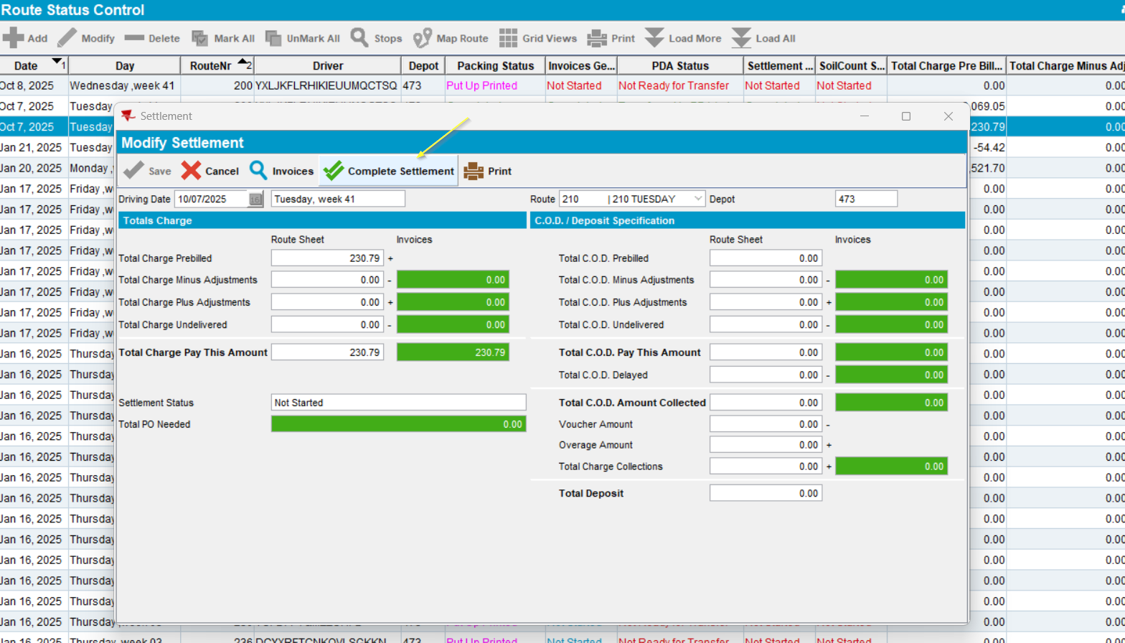
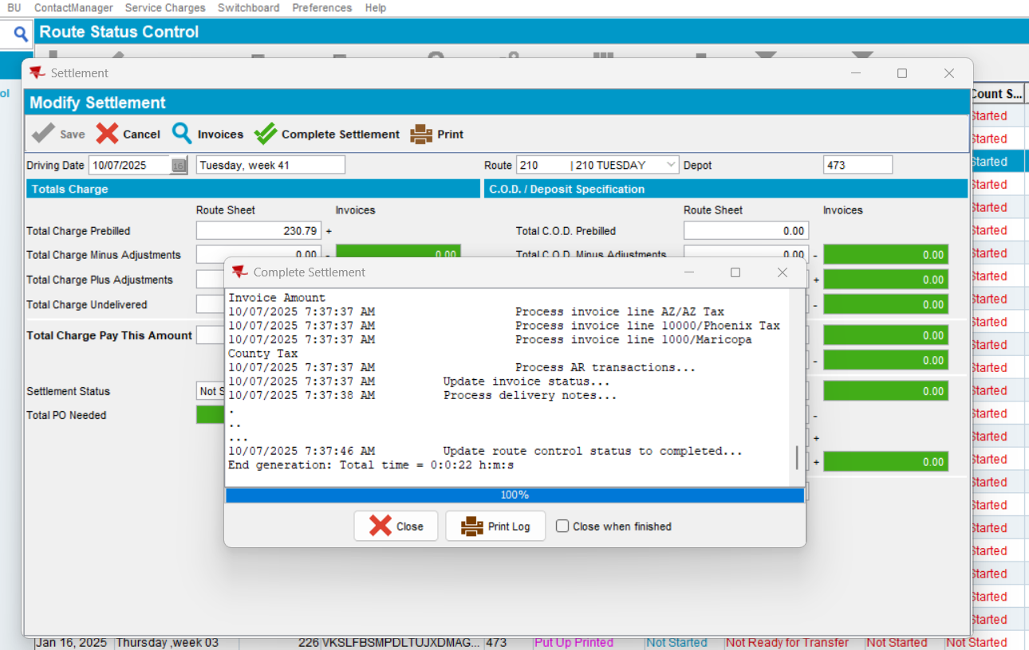
Route settled:
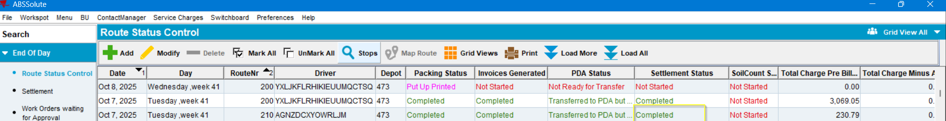
Turn back to the webclient X and try to mark a stop as undeliverable:
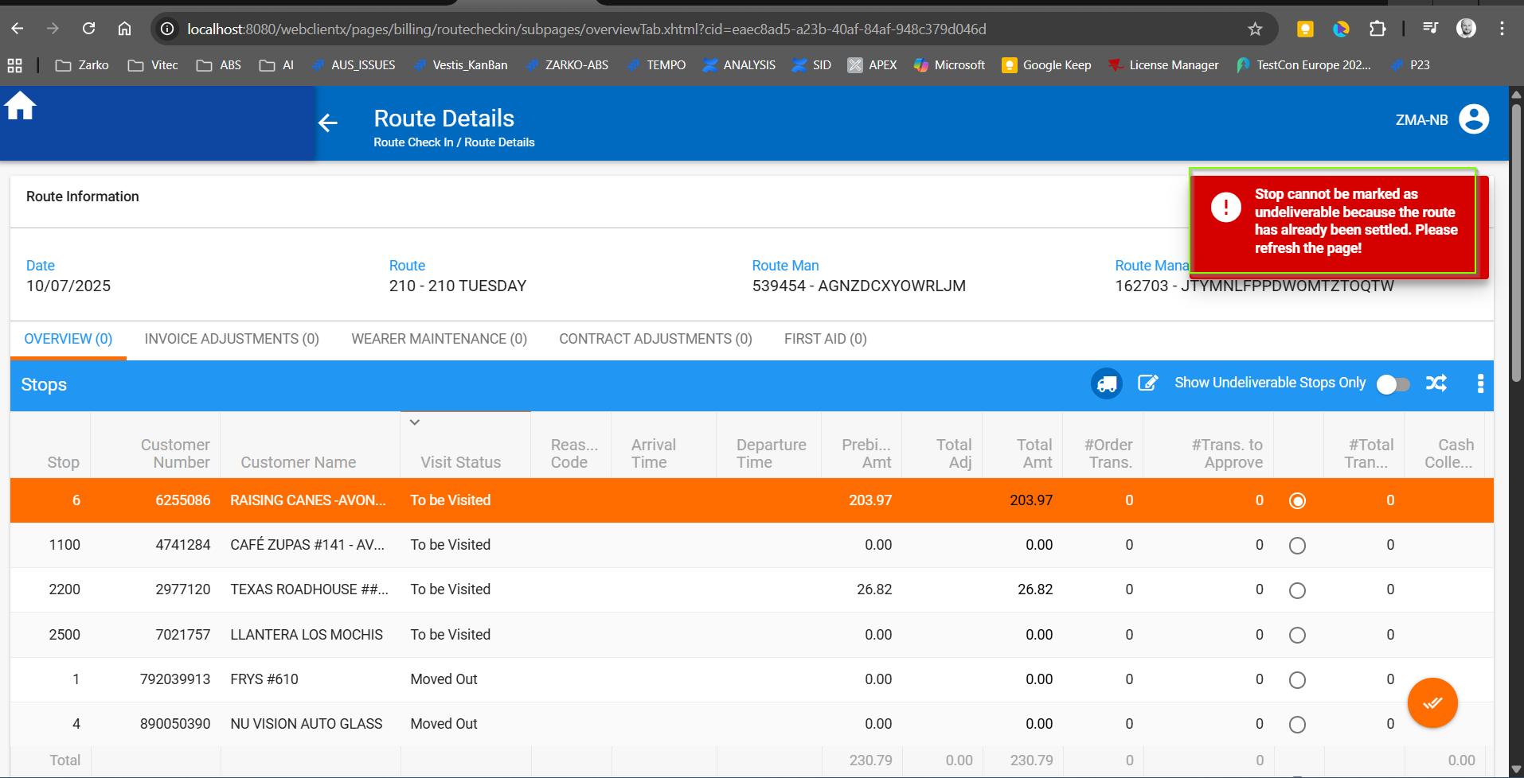
Stop couldn’t be marked as undeliverable with the following error.gih. Which was the expected behavior.
Refresh the webpage:
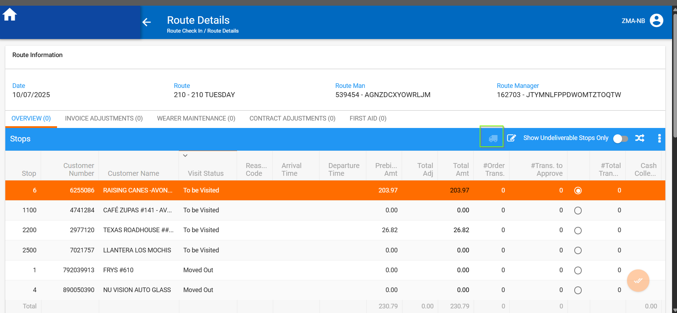
The icon was disabled.
TEST PASSED.

