ABSN-479 - Creating new Sales note populates Remarks from previous Note
Environment | Prerequisites
Version: 9.08.00.RELEASE.p22 DBServerName=abs-srv17.internal.abslbs.com  DBSID=CUST23  DBUser=AUS_MNT90800  DBPassword=WBG_MNT  Environment=Test | - Module: AUSCUSTOM, BKLBASIS, WISBASIS  - SS:
Contents
After Fix: 1
TEST CASE 1: Remark on consecutive Sales Notes (With Modifying the starting SN) – TEST PASSED 1
TEST CASE 2: Remark on consecutive Sales Notes (Without Modifying the Starting SN) – TEST PASSED 9
Test Case 3 – Navigating through the Sales notes activates the “Save and Exit” option, although no changes are performed – TEST PASSED. 13

After Fix:
HASH: 0a372ea5d8f6
BU code: 250 (MC250 Mineapolis QA 01/13/25 – CSO)
Plant code: 250 (Minneapolis (MC250)

TEST CASE 1: Remark on consecutive Sales Notes (With Modifying the starting SN) – TEST PASSED
Add a Sales Note:
Fill in the mandatory fields in the “Additional Order Information” tab:
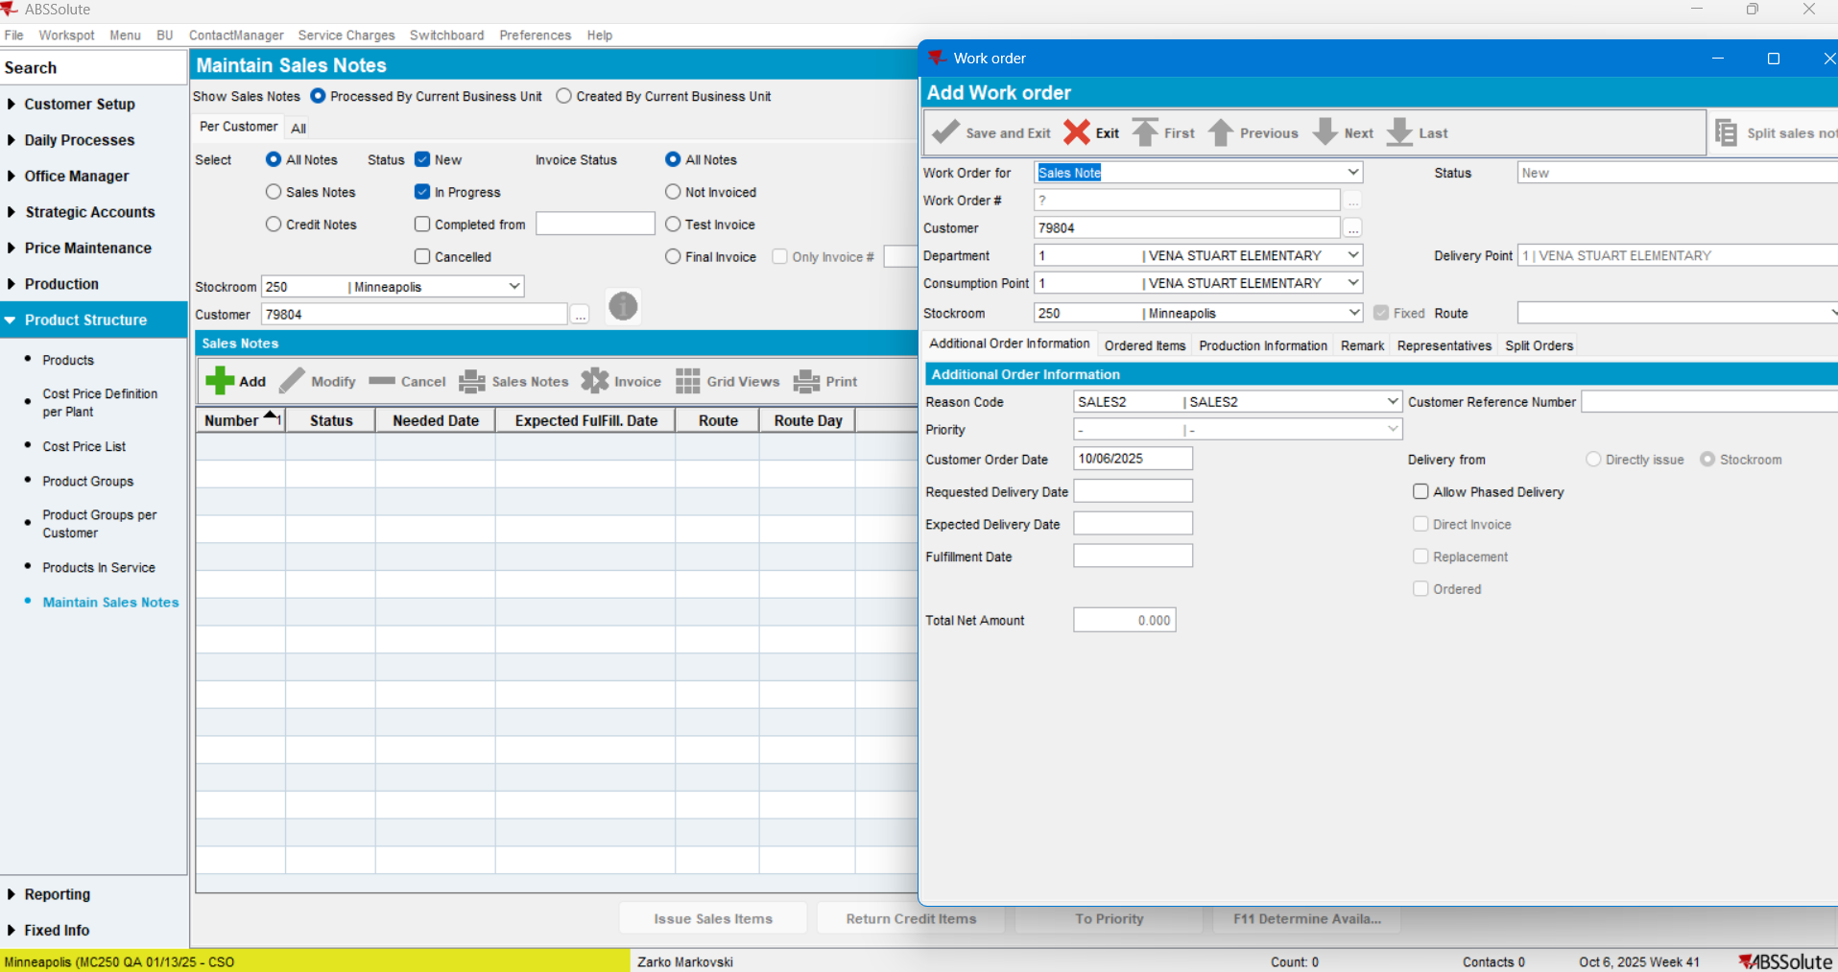

Move to the Remarks>Remark> fill in the remark > Save and exit:
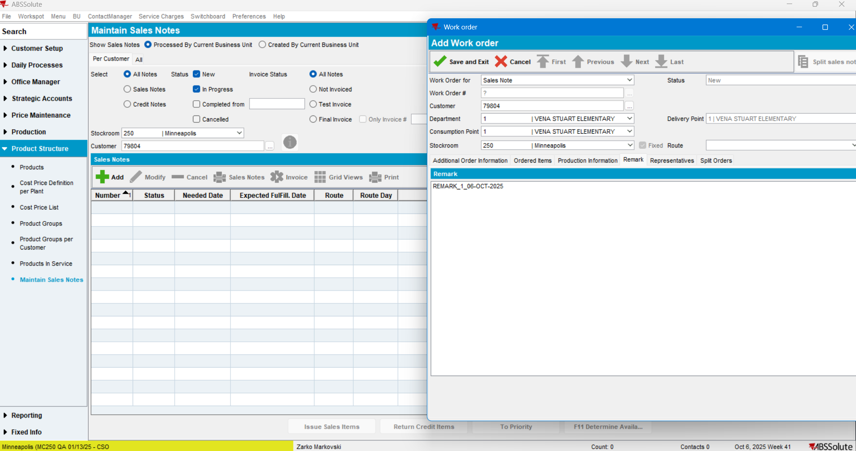
SN saved:
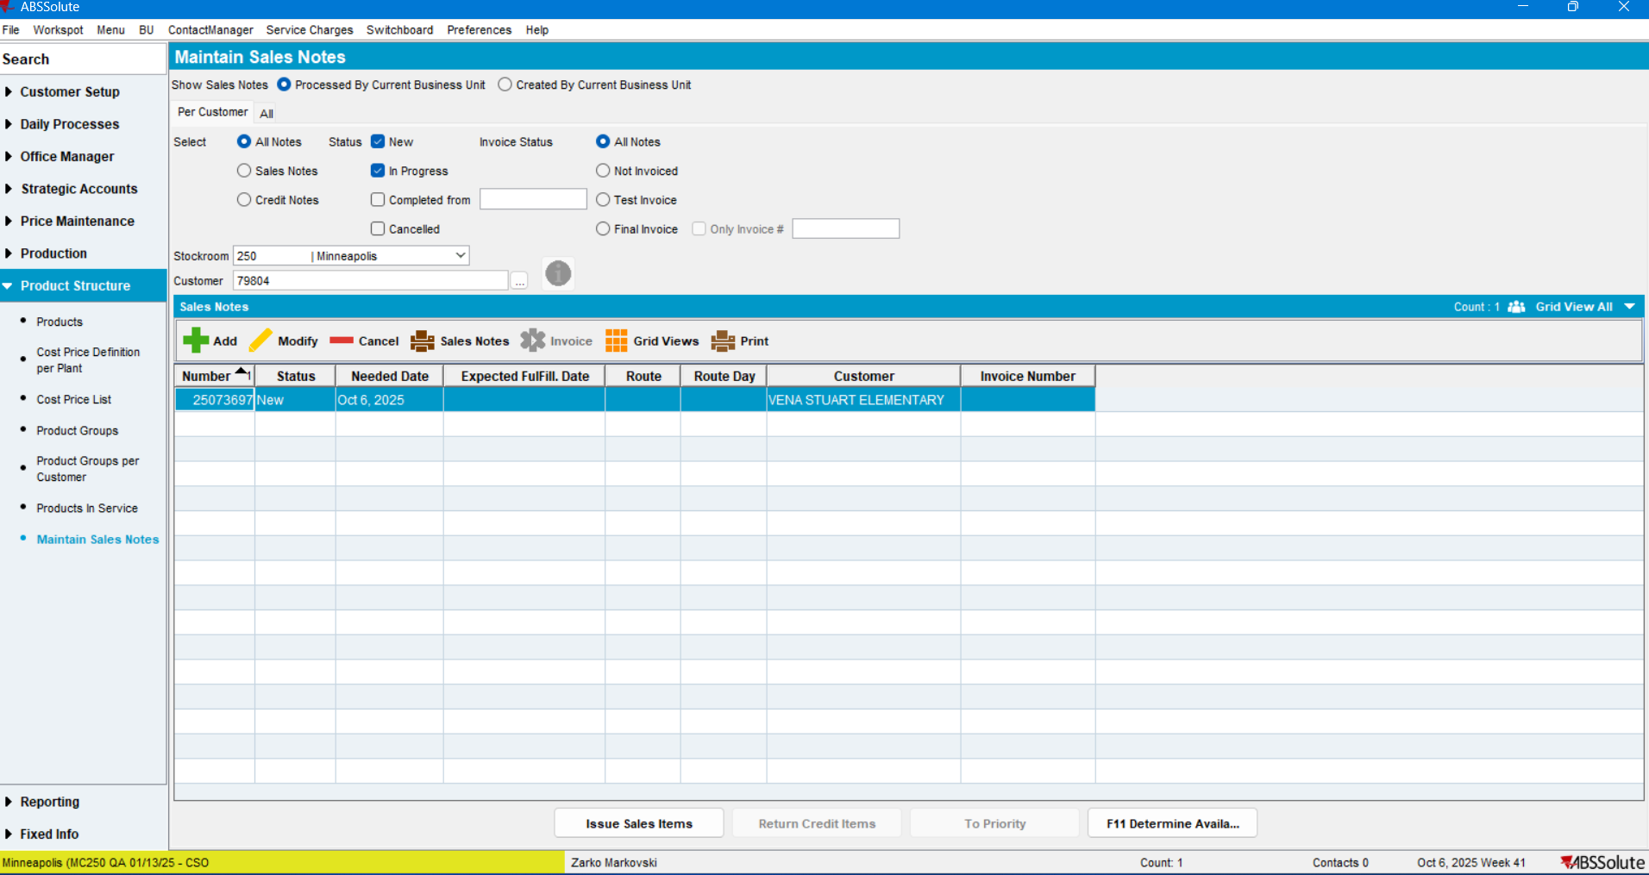

Reopen the Sales note and modify something. In this case the Customer Reference Number, and save the Sales Note:
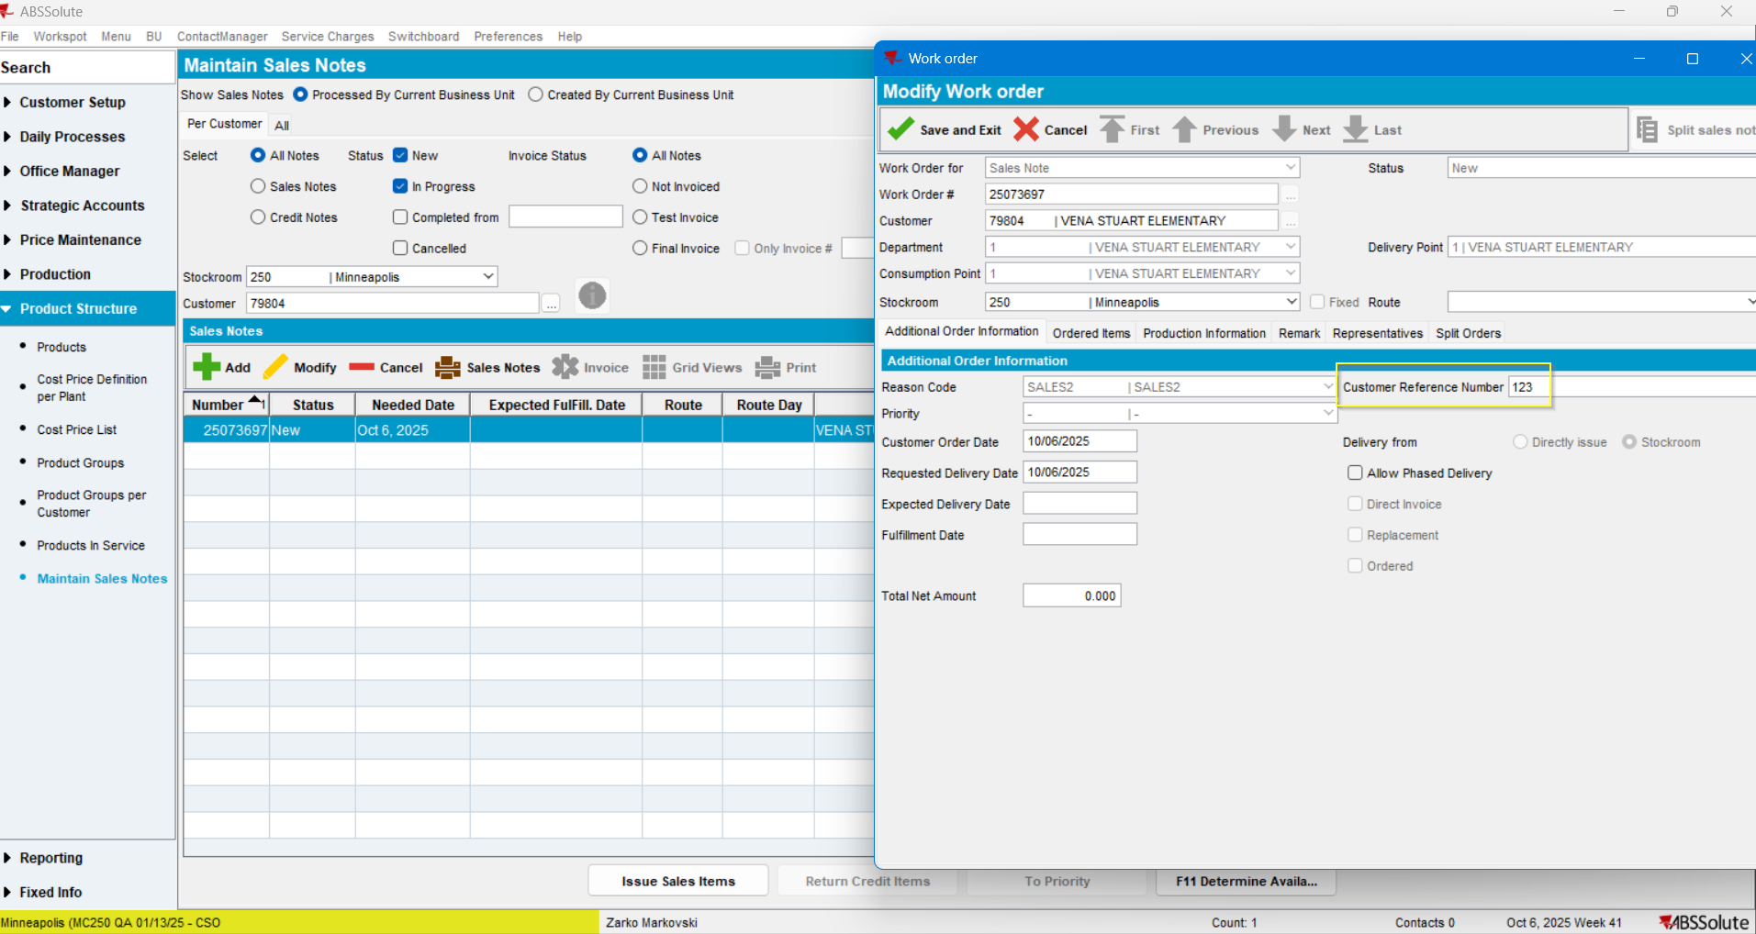
Now Create a New Sales note:
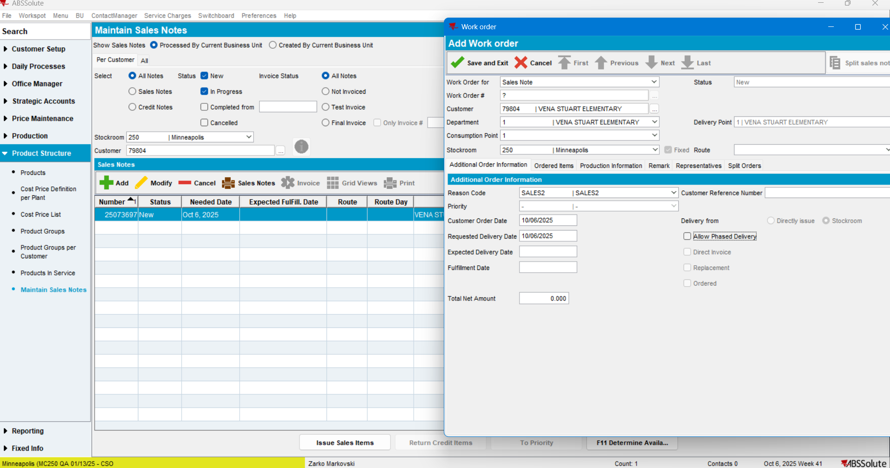

Move to the Remarks tab>Remark:
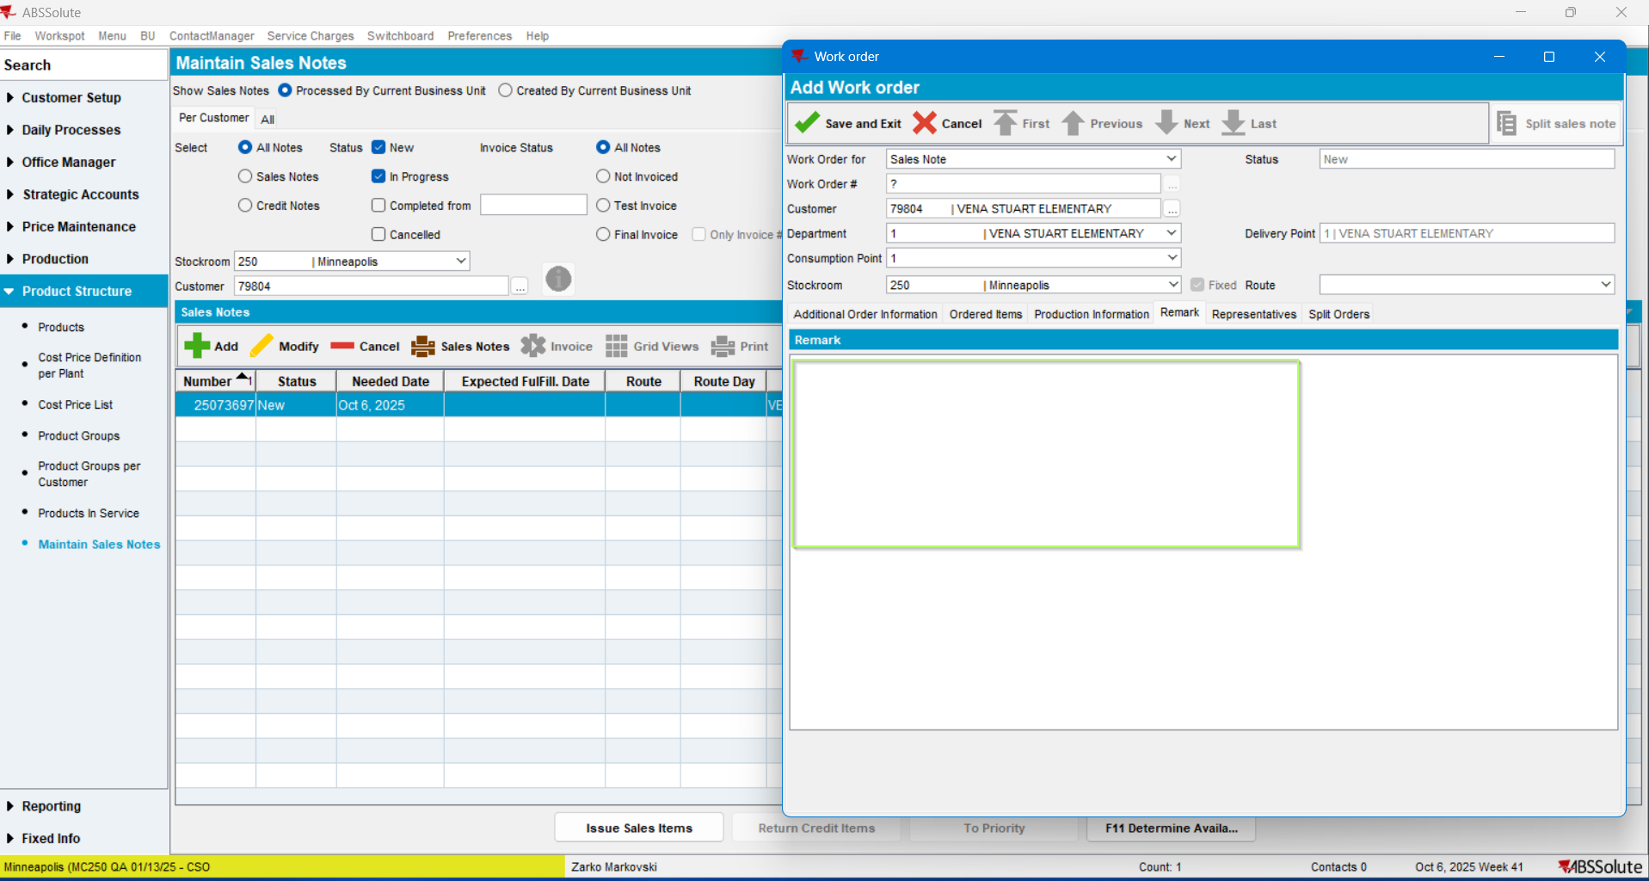
The Remark is blank, it was not copied from the previous Note.
Fill In the remark field and save the note:
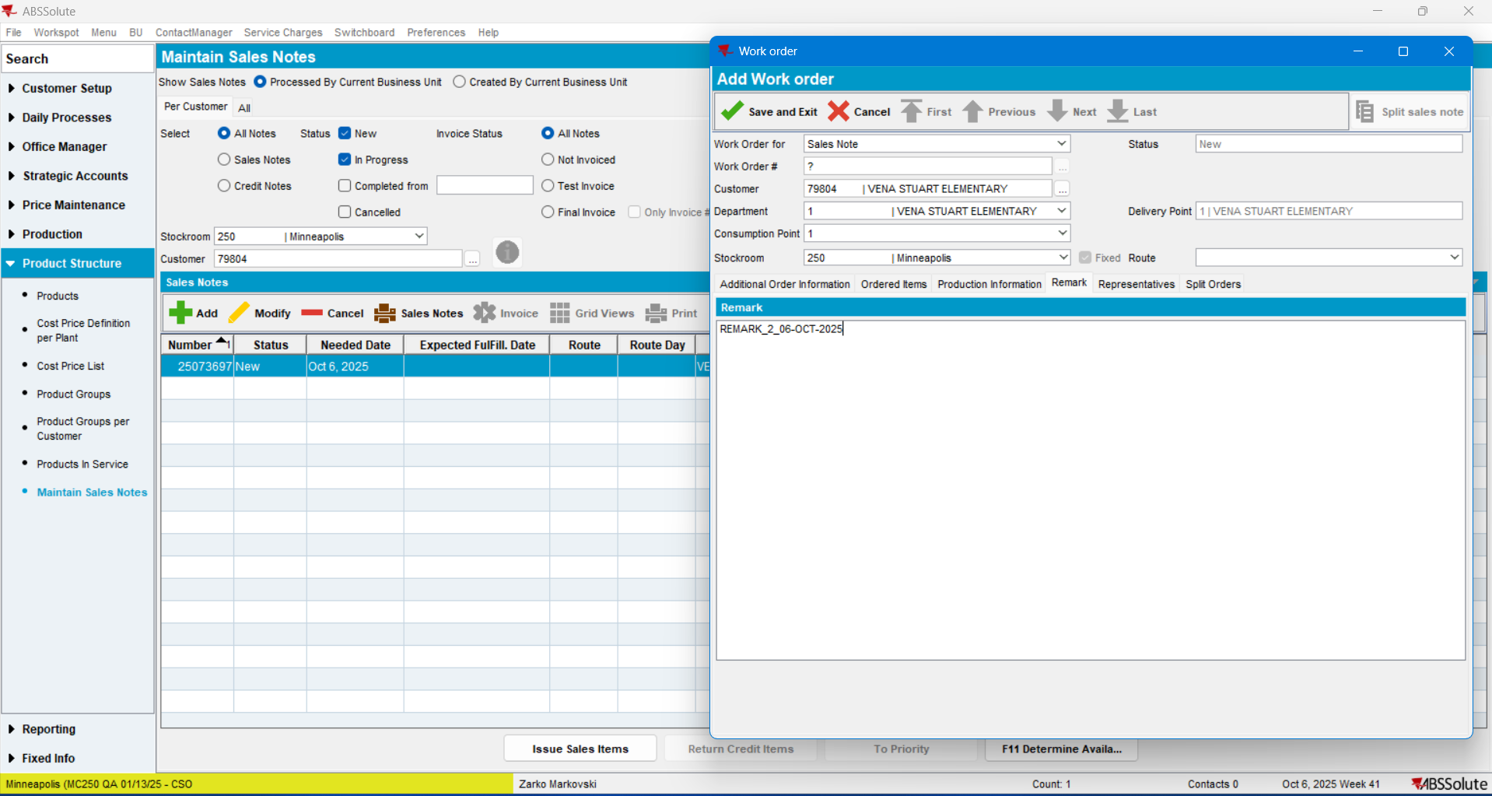

SN saved.
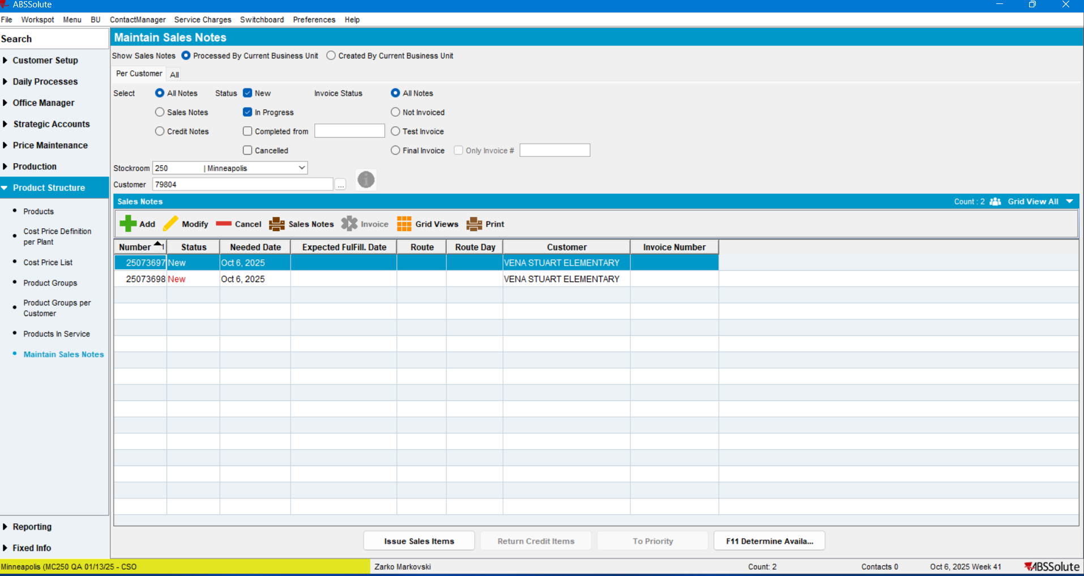
Open and move between the Sales Notes:
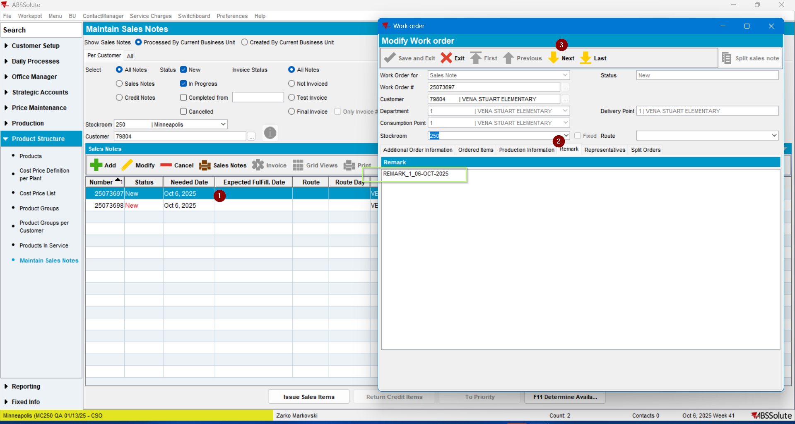

Previously saved remark in the 2-nd Sales Note is correct.
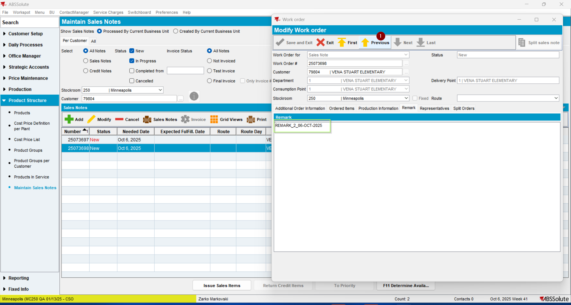
Move to the 1st Sales note the “Previous” Up Arrow Button:

The Remark is correct:
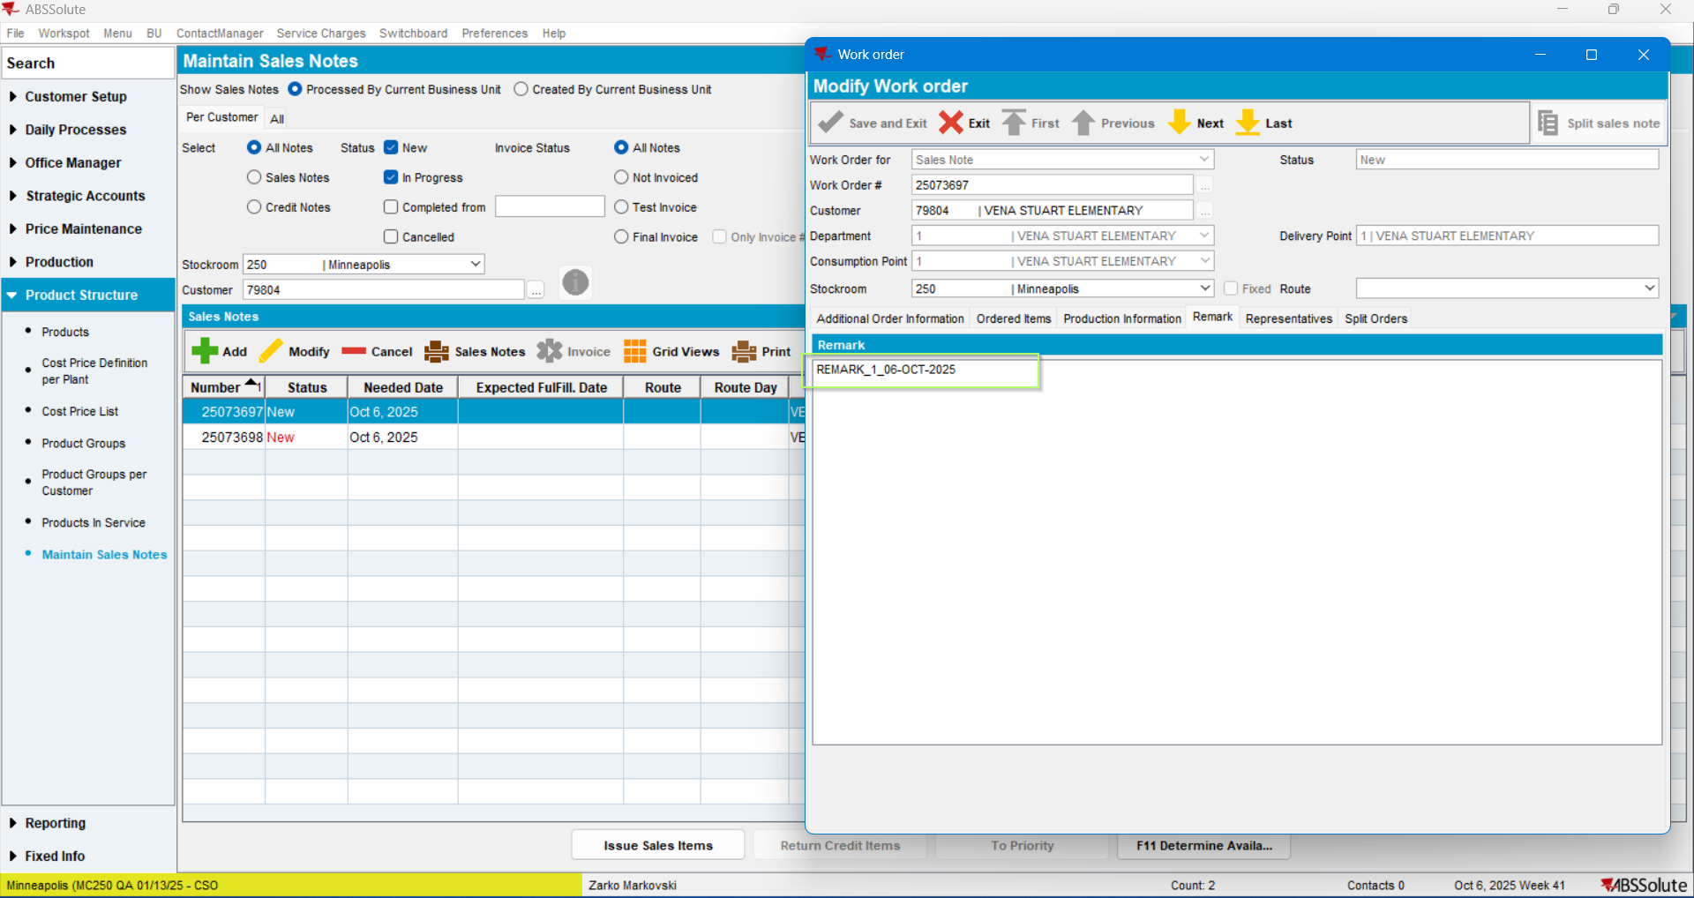
Move to the 2nd Sales Note using the “Last” arrow button:
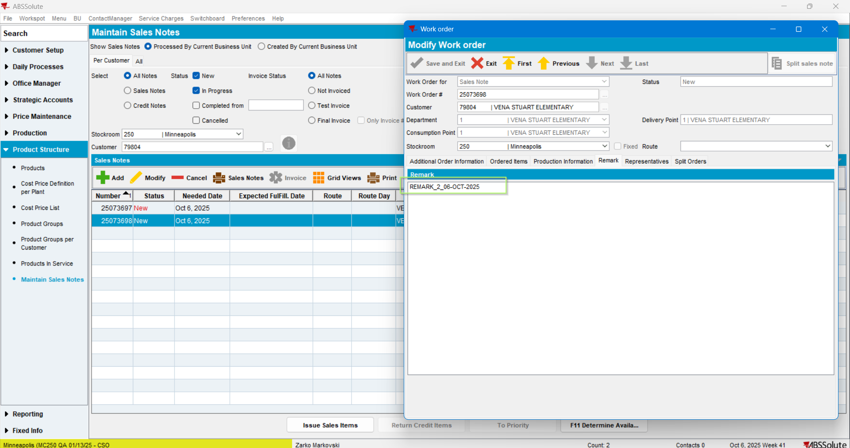
Remark is correct.

Go back to the 1st Sales Note using the “First” (up arrow button):
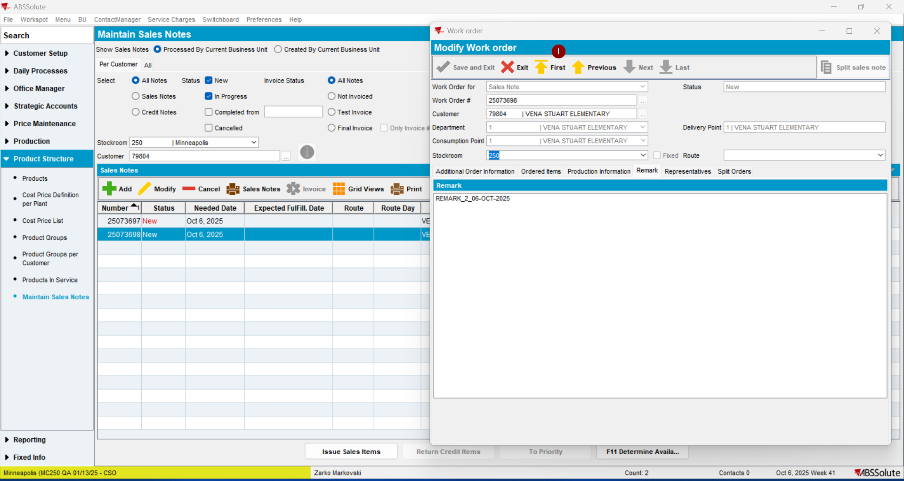
The remark is correct:
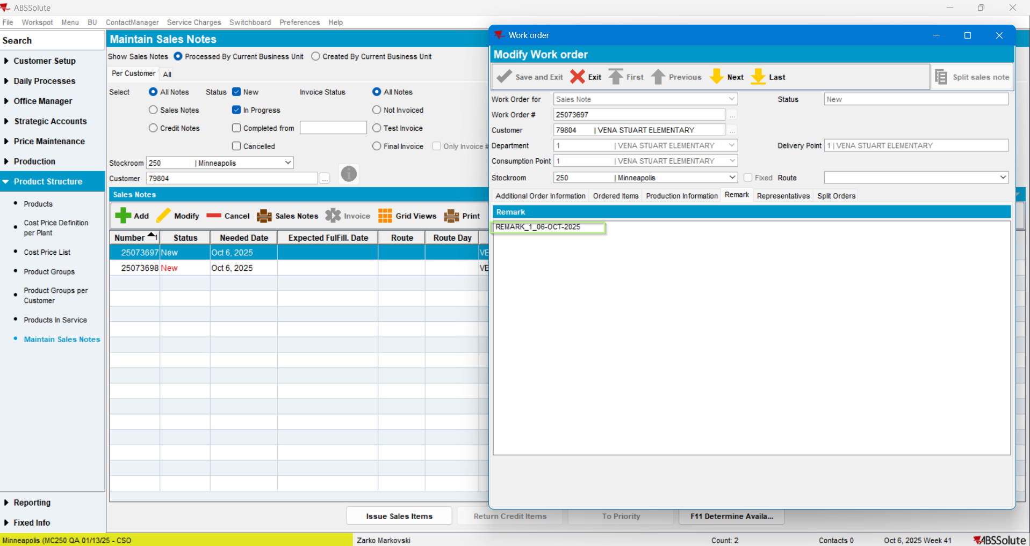
TEST PASSED.

TEST CASE 2: Remark on consecutive Sales Notes (Without Modifying the Starting SN) – TEST PASSED
Create another Sales Note:
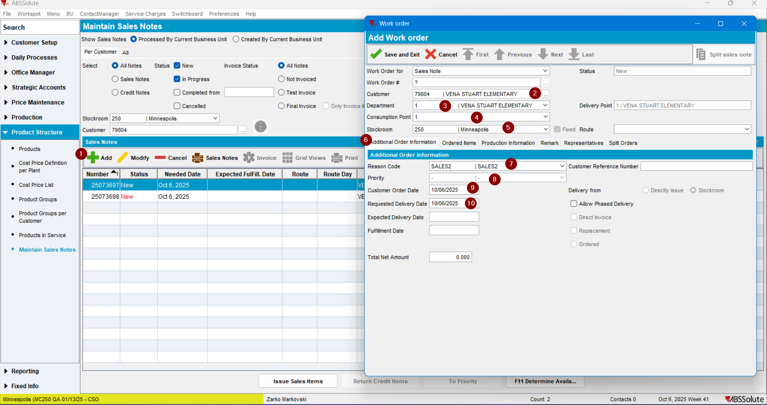
Fill in the Remarks field and save it:
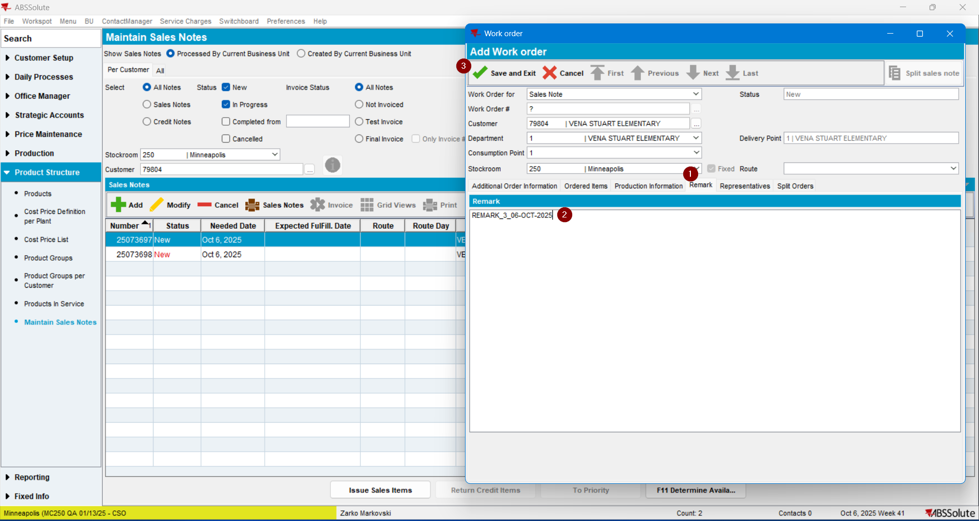

SN saved:
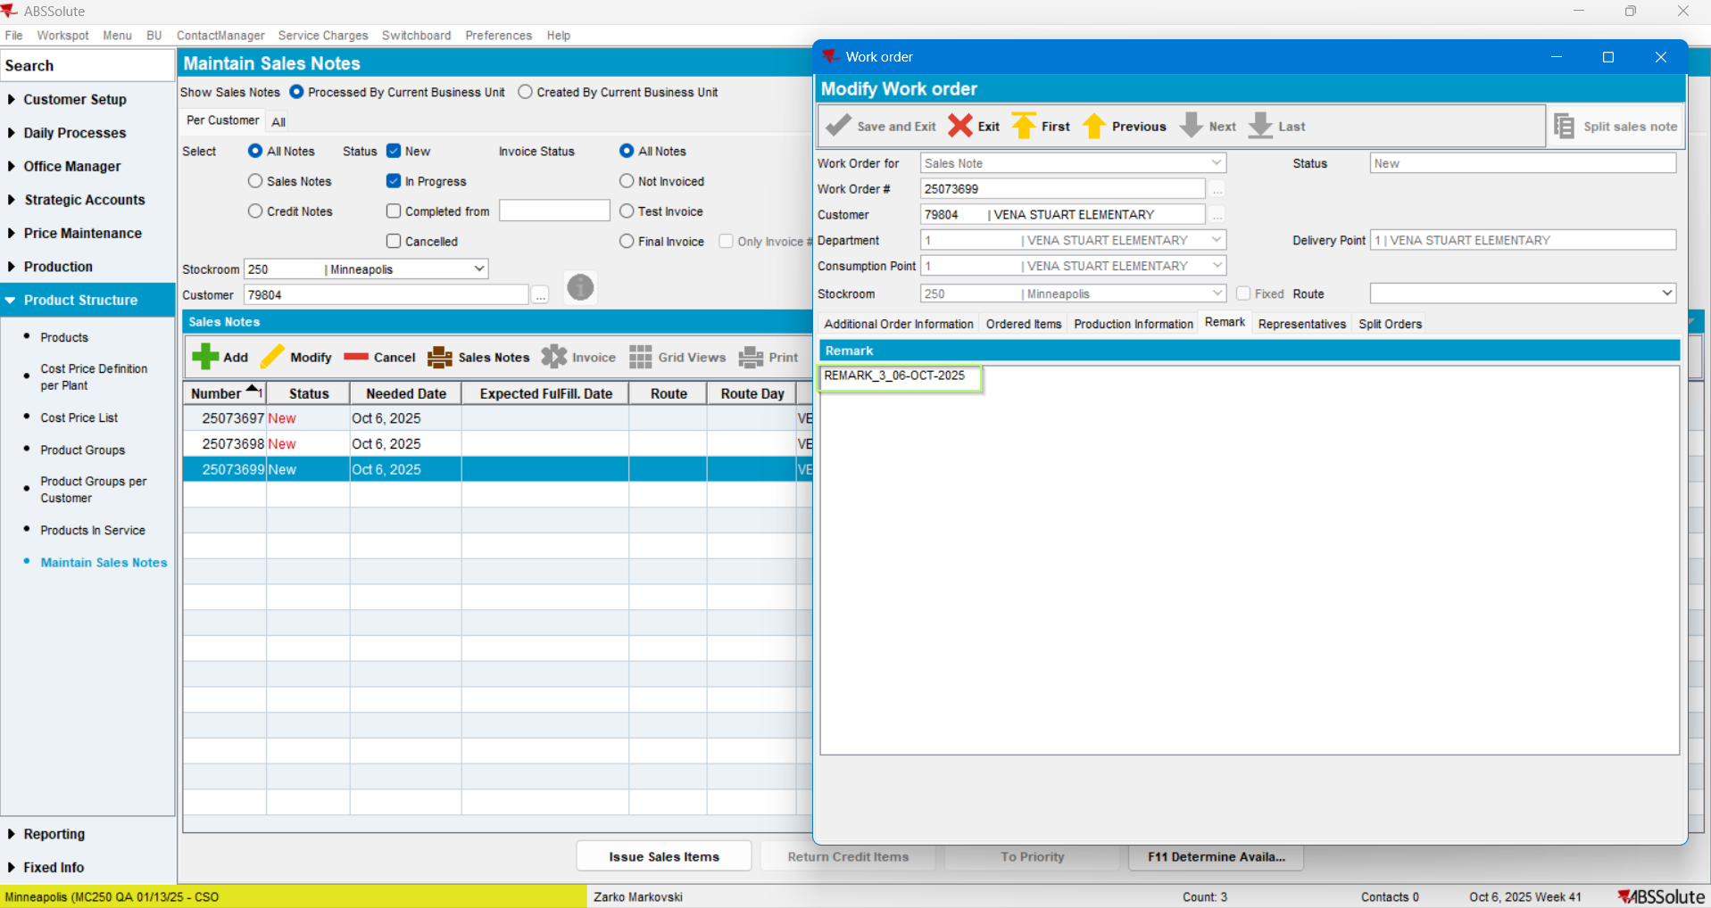
Now add another SN:
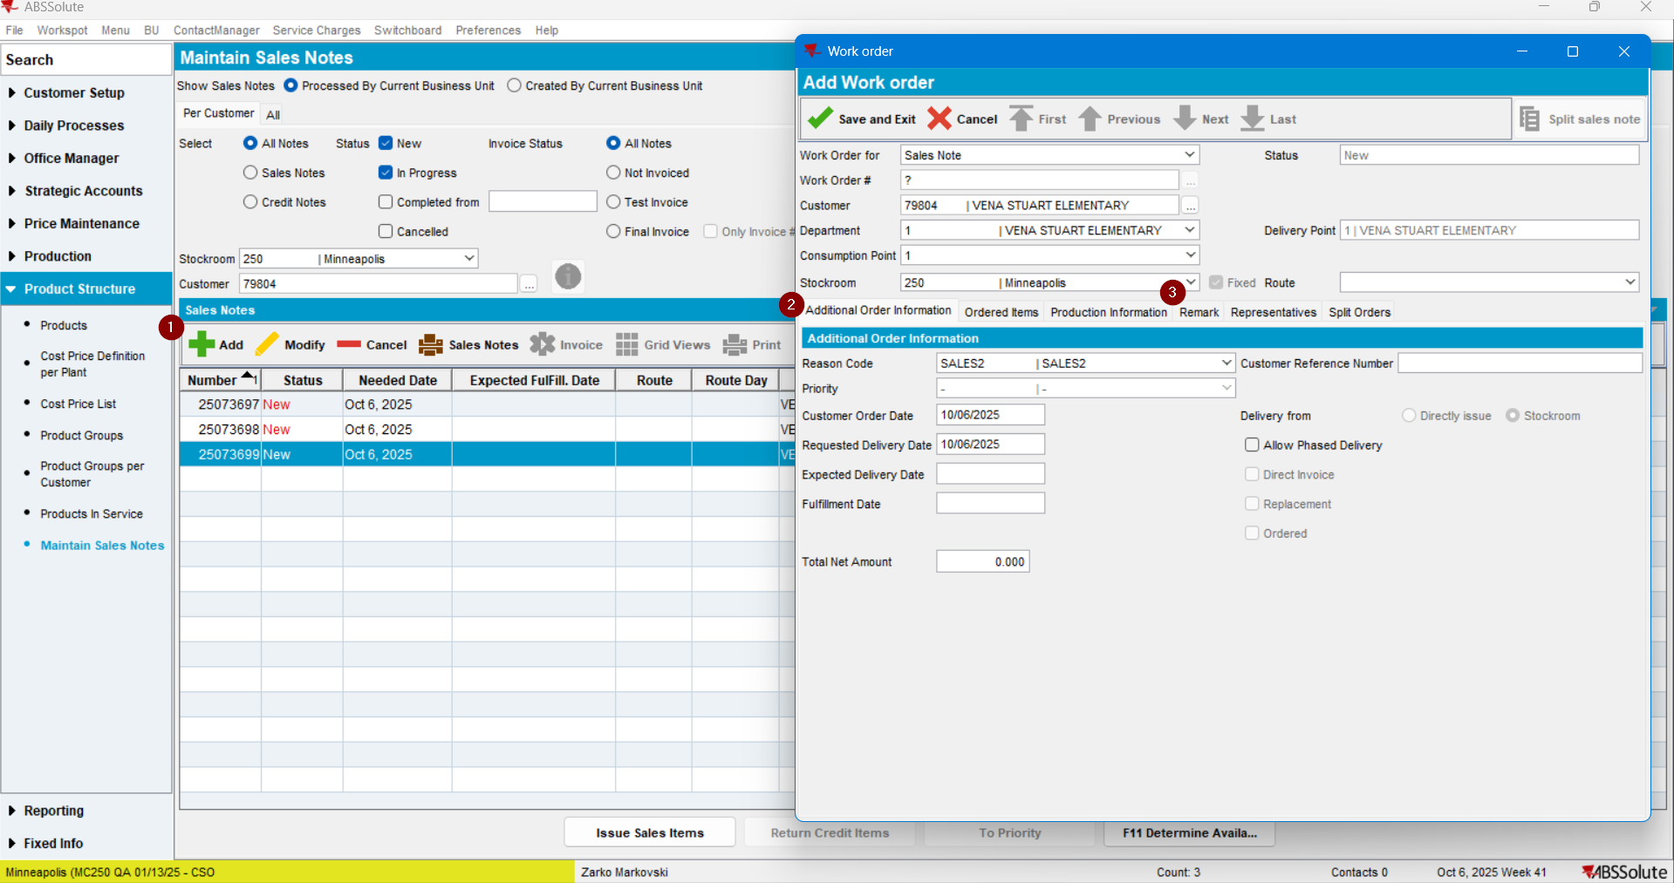

and check the Remarks field:
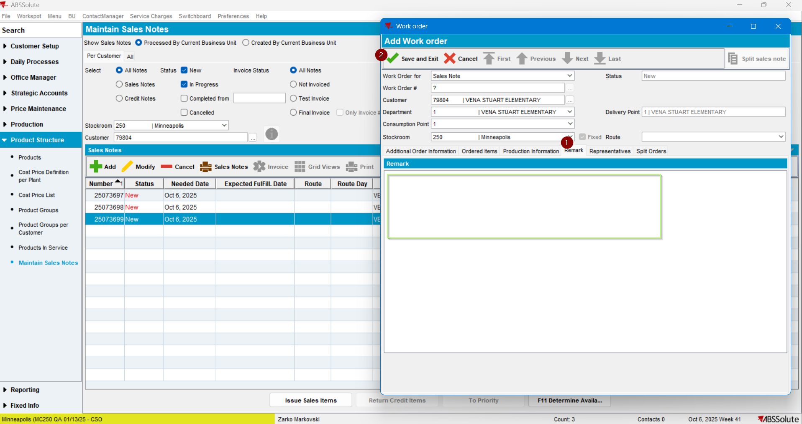
Remarks Field is empty.
Save the Note:
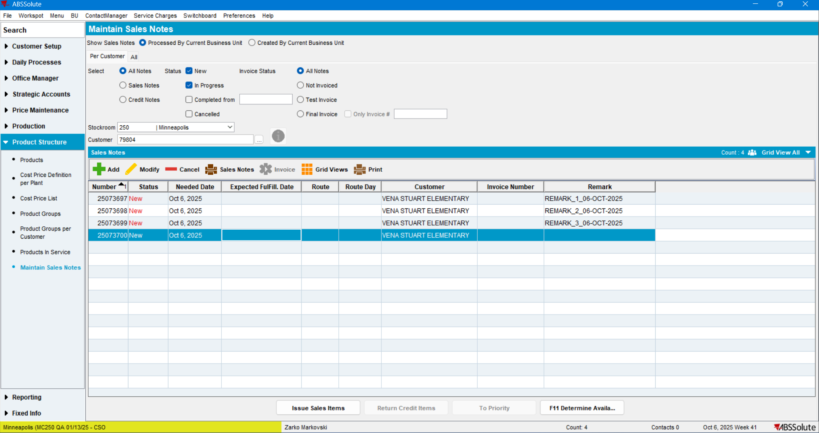
SN saved correctly.

Change the Remark field:
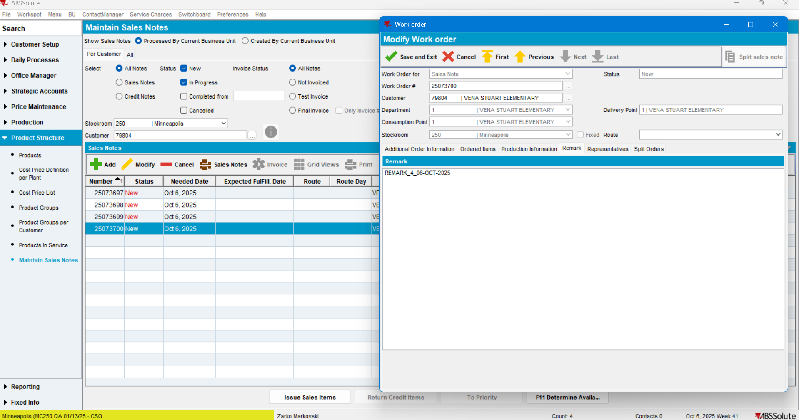
Save: (changes were saved)
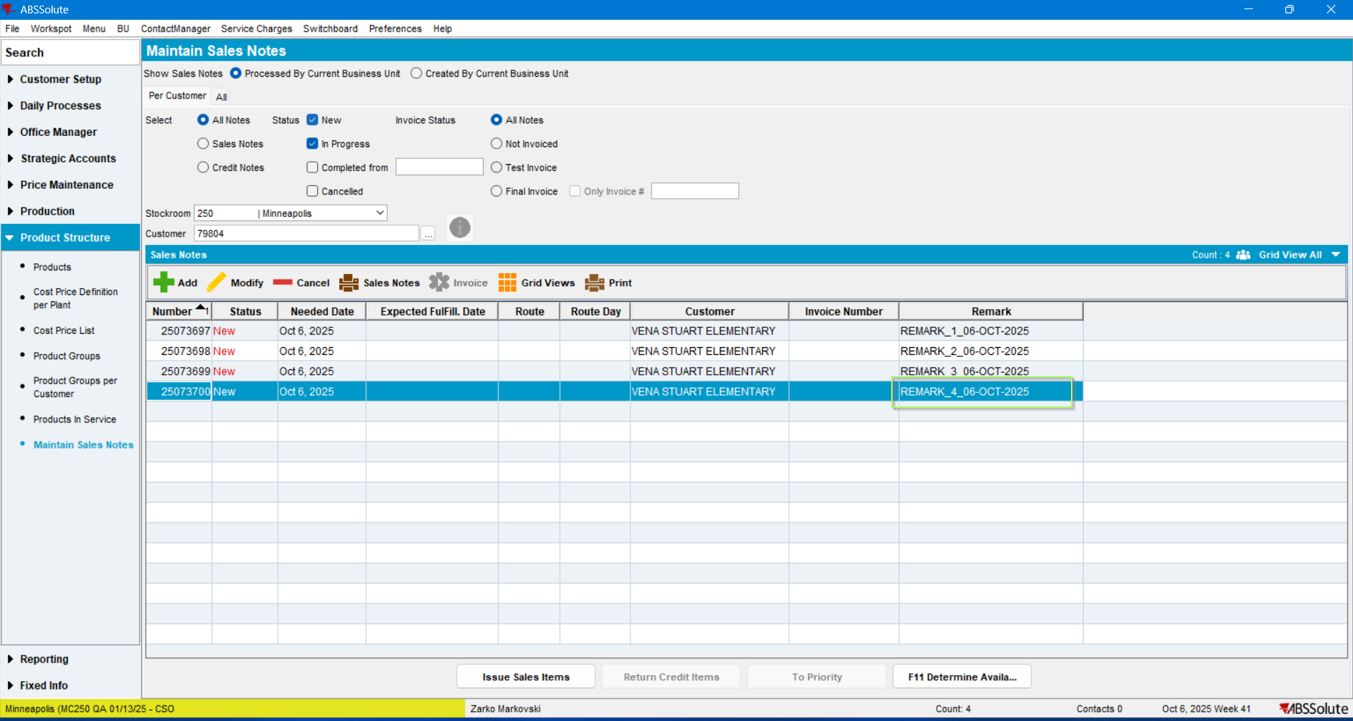
and reopen:
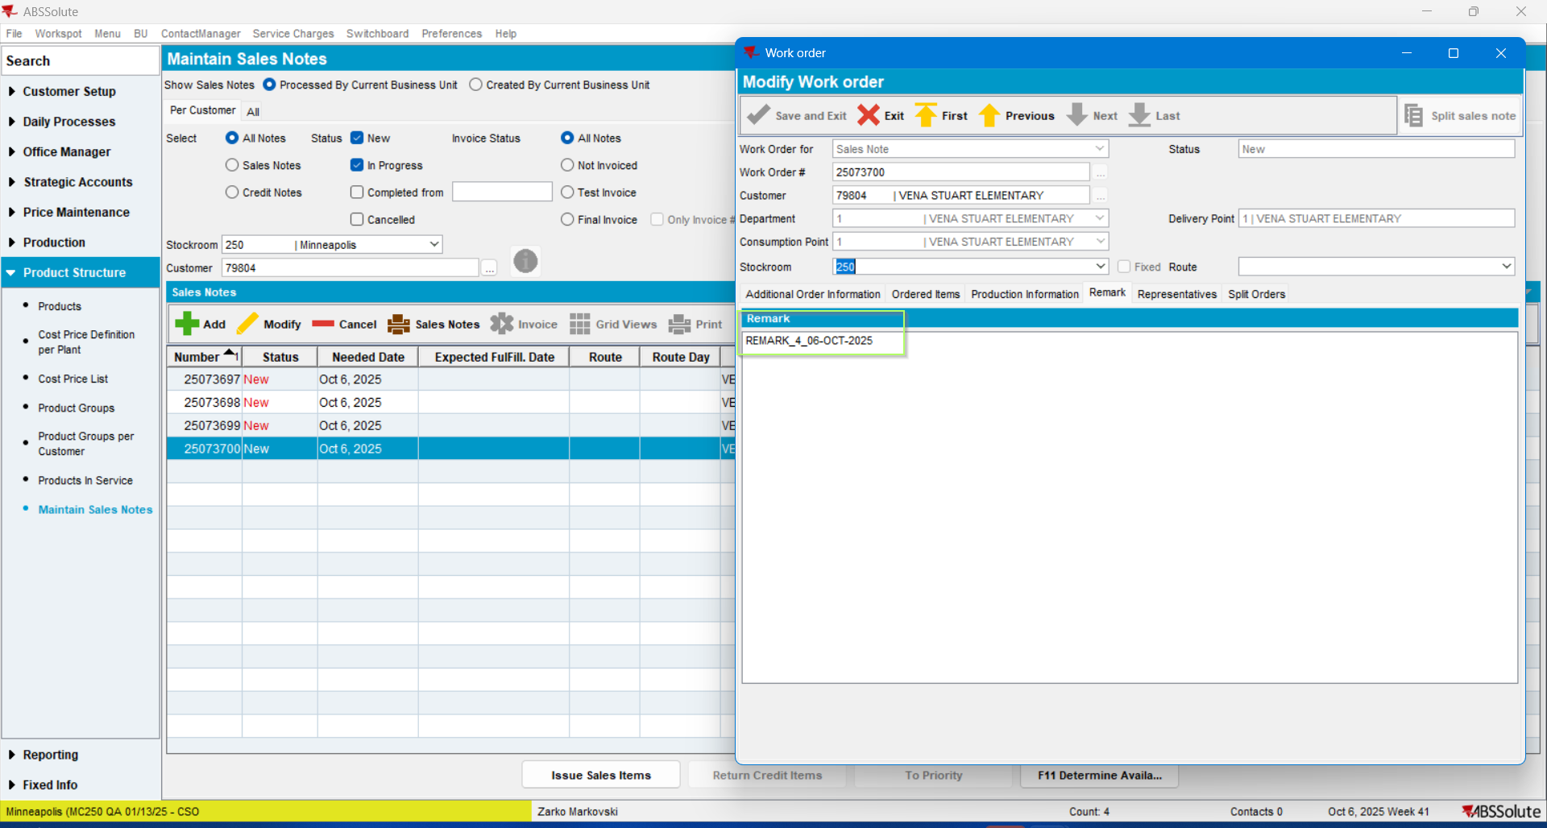
TEST PASSED.

Test Case 3 – Navigating through the Sales notes activates the “Save and Exit” option, although no changes are performed – TEST PASSED.
Previously, when navigating through the Sales Notes using any of the ARROW buttons (First, Previous, Next, or Last), by pressing the same button more than once, or switching the buttons, the “Save and Exit” button was unexpectedly reactivated, although no changes have been made. Like in the example below:
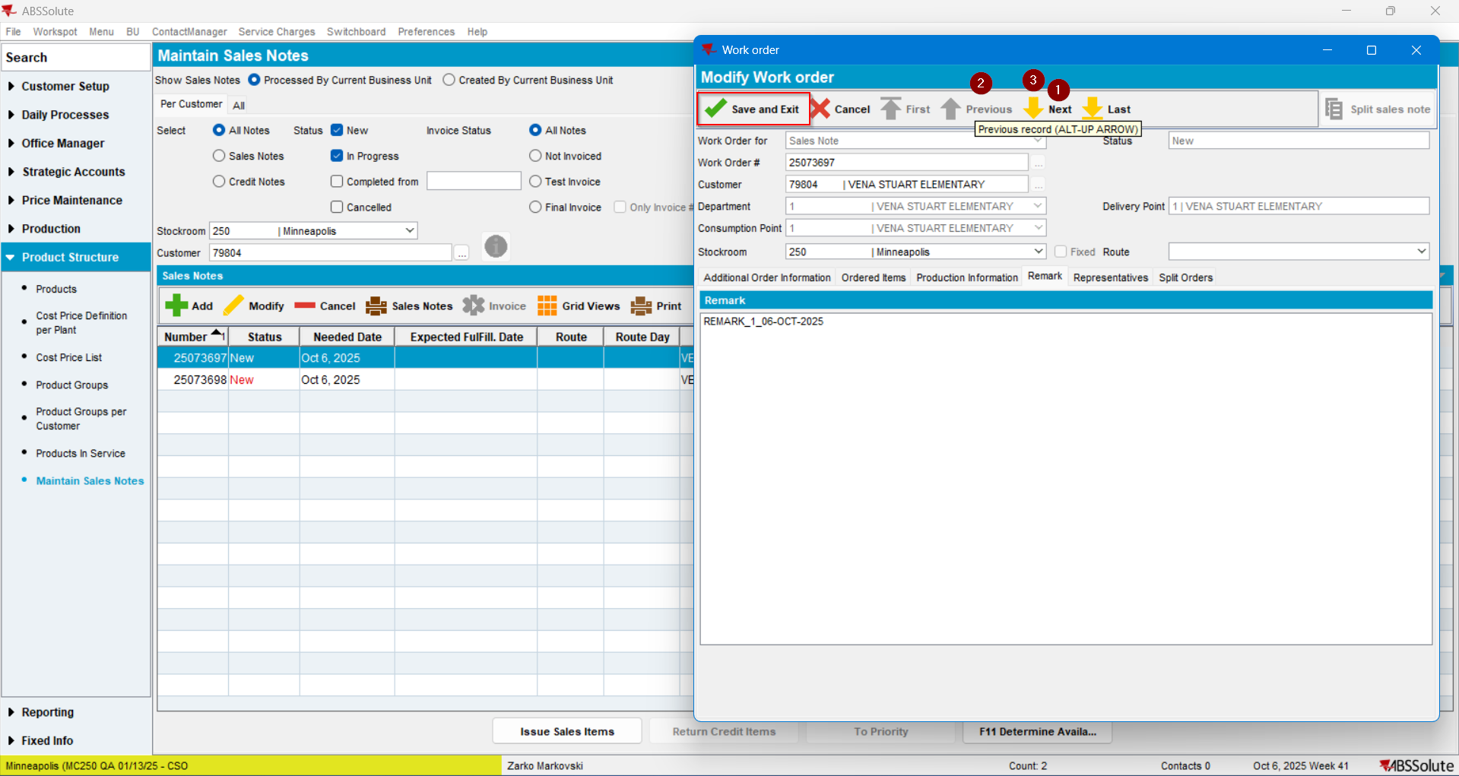
After restarting the Server/Client, the mentioned issue does not appear:
Select the first SN, switch to the Remark tab:
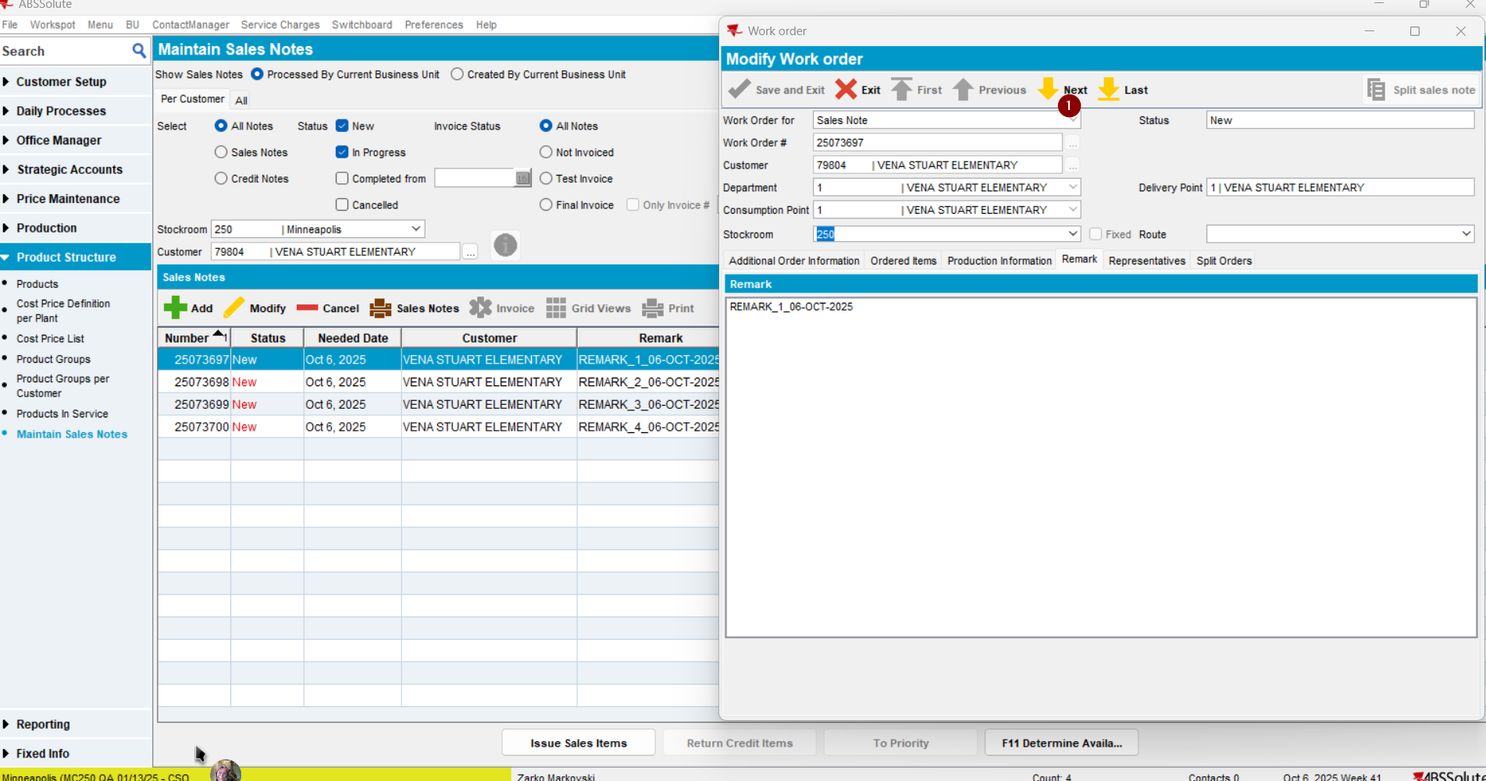
And press the Next button twice:
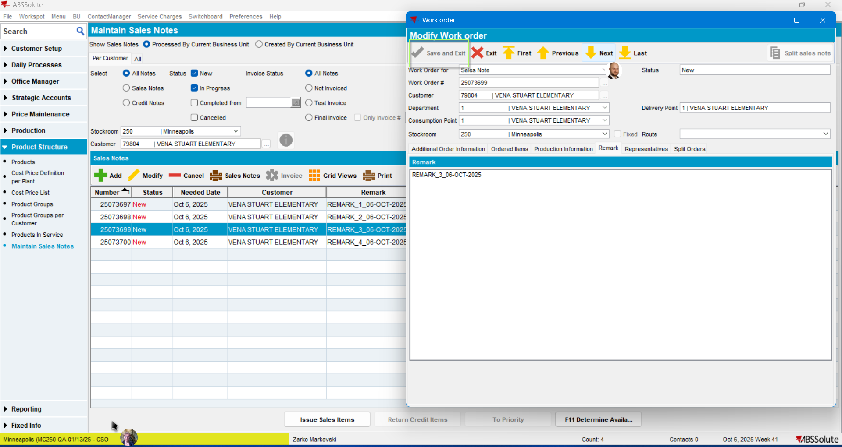
The Save and exit button remains disabled.

Then the Last and First buttons were pressed:
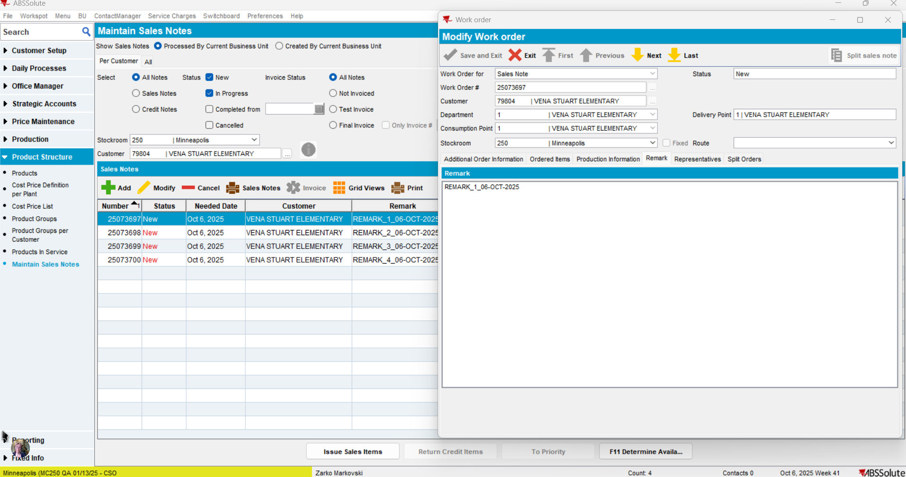
The Save and exit button was not enabled.

TEST PASSED

