ABS-168230 Web Client X - Diagnostics
Environment | Prerequisites
Version: 9.08.00.RELEASE.p22  Environment=PRODUCTION  DBServerName=db01-buc.internal.abslbs.com  DBSID= CUST25  DBUser= AUS_ND90502  DBPassword= AUS_ ND90502 | - Module: AUSCUSTOM  - Systems setting (optional, for invoice adjustments):  USEROUTECHECKINSCREEN, INVOICELINEADJADDRULE,  INVOICELINEADJAPPROVERULE,  INVOICELINEADJMODIFYRULE,  INVOICELINEADJVALUERULE  - Others: BU 503
Contents:
Web Client X - Diagnostics
#1 – Check Diagnostics option on Web Client X (X-RouteCheckInDlg) – Passed 1

#1 – Check Diagnostics option on Web Client X (X-RouteCheckInDlg) – Passed

Diagnostics is similar to the client implementation.
It is started by this option:
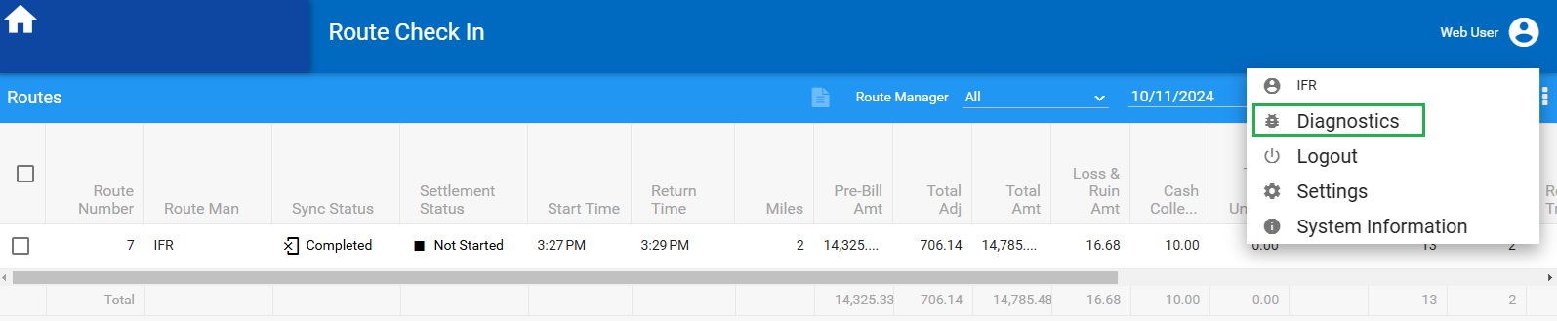

and opens a new tab with these options (this new tab is where you switch it off as well):
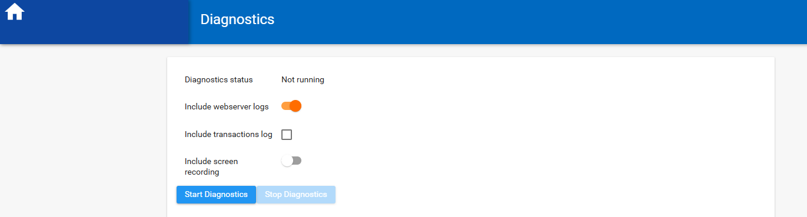
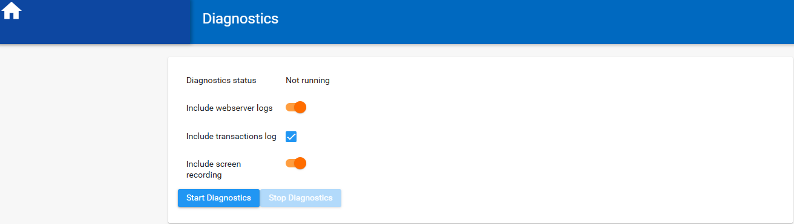

If you allow screen recording, then this popup appears, and you must select this tab:

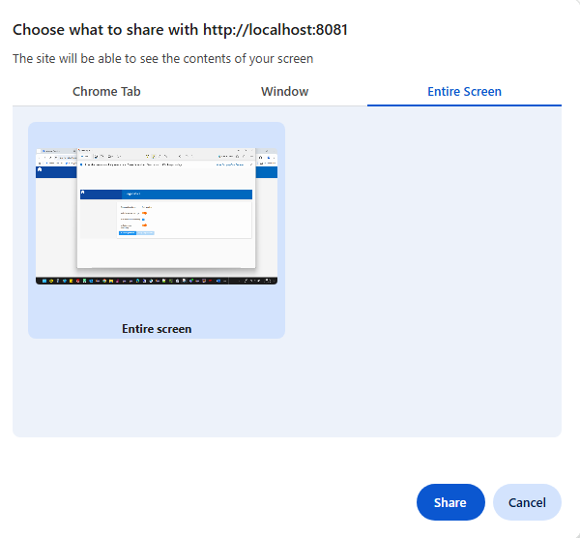

and if you are using Mozilla, it looks a little different where you must select “entire screen”:
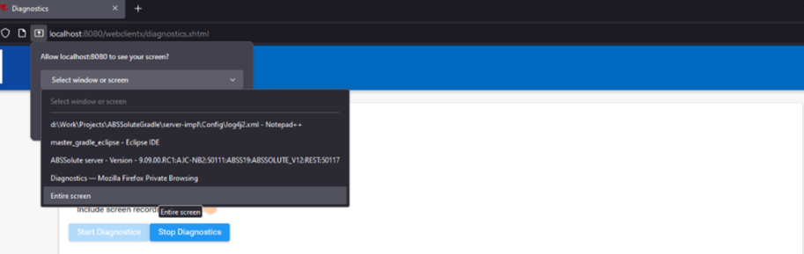

Which then tells the user that recording is started and will automatically stop after 5 minutes:
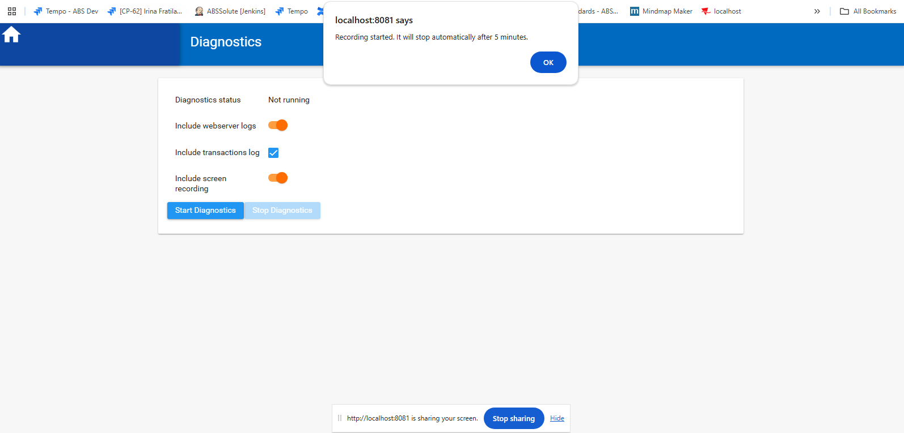

Go to the Route Details tab and do the current actions (which will be recorded):
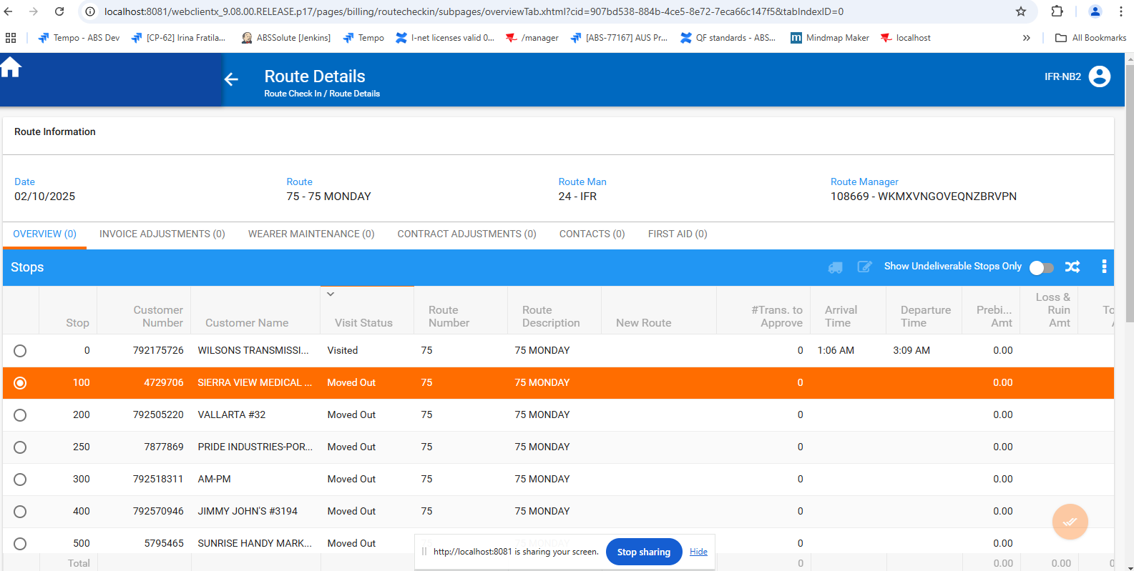

Press Stop sharing -> diagnostics zip file is saved automatically:

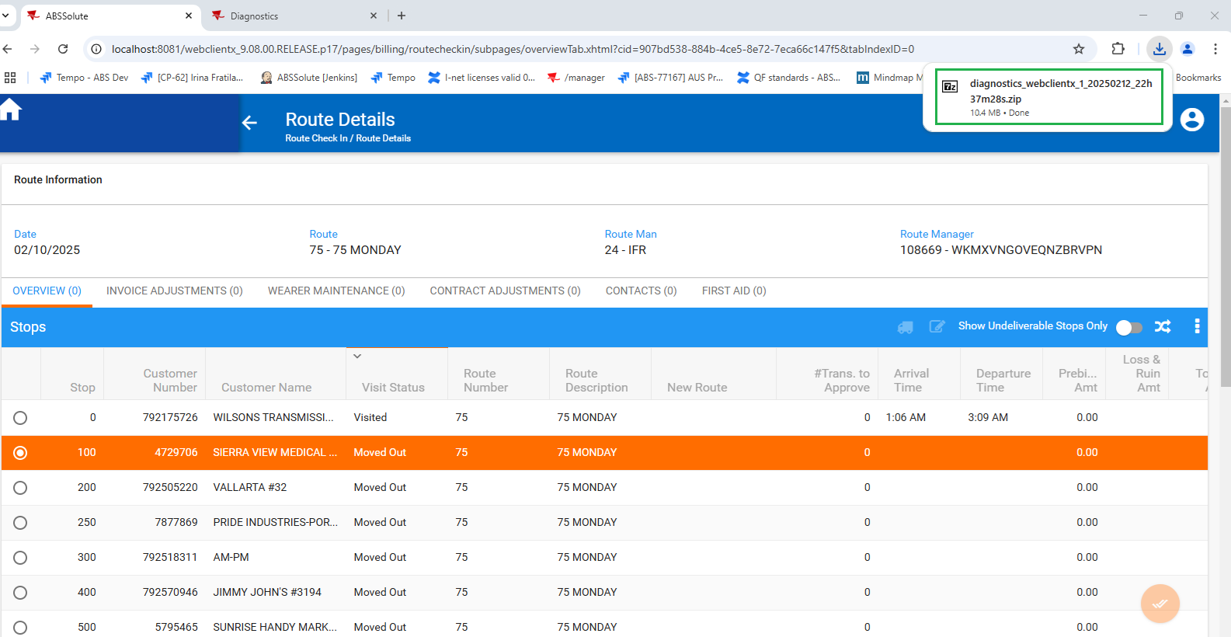

If the user does not manually stop recording, after 5 minutes is stopped automatically:

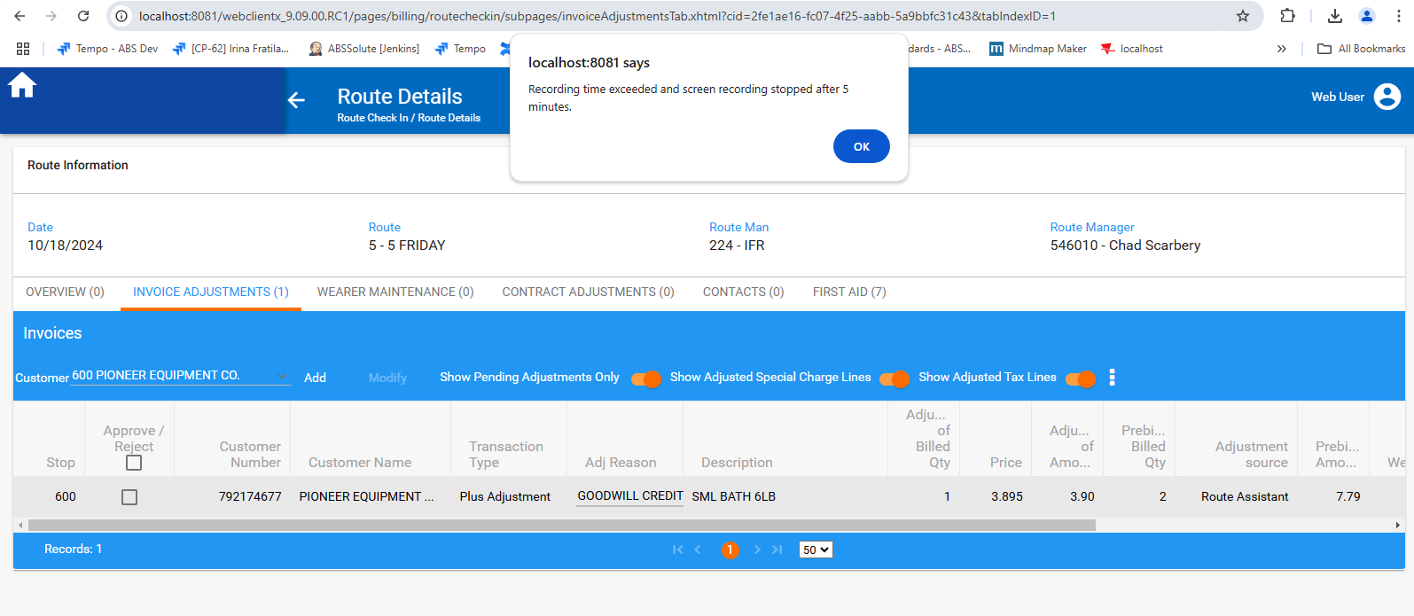

1. the user can start diagnostics by checking only one option, two or all three:
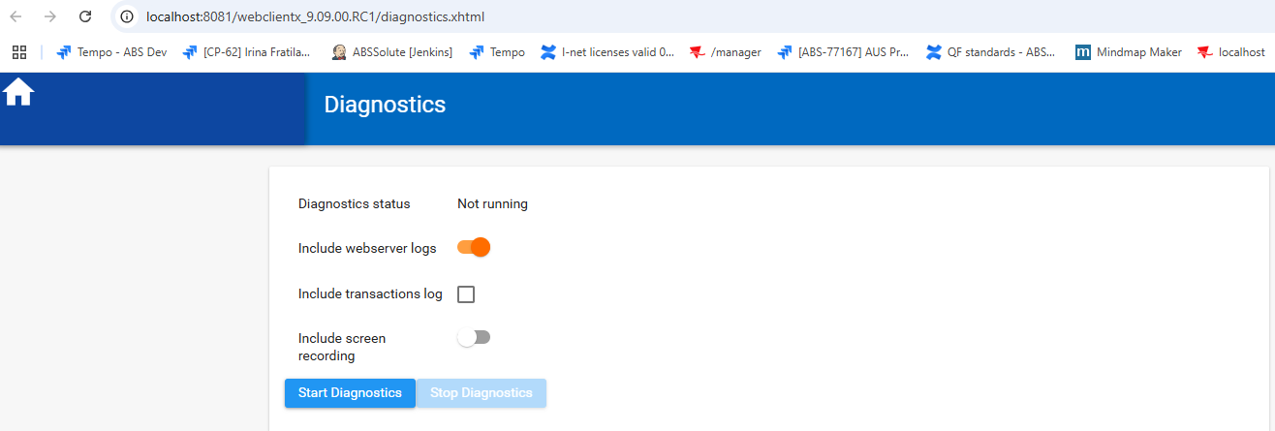

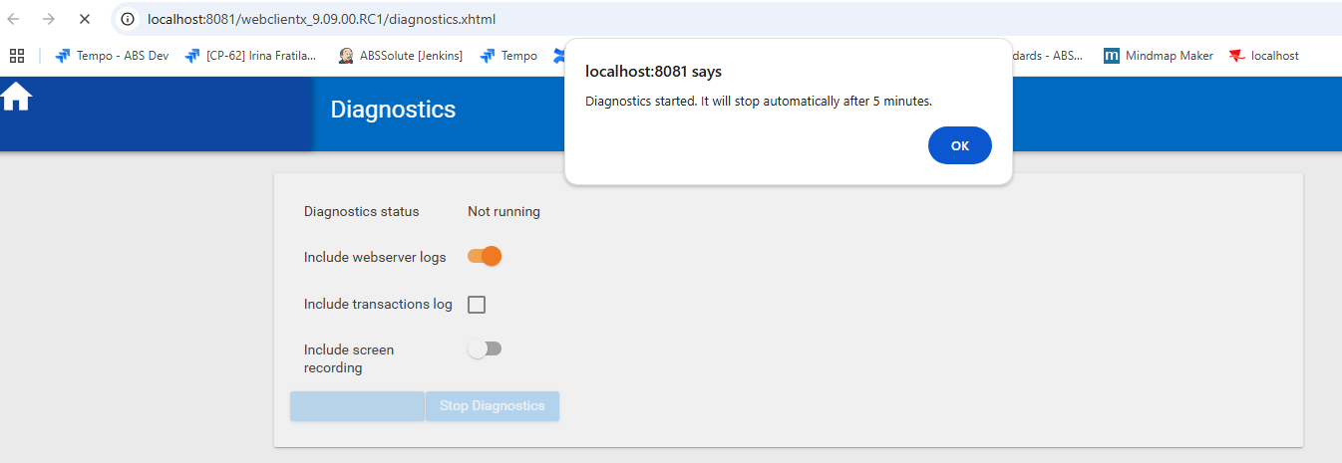

After 5 minutes the process is stopped automatically, the zip file is created/ saved and Stop Diagnostics button becomes enable:
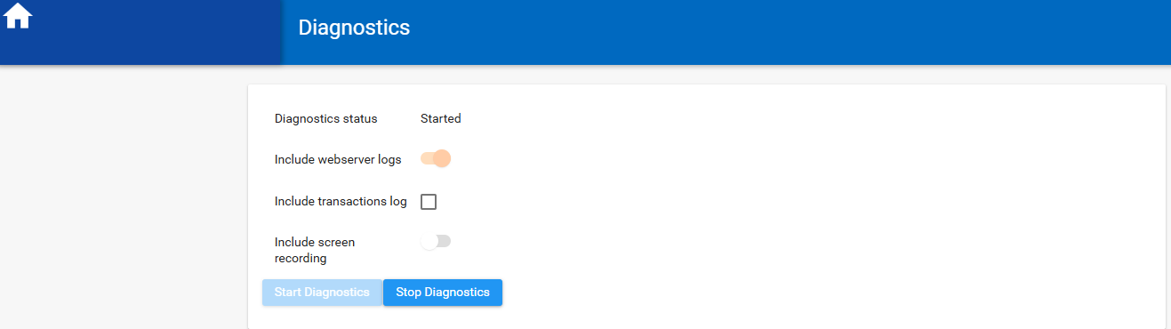

Also, the user can stop the process by pressing Stop Diagnostics button;
the zip file is created and saved automatically:
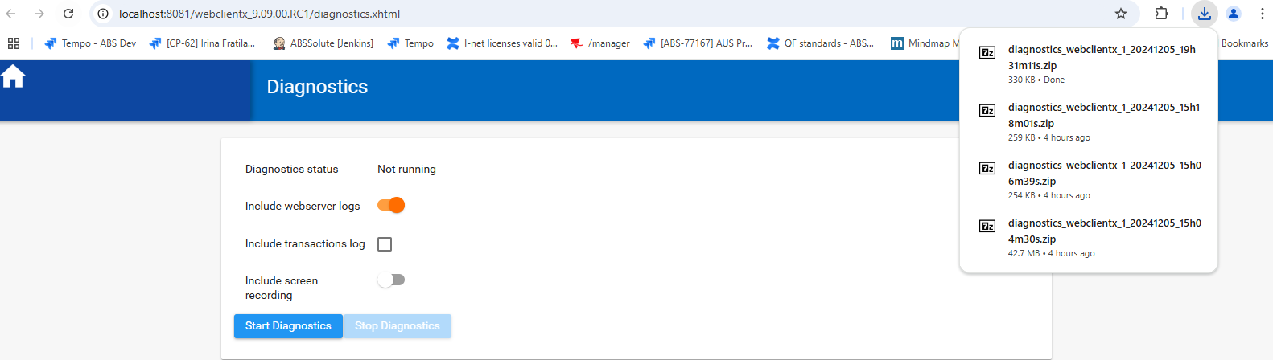

Include webserver logs option checked save a zip file with web logs and Server logs:
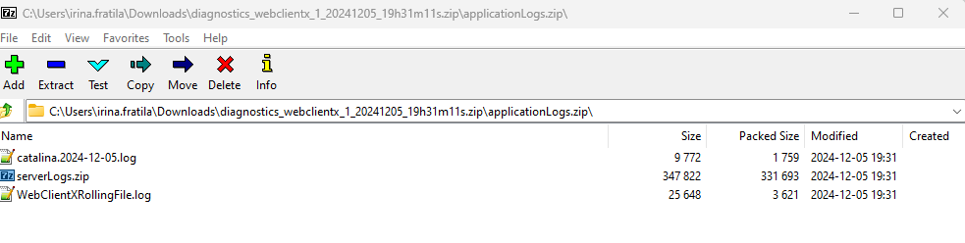
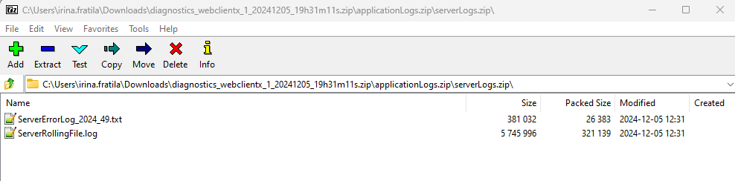

2. Start Diagnostics with Include transactions log option checked, also:
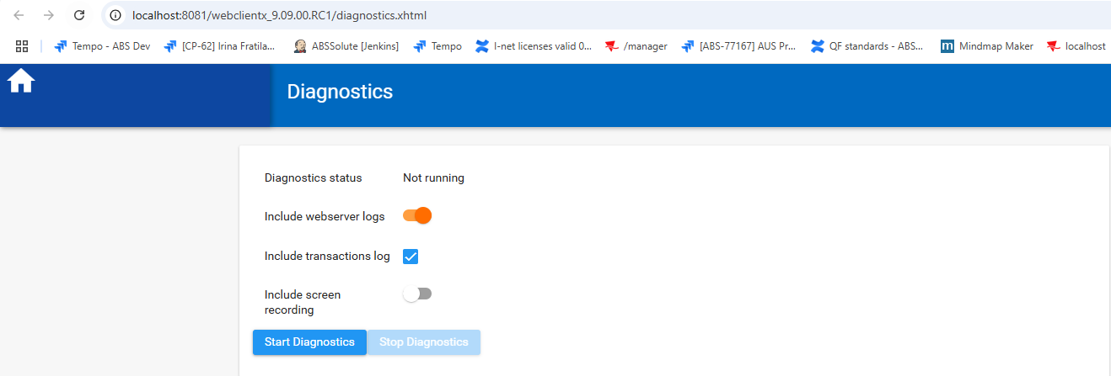

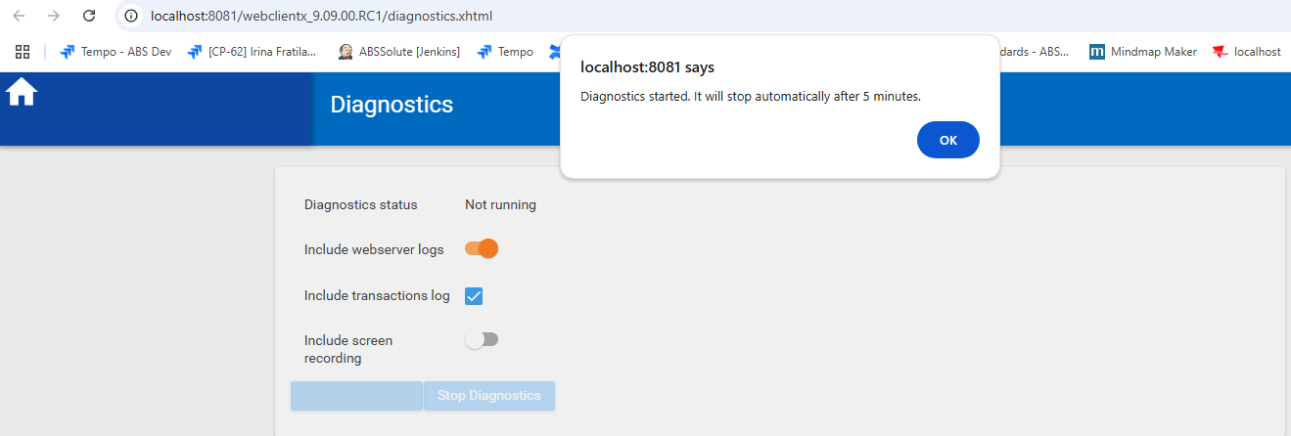

Include transactions log option checked save in addition, in zip file, ExecutedTransactionsLog file:
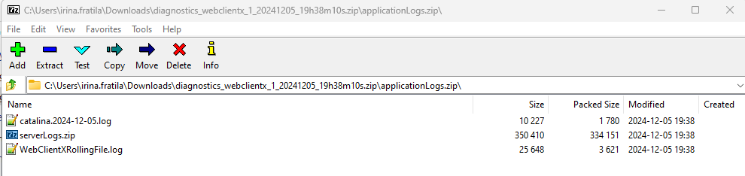
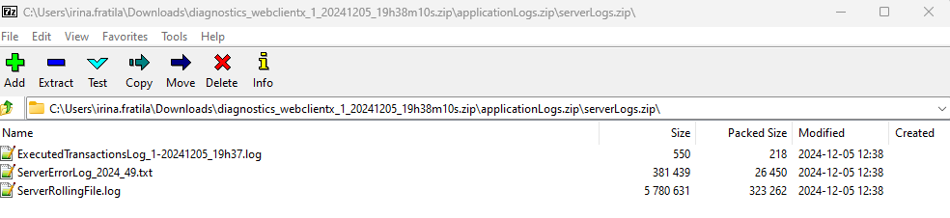

3. Start Diagnostics with all 3 options checked, Include screen recording option checked, also:
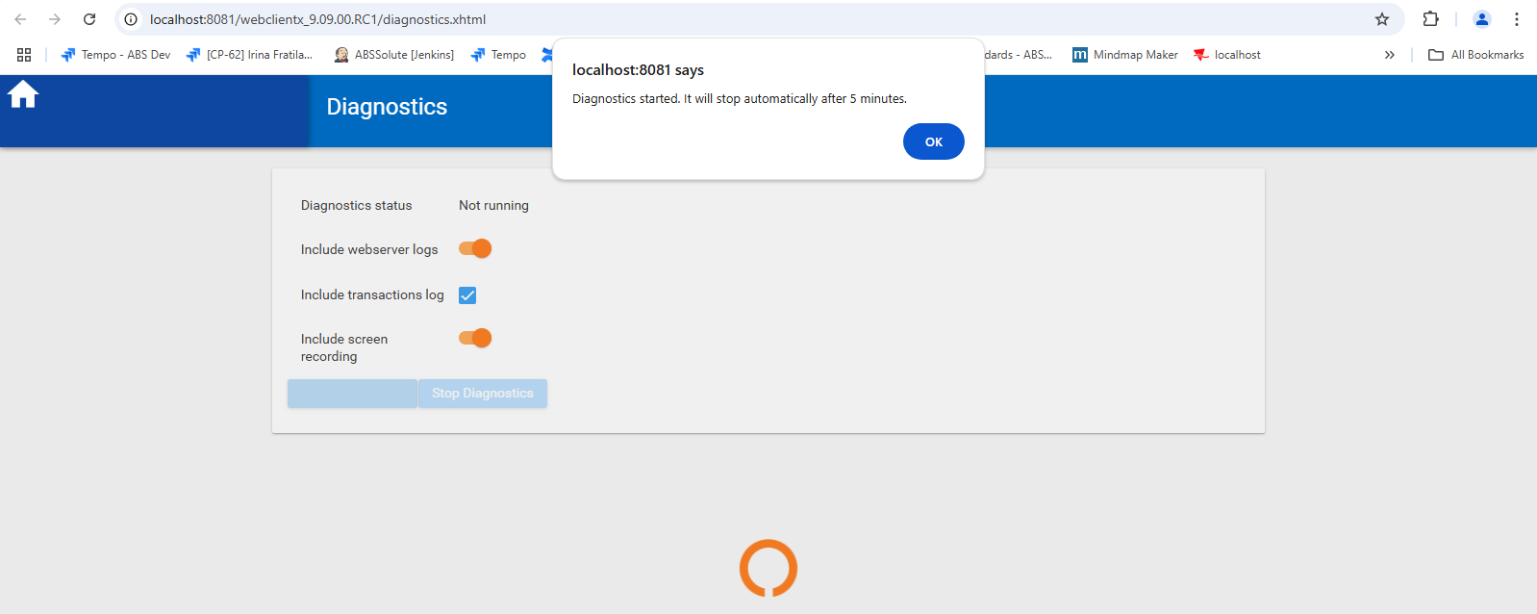

- Share your screen:
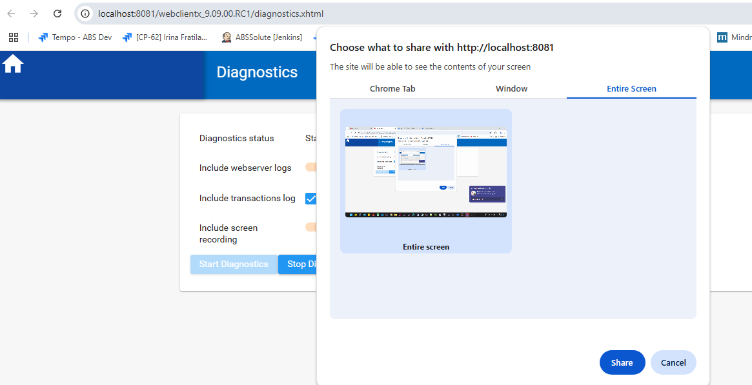

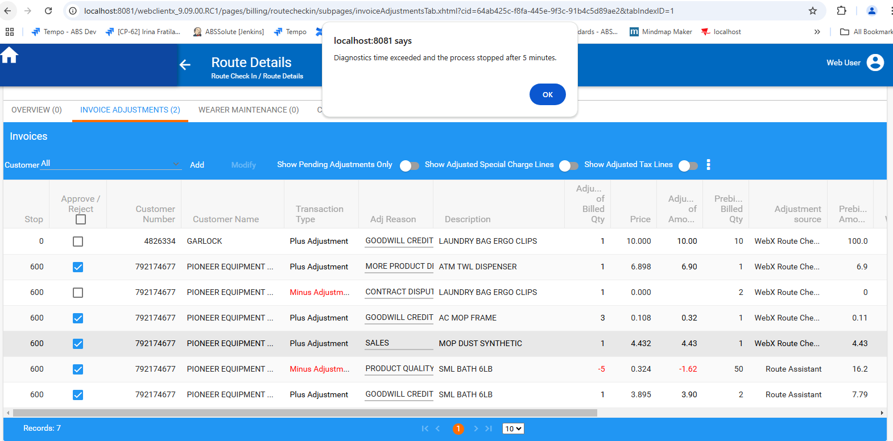

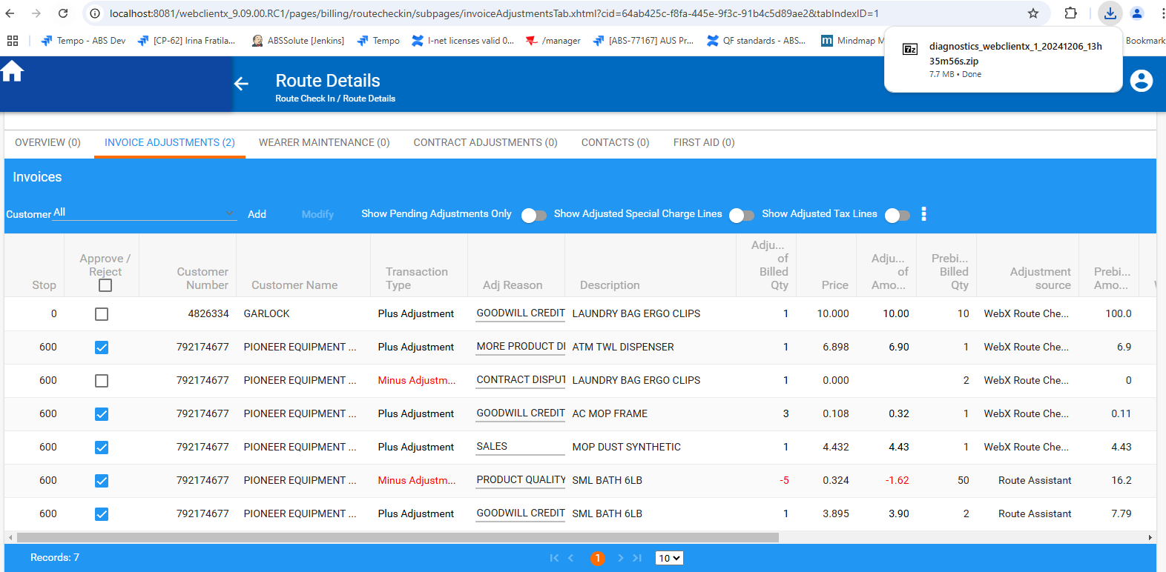

The zip file now also includes the video recording:
