ASDN-3780 Pack price issue with Size Billing Group Rent prices
Environment | Prerequisites
Version: 9.09.02.RC1, 9.08.00.RELEASE.p21  Environment=PRODUCTION  DBServerName=db01-buc.internal.abslbs.com  DBSID= CUST21, CUST25, CUST23  DBUser= AUS_COMP, AUS_ND90502, AUS_MNT90800  DBPassword= AUS_COMP, AUS_ND90502, AUS_MNT90800 | - Module: CHARGESPECIALSIZE  - System setting: SIZESPECIALCHARGEOPTIONS=7  - Others: BUs 255, 473, 503

Contents
Reproduction before fix 1
Retesting after fix 2

Reproduction before fix
BU:473
CUST22@AUS_COMP: 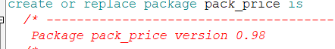
Initial price with SBG=null:
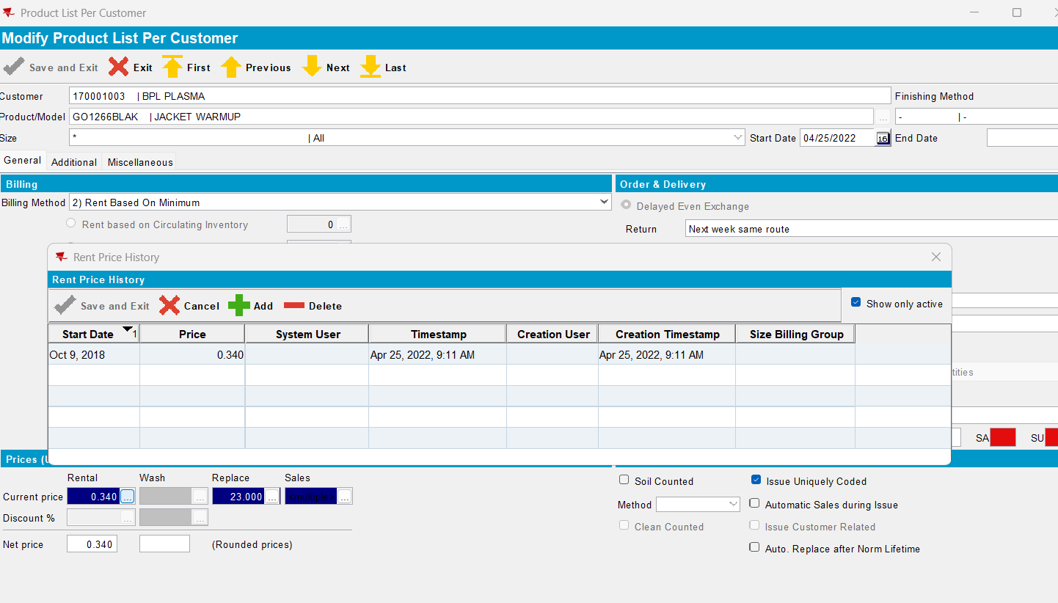
- Set customer for SBG
- Add new prices with SBG, one active and one inactive:
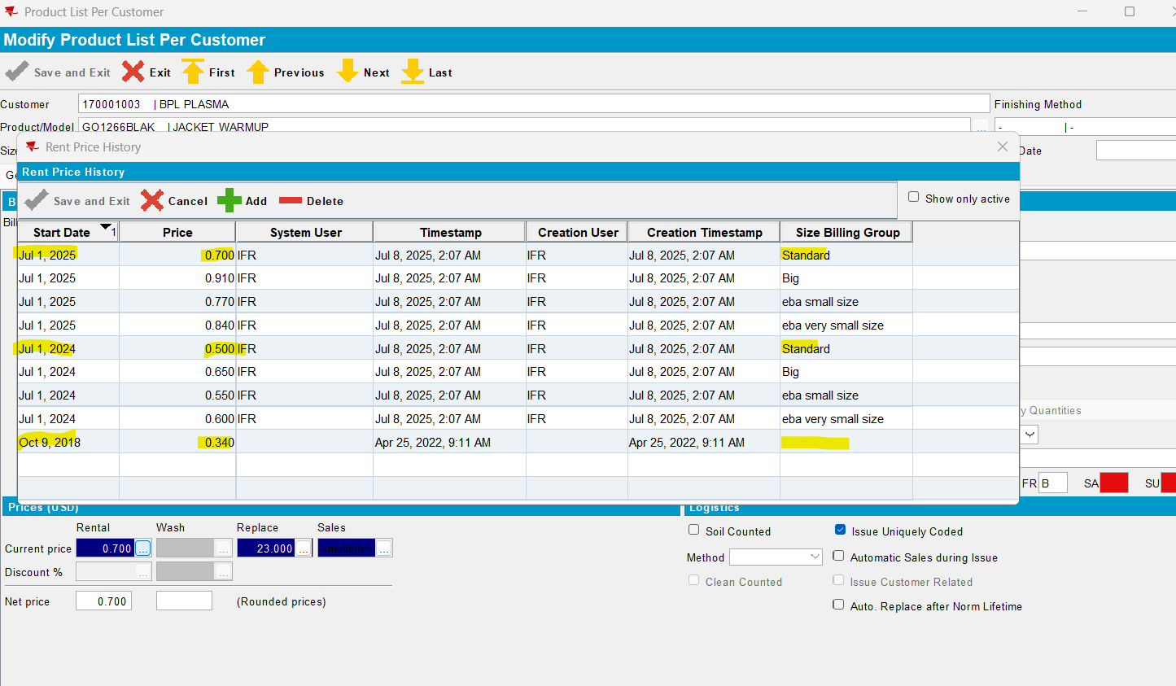
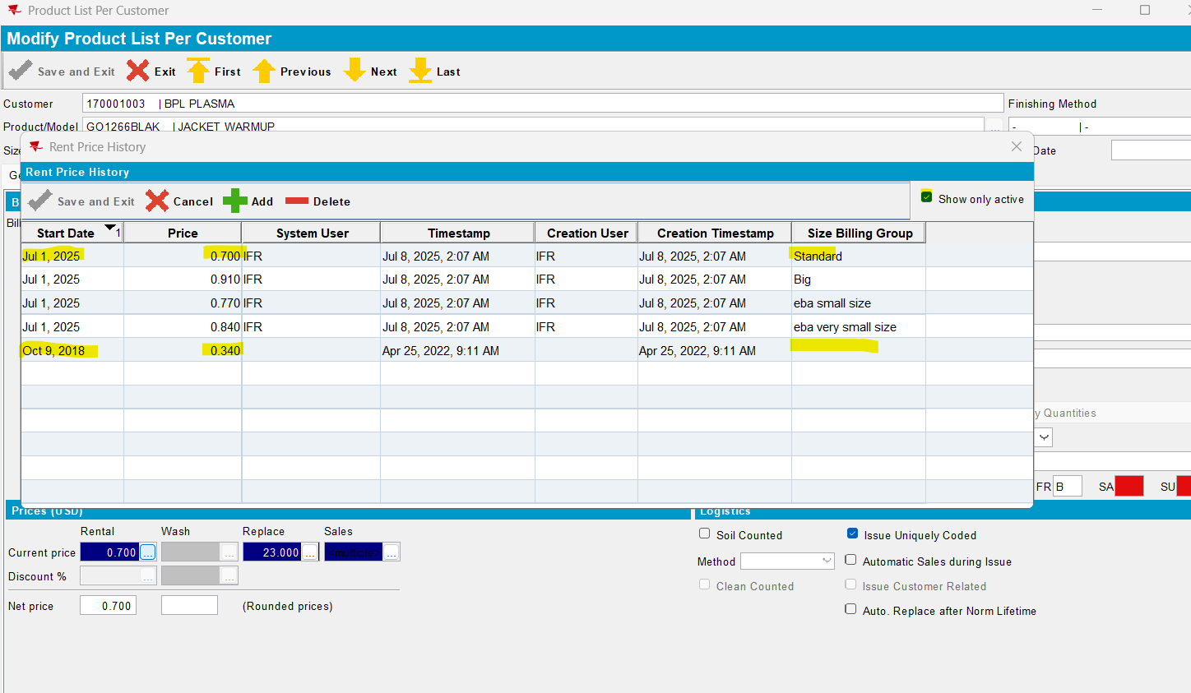
- Run pack_price -> the active price with SBG=standard is returned
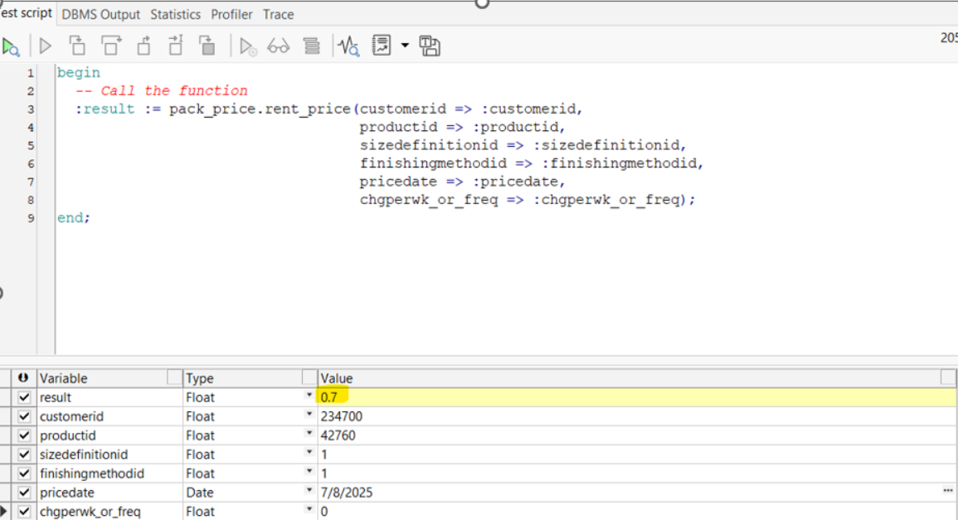

- Change the start date for active prices:
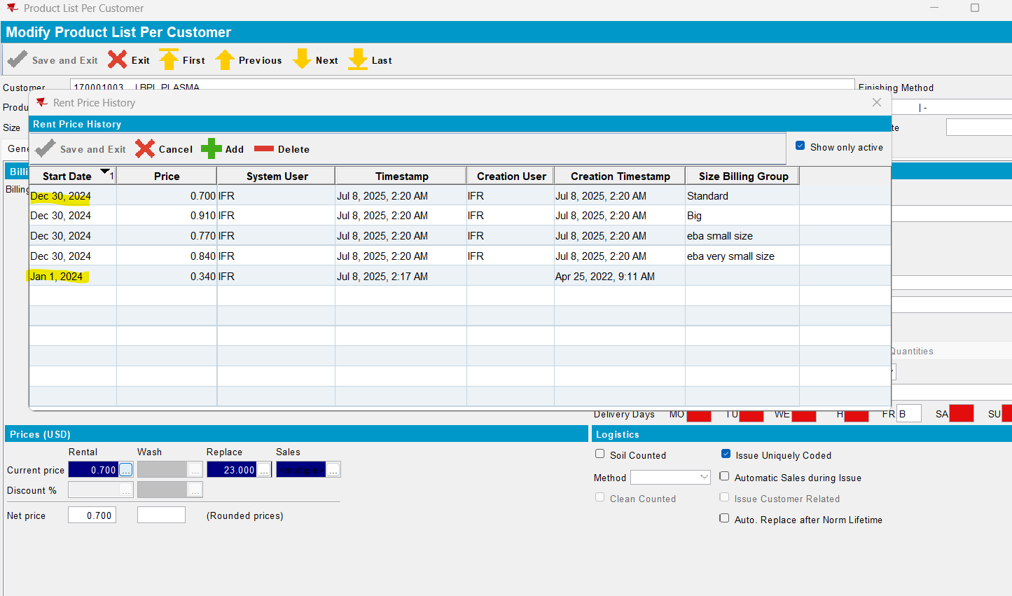
- Run pack_price -> the active price with SBG=standard is returned
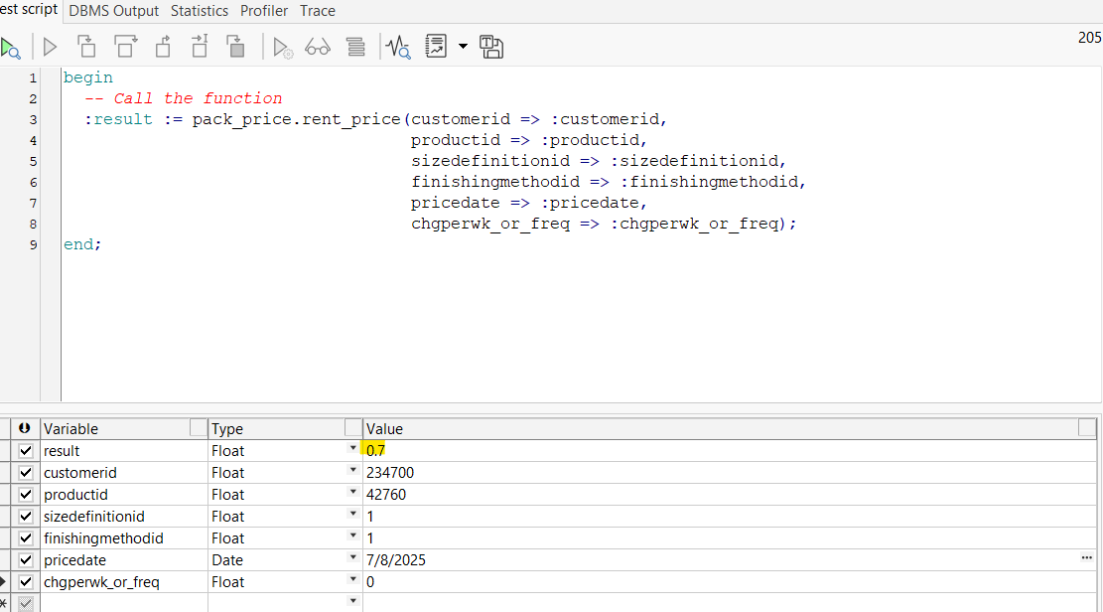
- Change the start date for active prices:
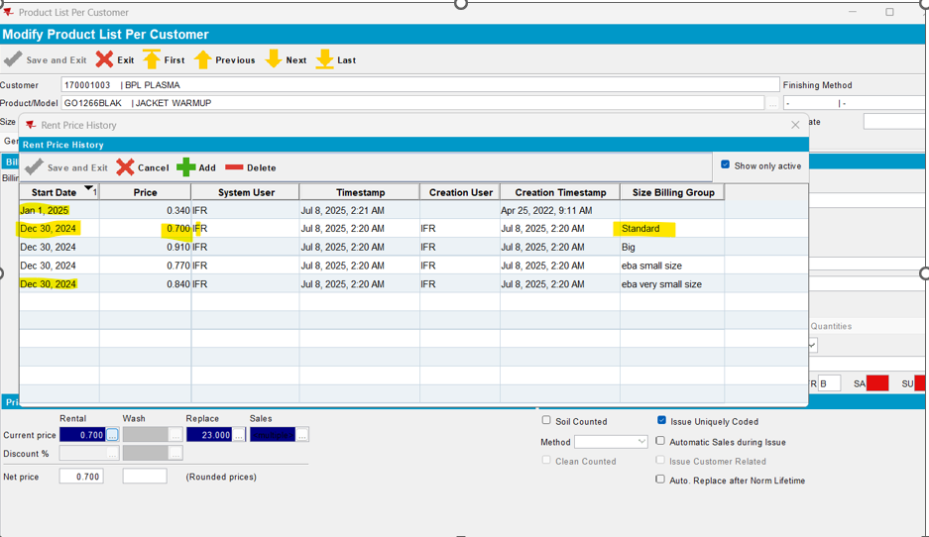
- Run pack_price -> the active price with SBG=standard is returned

CUST25@AUS_ND90502:
Initial:
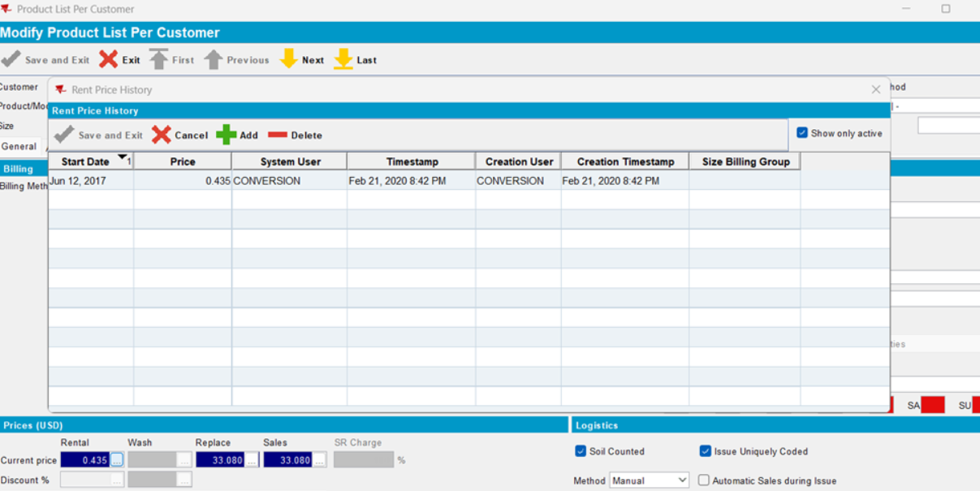
- Set customer for SBG

- Change start date:
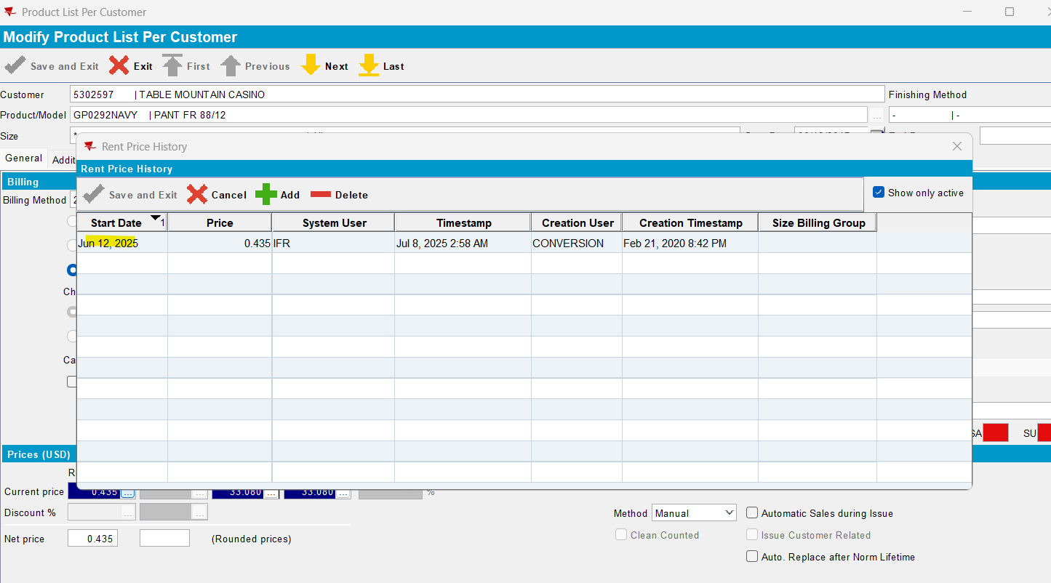
- Add new prices with SBG active and inactive:
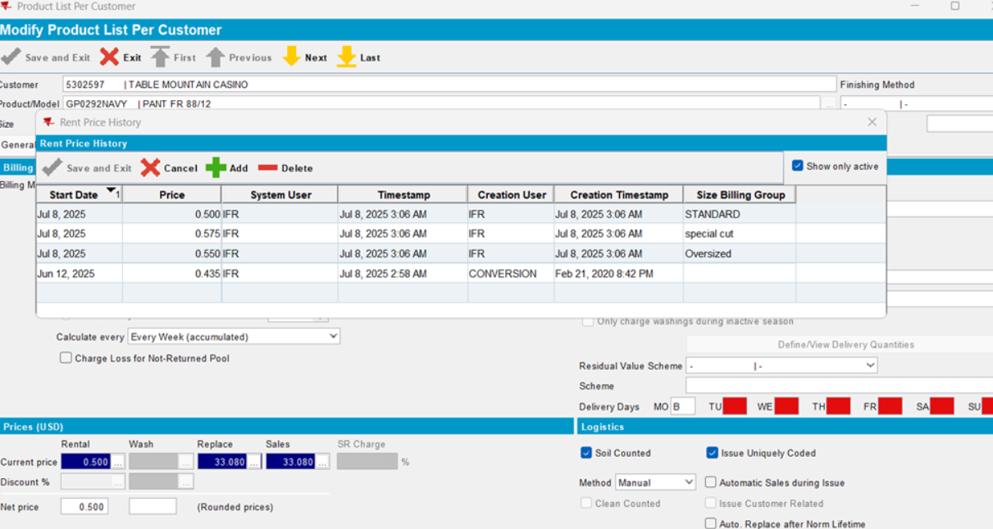
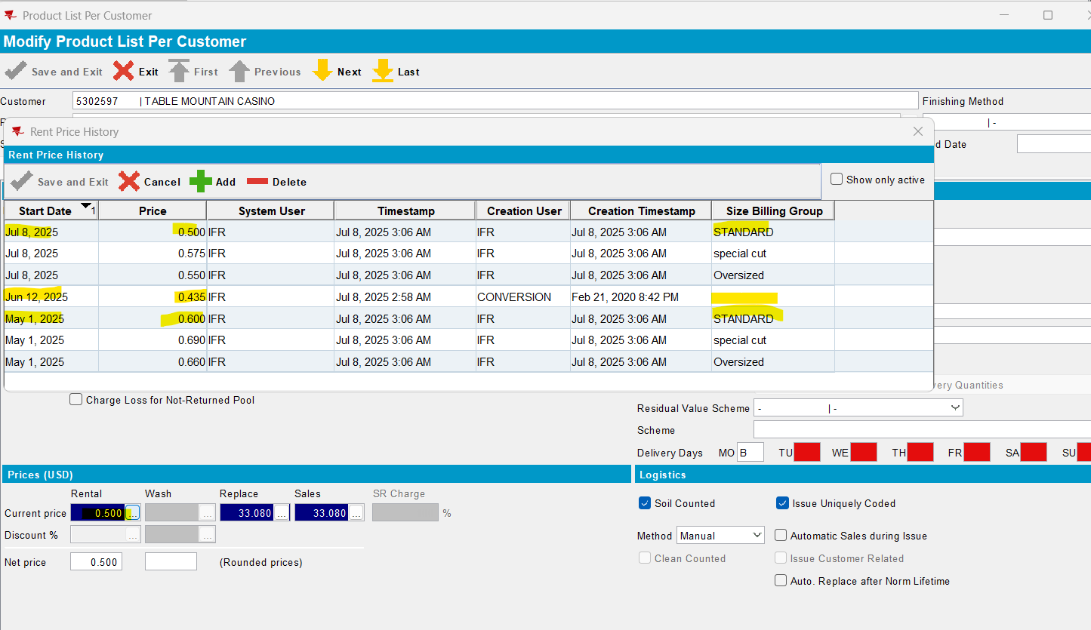
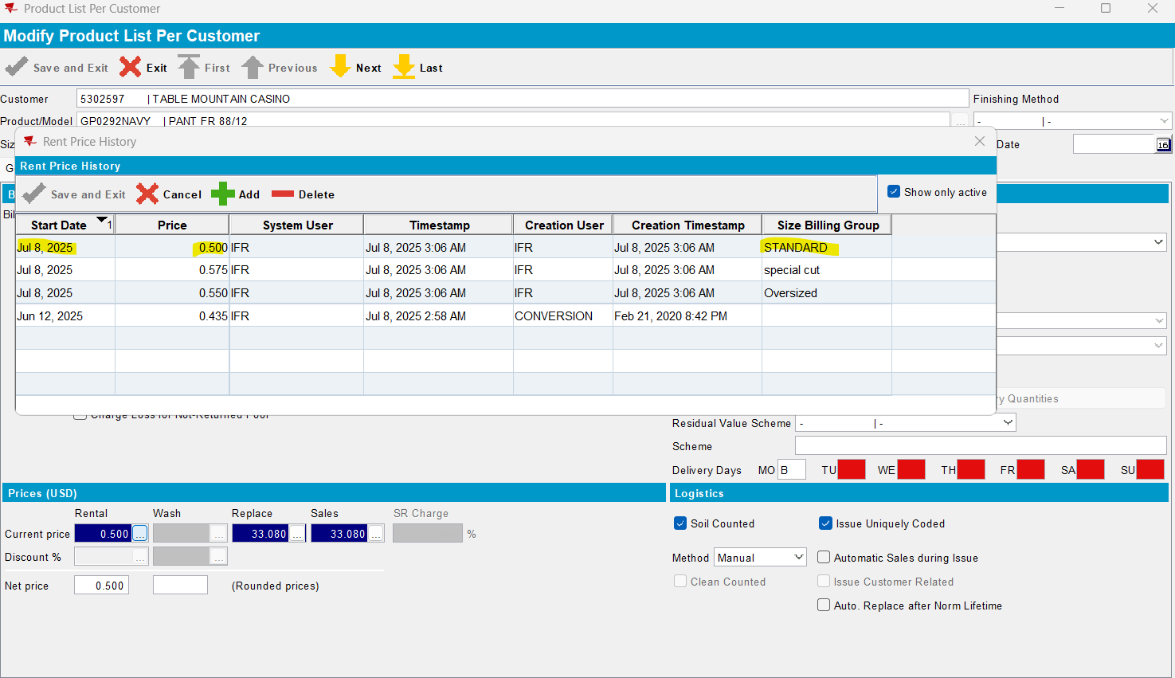

- Change start date:
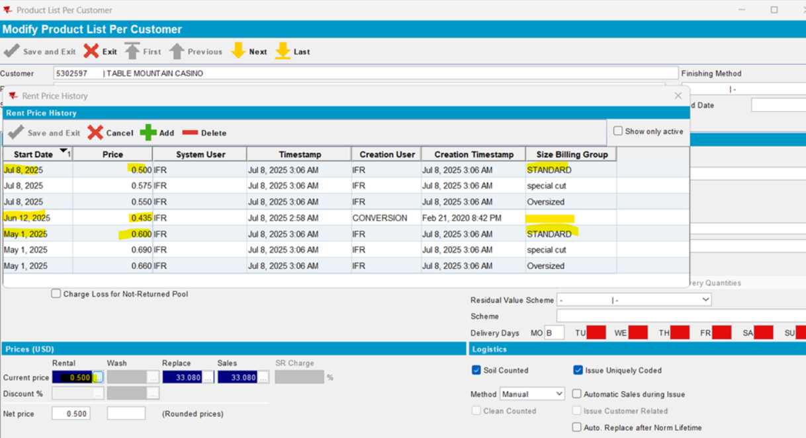
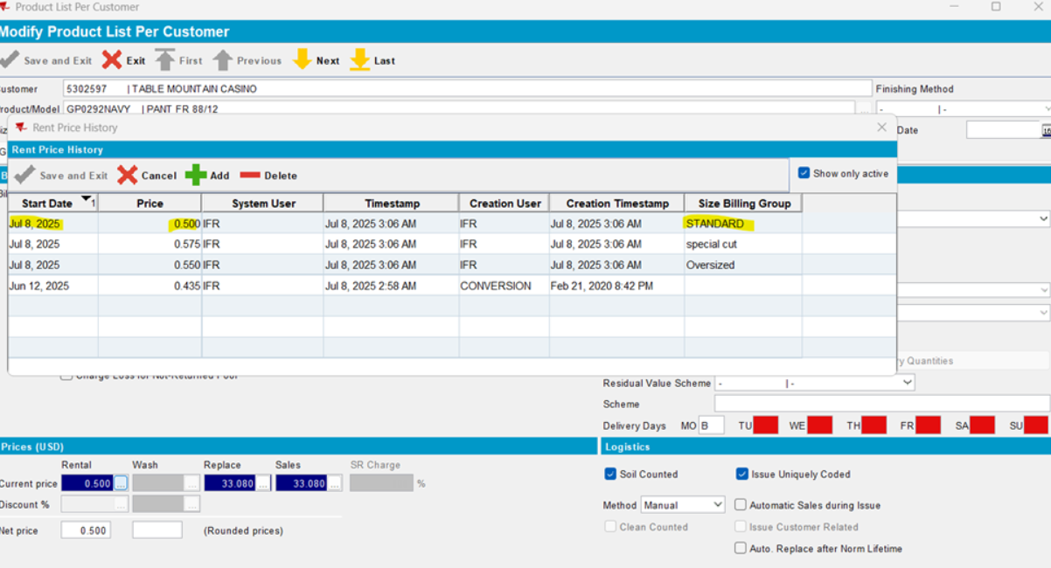
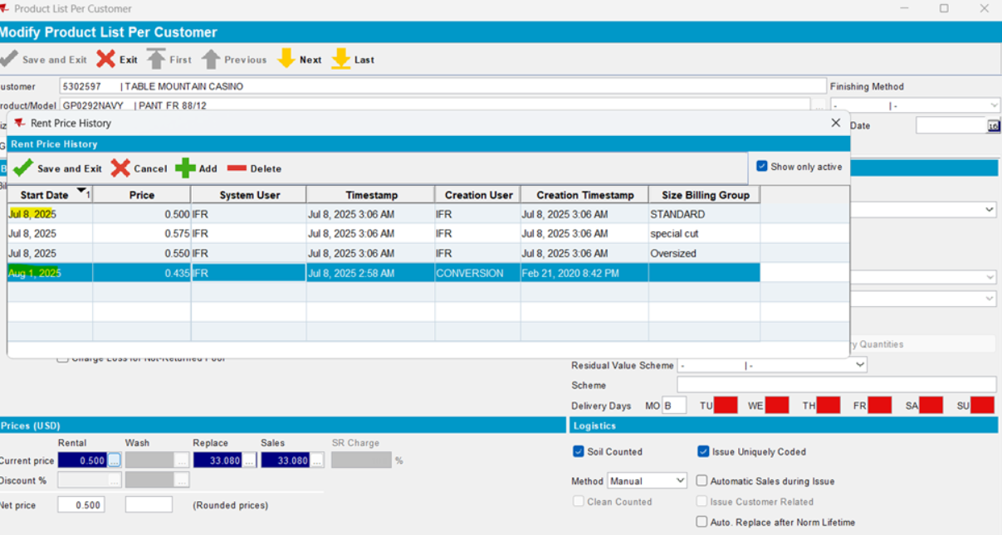
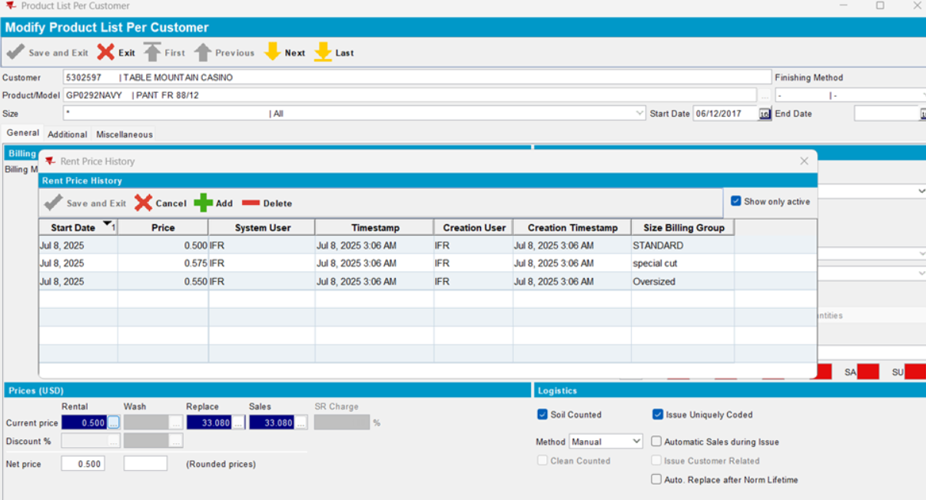
- Run pack_price
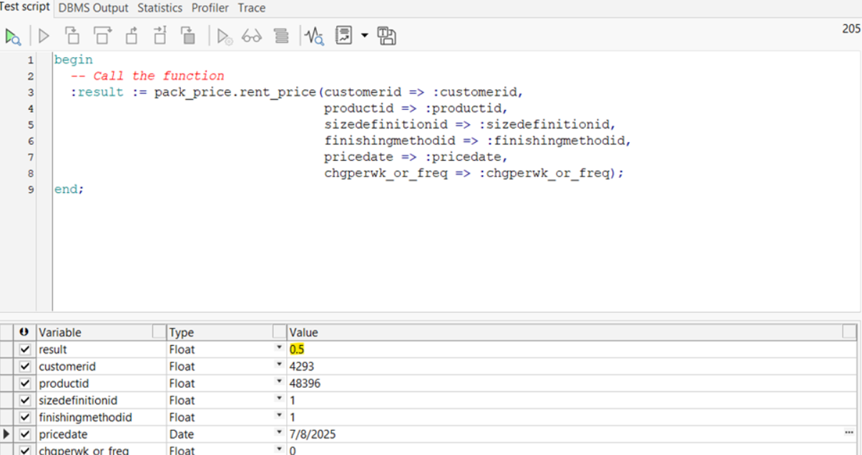
- Run pack_price -> the active price with SBG=standard is returned
- Repeat the test:
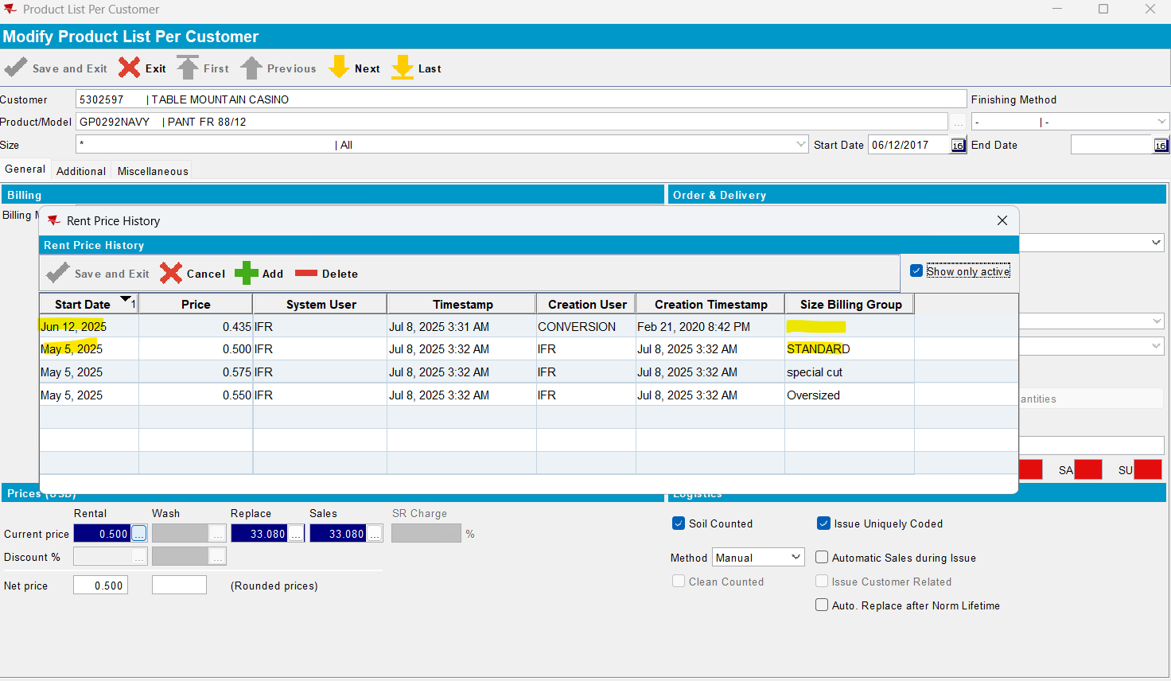

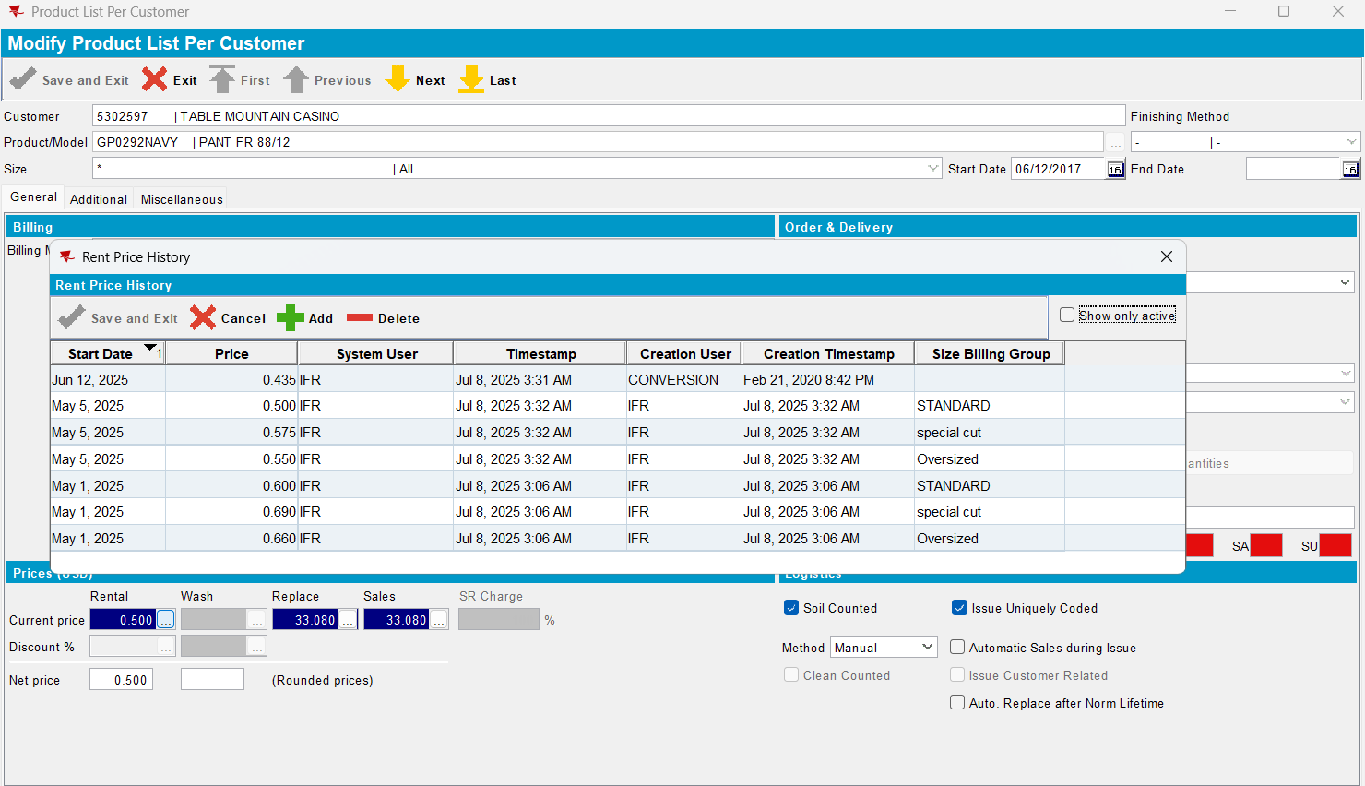
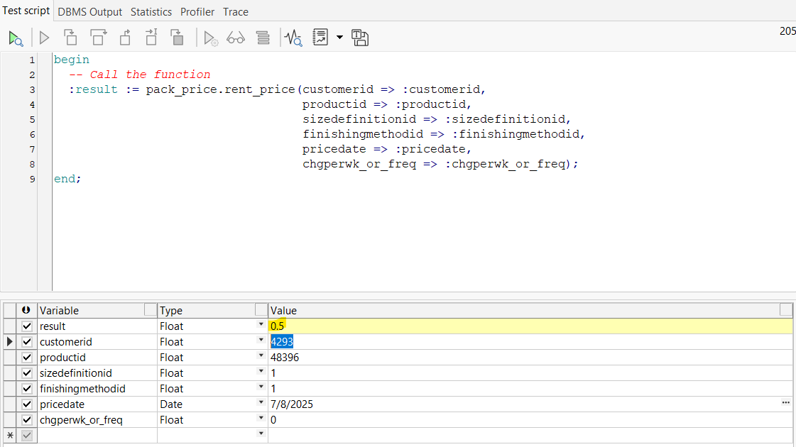

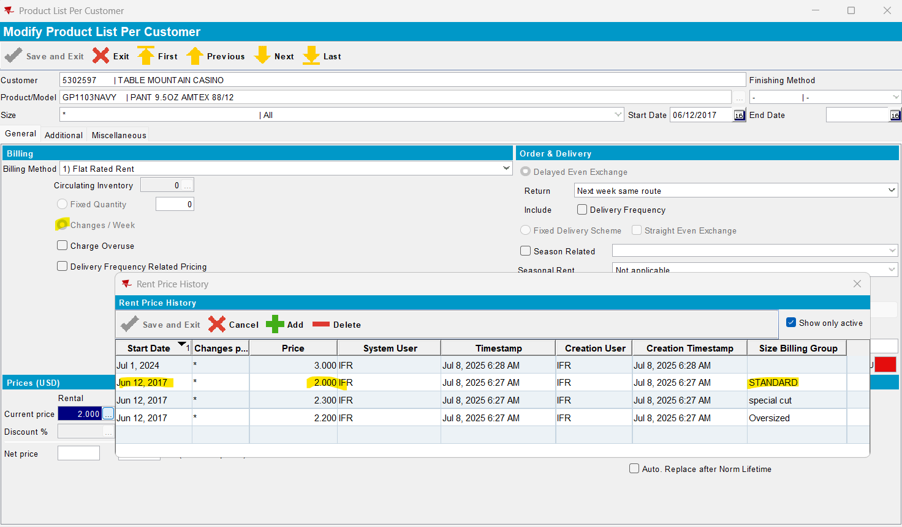
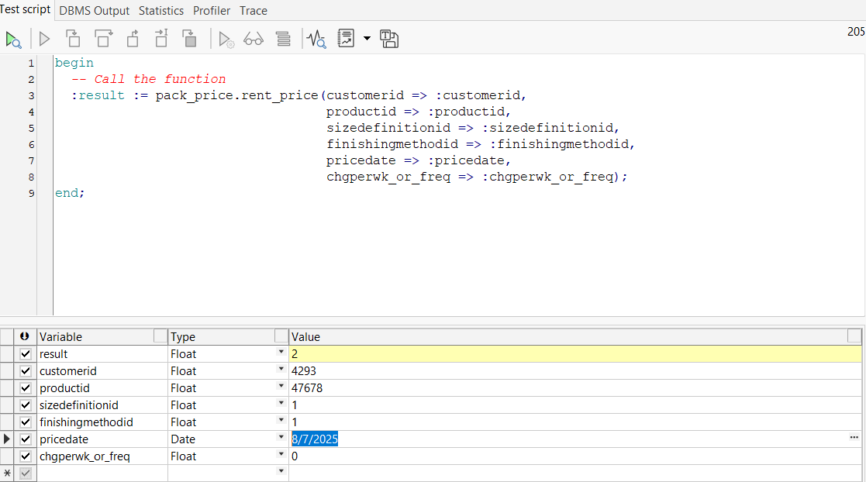
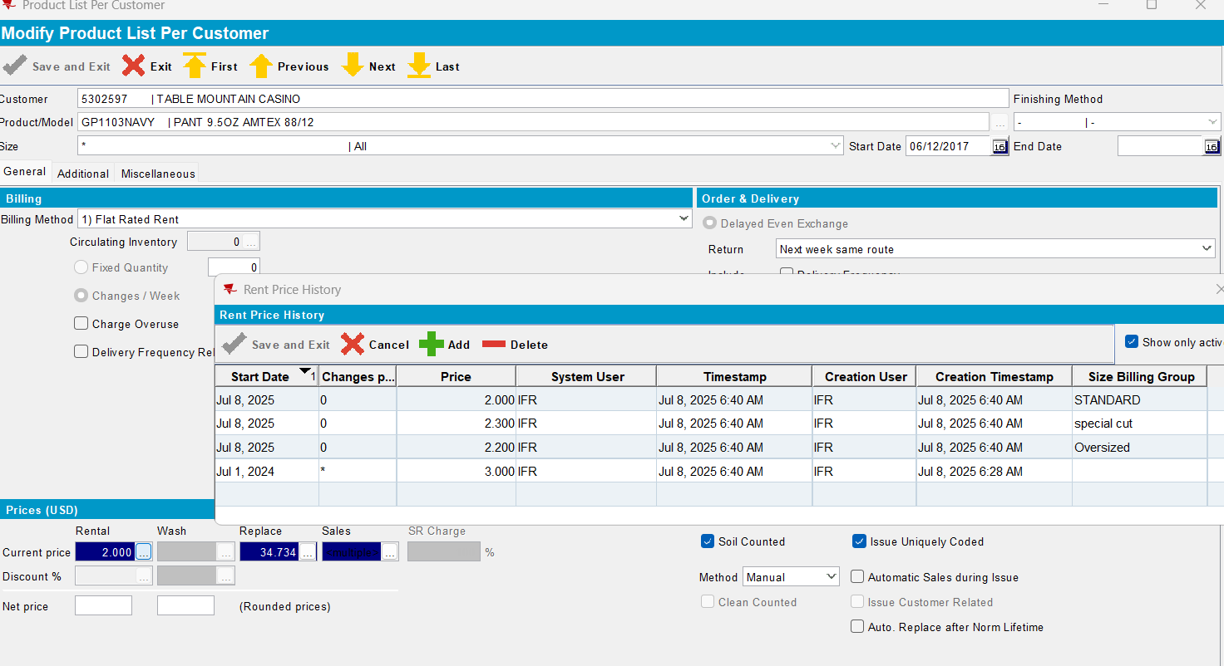
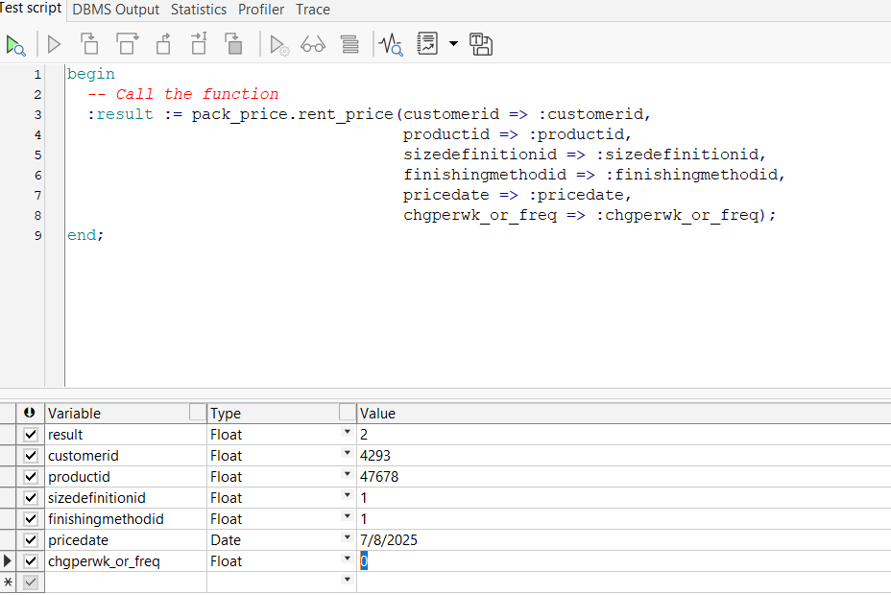
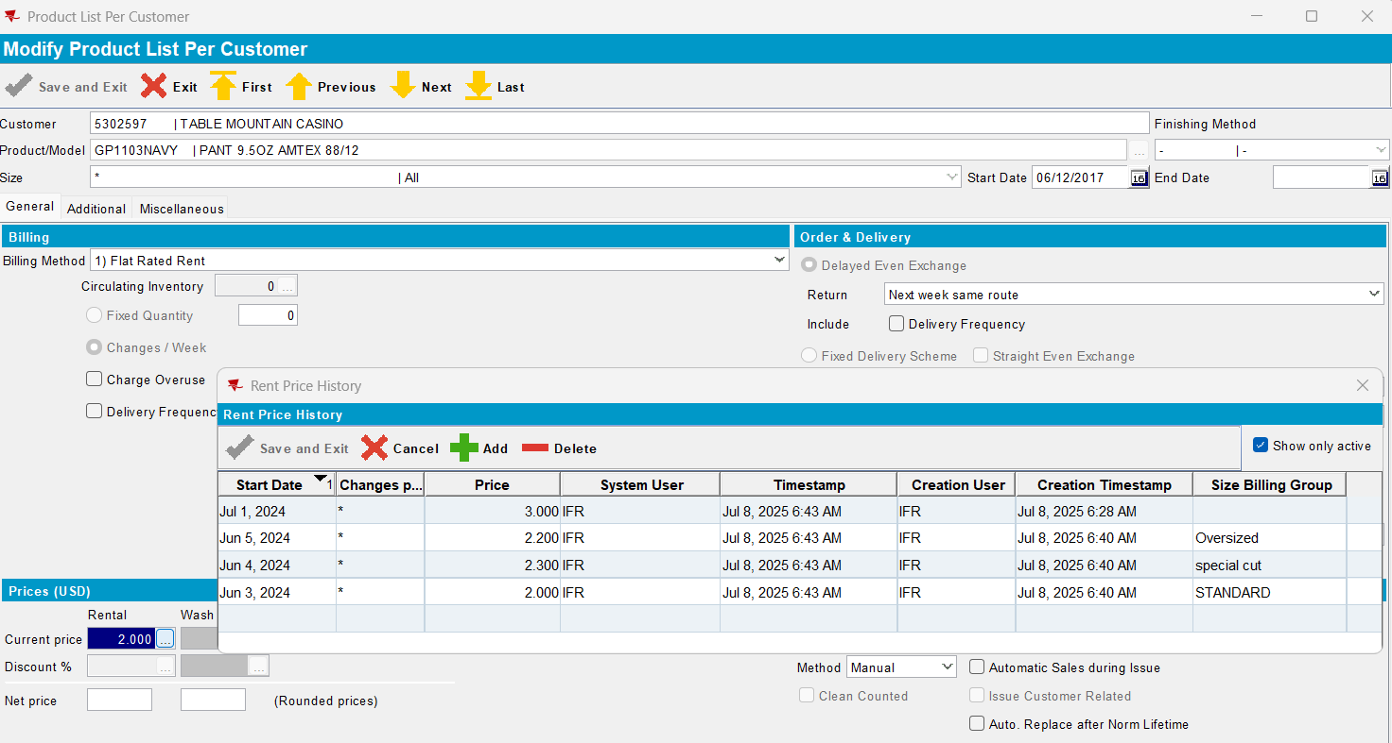
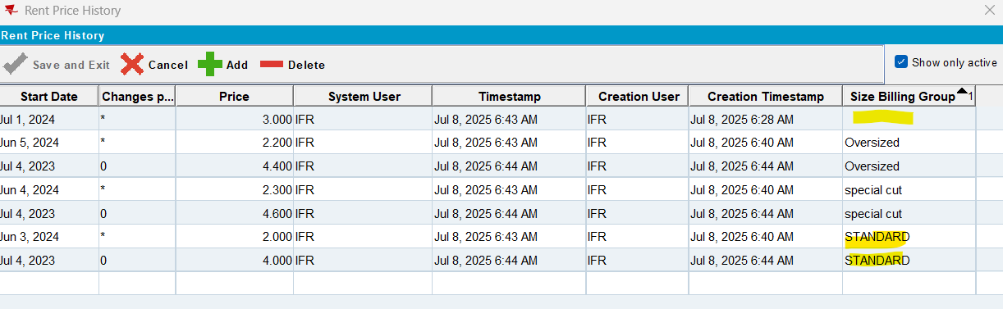
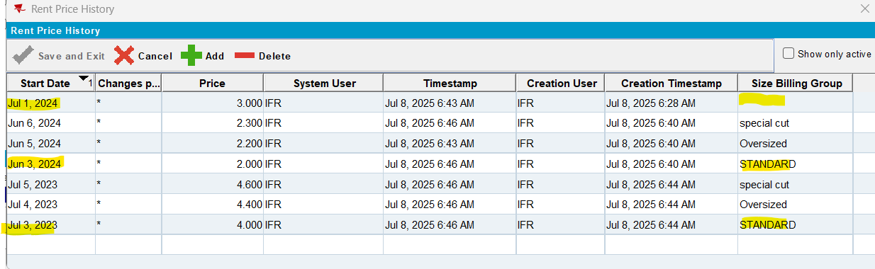
Not reproducible.
AUS_MNT90800@CUST23
Customer: 290822100
Product: GS0007NRDS
Size: *
FM: HANG 1
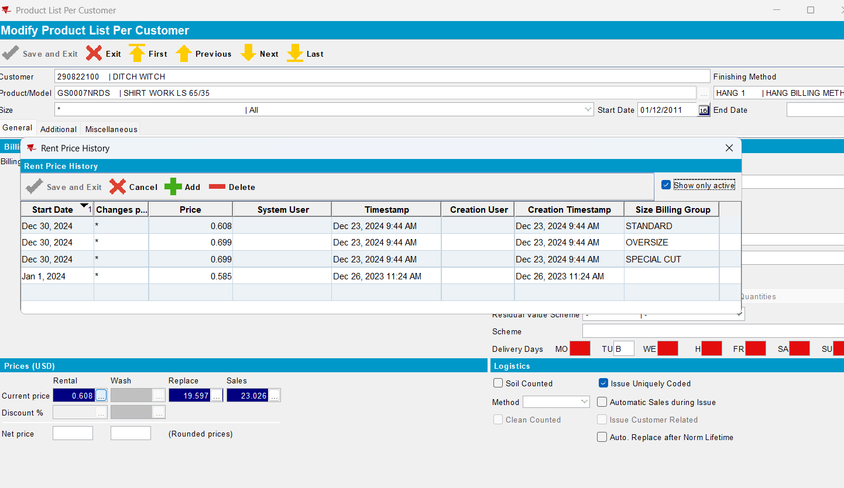
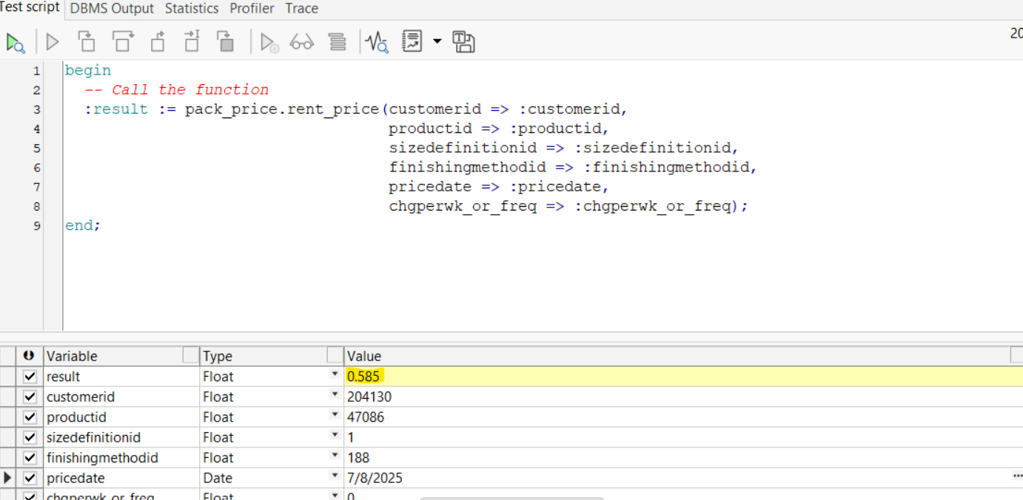
Reproduced.

Retesting after fix
AUS_MNT90800@CUST23
Customer: 290822100
Product: GS0007NRDS
Size: *
FM: HANG 1
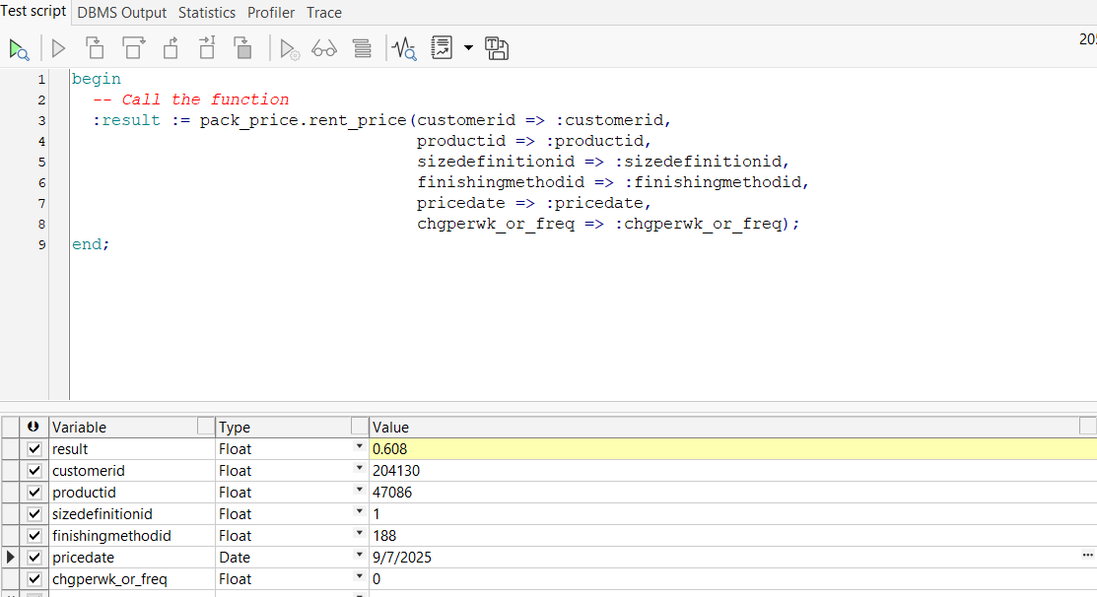
Passed.
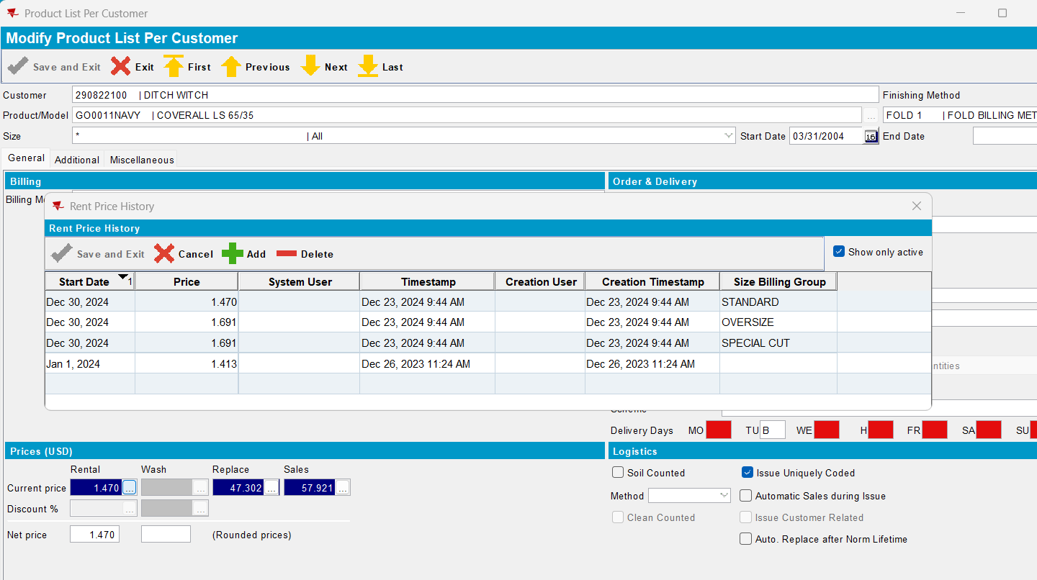
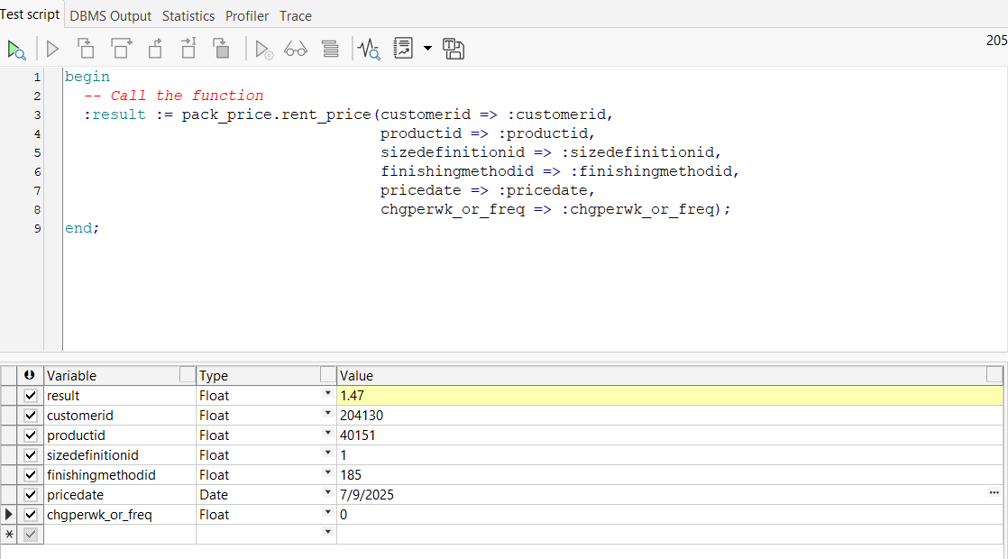
Passed.
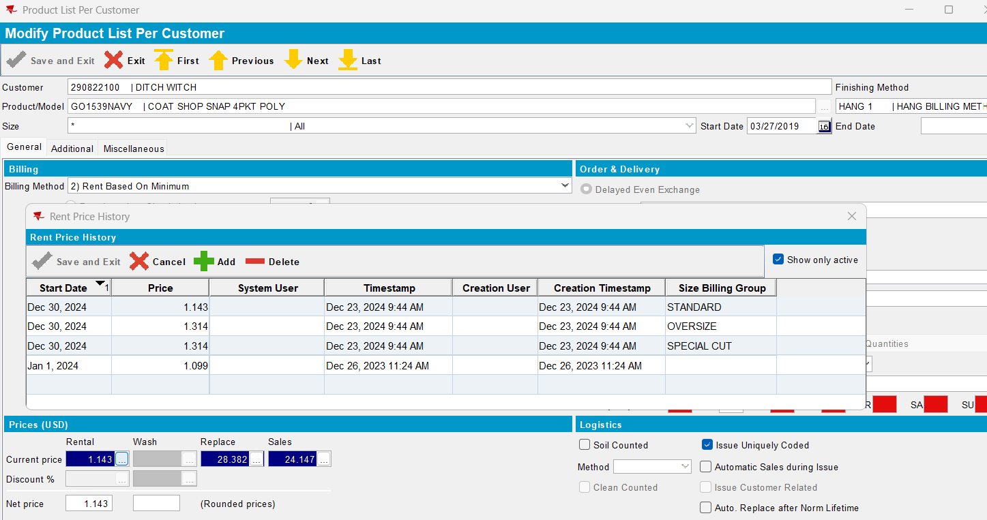
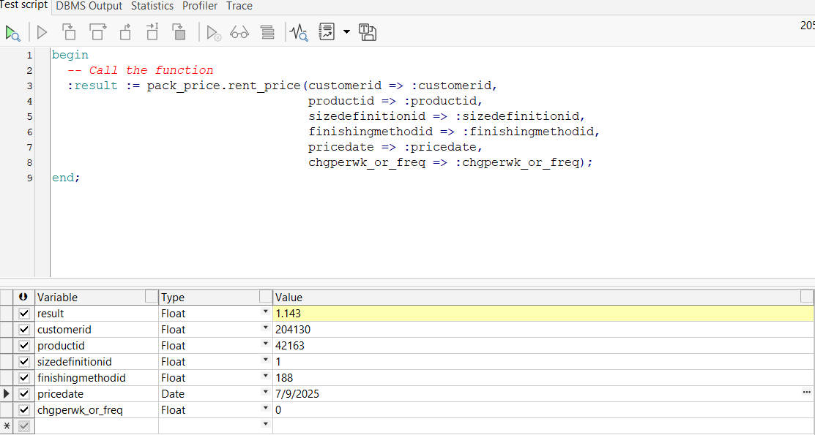
Passed.
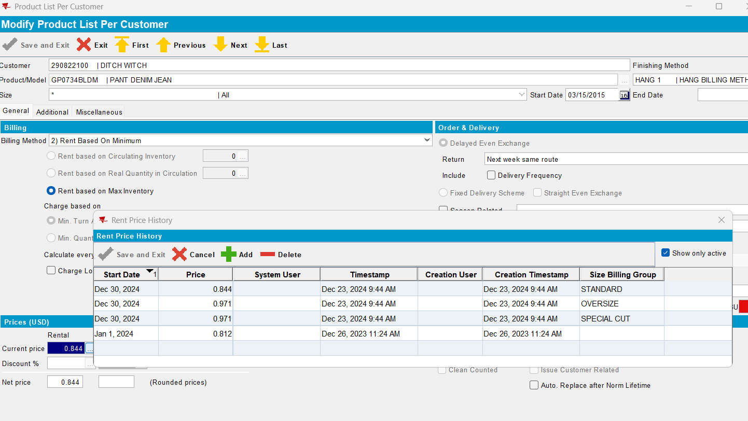
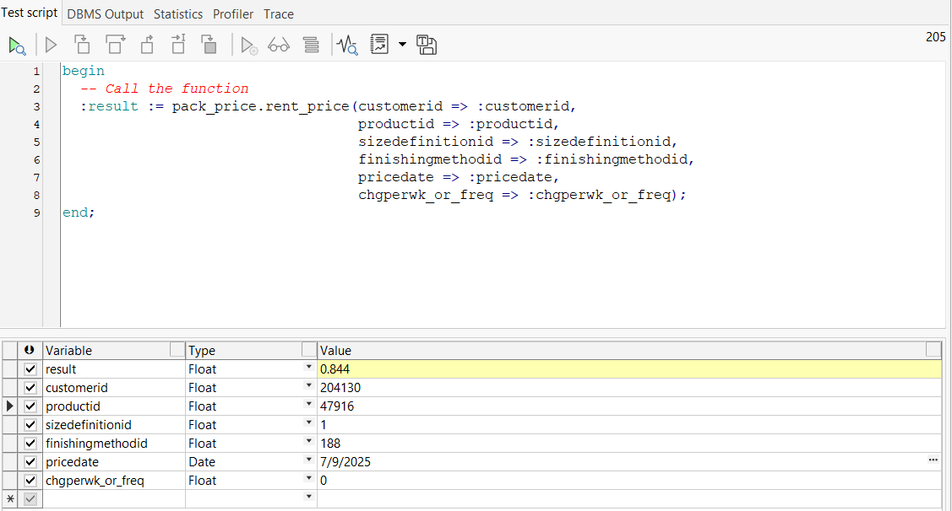
Passed.
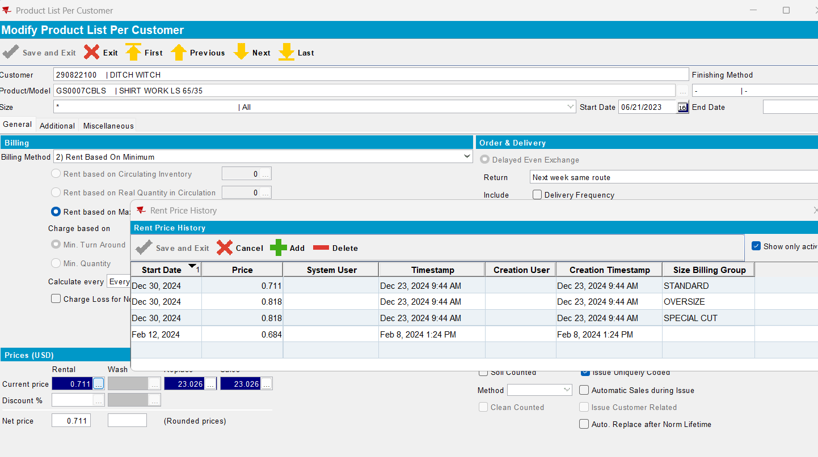
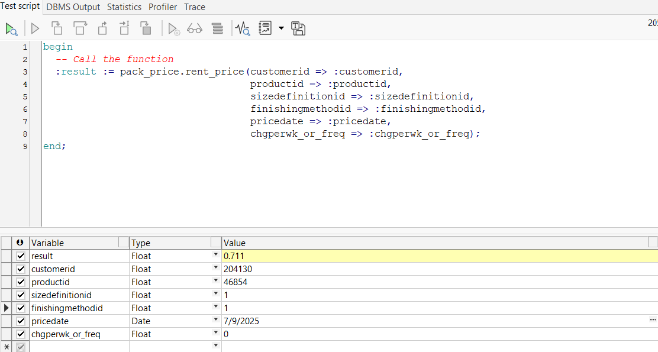
Passed.
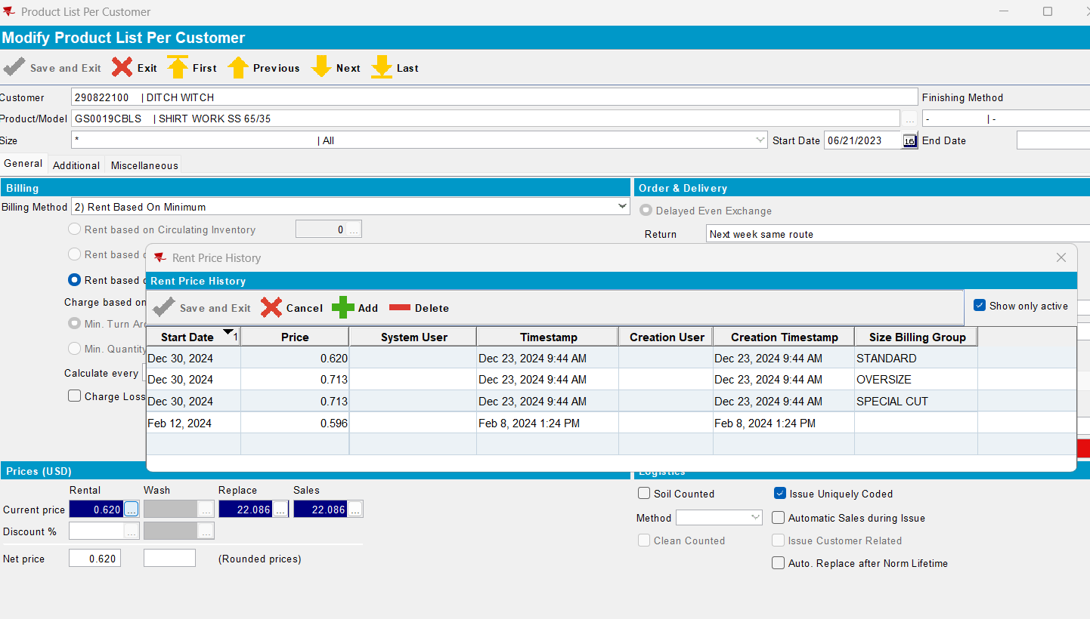
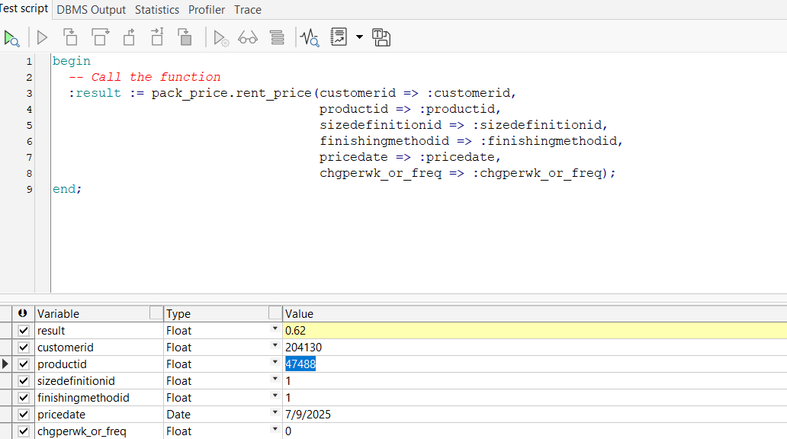
Passed.
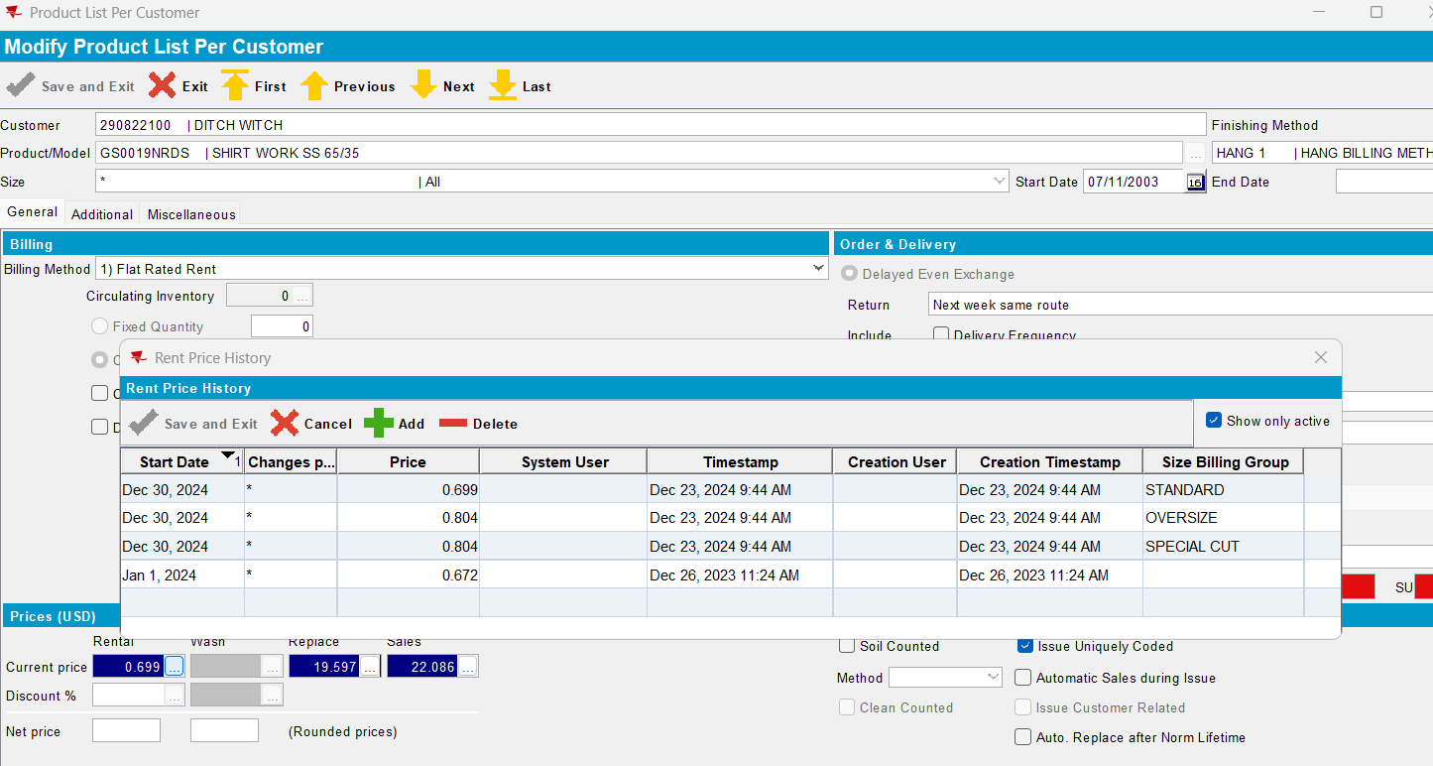
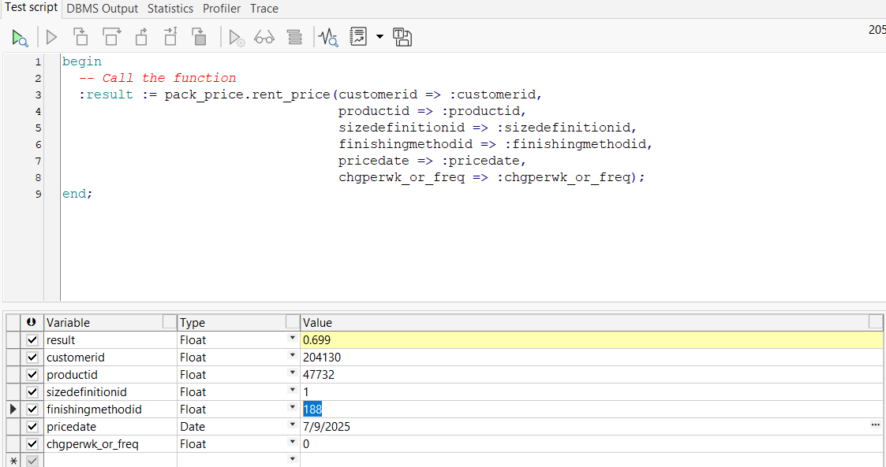
Passed.

Initial:
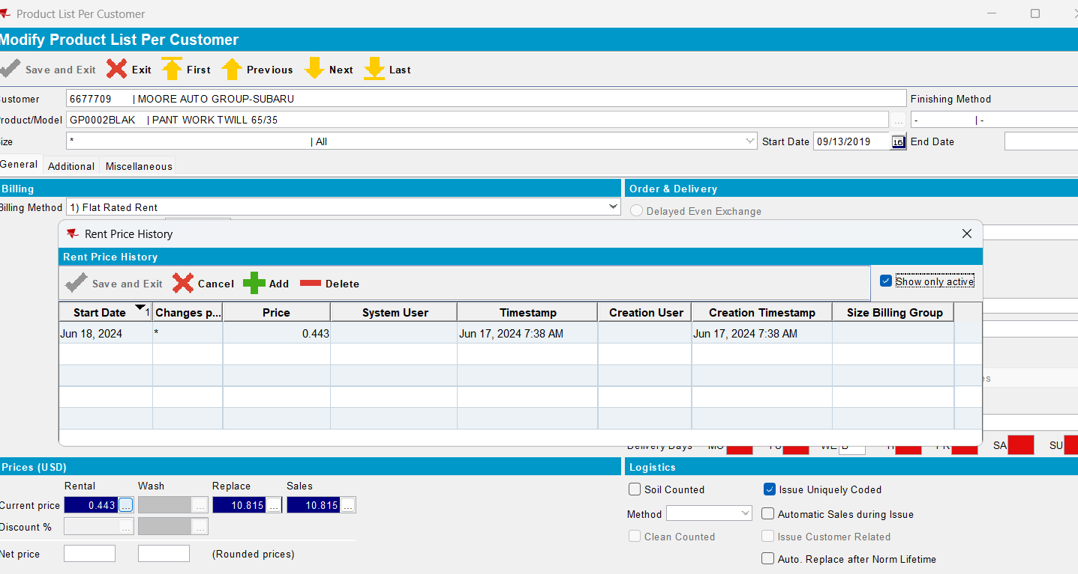
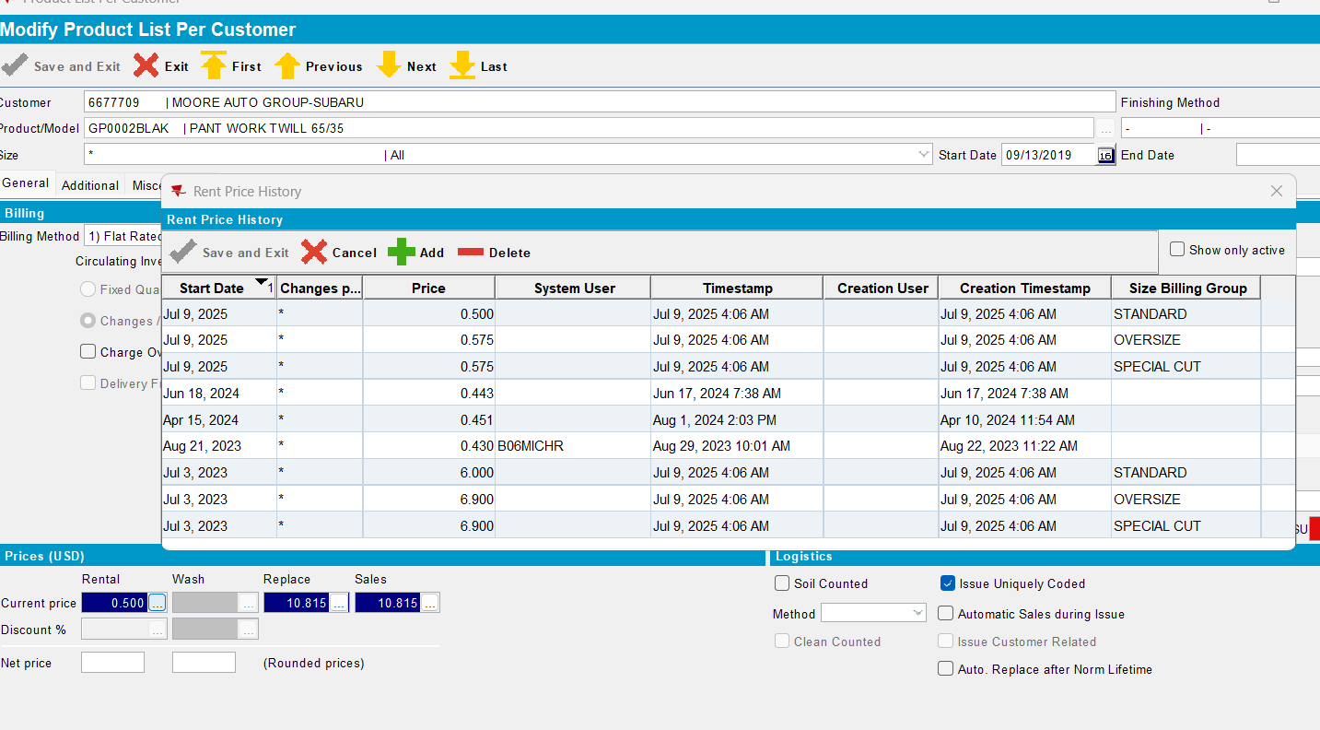
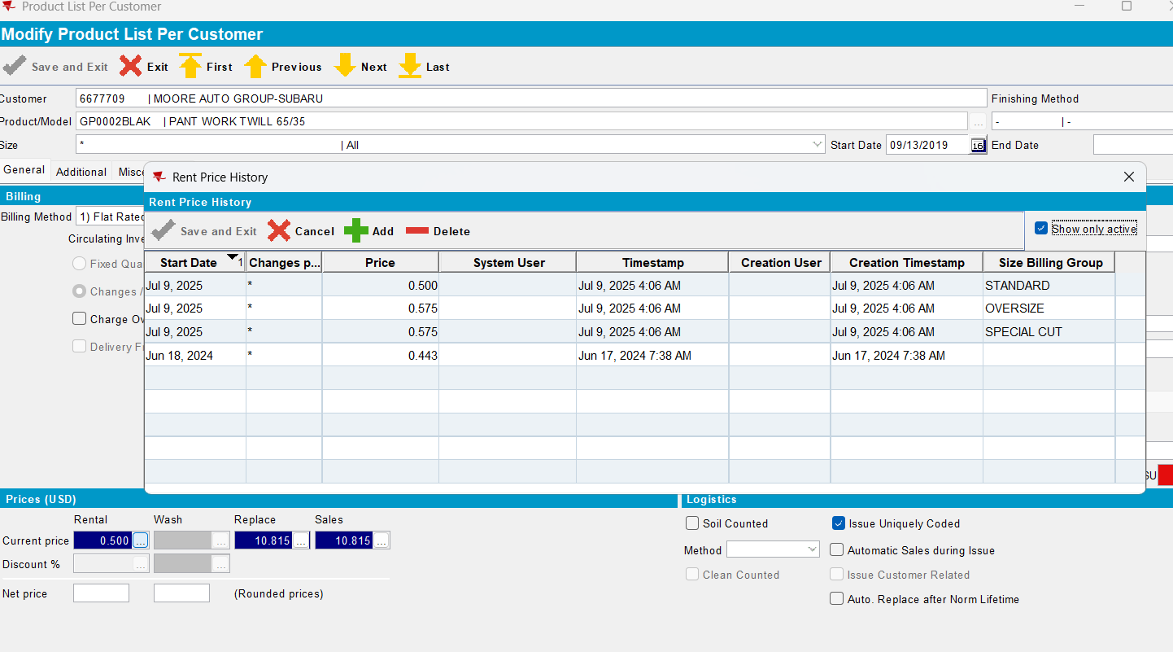
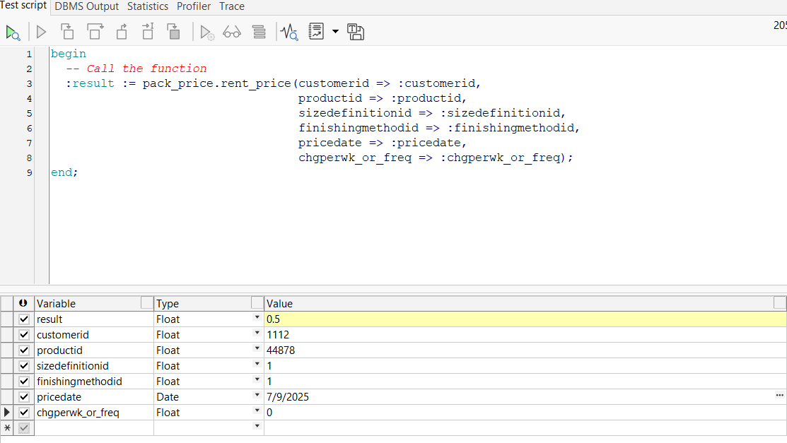
Passed.

CUST25@AUS_ND90502
BU:503
Customer: 5302597
GP0292NAVY
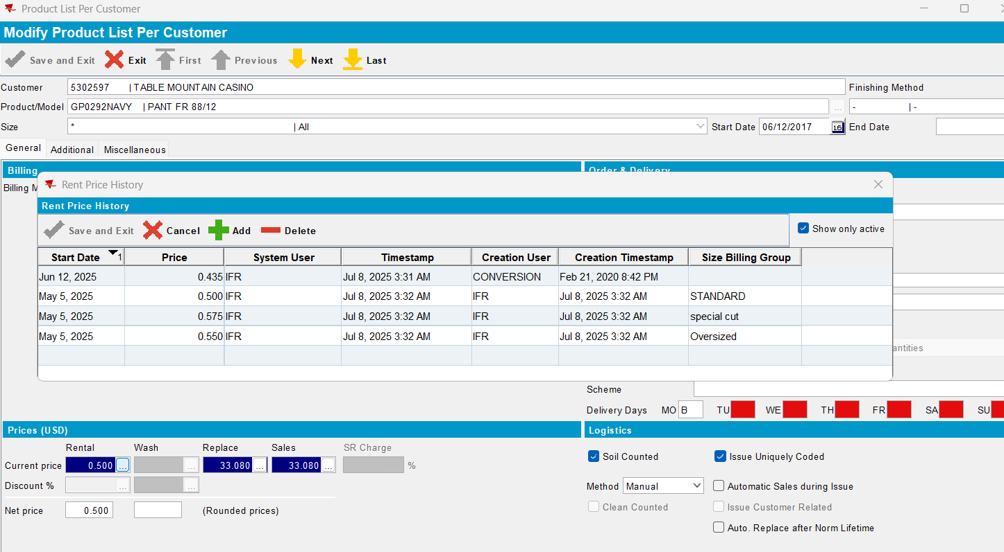
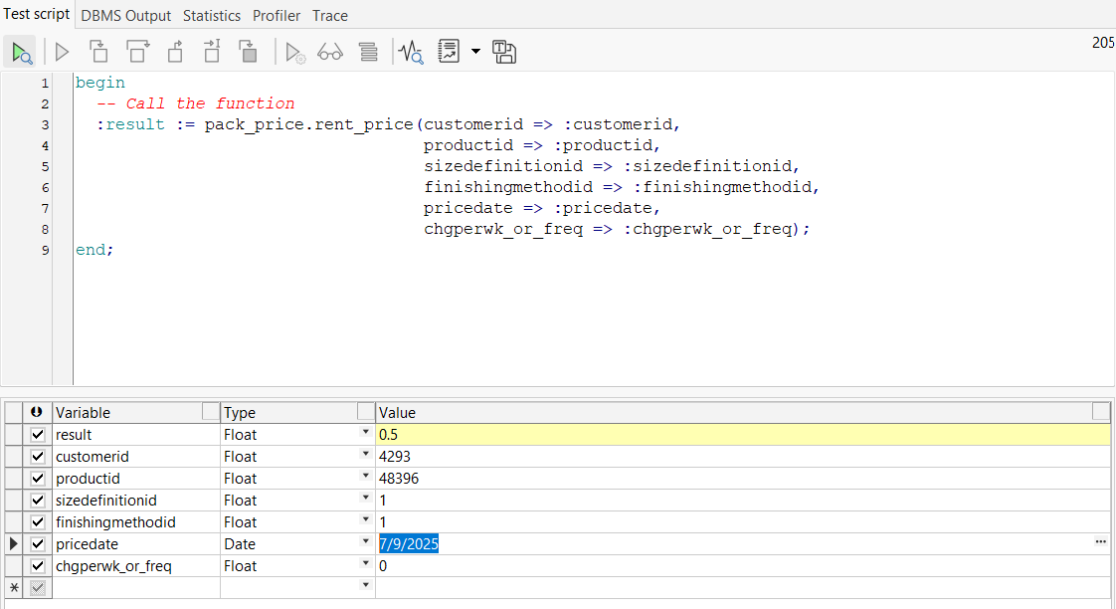
Passed.
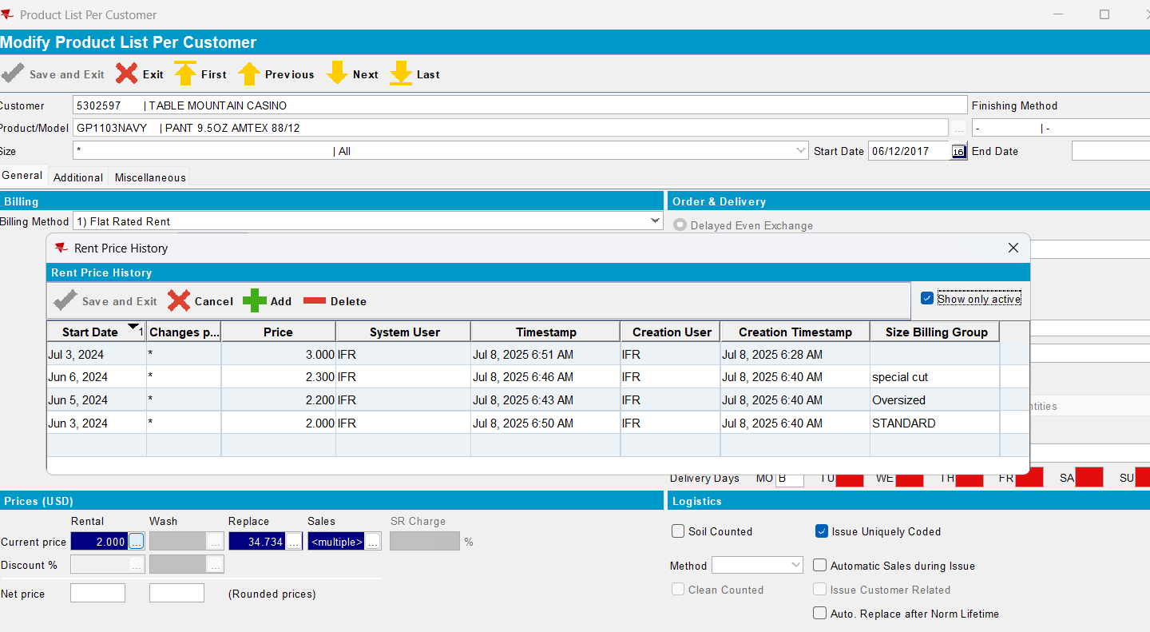
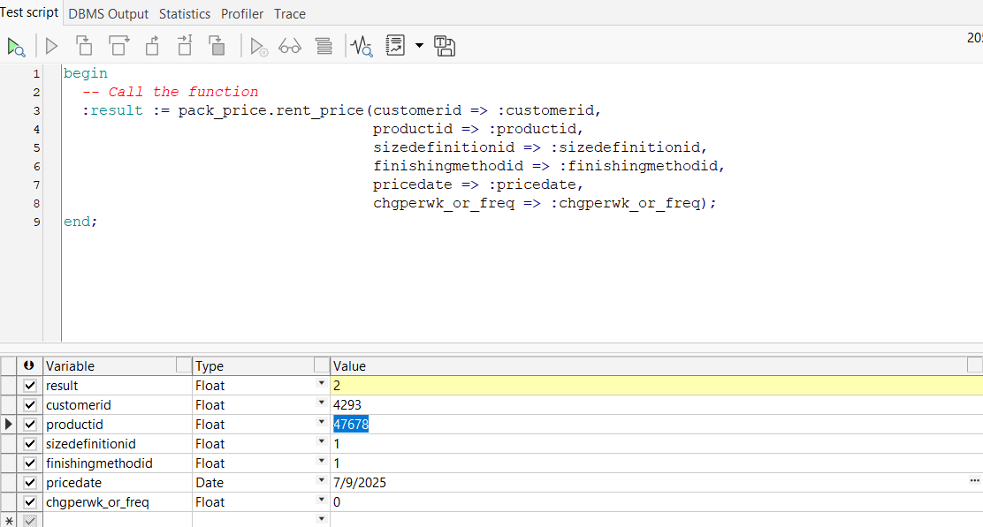
Passed.

CUST22@AUS_COMP
BU:473

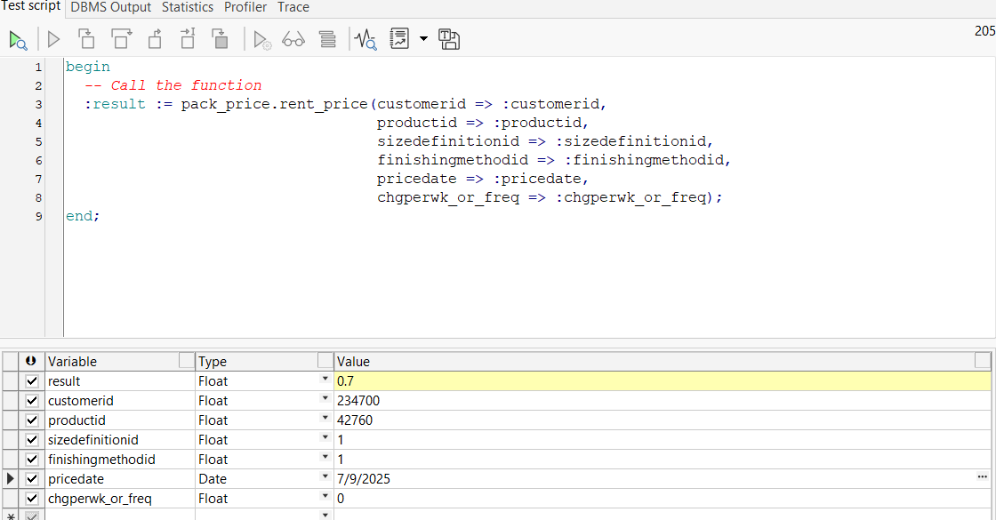

Passed.

