ABSN-9883 Max Open Cursors DB errors – 90800 test
Environment | Prerequisites
Version: 9.08.00.RELEASE.p21  DBServerName=abs-srv17.internal.abslbs.com  DBSID=CUST23  DBUser=AUS_MNT90800  DBPassword= AUS_MNT90800  Environment=Production | - Module: -  - System setting: -  - Others… : -  - BU:

Contents
Reproducing before fix 1
Retest after fix 3

Reproducing before fix

Hash: 302df9e
- Run the following select in a SQL page:
select count(OC.SQL_TEXT) HITS, SQ.SQL_TEXT, SE.USERNAME
from GV$OPEN_CURSOR OC
join GV$SESSION SE
on SE.SID = OC.SID
and SE.INST_ID = OC.INST_ID
join GV$SQL SQ
on SQ.SQL_ID = OC.SQL_ID
and SQ.INST_ID = OC.INST_ID
where SQ.OBJECT_STATUS = 'VALID'
--and SE.USERNAME = 'AMM'
and OC.CURSOR_TYPE = 'OPEN'
group by SQ.SQL_TEXT, SE.USERNAME
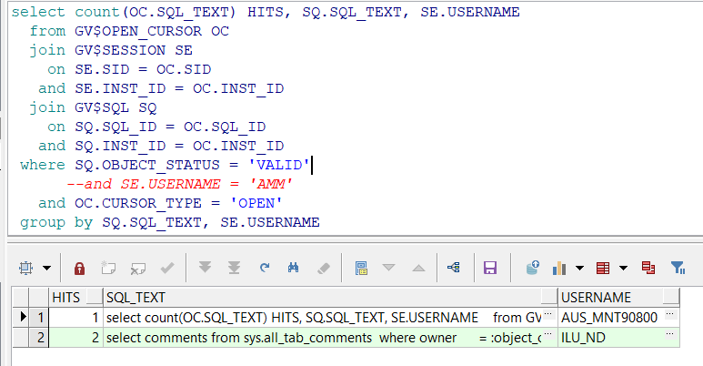
- Open Switchboard and press Find
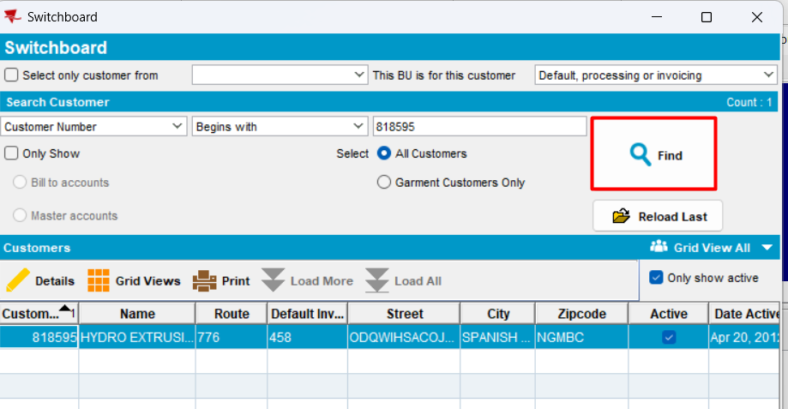
- Run again the same select from database
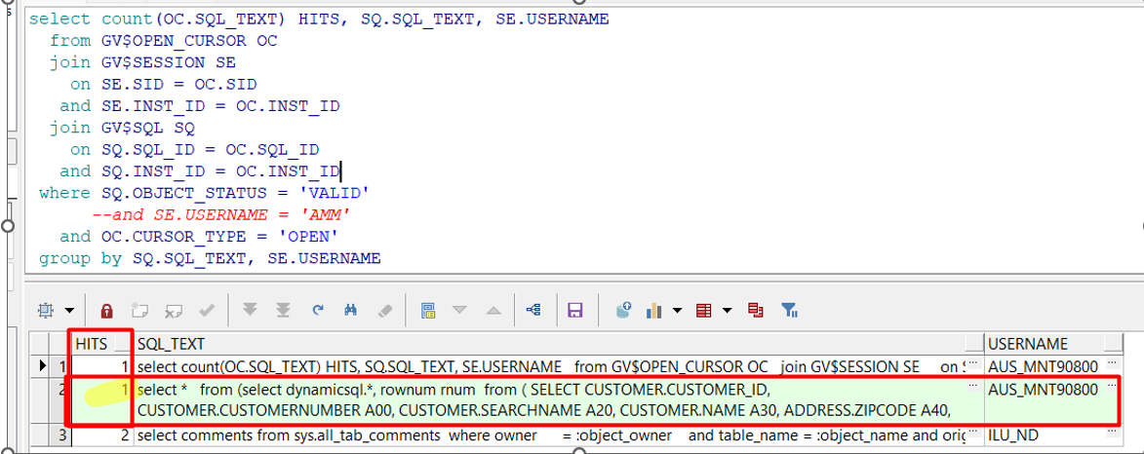
- Press again Find in Switchboard a couple of times
- Run the same select from database
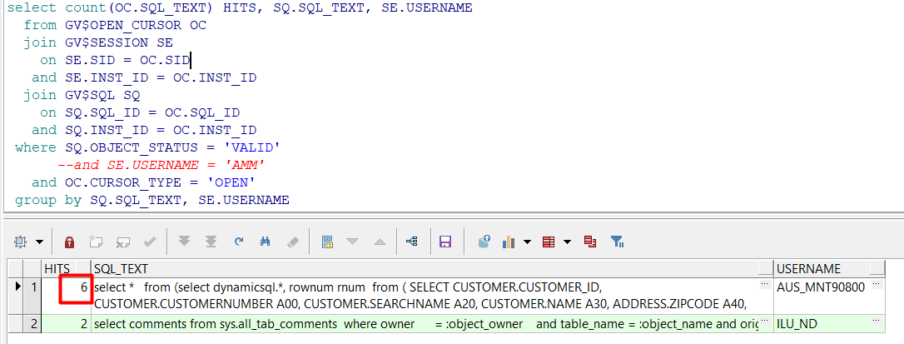
Actual behavior: every time a customer is searched in Switchboard dlg, a query is run in database, but it never is finished, so it keeps running in background and the sessions is never ended so the connections are adding.
Expected behavior: when a customer is searched in Switchboard dlg, only a single session should be run per search and then session should be ended.
REPRODUCED OK.

Retest after fix
Hash: e6ba6c5
- Run the following select in a SQL page:
select count(OC.SQL_TEXT) HITS, SQ.SQL_TEXT, SE.USERNAME
from GV$OPEN_CURSOR OC
join GV$SESSION SE
on SE.SID = OC.SID
and SE.INST_ID = OC.INST_ID
join GV$SQL SQ
on SQ.SQL_ID = OC.SQL_ID
and SQ.INST_ID = OC.INST_ID
where SQ.OBJECT_STATUS = 'VALID'
--and SE.USERNAME = 'AMM'
and OC.CURSOR_TYPE = 'OPEN'
group by SQ.SQL_TEXT, SE.USERNAME
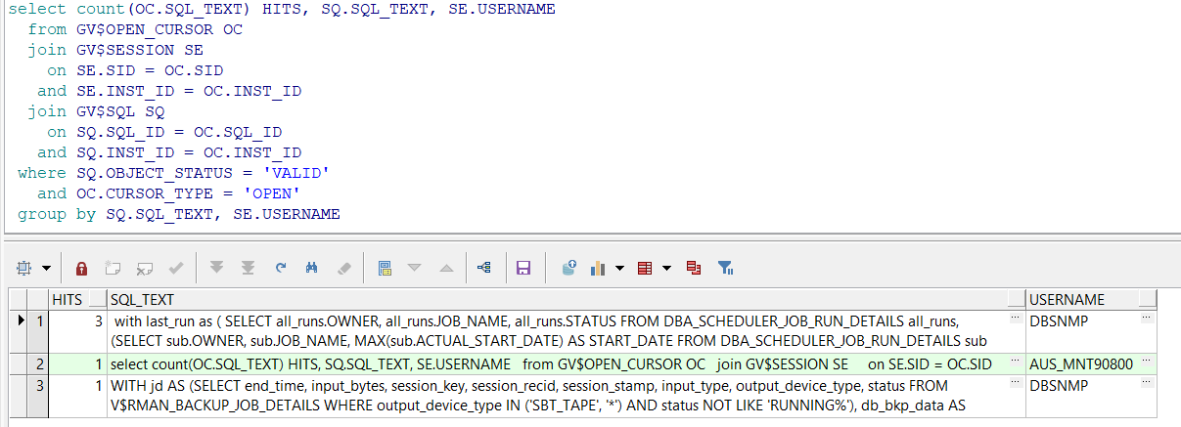
- Open Switchboard and press Find once
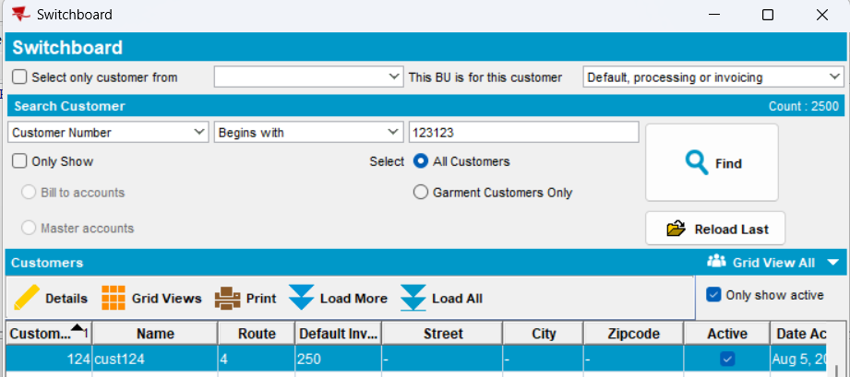
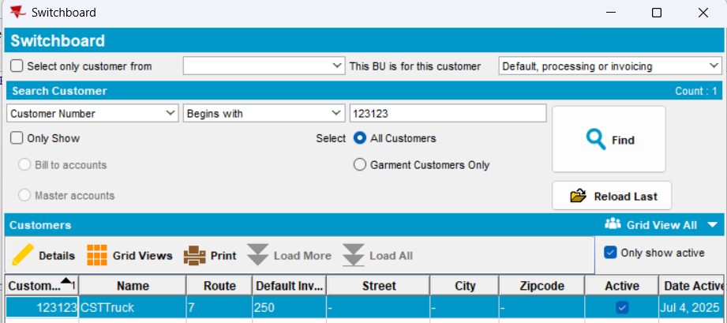
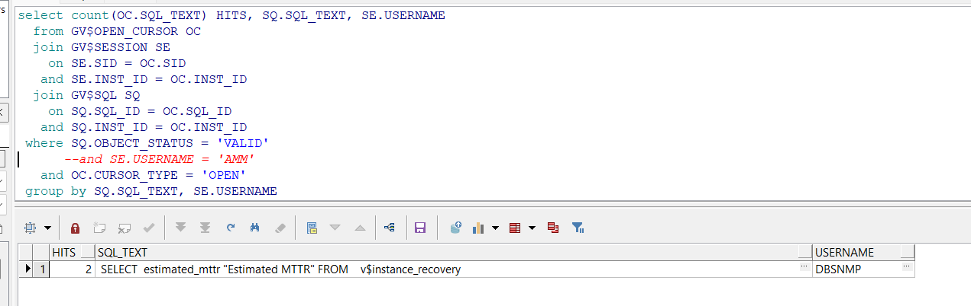
- In Switchboard, do not select any customer and press Find multiple times
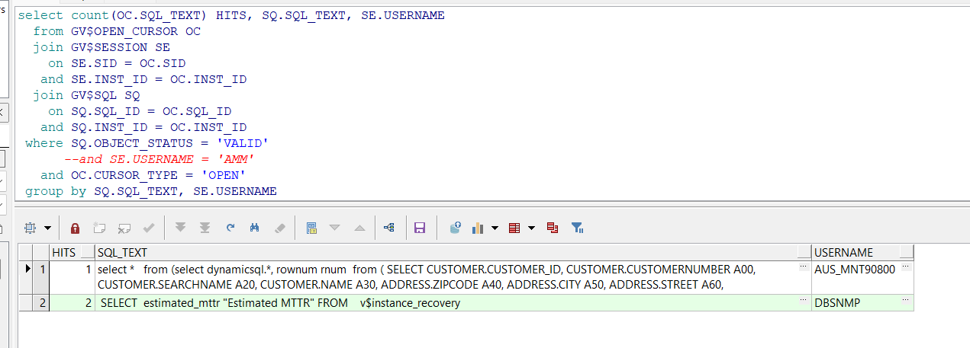
Expected behavior: in Switchboard dlg, when a search for a specific customer or a general search is done, only a single session should be run per search and then session should be ended.
Actual behavior: as expected
RETEST OK

