ABSN-9880 Missing Prep charge - Unable to save Customer dialog updates on Strategic accounts
Environment | Prerequisites
Version: 9.08.00.RELEASE.p22  Environment=PRODUCTION  DBServerName=db01-buc.internal.abslbs.com  DBSID= CUST25  DBUser= AUS_ND90502  DBPassword= AUS_ ND90502 | - Modules: AUSCUSTOM

Contents
Reproduction before fix 1
Retesting after fix 2

Reproduction before fix

Contract: A11214
Customer: 792347145 with predefined contract
- Contract with General Prep Charge price
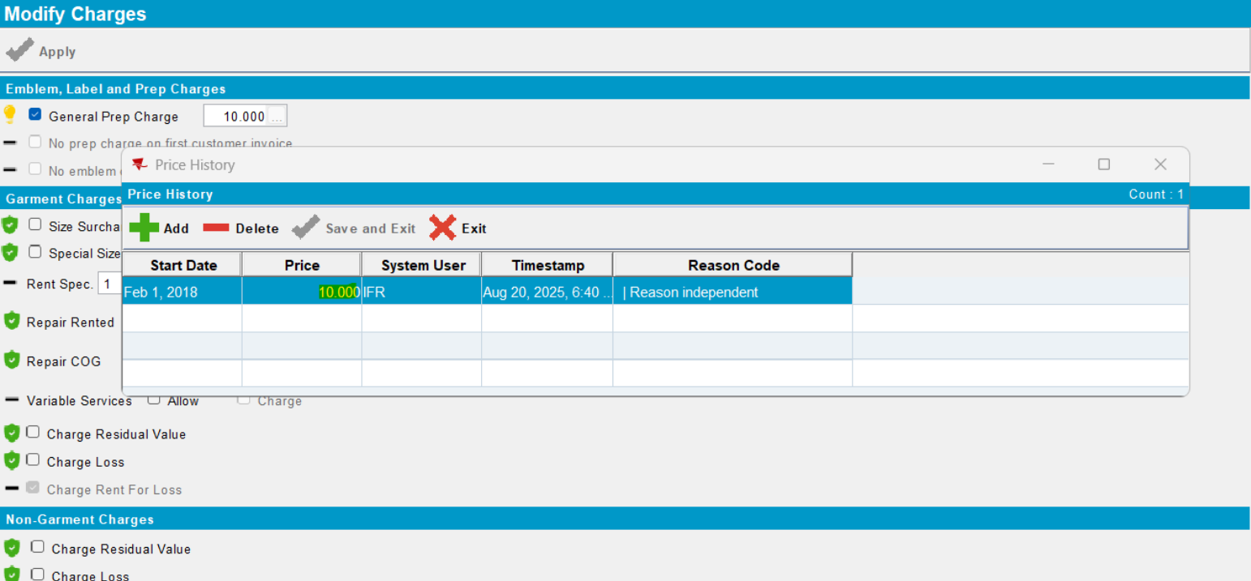

- Update Selected for this customer:
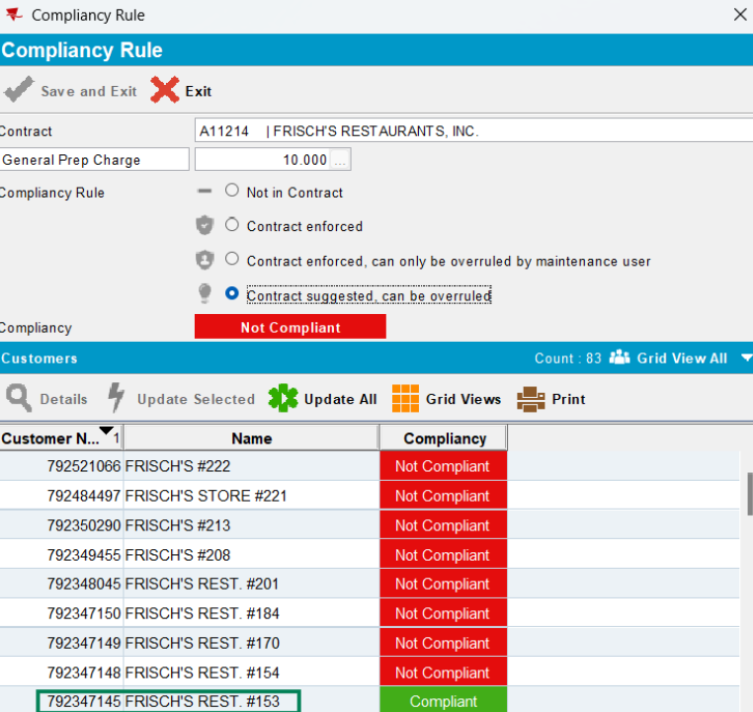

- Even if the price exist in the database, it is not copied on Client/ Customer dlg:

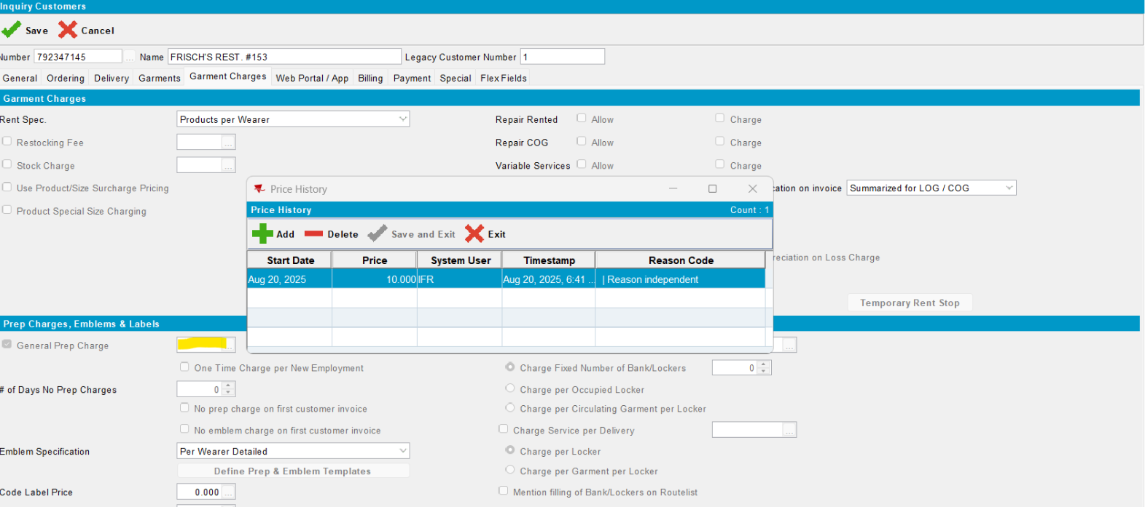
- Because of this any other modification and save attempt is not possible:
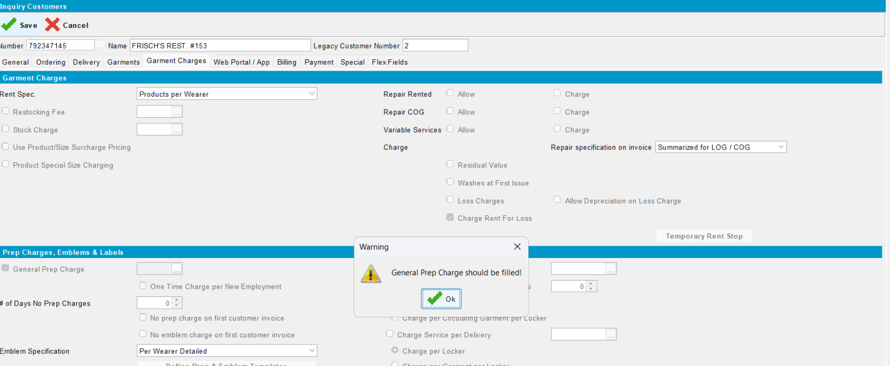
Reproduced.

Retesting after fix

- Contract: A11214
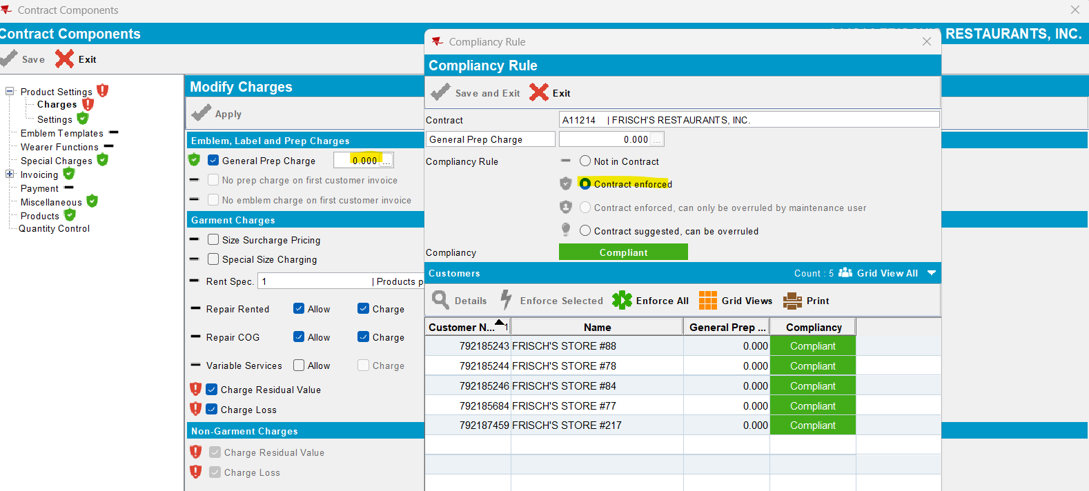

- Customers from this contract:
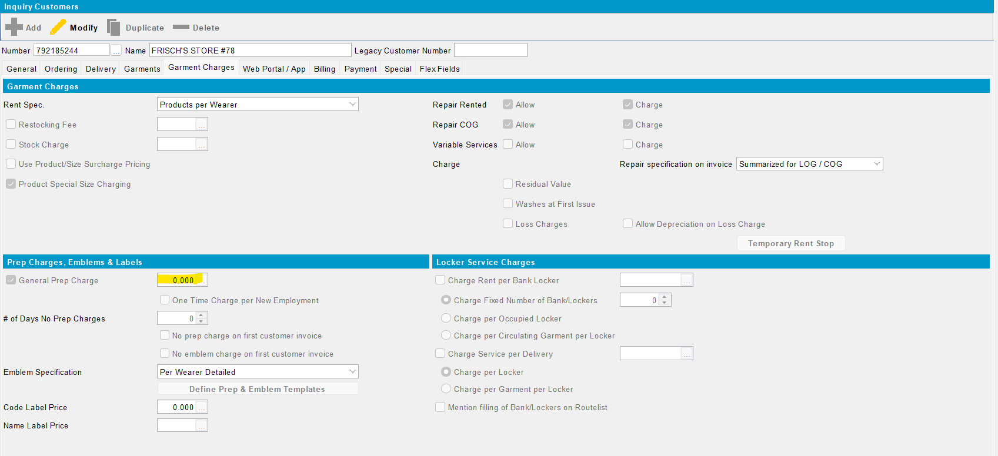

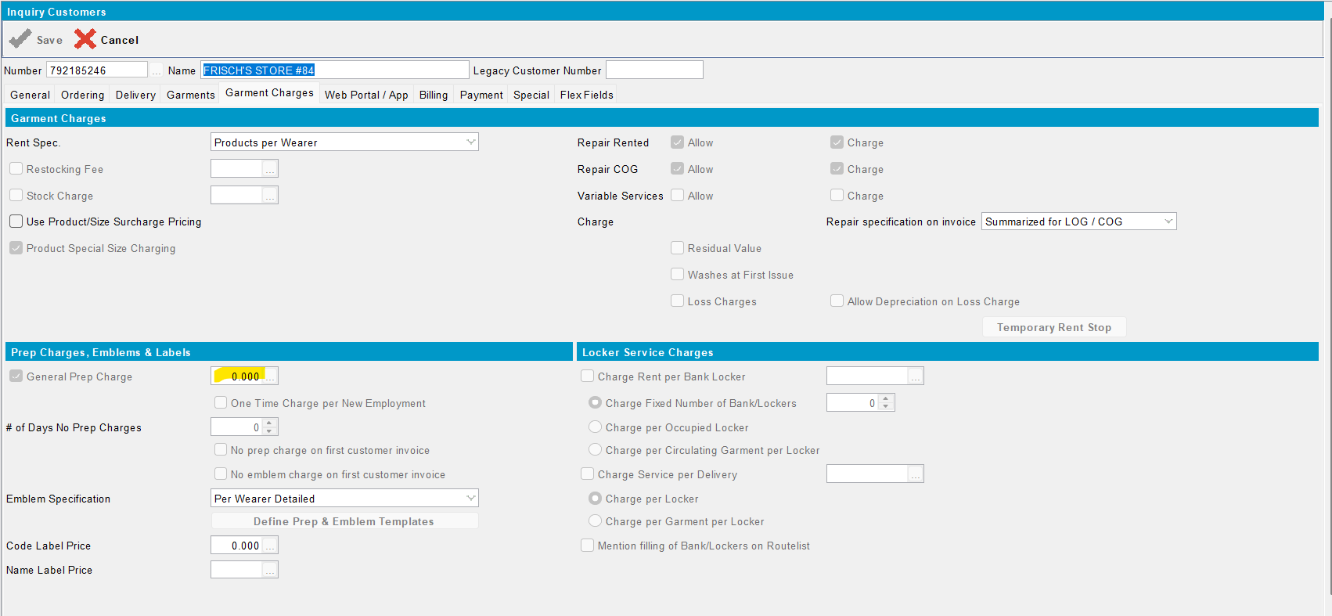

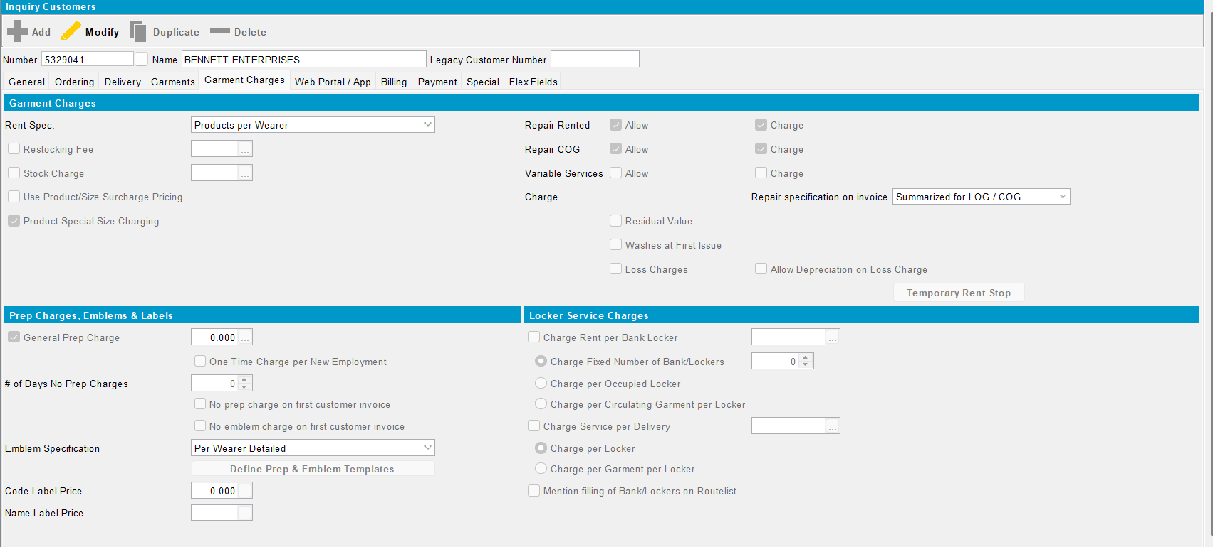
- The price is loaded now on client/ Customer dlg and any other changes can be saved.
Passed.

- Change the price (general prep. Charge) on Contract level:
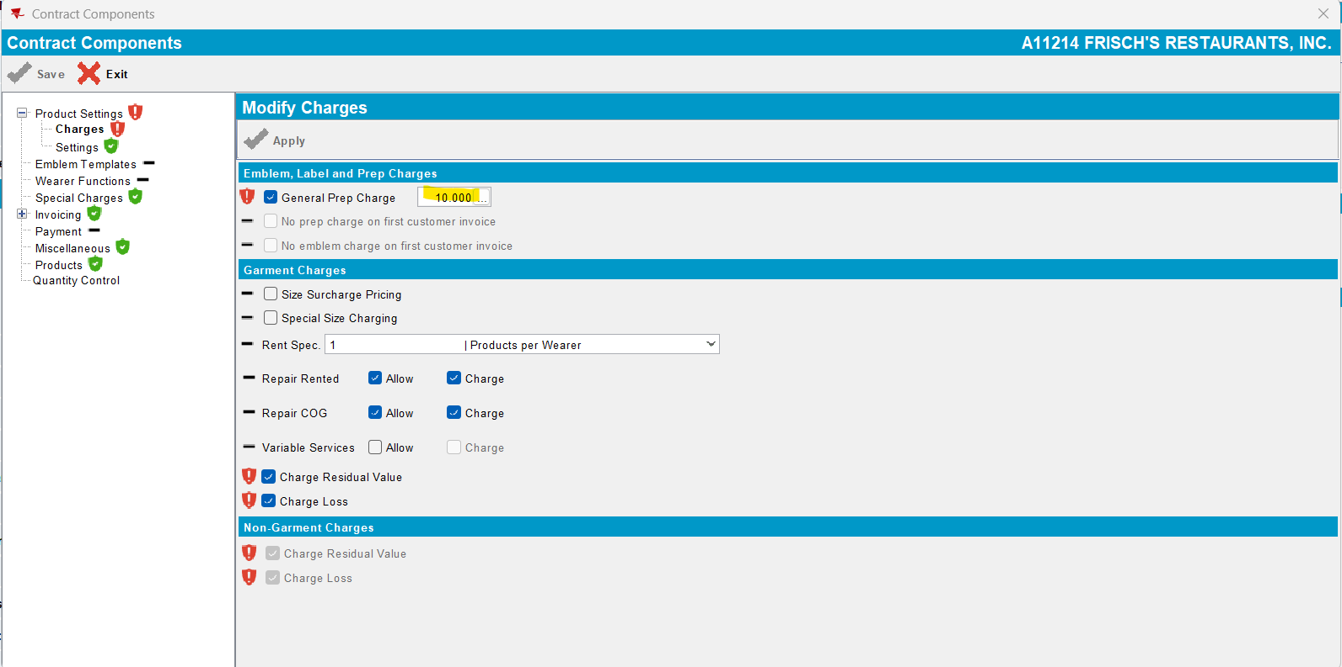

- Enforce All

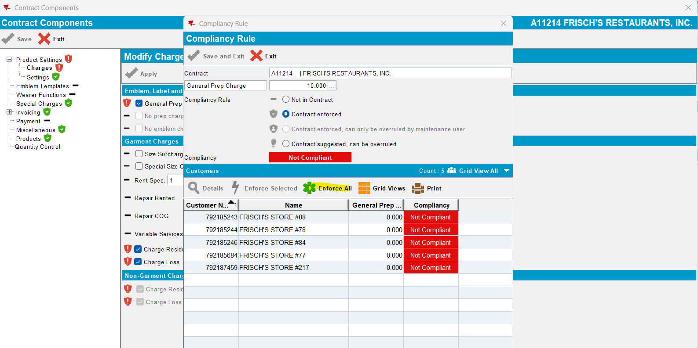

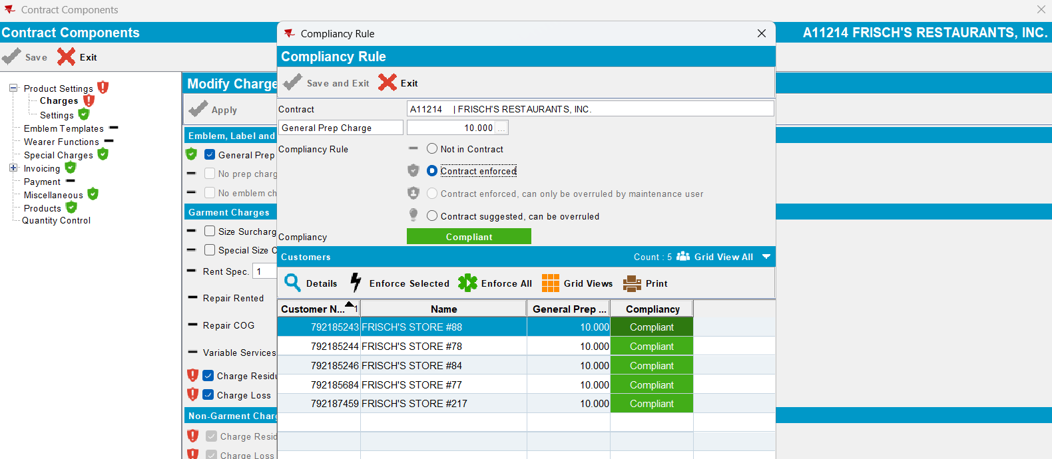

- Check on Customer level:
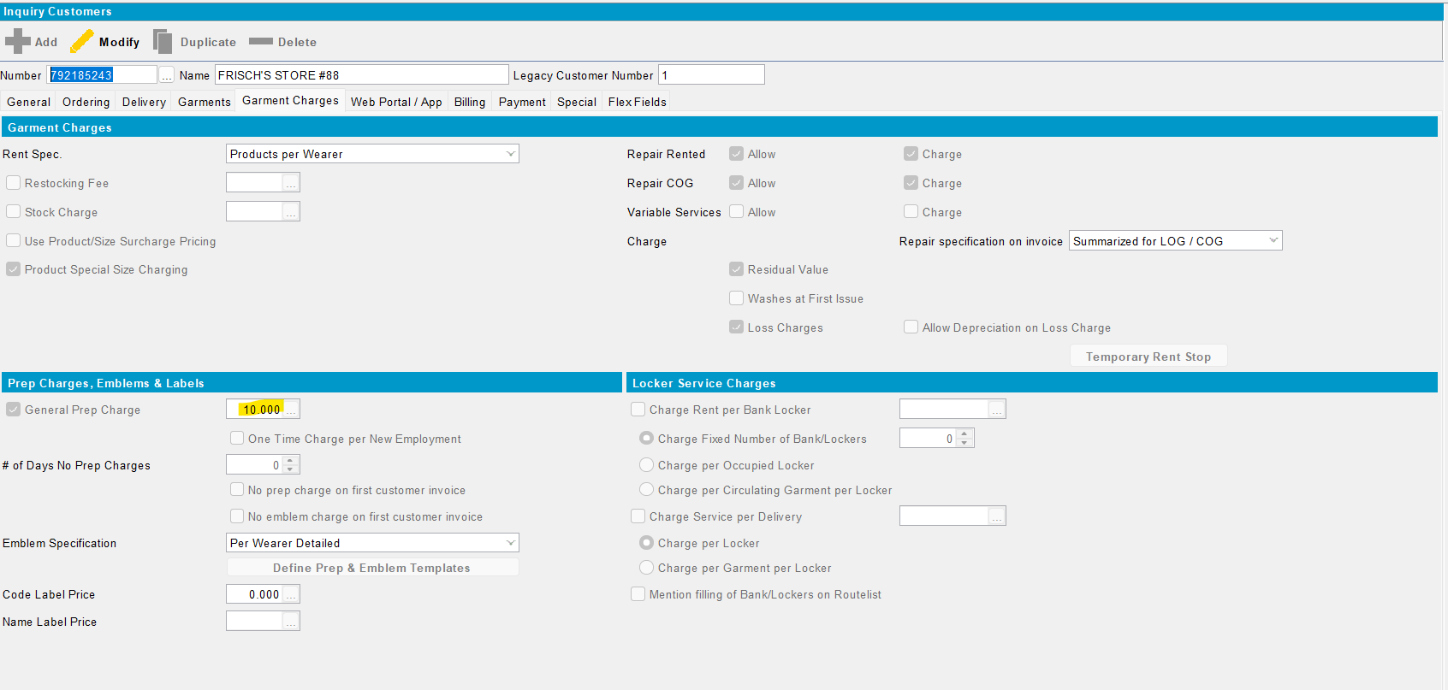

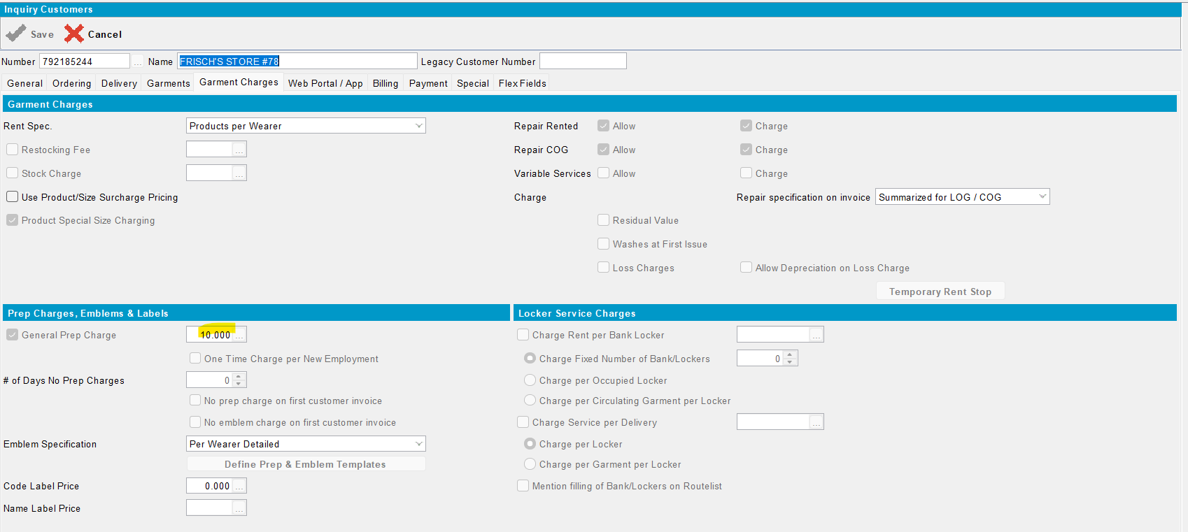

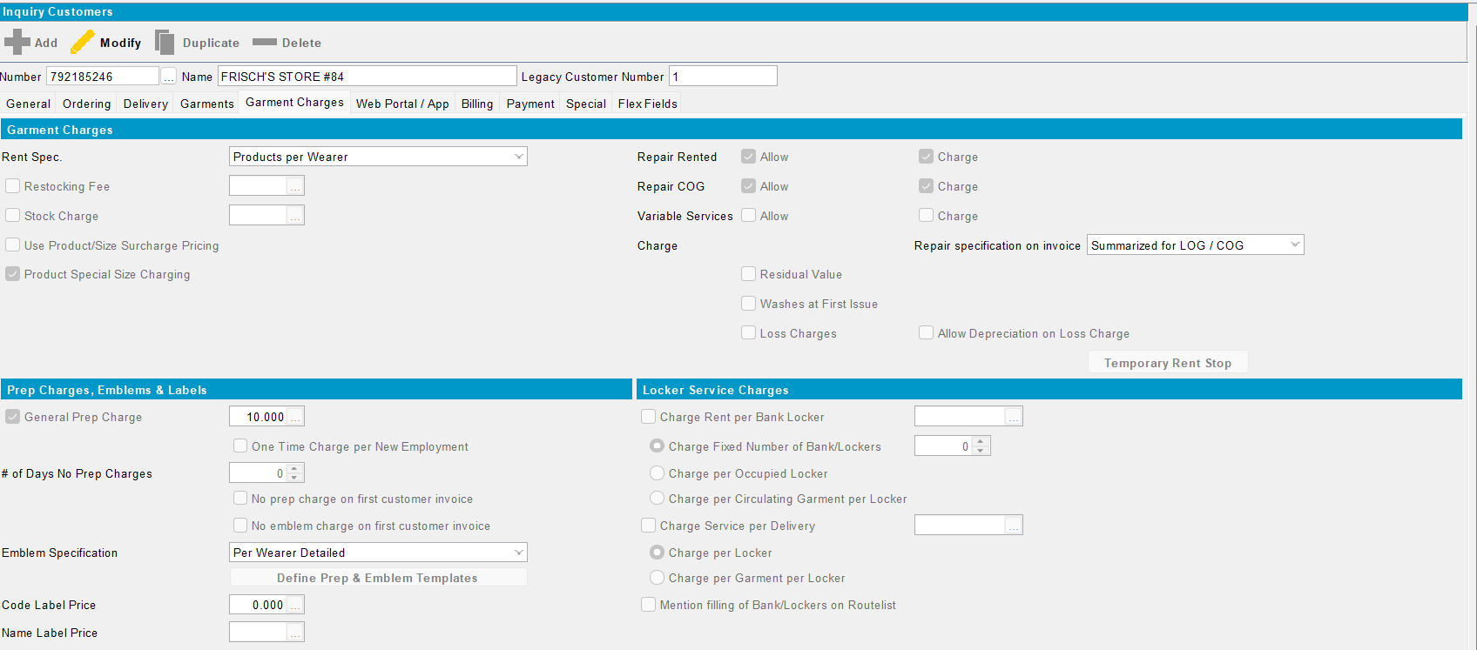

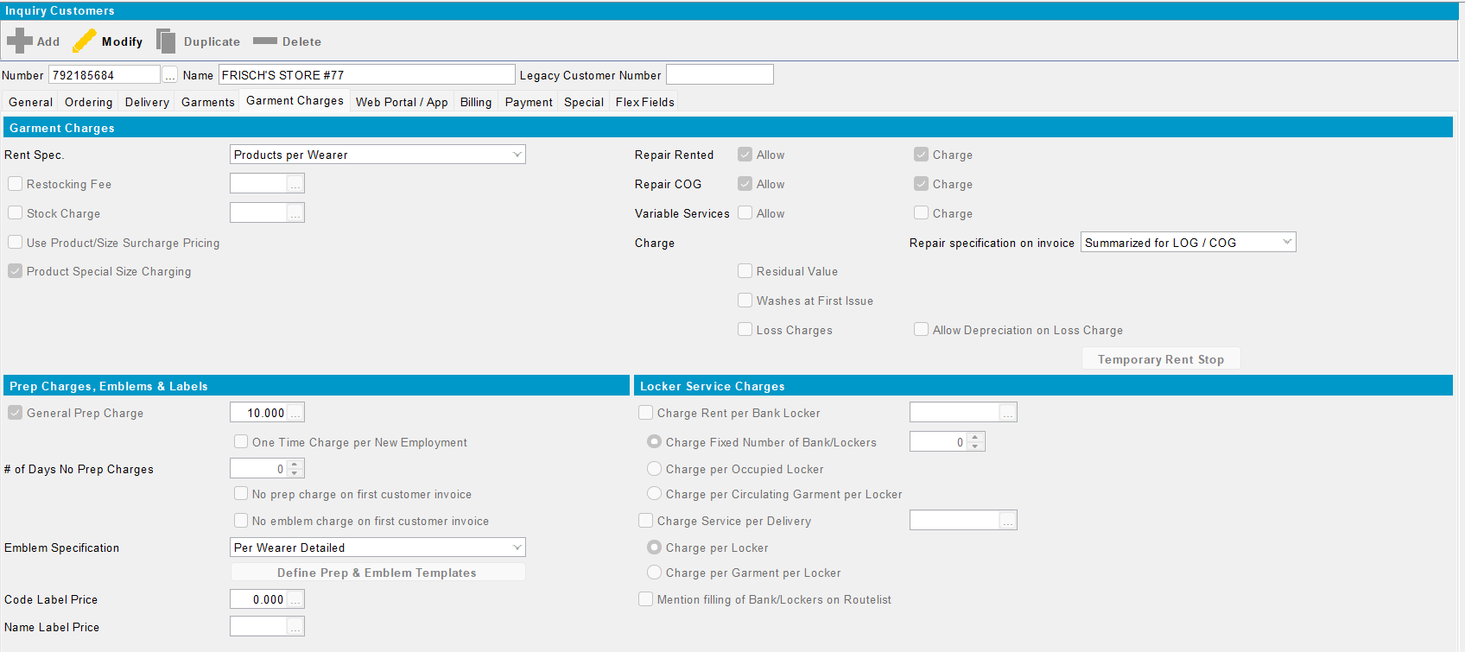

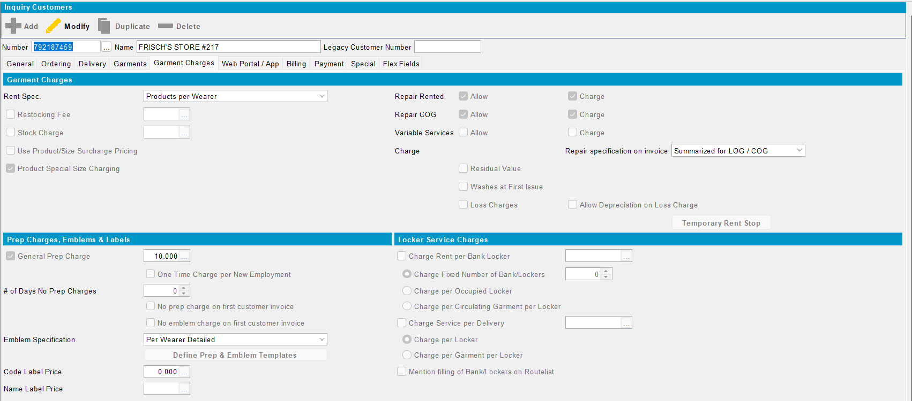
The price is updated.OK.

- Add a new customer (single contract)
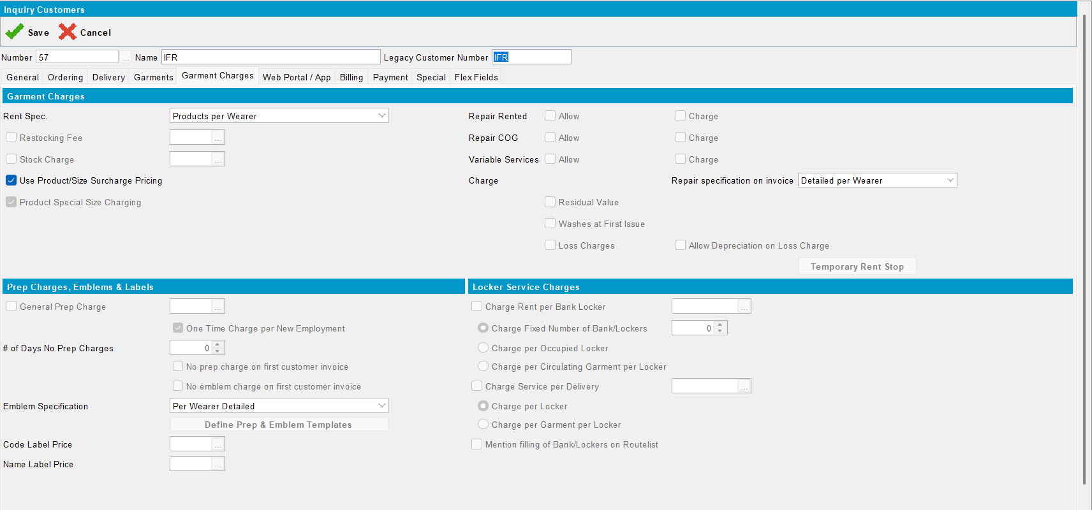

- General prep. Charge is not check because of this system setting:
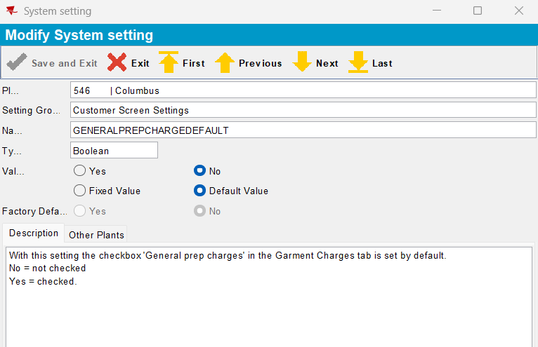

- but can be set a price and checked:
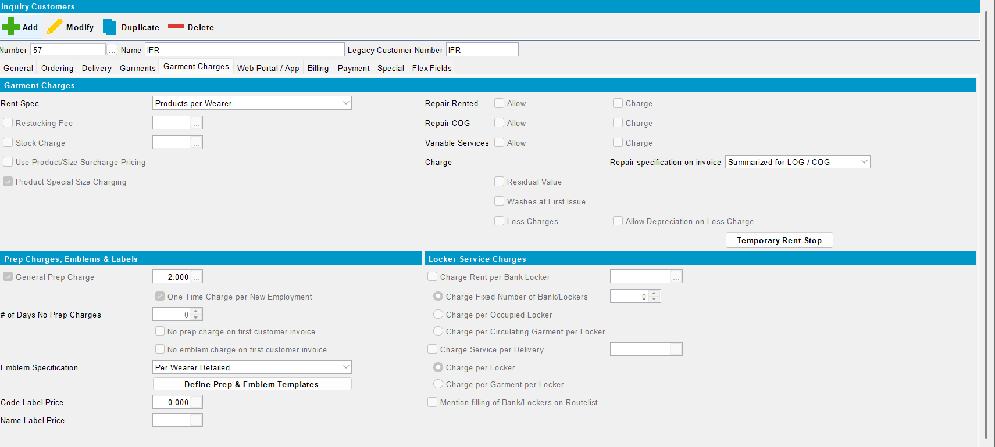
Passed.

