ABSN-697 No Log Lines until view refreshed
DataBase | Preconditions
Version:9.08.00.RELEASE.p21_AUS  DBServerName= db01-buc.internal.abslbs.com  DBSID=CUST25  DBUser=AUS_ND90502  Business Unit: 250/Plant:250  Hash: c2dc62a41861 | - Module:  - System setting: WEARERINACTIVEWITHNOCIRC  WEARERDELETEWHENINACTIVE  - Other applications versions (if is applicable)  - Device used for mobile applications (if is applicable: Memo, physical device, Nox)
Contents
Current Behavior: 1
Expected Behavior: 1
Summary: Reproducing before fix 1
Summary: Retest after fix 4

DESCRIPTION:

Current Behavior:
Process log results are not correctly refreshed.

Expected Behavior:
Process log results should be correctly refreshed and displayed in accordance with the filters used.

Summary: Reproducing before fix
Preconditions:
9.08.00.RELEASE.p20
Hash: b6b17f5e9ce1
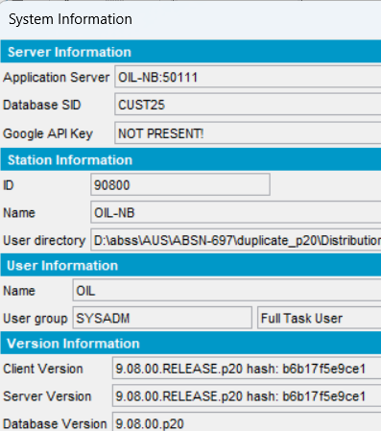
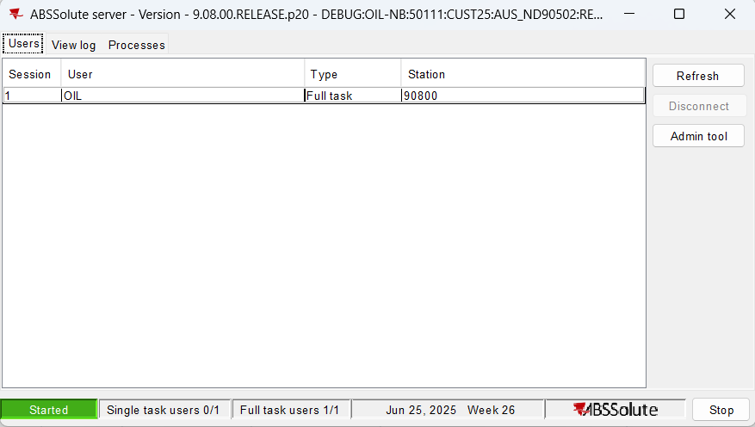
Step 1) Go to “View Process Log” dlg:
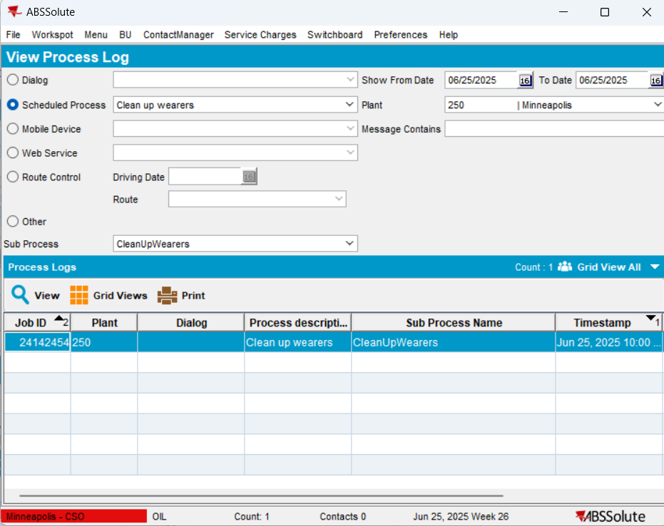
Step 2) Select a log and press “View”: notice there is no log to view
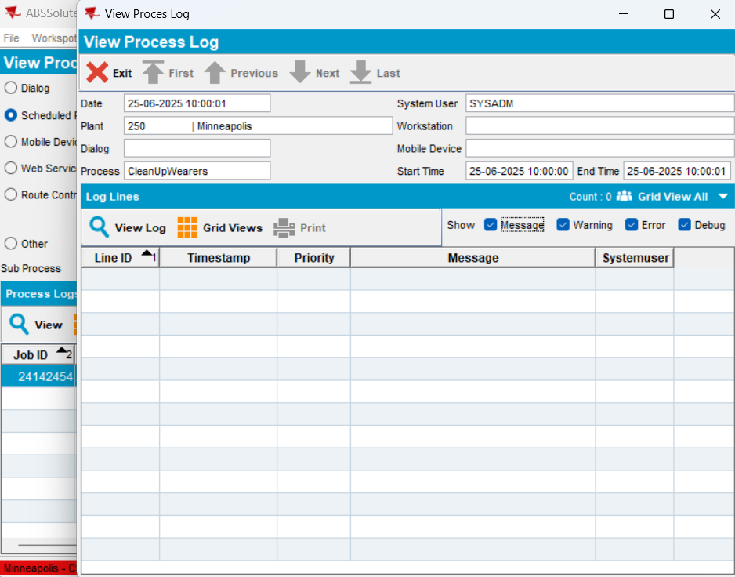
Step 3) Select a log and press “View Log”: notice there is no log to view
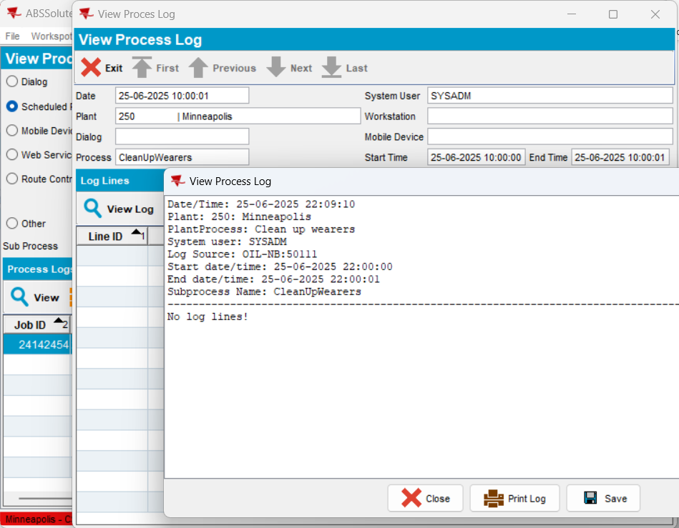
Step 4) If you uncheck “Message”, “Warning”, “Error”, “Debug” the log will not appear on screen:
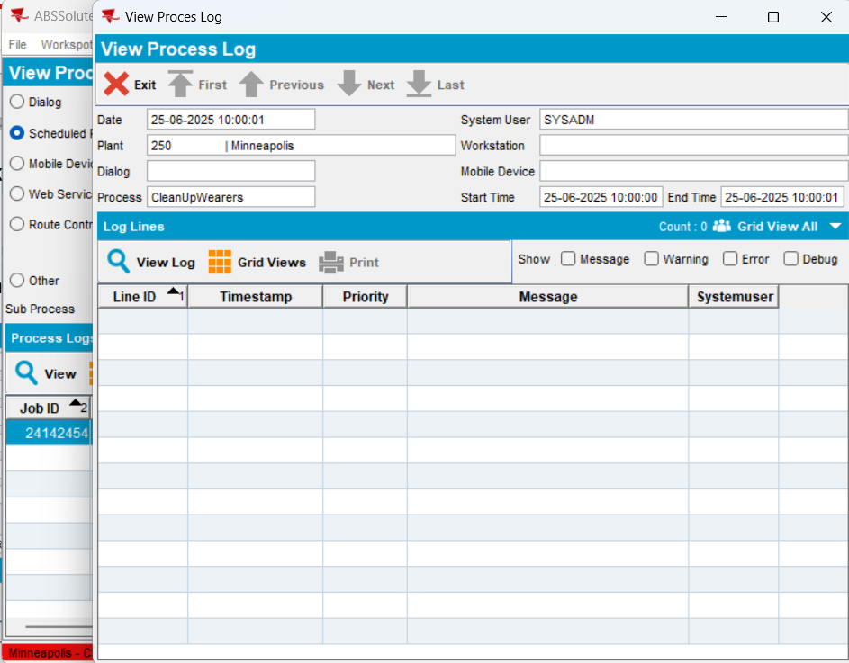
Step 5) Process Scheduler:
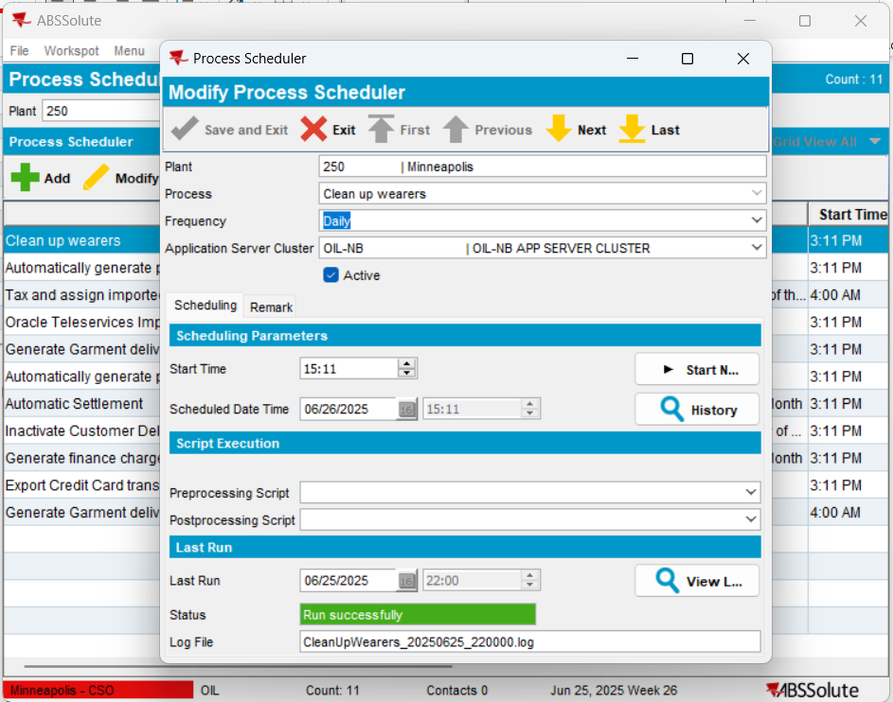
View Log:
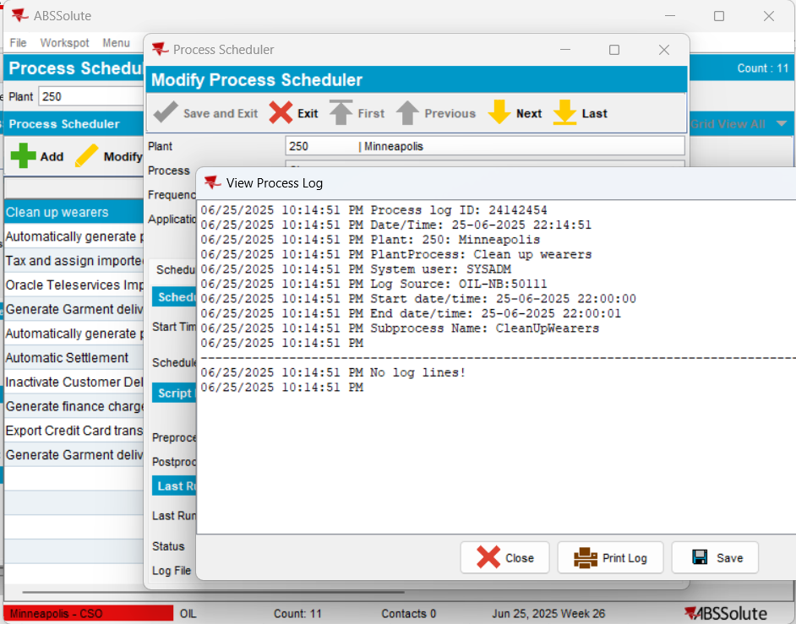
No Log Lines!

REPRODUCED OK

Summary: Retest after fix

Test in: https://jenkins.internal.abslbs.com/job/PatchBuilder/job/9.08.00.RELEASE.patchesAUS/1321/artifact/dist/exe/
Hash: c2dc62a41861
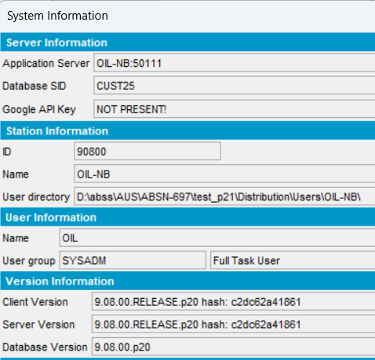
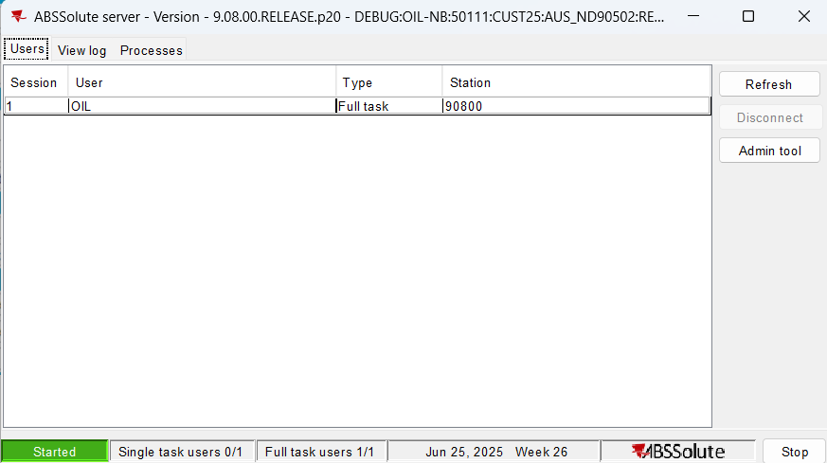
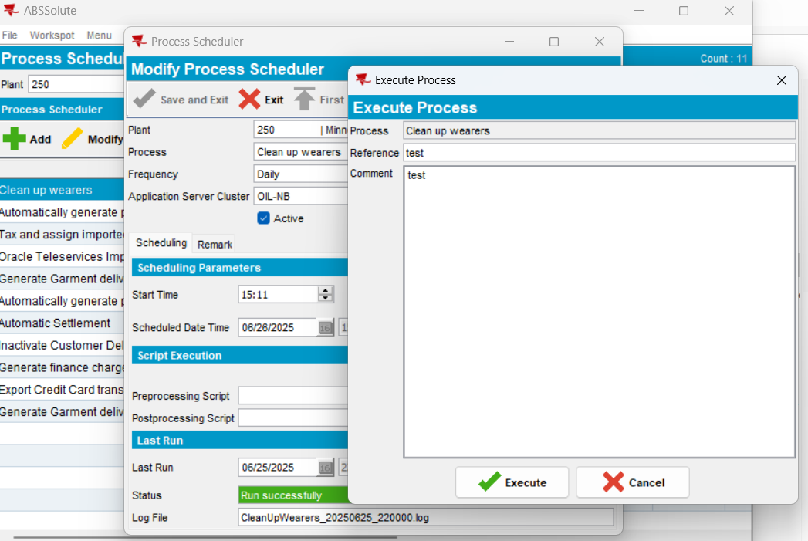

Step 1) System settings =0
WEARERINACTIVEWITHNOCIRC=0
WEARERDELETEWHENINACTIVE=0

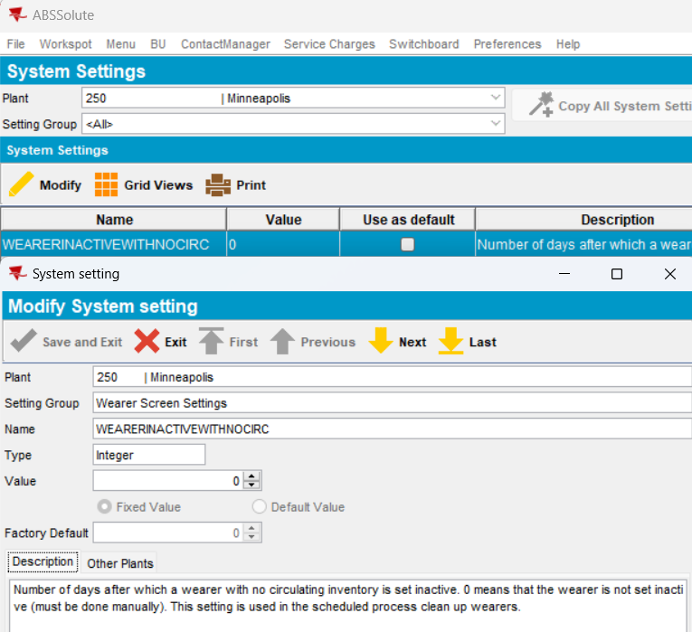

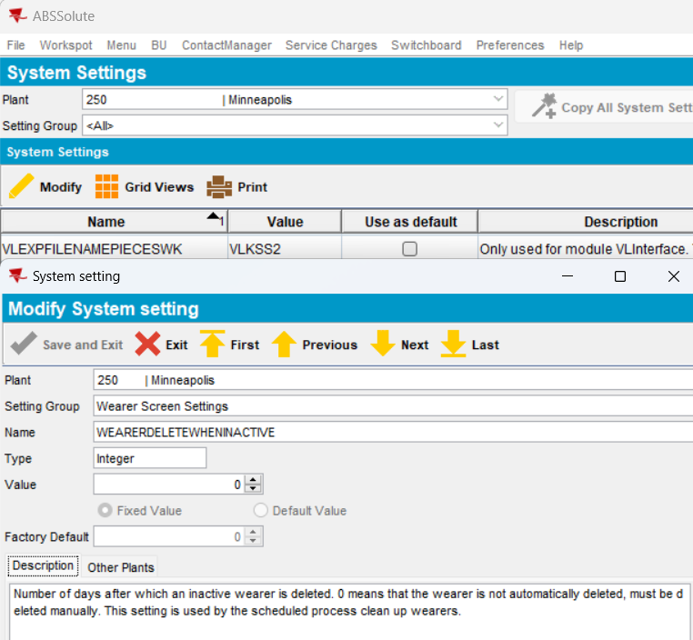
Run process scheduler:
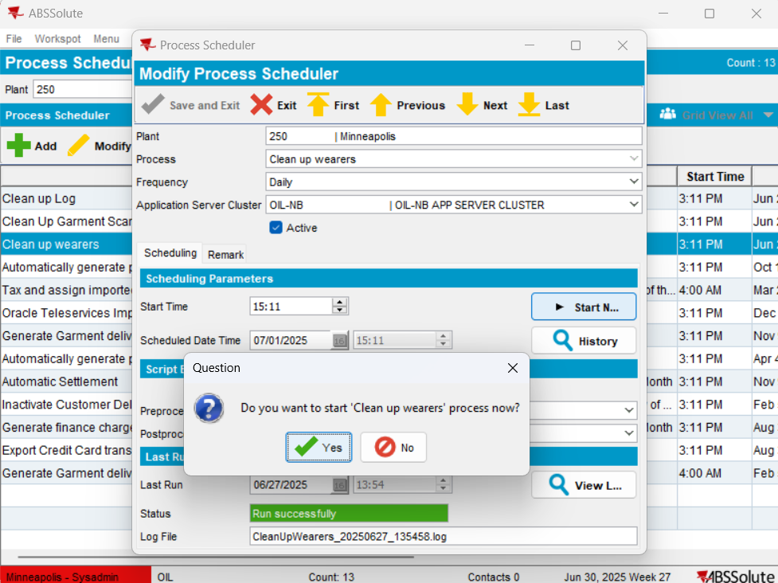
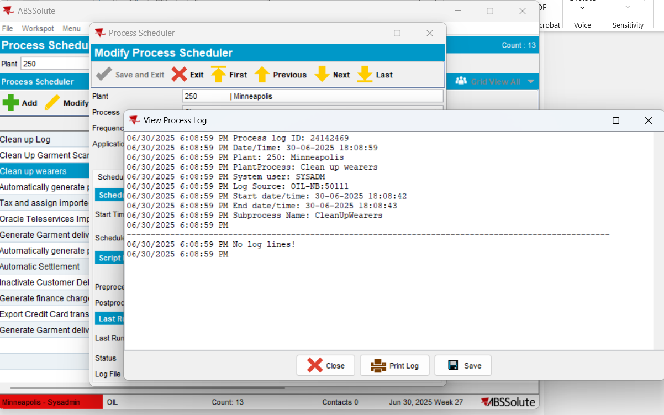
Go to “View Process Log” dlg:
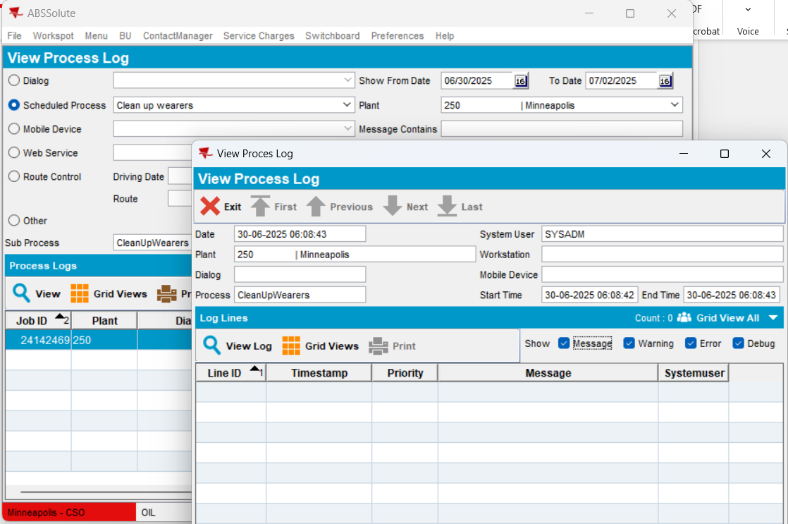

No logs created doe to both ss=0
TEST OK

Step 2) At least one system settings >0
WEARERINACTIVEWITHNOCIRC=1
WEARERDELETEWHENINACTIVE=0

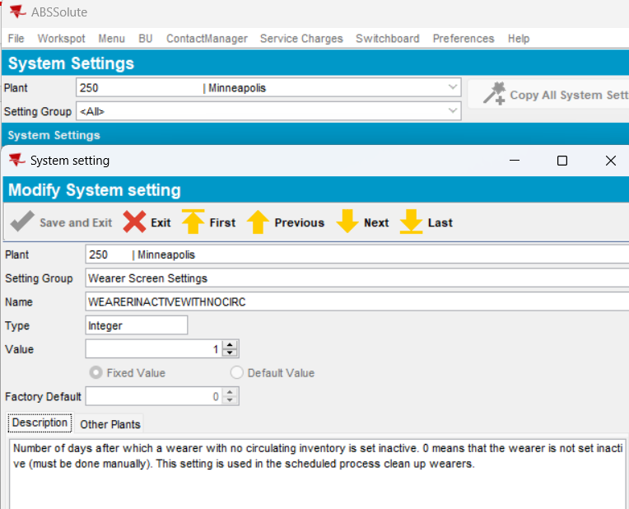

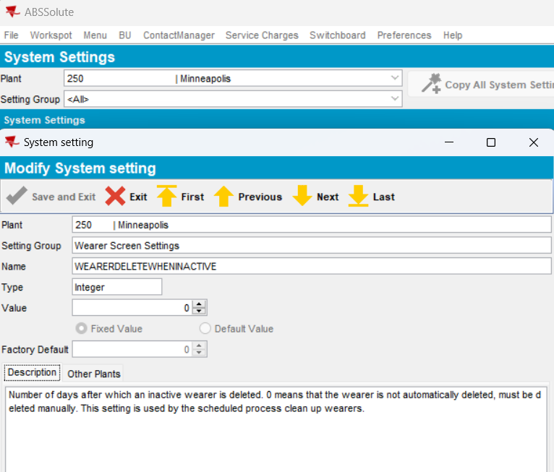

Run process scheduler:
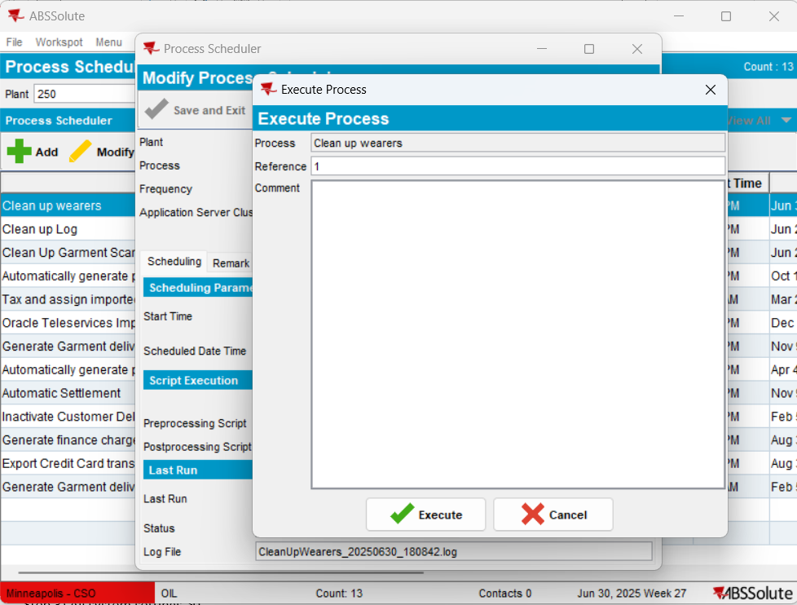

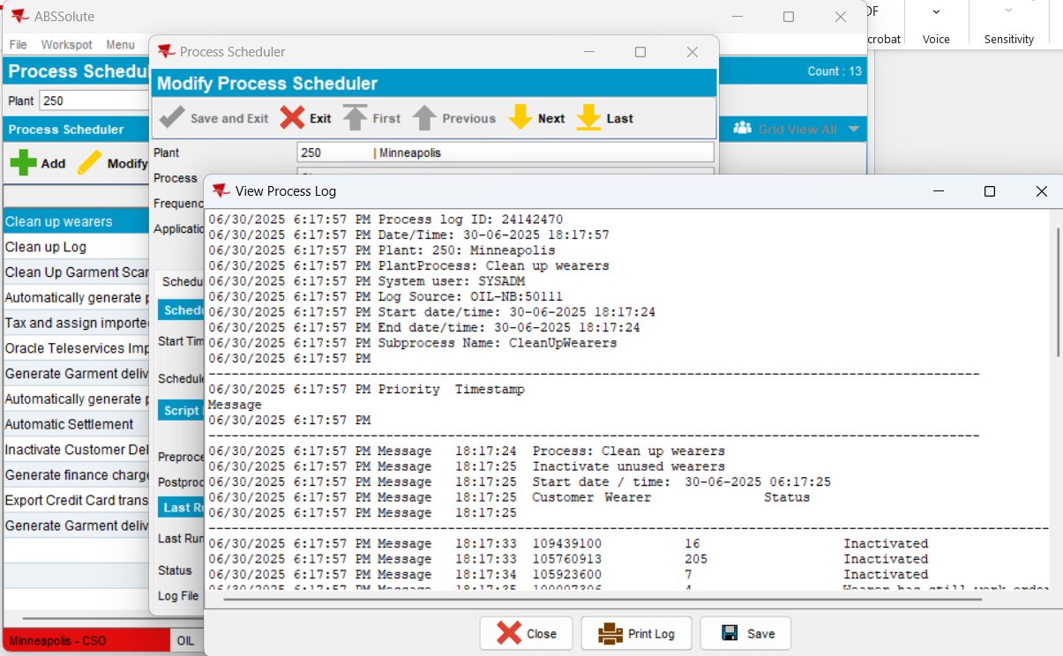
Go to “View Process Log” dlg:
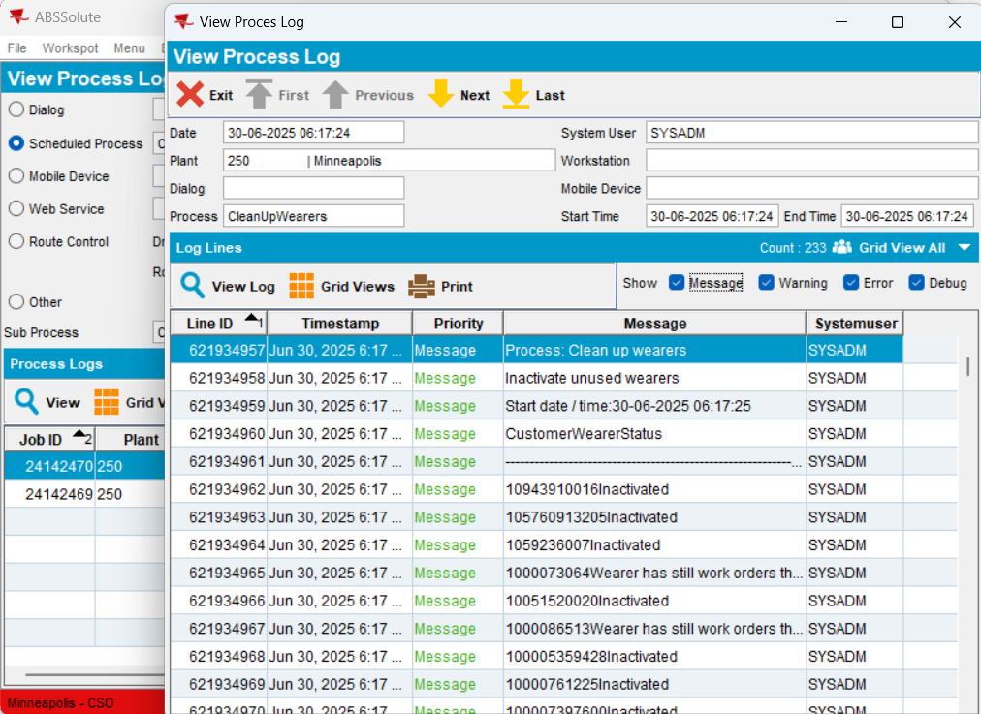

Logs available due to at least on ss>0

Uncheck Show Message and logs disappeared:
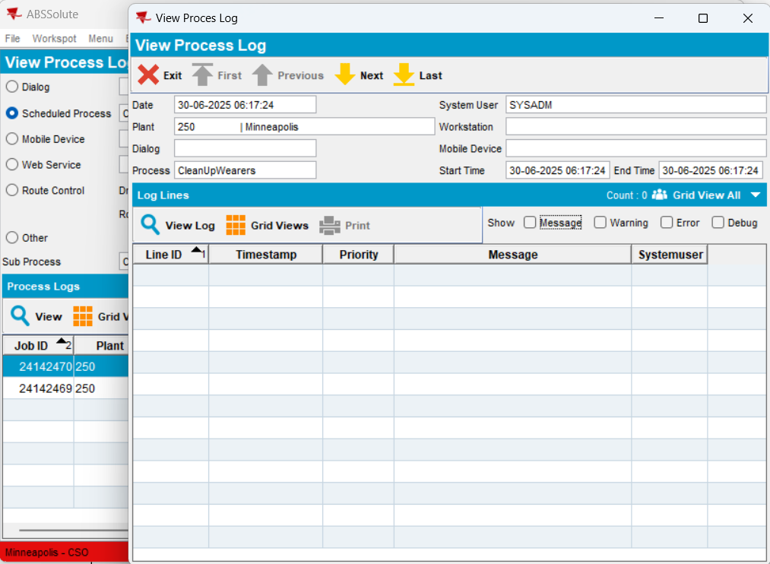

TEST OK
Step 3) All system settings >0
WEARERINACTIVEWITHNOCIRC=1
WEARERDELETEWHENINACTIVE=1
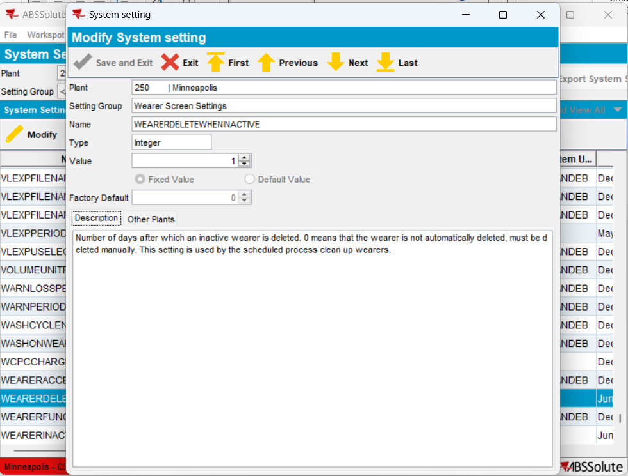

Run process scheduler:
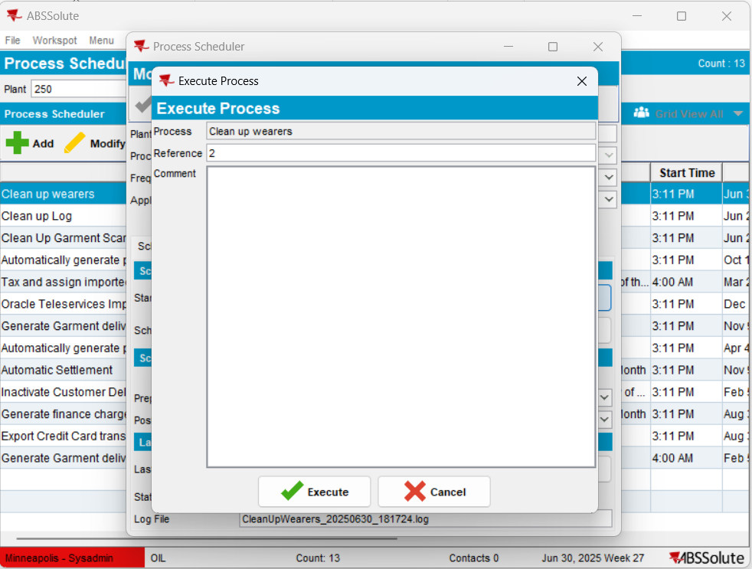

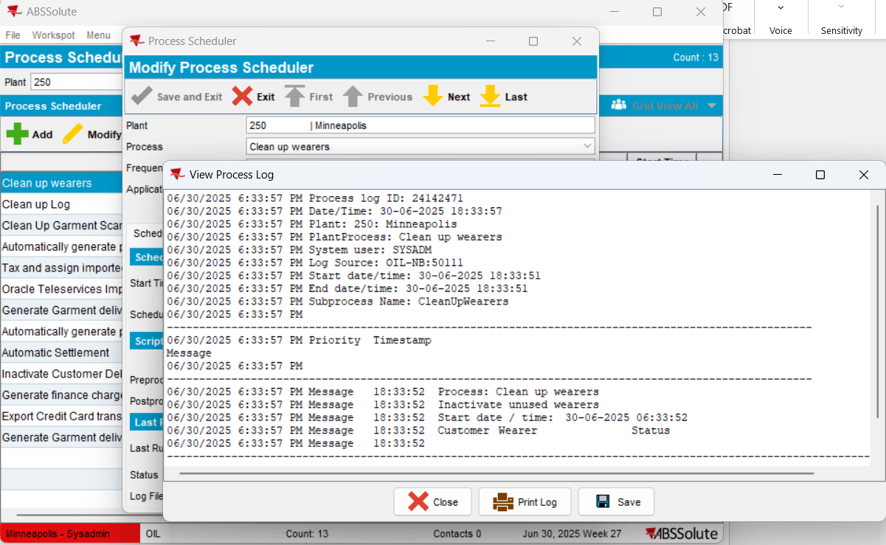

Go to “View Process Log” dlg:
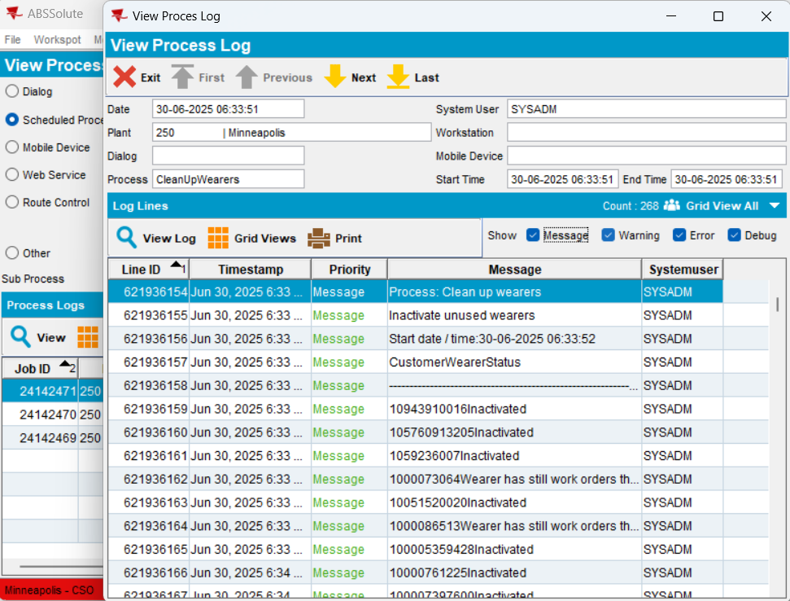

Logs are available due to ss>0
Uncheck Show Message and log disappeared:
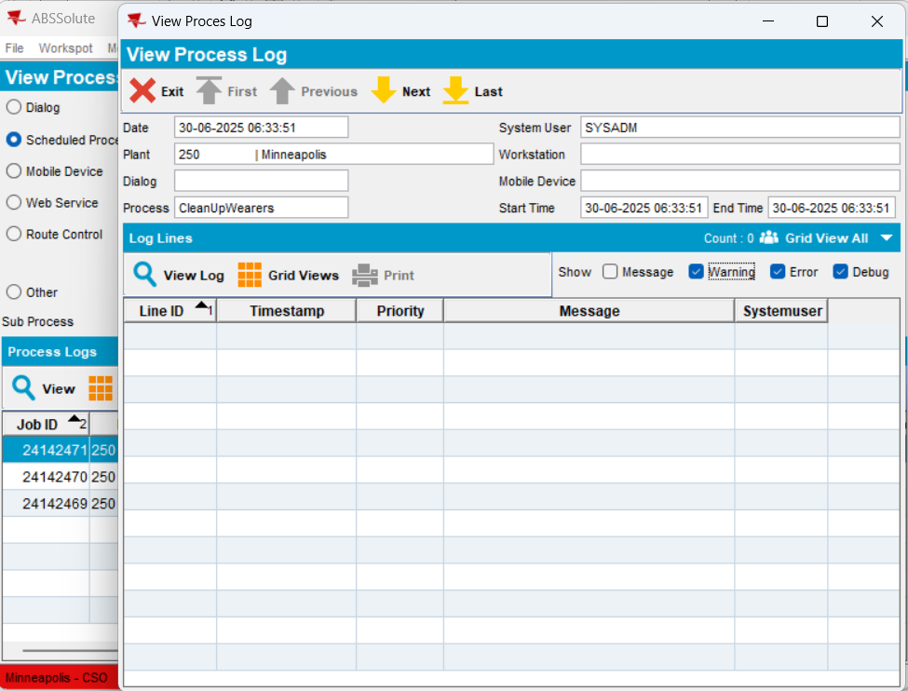

TEST OK
RETEST OK

