ABSN-5552 Blocking undeliverable and negative value line adjustments in WebX route check in
Environment | Prerequisites
Version: 9.08.00.RELEASE.p21  Environment=PRODUCTION  DBServerName= db01-buc.internal.abslbs.com  DBSID= CUST25  DBUser= AUS_ND90502  DBPassword= AUS_ ND90502 | - Module: -  - System setting: ALLOWUNDELIVROUTECHECKIN, INVOICELINEADJVALUERULE  - Others: BUs 250, 503
Contents:
Blocking undeliverable and negative value line adjustments in WebX route check in
#1 – Check Web Client X - Change Visit Status option – Passed 1
#2 – Check Web Client X - Modifying an Invoice Line Adjustment option – Passed 12

#1 – Check Web Client X - Change Visit Status option – Passed
Expected result:
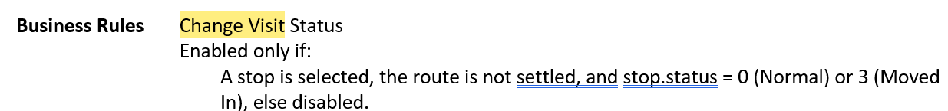
- If system setting ALLOWUNDELIVROUTECHECKIN = 1 and the currently select stop is marked as visited, then disable (so you cannot make a visited stop undeliverable but you can make an undeliverable into a visited stop)
- If system setting ALLOWUNDELIVROUTECHECKIN = 0 then no extra checks on the current stop status
Test case 1:
With module: AUSCUSTOM (BU:503)
ALLOWUNDELIVROUTECHECKIN = 1
- For Visited status the button: Change Visit Status is disabled
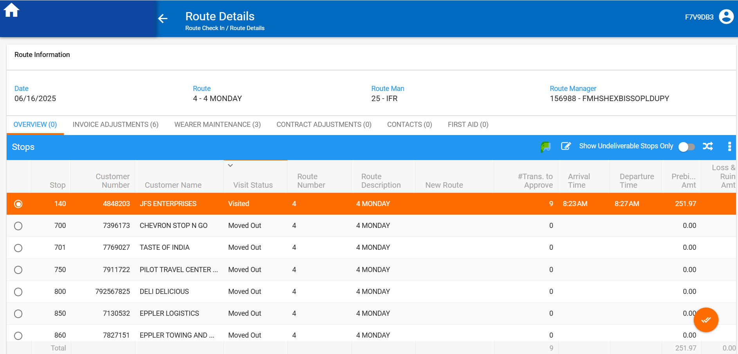
- For Cancelled status the button: Change Visit Status is disabled
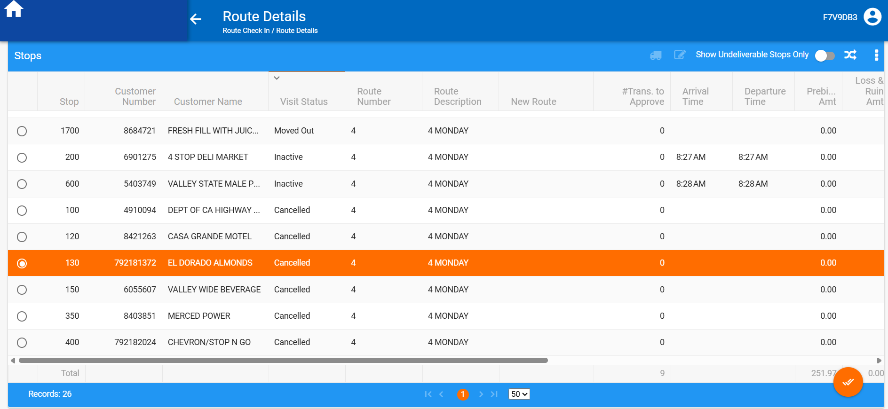

- For Moved Out status the button: Change Visit Status is disabled
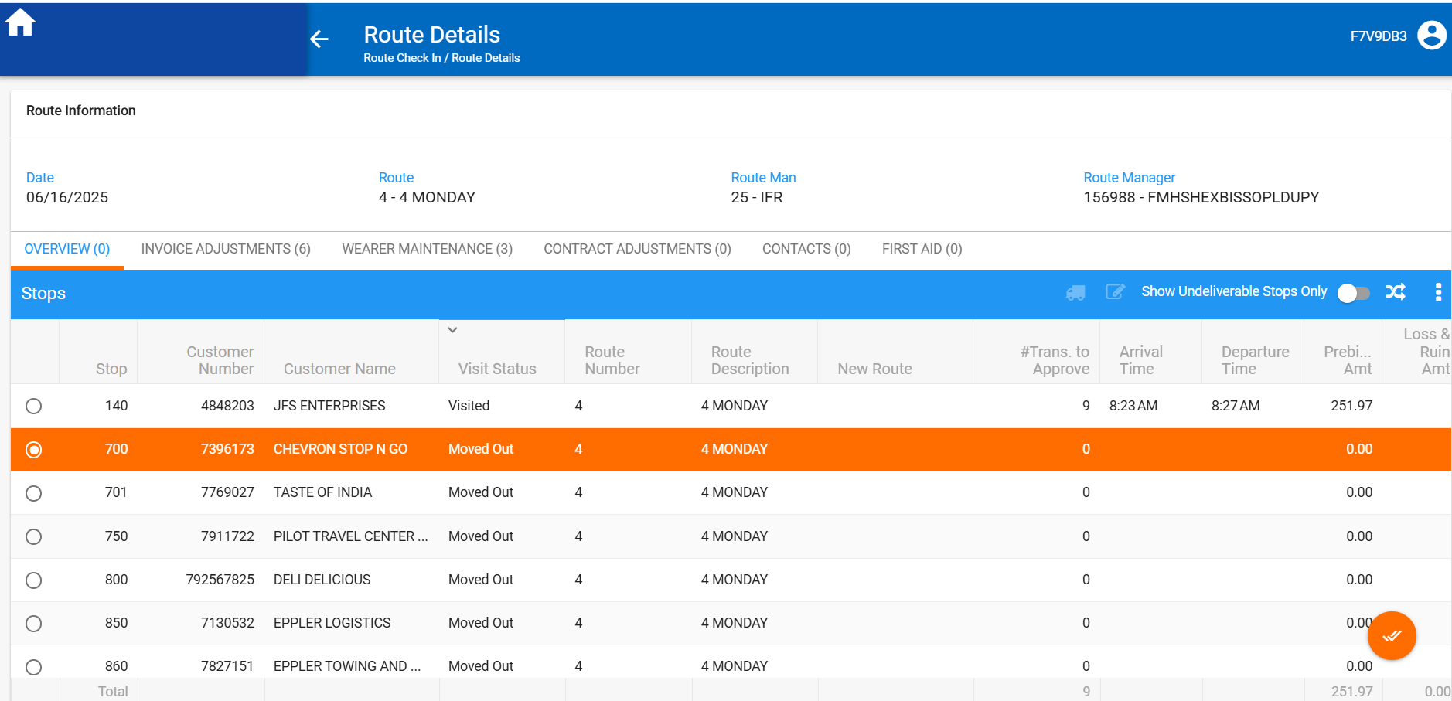

- For Inactive status the button: Change Visit Status is disabled
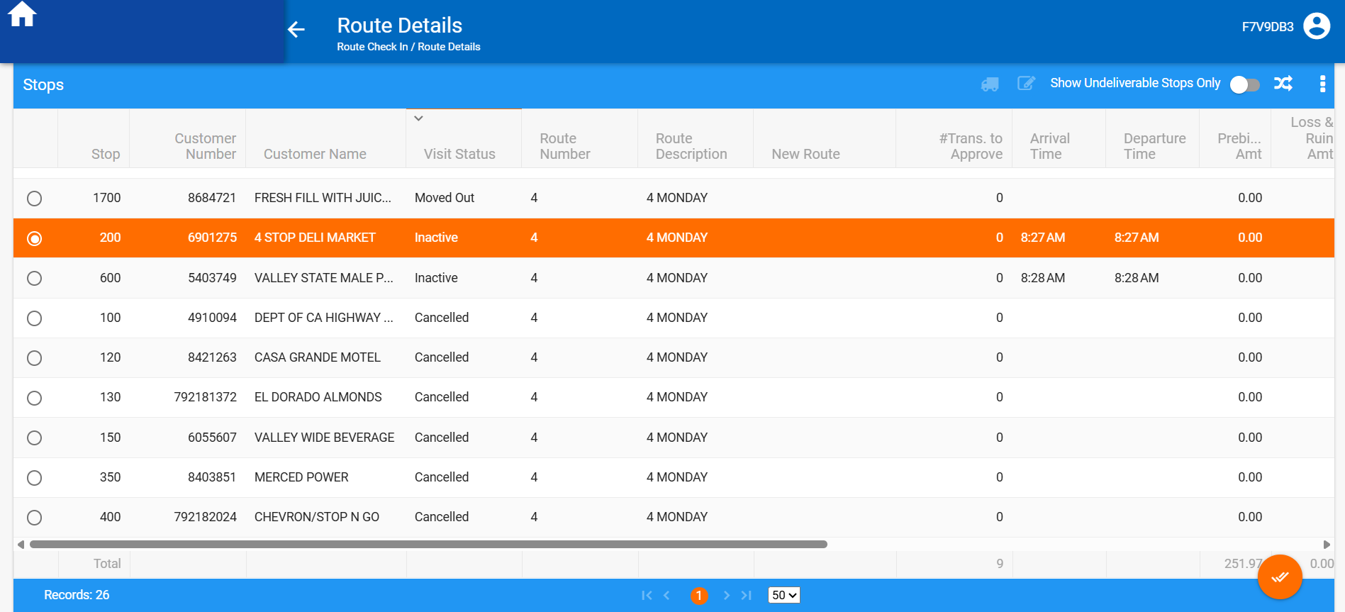

- For To be Visited status the button: Change Visit Status is enabled
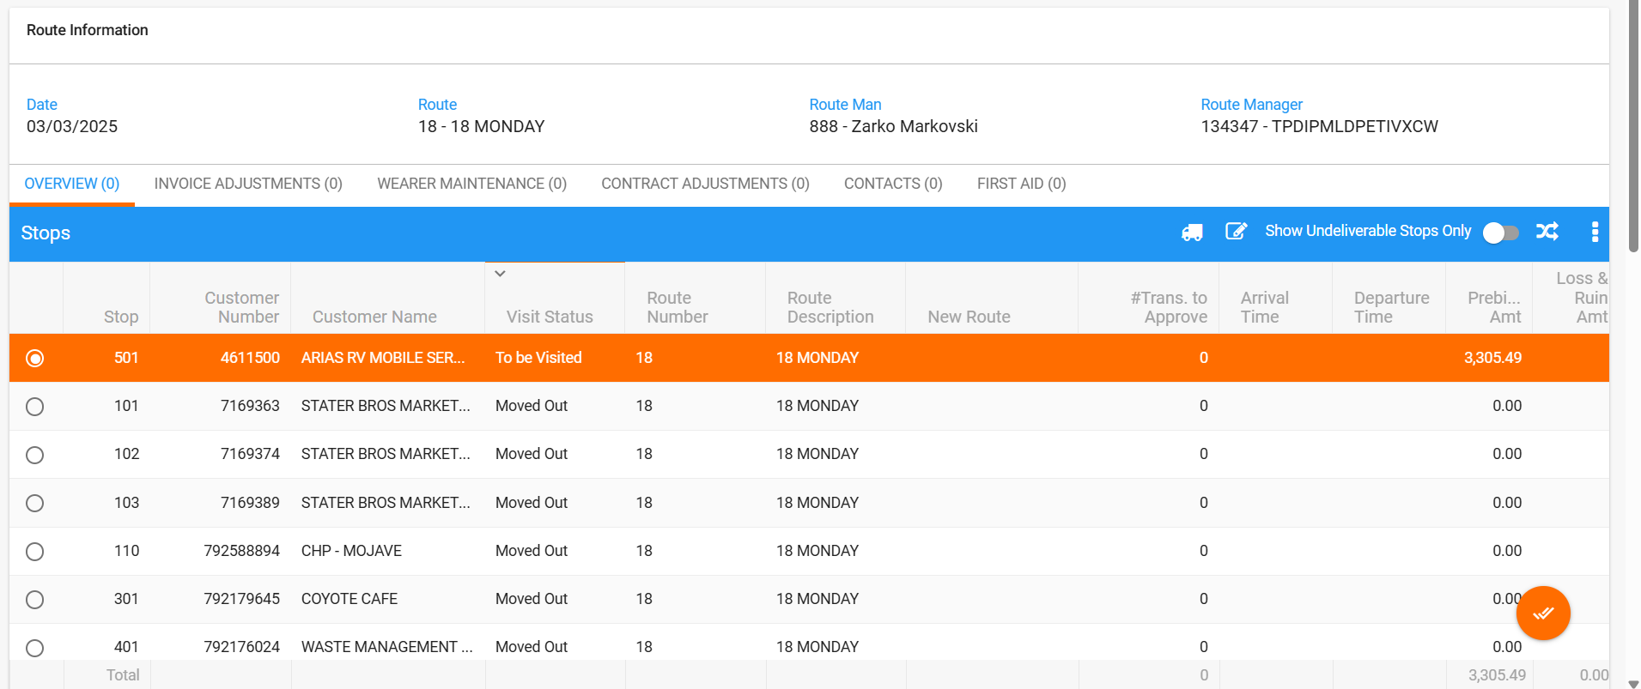

BU:250 without AUSCUSTOM module
Route 51 from 16.06.2025
For Visited status the button: Change Visit Status is disabled
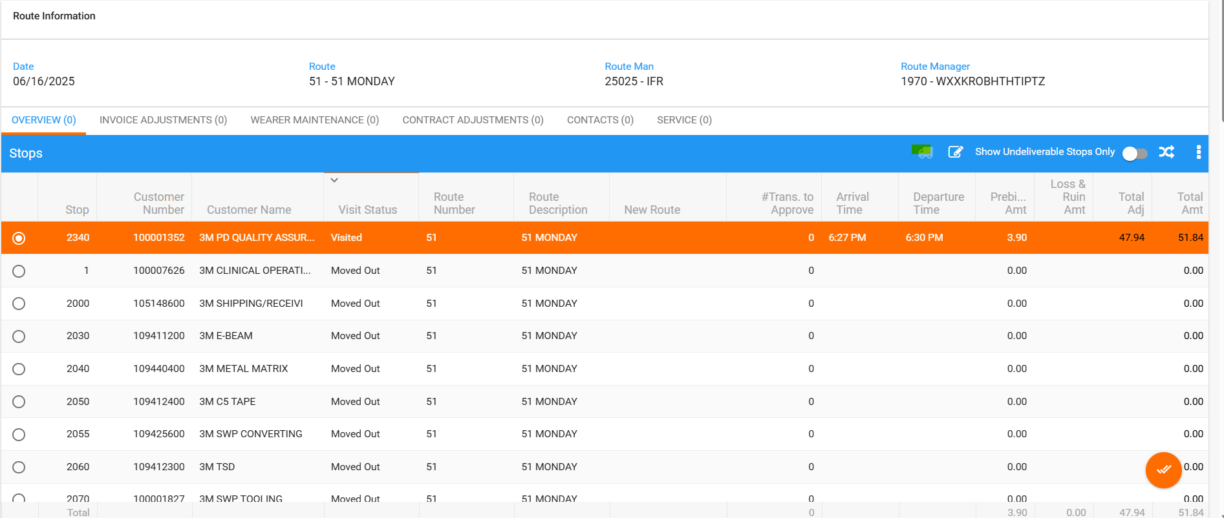
For Moved Out status the button: Change Visit Status is disabled
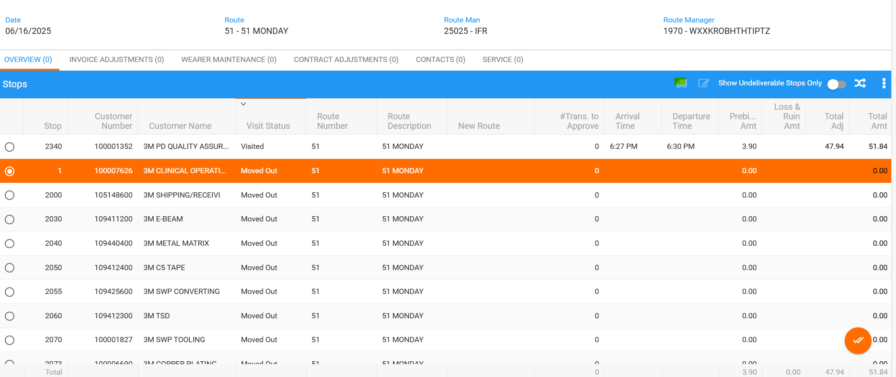

Test case 3:
Without module: AUSCUSTOM (BU:250), with module: AUSCUSTOM (BU:503)
ALLOWUNDELIVROUTECHECKIN = 0
- For Visited status the button: Change Visit Status is enabled
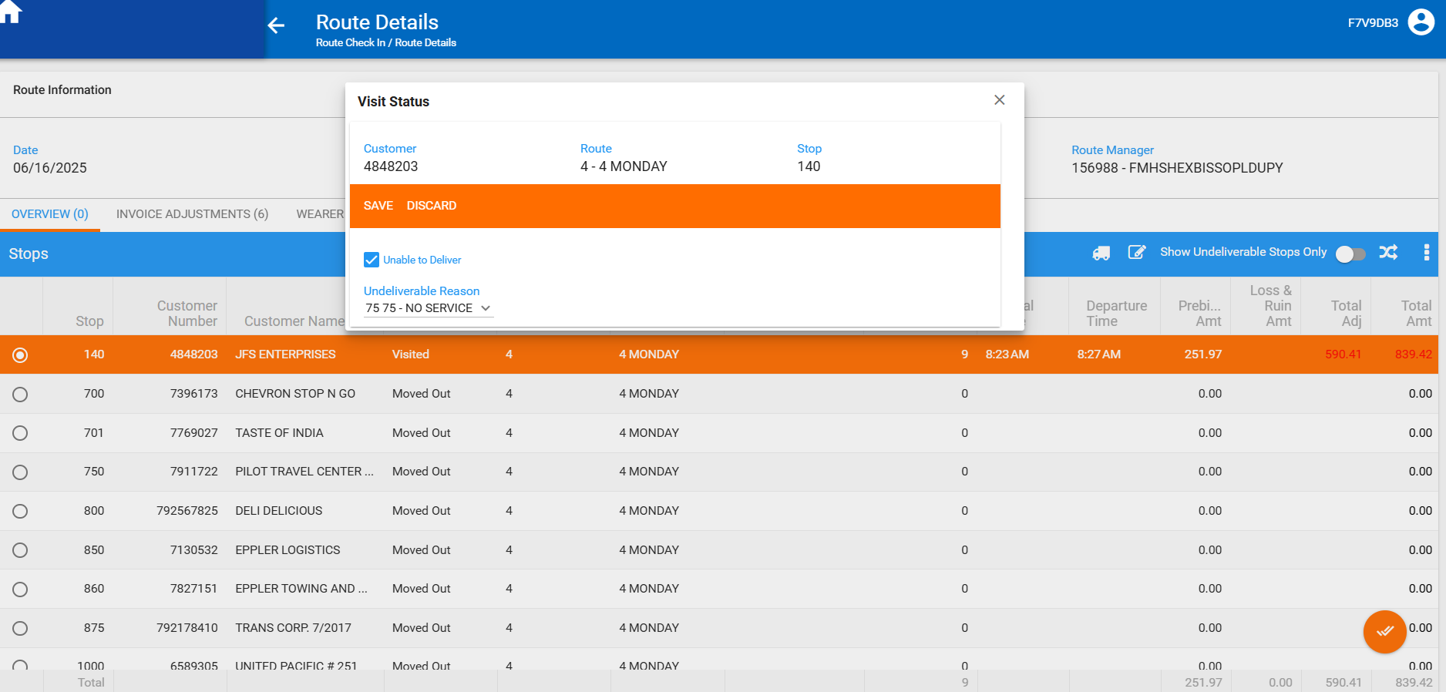

- For Cancelled status the button: Change Visit Status is disabled

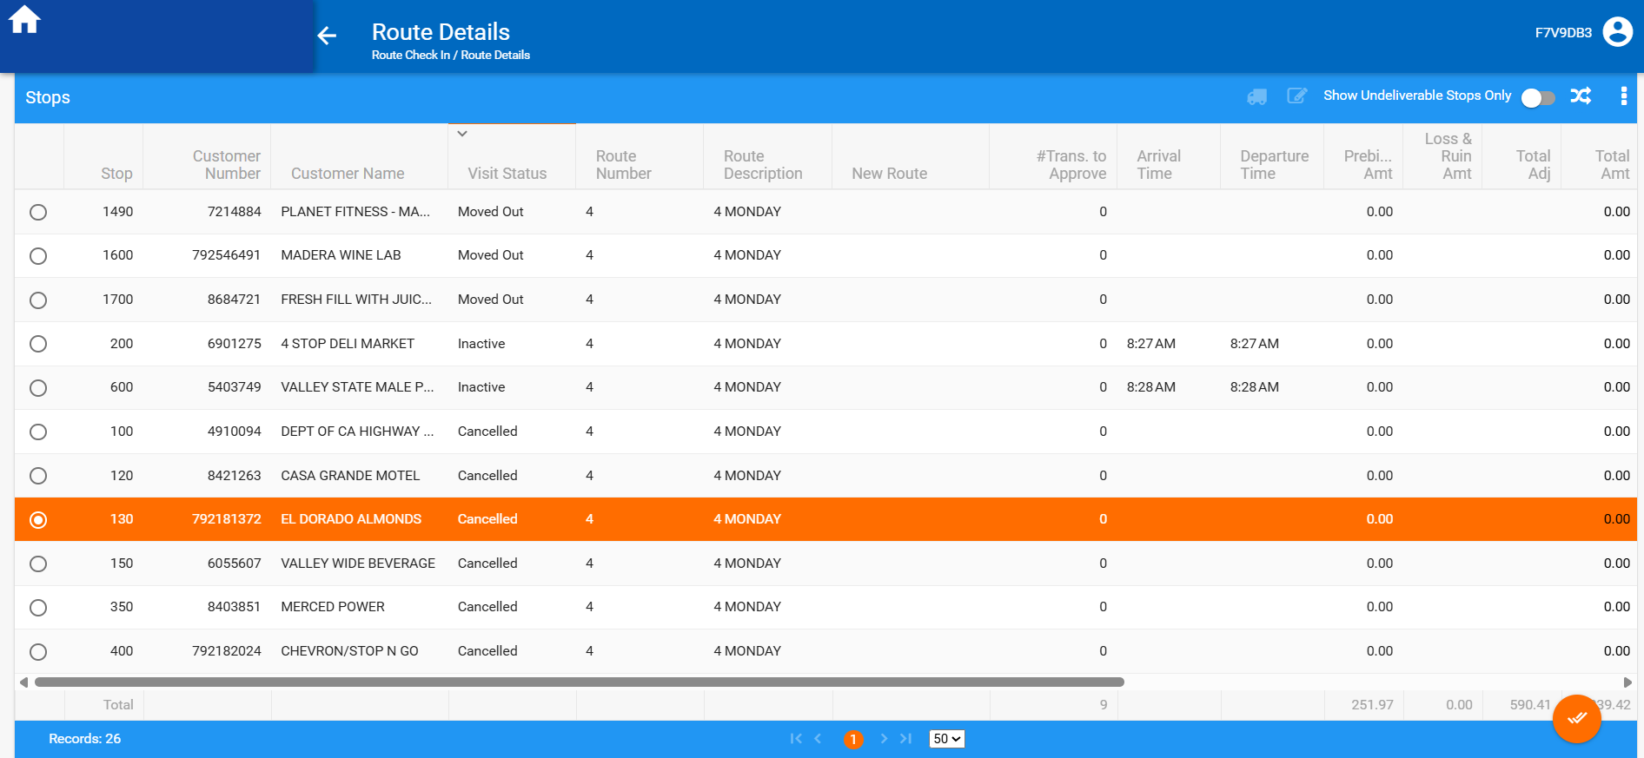

- For Moved Out status the button: Change Visit Status is disabled

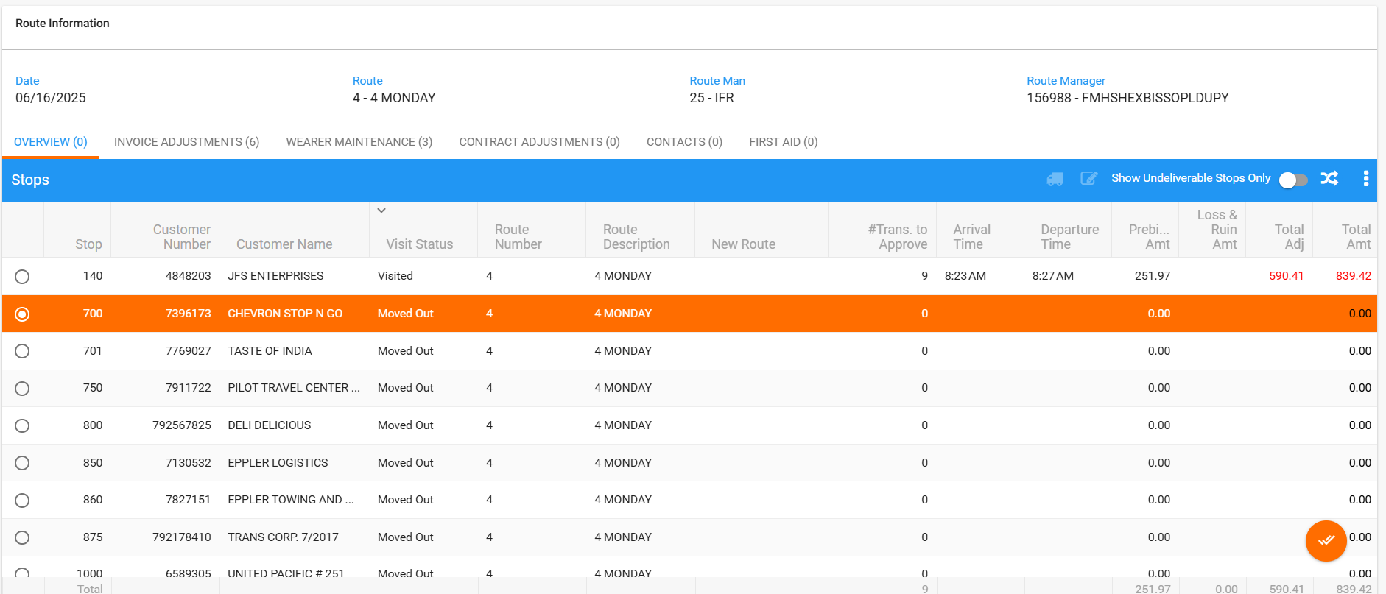

- For To be Visited status the button: Change Visit Status is enabled
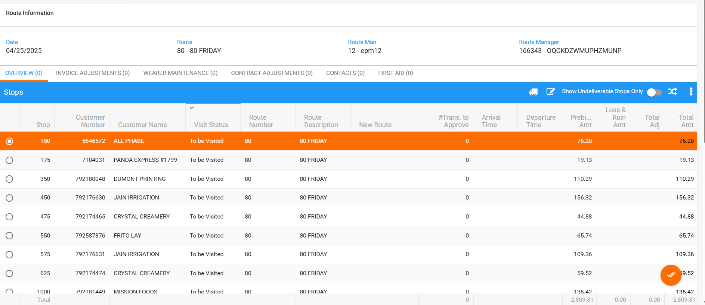

- For Inactive status the button: Change Visit Status is disabled

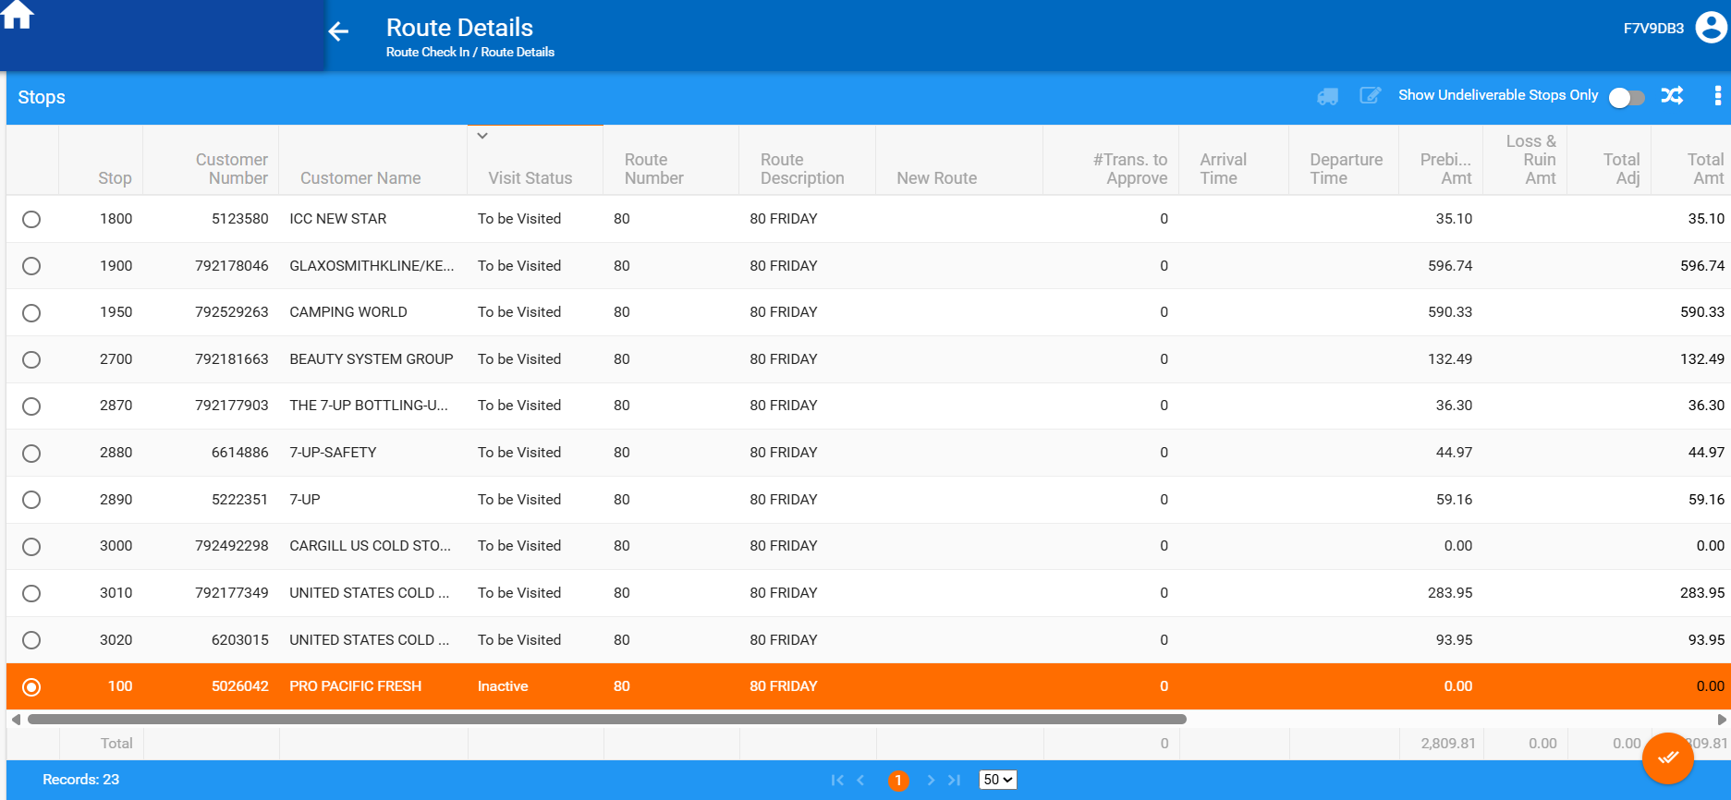

#2 – Check Web Client X - Modifying an Invoice Line Adjustment option – Passed

Expected result:
- In ADD mode:
- If system setting INVOICELINEADJVALUERULE = 2 then the adjusted amount cannot be negative. If so, then on save show an error saying “You cannot decrease the amount of this invoice line” and do not save

- In MODIFY mode If system setting INVOICELINEADJVALUERULE = 2
- If the adjustment being made decreases the value of the invoice line that came from the RA (so the value of the invoice line the customer signed for) then this is not allowed.
- If not allowed, then show an error message like the above but worded “You cannot decrease the amount of this invoice line” reset the value and block the save.
Test case 1:
INVOICELINEADJVALUERULE=2 (BU:250 without AUSCUSTOM module)
Route 51 from 16.06.2025
- Initial values from RA:
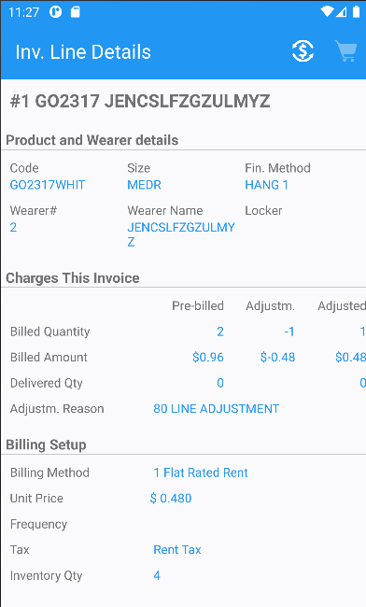
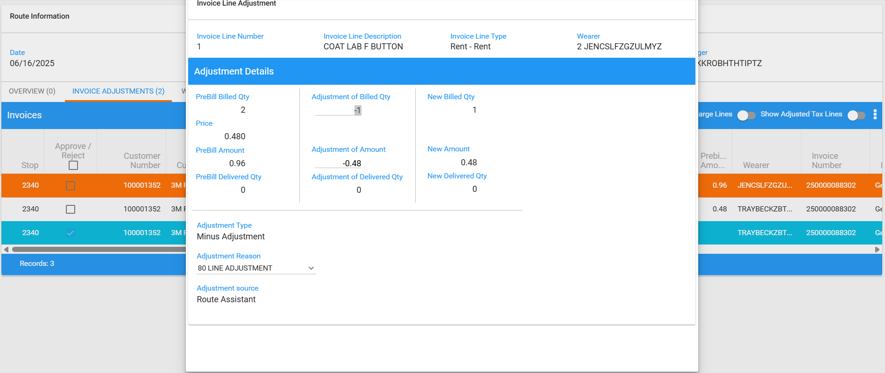
- Modify:
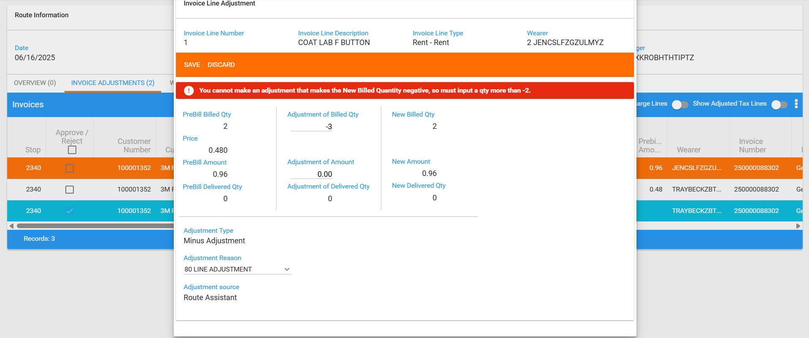
- Correct error message.
- Do a plus adjustment
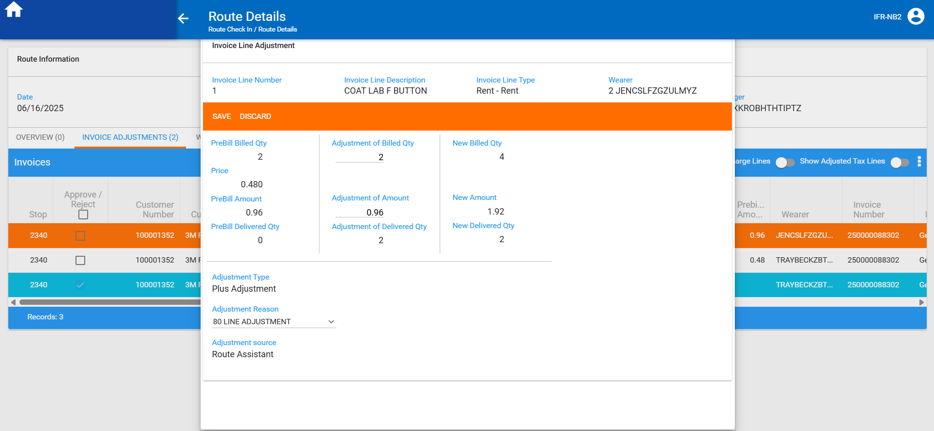
- It is allowed
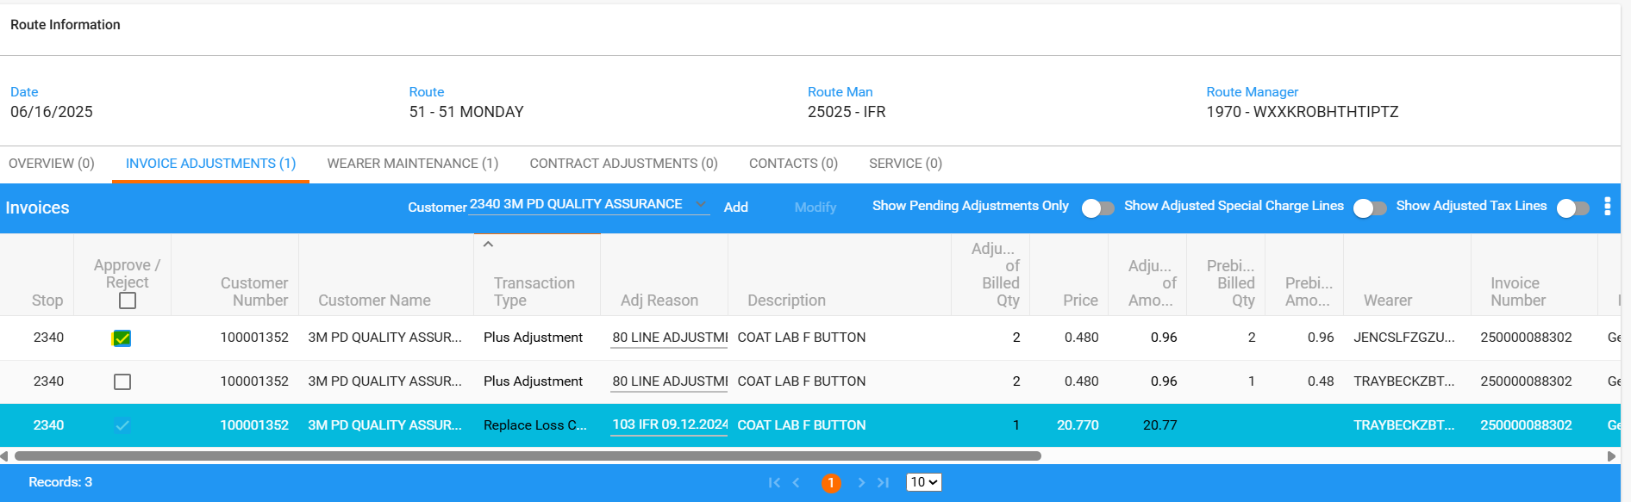

- Another invoice line:
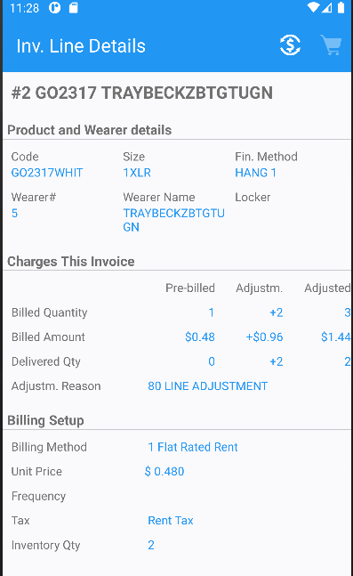
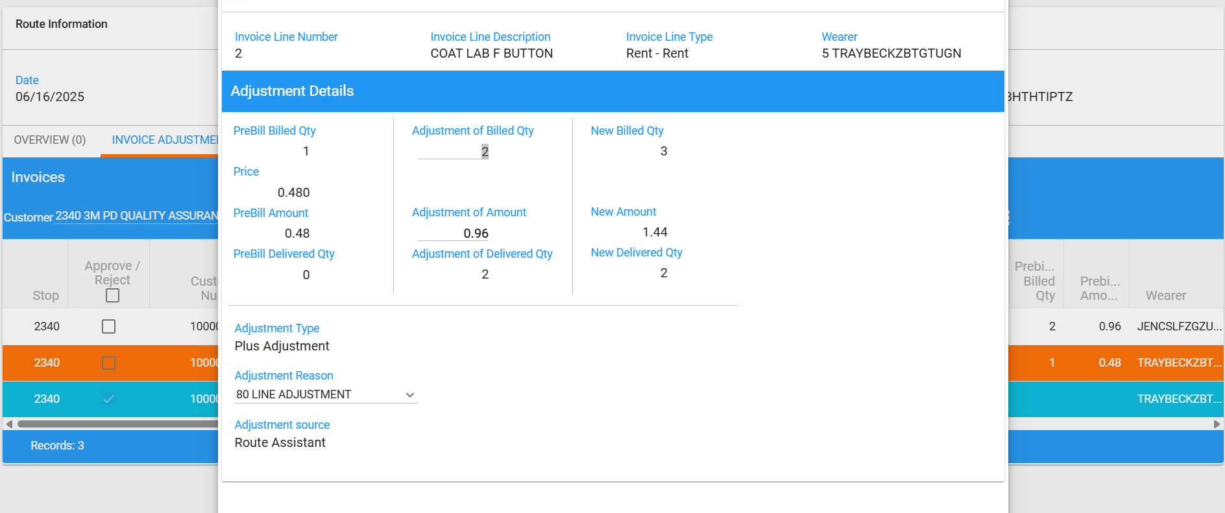
- Modify:
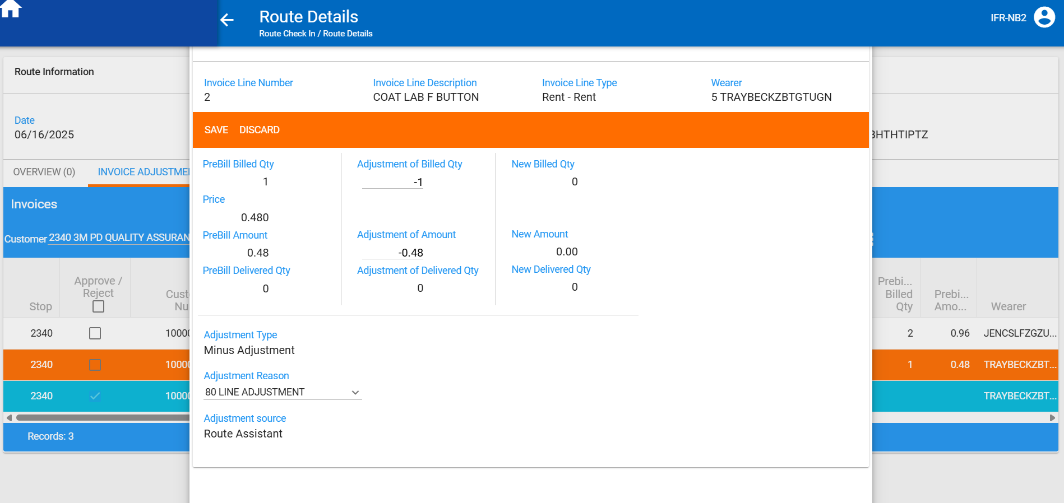
- New amount: 0 < initial RA amount: 1.44 -> decrease is not allowed -> passed
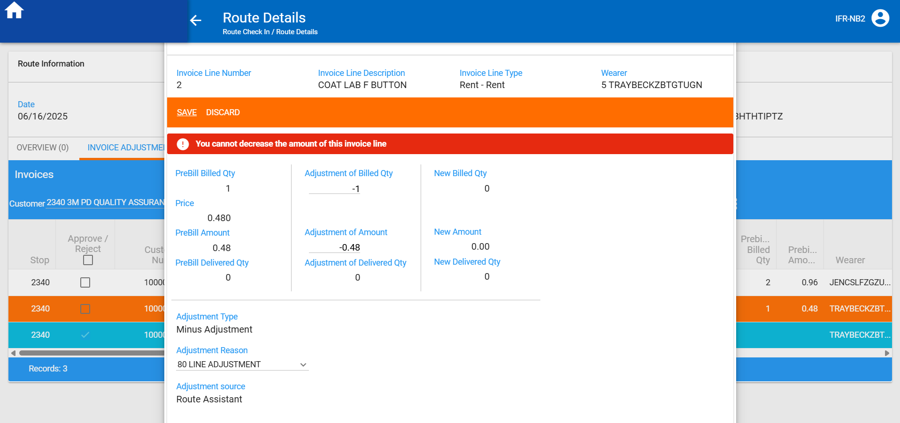

- Another invoice line:

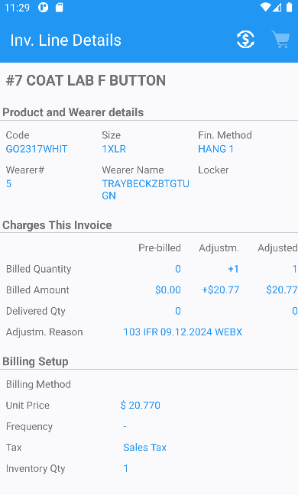
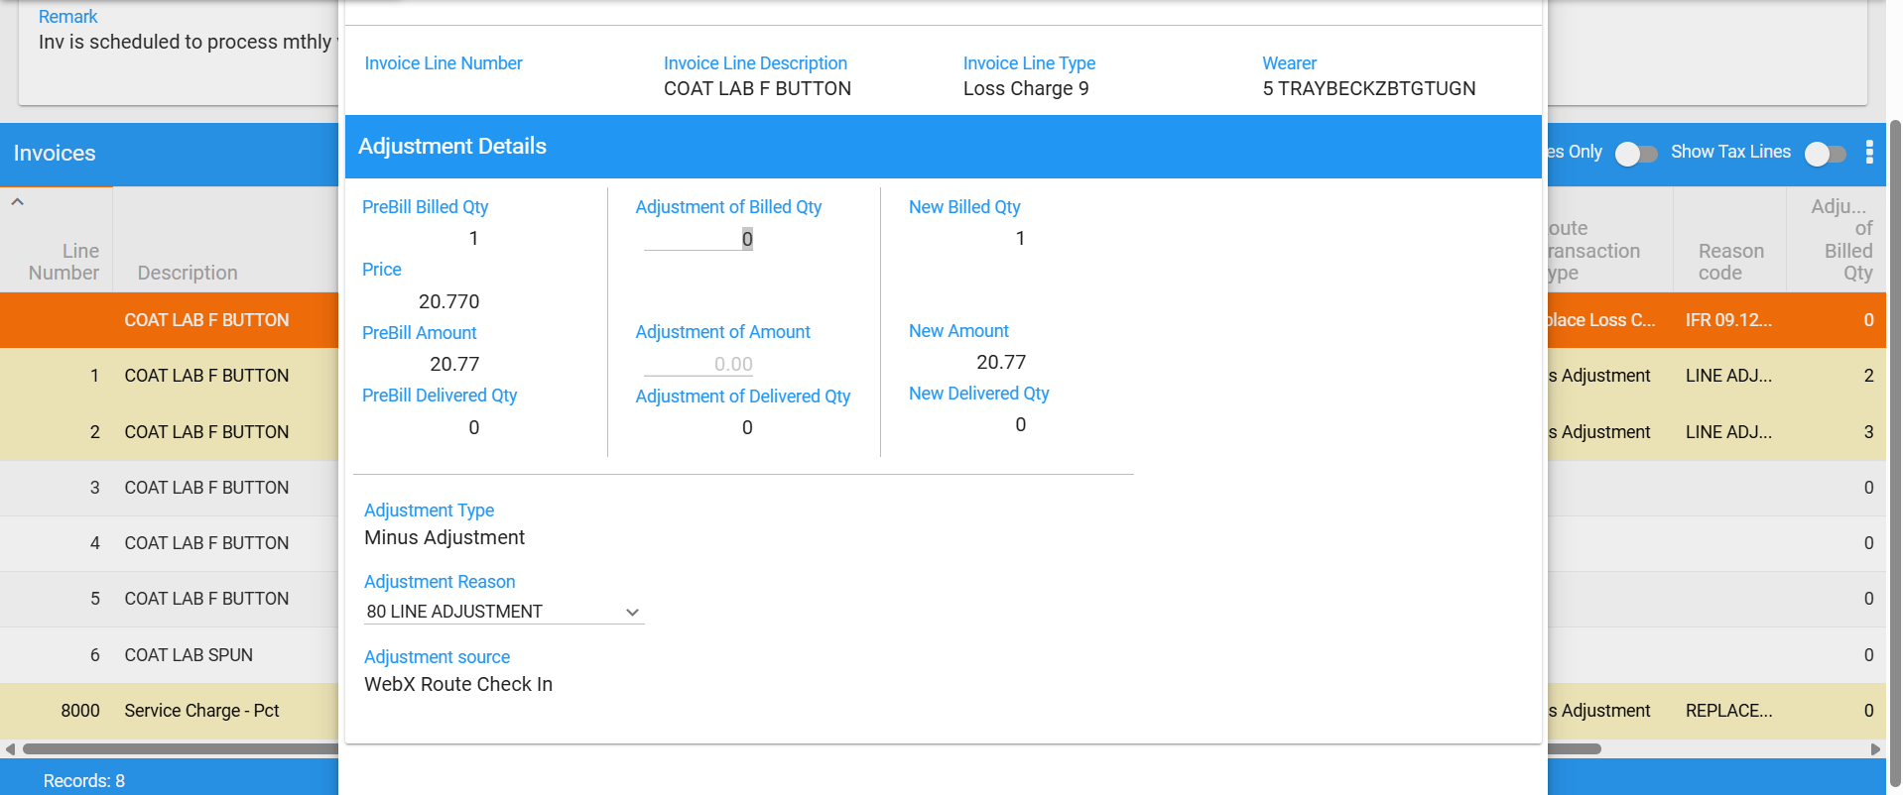
- Modify:
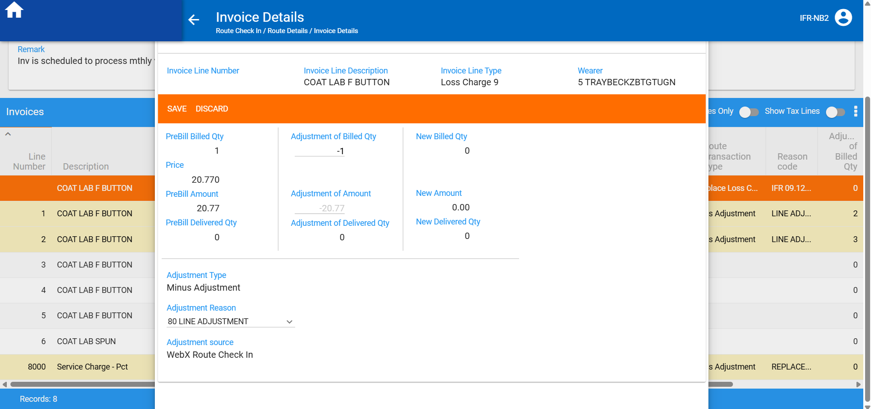
- New amount: 0 < initial RA amount: 20.77 -> decrease is not allowed -> passed
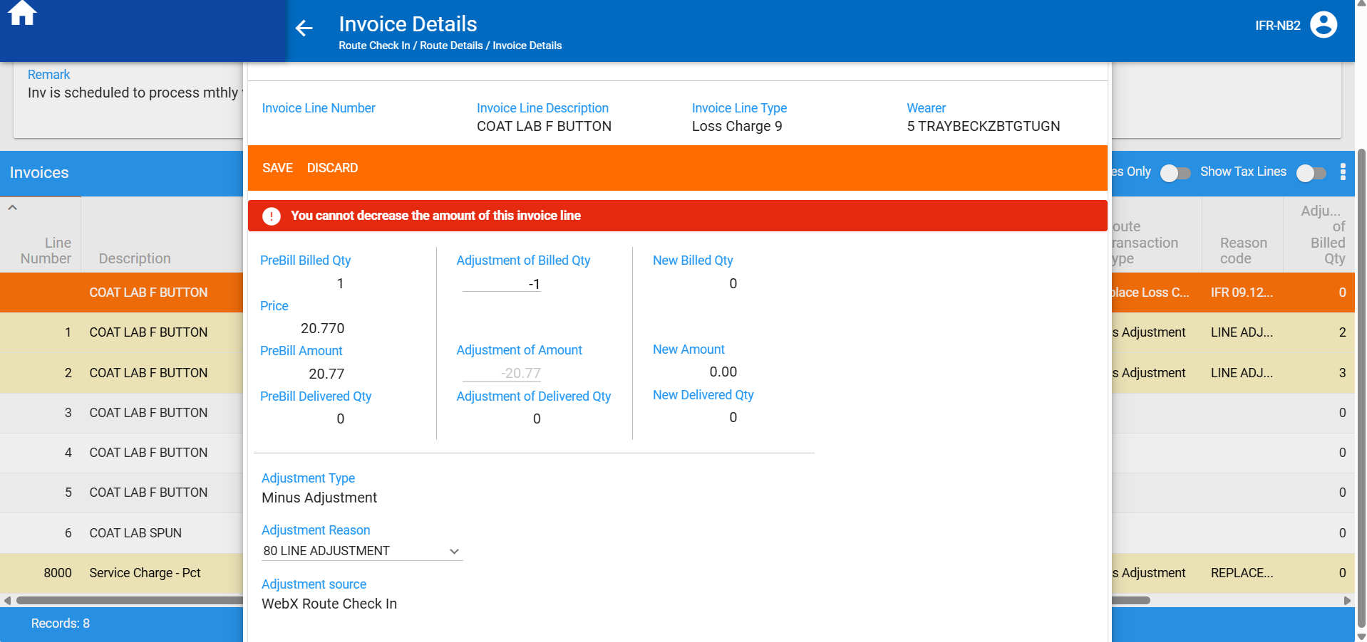

Test case 2:
INVOICELINEADJVALUERULE=2 (BU:503 with AUSCUSTOM module)
Route 4 from 16.06.2025
Invoice Adjustments tab -> Modify mode
RA values:
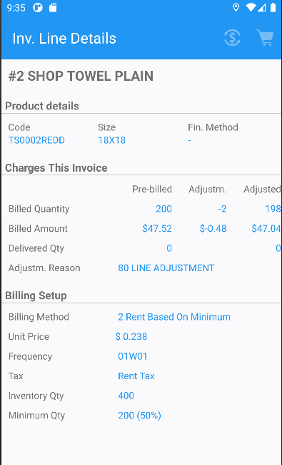
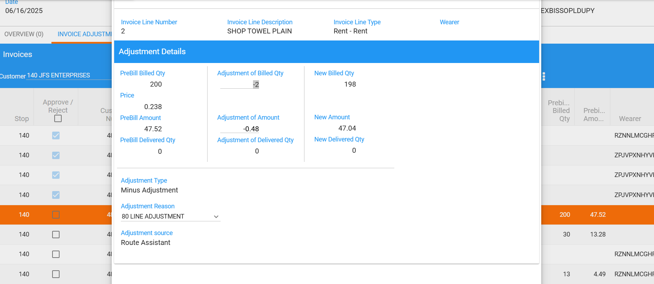
- Modify adj.qty to -1
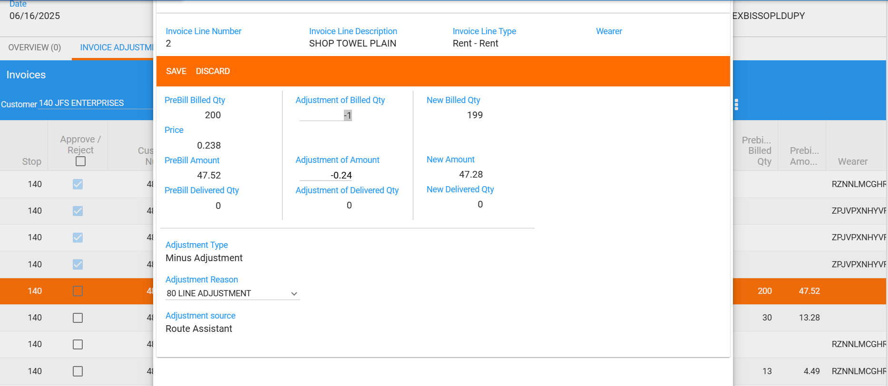
- Initial RA amount: 47.04 < New amount: 47.28 -> decrease is allowed -> passed
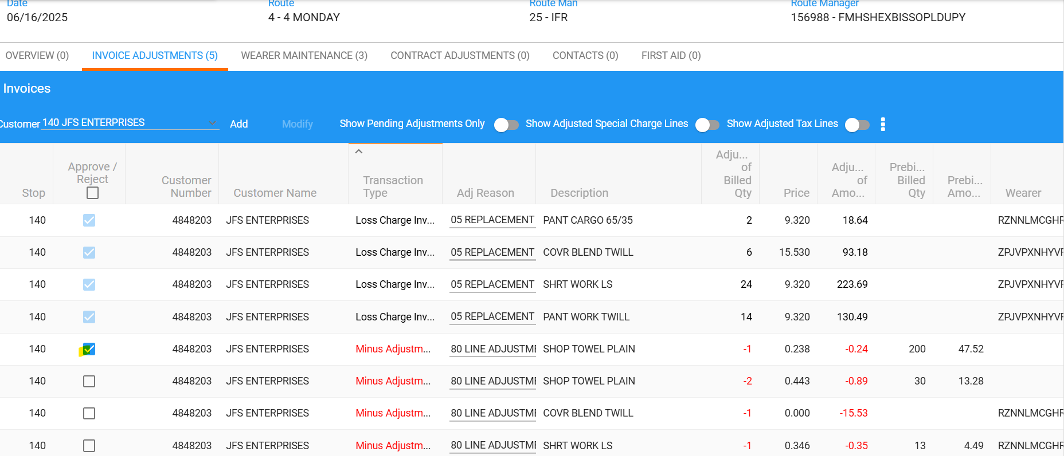
- Unapproved the adjustment for this line and modify again to – 3 qty
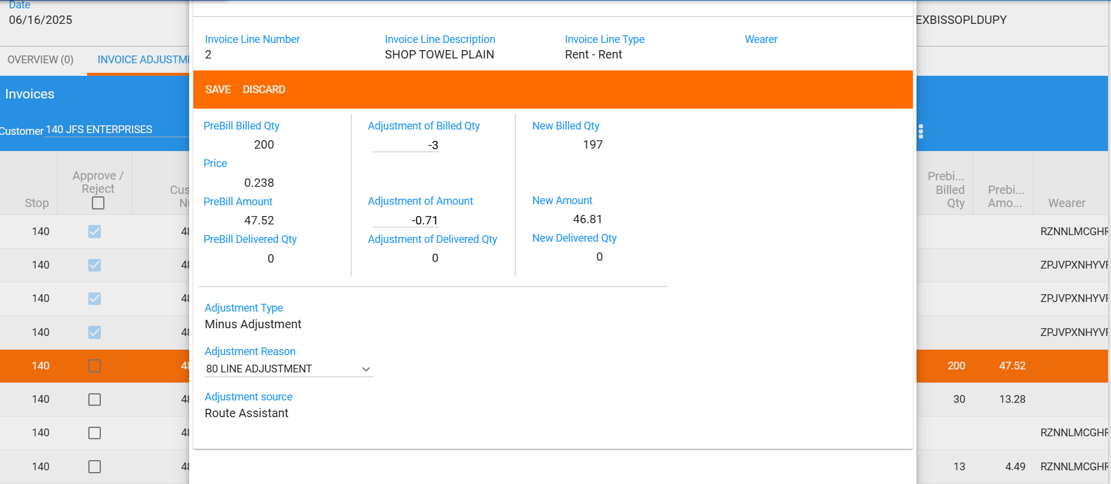
- New amount: 46.81 < initial RA amount: 47.04 -> decrease is not allowed -> passed
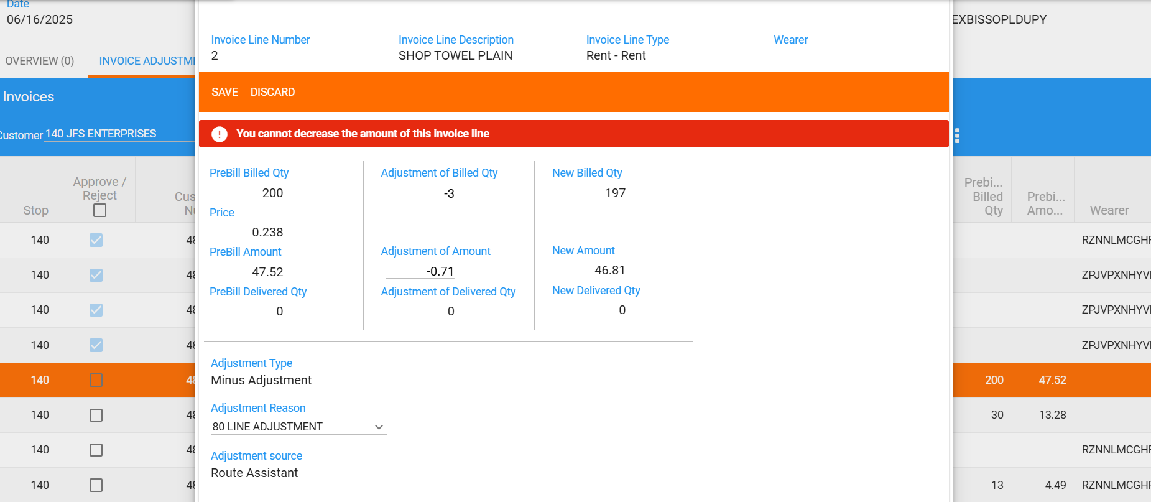

- Another invoice line with RA amount: 12.39
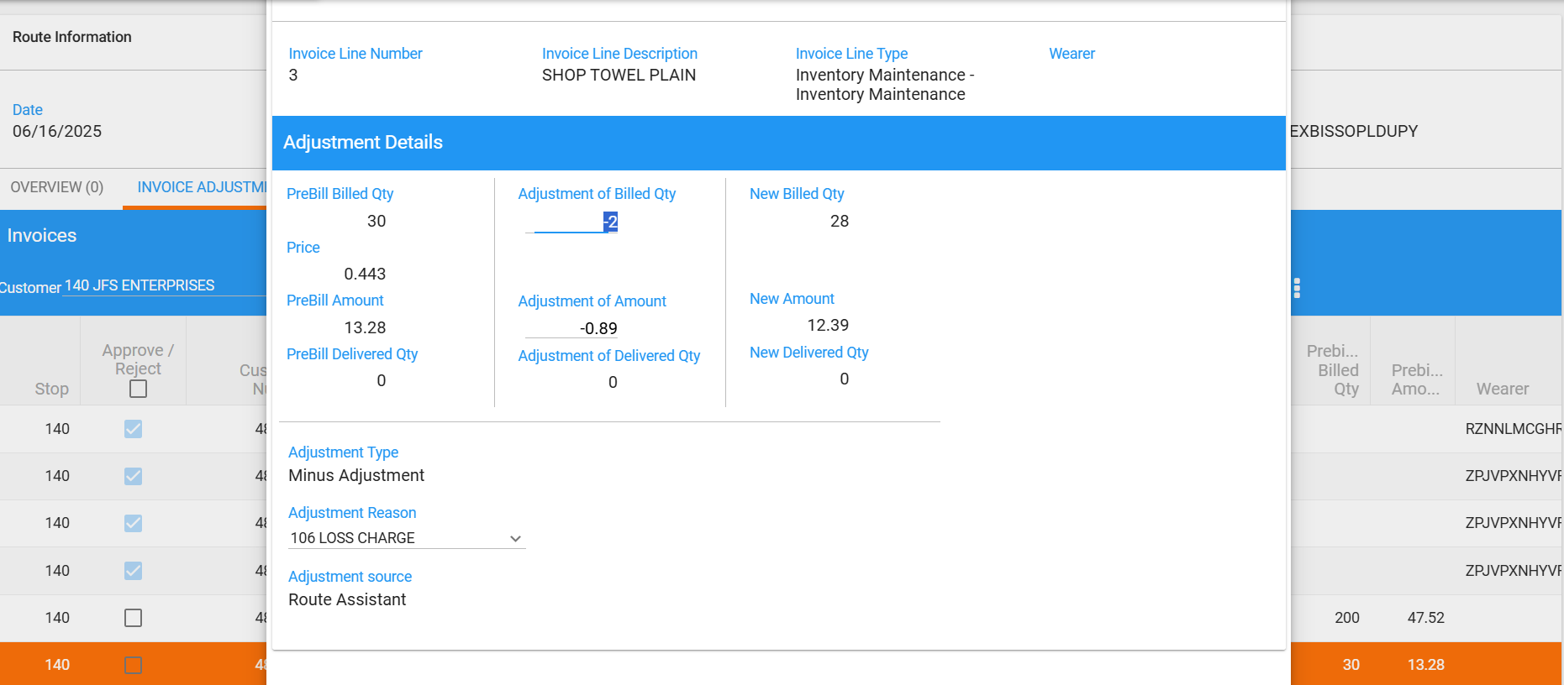
- Modify:
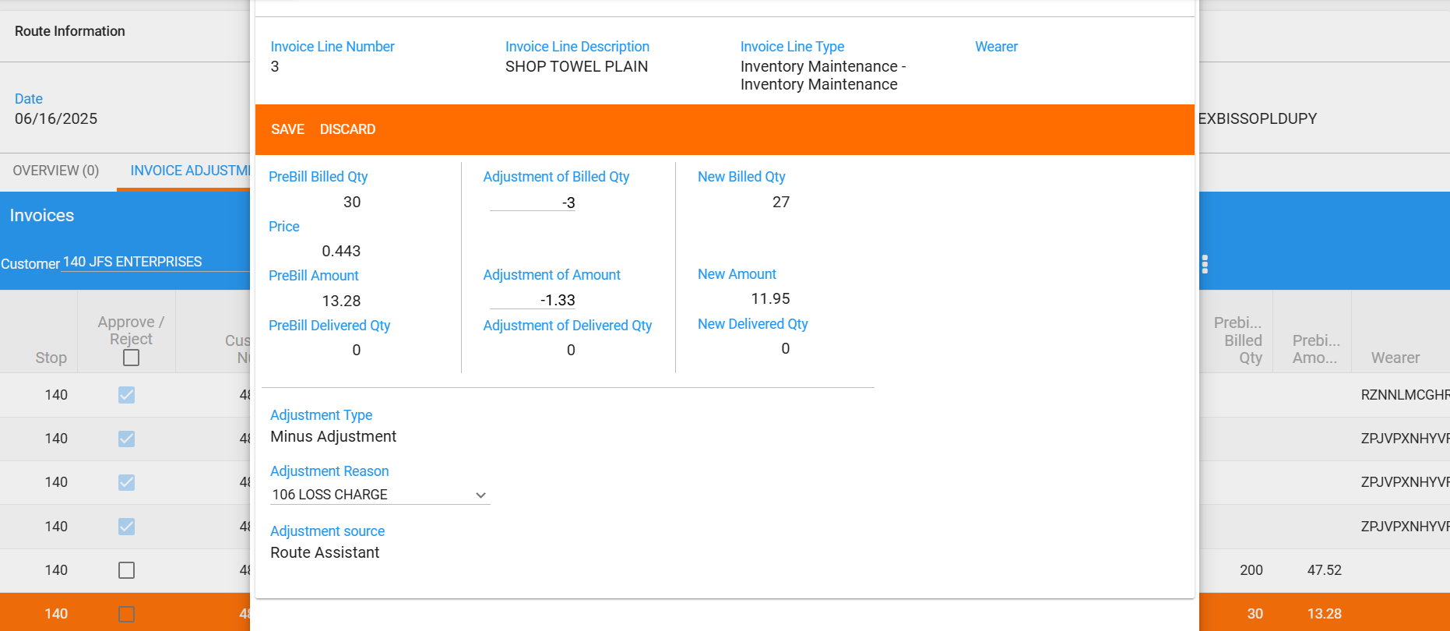

- New amount: 11.95 < initial RA amount: 12.39 -> decrease is not allowed -> passed
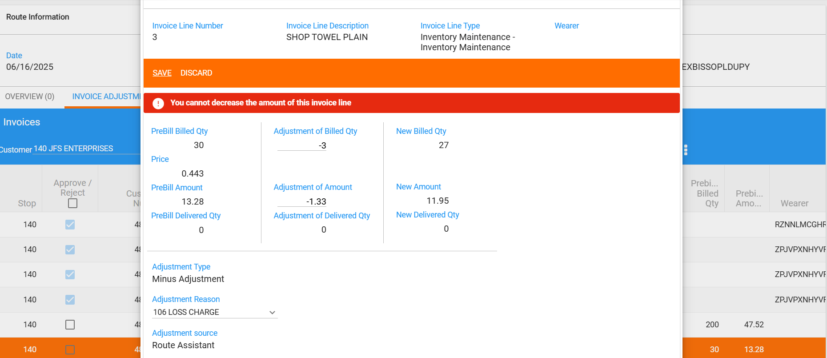
- Modify adj. of amount:
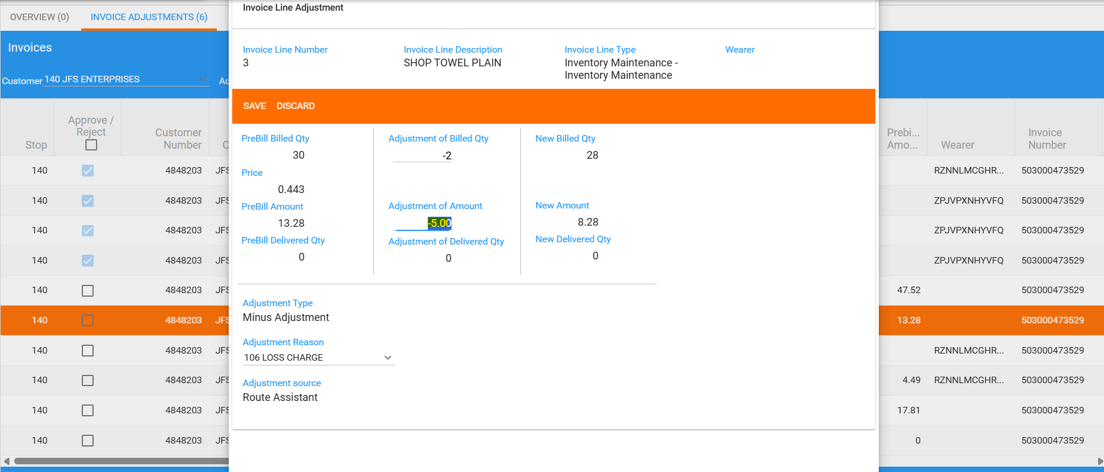

- New amount: 8.28 < initial RA amount: 12.39 -> decrease is not allowed -> passed
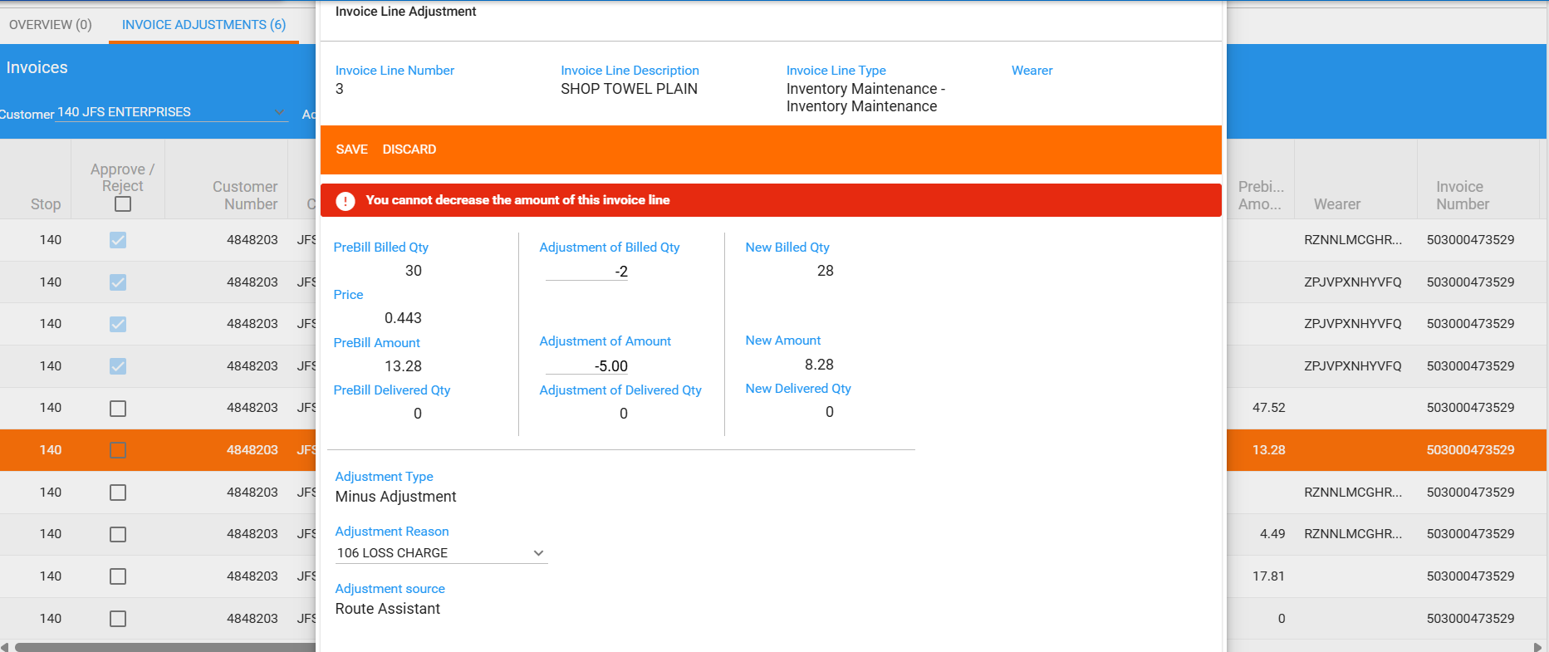

- Another invoice line:
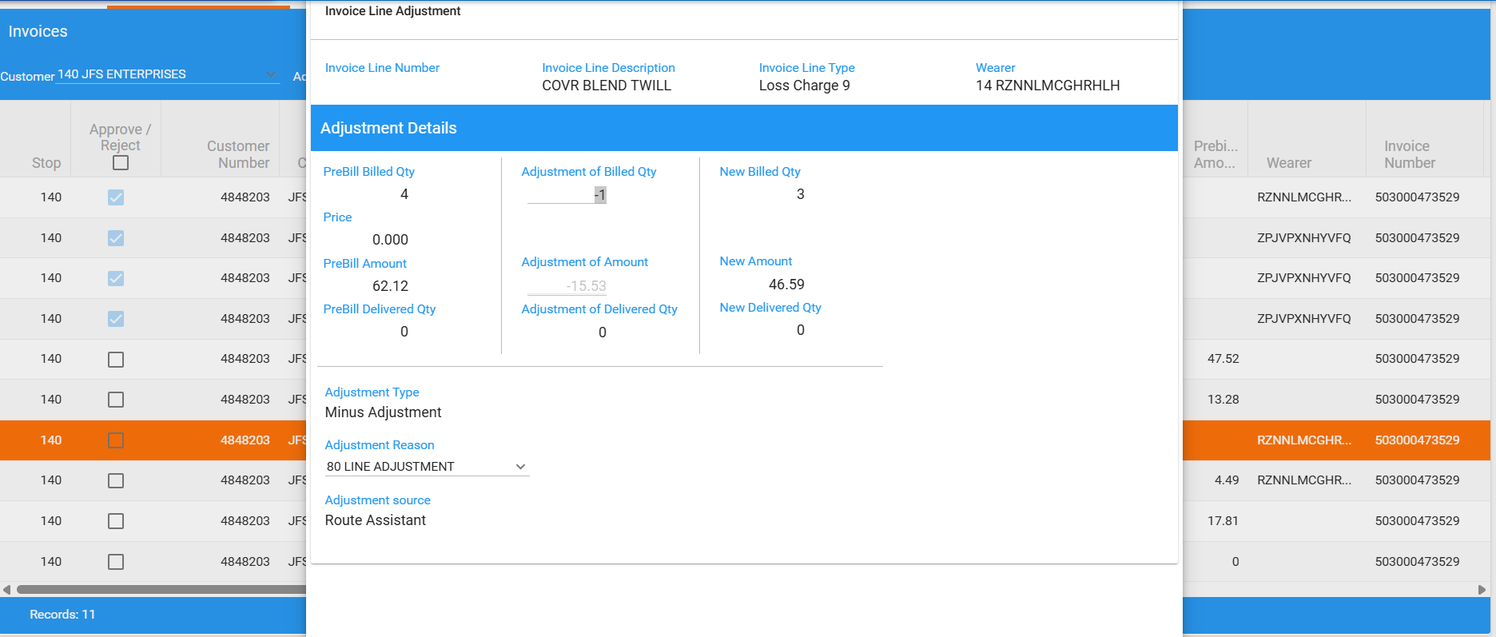
- Modify:
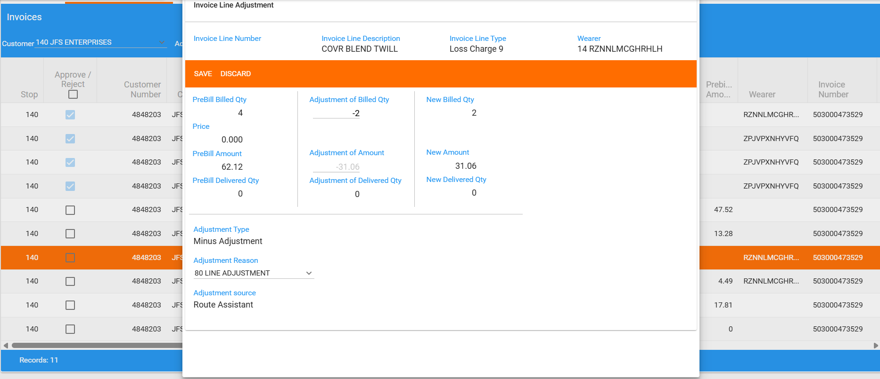
- New amount: 31.06 < initial RA amount: 46.59 -> decrease is not allowed -> passed
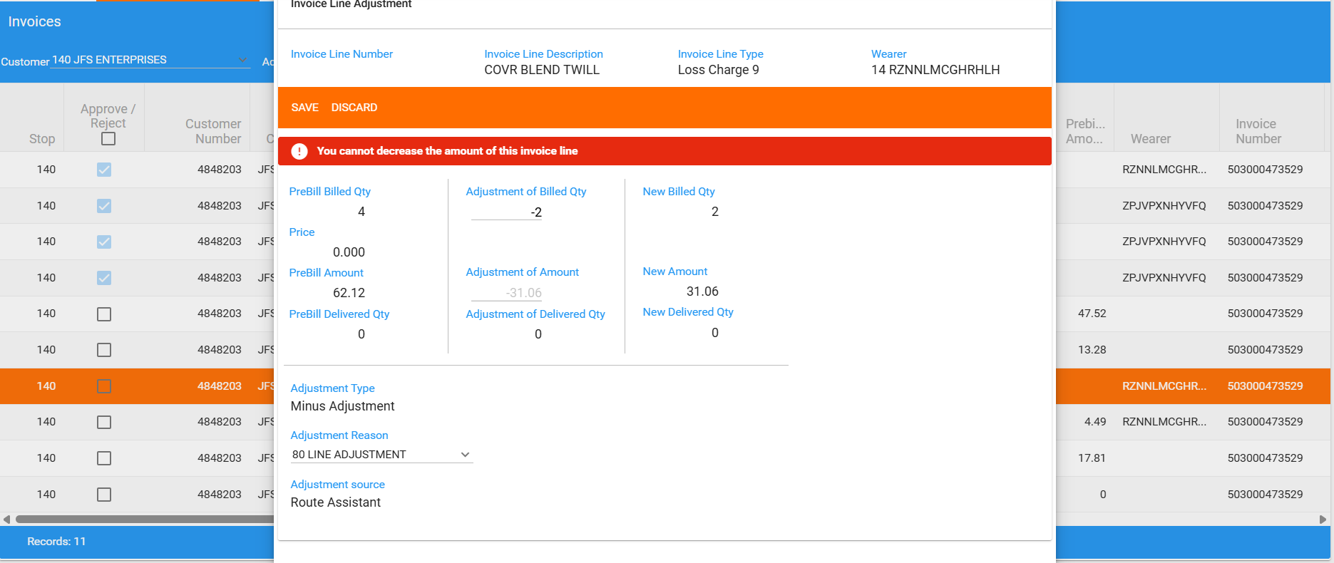

- Another invoice line:
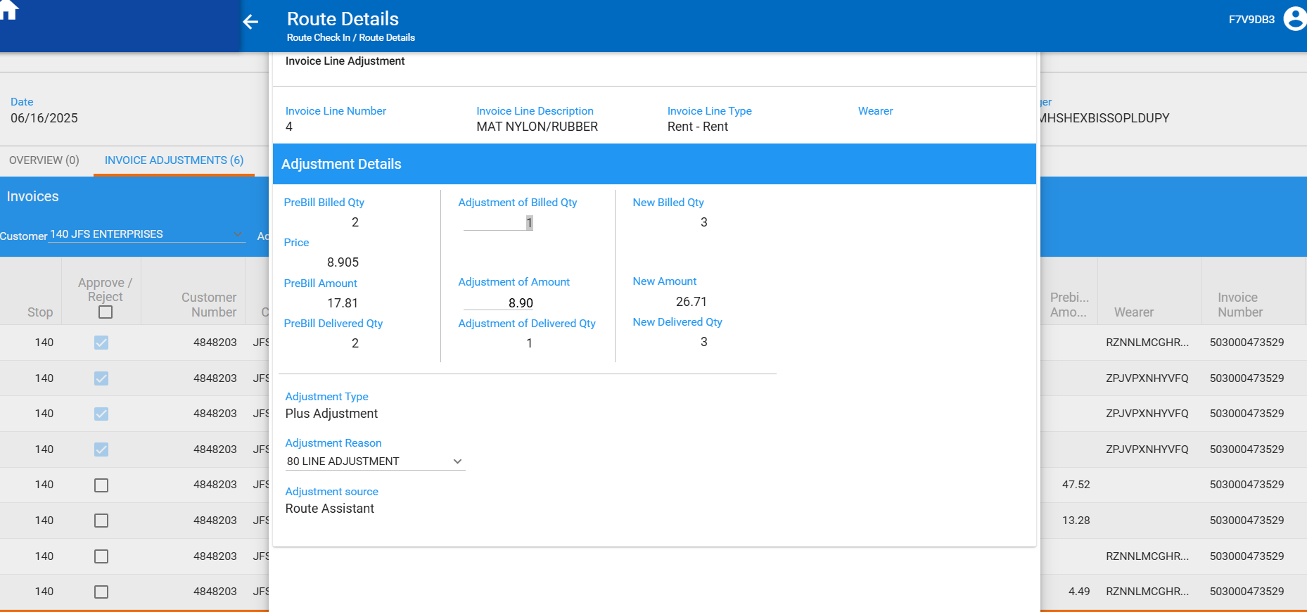
- Modify
- New amount: 8.90 < initial RA amount: 26.71 -> decrease is not allowed -> passed
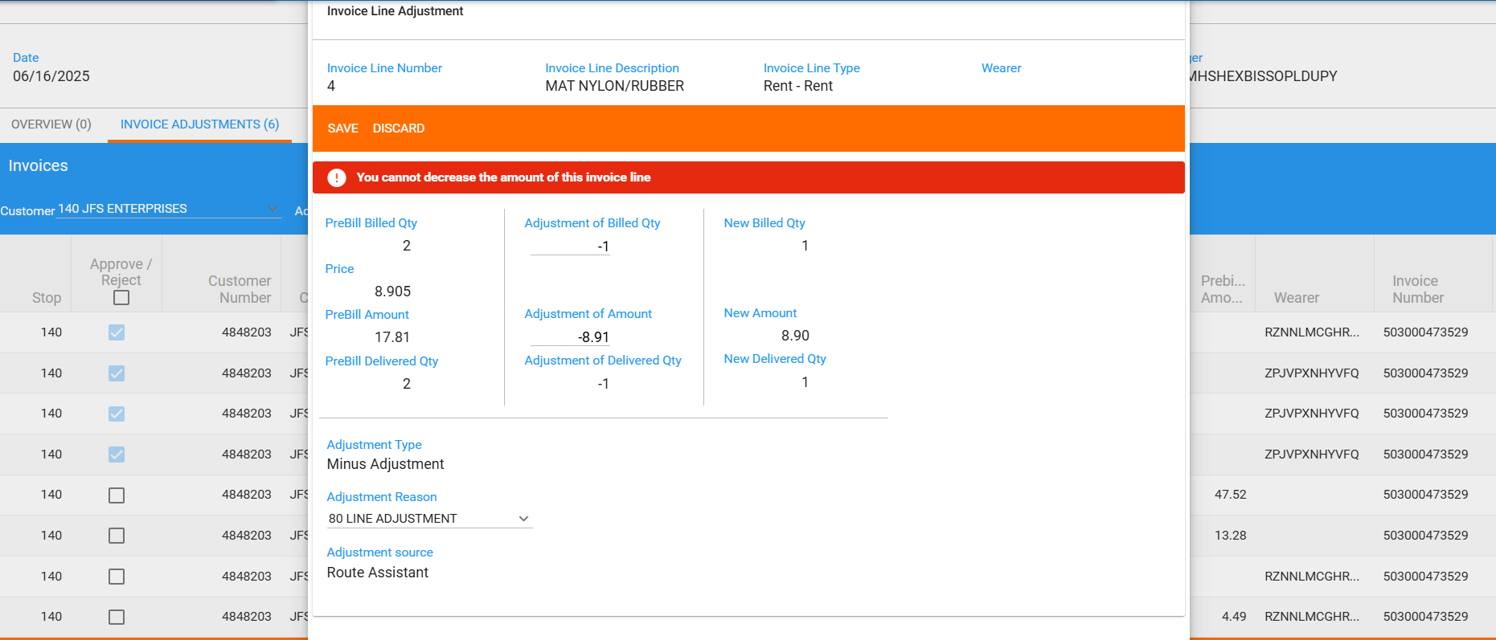

- Invoice details page
- Add a minus adjustment for a loss charge invoice line
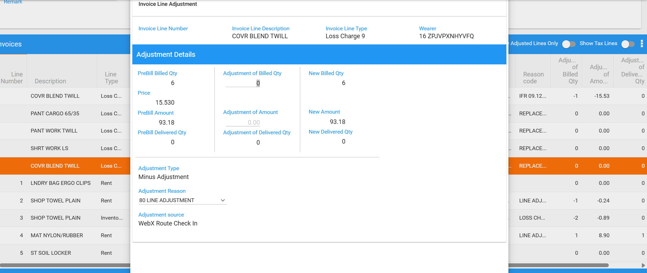
- Decrease in add mode is not allowed -> passed
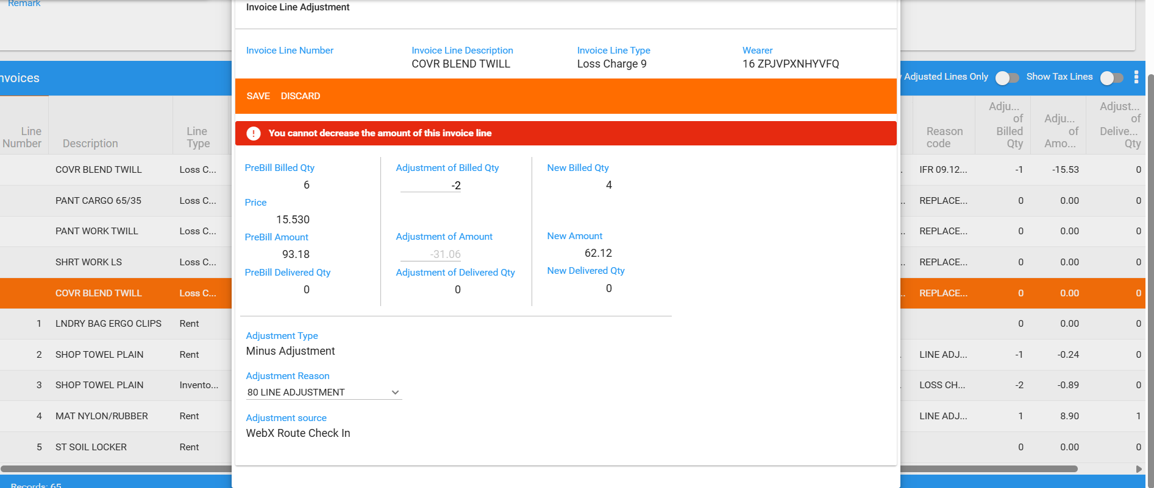

- Add a plus adjustment for another invoice line:
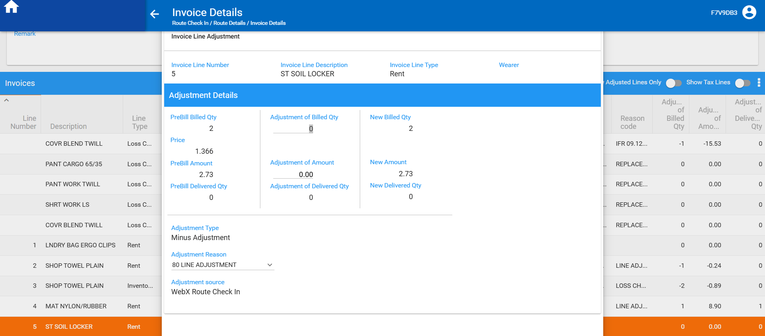
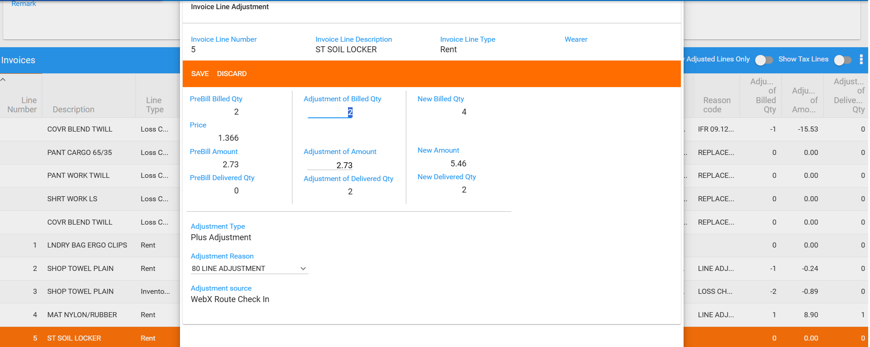
- Unapproved this new invoice line on Invoice Adjustments tab:
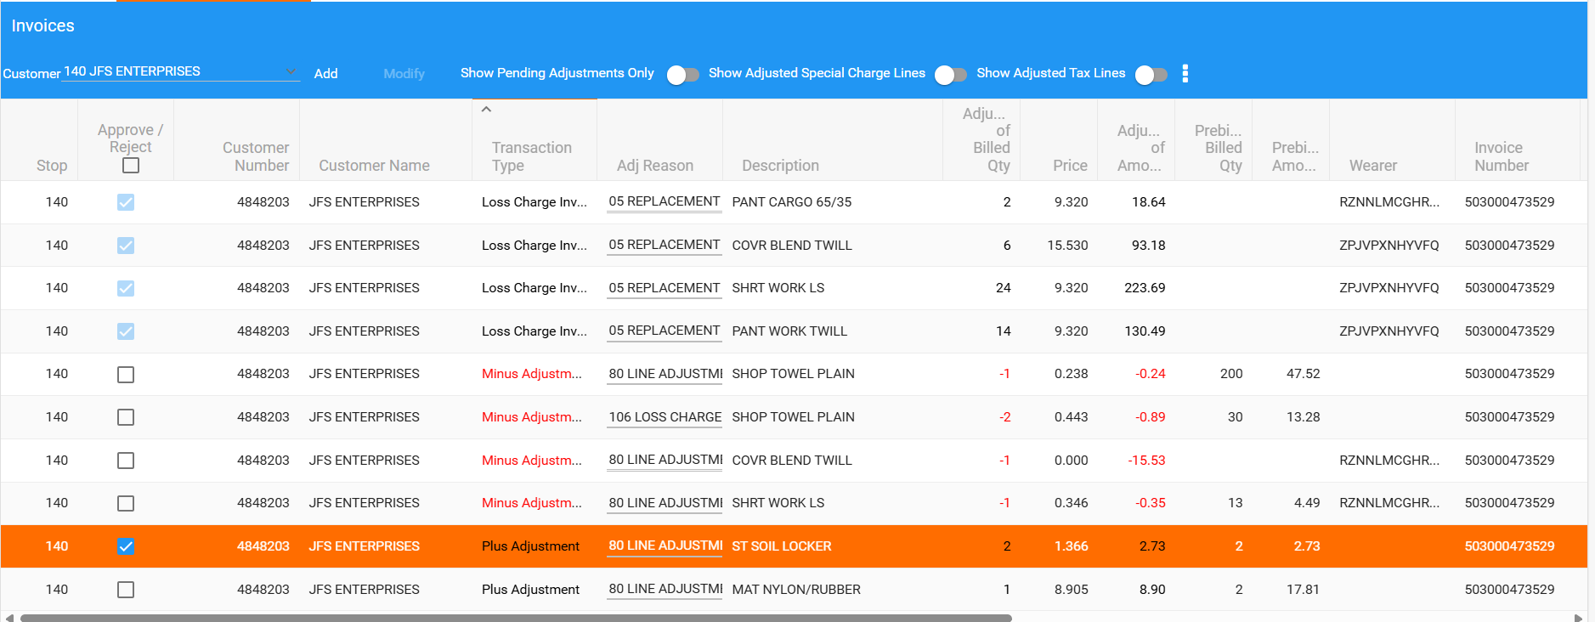
- Modify:
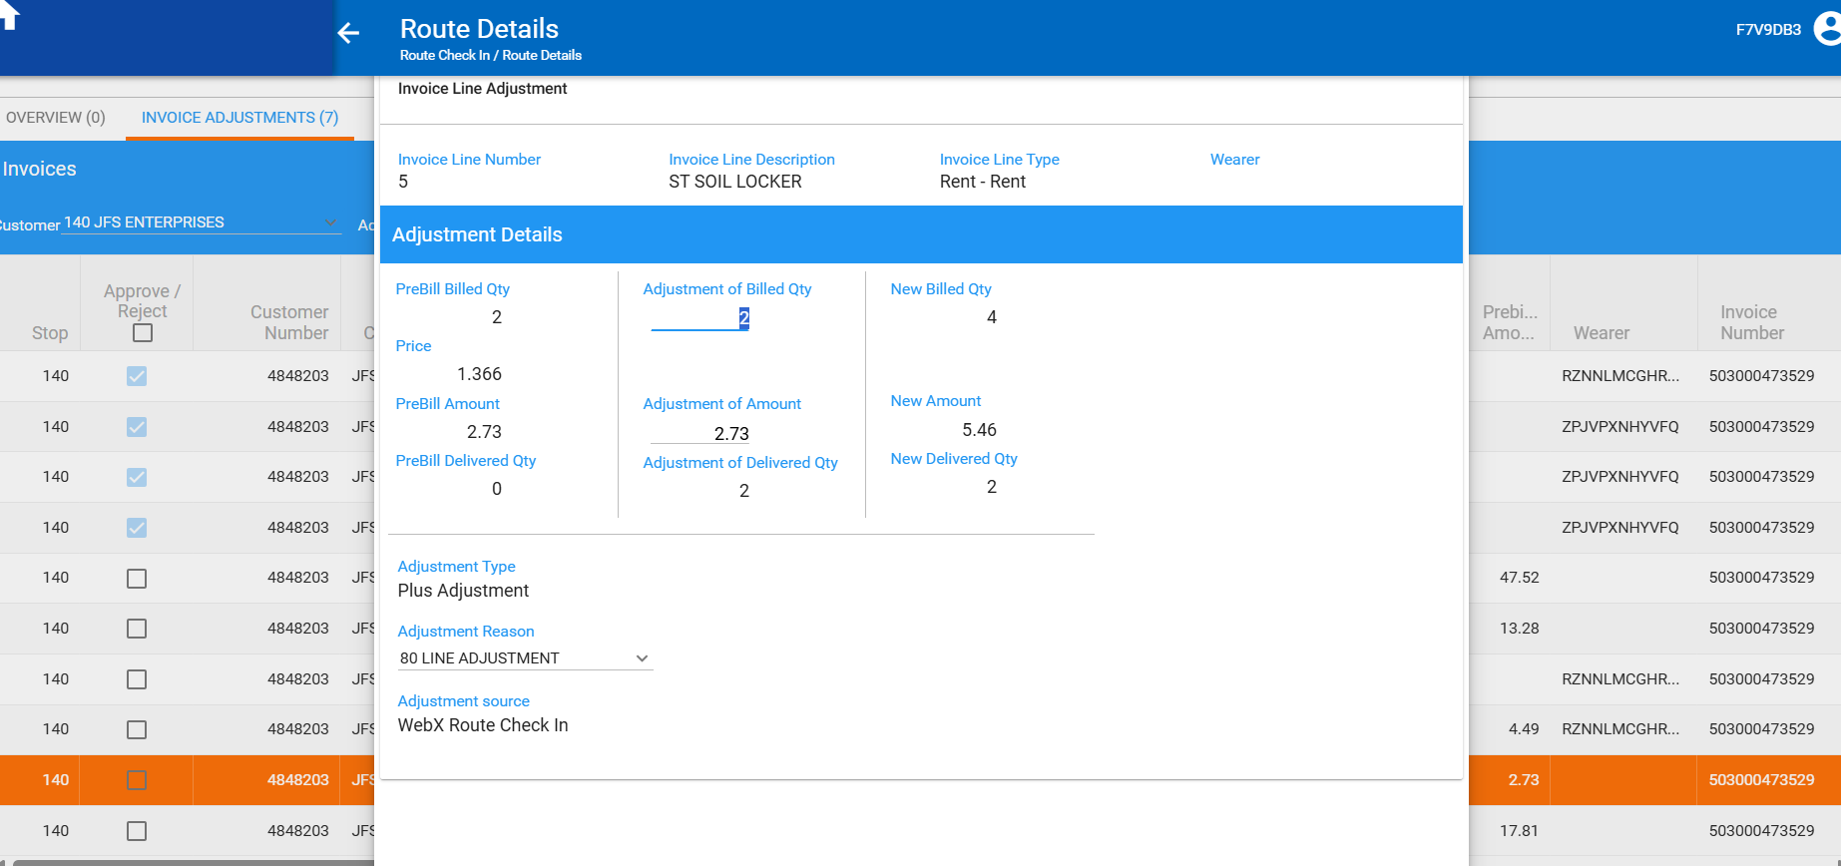
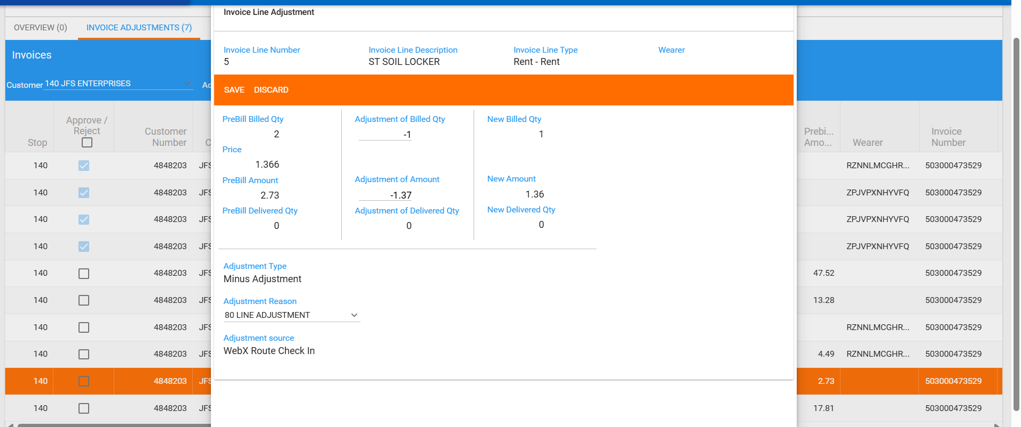
- New amount: 1.36 < initial RA amount 5.46 -> decrease is not allowed -> passed

