ABSN-3162 Cannot change del scheme or end date - BM6 consumption point product

Environment | Prerequisites
Version: 9.08.00.p21  Hash: 80d9ca263cb2  DBServerName=db01-buc.internal.abslbs.com  DBSID=CUST25  DBUser=AUS_ND90502  DBPassword=AUS_ND90502  Environment=TEST | - Module:  - SS:
Contents
Fix 1
Steps to reproduce: 1

Duplicate

HASH: b6b17f5e9ce1
BU code = ‘473’ Phoenix/ Plant code = ‘473’ Phoenix

Current behavior: End Date disabled & CPL with multiple delivery schemes, modify mode, change current DS with a new one and return to the initial DS: doesn’t keep the initial settings on CPL day and qty (wrongly discard).

Expected behavior: End Date enabled & CPL with multiple delivery schemes, modify mode, change current DS with a new one and return to the initial DS: keep the initial settings on CPL day and qty.

Step1) System Information:

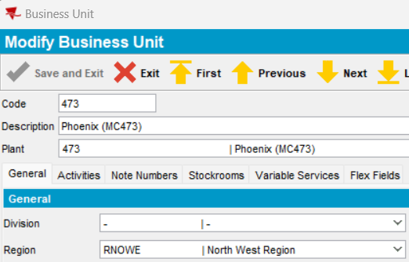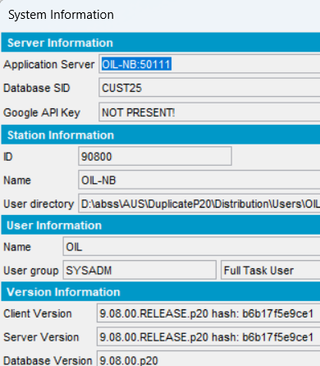

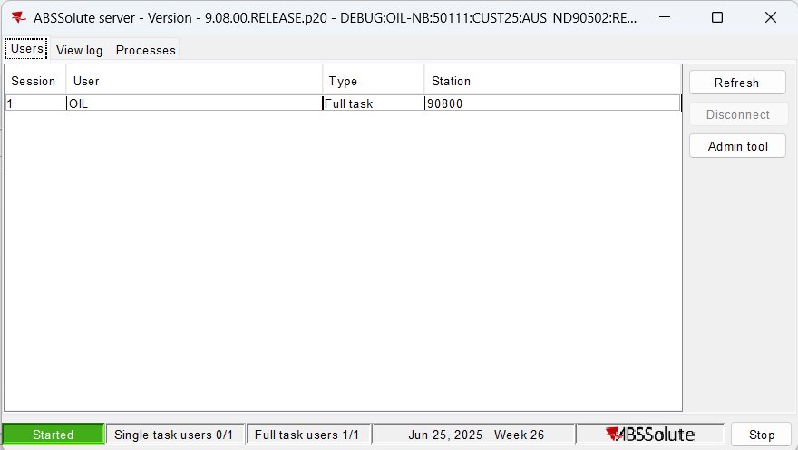

Step2) Customer with multiple DS:

2926425

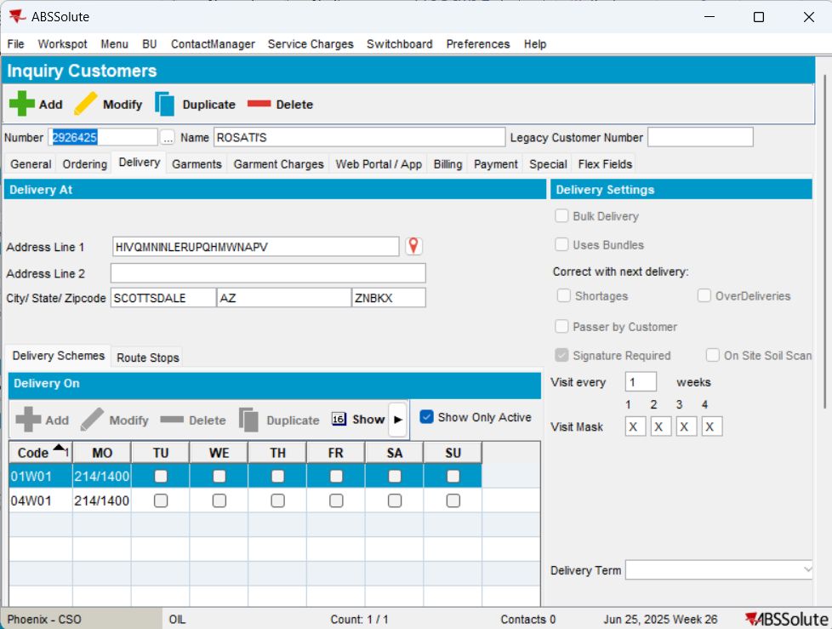

Step3) CPL:

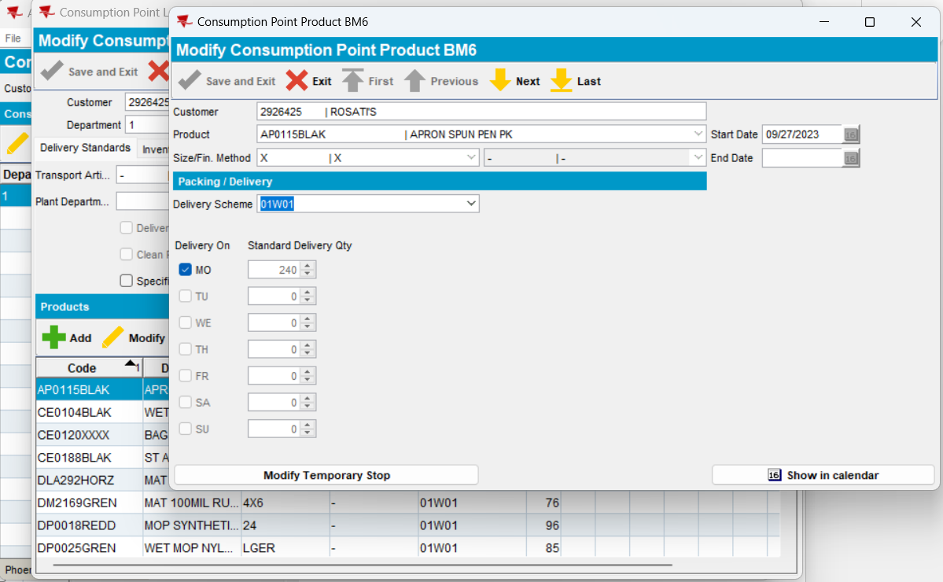

End Date disabled - duplicated

Change DS:

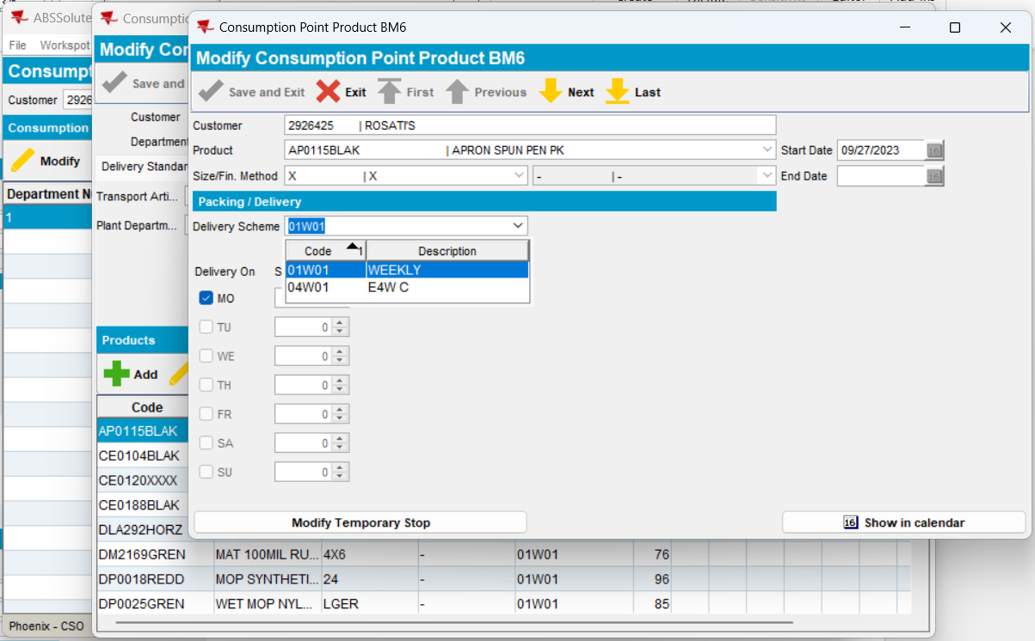

-Change with the second DS

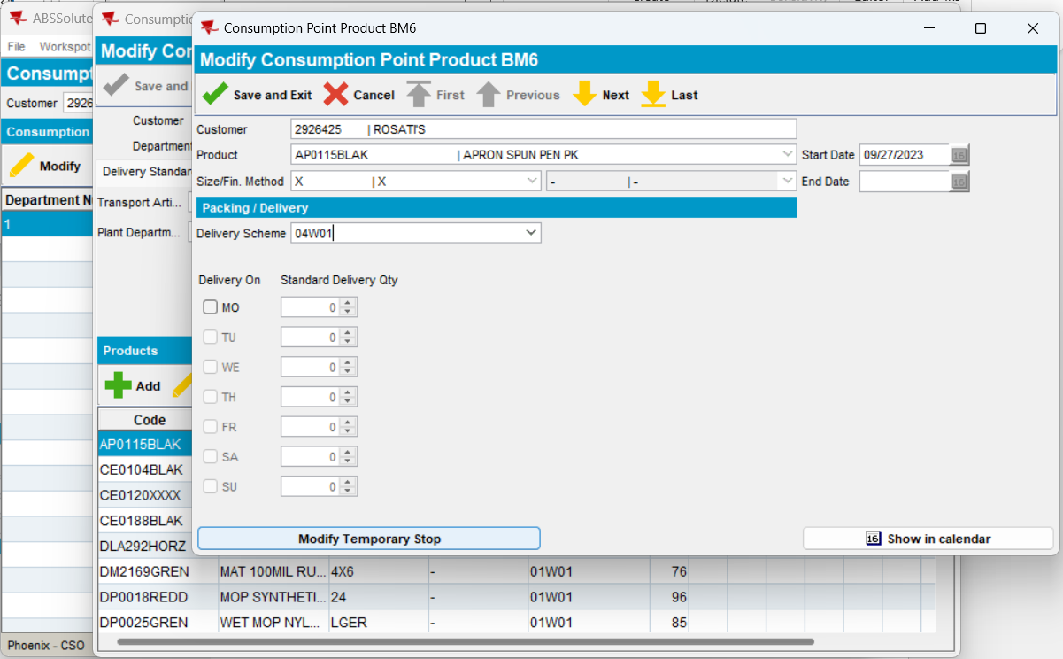

Return to the initial DS
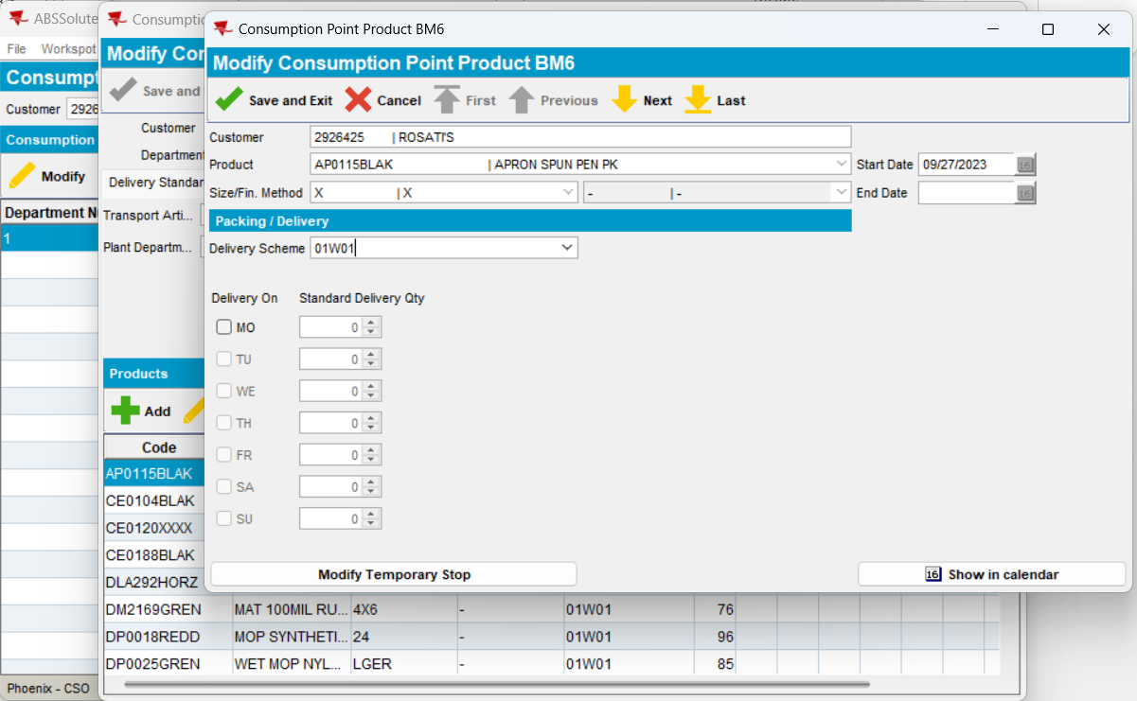

Doesn’t keep the initial settings on day and qty (wrongly discard) – duplicated.

Cancel:

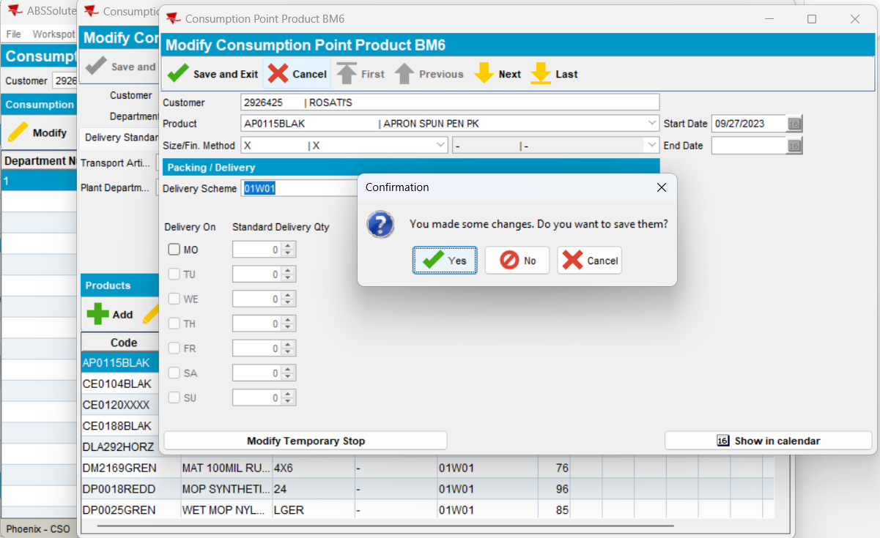

Yes
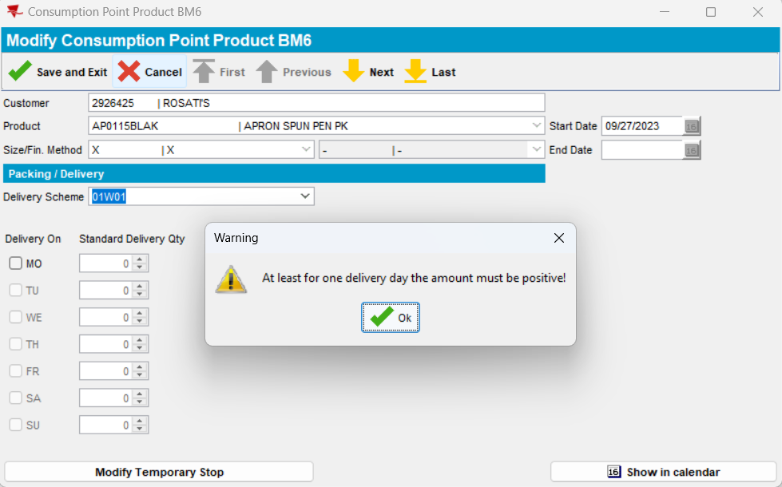

Cancel:

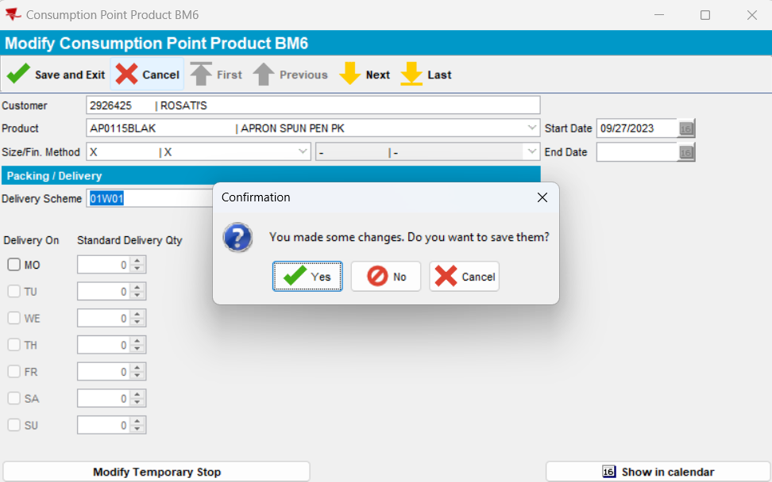

No:

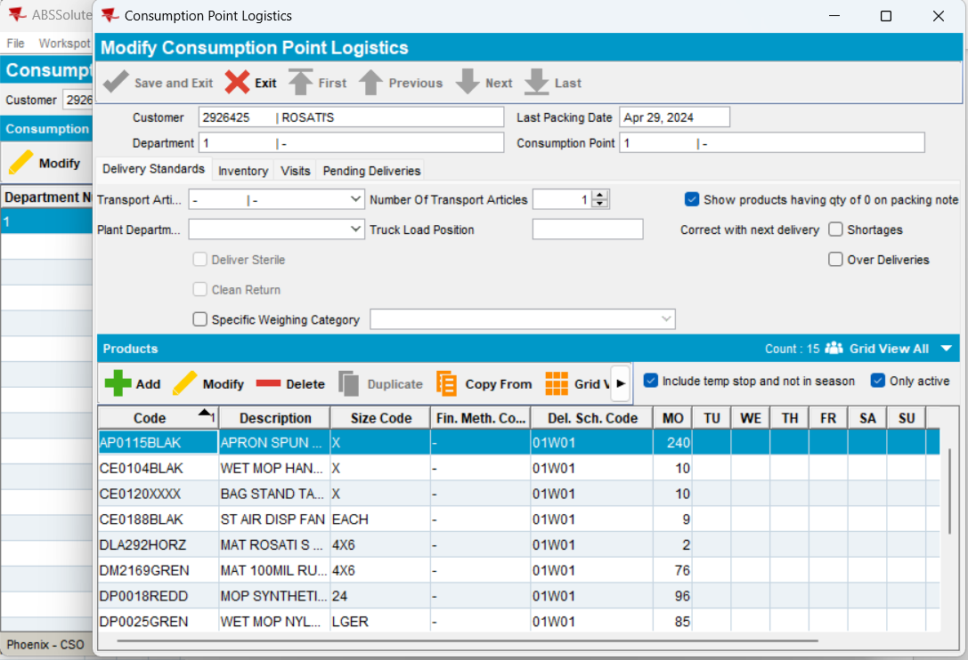

Modify:

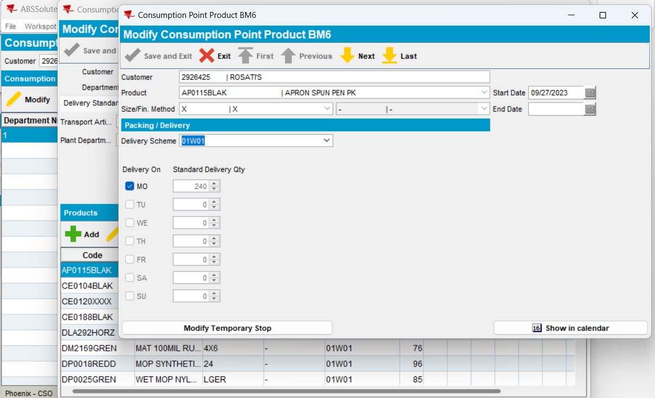

Delivery day and qty are ok.

Step4) PLPC:

View Delivery Quantities button:

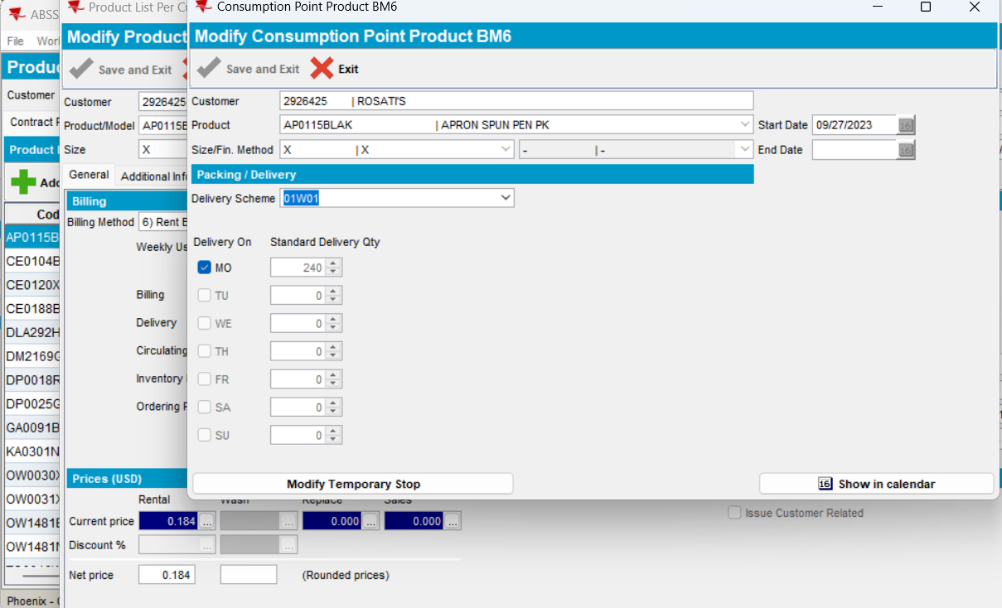

End Date disabled - duplicated.

Change DS:

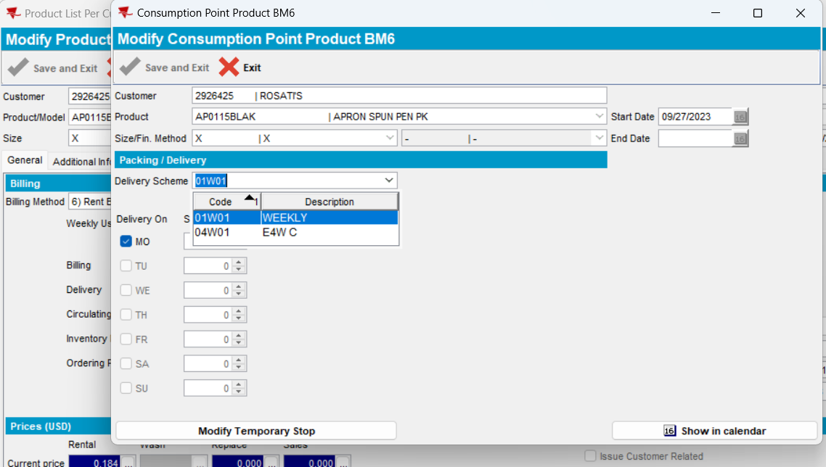

Change DS with a new one:

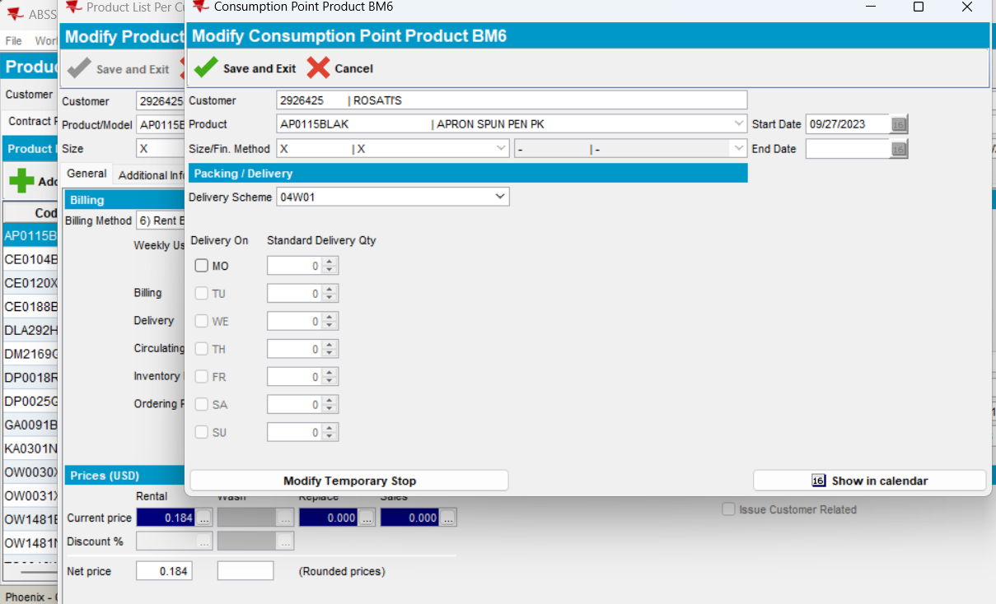

Return to the initial DS:

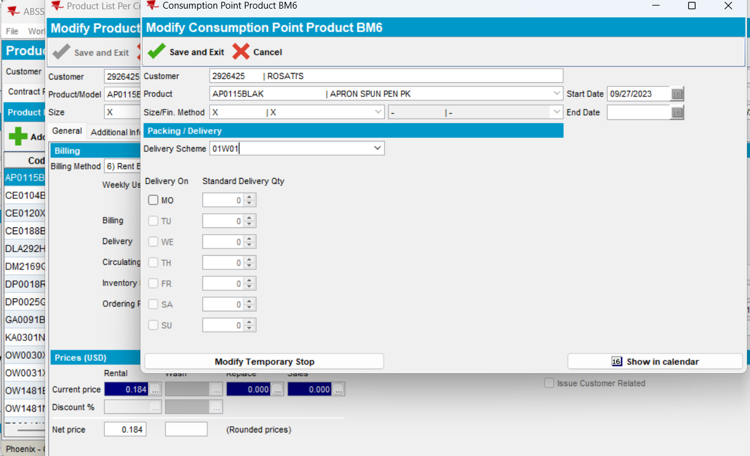

Doesn’t keep the initial settings on day and qty (wrongly discard) – duplicated.

Cancel:

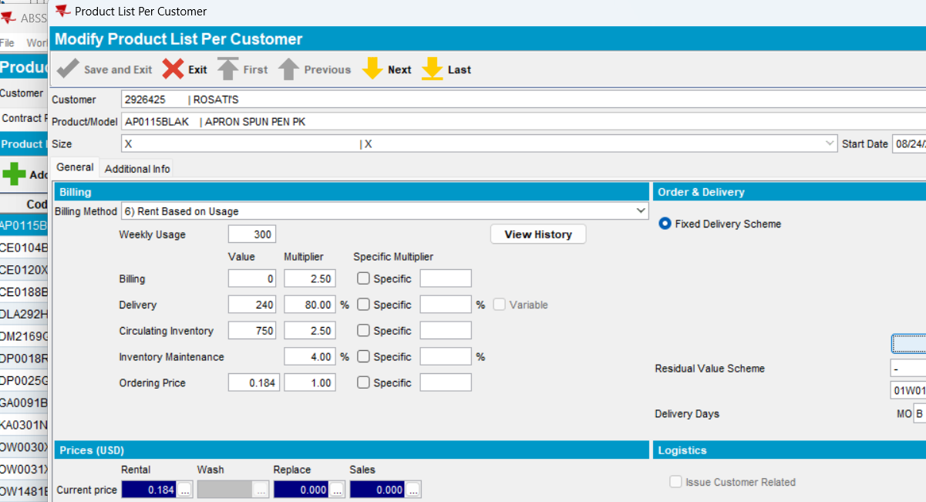

View Delivery Quantities:

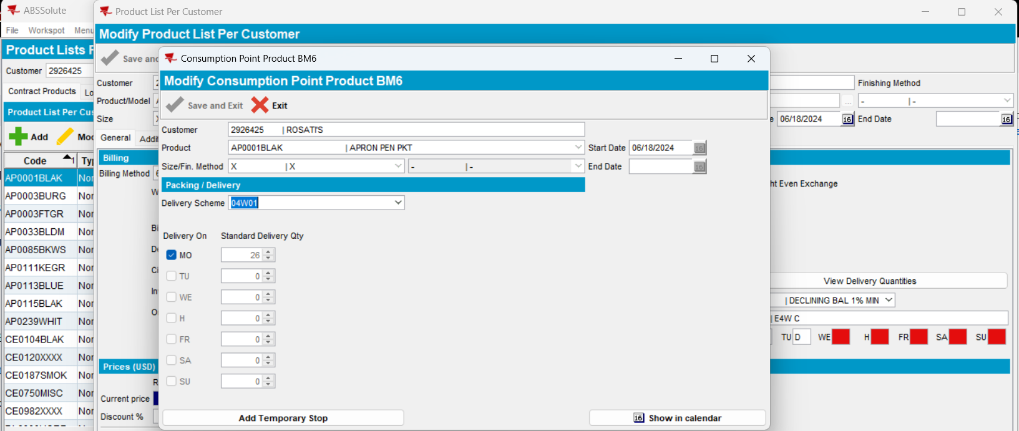

Delivery day and qty are ok.

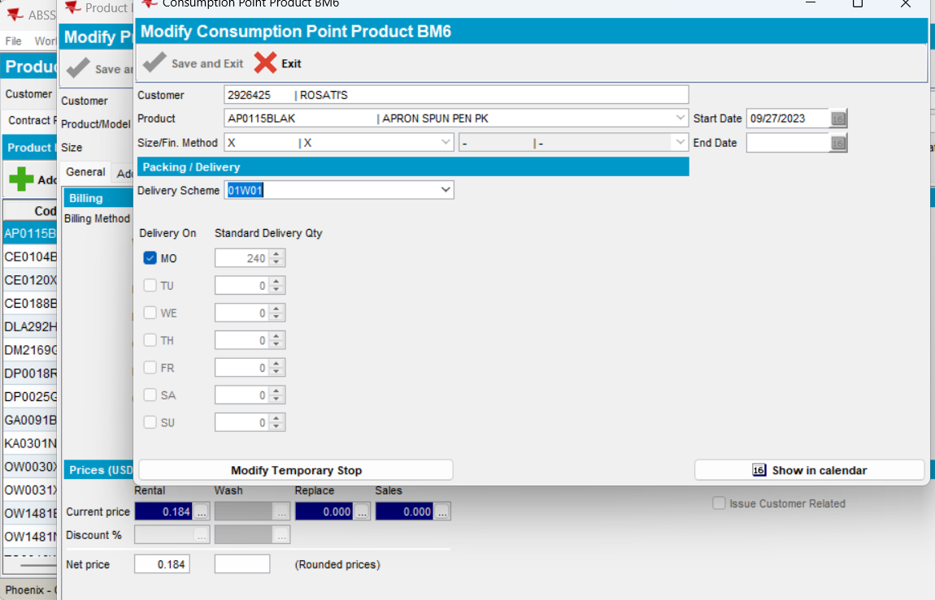

Current behavior: End Date disabled & CPL with multiple delivery schemes, modify mode, change current DS with a new one and return to the initial DS: doesn’t keep the initial settings on CPL day and qty (wrongly discard).

Expected behavior: End Date enabled & CPL with multiple delivery schemes, modify mode, change current DS with a new one and return to the initial DS: keep the initial settings on CPL day and qty.

DUPLICATED

Test in

https://jenkins.internal.abslbs.com/job/FastBuilder-MultiBranch/job/bugfix%252FABSN-3162-cannot-change-del-scheme-or-end-date-bm6-consumption-point-product/

HASH: 80d9ca263cb2
BU code = ‘473’ Phoenix/ Plant code = ‘473’ Phoenix

Step1) System Information:

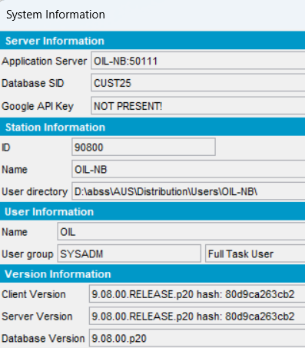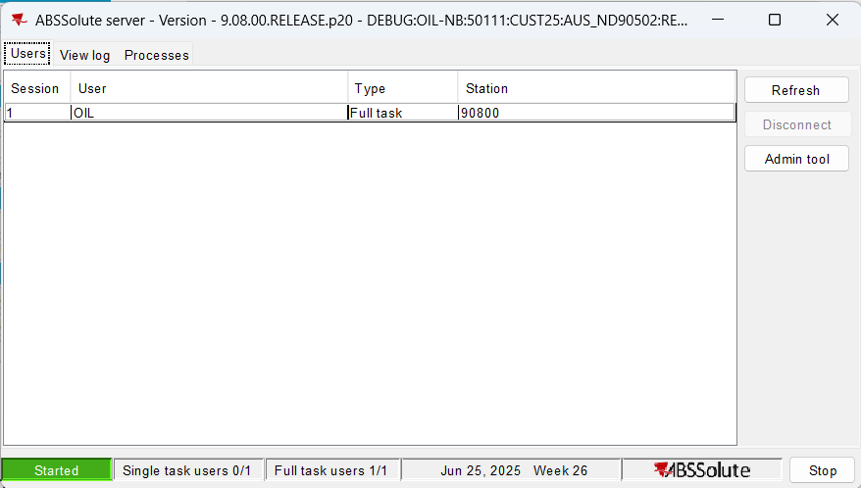

Step2) Customer with multiple DS:

2926425

Step3) CPL:

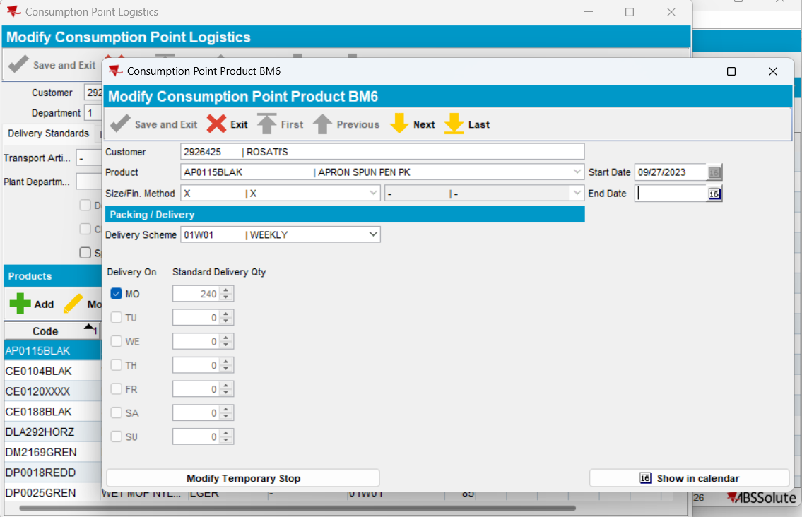

End date enabled – OK.

Change the existing DS with a new one:

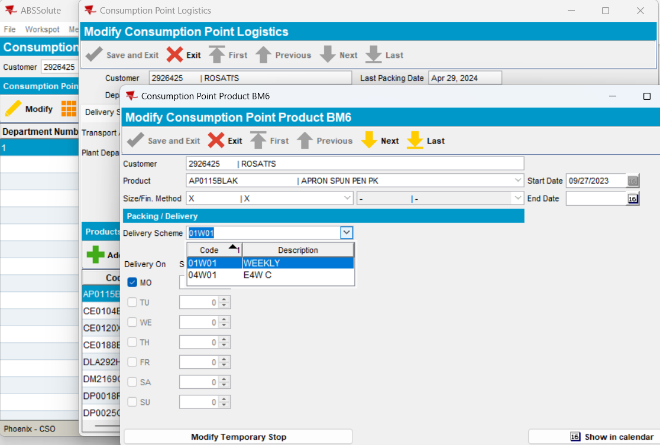

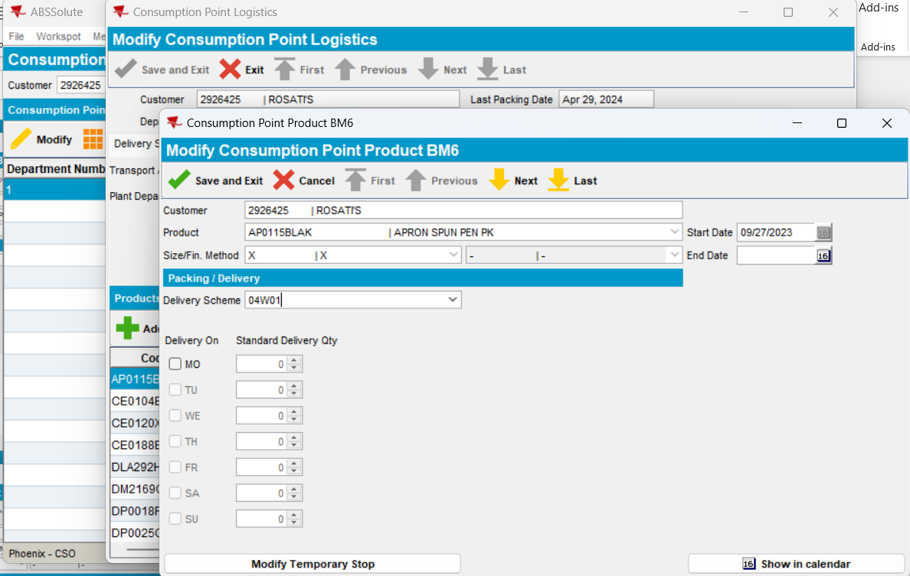

Nothing checked.

Return to the initial DS:

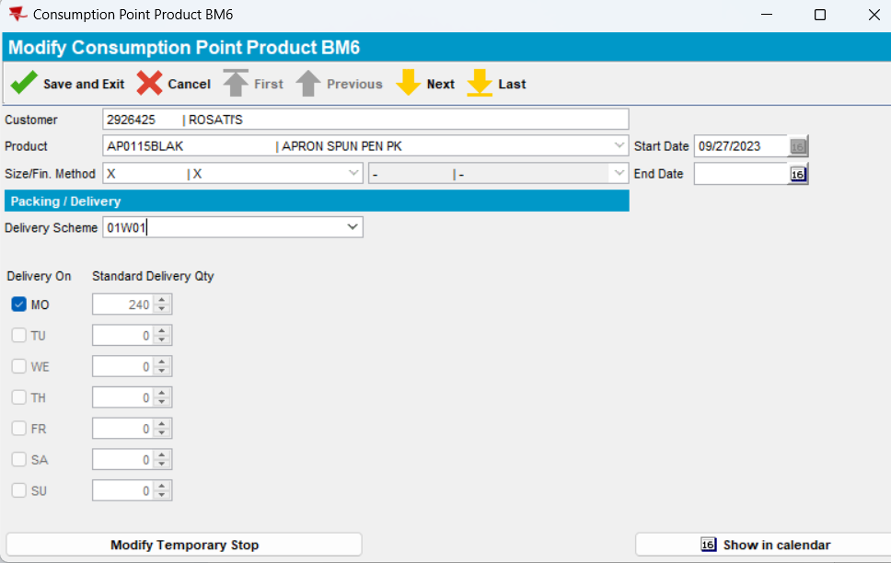

The original Delivery date and Quantity is present – OK

Save and exit:

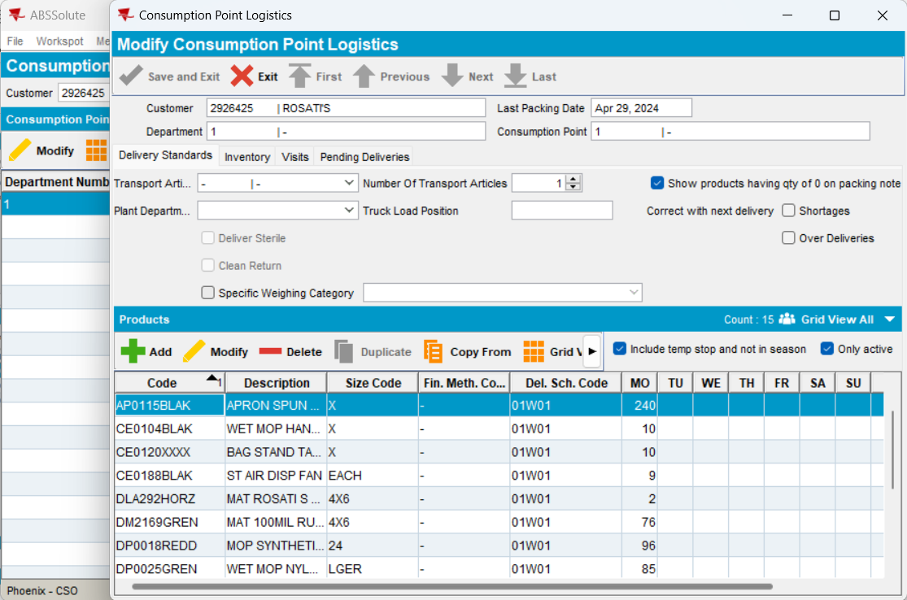

Modify:

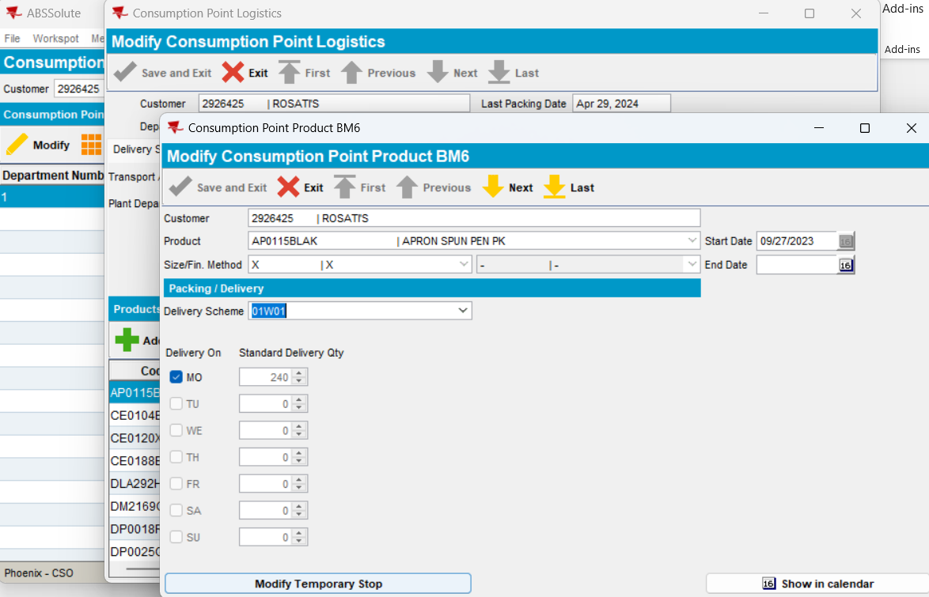

DS, Delivery Day and quantity OK.

Step 4) PLPC:

View Delivery Quantities button:

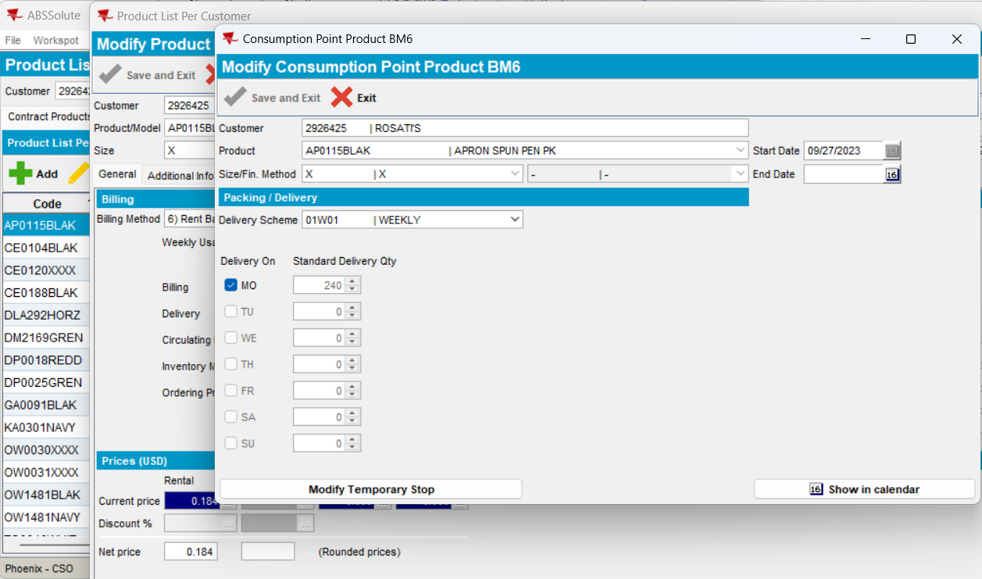

End Date enabled – OK

Change the existing DS with a new one:

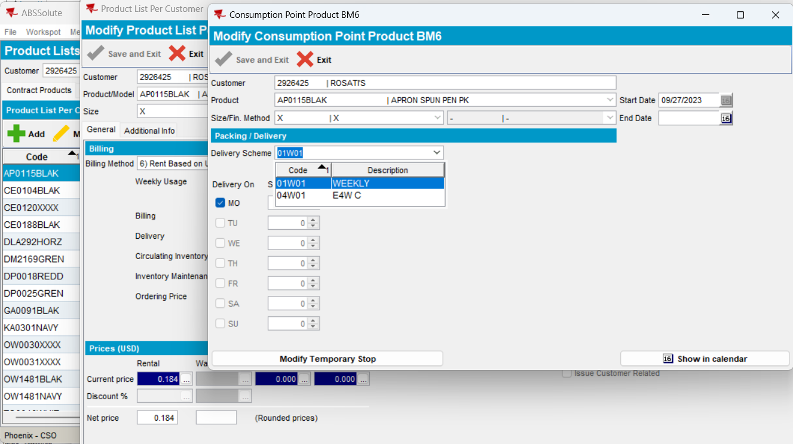

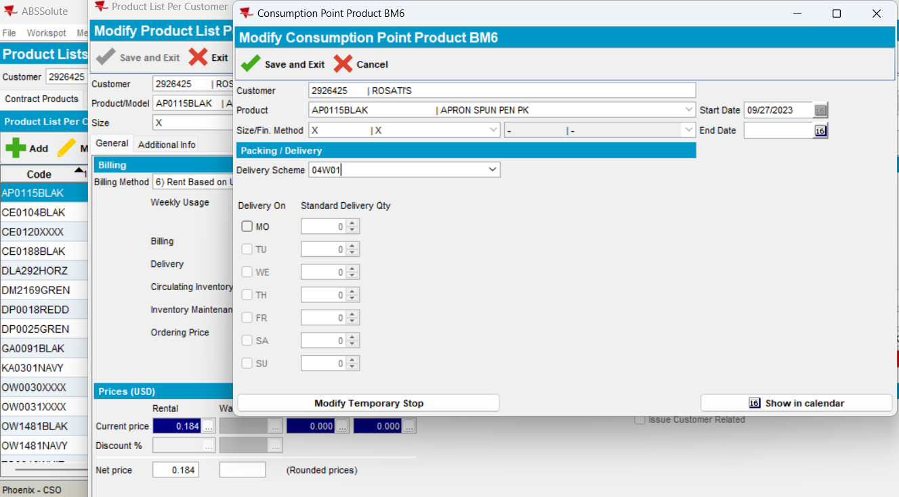

Return to the initial DS:

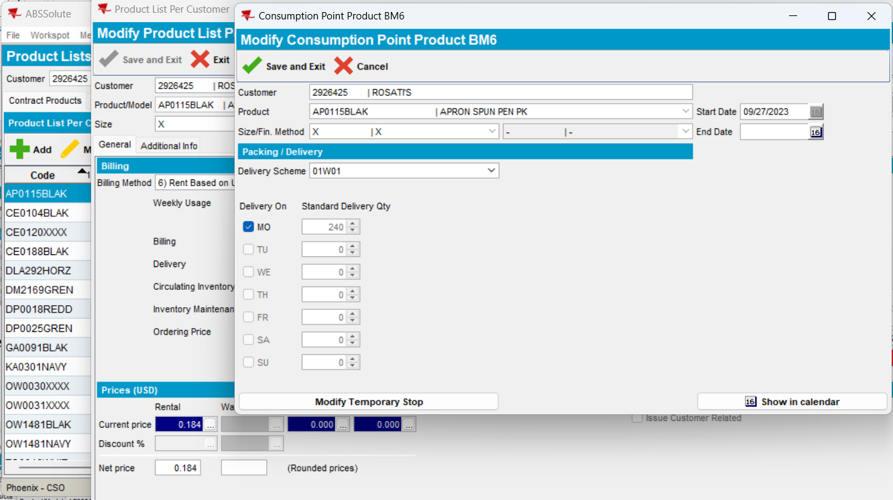

DS, Delivery Day and quantity OK.

Save and exit and check again:

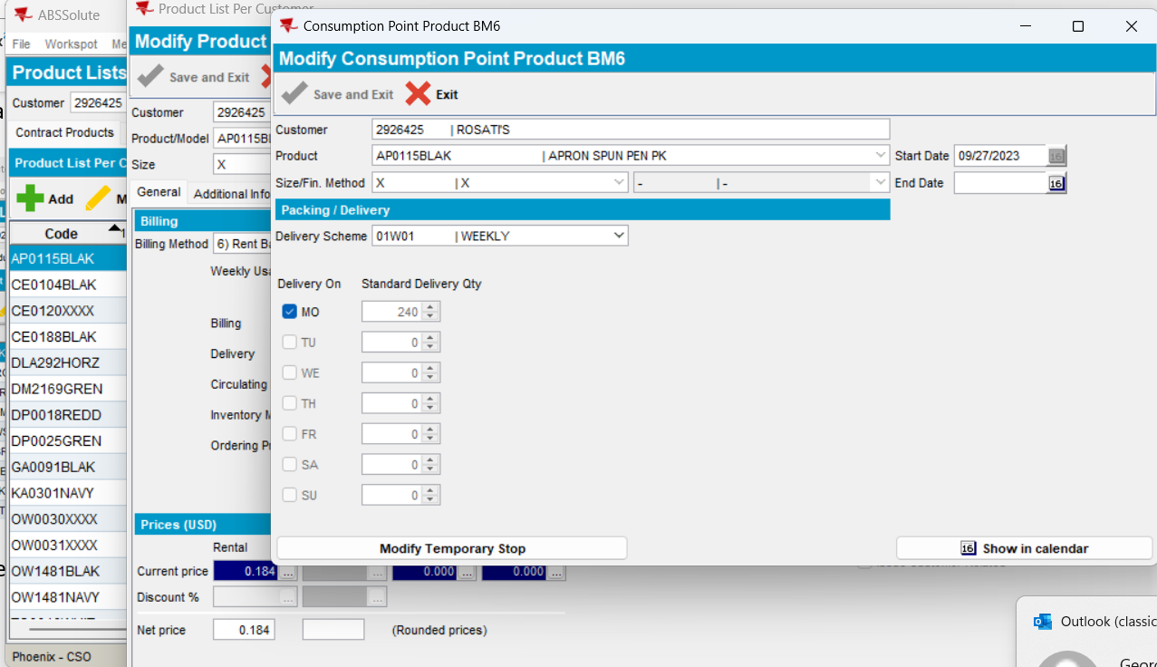

DS, Delivery Day and quantity OK.

Cancel and check again:

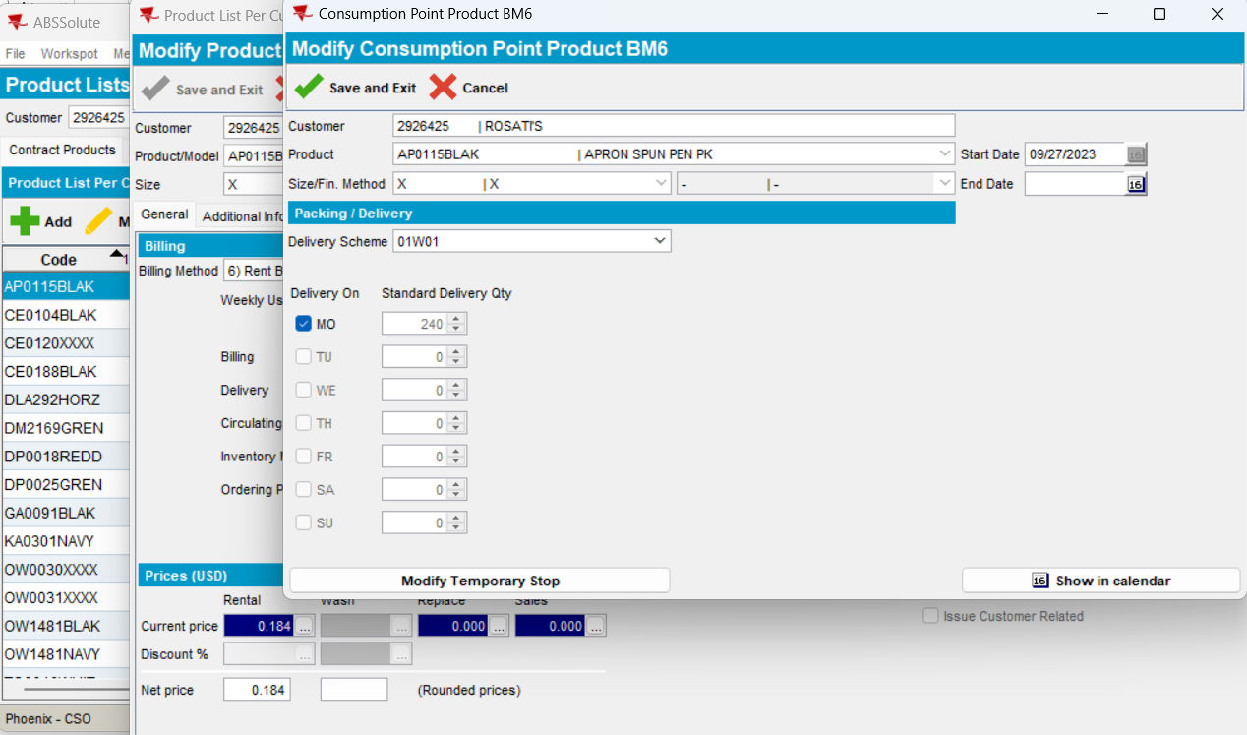

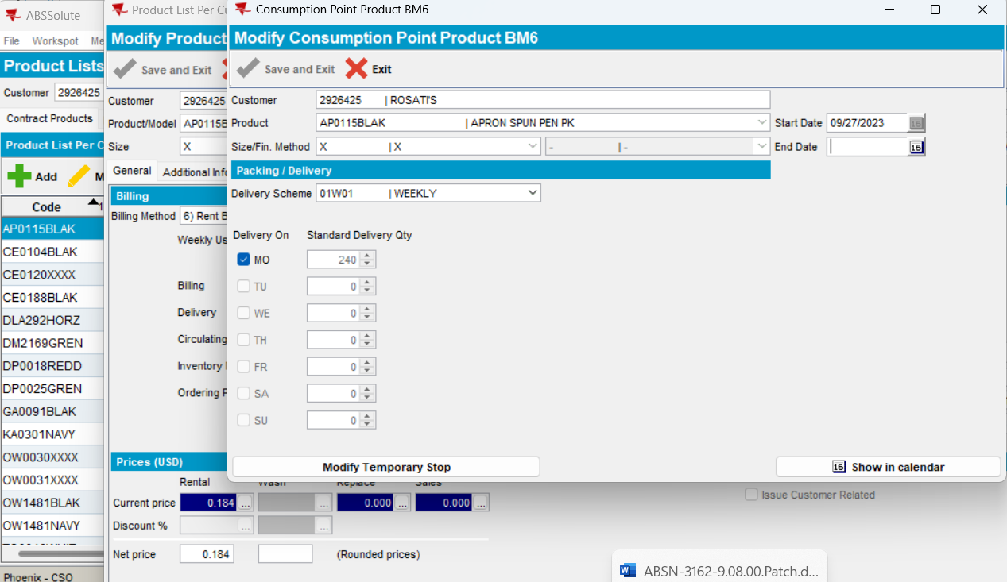

End Date enabled & CPL with multiple delivery schemes, modify mode, change current DS with a new one and return to the initial DS: keep the initial settings on CPL day and qty.

TEST OK

