ABSN-2626 Stop not to be shown in grid for manual invoice created on non-delivery day
DOWNGRADE 9.08.00
Environment | Prerequisites
Version: 9.08.00.RELEASE.p20  DBServerName=db01-buc.internal.abslbs.com  DBSID=CUST25  DBUser=AUS_ND90502  DBPassword=AUS_ND90502  Environment=Production  EnvironmentSABStage=Production | - Module: FAKT, RAS  - SS:
Contents
Retest after fix 1
Test Case 1 – Stop on Manual Invoice for Non-Delivery Day – TEST FAILED. 1
Test Case 2 – Stop on Manual Invoice for a Delivery Day – TEST PASSED 5

Retest after fix
Hash: 2125dfb26e94
BU code: 473
Plant code: 473

Test Case 1 – Stop on Manual Invoice for Non-Delivery Day – TEST FAILED.
Expected behavior: Stop number value in the Maintain Invoice grid and in the Invoice details field, for manually added invoices on a Non-Delivery day should be “NULL” not “0”
Step1) Select a customer and check its delivery days:
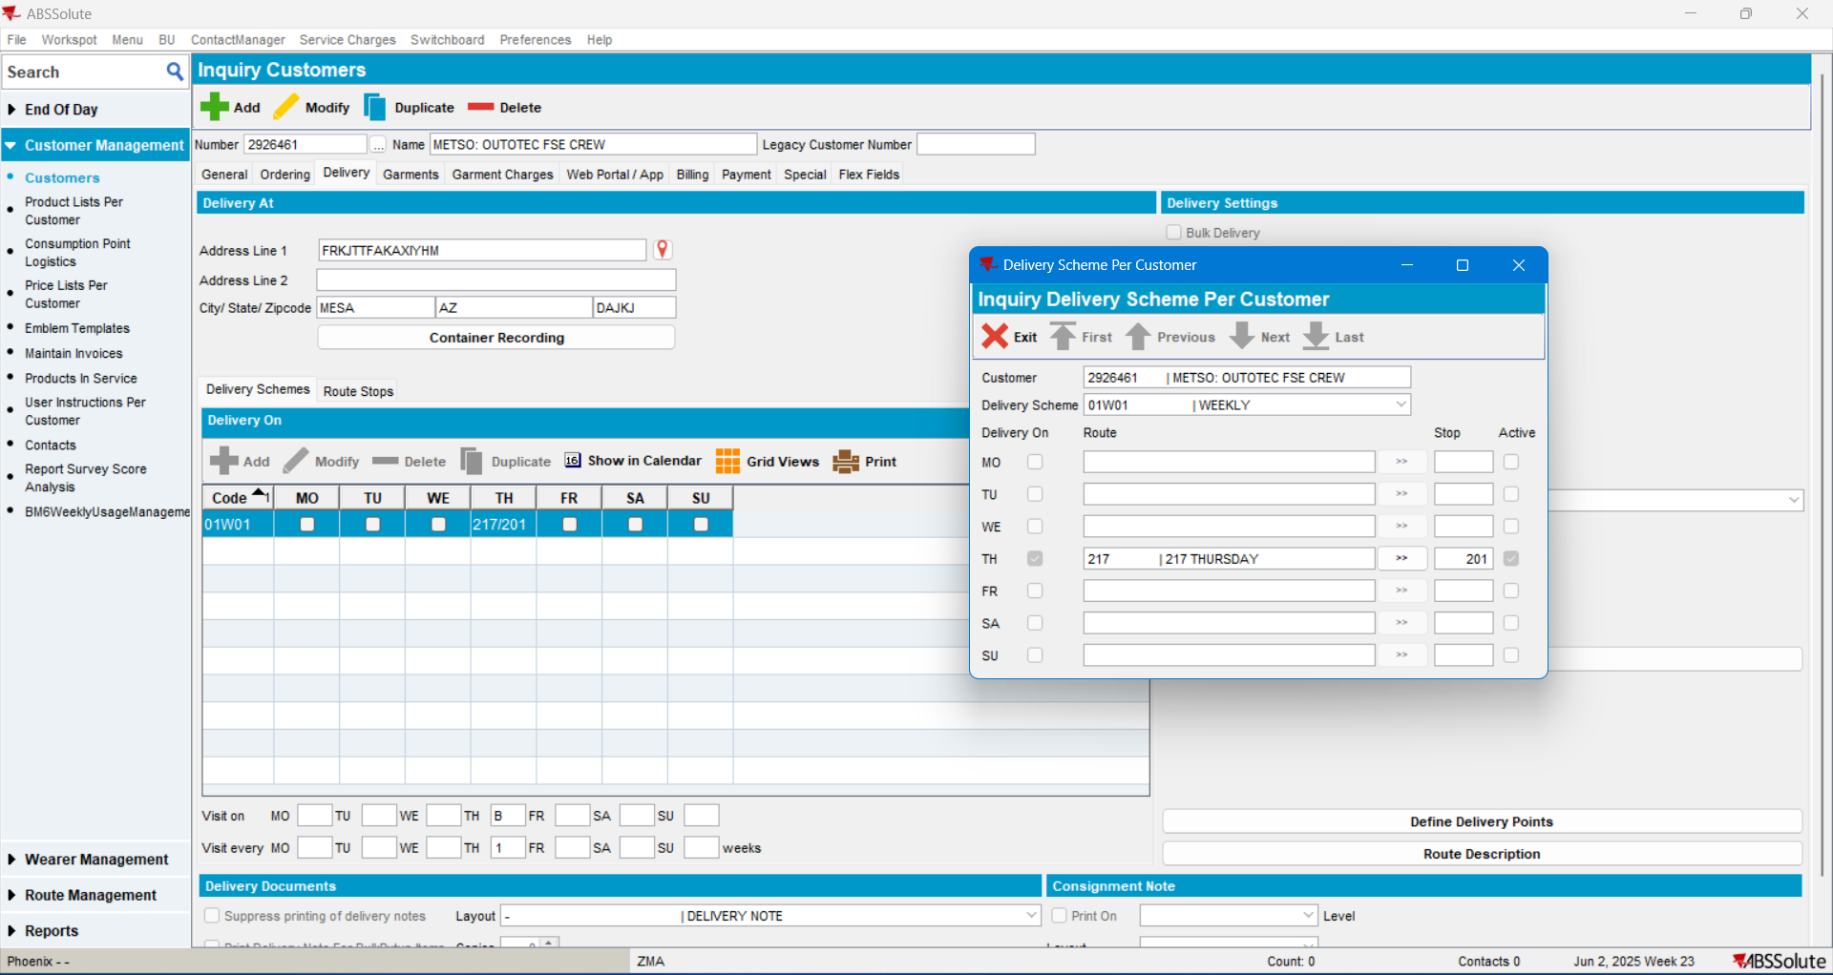

Step2) Add Manual invoice on a non-delivery day:
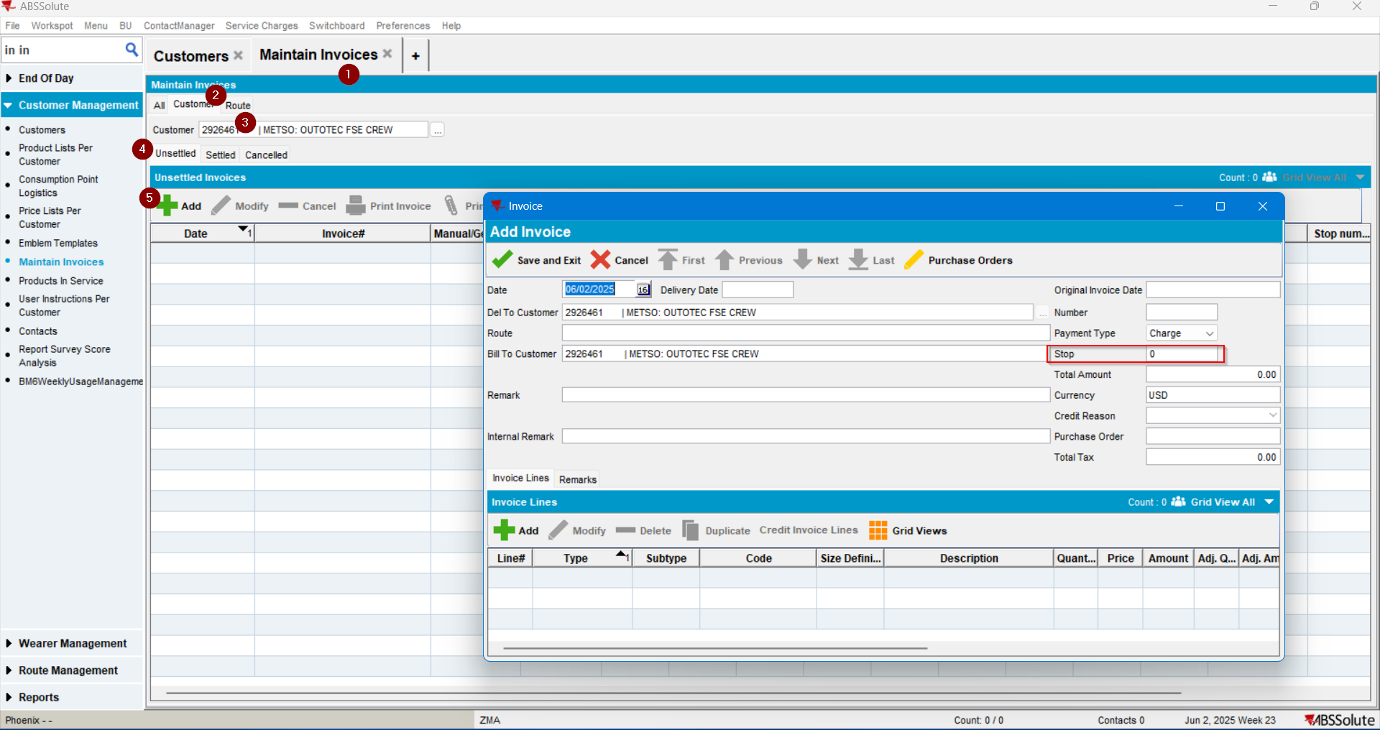
The Route is blank, but the Stop Number is 0 (not “Null”). Which was not the expected behavior.
Yet we’ll continue the test to check the STOP NUMBER on the finalized manual invoice.
Step3) Now add an invoicing line and save the invoice:
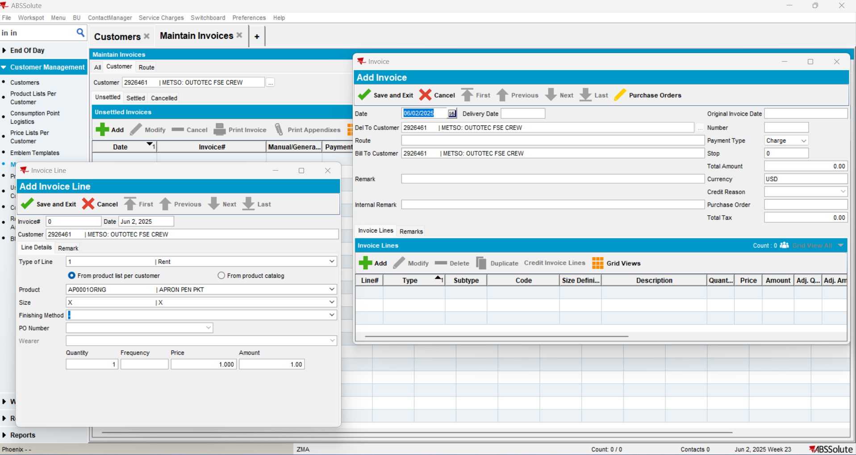

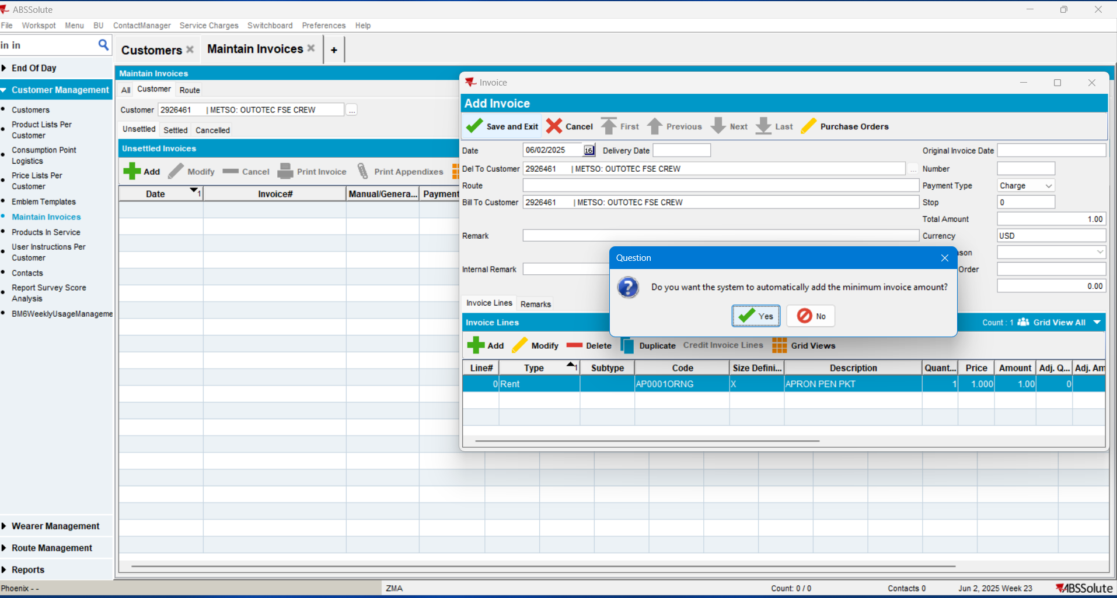
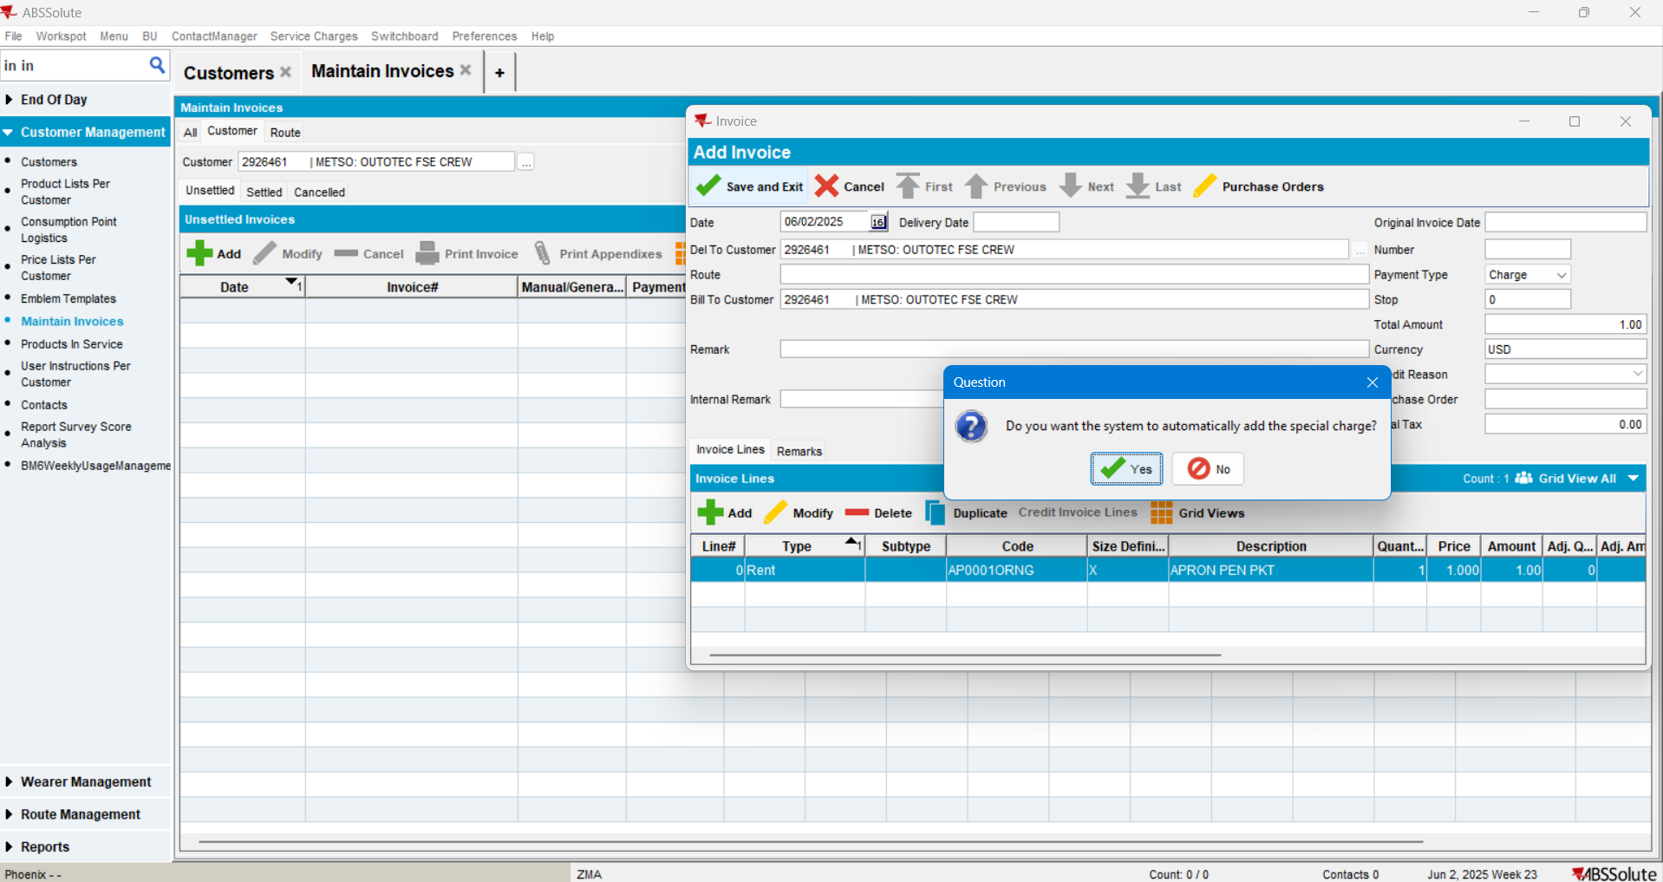

Step 4) Check the Stop value in the Maintain Invoice Grid:
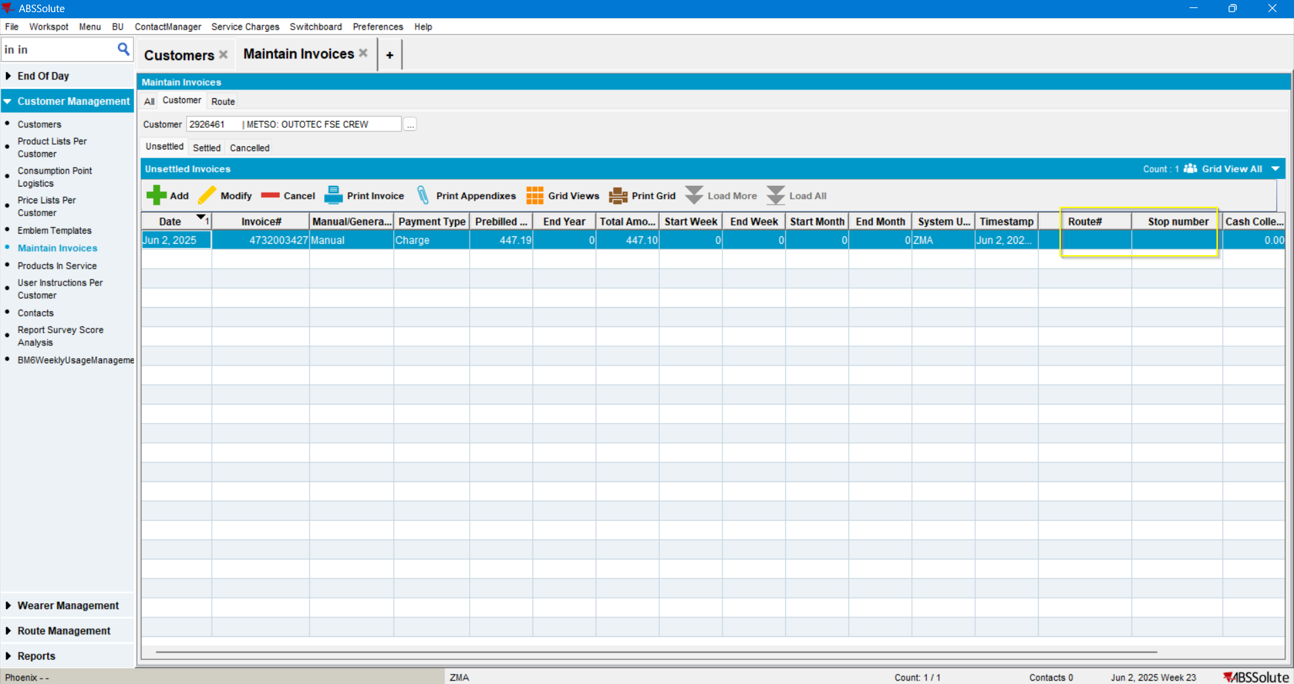
The Route Stop number is “Null” as expected.

Step 5) Reopen the manually created invoice:
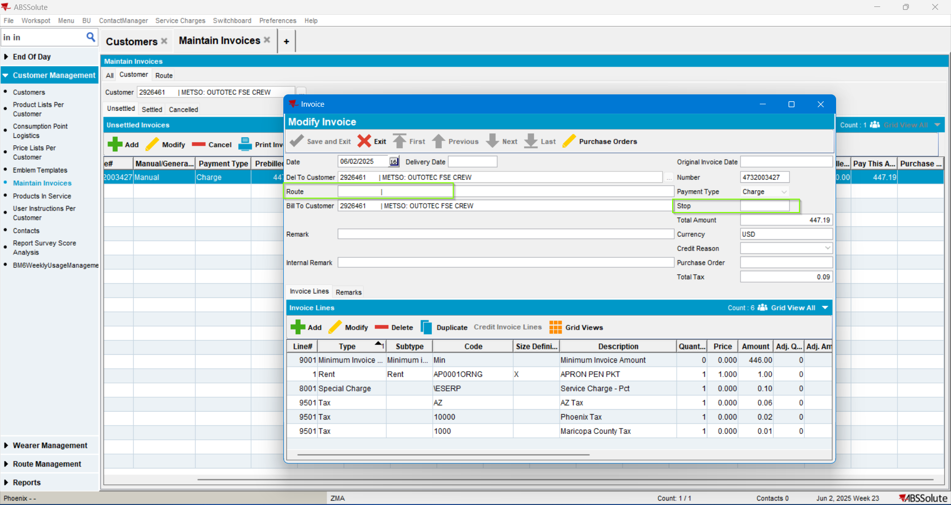
The Stop Field is “Null”. As expected.
The intermediary step failure to be discussed with the programmer.

Step 6) Check the Stop value in Database:
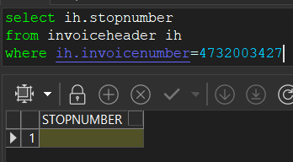
It is null as expected.
TEST PASSED.

Test Case 2 – Stop on Manual Invoice for a Delivery Day – TEST PASSED
Expected behavior: Stop number value in the Maintain Invoice grid and in the Invoice details field, for manually added invoices on a Delivery day should be filled in as in customer’s Delivery settings.
Step 1) Create a new manual invoice for a Delivery Day
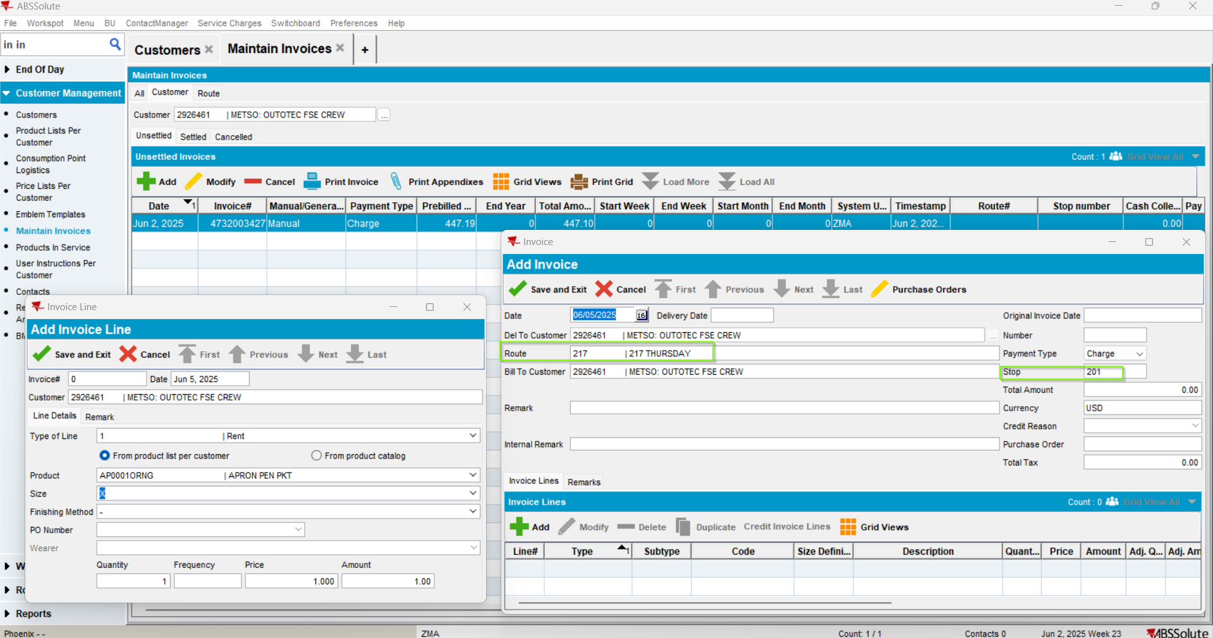

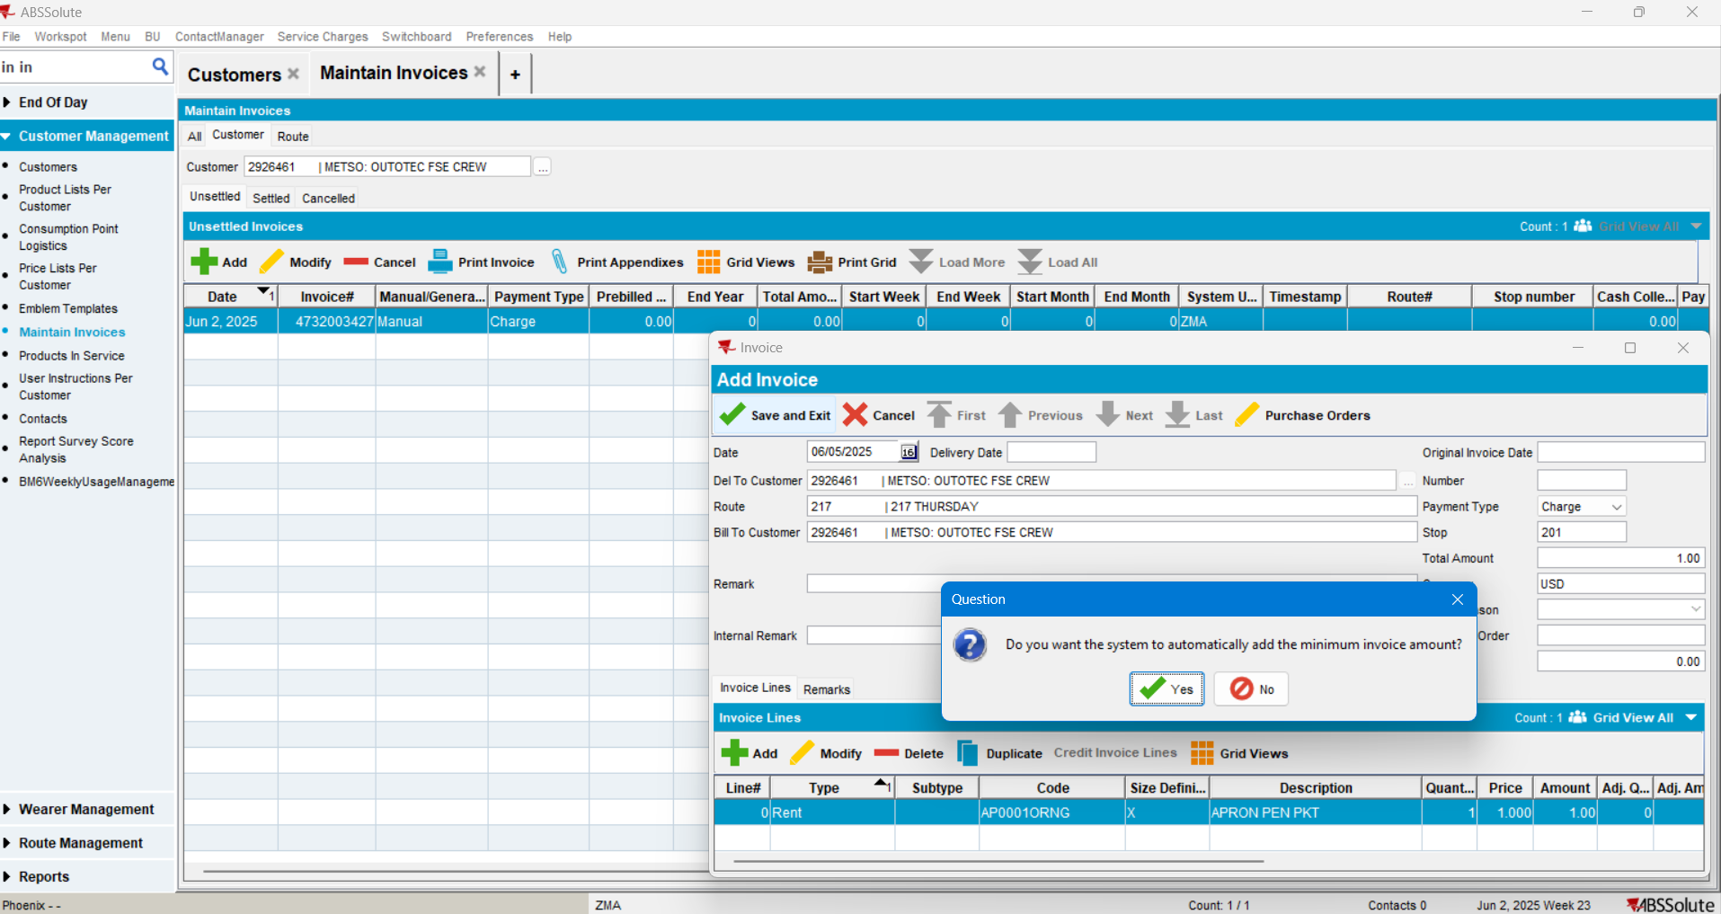
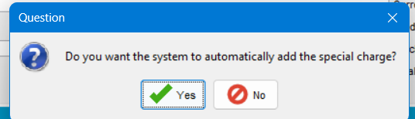
Step 3) Check the Stop in the grid and in the corresponding field in Add invoice screen:
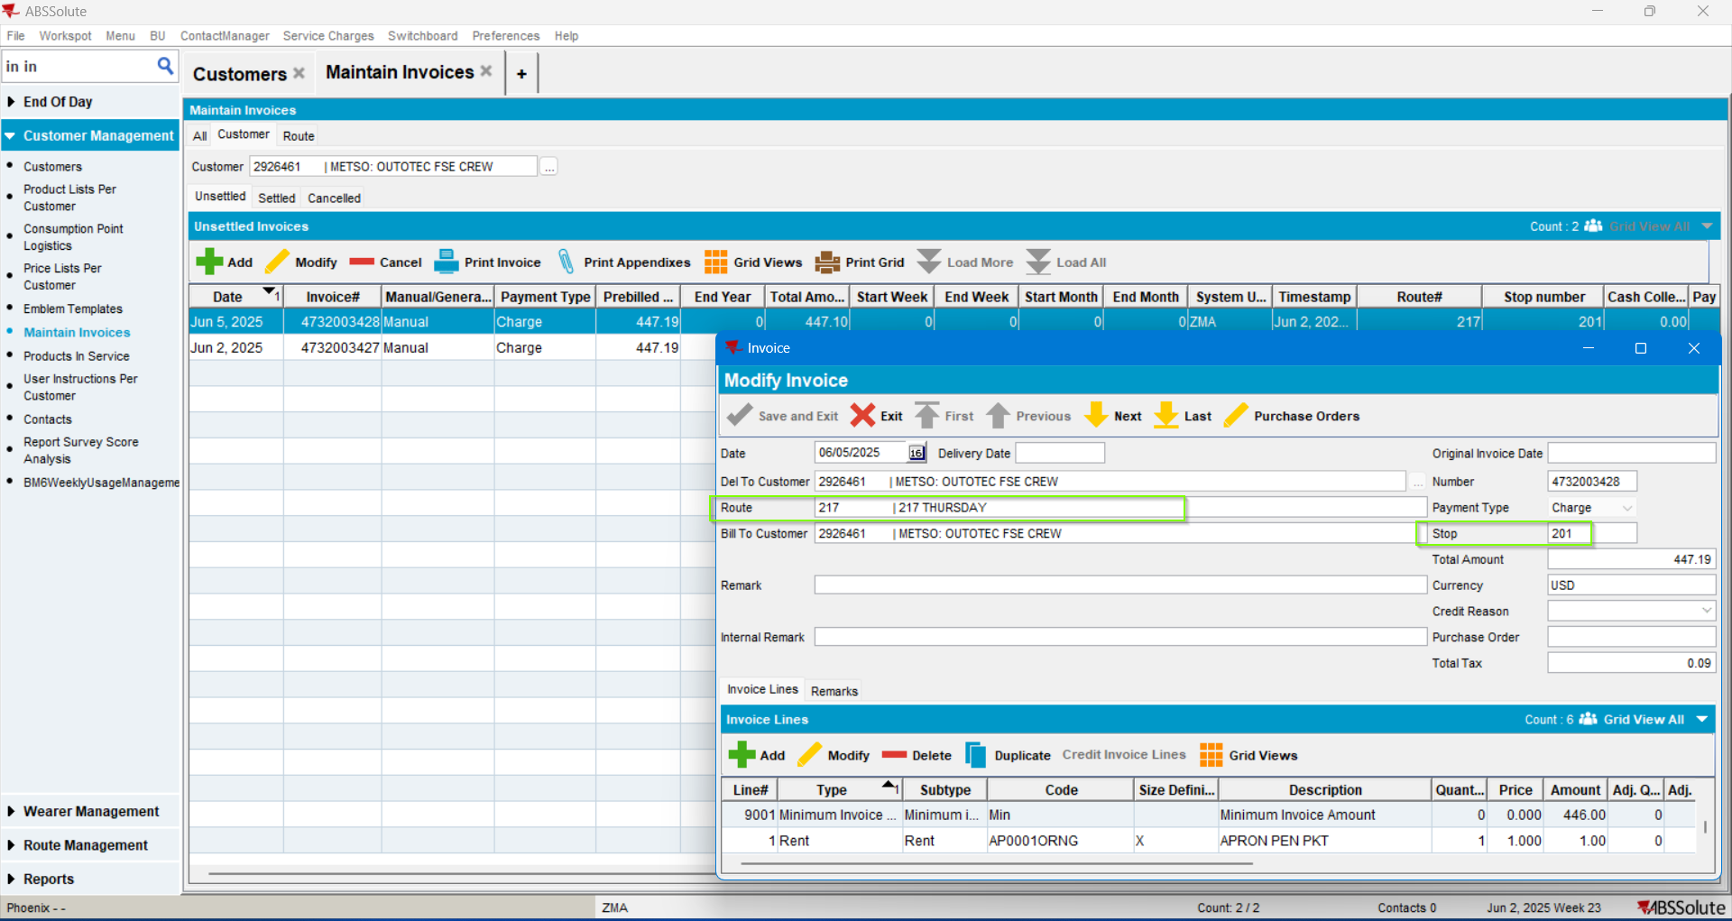
The Route and the Stop numbers are correct.

Step 4) Check the Stop number value in the database:
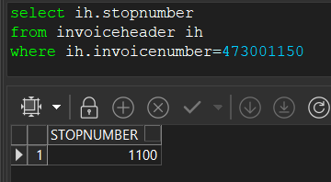
Step 4) Check the Stop number value in the All tab:
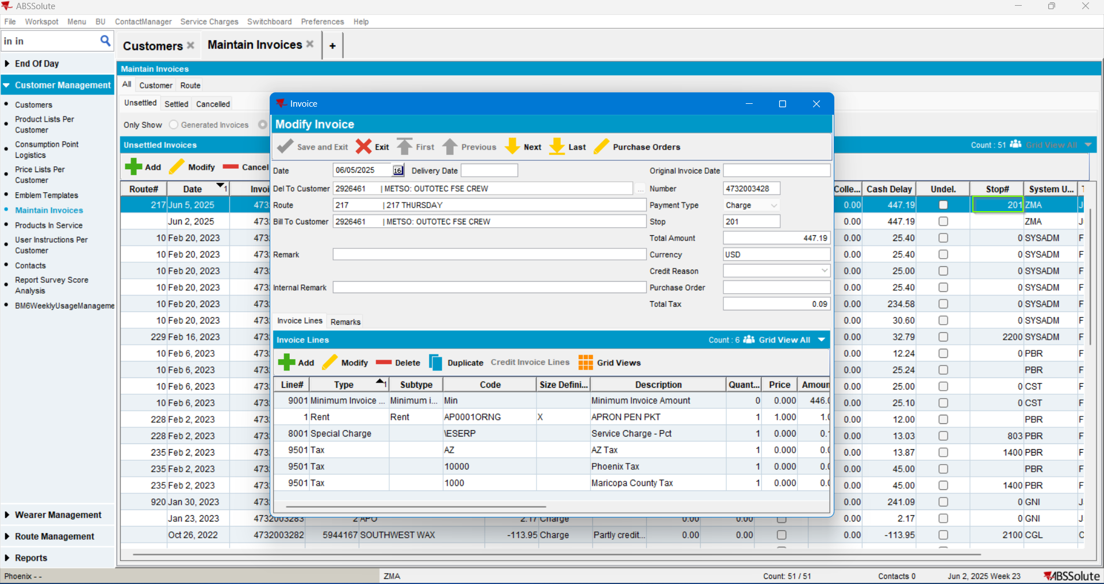
It is the expected value.
Test passed.

