ABSN-2238 Downgrade to 9.08.00.RELEASE.p21_AUS
Environment | Prerequisites
Version: 9.08.00.RELEASE.p20  DBServerName=abs-srv17.internal.abslbs.com  DBSID=CUST23  DBUser=AUS_MNT90800  DBPassword= AUS_MNT90800  Environment=Production  Hash: 4f83edb | - Module: AUSCUSTOM  - System setting: -  - Others: BU 509, 549, 529  - RA 13.24

Contents
Retest after fix 1

Retest after fix
Customer: 792096311
- Generate next week’s route on BU 509 (Tested on 4/15/25) – route 393, stop 5000 from June 10th, 2025
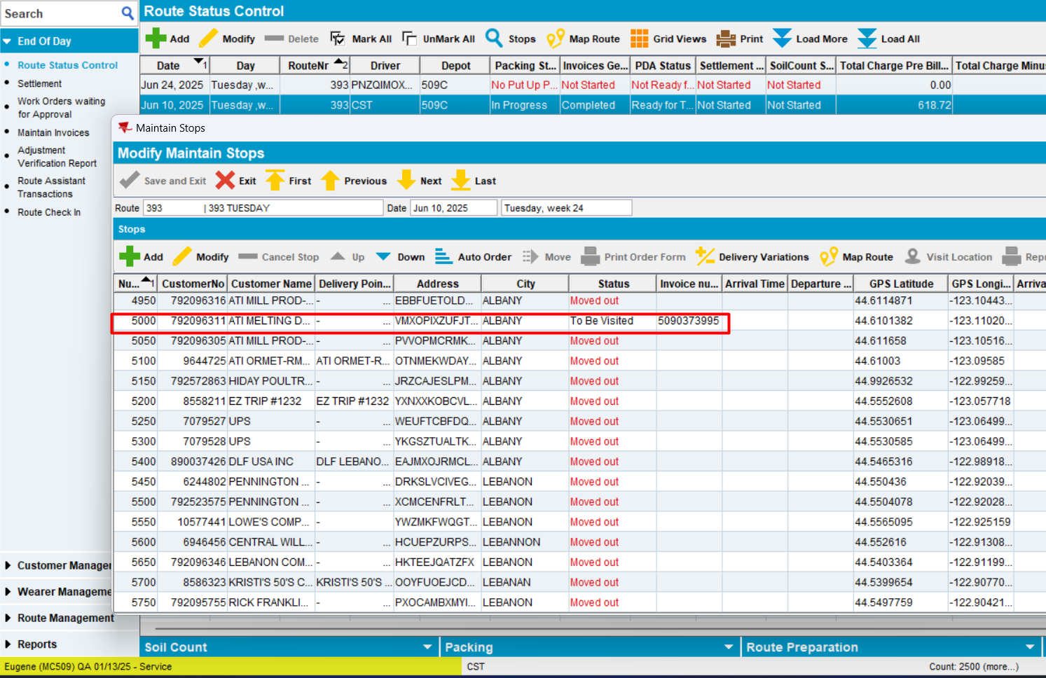
- On RA, select Scan Garments -> Replacement and Scan Items as Replacement-Ruin on RA
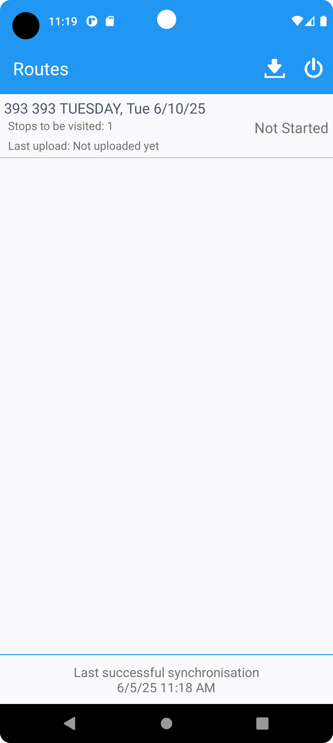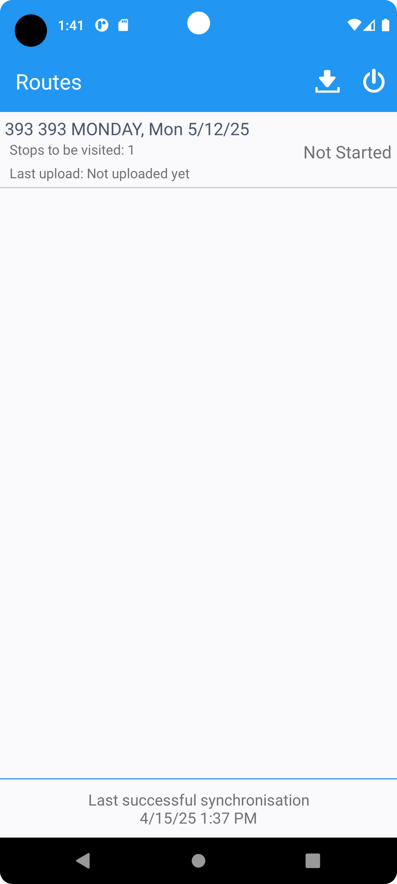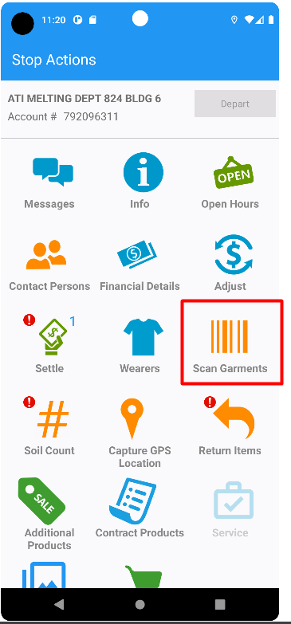
Wearer | ID Code | Product | Size | Description | Where to scan?
Wearer 1 | 5090319585 | GO0809INDG | 38X34 | OVERALL BIB DENIM | BU 549
Wearer 4 | 5090301940 | GO0218NAVY | 3XLR | JACKET HIP 65/35 | BU 529
Wearer 5 | 7585596928 | GS0652LTBL | 1XLL | SHIRT FR LS BUTTON 88/12 | BU 509

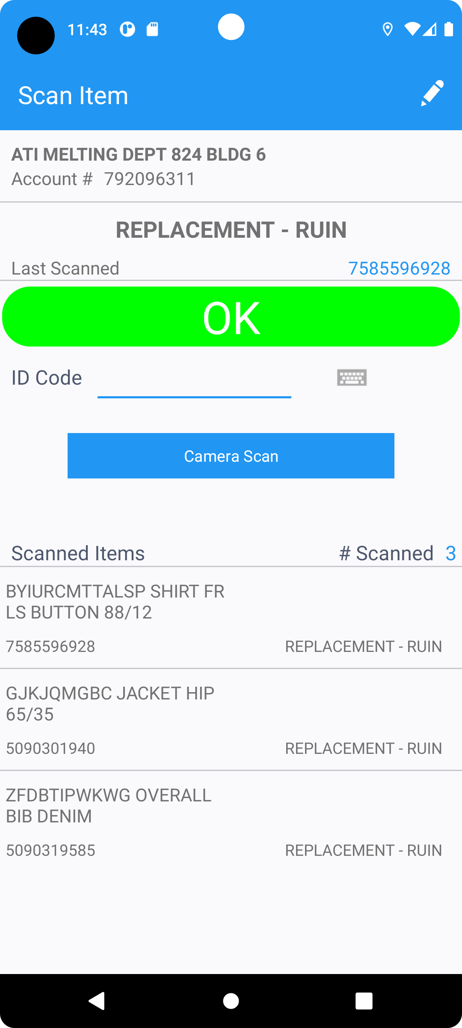
- Upload Route.
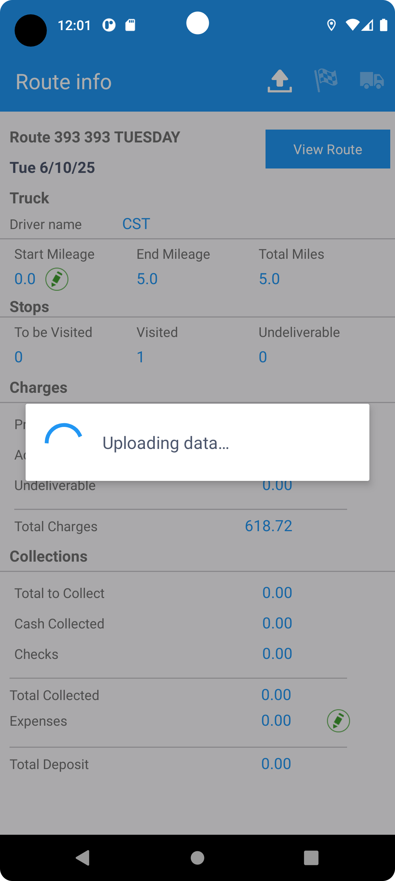
- Verify in db what are the scanned id codes
select OCH.OUTOFCIRCULATIONHISTORY_ID, och.primaryid,
OCH.DISTRIBUTIONPOINT_LINK_ID,
DIP.COSTCENTER_ID,
OCH.PRODUCT_LINK_ID,
PR.TYPEOFMERCHANDISE,
OCH.SIZEDEFINITION_LINK_ID,
OCH.TOBECHARGEDPERCENTAGE,
OCH.QUANTITY,
OCH.STATUS,
OCH.OUTOFCIRCDATE,
OCH.RESIDUALVALUE,
OCH.CHARGETYPE,
OCH.AMOUNT,
OCH.WEAREREMPLOYMENT_LINK_ID,
OCH.REASONCODE_ID,
RC.INVOICECATEGORY,
OCH.PROCESSBUSINESSUNIT_ID,
WI.FINISHINGMETHOD_ID,
RC.CHARGERESIDUALINSURANCE,
OCH.RAGREASON_ID,
RR.CHARGERESIDUALINSURANCE,
RR.BYPASSCUSTOMERINSURANCE,
null,
ILSUBTYPE.INVOICELINESUBTYPE_ID,
OCH.FORBUSINESSUNIT_ID
from OUTOFCIRCULATIONHISTORY OCH
join PRODUCT PR
on OCH.PRODUCT_LINK_ID = PR.PRODUCT_ID
left outer join RAGREASON RR
on OCH.RAGREASON_ID = RR.RAGREASON_ID
left outer join RAGREASONILSUBTYPE ILSUBTYPE
on RR.RAGREASON_ID = ILSUBTYPE.RAGREASON_ID, DISTRIBUTIONPOINT DIP,
REASONCODE RC, WEARERINVENTORY WI
where OCH.INVOICEBUSINESSUNIT_ID = 162 -- Eugene
and OCH.CUSTOMER_LINK_ID = (select ct.customer_id from customer ct where ct.customernumber=792096311)
and TRUNC(OCH.OUTOFCIRCDATE) <= TO_DATE('2025-06-06','YYYY-MM-DD')
and NVL(OCH.INVOICEHEADER_ID, 0) = 0
and OCH.DISTRIBUTIONPOINT_LINK_ID = DIP.DISTRIBUTIONPOINT_ID
and OCH.REASONCODE_ID = RC.REASONCODE_ID
and OCH.WEAREREMPLOYMENT_LINK_ID = WI.WEAREREMPLOYMENT_ID
and OCH.PRODUCT_LINK_ID = WI.PRODUCT_ID
and OCH.SIZEDEFINITION_LINK_ID = WI.SIZEDEFINITION_ID
and OCH.CHARGETYPE in (1,4,3)
order by OCH.WEAREREMPLOYMENT_LINK_ID,
OCH.PRODUCT_LINK_ID,
OCH.SIZEDEFINITION_LINK_ID,
ILSUBTYPE.INVOICELINESUBTYPE_ID,
OCH.STATUS desc,
RR.BYPASSCUSTOMERINSURANCE
- Settle Route.
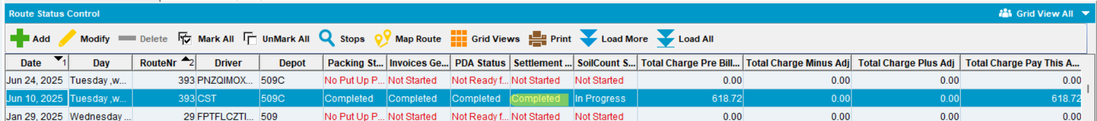
- Create new User under 549-Production Stockroom (Access to BU’s 549, 529, and 509)
- Stockroom 549
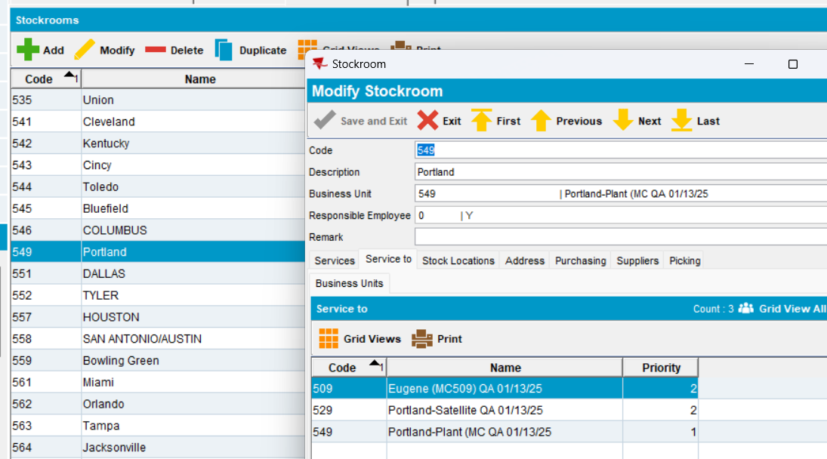
- new User
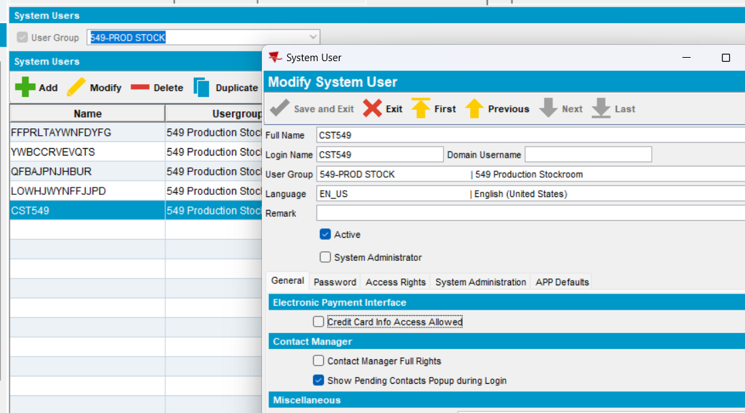
- Login as new test user.
- Rag Item under BU 549 (Plant BU Portland Plant).
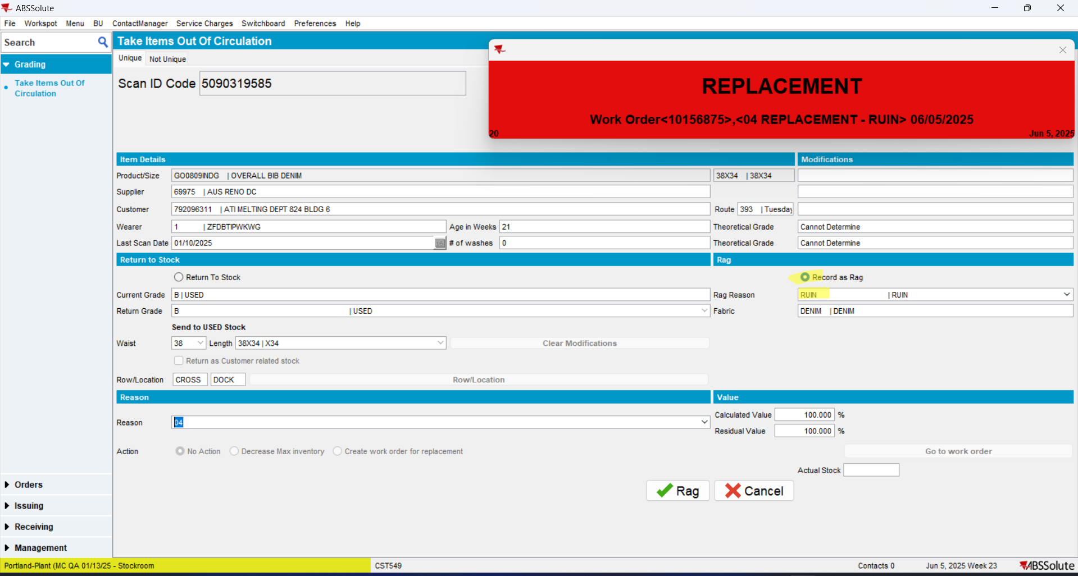
- Rag Item under BU 529 (Another BU this plant services - Plant BU Portland Sattelite).
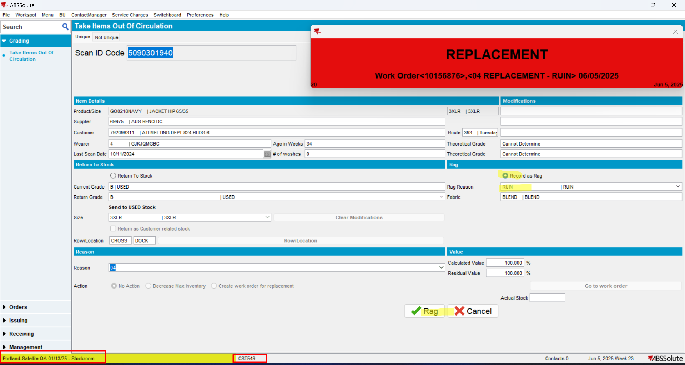
- Rag Item under BU 509 (Invoicing BU for Customer).
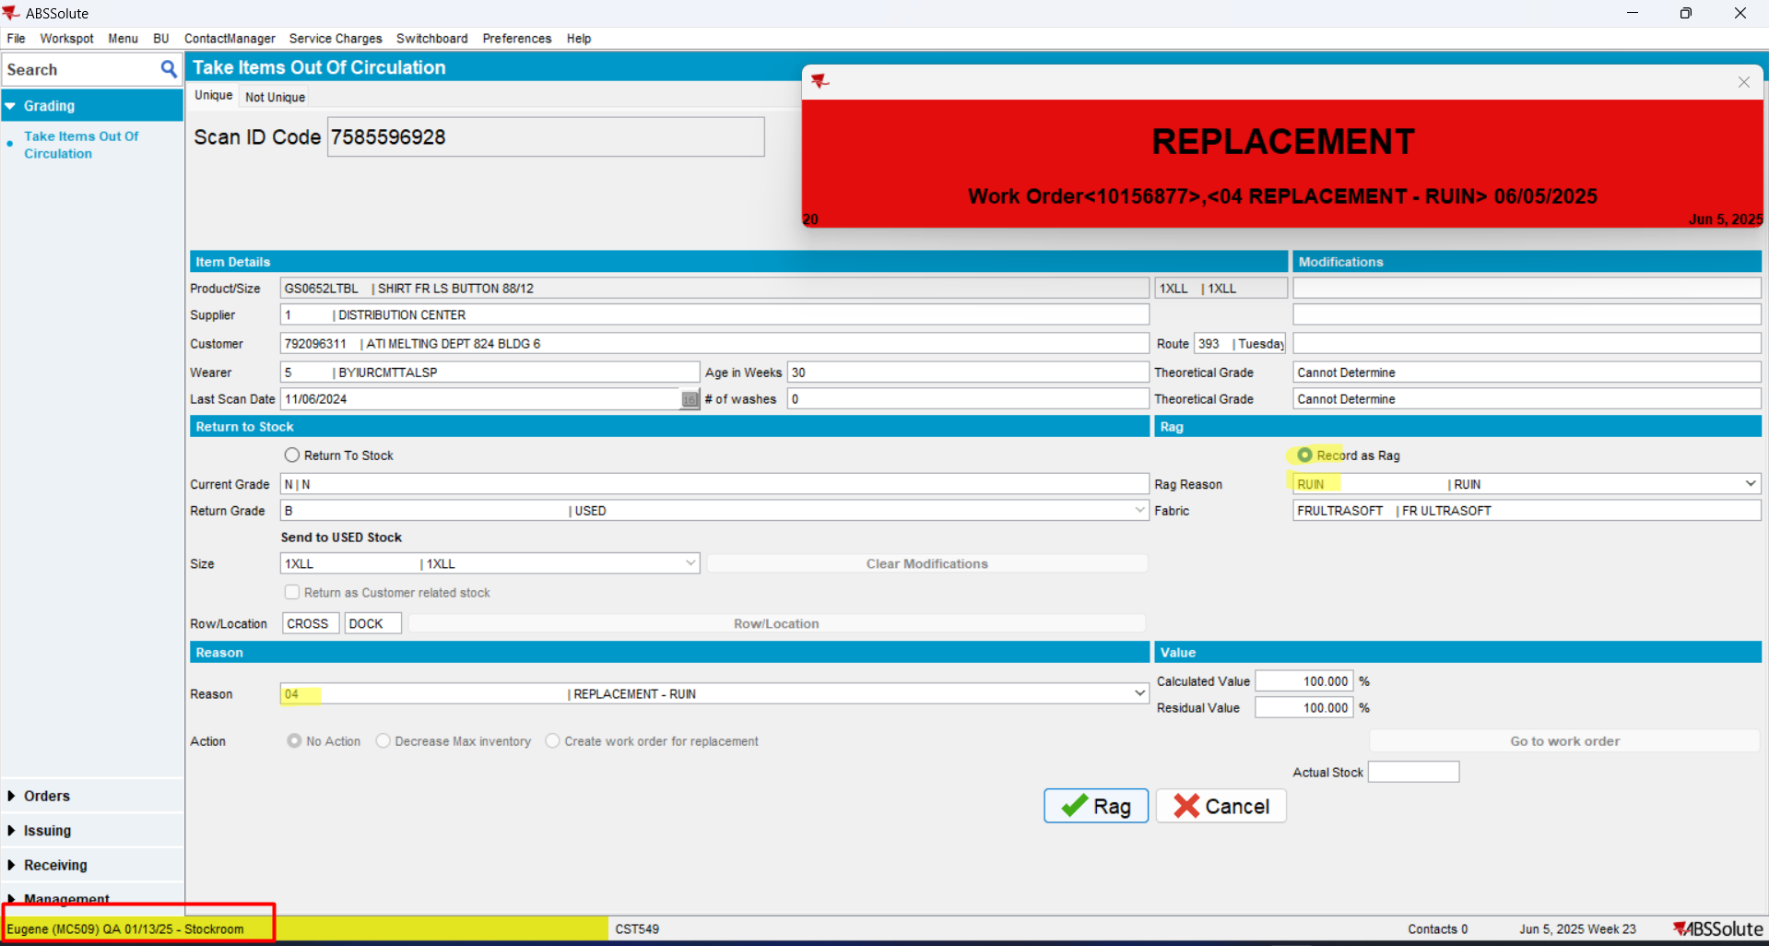
- Check in db the ID codes -> in database, there are 3 records scanned, because 3 id codes were scanned on PDA
- Generate Put Ups and Invoices for the next week in BU 509.
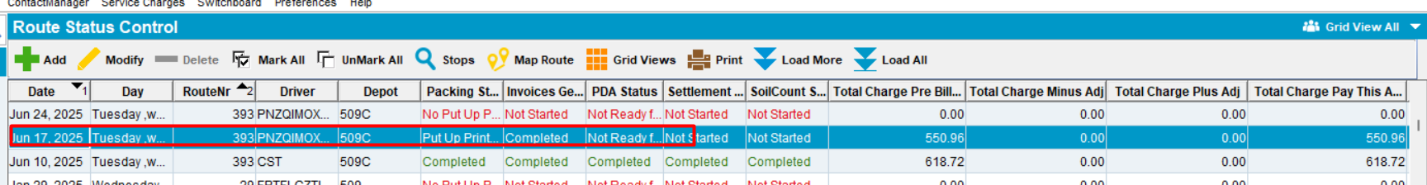
- Review Invoice.
RESULT: Wearer 1 and wearer 4 have 1 billed Ruin Charge.
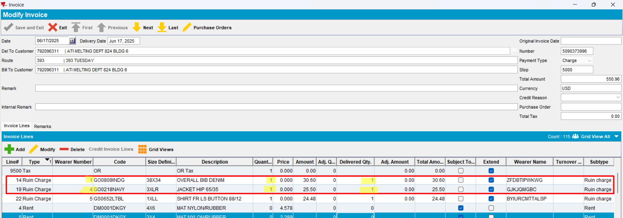
Every ID Code that was ragged out under BU 549 and 529 appears only once, which is correct.
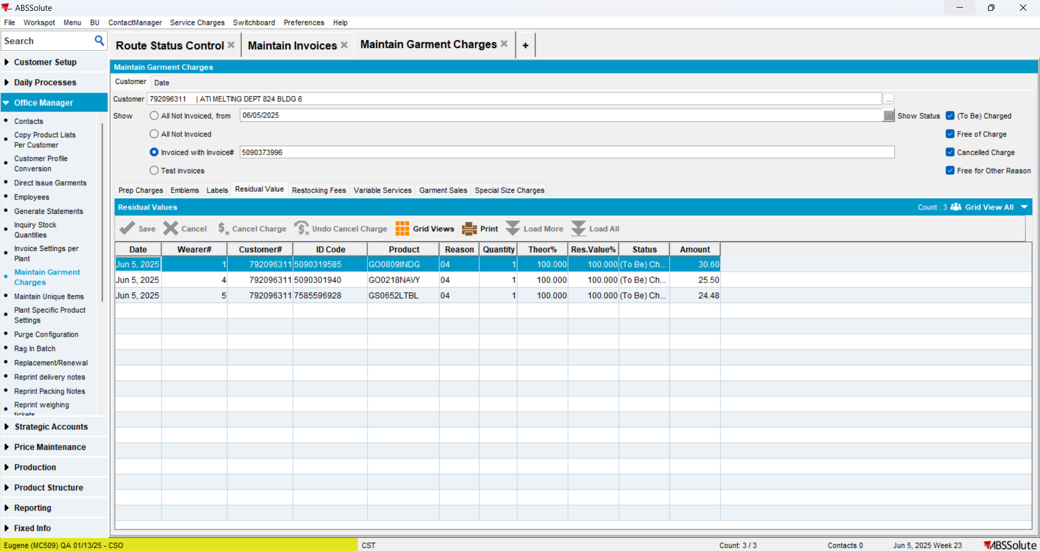
RETEST OK

