ABSN-223 Downgrade to 9.08.00.RELEASE.p21_AUS
Environment | Prerequisites
Version: 9.08.00.RELEASE.p21  DBServerName=abs-srv17.internal.abslbs.com  DBSID=CUST23  DBUser=AUS_MNT90800  DBPassword= AUS_MNT90800  Environment=Production  Hash: b364700 | - Module: AUSCUSTOM  - System setting: -  - Others…

Contents
Retest after fix 1
1. Active BM6 product -> to be end dated 1
2. Already Inactive BM6 product -> modify weekly usage 6
3. Customer without delivery 14

Retest after fix
Hash: b364700
BU: 632 La Crosse

1. Active BM6 product -> to be end dated
- In Product List per Customers dlg, open a customer that has BM6 products
- Select a BM6 product and modify it
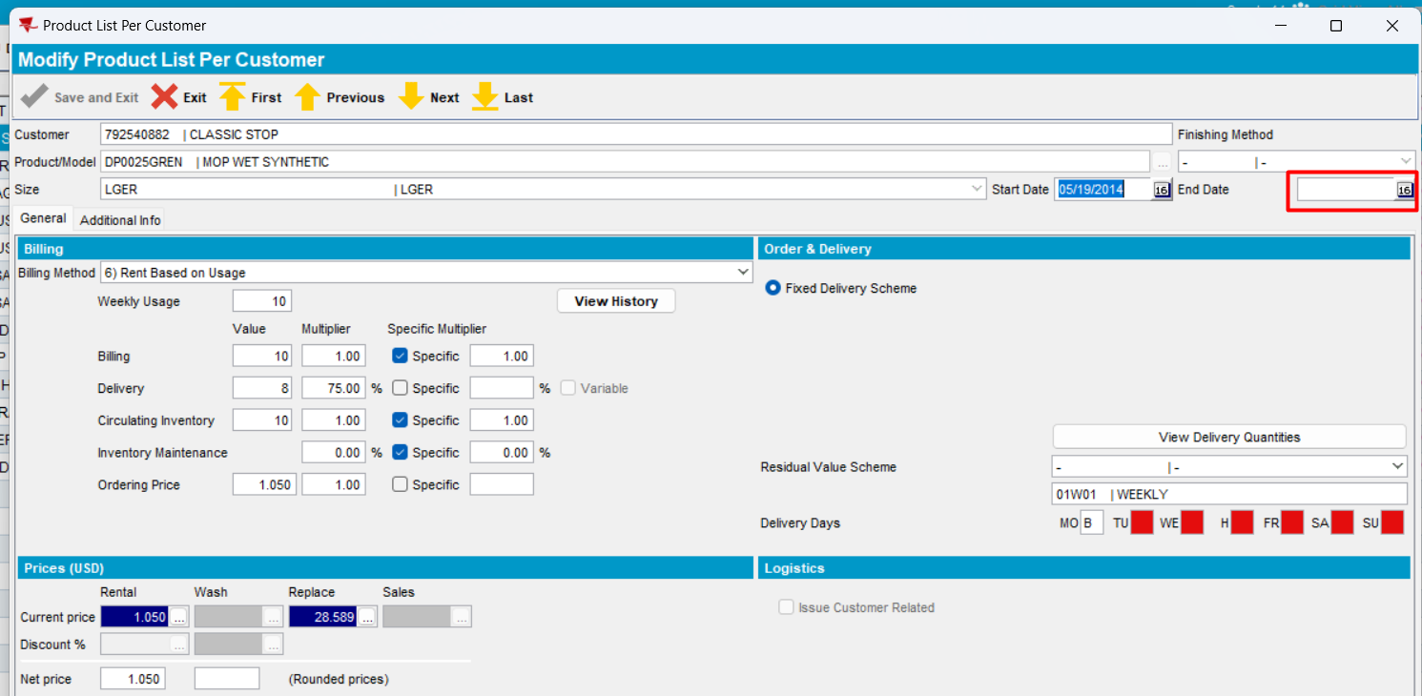
- End date the product and press button “Save and Exit”
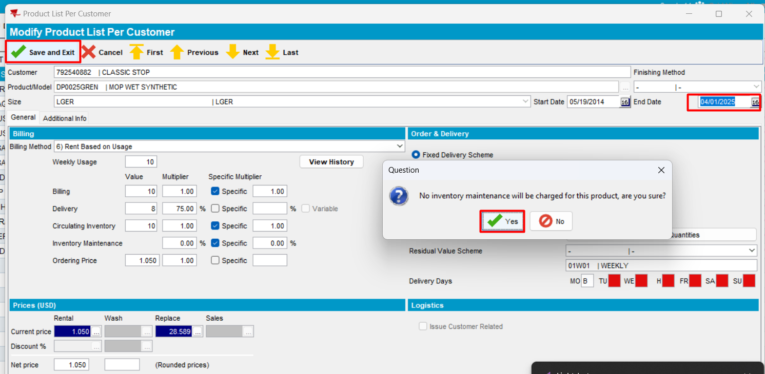
Press Yes
The PLPC is end dated.
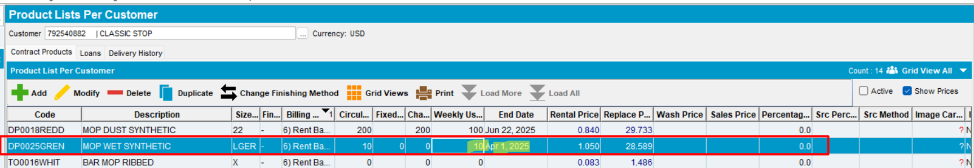
- Reopen product
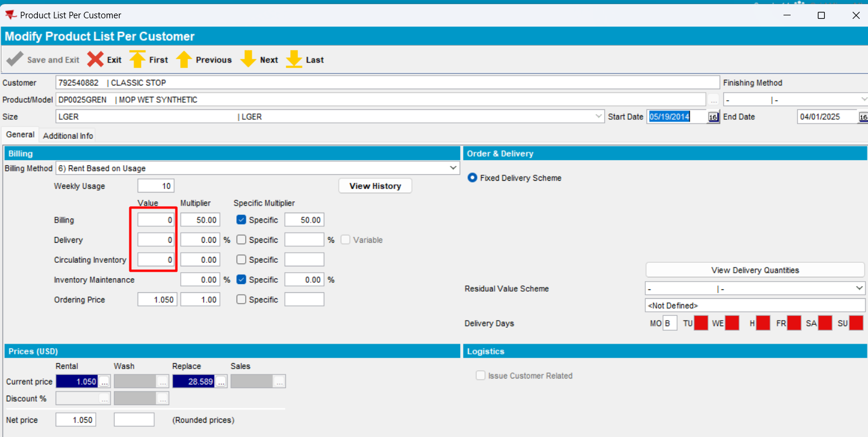
The PLPC has an end date. Note, all the values 0 are as the SDL lines are also ended.
- Change weekly usage and save the new value
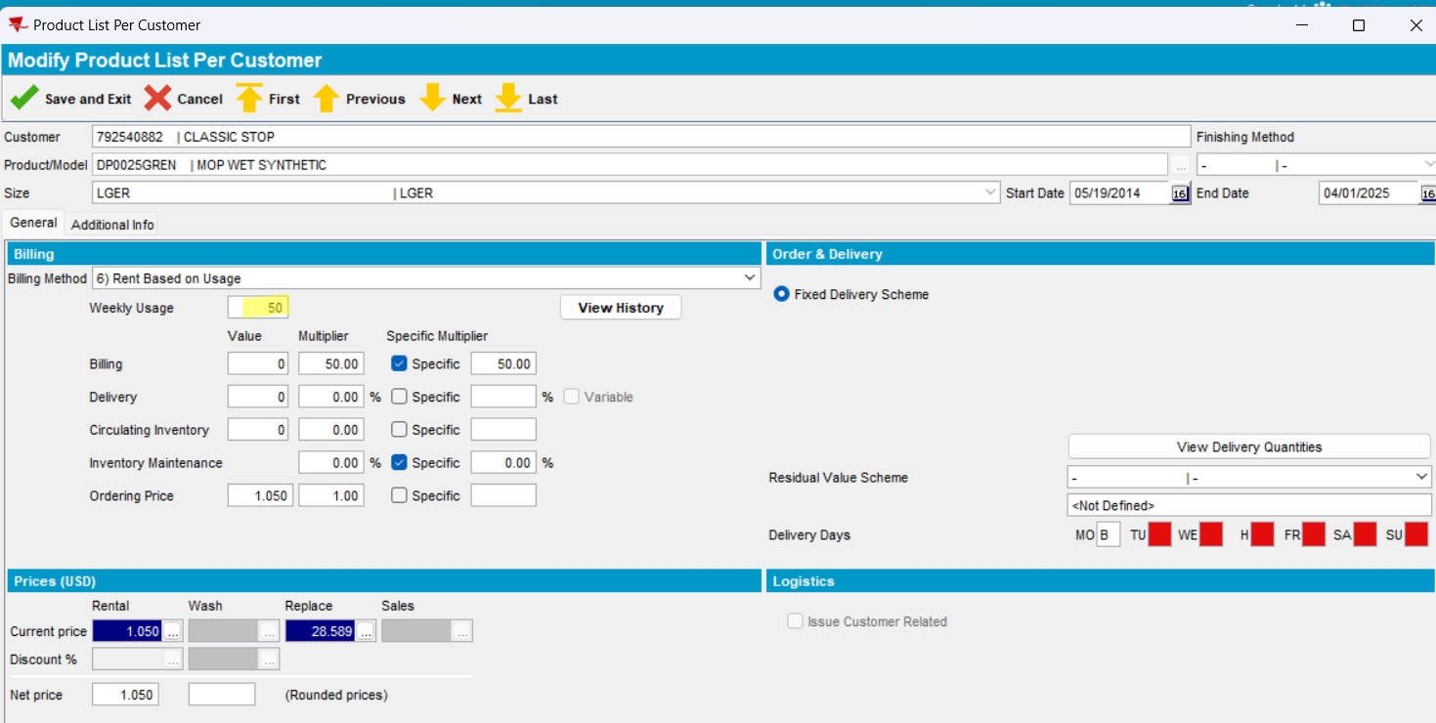
Save
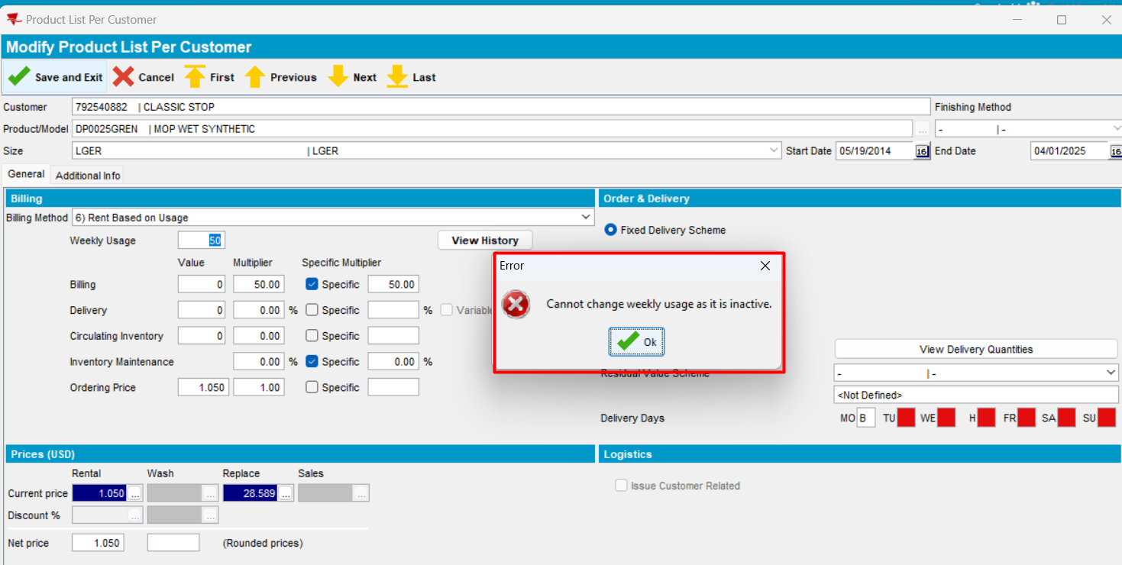
Expected behavior: If the PLPC is inactive and weekly usage is changed, then on save, show the error message "Cannot change weekly usage as it is inactive"
Actual behavior: as expected
- Press Cancel and Yes
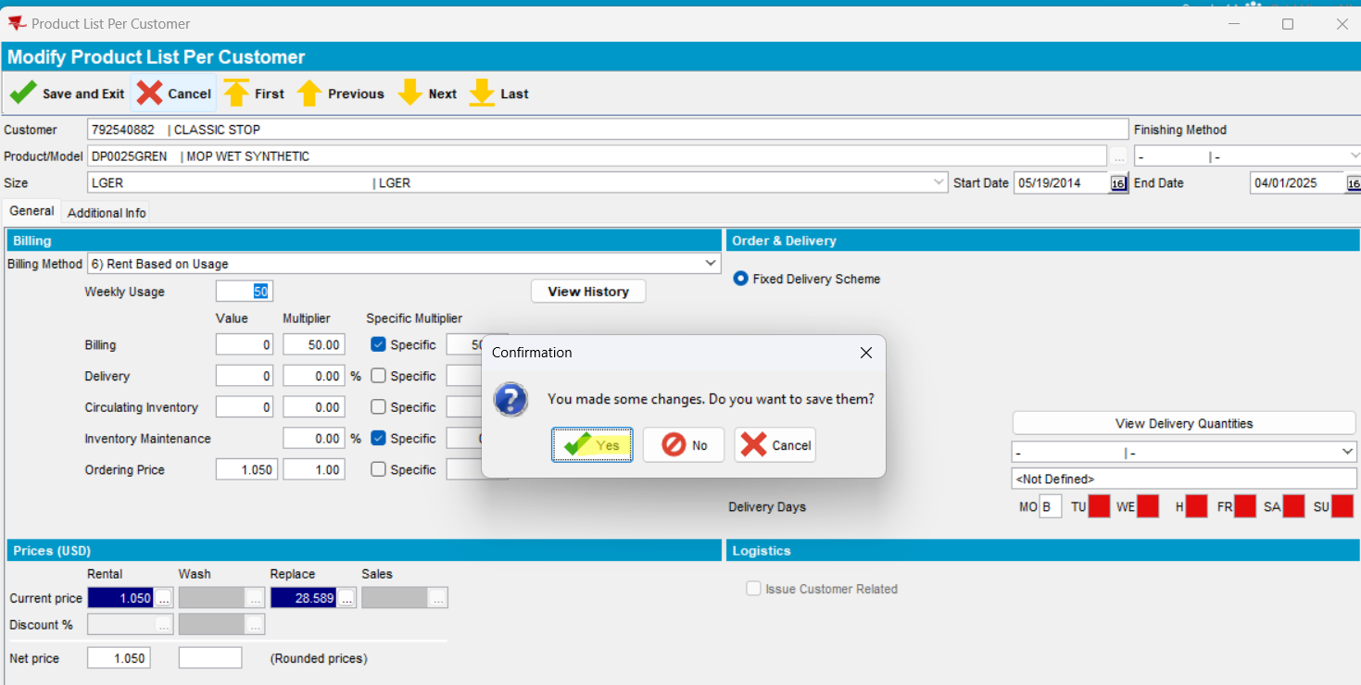
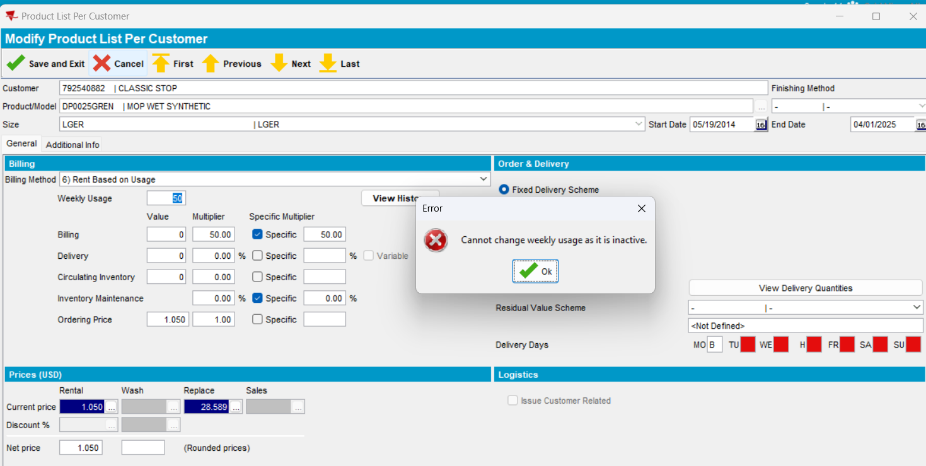
Expected behavior: If the PLPC is inactive and weekly usage is changed, then on save, show the error message "Cannot change weekly usage as it is inactive"
Actual behavior: as expected
- Press Close and Yes
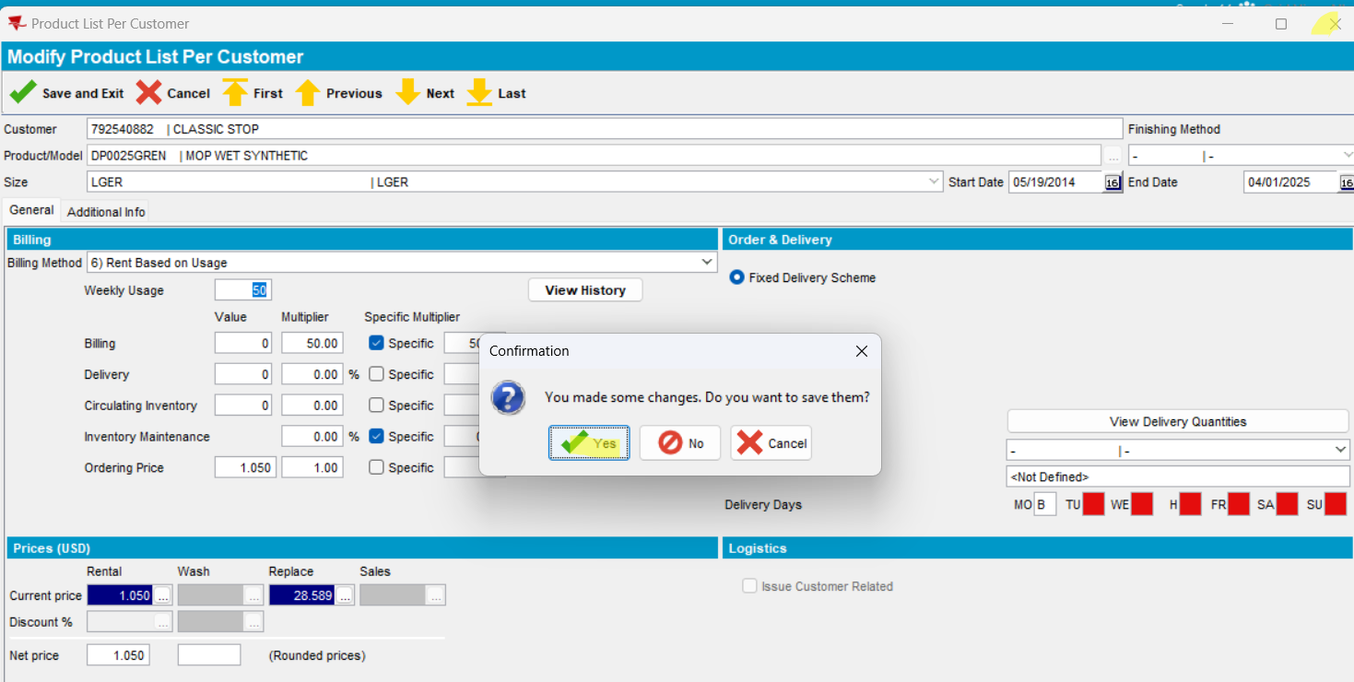
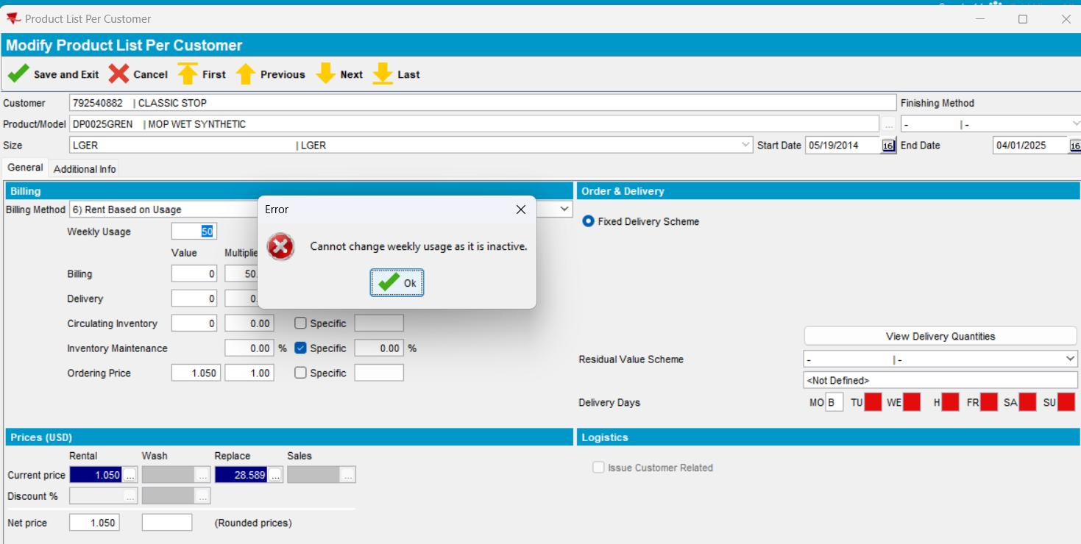
Expected behavior: If the PLPC is inactive and weekly usage is changed, then on save, show the error message "Cannot change weekly usage as it is inactive"
Actual behavior: as expected
Test OK

2. Already Inactive BM6 product -> modify weekly usage
- Load a customer in PLPC and select an inactive plpc record with BM6
- Modify product
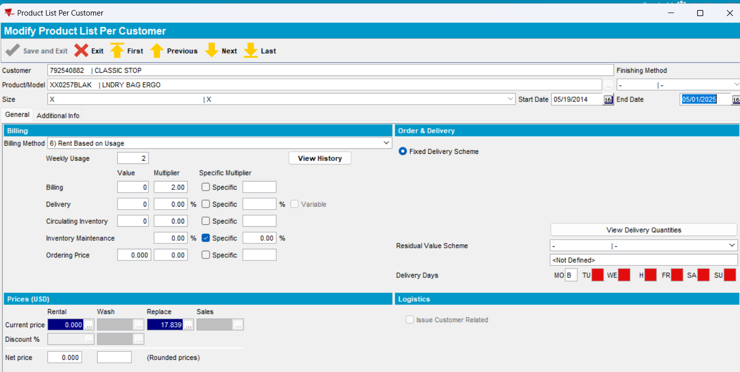
- Modify weekly usage and save it
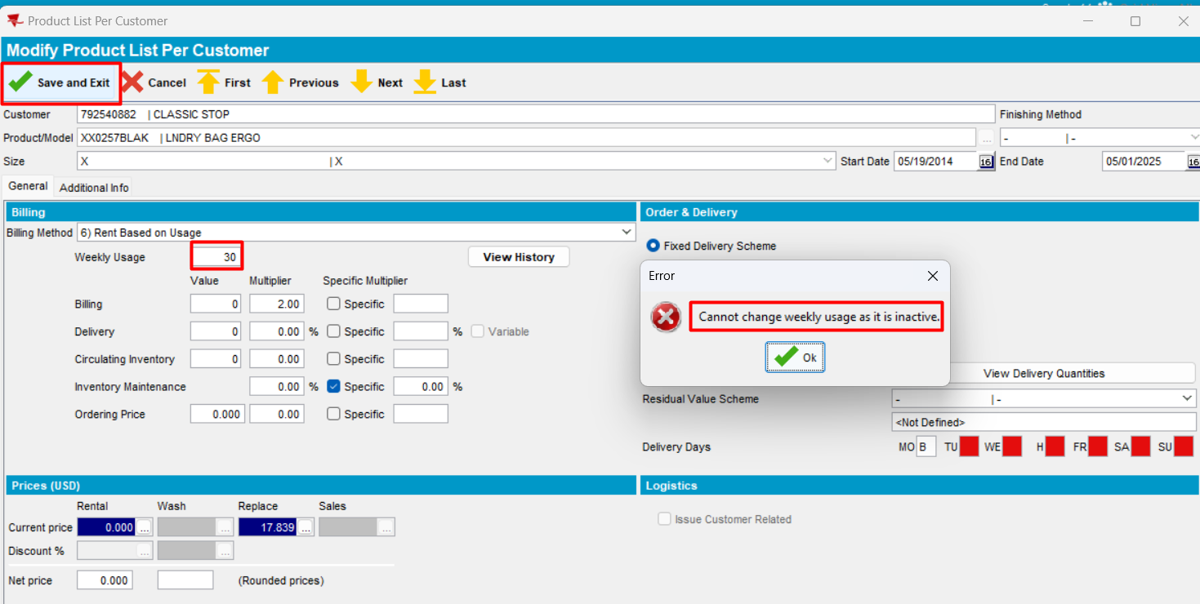
Expected behavior: If the PLPC is inactive and weekly usage is changed, then on save, show the error message "Cannot change weekly usage as it is inactive"
Actual behavior: as expected
Test OK
- Click on Cancel and select Yes
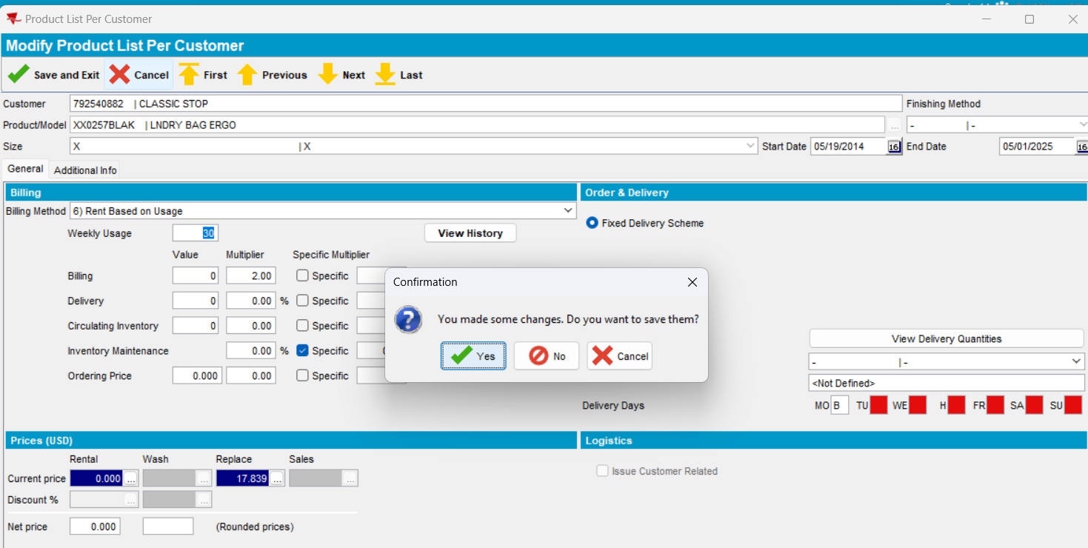
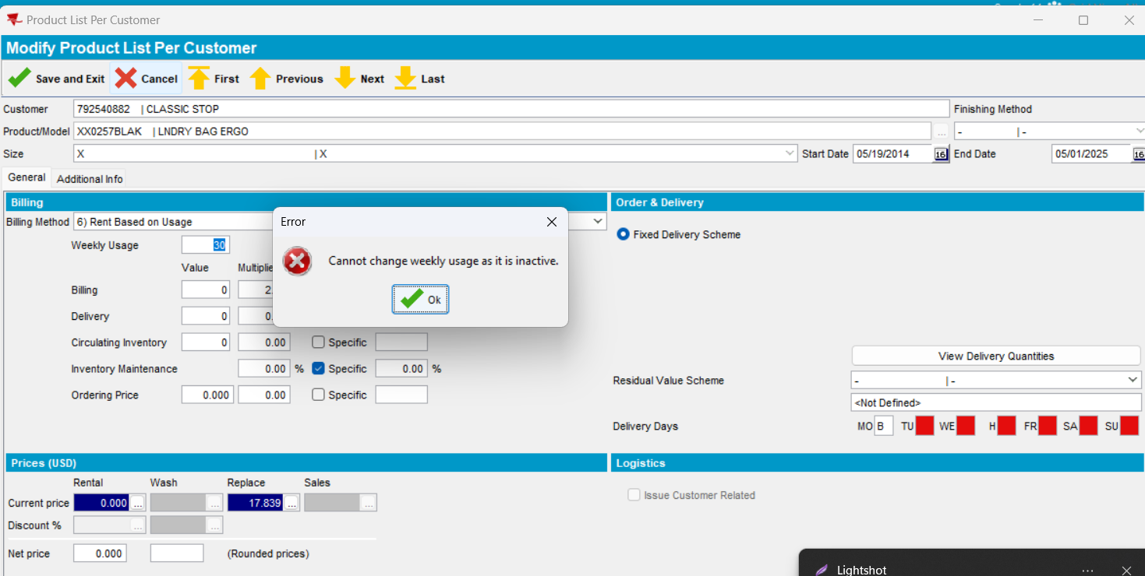
Expected behavior: If the PLPC is inactive and weekly usage is changed, then on save, show the error message "Cannot change weekly usage as it is inactive"
Actual behavior: as expected
Test OK
- Click on Cancel and select No
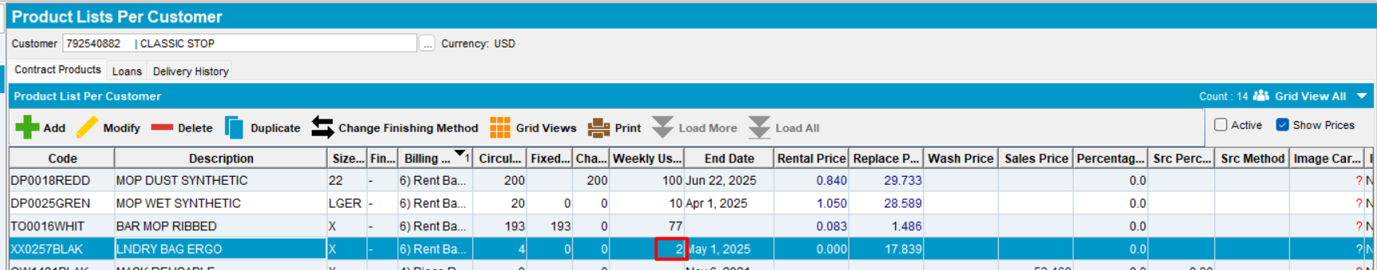
Value remained unchanged
- Click on Close and select Yes
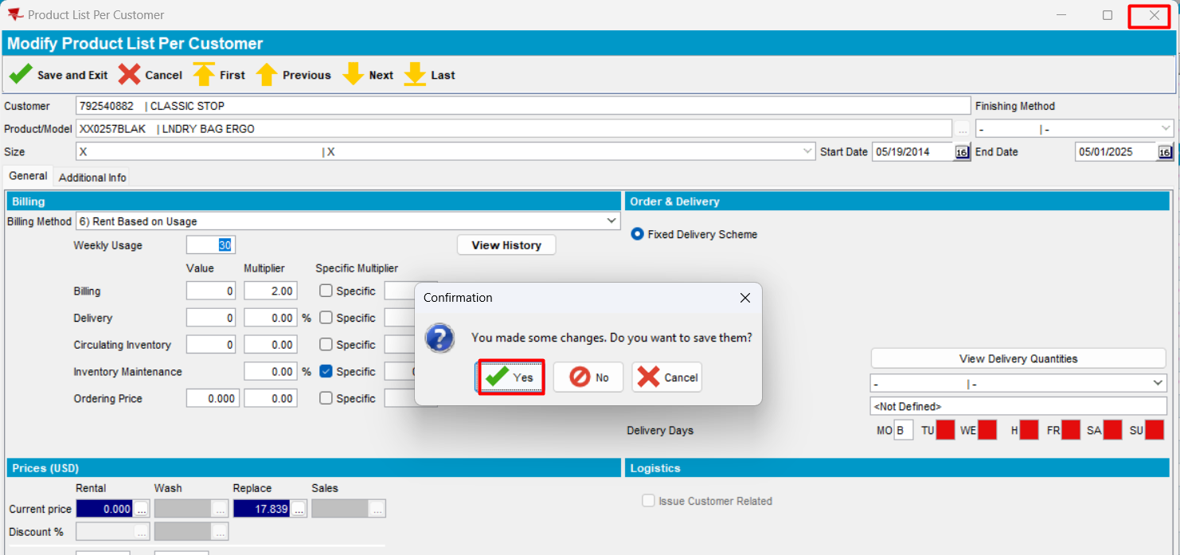
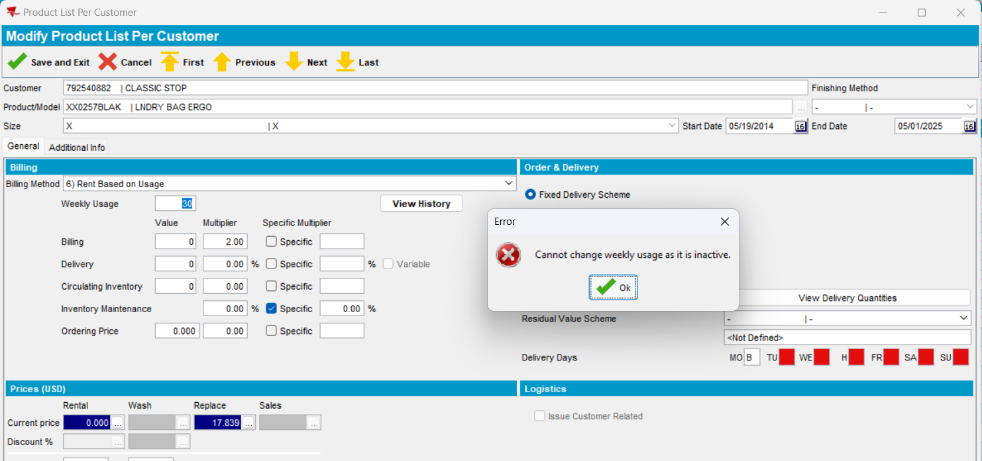
- Click on Next and select Yes
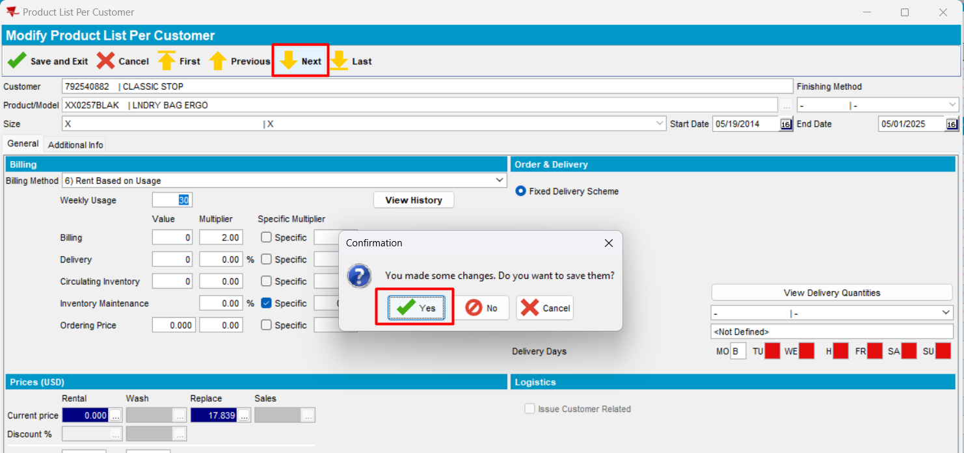
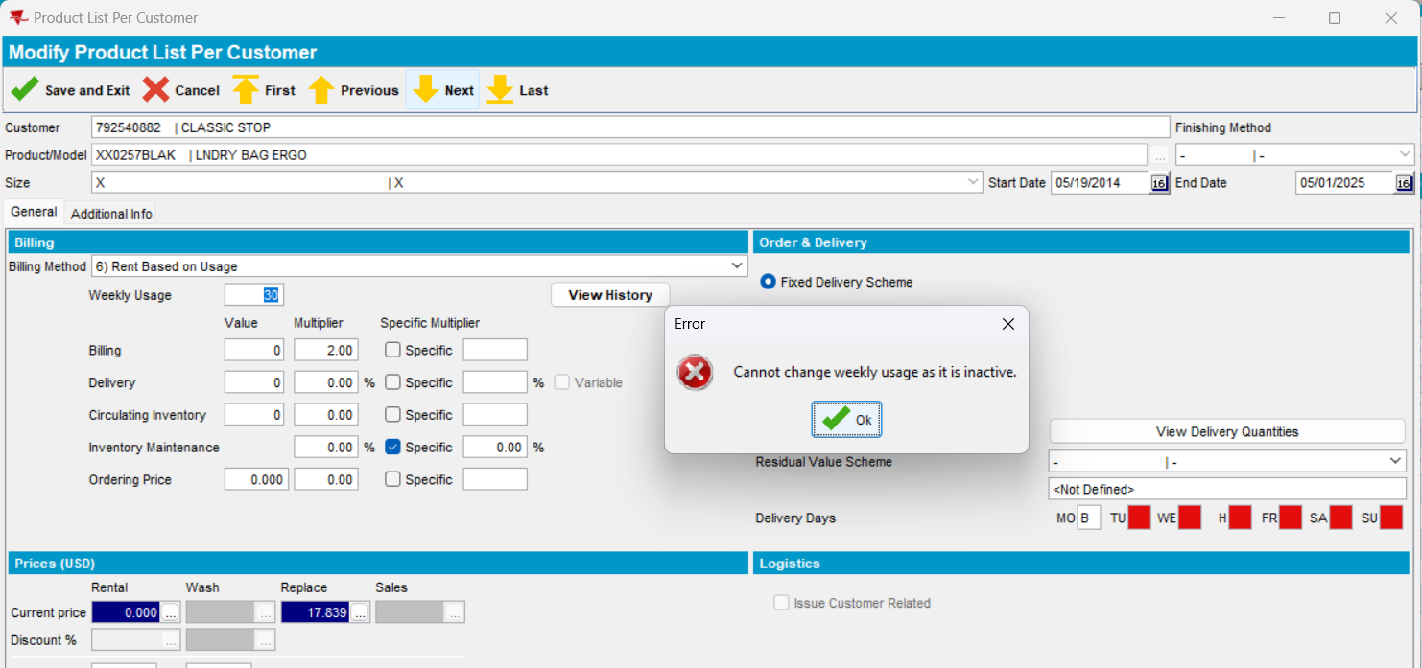
Expected behavior: If the PLPC is inactive and weekly usage is changed, then on save, show the error message "Cannot change weekly usage as it is inactive"
Actual behavior: as expected
Test OK
- Click on Previous and select Yes
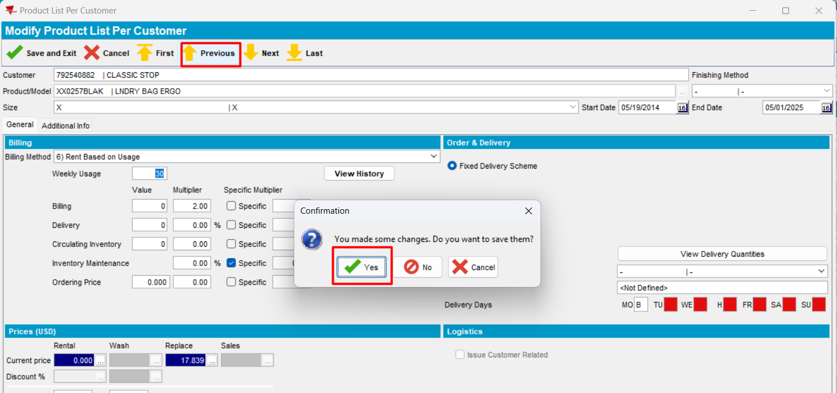
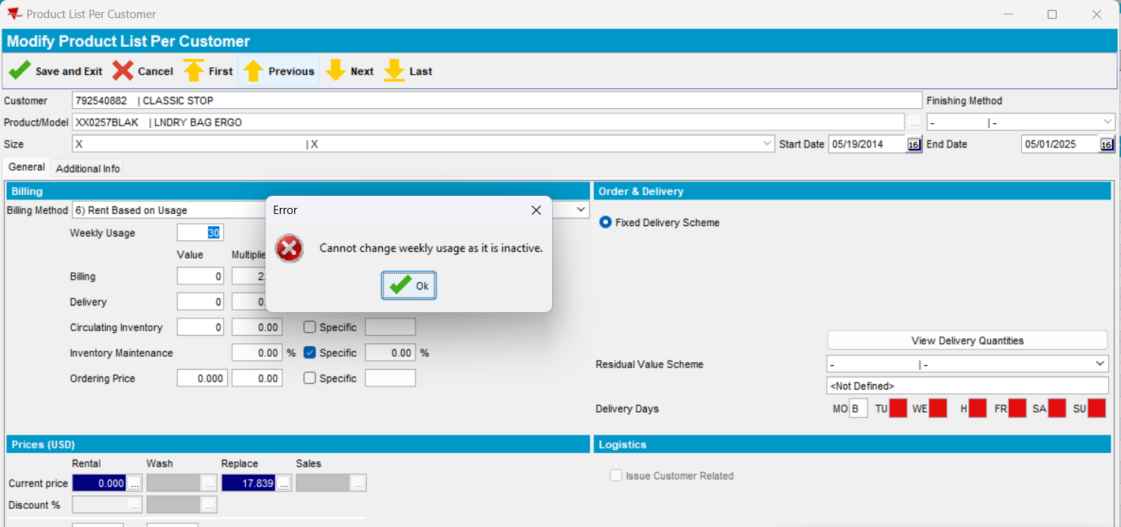
Expected behavior: If the PLPC is inactive and weekly usage is changed, then on save, show the error message "Cannot change weekly usage as it is inactive"
Actual behavior: as expected
Test OK
- Click on Last and select Yes
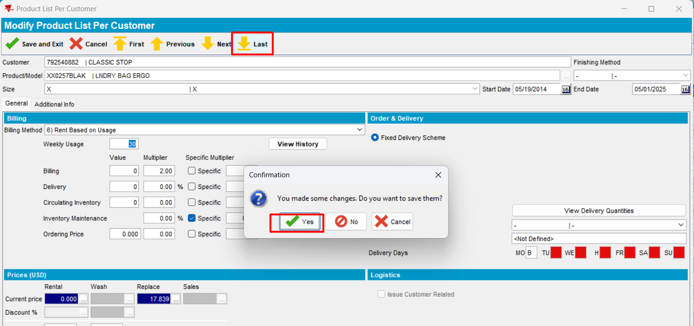
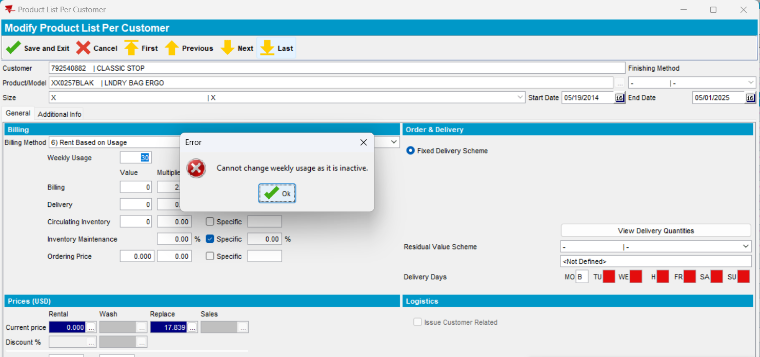
Expected behavior: If the PLPC is inactive and weekly usage is changed, then on save, show the error message "Cannot change weekly usage as it is inactive"
Actual behavior: as expected
Test OK
- Click on First and select Yes
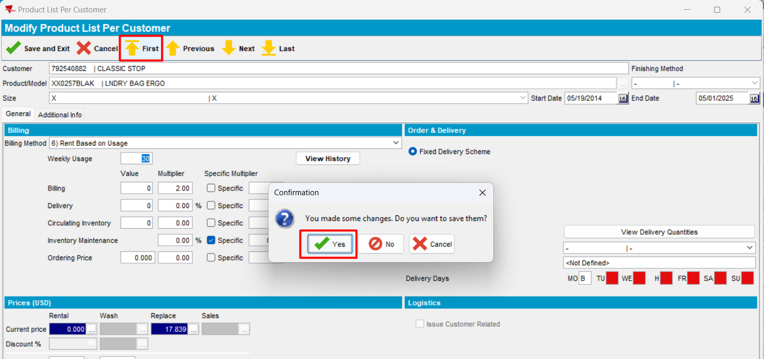
Expected behavior: If the PLPC is inactive and weekly usage is changed, then on save, show the error message "Cannot change weekly usage as it is inactive"
Actual behavior: as expected
Test OK

3. Customer without delivery
- Have a customer without delivery day
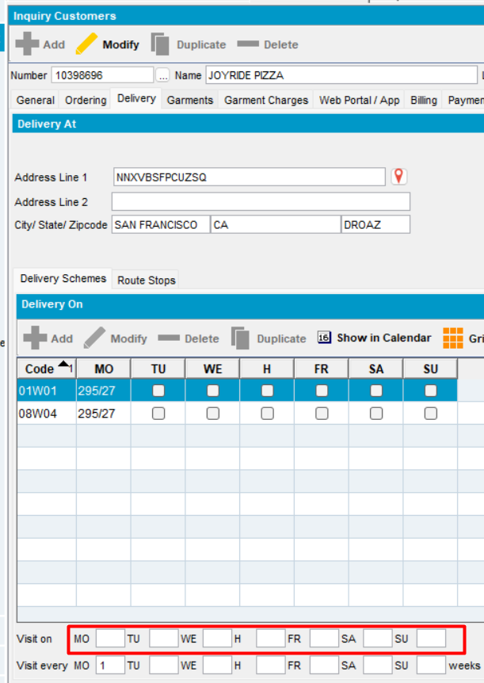
- In Product Lists per Customer, add a BM6 product
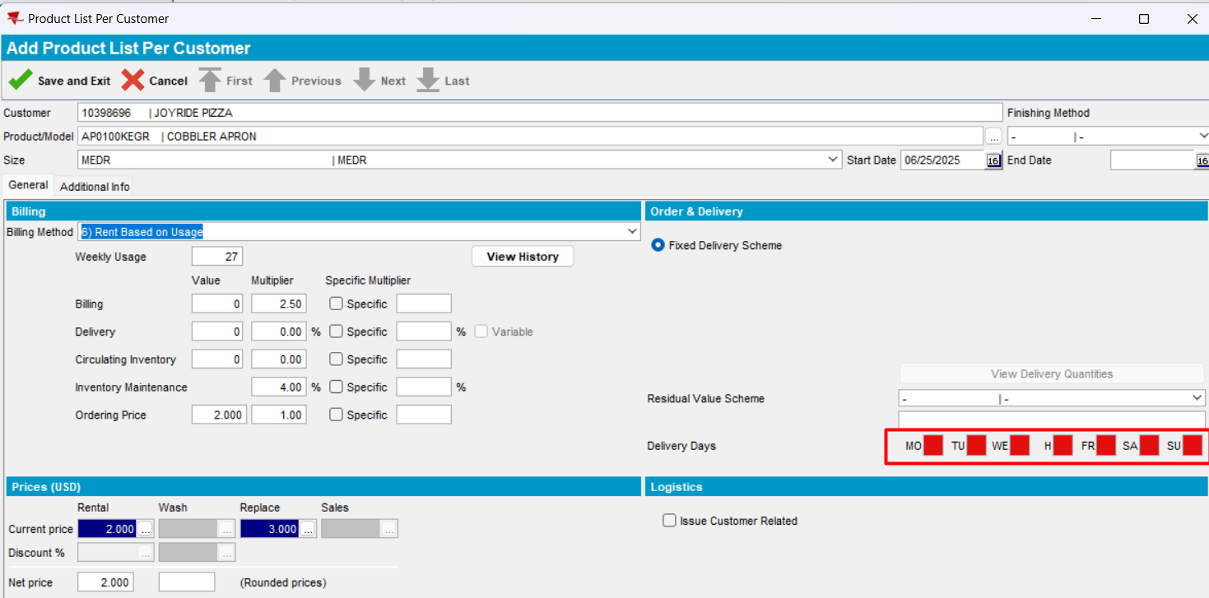
- Save
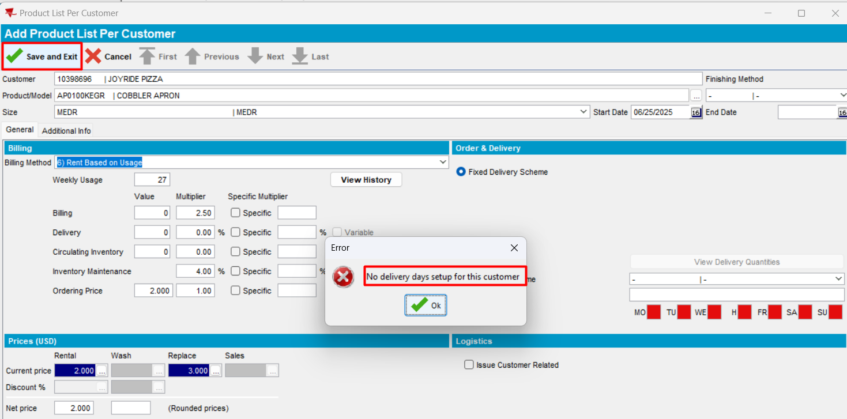
Because the customer does not have a delivery day, the correct error occurs.
- Press Cancel and Yes
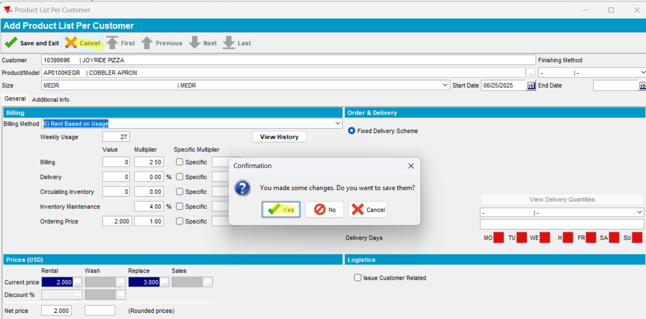
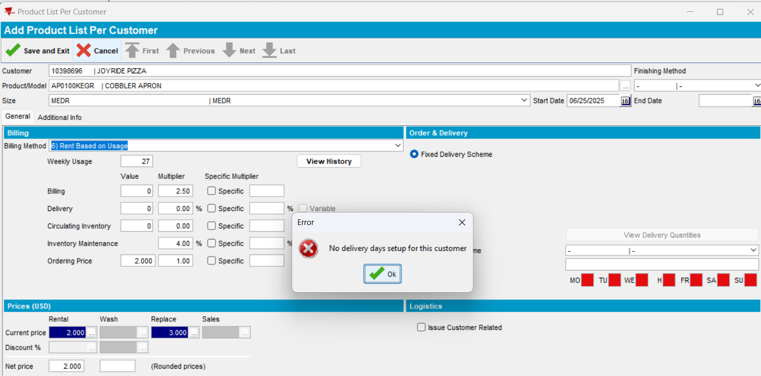
Because the customer does not have a delivery day, the correct error occurs.
- Press Close and Yes
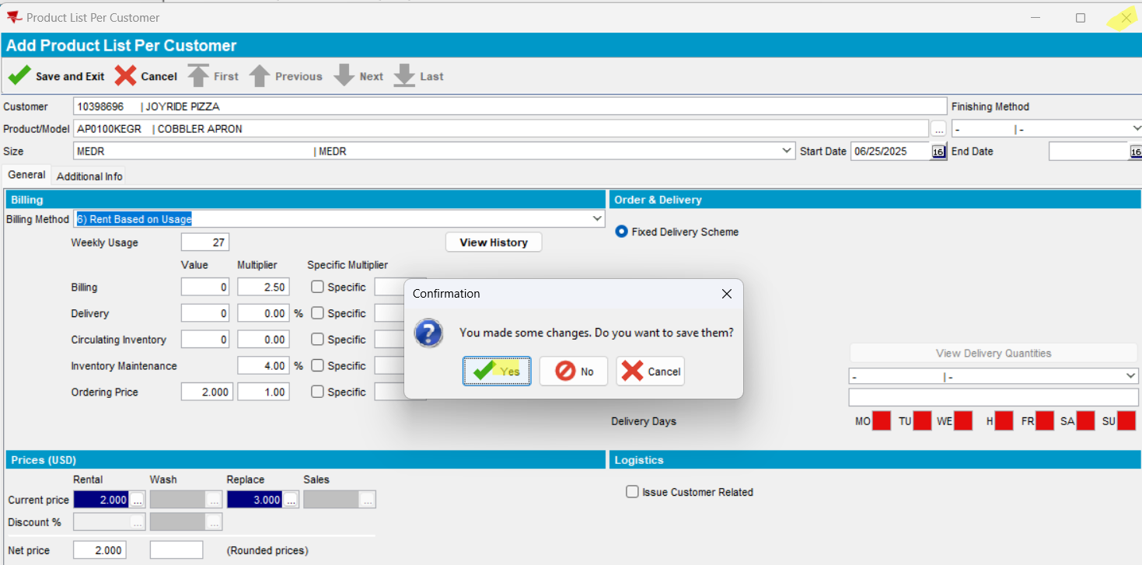
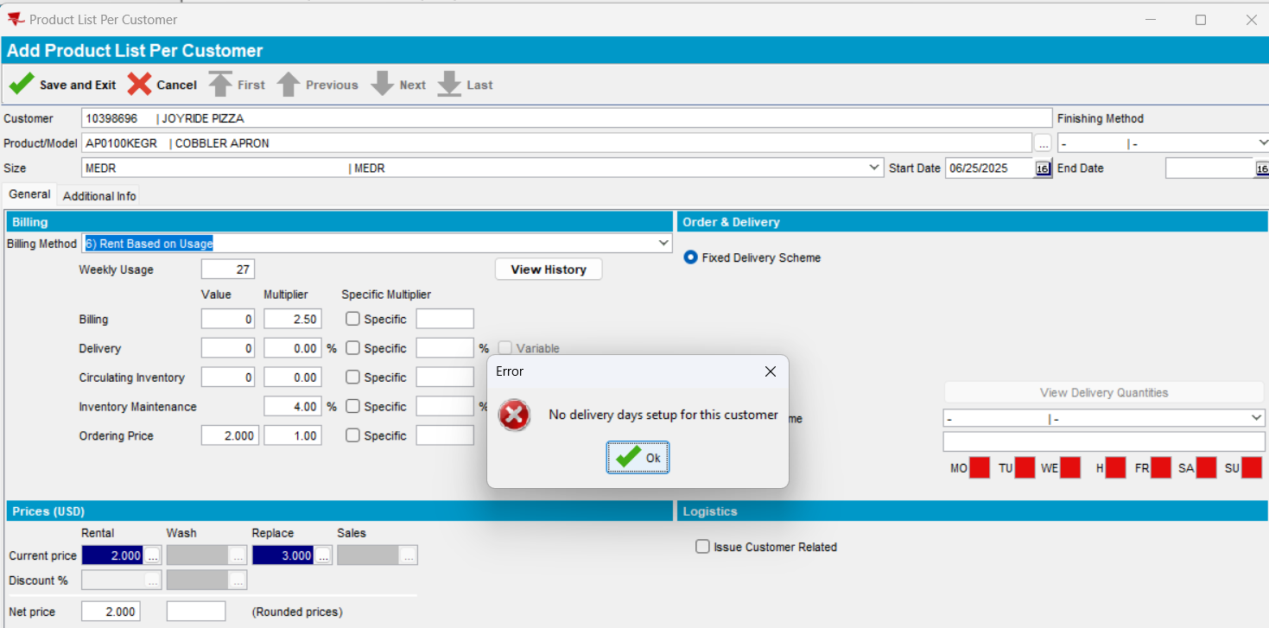
Because the customer does not have a delivery day, the correct error occurs.
TESTED OK

