ABSN-2163 Contract Product Add - restricting products based on PSPS active by plant
DOWNGRADE TEST 9.08.00-AUSs
Environment | Prerequisites
Version: 9.08.00.RELEASE.p20  DBServerName=db01-buc.internal.abslbs.com  DBSID=CUST25  DBUser=AUS_ND90502  DBPassword=AUS_ND90502  Environment=Production  EnvironmentSABStage=Production | - Module: DASHBOARD  - SS:
Contents
Test Case 1 - Add an inactive Plant Specific Product on contract – PASSED 1
Test Case 2 - Add an active Plant Specific Product on contract – PASSED 4

AFTER Fix:
HASH: 2125dfb26e94

Test Case 1 - Add an inactive Plant Specific Product on contract – PASSED
BU code: 250 (Minneapolis)
Plant code: 250 (Minneapolis)

Expected result: As contract resides “above” plant level, the check on product (PlantProductSettings PPS.Active = ‘Y/N’, that is the product checkbox “ACTIVE” in Plant Specific Product Settings dlg.), should not be decisive if a product can or cannot be added to a CONTRACT.
Product Used: Product.code=KX0016XXXX
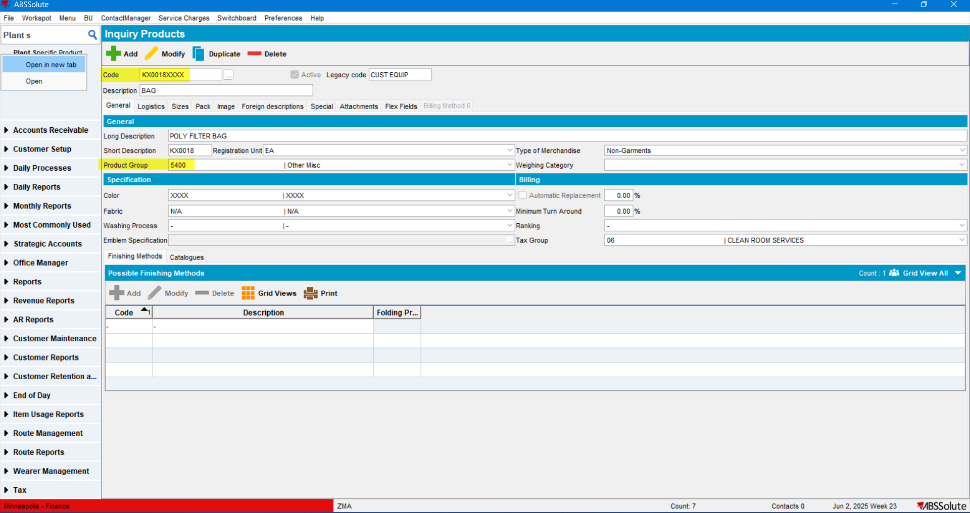

The product is inactive on Plant.code=250:
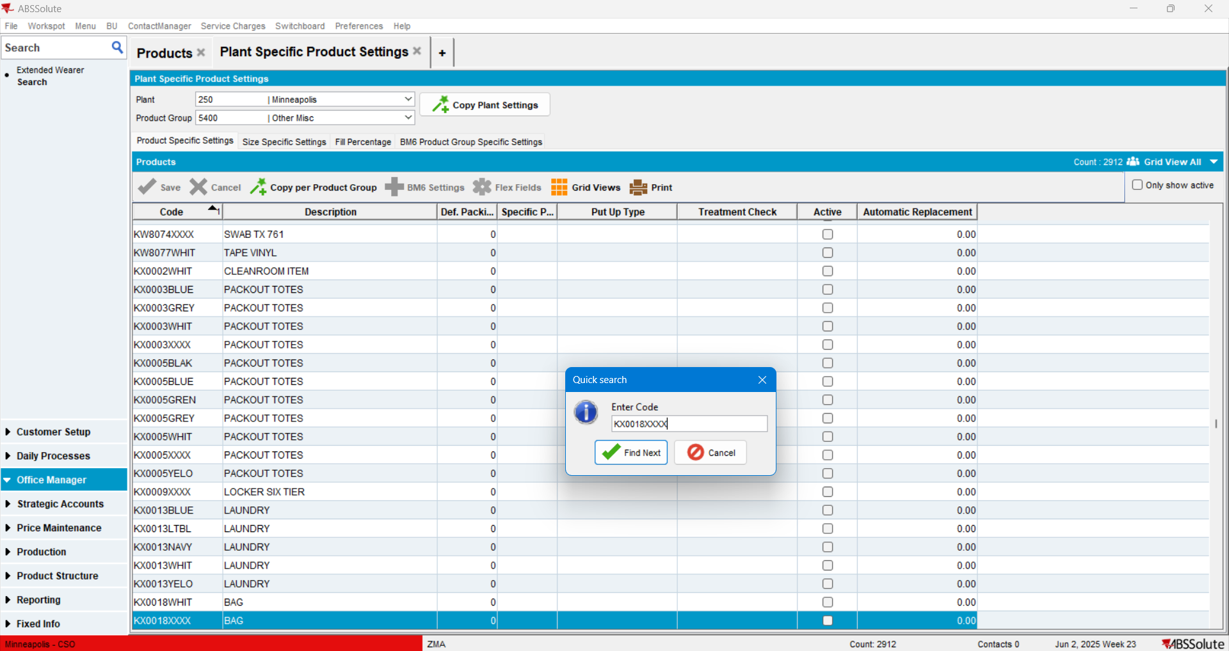

Open the Contracts dlg.> select a contract> and open it in Modify mode > Components tab > Products:
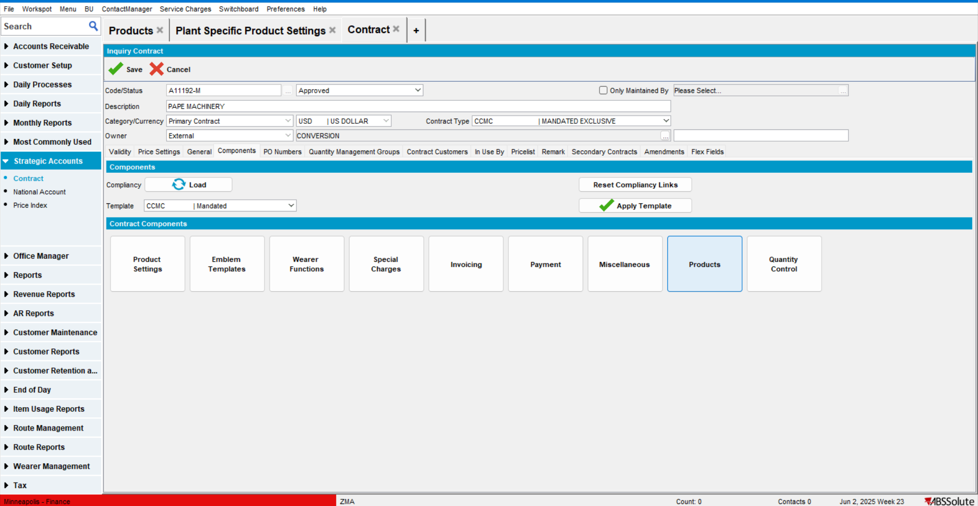
Add the product: 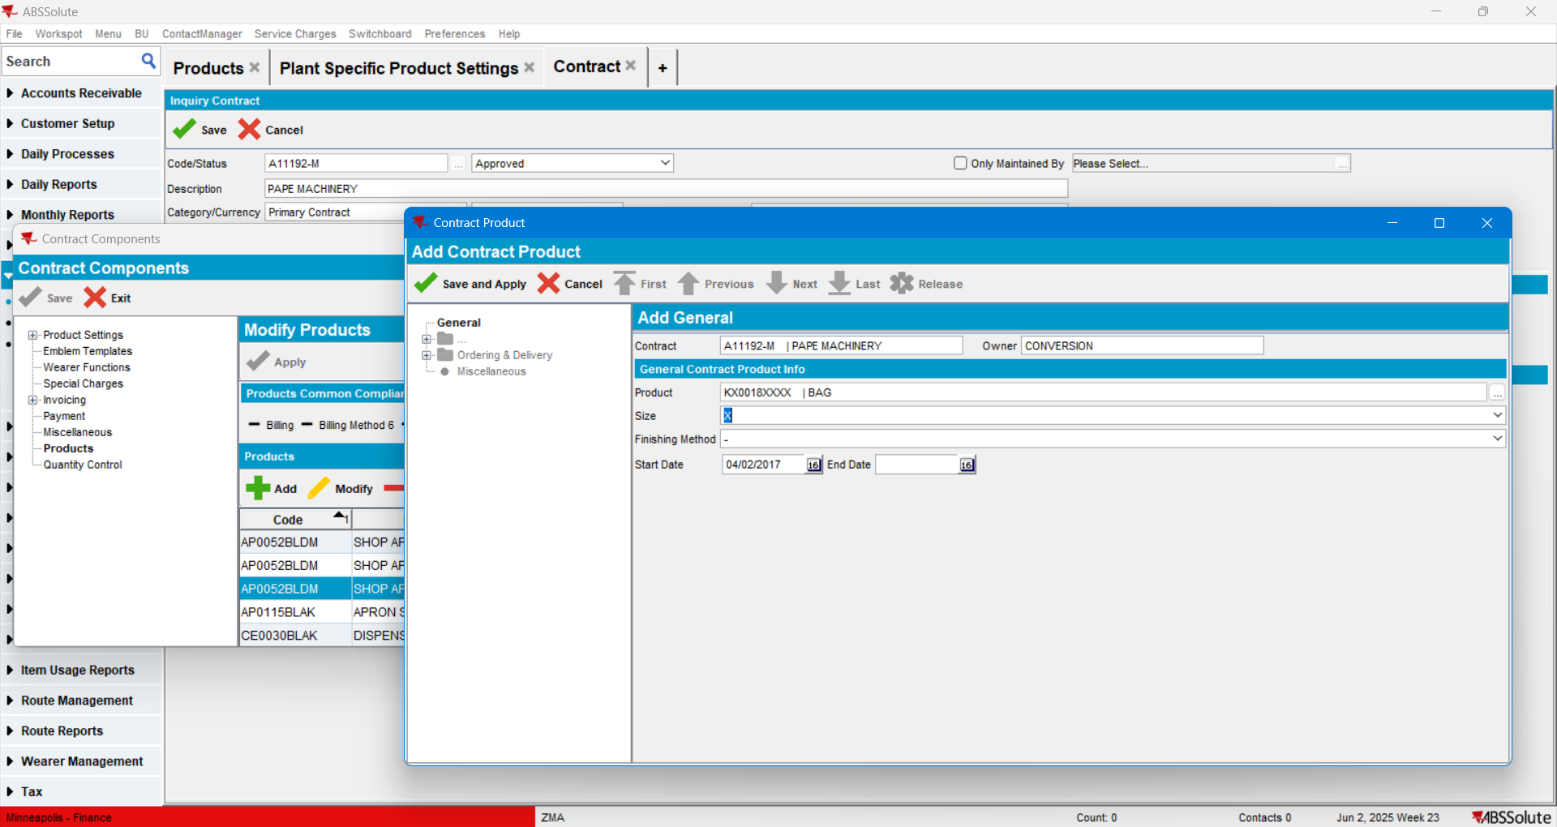
The product was added without any error messages:
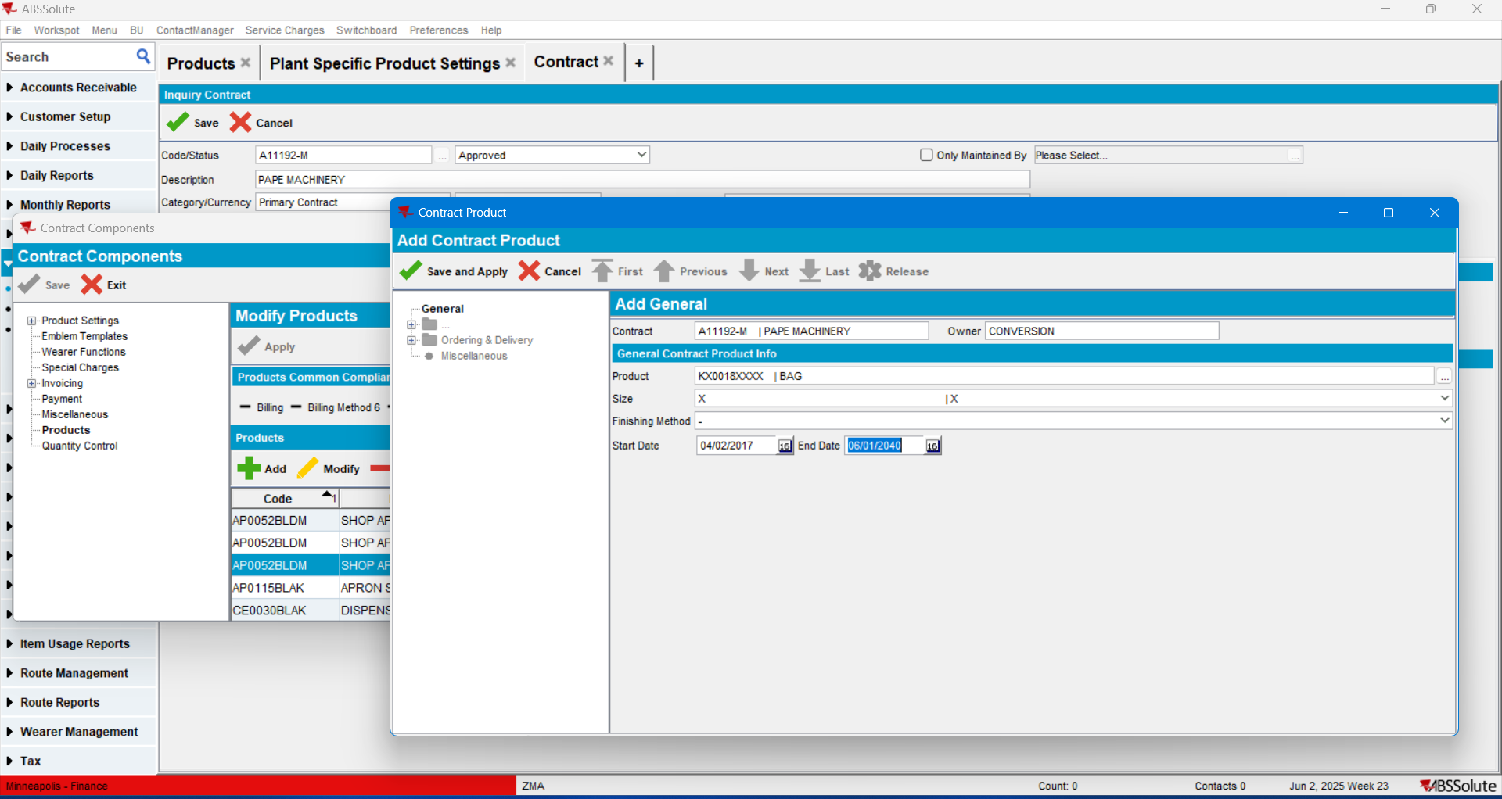
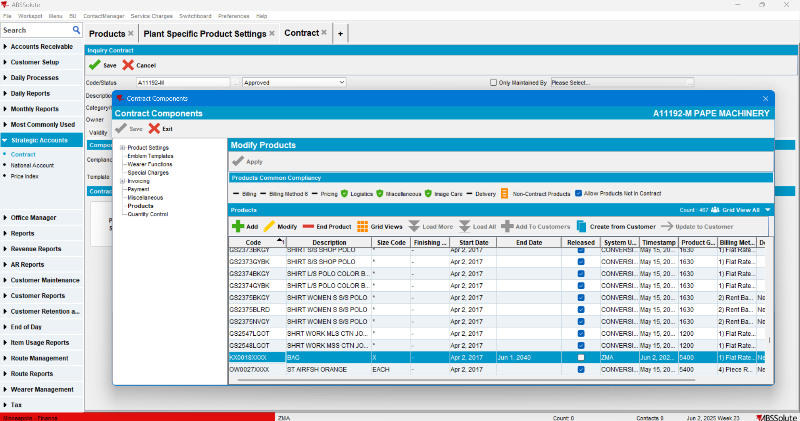
TEST PASSED.

Test Case 2 - Add an active Plant Specific Product on contract – PASSED
BU code: 252 (Fargo)
Plant code: 252 (Fargo)
Expected result: As contract resides “above” plant level, the check on product (PlantProductSettings PPS.Active = ‘Y/N’, that is the product checkbox “ACTIVE” in Plant Specific Product Settings dlg.), should not be decisive if a product can or cannot be added to a CONTRACT.
Product.code= BL0007ARKN is active for this BU in Plant Specific Product Settings dlg.:
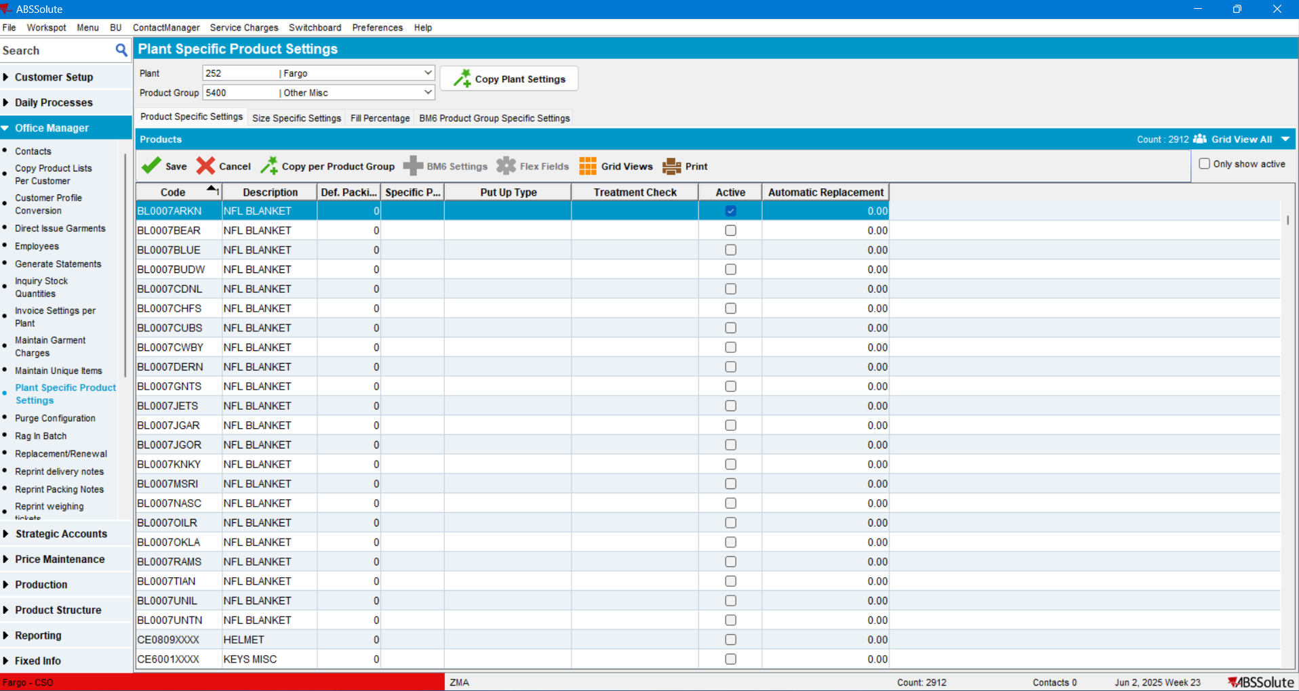

Open the Contract dlg. > Select the contract and open it in Modify mode > Components tab > Products:
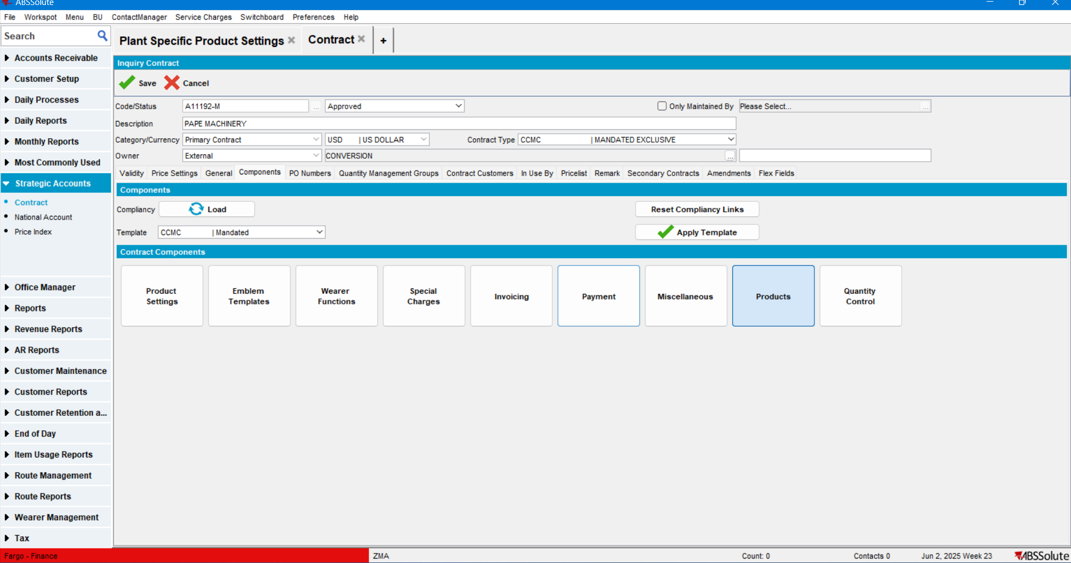

Add the product:
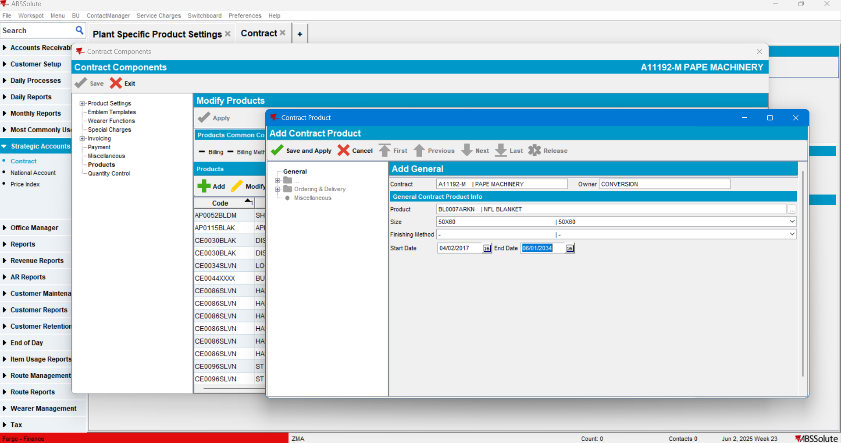

The product was added without any error messages:

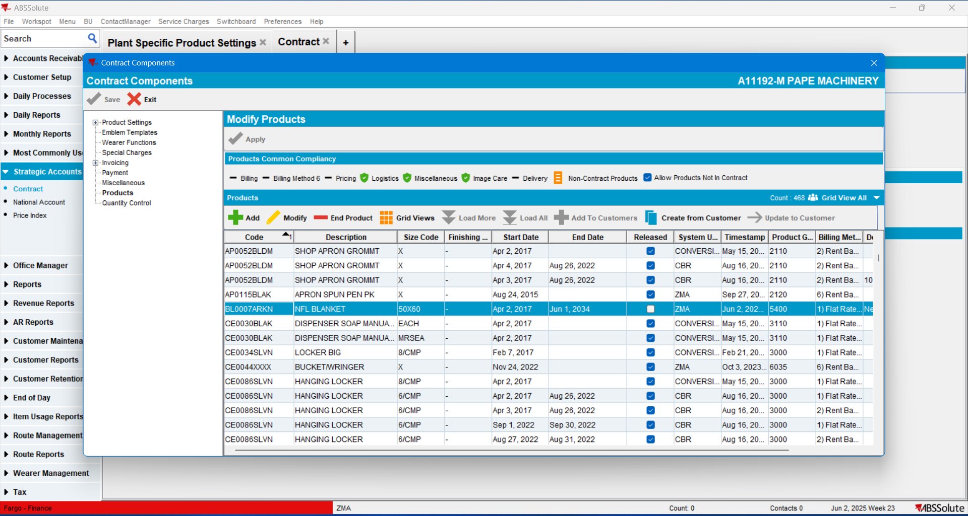

TEST PASSED.

