ABSN-2146 Maintain Garment Charges - Cancel charge buttons
DOWNGRADE TO 9.08.00.P20 AUS
Environment | Prerequisites
Version: 9.08.00.RELEASE.p20  DBServerName=db01-buc.internal.abslbs.com  DBSID=CUST25  DBUser=AUS_ND90502  DBPassword=AUS_ND90502  Environment=Production  EnvironmentSABStage=Production | - Module: BKLBASIS, UHFREADER, UNIQUEPOOLLINEN  - System setting:

Contents
Retest after fix 2
Expected behavior 2
Test Case 1 – Residual value – PASSED 2
Test Case 2 – Restocking fees – PASSED 5
Test Case 3 – Garment Sales – PASSED 7
Test Case 4 – Emblems – PASSED 9
Test Case 5 – Labels – PASSED 10
Test Case 6 – Repair History / Variable Services – PASSED 12

Retest after fix
Hash: 04cdb97b5043

Expected behavior
Cancel Charge or Undo Cancel Charge, in the Data Base, should update only Status, System User and Timestamp.

Test Case 1 – Residual value – PASSED
BU.code/Plant.code=473/473
- Open the Maintain Garment Charges dlg > Open the “RESIDUAL VALUE” tab and do a “Cancel Charge” of a line marked as “TO BE Charged”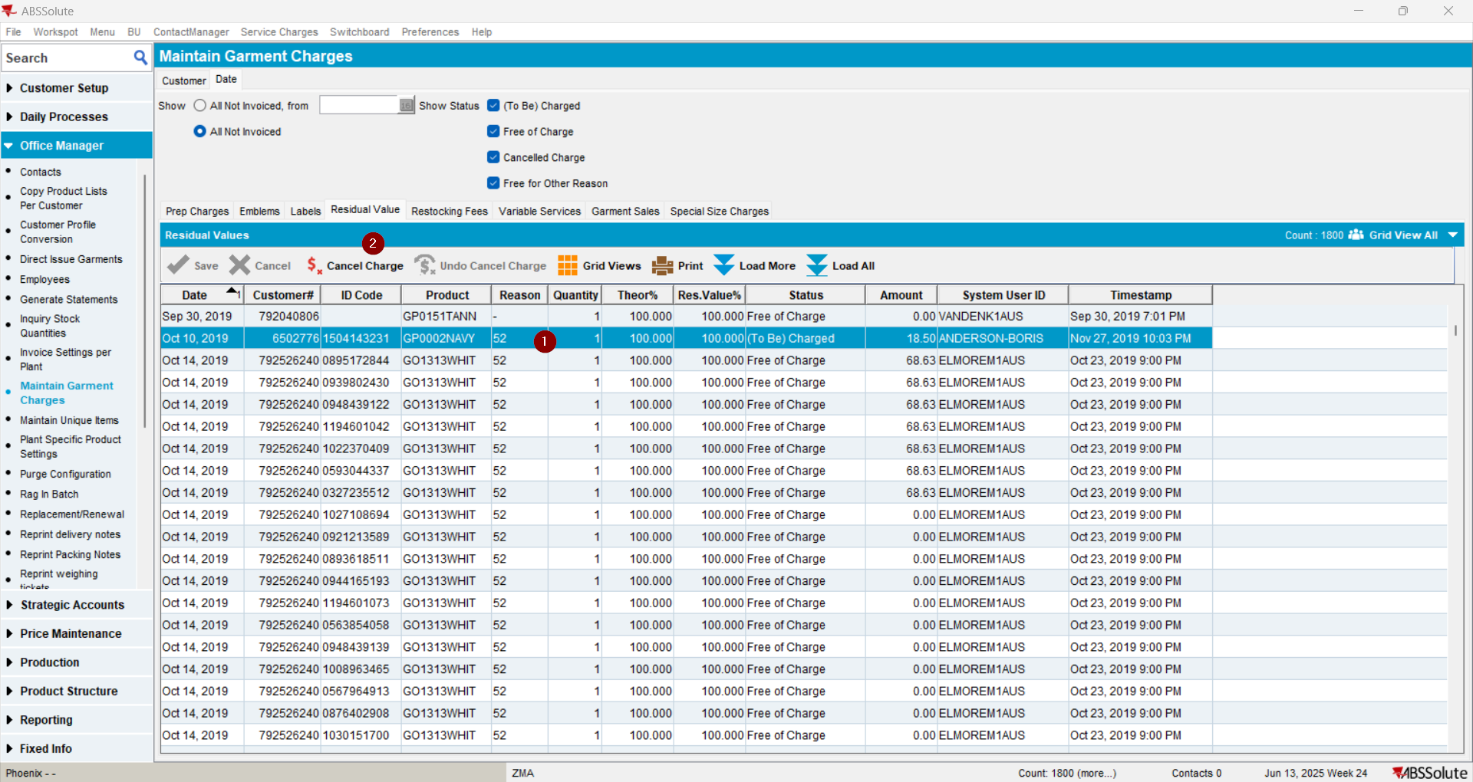
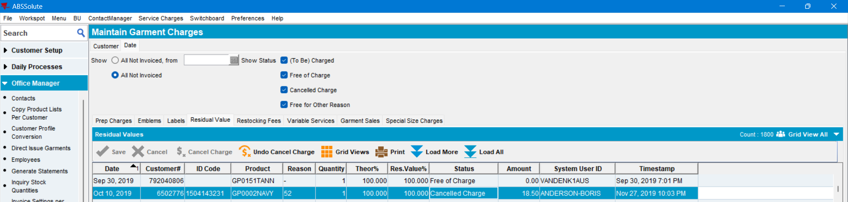
- Check the Executed Transactions for the update 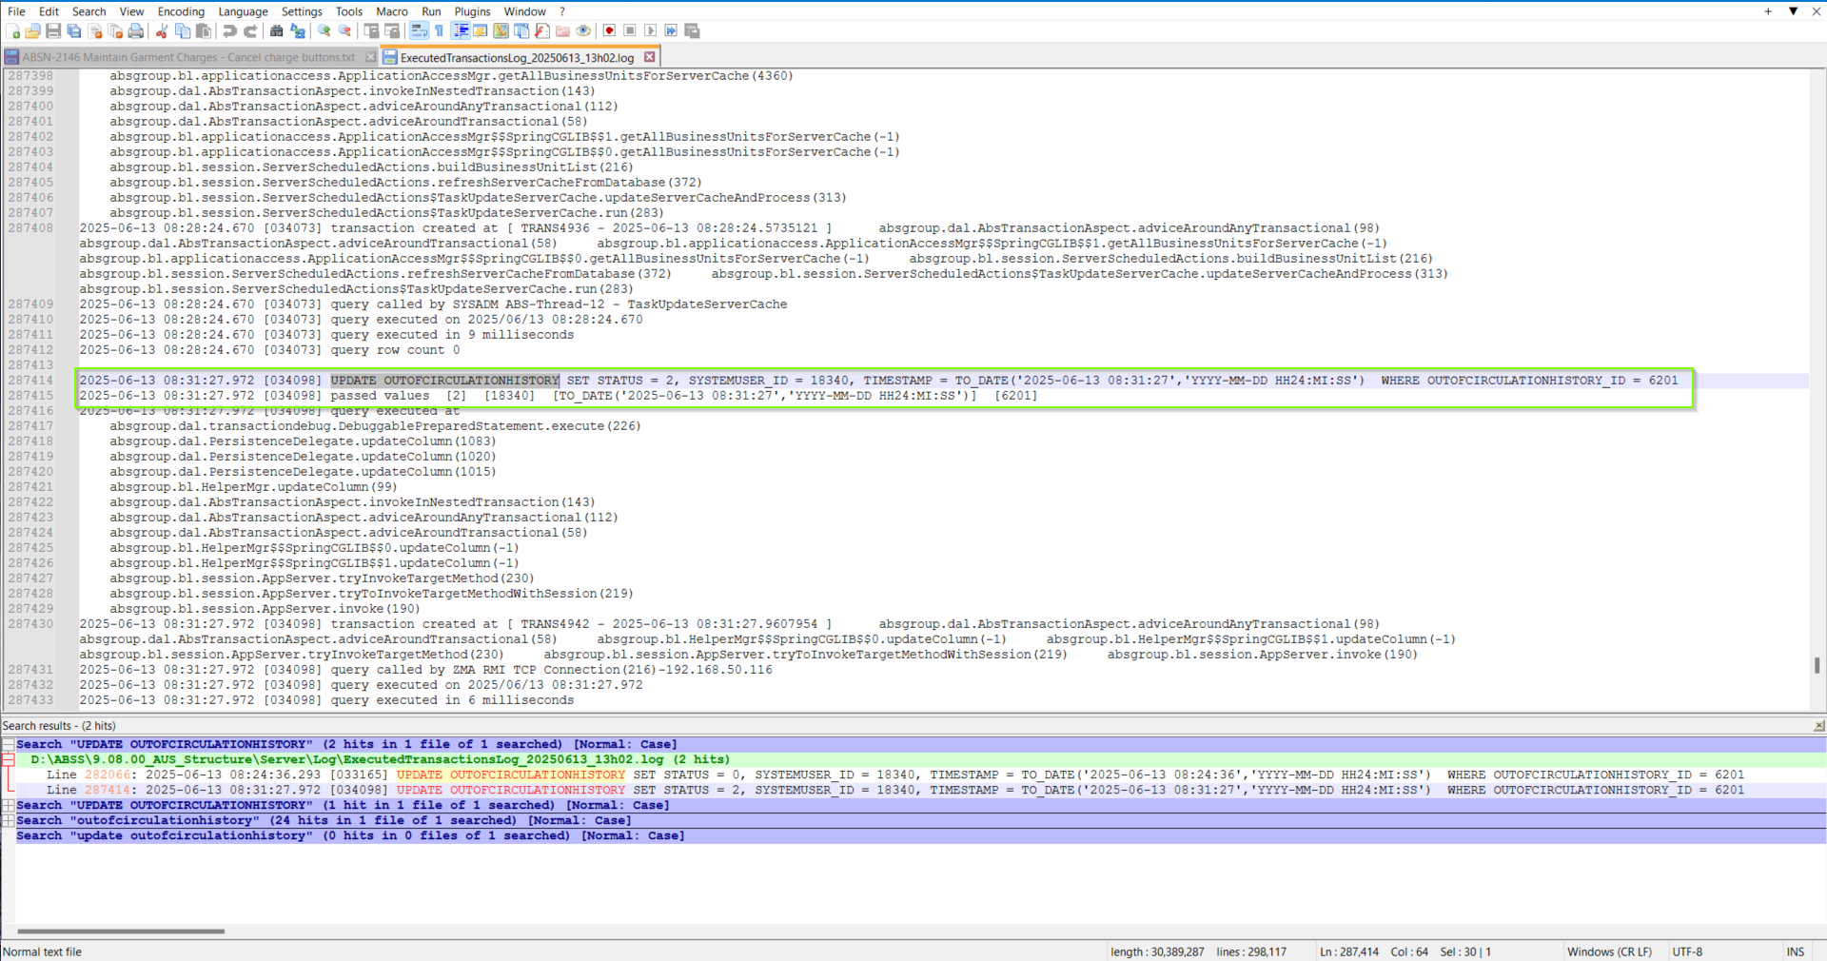
- Do an Undo Cancel Charge 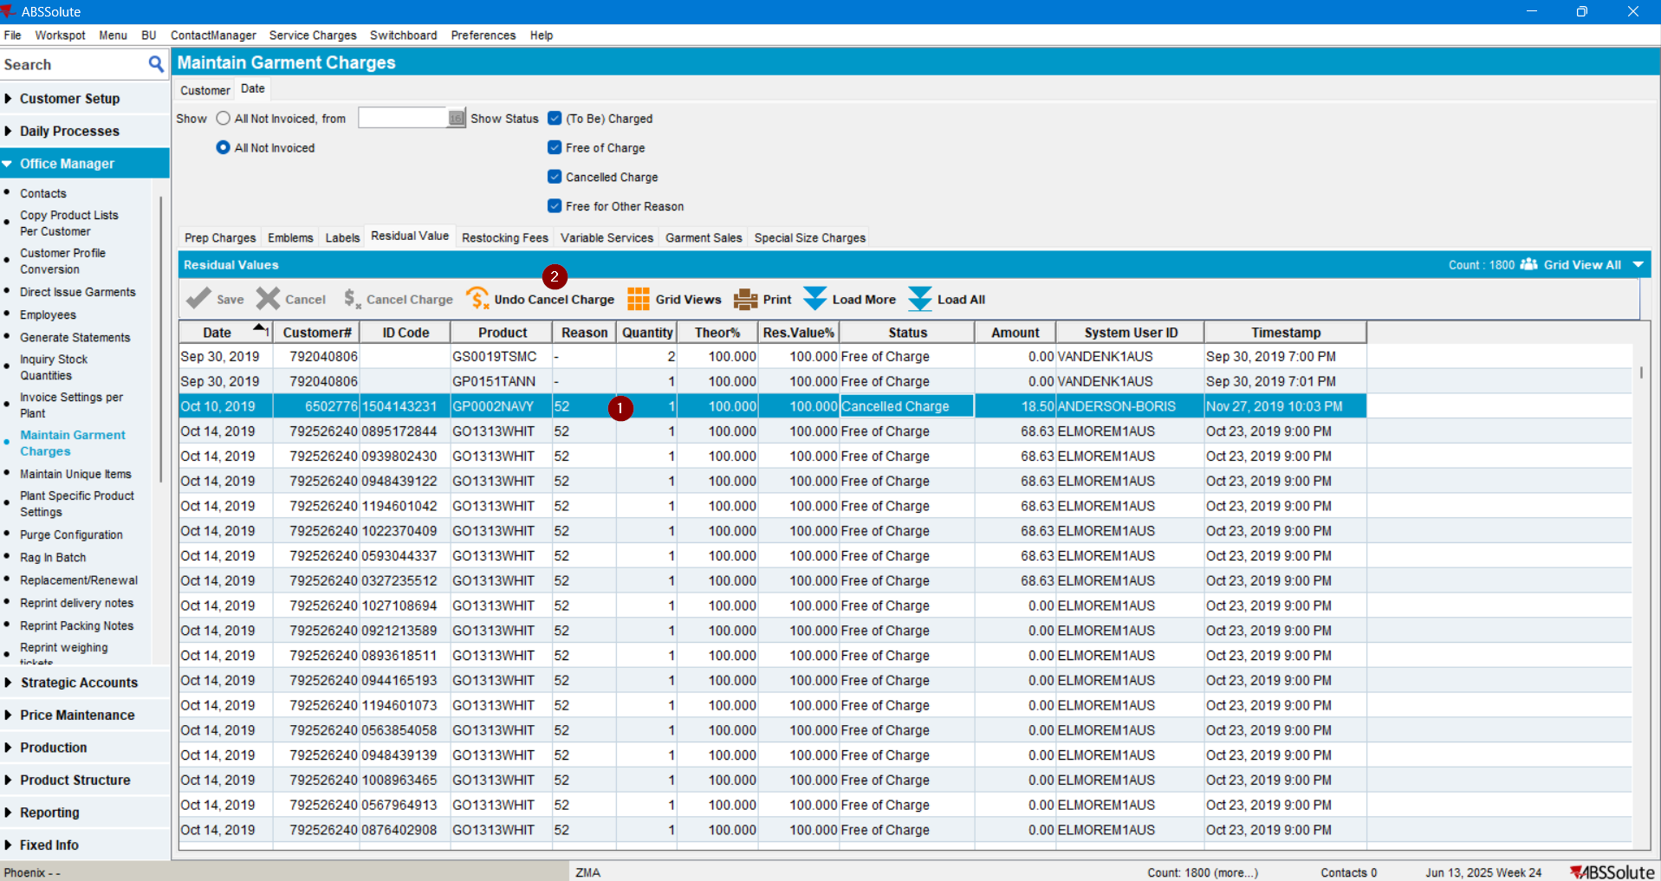
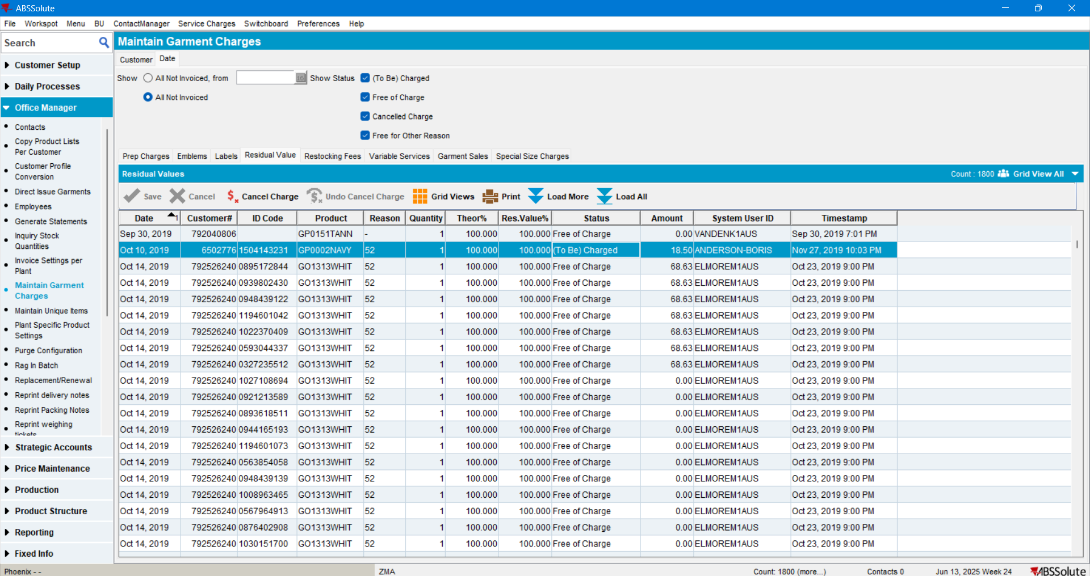
- Check the Executed Transactions for the update 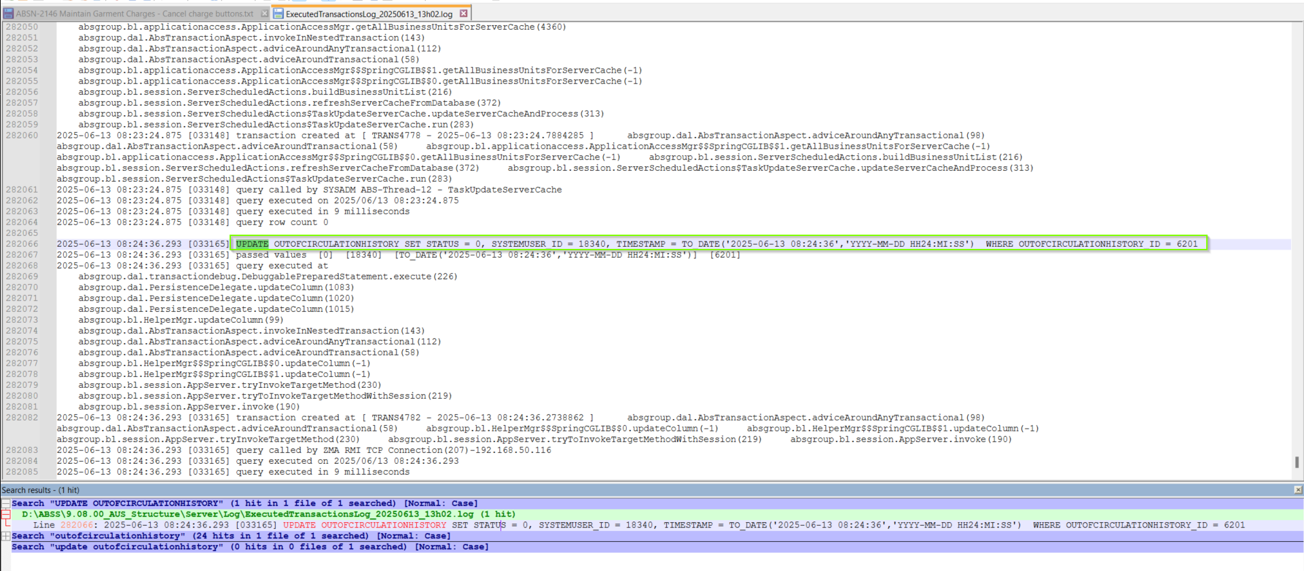
Current behavior is the expected one. The only fields that were updated are: The Status, the System user and the timestamp.

TEST PASSED

Test Case 2 – Restocking fees – PASSED
BU.code/Plant.code=533/533 (Cherry Hill)
- Open the Maintain Garment Charges dlg > Select the Restocking Fees tab > and do a “Cancel Charge” 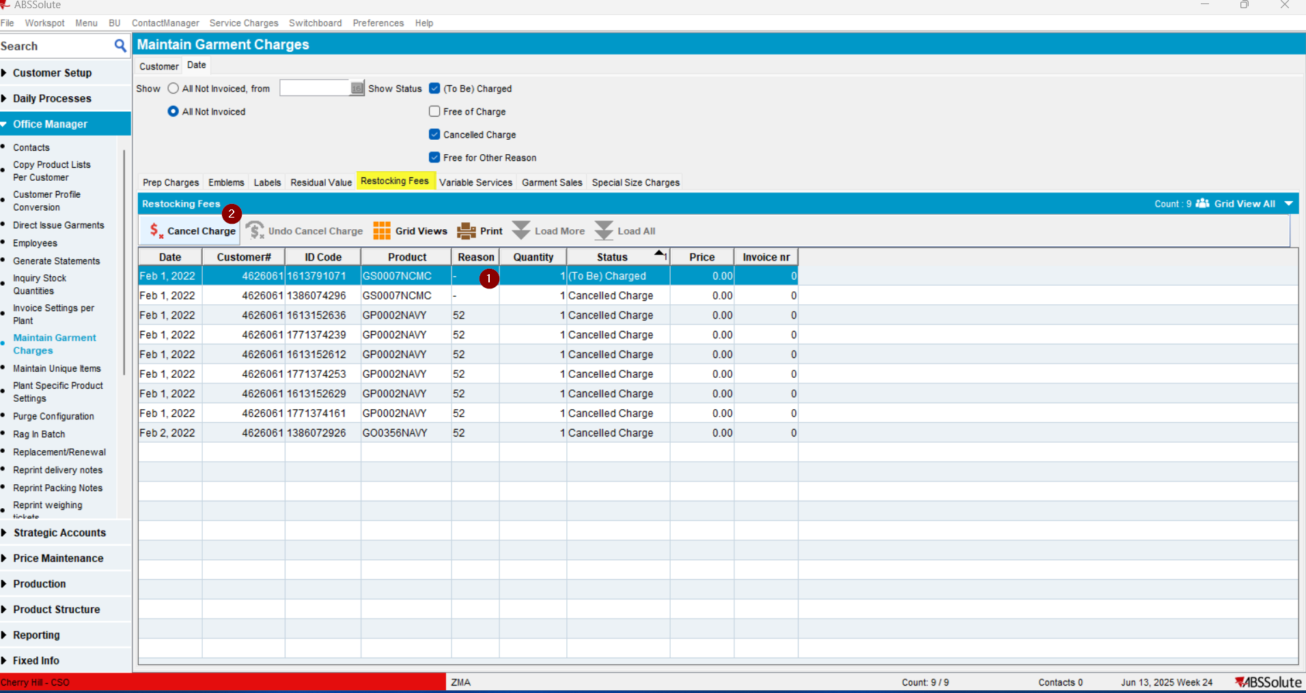
The line was cancelled:
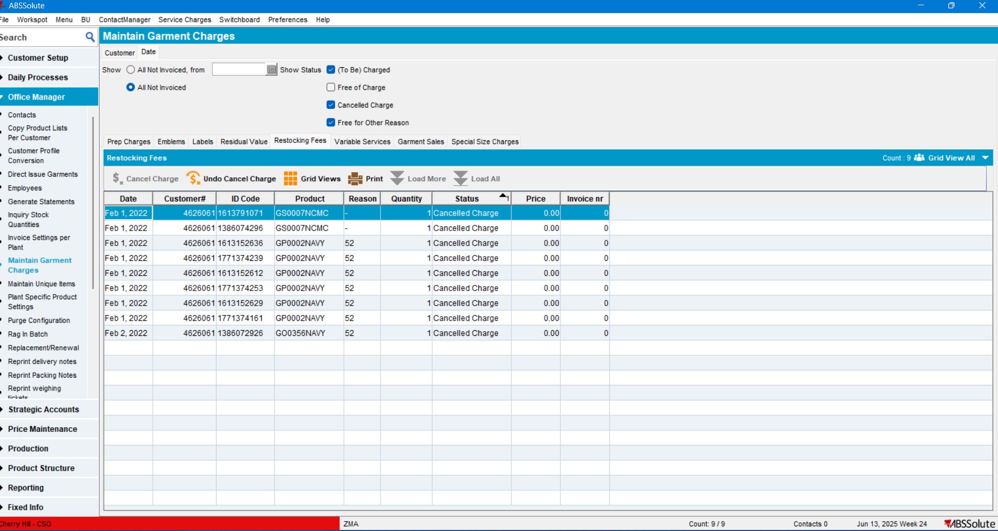
- Check the Executed Transactions for the update 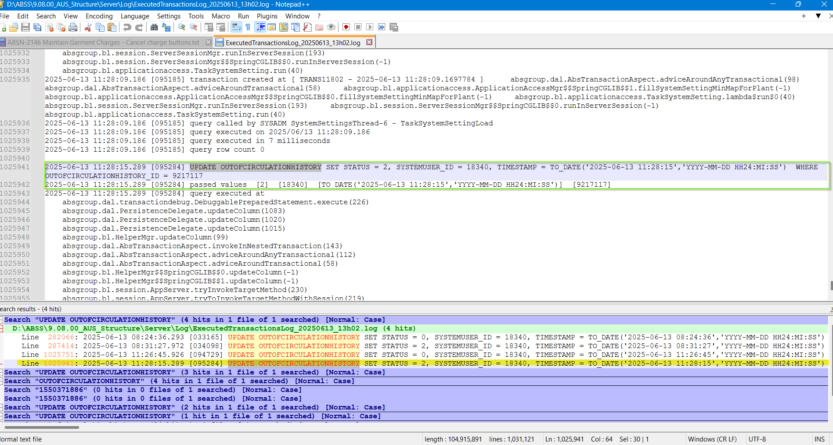
EST PASSED
- Do an Undo Cancel Charge 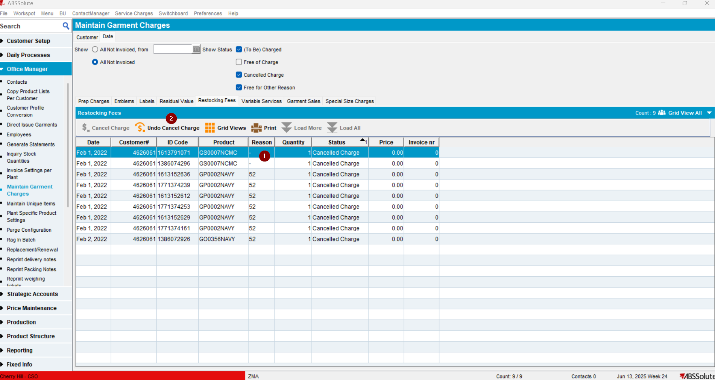
- Check the Executed Transactions for the update 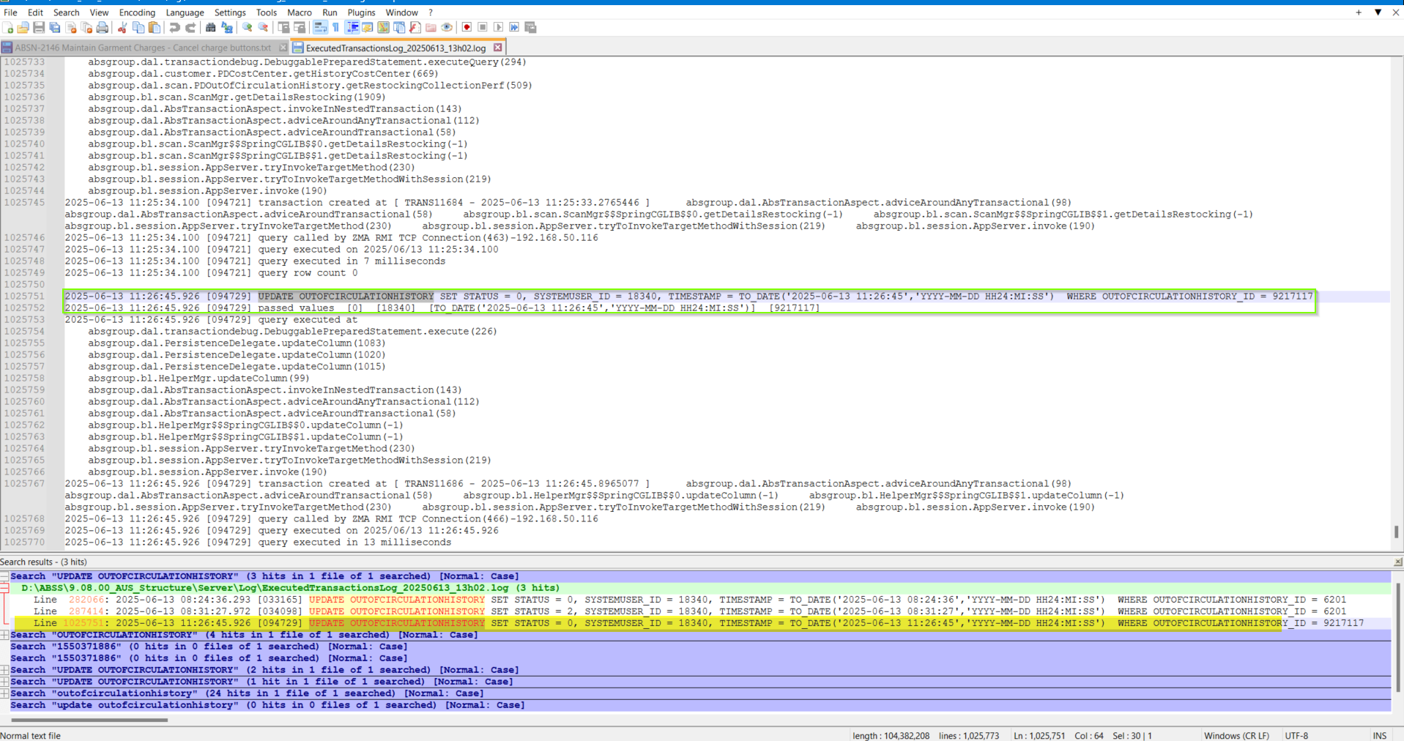
TEST PASSED.

Test Case 3 – Garment Sales – PASSED
BU.code/Plant.code=503/503 (Fresno):
- Open the Maintain Garment Charges dlg. > Go to Garment Sales tab and do a “Cancel Charge”of a To Be Charged line.
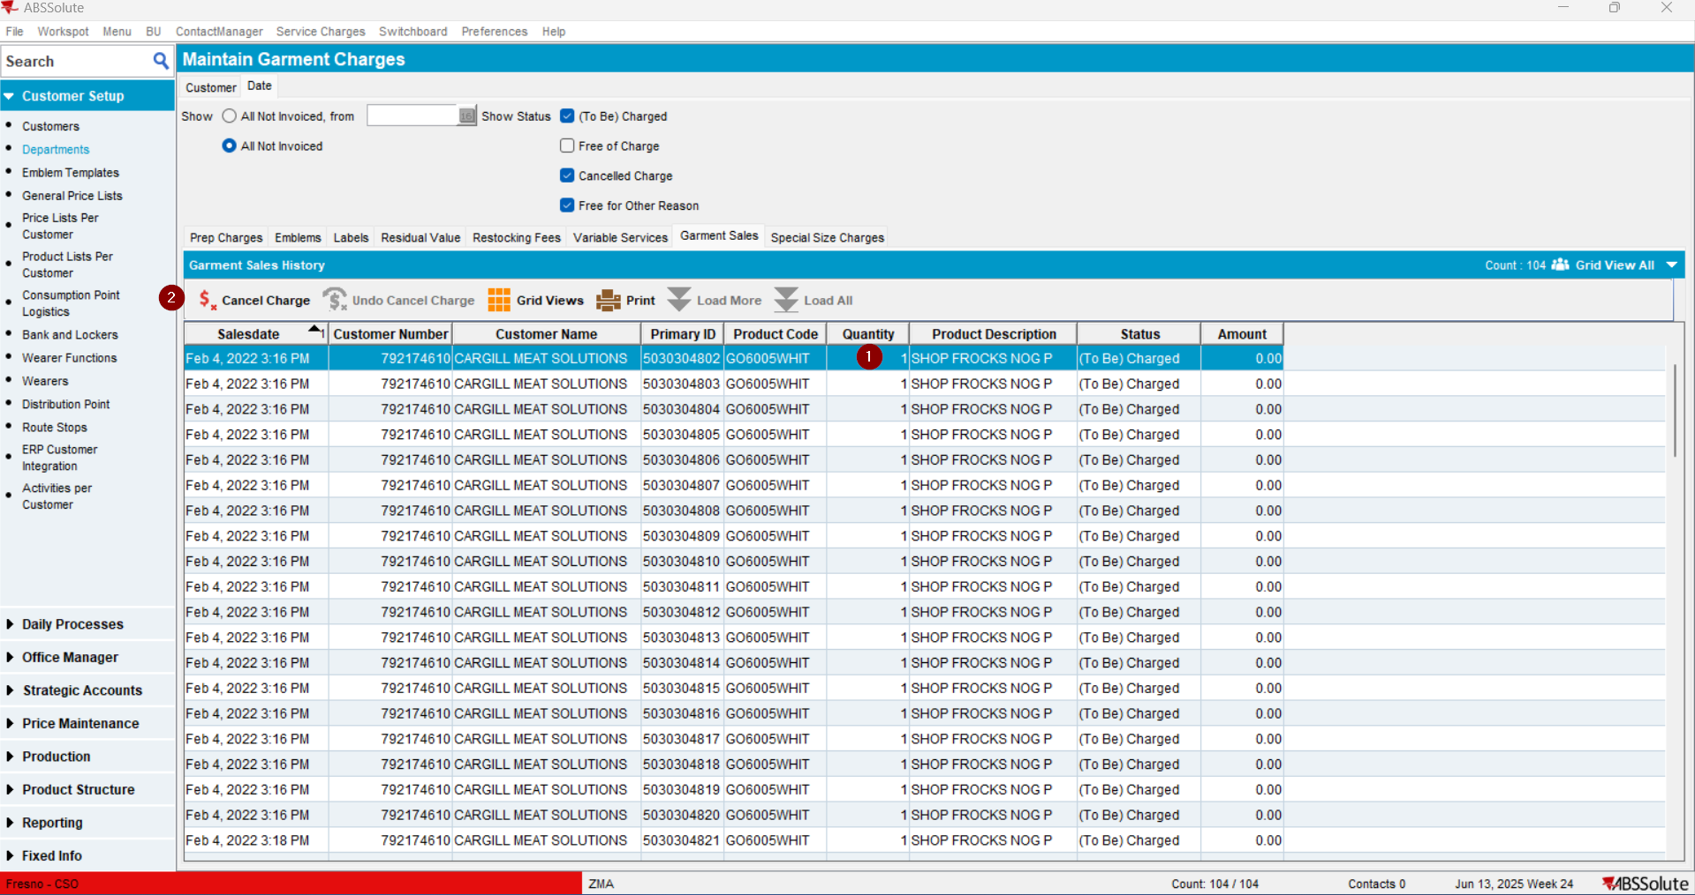
- Check the Executed Transactions for the update 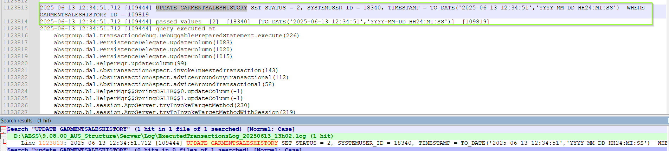
TEST PASSED
- Do an Undo Cancel Charge 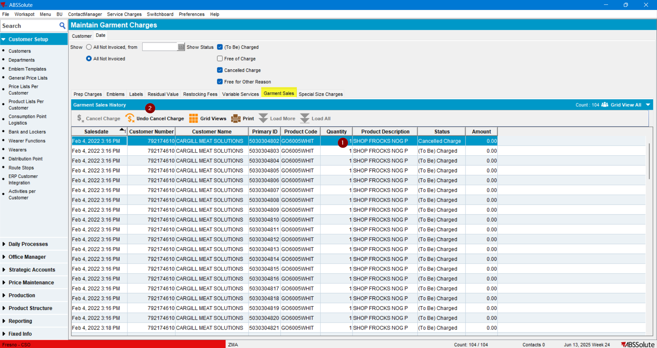
- Check the Executed Transactions for the update 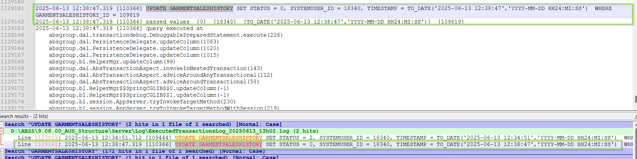
TEST PASSED.

Test Case 4 – Emblems – PASSED
BU.code / Plant.code = 503 (Fresno)
- Open the Maintain Garment Charges dlg. > go to the “Emblems” tab and do a “Cancel Charge”: 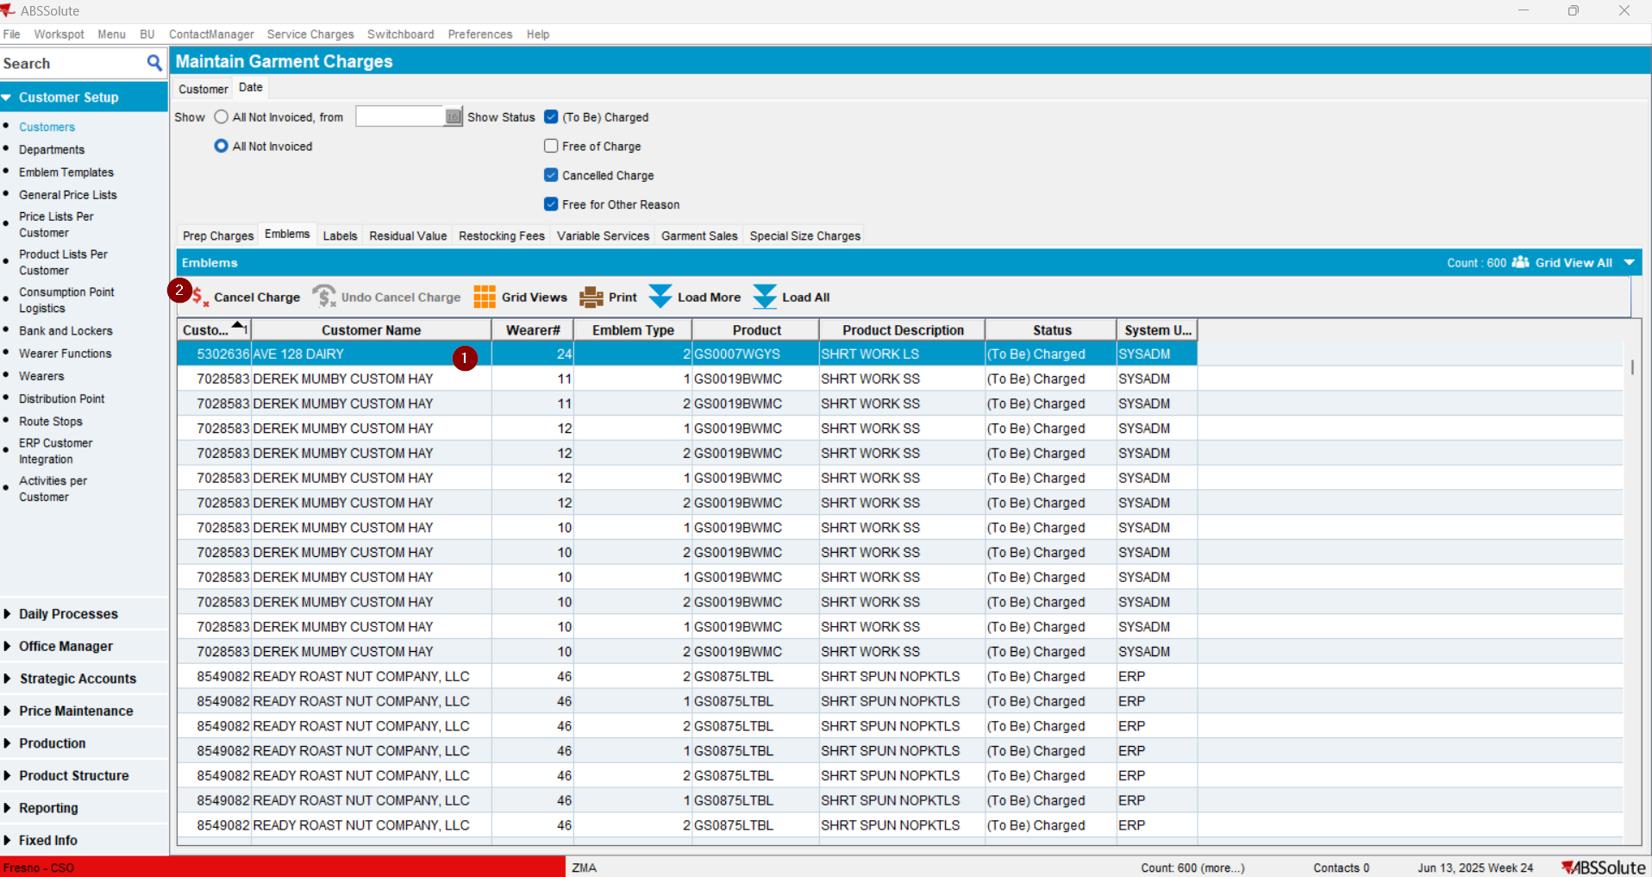
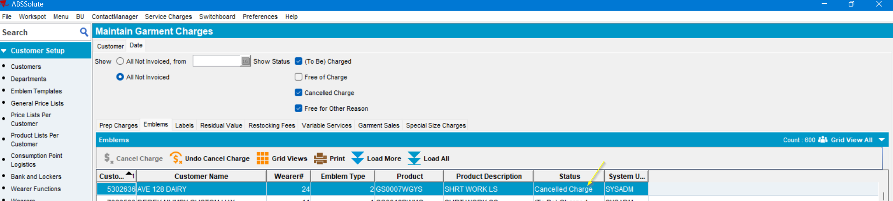
- Check the Executed Transactions for the update 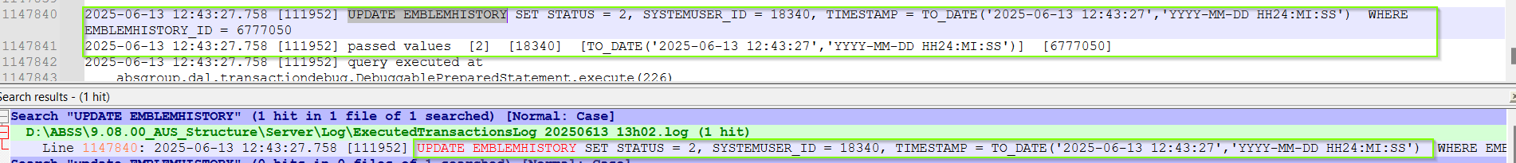
EST PASSED
- Do an Undo Cancel Charge 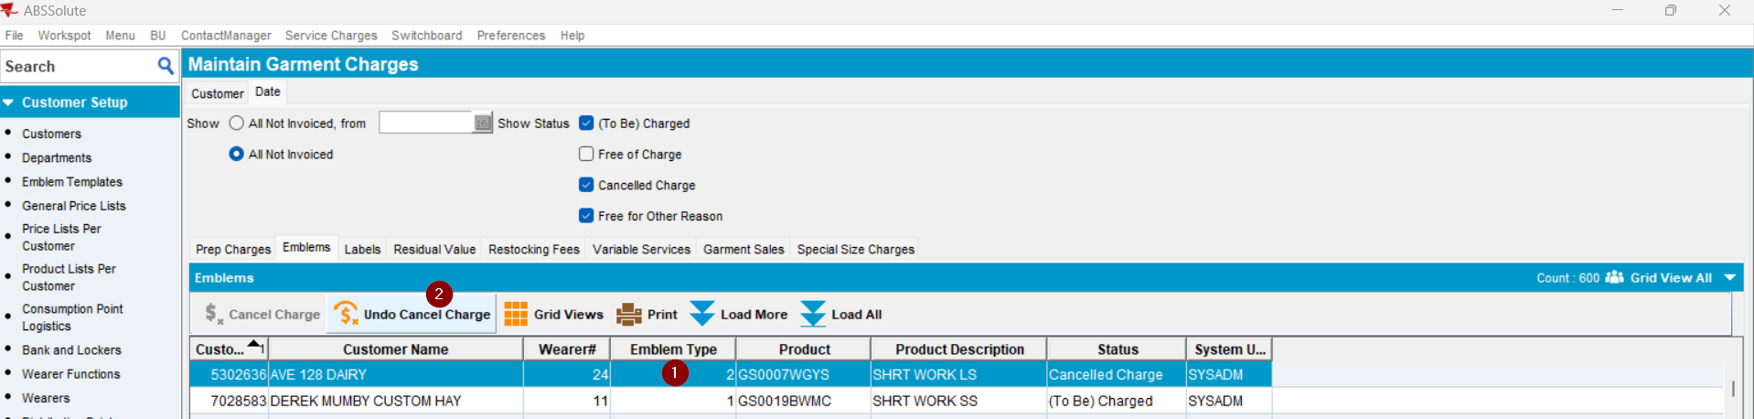 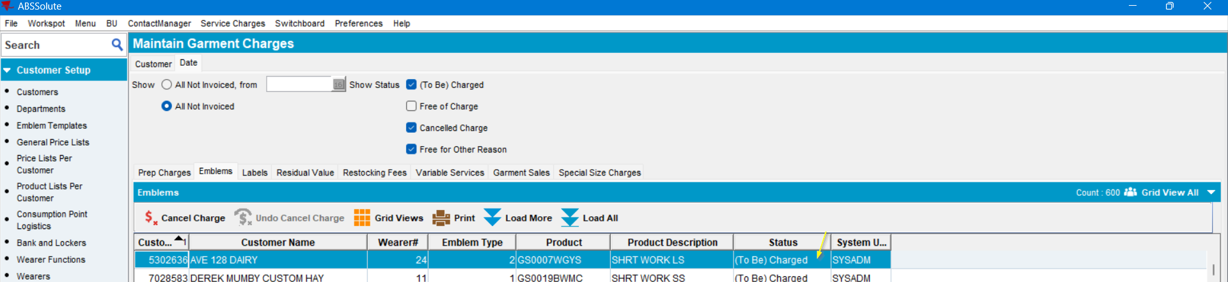
- Check the Executed Transactions for the update 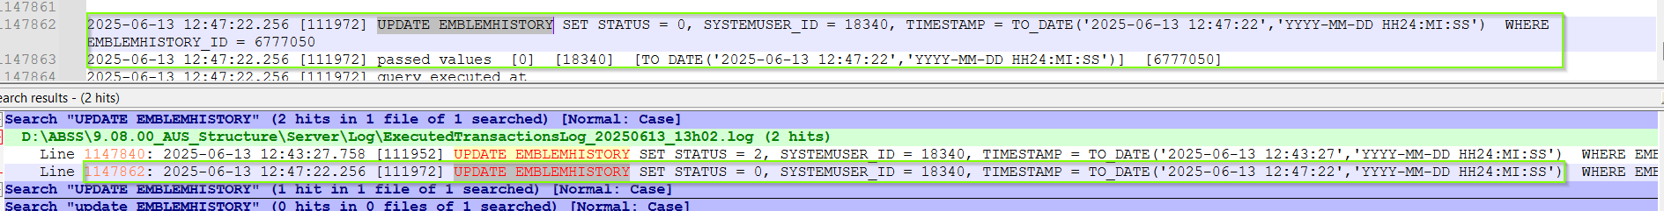

Test Case 5 – Labels – PASSED
BU.code / Plant.code = 503 (Fresno)
- Open the Maintain Garment Charges dlg., go to the Labels tab > and do a “Cancel Charge”: 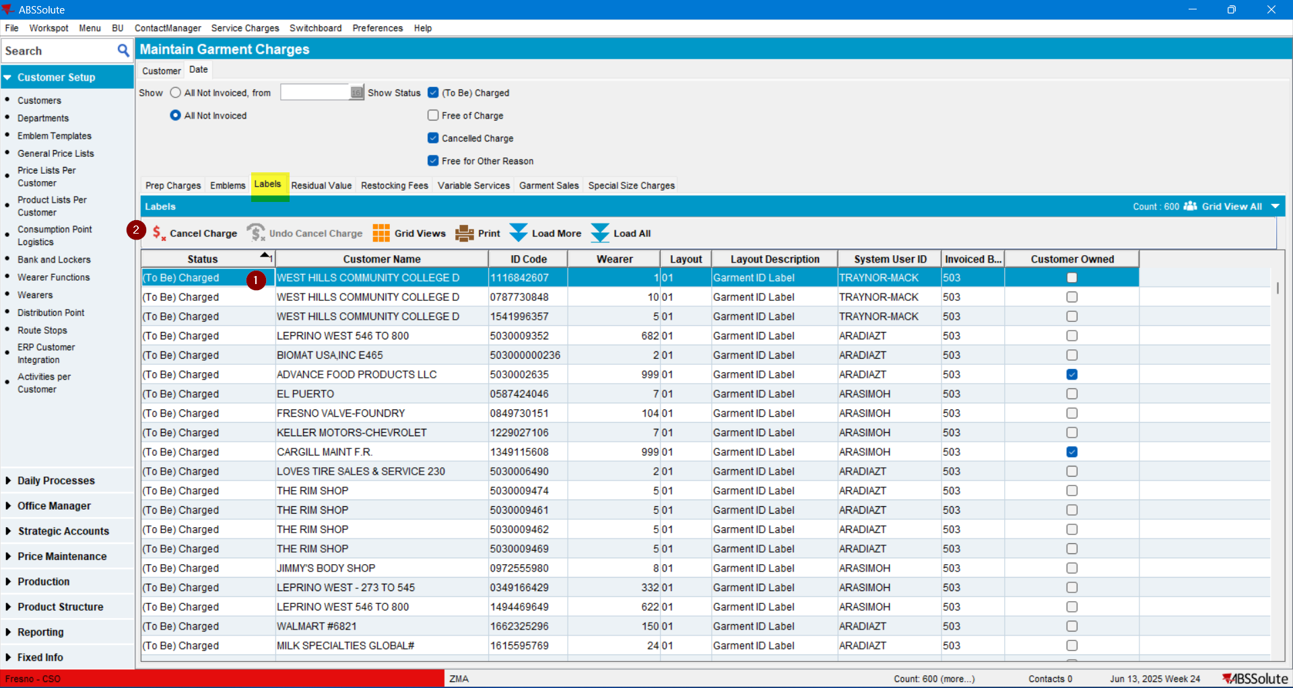
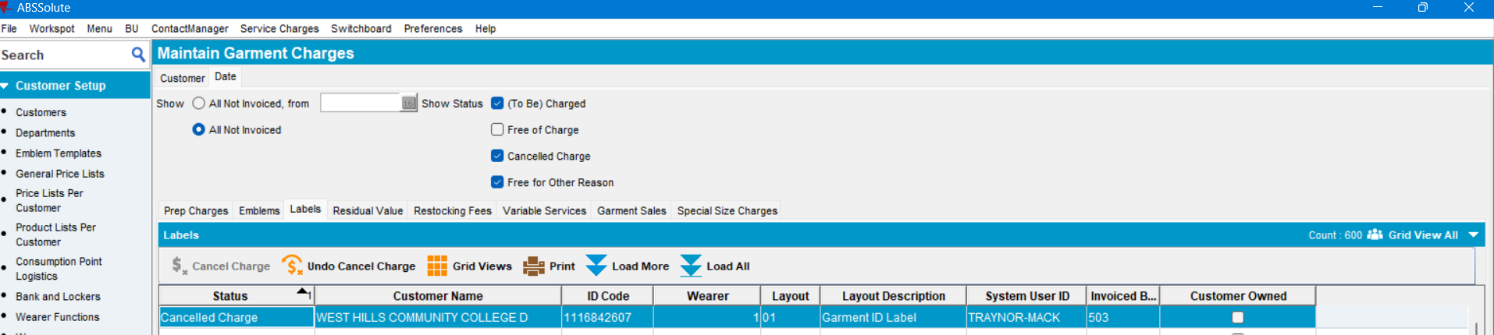
- Check the Executed Transactions for the update 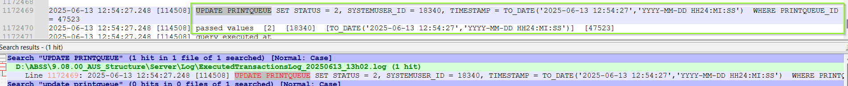
TEST PASSED.
- Do an Undo Cancel Charge 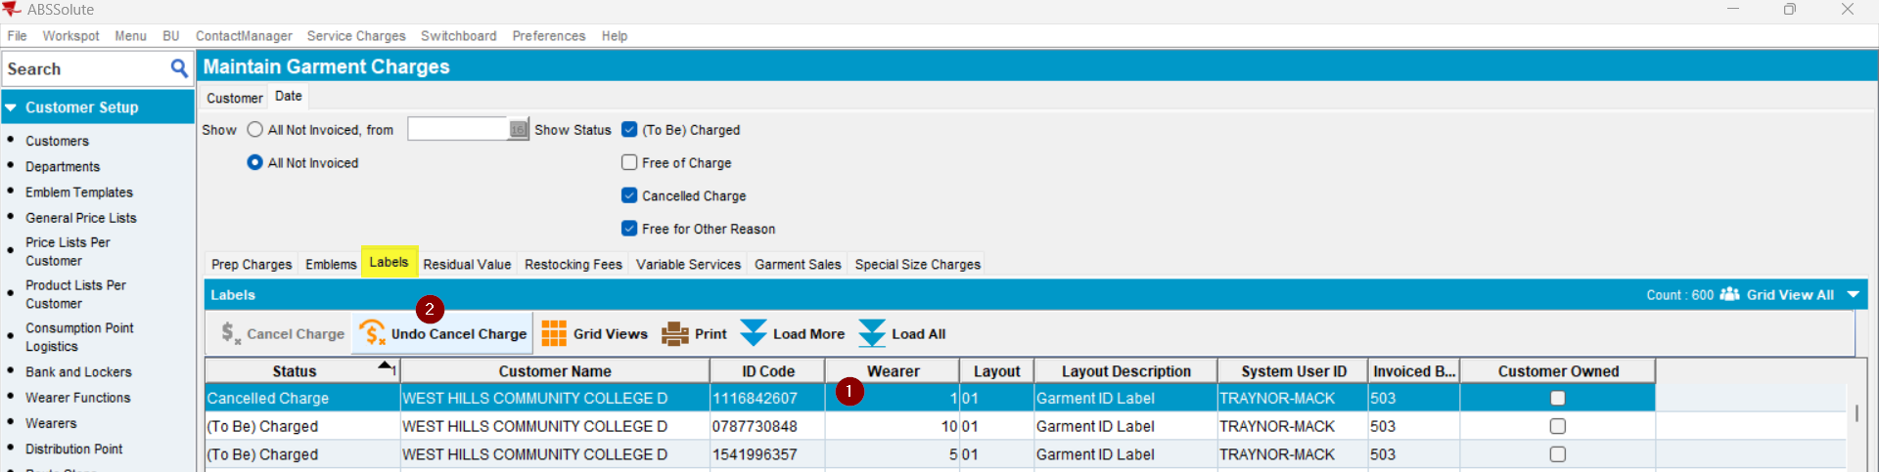
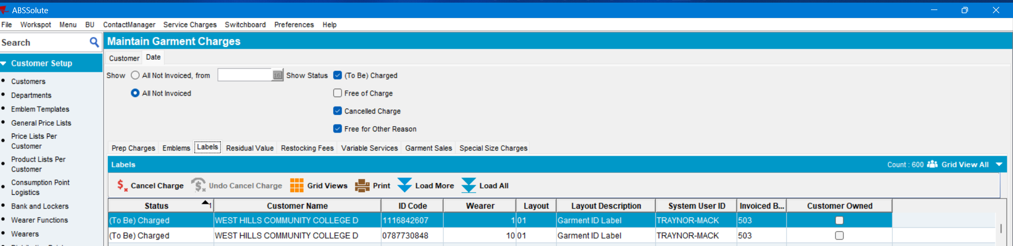
- Check the Executed Transactions for the update 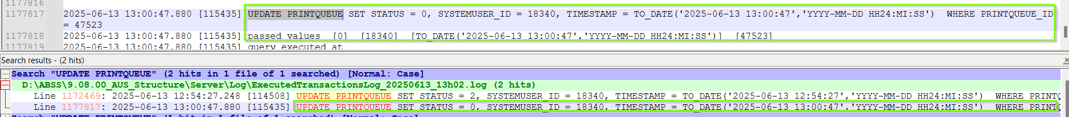
TEST PASSED

Test Case 6 – Repair History / Variable Services – PASSED
BU.code / Plant.code = 503 (Fresno)

- Open the Maintain Garment Charges dlg, go to the Variable Services tab and do a “Cancel Charge”: 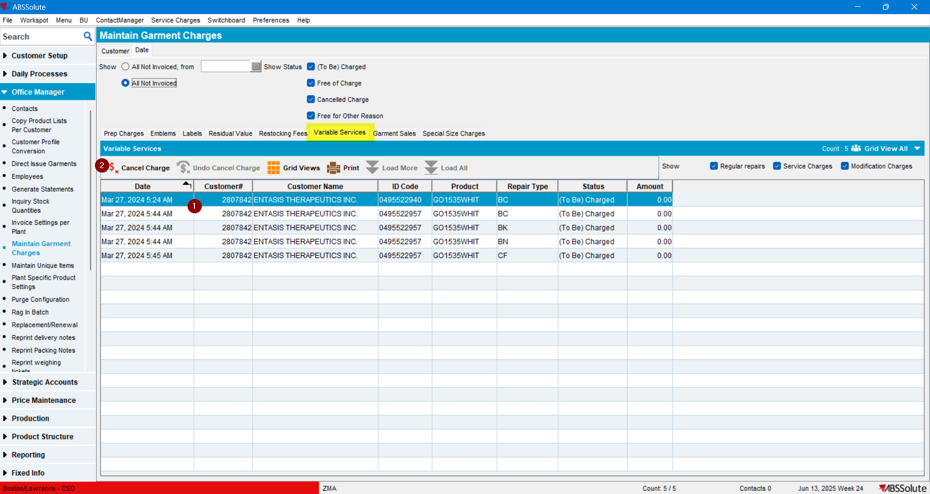
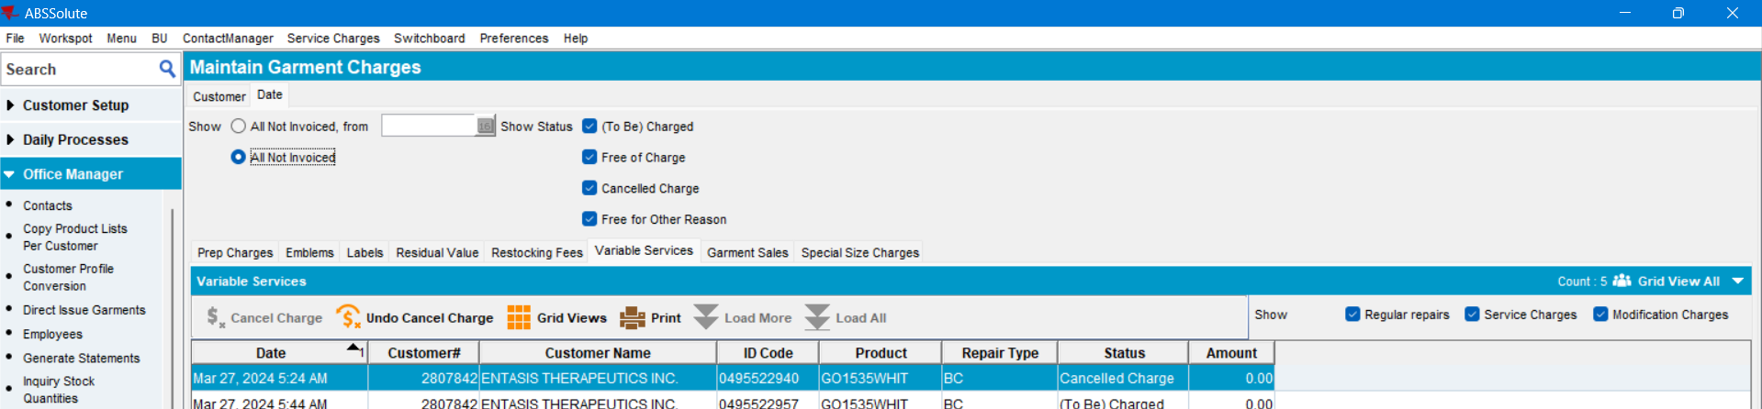
- Check the Executed Transactions for the update
TEST PASSED
- Do an Undo Cancel Charge 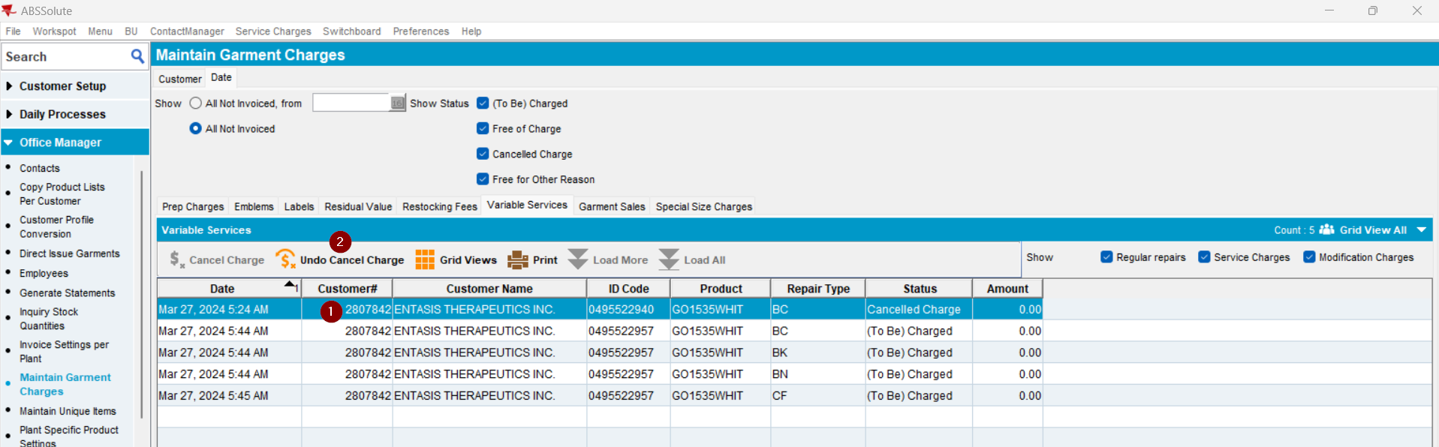 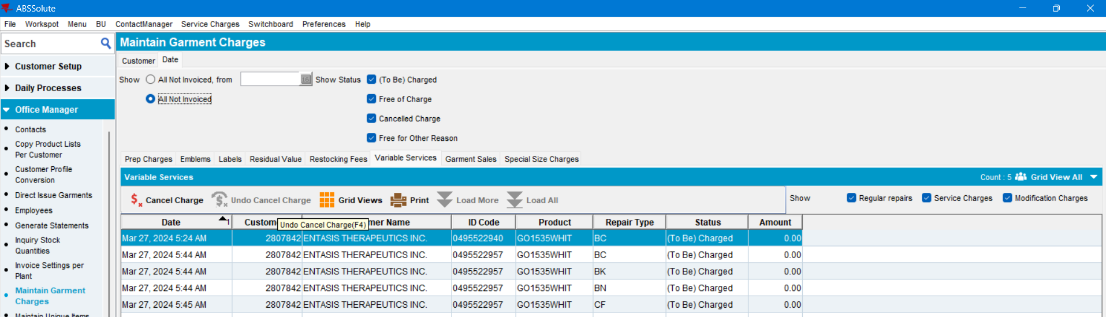
- Check the Executed Transactions for the update 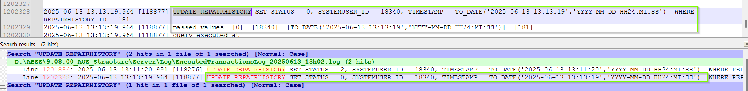
TEST PASSED

