ABSN-6750 Downgrade to 9.08.00.release.p20_AUS

Environment | Prerequisites
DBServerName=abs-srv17.internal.abslbs.com  DBSID=CUST23  DBUser=AUS_MNT90800  DBPassword= AUS_MNT90800  Environment=Production  Hash: 6d44d9c | - Module: AUSCUSTOM, BKLBASIS  - System setting: -  - Others: BU Burr Ridge

Contents
#1. Test report when option “Include Repairs” is not selected 1
#2. Test existing repair in client – Test OK 3
Generate report – route: SELECTED, customer: ALL, day: Wednesday, 1 WEEK selected 4
Generate report – route: SELECTED, customer: ALL, day: Wednesday, 1 DAY selected 5
Generate report – route: SELECTED, customer: ALL, day: ALL, 1 WEEK selected 6
#3. Test report when id code is scanned 7
Generate report – Route: SELECTED, customer: ALL, day: Monday, 1 WEEK selected 8
#4. Test DDB type customer – Test OK 9
Generate report – Route: SELECTED, customer: ALL, day: Monday, 1 WEEK selected 11
Generate report – route: SELECTED, customer: ALL, day: ALL, 1 WEEK selected 12

#1. Test report when option “Include Repairs” is not selected
- Open dlg Report Scanning Reconciliation and check the dialogue
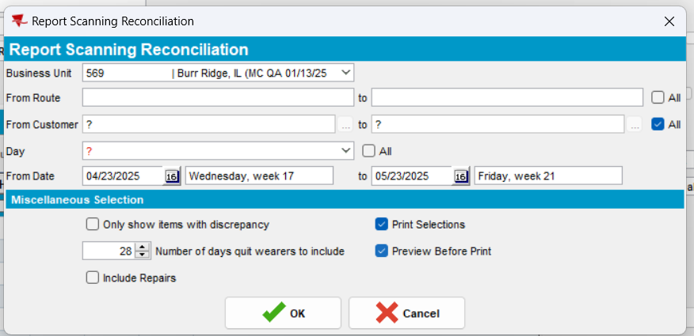
Expected behavior:
- Check box “Include Repairs” - default unchecked
- From Customer… to … ALL checkbox – default checked.
Actual behavior: as expected.
Test OK
- Generate a report when Check box “Include Repairs” not selected
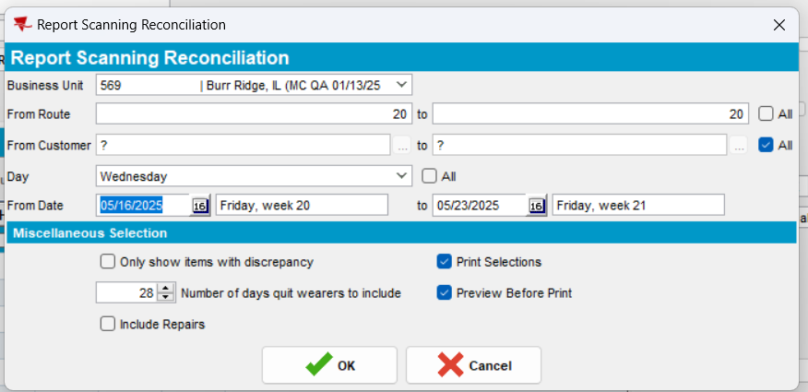
Column Repairs does not appear.
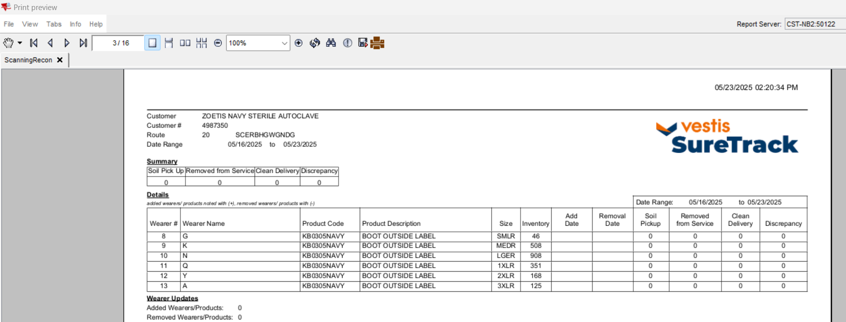
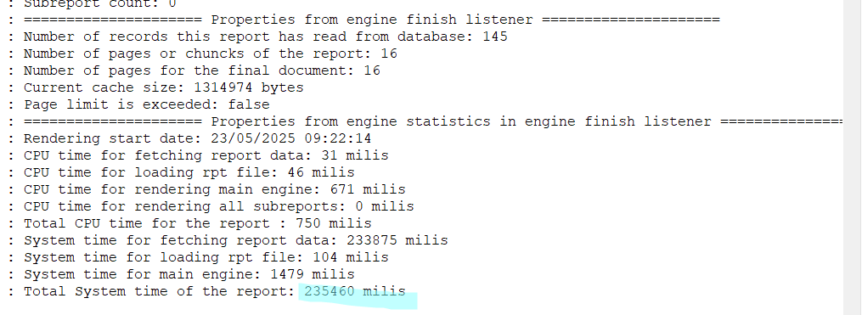
Test OK

#2. Test existing repair in client – Test OK
- Generate report for existing scans
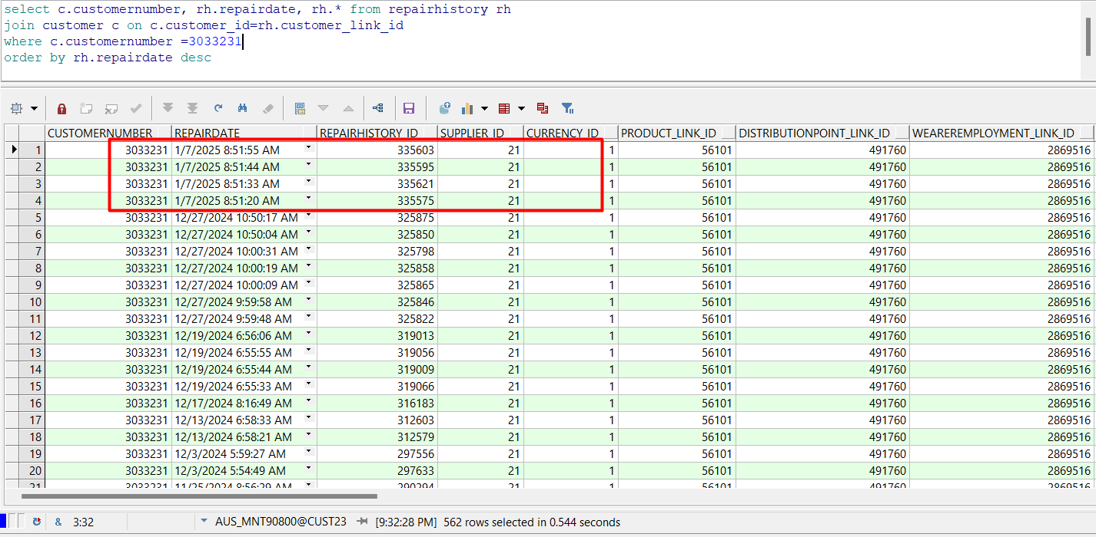

Generate report – route: SELECTED, customer: ALL, day: Wednesday, 1 WEEK selected
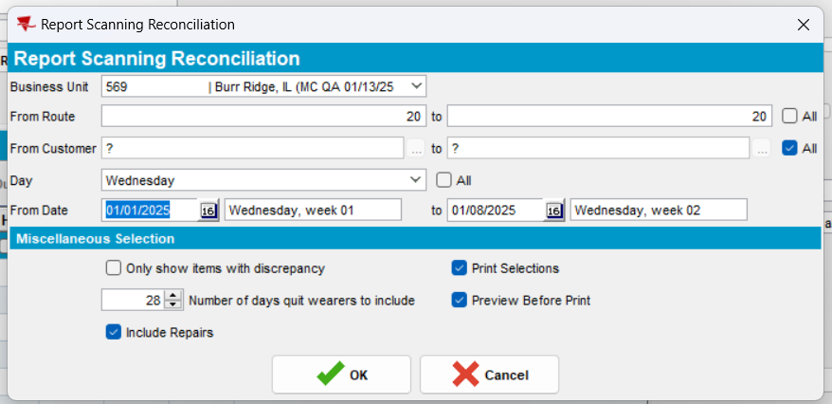
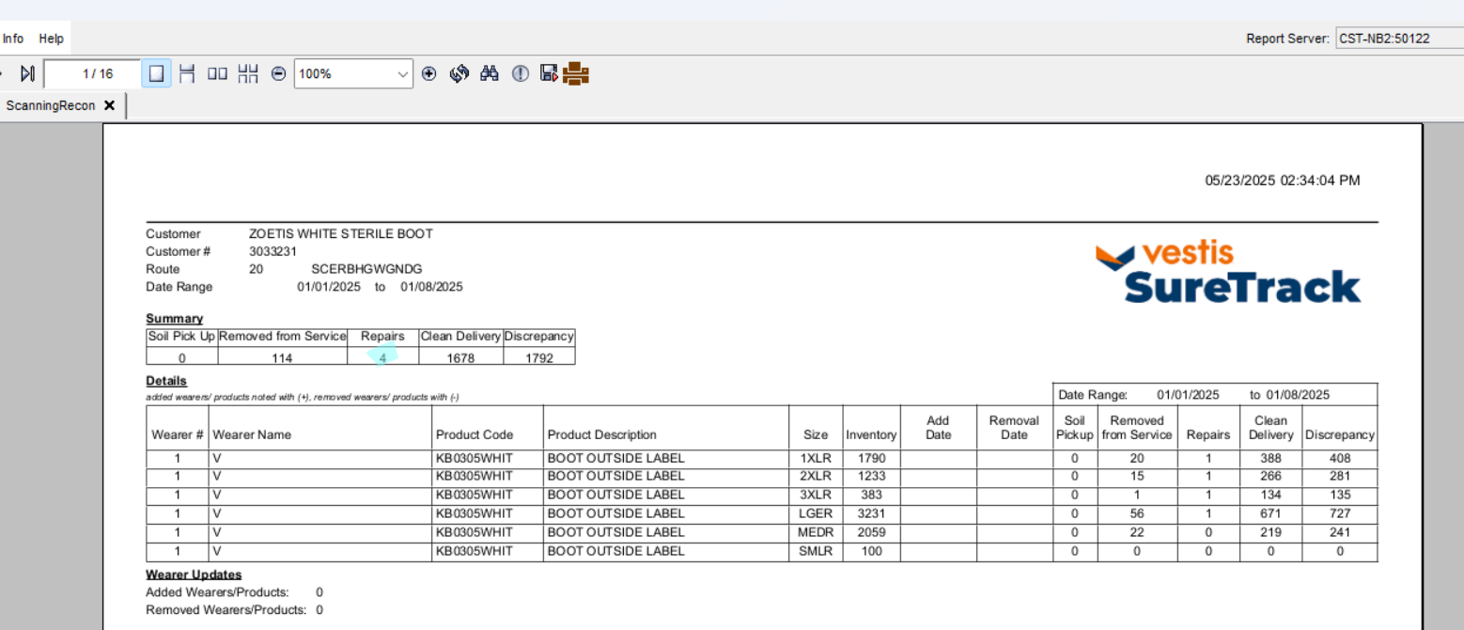
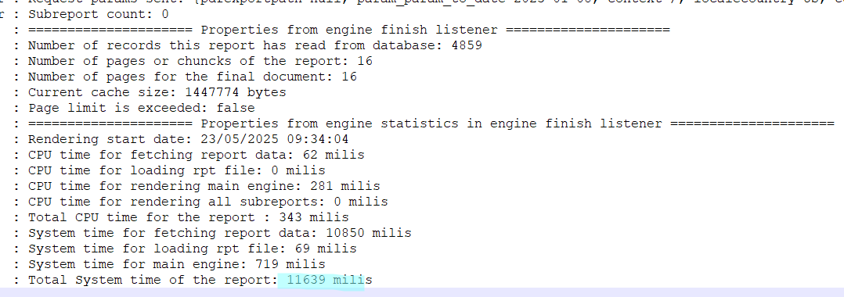

Generate report – route: SELECTED, customer: ALL, day: Wednesday, 1 DAY selected
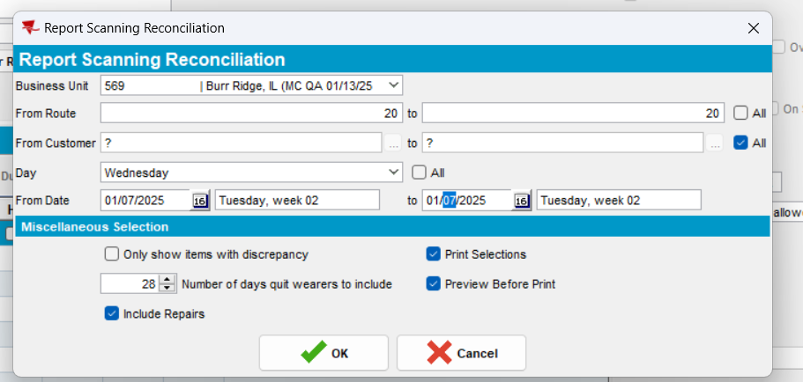
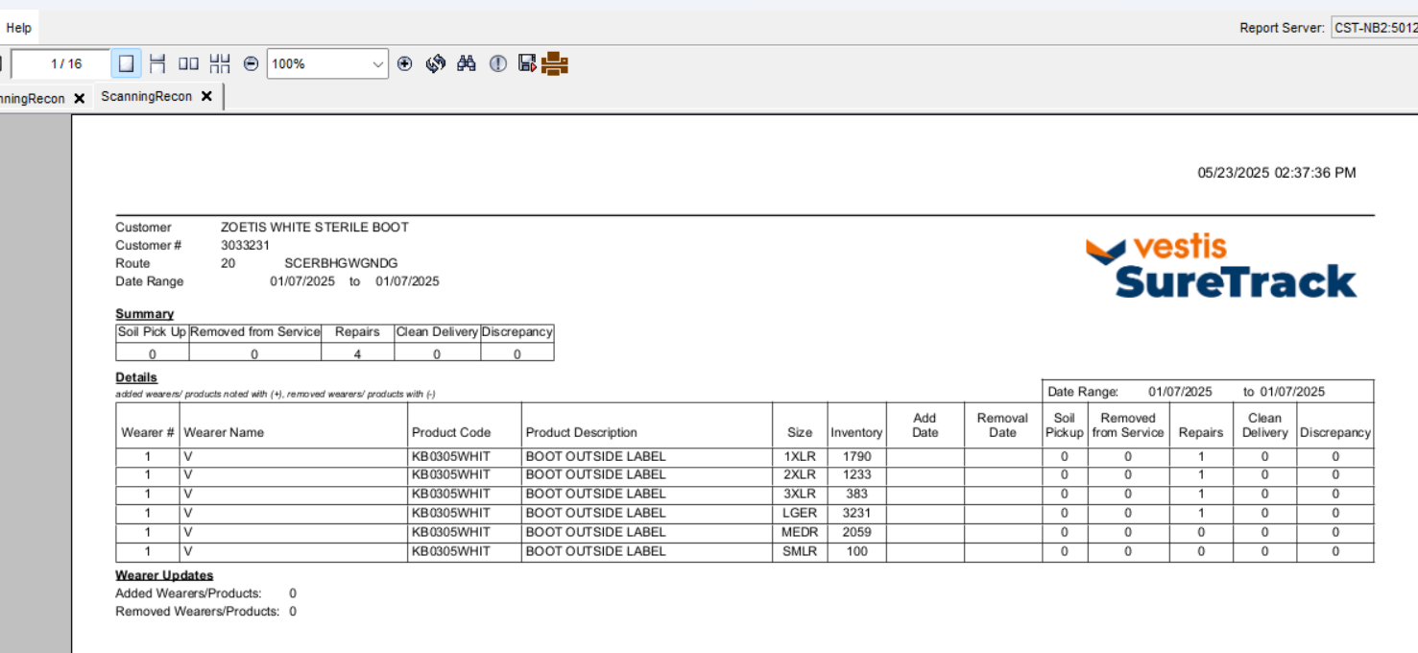

Generate report – route: SELECTED, customer: ALL, day: ALL, 1 WEEK selected
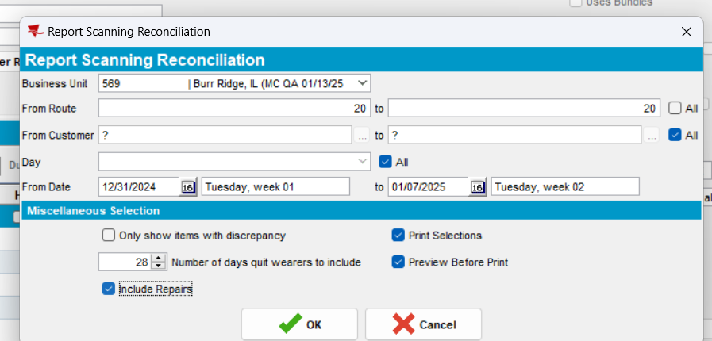
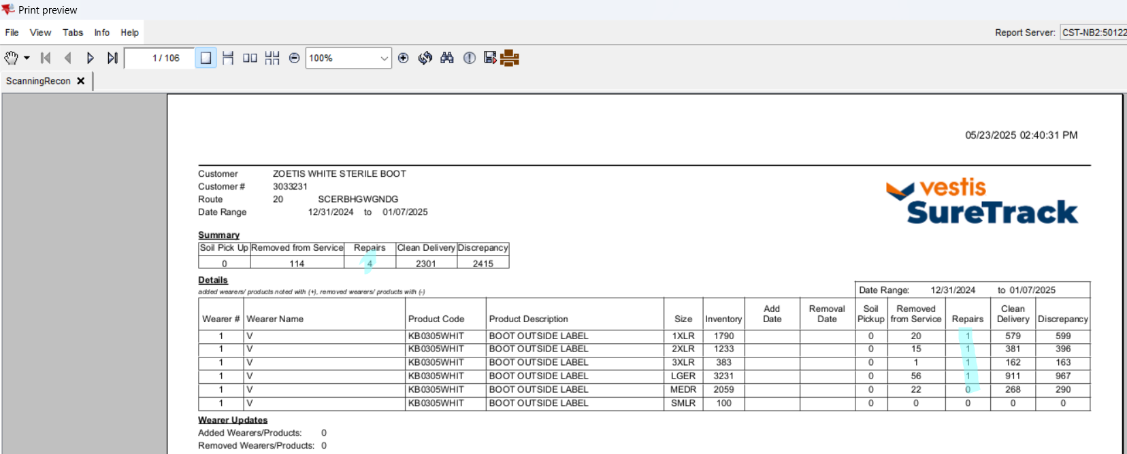
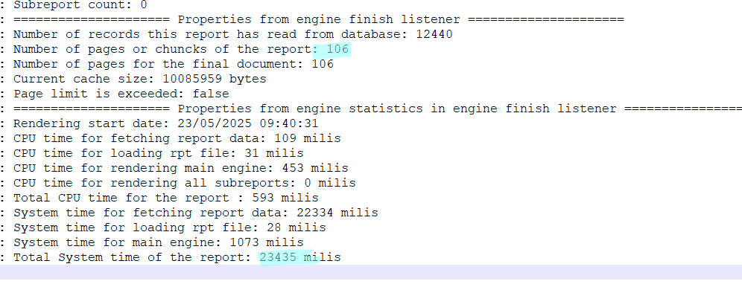

#3. Test report when id code is scanned
- Scan 1 id code for repair from a customer
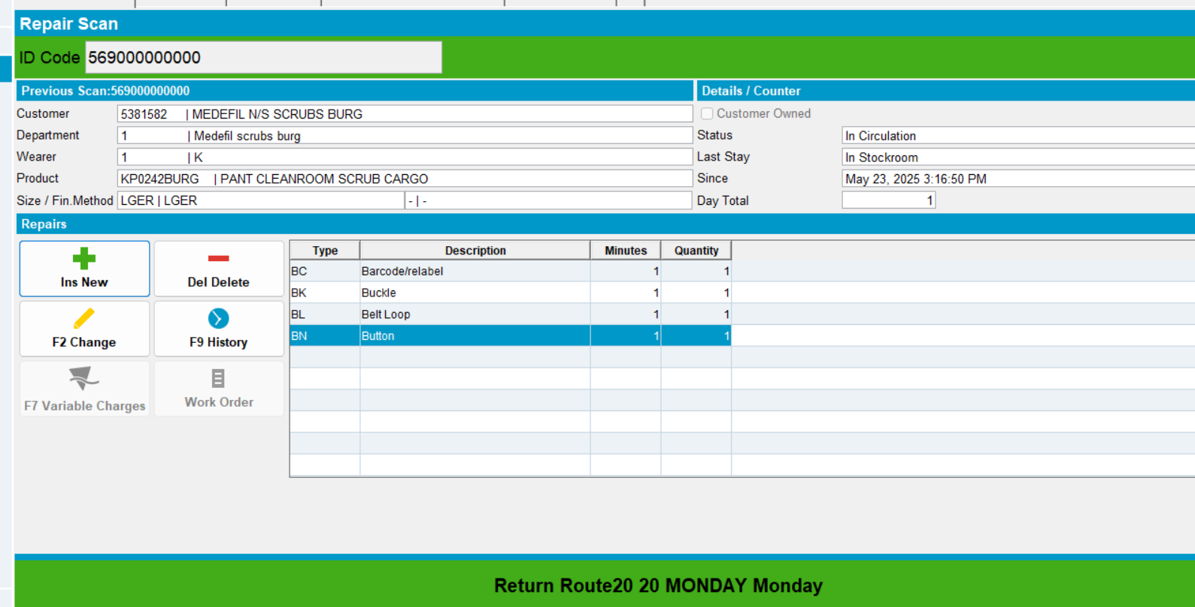

Generate report – Route: SELECTED, customer: ALL, day: Monday, 1 WEEK selected
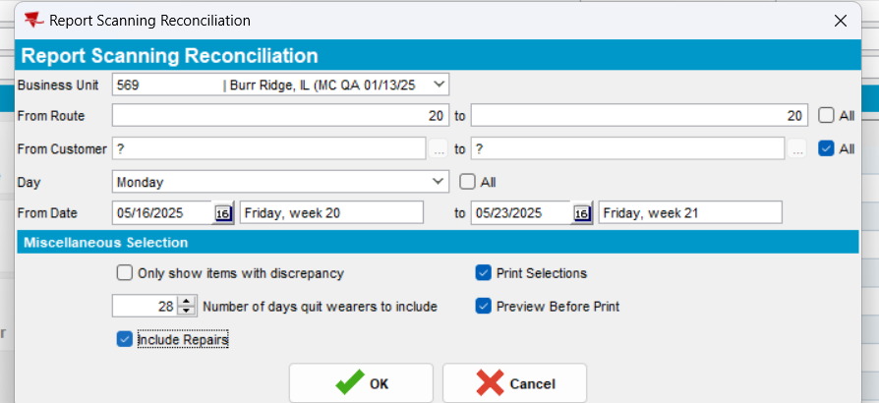
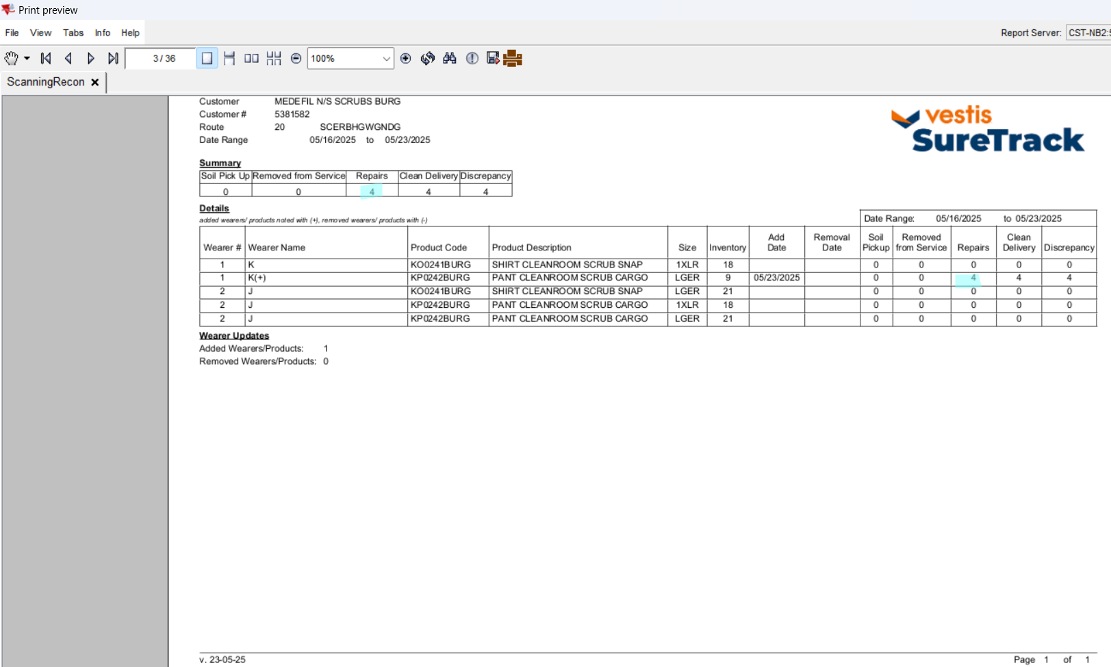
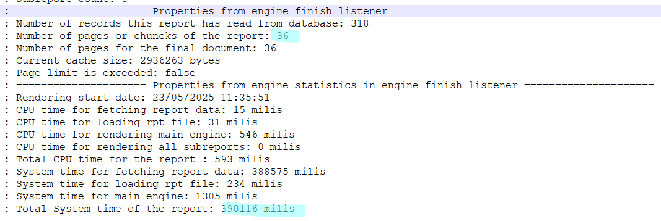

#4. Test DDB type customer – Test OK
- Have a customer of type DDB
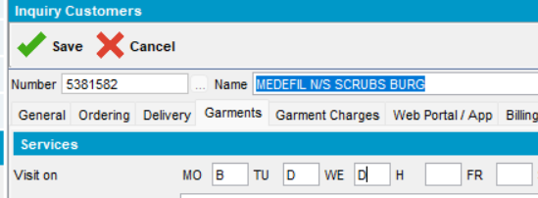
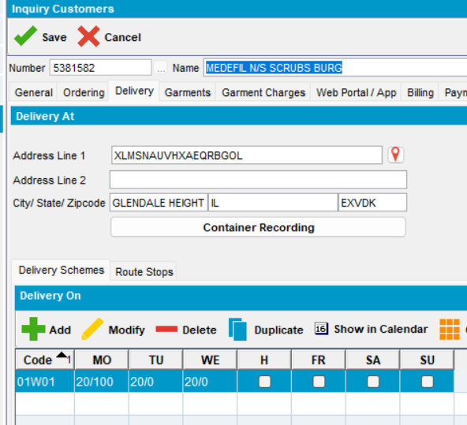
- Using the existing data, print reports with different settings:

Generate report – Route: SELECTED, customer: ALL, day: Monday, 1 WEEK selected
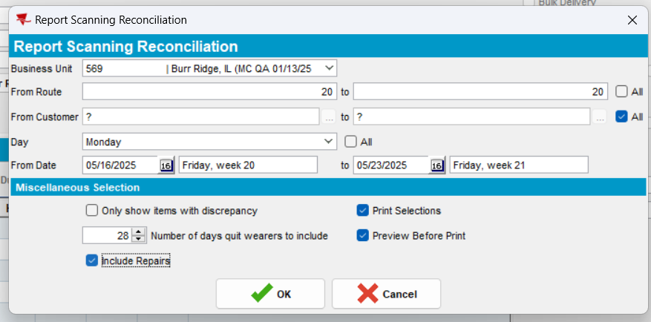
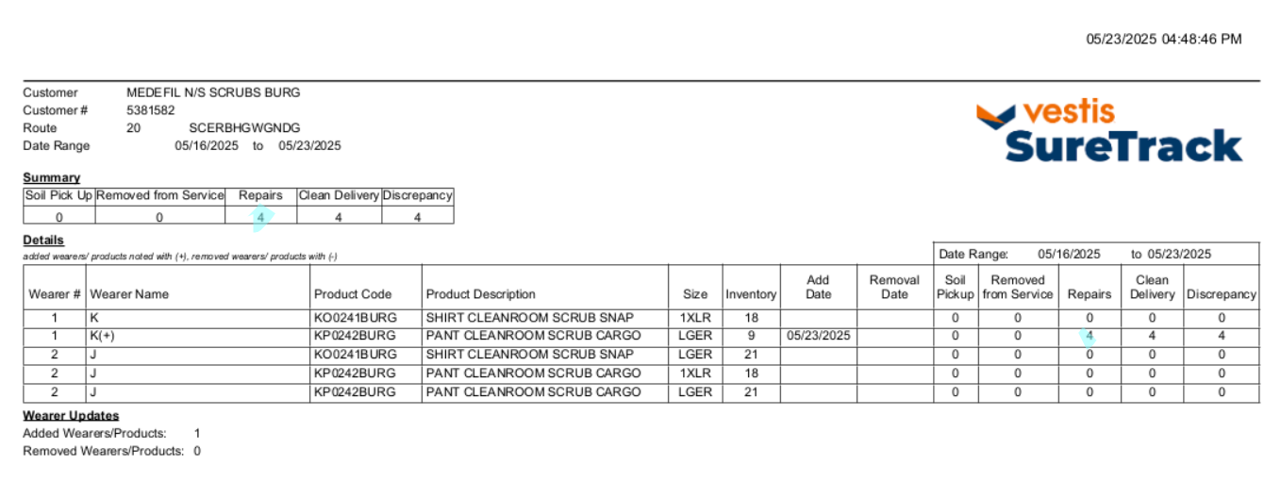
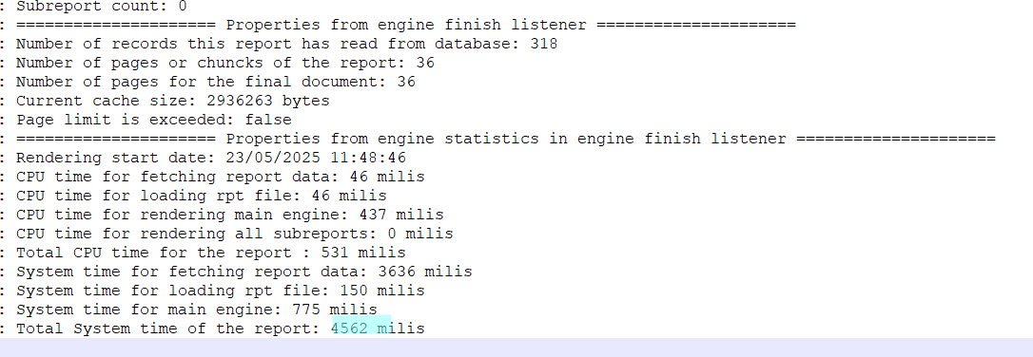

Generate report – route: SELECTED, customer: ALL, day: ALL, 1 WEEK selected
