ABSN-4634 Duplicate install records for First Aid Cabient and duplicate deletion
Environment | Prerequisites
Version: 9.08.00.RELEASE.p20  DBServerName=db01-buc.internal.abslbs.com  DBSID=CUST25  DBUser=AUS_ND90502  DBPassword=AUS_ND90502  Environment=Production  EnvironmentSABStage=Production | - Module: UNIQUEITEMSERVICE  - SS:  - ROUTE ASSISTANT: Version 13.28.INTERNAL_TEST_ONLY_89fb6887a
Contents
Retest after fix 1
Test Case 1 – Duplicate installation of FA cabinets when customer moved from one BU to another – TEST PASSED 1
Test Case 2 – Duplicate deletion of FA cabinets – TEST PASSED 20

Retest after fix
Hash: b1d9a51028ce
BU code: 503, 473
Plant code: 503, 473

STEPS IN THESE TESTS WILL BE SIMPLIFIED. FOR MORE SETTINGS AND CONFIGURATIONS. CHECK THE TEST ON MASTER FEATURE BRANCH 9.09.02.RC1

Test Case 1 – Duplicate installation of FA cabinets when customer moved from one BU to another – TEST PASSED
Expected behavior: Changing of the FA Cabinets ID CODE’s, after a customer is moved from one BU to another should be done seamlessly.
FA Cabinets used:
FA Cabinet 1: CE0750XXXX
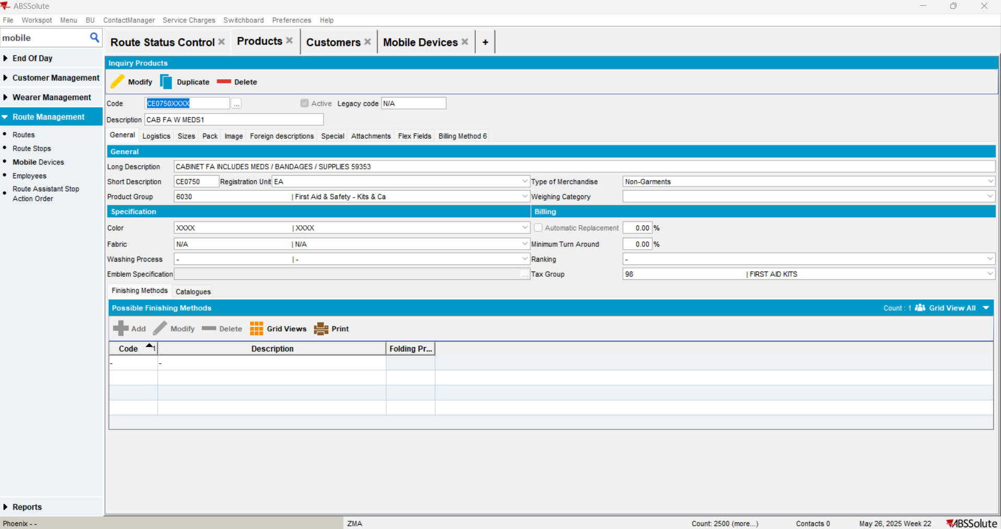
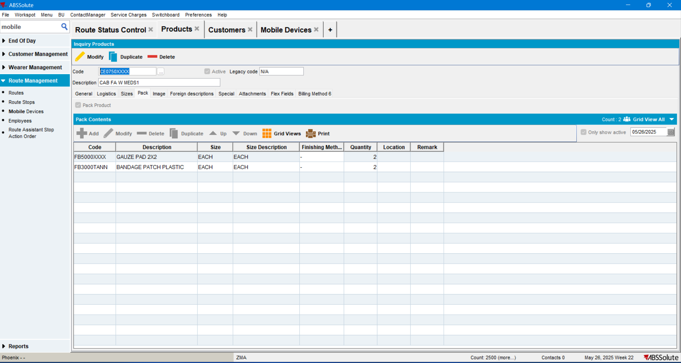

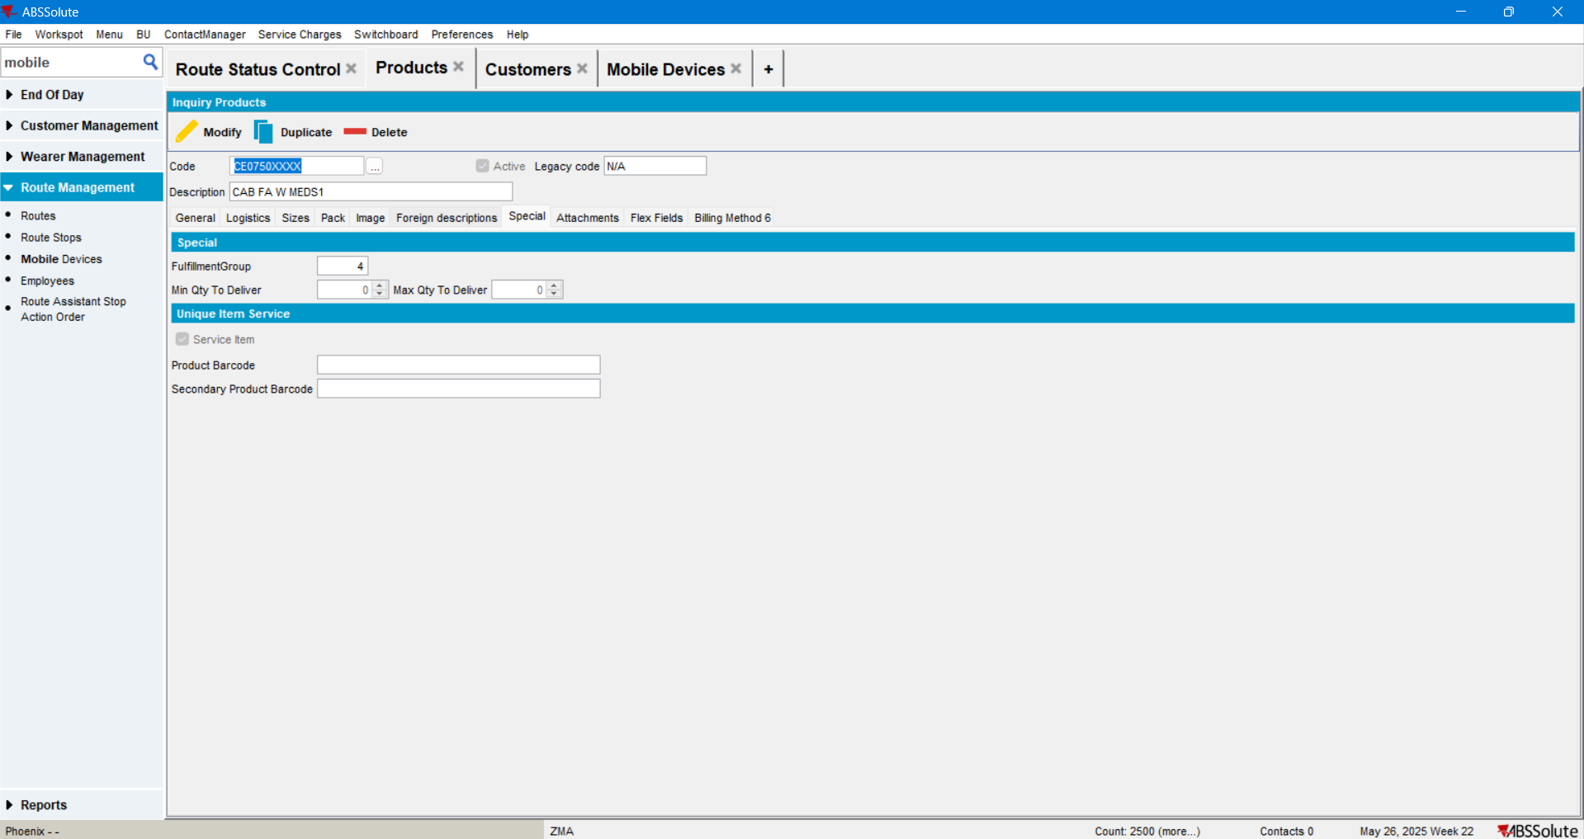

Check if the product is active for the current plant:
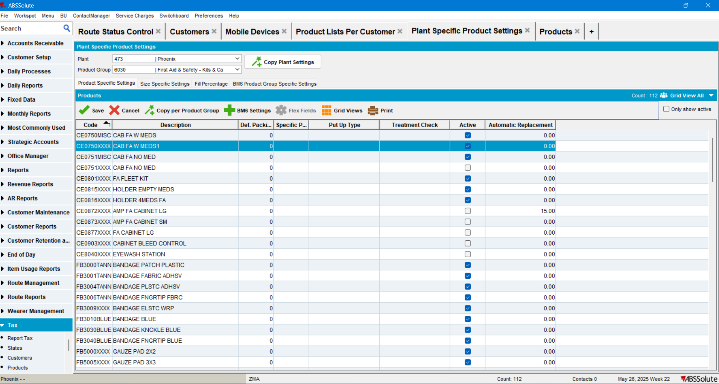

Check for suitable routes in RSC:
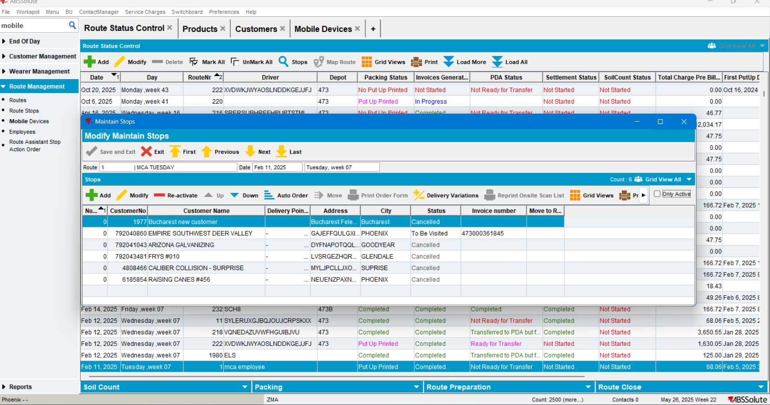

The following route seems to have fewer customers. Select one of the customers and check it’s delivery scheme:
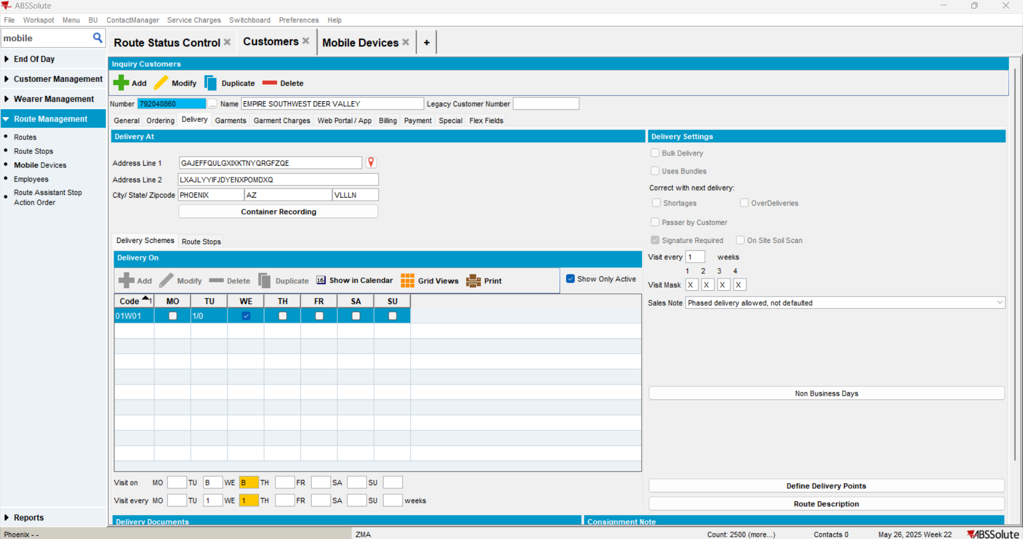

Add the FA Cabinet in customer’s PLPC list:
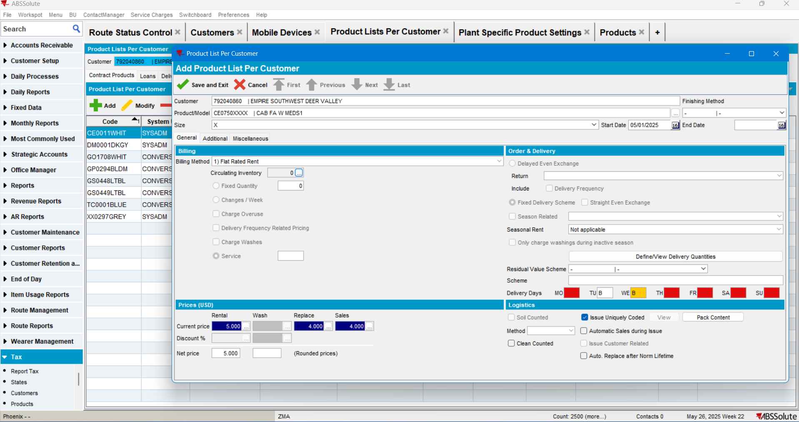

Configure a mobile device:

And Employee (Driver) that will use it:
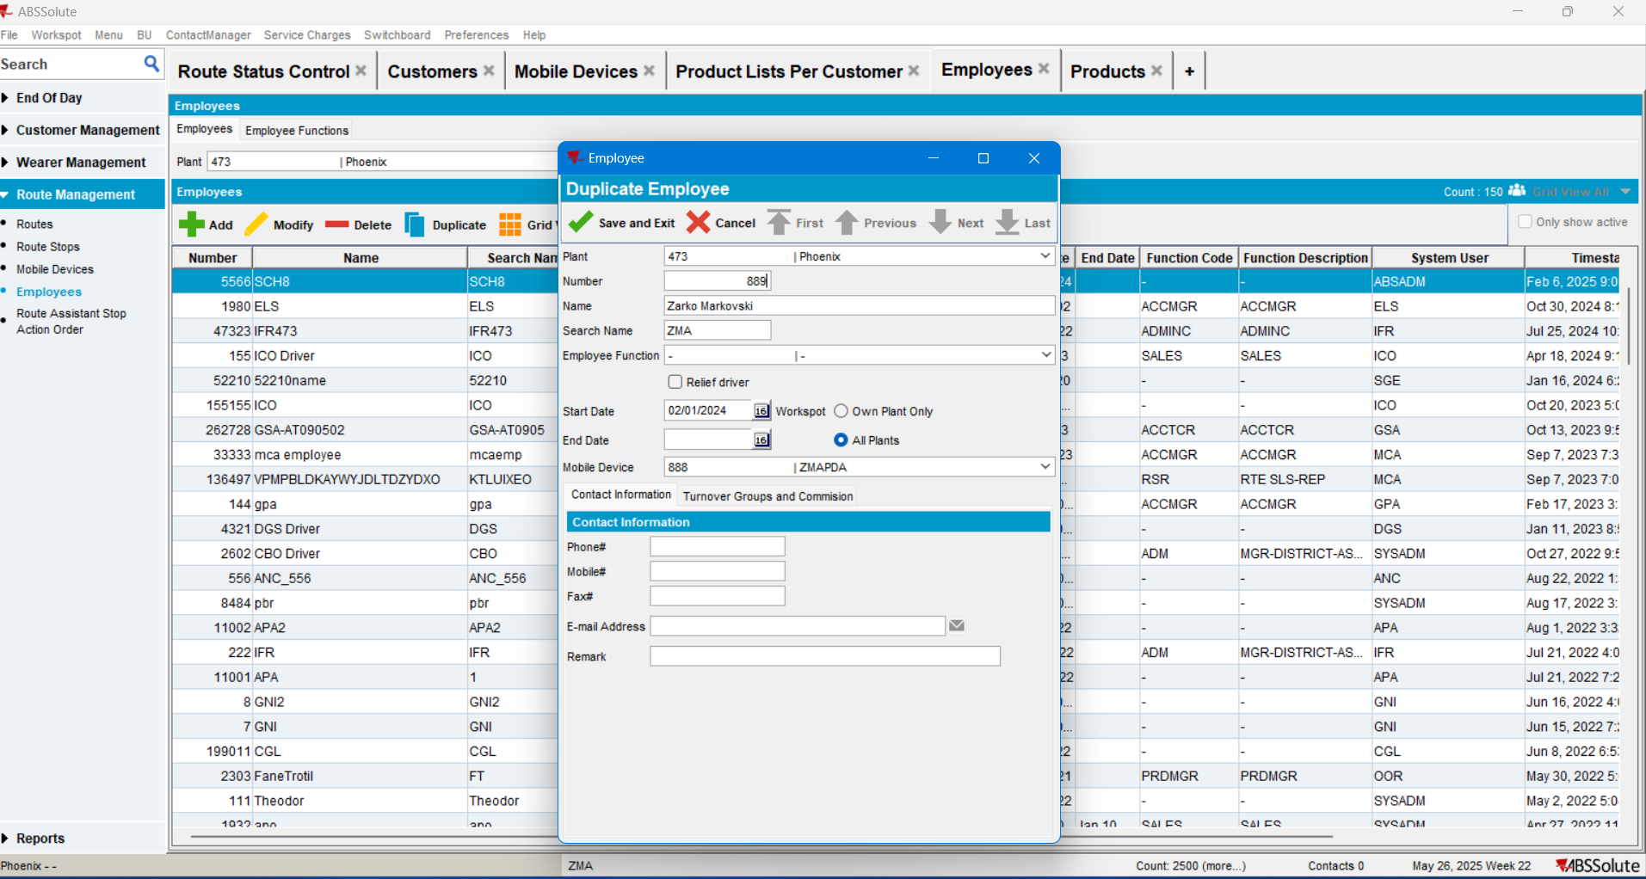

Route Transaction Type “INSTALL” (code.851) should not be set to be approved Manually:
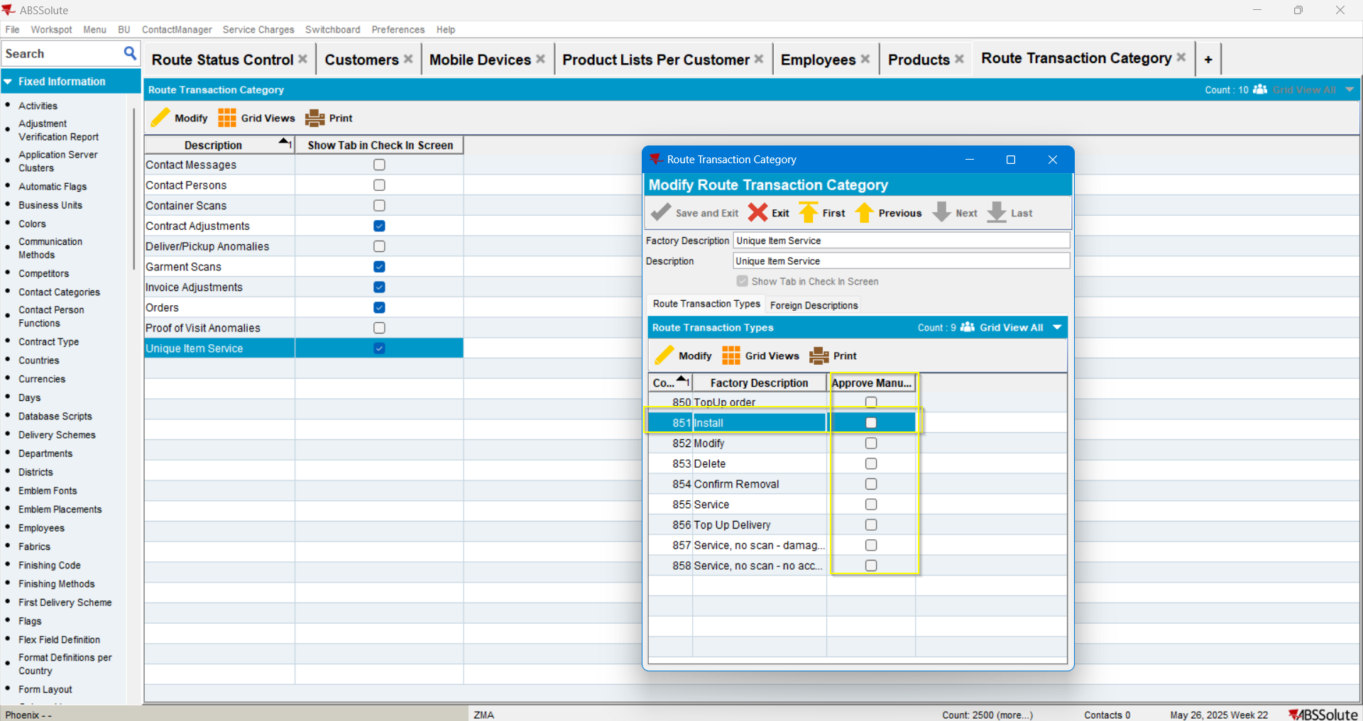
Add/create or modify an existing route. In this case the route selected was this one. Move out or cancel all but one of the stops:
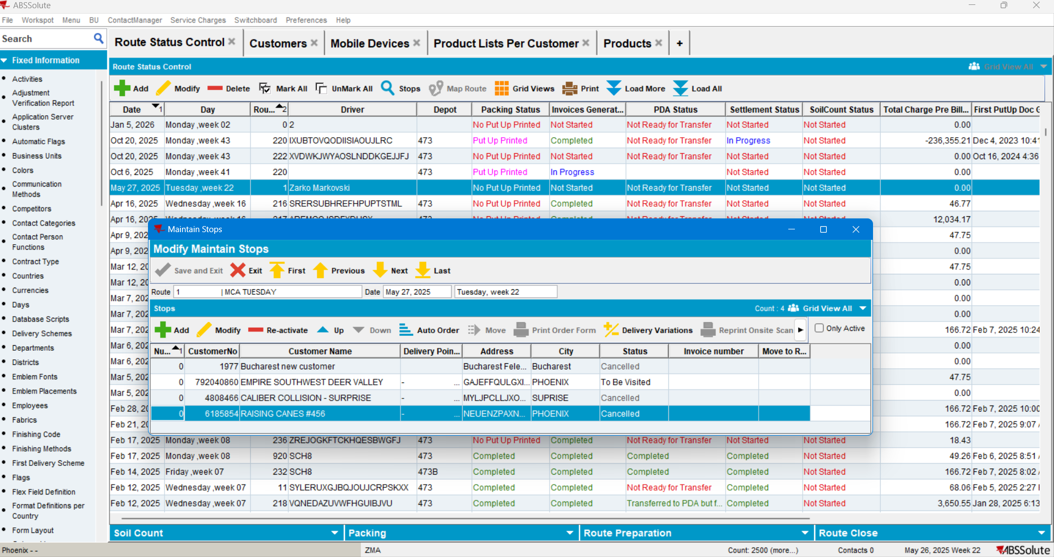

Create Delivery Variations for the FA Cabinet with delivery date for the created route:
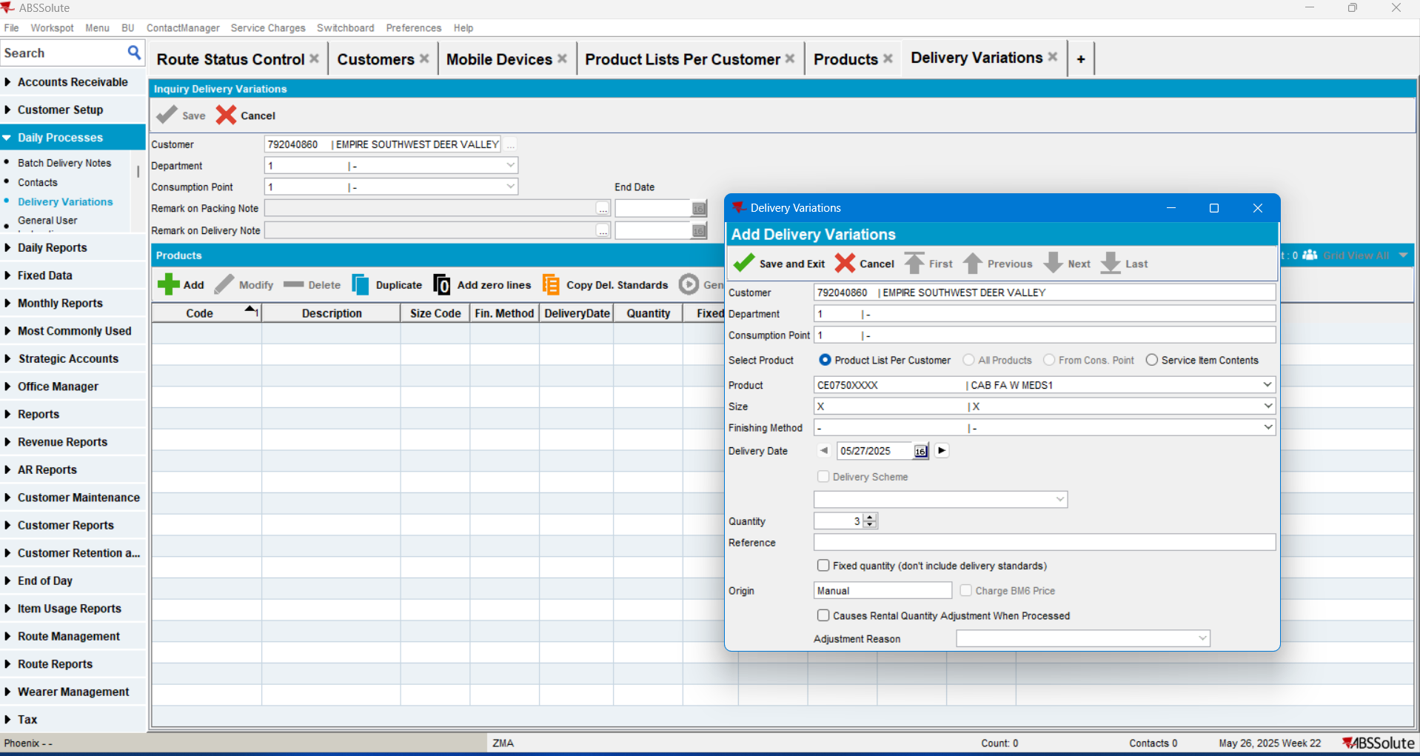
Generate the Packing Notes:
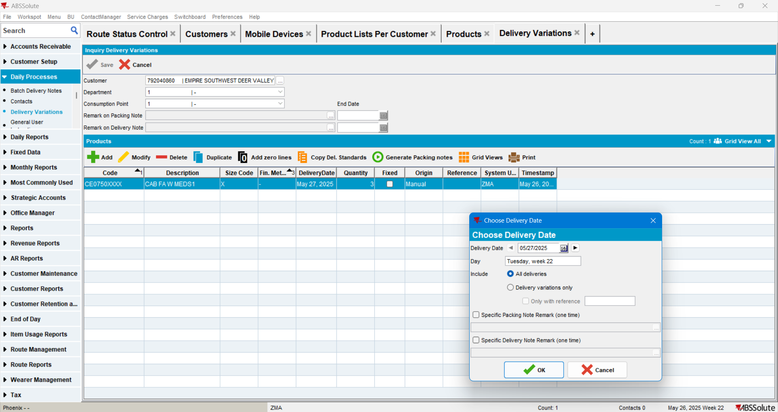

In RSC:
- Generate the Packing Notes:
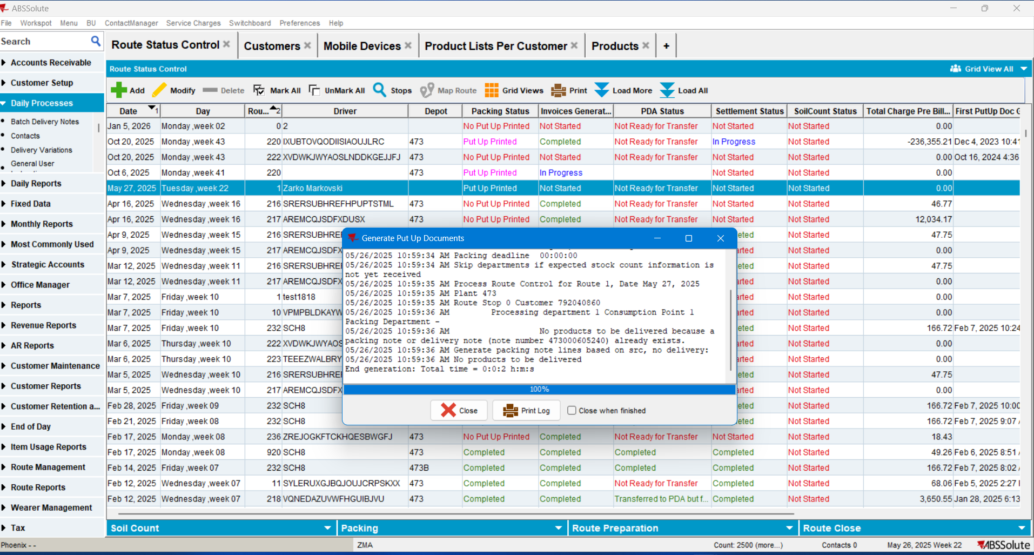
- Generate the Invoices:
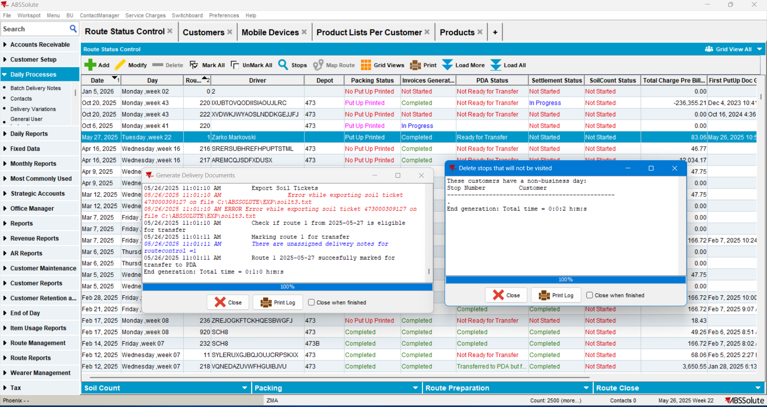

- Mark the route to be Transferred to PDA
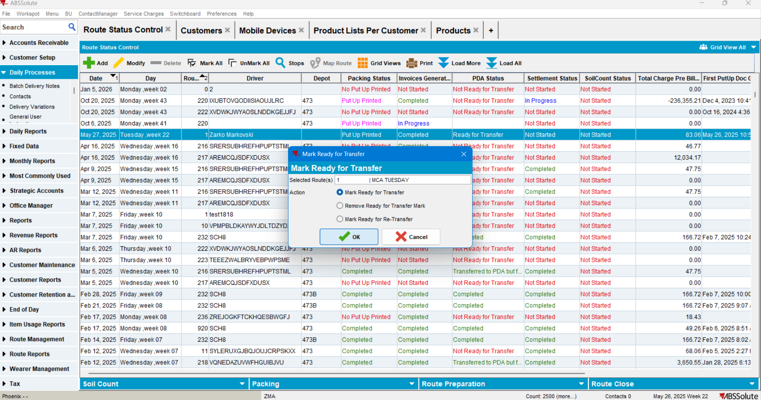
Set the Truck and the Driver for the route:
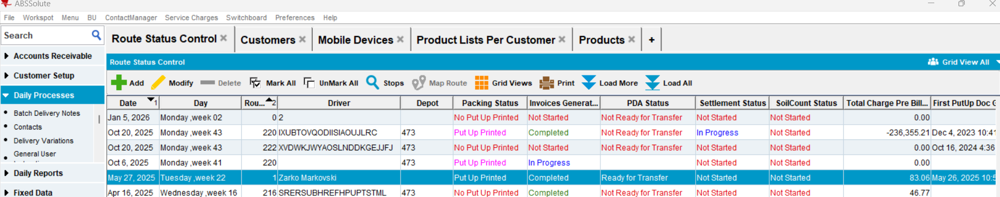
Start the PDA and follow the flow.
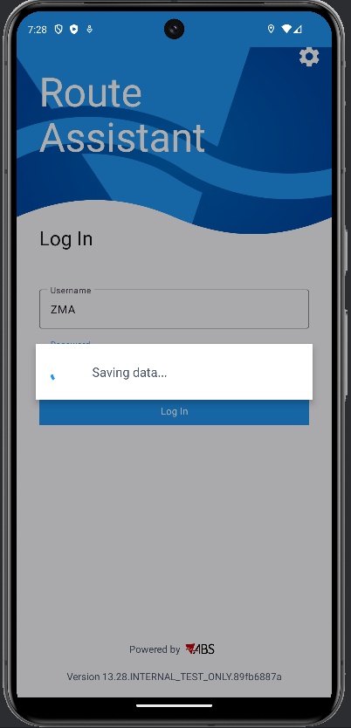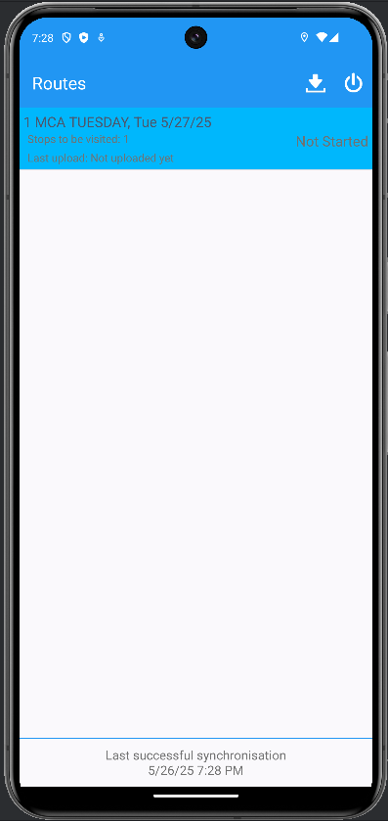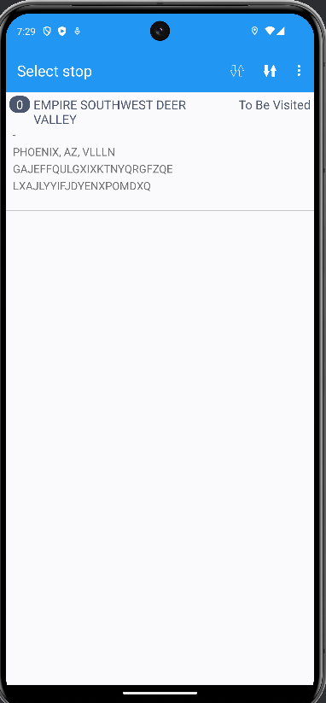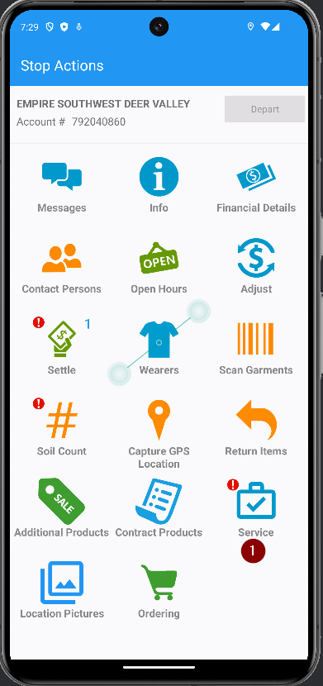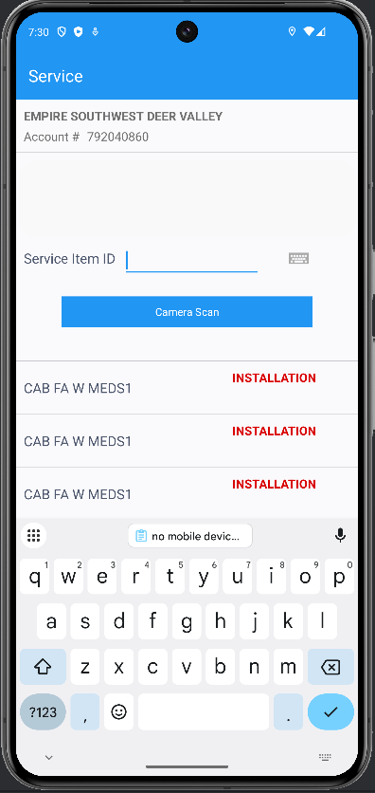

Install the cabinets like this. All Cabinets were installed, D Depart, go back, and Finish the route and upload it ot the server:
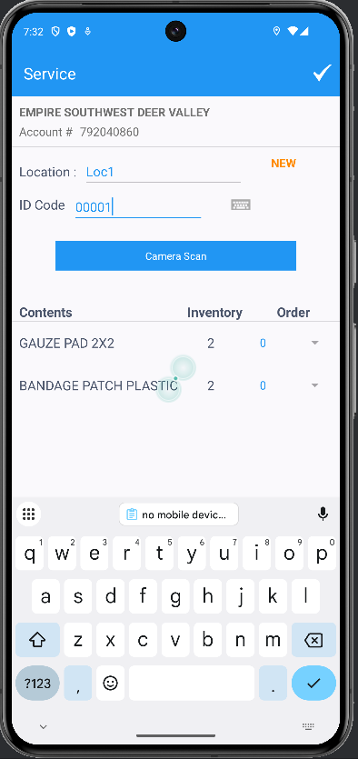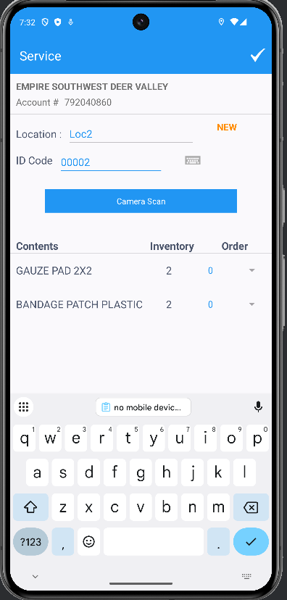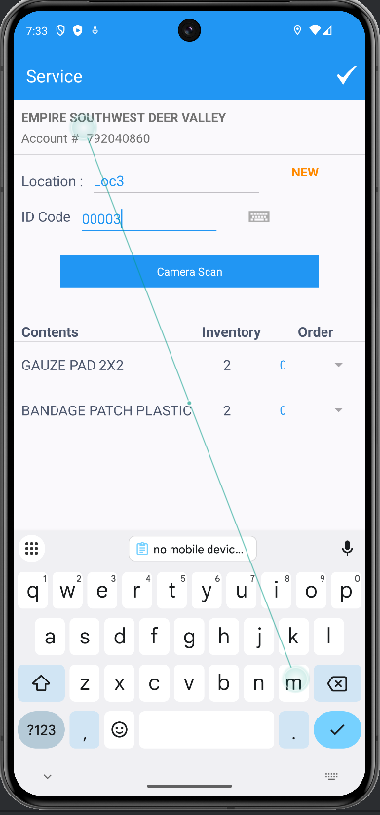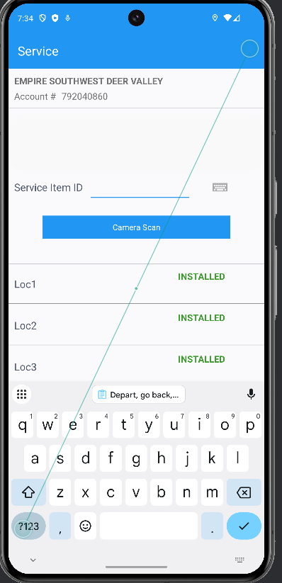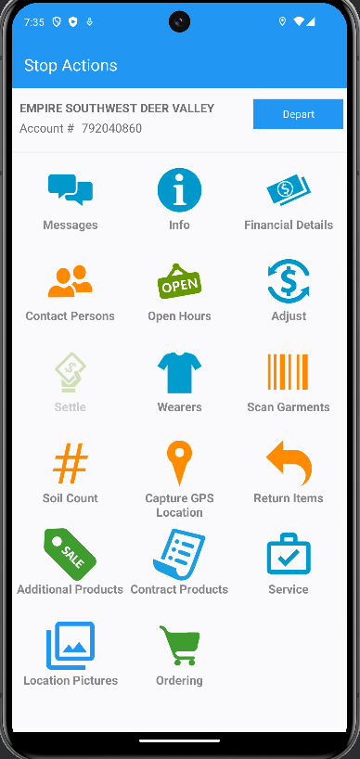
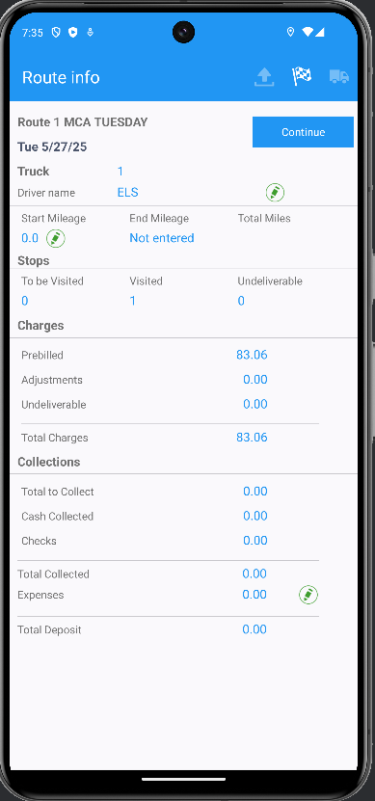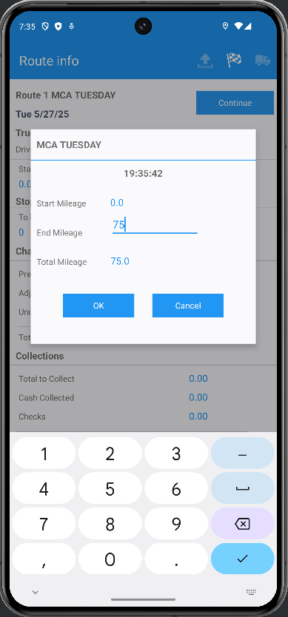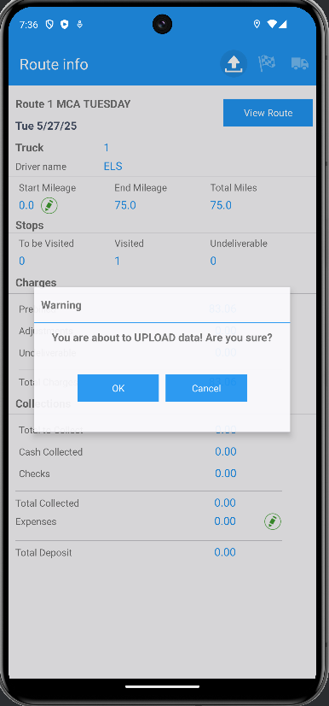

Check the data created:
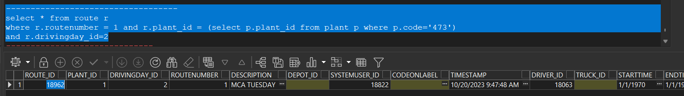
Find RouteControl_ID:
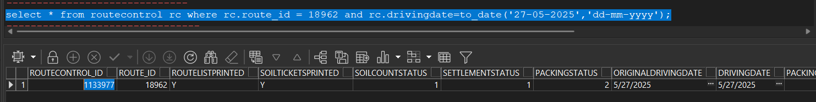

Find Route Transactions (P.S. Route Transactions TYPE ‘851’ = INSTALL
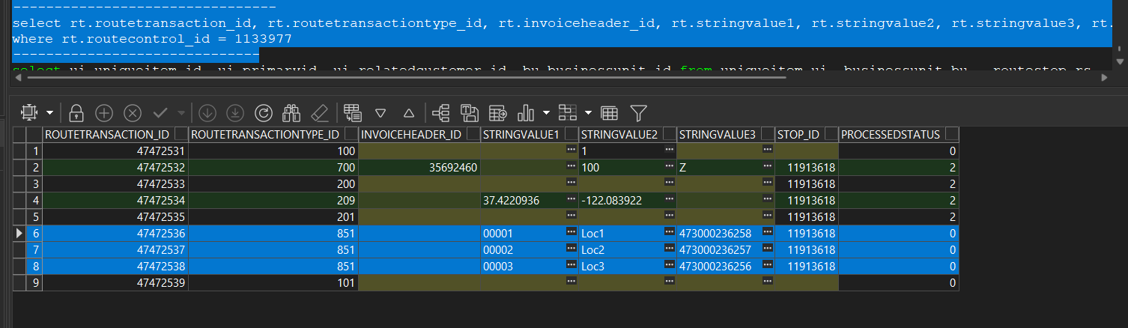
FA Cabinets IDs before route settlement:
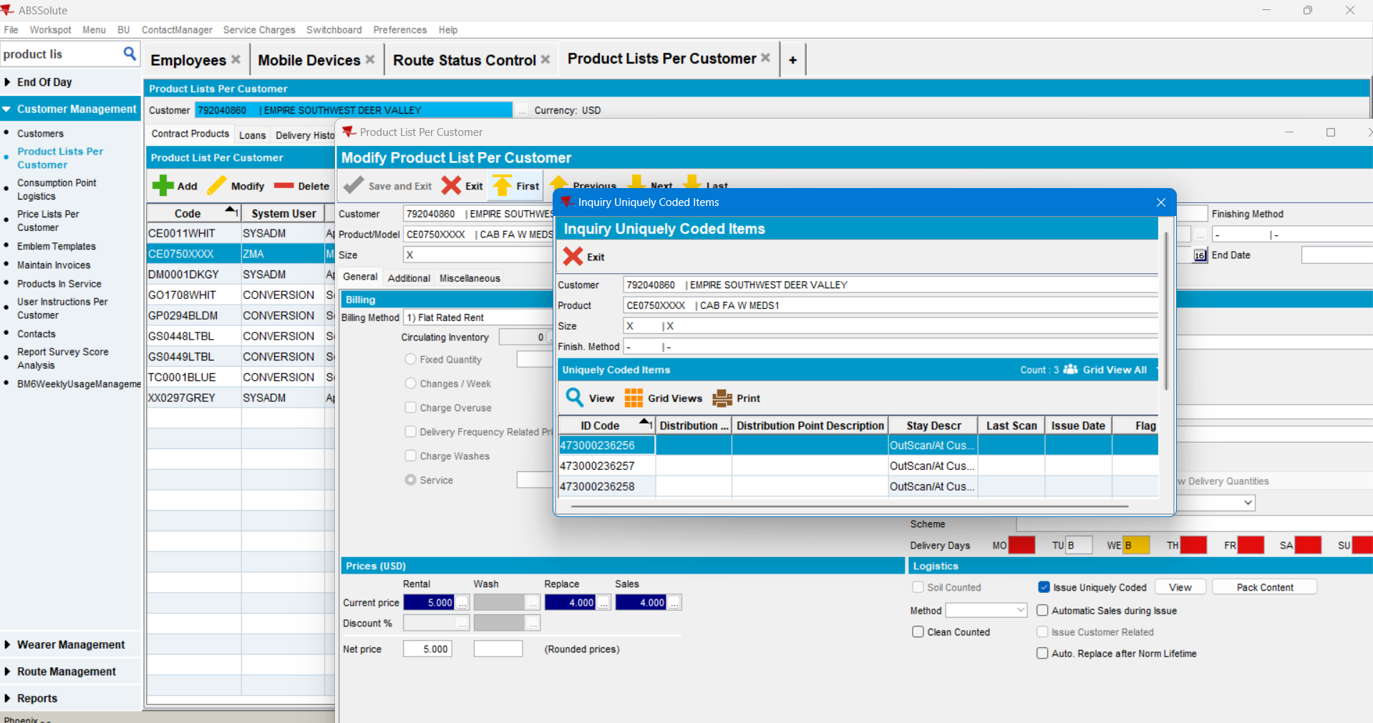
Now settle the route from the Swing Client:
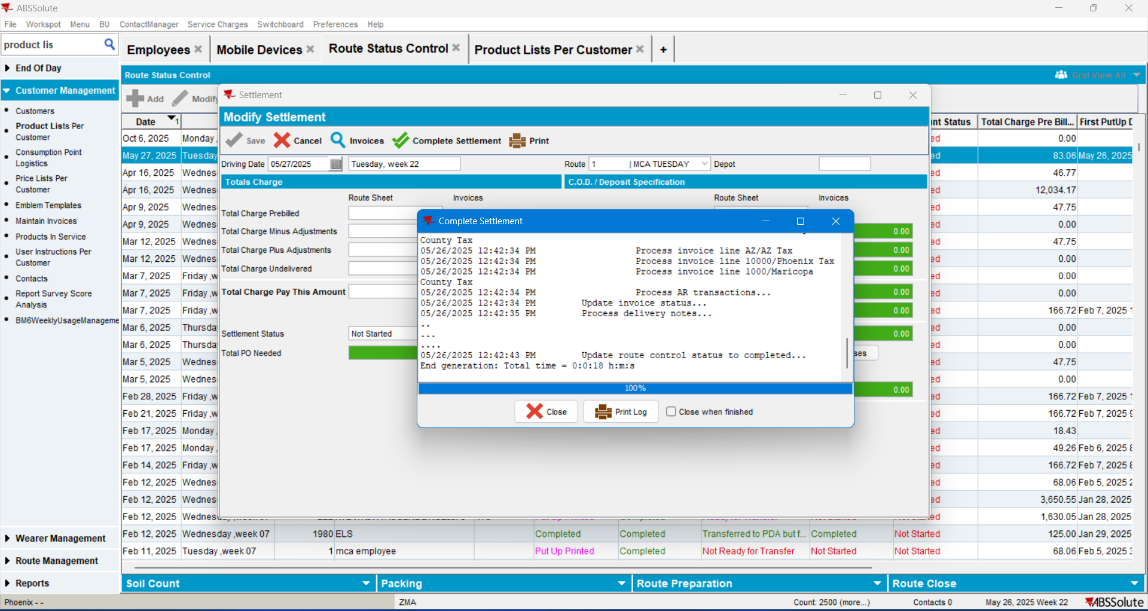

Check the FA cabinet ID codes in customer’s PLPC:
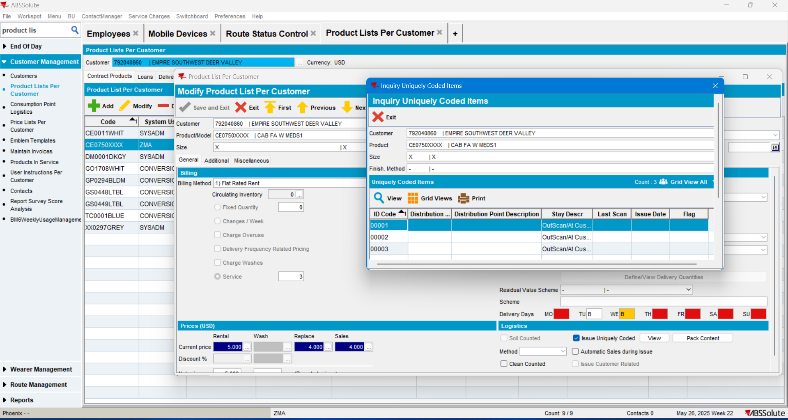
They are correct (the ones introduced from the RA android app upon installation)

Create new Delivery Variations for next weeks route:
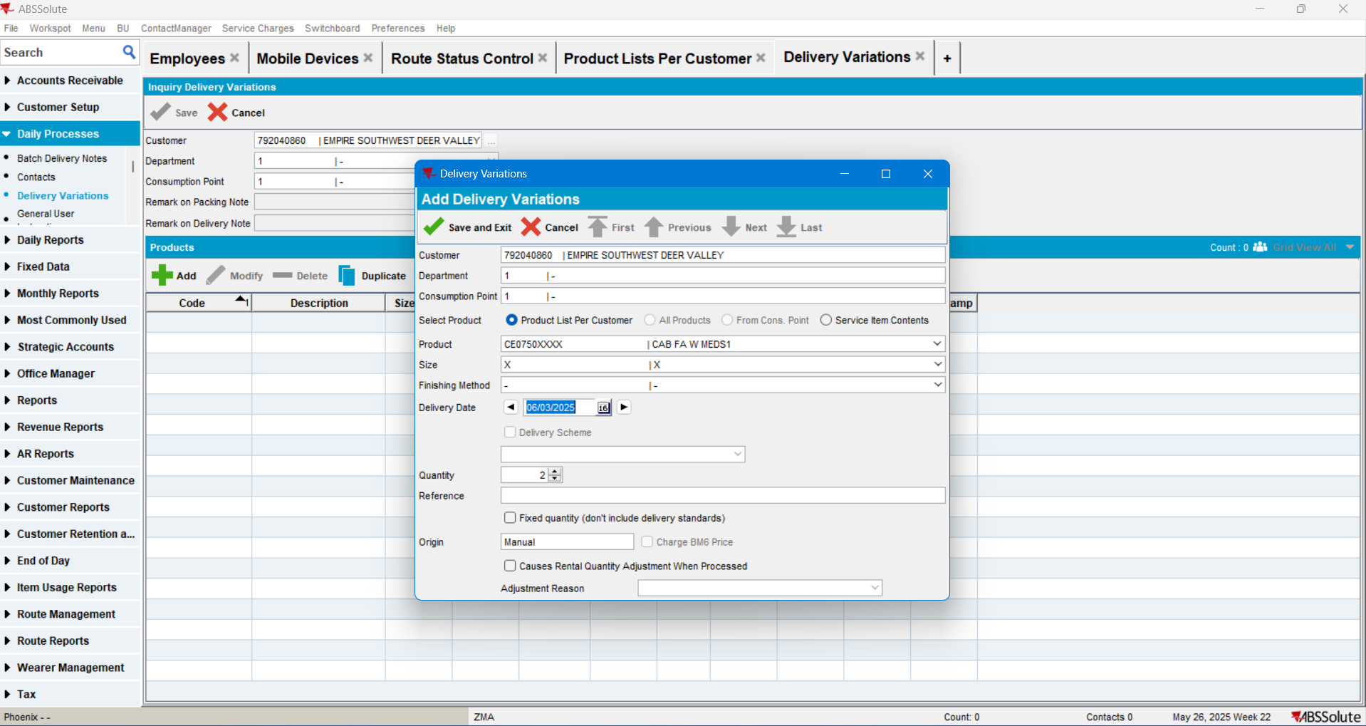

Generate the Packing Notes:
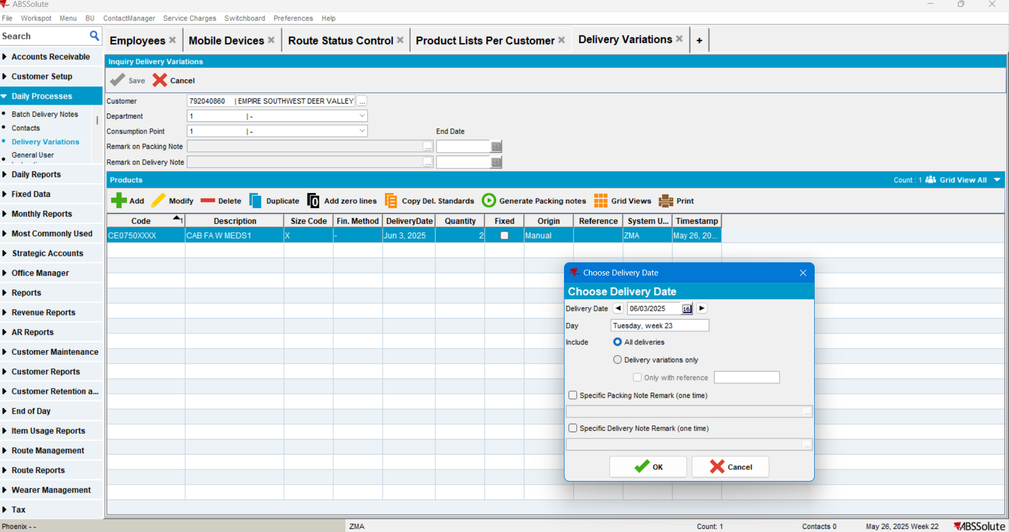
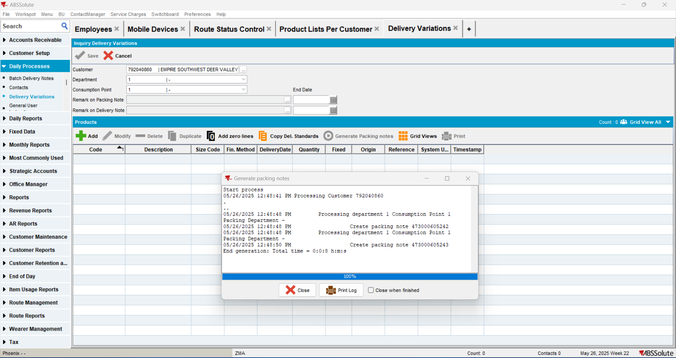

Check the ID’s created in PLPC for these 2 new Cabinets:
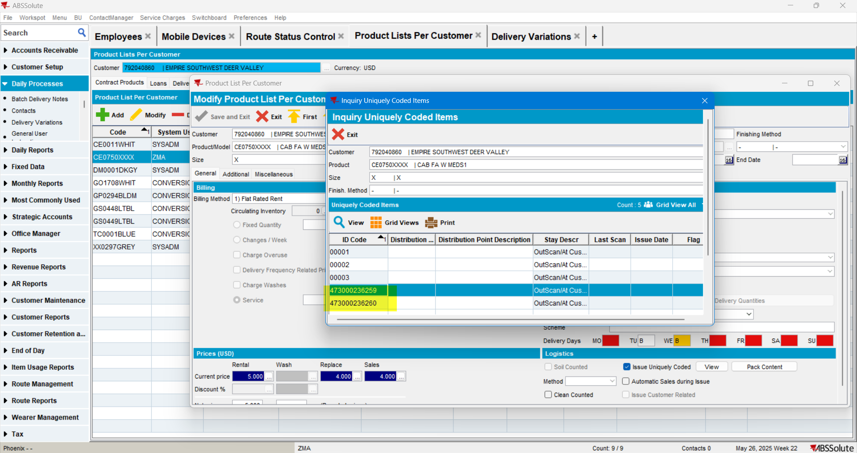Switch to tne new BU:
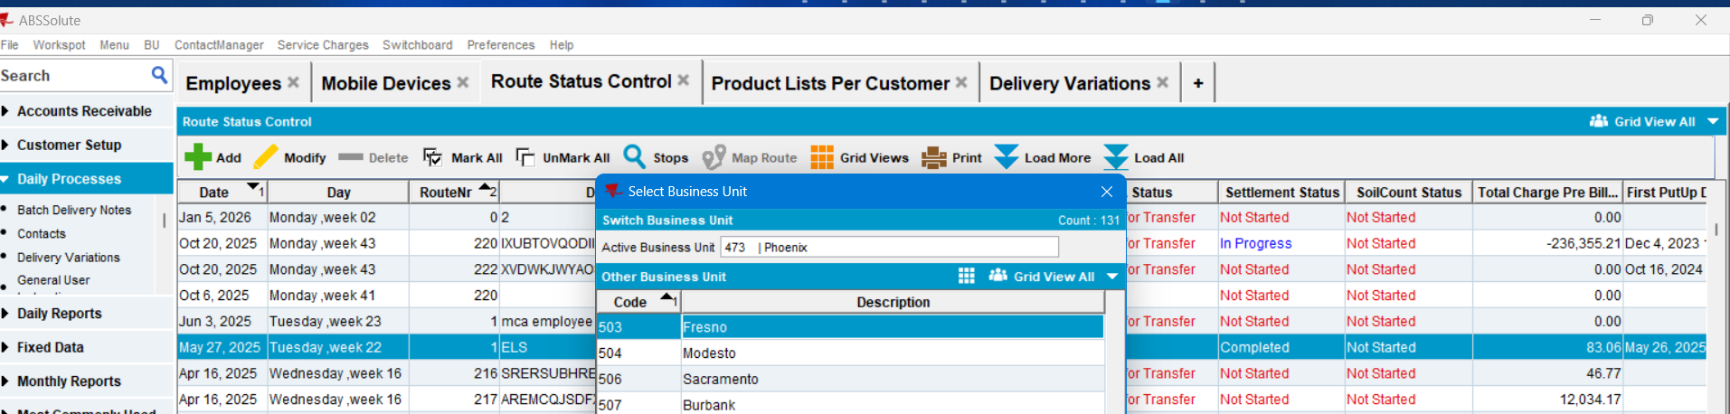

Make sure that the identical route (number and driving date) exists in the new BU, or create one:
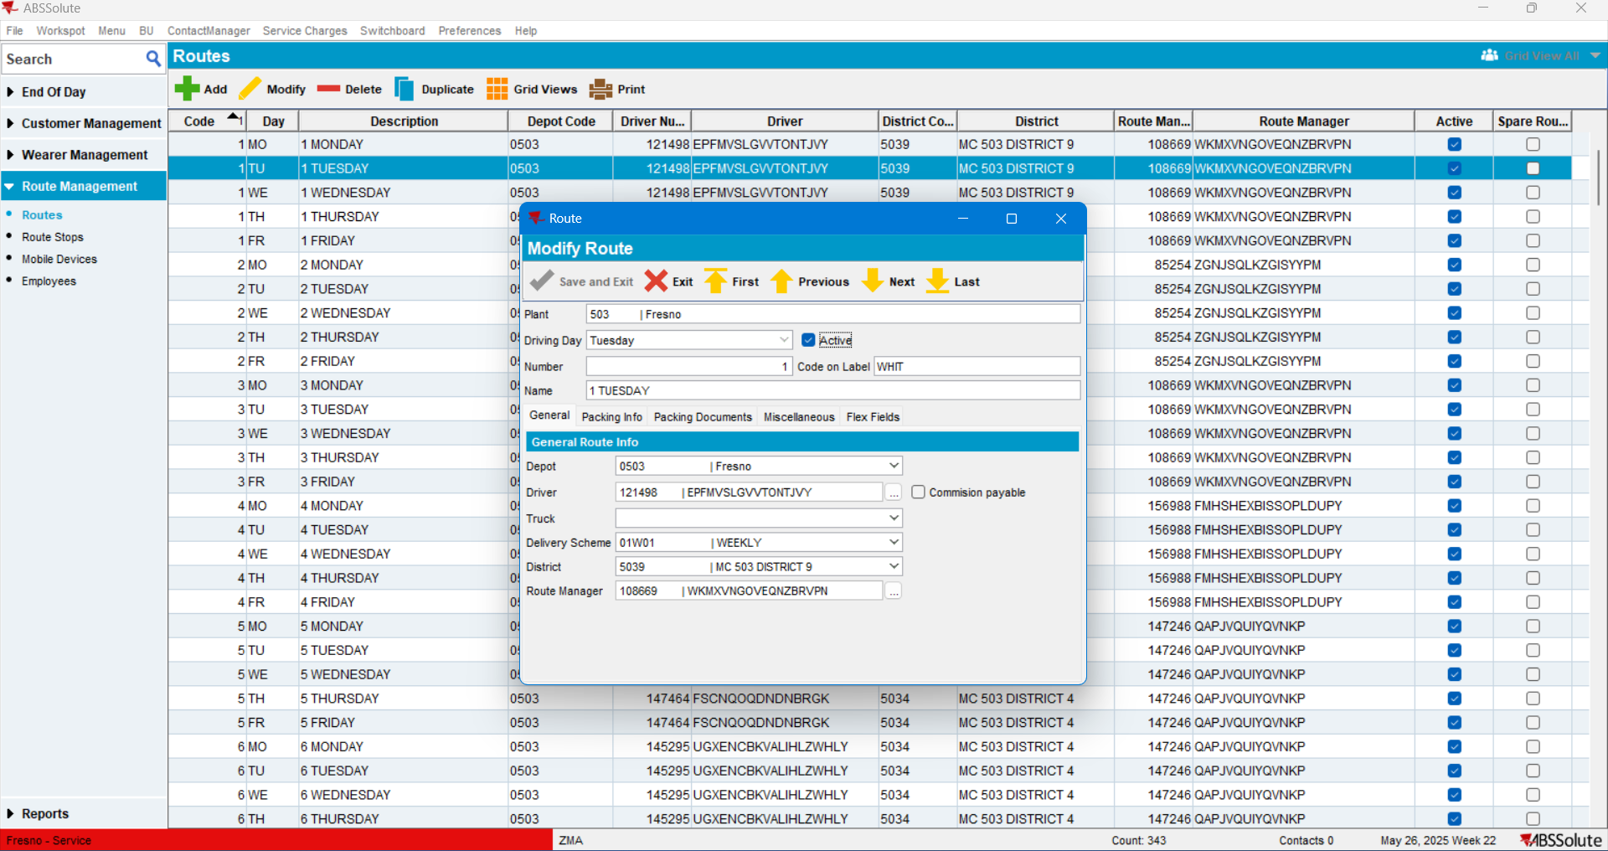
In order to move the customer from the old to the new BU:
- Run this insert command:
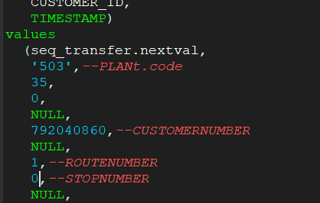
Comitt the changes 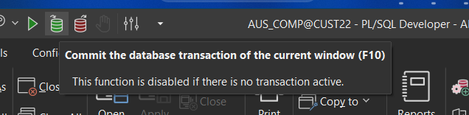
- RUN this procedure in SQL as TEST WINDOW:
pack_u_generic_data.n35_transfercustomer
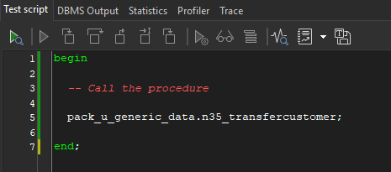
The customer was moved from BU.code=’473’ to ‘503’:
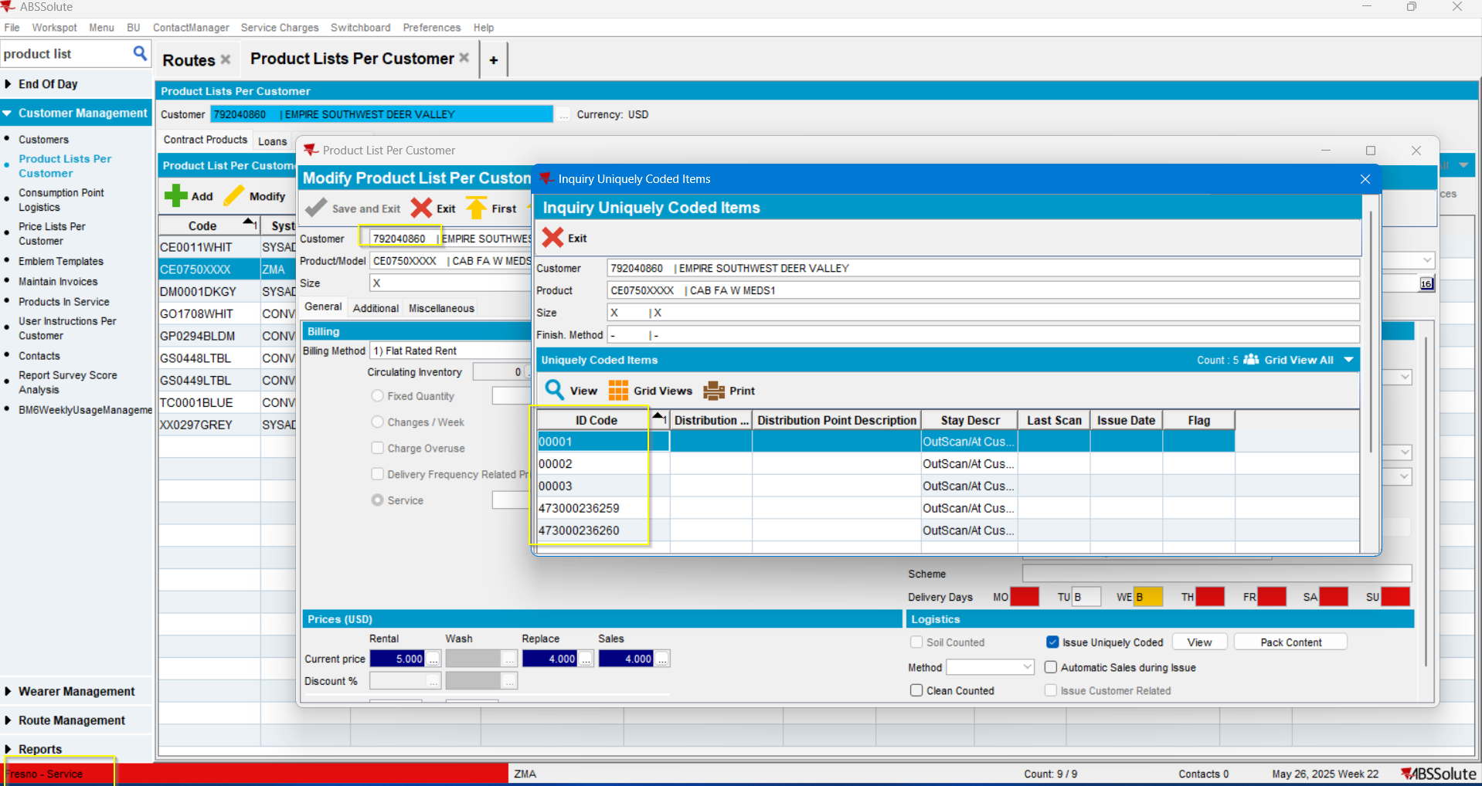
The customer is now at BU.code=’473’ and FA Cabinets with the latest ID codes are correct (3 that were installed while the customer was with the old BU and 2 more pending to be installed).

Create a new route control in the new BU for the delivery variation created in the old BU:
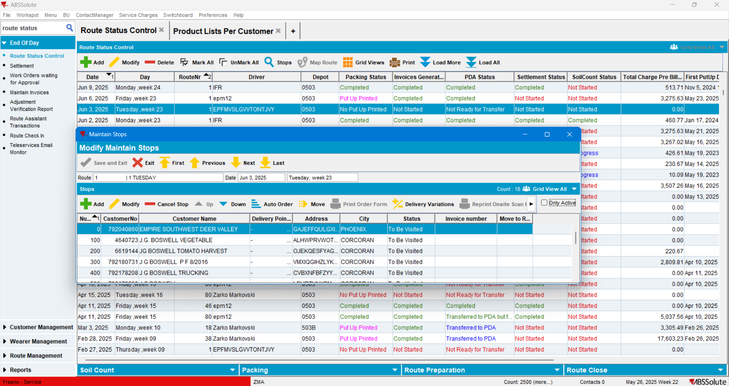
Move all stops to another route except for the used customer:
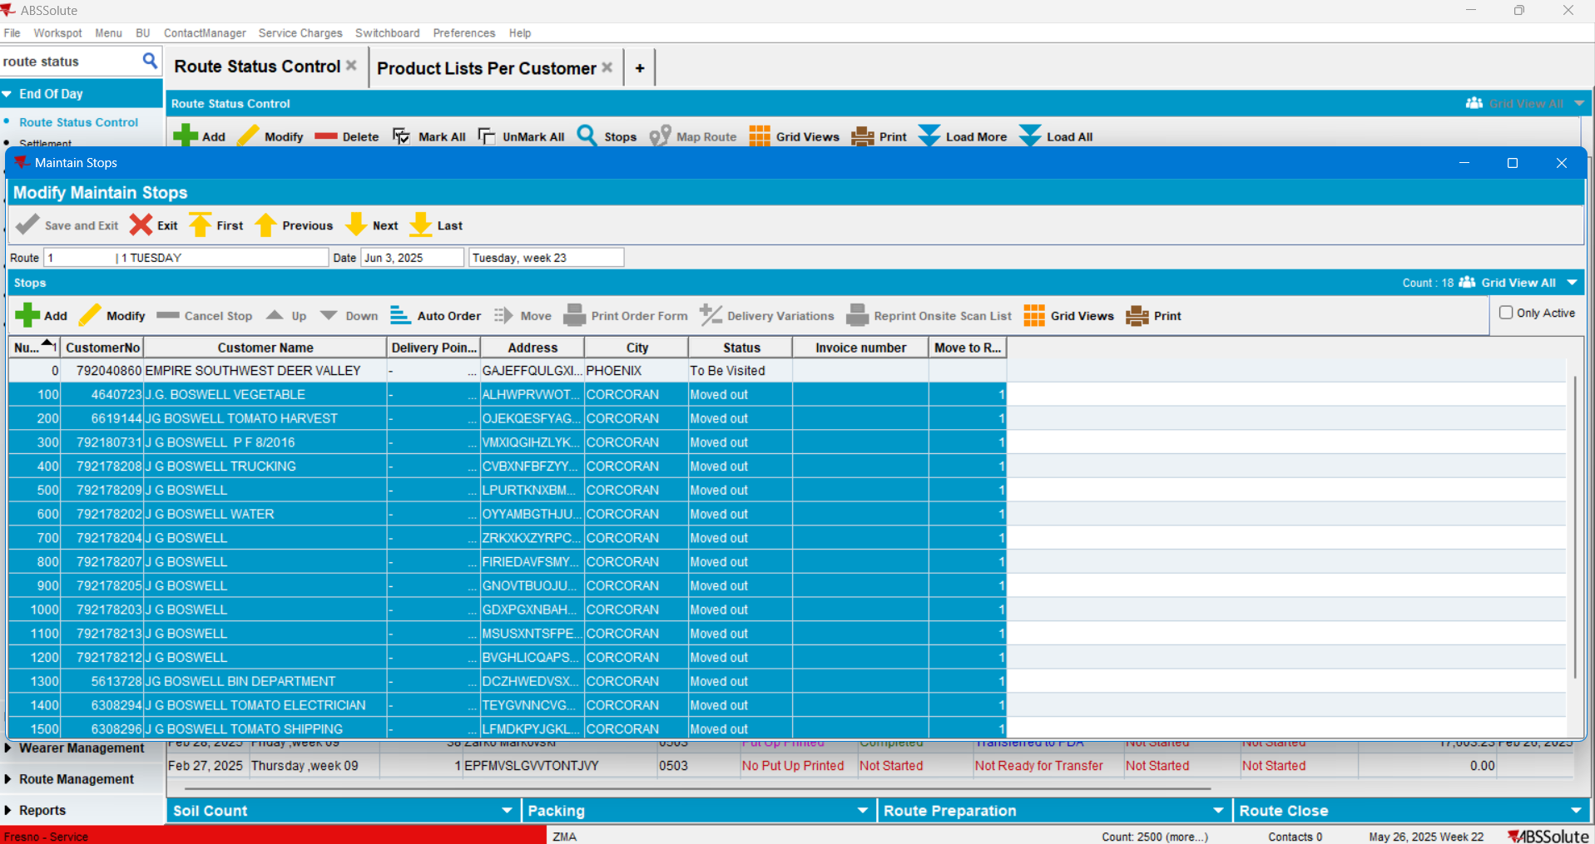

- Generate packing notes:
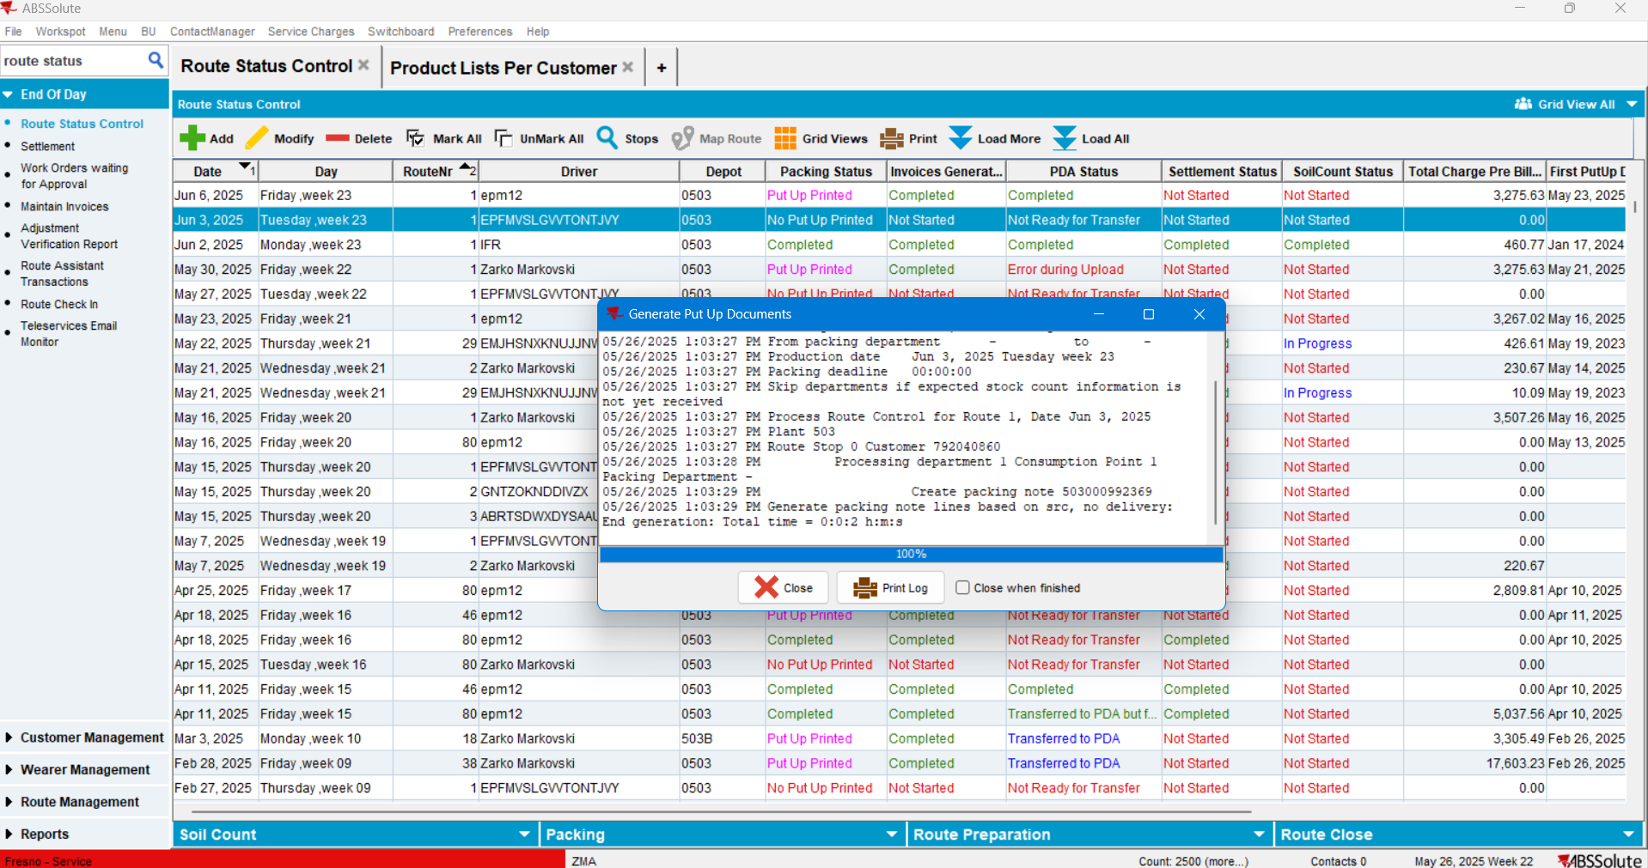
- Generate Invoices:
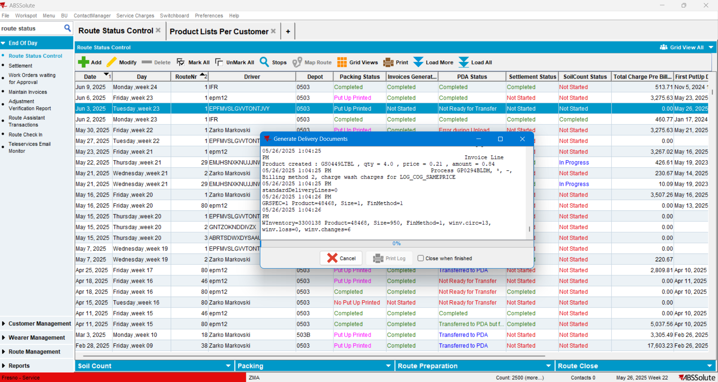

Set up driver and truck:
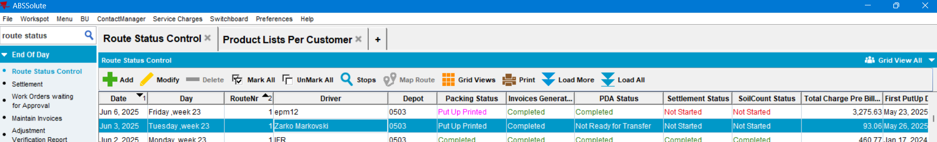
Mark ready to transfer to PDA:
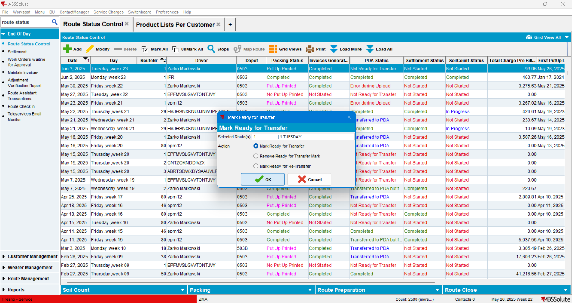

Do the same flow as above in PDA to install the FA Cabinets. Service and install them:
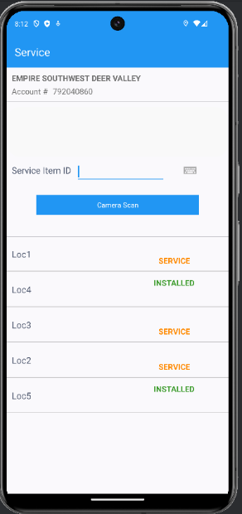
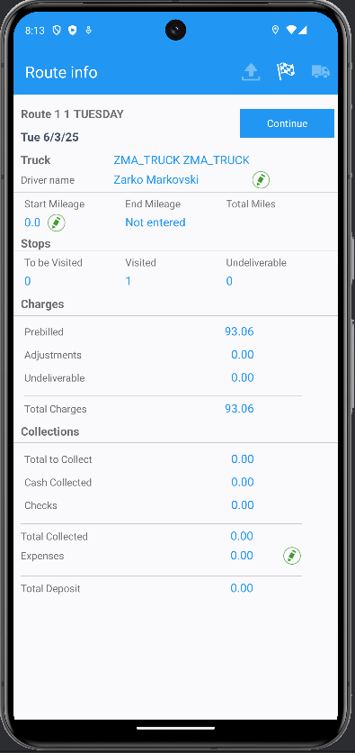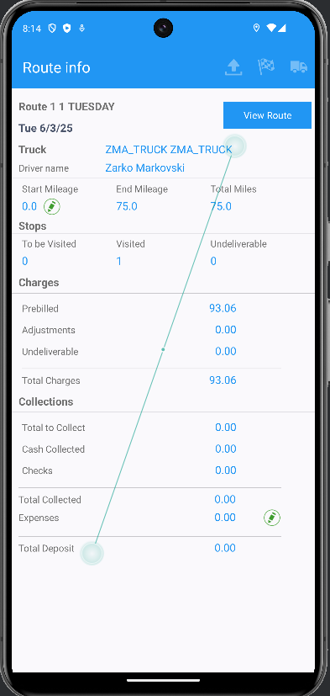

Settle the route from Swing Client;
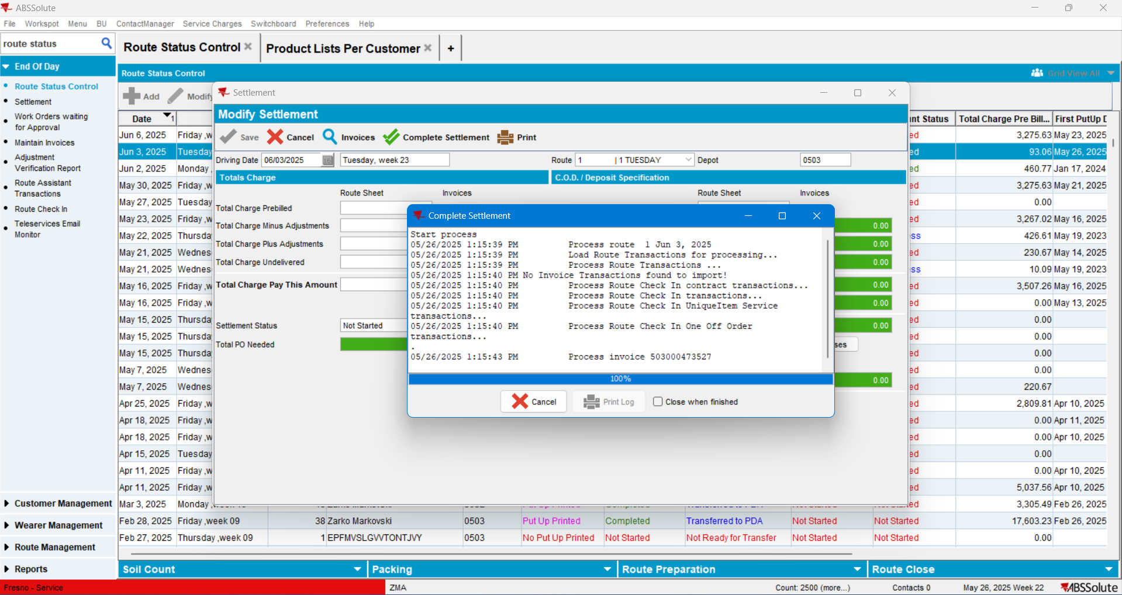
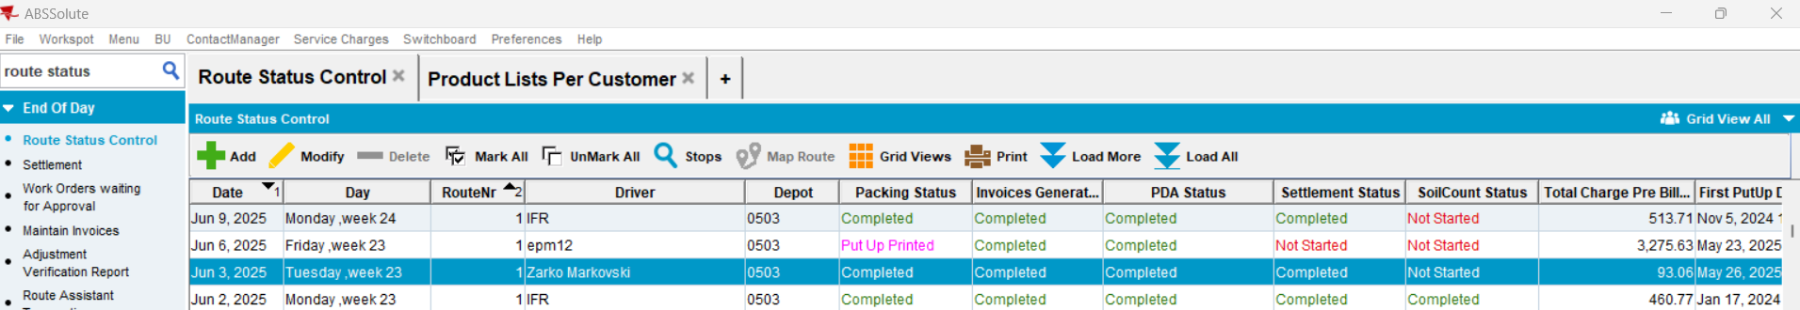
Check the FA Cabinet’s IDs in PLPC:
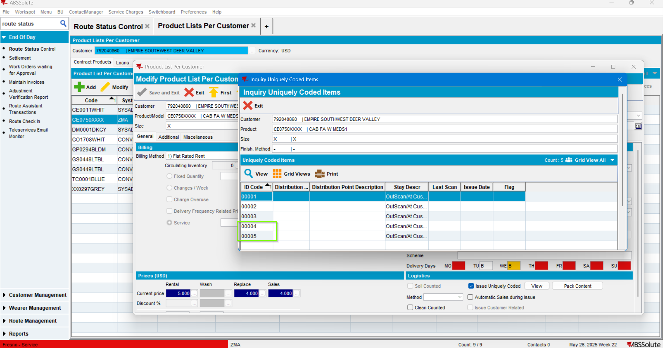
The ID codes are correct, the ones that were set in the RA application.
TEST PASSED

Test Case 2 – Duplicate deletion of FA cabinets – TEST PASSED
Expected behavior: If duplicate ID codes exist in the DB for FA cabinets, but for different customers, then upon deletion of a cabinet through the RA, only the cabinet for the selected customer should be deleted, not all cabinets for all customers that carry the same ID.
BU.code=’473’, ’503’
Plant.code=’473’, ’503’

Create duplicate ID’s from the database by changing the Primary ID for one of the Cabinets created in the previous run using a Primary ID from another UI from the other BU ‘473’.

Find what FA Cabinets are used by customers on BU ‘473’:
select p.code, c.customernumber
from productlistpercustomer plpc, customer c, businessunit bu, product p
where plpc.customer_id=c.customer_id
and c.defaultbusinessunit_id=bu.businessunit_id
and p.product_id=plpc.product_id
and bu.code='473'
and p.productgroup_id=(select pg.productgroup_id from productgroup pg where pg.code='6030')

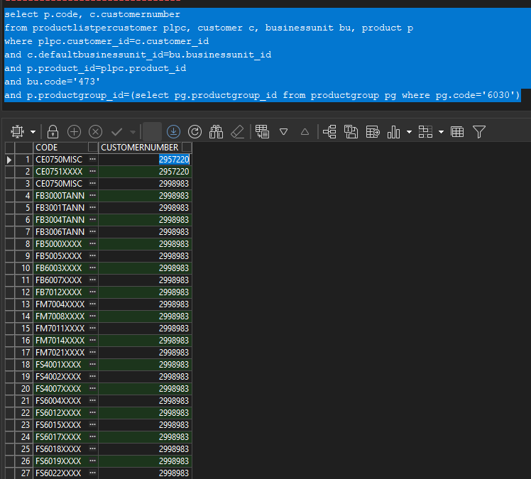
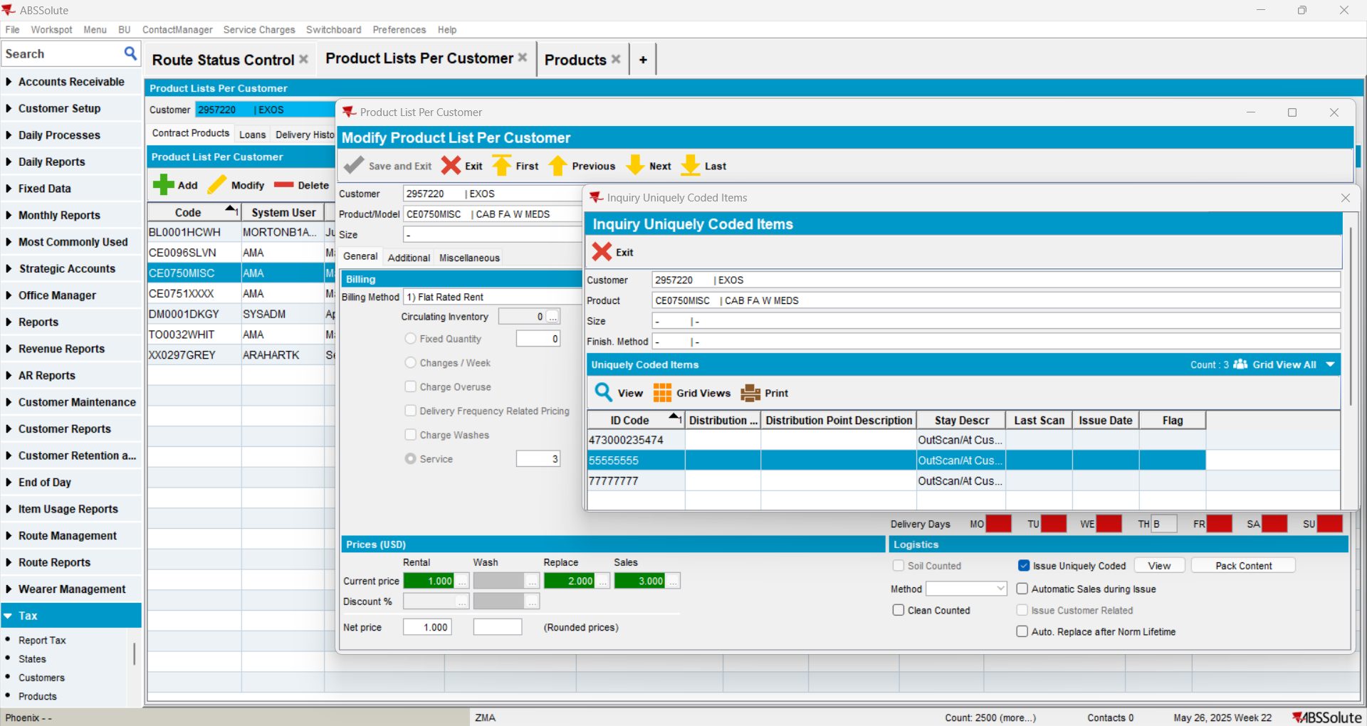
Primary_ID to be used ‘55555555’.

Primary ID to be updated:
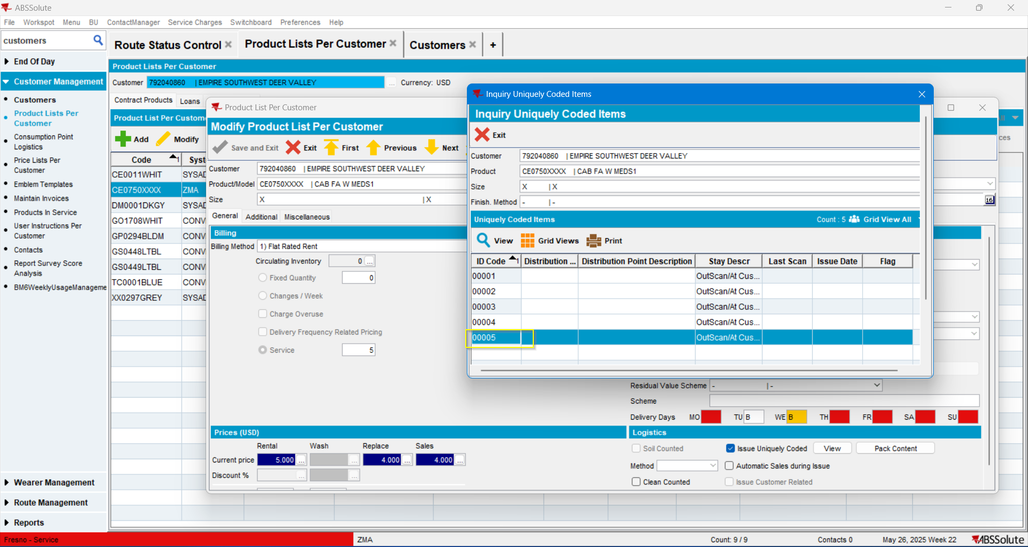
Primary ID ‘00005’
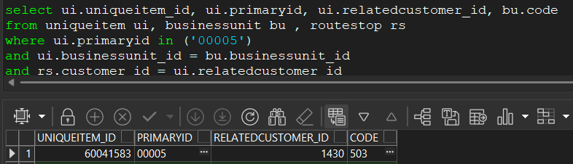
Primary ID from another product from BU=’473’.
update uniqueitem ui
set ui.primaryid=’55555555’
where ui.uniqueitem_id=60041583

Primary_ID of the product was changed:
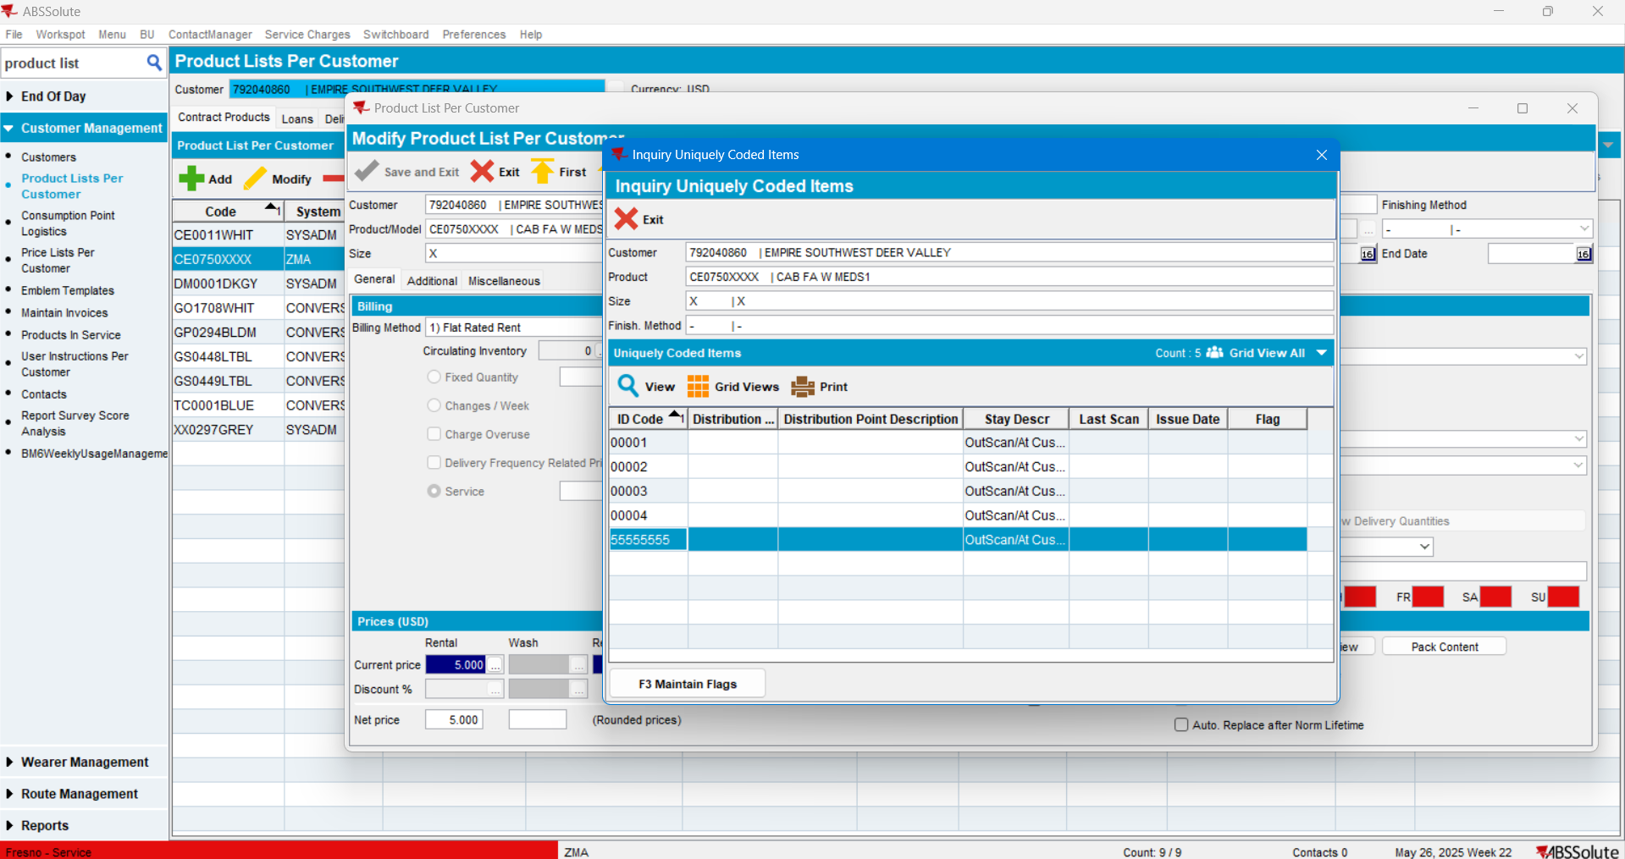

So now there are two UI items with the same Primary ID:
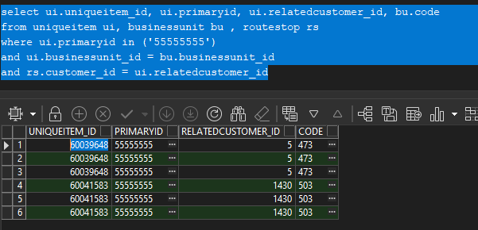

Create a new route for the customer and move the stops for the other customers:
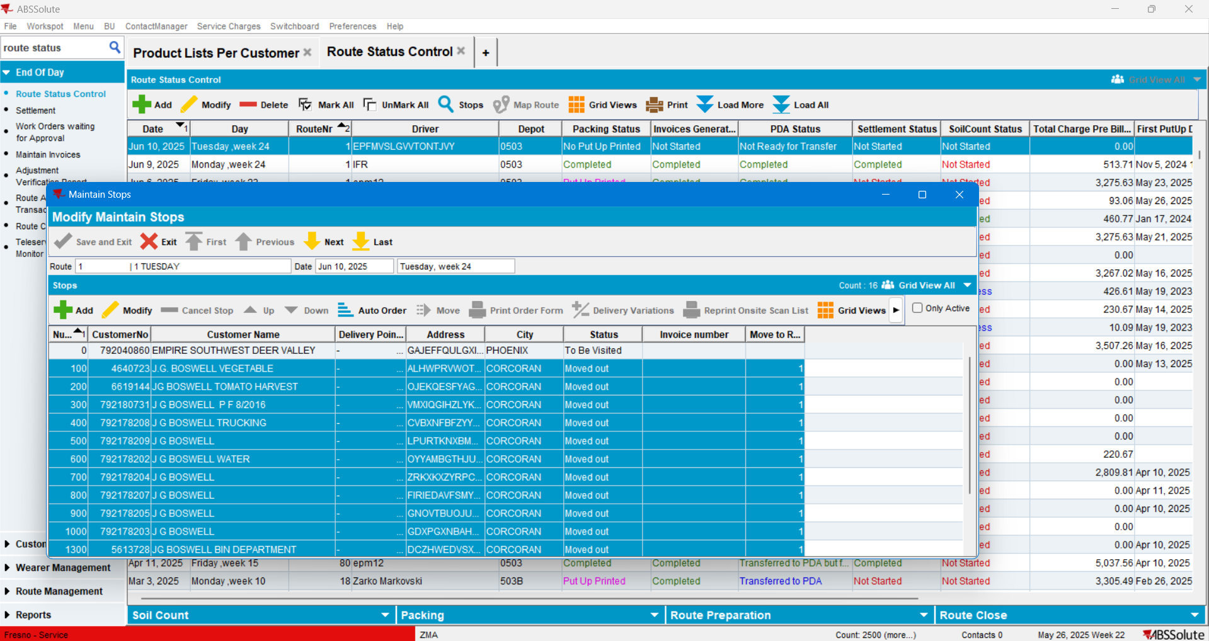
- Create PN:
- Generate Invoices:
-Mark ready for transfer PDA
-Set Driver:
-Move to PDA do the normal flow
- At the step of Service-ing the cabinets DELETE the first CABINET (the duplicated one):
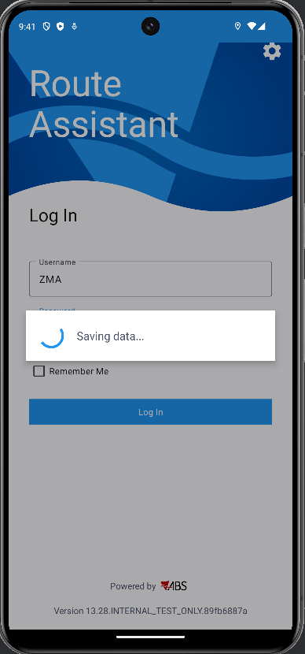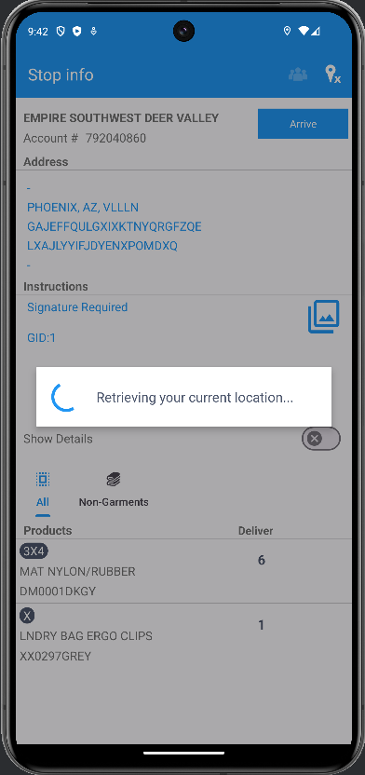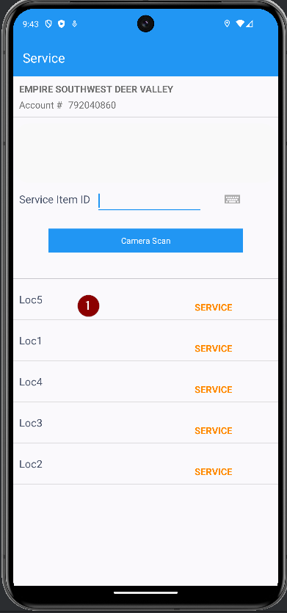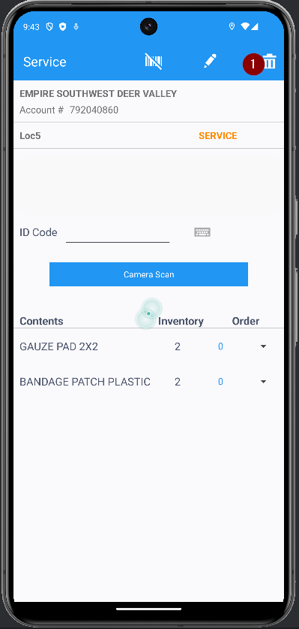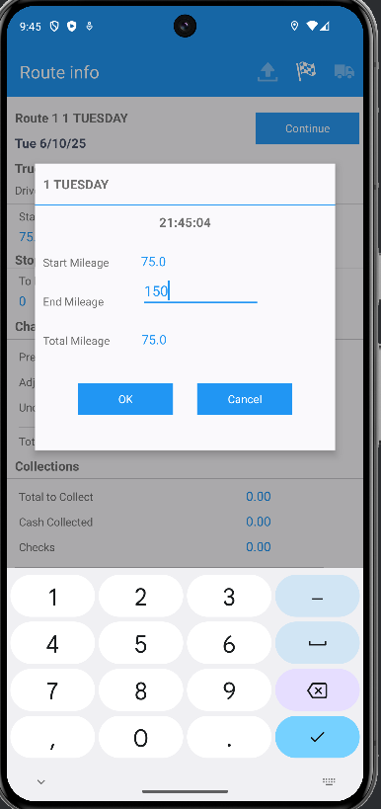

Settle the route from the swing client:
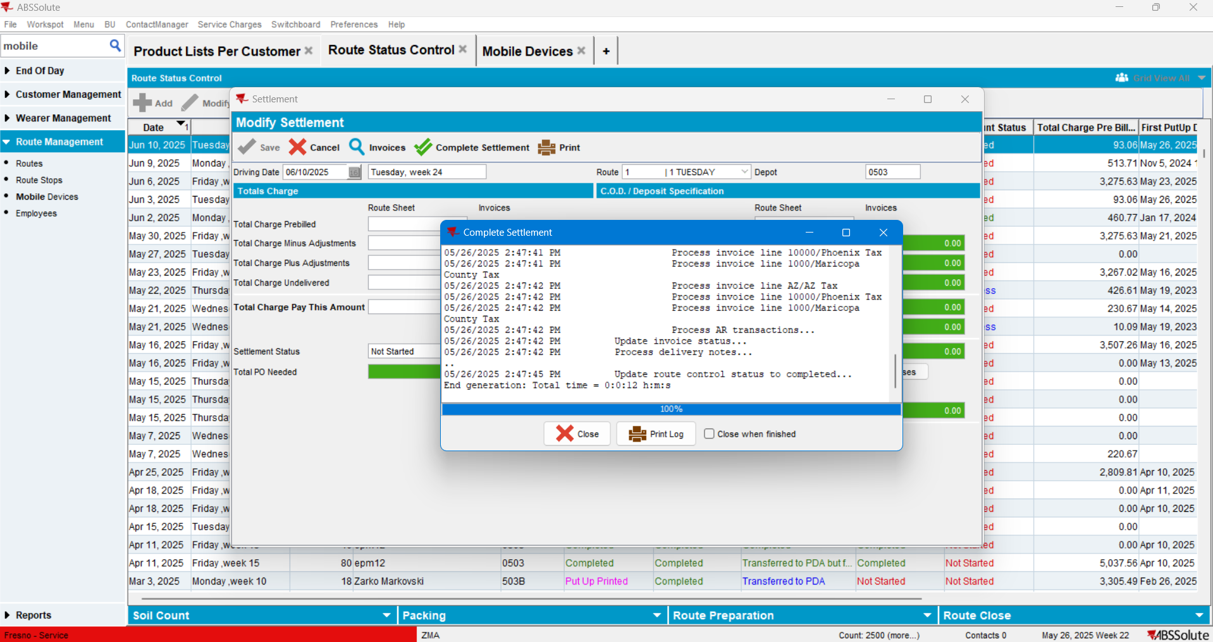
Check the PLPC of the Customer whose FA Cabinet was deleted:
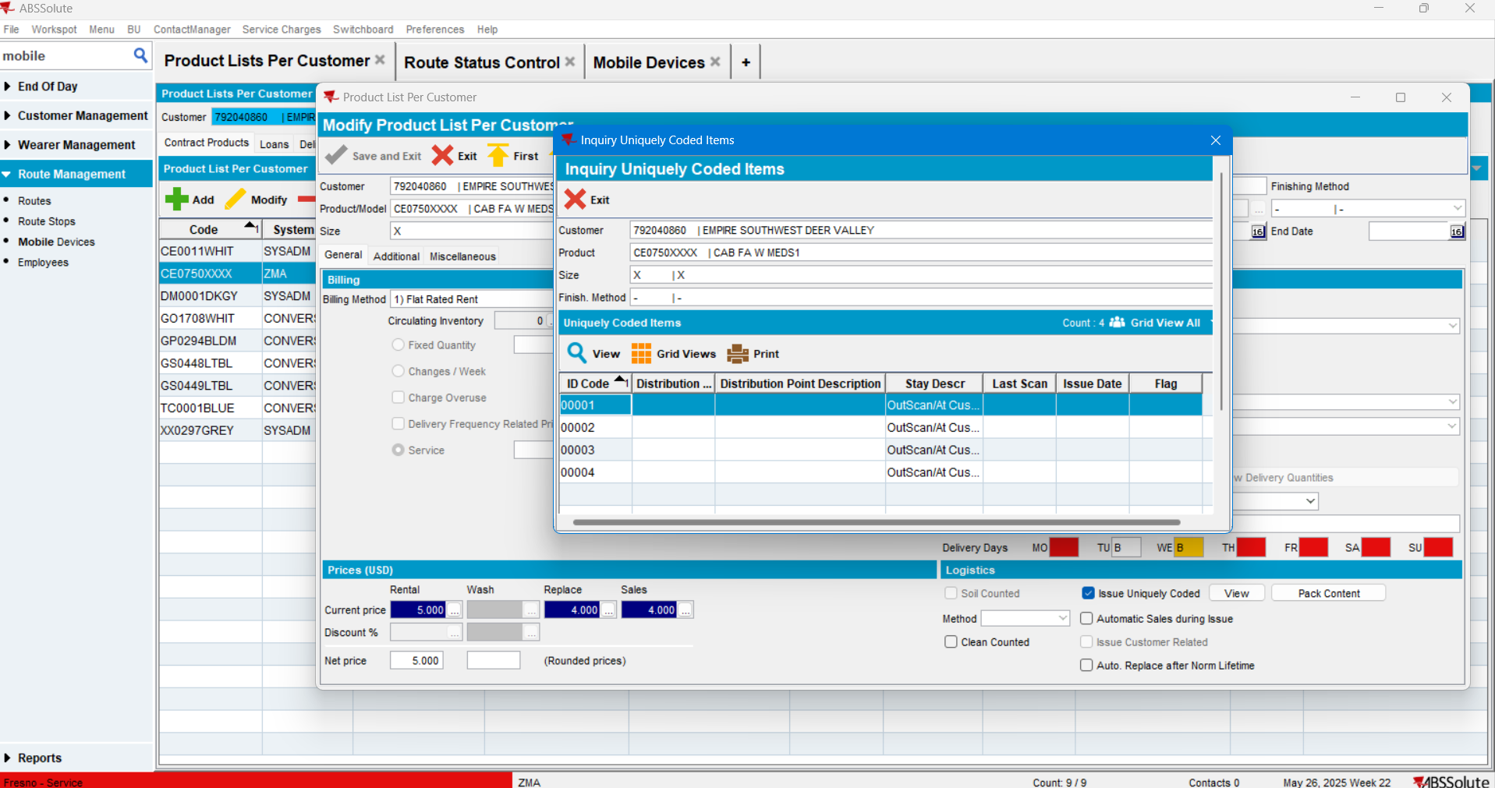
The cabinet was deleted.

Check the PLPC of the customer with the original Primary_ID:
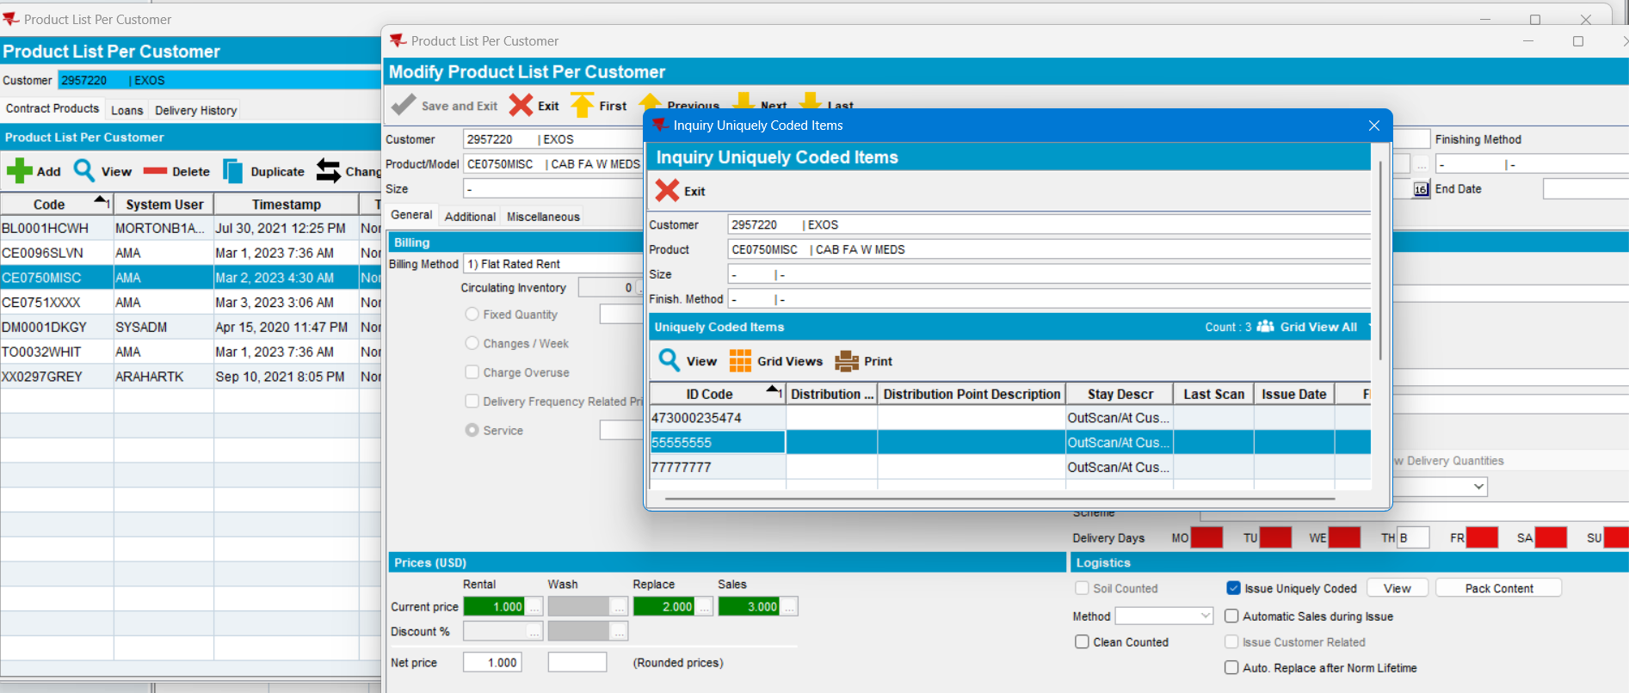

The FA cabinet wasn’t deleted.

TEST PASSED.

