ABSN-3108 Downgrade to 9.08.00.release.p19_AUS
Environment | Prerequisites
Version: 9.08.00.RELEASE.p18  DBServerName=abs-srv16.internal.abslbs.com  DBSID=CUST21  DBUser=AUS_ND90502  DBPassword= AUS_ND90502  Environment=Production  Hash: 8fb3f9b | - Module: AUSCUSTOM, BKLBASIS  - System setting: -  - Others: BU 506, 586,  - RA: 13.25

Contents
Retest after fix 1
1.1. Test when a customer is serviced by a plant that uses Central Stock functionality, and the stockroom is located in a different plant/BU – Test OK 2
1.2. Test in RA: Soin Scan, Scan Return, Quit Wearer and check Discrepancy in report – Test OK 10
1.3. Test report for Return to stock (Take Items Out Of Circulation) – Test OK 22

Retest after fix
- Have AUSCUSTOM in the license file
- Have BKLBASIS module in the license file
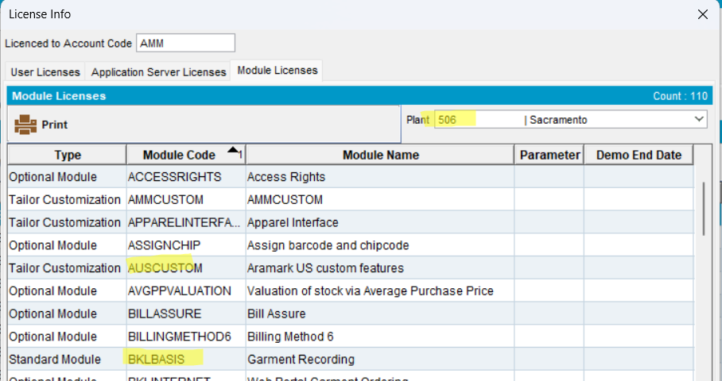
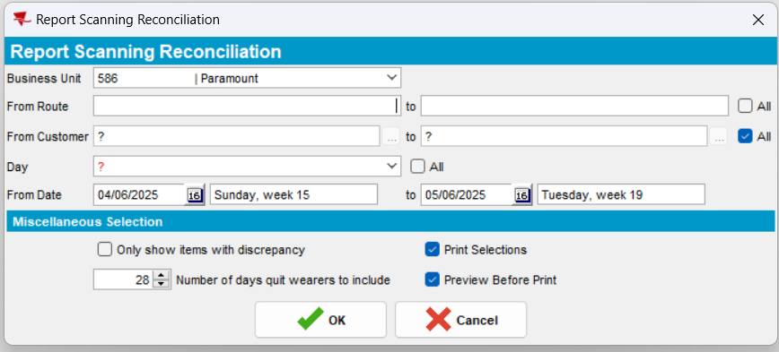

Test when a customer is serviced by a plant that uses Central Stock functionality, and the stockroom is located in a different plant/BU – Test OK
      - Select a customer from BU 586 (customer: 8564945). For this customer, in Wearers dlg, select a wearer
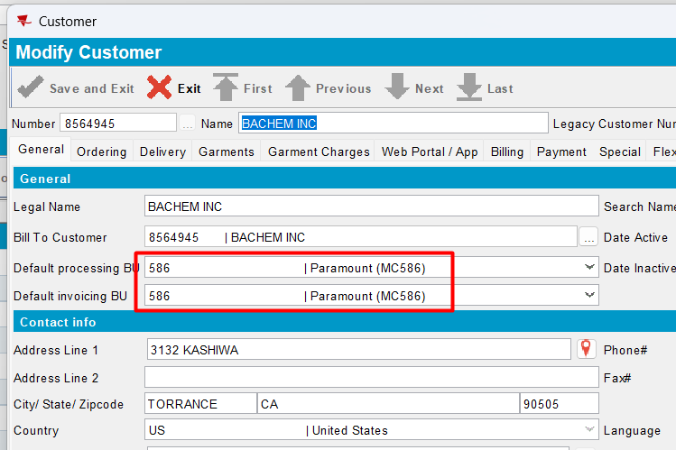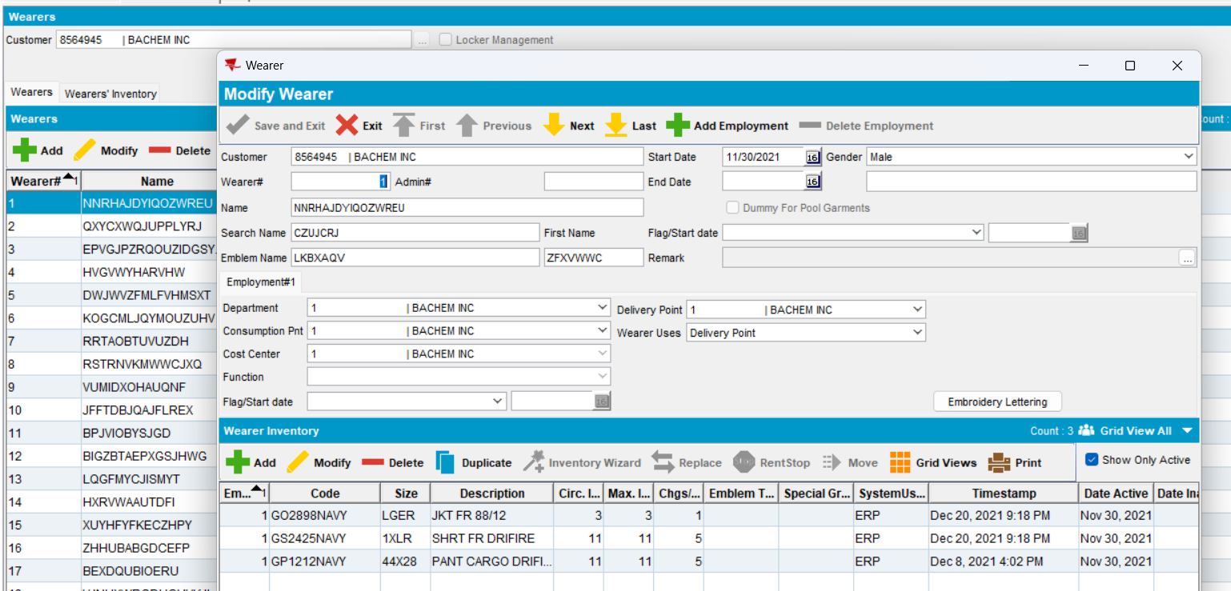
      - Go to Business Units dlg and check which business unit belongs to which plant
- BU 501 belongs to plant 501
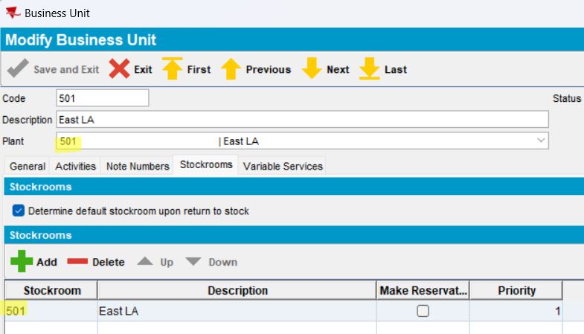
- BU 586 belongs to plant 586
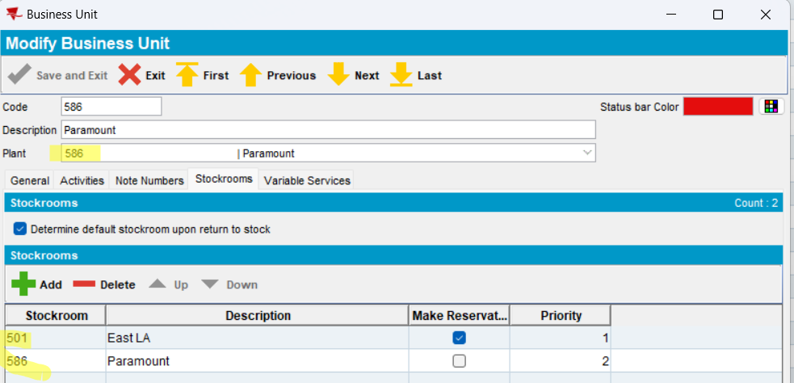
      - Go to Stockroom dlg, for BU 501, tab Services, select “Service also to other Business Units”. In tab Service to have BU 586 selected.
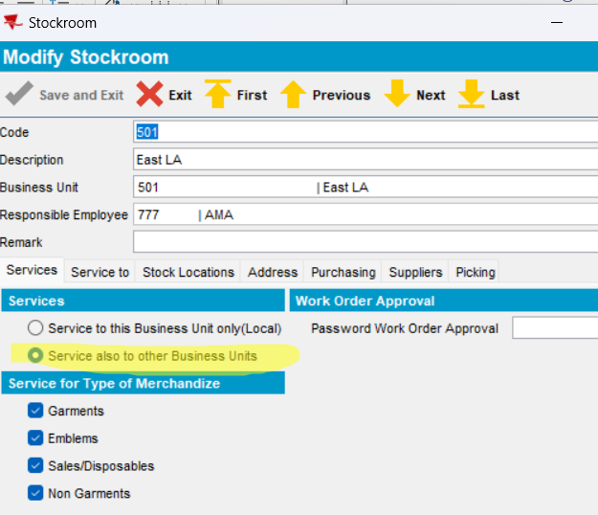
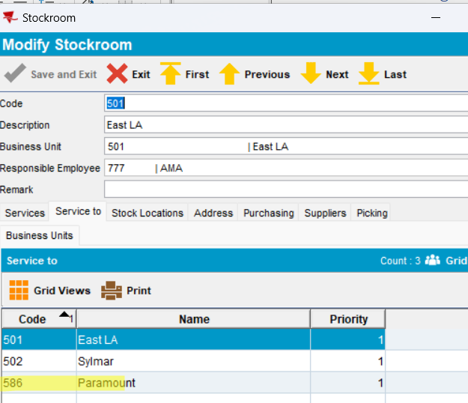
      - Go to Stockroom locations dlg, for BU 501 and select a preferred location
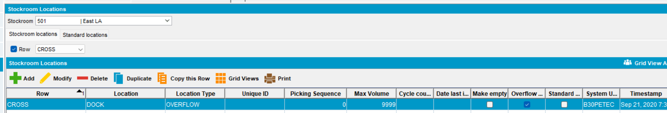
      - Go to BU 501 and for the selected customer (8564945), select some ID codes and Return to Stock
Wearer 1 -> column ‘Removed From Service’ will be filled
1966978358 | GP1212NAVY | PANT CARGO DRIFIRE | 44X28
1971813484 | GO2898NAVY | JKT FR 88/12 | LGER

Wearer 2 -> column ‘Removed From Service’ will be filled
1971833802 | GP1212NAVY | PANT CARGO DRIFIRE | 36X30
1971833819 | GS2425NAVY | SHRT FR DRIFIRE | LGER

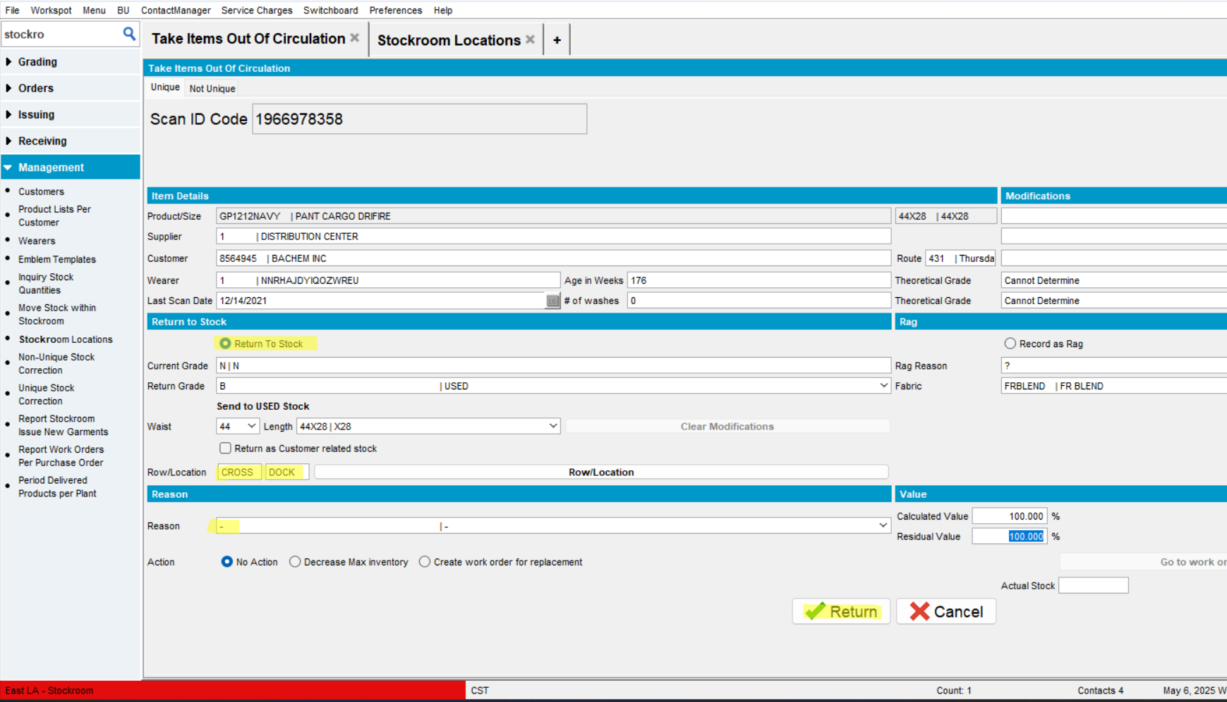
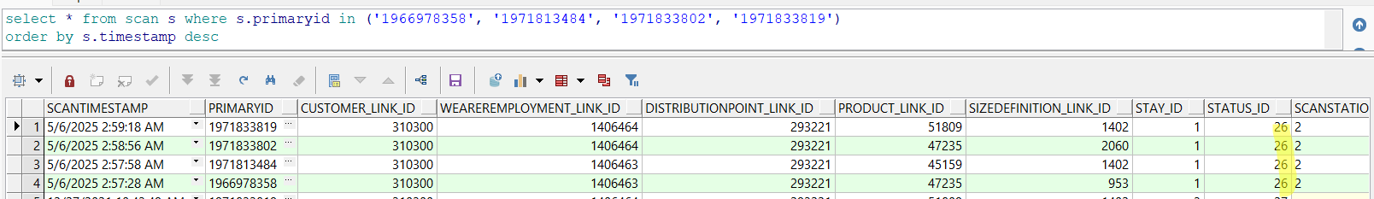
      - In Take out of circulation dlg, select the following id codes and rag them -> column ‘Removed From Service’ will be filled
Wearer 3
1966978464 | GP1212NAVY | PANT CARGO DRIFIRE | 34X30
1966978471 | GP1212NAVY | PANT CARGO DRIFIRE | 34X30
1966978488 | GP1212NAVY | PANT CARGO DRIFIRE | 34X30
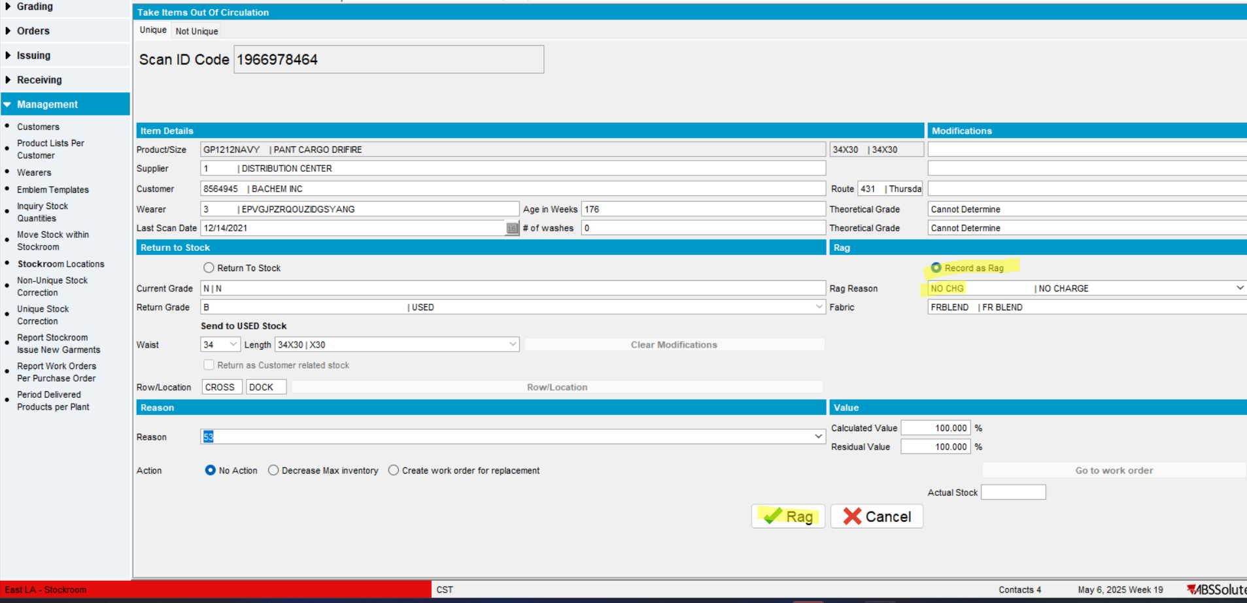
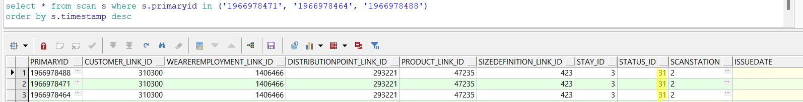
      - Check the ragged ID codes in Maintain Unique Items
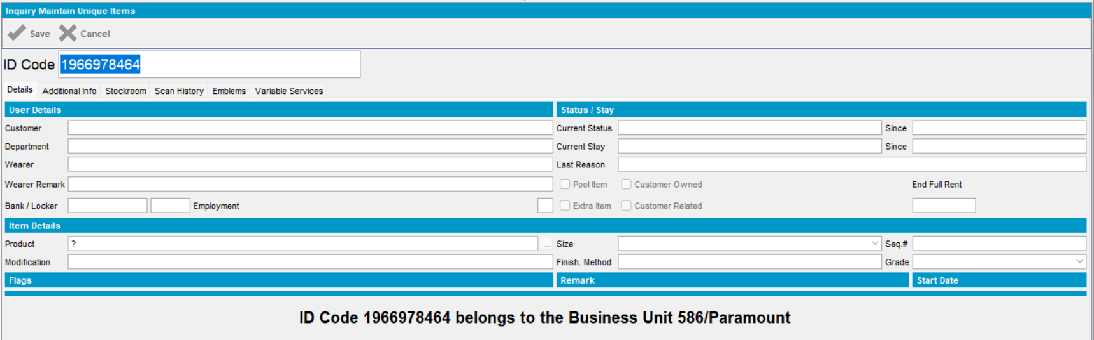
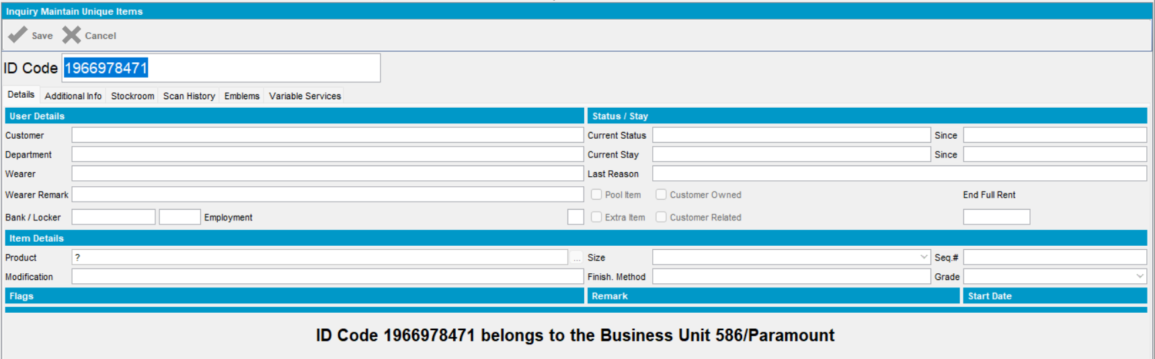
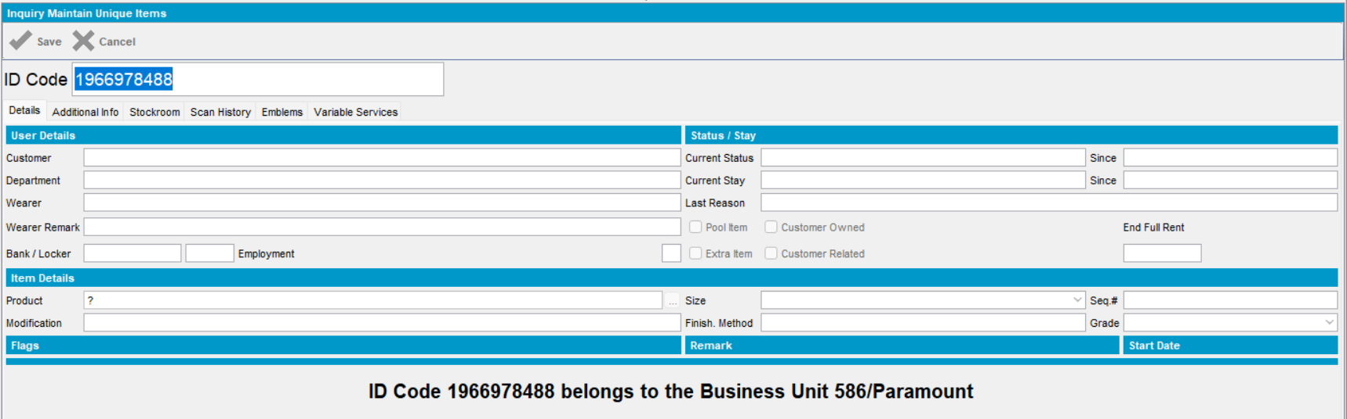
      - Check in db the scanned items
select s.transactiontype_id, s.* from scan s where s.customer_link_id= (select c.customer_id from customer c where c.customernumber=8564945) order by s.timestamp desc
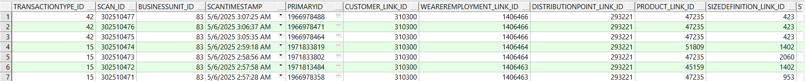
      - Generate Report Scanning Reconciliation for this customer, on scanning date (April 8th, 2025) on BU 501
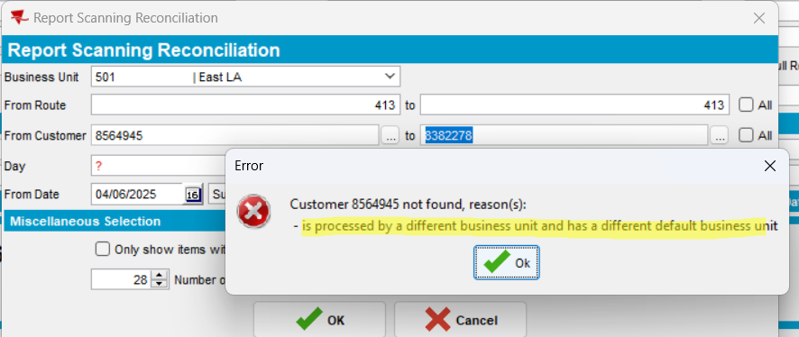
On BU 501, the report cannot be generated because the customer belongs to a different BU (586)
      - Generate Report Scanning Reconciliation for this customer(8564945), on scanning date (May 6th, 2025 – when scans are made) on BU 586
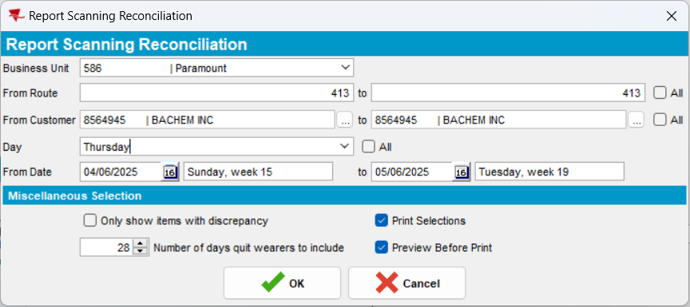
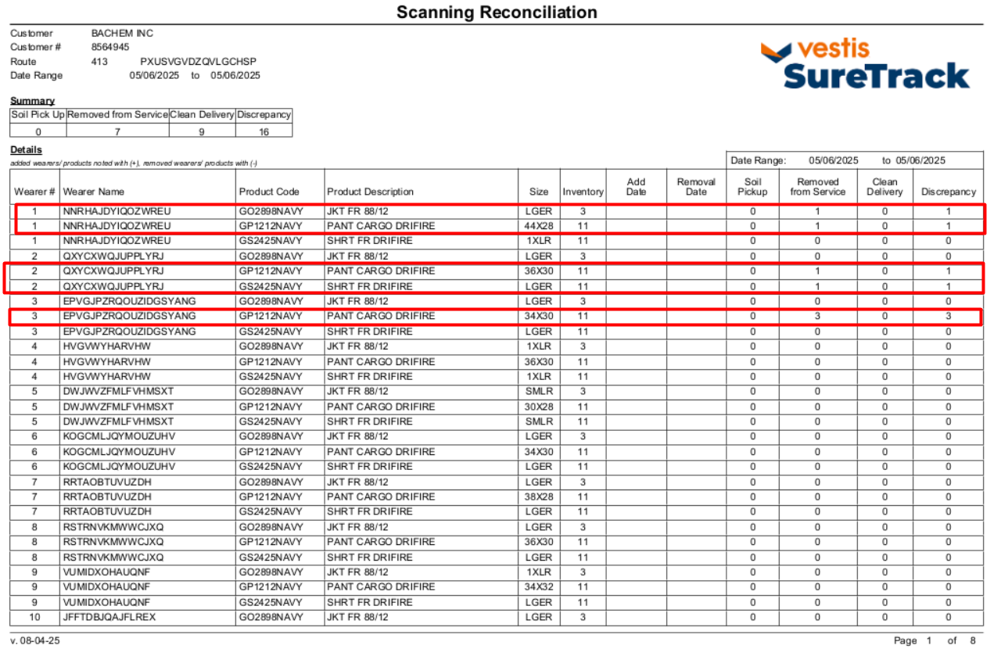
The scanned items are correctly showed on report.
- Because 2 wearers are added on this date, as shown below, added wearers/products: 2 and column ‘Clean Delivery’ is filled with correct quantities, due to ‘issue garment from stock’.
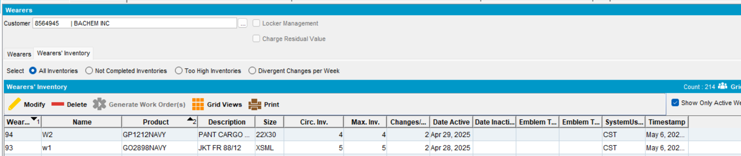
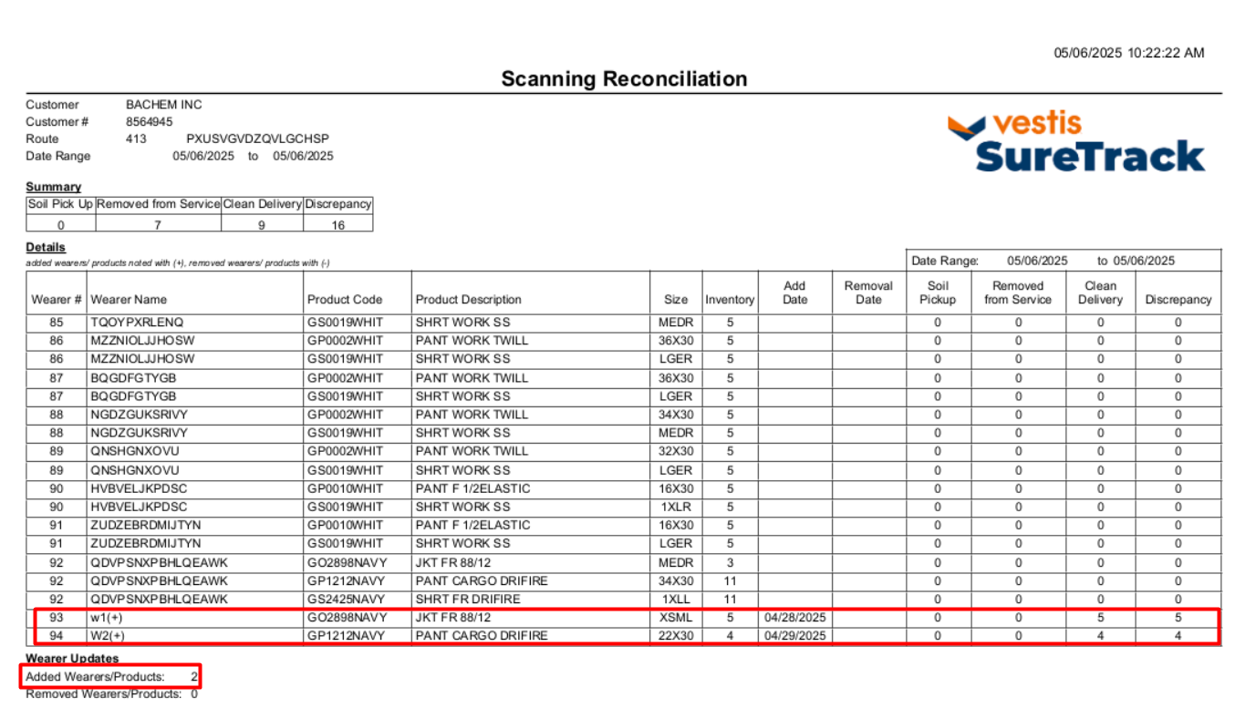
Tested OK

Test in RA: Soin Scan, Scan Return, Quit Wearer and check Discrepancy in report – Test OK
- In Customers dlg, check the checkbox “On Site Soil Scan”
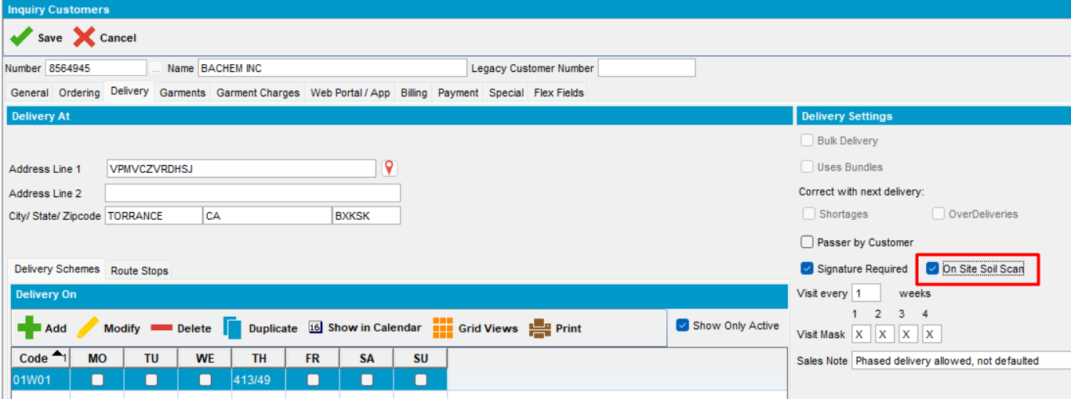
- In Wearers dlg, add some new wearers with wearer inventory and generate work order
- Approve work orders
- Issue garments from stock via work order
- For some wearers, return to stock some items
Issue date: May 6, 2025 -> column Clean Delivery will be filled
Returned To Stock date: May 6, 2025 -> column Removed From Service will be filled
At this moment, the report is:
- In Route Status Control, add a route control for the above customer – route control
- Generate Put Up Doc
- Generate Invoice
- Mark Ready For Transfer to PDA
- Download data to PDA and start the route
- Add product for one wearer and then quit another wearer
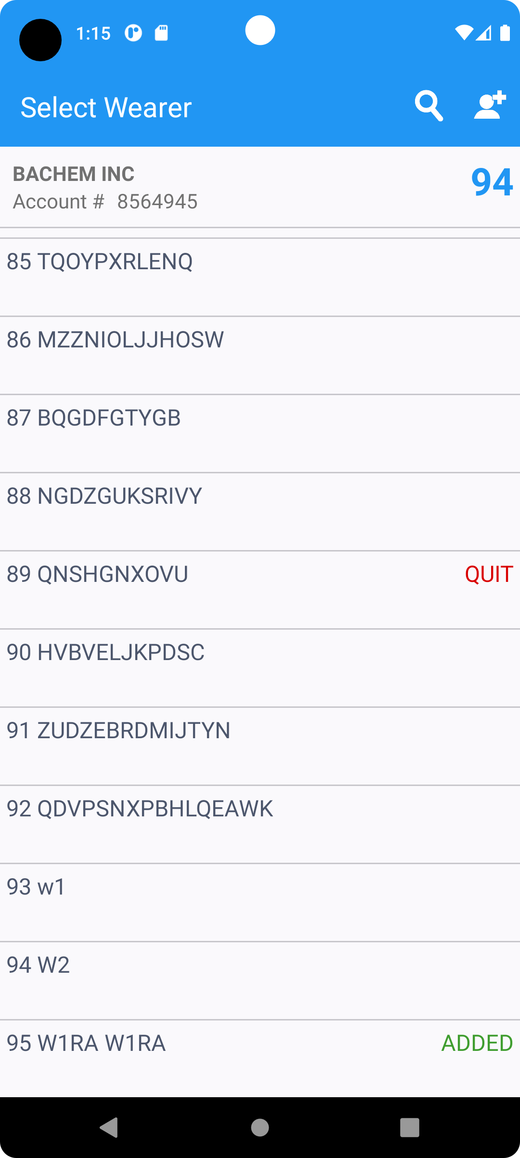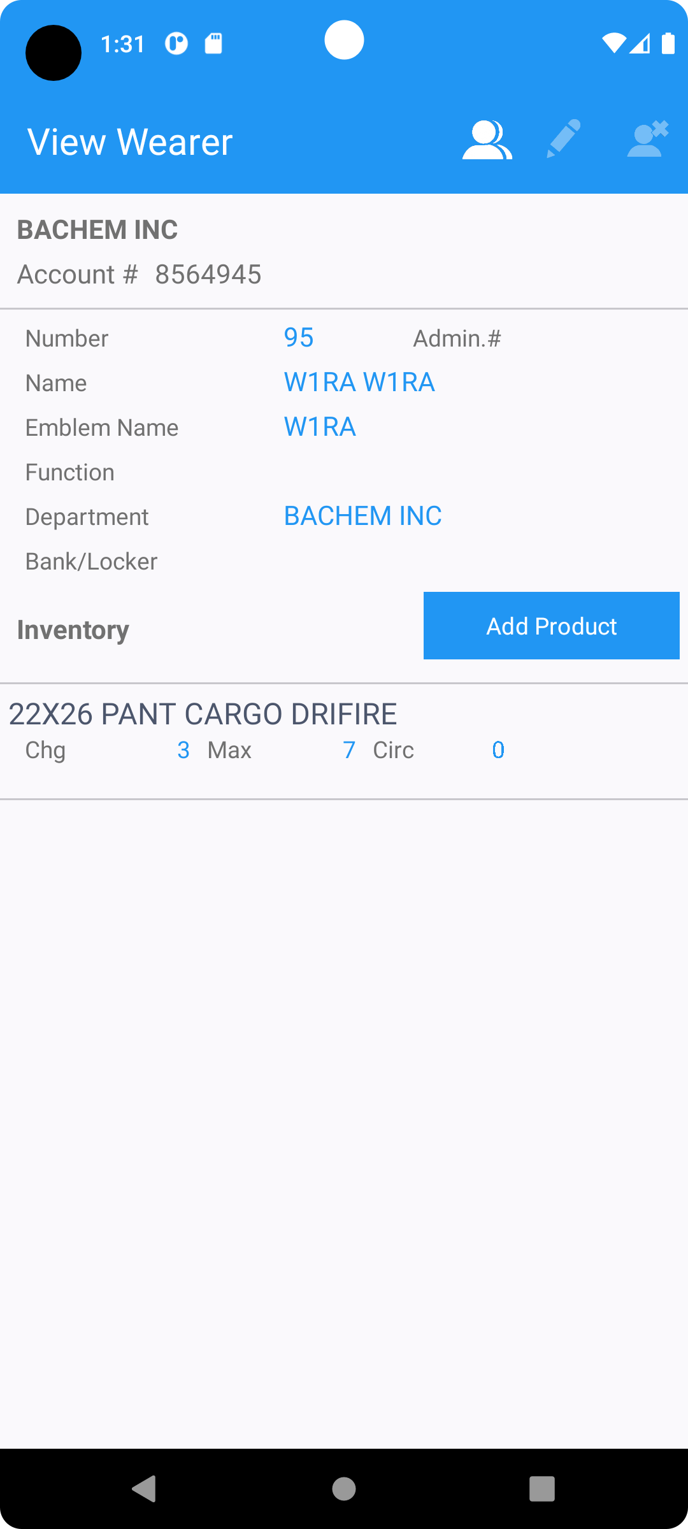
- Select Scan Garments and Soil Scan and scan id codes:
Wearer 1 -> 2 items for Soil Scan
1966978396 | GP1212NAVY | 44x28
1966978402 | GP1212NAVY | 44x28

Wearer 3 -> 5 items for Soil Scan
1966978518 | GP1212NAVY | 34X30
1966978525 | GP1212NAVY | 34X30
1966978532 | GP1212NAVY | 34X30
1966978549 | GP1212NAVY | 34X30
1966978556 | GP1212NAVY | 34X30
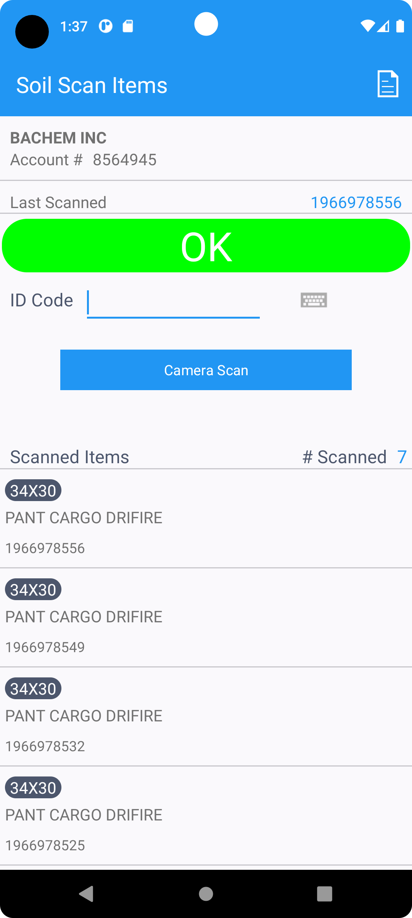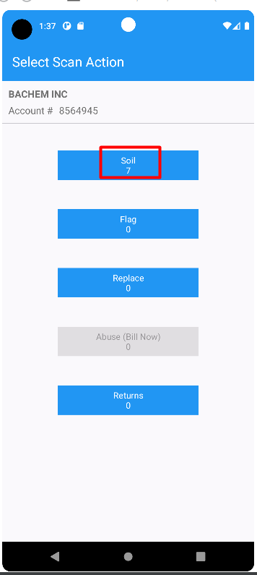
- Quit wearer W3
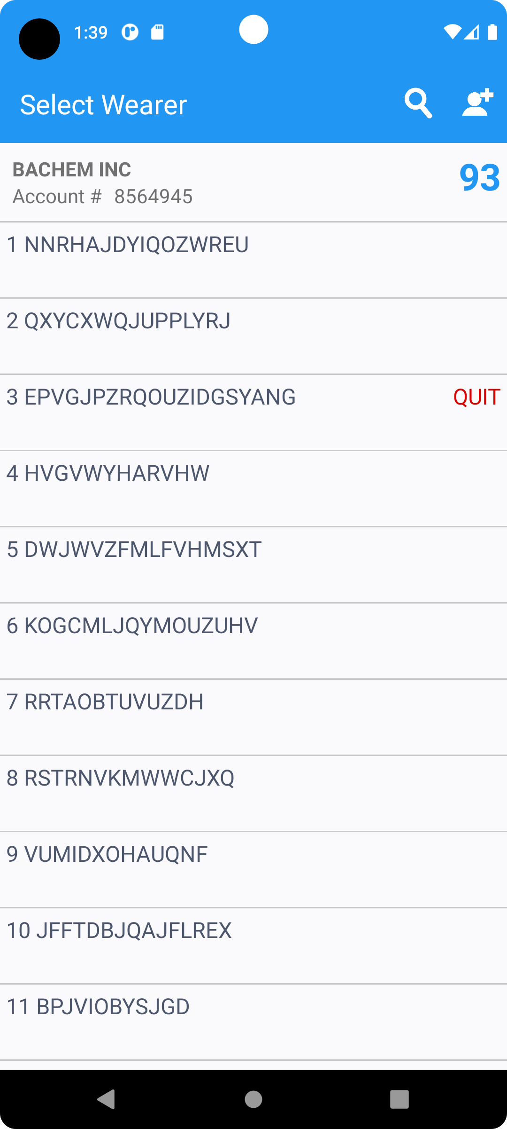
- For wearer 3, in Scan return, scan the following 5 id codes
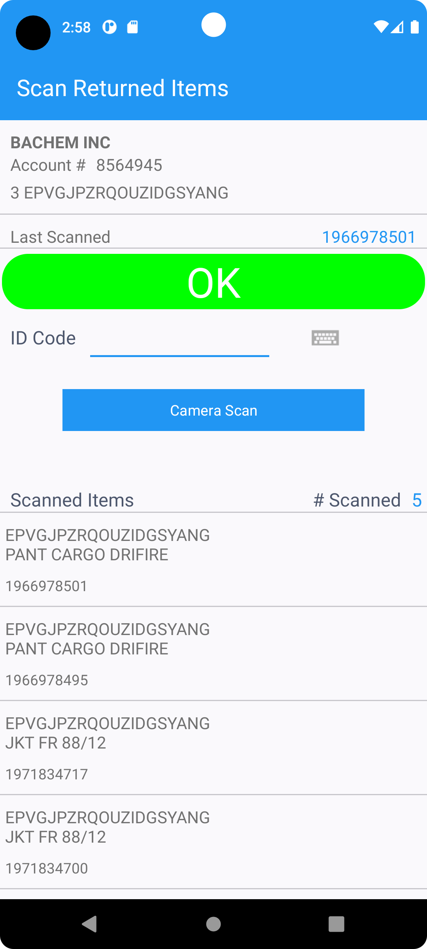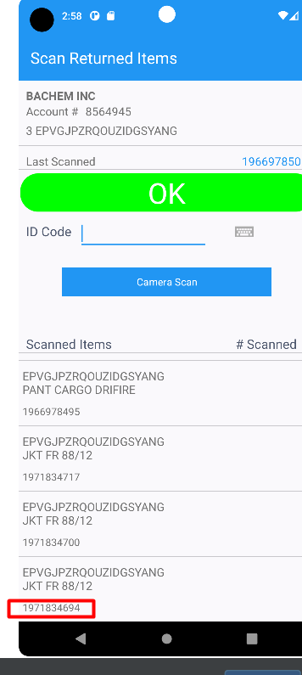
- Settle
- Depart
- Upload data
- Settle the route control
- In Outscan dlg, outscan the idcodes that were soil scanned in RA. For wearer 3, outscan is not possible because the wearer is quit.
Wearer 1 id codes
1966978396 | GP1212NAVY | 44x28
1966978402 | GP1212NAVY | 44x28
- Check the wearers that were quit in RA
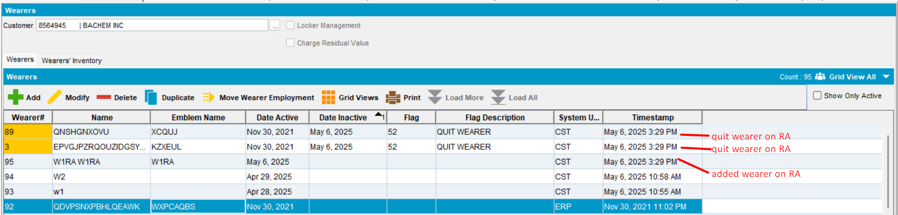
- Check the report before settlement
- Check the report after settlement
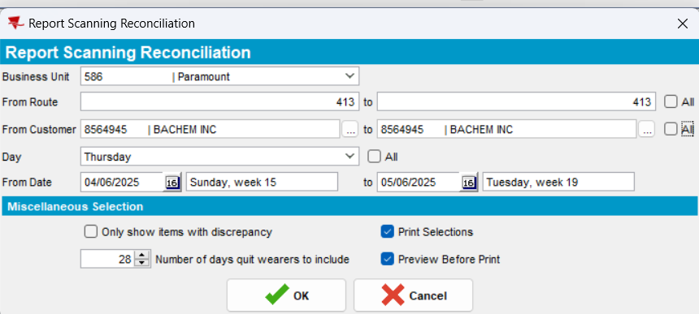
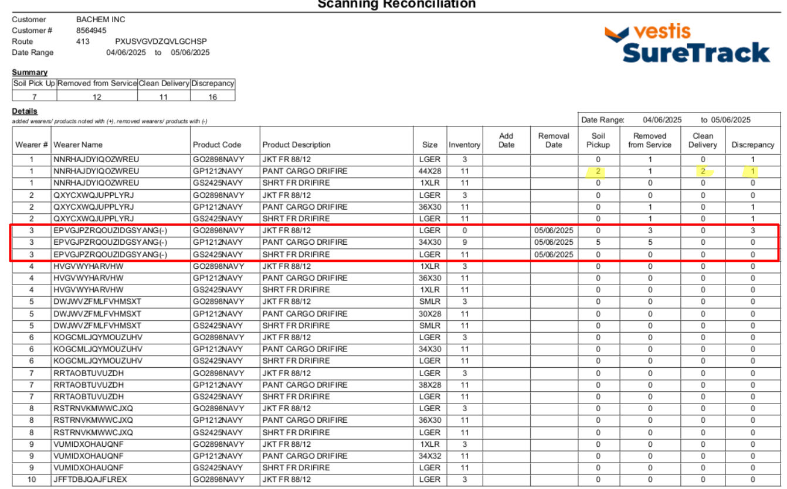
- Wearer 1 -> 2 items scanned for Soil Scan in RA -> column Soil Pickup: 2
- Wearer 3 -> 5 items scanned for Soil Scan in RA -> column Soil Pickup: 5 (product GP1212NAVY 34X30)
- Wearer 3 is quit on RA -> removal date is filled 05/06/2025, then 5 id codes are scanned in Scan Return -> column “Removed from Service”: 5
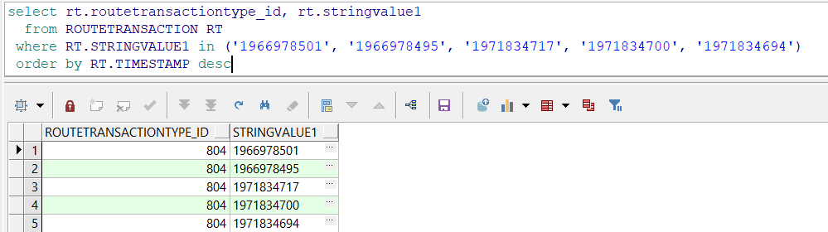
- Discrepancy is adjusted according to the formula: 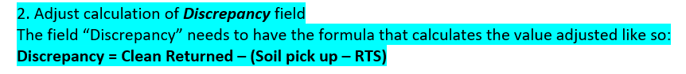
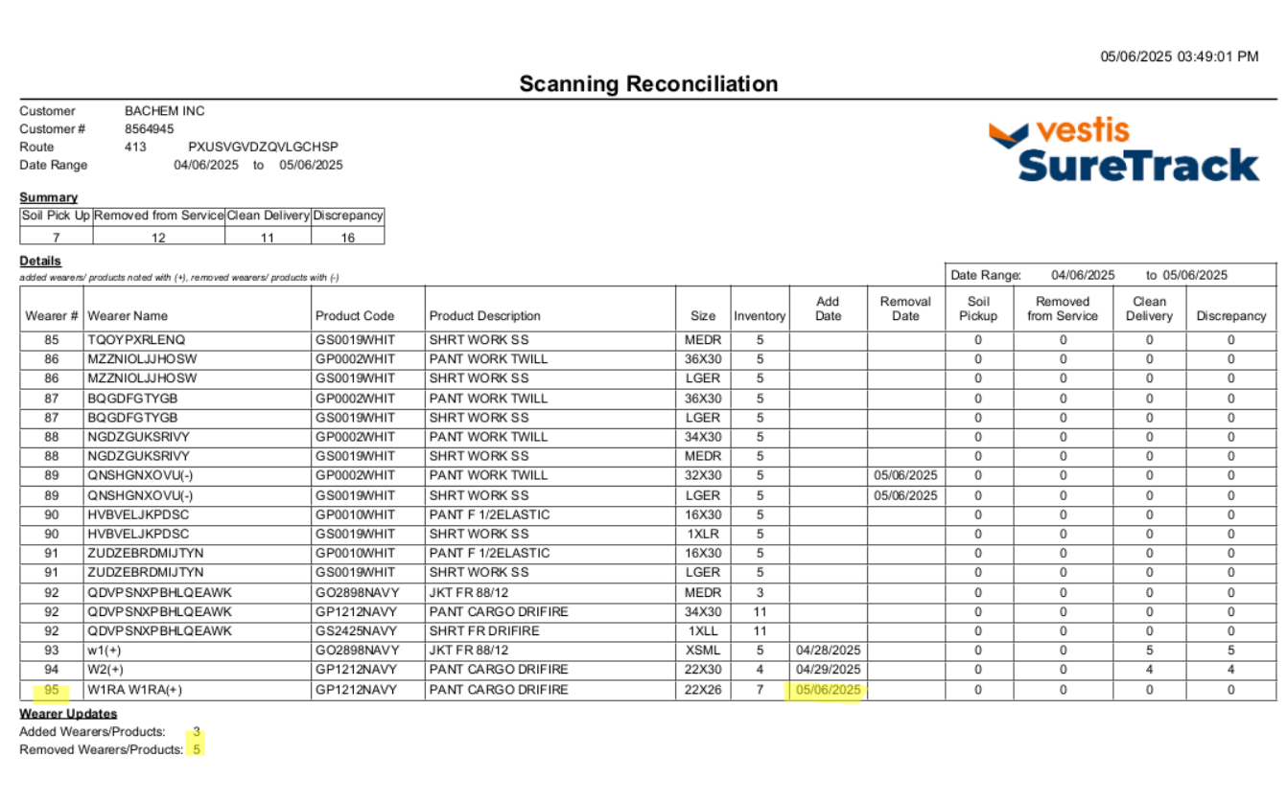
- Wearer 89 is quit -> removal date is filled 05/06/2025
- Wearer 95 is added on RA -> Add date is filled 05/06/2025
- Wearer 93 and wearer 94 are added earlier in time -> Add date is filled according to Wearers dlg
- Finally ‘Added Wearers/Products’, ‘Removed Wearers/Products’ fields are updated
- Summary table is updated

- In Wearers dlg, end date some wearers and verify when option “quit wearers to include=3”
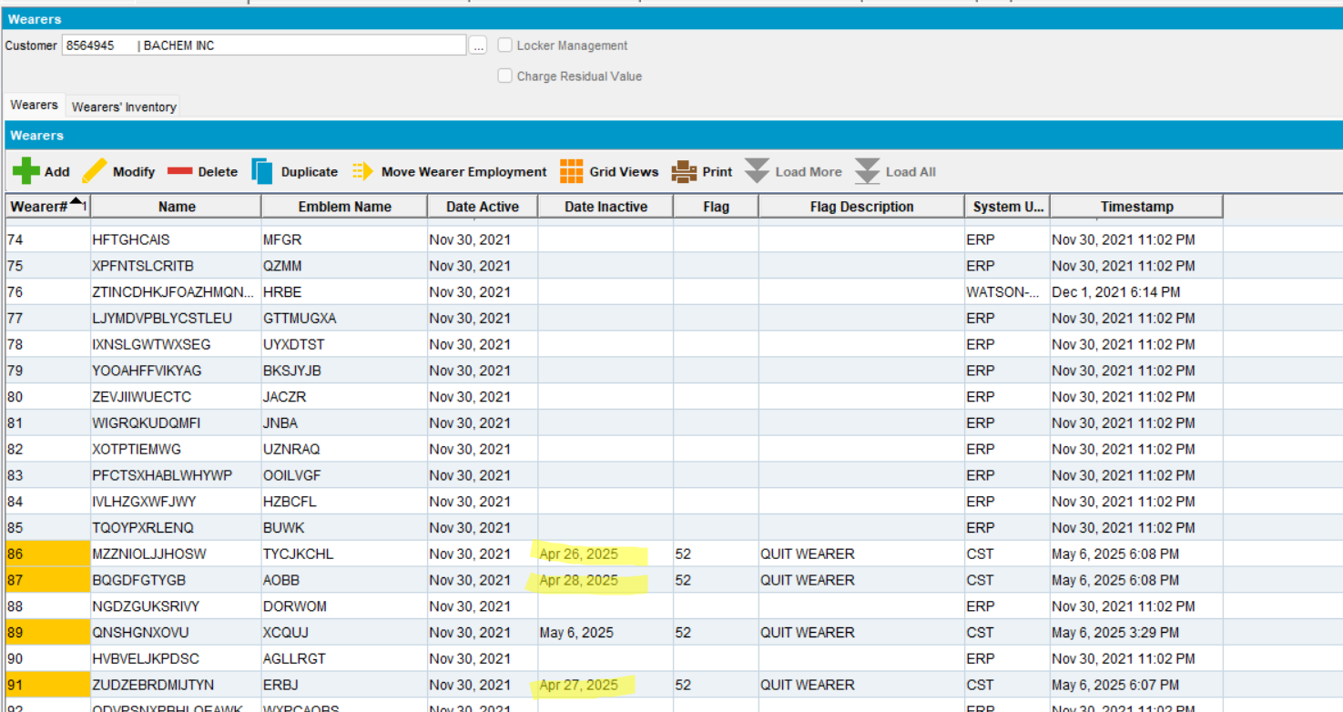
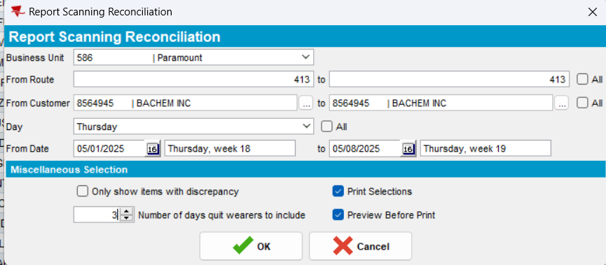
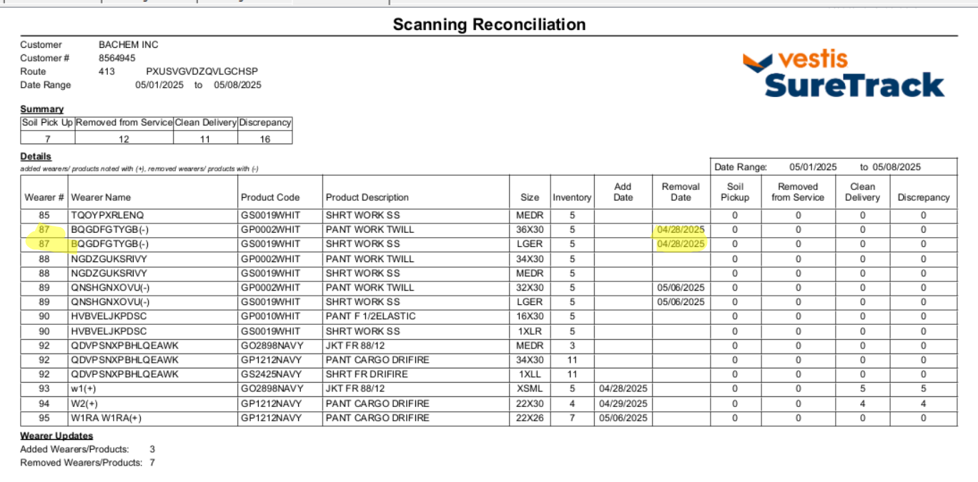
The report is correct, showing the removed wearers during the 3 days before “From date”.
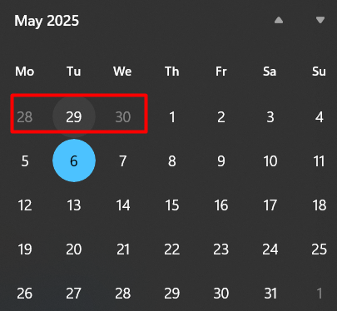
- Verify the report on route control date(may 8, 2025). On may 6, 2025 the route was sent to RA
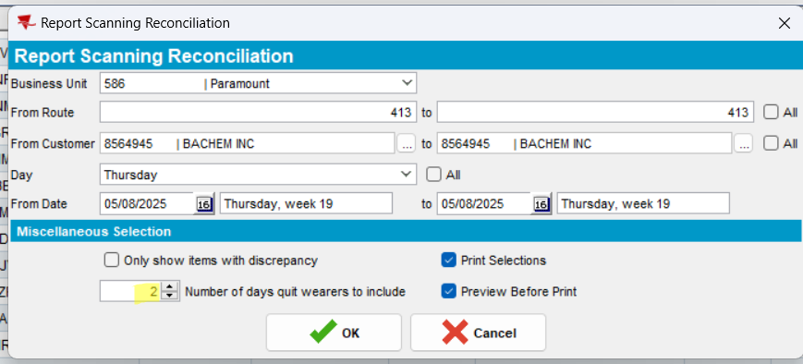
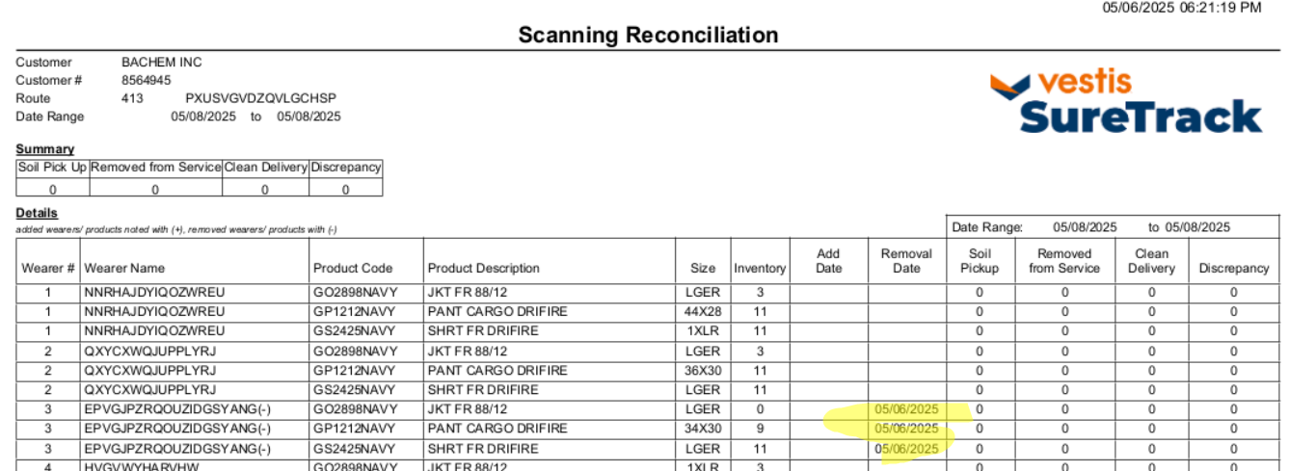
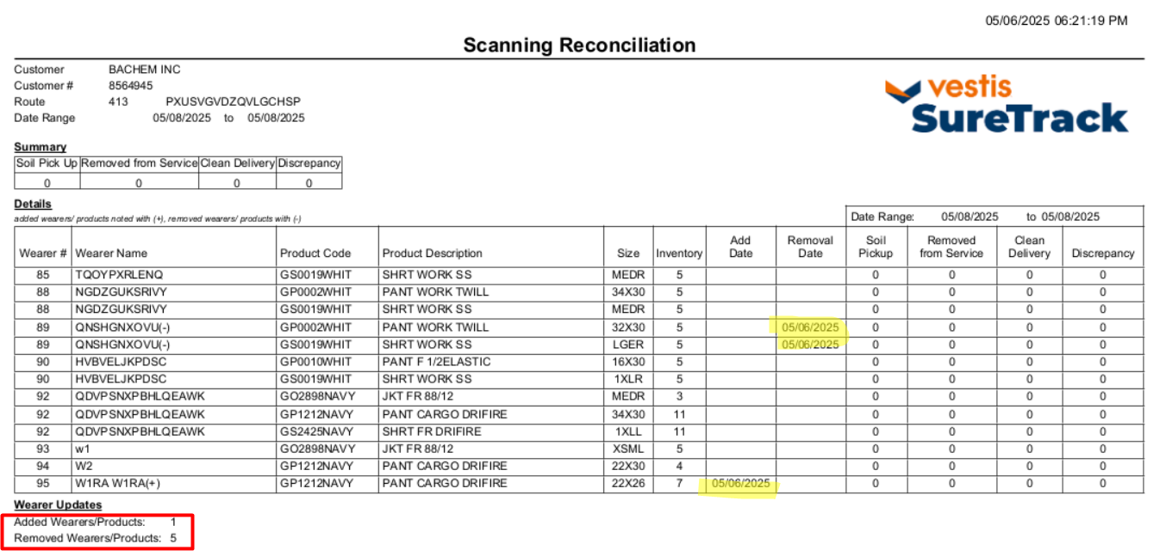
Tested OK

- For wearer 3, where the following id codes were scanned return in RA, scan as rag 2 of them.
- Id codes scanned as return on may 6, 2025
1966978501
1966978495
1971834717
1971834700
1971834694
- Id codes scanned as rag in client on may 7, 2025
1966978501
1966978495
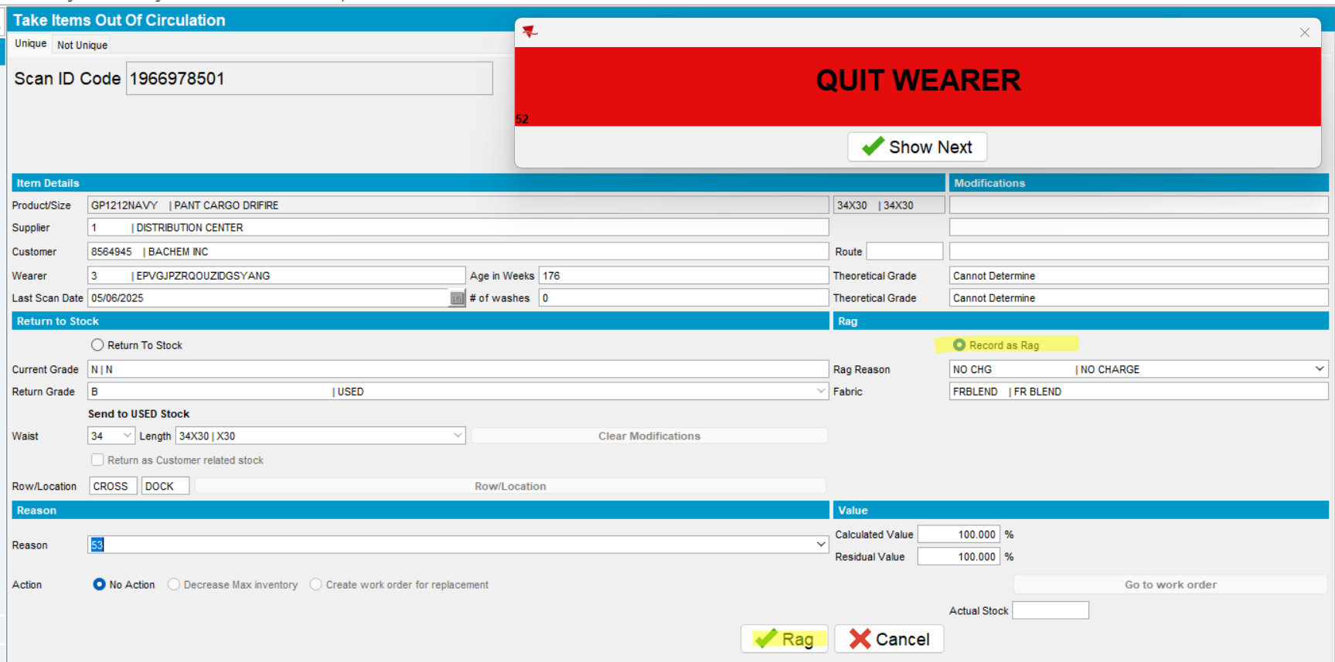
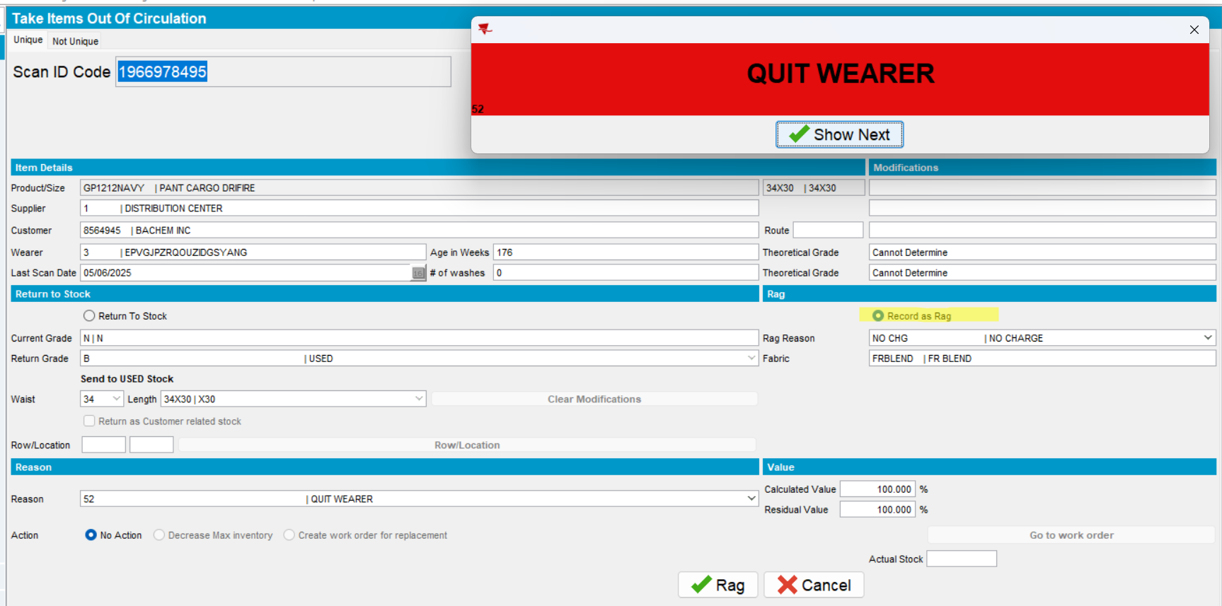
Print the report
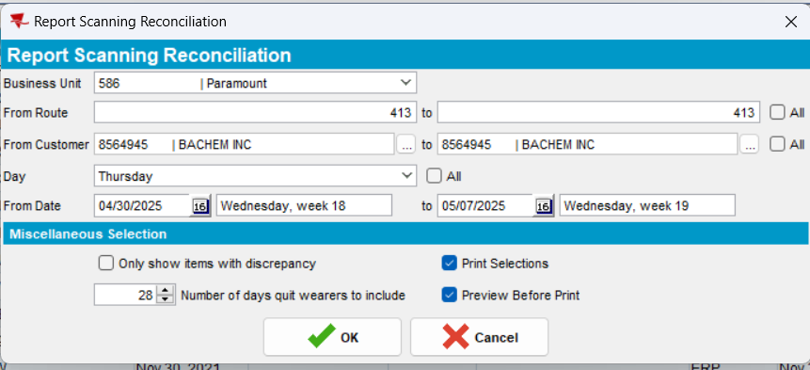
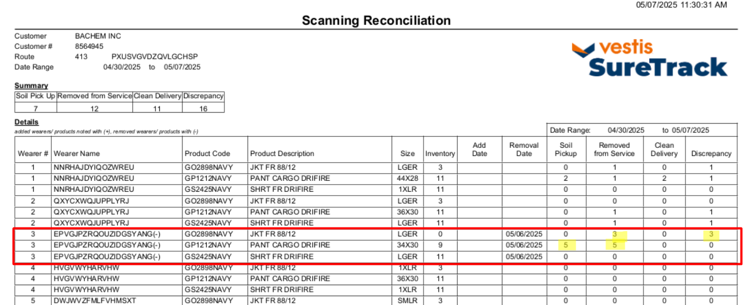
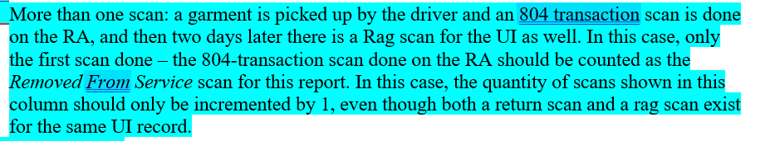
Test ok.

Test report for Return to stock (Take Items Out Of Circulation) – Test OK
- Go to Wearers dlg, select a wearer, modify it and see the ID codes from Wearer Inventory
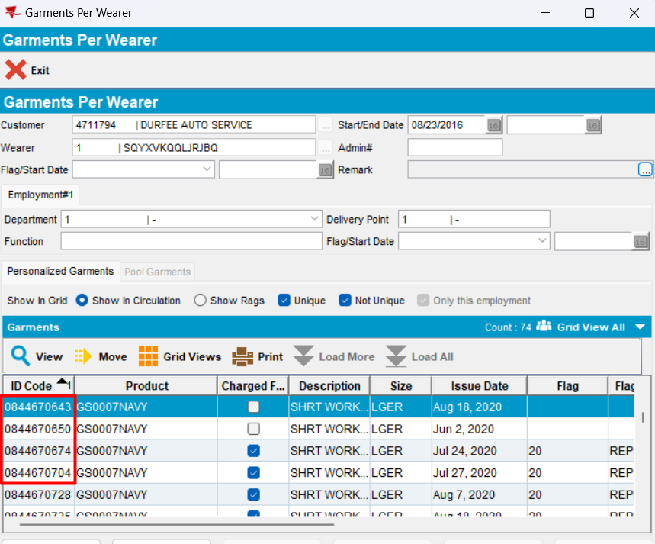
- In Take Items Out Of Circulation, scan the above ID codes to return to stock (Apr. 4, 2025)
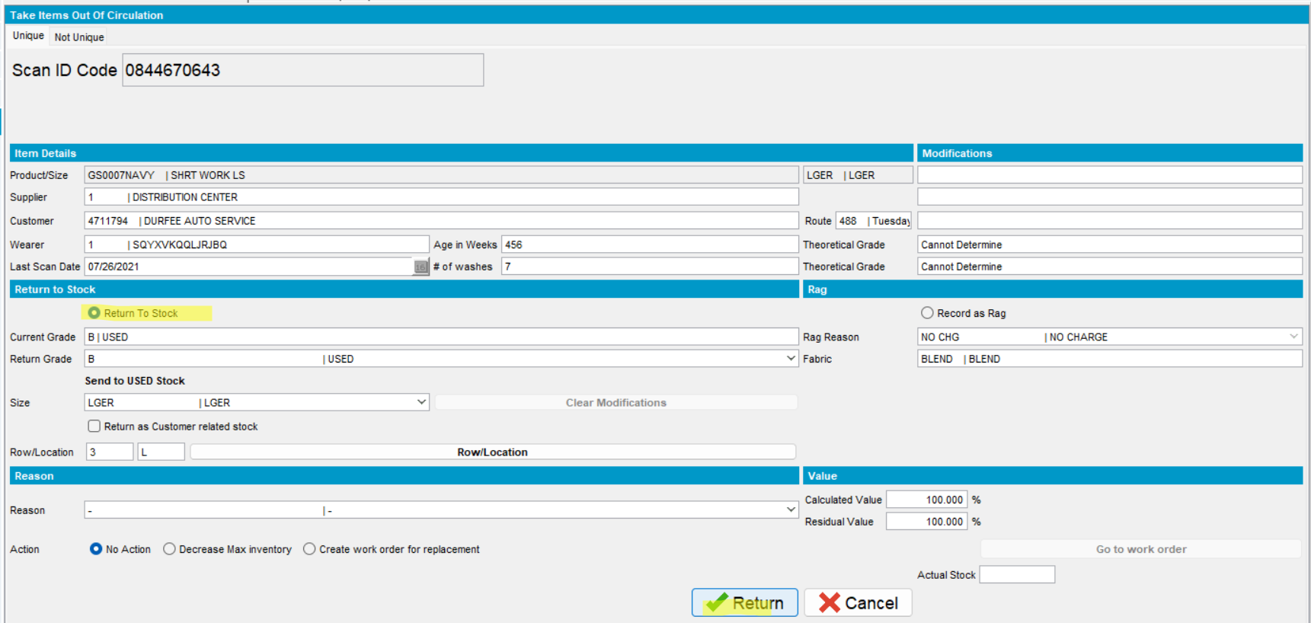
- Check the database
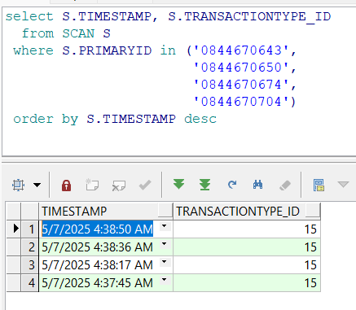
- See the Report Scanning Reconciliation for date when Id Codes were Returned To Stock
Returned To Stock date: may, 7, 2025 -> column Removed From Service will be filled
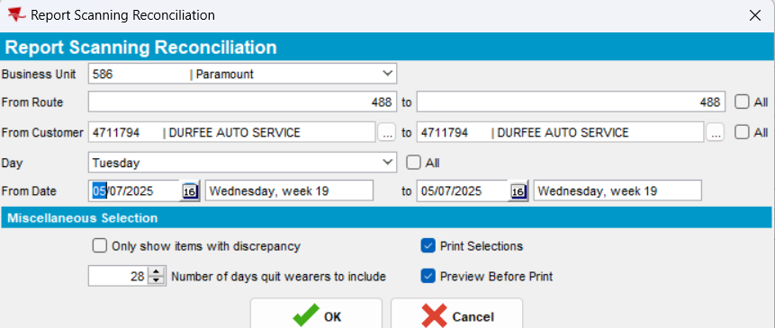
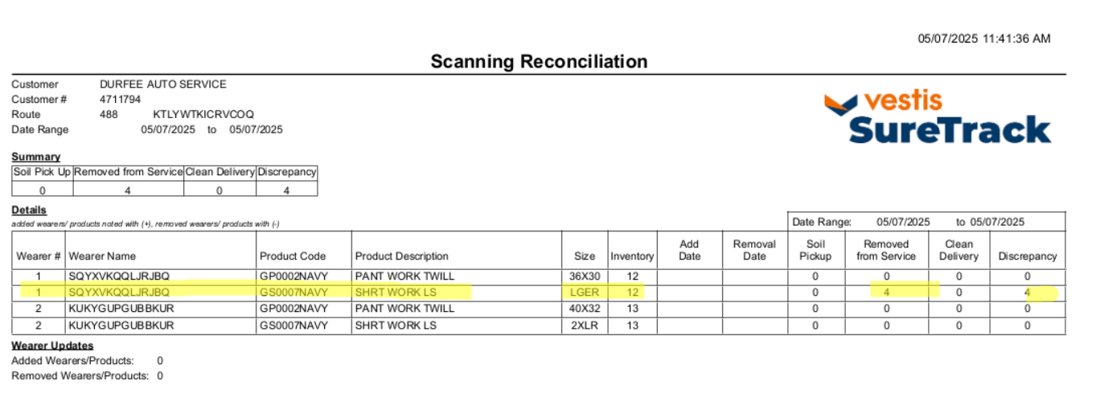
Expected behavior:
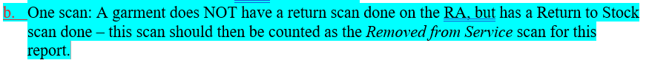
Actual behavior: as expected.
Tested OK

Test load
- One route, all customers, one week – took 3 minutes
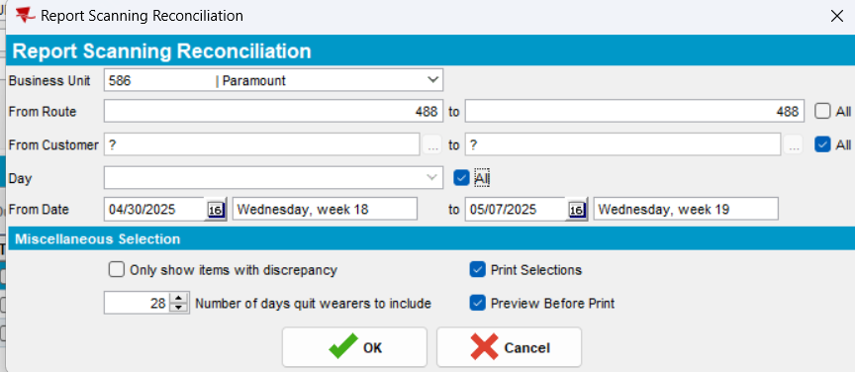
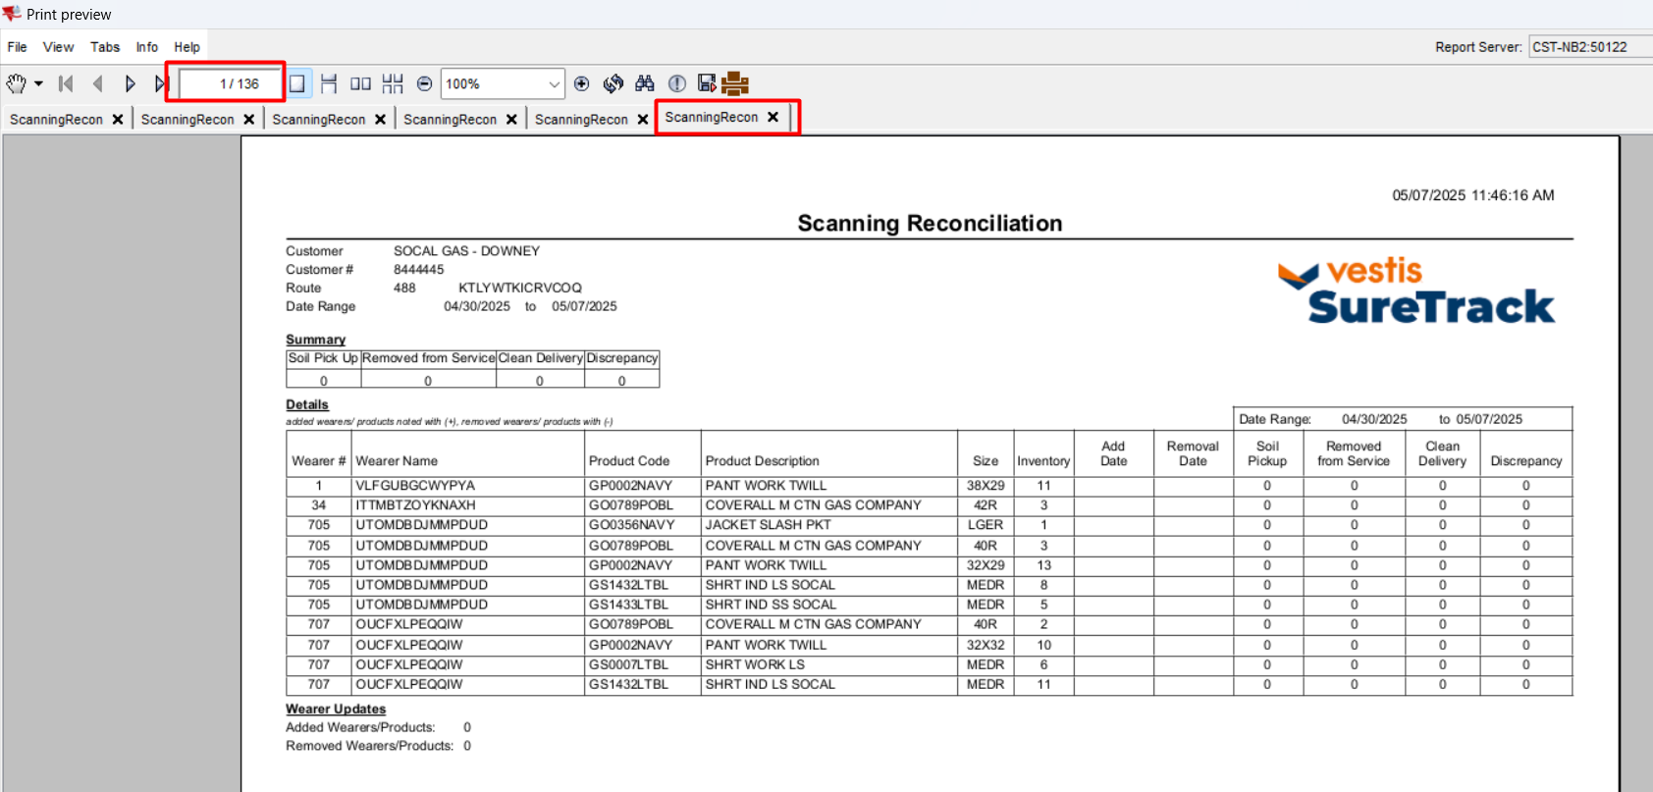

- One route, all customers, one month – took 3 minutes
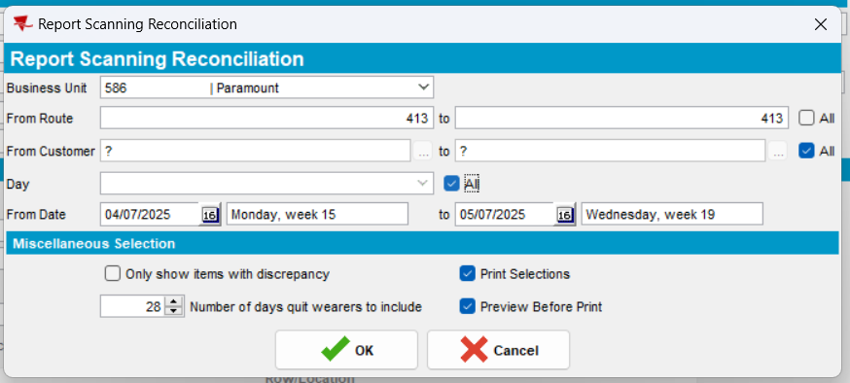
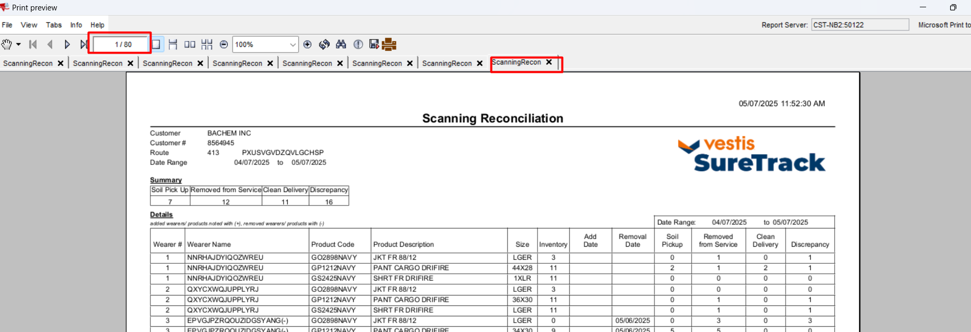

- All routes, all customers, one week – took 3 minutes
