ABSN-2640 Report Scans per Wearer issue - time out - Downgrade to 9.08.00.release.p19_AUS

Environment | Prerequisites
Version: 9.08.00.RELEASE.p18  DBServerName=abs-srv16.internal.abslbs.com  DBSID=CUST21  DBUser=AUS_ND90502  DBPassword= AUS_ND90502  Environment=Production | - Module: -  - System setting: -  - Others: BU 506

Contents
Retest after fix 1

Retest after fix
BU: 506 Sacramento
Hash: 3bab511
- Selection criteria for one customer for one week
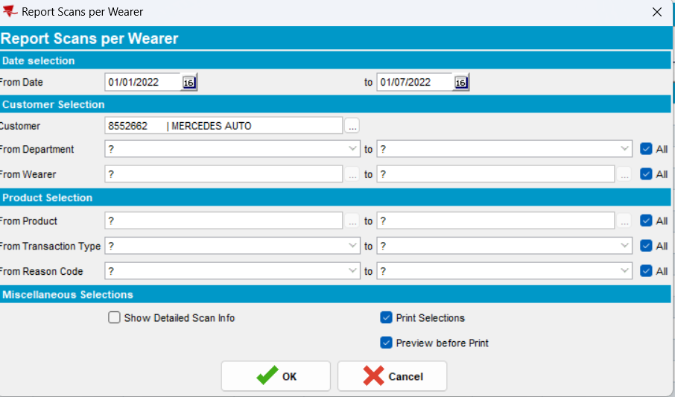
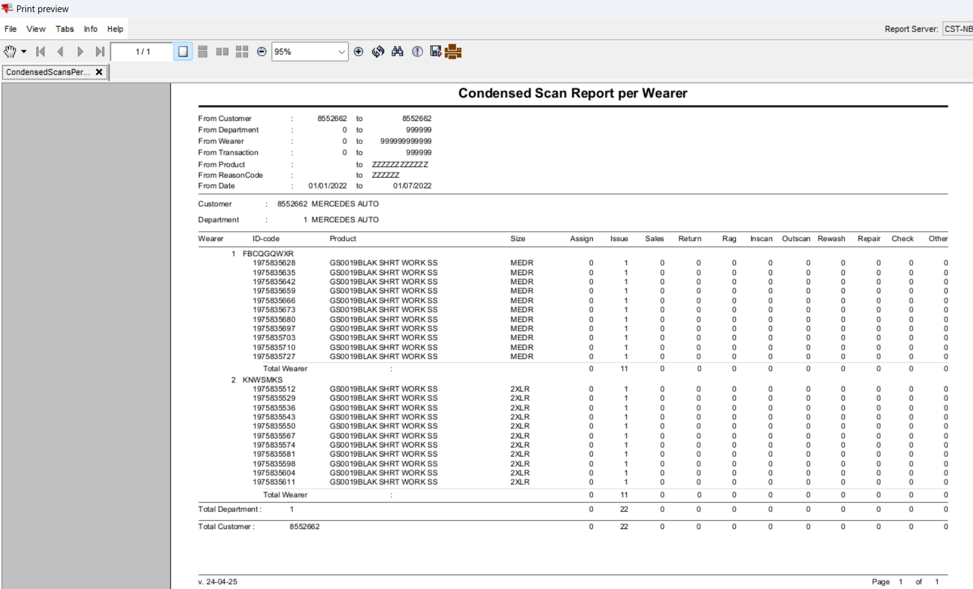
Try a different date interval:
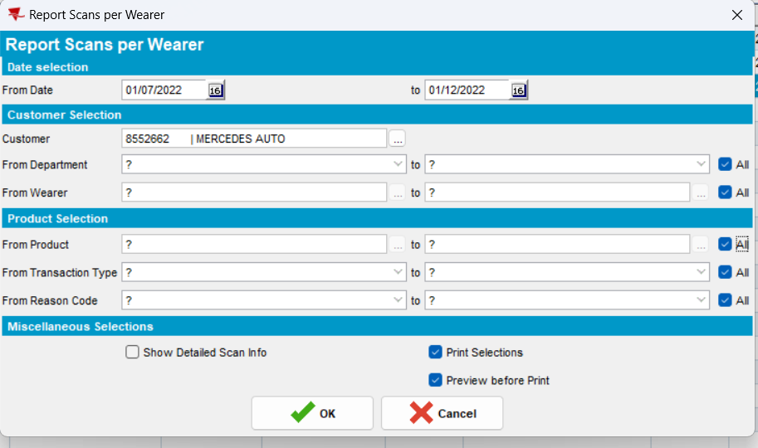
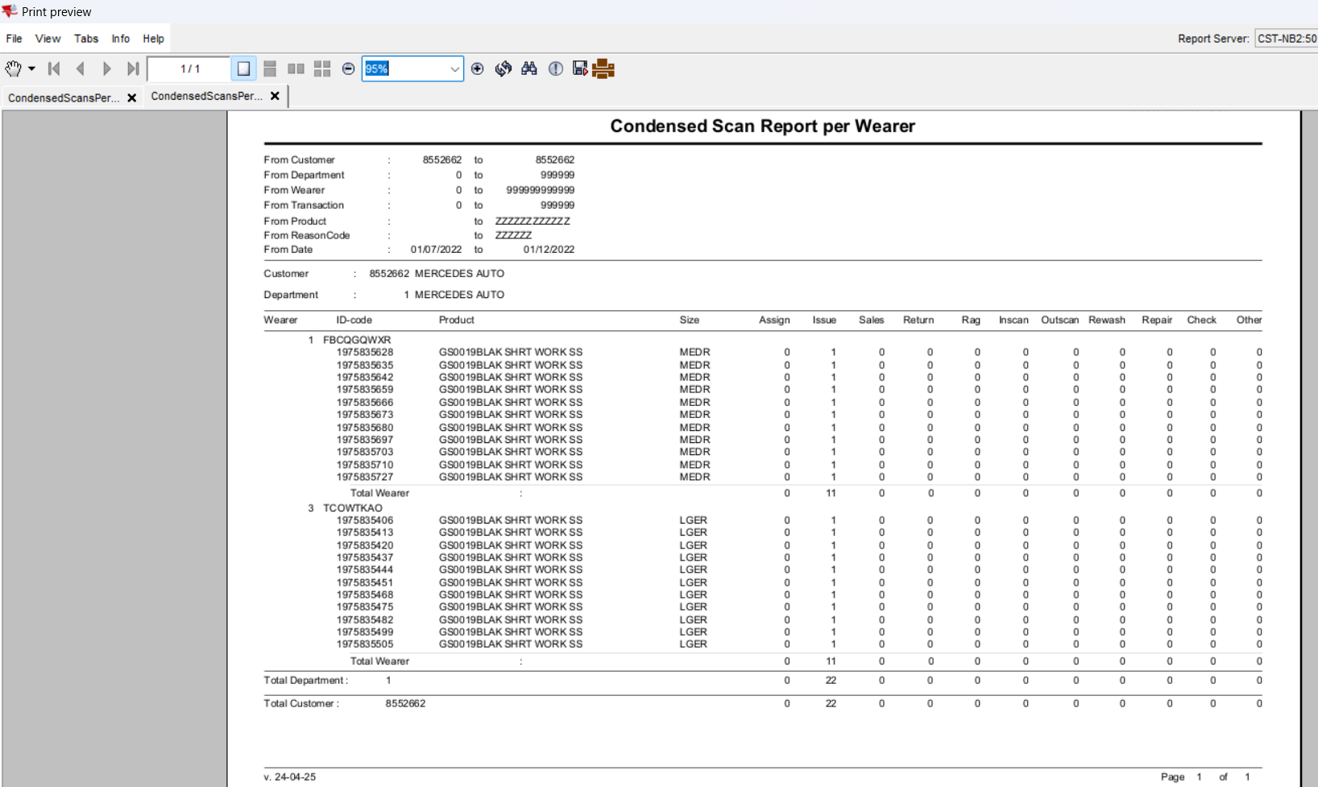
RETEST OK

