ABSN-3506 Downgrade to 9.08.00.release.p18_AUS

Environment | Prerequisites
Version: 9.08.00.RELEASE.p17  DBServerName=abs-srv16.internal.abslbs.com  DBSID=CUST21  DBUser=AUS_ND90502  DBPassword=AUS_ND90502  Environment=Production  Hash: 6b08b1f | - Module: -  - System setting: -  - Others: BU 473

Contents
Retest after fix 1
#1. Convert from BM1 -> BM6 – Tested OK 1
#2. Convert from BM2 -> BM6 – Tested OK 4
#3. Convert from BM4 -> BM6 – Tested OK 7
#4. Convert from BM3 -> BM6 – Tested OK 10

Retest after fix
Go to Contracts dlg, load a contract and modify it, select Contract Components and load Compliancy. Go to Products

#1. Convert from BM1 -> BM6 – Tested OK
- Select BM1 contract products, release them, with different SRC methods and convert them to BM6
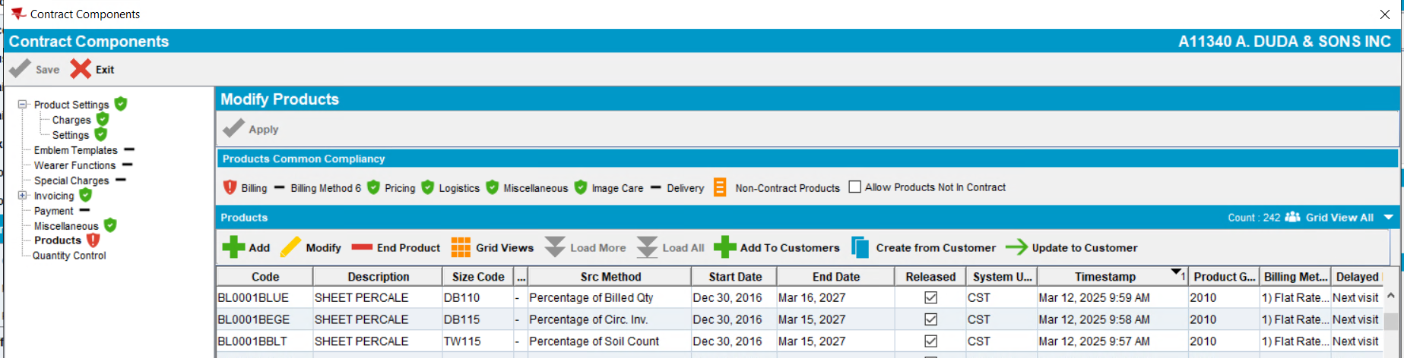
- Click Apply
- Save and exit
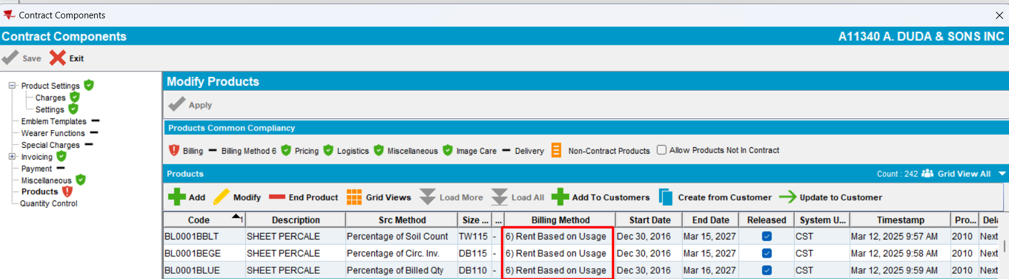
- Select product and click on Add to Customers. Select a customer that does not have that contract products in PLPC
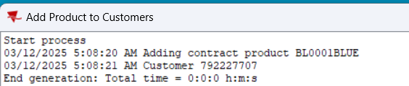
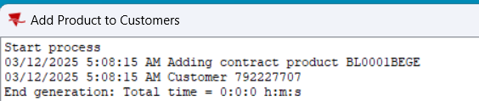
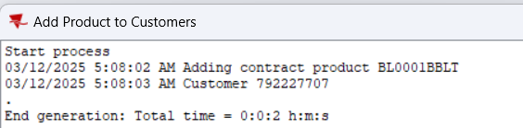
- Select product and check Billing Compliancy
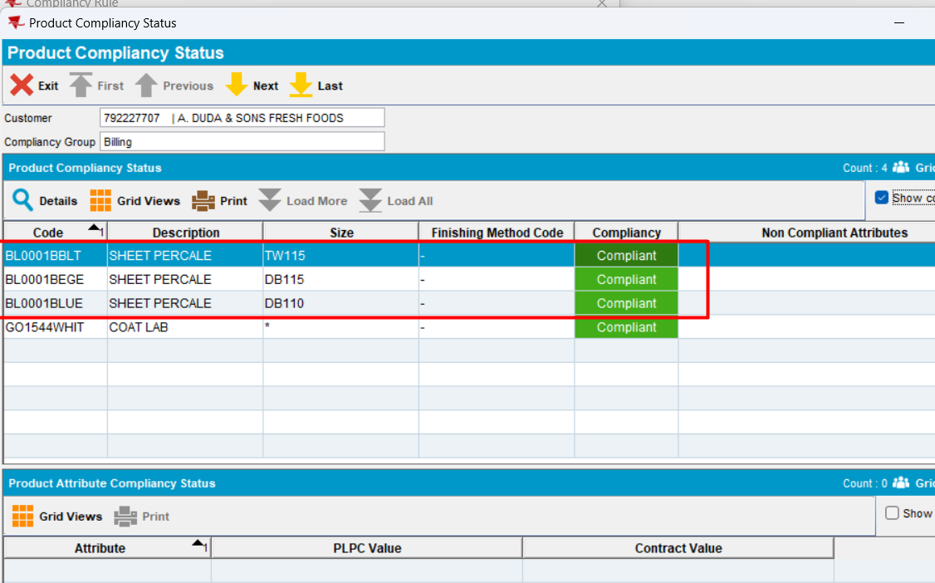
Expected behavior: on contract, a contract product with BM1 was converted to BM6 by changing the billing method. The modification is applied and saved. Then, the product is added to a customer from that contract. The compliancy should be correct.
Actual behavior: in PLPC, Billing Compliancy is correct after changing billing method
- Check in the database
select CP.CONTRACTPRODUCT_ID,
max(PLPC.SRCMETHOD),
max(CPBA.SRCMETHOD),
max(DECODE(CA.INTERNALNAME,
'cbrbSystematicReplacement',
PLPC.SRCMETHOD || '/' || CPBA.SRCMETHOD,
'')) CBRBSYSTEMATICREPLACEMENT,
PLPC.PRODUCTLISTPERCUSTOMER_ID,
CP.PRODUCT_ID,
CP.SIZEDEFINITION_ID,
CP.FINISHINGMETHOD_ID,
(select P.CODE from PRODUCT P where P.PRODUCT_ID = CP.PRODUCT_ID) PCODE, CPB.BILLINGMETHOD
from CONTRACTCUSTOMER CC
join CONTRACT C
on C.CONTRACT_ID = CC.CONTRACT_ID
join CUSTOMER CUST
on CUST.CUSTOMER_ID = CC.CUSTOMER_LINK_ID, COMPLIANCYGROUPATTRIBUTES CGA,
CONTRACTATTRIBUTE CA, CONTRACTPRODUCT CP
left outer join CONTRACTPRODUCTBILLING CPB
on CP.CONTRACTPRODUCT_ID = CPB.CONTRACTPRODUCT_ID
left outer join CONTRACTPRODUCTADDBILLING CPBA
on CP.CONTRACTPRODUCT_ID = CPBA.CONTRACTPRODUCT_ID,
PRODUCTLISTPERCUSTOMER PLPC, CONTRACTPRODUCTPLPC CPLPC
where CC.CUSTOMER_LINK_ID = PLPC.CUSTOMER_ID
and CGA.CONTRACT_ID = CC.CONTRACT_ID
and CGA.CONTRACTATTRIBUTE_ID = CA.CONTRACTATTRIBUTE_ID
and CP.CONTRACT_ID = CC.CONTRACT_ID
and CPLPC.PRODUCTLISTPERCUSTOMER_ID = PLPC.PRODUCTLISTPERCUSTOMER_ID
and CPLPC.CONTRACTPRODUCT_ID = CP.CONTRACTPRODUCT_ID
and PLPC.DATEINACTIVE >=
TO_DATE('2025-03-07 00:00:00', 'YYYY-MM-DD HH24:MI:SS')
and C.CODE = 'A11340'
and CUST.CUSTOMERNUMBER = 792227707
group by CP.CONTRACTPRODUCT_ID,
CP.PRODUCT_ID,
CP.SIZEDEFINITION_ID,
CP.FINISHINGMETHOD_ID,
PLPC.PRODUCTLISTPERCUSTOMER_ID,
PLPC.DATEACTIVE,
PLPC.DATEINACTIVE,
PLPC.SYSTEMUSER_ID,
PLPC.TIMESTAMP,
CP.STARTDATE,
CP.ENDDATE,
CP.SYSTEMUSER_ID,
CP.TIMESTAMP,
CPB.BILLINGMETHOD
Actual behavior: PLPC.SRCMETHOD is equal with the CBPA.SRCMETHOD for every product added to customer.
Tested ok

#2. Convert from BM2 -> BM6 – Tested OK
- Select BM2 contract products, that are released and have different types of SRC Method and convert them to BM6
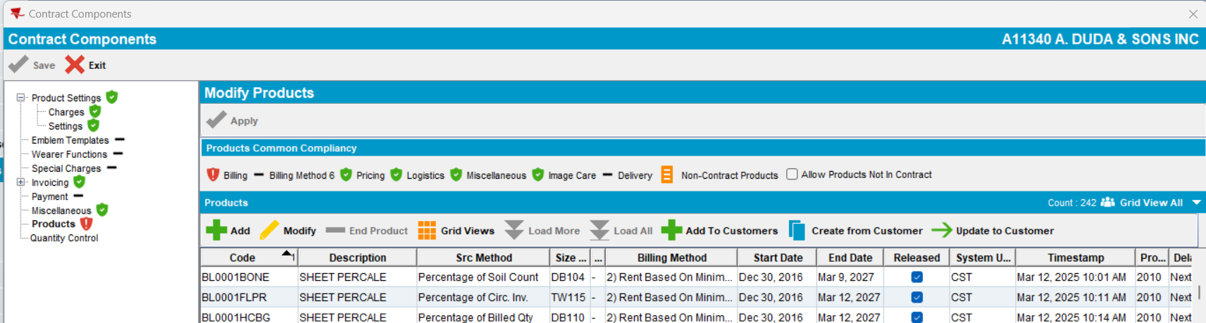
- Click Apply
- Save and Exit
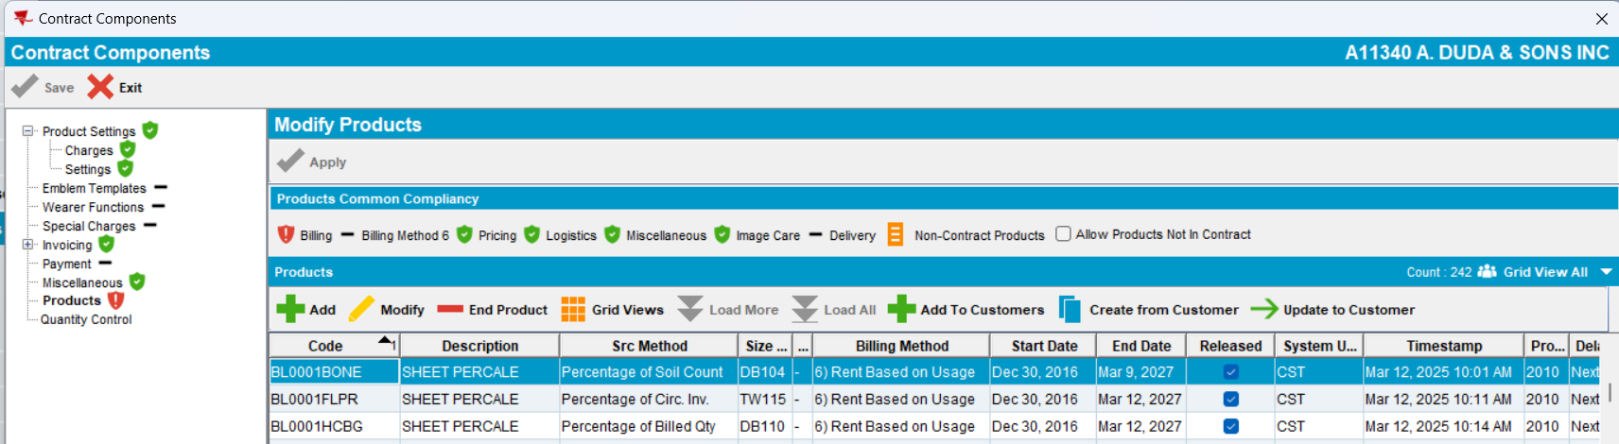
- Select every product and click on Add to Customers. Select a customer that does not have that contract products in PLPC
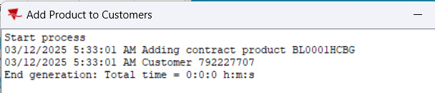
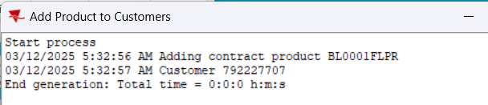
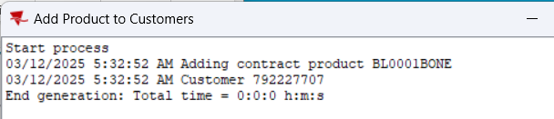
- Select product and check Billing Compliancy
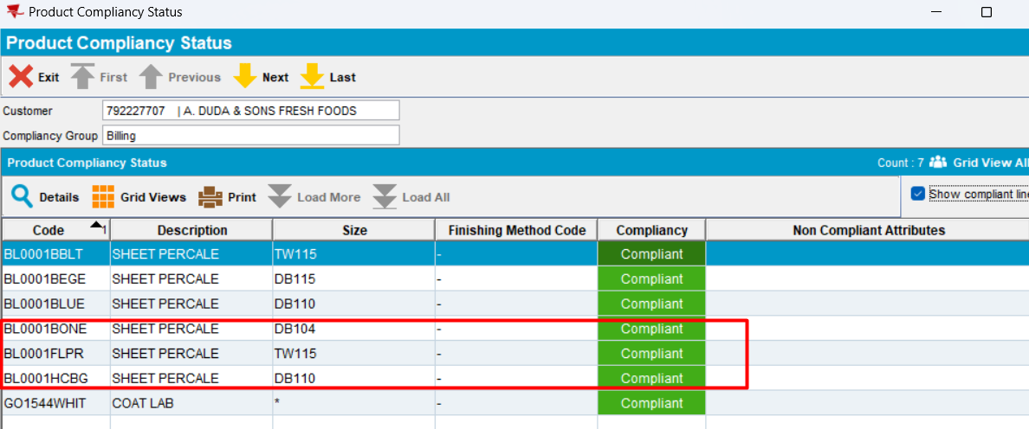
Expected behavior: on contract, contract products with BM2 were converted to BM6 by changing the billing method. The modification is applied and saved. Then, every product is added to a customer from that contract. The compliancy should be correct.
Actual behavior: in PLPC, Billing Compliancy is correct after changing billing method
- Check in the database
select CP.CONTRACTPRODUCT_ID,
max(PLPC.SRCMETHOD),
max(CPBA.SRCMETHOD),
max(DECODE(CA.INTERNALNAME,
'cbrbSystematicReplacement',
PLPC.SRCMETHOD || '/' || CPBA.SRCMETHOD,
'')) CBRBSYSTEMATICREPLACEMENT,
PLPC.PRODUCTLISTPERCUSTOMER_ID,
CP.PRODUCT_ID,
CP.SIZEDEFINITION_ID,
CP.FINISHINGMETHOD_ID,
(select P.CODE from PRODUCT P where P.PRODUCT_ID = CP.PRODUCT_ID) PCODE, CPB.BILLINGMETHOD
from CONTRACTCUSTOMER CC
join CONTRACT C
on C.CONTRACT_ID = CC.CONTRACT_ID
join CUSTOMER CUST
on CUST.CUSTOMER_ID = CC.CUSTOMER_LINK_ID, COMPLIANCYGROUPATTRIBUTES CGA,
CONTRACTATTRIBUTE CA, CONTRACTPRODUCT CP
left outer join CONTRACTPRODUCTBILLING CPB
on CP.CONTRACTPRODUCT_ID = CPB.CONTRACTPRODUCT_ID
left outer join CONTRACTPRODUCTADDBILLING CPBA
on CP.CONTRACTPRODUCT_ID = CPBA.CONTRACTPRODUCT_ID,
PRODUCTLISTPERCUSTOMER PLPC, CONTRACTPRODUCTPLPC CPLPC
where CC.CUSTOMER_LINK_ID = PLPC.CUSTOMER_ID
and CGA.CONTRACT_ID = CC.CONTRACT_ID
and CGA.CONTRACTATTRIBUTE_ID = CA.CONTRACTATTRIBUTE_ID
and CP.CONTRACT_ID = CC.CONTRACT_ID
and CPLPC.PRODUCTLISTPERCUSTOMER_ID = PLPC.PRODUCTLISTPERCUSTOMER_ID
and CPLPC.CONTRACTPRODUCT_ID = CP.CONTRACTPRODUCT_ID
and PLPC.DATEINACTIVE >=
TO_DATE('2025-03-07 00:00:00', 'YYYY-MM-DD HH24:MI:SS')
and C.CODE = 'A11340'
and CUST.CUSTOMERNUMBER = 792227707
group by CP.CONTRACTPRODUCT_ID,
CP.PRODUCT_ID,
CP.SIZEDEFINITION_ID,
CP.FINISHINGMETHOD_ID,
PLPC.PRODUCTLISTPERCUSTOMER_ID,
PLPC.DATEACTIVE,
PLPC.DATEINACTIVE,
PLPC.SYSTEMUSER_ID,
PLPC.TIMESTAMP,
CP.STARTDATE,
CP.ENDDATE,
CP.SYSTEMUSER_ID,
CP.TIMESTAMP,
CPB.BILLINGMETHOD
Actual behavior: PLPC.SRCMETHOD is equal with the CBPA.SRCMETHOD for every product added to customer.
Tested OK

#3. Convert from BM4 -> BM6 – Tested OK
- Select a BM4 contract products, that are released and have different types of SRC Method and convert them to BM6
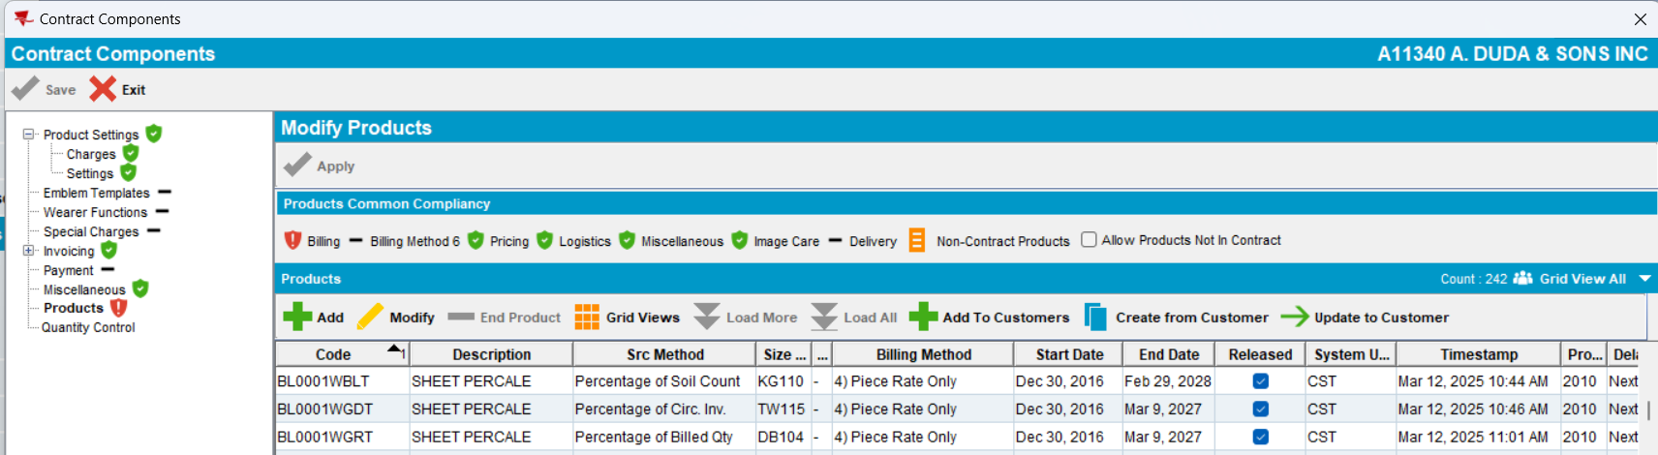
- Click Apply
- Save and Exit
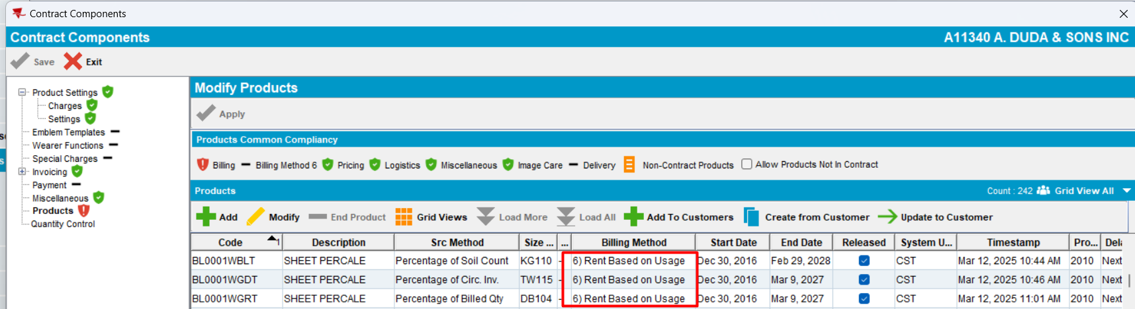
- Select every product and click on Add to Customers. Select a customer that does not have that contract products in PLPC
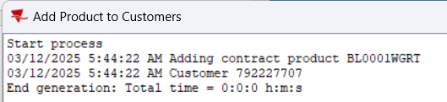
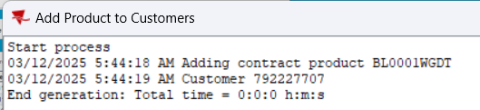
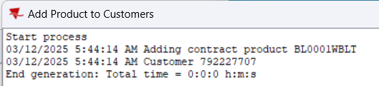
- Select product and check Billing Compliancy
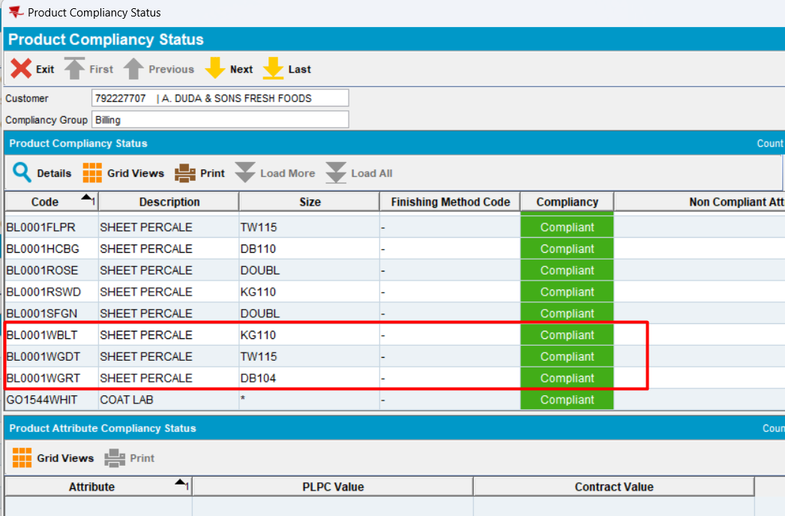
Expected behavior: on contract, contract products with BM4 were converted to BM6 by changing the billing method. The modification is applied and saved. Then, every product is added to a customer from that contract. The compliancy should be correct.
Actual behavior: in PLPC, Billing Compliancy is correct after changing billing method
- Check in the database
select CP.CONTRACTPRODUCT_ID,
max(PLPC.SRCMETHOD),
max(CPBA.SRCMETHOD),
max(DECODE(CA.INTERNALNAME,
'cbrbSystematicReplacement',
PLPC.SRCMETHOD || '/' || CPBA.SRCMETHOD,
'')) CBRBSYSTEMATICREPLACEMENT,
PLPC.PRODUCTLISTPERCUSTOMER_ID,
CP.PRODUCT_ID,
CP.SIZEDEFINITION_ID,
CP.FINISHINGMETHOD_ID,
(select P.CODE from PRODUCT P where P.PRODUCT_ID = CP.PRODUCT_ID) PCODE, CPB.BILLINGMETHOD
from CONTRACTCUSTOMER CC
join CONTRACT C
on C.CONTRACT_ID = CC.CONTRACT_ID
join CUSTOMER CUST
on CUST.CUSTOMER_ID = CC.CUSTOMER_LINK_ID, COMPLIANCYGROUPATTRIBUTES CGA,
CONTRACTATTRIBUTE CA, CONTRACTPRODUCT CP
left outer join CONTRACTPRODUCTBILLING CPB
on CP.CONTRACTPRODUCT_ID = CPB.CONTRACTPRODUCT_ID
left outer join CONTRACTPRODUCTADDBILLING CPBA
on CP.CONTRACTPRODUCT_ID = CPBA.CONTRACTPRODUCT_ID,
PRODUCTLISTPERCUSTOMER PLPC, CONTRACTPRODUCTPLPC CPLPC
where CC.CUSTOMER_LINK_ID = PLPC.CUSTOMER_ID
and CGA.CONTRACT_ID = CC.CONTRACT_ID
and CGA.CONTRACTATTRIBUTE_ID = CA.CONTRACTATTRIBUTE_ID
and CP.CONTRACT_ID = CC.CONTRACT_ID
and CPLPC.PRODUCTLISTPERCUSTOMER_ID = PLPC.PRODUCTLISTPERCUSTOMER_ID
and CPLPC.CONTRACTPRODUCT_ID = CP.CONTRACTPRODUCT_ID
and PLPC.DATEINACTIVE >=
TO_DATE('2025-03-07 00:00:00', 'YYYY-MM-DD HH24:MI:SS')
and C.CODE = 'A11340'
and CUST.CUSTOMERNUMBER = 792227707
group by CP.CONTRACTPRODUCT_ID,
CP.PRODUCT_ID,
CP.SIZEDEFINITION_ID,
CP.FINISHINGMETHOD_ID,
PLPC.PRODUCTLISTPERCUSTOMER_ID,
PLPC.DATEACTIVE,
PLPC.DATEINACTIVE,
PLPC.SYSTEMUSER_ID,
PLPC.TIMESTAMP,
CP.STARTDATE,
CP.ENDDATE,
CP.SYSTEMUSER_ID,
CP.TIMESTAMP,
CPB.BILLINGMETHOD
Actual behavior: PLPC.SRCMETHOD is equal with the CBPA.SRCMETHOD for every product added to customer.
Tested OK

#4. Convert from BM3 -> BM6 – Tested OK
- Select BM3 contract products, that are released and have different types of SRC Method and convert them to BM6
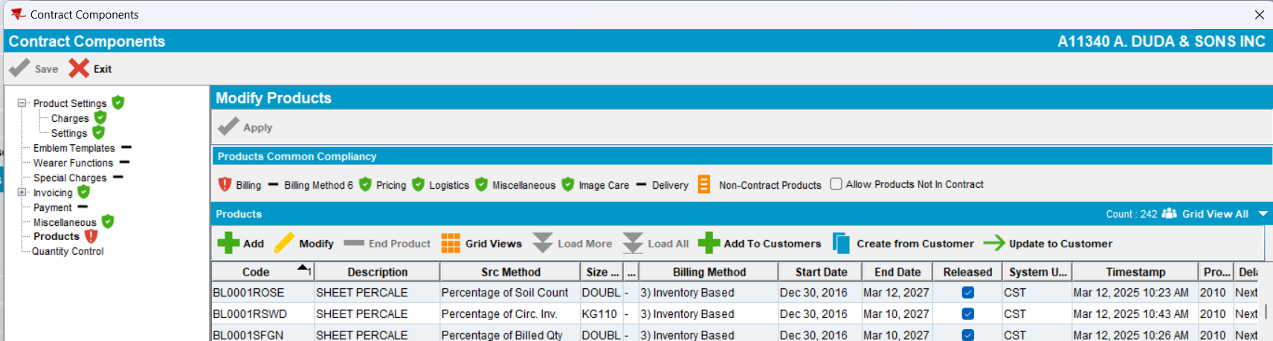
- Click Apply
- Save and Exit
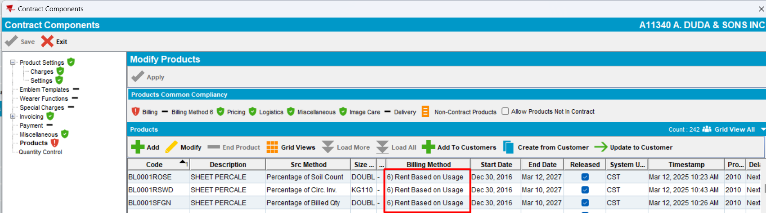
- Select every product and click on Add to Customers. Select a customer that does not have that contract products in PLPC
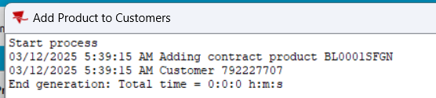
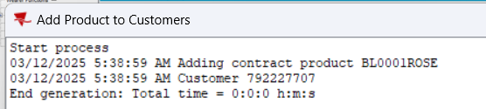
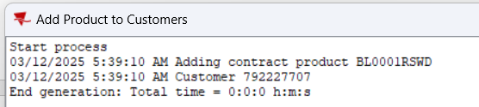
- Select product and check Billing Compliancy
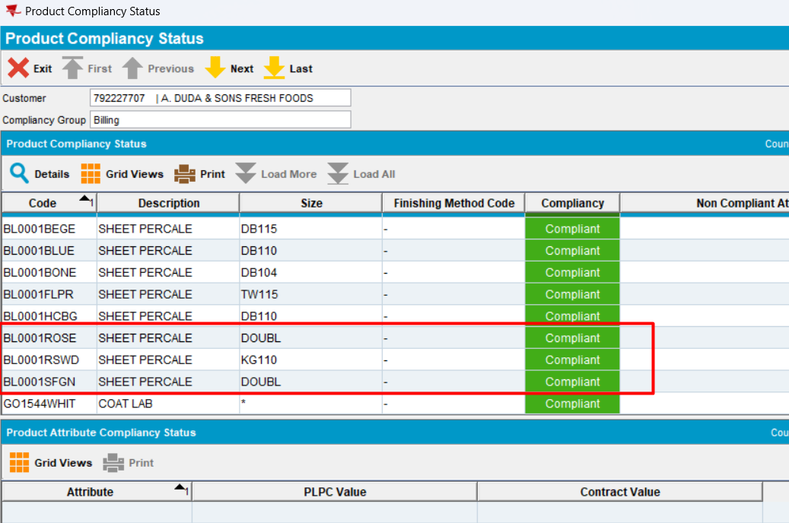
Expected behavior: on contract, contract products with BM3 were converted to BM6 by changing the billing method. The modification is applied and saved. Then, every product is added to a customer from that contract. The compliancy should be correct.
Actual behavior: in PLPC, Billing Compliancy is correct after changing billing method
- Check in the database
select CP.CONTRACTPRODUCT_ID,
max(PLPC.SRCMETHOD),
max(CPBA.SRCMETHOD),
max(DECODE(CA.INTERNALNAME,
'cbrbSystematicReplacement',
PLPC.SRCMETHOD || '/' || CPBA.SRCMETHOD,
'')) CBRBSYSTEMATICREPLACEMENT,
PLPC.PRODUCTLISTPERCUSTOMER_ID,
CP.PRODUCT_ID,
CP.SIZEDEFINITION_ID,
CP.FINISHINGMETHOD_ID,
(select P.CODE from PRODUCT P where P.PRODUCT_ID = CP.PRODUCT_ID) PCODE, CPB.BILLINGMETHOD
from CONTRACTCUSTOMER CC
join CONTRACT C
on C.CONTRACT_ID = CC.CONTRACT_ID
join CUSTOMER CUST
on CUST.CUSTOMER_ID = CC.CUSTOMER_LINK_ID, COMPLIANCYGROUPATTRIBUTES CGA,
CONTRACTATTRIBUTE CA, CONTRACTPRODUCT CP
left outer join CONTRACTPRODUCTBILLING CPB
on CP.CONTRACTPRODUCT_ID = CPB.CONTRACTPRODUCT_ID
left outer join CONTRACTPRODUCTADDBILLING CPBA
on CP.CONTRACTPRODUCT_ID = CPBA.CONTRACTPRODUCT_ID,
PRODUCTLISTPERCUSTOMER PLPC, CONTRACTPRODUCTPLPC CPLPC
where CC.CUSTOMER_LINK_ID = PLPC.CUSTOMER_ID
and CGA.CONTRACT_ID = CC.CONTRACT_ID
and CGA.CONTRACTATTRIBUTE_ID = CA.CONTRACTATTRIBUTE_ID
and CP.CONTRACT_ID = CC.CONTRACT_ID
and CPLPC.PRODUCTLISTPERCUSTOMER_ID = PLPC.PRODUCTLISTPERCUSTOMER_ID
and CPLPC.CONTRACTPRODUCT_ID = CP.CONTRACTPRODUCT_ID
and PLPC.DATEINACTIVE >=
TO_DATE('2025-03-07 00:00:00', 'YYYY-MM-DD HH24:MI:SS')
and C.CODE = 'A11340'
and CUST.CUSTOMERNUMBER = 792227707
group by CP.CONTRACTPRODUCT_ID,
CP.PRODUCT_ID,
CP.SIZEDEFINITION_ID,
CP.FINISHINGMETHOD_ID,
PLPC.PRODUCTLISTPERCUSTOMER_ID,
PLPC.DATEACTIVE,
PLPC.DATEINACTIVE,
PLPC.SYSTEMUSER_ID,
PLPC.TIMESTAMP,
CP.STARTDATE,
CP.ENDDATE,
CP.SYSTEMUSER_ID,
CP.TIMESTAMP,
CPB.BILLINGMETHOD
Actual behavior: PLPC.SRCMETHOD is equal with the CBPA.SRCMETHOD for every product added to customer.
RETEST OK

