ABSN-2470 Ruin Abuse on spot billing rent and loss charge
Environment | Prerequisites
Version: 9.08.00.RELEASE.p18  Environment=PRODUCTION  DBServerName=abs-srv16.internal.abslbs.com  DBSID= CUST21  DBUser= AUS_ND90502  DBPassword= AUS_ND90502 | - Modules: AUSCUSTOM  - System Settings:  USEROUTECHECKINSCREEN, INVOICELINEADJADDRULE,  INVOICELINEADJAPPROVERULE,  INVOICELINEADJMODIFYRULE,  INVOICELINEADJVALUERULE,  INVOICELINEADJNORARULE,  PDAAUTOSYNCSTOP  - Others: BU 553

Contents
Reproduction before fix 1
Retesting after fixing 9

Reproduction before fix
Reproduced on master.
Pre-conditions:
USEROUTECHECKINSCREEN=Y
INVOICELINEADJADDRULE=1
INVOICELINEADJAPPROVERULE=1
INVOICELINEADJMODIFYRULE=1
INVOICELINEADJNORARULE=1
INVOICELINEADJVALUERULE=0
PDAAUTOSYNCSTOP =Y
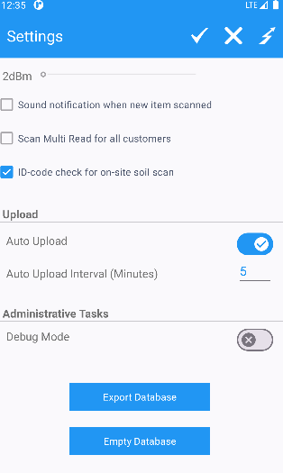
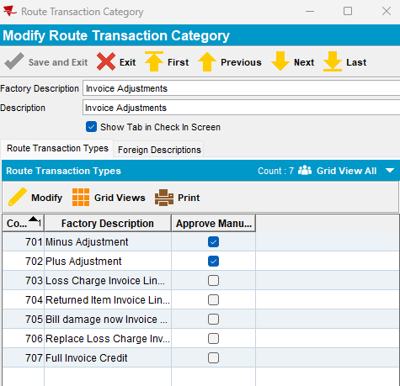
Test case 1:
- Customer: 5947649
- Wearer: 12
Steps to reproduce:
- Route 114 from 05.05.2025
- Add route on RSC
- Generate PNs and invoice
- Mark ready for transfer to PDA
- Downloading route
- Start route
- Scan for abuse 2 ID Codes for wearer=12
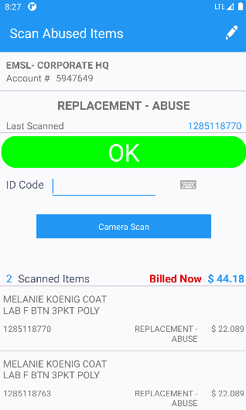
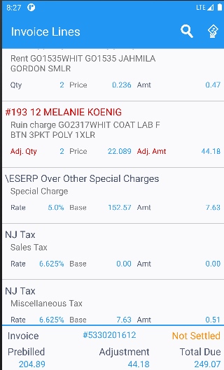
- Settle route
- Depart route
- Uploading route
Result:
Charge For Loss for these two ID codes is unchecked:
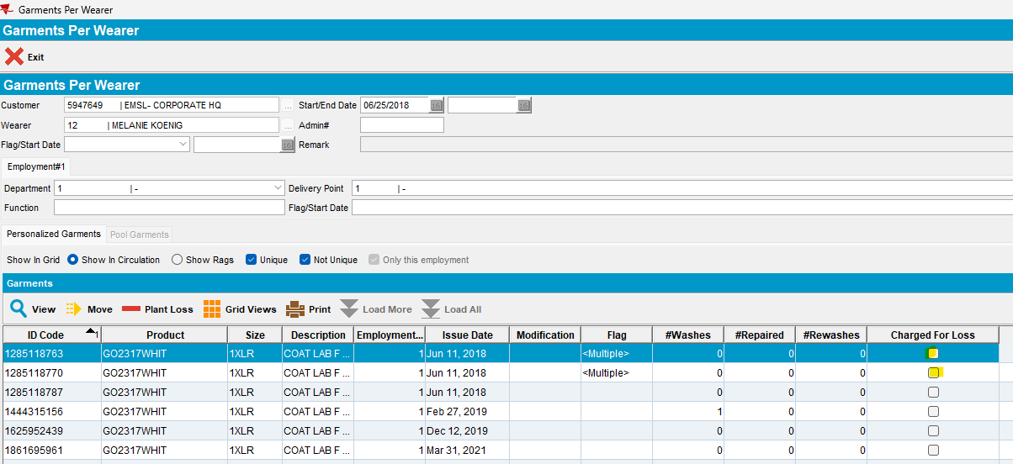
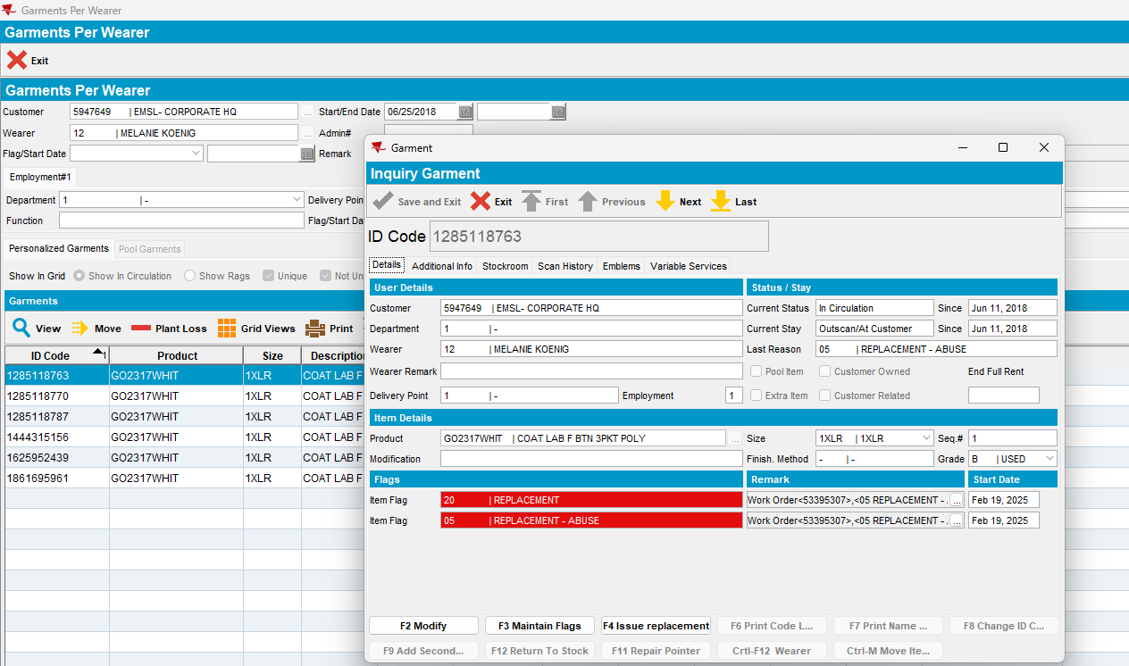
- Open route on WebX
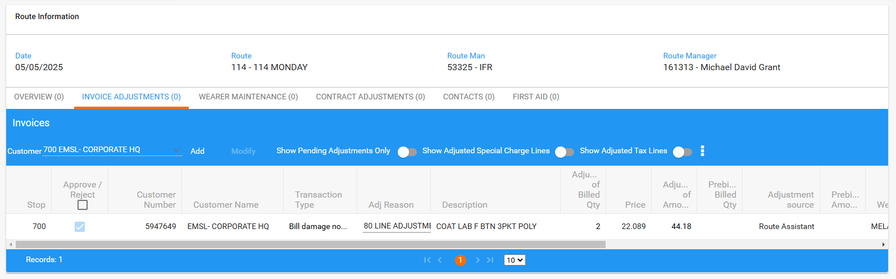
- Settle route from here:
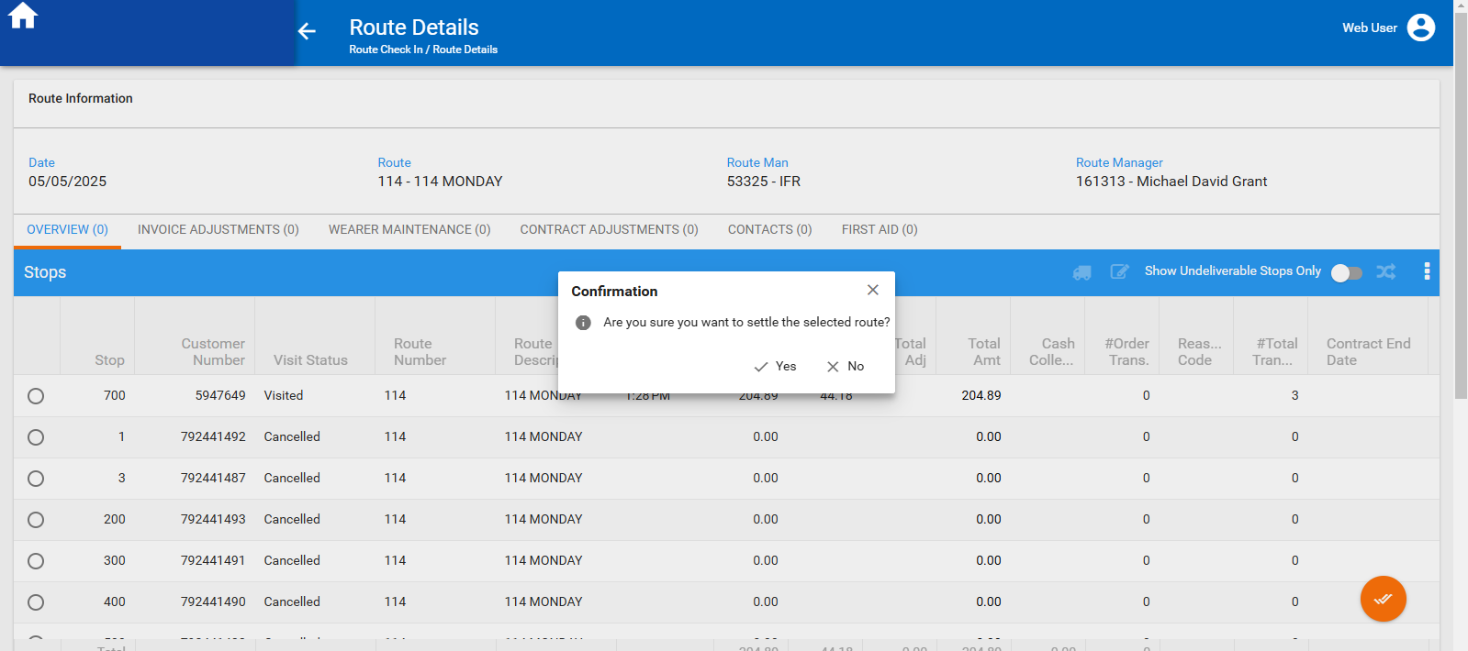
- The two items are now with Charge For Loss= checked:
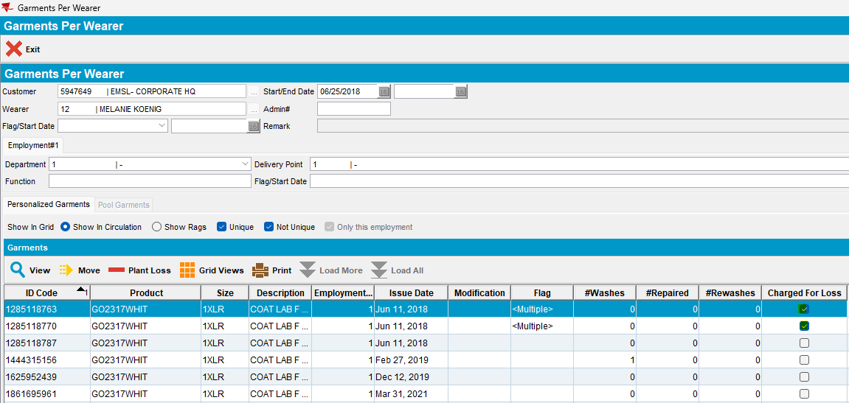
- Check invoice
- Ruin charge invoice line is ok added on the invoice:
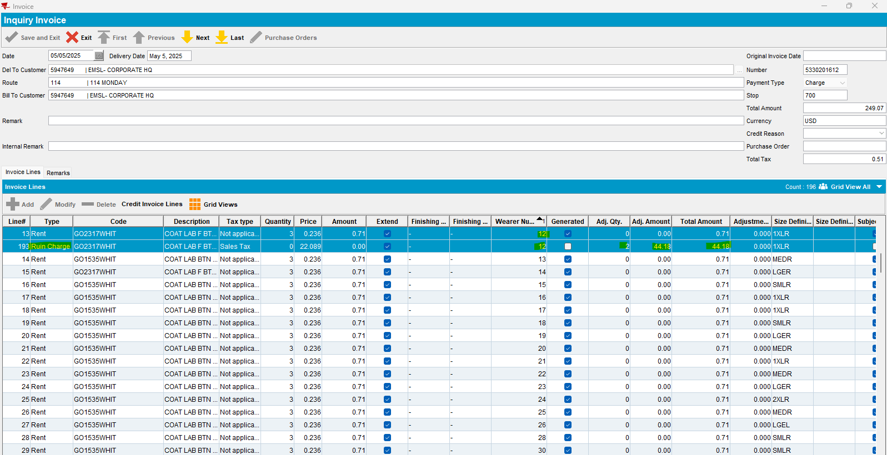
- Add, on RSC, next delivery route
- Generate PNs and invoice and check, also, this invoice (from 12.05.2025)
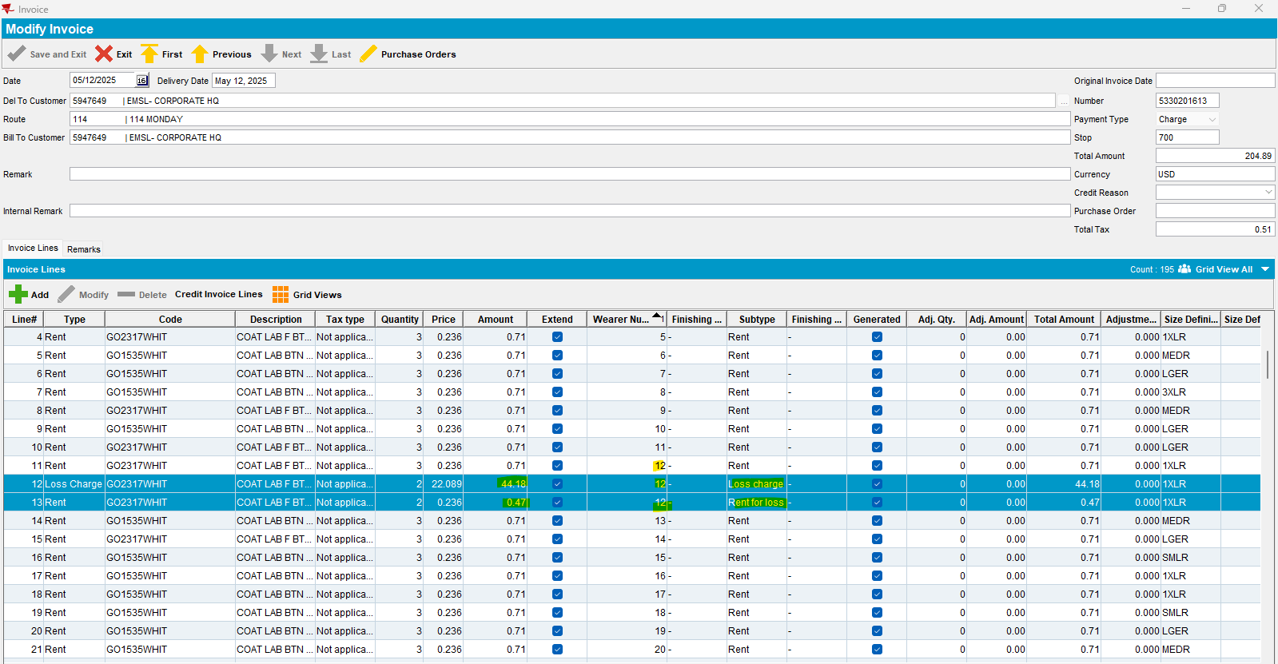
Two new invoice lines, loss charge and rent for loss, billed, are added on this invoice nok.
Reproduced.
The only difference between my case and Vestis’s case is that, in their case, loss charge invoice line is not billed.
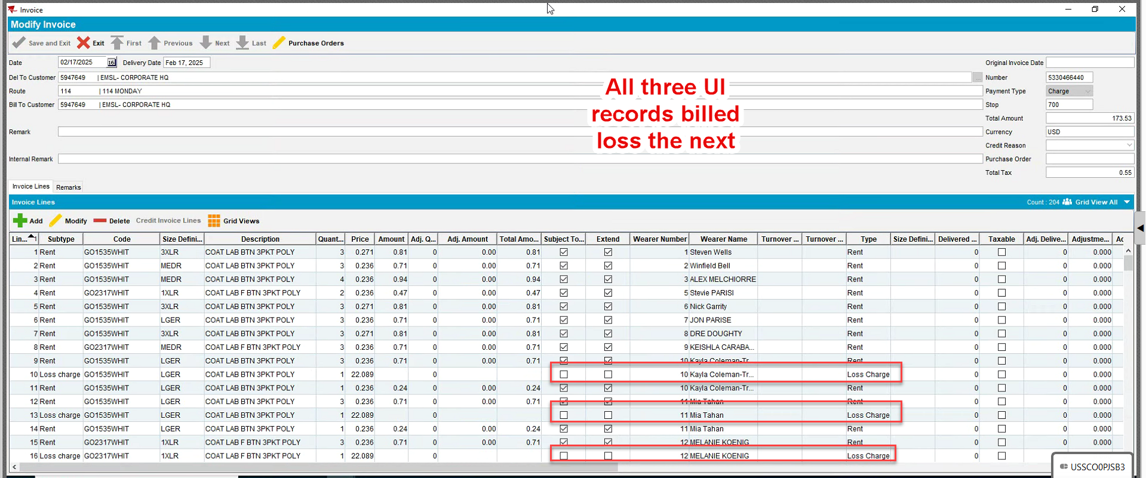

Test case 2:
Add this:
- Repeat the steps for customer: 5491919
- Wearer: 4, BM2 garment
- Route: 105 from 26.02.2025 and 05.03.2025
- Invoice from 05.03.2025:
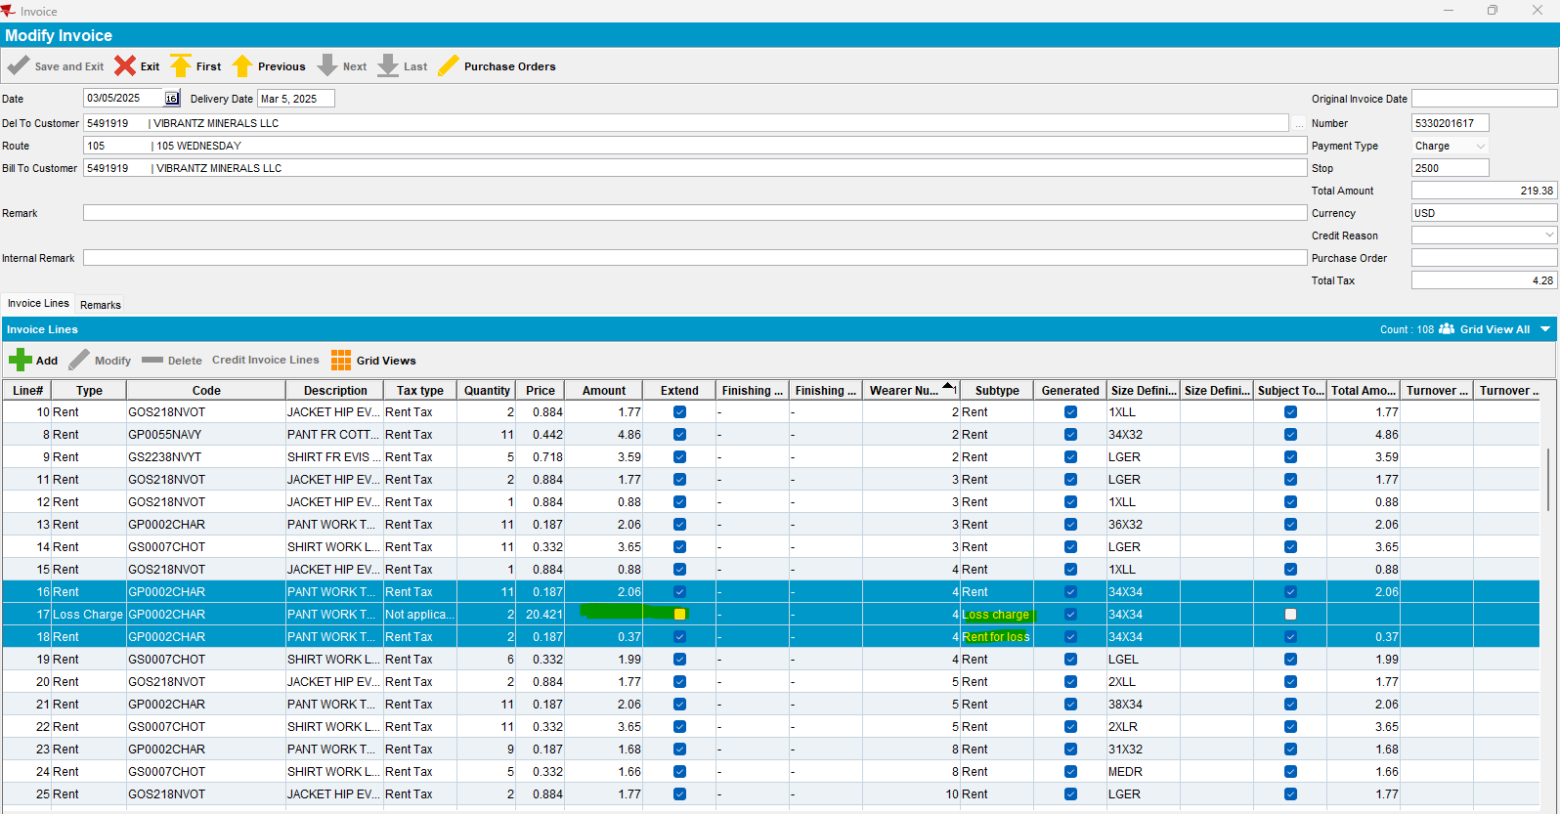

Reproduced.

Test case 3:
- Repeat the steps for: Customer: 4558233
- Route 174 from 20.02.2025 and 27.02.2025
- Wearer: 301, BM1 garment
- Invoice from 27.02.2025:
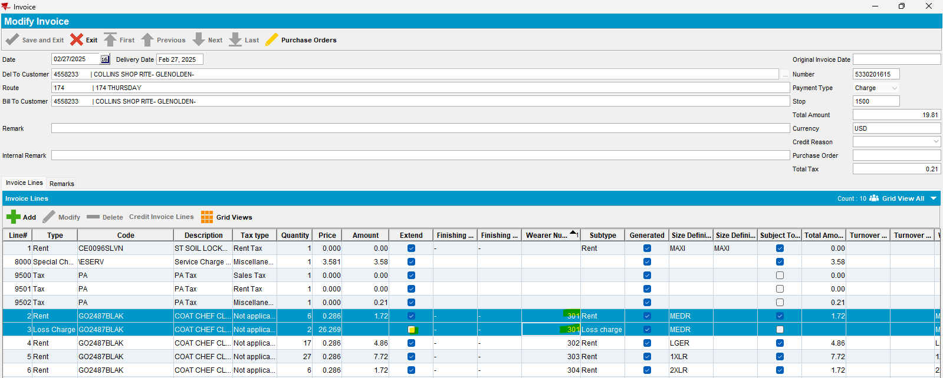

Reproduced.

Retesting after fixing

Test case 1:
- Customer: 6255680
- Wearer: 1

Steps to reproduce:
- Route 152 from 28.02.2025 and 07.03.2025
- Add route on RSC
- Generate PNs and invoice
- Mark ready for transfer to PDA
- Downloading route
- Start route
- Scan for abuse 2 ID Codes for wearer=1 (806 transaction)
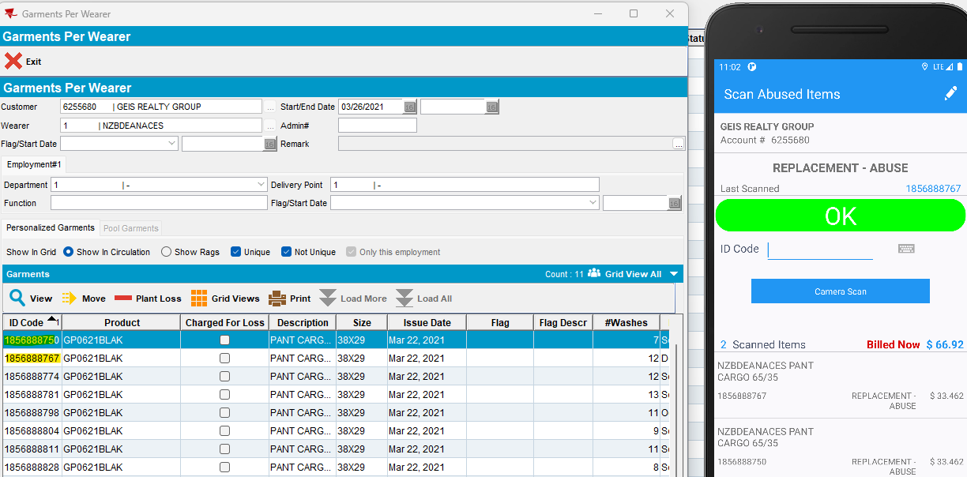
- Settle route
- Depart route
- Upload route
- Open route on WebX and settle route from here (Overview tab)
- Check the invoice:
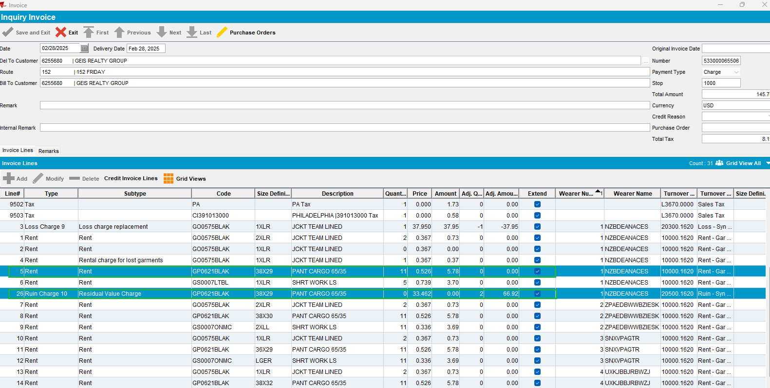
- Ruin Charge invoice line with adj. amount for those 2 id codes is ok added on the invoice
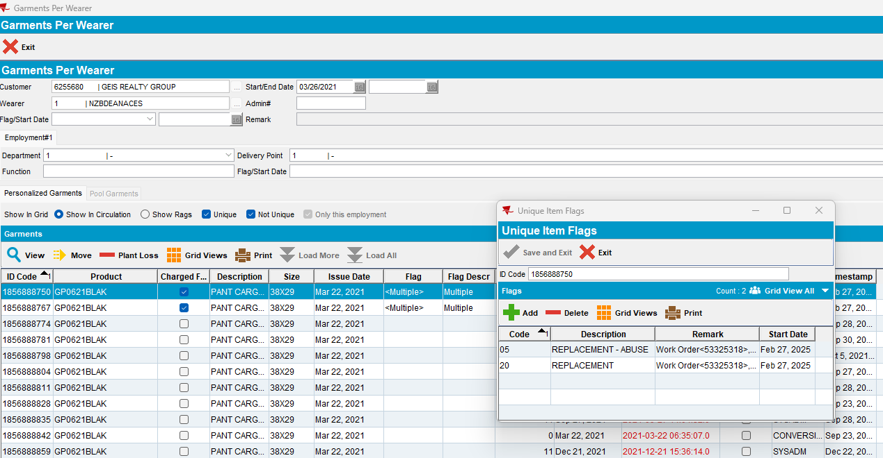
- also, on Garments Per Wearer, Charge for Loss option is checked, and the right flags are added
- Add, on RSC, the next delivery route
- Generate PNs and invoice
- Check this invoice:
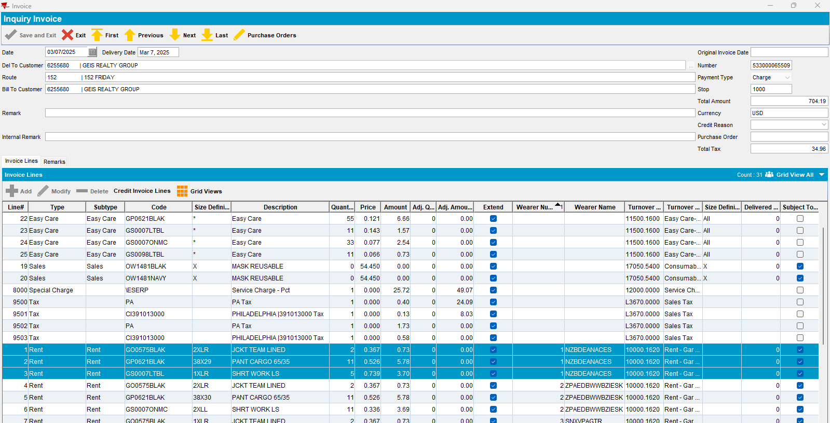
- No other Loss or Ruin invoice line, for this wearer, is not anymore added/ displayed on the invoice -> Passed.

Test case 2 (regression test):

- Customer: 6255680
- Route 152 from 28.02.2025
- Also, for wearer=1, scan one item for return:
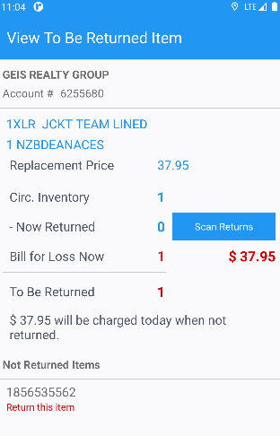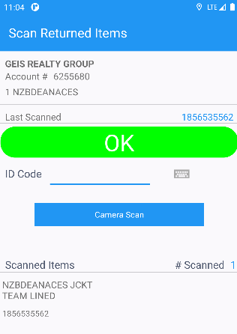
- Loss Charge and Rental charge for lost garments invoice lines are ok added on the invoice:
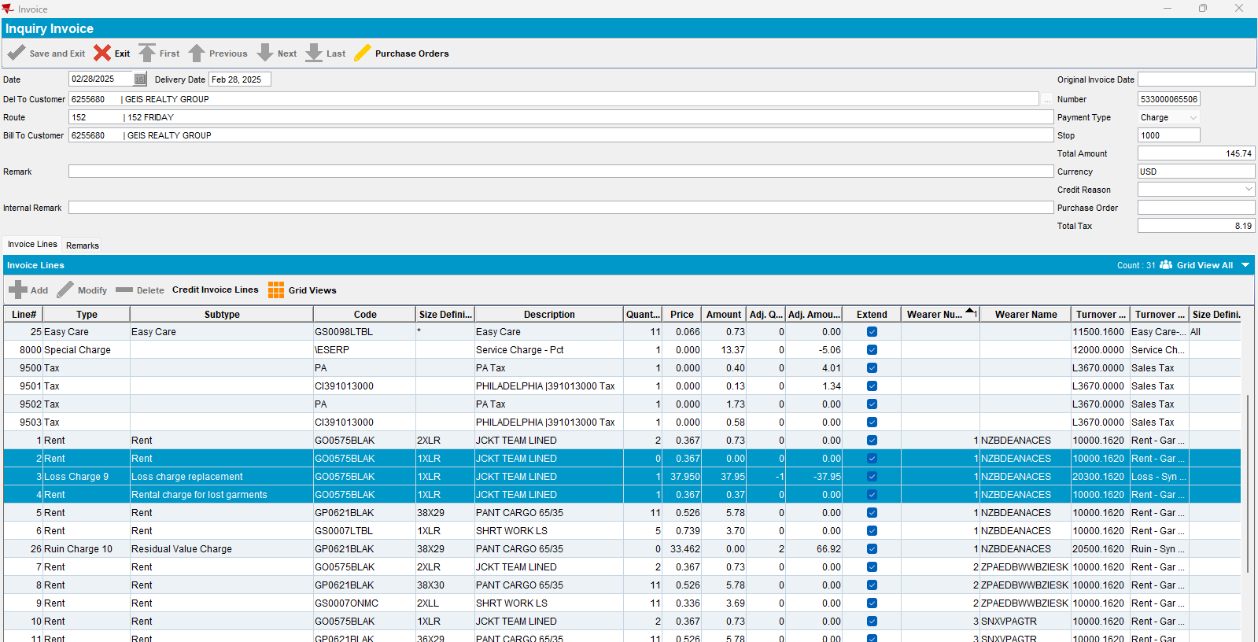

- also, on Garments Per Wearer is charged for loss with right flags:
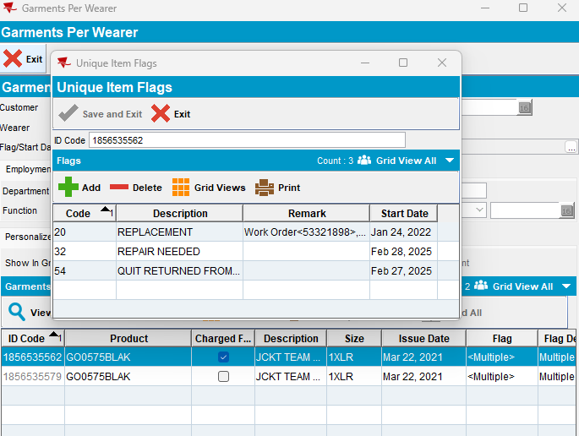
- On the same route, for wearer 5, scan for replace 3 id codes (801 transaction):
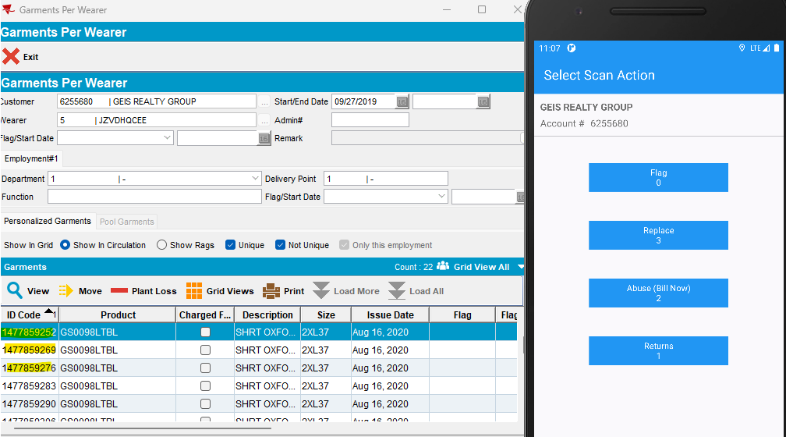
- Settle route
- Depart route
- Upload route
- Open route on WebX
- Bill damage and scan for return lines are displayed:

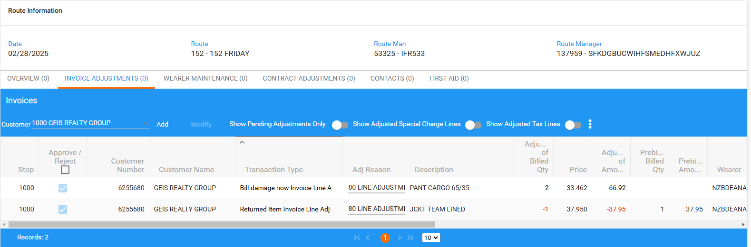
- Settle route from WebX (Overview tab):
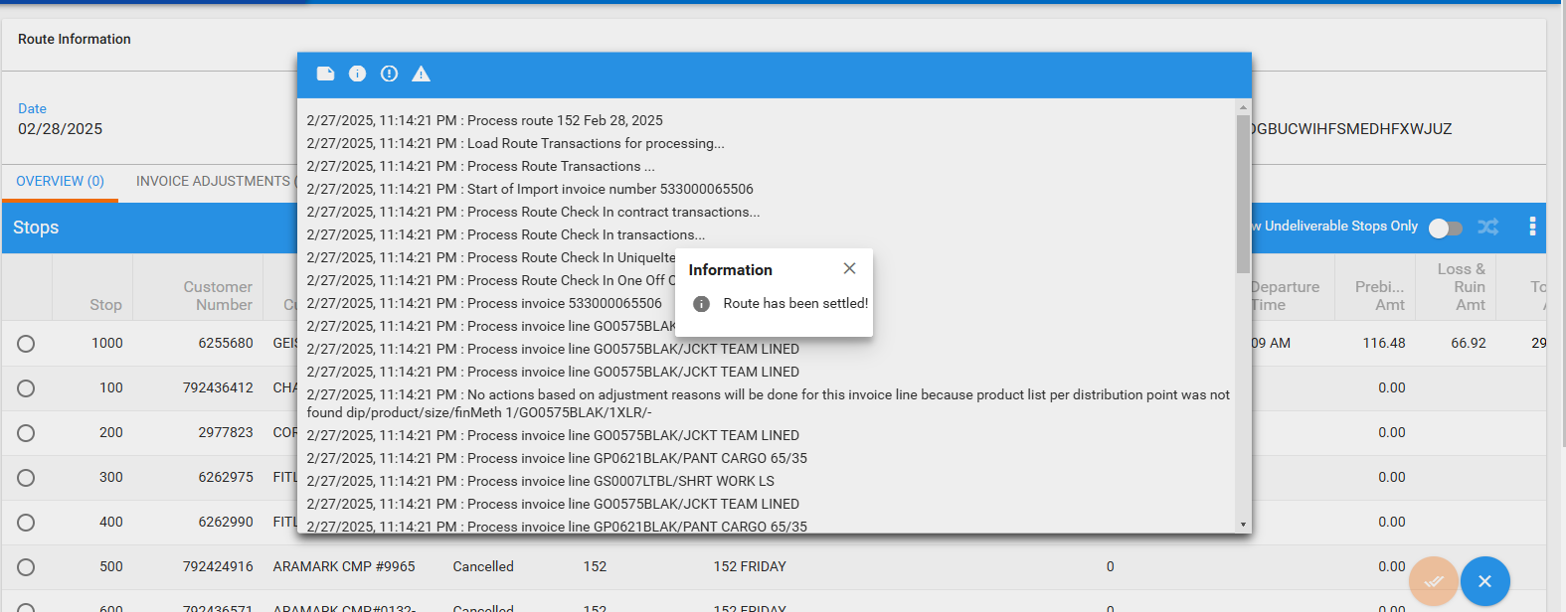
- Check invoice from 28.02.2025
- Wearer=1 -> Scan for abuse (bill now) 2 ID codes: Residual Value Charge invoice line ok added on the invoice
- Wearer=1 -> Scan for return 1 item: Loss Charge and Rental charge for loss invoice lines ok added on the invoice
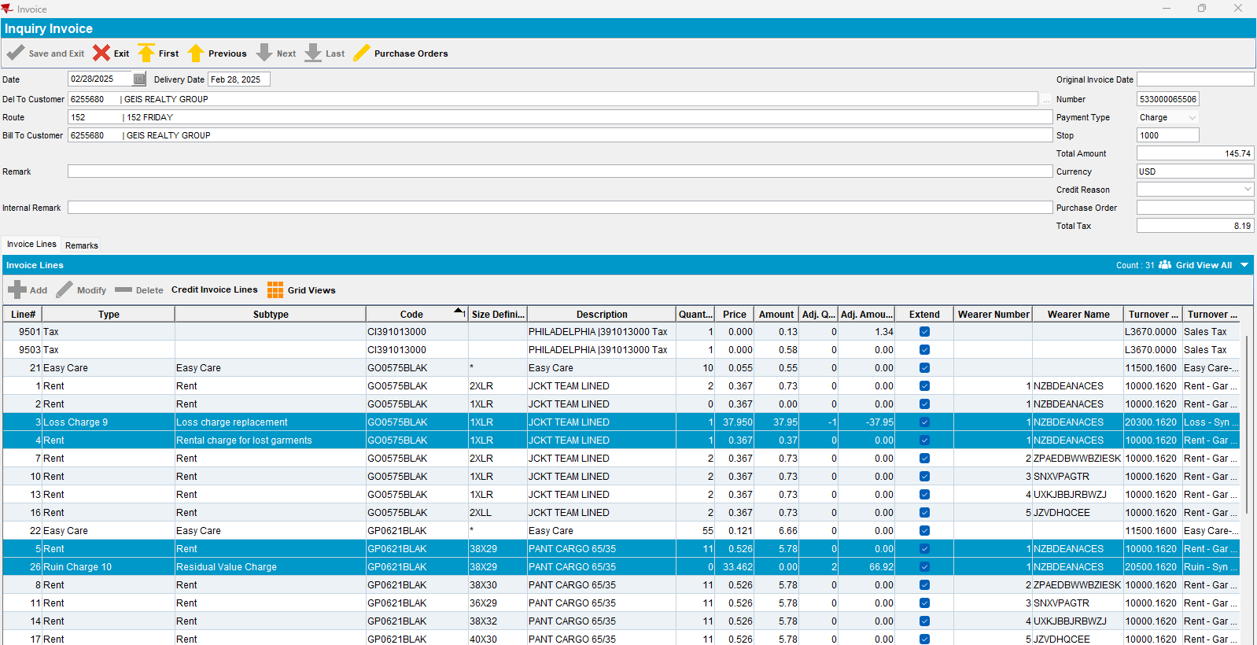
- For these 3 ID Codes replaced for ruin, abuse, worn out:
- Generate next invoice (from 07.03.2025) and check this invoice:
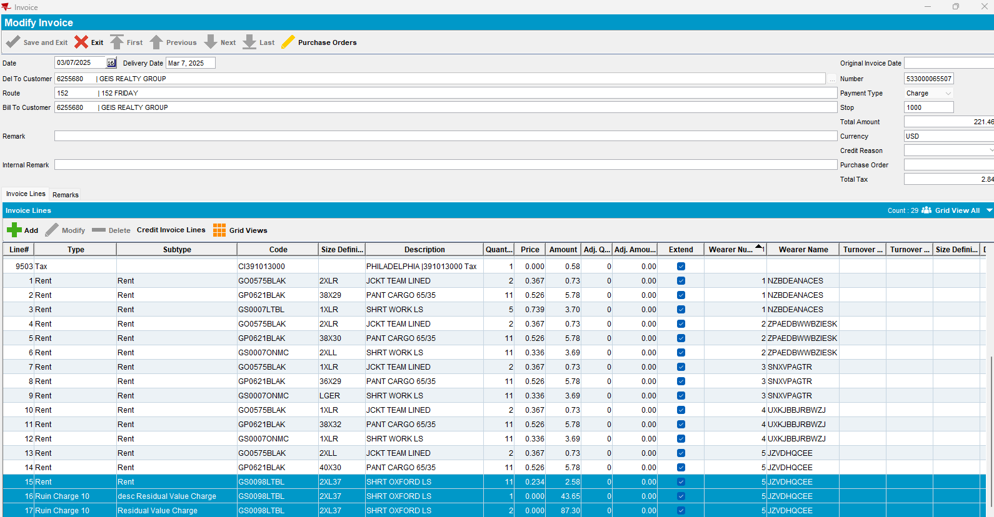
- Ruin Charge invoice lines, for 3 qty, are added ok the invoice

Test case 3 (regression test):
- Do also a quit wearer inventory on client
- On PDA, do bill for loss now for this quit wearer inventory (wearer number=4, garment: GP0621BLAK):

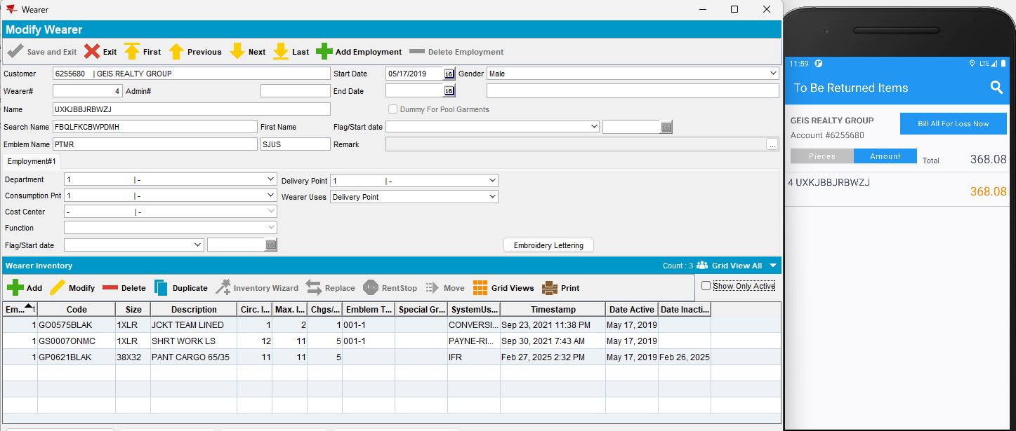

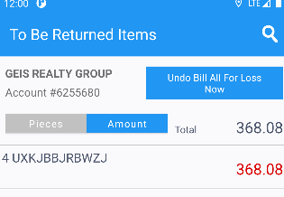
- Do, also, for wearer number=3, garment: GP0621BLAK, a replacement for abuse:
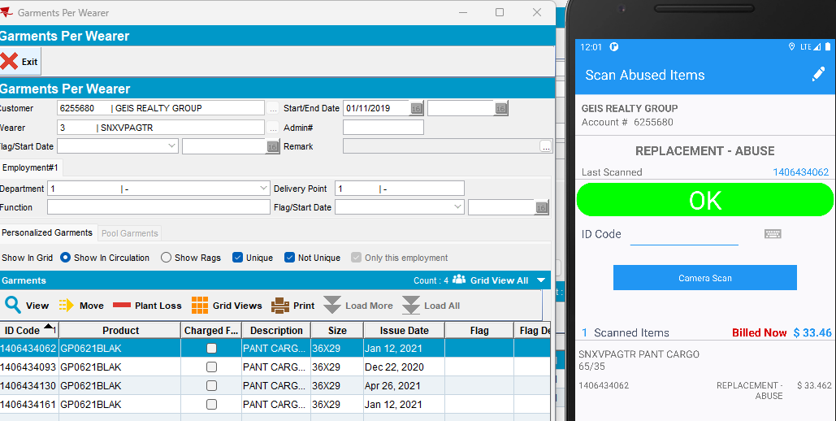

- Settle route
- On invoice, ruin charge invoice line is added correctly for replacement for abuse and is billed:
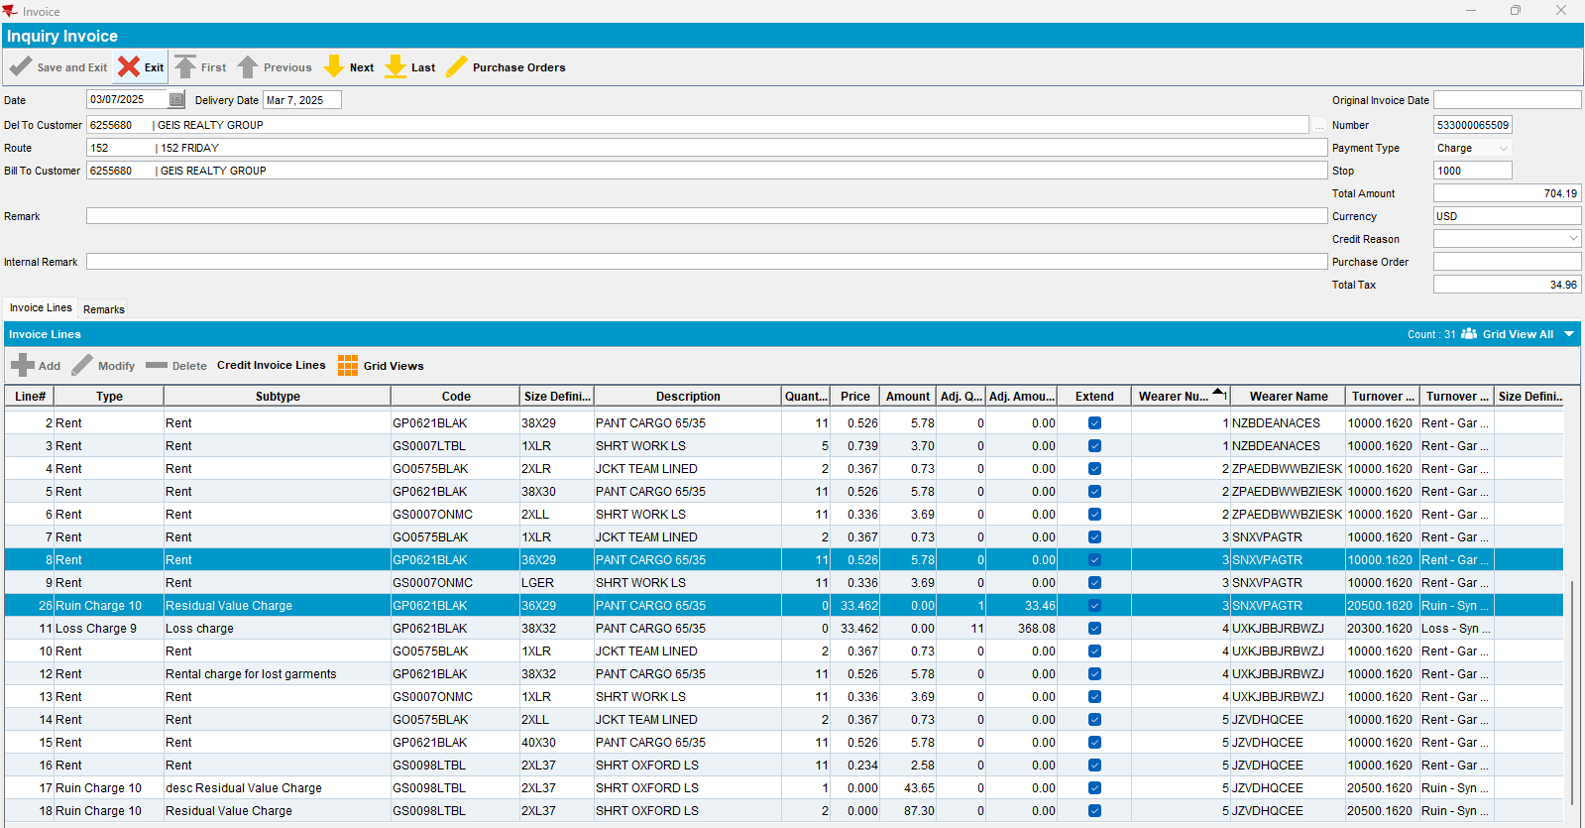

- and loss charge with rental charge for lost garments invoice lines for bill for loss now (quit wearer inventory) are added correctly and are billed:

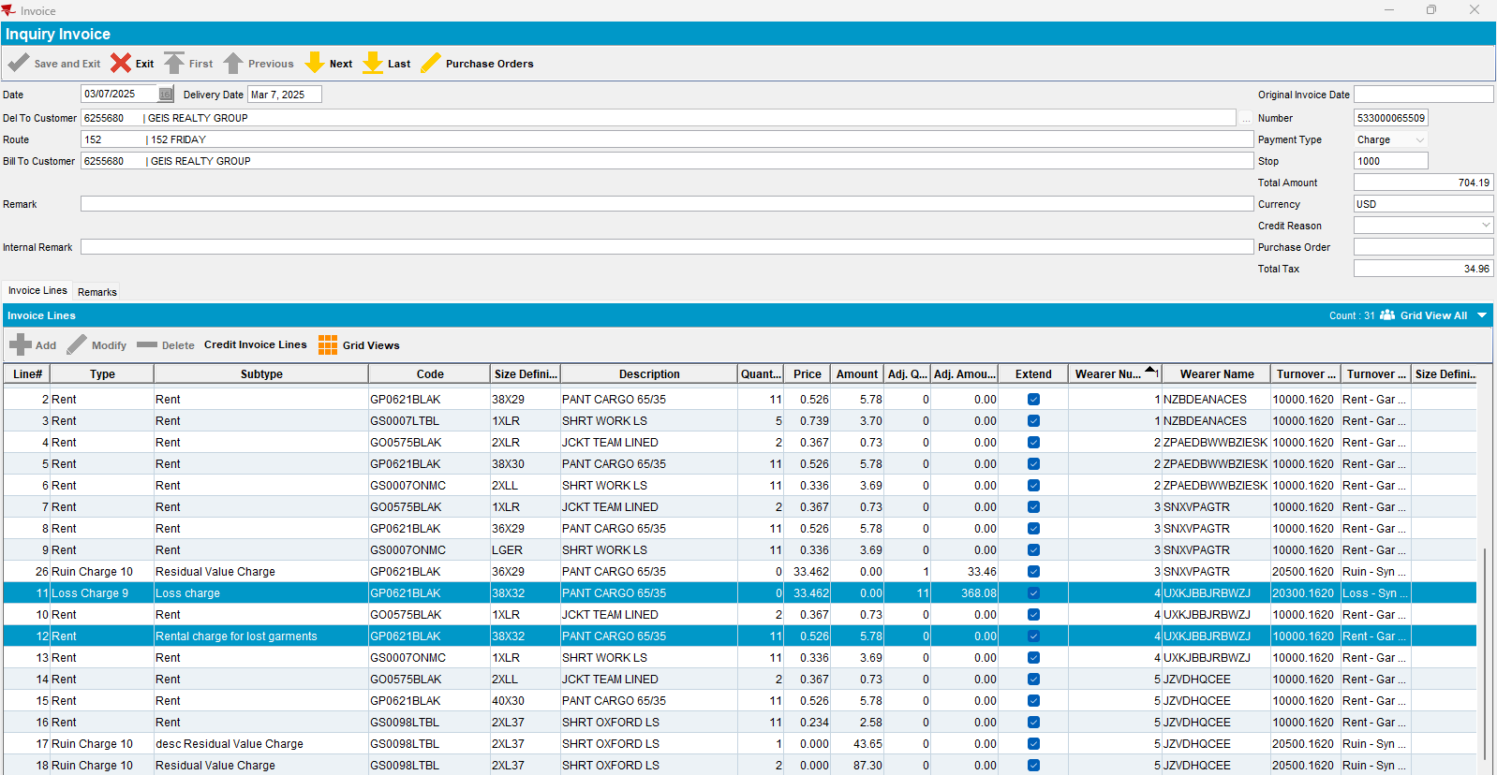

- Generate next invoice:
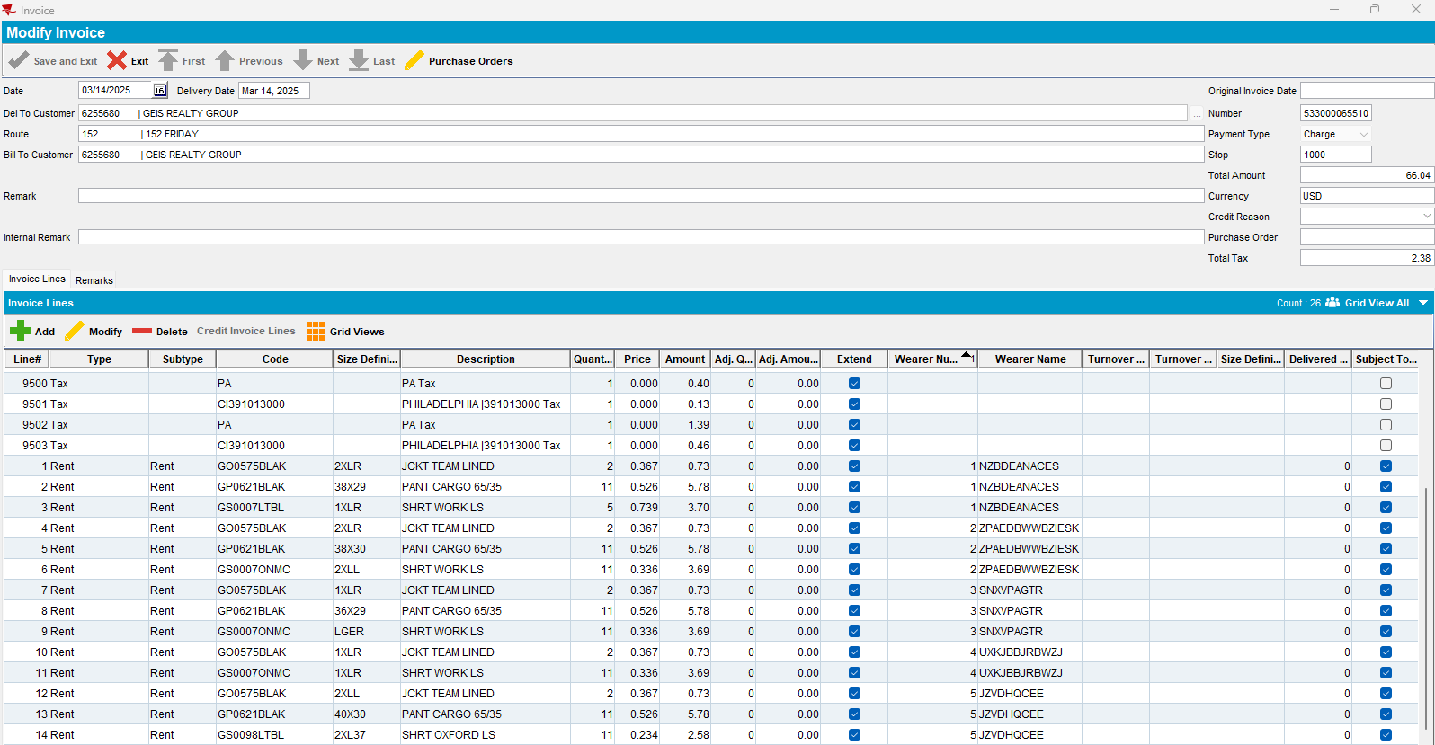

- No ruin or loss charge invoice lines are added -> Passed.

