ABSN-2467 Downgrade to 9.08.00.release.p18_AUS
Environment | Prerequisites
Version: 9.08.00.RELEASE.p17  DBServerName=abs-srv16.internal.abslbs.com  DBSID=CUST21  DBUser=AUS_ND90502  DBPassword=AUS_ND90502  Environment=Production | - Module:-  - System setting: MAXWEARERSPDA  - Others: BU: 259 Sacramento  - RA version: 13.12

Contents
Reproducing before fix 1
Retest after fix 7

Reproducing before fix
Hash: 802cd89
- Select a customer that has a lot of wearers
select count(w.wearer_id) nrWearers, w.customer_id
from wearer w
group by w.customer_id
order by nrWearers desc
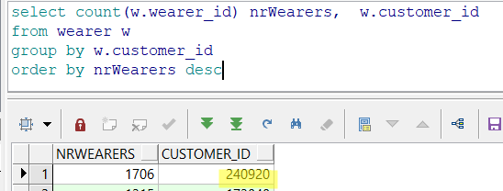

select * from customer c where c.customer_id=240920
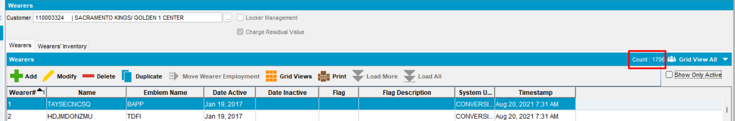
- All wearers: 1706
  - Active wearers: 1688
  - Inactive wearers: 18
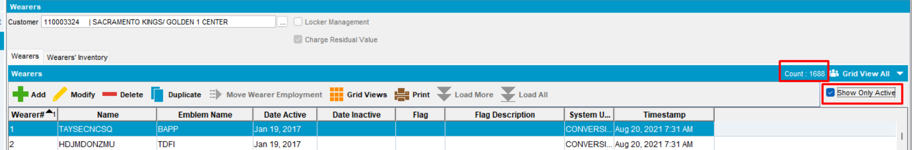
- Set the value of system setting:
System setting MAXWEARERSPDA have to be greater than active wearers, but less than total number of wearers.
MAXWEARERSPDA = 1695
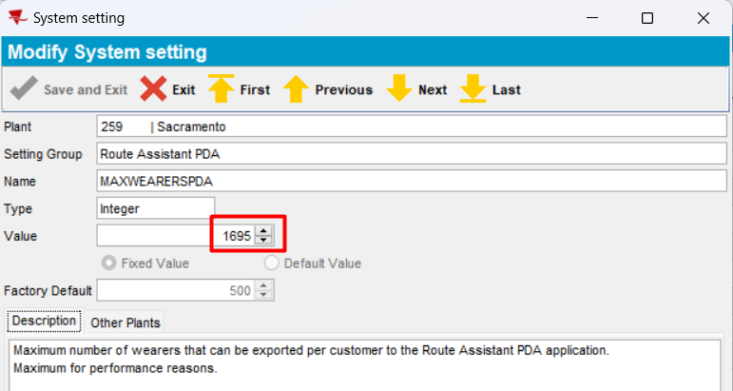
- Have some ID CODES on wearer
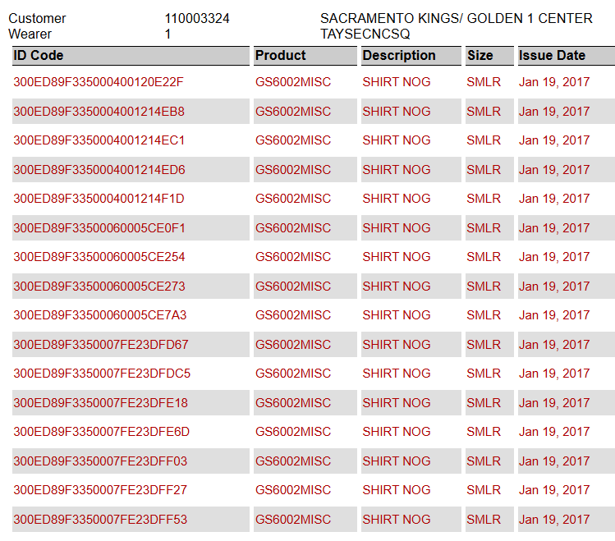
- In Route Status Control , add a route control
- Generate Put Up Docs and Invoice
- Mark route “Ready for Transfer to PDA”
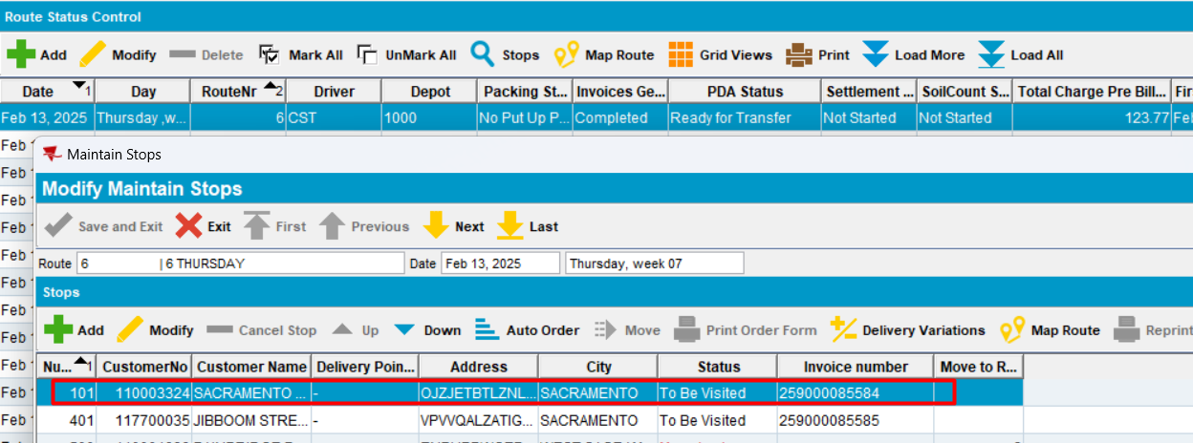
- Connect to RA, start the route
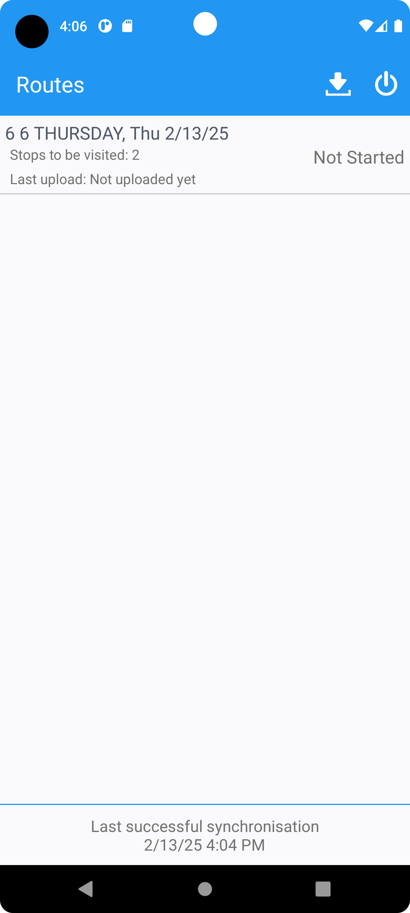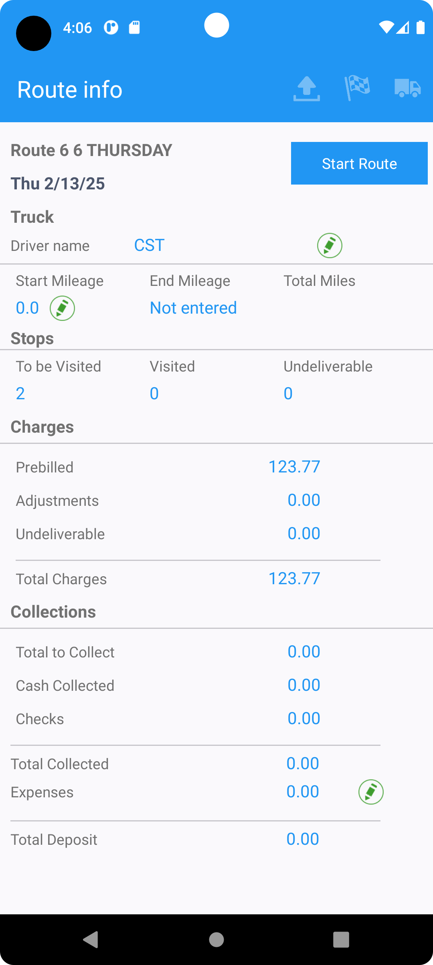
- Visit the customer
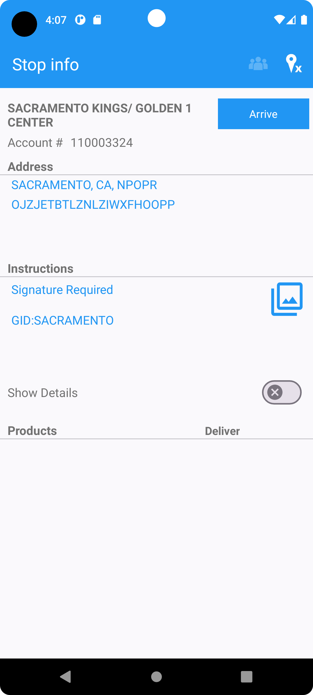
- Select Scan Garments.
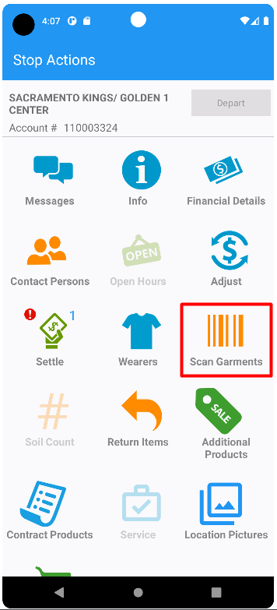
- Scan for replacement – ruin
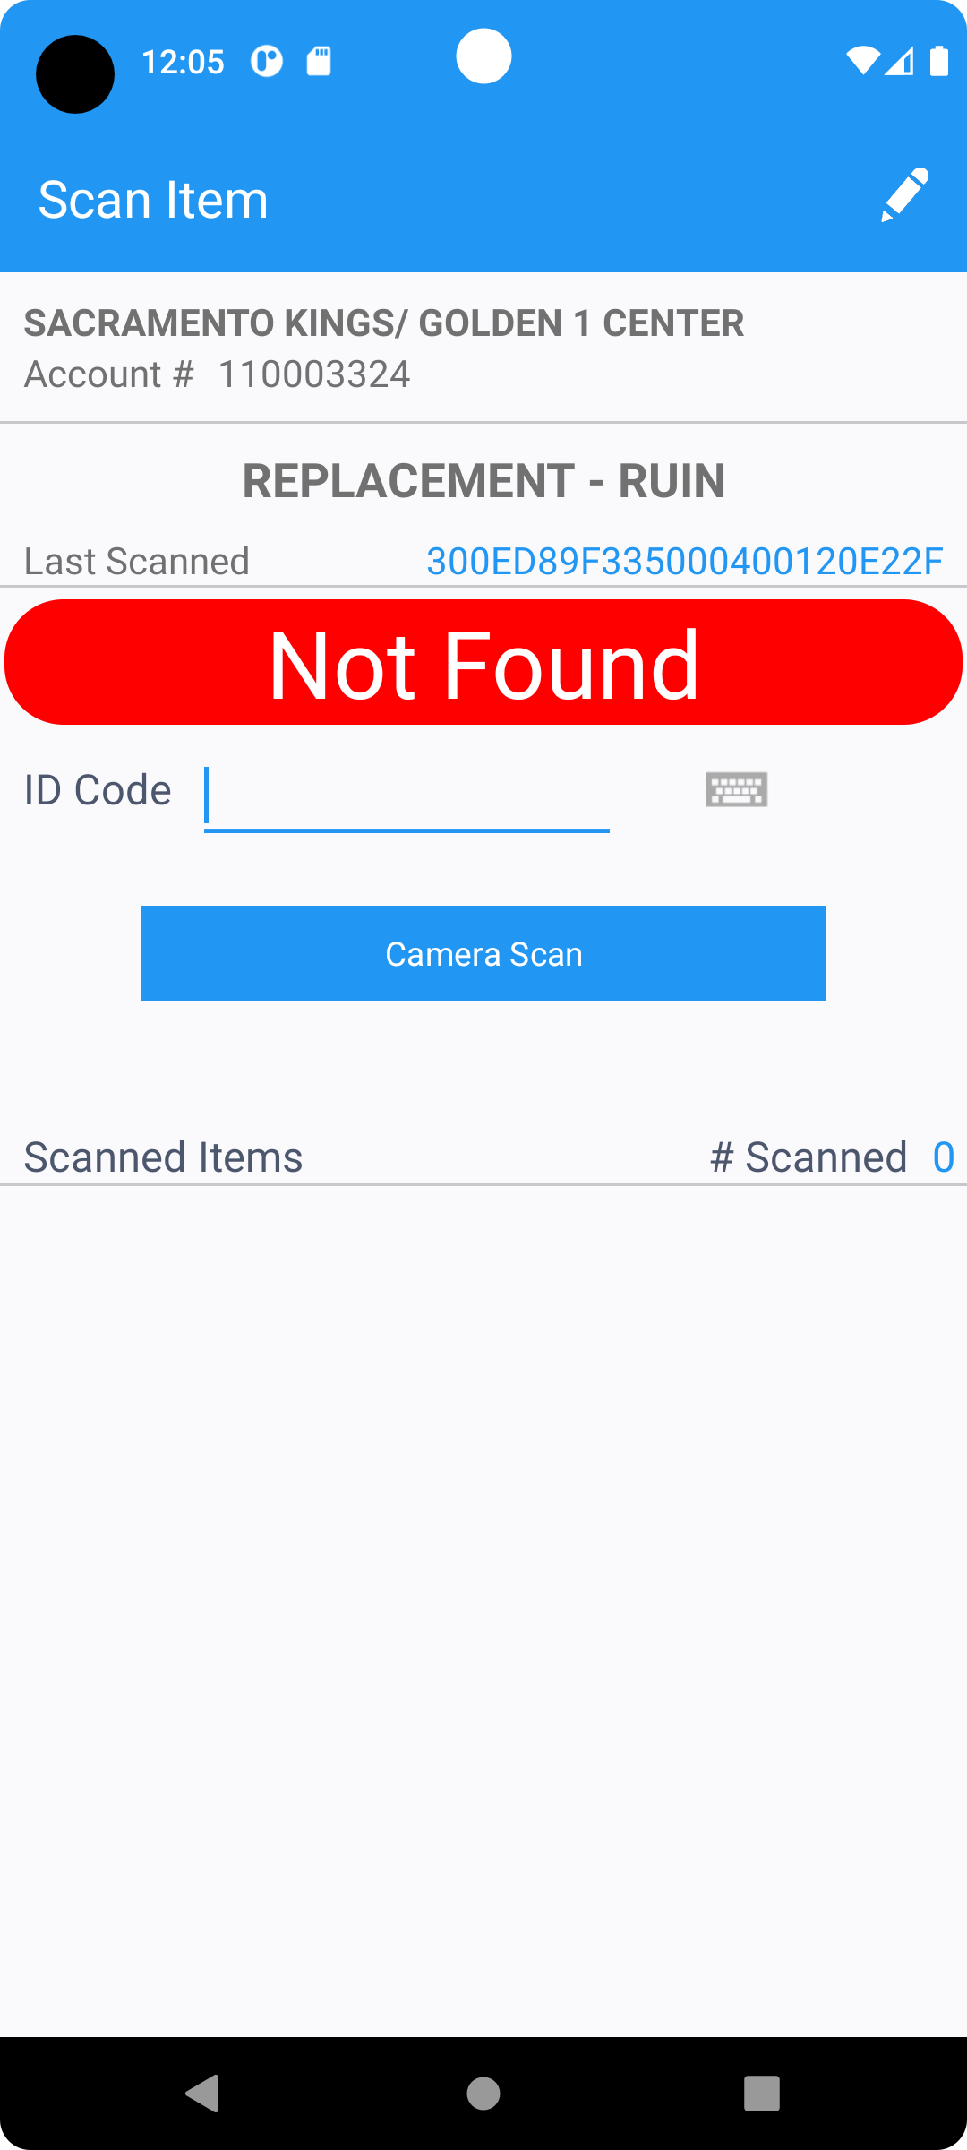
- Scan for replacement – abuse
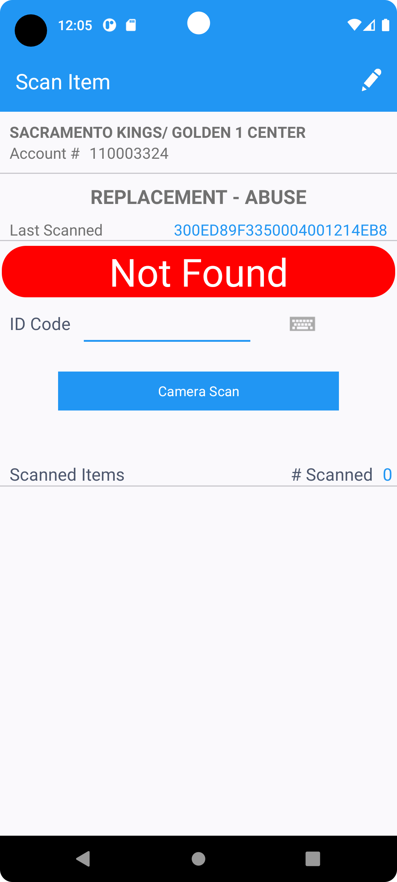
- Scan for replacement – worn out
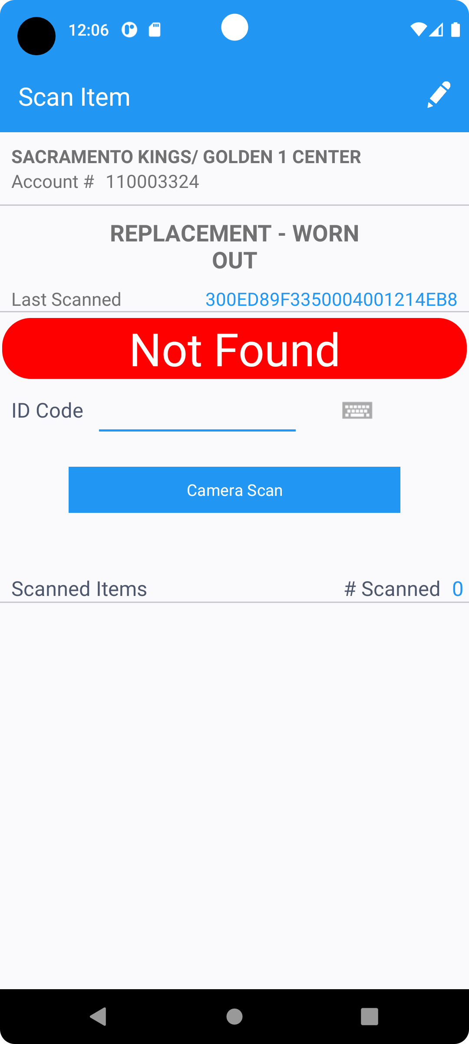
- Select Return Items and scan id codes
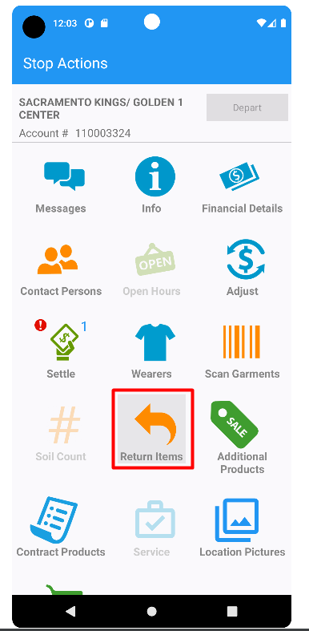
Scan the following ID Codes
300ED89F3350007FE23DFE18
300ED89F3350007FE23DFDC5
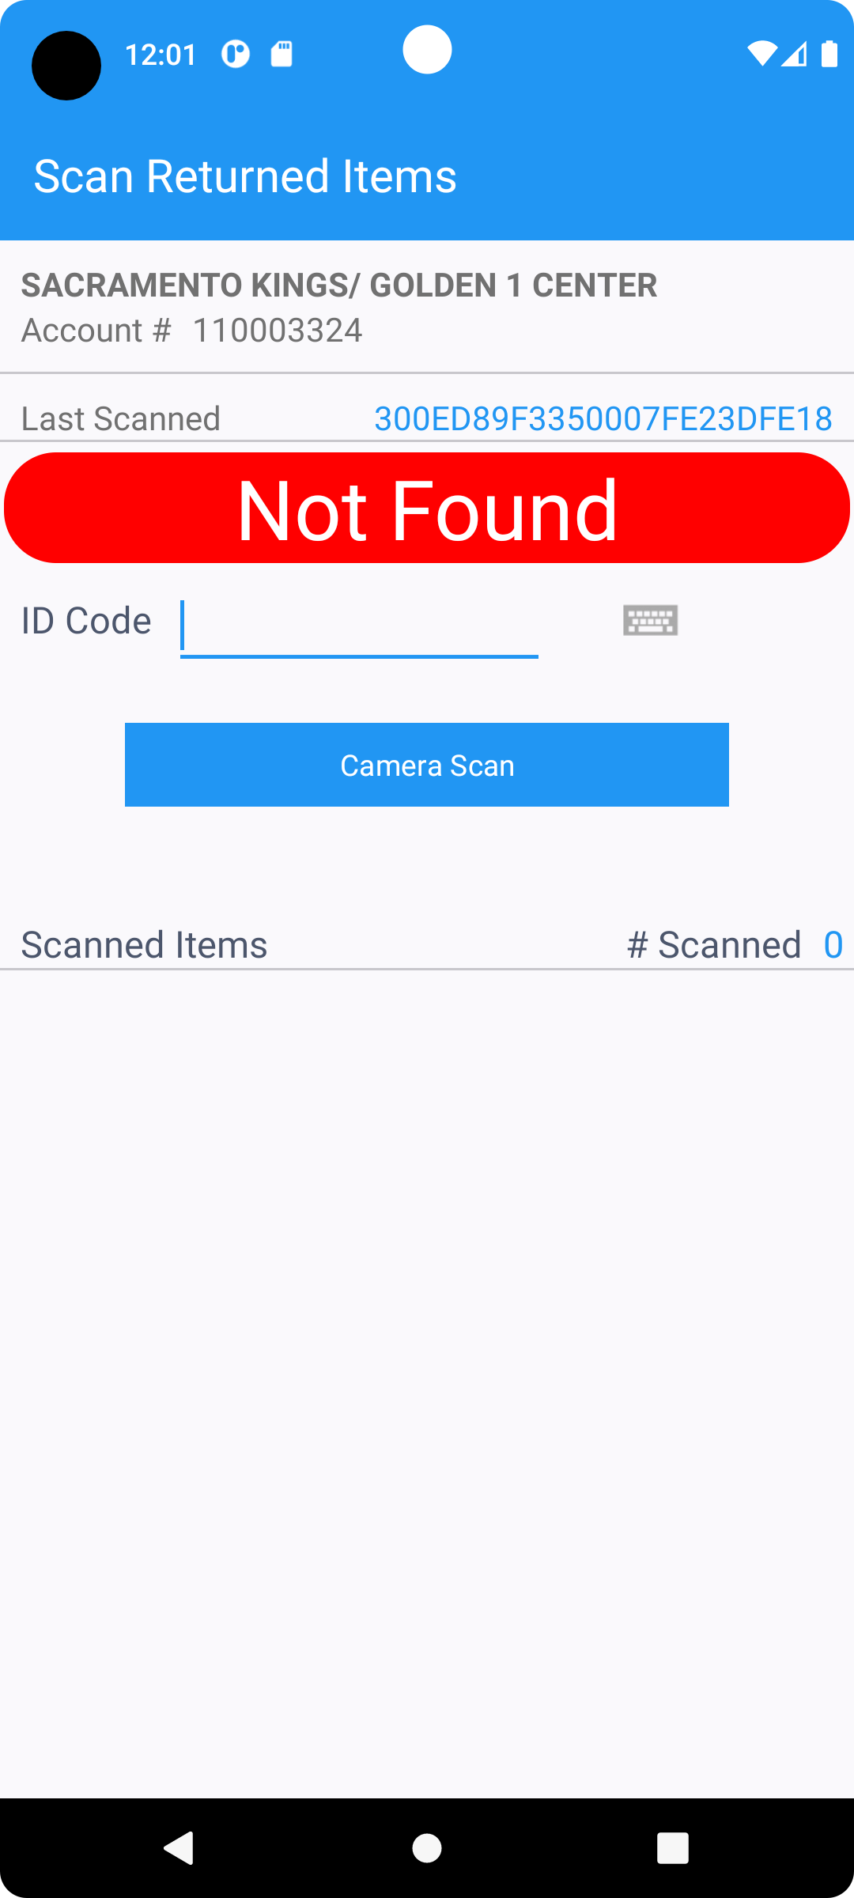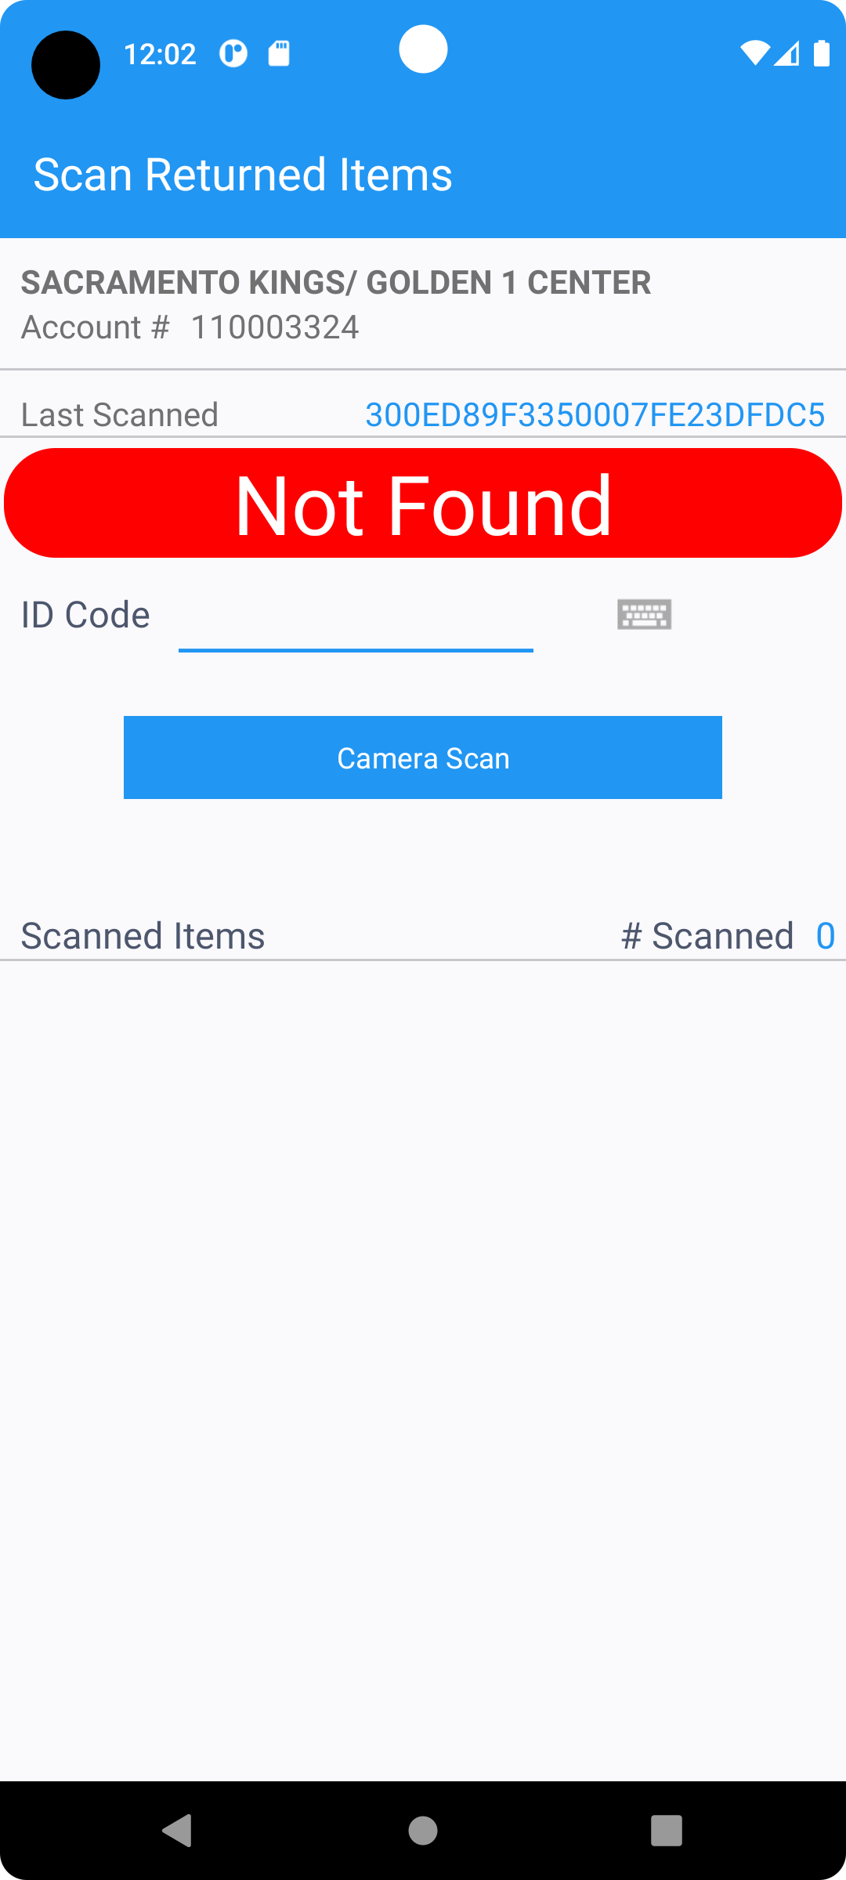
ID CODEs can not be scanned.
REPRODUCED OK

Retest after fix
Hash: e852e00
- Select a customer that has a lot of wearers
- All wearers: 1706
  - Active wearers: 1688
  - Inactive wearers: 18
- Set the value of system setting:
System setting MAXWEARERSPDA have to be greater than active wearers, but less than total number of wearers.
MAXWEARERSPDA = 1695
- In Route Status Control , add a route control
- Generate Put Up Docs and Invoice
- Mark route “Ready for Transfer to PDA”
- Connect to RA, start the route
- Visit the customer
- Select Scan Garments.
- Scan for replacement – ruin
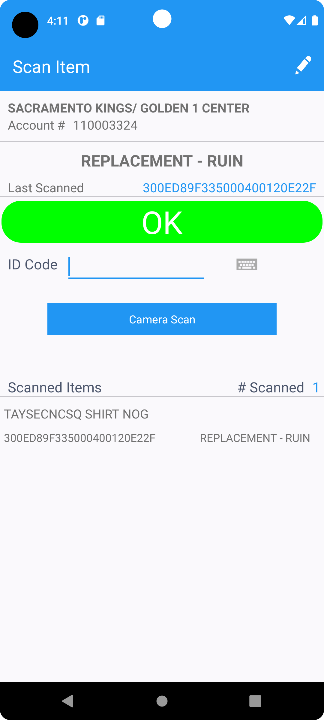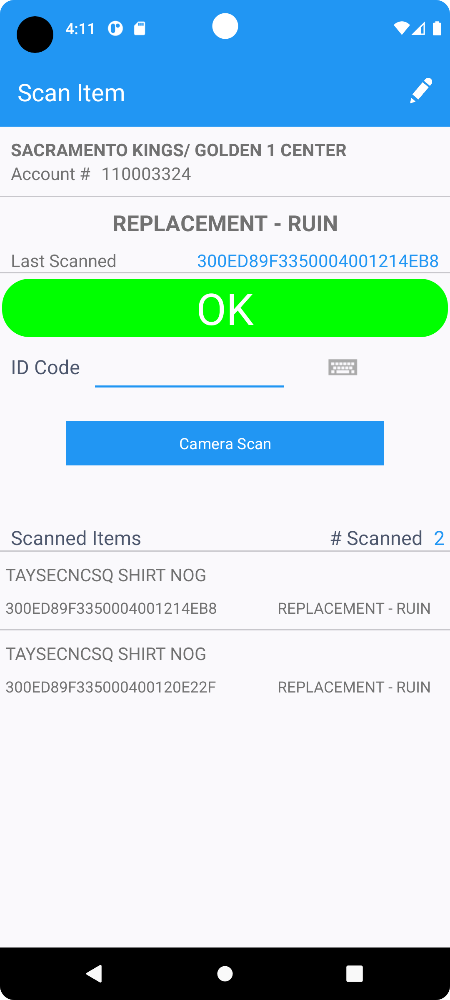
IDCODEs are successfully scanned.
- Scan for replacement – abuse
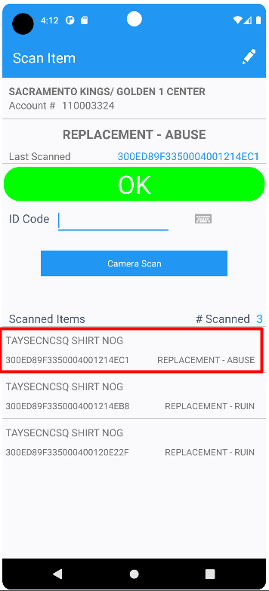
IDCODE is successfully scanned.
- Scan for replacement – worn out
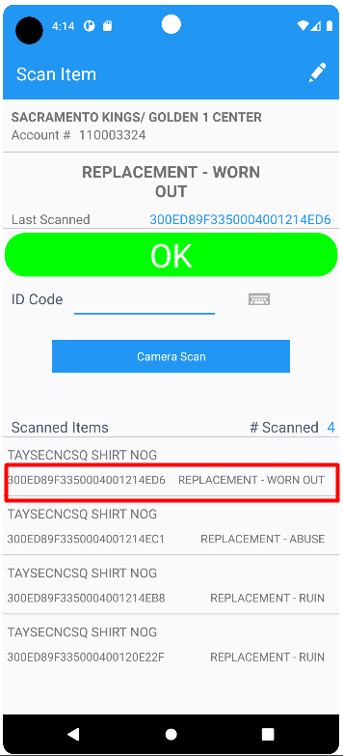
IDCODE is successfully scanned.
- Scan abused items
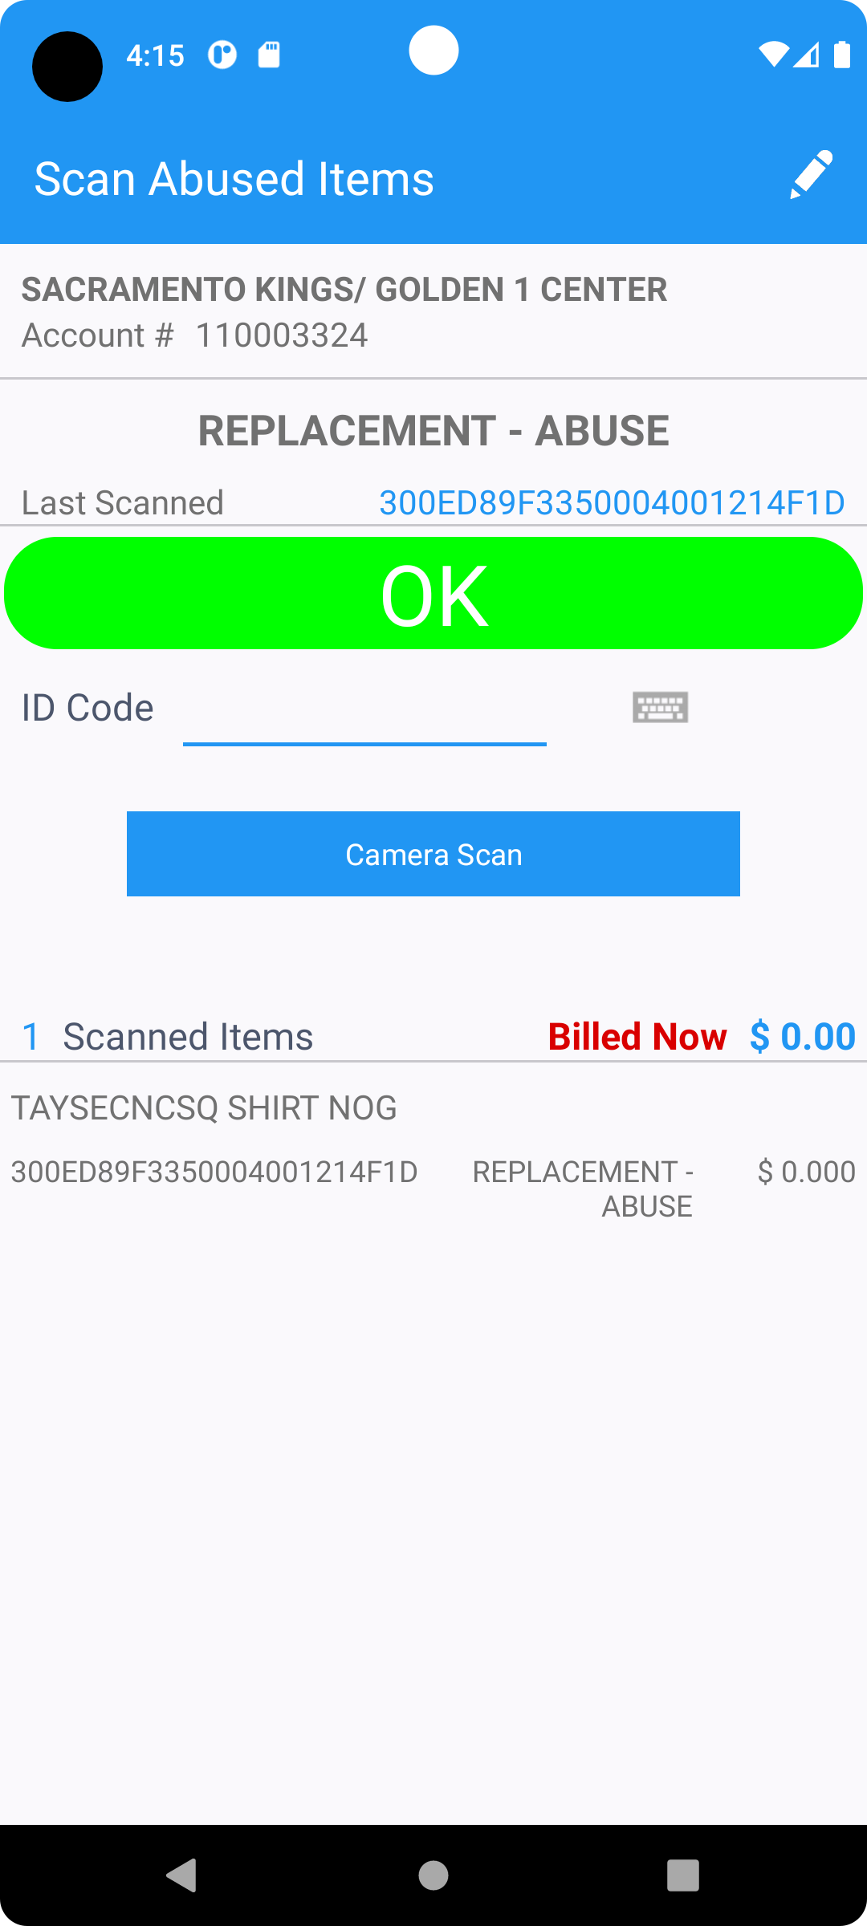
IDCODE is successfully scanned.
- Scan Returned items
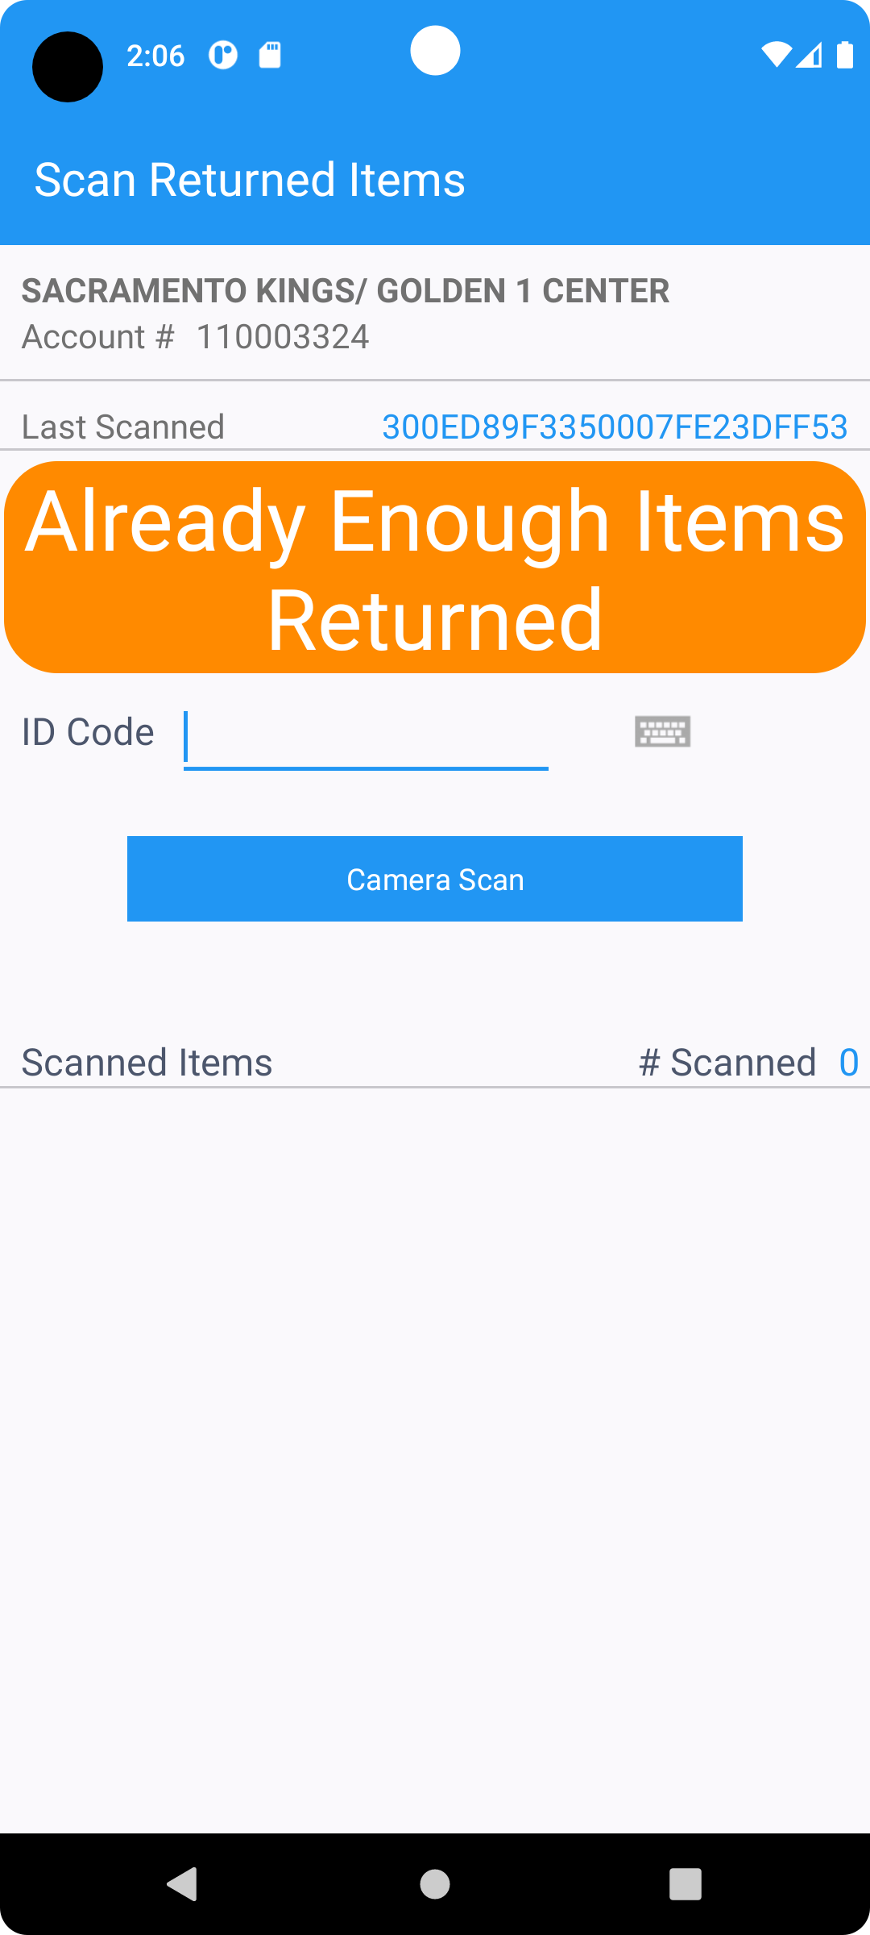
- Check if all the wearers are downloaded
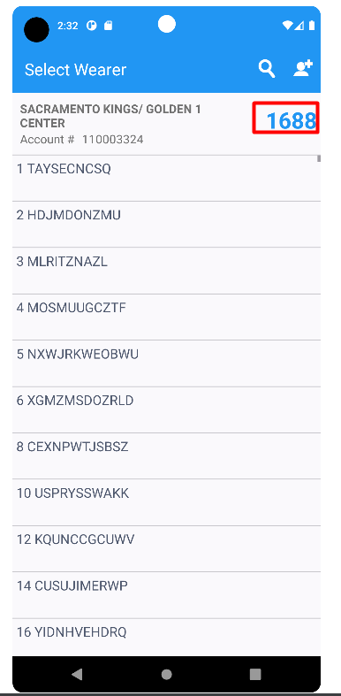
All the active wearers were downloaded.
RETEST OK

