ABSN-2252 BM6 Delivery Scheme Change issue
Environment | Prerequisites
Version: 9.08.00.RELEASE.p18  Environment=PRODUCTION  DBServerName=abs-srv16.internal.abslbs.com  DBSID=CUST21  DBUser=AUS_ND90502  DBPassword= AUS_ ND90502 | - Module: AUSCUSTOM, BILLINGMETHOD6  - Systems setting: -  - Others: BUs 473/ 503

Contents
Reproducing before fix 1
Retesting after fix 4

Reproducing before fix

BU code / Plant code: 473/473
Data preparation:
Step1) Find customer with inactive delivery scheme/s:
select c.customernumber, bu.code, ds.code
from customerdeliveryscheme cds
join deliveryscheme ds on ds.deliveryscheme_id=cds.deliveryscheme_id
join customer c on c.customer_id=cds.customer_id
join businessunit bu on bu.businessunit_id=c.defaultbusinessunit_id
where bu.code='473'
and cds.active='N'
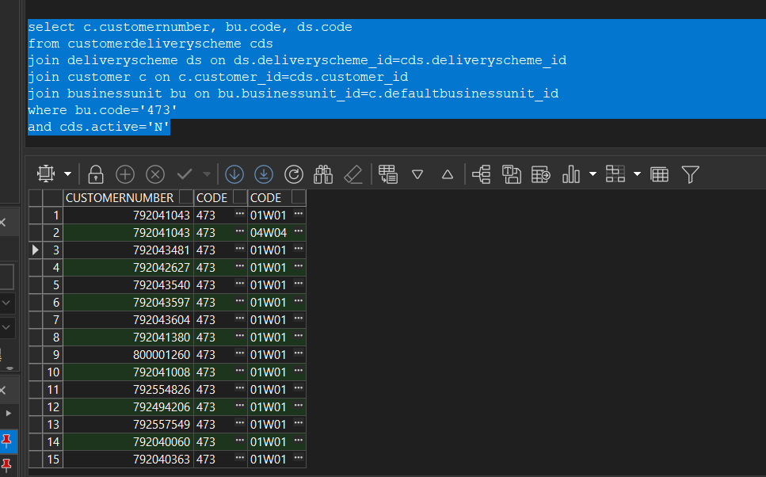
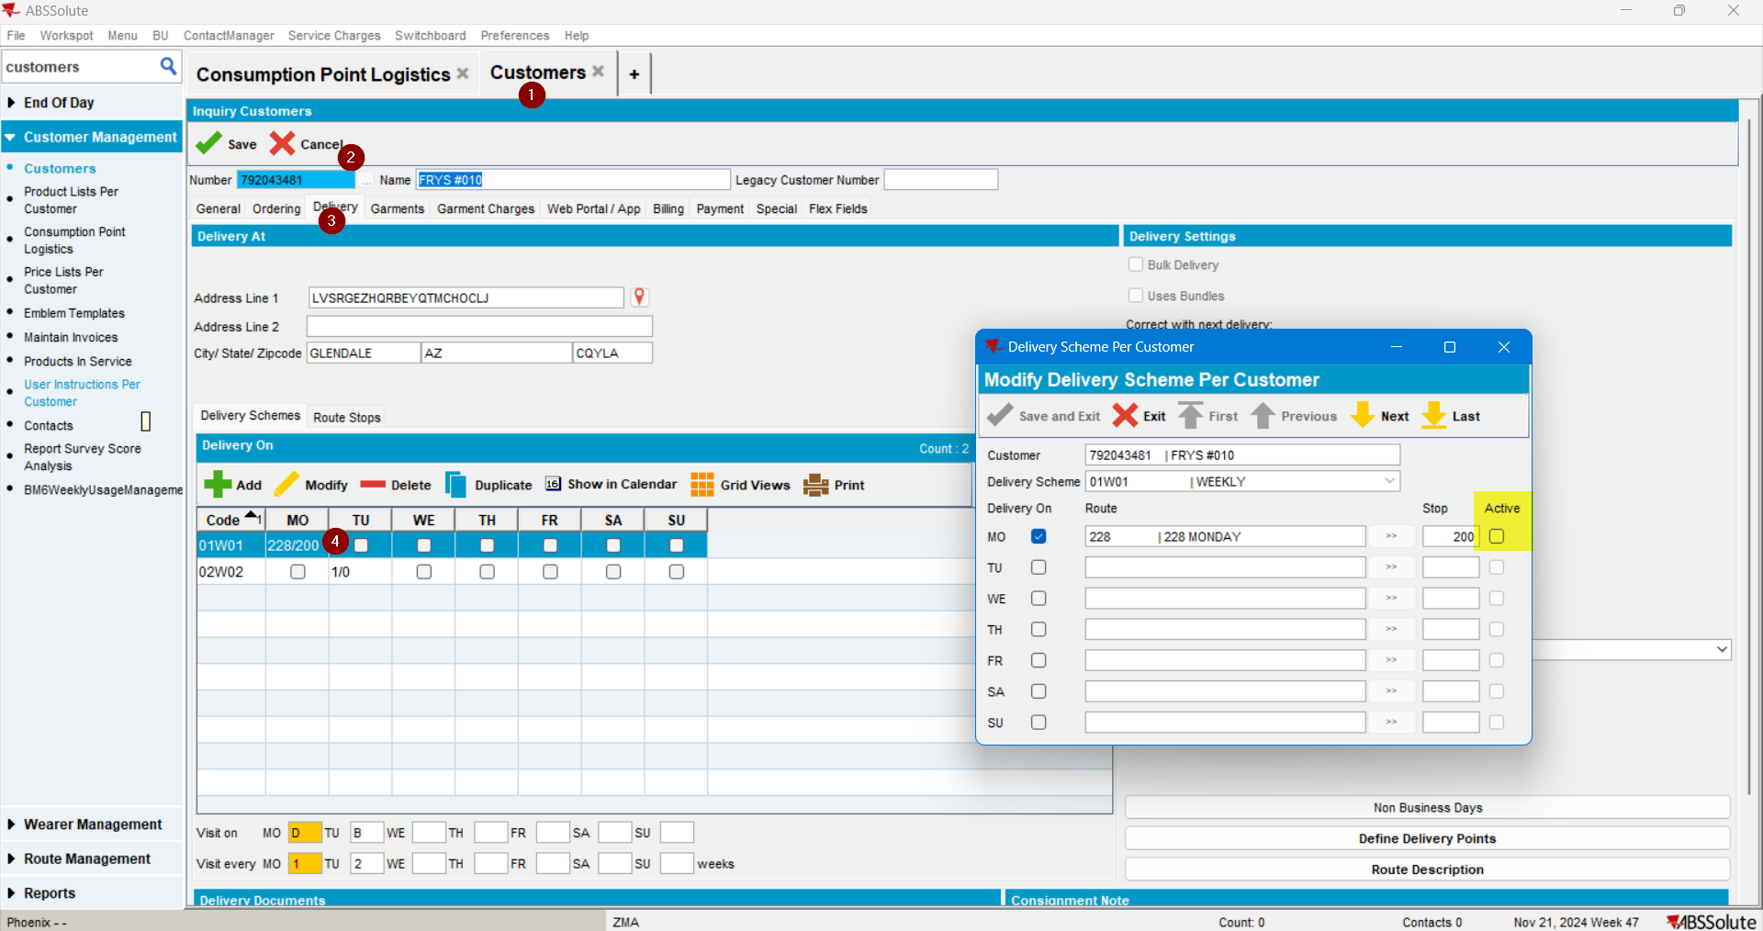
Step 2) Make sure that customer has BM6 products in its PLPC (or create/modify one to BM6)
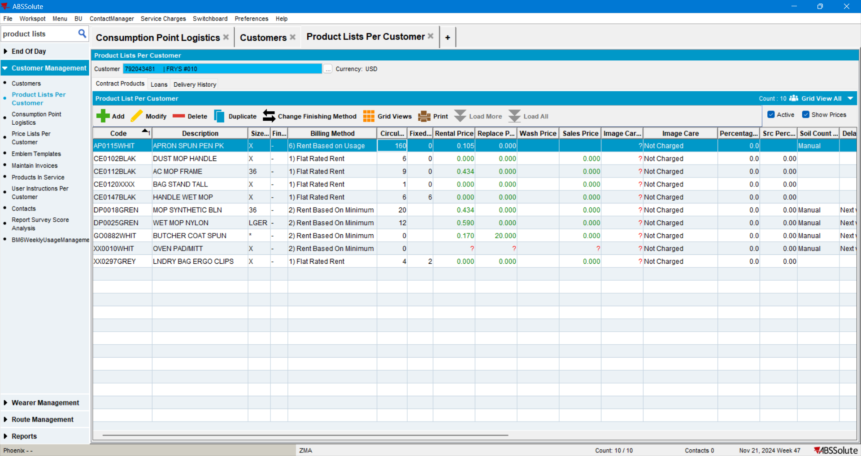

Step 3) Make sure that the BM6 product has the following delivery scheme: 02W02 | EOW B
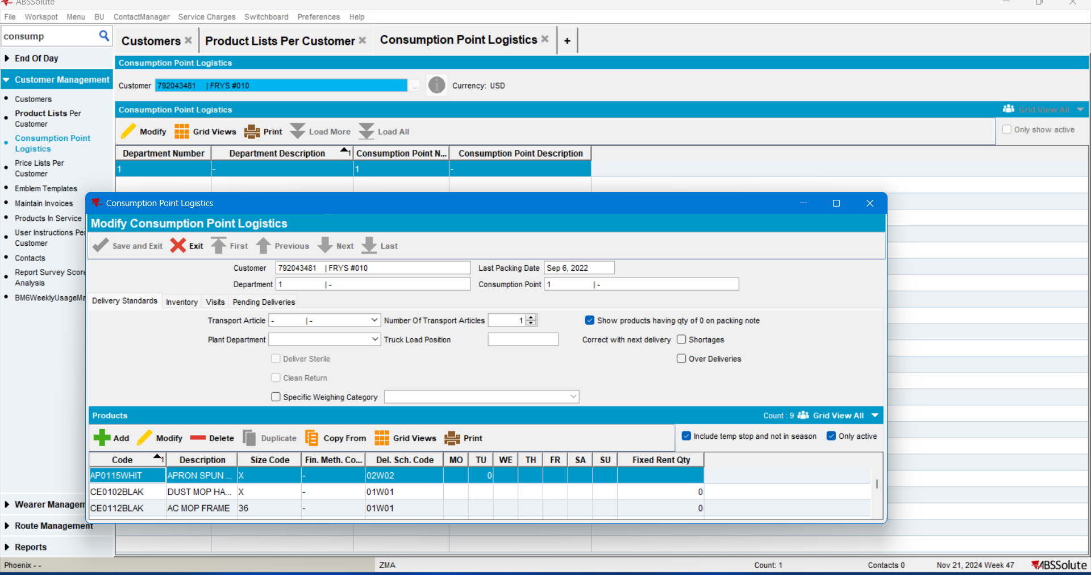

Steps to reproduce:
Step1) Change the delivery scheme of the analyzed BM6 product from every 2 weeks to weekly:
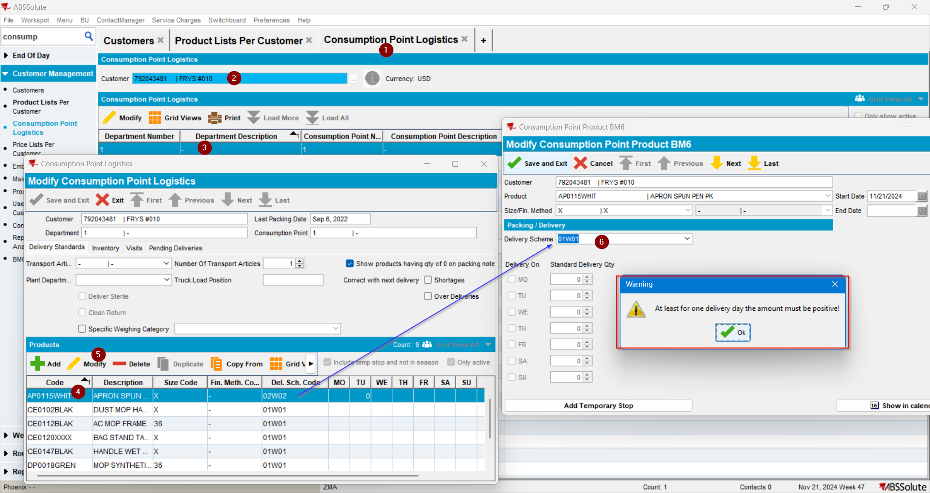
The delivery days are disabled, so none can be selected and the change cannot be saved:
REPRODUCED OK.

Retesting after fix

select c.customernumber, bu.code, ds.code, cds.active, plpc.billingmethod
from customerdeliveryscheme cds
join deliveryscheme ds
on ds.deliveryscheme_id = cds.deliveryscheme_id
join customer c
on c.customer_id = cds.customer_id
join businessunit bu
on bu.businessunit_id = c.defaultbusinessunit_id
join productlistpercustomer plpc
on plpc.customer_id = c.customer_id
where bu.code = '503'
and cds.active = 'N'
and plpc.billingmethod = 6;

Test case 1:
- Customer with some delivery schemes and some inactive stops:
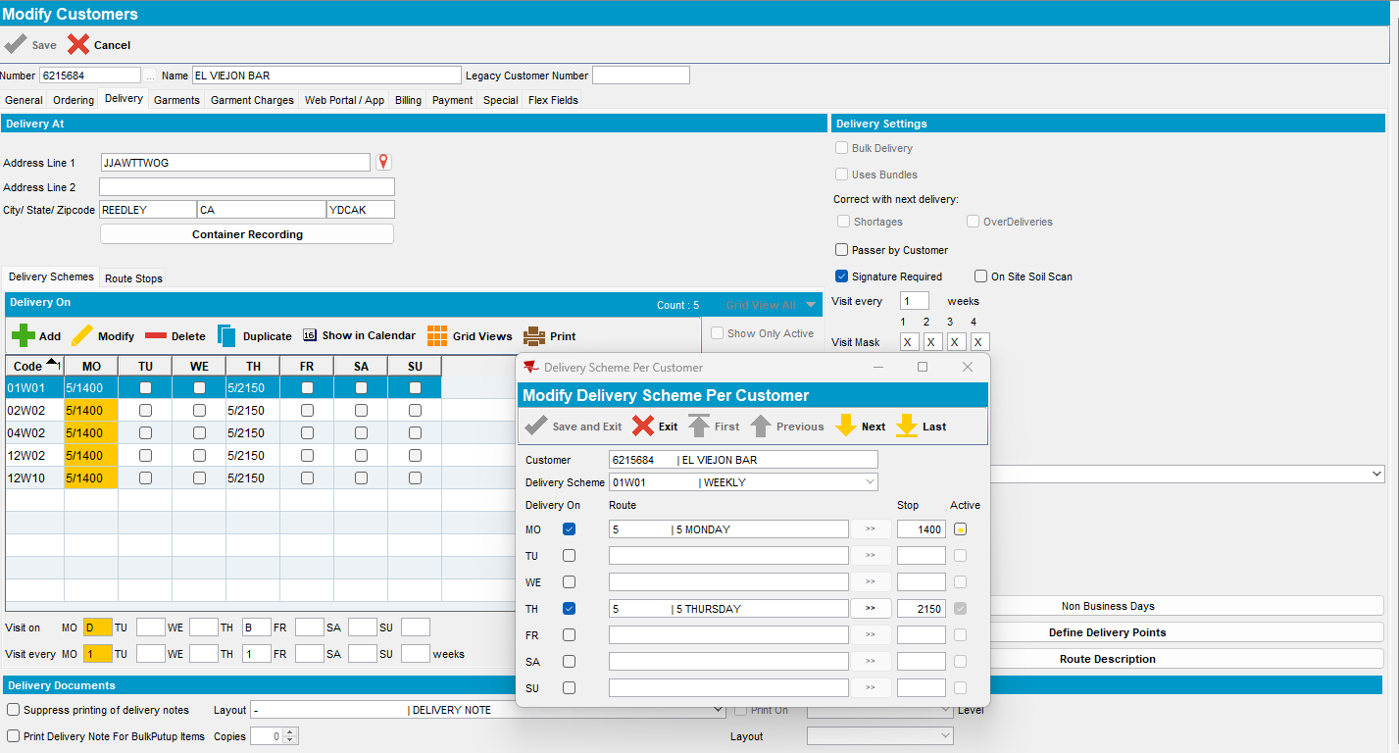

- BM6 product with 01W01 delivery scheme and only active stop day displayed or enable:
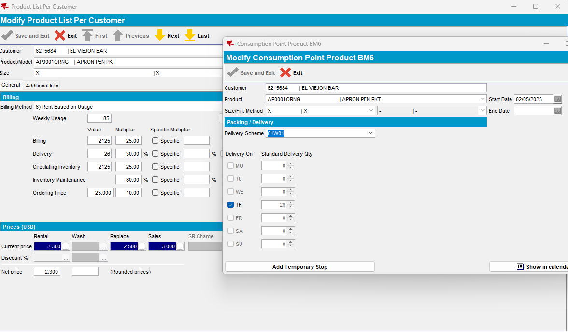

- Change delivery scheme:
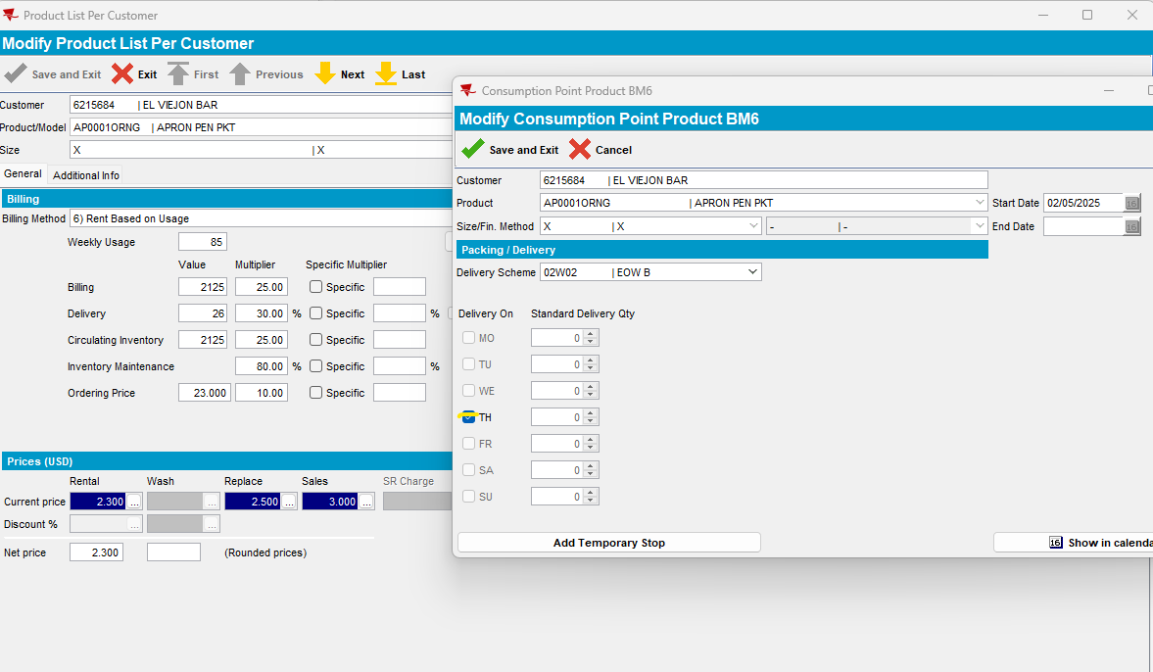
Only active day/ stop is enable -> Tested ok.

Test case 2:
- Customer with one delivery scheme and one inactive stop (unchecked and with date inactive filled)
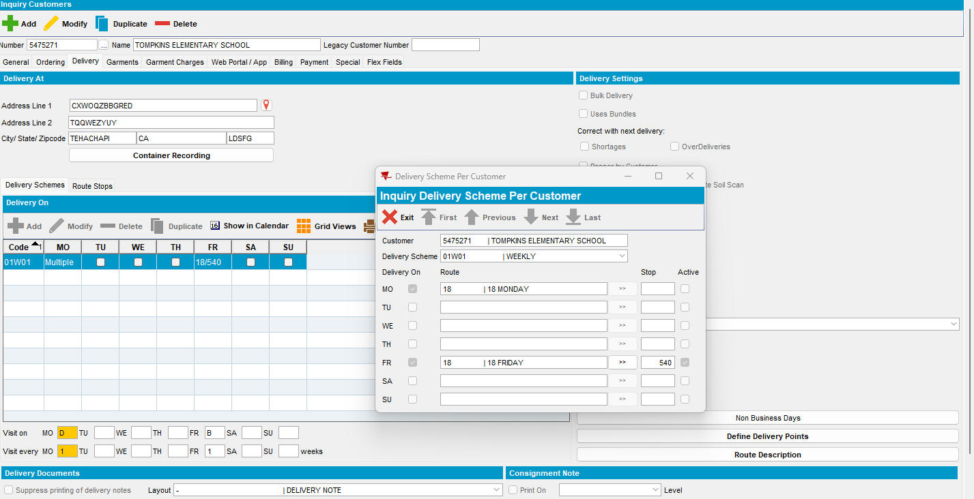

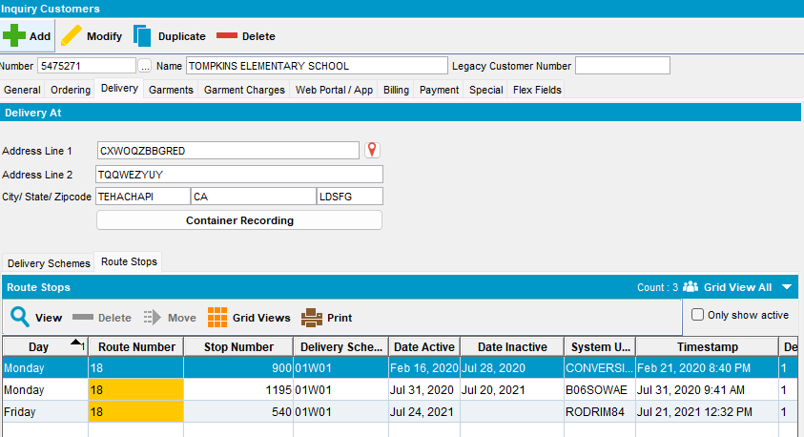

- On CPL the only active day/stop is enable:
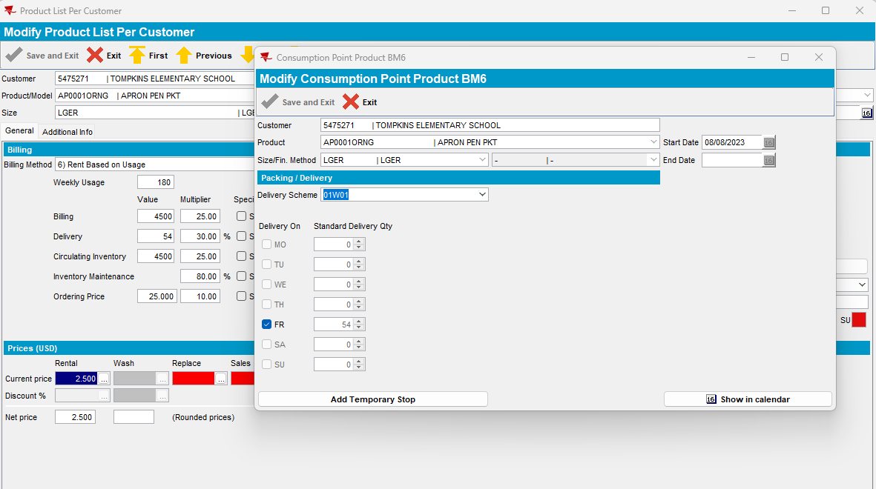

Tested ok.

