ABSN-221 BM6 - min invoice and inventory maintenance issues (reproducible for SRC Method=4, Percentage of Billed qty, no matter what Billing Method is)
Environment | Prerequisites
Version: 9.08.00.RELEASE.p18  Environment=PRODUCTION  DBServerName=abs-srv16.internal.abslbs.com  DBSID= CUST21  DBUser= AUS_ND90502  DBPassword= AUS_ND90502 | - Modules: AUSCUSTOM, BILLINGMETHOD6  - Others: BU 503

Contents
Reproduction before fix 1
Retesting after fix 7

Reproduction before fix
BU:503
Pre-condition:
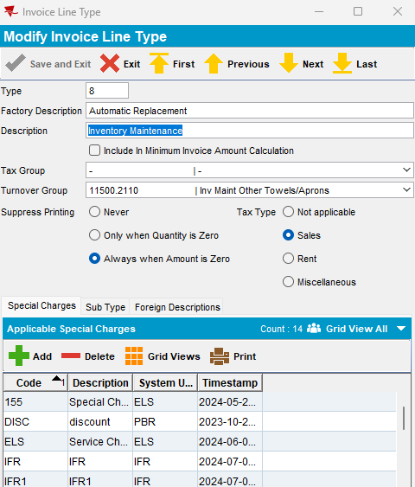

- Customer with Min. Inv. Amount = 25.00
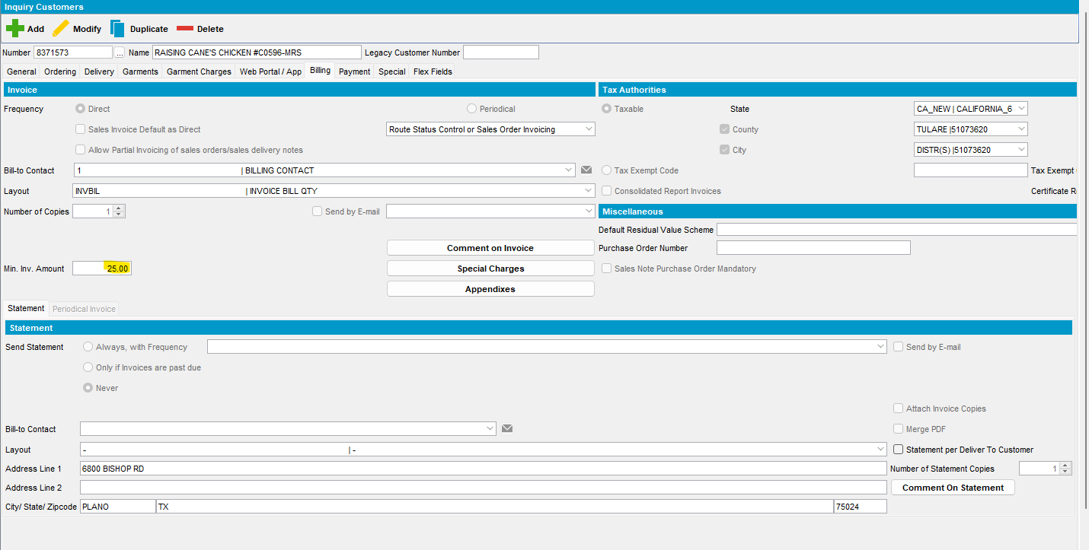
- Product first with BM2:
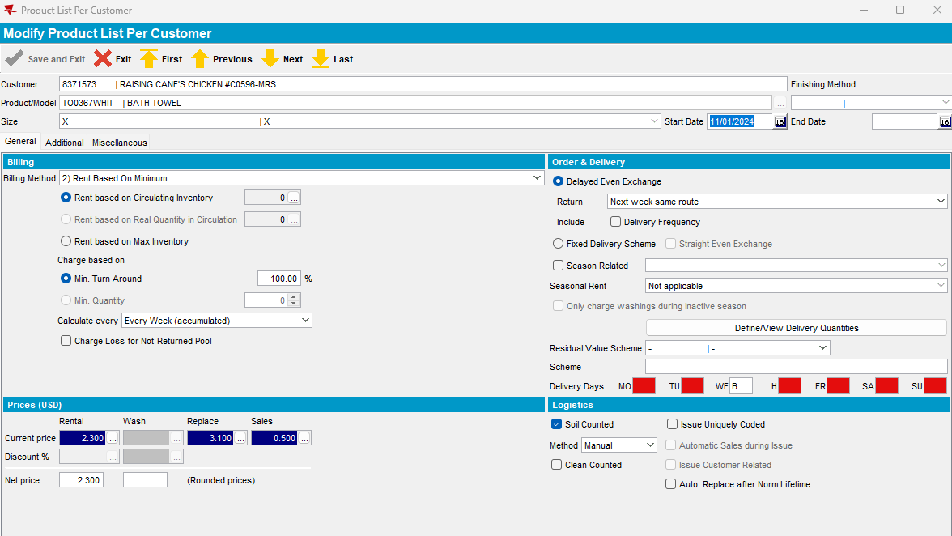

- SRC Method= 2
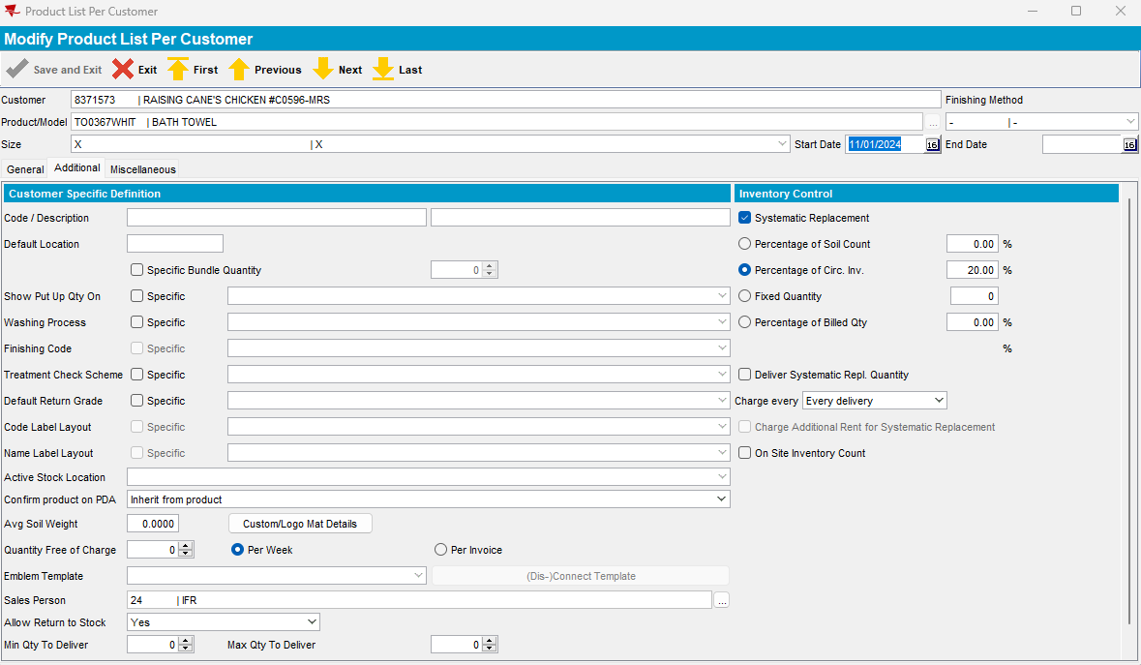
select plpc.srcmethod, plpc.srcfrequency, plpc.srcpercentageinventory
from productlistpercustomer plpc, customer c, product p
where plpc.customer_id=c.customer_id
and p.product_id=plpc.product_id
and c.customernumber=8371573
and p.code='TO0367WHIT'

- Route 72 from 13.11.2024 -> invoice:
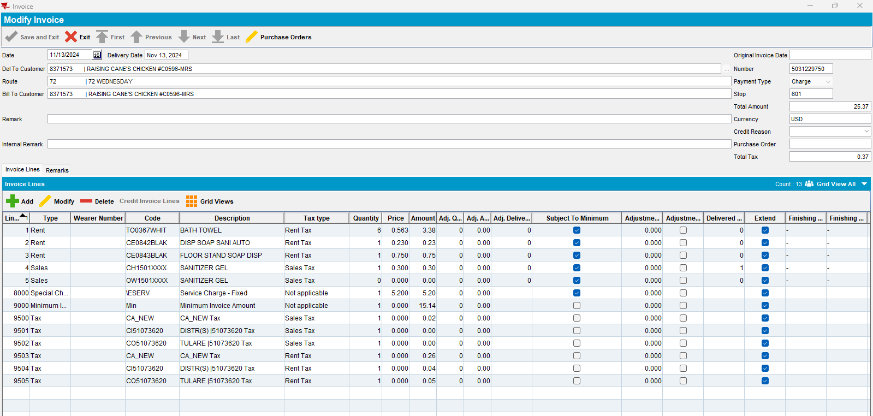
Invoice lines subject to minimum: 3.38+0.23+0.75+0.30+5.20= 9.86
Min. Inv. Amount = 25-9.86 = 15.14 (ok)

Expected result:
If ((system setting DELIVERYDAYS_US = ’Y’)
and (system setting SETTLEMENTACTIVE = ‘Y’)
and (system setting MINIMUMINVOICEAMTPDA = 2)) Then
Customer.MinimumInvoiceAmount from delToCustomer – total amount of the invoice lines with SubjectToMinimum = ‘Y’ (when total amount >= minimum invoice amount, then set to 0
Else
Customer.MinimumInvoiceAmount from delToCustomer – total amount of the invoice lines with SubjectToMinimum = ‘Y’ (only when total amount < minimum invoice amount)

- Convert the product from BM2 to BM6:
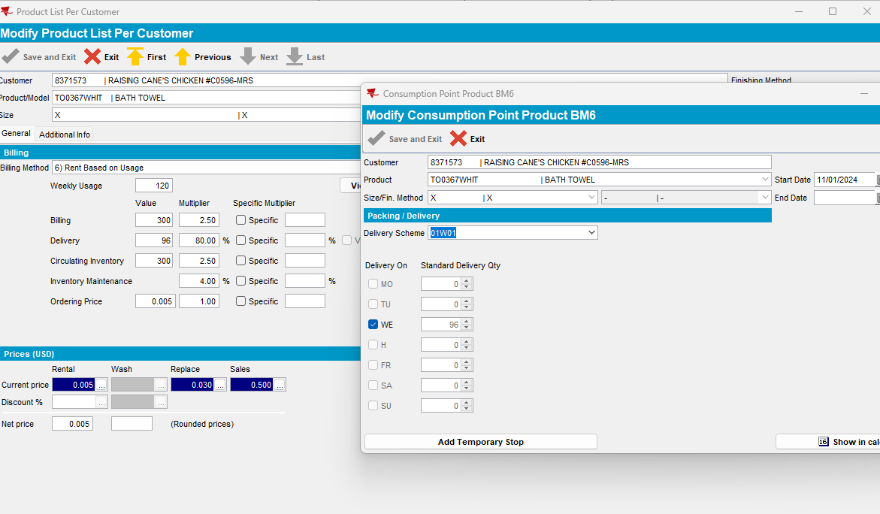
- Inventory Maintenance Percentage for this product = 4.00%
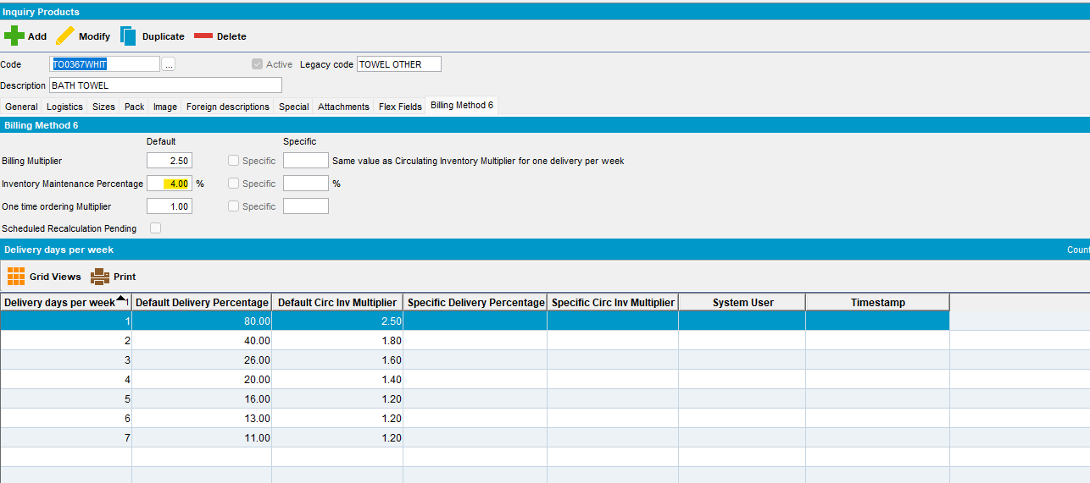
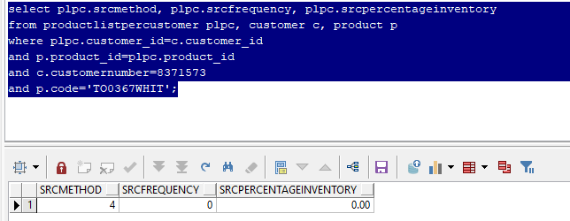
Expected result:
SRC Method= 4 > BILLEDQTY - when module BILLINGMETHOD6 is in license, For PLPC’s with BM6, BILLEDQTY from Rent line * current factor from Inventory Maintenance Multiplier / 100, rounded

- Inventory Maintenance invoice line for BM6 product:
- (300*4)/100 = 12* replacement price (0.030) = 0.36 (ok)
- Route 72 from 20.11.2024 -> invoice:
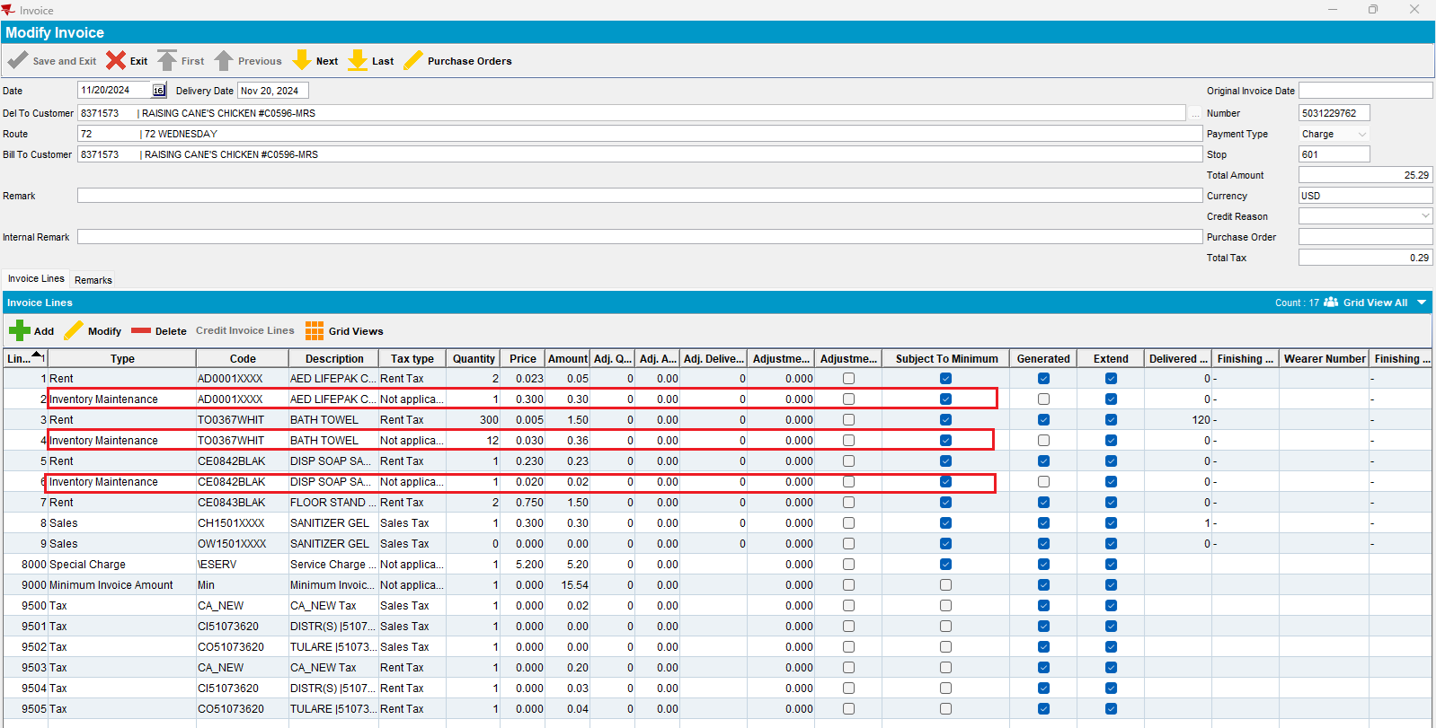
- In PLPC I have BM1 or BM2 products with SRC Method = 4 (Percentage of Billed qty) and for all these products (not only for BM6 product) Inventory Maintenance invoice line is marked as Subject to Minimum and taken into account for Minimum Invoice Amount line:
- 0.05+0.30+1.50+0.36+0.23+0.02+1.50+0.30+5.20=9.46 <25.00
- 25.00-9.46= 15.54 (Min. Invoice Amount amount) (nok)

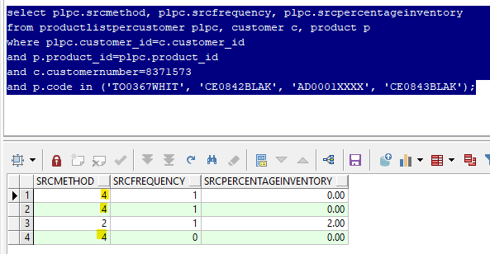

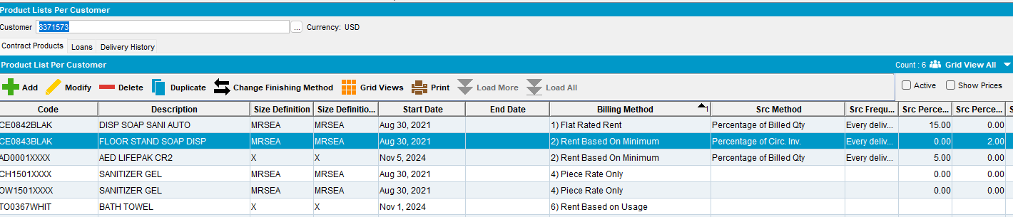

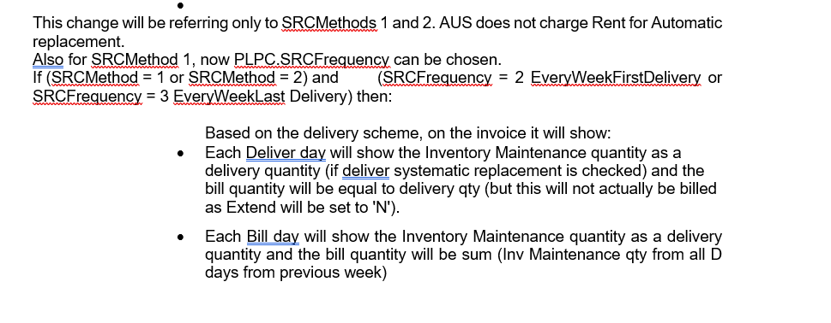

Reproduced.

Retesting after fix
BU:503
Pre-condition:
- Customer with Min. Inv. Amount = 25.00
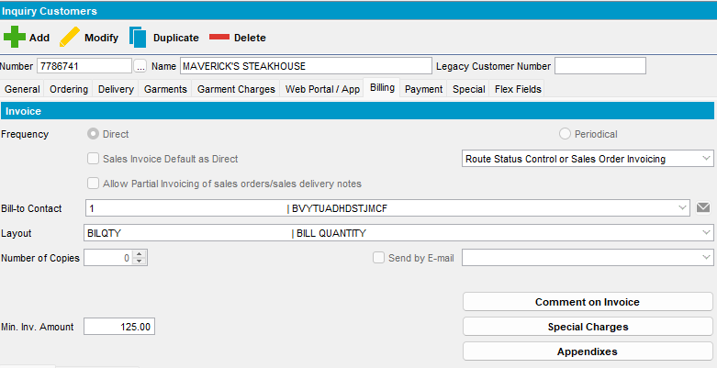

- Product first with BM2:
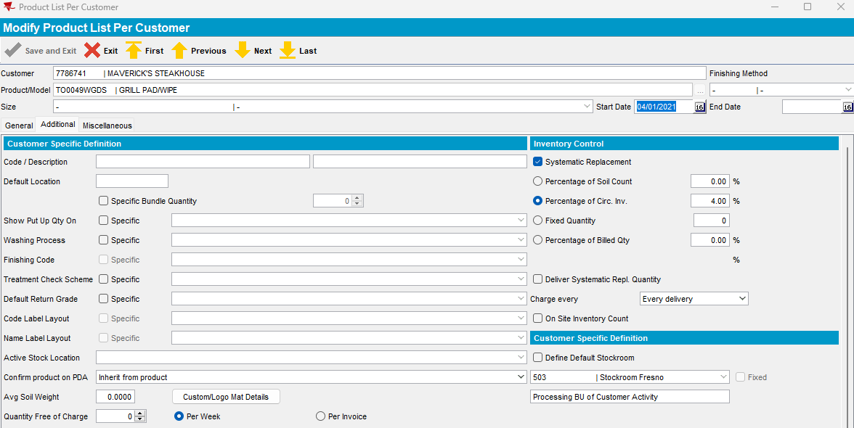

select plpc.srcmethod, plpc.srcfrequency, plpc.srcpercentageinventory
from productlistpercustomer plpc, customer c, product p
where plpc.customer_id=c.customer_id
and p.product_id=plpc.product_id
and c.customernumber=7786741
and p.code= 'TO0049WGDS';

- Route 32 from 20.02.2025 -> invoice:
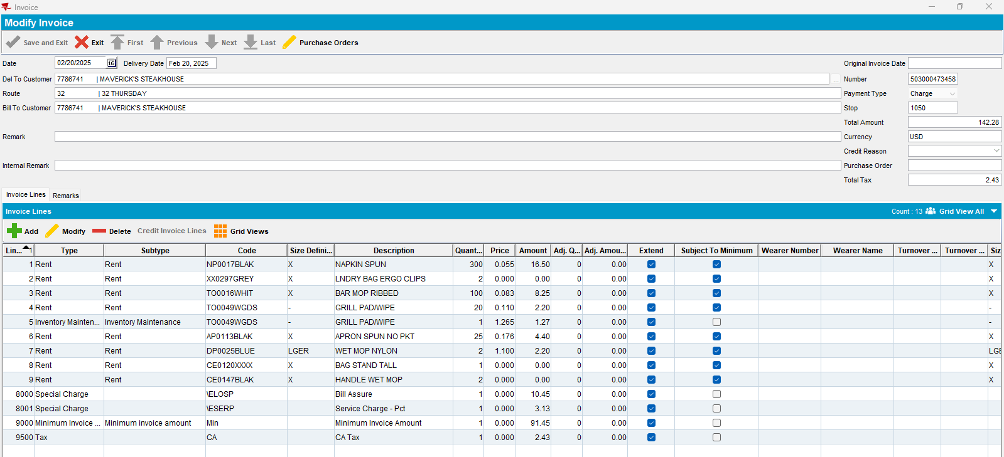
Invoice lines subject to minimum: 16.50+8.25+2.20+4.40+2.20=33.55
Min. Inv. Amount = 125-33.55 = 91.45 (ok)

Expected result:
If ((system setting DELIVERYDAYS_US = ’Y’)
and (system setting SETTLEMENTACTIVE = ‘Y’)
and (system setting MINIMUMINVOICEAMTPDA = 2)) Then
Customer.MinimumInvoiceAmount from delToCustomer – total amount of the invoice lines with SubjectToMinimum = ‘Y’ (when total amount >= minimum invoice amount, then set to 0
Else
Customer.MinimumInvoiceAmount from delToCustomer – total amount of the invoice lines with SubjectToMinimum = ‘Y’ (only when total amount < minimum invoice amount)

- Convert the product from BM2 to BM6:
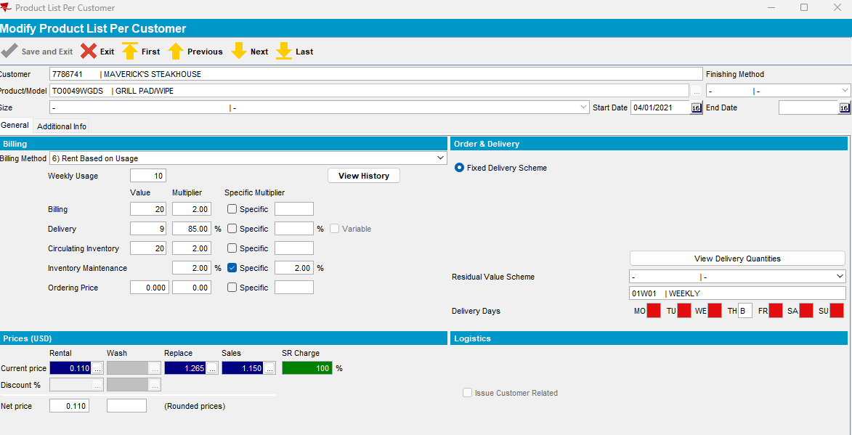
- Inventory Maintenance Percentage for this product = 2.00%
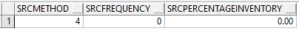
Expected result:
SRC Method= 4 > BILLEDQTY - when module BILLINGMETHOD6 is in license, For PLPC’s with BM6, BILLEDQTY from Rent line * current factor from Inventory Maintenance Multiplier / 100, rounded
- Inventory Maintenance invoice line for BM6 product:
- (20*2)/100 ~ 1* replacement price (1.265) = 1.27 (ok)
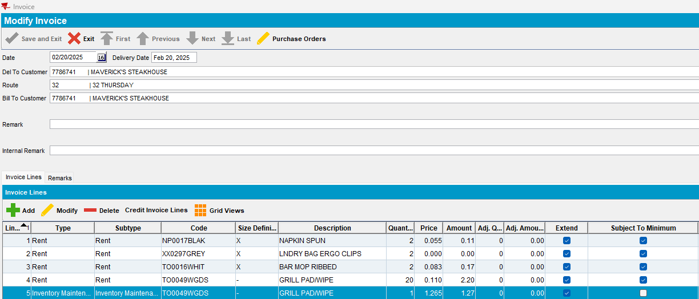

- In PLPC I have BM1, BM2 or BM6 products with SRC Method = 4 (Percentage of Billed qty) and for all these products (not only for BM6 product) Inventory Maintenance invoice line is not marked as Subject to Minimum and is not considered for Minimum Invoice Amount line:
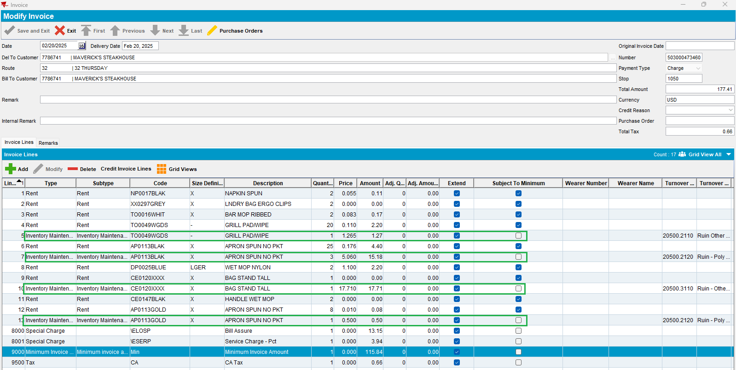

- 0.11+0.17+2.20+4.40+2.20+0.08=9.16
- Min. Inv. Amount = 125-9.16 = 115.84 (ok)

select plpc.srcmethod, plpc.srcfrequency, plpc.srcpercentageinventory, plpc.billingmethod
from productlistpercustomer plpc, customer c, product p
where plpc.customer_id=c.customer_id
and p.product_id=plpc.product_id
and c.customernumber=7786741
and p.code in ('AP0113BLAK', 'CE0120XXXX', 'AP0113GOLD','TO0049WGDS');
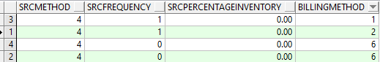

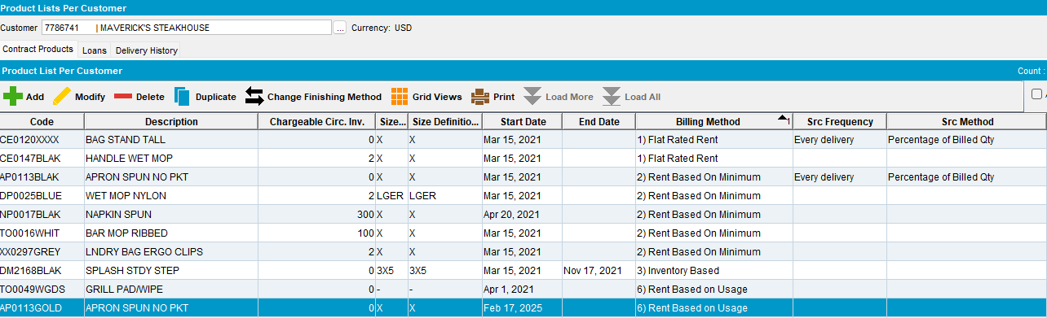
Tested ok.

